

LEVEL 4 ASSESSMENT SPECIFICATION
Program: BA Business Management
Module: Marketing Fundamentals
Module code: LCBB4004
Module Coordinator/ Lecturer: Tushara Balendran
Assignment Title: Assessment 1 Blogging to communicate

Student’s Name:Marian Busca
Student ID:2125297

  - GUCCI: The Journey

Journey of Gucci
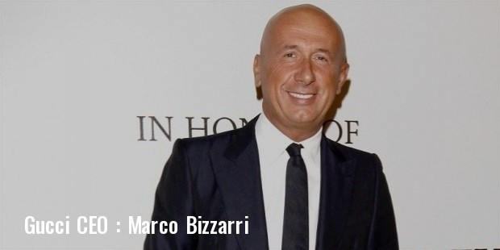
In 1921, Guccio Gucci established his own fashion brand in Florence, Italy. Inspiring him to start the business was the high-end baggage he carried up for visitors at hotels in Paris and London. This motivated him to establish a leather products business in his hometown of Florence, where he was born. Guccio passed away in 1953, at the age of seventy-two. Aldo, Vasco, Ugo, and Rodolfo, his four sons, eventually joined the firm and continued building the rapidly expanding brand's name.
Gloves, purses, trunks, belts, and shoes sold well at their Florence shop, which attracted customers from all over the world. Because of the rise in popularity of horseback riding, the Horsebit emblem was designed. After ten years in business, the firm began manufacturing loafer shoes and established shops in Milan and Rome.
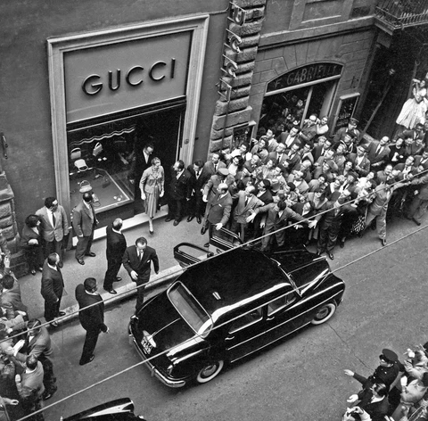
The family persisted in devoting a great deal of effort to the expansion of the business, despite disagreements about inheritance and day-to-day operations. Products bearing the Gucci label had already become the industry standard by the late '60s, thanks to their innovative styles and high-quality construction. Many well-known actors and actresses have been seen wearing Gucci.
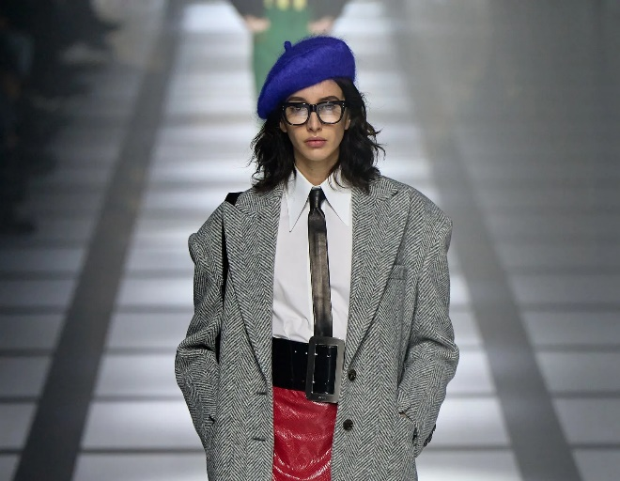
Because of the brand's sudden popularity, shops were established in New York, Florida, London, and Beverly Hills. In addition to producing clothing and accessories, Gucci also entered the perfume industry in the 1970s with the launch of its first perfume line.
  - Vision:
“Gucci Group strives to attract, hire, motivate, and retain the best talent in order to achieve excellence in all aspect of businesses.”
  - Mission:
“The price is forgotten long after the quality remains.” &
“To achieve profitable growth, while pursuing international expansion in a spirit of achievement and creativity.”
  - Gucci Logo And Name
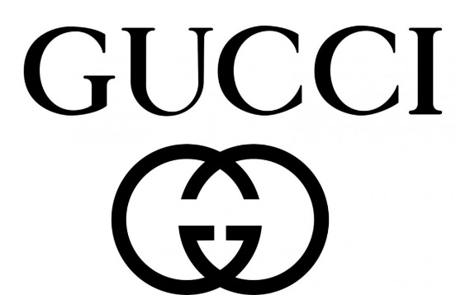
Among premium brands, the Gucci logo is instantly recognizable the world over. Aldo Gucci, who joined the firm in 1993 and is the son of Guccio, created the logo.
The logo's double "G"s is a reference to Guccio Gucci and his surname. The two Gs' intertwined design stands for the infinite. To artistically portray the timeless value of the founder in such a way is a novel and long-lasting approach. This term has entered the vernacular and come to represent the height of style. The phrase "doing well" has a slang meaning of being successful.
People who have made it in the public eye are believed to like the Gucci line of clothing and accessories. Especially rappers have been influenced by the brand's ostentatious lifestyle, leading to the creation of this slang.
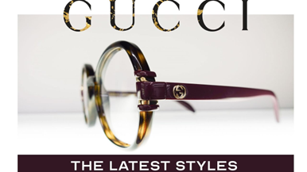
  - Growth and Expansion of Gucci
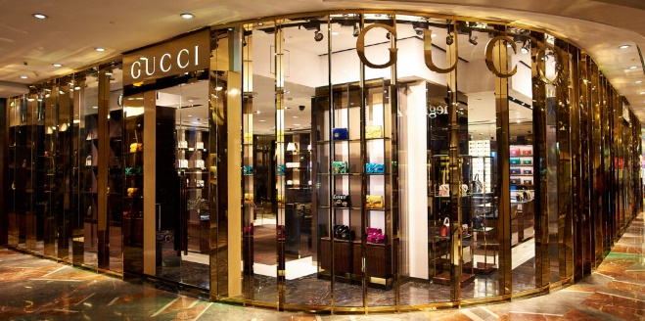
Florence, Italy, was the site of the first Gucci boutique. There was once a little shop where motorcyclists could purchase expensive leather goods. With the support of his son, Guccio quickly opened shops in Milan (1938) and Rome (1951). As the company expanded, Gucci launched its first U.S. location in New York in 1953. Guccio was just 15 days into the opening of his much-anticipated New York shop when he tragically passed away.
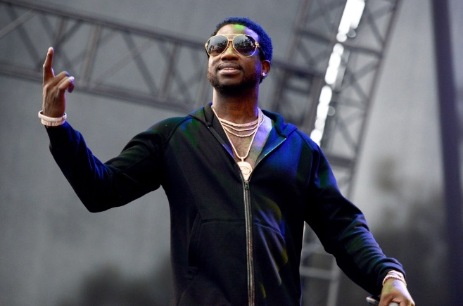
The first locations of both the Palm Beach and London businesses debuted in 1961. Their bag, once known as "Fifties Constance," was renamed "Jackie" at the same time. When First Lady Jackie Kennedy carried one, its popularity skyrocketed. In that era, the clothes, and accessories she wore had a significant influence on how others saw her.
Princess Grace Kelly of Monaco commissioned a custom floral scarf pattern from Gucci in 1966. This, in addition to praise from the First Lady of the United States, contributed to Gucci's meteoric climb to prominence. High-quality products and support from influential people helped make the company famous at the time. In 1975, Gucci introduced the world to its debut perfume. Aside from Gucci, you can get this perfume at many other retailers today.
Gucci's new CEO, Marco Bizzarri, was announced in December 2014. To serve as the company's artistic director, he recruited Alessandro Michele. A major shift in the company's trajectory has just occurred. The two reimagined Gucci from the ground up, doing away with preconceived assumptions that were holding back the brand's progress and making it ready for the next generation. Brand icons like Grace Kelly have been supplanted by more contemporary stars like Rhianna.
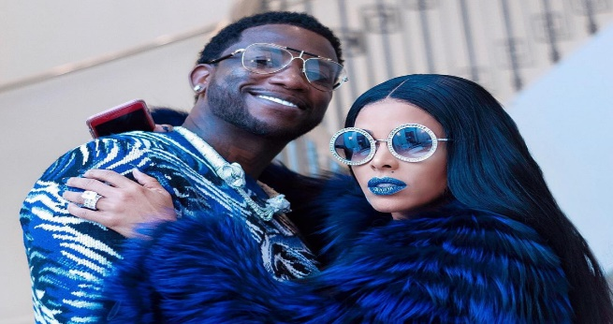
A further expansion tactic used to raise recognition of the brand was the use of social media. Teenagers and young adults have embraced this channel in unprecedented numbers, helping the Gucci brand amass more than 30 million followers on Instagram. The company's digital footprint has expanded greatly since Michele was promoted to the position of Creative Director.
With Marco and Michele at the helm, Gucci has undergone a transformation, adopted a new philosophy and refocused on a younger clientele. Currently, there are more than 540 high-end Gucci stores located in countries all over the globe.

  - Controversies Associated with The Gucci Brand
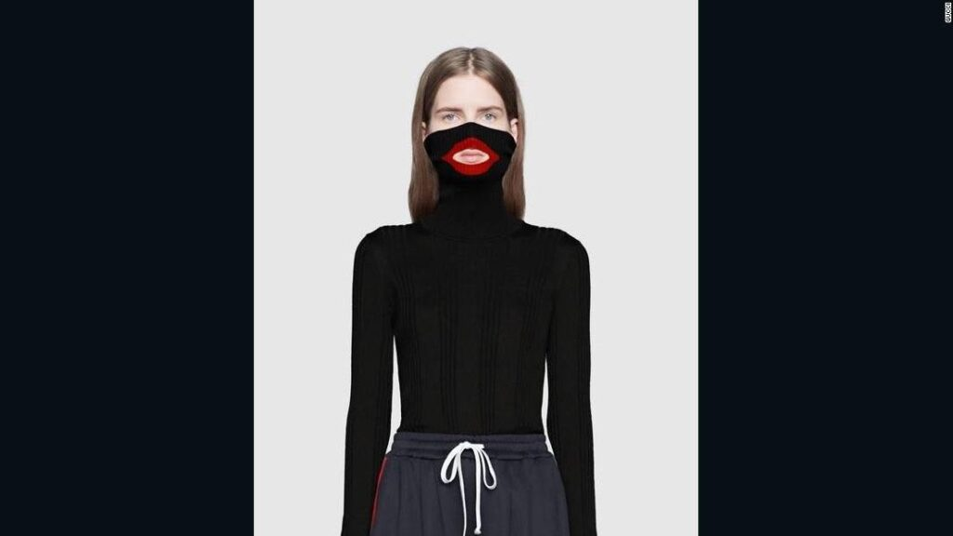
Fights and public conflicts within the Gucci family have kept the firm in the spotlight for the last two decades. Everything has revolved around the family money. From then on out, a tale of greed, envy, and strife inside the Gucci family developed, leading to Patrizio’s incarceration.
Patrizia Gucci had been preoccupied with the fortune that her two children and her would get from Maurizio Gucci, the grandson of Guccio Gucci, for over a decade. Two assassins killed Maurizio Gucci in front of his Milan office on March 27, 1995. This murder and the accompanying murder prosecution of Patrizia dominated headlines in late twentieth-century Italy.
After Alessandro Michele was appointed Creative Director in 2015, there was a great deal of controversy. On one of the 18 runways, Michele wore a jacket emblazoned with the Gucci logo and with voluminous bell sleeves. This parody of "Dapper Dan," a song by Daniel Day, was hilarious. The Harlem-based fashion designer who gained notoriety in the '80s and '90s for creating counterfeit goods with authentic-looking labels.
This was followed by the 2019 "blackface" controversy. As in, the $890 black sweater with the pull-up collar and the cut-out at the mouth area encircled by scarlet lips that Gucci was selling. This product caused a stir when it was labeled an "intolerable insult" due to its bigoted imagery. Customers vowed to send back any products purchased from Gucci and to stop buying the brand altogether.
Despite the company's best efforts, it was once again accused of bias. For $800, a controversial Indy complete turban was up for sale on this round's 19 runways. Like a dastaar, a piece of sacred Sikh garb. Sikhs often encounter hatred due to their visible turbans. After the turban was shown on a white male model walking the catwalk and subsequently on the Nordstrom website, customers began criticizing the fashion choice.

  - Future and Marketing Strategy of Gucci
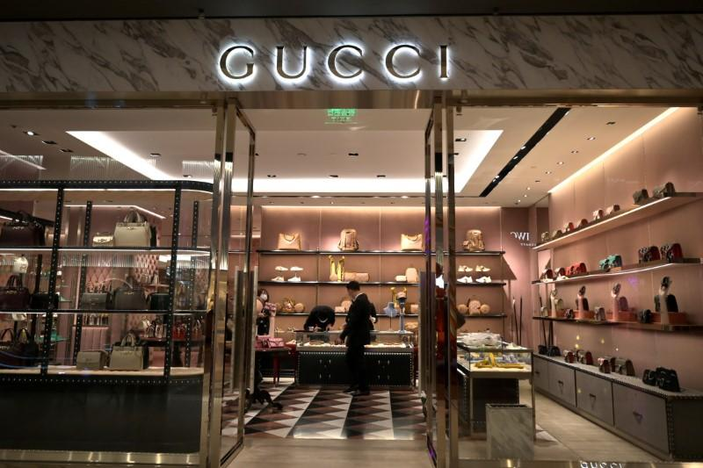
Saddles and other equestrian gear were Gucci's primary focus in the early years of the company. The business branched out into accessories, and soon the English nobility became avid consumers of the brand's wares. In 1938, Gucci brought in his three sons with the hope of growing the company. Gucci proved the viability of his concept by expanding to Rome and then Milan.
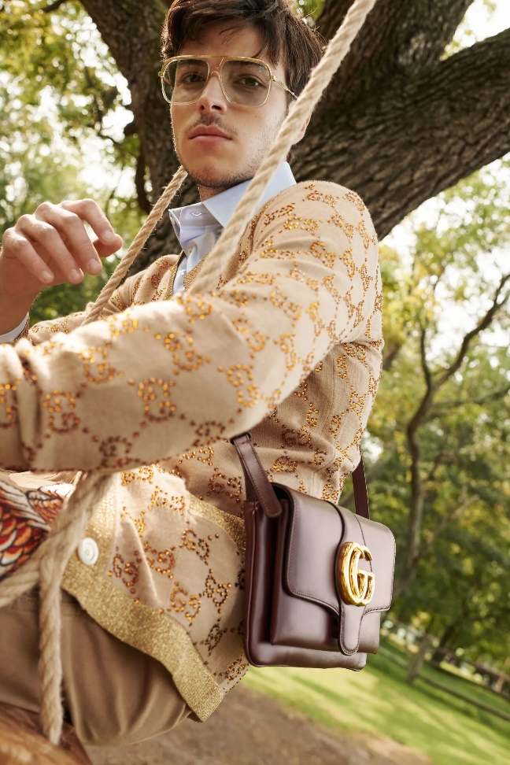
Due to Italy's economic difficulties in the 1930s, leather was in limited supply. Therefore, Gucci decided to explore new materials. The resulting Gucci design is recognized by its tiny, interlocking dark brown diamonds on a tan hemp background.
In 1947, when many craftspeople were short on supplies due to the recent conclusion of World War II, Gucci utilized Japanese bamboo to create its signature bag handles. The trademarked polished bamboo handles of Gucci handbags are the product of an exclusive manufacturing process devised by the company.
During the tenure of Giannini, Gucci partnered with Lapo Elkann, an heir to an elegant Italian automotive dynasty. In this way, we might rule not one, but two markets. At the Milan shop, the "capsule collection" was shown. Lapo was a symbol of Italian affluence and a fan of classic tailoring. Online menswear enthusiasts quickly took to his lifestyle and gave him a lot of support. He was the ideal way to connect with the luxury market's established clients as well as the younger customers who would drive the sector's transformation in the years to come.
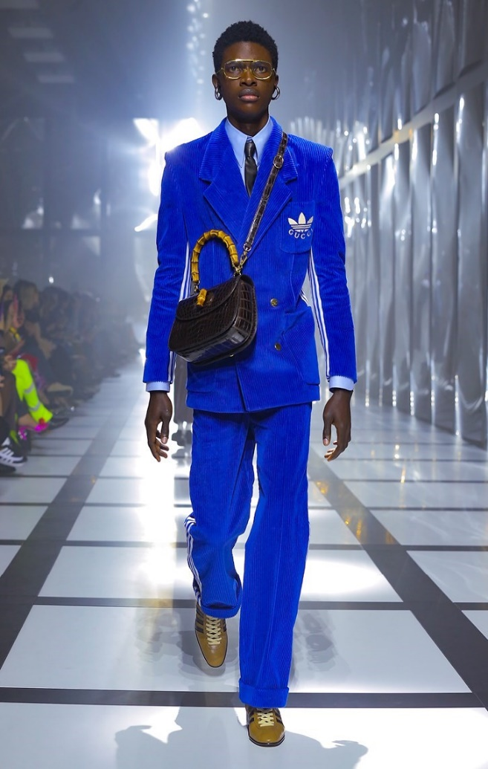
Gucci plans to bring more production in-house soon so that it can keep up with rising demand in the Asia Pacific region. As part of an effort to become eco-friendlier and more cost-effective, the firm had intended to reduce its dependence on third-party manufacturers of leather goods from 75% to 40%. Ten local suppliers have been purchased by Gucci, and another ten are expected to be purchased soon. Its goal is to provide manufacturers with more autonomy, which will allow them to devote more resources to innovation while simultaneously improving efficiency and productivity.
To surpass rivals and become the world's preeminent luxury brand, Gucci plans to grow leather in labs and increase annual sales to 10 billion sterling pounds. Alessandro Michele, the company's current creative director, was hired in 2015, and since then, the company's sales have skyrocketed.
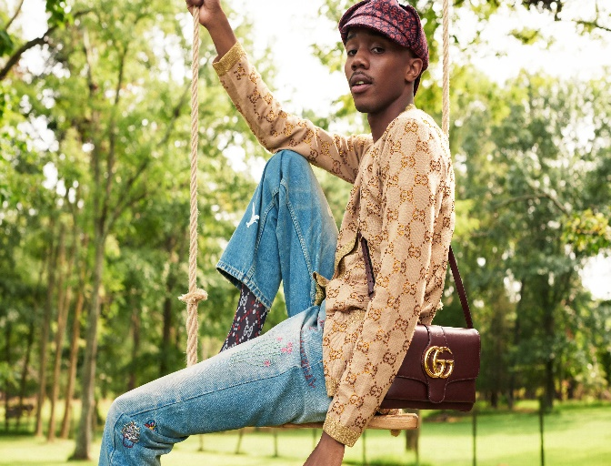
Gucci has never had a consistent brand identity, as can be shown by looking at the company's past objectives and methods. It's gone through several different iterations thanks to input from different art directors. Michele was cutting edge, whereas Gucci sold leather goods, Ford created the contemporary menswear industry, Giannini specialized in seasonal trends, and Giannini and Ford both produced groundbreaking clothing. One of the most recognizable brands in fashion, Gucci has a long and illustrious history that dates to the company's founder.

  - Marketing of Gucci Products
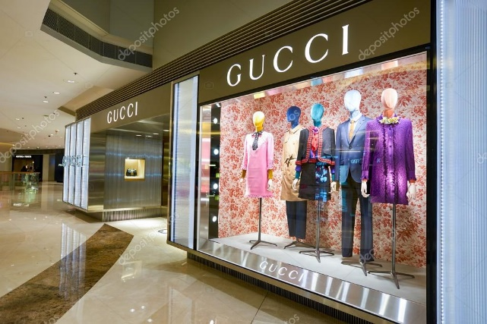
Gucci identifies the various segmentation characteristics using a mixture of psychographic and demographic segmentation methodologies. As a result, it produces superior products compared to its rivals in the fashion business. When it comes to releasing new merchandise, Gucci has made it a point to do so often and in accordance with the changing seasons.
In the spring of 2011, they showed the world their first cruise and children's collections. They used Jenifer Lopez's kids to market their kid-oriented brand. To get the word out about its newest products, Gucci uses a technique called "trend forecasting." Over the years, they've been able to sell out their one-of-a-kind wares by launching new products as limited editions and creating a false sense of scarcity among consumers.
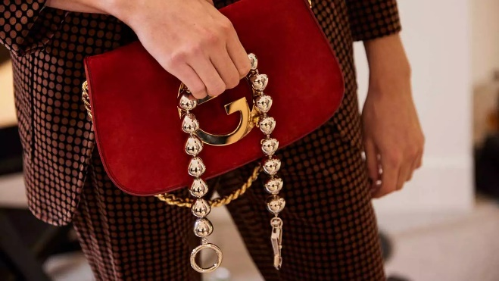
Made with a contemporary aesthetic and rigorous attention to detail, Gucci promotes its goods as a sign of excellence and the peak of Italian workmanship. Using a value-based positioning approach, it distinguishes itself as a premium provider of cutting-edge fashion accessories and apparel.
Strong brand associations and the generation of favorable publicity, such as "The G spot," have been profitable for Gucci. According to Forbes' ranking of the most valuable brands in 2020, Gucci comes in at number 31 with an estimated worth of $22.6 billion.
The company has several distribution points where buyers may buy their wares. Distributors, retailers, wholesalers, distributors, and company-owned outlets are all part of the distribution chain. As of the end of 2018, Gucci has 106 locations worldwide: 109 in North America, 65 in Japan, and 207 in other developing nations.

  - Philanthropy and Engagements
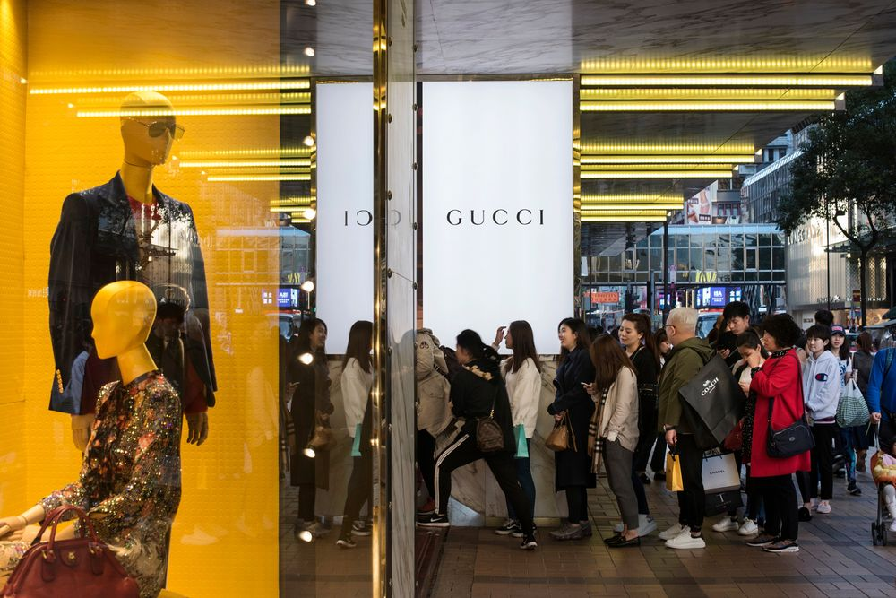
More than $20 million has been contributed by Gucci to UNICEF since 2015, mostly for the "Schools for Africa" program. This movement fights for orphans and other children from low-income backgrounds to be given the opportunity to get a decent education. More than 7.5 million children in China and Sub-Saharan Africa have benefited from this relationship. To celebrate 10 years of support for UNICEF's work, Gucci published a short film titled "Growing Tall." The video used narrators from a small Mozambican village to show the transformation that girls' and women's access to education has brought about over the course of a decade.
In 2013, Gucci launched the "Chime for Change" worldwide campaign to bring together advocates for gender equality. For this reason, it is centered on using novel strategies to raise both finances and public consciousness about problems in the areas of social justice, public health, and educational opportunity. In 2015, CHIME formed a lasting alliance with Global Citizen, an organization working to alleviate extreme poverty and advance gender equality worldwide by the year 2030. Gucci strongly condemns any kind of violence towards women.

In June of 2017, Gucci joined UNICEF's Girls Empowerment Initiative as a founding partner to find scalable solutions to some of the most critical problems facing teenage girls today. With Gucci's support, this initiative will be able to directly contact over 50,000 young women and indirectly reach over 150,000 via additional activities designed to inspire and empower them.
  - Conclusion
Long and winding is the tale of the Gucci brand. The company has gone a long way from its humble beginnings as a family-run leather goods manufacturer; it is now a publicly listed global powerhouse with offices in all the world's main fashion capitals. In the beginning of the tale, Guccio Gucci had four children who all worked for the company: Rodolfo, Vasco, Grimilda, and Aldo. To know more about the history, watch the movie “HOUSE OF GUCCI”
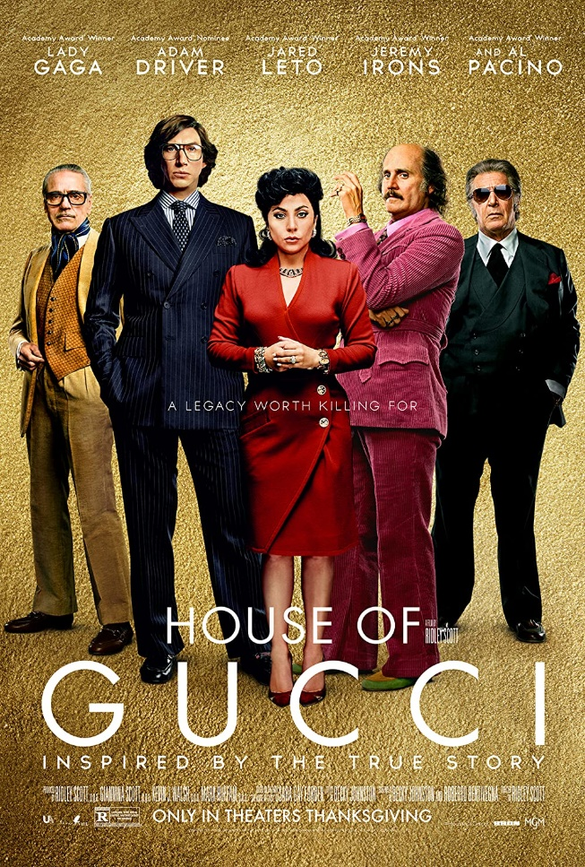
Thanks to Aldo's innate marketing prowess, the Gucci name has spread around the globe, and especially to the streets of New York. Nonetheless, Maurizio Gucci saw the decline of the Gucci empire in the 1980s and 1990s. Domenico De Sole and Tom Ford had to work together to save the empire and take it to new heights.

References:

B, C., 2015. Age Of Adaline ~ Blake Lively's Costumes. [online] Corinna B's World. Available at: http://corinnabsworld.blogspot.com.au/2015/04/age-of-adaline-blake-livelys-costumes.html (Accessed 17 August 2022)
Frisa, M., 2012. Gucci. New York, USA: Rizzoli New York.
Gov.uk. 2017. Intellectual property and your work - GOV.UK. [online] Available at: https://www.gov.uk/intellectual-property-an-overview (Accessed 17 August 2022)
Gucci.com. 2015. Gucci - 1960s. [online] Available at: <http://www.gucci.com/us/worldofgucci/articles/history-1960> (Accessed 17 August 2022)
Kering.com. 2014. Kering plans to take back control of its Eyewear business value chain | Kering. [online] Available at: http://www.kering.com/en/press-releases/kering_plans_to_take_back_control_of_its_eyewear_business_value_chain_ (Accessed 17 August 2022)
Kotler & Armstrong. 2016. Principles of marketing. Boston: Pearson
Muret, D., 2017. Kering's eyewear integration pays off. [online] FashionNetwork.com. Available at: http://uk.fashionnetwork.com/news/Kering-s-eyewear-integration-pays-off,793513.html#.WS6mIRM19mA (Accessed 17 August 2022)
Phillips, S., 2004. Licensing the Luxury Goods Industry | License! Global. [online] Licensemag.com. Available at: http://www.licensemag.com/license-global/licensing-luxury-goods-industry (Accessed 17 August 2022)
Staff, W., 2012. Gucci: A History Lesson. [online] WWD. Available at: <http://wwd.com/fashion-news/designer-luxury/history-lesson-3512770/> (Accessed 17 August 2022)
Vb.com. 2015. Gucci History & Timeline by VB.com. [online] Available at: <http://vb.com/gucci/> (Accessed 17 August 2022)

