UNIVERSITY OF WALES TRINITY SAINT DAVID

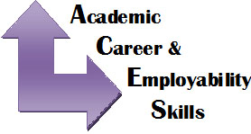

Student Name: Munevver Karabeyaz
Student Number: 1707893
Module Name: Academic and Employability Skills
ASSIGNMENT 1
Tutor Name: Shao-Yuen

Contents
INTRODUCTION 3
TIME MANAGEMENT 4
PROBLEM SOLVING 7
SELF-CONFIDENCE 9
WHAT IS CONSIDERED WHEN APPLYING FOR A HAIRDRESSING JOB 10
CONCLUSION 12
RESOURCES 12

INTRODUCTION

Academic and employability skills are a set of achievements and understandings that will make an individual gain a better opportunity to get a good job and to be successful in their chosen occupations. There are many types of skills that are needed to achieve their aims and goals. These skills will help you in your academic and employability future. Also, having these skills will not just help you get employed but, will motivate and help you to open your own business and be your own boss. I have finished Level 2 in higher education Women's Hairdressing City and Guilds in Bromley College. I would like to open my own hairdressing salon in the future. Before I can open my own business, I have to build up my skills and experience, so I would have to work in a salon with other employees. For this, time management, problem solving, and self-confidence are very important.

I will be talking about a few of these skills. I will explain what skills I have, what and why I need to improve them. Furthermore, I will discuss about some theories and whether or not I agree with them. Most importantly I will explain why these skills are important in the hairdressing business.

TIME MANAGEMENT

Time management is a very important skill and procedure. Being on time for a job will be a good reference for the employer. All businesses are looking for employees that are on time. It is a process of organizing and planning how to divide your time between specific activities. Organizing and planning your time will help you work more concentrated and make things easier to complete rather than being all rushed. Using this skill will make you complete your work in less time so you have more time to yourself for your other activities to do. Another thing that time management helps you with is that no matter how pressured you are, or your time is limited, it makes you gain a less stressful time to complete your work as you have organized your time.

This skill is familiar to me as I like being on time to work and school. The times that I have been late for work, school or any type of event because of traffic or a road condition, I have always felt bad. Also, there has been times where I haven't been able to decide whether I should spend time on one thing or the other. This puts me down and it's like my whole day has been stressed and depressing. It also lacks my concentration.

The way I can improve this skill is by organizing my travelling time earlier than I usually leave and checking for updates on travelling conditions. Additionally, I should plan my timing more and organize what I would need to do first by prioritizing.

Here is a graph that is showing a theory of dividing your time to gain time management successfully. According to Stephen Covey you should divide your time into four separate sections as shown in the diagram.

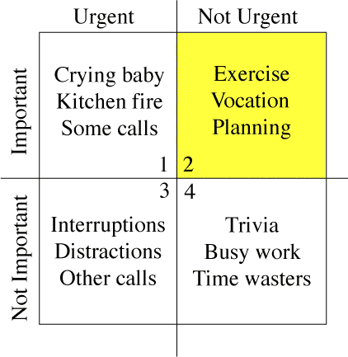
I have read up more detailed examples about this theory and I agree with Stephen Covey's theory as, if I plan my time the way he has shown us I will feel less stressed and even have time for myself. This is because I will finish my duties on time and will have full concentration on my aims. Apart from having time for yourself you can notice things that are actually distracting you for completing your work.
If you would like to read examples from Stephen Covey about this theory and take notes of more to help you understand and plan better, you can read his book. (Covey, S. 1994)

Another person that used this theory is Eisenhower. In a 1954, former U.S. President Dwight D. Eisenhower said: "I have two kinds of problems: the urgent and the important. The urgent are not important, and the important are never urgent." This "Eisenhower Principle" is said to be how he organized his workload and priorities. (Eisenhower, D. 1954)

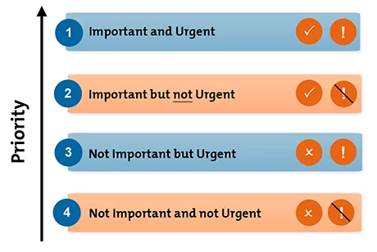
'Eisenhower Principle' (Eisenhower, D .1954)
As you can see in this graph, Eisenhower has prioritized his theory. I understand Eisenhower's theory clearer than Covey's theory. This is because it is explained in more open details and examples which is easier for me to understand this theory and how to use it. Also, he has ordered the way this theory should be prioritized.

This is an important skill as a hairdresser because most of your clients will be booked in with appointments and you will have to learn how to multi-task. If you don’t plan your time on what your client is having done your clients will be waiting past their time and everything will be all over the place. This will make you stressed and rushed which can cause for the client's enquiries to go wrong. Most importantly you will get a bad review from your customers which can end with losing your customers.

PROBLEM SOLVING

Problem solving is a big advantage in a business employment. If you can solve problems that will save money, earn money or save the business time, that's the right road to be successful in your career and employability opportunities. Another reason problem solving is so important to businesses is that the quicker you solve problems with good solutions the better chance you have of a pay rise or even being promoted.
Bransford's IDEAL model (1984) states:
1-Identify the problem
2-Define the problem through thinking about it and sorting out the relevant information

A simplified way to solving problems in whatever business it is, is;
Identify problem-Look at the impact-Give Examples-Research about it-Present your solution

My problem-solving skills are a bit weak. Sometimes when I'm asked to solve a problem then and there I just panic and lose balance. Even though I sit down and think after the problem is solved I think to myself that I wouldn't have been able to solve that problem. I need to improve this skill by thinking ahead of things that could happen in the workplace and try thinking of solutions for them.
Here are some points that involve problem solving skills for employability;

- Analyzing the factors or causes contributing to the unwanted situation
- Generating a set of alternative interventions to achieve your end goal
- Evaluating the best solutions
- Implementing a plan
- Assessing the effectiveness of your interventions
These are key points that are mentioned by (Alison Doyle, Updated August 24, 2017).

I agree with these points as they can help you solve problems quicker and it will be easier for you to solve them that moment if you keep building your skills of solutions by using these key points. You should also be creative when offering solutions. Employers are always looking out for individuals who can do more than thinking and use their imagination and present new solutions.

Problem-solving skills is important in hairdressing because You may have to solve problems to do with equipment and hair product problems, as well as business problems and resolving your customers’ problems. If you have a problem with client's hair and you can't find a solution for it, it could end in a disaster and also have you from your job and career as you will have a bad reference on your record.

SELF-CONFIDENCE

Self- confidence is a major part of your employability career. If you are not self-confident, most companies these days will not employ you. Businesses are looking for self-confident people who can talk, approach and present the business well.
This one of the skills that I never used to have. As I grew older and started working and studying away from home I built self-confidence as I was on my own and had to be confident. Yes, I have got self-confidence now, but this is still not enough. If there are a few people around me I'm ok but when there is a lot of people around me I get shy and nervous. I need to improve this by practicing more speeches in front of audience and thinking that if I'm not confident I won't be able to do the job I desire to do.

"A growing body of evidence suggests that one's perception of ability or self-confidence is the central mediating construct of achievement strivings (e.g., Bandura, 1977; Ericsson et al., 1993; Harter, 1978; Kuhl, 1992; Nicholls, 1984). Ericsson and his colleagues have taken the position that the major influence in the acquisition of expert performance is the confidence and motivation to persist in deliberate practice for a minimum of 10 years". (The National Research Council, 1994)

Self-confidence is important in hairdressing because you must believe in yourself and your own outcome of your work, making quick decision using your decisiveness, and then follow through with your decision without second guessing yourself. This skill for employability of hairdressing will also help you be confident in your creativeness of hair styles and colors.

WHAT IS CONSIDERED WHEN APPLYING FOR A HAIRDRESSING JOB

These are some of the skills you need for hairdressing employment considered from the perspective of an employer trying to recruit. Every business considers different skills for different types of jobs when being recruited by the employer. I have highlighted the skills I have mentioned to improve for this business and these skills mentioned below are the reasons they want these skills.

This business looks at skills like;
Interpersonal skills
You must be good with new people and like helping others. You must communicate using good verbal, having good listening skills and good writing skills. You must be good at making your clients comfortable and relaxed. You must also, be good at working independently and with other people.
Love of learning
You will need to concentrate on constantly learning about new styles and products and how to use new equipment. Additionally, you must have a training of 1-5 years to earn good levels of hairdressing.
Patience
You will need to be patient and tolerant with customers that are rude or awkward. Also, you may need to work with people you dislike so this is an important skill.
Problem solving skills
You may have resolve disputes and your customer's problems as well as solving problems to do with equipment’s or products.
Self-confidence
You must be proud and happy with the outcome of your work and believe in your own ability. Plus, you must stick to your own decisions and not have second thoughts about it alongside being talkative with your clients.
Creativity
You may need to design new styles, create new techniques.

Time management skills
In order to meet appointment timetables and to keep it from messing up your client’s time schedule, you must know how to make the most use of your time and priorities, and also be able to multi-task. (Hairdresser Insurance)

CONCLUSION

Overall, employability skills are very important in our generation of finding a job and being employed. Not matter what skill you have there is always a way to improve yourself more with those skills using theories and searching ways to help you. Searching and knowing which skills apply for the career that you want is one of the main aims to do before applying for that job as the employers are looking for those specific skills for the individual to have. These are a few of the skills that are part of employability skills. I have learned that when I am applying for my job I will be writing down what skills I have, how I will be helpful for their business and ways that I will be improving myself while being employed. Also, gaining experience. As a result, we can see that for a good future, career searching, improving and knowing what skills you have when you are applying for a specific job and gaining experience gives you a higher chance of being interesting for the employer when you give your CV or go for an interview and also, can even help to achieve to be your own boss for your business in the future.

Resources
(Covey,S (1994),Time Management Matrix, First Things First.)
https://sidsavara.com/coveys-time-management-matrix-illustrated/
The Balance (Alison Doyle, August 24, 2017)
https://www.thebalance.com/problem-solving-skills-with-examples-2063764

The National Academies of Sciences, Engineering, Medicine, The National Academies Press. The National Research Council (Learning, Remembering, Believing: Enhancing Human Performance (1994), Chapter: Self-Confidence and Performance)
https://www.nap.edu/read/2303/chapter/13
Hairdresser Insurance
https://www.hairdressersinsurance.org.uk/hairdresser-skills.html
Eisenhower's Urgent/Important Principle (Eisenhower, D. 1954)
Mind Tools, (Mind Tools Content Team)
https://www.mindtools.com/pages/article/newHTE_91.htm

