Supporting pupil progress: a detailed analysis of one child’s holistic development, with justification for the next steps in learning.

The detailed pupil analysis was undertaking in a large primary school based in the South Wales valleys. The identity of the school shall remain anonymous in line with BERA(2018)guidelines. The school has approximately 400 pupils based across two school sites, an infant and a juniors.
The focus pupil is a child in a Nursery class, who is four years of age. For the purpose of the study the child shall remain anonymous and shall be referred to as Child A. Both parental and school consent(see figures 1 and 2)were gathered prior to the process and the child’s assent was sought throughout, as Greenfield(2011)suggests, involved adults must respond to signals of a child not wishing to continue, this will be acknowledged throughout the study considering both verbal and non-verbal communications and responses.

The Mosaic Approach
Due to the nature of the study requiring an approach that gains a holistic awareness of a pupil, the principal method chosen for data collection is the Mosaic Approach. Developed by Clark and Moss(2001), the Mosaic Approach uses multiple methods to capture the viewpoints of children, the data collected can be pieced together in order to help understand childrens’ perspectives on matters that affect them(Greenfield, 2011). Mereweather and Fleet(2013), considers how the approach generates a composite picture through pieces of a mosaic that have allowed young children to express their opinions through a multiplicity of methods both visual, verbal and non-verbal. Cowie et al(2012), considers the importance of causing minimal disruption to children during the process, preferably using their usual environment, highlighting the advantages of using methods that appeal and suit young children archetypal to their everyday lives. The chosen method is flexible, adaptable and reflexive, although it can be time consuming and disruptive, its design shall consider any impact on Child A, the other class children and the Nursery environment.
The many ways children can communicate are highlighted in a ‘Hundred Languages’(Malaguzzi,1996), however, Fasoli(2003) deliberates the need for children to be provided with the necessary tools to become active communicators and participants in research. Mereweather and fleet(2013), support this notion further stating that children need to be provided with the prerequisites that will enable them to convey their thoughts in ways they feel comfortable. During the research the ‘tools’ (Fasoli,2003) provided shall be adapted to suit a child of Nursery age, considering the impact on the Child when they are disrupted from their normal schedule, attempting to when possible adopt a style that is familiar and can be integrated into their typical routine, for example within play(Cowie et al,2012).
Historically, the viewpoints of children have been overridden by the opinions of adults, children have been often deemed as being ‘invisible and voiceless’(Smith & Taylor, p.9, 2000), however, more recent research has suggested that children are competent in expressing opinions on matters that concern them(Baird, 2013), in agreement Clark and Moss(2005) regard children as experts in their own lives. The importance of children being given an opportunity to a point of view is reinforced within childrens rights, particularly ‘Article 12’ of The United Nations Convention on the Rights of the Child(Unicef,2010) that confirms that children have the right to ‘express their views, feelings and wishes in all matters affecting them, and to have their views considered and taken seriously.’ Furthermore, Estyn(2016) suggest that pupils should have an input into their education and that such participation is necessary in improving pupil’s well-being, behaviour and achievements in learning. Donaldson(2015) also suggests that pupils should become active participants in their education consequently supporting them to become ‘ethical, informed and active citizens of Wales’ with skills they can take forward in their lives.
The importance of adult alliance in the success of the Mosaic approach is paramount, adults should support by facilitating communication of young children(Clark, 2007), however, children should remain in control of the data collection (Greenfield, 2011).
Furthermore Greenfield(2011) considers the need to establish positive adult child relationship and Clark and Moss(2011) view adults and children as co-constructers. However, a limitation is the possibility of the supporting adults reporting on what they want to observe rather than what occurs, for this reason it is crucial for researchers to use all their senses(Greenfield 2011) to help establish a comprehensive account of the study. In practice, within the time available I consciously built a trusting relationship with Child A and endeavoured to remain as impartial and unbiased as possible whilst data collecting. It was also necessary to make the study exciting in order to engage Child A, however the child’s age effected the time the Child was able to concentrate resulting in the study being adjusted and delivered in shorter sessions in order to maximise participation by the pupil.
Adult input and a professional approach were also crucial to ensure the safety of the pupil ensuring compliance with the schools safeguarding and health and safety policies.

Data Methods
There are three elements of data collection or tiles that construct the mosaic in the study, all of which assisted in gathering qualitative data.

The first is child centred observation. Two observations took place, one with a focus on literacy and one on numeracy(see figures 6 and 7). Mereweather and Fleet(2013) consider child centre observation to be an ideal data collection method to gather quality qualitive data. Similarly, Grigg(2010) regard child centred observations as an essential process in the collection of data in a study although it can be time consuming and complicated. However, Clark and Moss(2011) note that there is a risk that child centred observation becomes merely an adult’s stance on a child’s life furthermore highlighting the need for observation to be combined with other pieces of the mosaic for it to be valuable.
As the observer I was ideally positioned near to Child A where I could closely observe the actions and interactions within the setting. As Bell(2010) explained it is impossible to go completely undetected when located so closely to participants, however, it is still a perfect location to gather real time data in an environment where the child will act naturally, although I took into consideration the possibility of the child performing in a way they felt the adults may want them to. Vygotsky’s(1962) theory suggests that environments have a considerable positive impact on a child’s learning, considering this, it is hopeful that the chosen environment generates substantial, quality interactions that can contribute to the collected data.
Due to the age of Child A, I did not formally explain my intentions as I felt that as a pupil in Nursery, they were used to adults note taking and being close to where they were working or playing. However, I considered the possibility of Child A wanting to involve me in their activities as they often did, consequently effecting the quality of note taking in the available time. As Greenfield(2011) explains there is also a possibility of younger children wishing to talk about unrelated topics, taking up valuable research time.
Further informal observations took place whilst Child A engaged with the available enhanced and continuous provision activities, this allowed for the construction of another layer of understanding of the child’s preferences to learning and gave another aspect on the child’s friendships and motivations whilst playing and learning independently.

The second data collection method is semi structured interview. Interviewing is a widely used tool for collecting qualitive data and is described by Cohen et al(2007) as ‘an interchange of views of two or more people’. It can generate data that is rich and varied, however interviews can also cause children to provide what they feel is the desired answer to please the interviewer rather than an accurate account. During the study this shall be considered, although an appreciation of the child’s open sincere persona and their age suggests that they are likely to respond with honest answers.
Mereweather and Fleet (2013) suggests that the success of the interview may improve if children can select the location of the interview. Similarly, Green and Hogan(2005) suggest that the interviewer shall give up some of their power allowing the child to have an input into the time and location of the interviewer. A limitation to this is although the child may enjoy selecting a location, they may become uncomfortable quickly particularly as the children in Nursery have very limited knowledge or experience of other parts of the school and may quickly want to return to their peers and familiar surroundings. Following discussion with the class teacher I deemed the Nursery classroom to be the most suitable environment making the interview an informal process directed at the child whilst they were at ease playing as this would encourage the most responses.
The interview questions to be used are adapted from Moss and Clark’s (2011)child conferencing interview questions(see figure 4) and are composed in child friend language. Although the interview is semi structured and will involve prepared open ended questioning, I intend to ensure Child A is relaxed and that a conversational approach is used, as Gillham(2000) suggests this flexible, reactive approach is more likely to lead to answers of the focus questions and is particularly suited to young children, in comparison, Dockett and Perry(2005) warn that a conversational approach can lead to a tendency of moving away from the interview focus. Due to Child A’s age and the length of time they were able to concentrate the questions were asked over three sessions.
A further interview took place with Child A’s class teacher, the interview questions were adapted from Clark and Moss(2011) interview schedule with a key worker(see figure 5).

The third data collection method is photography. Child A was taken around the Nursery and encouraged to take photographs of the areas that were the most important to them.
As Mereweather and Fleet(2013) suggest the photos alone only tell a partial story and in order to minimise this limitation the photographs were used as a prompt for further discussions with Child A(see figure 3). As Greenfield(2001) suggests photographs can act as a child initiated stimulus that can add a depth to the written observations and discussions with the child, furthermore Mereweather and Fleet(2013) explore the benefits of camera use for children who do not have strong written or oral communication skills and state that it offers a non-verbal means of a representation of ideas. In order to minimise any disruption to Child A or her peers the discussion of the photographs took place over a few short sessions. Although usually talkative, Child A’s comments on the photographs became less profound as each session went on. A change of questioning style and a different tone was utilised however her age and maturity affected the desire to invest in the activity to a level that could be reached with an older child, quite a few comments were similar such as ‘I love that’, ‘it’s my favourite’, ‘I love it…’ (Child A, 2019)(see figure 3).
Although Child A had strong oral skills the photography offered an opportunity for her to express her opinions through a different lens. Due to her age she required some support to use the technology, but confidently moved around the indoor and outdoor classrooms photographing all areas she enjoyed. As Clark and Moss explain cameras are a tool that allows a fun, enthusing medium for communication, Mereweather and Fleet(2013) describes the use of cameras as appealing and gives young children both freedom and control of their activity. Furthermore Greenfield(2011) suggests that the use of cameras empowers children, although it potentially reduces the control of the researcher and makes it difficult to ensure the purpose of the task is fulfilled within the allocated timeframes. Child A was very excited with the prospect of using a camera and was keen to take as many photographs as possible, she was reminded that it was important to take photographs of her most favourite parts and not of everything.

Analysis of Learner
Language
During the class teacher interview(see figure 5) it became evident that Child A’s greatest strength in Language is her well developed, mature oracy skills. Her class teacher commented on her use of a good range of vocabulary, her ability to construct sentences correctly, to offer explanations for her choices and to articulate her responses with maturity. An example of how she is able to understand instructions and verbalize her need for clarification of specific points was evident during a story sequencing activity, after she was given an explanation she said ‘wait a minute, do I lay all the pictures out like a puzzle then put them in to order?’ (Child A, 2019)(see figure 11), this response suggest she is achieving at a Reception child’s level, where pupils can ‘use a variety of questions to establish why things happen and to clarify understanding’(Welsh Government, p15,2015). During the term the focus story book has been ‘The Very Hungry Caterpillar’, this was taught through the Pie Corbett approach that teaches children to internally verbalise a text, remembering the language structures that it contains before retelling it and helping to improve the quality of pupils writing(Corbett and Strong, 2019). Following the input through the Pie Corbett approach, Child A confidently retold single lines as well as the whole story of ‘The Very Hungry Caterpillar’ this is evidenced in(see figure 11) this further suggests Child A is working at Reception age level, as she can ‘retell familiar stories in a simple way’(Welsh Government, p.21, 2015). Child A was witnessed recalling the story of Aladdin, a text she had been exposed to at home(see figure 17). She also brought in her version of ‘The Very Hungry Caterpillar’ and mentions books she has at home; this suggests she has access to many books and is encouraged to read both at home and in school.
Child A is beginning to recognise phonemes and some simple words, she participated in a Knowledge and Understanding of the World(Welsh Government, 2015) activity that required her to label the parts of a lifecycle(see figure 19) by identifying the initial phoneme of four words, she did so with confidence although the extent of her phonic knowledge is quite limited at the moment, she is an active participant in regular ‘Read Write Inc’ sessions and is constantly acquiring new comprehension of letters, sounds and words each week.
Child A has a passion for literature often asking to have a story read to her but equally accessing books in continuous provision. She engages in story time at the end of each day, showing non-verbal signs of interest through facial expressions and often contributes to discussions following each story. She regularly plays with masks, puppets and story enhancing resources in enhanced and continuous provision.
Child A can also recognise and write her name and is beginning to use the correct formation whilst forming letters, she can also find most of the characters on a keyboard whilst typing her name on an Ipad, (see figure 19) supporting another Reception Digital Competency(DCF) skill where children can ‘add their name to digital work, e.g. type their first name on a keyboard’(Welsh Government,2019).

Numeracy
Child A has a good understanding of number, her class teacher describes her as having ‘a good all round base’(Child A’s Class Teacher, 2019)(see figure 5). Child A joins in with number songs confidently and enthusiastically(see figure 7), she follows the teachers lead to join in with actions and she uses fingers to represent each number concerned, this shows that Child A understands that each numeral has a value (see figure 15 and figure 22).
A distinct strength of Child A is her ability to take forward her own learning independently. Following a focus task where she has been taught a skill or concept, she then often explores her understanding further during Enhanced Provision tasks, this is demonstrated when she completed an independent task involving repeating patterns following a focus task(see figure 20). A further example of this was whilst during snack time Child A independently used her fruit to create the same pattern as demonstrated in ‘The Very Hungry Caterpillar’ story(see figure 18).
Child A has demonstrated her understanding of sorting by working collaboratively with her peers and an adult to complete a Venn diagram, (See figures 12 and 13)such opportunities are also supporting Child A’s development in wellbeing that allows her to work as a pair or in a team, forming friendships and working collectively(Welsh Government,p.10, 2019).
Both examples demonstrate how Child A has sorted objects using ‘more than one criterion’(Welsh Government,p35,2019), although the activity taught a Year 1 skill, completion of the activity required some adult support and was fulfilled collaboratively with her peers.

Wellbeing
Child A responds well to the sanction of school rules, this is evident during circle time when she listens intently to the behavioural expectations and responds appropriately(see figure 7) this indicates progression of social development skills where pupils are expected to ‘develop an understanding of the behavioural expectations of the school and understand that rules are essential’ (Welsh Government, p.10, 2019), she is starting to understand the link between rules and safety. Furthermore, her class teacher has the opinion that she enjoys “rules and conformity”(Child A’s Class Teacher, 2019)(see figure 5).
During circle time sessions, Child A is keen to support her peers, during an observed session(see figure 7) she offers support to her peers by explaining to them where they should stand or sit, she also shows them how to hold hands to help form a circle, this indicates she has an understanding of value of friends and family showing an empathy for their emotions, Child A’s class teacher also commented on her ability to ‘emphasise with her peers’,(Child A’s Class Teacher, 2019)(see figure 5).
A further example of Child A’s positive opinion of her friends and an awareness of their emotions is clear during the semi structured interview where she confirms the importance of her friends ‘I love my friends, they are so special to me’(Child A, 2019)(see figure 3) although her Class Teacher suggests that she has lots of friends and no particular set group and describes her as ‘resilient’(Child A’s Class Teacher, 2019)(see figure 5).
During an activity where children made fruit kebabs(see figure 16) Child A suggested how to keep herself safe, explaining that pupils should wash their hands and be careful when using the kebab skewers as they are sharp. She also comments on the health benefits of eating fruit, claiming that ‘it makes us so healthy’ (Child A, 2019)(See figure 4). Child A confidently looks after her own personal needs, using the bathroom appropriately and is responsible for her belongings such as her coat and water bottle, this indicates that she ‘adopts appropriate behaviour in different situations’ and is able to ‘cater for most personal needs’(Welsh Government,p50,2019), suggesting that Child A is working towards some elements of Outcome 3, which is one level above the expected in Nursery.
During the semi structured interview(see figure 4) Child A explains how the teachers in her class have allowed her to have an input into developing the outdoor playhouse ‘they ask us what we want, like how to do the house out’, she then proceeded to explain the detail of the planned decoration, an example of her enthusiasm and independence in taking her learning forward, also striving to do well in school. She also comments on ‘being a good person, knowing everything’ (Child A,2019)(see figure 4)suggesting that achievement in school is important to her and is something that she values.

Child A’s Next Steps

Language
It is clear from the analysis that Child A has a love of reading, she is familiar with many texts that give her the confidence to retell stories utilising story picture cards, creative displays, toys, masks and prompts. To further develop her language skills, I suggest that Child A is provided with further opportunities to access a wide range of literature during Storytime, focussed tasks and enhanced provision.
The links between early reading experiences and higher attainment are often reported, A ‘Save the Children’(2015) report suggests that children with poorly developed language skills in the early years are more likely to fall below the expected level of achievement at the age of eleven(Save the Children,2015). Reading to children is a key component in the development of early language skills, helping children to grow an understanding of the world around them and the ability to emphasise with others. The Save the Children(2015)‘Ready to Read’ campaign suggests that weak early language development is likely to lead to children having limited phonological understanding, limited vocabulary and listening skills and a limited awareness of how sentences are structured leading to difficulties in the social use of language whilst communicating. Child A’s language skills are well developed for her age but to enhance this further I suggest that we create a language rich environment, exposing Child A to new and varied literature and vocabulary, this will be supported through the exposure of a range of genres including poetry and non-fiction texts, as well as literature being distributed through enhanced learning opportunities. This shall guide Child A towards reception level Literacy and Numeracy Framework (LNF)skills, that allow children ‘to show an awareness of the difference between stories and information texts’, it also supports Donaldson’s(2015) Language, Literacy and Communication Area of Learning and Experience where schools should strive to ‘generate a love of reading that will enrich lives and contribute to present and future well-being’(Donaldson,p36,2015). I also suggest exposing Child A to a variety of reading materials such as magazines or leaflets along with eBooks that can be accessed using the class iPads, this supports the Digital Competency Framework(DCF), where children should ‘safely use digital devices’ (Welsh Government,p15,2018). An example of ICT work is shown in figure 23, although the mosaic tiles have not suggested that ICT is an area of particular interest to Child A, accessing literature through devices may engage her in digital tasks. A limitation to this approach is the need for adults to make careful literature choices, ensuring that the literature is accessible to the child, is age appropriate and does not include themes that are too mature for the child or other children in the Classroom. I also suggest that the use of a structured method such as Pie Corbett is continued as this has been well received by Nursery children and has been evident in Child A’s ability to confidently retell a story (see figure 11), the approach enables children to access a variety of quality fiction, non-fiction and poetry reading materials developing reading, oracy and writing skills,(Talk for Writing,2019). A limitation of this is that it is a whole class approach so there is risk that Child A may become bored or disinterested if she grasps it quicker than her peers, for this reason it will be important to stimulate Child A further through thought provoking questioning across examination of characters or scenarios.
Child A often shares her home experiences of literature, often commenting on stories or linked films she has at home, performing them through resources or roleplay(see figure 17). I suggest that we set up a reading café once a month to bring together children and parents to enjoy reading experiences together, this would establish strong home school links and further promote advancements in language skills, the Sutton toolkit suggests that ‘involving parents in developing early literacy strategies can be beneficial’(Education, Endowment Foundation,2019), furthermore there is a suggestion that such parental engagement programmes can add up to four months progress in attainment over a year(Sutton Trust Toolkit,2019). A limitation of this approach could be an adverse effect on other learners whose parents are not able to attend the reading café.

Numeracy
As noted, Child A has ‘a very good all round base’ of numeracy(Class Teacher, 2019)(see figure 5). To advance her skills I suggest a mixture of adult led taught focussed task that are then supported through child led numeracy tasks in enhanced provision areas.
Donaldson(2015) suggests that pupils require regular numerical learning opportunities that develop their understanding of number. Such experiences are likely to be more beneficial if available in different contexts and for this reason I suggest that numerical learning experiences are integrated in enhanced provision areas that allow children to experience number in real-life situations such as in imaginative play. In support of this, Donaldson(2015) suggests that pupils are given the opportunity to broaden their numerical experiences through broader numerical and financial skills in real life scenarios’ (Donaldson,p36,2015). Enhanced provision provides an opportunity for a continuation of pupils learning where adults support through the resourcing of appropriate activities with specific learning opportunities or new concepts(Welsh Government,2015). Quality enhanced provision tasks can allow children to ‘think more deeply, practise new skills, or learn new ways of working’(Estyn,2019). Furthermore, Vygotsky’s(1934) social development theory considers the benefits of children working independently suggesting that they become actively involved in their own understanding and progress. I suggest that the next steps for Child A should include Reception level skills such as learning number bonds to 5, counting in 2’s and 10’s, handling coins to pay for items and early adding and subtraction. Such skills shall be explained by an adult initially and then conveyed into enhanced provision areas, the adults shall support activities through an investment in quality questioning and encouragement of active play. A limitation of this is that enhanced provision areas are accessed by all pupils so differentiated tasks shall need to be implemented to provide enough challenge for all pupils. Preparation of quality directed resources can be time consuming and planned activities are not always utilised by pupils as intended, although any exploration should help to develop pupils emotional and social skills.

Well being
Assessment for Learning(AFL) is a regularly used tool for formative assessment, its benefits are widely published and it is considered to improve classroom learning experiences, progress and achievement for pupils (Welsh Government,2013)furthermore it can embolden learners to ‘become independent and autonomous’(Welsh government,p.10,2013).
Donaldson suggests that pupils who self-assess have skills that will allow them to reflect and diagnose their own progress developing the capacity to learn throughout their lives, impacting on their progression to become capable, ambitious learners(Donaldson,2015).
An Estyn Case study suggests that effective strategies for young children could involve the use of colourful ‘De Bono’s’ thinking hats, clear learning objectives written in child friendly language and a traffic light system that allows children a simple, visual system of self-assessment(Estyn, 2018),all of which will be introduced into nursery, a limitation is the length of time it may take to teach young pupils a process or concept.
Child A is beginning to develop an awareness of self-assessment. Activities have allowed her to use an emoji to assess her work(see figures 19 and 21). It is necessary to further develop her understanding of how to make a judgement on her work and to also support her in understanding her next steps. Before this occurs, it will be necessary to further develop questioning skills with Child A, as she needs to understand the meaning of ‘why?’ before she can offer appropriate reasons for her self-assessment choices, this will be developed through repetition during focus and enhanced provision tasks.
As explained, Child A, enjoys conformity in school although she can at times be overpowered by her peers. As noted by her class teacher, a good day in Nursery would include the opportunity ‘to work with an adult’ and to ‘have grown ups listen to her’(Child A’s Teacher,2019). Child A already has high expectations of herself but at times she is overpowered by her peers, to support her wellbeing I suggest that Child A is given clear opportunity to work independently but also with adults who enhance her learning experiences by not only providing her with the tools and resources she requires but to also engage in quality interactions and communications that develop her emotional and social wellbeing.
Child A has particularly enjoyed being given the opportunity to contribute to the development of the outdoor playhouse(see figure 4). Welsh Government(2014) suggest that pupil engagement, wellbeing, behaviour and learning can all be improved through the effective use of pupil voice strategies. Furthermore, Donaldson(2015) promotes the use of collaborative planning and assessment, stating that such involvement allows pupils to develop metacognitive skills that allow children to become active participants in their learning.

Conclusion
Some data collection methods used were more beneficial than others, the semi structured interviews gathered quality qualitive data. Child A’s class teacher gave an invaluable insight into the main characteristics of the child, although it is based on personal opinion, the amount of time that I had available to get to know the child was limited and a response from a professional who knew the pupil so well was invaluable. The child interview also provided a greater insight into the child’s knowledge and motivations although due to her age this had to be carried out over numerous sessions to gather enough response. The photography was less effective and the use of the iPad was more of a novelty to the pupil than a tool that contributed to the tiles, this method would be more suitable to older children. Child A’s responses were very similar in each picture and she lost interest in the activity quickly.
Overall, it is clear from the evidence that Child A securely possesses many Nursery skills and therefore the next steps in learning are driving towards Reception or even Year 1 learning, although practitioners need to still nurture and support her and ensure that her love of learning continues onwards into her next class.
References
Bera (2018), Ethical Guidelines for Educational Research, available at: https://www.bera.ac.uk/wp-content/uploads/2018/06/BERA-Ethical-Guidelines-for-Educational-Research_4thEdn_2018.pdf?noredirect=1 accessed on: 27th May 2019.
Clark, A. and Moss, P. (2011) Listening to Young Children, The Mosaic Approach, 2nd Addition, NCB, London.
Cohen, L. Manion, L. Morrison, K. (2007) Research Methods in Education, (7th Edition) Routledge, New York.

Corbett, P. & Strong, J. (2019), Talk for Writing, available at https://www.talk4writing.co.uk/about/ accessed on 24th May 2019.

Cowell, C, (2018), If we want Children to Thrive, Teach them to Read, Independent Newspaper, available: https://www.independent.co.uk/voices/children-reading-for-pleasure-learning-to-read-a8666611.html accessed on 26th May 2019.

Cowie, H. Huser,C and Myers, C.A. (2012) The Use Of Participatory Methods In Researching The Experiences Of Children And Young People, Croatian Journal of Education, available at http://epubs.surrey.ac.uk/810003/12/Participatory%20methods%20in%20researching%20the%20experiences%20of%20CYP.pdf accessed on 22nd May 2019.
Dockett, S., Perry, B. & Kearney,E. (2012). Promoting children’s informed assent in research
participation. International Journal of Qualitative Studies in Education.
Donaldson, G. (2015), Successful Futures, available at: https://gweddill.gov.wales/docs/dcells/publications/150317-successful-futures-en.pdf accessed on 27th May 2019.
Education, Endowment Foundation (2019), Early Literacy Approaches, Sutton toolkit available at: https://educationendowmentfoundation.org.uk/evidence-summaries/early-years-toolkit/parental-engagement/ accessed on:27th May 2019.
Estyn (2018) Assessment for Learning and thinking skills available at: https://www.estyn.gov.wales/effective-practice/assessment-learning-and-thinking-skills accessed on: 27th May 2019.
Estyn (2019), Enhanced Provision, available at: https://www.estyn.gov.wales/glossary/enhanced-provision accessed on 27th May 2015.
Estyn inspection report (2015) available at: https://www.estyn.gov.wales/sites/default/files/documents/Cyfarthfa%20Park%20Primary.pdf accessed on 25th April 2019.
Estyn (2016) Pupil participation: a best practice guide, available at: https://www.estyn.gov.wales/thematic-reports/pupil-participation-best-practice-guide accessed on 11th May 2019.
Greenfield, C. (2011) Personal Reflection on Research Process and Tools: Effectivenes, highlights and challenges in using the Mosaic Approach, Manukau Institute of Technology, Australian Journal of Early Childhood, Volume 36, Number 3.
Greene and Hogan, available at: https://www-dawsonera-com.ezproxy.uwtsd.ac.uk/readonline/9781847877253 accessed on 14th May 2019.
Grigg, R. (2010), Becoming an Outstanding Primary School Teacher, available at: https://www-dawsonera-com.ezproxy.uwtsd.ac.uk/readonline/9781408263143 accessed on: 27th May 2019.
Malaguzzi, L. (1996). The hundred languages of children: Exhibition catalogue. Reggio Emilia, Italy: Reggio Children.
Mereweather, J. & Fleet, A. (2013) Seeking children’s perspectives: a respectful layered research approach, Australia, available at: https://espace.curtin.edu.au/bitstream/handle/20.500.11937/16187/193200_Merewether%20%20Fleet%202013%20Seeking%20Children%27s%20Perspectives%20final%20manuscript.pdf?sequence=2&isAllowed=y accessed on 12th May 2019.
Save the Children, 2015, Ready to Read - Closing the gap in early language skills so that every child in Wales can read well, available at: https://www.savethechildren.org.uk/content/dam/global/reports/education-and-child-protection/ready-to-read-wales.pdf accessed on 26th May 2019.
Smith, A. & Taylor, N. (2000) Childrens Voices, Research Policy and Practice, Auckland, Pearson Education New Zealand.

UNICEF, United Kingdom (2010), A summary of the un convention on the rights of the child, Available at: https://www.unicef.org.uk/wpcontent/uploads/2010/05/UNCRC_summary-1.pdf accessed on 11th May 2019.

Vygotsky, L. S. (1978) Mind in Society, Cambridge, Harvard University.

Welsh Government (2018) The Digital Competency Framework, A Guide, available at: https://s3-eu-west-1.amazonaws.com/hwb-live-storage/6e/7f/33/19/c3494e069deaeab755d4c156/digital-competence-framework-guidance-2018.pdf accessed on 27th May 2019.

Welsh Government (2013) Assessment for learning and the National Literacy and Numeracy Framework, available at: https://learning.gov.wales/docs/learningwales/publications/131104-assessment-for-learning-and-the-nlnf-en.pdf accessed on 27th May 2019.

Figure 1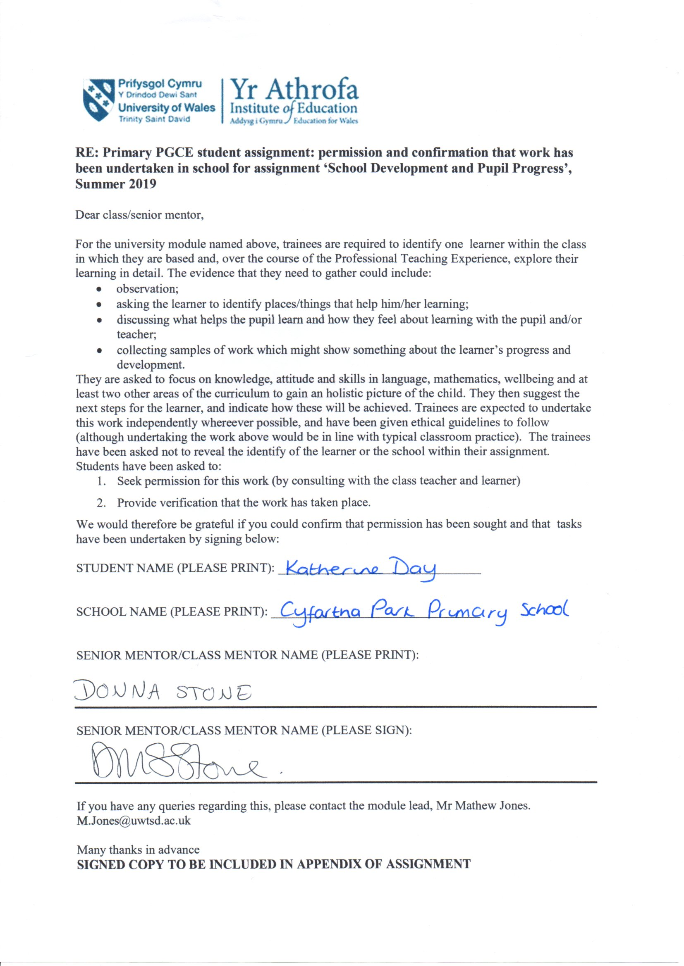
Figure 2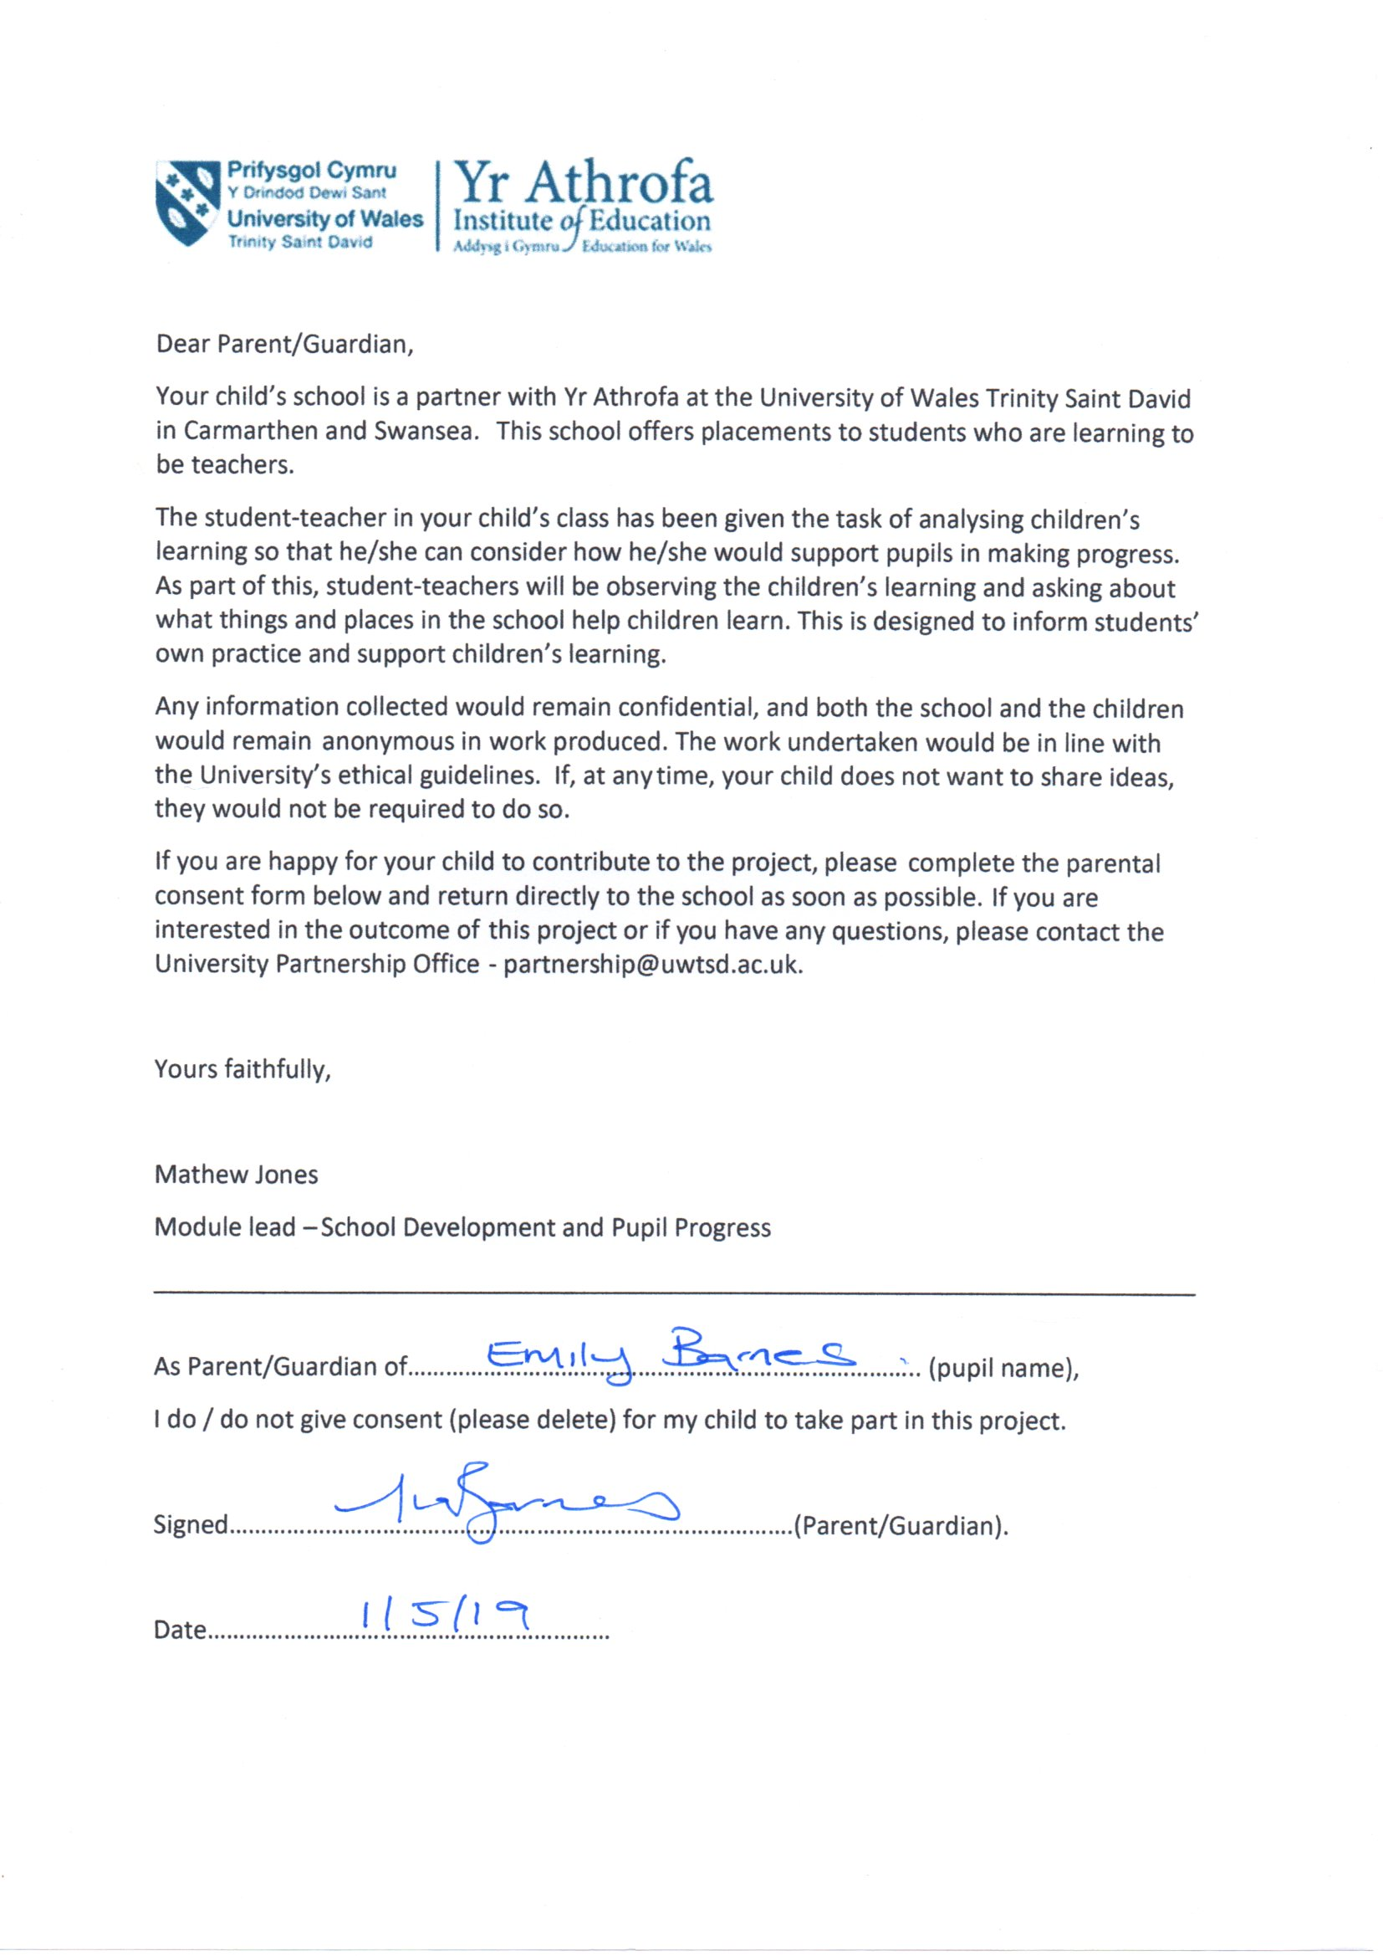
Figure 3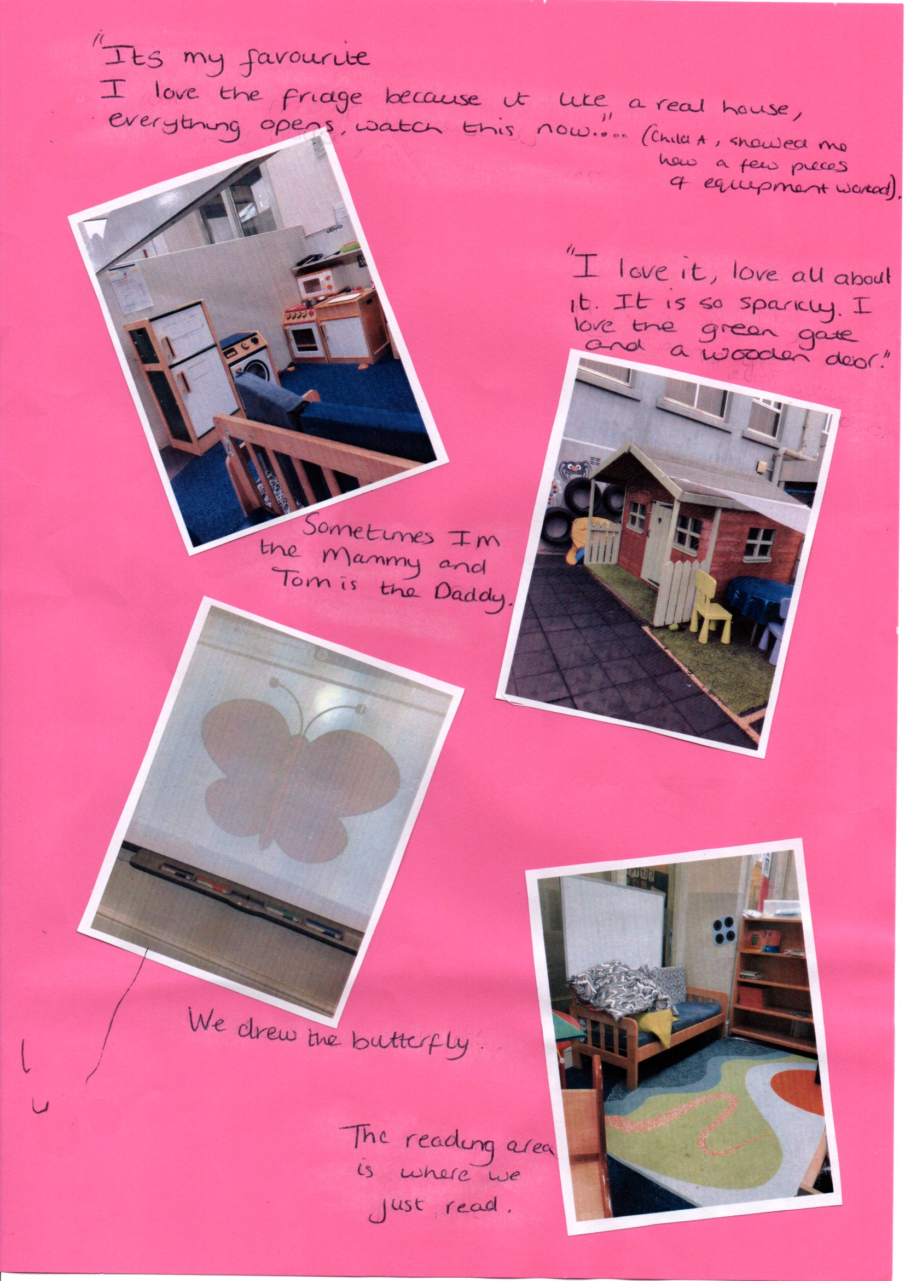
Figure 3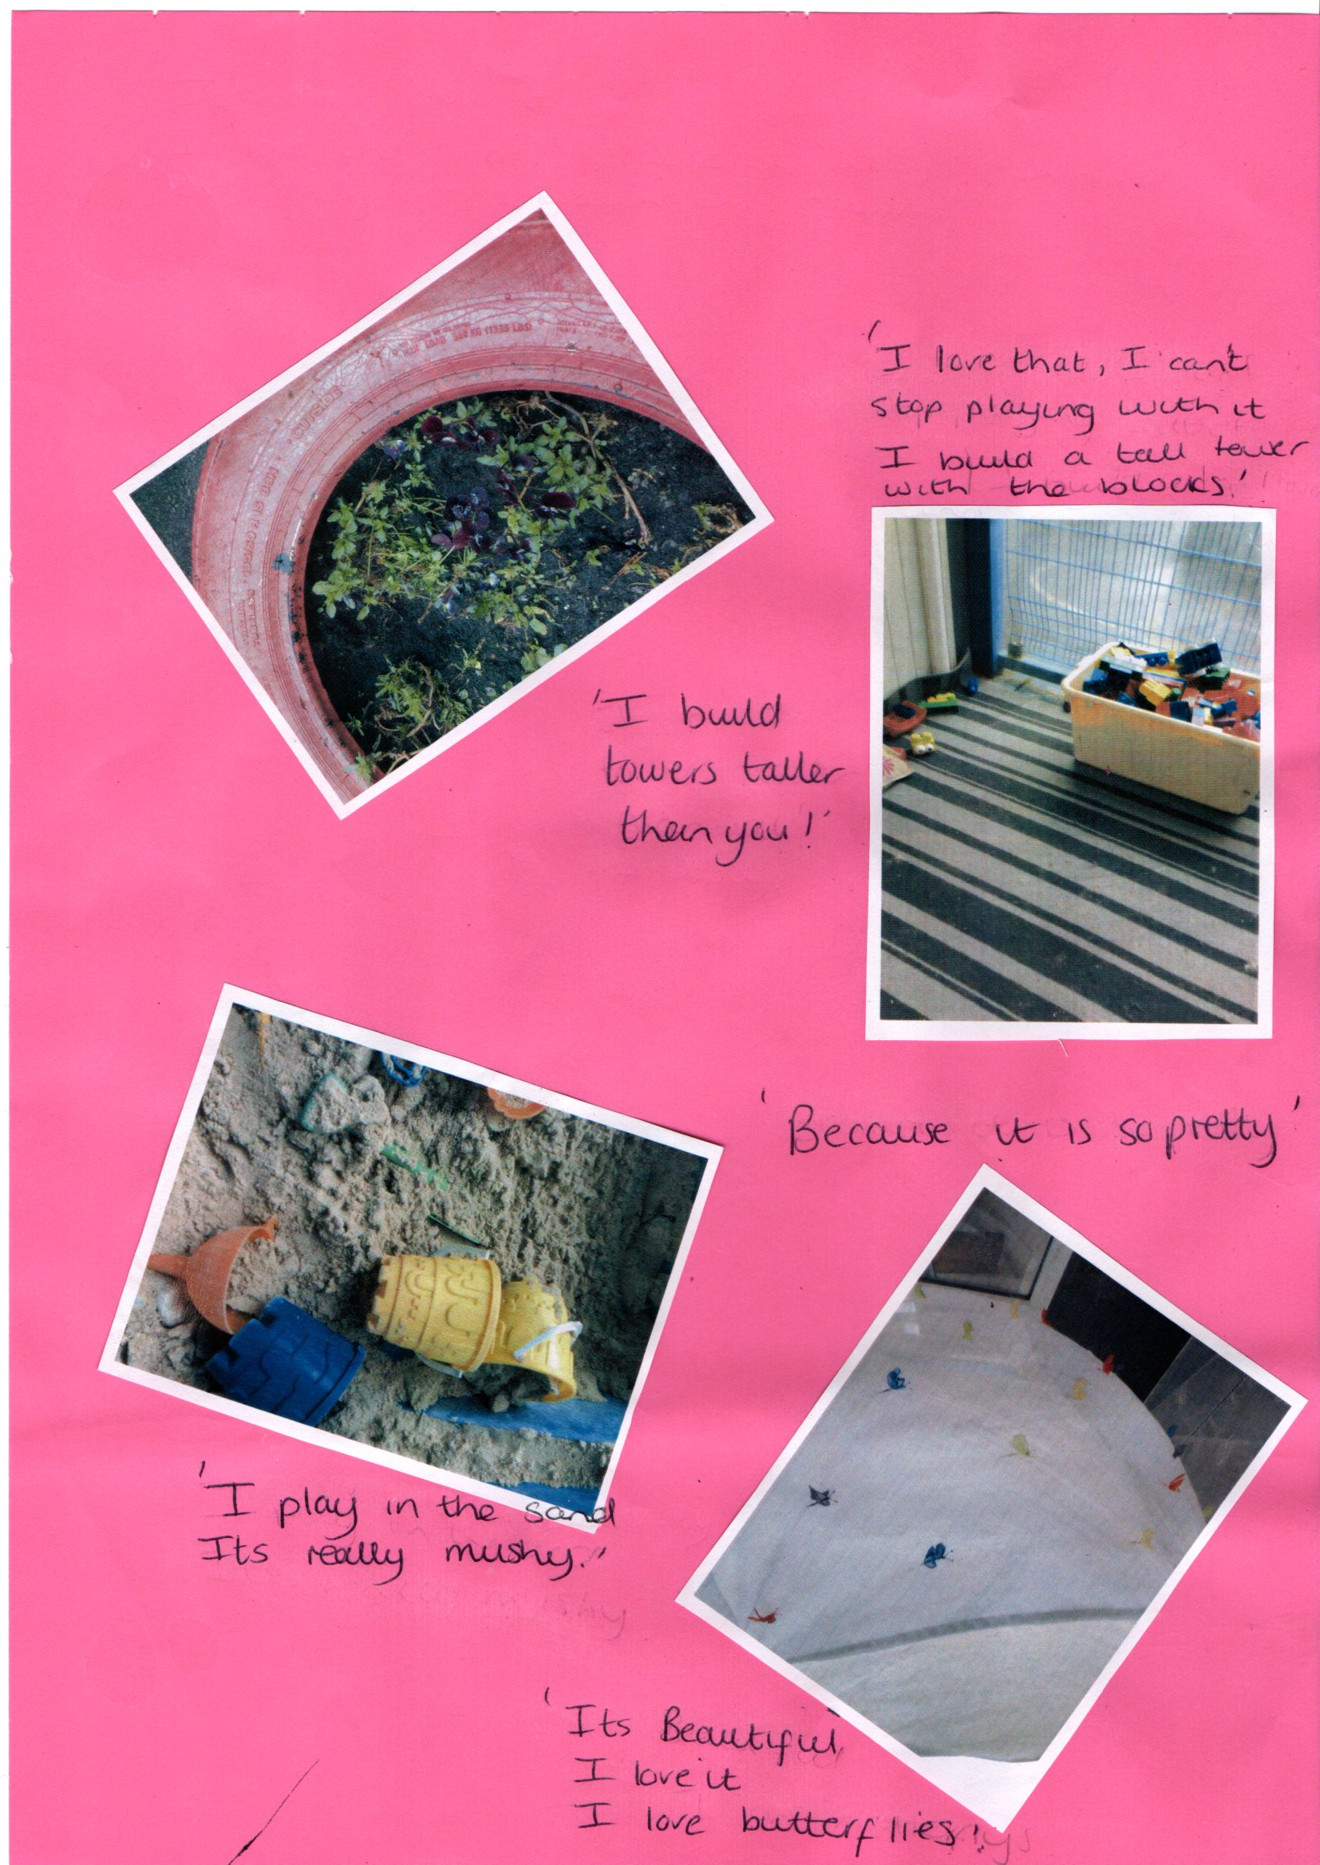Figure 4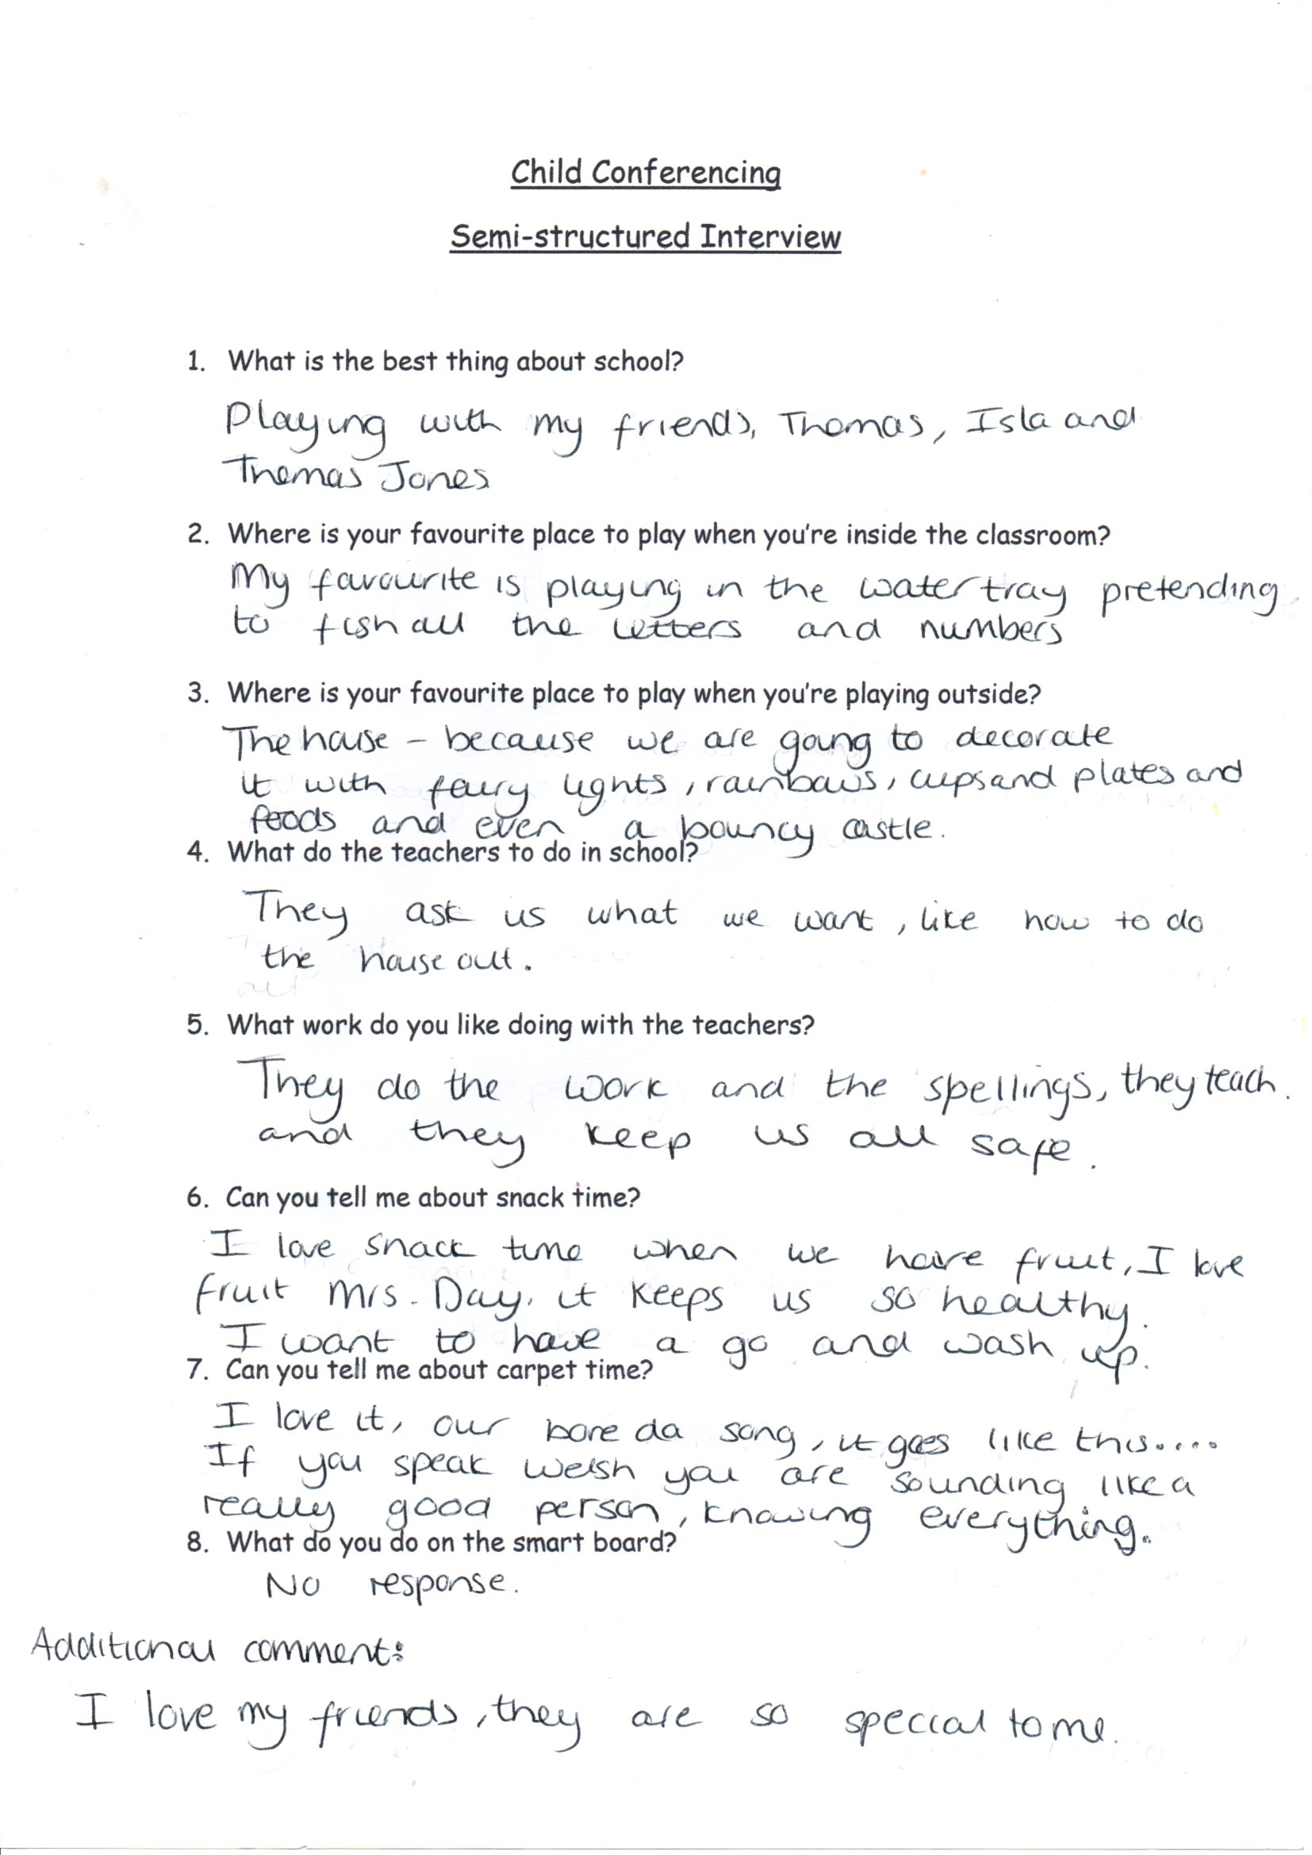
Figure 5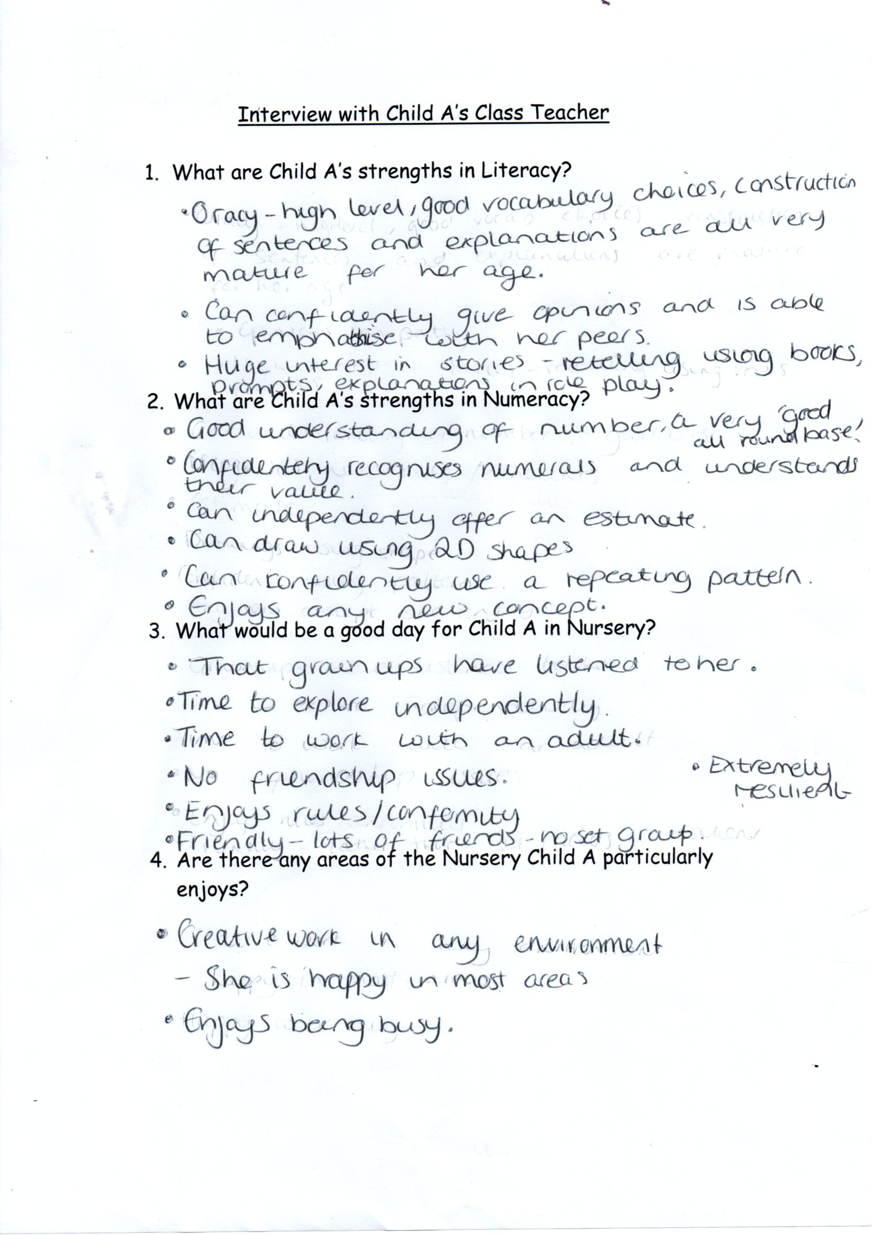
Figure 6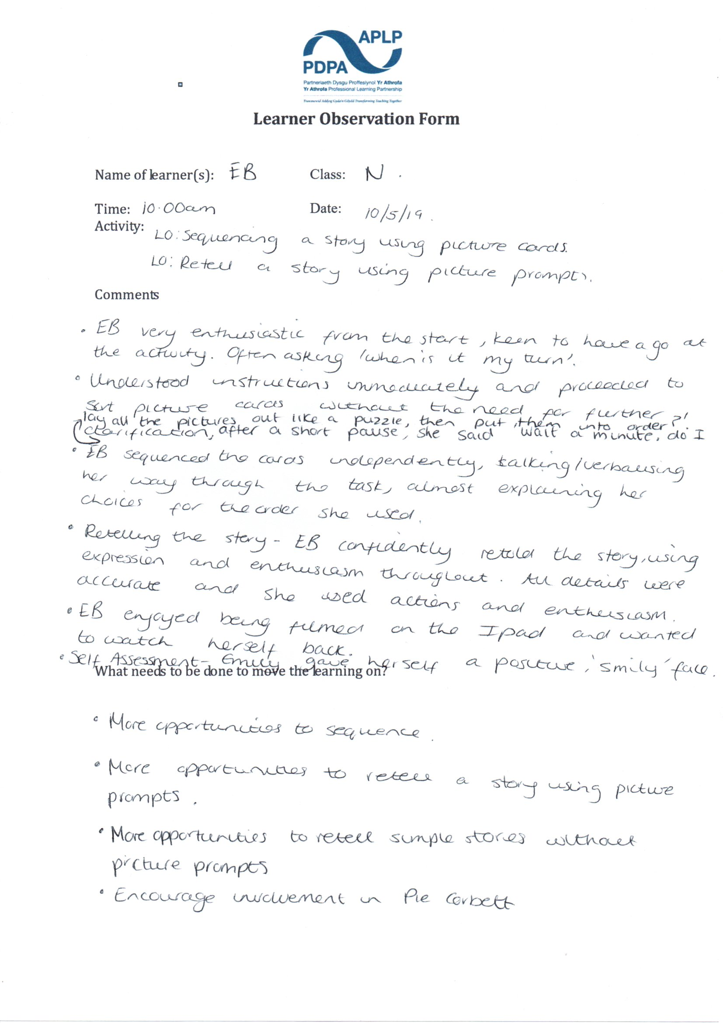
Figure 7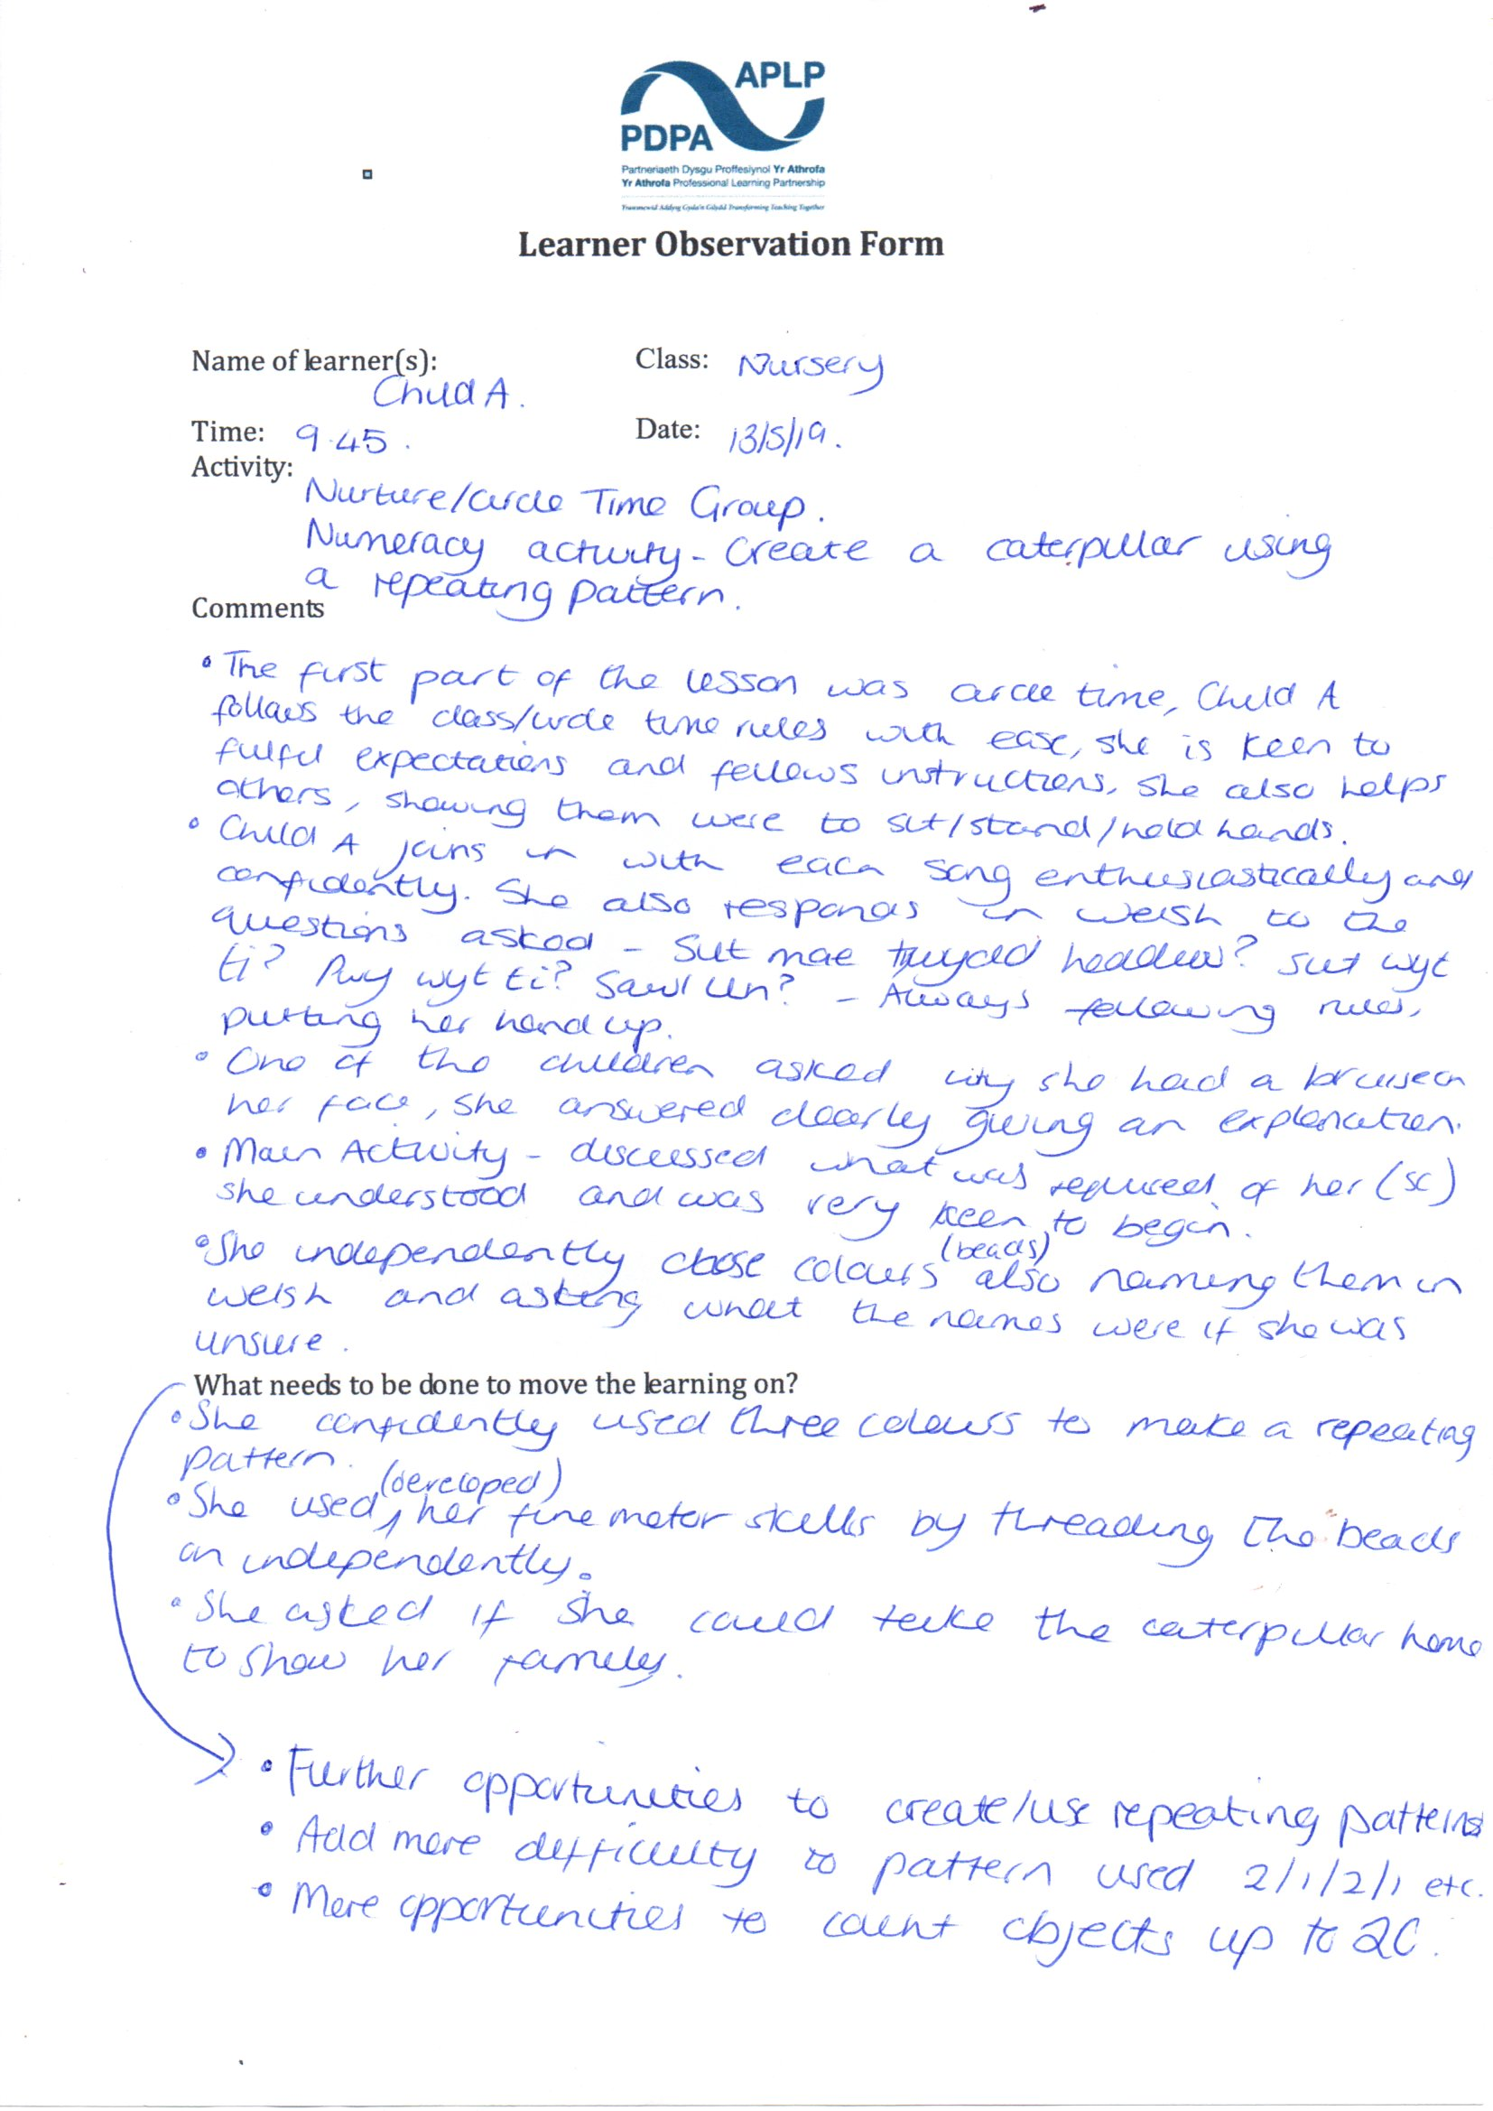
Figure 8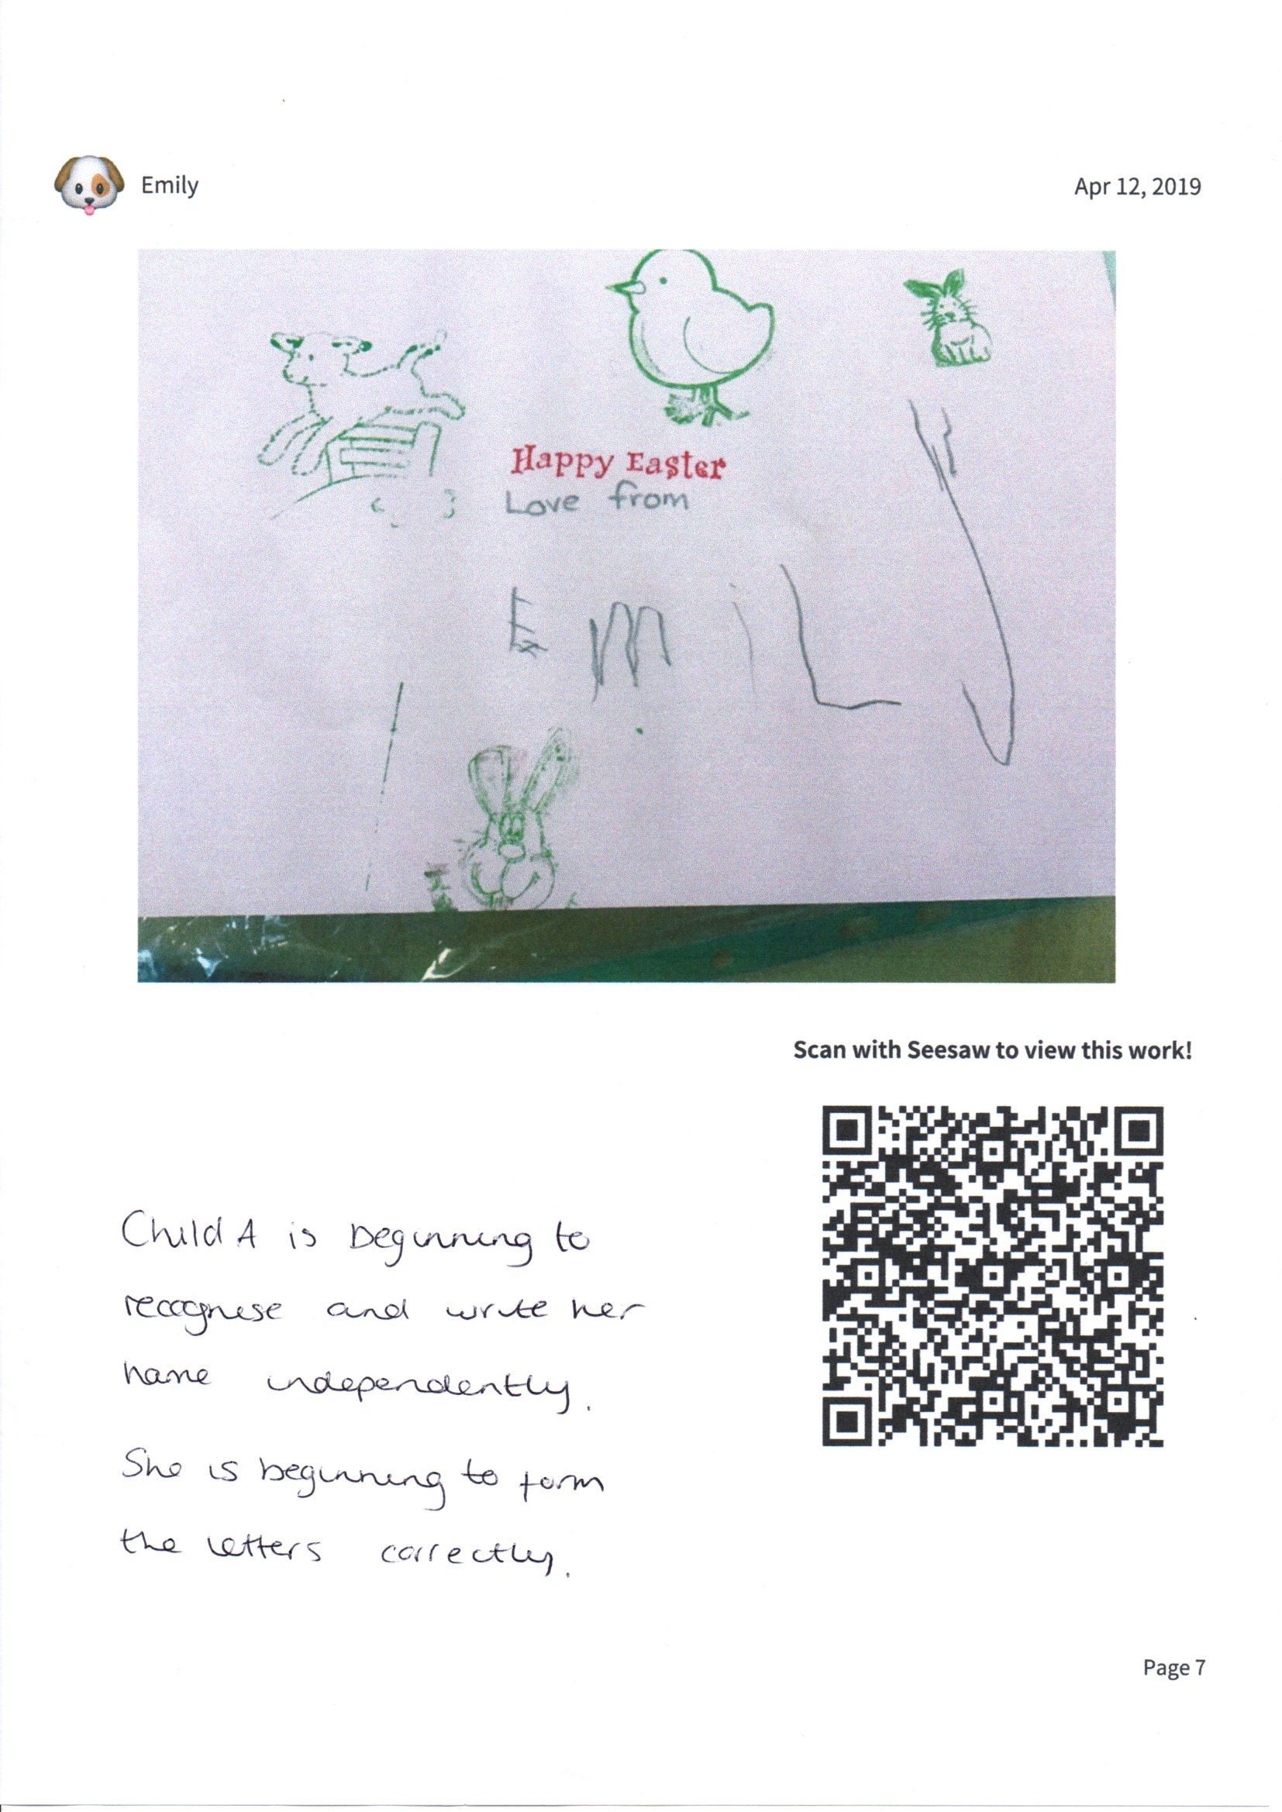
Figure 9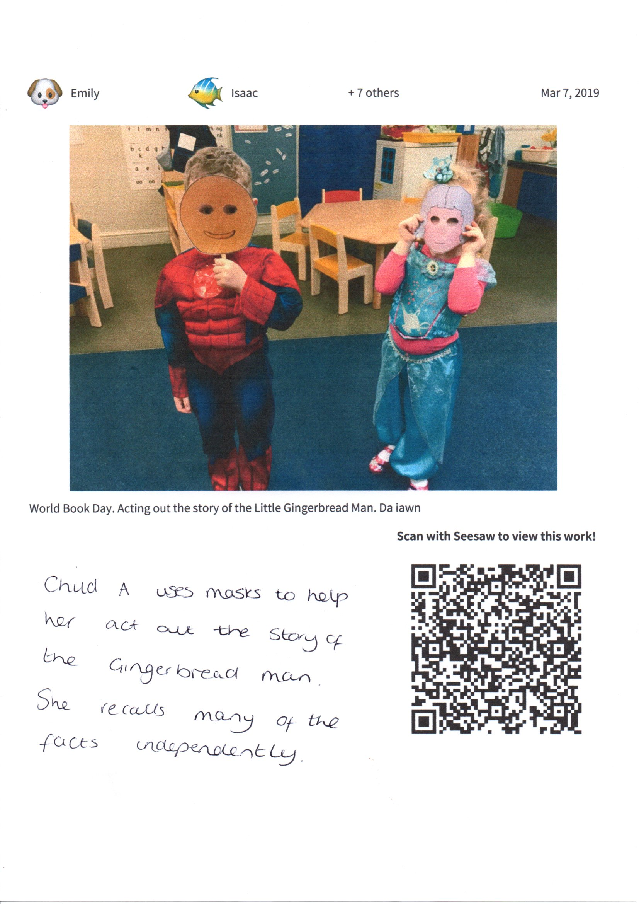
Figure 10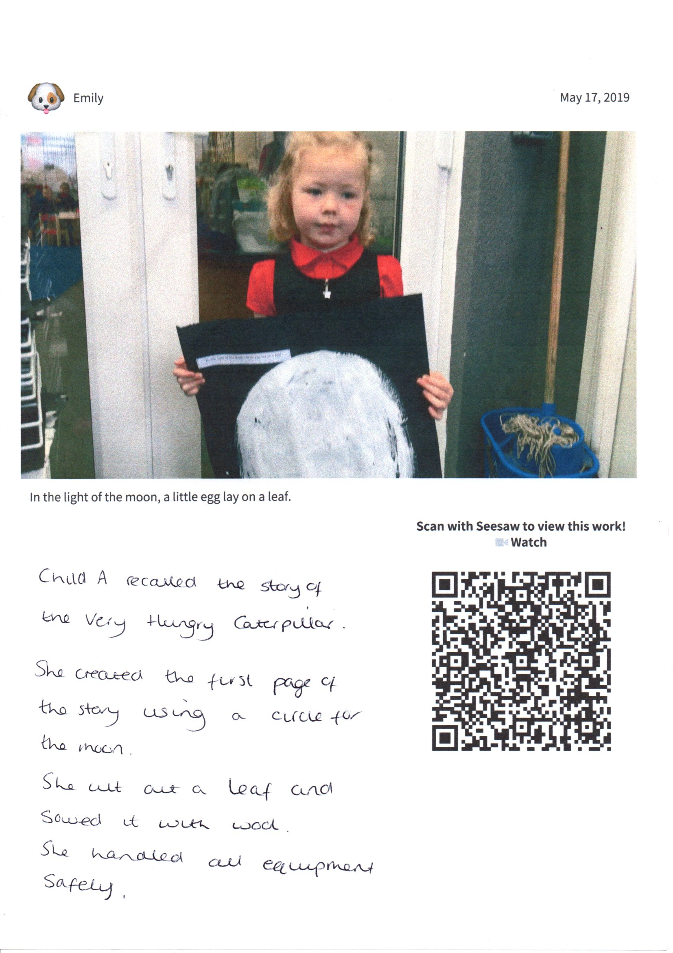
Figure 11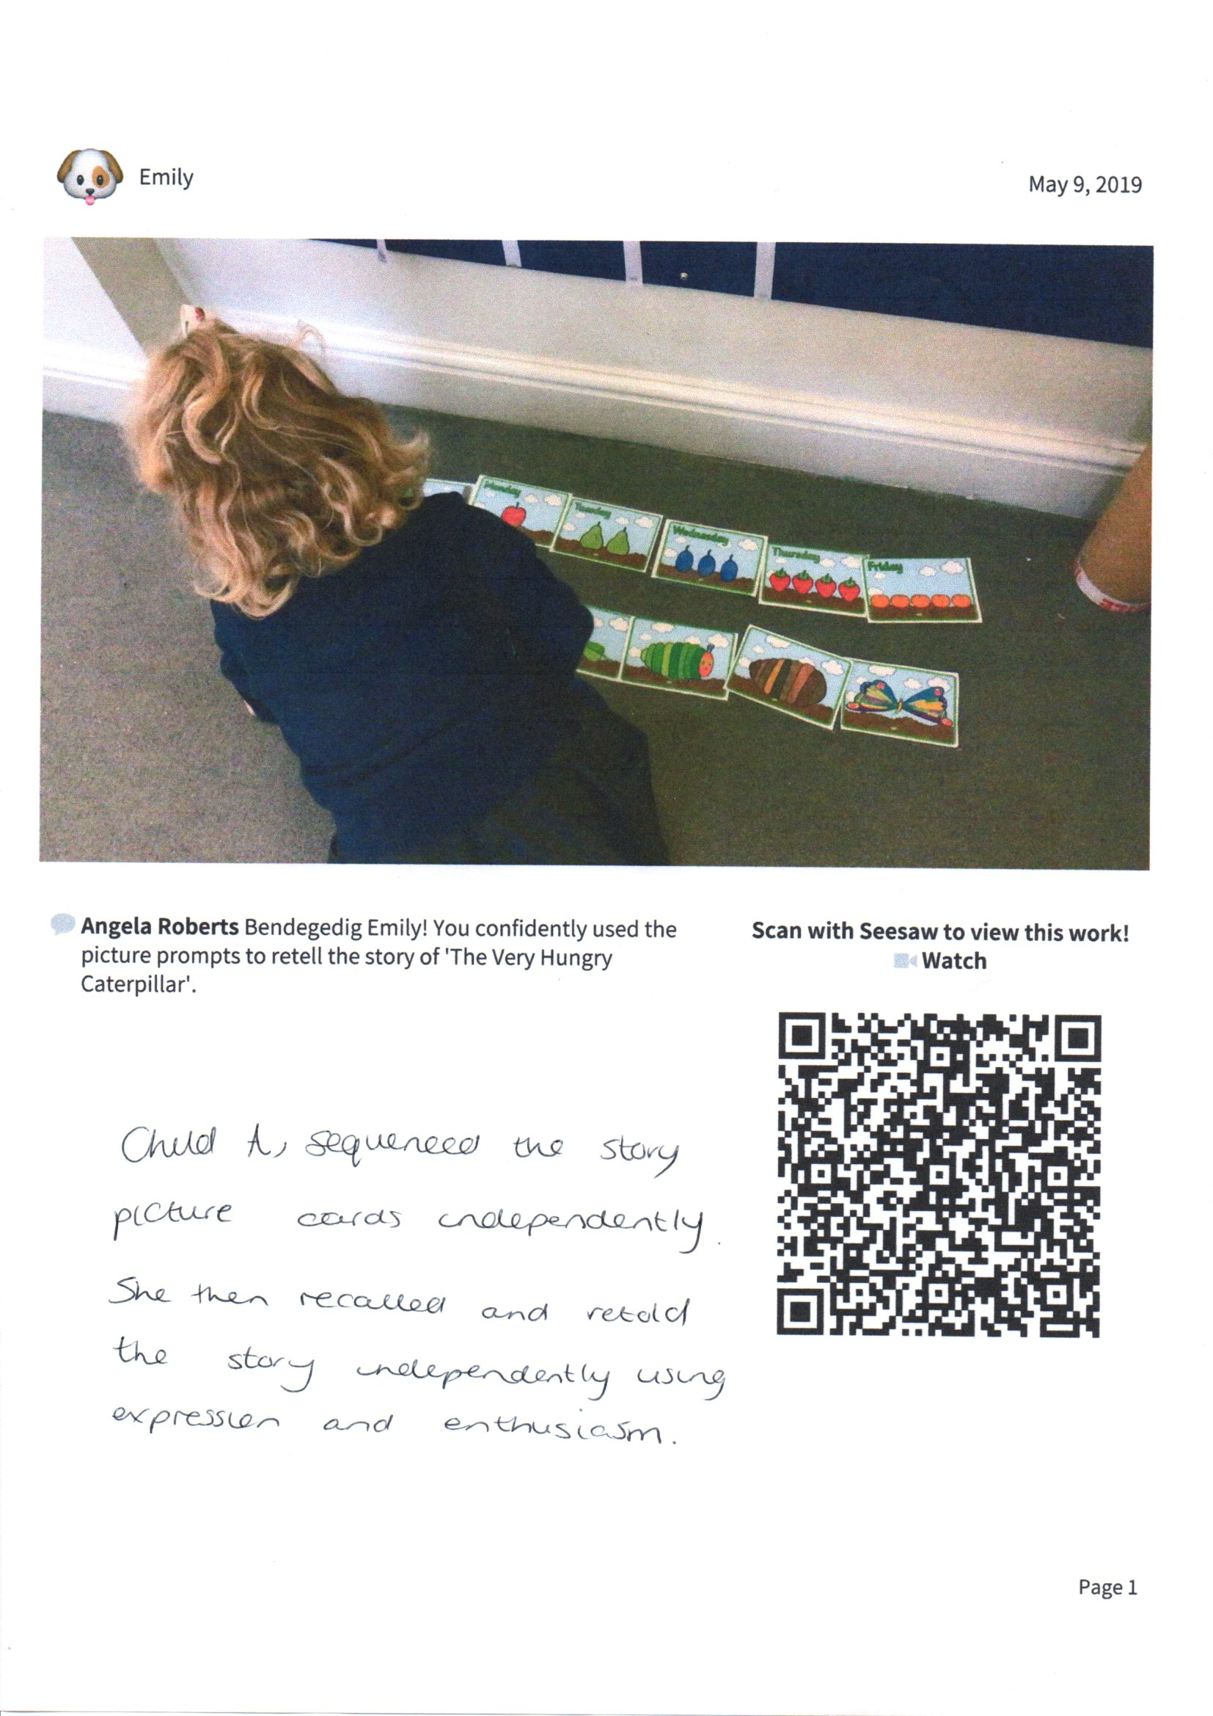
Figure 12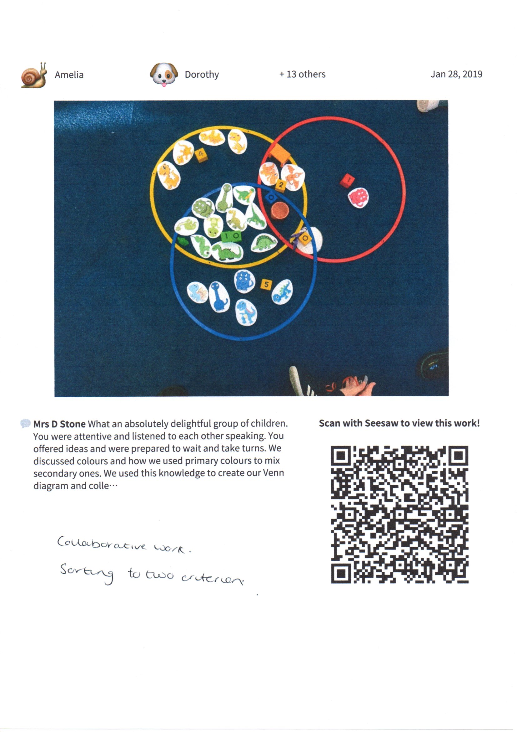
Figure 13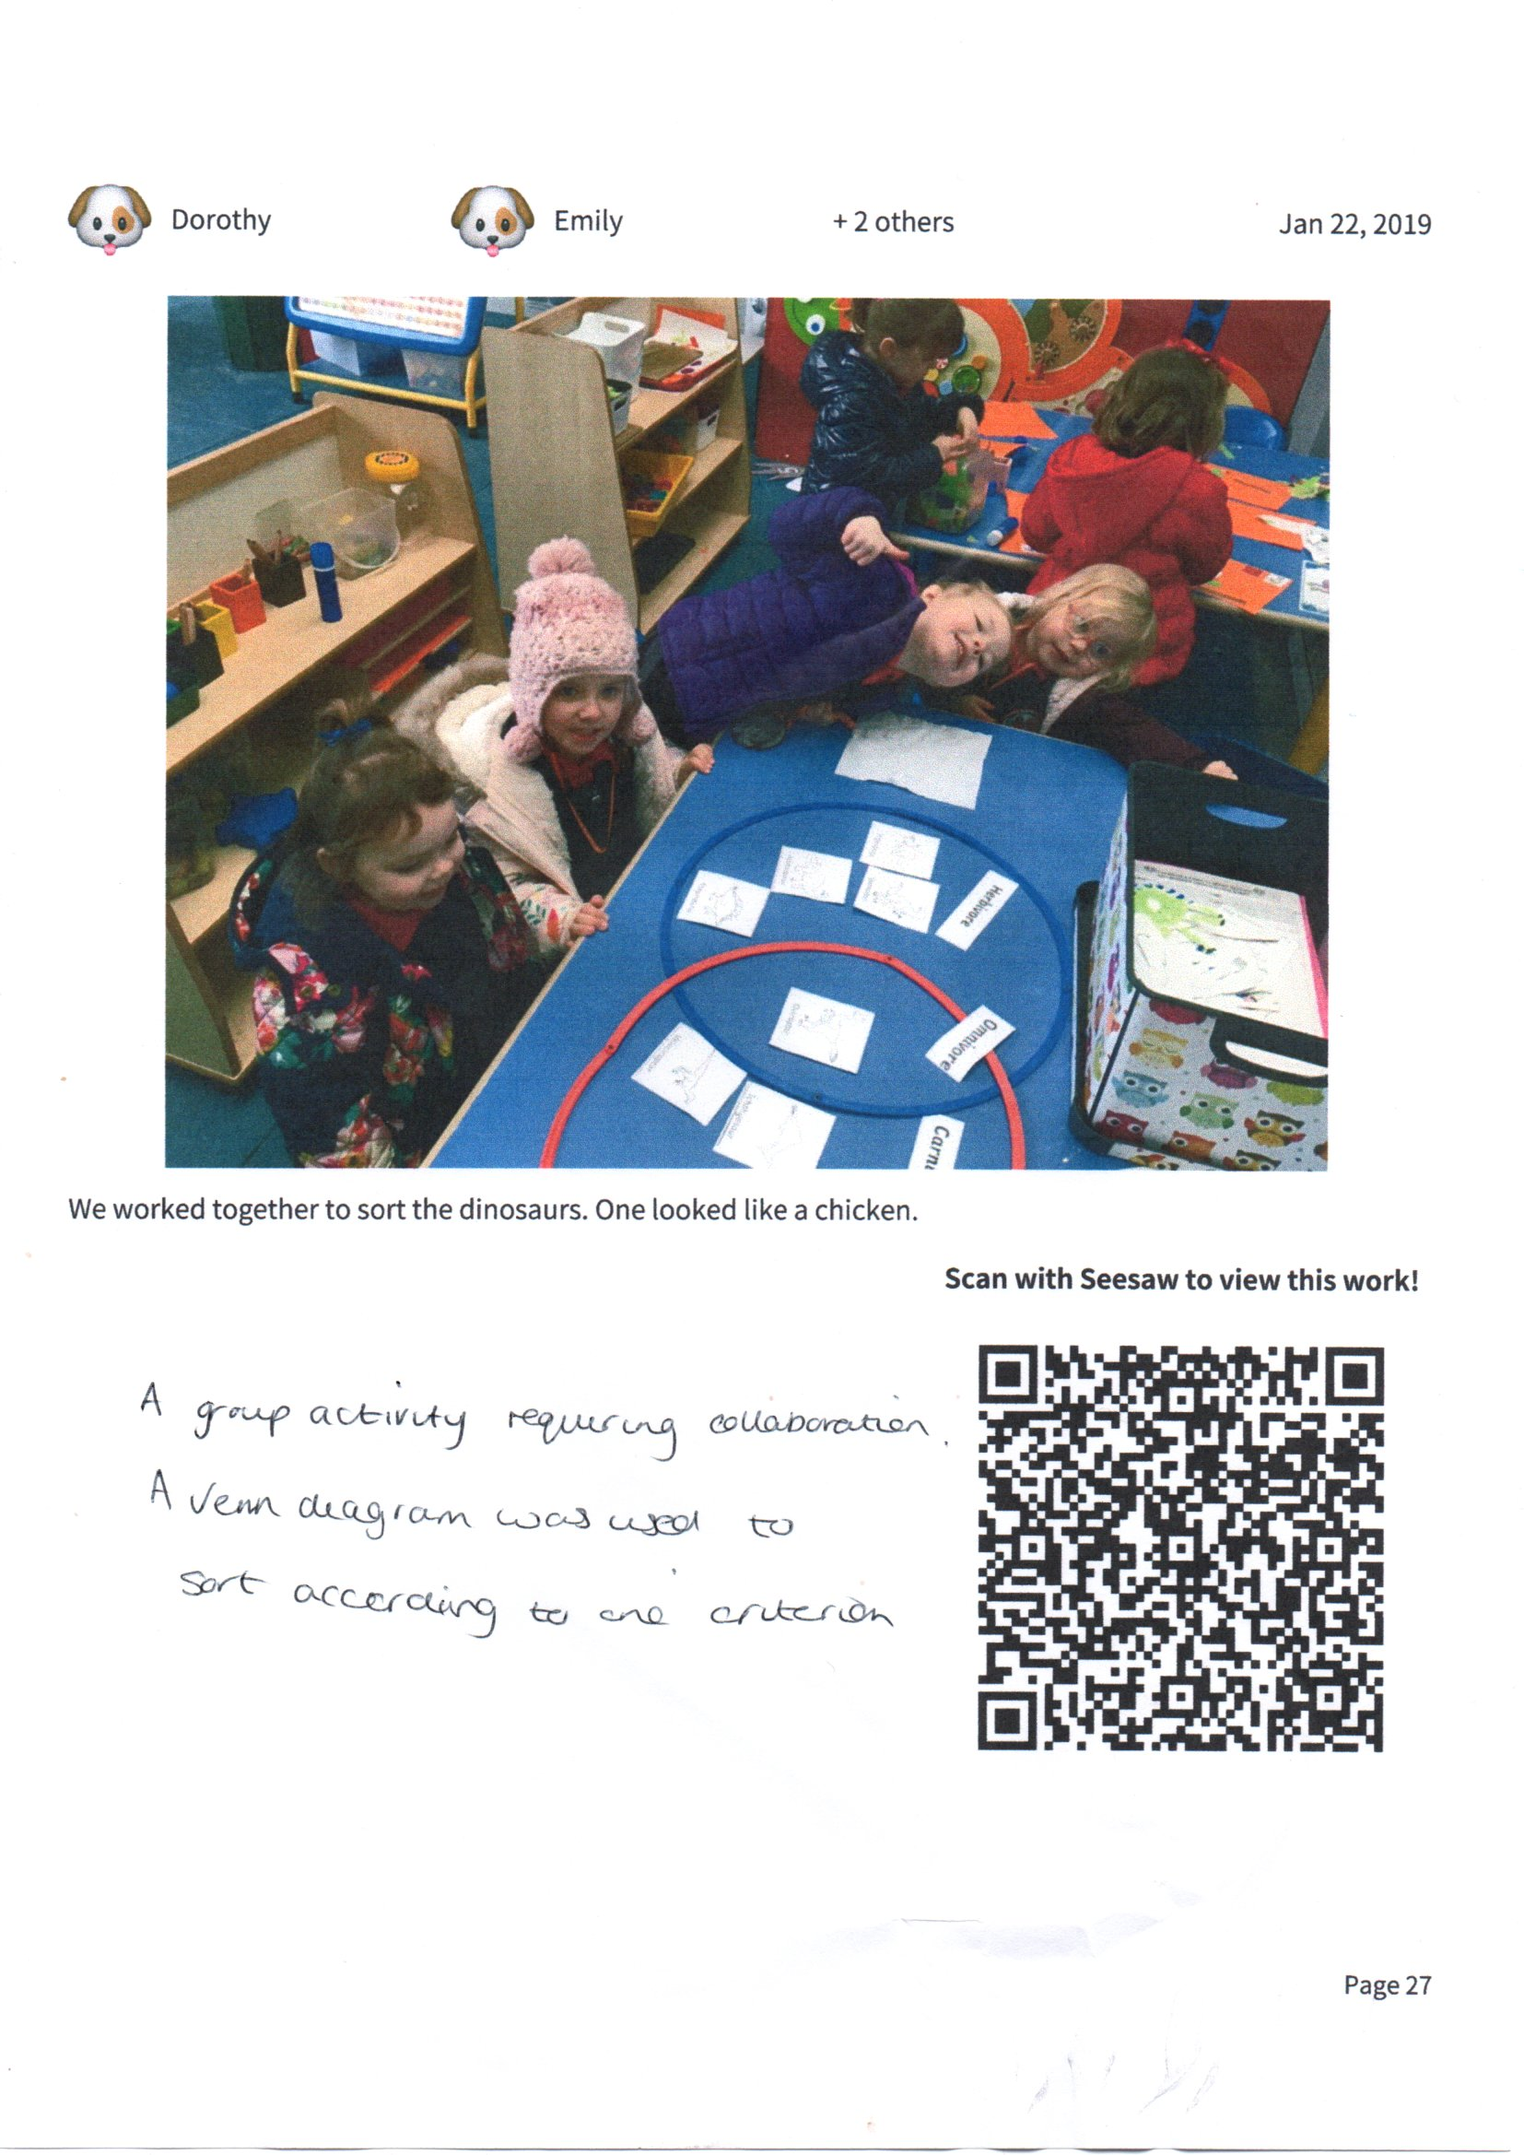
Figure 14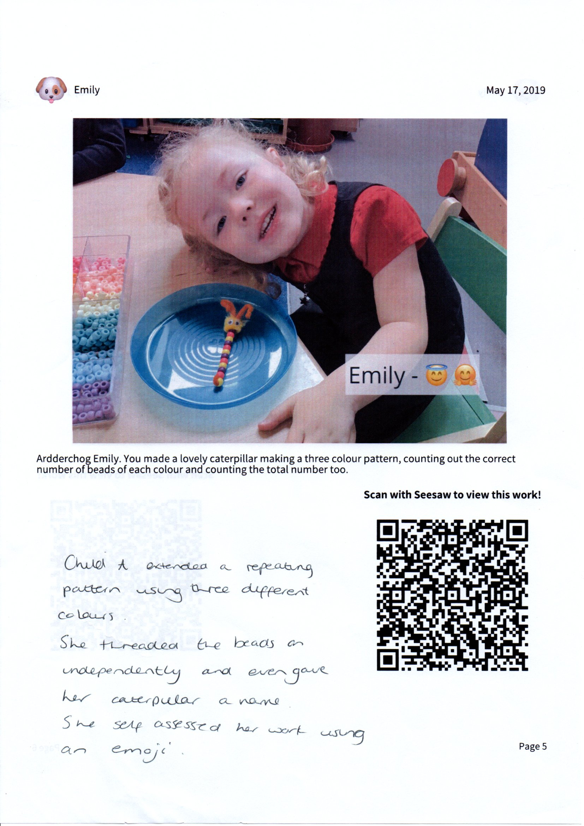
Figure 15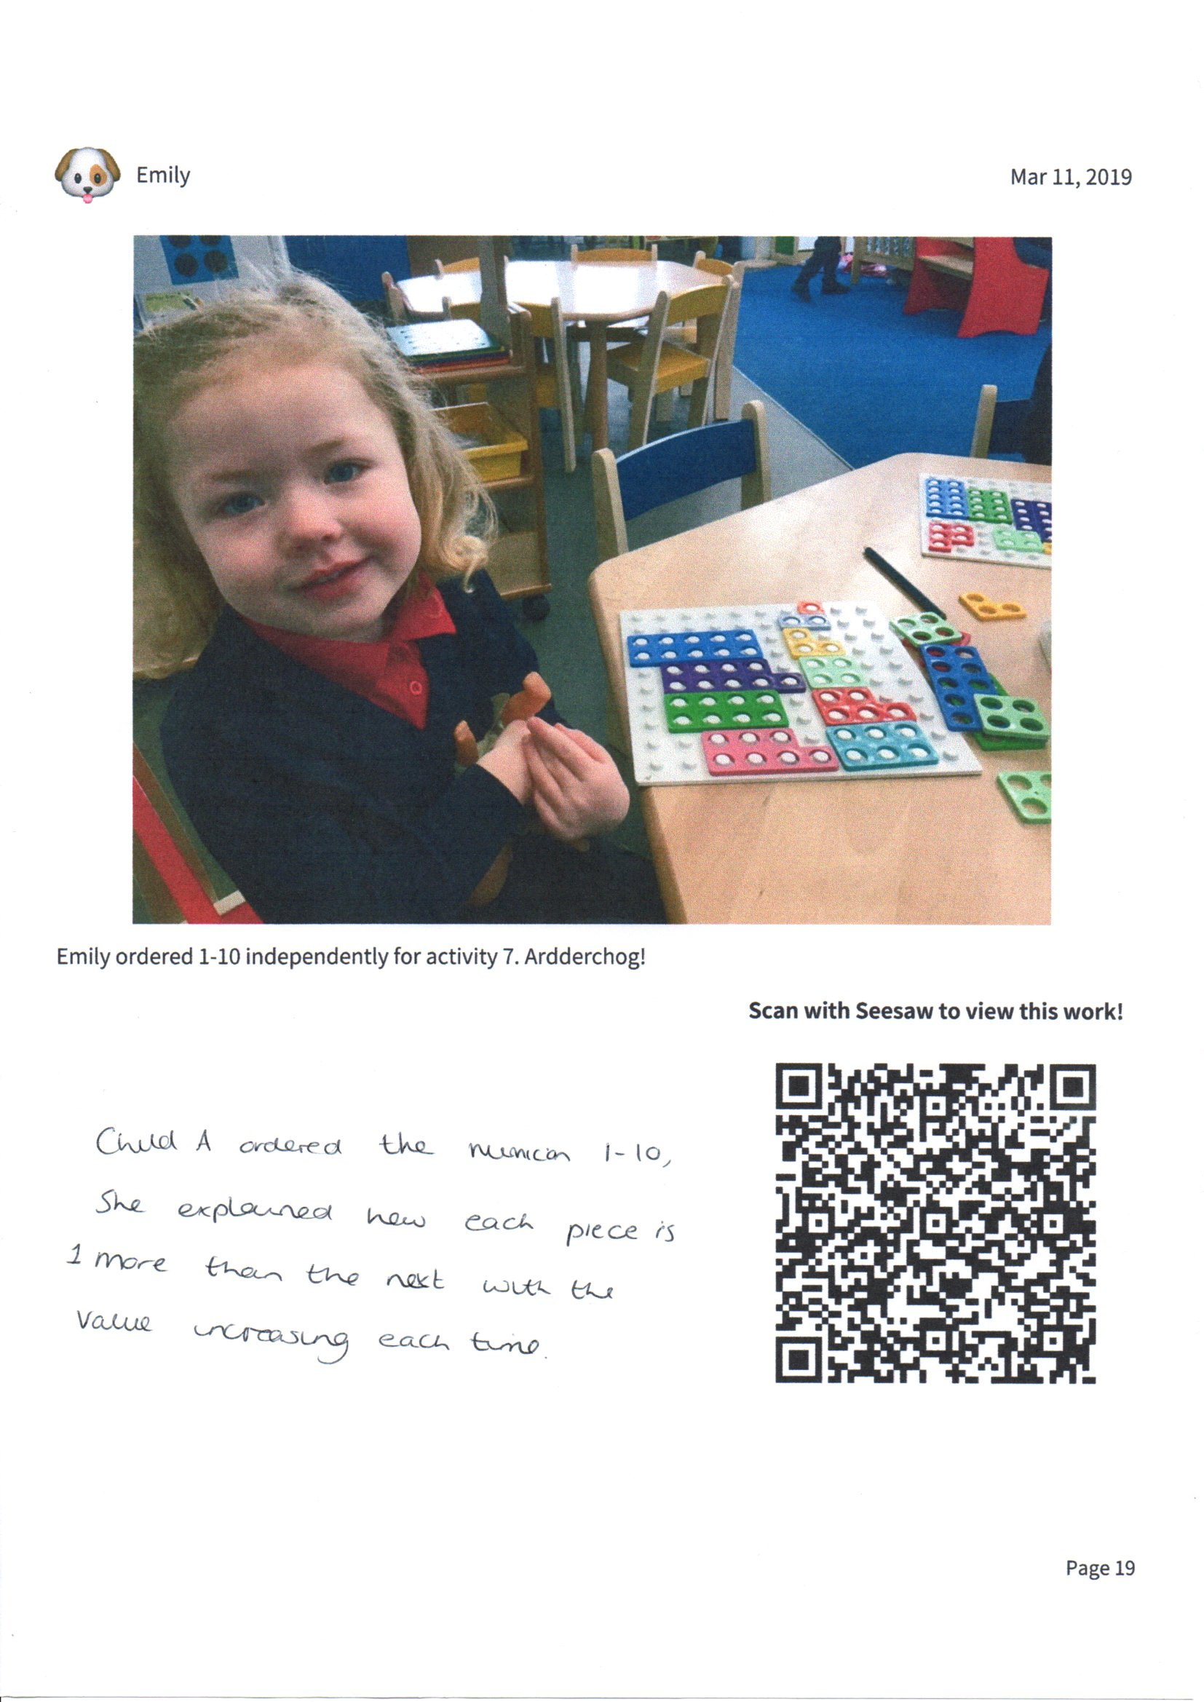
Figure 16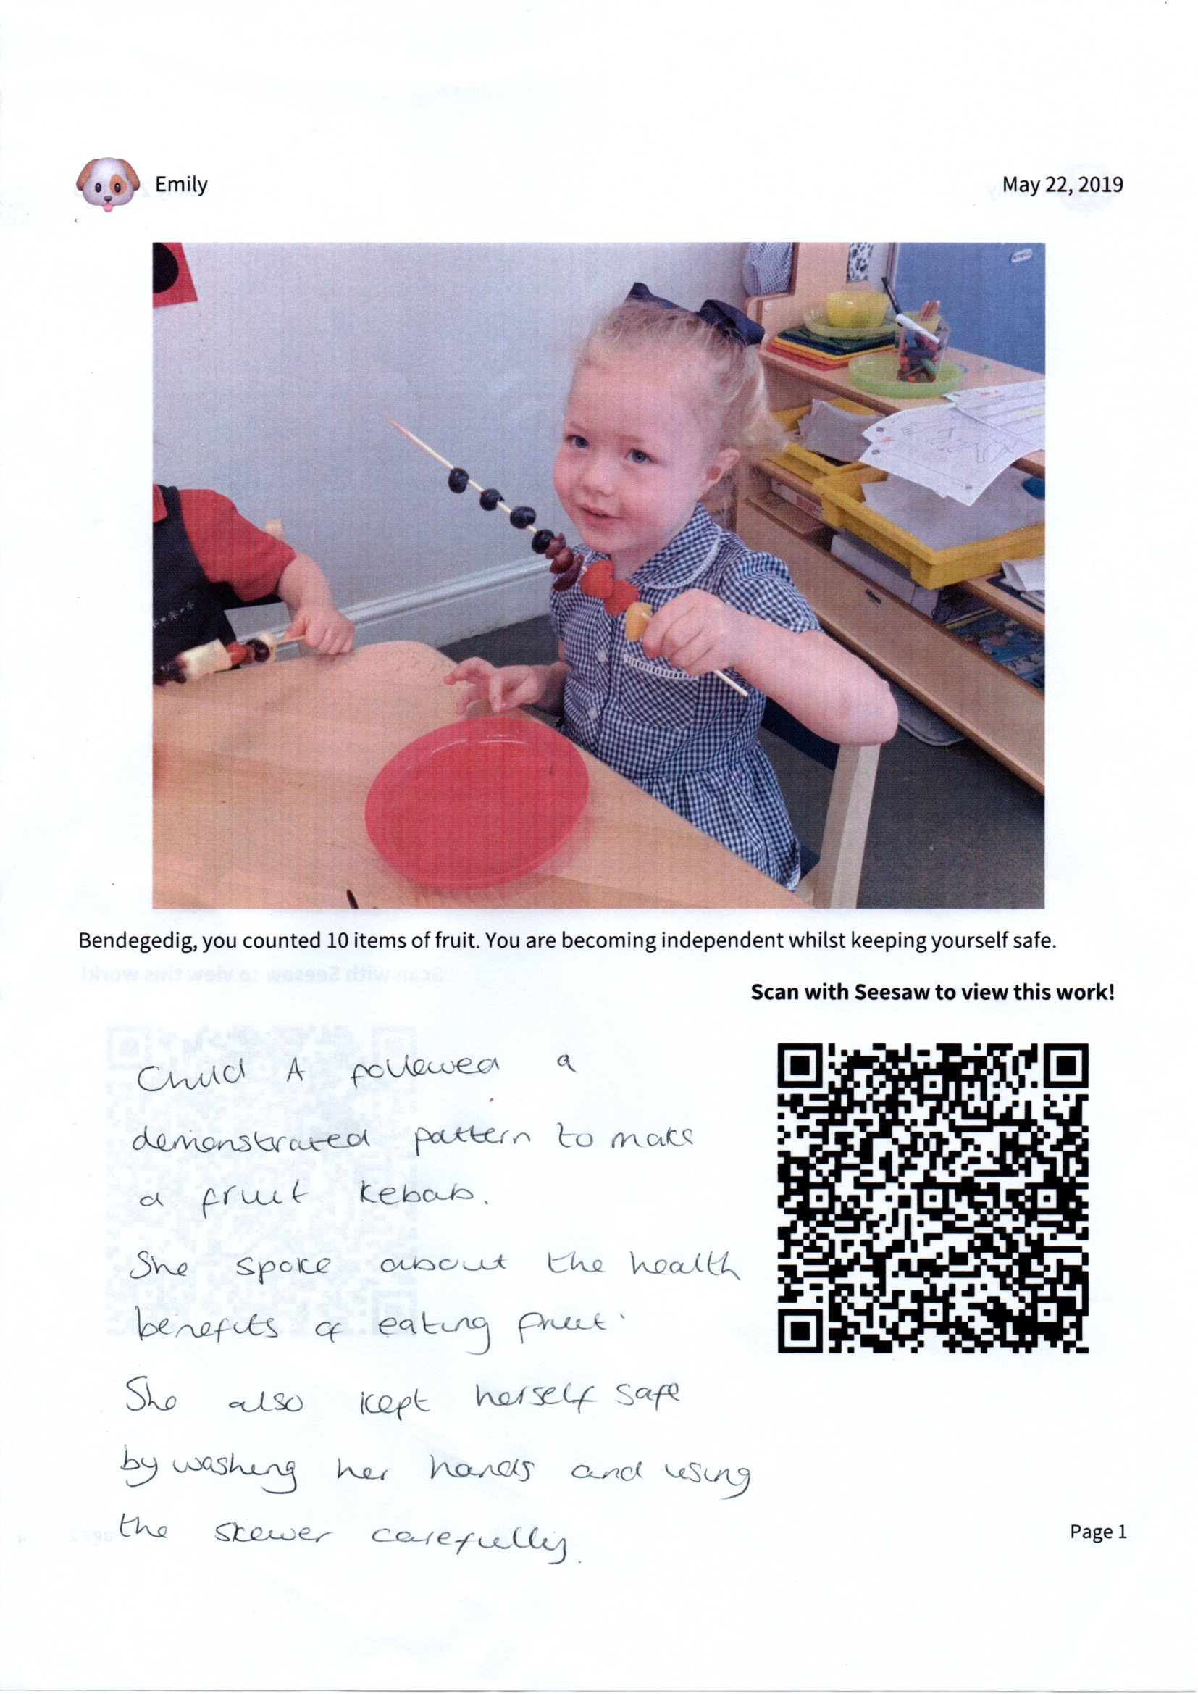Figure 17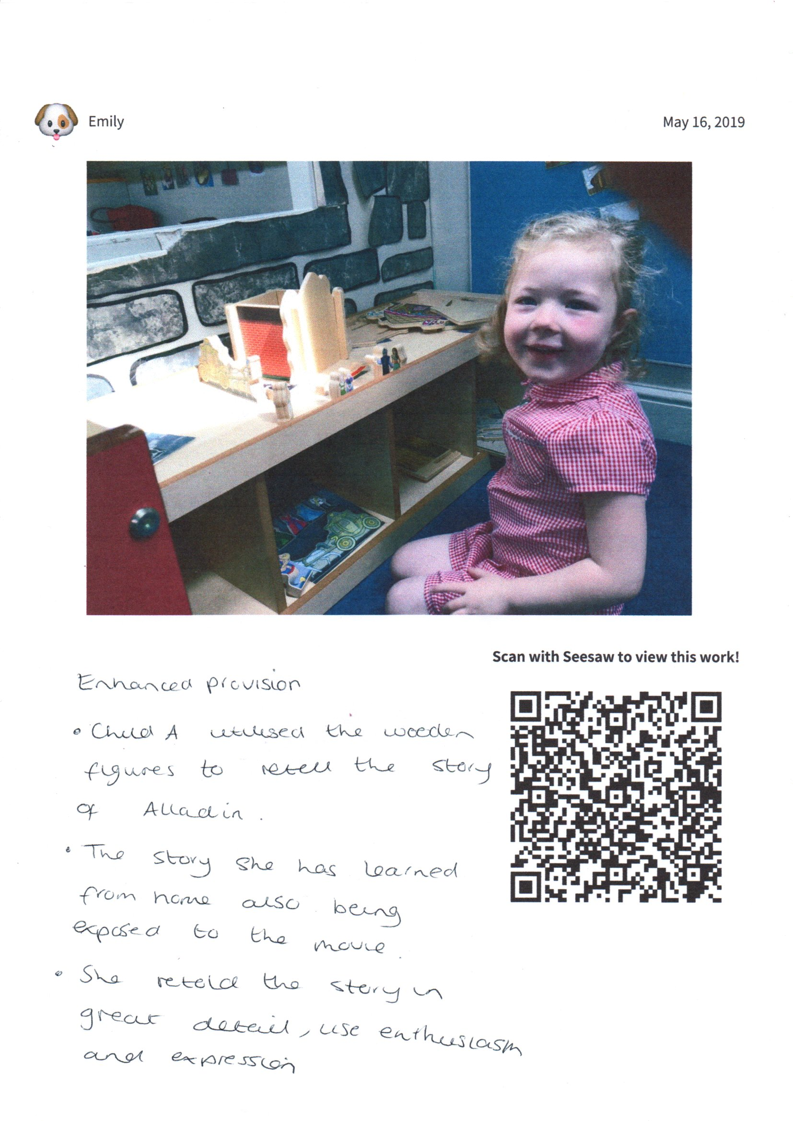
Figure 18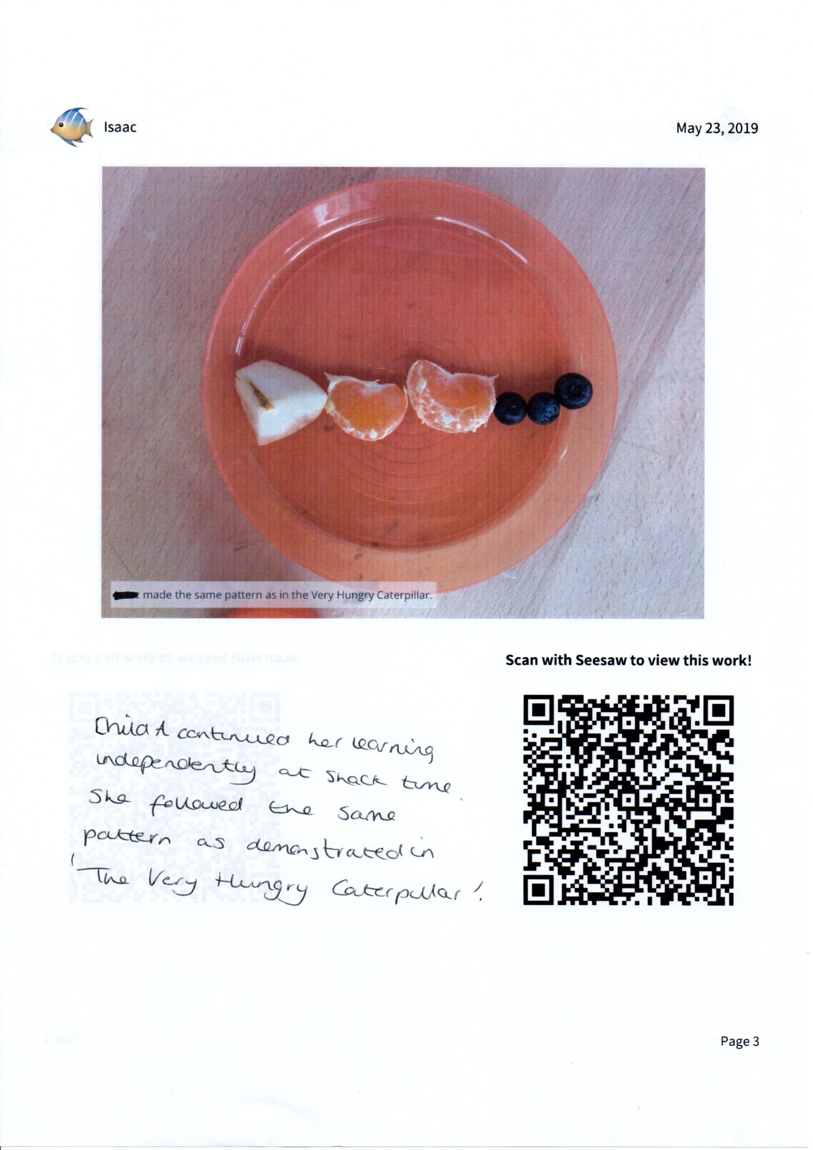
Figure 19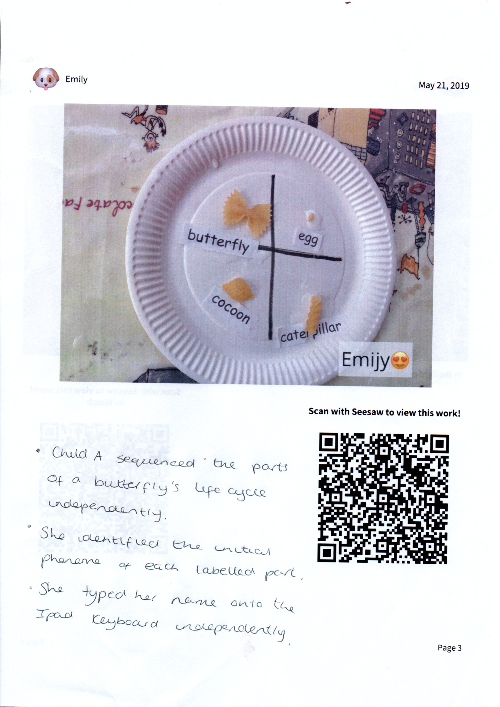
Figure 20

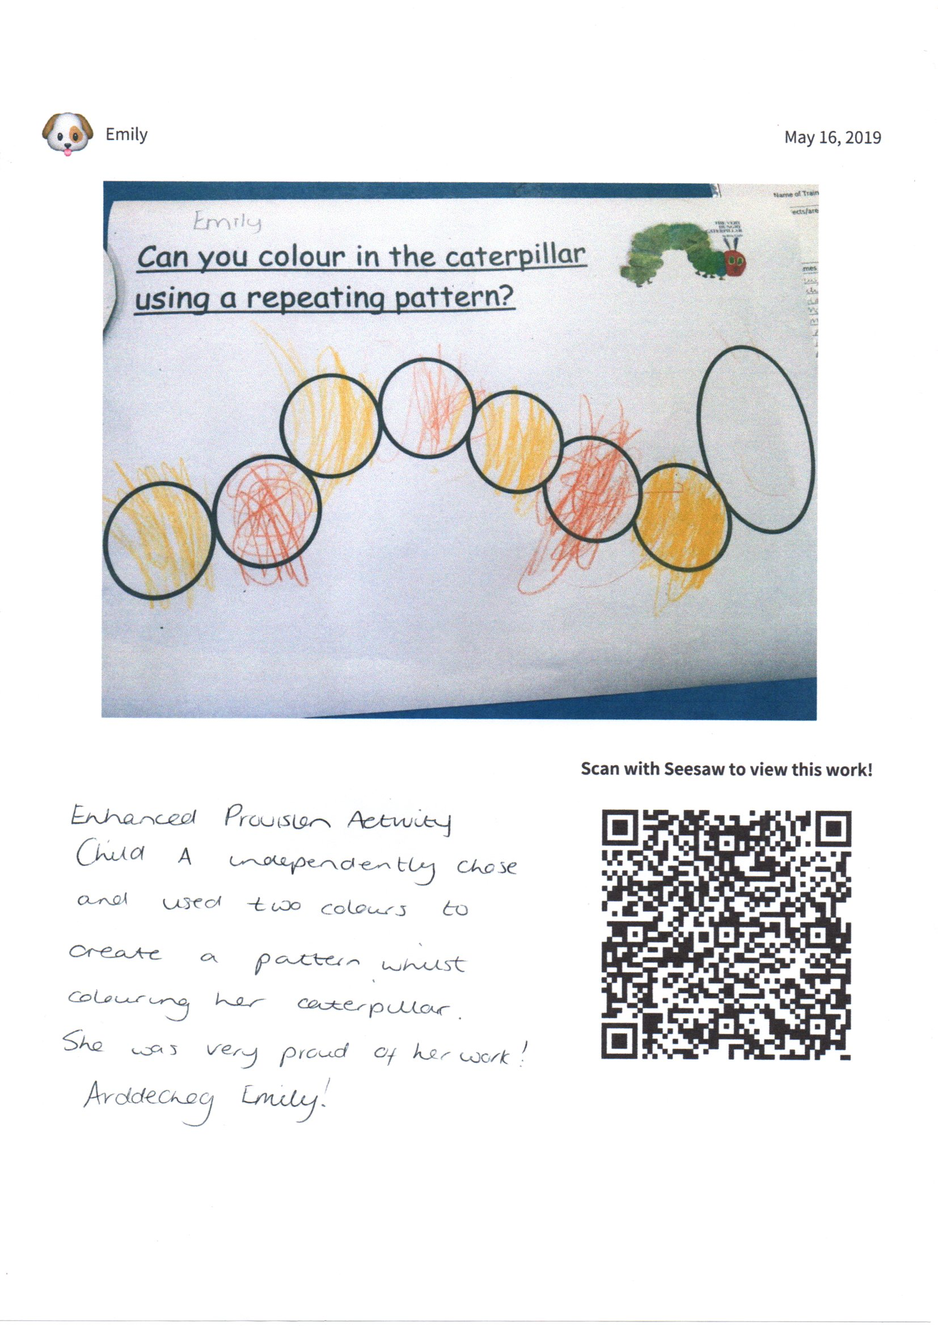
Figure 21
Figure 22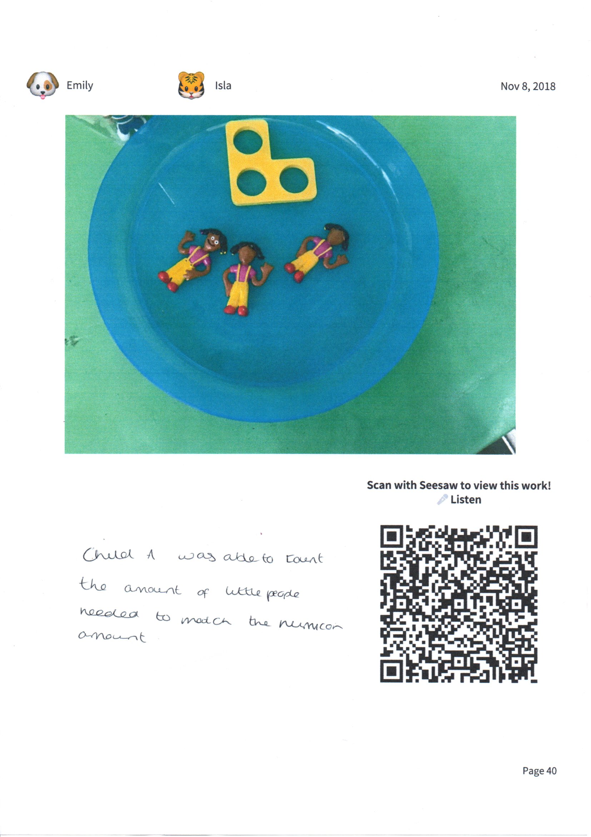
Figure 23

