

Collective Intelligence could help give user feedback of a multi-camera edit therefore having experts co-create with the crowd
by
Solomon Mukata Simukoko
Supervisor: Tim Bashford

Project submitted as part of the requirements for the award of
MSc Software Engineering

Abstract
This dissertation investigates whether Collective Intelligence of user feedback for a multi-camera editing process could help experts co-create with the crowd. This will be done by creating a tool which will be used to collect data from the crowd. Four tests will be set up which will be given to the crowd;
- Colour science tests will be done by showing users different colour grades,
- On-change test for duration of shots, this will help decide narrative clarity and subtext, and what the preferred shot size is.
- Emotional test by tracking participant responses as they watch videos
- Eye-tracking to see what people are watching in the video in test.
Kanban was the agile methodology used for development, with Google design sprint to be used for system design. Another key approach cardinal to the design process was to have User-centred design. This was done by combining User testing with Semi-structured interviews with key experts.
The experts found functions of the artefact very usable. One important point was that the application combined various metrics in a quite unique way, taking the artefact data collection ability into emergent data territory. This, therefore, gives film editors and directors a fresh look on how they test films. Experts also expressed the need to want to analyse composition, to determine what works best for a given scenario. Hence, knowing where viewers are looking, and details like the emotional state of the test subject worked well for this sort of cinematography testing. Another consideration from the experts is the usage of the app by academia because it would be a good research tool for analysts and educators.
In conclusion the hypothesis can be said to be proven because the experts have used the artefact and found that it obtained usable feedback.

DECLARATION
I, Solomon Mukata Simukoko declare that I am the sole author of this Project; that all references cited have been consulted; that I have conducted all work of which this is a record, and that the finished work lies within the prescribed word limits.

This has not previously been accepted as part of any other Masters' submission.


Signed : .............................................
Date : 28/01/20

FORM OF CONSENT
I Solomon Mukata Simukoko hereby consent that my Project, submitted in candidature for the M.Sc. Software Engineering, if successful, may be made available for inter-library loan or photocopying (subject to the law of copyright), and that the title and abstract may be made available to outside organisations.

Signed : .............................................
Date : 28/01/2020
Table of Contents
Table of Figures 6
Introduction 9
Aim of the Study 11
Objectives of the Study 11
The hypothesis 11
Literature Review 12
Introduction 12
Collective Intelligence 13
Co-Creation 14
Examples of Collective Intelligence and Open source co-creation 15
Crowdsourcing 16
User Farm as an example of Crowdsourcing of video production 17
Brief History of Video Editing 20
Collaboration and Co-creation in the Video Editing process 21
Film pre-release process "Test Screening" 22
Could Collective Intelligence be the next evolution in non-linear Editing? 23
Does collective intelligence work well in a creative space? 23
Does collective intelligence work with an infinite number of contributors? 24
Collective Intelligence in Video Editing 24
Editing for Aesthetics 26
What areas could Collective Intelligence help editors 28
On Change 28
Colour Science 29
Eye-tracking 30
Emotion Tracking 31
Examples of Collective Intelligence in Video Production 35
Click2SMRY framework 35
Caption for Speech Recognition 35
Limitations, problems and considerations in the use of Collective Intelligence 36
Social Singularity vs Artificial Intelligence 38
Methodology 40
Introduction 40
Design Sprint 40
Understand (Semi-Structured interview) 42
Diverge/Sketch and Decide 43
Prototype and the Validate Usability Analysis 46
Development Plan working in Agile Kanban 48
Environments 49
Development Methodology 50
Preliminary 50
Results and Discussions 68
Introduction 68
Survey from the expert 68
Results 71
Colour Analysis 71
On-change 72
Eye Tracking 74
Emotions 76
Limitation of Study 80
Conclusion 82
Future Work 83
Reflection 85
Bibliography 86

Table of Figures
Fig 1 Crowdsouring 19
Fig 2 Understand Colour [55] 27
Fig 3 Adobe Multi-cam 29
Fig 4 CMLtrackr [65]. 34
Fig 5 Design Sprint logic [81] 41
Fig 6 Design Sprint Steps [81] 42
Fig 7 Database Diagram 44
Chart Fig 8 System Flow 45
Fig 9 System Package Diagram 46
Fig 10 Development Parts and Environments 51
Fig 11 CorsFilter 52
Fig 12 ORM 52
Fig 13 Database Connection 53
Fig 14 expose ID 53
Fig 15 Create Project 54
Fig 16 Upload Video 54
Fig 17 Express JS 55
Fig 18 Colour Analysis Example 55
Fig 19 POST colour Info 56
Fig 20 Dashboard 56
Fig 21 Colour Grade 58
Fig 22 Colour Filter 59
Fig 23 Select Eye Tracking 59
Fig 24 Eye-tracking info 60
Fig 25 Calibrate Eye tracking 60
Fig 26 Do Eye tracking 61
Fig 27 Graph Eye-tracking 61
Fig 28 POST Eyetracking 62
Fig 29 emotional Model 63
Fig 30 Capture User Infor 63
Fig 31 Emotional and On Change Test Example 64
Fig 32 Emotional and Onchange Control 65
Fig 33 On-change Code 65
Fig 34 Emotions Window 66
Fig 35 Post Emotions 67
Fig 36 Emotional and On-Change Graph 67
Fig 37 On Change Example one to understand Colour 72
Fig 38 On Change Example two 73
Fig 39 On Change Example three 74
Fig 40 Eyetracking example 75
Fig 41 QuickSight 76
Fig 42 [93] Error Ratees in Commercial Gender Classification 77
Fig 43 [97] Problem with CLM tracker 78
Fig 44 Sample Results 79
Fig 45 Comparing Ethnicity 80
Fig 46 Automation 84

Abstract
This dissertation investigates whether Collective Intelligence of user feedback for a multi-camera editing process could help experts co-create with the crowd. This will be done by creating a tool which will be used to collect data from the crowd. Four tests will be set up which will be given to the crowd;
- Colour science tests will be done by showing users different colour grades,
- On-change test for duration of shots, this will help decide narrative clarity and subtext, and what the preferred shot size is.
- Emotional test by tracking participant responses as they watch videos
- Eye-tracking to see what people are watching in the video in test.
Kanban was the agile methodology used for development, with Google design sprint to be used for system design. Another key approach cardinal to the design process was to have User-centred design. This was done by combining User testing with Semi-structured interviews with key experts.
The experts found functions of the artefact very usable. One important point was that the application combined various metrics in a quite unique way, taking the artefact data collection ability into emergent data territory. This, therefore, gives film editors and directors a fresh look on how they test films. Experts also expressed the need to want to analyse composition, to determine what works best for a given scenario. Hence, knowing where viewers are looking, and details like the emotional state of the test subject worked well for this sort of cinematography testing. Another consideration from the experts is the usage of the app by academia because it would be a good research tool for analysts and educators.
In conclusion the hypothesis can be said to be proven because the experts have used the artefact and found that it obtained usable feedback.

Introduction
Francis Galton in 1907 noticed an interesting phenomenon while attending a weight judging competition in the West of England [1]. The competition was to calculate the weight of an ox. He had collected approximately 800 of what he referred to as ‘tickets' of various members of the audience estimations, who took part in the competition. The average of all the 800 tickets was closer to the actual weight of the ox than that of an experienced farmer. He noted that "The judgments were unbiased by passion and uninfluenced by oratory and the like" [2]. From this he coined the term "The wisdom of the crowd” [2]. The difference between what he had observed, and other forms of democracy was that the lesser the influence the more accurate the result [2].
Galton’s wisdom of the crowd in the era of Tim Berners-Lee’s World Wide Web means the audience is now everywhere, where there is a computer or device connected to the internet [3]. The ability of the many to contribute to make a common more informed decision is known as collective intelligence. In today’s world of Web 3.0 mass communication and collaboration have become a common place. From social media to online gaming, individuals around the world are increasingly interacting [6]. Therefore, leveraging the power of collective intelligence through interactions, such as online user contributions, online interactions and online feedback are a key requirement for a firm to corner the market [3]. It has become extremely easy to get information from the crowd. Democratising processes has become easier; all one needs to do is look at Reddit [7]. However, also increasingly, experts are looking at how they can leverage the power of the crowd. Therefore, it is important to have powerful programming techniques which help discover the common patterns namely, what the inter-relationships between data sets are? and especially, how do you extract useful information from vast amounts of data [4]?
Testing of audience feedback is seldom done before the video editing process has been completed. Compared to the software development process which has moved to a more testing first approach, testing of video edits before the actual editing is done could help save money. However, how could audience feedback be collected before the editing process is completed and could collective intelligence be helpful in this regard?
This dissertation investigates whether Collective Intelligence could help give user feedback of a multi-camera edit therefore having experts co-create with the crowd. This will be done by creating a tool which will be used to collect data from the crowds. The data can then be used to analyse what preferences the users have. Four tests will be set up which will be given to the crowd;
- Colour science tests will be done by showing users different colour grades,
- On-change test for duration of shots, this will help decide narrative clarity and subtext, and what the preferred shot size is.
- Emotional test by tracking participant responses as they watch videos
- Eye-tracking to see what people are watching in the video in test.
Thereafter, the data will be examined by experts in the field to see if they would integrate this into their practice.

Aim of the Study
This study aims to see if Collective Intelligence could help give user feedback of a multi-camera edit therefore having experts co-create with the crowd.

Objectives of the Study
- Develop an artefact which could be used to collect data for collective intelligence in video production.
- To use the artefact to research how duration of shots and shot sizes can be used to decide narrative clarity, dramatic emphasis and subtexts.
- Look into how collective intelligence can work out the Colour science to give viewers a better aesthetic experience of the video.
- To use the artefact to research how collective intelligence could be used to find what individuals are looking at as they watch and interact with the content.
- To use the artefact to research how collective intelligence can be used to show emotional responses to determine which edit is more effective.
All the objective will be subjected to review by video editors to ensure that these objectives have been met been met.

The hypothesis
Video editors mostly receive feedback after they have finished the edit. Therefore, to mitigate this, the hypotheses is
‘Collective intelligence could be used to obtain feedback from the crowd for edits’ has been defined. This is experimented by introducing an artefact which would test emotions, eye tracking, colour analysis and on-change events. This is because Collective intelligence aggregates user feedback therefore, the sum of the answer of many is better than that of the one.

Literature Review

Introduction
This section aims to present the background information to the project. To understand why Collective Intelligence is a medium or tool which video editors can use to aid in the editing process, there is a need to understand what collective intelligence is and how it comes about. Therefore, in this section, Collective Intelligence will be examined from a historical point of view and thereafter looked into with a view of establishing a more relevant overview in the field of video editing. Collective Intelligence will also be analysed with regard to crowdsourcing and co-creation.
Additionally, the video editing process will be analysed in detail, to gauge which sections in the editing process can be sublet to the Collective Intelligence process. Another important stage will be to look at benchmarking the editing styles to understand how Collective Intelligence will formulate an aid to the edit.
Finally, there will be an investigation into how other video projects have incorporated collective intelligence into determining their output and what the limitation of it is.

Collective Intelligence
Collective intelligence (CI) [8] can be defined as an aggregation of shared intelligence that is attained from a mass of individuals as they collaborate to achieve a similar goal. Thomas Malone defined collective intelligence as "groups of individuals acting collectively in ways that seem intelligent" [9]. The results of collective intelligence will be an appearance of consensus in decision making [9]. It is important to note that it is not that the individuals involved finalising to the same conclusion, but the aggregation of opinions creates the decision. This is very similar to poll voting [9]. The concept of collective intelligence was first postulated in 1785 by Marquis de Condorcet [9], who introduced a theorem called "jury theorem". To summarise, the theorem states that members of voting sections of society may not make the correct decision, however, the probability that the highest vote is correct increases with the increase of voting members [10].
In today's world, technologies have changed so much that in modern times leveraging the power of Collective Intelligence happens on a day to day basis [11]. From Wikipedia to Linux, the power of Collective Intelligence is in use [12]. Every day people are contributing together to create new projects with very minimum cost [12]. James Surowiecki [13] explains this new paradigm shift this way, that the concepts of the wisdom of crowds is not that the crowd will always have the right answer, however, that on average the crowd will always consistently come up with a better answer then one can provide [13].
Clay Shirky [14] points out that traditional methods of creation are not being replaced but are having lesser influence. However, Shirky states that there is a real competition to the traditional institution of commerce and industry and that the model of creation which we have become accustom to are weakening as novel alternatives come into play [14].
This report identifies four main advantages to Collective Intelligence;
- Everyone knows something which others may have not come across and collective intelligence draws from them all [15]
- People are influenced by others and that is expected regardless of the originality of the idea. Nevertheless, because of the isolated nature of online collective intelligence, this influence is limited [16]
- There is no central place to collect data therefore if one person or service is unavailable another service or person takes this place
- Aggregation means that there are greater pools of data to draw from [8]

Co-Creation
From the above we see that experts and individuals play different roles. This means that the crowd in some situations cannot replace experts [19]. Therefore, one very important question becomes apparent, that is, how then can the experts and the crowd work together to produce a project by leveraging both their strengths? The answer to this seems to be found in the process of co-creation [19]. Consumer co-creation as defined by Jason Potts is that co-creation is a partnership where consumers and service providers create products together. This is done by consumers engaging in the production and innovation process [19].
Most companies at this point still use traditional ways of creating products. ‘Needless to say, the traditional concept of a market is company-centric.' [20]. However, more companies are moving away from this model. Ramaswamy and Ozcan [21] validate this point by presenting co-creation in organisations as institutions who are focusing less on ‘firm-centric, utilitarian view of unilateral value creation to co-creation' [20]. This approach leverages both sides by having experts using the power of Collective Intelligence to answer questions they are having in their design or build processes [21]. This will need all the institutions involved in production to start thinking less of product-centred approach and instead focus on the experiences that customers will seek to co-create. [20]
Co-creation can be used to mitigate the negative effects of not having experts in the Collective Intelligence process do all the tasks [22]. This happens when experts are the main driving force behind a project, and they crowdsource the more mundane processes [22]. Also, experts can use collective intelligence for deciding the likeability of different parts of the product which producers are not sure of before releasing it to similar customers [23].
One big way in which companies use the crowd is in customer user tests. Bolt & Tulathimutte [24] have postulated that user testing in the future will increasingly be less found in the test laboratory of the organisation and will be situated in real-life environments.

Examples of Collective Intelligence and Open source co-creation
Considered two of the fundamental examples of collective intelligence and collaboration are Wikipedia and Linux [32]. Linux is one of the largest open-source projects to date. Linux is built under the General Public License (GNU GPL or GPL) [33]. This means that the end-user can change or do what they want to the software and contribute to the on-going development. However, the collective intelligence in the creation of the Linux operating system consists of a collective of experts (by the mere fact that they must all be programmers) who develop different parts of the Linux kernel with moderation from other users [34]. However, in video editing with the use of collective intelligence, the group sourcing will most likely be the untrained eye.
Wikipedia, the online encyclopaedia [35], is another example of how collective intelligence can be used as an aggregation of opinions to produce consensus. Wikipedia takes in information from multiple contributors around the world with others moderating the information [36]. However, it should be noted that the very fact that anyone can contribute to Wikipedia means experts have an equal standing to an everyday person [35]. However, this will not be the same for a co-created video, because experts will be the drivers of the process.

Crowdsourcing
To truly understand collective intelligence, it is important to look at how collective intelligence fits in with crowdsourcing [37]. It is important to understand with the coming of Web 3.0. crowdsourcing has become ubiquitous. Therefore, crowdsourcing platforms are available all over the web. Crowdsourcing means that internet consumers do not have to be passive users of the technology with static diffusion, unilateral and most importantly hierarchical models of Web 1.0 and Web 2.0 but can actively get involved in development [38].
Crowdsourcing can simply be defined as getting groups of individuals to input into a task or a set of tasks [38]. The main focus of its usage is to bring large amounts of input into a task, therefore, the duration of time for task completion is reduced [37]. Crowdsourcing’s main aim is to reduce the cost and time of doing a task. Therefore, crowdsourcing’s main consideration is not to gain insight into the ways and why individuals have performed the task or in fact to learn anything from the individuals. It should be noted that may be a side effect of the above phenomenon, however, crowdsourcing is about task completion at speed and reduced time [38]. If the purpose of using the crowd is to focus on the job being done; then it is impossible to capture the true motivations of decision-making as the crowd does the tasks. Therefore, there is no way of computerising the decisions for the future [39]. In contrast, collective intelligence's main focus is to ask what wisdom you get when the crowd comes together. Collective Intelligence happens even in everyday life as long as consensus in decision-making, mass communications, and other similar phenomena are taking place [39].
Another key consideration is that even though crowdsourcing has the word crowd in it, the number of individuals needed for a task is proportional to the amount of work needed to be done [39]. Whereas, in collective intelligence, the work to be done could be without an end in mind or could eventually be something that is computerised. It is possible to undertake a crowdsourcing exercise and only need one person to do the task. In contrast, in collective intelligence the more individuals which can be sourced, the more accurate the results become [39].

User Farm as an example of Crowdsourcing of video production
The following discusses an example of how crowdsourcing is used in video production. User Farm is a website which provides crowdsourcing for video production [40]. This is done in the following four stages [40]:
- The first step in using User Farm is developing the brief. The client is encouraged to put as much as possible into the brief. They then upload the comprehensive brief into their profile.
- The second stage is what is called the call for ideas. The different video makers submit ideas and budgets for what it takes to undertake the brief.
- The third stage is selecting the idea. In this stage, the client is encouraged to engage with the idea and change the suggested ideas to better fit their needs.
- The final stage is production which is making the idea into a ready video.
Then if the sets of ideas are many and quick completion is important, with User Farm, it is possible to divide the work into smaller chunks and distribute to different directors [40]. Therefore, more than one crew can work on a project. It is important to note this creates inconsistent videos and forces the client to mostly deal with the same director. Another problem with this is that getting the job done is the focus of this process and not collecting the information. Therefore, there is no way of collecting vital information which is used to help with the next job [40].
This means the process of collective intelligence using crowdsourcing platforms like User Farm, is hard to be observed because it is difficult to organise more minds to do the tasks. It is important to note for what it is; crowdsourcing is very effective, however, unless modified to permit collective intelligence, automation and eventual machine learning is nearly impossible to achieve [40].
User Farm crowdsourcing project presents the following considerations;
- Does collective intelligence work well in a creative space?
- Does collective intelligence work well with an infinite number of contributors?
How can we move from crowdsourcing to collective intelligence? Crowdsourcing is about sharing work and collective intelligence is about getting usable information from the crowd. Collective Intelligence expert Michael Silverman [1] explains that Crowdsourcing can lead to Collective Intelligence, however, he points out that it is not always the case. He explains that Crowdsourcing is a process with the main objective of distributing workload from one to many. Collective Intelligence, however, can be better thought of as a goal in itself, with the focus on the output [1].
Crowdsourcing could lead to collective intelligence if it focuses on the following: Collective Intelligence is not about the building of an institution which is a guided hierarchy, but one where all can contribute equally [1]. Collective Intelligence does not come from the brain but emerges from the group. The use of incentive structures and communication structures instead of hierarchical organisation could aid in how to get collective intelligence to work. The four areas which crowdsourcing needs to note for it to leverage collective intelligence accurately are as follows [1];
- Feedback in innovation [37]
- Knowledge sharing and workload distribution
- Help to increase the accuracy in predictions [37]
- Coordination and collaboration [1]
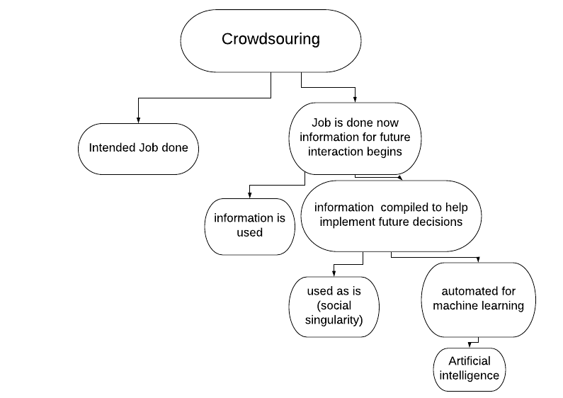
Fig 1 Crowdsouring

A clear way is to change focus to what can be learnt from how the job has been done. Therefore, if valued information could be gained from individuals doing the task, then the more individuals doing a task the more valued information is gained. From the above diagram (fig One) it can be seen that information taken from crowdsourcing can be compiled and used to make decisions for the future. One of the ways in which the information could be used is to automate processes as shown in (fig One). These automated processes could end up as artificial intelligence [41].

Brief History of Video Editing
Video editing begins with what is referred to as the post-production process. Video editing comes from the craft of film editing [42]. Film editing happens by cutting physical tapes together to create a film reel which would be copied to produce a film. [42].
Video editing can be done in two ways; nonlinear video editing and linear video editing. Linear video editing can be defined as the part of the post-production process concerned with arranging and selecting appropriate shots together. In the process of video editing, it is possible to modify images and sound alike [43]. The key to linear video editing is that it is done in a pre-determined order [43]. An important thing to note is regardless of how the footage was captured whether it be tapeless camcorder, video camera, or even if it was recorded in a television studio, the footage must be accessed linearly or in a sequential manner [44].
One of the many problems in the process of linear video editing is that the source footage is destroyed after the process of editing and if there was a re-edit required, the footage would be unavailable. To avert this, non-destructive editing processes were introduced [43]. Non-destructive video editing is a process in which video, audio, and images or animated images are edited together, and the original content is not changed or modified [43]. This is done by using specialised software which processes the content without changing the original. The software is referred to as a non-linear editing system (NLE) [44]. The process of editing can be divided into the video (NLVE) or audio editing (NLAE) [44]. In more advanced productions, audio is edited using a digital audio workstation (DAW) [43]. Nonlinear video differs from the 20th-century methods of linear video editing and film editing by being a process which is more computationally intensive and even though the source footage is not directly modified, the edits are being done almost instantly [43].

Collaboration and Co-creation in the Video Editing process
In today's world of non-linear editing, editing can be done by one person or by a team of people. In fact, in today's film industry multiple companies collaborate to produce a single movie or television programme [45]. Non-linear editors like avid video composer [46] or adobe creative cloud [45] have created platforms where collaboration takes place even across countries. Therefore, one can say collective intelligence in large-scale productions is taking place. The post-production process from assembling the different video components, adding advanced video effects, having audio production teams working on the sound, animators adding the animations all up to the titling, is continuously happening on a single film [47]. This could mean that these productions run into thousands of individuals contributing together. The question one may ask is even though collaboration is taking place on mass, are the decisions which go into the edit truly democratised. The reader should consider that, Collective Intelligence needs to be non-hierarchical [12]. In any form of mass collaboration or collective intelligence, it is important to have some form of moderation, we have seen this when we looked at Wikipedia and Linux [12]. However, the moderators at Wikipedia [12] or Linux do not initiate what needs to be done. This is not the case in film editing; the director is still the person overall in charge of the whole process [12]. Therefore, the film editing process even though mass collaboration is occurring is still a top-down approach to collective intelligence. This gives the people who are creating the product very little room to express their full creativity or give their opinions [12].

Film pre-release process "Test Screening"
One of the things this dissertation is concerned with is how to infuse user input into a video edit. A good question which needs to be answered is: currently what the approved method of user testing is done in video production?
Feedback in video production, in most cases, happens after the video editing process is done [22]. Therefore, it becomes a problem because feedback is collected after the video has been finished [22]. This, therefore, means it could be hard to re-arrange a re-edit because of the cost involved [22]. Therefore, the most likely scenario is that the cumulated feedback is pushed into the next video produced and not necessarily the video at hand. This creates another problem which is that it is hard to adequately input changes into the next video as the premise for the new film will most likely be different [22].
Current practice is that before a film is released most films have a pre-release version shown to selected members of the public. This is called screen testing. Harold Lloyd [42] was the first to undertake the screen-testing process, having used it as early as 1928. The audience is shown an early version of the film and are asked to give feedback on it. This test is good for getting the overall view of the film [42], however, it does not help the film editor or director know what the audiences’ thoughts on specific sections of the film are [42]. The process also lacks any method of the audience interacting with direct views of the film. Screen tests behave in the same way as functional or black-box [48] testing in software engineering and are unlike unit tests. Therefore, creating a method where tests could be done on smaller parts of the edit, by leveraging the power of collective intelligence could be advantageous [42].

Could Collective Intelligence be the next evolution in non-linear Editing?
Before we could consider this point, it is important to consider the questions raised while discussing the User Farm crowdsourcing platform. Below is what needs to be considered:

Does collective intelligence work well in a creative space?
Video editing is a creative process and crowdsourcing demonstrates that creative ideas are individualistic. Therefore, a unique way of aggregating creative choices needs to be established if collective intelligence is to be applied [49]. A simple way of doing this is to take away the ability to initiate the design process. That means in the process of co-creation, stylistic choices must be given to the video editor and only high-level design choices are given to the crowd. For example, if the editor would like to know what colour something should be [50], they do not leave this decision open but, they give the crowd some choice to make [50]. Then the crowd decides on the choice within a limited range. Another way of doing this is to break down the decision process into steps. For example, if from the above scenario the crowd chooses blue then in the next stage different shades of blue are presented to the crowd for selection [50].
However, can the process of collective intelligence remove creativity? Lixiu Yu, Jeffrey V. Nickerson Stevens and Yasuaki Sakamoto [50] researched this very question in an article they called Collective Creativity [50]. In their research it was discovered that collective intelligence could be used in the creative process and in fact they suggest frameworks which could be used to improve collective creativity. The research further states that collective creativity is largely unexplored and that by combining features of different systems, they have discovered new systems from it [50]. An example, they give is in interactive feedback of gaming. Where they stated that due to the collaboration with network organisations they conceptualised the Evolutionary Collective Design System, which produced large ad-hoc organisations working to produce new and useful products. [50].
One thing to note is that not a lot of research has been done in this area. This research shows that the creative process could be ascertained from the crowd [50]. Therefore, this research shows that collective intelligence aggregates creativity. It would be interesting to investigate in future studies the different results you get from individuals’ creativity and collective creativity.

Does collective intelligence work with an infinite number of contributors?
The more participants take part in collective intelligence, the better the results of it. However, it is important to note that setting up a system which can adequately deal with large data sets is important. Alag Satnam [51] states that even though there is great wisdom in the crowd it is important to understand a way of dealing with a thousand voices talking at once? Therefore, there should be a method of identifying the wants, needs, and knowledge gaps of end users otherwise it could end up like “listening to a mob." [51].
Based on the above observation, it is clear that Collective intelligence can be used to aid decisions when doing a non-linear edit, however, the process could be a costly exercise. Nevertheless, if the decisions of the crowd are fed into a machine learning algorithm, the cost could significantly be reduced.

Collective Intelligence in Video Editing
The fundamental question which needs to be answered is can all of the processes discussed above (Collective Intelligence crowdsourcing and co-creation) be used to help video editors improve their process? Adobe editing workflows [47] identifies the following parts to the editing process:
- Capture and import video and audio
- Assemble and refine a sequence
- Cutting
- Add transitions and titles
- Colour correction effects
From the above, it is clear that the main process of video editing is cutting. Cutting determines what vantage view the audience will watch depending on the timestamp of the project. Cutting determines what the audience will experience at the final render of the video. It also determines which shot size will be used and at what time code it will be used. Ken Dancyger [44] identifies four areas in which an editor must consider when he is cutting:
- Editing for Narrative Clarity
- Editing for Dramatic Emphasis
- Editing for Subtext
- Editing for Aesthetics
Looking at the four areas, which Dancyger [44] identifies above, one can ask the question, is it possible to deduce or evidence the four areas using collective intelligence to determine in part the best outcome? To answer the above question collective intelligence needs to be put to the test to see if it could be used to predict in part by questioning the following.
- By asking how long a shot should remain on the screen, Narrative Clarity and Subtexts could be inferred.
- By asking what the preferred colour grade is, it may be possible to determine the best grade without the use of complex colour science techniques. Therefore, could Aesthetics be determined by collective intelligence.
- By asking what preferred shot size will easily determine the dramatic emphasis of the piece.

Editing for Aesthetics
The colour palette is one of the most thought about aspects of a film. In the TV and film industry, a crew of skilled colourists undertake a process which is known as colour grading to achieve a visual look which they prefer [44]. This process takes time and means that amateur film makers cannot achieve the same level for their own grades. However, there are a lot of different automated features found in modern non-linear editing suites which are on offer. One fundamental question which this dissertation raises is could collective intelligence be used to help improve this process [44].

For automation to occur three things need to be undertaken;
- Firstly, a way to measure colour of the video
- Secondly, a way to collect the data from the crowd about the colour choices
- Thirdly, a way of comparing data in step one with data in step two

According to television writer director and editor Lewis Bond [54] [55] colour in film has three main parts. Hue – what the colour is, Saturation how vibrant that colour is, and the value of the darkness or the lightness. Further, he states that colour can have an emotional impact on views which can be a psychological and to some extent a physical one. All this happens without the viewer even being aware, except on a subdue cognitive level [55]. In film the director and the editor use both balance and discordance to create harmony or disharmony.
Examples of where harmony works are as follows [55]

- Monochromatic the use of a single main colour
- Analogous colours which sit next to each other in the colour wheel see fig below
- Complementary these are colours which may seem at different ends of the colour spectrum but complement each other
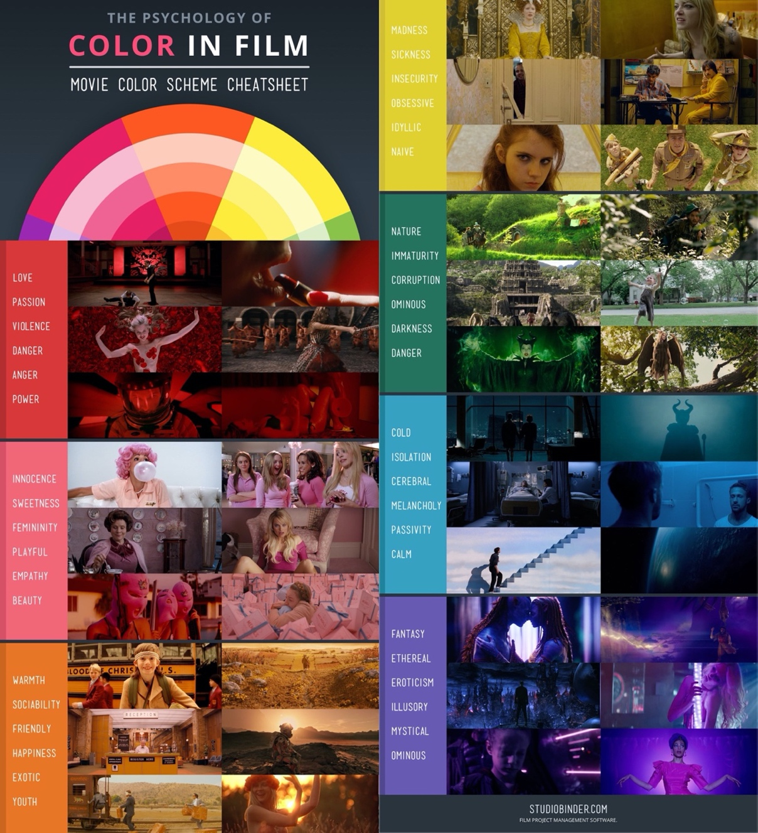
- Triadic are colour schemes which are comprised of just three colours and the key to them working is that they are evenly spaced on a colour wheel [55]

Fig 2 Understand Colour [55]

What areas could Collective Intelligence help editors
So far, this dissertation has identified the following areas which could benefit from collective intelligence testing, narrative clarity, dramatic emphasis, subtext and aesthetics. However, one fundamental question which needs to be asked is, what are the practical test matrix which could be used to determine these. Another key question is, for collective intelligence to work, how much assistance is needed from the expert for the test to;
- Firstly, quickly collect results
- Secondly, have a process which is easy to change the pace of data gathering
- Thirdly, could be conducted remotely
- Lastly, need as few instructions as possible
The success of crowdsourcing is due to the fact that it is done over digital formats and remotely [52]. Therefore, if this research is to achieve the same level of success as crowdsourcing it is important for every part to be digitalised [52]. Therefore, this dissertation found four areas which could be included in the tests and could be digitised and done remotely. The four tests will be discussed in detail in the following sections.

On Change
Multi camera (multi-cam) [53].editing has moved from linear editing domain to the nonlinear editing style. In a nonlinear system, monitors display one or more timelines and in each timeline the tracks are separated into different displays. All three of the main nonlinear systems (Adobe Premiere Pro, Final Cut and Avid Media Composer) have multi-cam views or modes with the ability to align the video by audio [53]. In Adobe Premiere Pro you have the ability to link the video with similar audio and then just by clicking one of the videos while all videos are in view creates the edit [45]. The picture below is a screen shot taken from Adobe Premiere Pro CC 2019. In the monitor window you see that you have one large video to the right and three small videos to the left. The editor just picks one of the small videos as the video progresses and that becomes the main video. This simulates the video in a live event.

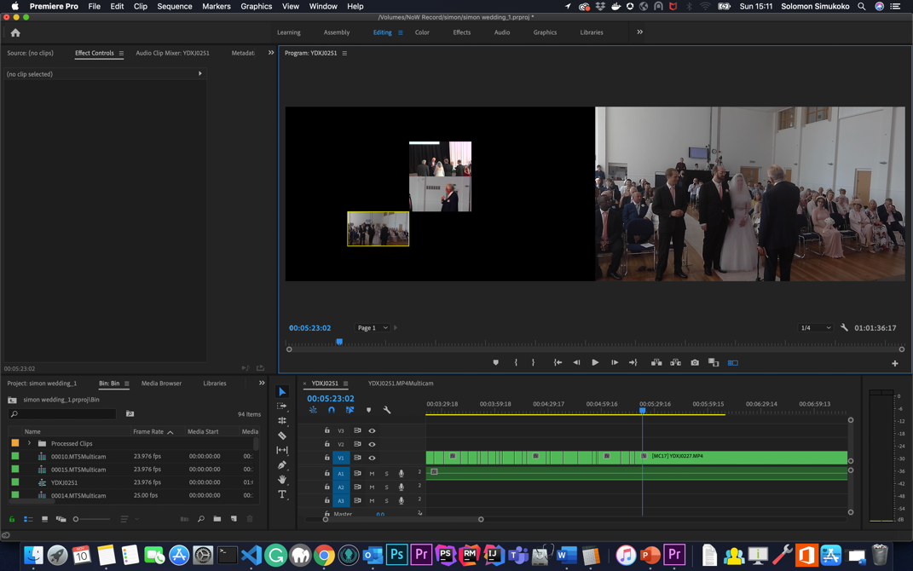
Fig 3 Adobe Multi-cam

In the timeline views both audio and videos are included. Other assets including graphics and digital video effects sources are not included but could easily be added at a later time in the process [53].
The simplest test which could be created off this concept is an on-change test. The on-change test could simply be giving the same functionality to the crowd as a test to see how long they spend on a video and what video they keep coming back to [53].

Colour Science
To measure the effect of colour in a film there are different JavaScript libraries which could be introduced in the app. The following were some which were considered for use.

imgcolr
imgcolr uses jQuery to get the most dominant colour of a given image. It is important to note that imgcolr struggles to handle images with colourful borders properly. Therefore, is should only be used within very simple user cases. Another key think to consider is the lack of popularity of jQuery as a JavaScript library which would mean that if used the project would not be adequately future proofed.
Vibrant.js
One of the most popular colour extraction JavaScript libraries is Vibrant.js. However, the writer of this dissertation found that getting Vibrant.js to initialise required significant time and effort.
ColorThief.js
One of the easiest to use scripts for grabbing colour palettes is a JavaScript library called Colour Thief. It uses a reference to the canvas object [56]. Therefore, if the images are already loaded in the DOM, it is possible to retrieve synchronously all the palette of colours. It displays the main colour and then breaks down the palette into nine different variations. It also has easy to use examples ready out the box [56].
This was the selected method to be used to pick out the colours in a video. However, it is important to have the crowd set the hue, saturation and other such values and to see if this data could be used to determine the colour correction of a given video and compare choices with the colours obtained by the colourThief.js [56].

Eye-tracking
In the past eye-tracking needed specialist equipment and software [57] [58]. This remained true until researchers at Brown University developed a JavaScript library which uses normal webcams from devices like computers, laptops and mobile devices to conduct Eye-tracking with JavaScript. The JavaScript library they developed was called WebGazer JS [57] [58]. WebGazer [58] self-calibrates by tracking where and how the eye interacts with the screen, thereafter, mapping between features of the eye and positions on the screen. WebGazer [58] approach was to provide a natural experience therefore not restricted Eye-tracking found in high end laboratories and highly controlled Eye-tracking studios. WebGazer [57] uses the following key components: a pupil detector this is used in combination with most common eye detection libraries and the gaze estimator which uses regression analysis to inform its user interactions.
Ole Baunbæk Jensen [59] a product director at iMotions summarises the problem of using webcams for Eye-tracking as follows;
- Infrared eye trackers are more accurate and precise as compared to the webcam [59]
- Respondents need to maintain steady posture throughout the whole process because of how sensitive the system needs to be to lock onto the eyes an even the pupil. [59]
- Webcam eye trackers have difficulties in low-light situations and because most of these cameras have autoexposure the camera exposes to what the manufacture sets. This limits what the app could do to compensate. [59]
- Eye-tracking also needs a high frame rate to ensure accuracy. This is lacking in webcams
- The low resolution of most webcams means that there is limited facial points to work with.
- The Calibration process of Eye-tracking has to take account of different brands of webcams. [59]
Nevertheless, the ubiquity and cheapness of the webcam still makes it a good alternative. Secondly, the testing could be done remotely with limited equipment. [59]

Emotion Tracking
Measuring emotion from a webcam by scanning faces is now ubiquitously available. In fact, there are many JavaScript libraries available to measure the basic emotions which are Happiness, Sadness, Anger, Fear, Disgust, Surprise as well as a Neutral state [60].
One of the key points to consider when tracking emotions is modelling human states. Individuals do have different appearance depending on age, gender, and ethnicity [61]. Also, another key consideration are the cultural influences or the cultural norms which an individual subscribes to, which would mean that different behaviour and reaction to emotions like grief or happiness may be mutedly displayed [61].
JavaScript emotional monitoring like JavaScript Eye-tracking has many limitations;
- Limitation for Deep learning
- Resolution and low light - because the tests could be conducted anywhere there is need to consider the room lighting noise and other destruction
- The precision of the webcam
- Frame rate

Affectiva Tracking Emotions for Advertisements
One of the very first studies which tested emotion while test subjects watched video occurred at the MIT Media Lab [62]. The studies were so successful that MIT Media Lab span out the research and created a company called Affectiva, which produced a product called Affdex [62]. Affectiva finds research individuals to watch set advertisements. This is done in a regular location and not in lab situations and they use normal everyday computing equipment like webcams on laptops, tablets, and smartphones to collect data [62]. The data collected is passed through machine learning algorithms which track facial cues by focusing prominently on different parts of the face mainly the eyes, eyebrows, and mouth [63].
Affdex the software would then infer this data to determine emotional cues. Emotions like anger, disgust enjoyment, surprise, or even confusion are used to determine whether the test participant “likes” or “dislikes” an advertisement [58].
Affectiva conducted a study of about 1,500 participants from different parts of the United States and Europe [64]. The research had their participants view about 200 Advertisements and tracked their emotions with Affdex and tied this data to the sales volumes of the different products in the advertisements [58]. Surprisingly the tests where the advertisements were received positively could accurately predict the sales volume. Therefore, there is scope to use emotional detectors to determine which edit works best for a video editor.

What are the choices of JavaScript Libraries available for Web based Emotion Trackers
Affectiva does have an API which third parties could use however; they do not allow their JavaScript library to be hosted remotely. Therefore, this causes the following objections;
- What are the GDPR implications of collecting data from a third-party application
- Would changes to their API affect the result sets which have been collected
- What are the unseen costs of using these API as they are a commercial entity

The JavaScript ecosystem for machine learning is not as mature as Python. Regardless of these disadvantages, there are a few good emotion detecting libraries which use JavaScript. The following are a few examples of this;

Tracking.js
The library uses a modern approach which brings different algorithms and techniques which have been mainly found in desktop application to the browser environment [56]. It does this by utilising the HTML5 specifications which then enables the user to do colour tracking, face detection and other forms of tracking. It is a light but effective solution and only about 7kb in size [56].

Clmtrackr
Clmtrackr is a JavaScript library and is the most preferred library by the author at the time of writing this dissertation [65]. This was because the Clmtrackr’s core function was facial tracking and had facial emotion tracking ready. The regression model which Clmtrackr uses is good for fitting facial models to both videos and images. It uses implementation of “constrained local models fitted by regularised landmark mean-shift” [66]. This was postulated by Jason M. Saragih's [66]. Another key advantage of Clmtrackr is it tracks a face and then outputs the coordinates of its position in an array. The example Below shows how Clmtrackr tracks points on the face. Most importantly if you look at the figure below you can see points 27 and 32 which tracks the position of the pupil which is important if you need to track the eye [65].
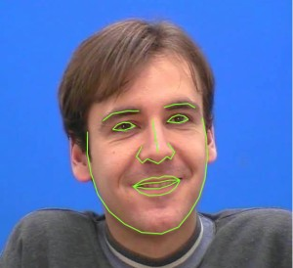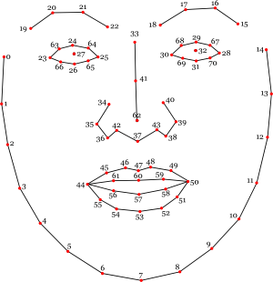

Fig 4 CMLtrackr [65].

Examples of Collective Intelligence in Video Production
Collective Intelligence has in the past been used with video. Below are two examples of where collective intelligence techniques work.

Click2SMRY framework
Click2SMRY framework [43] is a video summary framework which leverages collective intelligence or crowdsourcing to produce a video summary. This happens by having the crowd mark points on a video and averaging the points. The points with the most marks, on the video, will be used in a highlights video. If for example, you have a golf game, you have a group of people watch the whole game and mark important parts of the game. A video is created as a result of these marks [67].
The major criticism of Click2SMRY framework is that the video is the final resource [67]. Therefore, the biggest problem is that the data collected is not analysed for patterns of choices and because of that, automation of the process is not possible. The goal of using collective intelligence is to have machine learning automate collective intelligence.

Caption for Speech Recognition
One example which uses Collective Intelligence or Crowdsourcing is the correction of speech recognition software which is used for correcting caption errors [68]. Today, speech recognition software is ubiquitous. Most notable in its use is YouTube [69]. Because, captions are corrected in this way, crowdsourcing in the correction of captions is fed back into the systems; machine learning could be utilised so that the system gets better at giving out captions.

Limitations, problems and considerations in the use of Collective Intelligence
From the discussion above one can be convinced to think that collective intelligence can fix a lot of modern-day problems. However, there is a problem which collective intelligence poses. Martin Luther King said that "we have guided missile and misguided man" [74]. To truly understand this problem all that needs to be done is to examine the internet, which can be argued to be the largest sort of collective intelligence. Annie Proulx’s [75] reference to it as the "tsunami of garbage" [75] which everyone contributes to. How do you then overcome the challenges of disinformation, trolling and deliberate attempts to undermine the collective intelligence of others?
Andrew Keen [17] in his book asks a fundamental question where this leaves expertise? Keen further states that ‘amateur monkeys’ use interactive devices to post review, publish or comment to create uninformed political commentary creating amateurish music, poems or novels [17].
Lanier [18] further postulates that collective intelligence does not produce expertise. It produces masses of information which makes it difficult to go through to find the information required. However, it is important to note that aggregating the information and making sure that the information is put into correct categories mitigates this. Also, most importantly what this research is looking for is not for the removal of experts but for the expert to produce the video by leveraging the power of collective decisions to help them make a more educated choice.
Geoff Mulgan further points out that intelligence has come from the following elements [76]
- Observation and data
- Live model of the world
- Analysis of prediction
- Memory
- Motor coordination
- Empathy
- Creativity
- Judgement
- And Wisdom
Mulgan [76] questions whether collective intelligence has all of these attributes. Mulgan argues that collective intelligence does not have judgement and seldom has wisdom. Mulgan further references what he calls "collective stupidity” [76] the imbalance of the elements of intelligence if you are too obsessed with the observation, you make stupid mistakes. Mulgan gives a few examples of collective intelligence’s failures of which Stalinism is one. Another example he gives is the 2008 financial crash, where the data-driven financial organisations focused more on input and less on judgment thereafter leading the world financial crash [76].
One important question then is would this problem be evident if collective intelligence is used in video editing? The answer to this is moderation. It is important for the expert to drive the process and to moderate the whole process. Another consideration Mulgan [76] talks about is that the key to having collective intelligence which works is to look at "macro treads" and to look at collective intelligence assemblies of which, he states Google maps as a good example. People contribute to google maps without ill intentions and Google has some sort of moderation in the process. Google has done this with the mind to expand on co-creation, firstly using developers to develop the software then using the crowd to collect real-time information. Mulgan [76] refers to this as the type of co-creation as intelligence assemblies. Mulgan further states that another example of this is how many scholars contributed to and came up with the Oxford dictionary where individuals contributed, and a moderator puts this information together [76].

Social Singularity vs Artificial Intelligence
So far, this dissertation has taken the position that collective intelligence leads to artificial intelligence. However, there are two problems which need to be considered if automation of creativity is to be achieved. Firstly, artificial intelligence has not reached a point of learning from all data sources. Computers process data well if the data is well structured, unambiguous, clean, explicit, and digital. However, if the data is analogue, noisy, implicit, ambiguous or unstructured it makes it difficult for the computer to do. Therefore, human brains are far superior for gleaning information from such unstructured data [51].
The information has to be well-formatted to get better results however, the human brain can get information from unprocessed data. The human brain can make judgements which artificial intelligence cannot at this moment in time. Therefore, creativity cannot be easily automated. The second consideration is Max Borders [77] social singularity. Borders assessment is that collective intelligence does not lead to artificial intelligence. He believes that collective intelligence leads to social singularity. Social Singularity makes a key distinction between artificial intelligence and collective intelligence. Social singularity is about how decisions are made by the collective where artificial intelligence is about using machine learning to automate decisions [78].
Social singularity can simply be defined as how society is getting decentralised by a decision which is being made by collective intelligence [77]. In the context of video editing, giving more choices to the general public means that the directorship of the group moves from the one to the crowd, hence creating a social singularity. An important question which needs to be answered is does that mean collective intelligence has democratised the creative process? The second question: is the creativity of the individual lost in the process? Lastly, if the individuals creativity is lost are the videos which will be created now the only safe videos, as that is the only type of video which people are comfortable with?
One possible answer to these questions is for the director or video editor to use the insight gained to answer the exact opposite of the achieved results. For example, use the crowd to decide what makes them feel uncomfortable, like something which scares them. Another important way of answering these questions is to keep the expert in situ, that is the director and the editor. Therefore, the expert is the driver of the process and only uses the process to get the information he is not sure of.

Methodology

Introduction
In this section of the dissertation, the methodology will be discussed in detail. From the beginning, it was decided that the development and the design process should be separated. Kanban was the agile methodology used for development, with Google design sprint to be used for system design. The Google design sprint has one thing in common with the agile development sprints, that is they both have the iterative and incremental approach at the centre [79]. Another key approach which was cardinal to the design process was to have User-centred design. This meant the design and development methods had both users and iteration as the key to unlock the sustainable implementation of the system [80]. Users were considered from the beginning with both semi-structured interviews and usability studies used to collect requirements. Data collected was used to start paper prototyping, this ultimately leading to beta testing with users actively contributing to the development [80].

Design Sprint
The model which the design sprint followed was the Google design sprint [81]. The design sprint has five stages [81];
- understanding,
- diverge/ sketch
- design
- decide
- and lastly prototyping.
Please note that this dissertation did not adhere to the five stages of the design sprint in five days as is the ethos of the design sprint but used it as a framework to achieve the design. One of the key modifications to the sprint was to introduce UML and database design to the diverge and sketch. The purpose of the google design sprint is to mainly focus on UI design. However, this dissertation ensured that not only where the UI screen designs considered but other parts of the system like the database design or the architectural pattern.
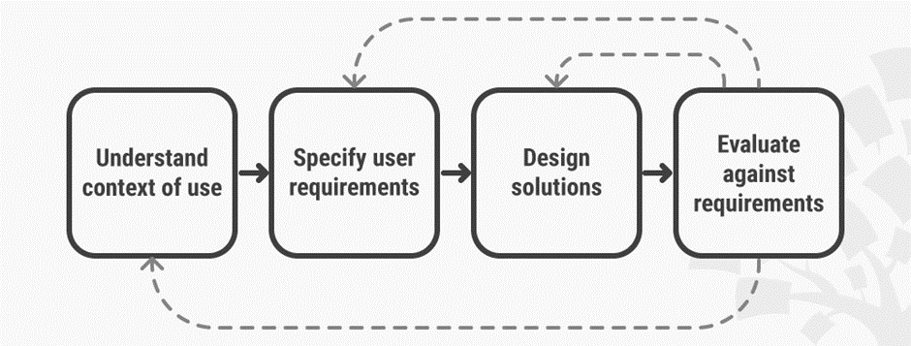
Fig 5 Design Sprint logic [81]
The following are the design sprint stages and modifications used;
- Understanding user needs. This was done by conducting semi-structured interviews with members of the video editing community [81].
- Diverge or sketch process developed both the User Interface (UI) screens and Unified Modelling Language (UML) and the database Entity-relationship (ER) diagram. UML diagrams [81].
- Decide stage will be to select the most preferred design pattern and approach. [81].
- Prototyped. The mock-up design will be firstly a paper prototype then it will be transformed into a html5 template [81].
- Usability tests were then be performed on all aspects of development [81]
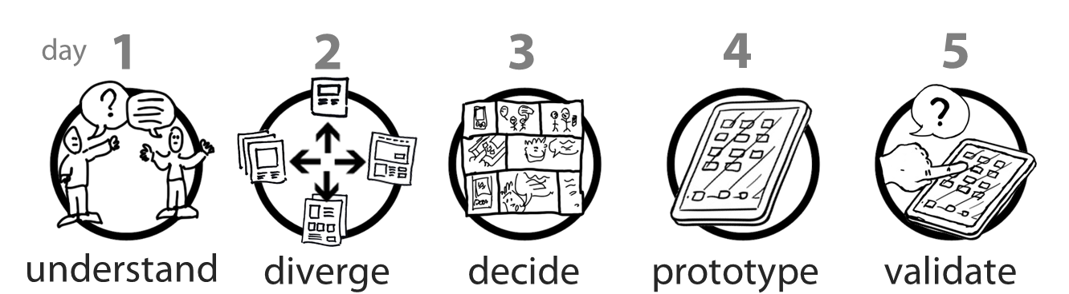
Fig 6 Design Sprint Steps [81]

Understand (Semi-Structured interview)
In this stage of the design sprint the dissertation sets out to understand the end user of this system. Three main questions were asked to find out how editors obtain input to the process and how much input they require. The following are the questions asked and a synthesis of the response obtained.

How do you handle parts of the edit you are not sure of?
Most editors mentioned research would be conducted if there is an area, they were unsure about. One mentioned they would look at YouTube to see how others dealt with similar bottle necks. Others said they would consult the client or director to see if they could gather additional requirements to help with the impasse. At no stage was user input a consideration for any of the editors or was there even a question of how they possibly could include end user input. The video editors seemed to be concerned about what their client or director thought.

If you need feedback on a part of the edit, how long should it take?
All the editors asked were open to feedback but expressed that it should happen very quickly. One pointed out that feedback should not take 24 hours to obtain.

How keen would you be to allow collective creativity to have an input in your edit?
When the word creativity was mentioned instead of intelligence some of the video editors became protective. One example of this was this comment which was received;
“I am not very keen to allow collective creativity to have input in my edit for the simple reason that everyone has his own style, and the editing should reflect the work of a particular editor, meaning his style must be stamped on”
While others had the exact opposite view and said that there was nothing wrong with more creativity and some were on the fence about it.

Take Back
From the semi-structured interview, the following considerations should be made
- Feedback from client should be made accessible
- Feedback should be timeboxed
- Creativity should only be done for the parts where the experts are questioning, however it should be introduced as help rather than usurping the creative process.

Diverge/Sketch and Decide

Database Design
During this section it was decided that the first thing to do is decide what information would be collected for analysis. Thereafter, the first diverge/sketch process was to design a database.

Below is the Entity-relationship (ER) diagram of the database.

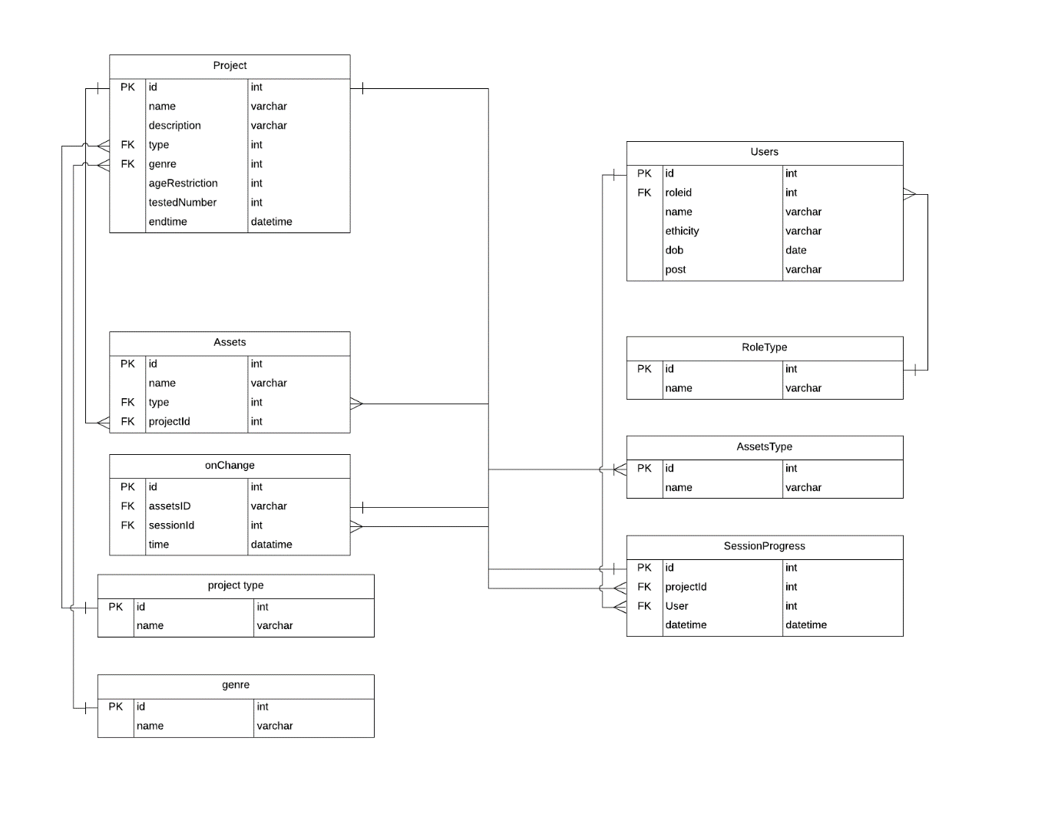
Fig 7 Database Diagram

UML
Unified Modelling language (UML) was then used to help design the logical components of the program and map out the user journey.

Flow Chart
The first step to create the UML diagrams for the project was in the form of a flowchart. One key question which needed answering was what the user journey of the system is. They are two unique users of the system. The expert user who sets up the test and the end user who is the ultimate consumer of the project.
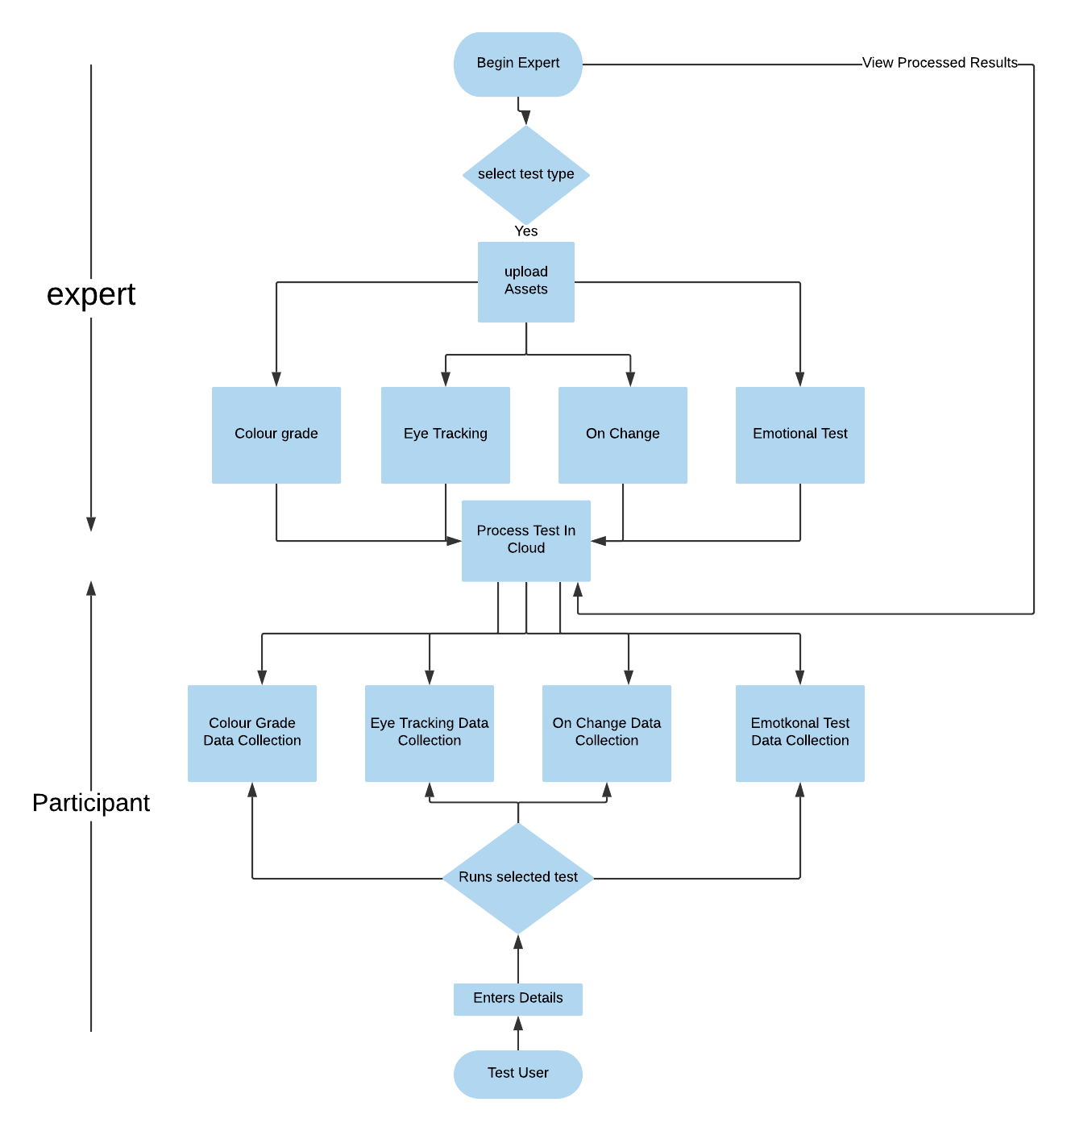
Chart Fig 8 System Flow

The expert
From the above diagram the expert has the responsibility of setting up the project. They have to select what they would like to test from the following; colour grade, angle selection, shot size and emotional test. Then they will upload assets into the project. This will than send an API POST to the server-side logic which will ultimately be deployed in the cloud.

The Test user
The participant begins his journey on the opposite direction by entering his details and runs the test they were selected for. The participant results are then aggregated to form test results.

Package Diagram
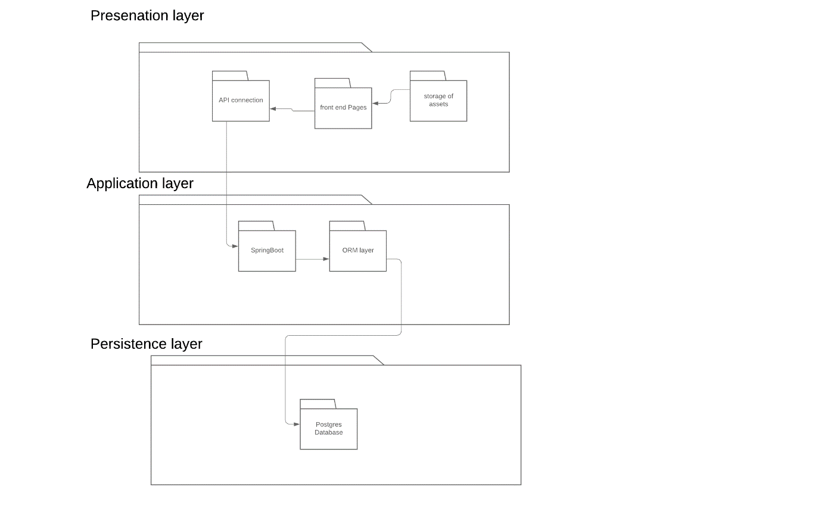
Fig 9 System Package Diagram
A key point is that software development of this nature should never be done without a formal architecture in place, because as the system adds more project types it needs to be easily scaled. The Software Architectural Design model which this system will comply to is the Layered / N -Tier Architectural pattern [84]. Therefore, the artefact was split into three independently isolated partitions of the system. The diagram above represents the three set packages for the project. Each layer must expose its functionality through an abstract API [84]. The first package is the presentation layer where all the UI components are to be situated. The second package is the application layer where the domain and other layers sit. Last will be the persistence layer where the database is situated. See package diagram above.

Prototype and the Validate Usability Analysis
To ensure that the design is focused on a user- centric approach it was decided that usability testing be done at every part of development [85]. The usability analysis took place in four phases;
- the first phase took place during the design sprint this is on paper prototypes
- the second phase also would take place during the design sprint this is after a mockup of the layout has been done
- the third phase will come when the prototype will reach the Minimum Viable Product (MVP).
- the final phase involves beta testing when the system development is nearing completion this usability test will mainly focus on how the completed modules interact and the latency of video playback in the system.
Due to the nature of this project, the usability analysis will be a combination of both remote testing, a format developed by Nate Bolt [24], and Steve Krug [85] of usability testing.

Development Plan working in Agile Kanban
The agile sprint Kanban was used as the chief methodology [86]. Kanban helped because it allowed continuous flow of delivery and meant changes could happen at any time. Kanban was chosen over other agile methodologies like scrum because;
- Only one person was involved in all positions, therefore, all the job roles were done by a single person [86].
- The sprint was not time-boxed even though a Gantt Chart was created to govern the progression of the sprint [87].
Before development could begin it was important to define “The definition of ready” and “The definition of done”. This was important because it helped define the criteria to use to move user stories across the Kanban board.

Behaviour Driven Development
Behaviour Driven Development (BDD) was the technique employed on this dissertation where the acceptance criteria were defined in each user story/epic before the implementation actually began [89]. These acceptance criteria with the necessary information were written in a format which could be easily be converted into Gherkin syntax [90].

Environments
The program to be developed will be divided into different parts, therefore, requires different environments. The following are the main environment which were used.
AWS Elastic Beanstalk and AWS RDS
Amazon Relational Database Service (Amazon RDS)
The Postgres database used was hosted in Amazon Relational Database Service (Amazon RDS). Accessing the Amazon RDS endpoint, was done using Pg Admin 4. The database was available using the following URL:
spring.datasource.url=jdbc:postgresql://database.cmp8xyd7y0wj.us-east-2.rds.amazonaws.com:5432/production

Elastic Beanstalk
Elastic Beanstalk is an Amazon Web Service AWS which can be used to deploy and manage applications. Elastic Beanstalk hosts web applications using AWS Cloud. This is done without the need to manage major infrastructure. Elastic Beanstalk was selected because it helped reduce management time or the service without restricting control of what could be achieved. A Spring Boot API service was uploaded to Elastic Beanstalk. It automatically handles all the necessary load balancing, scaling, and application health monitoring. The API end point which were created by the spring boot service was then visible at the following URL http://civideo-env.pjcyhcpfk2.us-east-2.elasticbeanstalk.com/

Development Methodology

Preliminary
The following section describes how the application was initially built and how projects are set up.

Setup
The application was build using Layered Architectural pattern. The different environments discussed in the environments section where used to host different layers. The reason for using different layers was as follows;
- The use of Layered Architecture meant the application concerns were separated in the design.
- The Layers of isolation means that the application could be easily tested [84].
- Development also meant that changes to one layer had a limited effect on the other layers as long as the rest end points where kept the same [84].
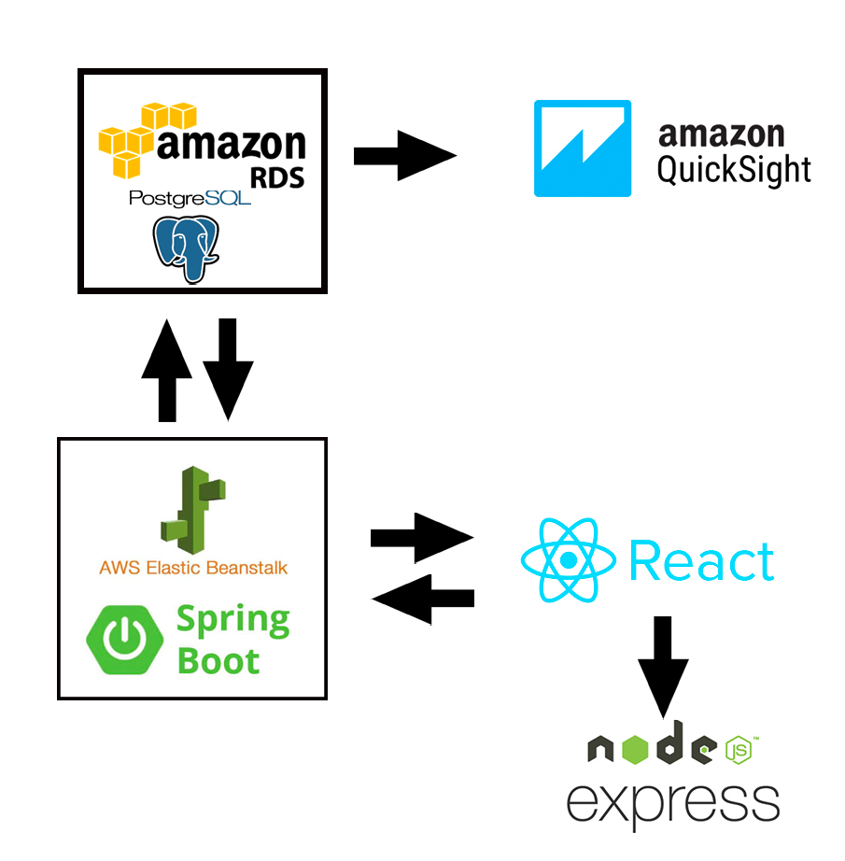
Fig 10 Development Parts and Environments
Presentation Layer
The presentation layer was built using mostly react.js. React.js was selected because at the time it was the most popular JavaScript framework and its main purpose is for building interfaces. The application developed was a single-page app which was initiated using Create react method as prescribed by the react git repository. The prerequisite is to install node.js this was done by first installing Node Package Manager (NPM). NPM is the default package manager for JavaScript and is used for the runtime environment for Node.js. The main CSS style used was Bootstrap. Any of the uploads for assets whether video, audio or photos used Node Express.js.
Application and Persistence Layers
The application layer was developed in spring Boot and was set up as described in the environment section. The application layers display rest end points which the presentation layer performs Create Read Update Delete CRUD operations on.
To connect to the presentation layer a Cross-origin Resource Sharing (CORS) filter was added.
public class CorsFilter implements Filter {
public void doFilter(ServletRequest req, ServletResponse res, FilterChain chain) throws IOException, ServletException {
HttpServletResponse response = (HttpServletResponse) res;
response.setHeader("Access-Control-Allow-Origin", "*");
response.setHeader("Access-Control-Allow-Methods", "POST, PUT, GET, OPTIONS, DELETE");
response.setHeader("Access-Control-Max-Age", "3600");
response.setHeader("Access-Control-Allow-Headers", "Content-Type, Authorization, Content-Length, X-Requested-With");
chain.doFilter(req, res);
}
}
Fig 11 CorsFilter
In the application layer there is an integration of Hibernate, Java Persistence API (JPA) and Java Data Objects (JDO). Object-relational mapping (ORM) was used to convert data between incompatible POJO in the entity package of the system by mapping entities to the tables in the relational database [77]. Therefore, a virtual database in memory where CRUD could be conducted in memory help the application reach persistence [77]. 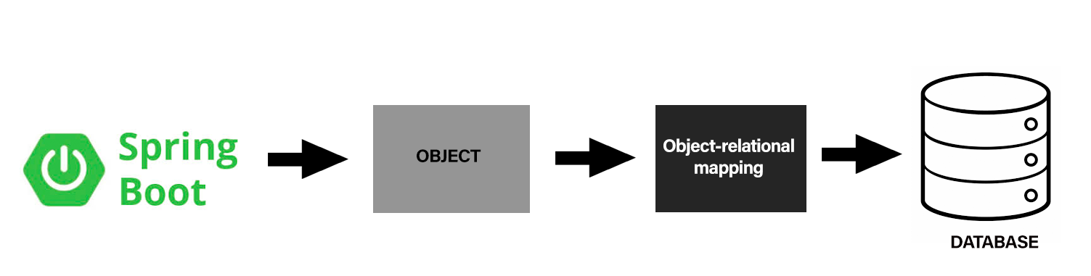
Fig 12 ORM
In the application properties the connection to the persistence layer is set below is an example of how this was done.

spring.datasource.driver-class-name=org.postgresql.Driver
spring.datasource.url=jdbc:postgresql://database.cmp8xyd7y0wj.us-east-2.rds.amazonaws.com:5432/production
spring.datasource.username=postgres
spring.datasource.password=postgres
spring.jpa.database-platform=postgres
Fig 13 Database Connection
In AWS Elastic BeanStalk the default port which needed to be set was 5000.
For ids to be exposed a repository configuration class was added
@Configuration
public class RepositoryConfig extends RepositoryRestConfigurerAdapter {
@Override
public void configureRepositoryRestConfiguration(RepositoryRestConfiguration config) {
config.exposeIdsFor (project.class);
config.exposeIdsFor (assets.class);

Fig 14 expose ID

Create Project
Setup Project
The prerequisite actions need to occur in the same manner all the time. These are firstly all assets are prepared. The assets should comprise of three videos and three screen shots of the same videos. The video should have the same audio on every track and should be of equal length. The idea is having the assets come straight from the editor’s timeline.
The form captures the generic information like the project name and description with other information which could be used to group later different projects by attributes like the age restriction, end date, number to be tested and the genre.
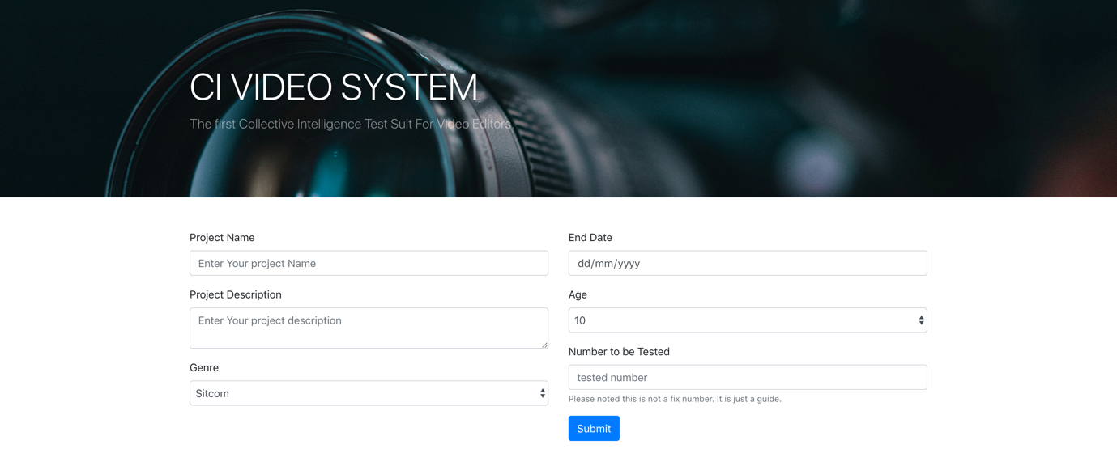
Fig 15 Create Project
After the project has been created a project id is passed as a query parameter to the video upload page. The three video assets are uploaded. Uploading happens using Node Express JS. The videos are posted to the express end point which is located at port 8000.
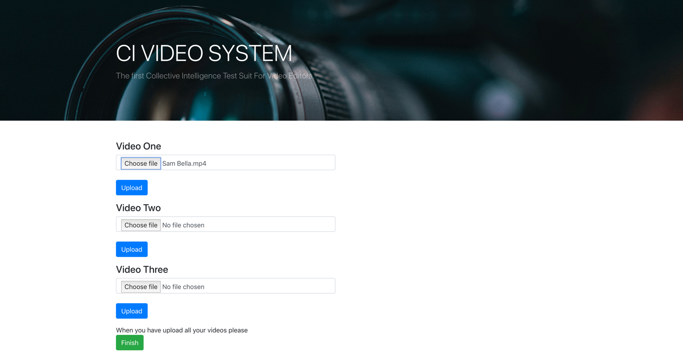
Fig 16 Upload Video
The express js would then upload the assets file to the upload folder in the public folder. Because Express js uses port 8000 which is different from port used by the presentation layer, which uses port 3000, Cross-Origin Resource Sharing (CORS) has to be considered. In the code below you can see how this was addressed.
const cors = require('cors');
app.use(cors());

res.json({file: `public/upload/${req.body.filename}.mp4`});

app.listen(8000, () => {
console.log('8000');
});

Fig 17 Express JS
Thereafter, the three images are uploaded using the same process as above. After the images have been uploaded, colour information is extracted and because the capture query parameter is equal to ‘1’ the colour information is posted to the Postgres database in AWS via the spring boot app.
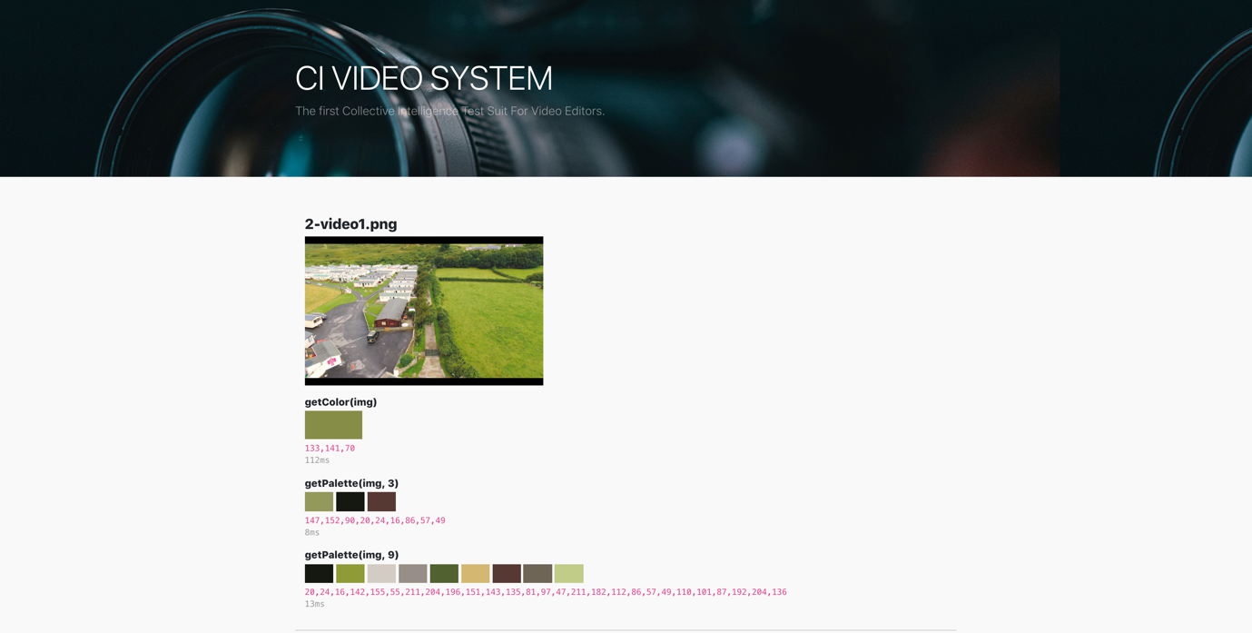
Fig 18 Colour Analysis Example
In the code snippet below you can see how the variable of capture would be set. When that is set to ‘1” the colour information is posted to the application layer. Also, it can be seen how the colour information has been base encoded.

const search = window.location.search;
const params = new URLSearchParams(search);
const id = params.get('id');
const capture = params.get('capture');
let photo = image.getAttribute('src');
var encodedData = window.btoa(result);
if(capture==1){
postData('http://civideo-env.pjcyhcpfk2.us-east-2.elasticbeanstalk.com/colour', {
"name" :photo,
"projectid":id,
"colour": encodedData
});
}

});

Fig 19 POST colour Info
After the project has been added, the page redirects to the dashboard page which contains all the list of projects available. From there the user could run sessions on the available tests.
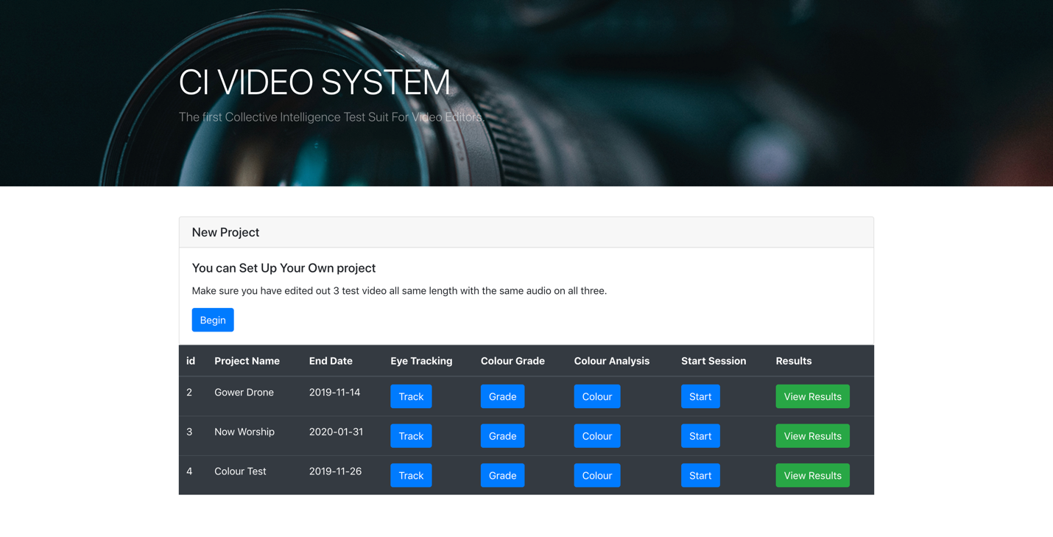

Fig 20 Dashboard

The tests
This section describes the four test which could be conducted using the application and their results. The last two test the emotion and the on change are combined in the app therefore will be talked about together.

Colour Analysis
Colour correction and grading is one of the key functions of the video editor, on larger productions a dedicated colourist is present during postproduction. Therefore, one of the key functions of this application is colour. After a project has been setup it is possible to allow the crowd to decide what they feel is the best colour feel. By clicking on the grade button on the dashboard you enter the grading tool. In the tool you select which of the three videos you want to grade. Thereafter, the user could control one of the following;
- Blur
- Saturation
- Hue
- Brightness
- Contrast
- Invert
- Sepia
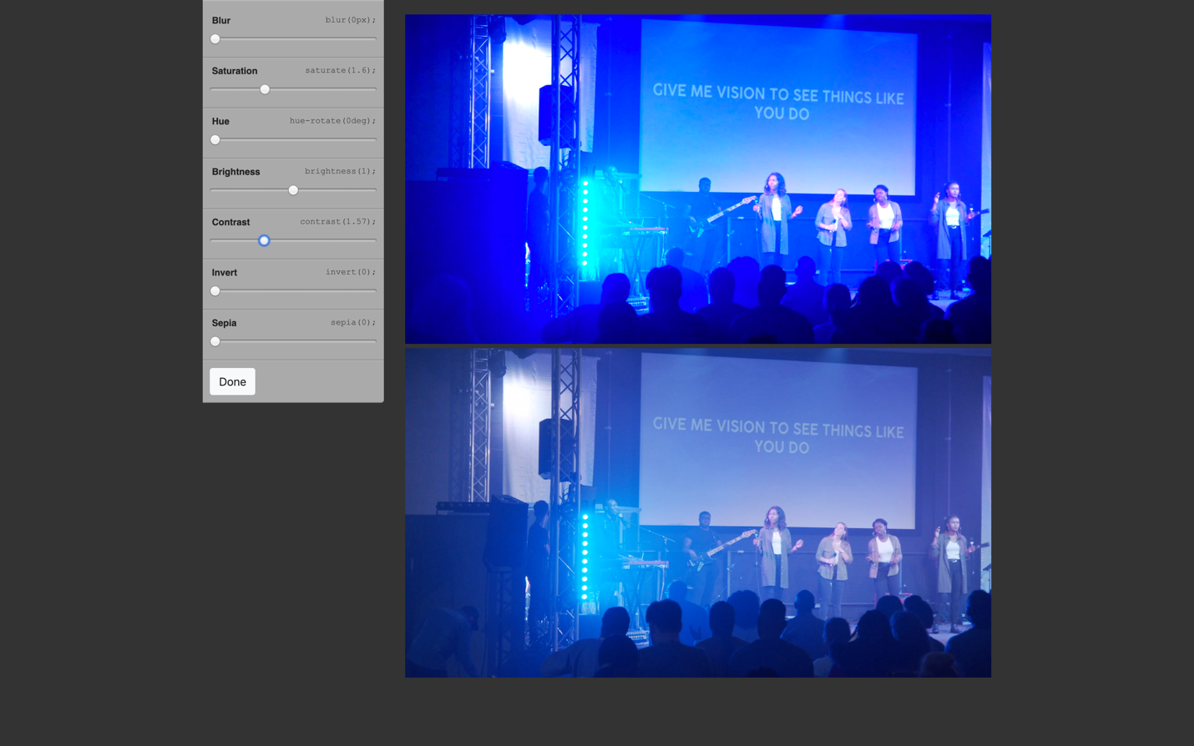
Fig 21 Colour Grade
From the picture above you can see the change of adding contrast to the video. The user can then compare the top video with the bottom video, which will not have changed, therefore will not have the new grade. When the user is happy with his choice they just have to click on the done button. The information is then posted into the Spring application which saves as the application layer which in turn posts to the database the persistence layer. The aim is to have this information compared to the colour analysis information already collected as described in the setup section. The purpose of this is to see if there could be any correlation between the crowd’s choices and video colour profile. The function below is how values taken from the sliders where used for the DOM to change the video [92].

function filter(blur, saturate, hue , brightness, contrast, invert, sepia){
let filters = "blur(" + blur + "px) saturate(" + saturate + ") hue-rotate(" + hue + "deg) brightness(" + brightness + ") contrast(" + contrast + ") invert(" + invert + ") sepia(" + sepia + ")";

$("#video").css('filter', filters);
$("#blur-val").text(blur);
$("#saturate-val").text(saturate);
$("#hue-val").text(hue);
$("#brightness-val").text(brightness);
$("#contrast-val").text(contrast);
$("#invert-val").text(invert);
$("#sepia-val").text(sepia);

}

Fig 22 Colour Filter

Eye-Tracking
Firstly, like the colour grade test you have to select a project you want to work with and thereafter, select the video you want to track.
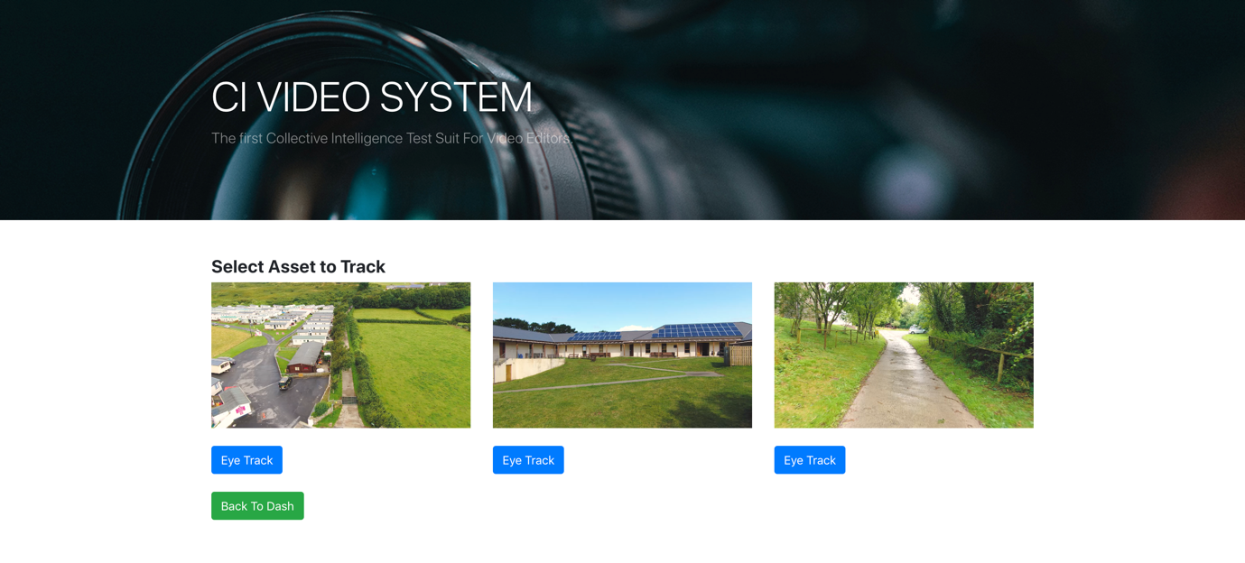
Fig 23 Select Eye Tracking

Then, you are required to fill in details of the test subject. Only generic details are collected and nothing which could identify the test subject.
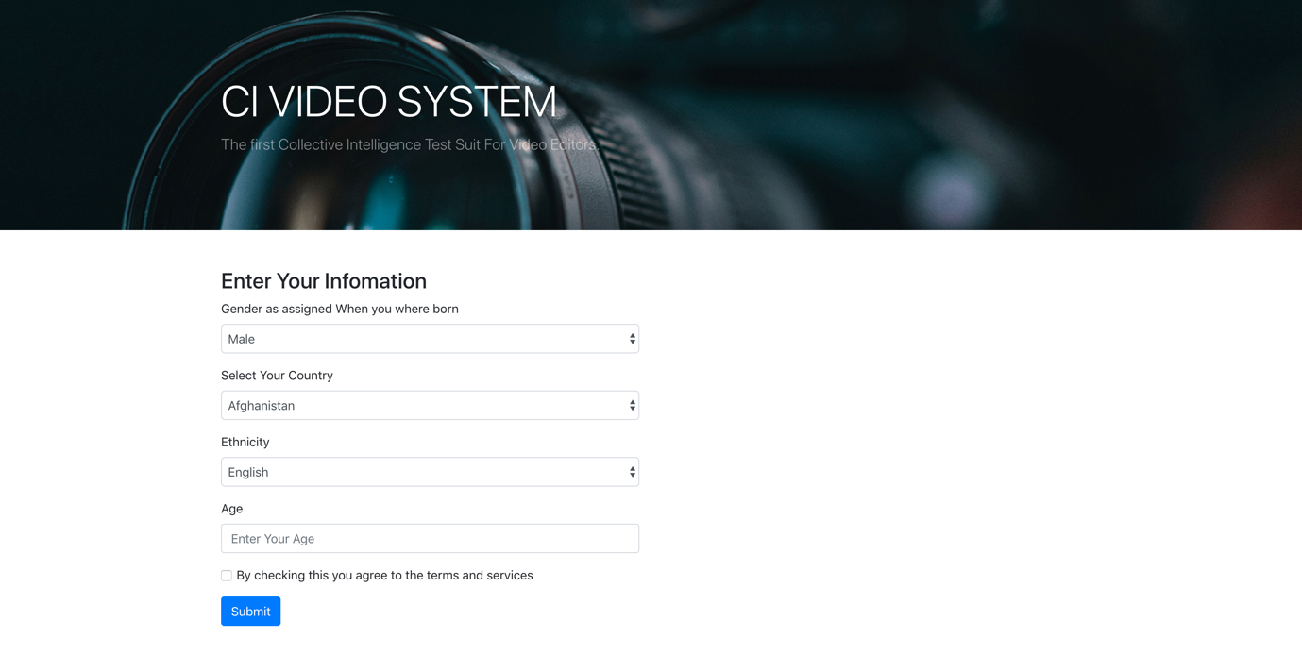
Fig 24 Eye-tracking info

Most importantly, even though the process of Eye-tracking is using a Webcam, at no time in this process is the image captured.
To calibrate the webcam a staging phase is undertaken. As seen below

Fig 25 Calibrate Eye tracking
The test subject has to firstly make sure that they align their head with the red box until it turns from red to green. Thereafter, the test subject must click on different parts of the window as a red dot follows. This allows the webcam to take actual readings of the eye movement therefore, calibrating the application. This process will take exactly a minute. During testing one minute was found to be enough time for an individual to calibrate the webcam.
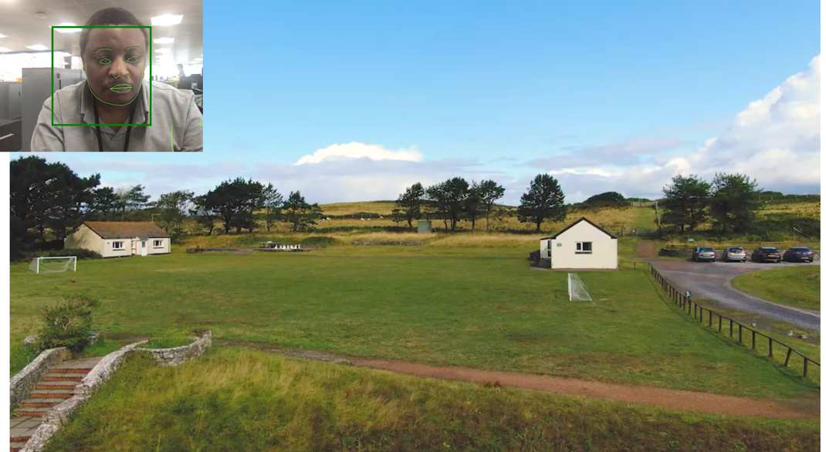
Fig 26 Do Eye tracking
After the calibration process a video loads and the test subject watches the video. As the test subject watches, x and y co-ordinates of what the subject is watching is posted to the spring service. Thereafter, the page redirects to the results page. The results chart then plots the x y co-ordinates into a scatter chart.

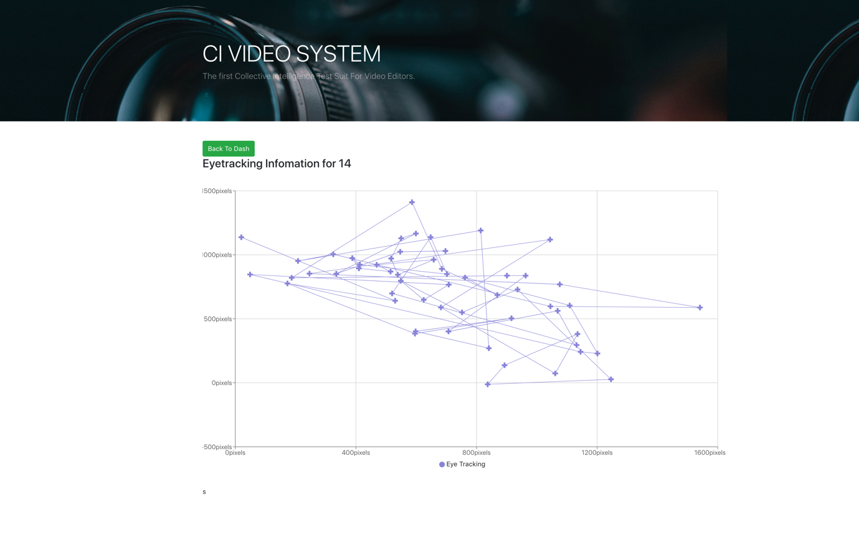
Fig 27 Graph Eye-tracking
Another interesting fact about this project was that for it to work there had to be two different listeners, the first one initialised the project with the .begin(). This was done on a onload event against the DOM. The purpose of this listener was to help the test subject calibrate the webcam for eye tracking. The second was triggered 60 seconds after the video is loaded, ready for the test. In the second listener the x, y co-ordinates were collected. The function below shows how the x, y co-ordinates are plotted and how only about 1 post a second is taken.

(function() {
setTimeout(
function() {
document.getElementById('sign').style.display = 'none';
const videoName = params.get('video');
const video = "../upload/" + videoName;
elem.src = video;
openFullscreen();
elem.play();
webgazer.setGazeListener(function(data, time) {
if (data !== null) {
if (count > 28) {
postData('http://civideo-env.pjcyhcpfk2.us-east-2.elasticbeanstalk.com/dotrack', {
"x": data.x,
"y": data.y,
"registrationtrackingid": params.get('trackingsessionid'),
"projectid": params.get('id'),
"time": time
})

count = 0
} else {
count = count + 1
};
}
})
}, 60000);
})();
Fig 28 POST Eyetracking

Emotion and On-change
The last test this dissertation addressed is actually a combination of two tests. The emotional test and the on-change test. Again, before this test could be conducted basic information is collected. The information is generic. The purpose of collecting this information in this instance is to see if ethical leaning will affect how choices are being made. The library has a gender bias model variable. The variable takes into account the different genders. An extract of the variable is as follows;
var emotionModel = {
"female" : {"bias" : 0.2032715028,"coefficients" : [-0.012175107151058892, -0.02547077166891205, -0.2566348527573602, 0.11310242239983805, 0.047662190057044897, -
"male" : {"bias" : -0.2032715028,"coefficients" : [0.012175107151058849, 0.02547077166891203, 0.25663485275736025, -0.11310242239983825, -0.047662190057045001,
};

Fig 29 emotional Model

Therefore, if the information needs to be adjusted based on new reading it is important to know what the test subjects’ gender is. Below is the form which shows what information is collected.

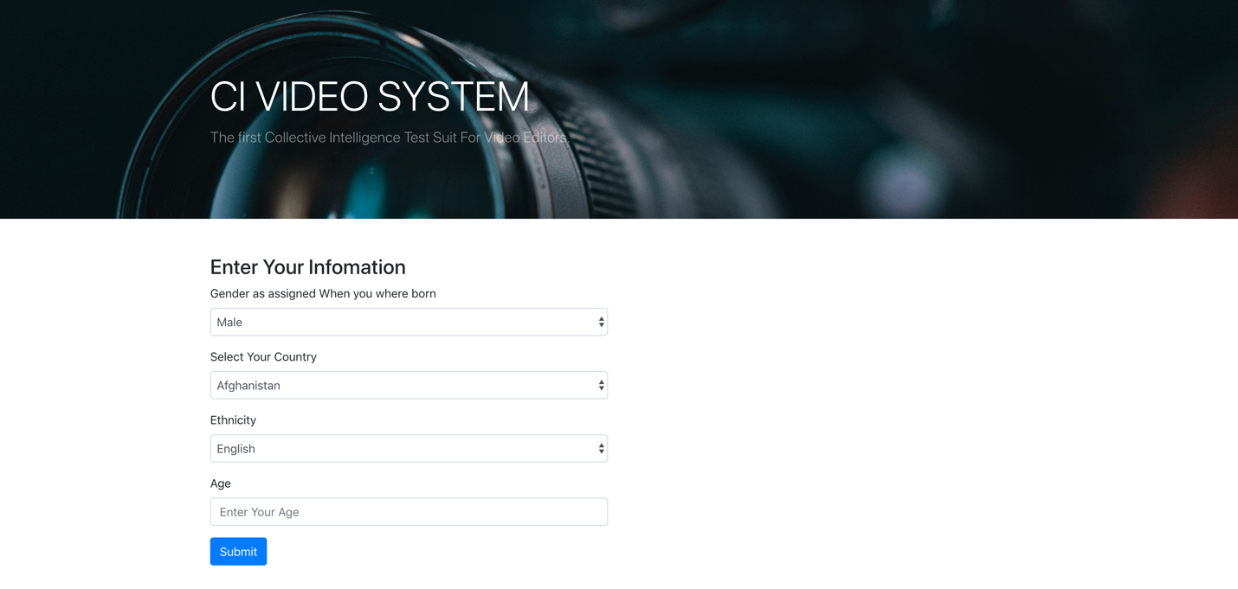
Fig 30 Capture User Infor
The layout for the test is seen below. The test subjects have three video windows with a large review video. The subject can click on any of the video which will display the video which needs to be viewed in the review window. In the example below the test subject has selected the video with the drummer.

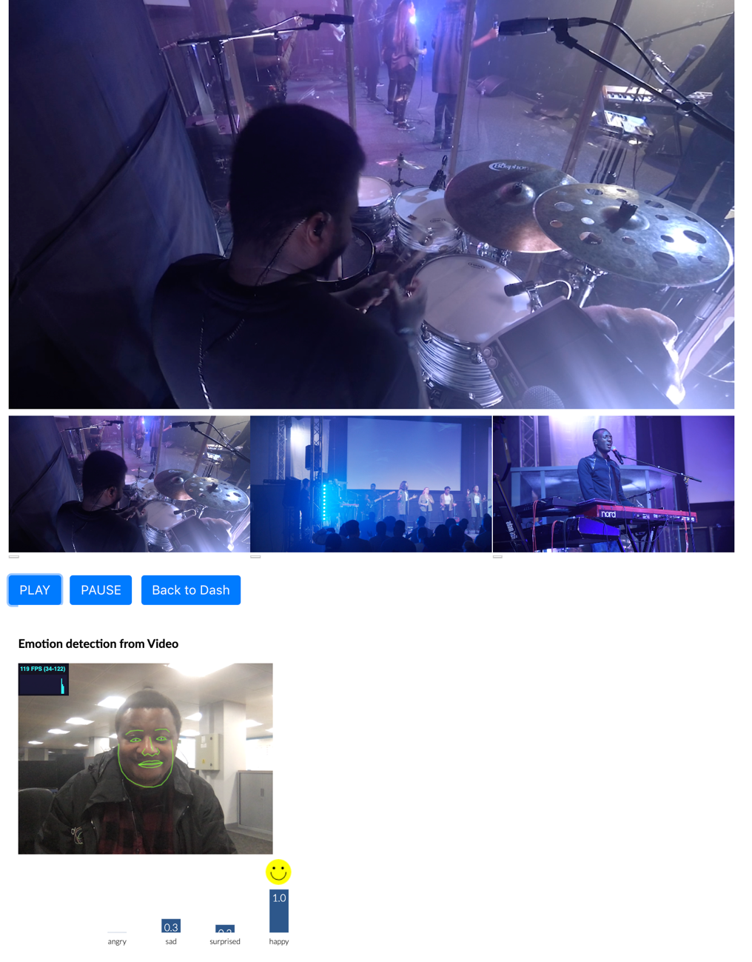
Fig 31 Emotional and On Change Test Example
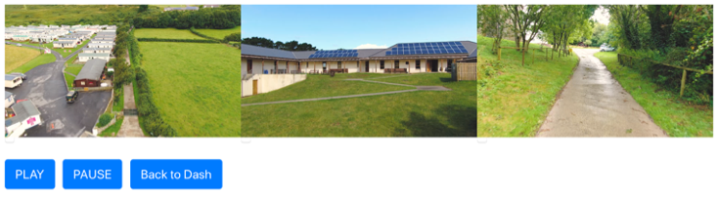
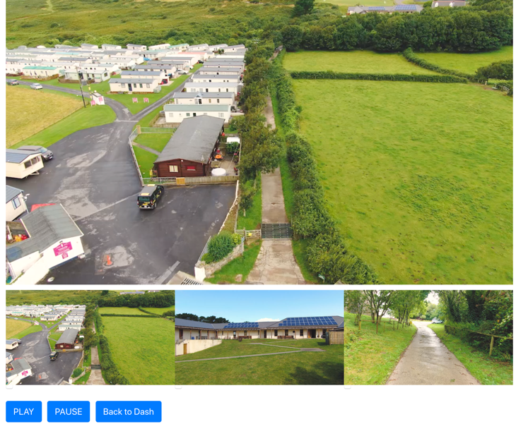

Fig 32 Emotional and Onchange Control

The example on the right below shows the videos which can be selected with control buttons beneath them. As this is happening the choices are logged and posted from the react component in the presentation layer to the application layer as specified in the code sample.

changevideo(videoName){
let vid = document.getElementById('largeVideo');
let time = this.calculateTime(vid);
let video = "../upload/"+videoName;
document.getElementById("mp4_src").src = video;
vid.load();
vid.currentTime = time;
vid.play();
this.setState({ latestVideo: videoName});
this.props.changeVideoHandler(videoName);
this.postData('http://civideo-env.pjcyhcpfk2.us-east-2.elasticbeanstalk.com/onchange', {
"assetname" : videoName,
"sessionid" : this.props.sessionid,
"timedone": time
});
}

Fig 33 On-change Code

Fig 34 Emotions Window

When the test subject presses on play, the emotions component opens below in an iframe as seen in the diagram below.
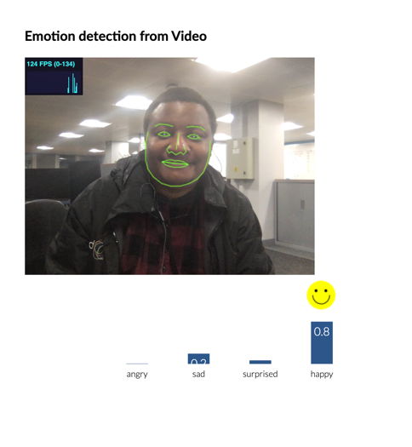
The emotional values begin to post from the iframe component to the application layer. Even though the emotional values are captured about 12 frames a second the system limits the post to the application layer to about 1 frame a second.
function getEmotion(angry, sad, surprised, happy){
const search = window.location.search;
const params = new URLSearchParams(search);
const id = params.get('sessionid');

postData('http://civideo-env.pjcyhcpfk2.us-east-2.elasticbeanstalk.com/emotion', {
"sessionid" : id,
"angry": angry,
"sad": sad,
"surprised": surprised,
"happy": happy,
"time": Date.now()

});
}

if(count > 28){
getEmotion( data[0].value, data[1].value, data[2].value, data[3].value);
count = 0
}else{
count = count + 1
};
Fig 35 Post Emotions

Thereafter, the session is graphed. The on-change graph (shown below) shows how long the test subject spent on each video watched.
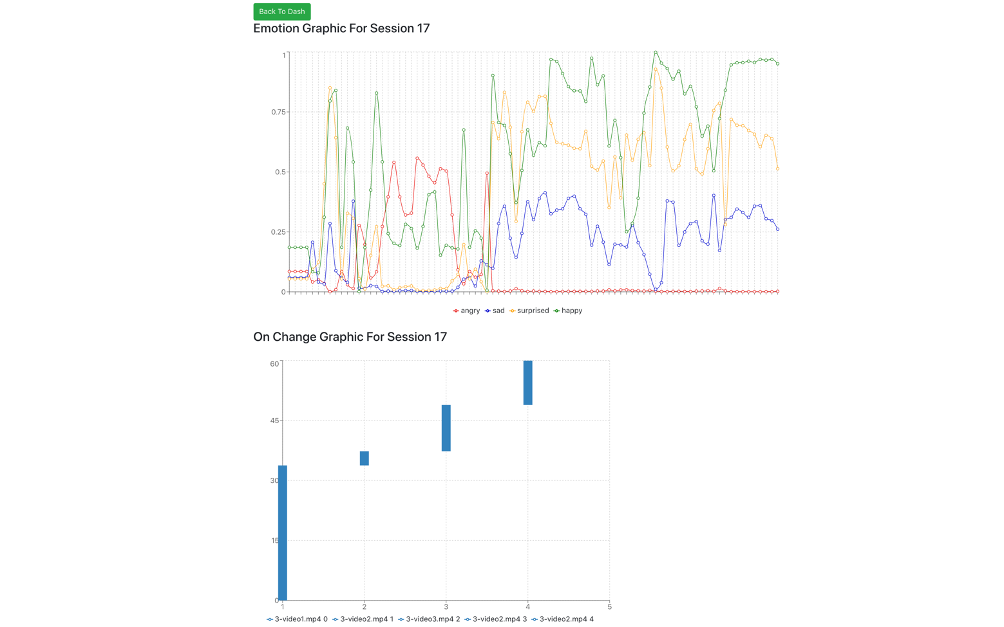
Fig 36 Emotional and On-Change Graph

Results and Discussions

Introduction
This section of the dissertation is an analysis and the examination of the artefact developed in the previous section. This analysis was obtained by firstly, investigating what the experts, consulted in the app development and what they thought about the app. The experts’ thoughts will be taken from the usability testing conducted and the more general questions which arose from the interaction. The questions asked were derived from the objectives outlined in the introduction section of this dissertation. Secondly, the analysis of results obtained by conducting sample tests conducted using the app itself. Thirdly, a general discussion will be conducted looking at what was learn during the process. Lastly, this section will explain the limitations experienced during development and testing process.

Survey from the expert
From the beginning of development, different experts in the field where consulted and usability studies were conducted with their input. The first expert was a senior lecture at Swansea University on undergraduate and postgraduate modules in digital media who has a PHD in the field and specialises in media theory and brings to his teaching a breadth of expertise as a researcher, programmer and practitioner. The second expert was a Technician and tutor at Swansea College of Art for over 10 years. They also were a freelance digital designer and VJ & lighting engineer for over 15 years. The third expert was for 14 years a lecturer and Head of School at Swansea College of Art. Their main academic interest was communication studies: music, storytelling, medium theory, and semiotics. In which they did a PHD in. They are currently an Associate Lecturer in Music at Gower College Swansea. Then, three freelance videographers based in Swansea. Lastly different members of the Emerging Lab at the DVLA were also used as experts.

When the artefact was ready, the artefact was presented to the experts one more time. The purpose of doing it this time was to glean from the experts if the artefact could be useful to them and to answer the question, “could collective Intelligence help determine the best experience of a multi-camera edit using a co-created video edit”. The expert would be told the overall intention of the project thereafter, the expert would be given the chance to undergo the tests available while being asked non leading questions. Unlike most usability studies the events where not time boxed as to allow the expert to express themselves in full. In some instances, the experts were requested to submit an email expressing their thoughts. The following are the key points which were noted during this process.

One key point stated was that the application combined various metrics in a quite unique way, taking the artefact data collection ability into emergent data territory. Therefore, giving film editors and directors a fresh look on how they test films. This means, the expert could discover new ways, that have not yet been considered to test their footage.
One of the experts stated that a film producer would consider emotional tracking to be most important, as they will be looking for some way to quantify the impact of a narrative. They further stated that everything else feeds into that. The gaze analysis, colour palettes and choice of shot angle all give context to the emotional response. Therefore, emotional tracking was the centre of the artefact for the expert.
However, another expert pointed out that there was not enough evidence emotion recognition works accurately enough at this point in time to be used by itself. They also stated that regulators should consider restricting its usage in critical systems because calculating emotion by facial tracking on its own could not accurately tell the real emotion, which is being felt by someone, therefore, causing false reading. This could have a devastating effect.
Expert expressed the need to want to analyse their composition, to determine what works best for a given scenario. For example, horror films which build tension through anticipation. Hence, knowing where viewers are looking, and details like the emotional state of the test subject would work well for this sort of cinematography.
An Expert noted that apart from it being used for editors and directors it would be a good research tool for analysts and educators. Lecturers could bring up some statistics gained through the artefact while teaching their students how to build an effective colour palette, for example. Students could also use the artefact to collect data to justify their choices.
Some expert stated that a lot of data is already known such as colour theory, however, trying to get some hard data on how it relates to a highly subjective medium is difficult to do, however the artefact could be a good starting point, as it provides a good method of analysing data in greater details.
Another expert stated that this is a good study to investigate collective intelligence in general. Studying how the crowd behaves based on their choices could be analysed and applied to other disciplines’. Especially if the goal of collective intelligence is automation because the data could be used to model other behaviours of other collective intelligence models.
Another expert stated that the system should also test concentration levels. For example, at what point do people start losing concentration as they watch footage. For example, if we look at video advertisements, one can ask which type of videos do individual spend more time watching before clicking the next button by looking at concentration levels. The data collected by the artefact could be used to understand the frequency of distraction but also looking at levels and intensities of the same. This, therefore, allows experts to make informed decisions and for the expert to create videos which are subtle, relevant, and with appropriate interventions considered.
One clear point stated by all the experts consulted is that they could all see the potential of the artefact. The potential goes beyond video editoring to the field of marketing and advertisement. Therefore, most importantly Collective Intelligence could help determine the best experience of a multi-camera edit using a co-created video edit.

Results
The artefact was created to test if collective intelligence could be used to create a co-created video edit. For the most part the expert analysis has proved that this is possible. However, four benchmarks were established which are key to the editing process and it important to establish if these benchmarks were met. The following are the benchmarks;
- Narrative clarity
- Dramatic emphasis
- Subtext
- And aesthetic
Therefore, the key question is, do the tests which the artefact conducts help resolve or improve any of the benchmarks. Even though most of the results were graphed in the react library called Recharts, there was need for greater analysis of the data collected by the artefact. To do this the AWS RDS Postgres database used was plugged into another AWS tool called QuickSight. Amazon QuickSight is a utility which helped the system create and analyse the data and created visualizations of it. Amazon QuickSight uses Parallel, In-memory Calculation Engine (SPICE) to perform the needed data calculations then graphed the results.

Colour Analysis
One key area which effects all the four benchmarks described above is colour or the colour grade. The artefact looks at colour in four principle ways. The first principle is that If you have a different colour object on the screen the artefact can help you see if the test subject looked at it with the Eye-tracking test. This principle helps understand what the narrative clarity is. More information about this test to come in the Eye-tracking section.
The second key principle is that the artefact determines what the main colour of the image is. Depending on colour theory the dramatic emphasis could be noted. Also, if the director intended to use any of the colour science theory, discussed in the literature review, the artefact could break up the colour detail. Also as examined in the literature review, colour can be used to determine the mood in the scene of a film. This could be linked to the analysis of a person’s emotion.
The third principle is that the artefact has a colour grade feature. Therefore, it is easy to let the test subject change the colour grade using the tool. Hence, using this tool it is possible to determine the aesthetic of a given piece.
Lastly the fourth principle uses on-change to help determine what the subtext of the film is by having the test subject change between different colour grades. The example below shows the video edited with different colour effects. The test subject is asked to click through the video and after the test is done the time is calculated to see how long was spent on each video and what emotion was evoked by each of the videos.
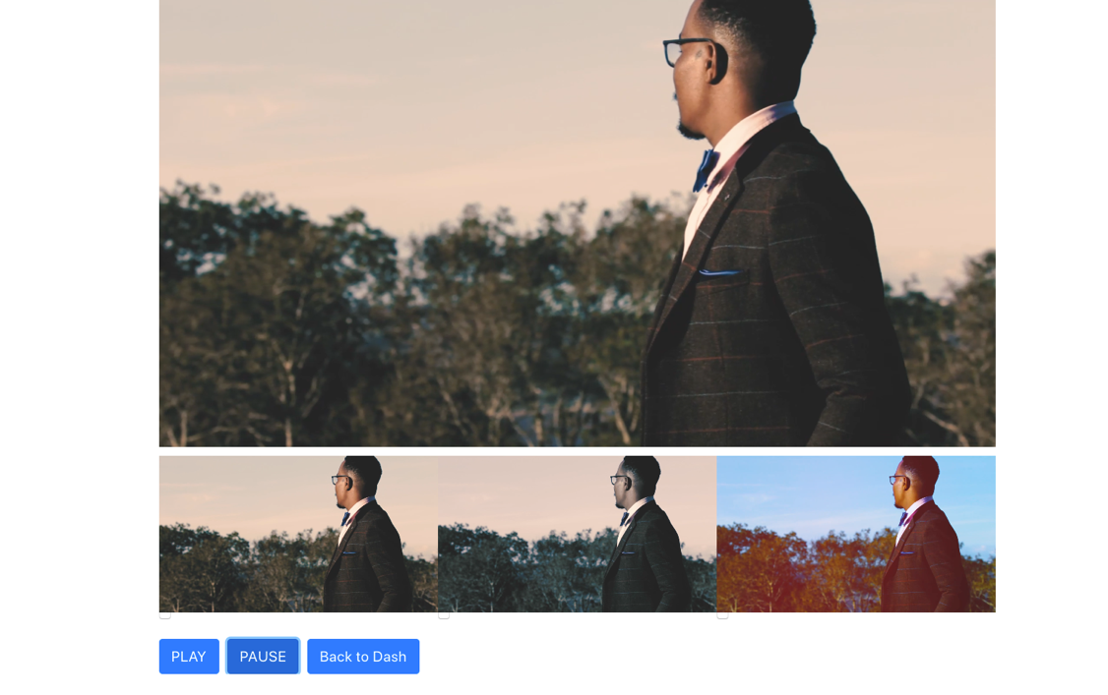
Fig 37 On Change Example one to understand Colour

On-change
The on-change test worked well and produced some of the most accurate results. However, the results of the on-change for shorter clips where not very accurate for first time users. This was because first time users were still getting used to the system. With more experience gained or if the clips are longer the test subject focused more on what they were watching and stopped randomly changing videos. In the future a staging or training section should be added to the on-change test. A second consideration, for the test, is that sometimes the subject would focus more on watching the three videos at the bottom than pressing on the video and watching it on the main view. However, a little prompt helped get the test subject back on track.
It was found that the on-change test could be used to test for dramatic emphasis of a video. This is done by examining at what point in the video the test subject changed to a new video. An example of this test and how dramatic emphasis was tested is the test depicted in the video image below. When the drummer changes play, the test subject would switch to the view of the drummer. The same went for the singer, if the singer changed pitch or style of the singing the test subject would change to him.

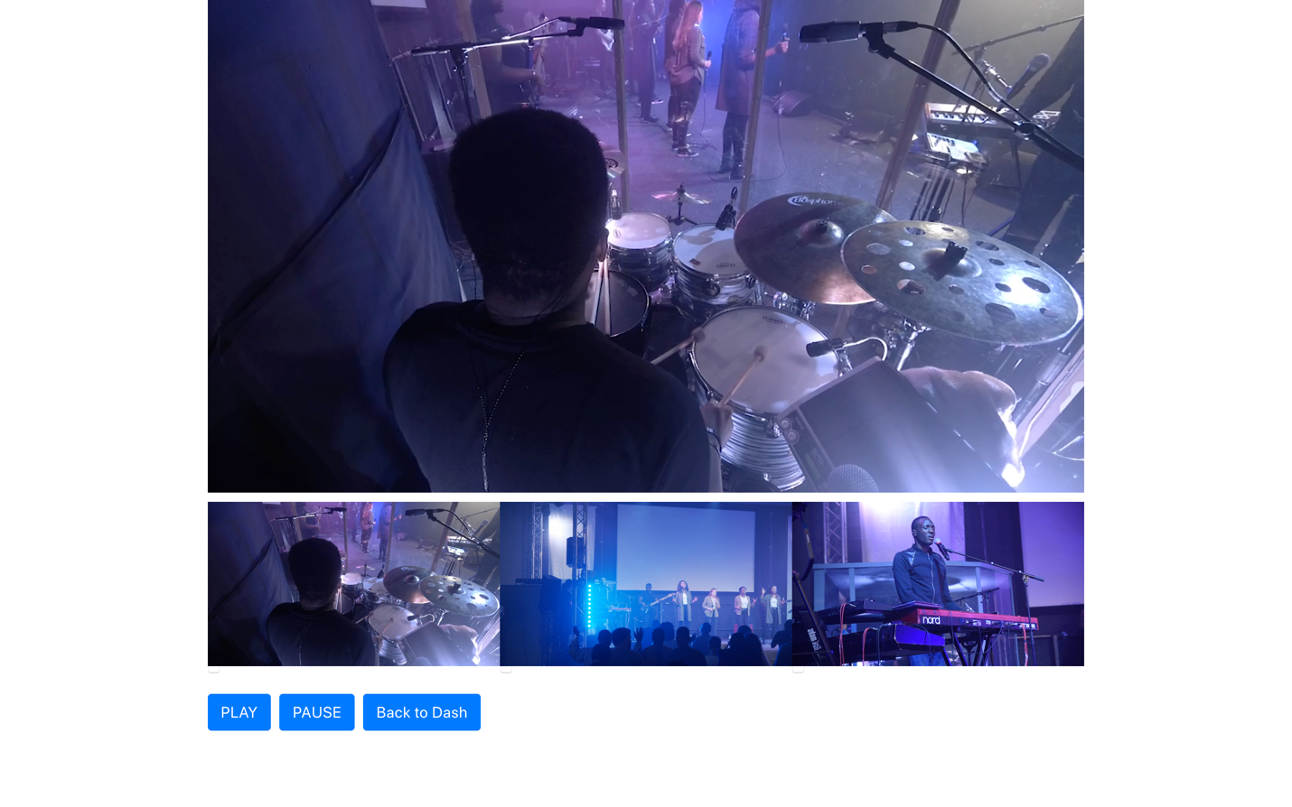
Fig 38 On Change Example two

Also, narrative clarity could be tested using the on-change test. This test was done by uploading videos with different vantage points of the same scene. Therefore, as the video proceeded the test subject observations where noted to see what video the test subject watched the longest. The video test which was used was a lady singing and footage taken from three angles. Below is an image of the video taken.
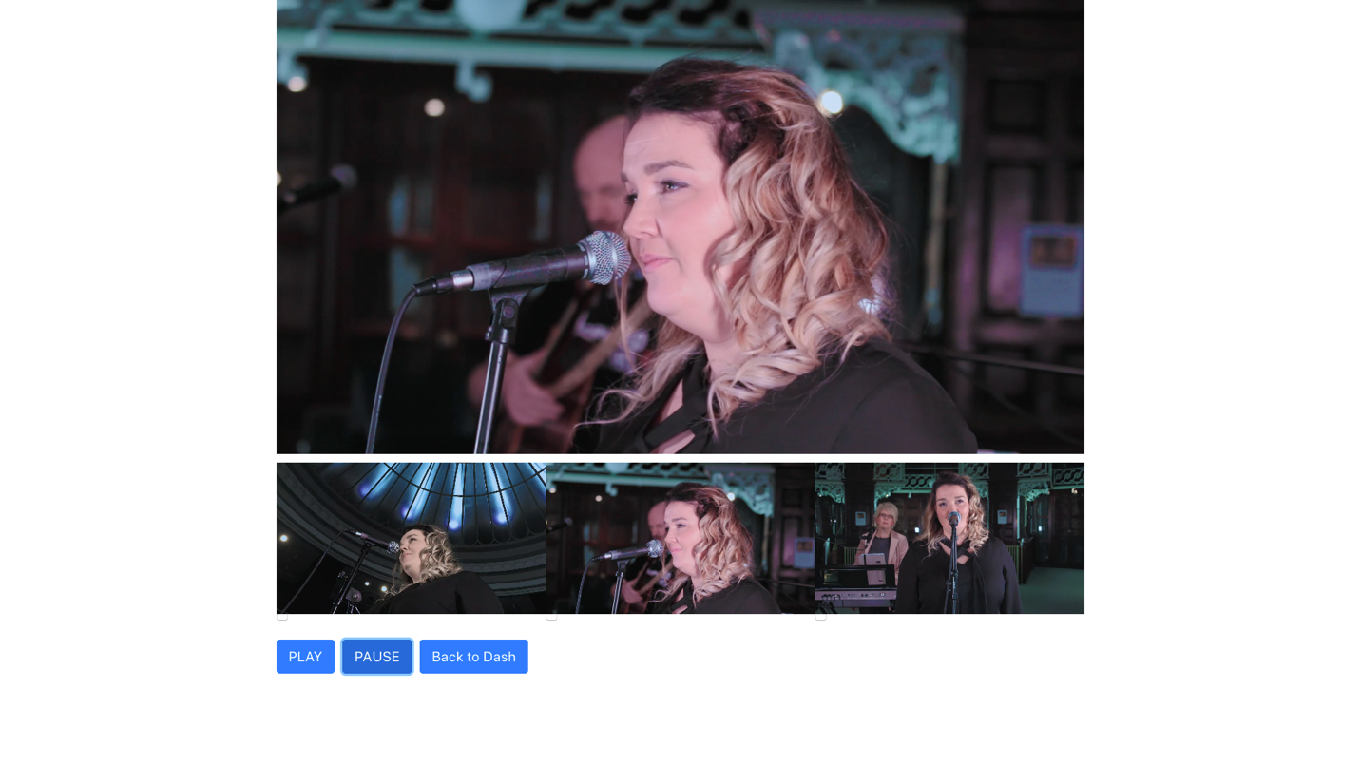
Fig 39 On Change Example three
Similarly, subtext and aesthetic (as explained in the colour analysis section above) where tested using the same principles highlighted above using the on-change test.

Eye Tracking
Eye-tracking Accuracy was highly depended on the web cam in use. However, results were still attained. One important problem is understanding that the plotting happens on the viewport of the system and may not be aligned to the resolution of the video. Therefore, the app needs to make itself aware of the viewpoint resolution. Using Aws Quick insights, the emotion test was tracked in real time.
It was found that eye-tracking is a good test for dramatic emphasis. Testing Showed that the test subjects, at most times, watched what was expected of them. Below is an example of the same. The person singing is the focal point of the video. However, the problem which was found with graphing eye tracking data is that its maps out the results upside down.

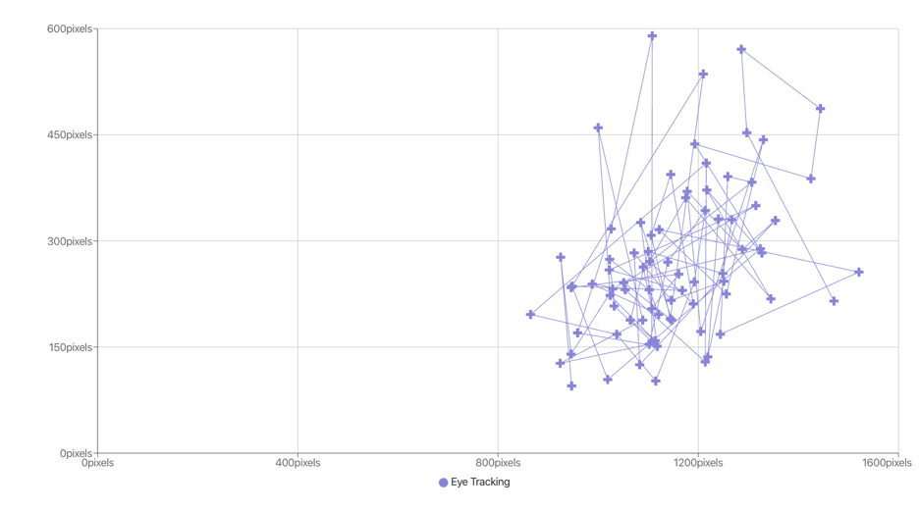

Fig 40 Eyetracking example

In QuickSight a dashboard was created. The dashboard showed a scatter chart populated in real time as the eye-tracking tests were conducted. Below are three chats created based on three of the test projects setup. Looking at the data it is possible to observe that for the most part people looked at the same sort of things. This showed collective intelligence in practice as this board informs the expert exactly what the crowd is looking at. Every dot has a unique Unix timestamp which is represented by a distinct colour.
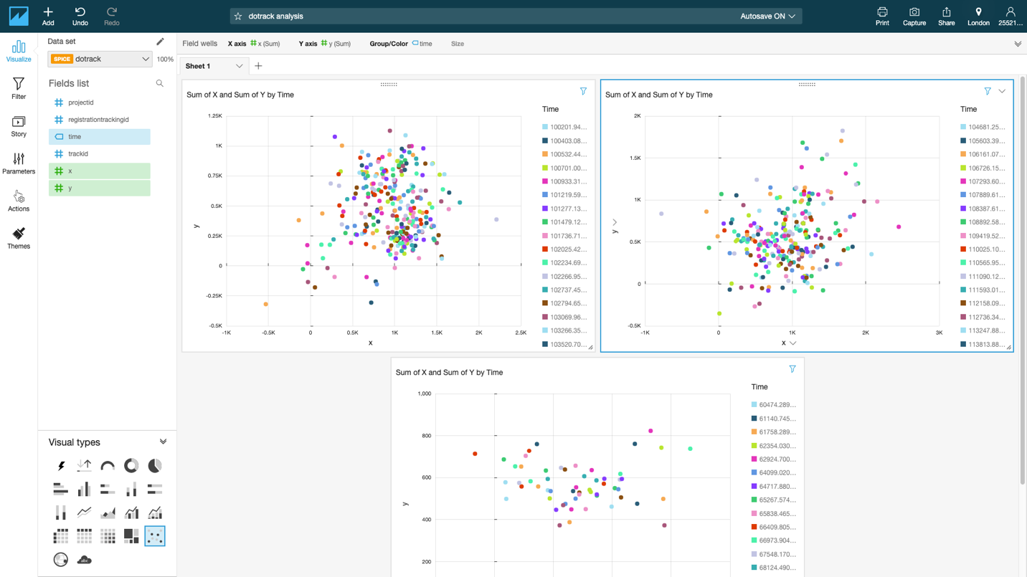
Fig 41 QuickSight

Emotions
For the most part the emotional test worked well. However, if an individual is concentrating it sometimes registers as angry. The longer the video the more the test subject forgot about the tracking. This meant you got a more accurate calculation of their emotion. Therefore, shorter videos had mixed results.

Emotional Test and Ethnicity
One key factor effecting emotional tracking was that the system has problems identifying Black and Minority Ethnicity BME. The problem noticed by the system was that for the most part the system library which used CLMTrackr would read BME test subjects (especially from Africa) as if their mouths where open when they were not. This would mean that the surprise reading of the system will be high most of the time.
It was discovered that similar problems were found in different libraries [93]. The United Kingdom Passport Office also had similar issues with their system, where black African passports were rejected because the system thought their mouths where open [94] [95]. Similarly, Google was forced to apologise for its Photos app, as it mistook a black couple for "gorillas" [96].
Research into similar issues was conducted by Rachel Meade a data scientist at the University of Texas [93]. Meade found that the majority of images that are used in the training algorithms used for predictions are obtained from Wikipedia and IMDB images [93]. Meade further discovered that over 100,000 actors and actresses from Wikipedia and IMDB are used. The problem with this is a dataset of only celebrities who are mostly white Caucasian cannot be a representative sample set [93]. Also noted is that they use a higher proportion of males and some of these celebrities have under gone surgeries to make themselves look younger, which has further skewed the dataset [93]. Below is the summary of Meade’s research.
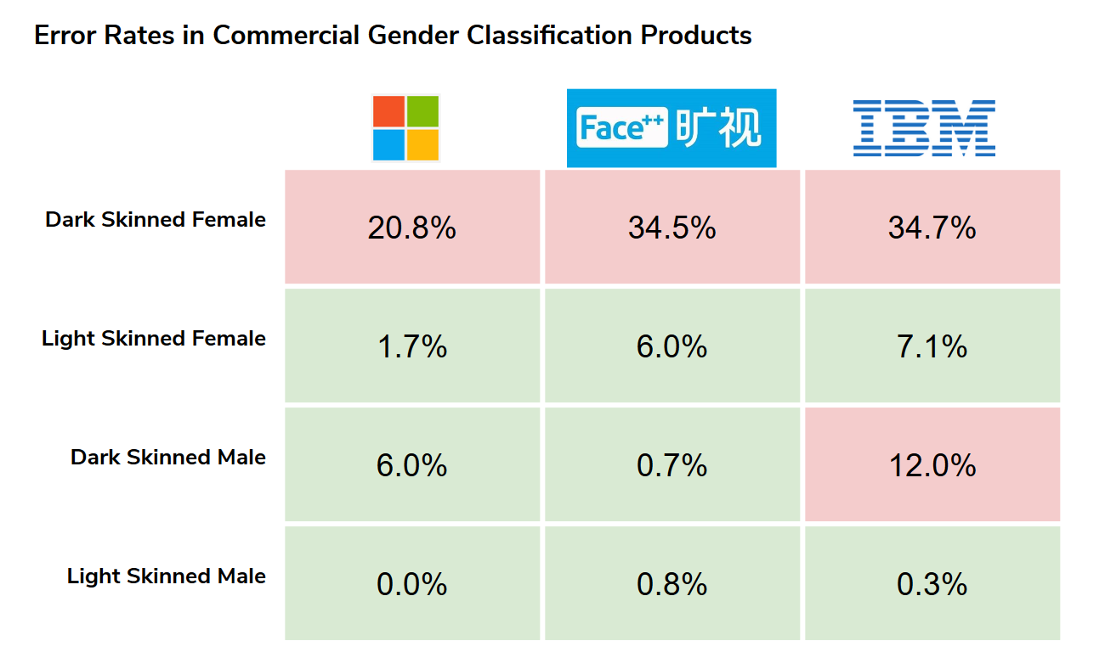
Fig 42 [93] Error Ratees in Commercial Gender Classification
CLMtrackr, the library used for tracking, has had issues with darker skin tone before. Back in 2014 it had to have more training data to help it detect dark faces [97].
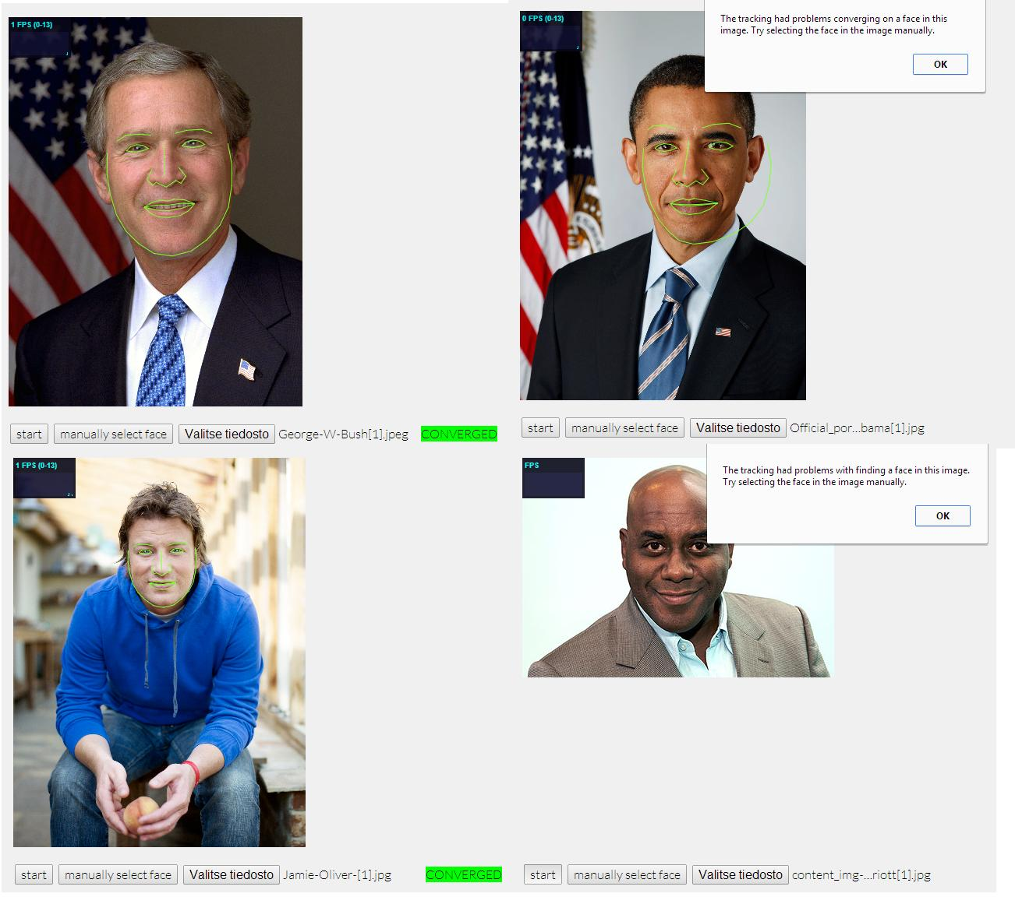
Fig 43 [97] Problem with CLM tracker
However, to improve the accuracy Clmtrackr used training data from the MUCT database which consists of 3755 faces [97]. MUCT database was created for helping such libraries improve diversity of skin colour, age, or ethnicity [97]. However, did this approach work? Preliminary testing has proved that there is still a large disparity between Caucasian and African test subjects.
One question which needs to be answered is how much do white Caucasian test subjects differ, compared to BME in the CLMtrackr library. An experiment was conducted to find out the same by comparing British white Caucasian to black Africans. The experiment collected data from two unpaired sample sets. Both these sample sets contain five participants.
To ensure that the black African sample set had no regional bias the sample set was further segmented into different regions of Africa. From West Africa the test subject came from Nigeria, from Southern African South Africa and Botswana from East Africa Kenya. From South Central Africa Zambia and Zimbabwe. Candidates where asked to look at the screen with their mouth closed for 30seconds then readings of their mouth where taken. The results were fed into the AWS database which was plugged into AWS QuickSight.
From the results collected, eleven randomly selected results were taken from both sample sets.

Results
 | Variable 1 | Variable 2
Mean | 0.017483854 | 0.201577274
Variance | 0.000229463 | 0.077014278
Observations | 11 | 11
Fig 44 Sample Results
By looking at the value of the means you see that white Caucasian is 0.017483854 compared to 0.201577274 in black African. The variance was also widely different. Critically analysing the experiment, the black African had a 20% more chance of the system falsely detecting that their mouths where open.
Another key consideration with the results was that in some instances the system will only trace the top lip of the mouth in the black African sample group. The implication of this is that the library assumed that the mouth was closed regardless of the situation therefore had a constant reading of angry. The chart below showed a graph of both Caucasian series one and African series two. The reading from value 163 on the x axis shows the reading of the test where the black test subject has their mouth top lip read as the whole mouth.

Fig 45 Comparing Ethnicity

Limitation of Study
For the most part, development met the set aim and objectives. However, the were areas which could have improved. One such area was testing in general. Most of the testing which was done where manual testing and usability testing. However, the system could have done with more comprehensive functional testing. The app was also never really tested on different devices. If the system is going to be used for collective intelligence the system needs to be available ubiquitously.
One fundamental problem of working with video was file sizes. File size meant that Resolution required vs the bitrate required was always where the compromised had to happen. The higher the resolution or the bitrate the higher the file size. Hosting the Express Js service remotely proved to be of high expense. This meant that the presentation layer of the application was hosted locally. The implication of this was that the application was not tested in real life situations.
Collective Intelligence exercises work better if you have the right numbers. However, due to the time constraint data collection had to be made up of smaller sample sizes. Nevertheless, the data collected was very usable.
Integrating react js with different libraries proved to be a challenge especially on older libraries, however it should be noted that libraries are quickly catching up with this.

Conclusion
In the literature examination it was shown that collective intelligence should always give an appearance of consensus in decision making. This is besides the fact that different minds come to different conclusions. This is because collective intelligence is an aggregation. The process of collective intelligence means that there is no hierarchy. However, co-creation could be used to mitigate the negative effects of not having experts in the Collective Intelligence process do all the tasks. This happens because experts are the main driving force behind a project, and they crowdsource the more mundane processes. Therefore, the video editing process could incorporate collective intelligence in new and novel ways. The video editor would engage crowdsourcing as a source of test subjects.
However, there was a clear demonstration that crowdsourcing’s main consideration is not to gain insight into the ways and why individuals have performed the task or in fact to learn anything from the individuals. Therefore, crowdsourcing needs to have collective intelligence to ensure there is a process of learning from decision making something which video editors could need. This dissertation identified the following areas which could benefit from collective intelligence testing, narrative clarity, dramatic emphasis, subtext and aesthetics.
To conduct the test of collective intelligence this dissertation developed an artefact. It was decided that the development and the design process, building the artefact should be separated.
A key approach in development was to use User-centred design. This meant that experts in the field of video editing where consulted throughout the whole process.

The four tests created from the artefact to test the objectives described in chapter one were.
- The eye-tracking test
- The on-change test
- The emotion test
- The colour analysis test
The experts found functions of the artefact very usable. One important point was that the application combined various metrics in a quite unique way, taking the artefact data collection ability into emergent data territory. This, therefore, gives film editors and directors a fresh look on how they test films. Experts also expressed the need to want to analyse composition, to determine what works best for a given scenario. Hence, knowing where viewers are looking, and details like the emotional state of the test subject worked well for this sort of cinematography testing.
Another consideration from the experts is the usage of the app by academia because it would be a good research tool for analysts and educators.
One clear point stated by all the experts consulted is that they could all see the potential of the artefact. The potential goes beyond video editors to the field of marketing and advertisement.
In conclusion the hypothesis can be said to be proven because the experts have used the artefact and found that it obtained usable feedback. Also, the tests conducted which where; emotional, eye tracking, colour analysis and the on change test had positive results. However, even though there is more work which needs to be done to improve the test, it is clear that Collective Intelligence could help determine the best experience of a multi-camera edit.

Future Work
Even though for the most part, the colour science test above proved successful, there are areas which were not completely linked concerning colour science and the artefact. One of these areas which was a key consideration for this dissertation was to use machine learning to automate some of the process. One area which could do with automation was to correlate data collected from the grade test and the colour profile. Below are the two tests side by side examining the same video clip. From the colour grade tool on the left, the crowd select what they would like to adjust, and the average is determined. Then the average colour attribute is mapped on to the determined colour value on the second test on the right.
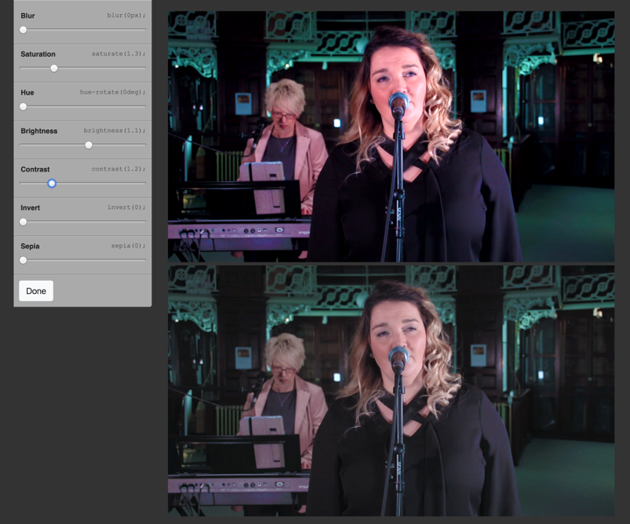
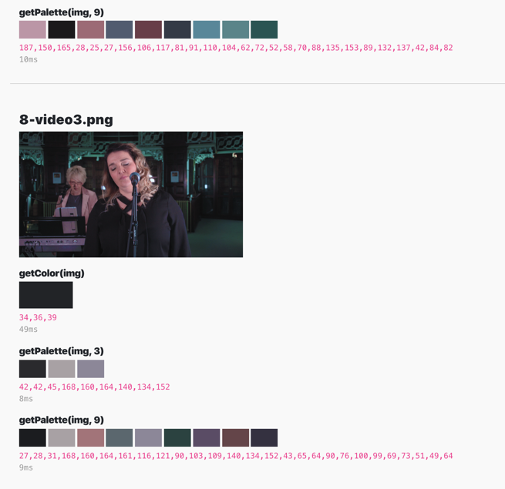
Fig 46 Automation

The form of machine learning which is proposed is supervised learning because the crowd uses collective intelligence to provide the data. The form of supervised learning should be a form of Linear Regression this is because X and Y co-ordinates could easily be created based on the colour attribute value based on the grade test and the colour values extracted using the colour analysis tool. If we take brightness as an example of an attribute, we have the following;
The dependent variable (the attribute of brightness)
Independent variable (colour of the video)

Then using the Linear Regression formula we can calculate an unknown value of brightness by looking at the known values compared to the values of colour extracted the following way
brightness = B₀ + B₁(ColourOFVideo) + e
However, at this point in time not enough information has been collected to conduct the test.

Reflection
I found developing this project very useful as it connected to different parts of my life. That is software engineering self and the digital media self. Collective creativity is a big consideration for me in this project. And that is I think it is easy to prove that collective intelligence can be aggregated however, I think once you add the concept of creativity you start entering a new space. This is because how do you then automate aesthetic design? Design and creativity of very subjective disciplines. In software engineering looking at just testing alone, it is easy for you to come up with a process to test results, because they are always quantitative. However, when you look at the digital media world you find that creativity and design is very subjective and ends up being more qualitatively analysed therefore, it is hard to graph creativity.

I also think the needs to be more studying to what emotion means when it is being captured by a computer. I suppose companies which have successfully used AI to track emotions have shown that it is possible to capture human emotion. In fact, this paper has shown highly successful companies doing just that. However just like lie detection is not an exact science, I don't think that emotional detection has matured enough to be an exact science. The human is such a complex organism which in itself shows complex design by a designer, therefore, cannot be boxed in by a computer. There for emotional tracking should never be used in situations where you need a definite answer. However, I feel that collective intelligence works well with emotional tracking because it is an aggregation of a lot of people's emotions not just the one therefore, on average you get a better reading of results.

Bibliography

[1] | M. Silverman, “Collective Intelligence in Organisations Uses and Challenges,” Silverman Research, 2015.
[2] | F. Galton , “Vox Populi (The Wisdom of Crowds),” Nature, No., vol. 75, pp. 450-451 , 1949.
[3] | T. Berners-Lee and M. Fischetti, Weaving the Web: The Original Design and Ultimate Destiny of the World Wide Web by Its Inventor, Paw Prints, 2008.
[4] | J. P. Sahlin, Social Media and the Transformation of Interaction in Society, IGI Globel, 2017.
[5] | J. Öörni, Beginner’s Reddit Social Media Marketing Guide: How to Promote Products, PublishDrive., 2017.
[6] | S. Alag, Collective Intelligence in Action, Greenwich: Manning , 2008.
[7] | P. Levy, Collective Intelligence., Cambridge, MA: Perseus Books., 1997.
[8] | W. T. Malone and M. L. Bernstein, Handbook of Collective Intelligence, MIT, 2015.
[9] | A. W. Woolley, C. . F. Chabris, . A. Pentland, N. Hashmi and T. . W. Malone, “Evidence for a Collective Intelligence Factor in the Performance of Human Groups,” Science, vol. 6004, no. 330, pp. 686-688, 2010.
[10] | M. Levy, Call: Context and Conceptualisation, Oxford : Oxford University Press., 1997.
[11] | E. Bonabeau, “MITSloan Management Review,” Decisions 2.0: The Power of Collective Intelliegenc, vol. 50, no. 2, pp. 45-52, 2009.
[12] | J. Surowiecki, The W Here Comes Everybody: The Power of Organizing Without Organizations Hardcover, Allen Lane, 2008.
[13] | C. Shirky, Here Comes Everybody: The Power of Organizing Without Organizations, 2008.
[14] | T. Segaran, Programming Collective Intelligence: Building Smart Web 2.0 Applications, O'Reilly , 2007.
[15] | T. M. Szuba, Computational Collective Intelligence, John Wiley & Sons, 2001.
[16] | J. H. J. B. J. Potts, “Consumer Co-Creation and Situated Creativity,” In Industry and Innovation, vol. 15, no. 5, 2008.
[17] | C. a. R. V. Prahalad, “Co-Creation Experiences: The Next Practice In Value Creation,” Journal of Interactive Marketing, vol. 18, no. 3, pp. 5-14, 2004.
[18] | R. a. Ozcan, V. Ramaswamy and K. Ozcan , The Co-Creation Paradigm., Stanford:: Stanford Business Books., 2004.
[19] | P. P. M. A. A. Stephen L.Vargoa, “European Management Journal,” On value and value co-creation: A service systems and service logic perspective, pp. 145-152, 2008.
[20] | C. Grönroos and P. Voima, “Critical service logic: making sense of value creation and co-creation,” Journal of the Academy of Marketing Science, vol. 41, no. 2, pp. 133-150, 2013.
[21] | N. Bolt and T. Tulathimutte, Remote Research, Rosenfeld Media, 2010.
[22] | I. Karydis, S. Sioutas, M. Avlonitis, P. Mylonas and A. Kanavos, “A Survey on Big Data and Collective Intelligence,” in Algorithmic Aspects of Cloud Computing: Second International Workshop, ALGOCLOUD 2016, 2016.
[23] | G. Moody, Rebel Code: Linux and the Open Source Revolution, Basic Books, 2009.
[24] | M. K. D. T. D. L. K. Matt Welsh, Running Linux, O'Reilly , 2002.
[25] | D. J. Barrett, MediaWiki: Wikipedia and Beyond, O'Reilly, 2009.
[26] | C. M. B. Y. Phoebe Ayers, How Wikipedia Works: And how You Can be a Part of it, No Starch Press, 2008.
[27] | J. Howe, Crowdsourcing: How the Power of the Crowd is Driving the Future of Business, Business Books, 2009.
[28] | M. Andro, Digital Libraries and Crowdsourcing, Wileys, 2018.
[29] | T. Buecheler, . J. H. Sieg, R. M. Füchslin and R. Pfeifer, “Crowdsourcing, Open Innovation and Collective Intelligence in the Scientific Method: A Research Agenda and Operational Framework,” in Proc. of the Alife XII Conference, 2010.
[30] | User Farm, “It's time to produce videos Quickly at a fraction of cost,” User Farm, 11 11 2019. [Online]. Available: https://www.userfarm.com/en. [Accessed 11 11 2019].
[31] | T. Segaran , Programming Collective Intelligence 2007 O’Reilly Media, 2007, O’Reilly Media .
[32] | C. Jones, The Guerilla Film Makers Handbook, Genevieve Jolliffe Continuum, 2006.
[33] | K. Darabi and G. Ghinea, “Video summarization by group scoring,” in Conference: 2014 International Conference on Multimedia Computing and Systems (ICMCS), 2014.
[34] | K. Dancyger, The Technique of Film and Video Editing: History, Theory, and Practice, Focal Press, 2013.
[35] | Adobe In, “Premiere Pro,” Adobe, 11 11 2019. [Online]. Available: https://www.adobe.com/uk/products/premiere/free-trial-download.html. [Accessed 11 11 2019].
[36] | Avid, “Media Composer,” Avid, 3 12 2019. [Online]. Available: https://www.avid.com/media-composer. [Accessed 3 12 2019].
[37] | Adobe Inc, “Work Flow,” Adobe, 30 05 2019. [Online]. Available: https://helpx.adobe.com/uk/premiere-pro/using/basic-workflow.html . [Accessed 30 05 2019].
[38] | C. Jones and . G. Jolliffe, The Guerilla Film Makers Handbook, Continuum;, 2006.
[39] | B. Beizer, Black-Box Testing: Techniques for Functional Testing of Software and Systems, Willey, 1995.
[40] | G. M. Tom Saunders, Governing with Collective Intelligence, nesta, 2017.
[41] | L. Yu and J. V. Nickerson, “Collective Creativity: Where We Are and Where We Might Go,” in Proceedings of Collective Intelligence 2012, 2012.
[42] | A. Satnam , Collective Intelligence in Action, Manning Publications, 2008.
[43] | L. Bond, “Colour In Storytelling | CRISWELL | Cinema Cartography,” Criswell, 29 07 2015. [Online]. Available: https://www.youtube.com/watch?v=aXgFcNUWqX0&feature=emb_title. [Accessed 11 11 2019].
[44] | M. Risk, “How to Use Color in Film: 50+ Examples of Movie Color Palettes,” Studio Binder, 10 10 2019. [Online]. Available: https://www.studiobinder.com/blog/how-to-use-color-in-film-50-examples-of-movie-color-palettes/. [Accessed 11 11 2019].
[45] | J. Howe, “The Rise of Crowdsourcing,” Wired Magazine, no. 14, 2006.
[46] | Adobe Inc, “Multi-camera editing workflow,” Adobe Inc, 11 11 2019. [Online]. Available: https://helpx.adobe.com/uk/premiere-pro/using/create-multi-camera-source-sequence.html. [Accessed 11 11 2019].
[47] | L. Dhakar, “COLOR THIEF,” Lokesh, 12 12 2019. [Online]. Available: https://lokeshdhakar.com/projects/color-thief/. [Accessed 12 12 2019].
[48] | A. Papoutsaki, A. Gokaslan, J. Wong, J. Tompkin and J. Huang, “Democratizing Webcam Eye Tracking on the Browser,” Brown Unverisity, [Online]. Available: https://webgazer.cs.brown.edu/. [Accessed 11 11 2019].
[49] | A. Papoutsaki, P. Sangkloy, J. Laskey, N. Daskalova, J. Huang and J. Hays, “WebGazer: Scalable Webcam Eye Tracking Using User Interactions,” in Explore scholarly publications in the NSF Public Access Repository, 2016.
[50] | O. B. Jensen, “Webcam-Based Eye Tracking vs. an Eye Tracker [Pros & Cons],” Imotion, 21 08 2019. [Online]. Available: https://imotions.com/blog/webcam-eye-tracking-vs-an-eye-tracker/. [Accessed 11 11 2019].
[51] | R. W. Levenson and J. J. Gross, “Emotion elicitation using films,” Cognition and Emotion, vol. 9, no. 1, pp. 87-108, 1993.
[52] | N. Lim, “Cultural differences in emotion: differences in emotional arousal level between the East and the West,” Interactive Medicine Research, p. 105–109, 2016.
[53] | E. Bramson-Boudreau, “When our devices can read our emotions: Affectiva’s Gabi Zijderveld,” MIT Techonlogy Review, 28 02 2019. [Online]. Available: https://www.technologyreview.com/s/613019/when-our-devices-can-read-our-emotions-affectivas-gabi-zijderveld/. [Accessed 14 11 2019].
[54] | Affectiva, “About Us,” Affectiva, 14 11 2019. [Online]. Available: https://www.affectiva.com/who/about-us/. [Accessed 14 11 2019].
[55] | R. Matheson, “A Market for Emotions,” MIT News, 31 07 2014. [Online]. Available: http://news.mit.edu/2014/with-emotion-tracking-software-affectiva-attracts-clients-mood-aware-internet-0731. [Accessed 14 11 2019].
[56] | Tracker Js, “Tracker Js,” Tracker Js, 27 01 2020. [Online]. Available: trackingjs.com. [Accessed 27 01 2020].
[57] | A. M. Øygard, “Javascript library for precise tracking of facial features via Constrained Local Models,” Auduno, 14 11 2019. [Online]. Available: https://www.auduno.com/clmtrackr/. [Accessed 14 11 2019].
[58] | J. M. Saragih, S. Lucey and J. Cohn, “Deformable Model Fitting by Regularized Landmark Mean-Shift,” International Journal of Computer Vision, vol. 91, no. 2, pp. 200-215, 2011.
[59] | W. Shao-Yu , . R. Thawonmas and C. Kuan-Ta, “Video summarization via crowdsourcing,” CHI EA '11 CHI '11 Extended Abstracts on Human Factors in Computing Systems, pp. 1531-1536, 2011.
[60] | M. Wald, “Crowdsourcing Correction of Speech Recognition Captioning Errors,” in W4A 2011: 8th International Cross-Disciplinary Conference on Web Accessibility, India, 2011-03-01, 2011.
[61] | Google, “Caption,” Youtube, 27 05 2019. [Online]. Available: https://support.google.com/youtube/answer/2734796?hl=en-GB. [Accessed 27 05 2019].
[62] | E. Jarecki, The American Way of War, Free Press, 2008.
[63] | B. Kachka, “Annie Proulx Gave One of the Best National Book Award Speeches in Recent Memory,” Vulture, 16 11 2017. [Online]. Available: https://www.vulture.com/2017/11/annie-proulx-national-book-award-speech.html. [Accessed 17 07 2019].
[64] | A. Keen, The Cult of the Amateur, London: London, 2008.
[65] | J. Lanier, You are not a Gadget., London: Penguin, 2007.
[66] | G. Mulgan, Big Mind: How Collective Intelligence Can Change Our World, Princeton University Press, 2017.
[67] | M. Borders , The Social Singularity, Social Evolution, 2018.
[68] | M. Border, “Artificial Intelligence vs. Collective Intelligence,” Social Evolution, 5 02 2019. [Online]. Available: https://medium.com/social-evolution/artificial-intelligence-vs-collective-intelligence-1c4ab65493ec. [Accessed 7 08 2019].
[69] | J. Knapp, J. Zeratsky and B. Kowitz , Sprint: How to Solve Big Problems and Test New Ideas in Just Five Days, Simon & Schuster, 2016.
[70] | J. J. Garrett , The Elements of User Experience: User-Centered Design for the Web and Beyond, New Riders, 2010.
[71] | Google Inc, “Design Sprint,” Google, 30 05 2019. [Online]. Available: https://www.gv.com/sprint/. [Accessed 30 05 2019].
[72] | M. Richards, Software Architecture Patterns, O'Reilly Media, Inc., 2015.
[73] | S. Krug , Rocket Surgery Made Easy: The Do-It-Yourself Guide to Finding and Fixing Usability Problems (Voices That Matter), New Riders, 2009.
[74] | . D. J. Anderson, Kanban: Successful Evolutionary Change for Your Technology Business, Blue Hole Press, 2010.
[75] | Japan Management Association, Kanban Just-in Time at Toyota: Management Begins at the Workplace, Productivity Press, 1989.
[76] | J. F. Smart, BDD in Action: Behavior-Driven Development for the Whole Software Lifecycle, Manning Publications, 2014.
[77] | R. Rajani, Testing Practitioner Handbook, Packt Publishing, 2017.
[78] | C. Bauer and G. King, Hibernate in Action: Practical Object/Relational Mapping, Manning Publications, 2004.
[79] | J. Yang, “CSS3 Filter Effects applied to HTML5 video,” Code Pen, 17 06 2017. [Online]. Available: https://codepen.io/ygjack/pen/xrqQjR. [Accessed 21 11 2019].
[80] | R. Meade, “Bias in Machine Learning: How Facial Recognition Models Show Signs of Racism, Sexism and Ageism,” Toward Data Science, 14 12 2019. [Online]. Available: https://towardsdatascience.com/bias-in-machine-learning-how-facial-recognition-models-show-signs-of-racism-sexism-and-ageism-32549e2c972d. [Accessed 17 12 2019].
[81] | BBC, “Passport facial recognition checks fail to work with dark skin,” British Broadcasing Coporation , 9 10 2019. [Online]. Available: https://www.bbc.co.uk/news/technology-49993647. [Accessed 17 12 2019].
[82] | J. Dunne, “Man stunned as passport photo check sees lips as open mouth,” Evening Standard, 19 09 2019. [Online]. Available: https://www.standard.co.uk/news/uk/man-stunned-as-passport-photo-check-sees-lips-as-open-mouth-a4241456.html. [Accessed 17 12 2019].
[83] | BBC, “Google apologises for Photos app's racist blunder,” BBC, 1 07 2015. [Online]. Available: https://www.bbc.co.uk/news/technology-33347866. [Accessed 17 12 2019].
[84] | Clmtrackr Git Repository, “clmtrackr with different colour of faces #3,” GitHub, 11 12 2013. [Online]. Available: https://github.com/auduno/clmtrackr/issues/3. [Accessed 17 12 2019].
[85] | W. Willett, J. Heer and M. Agrawala, “Strategies for crowdsourcing social data analysis,” CHI '12 Proceedings of the SIGCHI Conference on Human Factors in Computing Systems, pp. 227-236 , 2012.
[86] | P. Voigt and A. v. d. Bussche, The EU General Data Protection Regulation (GDPR): A Practical Guide, Springer, 2017.
[87] | V. Braun and V. Clarke, “Using thematic analysis in psychology,,” Qualitative Research in Psychology, vol. 3, no. 2, pp. 77-101, 2006.
[88] | G.-J. &. A. C. &. M. P. &. H. T. Qi, Collective intelligence, which aggregates the shared information from large crowds, is often negatively impacted by unreliable information sources with low-quality data. This becomes a barrier to the effective use of collective intelligence in a variety o, 2012.
[89] | J. Pine, Mass Customization: The New Frontier in Business Competition, Boston: Harvard Business School Press, 1993.
[90] | N. T. Nguyen, Transactions on Computational Collective Intelligence III, Volume 3, 2011.
[91] | N. T. Nguyen, Transactions on Computational Collective Intelligence III, Volume 3, Springer, 2011.
[92] | P. Levy, Collective Intelligence: Mankind's Emerging World in Cyberspace, Cambridge, MA: Perseus Books , 1997.
[93] | H. Landemore, Democratic Reason: Politics, Collective Intelligence, and the Rule of the Many, Princeton : Princeton University Press, 2017.
[94] | C. Ladas, Scrumban - Essays on Kanban Systems for Lean Software Development, Modus Cooperandi Press, 2008.
[95] | . Q. Guo-Jun, C. C. Aggarwal, J. Han and T. Huang, “Mining collective intelligence in diverse groups,” WWW '13, pp. 1041-1052, 2013.
[96] | A. Galletta, Mastering the Semi-Structured Interview and Beyond: From Research Design to Analysis and Publication, NYU Press , 2013.
[97] | E. Drever, Using Semi-Structured Interviews in Small-Scale Research. A Teacher's Guide., Edinburgh: Scottish Council for Research in Education, 1995.
[98] | D. S. Cruzes and T. Dyba, “Recommended Steps for Thematic Synthesis in Software Engineering,” IEEE Xplore, pp. 275-284, 2011.
[99] | Netflix, “Interactive Content,” Netflix, 30 05 2019. [Online]. Available: https://help.netflix.com/en/node/62526. [Accessed 30 05 2019].
[100] | Apple, “Global Collaboration Brings the Worlds of Sports & Music Together Like Never Before,” 23 05 2006. [Online]. Available: https://www.apple.com/uk/newsroom/2006/05/23Nike-and-Apple-Team-Up-to-Launch-Nike-iPod/. [Accessed 5 08 2019].
[101] | V. Ramaswamy, “Innovation through Co-Creation: Venkat Ramaswamy Interview,” Mack Institute for Innovation Management , 28 07 2013. [Online]. Available: https://www.youtube.com/watch?v=byYAcGofebw. [Accessed 8 08 2019].
[102] | C. DiBona , M. Stone and S. Ockman, Open Sources: Voices from the Open Source Revolution, O'Reilly Medi, 1999.
[103] | G. Mulgan, “Artificial intelligence and collective intelligence: the emergence of a new field,” AI & SOCIETY, vol. 33, no. 4, p. 631–632, 2018.
[104] | H. . N. A. Pham and E. Triantaphyllou, “The Impact of Overfitting and Overgeneralization on the Classification Accuracy in Data Mining,” Soft Computing for Knowledge Discovery and Data Mining, pp. 391-431, 2003.
[105] | . M. Schulman, and B. Kowadlo, Working Smart, South-Western, 2005.
[106] | K. Fogel, Producing Open Source Software, O'Reilly, 2006.
[107] | . E. Raymond, The Cathedral & the Bazaar, O'Relliy, 2001.
[108] | P. A. Bernstein and E. Newcomer, Principles of Transaction Processing, Morgan Kaufmann, 2009.
[109] | S. Bagui and R. Earp, Database Design Using Entity-Relationship Diagrams, Auerbach, 2003.

