Name:Alexandra Gjoka
Student Number:2224325
Teacher name:Ruth Taylor Davies

Marketing Essentials BMIH4005
Component A - Marketing Plan
Table of Contents
Introduction 3
Situation Analysis 3
Objective 5
Strategy 5
Tactics 6
Actions 6
Control 7
Conclusion 7
References 8

Introduction
The purport of this report is to make a situation analysis of a Multinational brand named Premier Inn. In this assessment, there will be a focus on the various frameworks and theories for example 5 C's that comprise the company, customers, collaborations, climate and the last one is the competitors. All the parts will be analysed through different models or frameworks in this assessment. In addition to this make focus on the SMART targets and the marketing mix also where analyse promotion, products, price and place regarding Premier Inn. Action will be demonstrated through Gantt Chart and justify the marketing channel. Success measurement will be covered in the control section of this assessment.

Situation Analysis
5 'C' in the marketing plan refers to the various elements that have explained below-
Company
SWOT analysis is going to introduce the microanalysis of Premier Inn.
Strengths: Strengths of Premier Inn are its occupancy rate which is more than 76.3%, its sturdy position in the UK, its presence near airports and tourist locations and its good brand image (Premierinn, 2023).
Weaknesses: Limited presence in the world, hygiene-related issues and many otters (Daskalaki and Hyams-Ssekasi, 2022).
Opportunities: Opportunities to expand in the new markets and huge growth chances in Germany.
Threats: Increasing numbers of potential competitors and legal threat issues with Premier Inn.
Customers
Know about customers through segmentation and targeting in Premier Inn.
Segmentation: The company makes segmentation of the customers through the base of Value-Behavioural segmentation. The market strategies of the company are value pricing strategies (Erdem and Şeker, 2022).
Target customers: The company targets young people and the age group of the people is 25 years to 35 years old people and the company has a 55.17% male audience and a 44.83% female audience. Mostly targeted to Travelers and backpackers with middle and high-income people (Similarweb, 2023).
Competitors
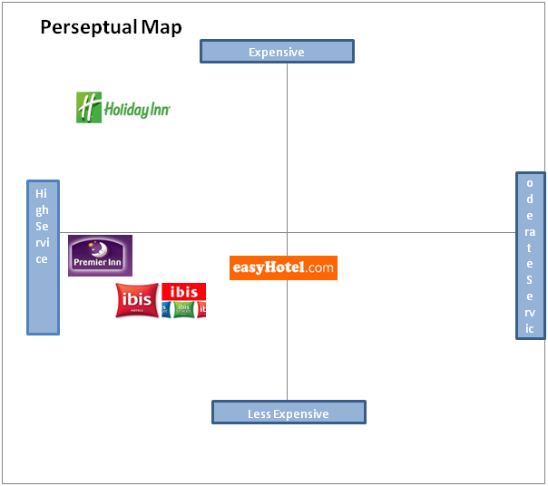
Figure 1: Perpetual map of Premier Inn
Source: (Facebook, 2023)
There are many competitors of Premier Inn in the UK. For example Easyhotel, Inis, Holiday Inn, Hilton and many others. As compared to the competitors the company is less expensive and provides high-quality services.
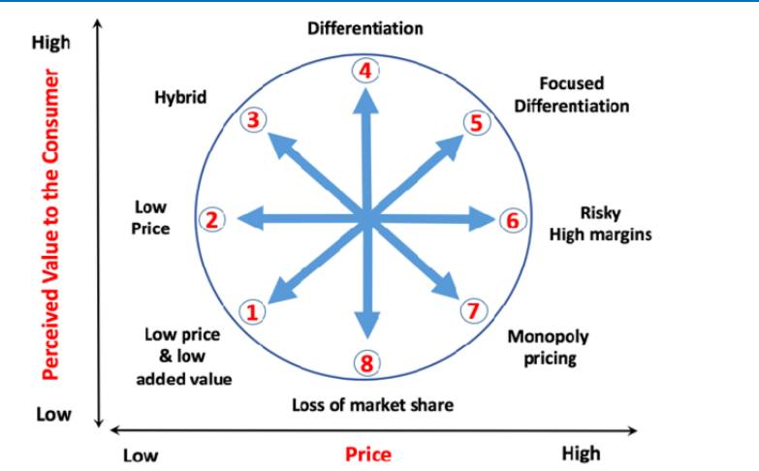
Figure 2: Bowman's strategy clock
Source: (Studysmarter.co.uk, 2023)
As per this model, the company competes with their customers by keeping low prices, hybrid, and differentiations in the company and also providing better services.
Collaborators
In the part of the collaboration, the company focuses on B2B relationships. For example, Premier Inn made a partnership with Nexa, a famous sales channel. In addition to this, the company has many partnerships with other companies that support its development (Digitalnexa, 2023). The company has 800 franchises throughout the UK, Germany and other three counties and plans to expand through franchises.
Climate
Political: Decrease in the corporation tax leads to increased profit (Tax Summaries, 2023).
Economical: £1bn annual loss owing to the covid-19 impact and cut of 6000 jobs (Kollewe, 2021).
Social: customers are looking for higher satisfaction in the budget amount but the shortage is an issue for Premier Inn.
Technological: The company has introduced new technology for customers named 'what3words', which aids in easy and safe travel (Dev, 2023).
Environmental: Increasing carbon emission, waste and issues related to cleanliness in the surrounding.
Legal: The company follows minimum wage regulations, health and safety rules and various laws related to the hotel industry.

Objective
The objective will be discussed through SMART tools for Premier Inn in the marketing plan.
Specific: The marketing plan aims to make expansion in other counties.
Measurable: It will be measured through the number of satisfied customers in the other counties.
Achievable: It will be achieved through increasing the number of staff and providing training related to increasing customer satisfaction.
Realistic: This is realistic to accomplish because getting positive feedback from the customer's point of view to expand in other places in the world.
Time Bound: It will take 1.5 years to reach the mentioned target.

Strategy
The value proposition of Premier Inn is to provide high-quality services to the customers on a minimum budget along with making a positive environment for the customers (Whitbread.co.uk, 2023). The company creates a difference by making promises of a great night but the company provides it to the upper level. The company promises real comfort along with providing a sense to the customers that they are in the home. In this way, there will be changes in the surroundings so that they can feel that they have reached heaven. It will make a positive effect on the targeting segment because it will spread very fast through word of mouth. There will keep in touch with the customers and provide a feeling of the hotel on a digital platform also.

Tactics
Marketing mix refers to a set of actions that are taken by the organisation to promote its products and services in the market. There is going to know about 4P and some set of actions that will be required for marketing (Mathew, 2022).
Product: For fulfilling its objective the company provides great services to their customers that can aid value in their life. The company provides coffee and tea facilities, a super comfy double bed with a duvet, a comfortable bathroom for the guest and facilities of wifi and many other services also (Fotiadis et al., 2022). But in the hotel, there will be some 3D animation covers on the wall so that it can realise that they are in heaven.
Place: In terms of place the company has a presence in 5 countries and there are many options available for customers to book rooms. For example, customers can book through the website, and mobile apps (Chen et al., 2022). In this way, there will be a focus on booking through third parties and make the process very simple for booking rooms in Premier Inn. All the facilities will be available on the app.
Price: In the pricing strategy, there will be a focus on four types of pricing strategies that are Flex, Semi-Flex, standard and advanced but it will vary from location to location and as per the preference of the customers (Ho et al., 2022). The most important thing is that this is based on market research so that there will be variety in the price point for the visitors. In this part, the AI will support. This will be displayed as per the paying capacity of the visitors.
Promotion: For the marketing, there will be a focus on content marketing, sponsorships, referral marketing, and event marketing and there will be a great discount for the new couple for the first time so that it can help to provide great services to them. It will work as word of mouth for the company.

Actions
Gantt chart for marketing activities
Activities | Week 1 | Week 2 | Week 3 | Week 4 | Week 5 | Week 6
Do marketing audit
Conduct market research
Identify target audience and set budget
Develop market strategies
Make an overall plan for implementation
Take actions

The Gantt charts display the marketing steps and they will be implemented within 6 weeks the activities have been demonstrated throughput colours in the above table.

Control
As per the marketing plan for Premier Inn, the success of the organisation will be measured through the feedback of the customers about newly implemented 3D printed walls and also the keeping a good margin of profit. The new customers will be added to the experience of new features in this part and the positive attitude of the costumes will be analysed through word of mouth of the customers. Large customers lead to high profits for the company.

Conclusion
Summing up all the mentioned points about the marketing plan of Premier Inn is that the company has a good reputation or brand image in the UK so it will be easy to explore. Some challenges related to the marketing plan are to provide training to the marketing team and target new customers. So that it is recommended to the marketing department implement effective strategies in the organisation so that it becomes easy to convince them.

References
Chen, X., Su, X., Li, Z., Wu, J., Zheng, M. and Xu, A., (2022). The impact of omnichannel collaborative marketing on customer loyalty to fresh retailers: the mediating effect of the omnichannel shopping experience. Operations Management Research, pp.1-15.
Daskalaki, E. and Hyams-Ssekasi, D., (2022). Unravelling Entrepreneurship and Innovation Within the Hospitality Industry: A Case Study of Selected Hotels in Cyprus. In Entrepreneurship and Change: Understanding Entrepreneurialism as a Driver of Transformation (pp. 239-267). Cham: Springer International Publishing.
Dev, C.S., (2023). the International Centre for Hotel and Resort Management at the University of West London.
Digitalnexa, (2023). Premier Inn - Web Case Study Nexa. Available at: https://www.digitalnexa.com/nexa-portfolio/premier-inn-web (Accessed: March 6, 2023).
Erdem, A. and Şeker, F., (2022). Tourist experience and digital transformation. In Handbook of Research on Digital Communications, Internet of Things, and the Future of Cultural Tourism (pp. 103-120). IGI Global.
Facebook, (2023) Facebook. Available at: https://www.facebook.com/academichelp1234/photos/perceptual-map-budget-hotel-industry/1622671714646445/?_rdr (Accessed: March 6, 2023).
Fotiadis, T., Folinas, D., Vasileiou, K. and Konstantoglou, A., (2022). Marketing and the Customer Value Chain: Integrating Marketing and Supply Chain Management. Routledge.
Ho, C.I., Liu, Y. and Chen, M.C., (2022). Factors influencing watching and purchase intentions on live streaming platforms: From a 7Ps marketing mix perspective. Information, 13(5), p.239.
Kollewe, J. (2021) Premier Inn owner Whitbread Swings to £1bn loss amid Covid Lockdowns, The Guardian. Guardian News and Media. Available at: https://www.theguardian.com/business/2021/apr/27/premier-inn-whitbread-loss-covid-lockdowns-beefeater-brewers-fayre (Accessed: March 6, 2023).
Mathew, V., (2022). Does Islamic marketing mix affect consumer satisfaction?: an analysis of consumer perception in the service industry. International Journal of Service Science, Management, Engineering, and Technology (IJSSMET), 13(1), pp.1-13.
Premierinn, (2023). About Us Premier Inn. Available at: https://www.premierinn.com/gb/en/why.html (Accessed: March 6, 2023).
Similarweb, (2023). Premierinn.com Traffic Analytics & Market Share | similar web. Available at: https://www.similarweb.com/website/premierinn.com/ (Accessed: March 6, 2023).
Studysmarter.co.uk, (2023). Bowman's strategic clock StudySmarter UK. Available at: https://www.studysmarter.co.uk/explanations/business-studies/strategic-direction/bowmans-strategic-clock/ (Accessed: March 6, 2023).
Tax Summaries, (2023). United Kingdom Corporate - Taxes on corporate income. Available at: https://taxsummaries.com/united-kingdom/corporate/taxes-on-corporate-income (Accessed: March 6, 2023).
Whitbread.co.uk, (2023). About Us Whitbread PLC. Available at: https://www.whitbread.co.uk/about-us/ (Accessed: March 6, 2023).

Appendix


