Arnas Kazlauskas (1920008)
Lecturer name: Timothy Hopkins
University of Wales Trinity Saint David
Module name: Effective Team Working and Communication

Assignment - Communication

Communication at workplace is very important nowadays. Communication itself means the process of exchanging the information as well as ideas, it can be done verbal and non-verbal. At workplace it is important because it can help to avoid confusion, it provides purpose of the job roles and other types of information. It can create accountability and build positive company culture. There are three models of communications which are: Shannon and Weaver (1948), Schramm (1954), Berlo (1960).
Shannon and Weaver is the type of linear communication model which provides the analysation of how the message are received and sent. Also, this model of communication is more technological than other models like Berlo or Schramm. This way of communication is created to develop the most effective communication between the sender and receiver. At the start of the model appearance, it was a lot more to improve the technical communication, however later it was mostly applied to field of communication. The examples of which kinds of concepts this model is noise, message, receiver, encode, decode, information source, channel, information destination. The example of how it works is:
SENDER: the person of the message or it can also be information source which makes desire message.
ENCODER: the process of transmitting the message which converts into specific signals
DECODER: the process of the place of the signal which then converts signals into required message. This can be explained in process of encode, however it is reversed process.
RECEIVER: this is the destination where it comes from the sender created into the message
NOISE: from encoder to decoder the messages are transferred throughout the channel. However, during this processes the message can be affected by so many sources for example physical noise , thunder, crowd noise , horn sounds and so many other . This is can affect the communication flow or the message sent can be received incorrect.



The example of the whole process:
Sender: Tom
Encoder: telephone
Channel: cable
Noise: voice distraction
Reception: telephone
Receiver: colleague
For example, the is a transmission error or it can be noise error as well, which means that the colleague cannot understand the message sent from Tom. Tom have sent the message ‘I would like you in my office’ however, the Colleague of Tom hears the message ‘I want’. Which means that this way of communication has an error and it can affect their work.

Schramm (1954)
This model is created in a circular and that it because communication is in nature circle. The process of this model is between two people. Two people are both receiver and the sender. They can communicate through only one direction. This model of circle is very different from the other two models mentioned before. This model is very useful because it is a dynamic model which can show how different situation can change through this process. Also, it provides information on how and why redundancy plays an important and essential part in the communication.
The example of this communication model:
ENCODER: this is who sends the message of encodes messages
DECODER: person who received the message
INTERPRETER: someone who is trying to analyse and understand the message
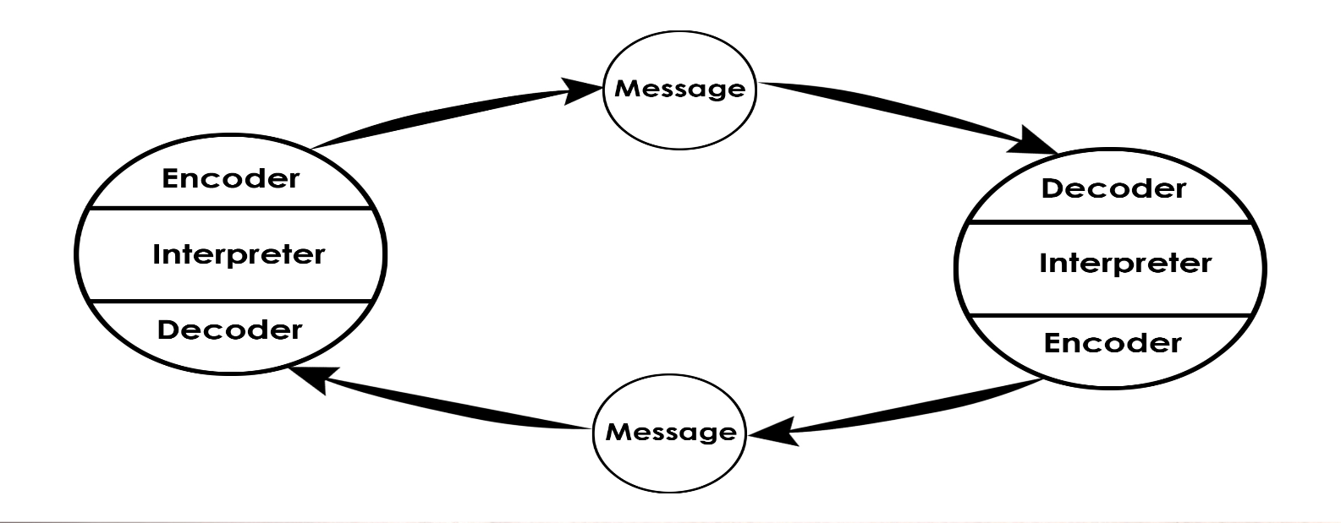
However, in this Schramm model it does not mention anything about sematic noise and uses only encoding and decoding.
Berlo (1960)
Berlo communication shows the simplest form of communication. This model represents a lot of different components which form easiest process of communication. This also can be used for efficient because this tool represents coding and decoding of the message that it sent. The creator of this communication method, David Berlo, has described three mostly used forms of communication which are the subject, the person who is receiving and message and also the speaker who is sending the message. The examples are:
SENDER: the person who is sends and creates the message to the person who is receiving the message. There is a source, which makes the process and the person who encodes the required message.
COMMUNICATION SKILLS: this can include like reading, speaking, listening and so on.
ATTITUDE: there is a relationship to the audience who are receiving the message, and also receiver and it can change the subject of the meaning and this can affect the message.
KNOWLEDGE: if the person who is receiving the message has an understanding familiarity of the subject, this can make the communication even more effective and understandable.
CULTURE: the culture and different background can result the message in being understood and received differently.

MESSAGE: this message can be sent in so many ways for example as an audio, text, video, other media or speech. The sender of the message always wants the receiver to understand the message in the same way as the sender. The message can be influenced by: content, elements, treatment, structure, code, channel, receiver and so many others.

Communication skills
In any workplace, in any industry people work in, it is important to have the ability to communicate in the most effective way with colleagues, staff, customers, supervisors and other workers within the business. Workers have to be able to effectively convey the received message, it can be received in so many ways like email, phone, social media or in person. Below there are examples of most important communication skills at work:
- Listening
At the workplace, to be able to listen properly is the way to be a good communicator. If the person who works at the bank, and having their manager to ask the employer to put count the money and the employer doesn’t listen properly does the opposite , for example instead of counting the money, the employer puts the money in the safe without counting it. Bad listeners can risk their employability and won’t be appreciated at work.
- Non-verbal communications
As an example, body language, eye contact, tone of voice or even hand gesture, all of them presents the message which is trying to be sent to the sender. At workplace it is very important , that is because if an employer is relaxed, arms open or legs relaxed and with the good/friendly tone will make other colleagues and supervisors to be more approachable towards the employer and it will make the courage to other to speak more openly towards the employer.
- Respect
The employer who is respectful, it will make other staff to be more open to communicating if there is a respect with the other person, who respects their ideas and the person itself. Respect can be shown in simple forms like using persons name, making eye contact and of course listening to the message that is sent, it will make the staff feel more appreciated. Especially when speaking on the phone, the person has to try and avoid distractions at the area and stay more focused on the conversion that it is going on.
Verbal communications
Verbal communication means the use of voice and words. This is the most common communication at workplace and in everyday life. There are key elements of verbal communication like sound, words, language and of course the physical speaking. Verbal communication can be not affective if it includes poor choice of wording, different and subjective opinions, physical disabilities, communication techniques and so on. There is an example
- Importance of corrective wrong
As an example, in the office, the employee had to save file and there was a small error occurred. When saying ‘I am sorry for the mistake ‘can make a huge impact, there is a big power of ‘sorry’ and it is very effective and it is a big part of verbal communication.
Non-verbal communication
In nowadays work, we use a lot of nonverbal cues and different kinds of behaviours which include gestures, facial expressions, postures, tone of voice and so many more. This type of non-verbal communication reveals our personalities, how it can also impact how we relate towards other people at work and in our everyday lives. There are some examples of non-verbal communications:
Facial expressions
This the mostly used way of non-verbal communication, it shows our happiness, anger, sadness and other expression of how we feel. At work it is important because we can realise how our colleagues feel, also if our supervisors/managers are happy with our work or if they are angry.
Gestures
This is the way we communicate without words. These common gestures include such as pointing, waving, using fingers etc. as an example, in the court workplace, the lawyers have been using different non-verbal signals which can help them to sway juror opinions. They can use gestures like looking at the watch which can suggest that lawyers arguments are tedious .Another example is if they use gesture of rolling eyes at the testimony by the witness it can mean that it is an attempt to undermine credibility in the courtroom.
Appearance
our look can show clothing, style and other factors which can affect out appearance in non-verbal communication. The research has shown me that colour of our look can evoke different kinds of mood. For example, when going for a job interview, the candidate will be more successful if it dresses appropriately.

Active Listening
Listening tool is very important at the workplace. Active listening will ensure better workplace relationship, which can also improve group work/productivity and other roles. When an employee is an active listener, it is the most important key to get the most of conversations with colleagues and managers. Also, another very important point key is to listening what has been told , however nowadays teenagers have a huge impact on the social media and phones, so it is very popular that teenagers spent a lot of time on their phones and not listen what has been told to them and that’s how misunderstanding comes and the conflicts at work and in every day life. Active listening can help us with:
- Building connections – when there is a good listener, others will feel way more comfortable when sharing important information. This has an opportunity in new projects and getting work done way faster.
- Identifying problems and solving them- active listening can help us with difficulties we come across at workplace and our everyday life, also we can be more quickly to solve problems if it occurs. Finding solutions and creating new plans will help if the person is an active listener.
Empathetic listener
Meaning of empathetic listener is a structure of listening and technique of questions. This can allow employees to develop relationships to the next level with a better understanding of what has been said in both ways of intellectually and emotionally. To improve empathetic listener skill is not very simple as it looks. There are so many ways that can affect to be empathetic listener as distractions, stress, being annoyed, being busy and so many more. For an employee to be affective empathetic listener, they would need to : read more books, socialise, engage in deeper conversations, build new strong relationships, identify their own personal biases and there are so many more. At workplace, employees can show that they are empathetic listeners by listening and not interrupting their colleagues or customers, smiling more, asking more questions than usual and so on.

Robinson and Robinson (1982) recognised that a lot of reasons can affect the message which has been sent to the receiver. The listener has to be able to understand what has been said. At my workplace, our company works outside every day, whatever it is hot or cold. When my manager comes outside to tell us important information on what is going to happen in an hour for example, change of plan, we get distracted by hot/cold weather, noise around as we work next to the port, and it means that my team is less focused on what the manager is trying to say. This can lead us to have a big misunderstanding and miss communication. In Maria and Pedro case study, the same situation has happened. Comparing this case study to my own experience, this miscommunication could have been avoided if there was no noise or other distractions around. On the other hand, this can be improved if in Maria and Pedro case study, they should have had to repeat the instructions to their selves few more times so that communication was clear. At my workplace, this could be solved if the manager would call us somewhere quieter without any distractions around.

In this report of communication, I have developed that communication skills are very important at workplace and as well as in my own everyday life. I have researched three models of communication, which shows different kinds of techniques and structures of communication. Also, I have discovered communication skills which are very important to be successful at work. I have understood what can affect communication at work, how to improve it and the examples of them.

References:
https://www.skillsyouneed.com/ips/communication-skills.html
https://www.communicationtheory.org/shannon-and-weaver-model-of-communication/
https://www.toolshero.com/communication-skills/schramm-communication-model/
https://www.communicationtheory.org/berlos-smcr-model-of-communication/
https://www.skillsyouneed.com/ips/communication-skills.html
https://www.mindtools.com/CommSkll/EmpathicListening.htm
https://www.workplacestrategiesformentalhealth.com/mmhm/pdf/full_communicating_0.pdf

