BREEAM Assessment FACE Building
BREEAM New Construction Assessment (M5X01883)
Abdul Rahman Al-Meshhedani (P152142)

Table of Contents
BREEAM Waste Assessment FACE Building - Introduction 3
Methodology 3
Results and Analysis 4
Wst 01 – Construction Waste Management 4
Wst 02 – Recycled Aggregates 5
Wst 03 – Operational Waste 5
Wst 04 – Speculative Floor and Ceiling Finishes 6
Wst 05 – Adaptation to climate change 7
Wst 06 – Functional adaptability 7
Conclusion 7
Appendices 9

BREEAM Waste Assessment FACE Building - Introduction

The aim of this assessment is to evaluate available evidence and provide a score for the Waste element of the BREEAM UK New Construction Assessment. The rationale of assessing each of the criterion outlined in the Waste issue in the BREEAM technical manual will be explained. Any evidence used will be referenced in order to provide justification for awarding any credits in this Waste assessment.

In turn, the results of this assessment carried out for this issue will be able to provide the client with a total score to achieve a BREEAM rating for the FACE Building in the new UWTSD campus building.

Methodology

The methods of assessment in this issue is mainly evaluating the criterion in each issue. Each criterion must be appropriately addressed in supporting documentation for the credits to be awarded. Compliance Notes found at the end of each issue can provide us with further stipulation required in order to be able to award the credit. In addition to this, Guidance Notes issued by BREEAM can provide valuable information to the assessor to base their assessment of each credit on.
All supporting documentation to validate a credit must be complete, unambiguous, robust and must be existing – i.e. evidence should not have to be created primarily to satisfy a BREEAM credit.
Documentation can be from general evidence such as design drawings, feasibility studies carried out for the project. It can be specific evidence for each particular BREEAM issue, e.g. a Site Waste Management Plan to satisfy the requirements for awarding credits in Wst 01. Other evidence can also be provided – such as written confirmation from a contractor or designer to verify a credit.
All information will then be collated and assessed on an individual basis. If the evidence provided satisfies the evidential requirements above, then a credit can be awarded. If not, a sufficient explanation of why the credit cannot be awarded will be stated. Credits can be withheld pending further information and can be awarded post-construction once that evidence becomes available. All evidence used here will be listed in the BREEAM Assessment Validation (Appendix A).
The credits will then be totalled, displayed in a table (shown in Appendix B) and divided by the issue weighting to provide a contribution to the overall BREEAM score for this project.

Results and Analysis

Wst 01 – Construction Waste Management

Construction Resource Efficiency (Up to 3 credits)

- A Resource Management Plan has been developed covering the non-hazardous waste related to on-site construction and dedicated off-site manufacture – see CN3. There is a general evidence type in the form of a Kier Waste Management plan general to the building. It is complete, accurate but it is a generic document. However, we are able to award the credit based on the reference made to minimizing non-hazardous waste in section 4.12.3 ‘Minimising non-hazardous waste’.

This RMP does show targets, with procedures and commitments for minimising non-hazardous waste, however, there is no reference with regards to point 7, ‘Procedures for reviewing and updating the plan’.

- Total waste generated for 100m2 gross internal floor space is 2.3 (that is excluding demolition and excavation waste). Therefore 3 credits for this issue. This is validated by the SmartWaste document. It is accurate, complete - contains reference to areas that are required by BREEAM and meets Compliance Note 3. However, the document is ambiguous as it does not make state which of the two buildings but this can be validated due to the content in the document.

- A pre-demolition audit is not applicable.

Diversion of Resources from landfill (One credit)

- As per table 52 – the credit cannot be awarded due to the minimum Volume for Non-demolition is 70% and the actual waste shown in the Smartwaste document shows 51.6%.

The Construction Methodology Plan shows that they will segregate waste enough to reach a 95% target diversion from landfill. However, this is not corroborated by the SmartWaste document. It is a robust document since it is provided by the contractor, however, it is not specific to the FACE building alone. it is complete in conjunction with the Kier Waste Management Plan document. It relates only to the design phase and the post-completion figures are not stated. This would have to be verified by the Waste Transfer Documents post-completion.

- In section 4.12.5 ‘Sorting, Reusing and recycling construction waste’ in the Kier Waste Management Plan document, it shows that Concrete, bricks and blocks, metals, timber, gypsum and plasterboard, packaging, soils and stones will be separated which meets the BREEAM requirements. However, the previous element in point 4 above is not currently met hence the credit cannot be awarded as this stage.

Wst01: THREE credits

3 for Construction resource efficiency
0 credits for Diversion of Resource from Landfill

Wst 02 – Recycled Aggregates

Recycled aggregates (One credit)

- The Site Waste Management Plan does not provide sufficient reference to the percentage of high grade aggregate that is recycled. Which either is due to unavailable evidence or that there are no aggregates. The minimum levels of high grade aggregate specified to meet table 54 cannot be verified. Although the Smart Waste document does make reference to the percentage of waste formed, it does not provide details for this criterion.

- There is no information on this, as per criterion 1 above. The Evidence section on P.296 on the technical manual, in order to provide evidence to validate criterion 2 for Wst 02 in the interim design stage, we need to have a calculation confirming the amount of recycled or secondary aggregate to be used. Also, in the final post construction stage we need a calculation confirming the amount of recycled or secondary aggregate used – Hence this credit is withheld until these two calculations are provided.
- Whilst the Kier Waste Management Plan refers to the methods in which recycled aggregates are obtained/treated, there is insufficient evidence to validate this criterion to award the credit as it is not clear whether the recycled construction, demolition and excavation waste is from on/off-site or if it is obtained from a non-construction post-consumer industrial by product source.
Exemplary level criteria
- None of the exemplary credits can be awarded as the preceding criterion cannot be verified at this stage (as per above)
- Nil exemplary credits can be awarded
- Nil exemplary credits can be awarded
Wst 02 – 0 credits can be awarded due to insufficient evidence. Point 2 above indicates credit may be awarded if the required calculations are available.

Wst 03 – Operational Waste

Operational Waste (one credit)

- According to the BREEAM FACE Technical Specification Document, it confirms that the following of:
- Waste labelling and segregation,
- accessible waste storage; and
- appropriate capacity and predicted volumes of waste will all be provided.

The design drawings are available but we need confirmation of the labelling of waste and the predicted volumes of waste that are to be recycled.

- The BREEAM FACE Technical Specification Document also confirms the criterion 2 will be met as the following will be provided:
- Static waste compactors or balers or dedicated waste management space.
- Vessels for composting suitable organic waste or an alternative composting facility.
- A water outlet provided for organic waste storage (hygiene purposes)

Confirmation of the above facilities is required

The document appears to be robust since it is provided by the contractor, however, it only outlines what will be provided and in not much detail. It is complete since it is a full review of the BREEAM issues that will be complied with. It is also specifically for the FACE building.

To further comply with the Wst 03 issue, CN3 requires assessment of the dedicated storage space. A particular waste storage area cannot be identified from the FACE Building GF layout drawings, it does show a central store with 98.99m² with rear access. To comply with CN3.2. ‘Multiple building assessment and buildings that form part of a wider estate’ – there is a waste storage accessible in the Library building. It is 10.61m2 which complies with the 10m2 required in CN3. It is also reasonably expected that a central waste storage facility, outside the library and the FACE building will be provided to meet this.

Furthermore, CN3.4 ‘Internal storage areas’ can be complied with since there is a large area adjacent to the library building which would allow ease of collection. CN3.5 ‘General waste’ - the FACE Building BREEAM Technical Specification document that the adequate separation will be provided.

Wst 03 – 1 credit awarded

Wst 04 – Speculative Floor and Ceiling Finishes

This does not apply to the FACE Building project as in the Assessment criteria it is only for office-type buildings. It is building specific and Is further corroborated by CN4 – ‘Office: Show Area. See Criterion 1’.

Wst 04 – this credit is not applicable.

Wst 05 – Adaptation to climate change

Structural and Fabric resilience (One credit)

- There appears to be no climate change adaptation strategy on this specific project. This means that a systematic risk assessment and impact cannot be assessed. This is corroborated by the BREEAM FACE Building Technical Manual providing no reference to this issue. This credit can be withheld until further information becomes available from the client/contractor.

Exemplary level criteria – Responding to climate change

- Since the preceding credit cannot be awarded at this stage, this exemplary credit cannot be awarded as per criterion 2 in Wst 05. It does not appear to be targeted by the client since there is no specific documentation for this or for the preceding criterion 1.

Wst 05 – Structural and fabric resilience and responding to climate change credits withheld until further information becomes available. 0 credits at this stage

Wst 06 – Functional adaptability

Functional adaptability (One credit)

- A building specific functional adaptation strategy study is not currently available to be able to adequately assess the measures in place to facilitate future adaptations. There is however, a RIBA stage 3 document for the project. It makes reference to the “Flexibility and growth” of this project; it mentions the allowances made for future growth on the lighting, Heating, Ventilation and Cooling system, Gas, Kitchen and Modular buildings. However, it is not the Stage 2 (or equivalent) document that this criterion relates to.

- As per CN3.1 – The Functional adaptation implementation information is not available, as a RIBA Stage 4 for (or equivalent) to outline the implementation of the information available for criterion 1 above. It does not appear to be targeted by the client as it is not included in the BREEAM FACE Specification document. But as the building appears to be adaptable as mentioned in criterion 1 above, further information may be able to validate this credit – hence it is withheld at this stage.

Wst 06 – 0 credits awarded

Conclusion

We can award a number of 4 credits – as shown in the table in Appendix B. Areas such as Wst 02 and Wst 05 may be able to be awarded when further information becomes available. Also, once the project reaches completion, the contractor will be able to provide definitive information based on waste transfer documents, climate change adaptation strategy and a RIBA Stage 2/4 documents. If these do become available at a later stage, then those withheld credits can be awarded.

Percentage weighting of total BREEAM assessment:

Without considering the withheld credits thus far, 8 credits available (excluding exemplary credits), 4 credits achieved at this stage. Waste weighting for a Fully fitted building: 8.5%, therefore, 50% * 0.085 = 4.25% of total BREEAM score achieved in this issue. Minimum standards of Wst 01 and Wst 03 have been met so credits achieved this issue can be used for the final score.

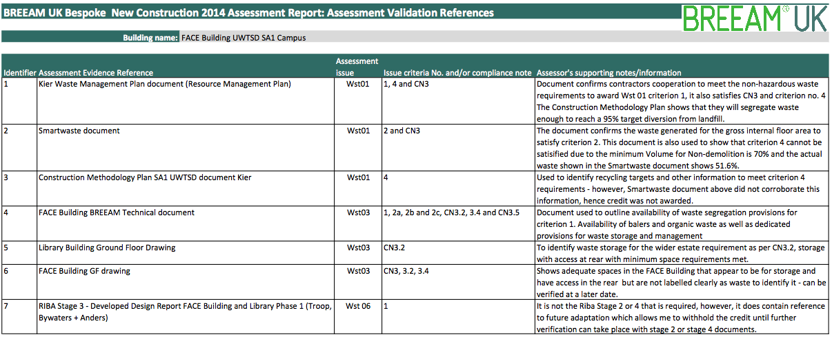
Appendices
Appendix A - BREEAM Assessment Validation References Table used in this FACE Building assessment
Issue | Available | Targeted | Achieved at this stage
Wst 01 – Construction Waste Management | 4 | 4 | 3
Wst 02 – Recycled Aggregates | 1 | 1 | 0
Wst 03 – Operational Waste | 1 | 1 | 1
Wst 04 – Speculative floor and ceiling finishes (not applicable) | 0 | 0 | 0
Wst 05 – Adaptation to climate change | 1 | 1 | 0
Wst 06 – Functional adaptability | 1 | 1 | 0
Total | 8 | 8 | 4

Appendix B - BREEAM Waste Issue Credit Table for FACE Building, UWTSD Waterfront Campus, SA1

