MARKETING FUNDAMENTALS
Assessment 1

Name: George Tivga
Student Number: 2024060
Module: Marketing Fundamentals (LCBB4004)
Module Lector Name: Sadeque Imam Shaikh
Table of Contents

Introduction …………………………………………………..………………………..…… 3
Blog 1 …………………………………………………………………………..…….……………… 4
Blog 2 ……………………………………………………………………………….……..………… 5
Blog 3 ……………………………………………………………………………….……..………… 6
Blog 4 ……………………………………………………………………………….……..………… 7
Blog 5 ……………………………………………………………………………….……..………… 8
Blog 6 ……………………………………………………………………………….……..………… 9
Conclusion ………………………………………………………………………………… 10
References ………………………………………………………………………..….…….. 11

Introduction

The transition period we are going through, which is also influenced by the SARS pandemic (Covid 19), in which face-to-face interactions are becoming rarer, makes the efficiency of alternative marketing tools surpass the classic ones. “Retailers are always searching for new marketing strategies to attract and hold customers.” (Kotler, 2017, p. 400).
Today, various marketing tools are used to increase the level of consumer interest (B-to-B, B-to-C). Each framework in building the brand identity of a company increases the interest of people in buying the experience offered by the marketing process.
The content must be up-to-date to increase the buyer's interest. “Simply posting a humorous video, creating a social media page, or hosting a blog isn’t enough.” (Kotler, 2017, p. 42).
According to the Cambridge Dictionary, the blog is a regular record of your thoughts, opinions, or experiences that you put on the internet for other people to read. Therefore, a blog helps to form an opinion about a product and the company that sells it.

BLOG 1
Vodafone turn on 5G signal in the UK

Vodafone switched on the 5G antennas for the first time in 7 cities in UK on 3 July 2019. The provider currently covers 127 UK towns & cities with a 5G signal. Even if the speed of the internet is ten times superior to 4G, the tariffs remain unchanged. Vodafone also offers 5G roaming services in many of its European cities. The company rolls out 5G across Europe faster than any other competitor. Through the company shops and local distributors, you can find 5G devices at any budget. And because technology is in transition, the new 5G devices are also compatible with 4G and older technologies. In addition to mobile internet, customers can also choose 5G home router that offers home internet at the same speed. In order to create transparency for customers, Vodafone provide a web page where you can check if the places where you are its covered by the 5G signal.
What do you think about 5G speed? Are you already using the new technology? Tell us about your 5G speed experience and what the difference is with 4G.
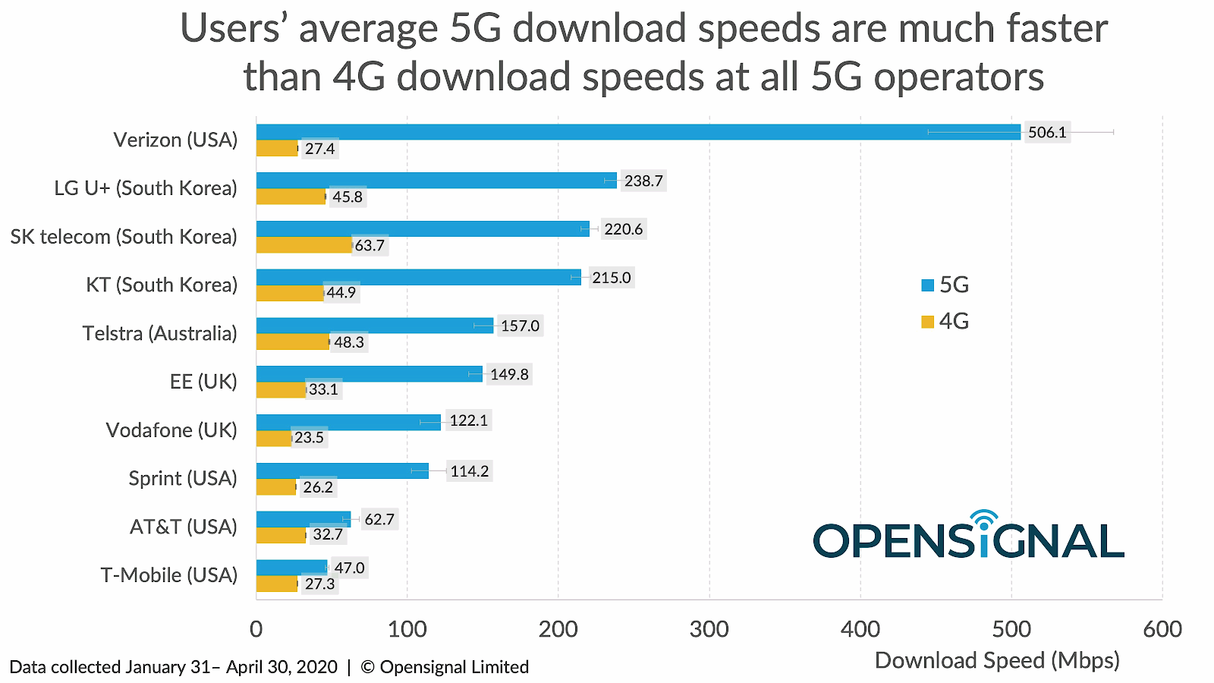

Source: https://www.ispreview.co.uk/index.php/2020/05/opensignal-examines-5g-speeds-at-ee-and-vodafone-uk-vs-rivals.html
BLOG 2
Vodafone helps you breathe clean

The future is green energy. But it is not enough just to produce it. To reach the final consumer, the energy must pass through the distribution network. Vodafone and UK Power Networks (UKPN) begin collaborating to implement 5G technology on computers used in real-time power management. UKPN started the project Constellation in April 2021, a system that reduce costs and has better ways to introduce green energy into its network. The system should be fully functional in September 2025 and the budget is £17,823,000. This innovation can reduce the electricity bill for UK with more than £132m and reduce carbon emissions by 1.9 million tCO2 by 2030. This is another step towards the organisation's commitment to bring to zero the carbon footprint by 2027. The company also wants to halve stakeholder carbon emissions by 2030. The implementation of new technologies helps to combat global warming. Made by Ericsson, a new 5G unit uses 43% less power and Vodafone wants to install 1,500 units in the next 12 months. Vodafone measures every move that can bring value to the company. Internet of Thinks (IoT) Connectivity is a product of the organization that has 136 million connected devices in 182 countries, half of which help reduce waste. The devices are usually sensors, cameras, or GPS trackers.
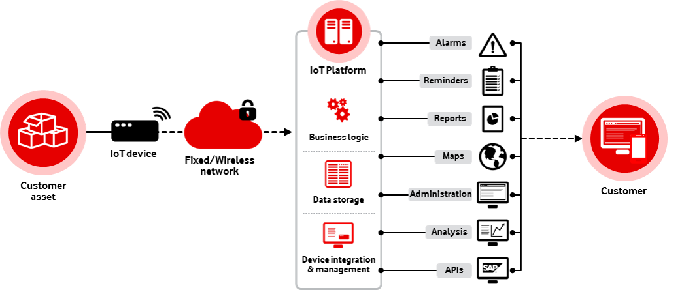
How would you use IoT technology to improve your life?

Source: https://www.vodafoneinnovus.com/product/iot-platform/
BLOG 3
It’s time to upgrade to iPhone 13

Buy iPhone 13 now if you want the latest technology from Apple in your pocket. If you are loyal to the Apple experience, you want to play with the latest iPhone model. Because you have a battery that lasts longer than previous models and because the cameras on this model help you take higher quality pictures when you go out in the evening. If you haven't had an iPhone before, you definitely want one. And because it has 5G technology that allows you to download your favourite series in a few seconds before you get on the plane. The new model is available in four versions, iPhone 13 and 13 mini and 13 Pro and 13 Pro Max, each of these models has different specifications.
You can pay the value of the phone in a single transaction or between 12 and 36 months depending on the flexibility you want. Because Vodafone wants to take care of your old phone, on October 15, 2020, it introduced the Trade-in Tool for Old Mobile Phones. If you have an iPhone X or 11, trade in and save up to £ 360 on selected 24-month Vodafone EVO plans. Recommend iPhone 13 to a friend if you already have one.
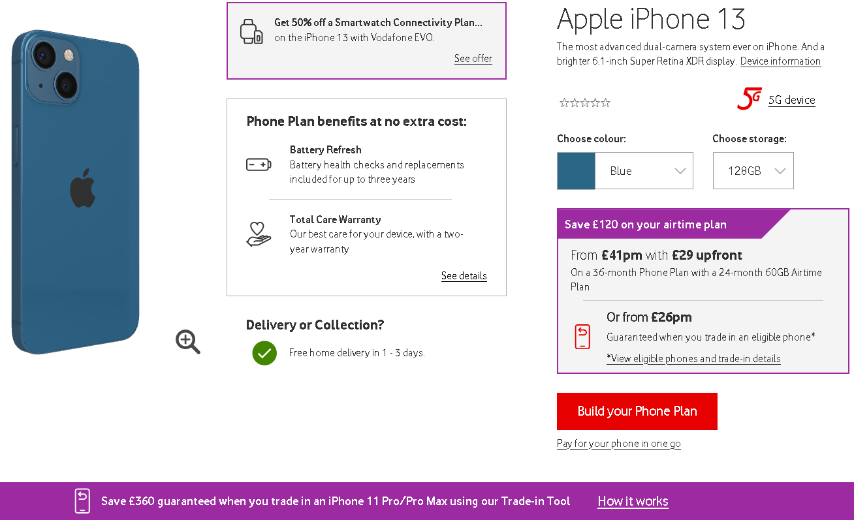
Source: https://www.vodafone.co.uk/mobile/phones/pay-monthly-contracts/apple/iphone-13#deviceselected
BLOG 4
Vodafone helps you grow your business

If you have a small, large or public sector business, Vodafone has the connectivity solution for you. Because we are a business that connects another business, our prices do not include VAT. For those who are already customers, there are also loyalty discounts. And the more employees your business has, the more generous our packages are.
The Business solutions that Vodafone offers are: the 5G package that includes, in addition to a wide range of phones and devices, data and voice package subscriptions; communication tools that contain in addition to solutions to have internet anywhere, support for video conferencing and call centres; business connectivity package containing land line, virtual line and VoIP services; Internet of Things (IoT) service that helps you organize and supervise your business plus the Cloud and Security package that helps you store and share data with your partners.
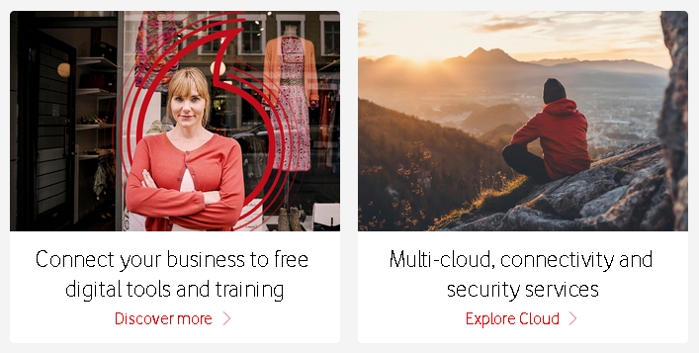
All these packages and solutions help your business reduce paperwork and increase productivity. How would you use these tools to increase the performance of your business? Have you ever measured your business productivity? Call us to find out what we can do to help your business reach its full potential. Vodafone's V-Hub provides guidance for business. The collection contains expert advice, training, events and a podcast.

Source: https://www.vodafone.co.uk/business
BLOG 5
Vodafone delivery

If you buy from the online Vodafone shop, then your device or Sim will reach you through DPD and Royal Mail delivery services.
You will receive by email when you order with whom the package will reach you. And if your package is shipped via DPD, then you can track it on the road to see exactly when it arrives. Also, at DPD you can change the destination address even if the package is on the way, but only by contacting the DPD. Because DPD wants the package to reach you, if you are not at home, another person in the house who is over 18 can take your package. But if he doesn't find anyone, then he will try to deliver it to you a second time before sending it back to Vodafone. Unfortunately, these services are not available for delivery by Royal Mail.
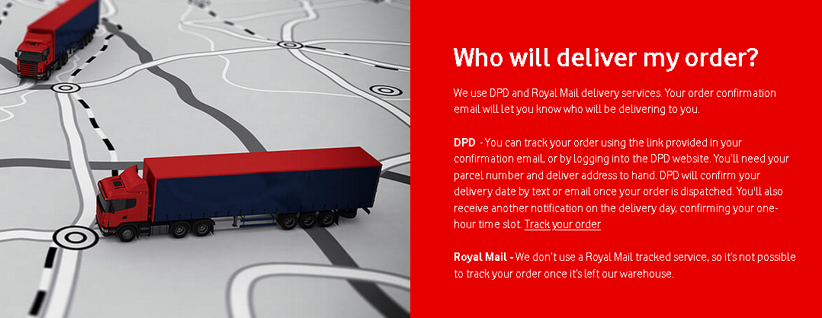

Source: https://www.vodafone.co.uk/my-vodafone-account/orders/delivery

BLOG 6
My Vodafone app makes your life easy

My Vodafone app is a free service offered by Vodafone that helps you track what you've consumed and how many minutes and more data traffic. Also, VeryMe is an in-app loyalty service that offers weekly prizes just for you. Another service integrated in the application is the TOBi, a virtual assistant that will try to help you with the problems you have related to the Vodafone network. With the My Vodafone application you can also check the network quality and Wi-fi speed. The application is available on Apple, Android and Huawei devices.
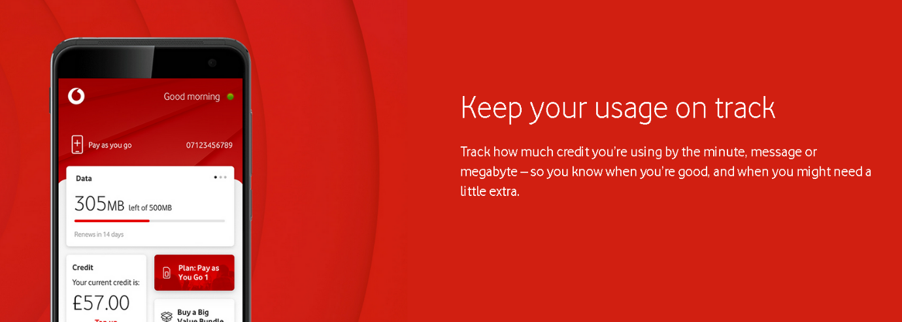
If you use or have already tried the application, what improvements would you make to have a great experience?

Source: https://www.vodafone.co.uk/my-vodafone-account/vodafone-apps/my-vodafone-app#pay-as-you-go

Conclusion

The blogs presented above are tools for forming opinion on potential customers. The marketing strategy STP is divided into segmentation, targeting and positioning. This strategy is used to create value for targeted customers. In Blog 1 we have a clear example of behavioural segmentation because it is directly addressed to the public interested in the latest technologies. To better identify potential customers, they fall into the category of "Benefits Sought" (Kotler, 2017, p. 216). The other blogs outline the retail strategy that needs to be followed to complete the marketing process. This strategy leads to the next step towards attracting customers.
If the strategy STP works, the organisation must set the retail marketing mix to create and increase customer engagement. The Four Ps of the Marketing Mix are: Product, Prince, Promotions and Place (Kotler, 2017, p. 78). These Four Ps directly influence the decision-making process. If one of them does not suit the potential customer, there is a possibility that he may migrate to another company that offers the same product.
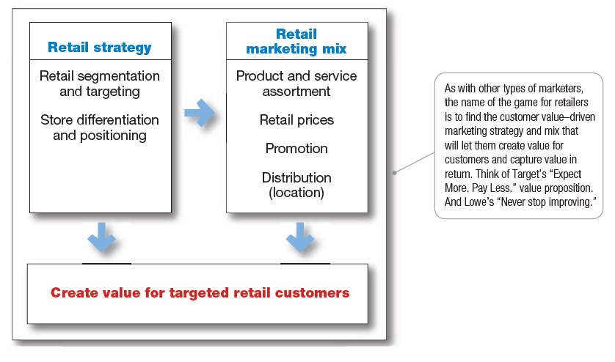
Marketing is a managerial process that creates the consumer the impression that he chooses the product freely, but which is led step by step.
Source: Kotler, 2017, p. 400
References

5G-enabled smart electricity substations to speed up switch to clean energy
https://newscentre.vodafone.co.uk/planet/how-5g-enabled-smart-electricity-substations-will-speed-up-the-switch-to-renewable-energy/
Accessed: 05.01.2022

Cambridge Dictionary
https://dictionary.cambridge.org/dictionary/english/blog
Accessed: 05.01.2022

Constellation
https://innovation.ukpowernetworks.co.uk/projects/constellation/
Accessed: 05.01.2022

Do it all in the My Vodafone app
https://www.vodafone.co.uk/my-vodafone-account/vodafone-apps/my-vodafone-app#pay-as-you-go
Accessed: 05.01.2022

Fife Council - Building a community
https://www.vodafone.co.uk/business/why-vodafone/case-studies/fife-council
Accessed: 05.01.2022

iPhone 13 vs iPhone 12: Here are the biggest differences
https://www.tomsguide.com/uk/face-off/iphone-13-vs-iphone-12-biggest-differences-to-expect
Accessed: 05.01.2022

IoT | Internet of Things
https://www.vodafone.com/business/iot
Accessed: 05.01.2022

Philip T. Kotler, Gary Armstrong, 2017, Principles of Marketing, 17th Edition, Pearson

Vodafone Business Solutions
https://www.vodafone.co.uk/business
Accessed: 05.01.2022

Vodafone 5G coverage and roll-out
https://5g.co.uk/coverage/vodafone/
Accessed: 05.01.2022

Vodafone 5G goes live on 3 July 2019 in the UK, with 5G roaming available this summer
https://newscentre.vodafone.co.uk/press-release/5g-uk-live-date-announced-5g-roaming-this-summer/
Accessed: 05.01.2022

Vodafone and UK Power Networks announce world’s first 5G substation
https://www.5gradar.com/news/vodafone-and-uk-power-networks-announce-worlds-first-5g-substation
Accessed: 05.01.2022

Vodafone best Sim Only deals
https://www.vodafone.co.uk/mobile/best-sim-only-deals?sortBy=recommended&adobe_mc_sdid=SDID%3D357963FA558F086A-612014D7F86F4712%7CMCORGID%3DBB2A12535131457C0A490D45%40AdobeOrg%7CTS%3D1641216996&adobe_mc_ref=https%3A%2F%2Fwww.vodafone.co.uk%2Fnetwork%2F5g
Accessed: 05.01.2022

Vodafone delivery
https://www.vodafone.co.uk/my-vodafone-account/orders/delivery
Accessed: 05.01.2022

Vodafone iPhone 13
https://www.vodafone.co.uk/mobile/phones/pay-monthly-contracts/apple/iphone-13
Accessed: 05.01.2022

Vodafone UK Launch New Trade-in Tool for Old Mobile Phones
https://www.ispreview.co.uk/index.php/2020/10/vodafone-uk-launch-new-trade-in-tool-for-old-mobile-phones.html
Accessed: 05.01.2022

Why Vodafone believes technology is crucial in the fight against climate change
https://newscentre.vodafone.co.uk/planet/why-vodafone-believes-technology-is-crucial-in-the-fight-against-climate-change/
Accessed: 05.01.2022

