Student name: Lee Risdale
Student number: 2117615
Module BMPF7013
Independent Study

Project Title:
What is breath support for singing, and what adjustments might be required for dynamic vocal styles?

Contents:

Introduction: 2
Occupational Context 2
Contradictions 3
Rationale 3
Relevance to Learner Needs 4
Ethical Considerations 4

Programme of Study:
Learning & Development Aims 5
Expected Learning Outcomes: Impact 5
Activities to Undertake; Methods & Resources (+Lit Review Methodology) 6
Timescales & Review Dates 7
Contextualisation of the Study (a current lit review; preliminary lit rev) 7
Limitations of Study (Impact as expected) 8
Conclusions 18
Future Recommendations 18

Assessment 2 – Written Assignment 20
References 32
Appendix 1: Diagrams 43
Appendix 2: Breathing & Singing Exercises 43
Appendix 3: Breathing Assessments 45
Appendix 4: Belt Exercises & Breathing Alignment Charts 47
Appendix 5: Respiratory Kinematics & Pitch Jumps 47-48

Introduction
Often, voice teachers teach breath work and believe that the study of breathing is the foundation and of paramount importance to good singing (Lyle, 2011). Within my own Vocal teaching practice and employment with University of Bath, I teach the basics of effective breath control applicable to all singing. I primarily work with Pop styles though also work privately with some Classical singers. These fundamentals include the importance of a ‘low breath’ with relaxed abdominals during inhalation (Doscher, 1993) and then contraction of the muscles of expiration, encouraging a high and wide ribcage with abdominal support for the diaphragm during exhalation and sustain of pitch (Thorpe et al, 2001). I have described these processes in my teaching, and I have visually illustrated them in a book which I am expanding to publish a second edition (Risdale, 2017). However, I have observed differences of teaching methodology among voice teachers (Emmons, 1988), and this can cause confusion for singers as there is much information to disseminate.
Occupational Context
This difference in teaching methodologies directly affects my teaching work with College, University, and private voice students. Many are singing Pop styles though some sing Classical, and my consideration is in developing an effective teaching practice which differentiates effectively for my students stylistically to reinforce versatility and diversity in my teaching practice. For these reasons, I intend to investigate Contemporary Commercial Music (CCM) and Classical methodologies on breath control for singing and draw a clearer understanding of how to differentiate between the fundamentals and more dynamic styles that require projection, reflecting upon their inherent advantages and disadvantages to build a more informed and effective teaching toolbox. My own teaching directions in facilitating breath work are required to be clear and deliberately rooted in scientific cause and effect to embed healthy technique and counter tendencies (Riggs, 1992) or habits that were previously detrimental to the student. Another consideration is that there will be necessary differentiation between individual students to adapt teaching directly in response to observations that require improvement of posture. There is also disadvantage in tight Sternocleidomastoid (STM) (Manternach, 2016) or Digastric muscles (Burt, 2014) as opposed to anchored muscular support which works to advantage. What exactly is correct ‘support’ for singing? Which muscles are required, and can they be trained? I aim to clarify, evidence, and apply using exercises and application within the singer’s repertoire to facilitate an effective and confident result that directly yields progress. In addition, I will be working to develop my previously published voice book with anatomically accurate instructional cues, description, and images as an accessible and informative guide to these key processes (Risdale, 2017). I aim to be mindful to differentiate my findings between One-to-One lessons and group lesson scenarios due the complexity of group teaching that demands a substantial level of differentiation between students’ tendencies and requiring various adjustments relevant to individuals. In essence, with intention to adapt between the individualised adjustments of private teaching and a more generic workshop approach as this will allow a sufficient level of progress accessible to all.
Contradictions
If we consider the breath as the source and the larynx and pharynx as the filter and resonator, Speech Level Singing, a contemporary extension of Bel Canto training, de-emphasises breath control (Buescher, 2004) in favour of enhancing the pharyngeal quality at the filter itself. Classical training was historically promoted with a strong degree of torso support (Miller, 2004) provided by Appoggio (Decharme, 2001). In contrast, Estill is concerned with variation depending on voice ‘configurations’ (Steinhauer, 2008) appendix 1, Fig.8, teaches six voice qualities that free-vary the breath. Speech Level Singing is more concerned with training vocal fold adduction and vowel modification (Riggs, 1992) though considers respiration is a biproduct of that which occurs naturally during the process of facilitating corrective and strengthening training. These contradictions lead me to consider what degree the filter plays a role compared with adjustments to breath support and sub-glottal pressure. However, there is evidence that dynamic variation (Turner and Kenny, 2010) in CCM styles requires powerfully projected voice qualities such as ‘belt,’ utilising ‘chest mix’ and this suggests more attention to breath support to steady these greater volumes. Contemporary singers will often need to stretch and challenge their ability with demanding repertoire that requires a mastery of breath control, especially with focus to execute long phrases with one breath (Miller, 2004). There is not a definitive way to teach this among voice teachers which gives way to confusion among vocalists and there is evidence of differing breathing motion between CCM and classically trained singers, requiring differentiation for contrasting vocal styles (Traser et al, 2020).
Rationale
Consequently, I wish to research how the muscles of expiration conspire effectively to produce dynamic vocal styles and so I intend to compare various philosophies of breathing. My question specifically refers to adjustments required for ‘dynamic’ vocal styles, and this encompasses to high energy vocalising characterised by belting as used in Musical Theatre and Mixed voice, sometimes referred to as Mixed Belt as used in CCM Pop styles, and how this is compared to the intensity of classical styles such as Opera singing. I consider that I may not be able to answer all the variables of voice quality for breath immediately as this may take more time to experiment and fully evidence although I seek to distinguish the adjustments that are required to facilitate greater vocal projection characterised by terminology such as CCM (Mixed voice), Musical Theatre (Belting) and Classical operatic singing. During my teaching experience I have encountered an issue with students who wish to develop their singing in both Classical and CCM Pop styles. I have also encountered a divided opinion among voice teachers as to whether the same training can facilitate both. My own respected mentor toured as lead role in Phantom of the Opera and taught that the fundamentals were essentially the same across style although there is not a clear distinction when attempting to sing dynamic louder voiced passages. There is something different going on and it comes back to the source of this power. The breath and the control of it. So, what adjustments are required and how do they differ, if at all, across these styles?
Relevance to Learner Needs
Vocalists are required to undertake songs that stretch and challenge them in the interests of progress in securing paid sessions, live performance or recording work. An effective breathing method and teaching strategies are vital to enable my students to advance with effective vocal workouts and tools for the contemporary singer (Peckham, 2005). With this I hope to define a clearer teaching strategy, building upon my previous research with descriptive, science correlated mental imagery (Risdale, 2023) to enhance technique. Due to the diverse methods of teaching breathing including Classical, Estill and Speech Level Singing, confusion exists, signalling a need for specific imagery that correlates with scientific fact to embed muscle memory (Emmons, 1988). Imagery has been nefarious in the past (Carter, 1993) but can be connected to scientific fact enabling exercises and imagery cues (Risdale, 2023) that clarify technical aspects of skill building (Carter, 1993), motivating and empowering vocalists to tackle challenging repertoire and reach their full potential.
Ethical Considerations
The results of my findings and revealed solutions must only be applied foremost with the benevolence of the individual student in mind. That requires differentiation, observation, and mindfulness of the student in question and understanding that one size does not fit all, whether technically or stylistically. It depends upon each individual singer, their experience, and their current habits, whether advantageous or not. We should never attempt to fix what is not broken. Alternatively, a well-trained habit, may be an advantage in one style and yet disadvantageous to another; for example, a singer with classical training attempting a contemporary modern pop song, and vice versa. I am conscious of moving away from the ‘one size fits all approach’ (Bartlett and Naismith, 2020). I will also be mindful of not over-working voices too soon. That is, indulging students who are too eager to progress and attempting challenging songs without mastering the fundamentals. An airflow to muscle balanced ratio is desirable whereby an imbalance may cause strain, when using too much airflow, too soon. (Riggs, 1998). The relationship between the source (Breath via lungs and diaphragm) and filter (Vocal folds and larynx) may be key to my study.
Learning & Development Aims
My first study task will be to explore and identify the muscles of inhalation and exhalation. This is necessary to establish a thread that correctly connects the key muscle groups to specific research and results. It is also my ethical responsibility to isolate specific muscles where necessary and their relationship (Pettersen & Westgaard, 2004) to facilitate a coherent system of exercises with view to creating a reliable training method for developing excellent breath control with my students. Nix discusses overload, specificity, individuality, and reversibility as key considerations for best practice and applying exercises that use motor learning (Nix, 2017) appendix 2, p33. For example, where a tight overworking of the abdominals without recoil, restricts recovery from a breath (Baldy, 2010). Isolating the function of specific muscles may facilitate greater awareness of application.
Secondly, I seek to identify the prevalent methodologies for breath control and compare them to differentiate their benefits contextually within the boundaries of CCM singing compared to Classical singing.
Thirdly, I seek to identify a range of breathing exercises to differentiate among voice qualities such as ‘belting.’ This is with a view to complete a later systematic study which would enable me to compile a tested library of tools: Imagery, illustration and kinaesthetic cues that may be combined to communicate an effective exercise training programme. This will potentially have a positive effect of streamlining my teaching practice.

Expected Learning Outcomes
My expectation is to confidently know the muscles of inhalation and exhalation. This will cement confidence in my teaching. Firstly, in sharing clear referencing and terminology to establish the confidence of my students. Secondly, to define the actions of each muscle strategically in the direction of pragmatic cause and effect vocal training.
I also seek to gain greater awareness of various breathing methodologies for singing and each of their contextual benefits and disadvantages.
My further intention is to collect a range of exercises and techniques to develop greater breath control while being able to differentiate between them to meet a specific objective, such as a belting quality.
My ultimate expectation is to become equipped to create and facilitate a robust breathing exercise programme for singers that can be integrated with other voice exercises to use effectively in vocal lessons and workshops.

Activities to Undertake; Methods & Resources (& Literature Review Methodology)
I will outline three possible methodologies and explain my reasoning for my final choice.
A Narrative or traditional literature review (Jesson et al, 2011) would allow me freedom and flexibility to explore and clearly define my topic, search for relevant academic literature, organise a logical structure and then interpret, discuss, and evaluate the relevant literature to form conclusions. I am aware there is already much literature on this subject, and it is my intention that this review methodology would provide a stronger awareness of historical context and contemporary thinking from both scientific journals and also peer reviewed Grey literature that sets the scene (Jesson et al, 2011), enabling me to learn and consider a variety of beneficial exercises within my vocal studio.
In addition to this, it may be beneficial to consider my findings with a view to conducting a future Systematic review measuring efficacy. A self-contained research project locating existing studies, reporting the evidence to allow reasonably clear conclusions to be reached (Denyer, 2009). That is, to improve the quality of the narrative by borrowing from systematic methodologies to increase rigour, compiling a spreadsheet for future testing exercises with participants to add weight to prior knowledge, aimed at reducing bias in selecting articles for review (Ferrari, 2015). This may allow me to explore and compare the effectiveness of breathing methods using vocal exercises from considered academic literature while conducting an ‘experiential’ qualitative review aiming to investigate the experience or meaningfulness of breathing practices in view of the participants as I did previously with my vocal imagery review (Risdale, 2023). This would follow well when I have received a strong grasp of conclusions in my narrative review though I would wish to test this with a significant collection of participant vocal students to be confident of results and organise to conduct the experiment at a future date (Appendix 4, Fig. 2 example).
An integrative review method has the potential to allow for diverse primary research methods, becoming a greater part of evidence-based practice (Whittemore & Knafl, 2005). Methodological strategies specific to an integrative review method could further enhance the rigour of the process, perhaps more than a systematic review. It is further suggested that the integrative review method is the only approach that allows for the combination of diverse methodologies that includes experimental and non-experimental research (Whittemore & Knafl, 2005).
In view of these methodologies, in my desktop study I have decided to follow of a Narrative review method which will also consider elements of a future Systematic review, considering how these can both complement each other (Collins & Fauser, 2005) to analyse and compare effectiveness of breathing teaching methods. I choose this pragmatically due to time constraints and a desire to focus on disseminating the current extensive literature on this subject although I am in favour of exploring literature to prepare for conducting a systematic or integrative review in the future that reveals further evidence to support and validate breath for voice discoveries to streamline my teaching practice.
Timescales & Review Dates
January 30th - Read Brief and Observe Video Content. February 28th – Tutorial; Finalise Title & Structure Assignment, Work on Part One; March 30th – Study and Collect contextual resources; April 30th - Meet with Tutor & take notes. May 17th - Develop Part 2 & Submit Draft. May/June: Complete and make adjustments following feedback; Submit Independent Study.
Preliminary Literature Review
Our vocal folds require airflow to phonate and create pitch. This is supplied by the lungs with the action of the diaphragm, a large dome-shaped muscle. The diaphragm requires support for the job of singing from the abdominal muscles, intercostal muscles between the ribs besides further anchoring muscles, each playing a part to deliver air pressure for phonation, known as subglottal pressure (Thorpe et al, 2001). Although teachers and students studying singing may not master all of the anatomical systems of respiration, they do require at least a minimum level of knowledge about muscular action during the vocal processes of singing (Kim, 2005), including knowledge about the muscle groups and posture. So how important is the breath in singing? It depends on the length of the phrase, when we took the breath, what we’re doing with the vocal folds; breathy or clear tone, how loud we are singing, sustained or choppy, or consonants interrupting and stopping airflow. Most importantly though, we need the breath to vibrate the vocal folds and sustain the pitch (Kayes, 2022).
Passive breathing is very different from the more complex active breathing required for singing that uses gravitation, resistance, and elasticity forces (Sundberg, 1992). The muscular effort required can be simulated with the assistance of specific exercises.
For this purpose, I am going to study and compare Speech Level Singing, Estill, and Classical methodologies to discern their philosophy on breath support, besides related exercises that isolate these specific muscles.
Reviews of historical breathing practices for voice pedagogy have explored interdisciplinary connections achieved when applying body alignment/posture and breathing work in dance. The methodology developed for young opera singers including The Swan Method suggest the benefits of transferable skills to singers’ stamina for voice production (Edwards & Swan, 2020).
Isotonic exercises, as taught by classical Italian masters produce movement whilst Isometric exercises increase tension in muscles without moving the body part. A study involving the effects of these exercises found that singers received many positive benefits when incorporating a regular vocal exercise routine that encouraged efficient glottal closure and in turn caused better efficiency of breathing support (Sabol et al, 1995). However, this also concluded a need for future research that may shed more light on a more personalised exercise regimen that considers the current position and individual needs of the singer.
Isometric exercises include ‘Messa Di Voce,’ a specific pitch begun with a crescendo and sustained at forte, then ending with a diminuendo. This can only be achieved using a controlled increase and decrease of sub-glottal pressure, a natural rise and fall in trans glottal airflow supported with an appoggio technique (Gregory, 2019). Differing from Isotonic exercises, Isometric are single, full muscle group contractions sustained for several seconds. Contrastly, Isotonic exercises (Sabol et al, 1995) allow vocal folds and intrinsic larynx muscles to change length at a slow rate and Calisthenic type exercises use many short contractions. Less agreement exists on exercises that use minimum tone in the soft part of the dynamic range, although further research suggests a benefit to the exercise of sustaining a vowel at the same frequency at low lung volume (Shipp et al, 1987). This demonstrates higher cricothyroid activity to keep the pitch constant at low lung volumes (50%), causing a rise in sub-glottic pressure to compensate (Rubin et al, 2006).
A ‘belly-in’ or contracted abdominals method was compared to a ‘belly-out’ relaxed abdominals method to examine inhalatory abdominal wall conditions (Hixon & Hoffman, 1978). The ‘belly-in’ method disadvantage being that the abdominals ‘already contracted’ have lowered efficiency for expiratory force. With ‘belly-out’ the diaphragm may be stretched at lower volumes and significant effects of lung volume were found. High lung volume was associated with higher subglottal pressures affected by a ‘belly out’ method, accessed by low breath, relaxed abs recoil.
Appoggio, using both ‘belly-in’ and ‘belly-out’ as taught in classical technique, poses certain advantages (Indik, 2009). It strategically brings support to the voice at the end of a breath supporting a sustained pitch, when pulling in the internal abdominals to steady the diaphragm (Indik, 2009). Appoggio incorporates glottal resistance and resonance balancing, besides breath management teaching a strategy to find a resonating space that complements the pitch, volume, and vowel, matching it with just the right amount of breath. Not too much, not too little (Robbin, 2014).
A study of respiratory dynamics found that during phonation experienced singers squeezed their lungs more effectively than amateur singers when exhaling and that different parts of the diaphragm were engaged during phonation than when simply exhaling or speaking (Traser et al, 2017). As this differs from passive breathing or speech, it suggests there is more going on than merely airflow pressure. The study indicates that phonation ‘back pressure’ appears to be linked in engaging the additional support (Traser et al, 2017) in turn affecting more diaphragm muscle and this may provide rigour to Titze’s semi-occluded vocal tract exercise that I will include later (Titze, 2021).
In analysing the position of Speech Level Singing (Riggs, 1992) which values awareness and engagement of specific larynx muscles to attain balance in the voice, we might consider that prioritising larynx muscular balance could also bring balance to breathing muscles as a positive biproduct. Perhaps over-breathing may hinder the singer. For example, the balancing of the antagonistic relationship between thyroarytenoid and cricothyroid muscles in bridging registers may make the breathing and consistency of airflow task much easier. This is echoed by a text in collaboration (Marafioti, 1981) with legendary opera singer, Caruso, which conveys the principle that breath is indispensable but not the essential power and that the function of singing develops the breathing apparatus. This insists that singing develops breathing, not breathing, singing. Perhaps this describes subglottal pressure (source) in collaboration with an efficient phonatory back pressure provided by the vocal folds (filter) and vocal tract (resonator) (Titze, 2004).
Dynamics in singing suggest the requirement of a variation in breath support and air pressure. I am cautious to over-emphasise and favour ‘breath work’ over other vocal exercises (Riggs, 1992) as this may be consequently to the detriment of the student (Bunch, 1982). Some singers become so fixated on breath control that they do not breath out enough (Kayes, 2004). Seeking to balance the voice using SLS type exercises that make use of consonants and vowels to equalise compression (Riggs, 1992) might be as vital as the breath work itself, suggesting an integration of processes is required to necessitate healthy vocal training. Similarly, to the Isometric exercise study (Sabol et al, 1995), this would also depend upon the assessment of the student by the teacher as all voices are not the same and are prone to unique ‘tend-to’ characteristics (Riggs, 1992) such as aspirate or over-compressed vocal fold onsets. The breath is vital but still only one connective part of the vocal anatomy.
Interestingly grammy-award winning CCM Soul vocalist, Michael Bolton trained with Seth Riggs who created the vocal technique Speech Level Singing (Riggs, 1992). Riggs has worked with performers such as Prince, Michael Jackson, Stevie Wonder, Ray Charles, Madonna, and Barbra Streisand. Interestingly, while working a classical piece, Nessun Dorma, a different genre than Bolton is used to singing, Riggs worked with him to adjust his technique, focusing on a low breath, belly out technique with a gradual release or gentle pulling in of lower abdominals that he describes as a ‘dropping (abs) into the pelvis’ as a gradual controlled release. This correlates to appoggio technique (Indik, 2009) that provides a balanced airflow for sustained notes, allowing the vocal folds to vibrate from a rested position ‘in the middle.’ It suggests that Michael had been used to ‘belly in’ abs engagement during touring which although tiring allowed him to sing in the CCM Rock and Soul style he was accustomed to. This approach is similar but there may be an important distinction here as CCM belting as used in Pop and Musical Theatre appears to utilise a ‘stack-up’ from abdominals to lifted and wide ribcage, lower ribs expansion which gives some control over breath from the internal intercostal muscles to increase airflow (Leborgne and Rosenberg, 2019).
What training can help differentiate these methods? Balancing type exercises used in CCM (SLS) focus upon registration and strengthening bridges and range, initially with emphasis on laryngeal development, teaching that the ability of the vocal folds to resist air pressure is relative to volume increase (Riggs, 2009). Original Bel Canto Classical training emphasises Appoggio, whilst cross training from other disciplines, such as Dance or Sport suggest exercises that may also benefit singers.
Critical Reflection – Classical Breathing methods descending from Italian Bel Canto masters; Appoggio, belly-in and belly-out, Isotonic, Isometric, Messa Di Voce, are thorough and complex compared to CCM methodologies; Estill and Speech Level Singing emphasise balance between airflow and phonation, the exercise of intrinsic larynx muscles and training of voice qualities relevant to style and vocal dynamics. The adjustments of subglottal pressure and the relationship with the support muscles to access that, appear to be unclear though in these methodologies and require further clarification that informs teaching practice.
How can the teacher distinguish between balancing exercises and projection exercises that encourage resilience and stamina for qualities such as belting? Specifically, what adjustments need to be made with breath control to support this dynamic change? What is the role of sub-glottic pressure and how can the breath be adjusted and enhanced to approach these contrasting vocal dynamics?

PART TWO
In this section I intend to dissect the muscles of inspiration and expiration specifically involved for breath control in singing, their role in adjusting sub-glottal pressure, anchoring and learn how the effect of these adjustments can access greater projection for vocalists. I will also consider and compare existing methodologies on breath work and form conclusions about adjustments required for greater projection in performance.
Which muscles for which task?
Inhalation activates the diaphragm, receiving a low into belly breath (releasing abdominals) with expansion of ribcage intercostal muscles to allow the lungs to inflate. Expiration follows and in singing this is a controlled balanced air pressure assisted by the abdominal and intercostal muscles, supporting the diaphragm. Voices are produced by a three-part Source-filter system comprising Power source (Lungs, trachea) Sound Source (Larynx, Vocal Folds) and Sound modifier or Filter system (Pharynx, Oral Cavity, Nasal Cavity) creating a glottal source and source filter interaction (Fruuolz and Belin, 2018). The power source initiating sub-glottal pressure is the breath itself. We will reverse to the original breathing mechanism to consider adjustments to this pressure.
It is important to identify which muscles are required for each breathing task, specifically when identifying the muscles of inhalation as opposed to exhalation. This is especially poignant when experience clearly demonstrates that breath control for singing is often a dynamic and athletic activity requiring a certain mastery and self-discipline, mindfulness, and much practice (Indik, 2009). We can begin by separating the muscles of inspiration from the muscles of expiration. Upon inhalation, the external intercostal muscles between the ribs assist the diaphragm, a dome-like muscle which contracts and lowers into the floor of the ribcage to allow the lungs to inflate up to 20cm beyond their resting position (Sundberg, 1992). See Appendix 1, p28.
The key muscles of exhalation include the internal intercostal muscles and the abdominal muscles which work together to provide support to the diaphragm in creating subglottal pressure as it returns towards its original position (Sundberg, 1992) Appendix 1; figures 2&3. Muscular, elastic, and gravitational forces are at work and the lung volume is increased and decreased using these respective muscles. The sub-glottic pressure can exert a pressure on the abdominal wall but expansion can be resisted by contracting the abdominals. (Sundberg, 1992).

Sub-glottal Pressure
Experiments show that subglottal pressure; the air pressure in the lungs that supplies the energy for phonation, affects not only the loudness but also the pitch (Sundberg, 1992). A raised subglottal pressure raises the pitch, in contrast to a lowered subglottal pressure which can flatten the pitch, creating the consequence of singing flat. Sub-glottal pressure must be tailored by the singer as it affects both pitch and loudness. Such is the importance of refined breath control.
How does this affect the action of the larynx Cricothyroid (CT) muscles that contract to affect pitch between thyroid and cricoid cartilages? A trachea-pull, that may occur at the end of a ‘belly-out’ co-contracted diaphragm phrase was found to affect the CT mechanism, indicating how a singer’s neural system takes much into account to meet a target pitch. Higher CT activity was found when using a ‘low diaphragm’ induced by high lung volume (Sundberg & Leanderson, 1989).
Hixon suggests that the most important aspect of breath control for singing is maintaining a balance of sub-glottal pressure to maintain the desired tone, pitch, and dynamic level and this is supported by resistance from the abdominals and intercostals (Hixon, 2006). Agreeing that inspiration is actioned by the diaphragm assisted by external intercostal muscles (ribs), he cites the expiration muscles as internal intercostals (ribs) with abdominal support: from the transversus abdominus and rectus abdominus, and the external and internal obliques (Hixon, 2006).
Singers can engage the intercostals and diaphragm to resist the abdominals so that the exhalation will be slow and steady. With lower ribs expanded, this may appear as though you are not expending any air at all (Vennard, 1967) Appendix 1 Figures 3-4. Using Electromyography (EMG) and biofeedback; the process of gaining greater awareness of many physiological functions of one's own body by using electronic equipment (Huang et al, 2006), it was corroborated that during phonation, professional opera singers activate Trapezium and Intercostal muscles to higher levels than student singers and this highlights a need to train development of these finer muscles processes to enhance expiration during energetic singing (Pettersen & Westgaard, 2005).

Anchoring
There are also accessory anchoring muscles which assist respiration. For inspiration these muscles are found in the neck, specifically the Scalene working together 25% more active to pull the ribs upwards and the Sternocleidomastoids (SCM’s) appendix 1; fig.3 are 70% more active; both acting to stabilise the head and neck position (Campbell, 1970) and confirmed in later studies (Watson et al, 2012). Measuring electromyographic activity (EMG) was recorded from the upper trapezius, the sternocleidomastoids, the scalenus muscles and the muscles in the posterior neck area (Pettersen & Westgaard, 2005). This also concluded in that when singing the highest pitch, activity of all neck muscles was significantly elevated, suggesting a requirement for anchoring using these muscles (Watson et al, 2012).
Anchoring muscles play a necessary role in support of louder singing (Kayes, 2000) and some practitioners agree that both vocal tract anchoring, and breath support muscle anchoring is necessary, especially for louder singing characterised by belting; Kayes later advocates support via a muscular voice-body connection. Something completely different from breath support, "anchoring"(Johnson, 2006). In addition, she provides exercises to develop awareness of these muscles. Sternocleidomastoid and Semispinalis Capitis muscles (Risdale, 2017) Appendix 1; fig.3, help stabilise the vocal tract (Watson et al, 2012) which can be corroborated (Pettersen, 2005) and in the case of breath support torso anchoring is required to stabilise the ribs, spine, diaphragm, and pelvis. Stabilising the back of the torso so that the front (ribs) can pull up and abdominals move back is achieved with help of Latissimus Dorsi (Lats) and Quadratus Lumborum (Quads) as well as iliocostalis and Serratus posterior inferior muscles in the back.

Existing Methodologies of Breath work
My literature review seeks to identify a range of methodologies on breath and compare their breathing philosophy for singing. These include Patsy Rodenburg, Arthur Lessac, Catherine Fitzmaurice, Jo Estill, and Seth Riggs.
Fine tuning the senses to create improved awareness of muscular processes is increasingly desired in voice training. Lessac’s Kinesensic feeling process (Hurt, 2014) is focused upon inner sensing of physical bodily sensation to complete a required task and offers methods to develop breath support, emphasising deep breathing and posture. The Acoustic Voice Quality Index (AVQI); a construct for quantification of overall voice quality based on analysis of continuous speech and sustained vowel (Hosokawa et al, 2017), and the Acoustic Breathing Index (ABI); evaluation of breathy voice quality, evidence suggests that this work enables singing voices to become significantly more resonant (Grama et al, 2021). Training focuses upon stretching, bodily awareness and physical relaxation teaching the premise that a tense body holds the likeliness of a psychologically tense singing apparatus and in contrast when the body is relaxed the mind is psychologically open (Hurt, 2014). Lessac described how during healthy vocal fold adduction, virtually all the breath is transformed into sound waves or voice (Lessac, 2012). This proposes an insight into the need to achieve balance within a voice and the balance of airflow, correct muscular support and posture, combined with healthy vocal fold adduction to achieve this balance. Although this is primarily used to treat conditions such as dysphonia, it also poses a strong case for prevention rather than cure. That is, the importance of a practice routine that preserves the voice and develops healthy habits.
Rosenburg’s teaching with singing actors advocates that proper voice work is very physical. ‘Breathe deeper and deeper, lowering the breath down into the groin’ (Rodenburg, 2018). Most vocal abuse is caused by not using abdominal and anchoring support muscles. She further advocates releasing on a light ‘s’ to relax and release the abdominal support muscles, enabling the recoil breath to prepare for abdominal support as the first consideration, and describes how a vocalist compensates when losing support, consequently squeezing the last ration of air from their lungs while larynx muscles create tension (Rodenburg, 2019). This is corroborated with analysis that indicates the diaphragm can act as both a fixator and as an agonist when remaining relaxed so that abdominal pressure increases (Maclem et al, 1978), later confirmed (Loring and Mead, 1982), and further experiments that measure elastic recoil suggest a fast inspiration induces greater change in elastic recoil and expiratory muscle activation (Tzelepis et al, 1997).
Hillmer, later identifies a difference in explanation between Lessac and Rodenburg (Hillmer, 2013). Rodenberg described the air entering the lungs as the first cause (Rodenberg, 2002), while Lessac (Lessac, 1997) described the low breath and ribcage expansion initiating the diaphragm contraction that beckons oxygen to fill the lungs to equalize the Co2 pressure. However, they both agree that there should be no movement in the upper chest. Hillmer also identified there to be a dominant teaching of ‘deep breathing’ among voice practitioners within the industry although during an Estill workshop encountered that breathing is ‘task-related’ (Hillmer, 2013). The Singing Athlete (Byrne, 2020) supports this view providing examples of assessments and exercises to improve breath control and illustrates that a key to better singing is when singers can become more confident with having more Co2 in their lungs and beginning to manage the habit of over-breathing that can cause hyper-ventilation. In effect, the survival driven brain thinks that even a small rise in CO2 is threatening, thus keeping us over-breathing although a singer requires good ‘air-hunger tolerance’ to achieve long sustained notes. Could sub-conscious panic over rising CO2 levels cause singers to over-breath when they might realistically be able to exhale for significantly longer? Byrne uses breathing drills (Appendix 3; p21-22) to make singers voluntarily breathe less and become less afraid of not having air (Byrne, 2020).
‘Restructuring’ is a technique that seeks to support the voice more effectively by accessing enough sub-glottal pressure due to engaging the Transversus deeper layer of abdominal muscle that is also used to ‘pull in’ and compress the stomach (Fitzmaurice, 2003). I wish to explore and question this further; particularly as other teachers point towards ‘leaning out’ with the abdominals which appears to be contradictory. So, which is it? A Systematic Approach brings attention to an outward (but not rigid) engagement of abdominals at the beginning of exhalation which follows to an inward tuck of the transversus at the end of a phrase, all the while maintaining a buoyant ribcage expansion (Ragan, 2020). This deeper layer of muscle (Transversus) is seldom used as it is mainly used to compress the stomach contents. Tucking it in on the exhale, however, helps voice support (Kotzubei, 2005).
‘Destructuring’ involves exercises that take singers out of a ‘response to a problem is to tighten and hold your breath’ and into deepened breathing that gathers access to necessary support muscles and improved neurological alertness (Fitzmaurice, 2003). This also involves some shaking which is a healing response of the body to perceived stress and besides its use in deepening breathing, it also enables release of tight muscles (Fitzmaurice, 2003).
Estill’s compulsory figures for voice and figure combinations for six voice qualities. Estill maintains that the breath will ‘free vary’ depending upon the larynx and resonators. This correlates with Speech Level Singing de-emphasis of ‘breath’ as compared to laryngeal and vocal fold focus (Steinhauer, 2008). Yet, there does appear to be more effort required to belt as opposed to ‘speech quality’ so it leads me to question support and subglottal pressure.
What is support exactly? It can mean airflow and breath management or muscle work in the body to assist the vocal tract. It can also mean both (Kayes, 2000). Passive inspiration is very different from ‘active.’ Rather than signals from the brain to contract the diaphragm on inspiration and its relaxing back to its dome-like position on exhalation, active inspiration needs to be faster for speech and exhalation slowed down and extended.
Factors that affect expiration include changes in subglottal pressure (Titze, 2006), changes in voice quality and the demands of the style and text as pertains to breath use. Kayes considers that singers either struggle with not breathing out enough or not allowing the breath to ‘drop in’. Exercises to combat this include an elastic recoil (Smith, 1981) and the diamond of support (Kayes & Cook, 2009).
A call for observation and awareness is required when teaching breath work. The Lovetri Method, rather than prescribing specific exercises, gives the teacher an understanding of how to construct exercises of their own to serve the present needs of the student (White, 2017). This promotes the openness of the ribcage, the flexibility of the diaphragm through relaxing the abdominal wall upon inhale and filling the lungs from the bottom, allowing movement of lower ribs and the intercostals develop more strength to resist exhalation.
CQ (closed quotient) of vocal fold closure is greater in mix than head voice, belt being higher CQ (Bourne & Kenny, 2015). Further to this, distorted singing applicable to rock CCM styles was shown to require significantly higher sub-glottal pressure. However, alternative experiments in view of CQ have found that trained singers CQ was higher regardless of sub-glottal pressure than untrained singers (Yeo et al, 2018) suggesting that their training had strengthen larynx muscles and closure to supply a significant advantage.

Enhancing variations of Sub-Glottal Pressure
To create a moderate tone, the vocal folds require around 10cm H20 pressure while a crescendo requires 50-60cm (Proctor, 1980). Lung capacity varies from 35-45% in quiet respiration, 35-65% in Speech and up to 80%+ in loud speech and singing (Hixon, 1973).
How can the Sub-glottal pressure be enhanced? Perhaps sometimes airflow can seek assistance. Semi-Occluded vocal tract exercises (SOVT) appear to be an answer to this question with the discovery of vocal tract inertance. This is a condition where increased acoustic pressure above vocal folds during the open phase of vocal fold vibration along with decreased acoustic pressure during the closed phase helps create a push and pull motion, sustaining vocal fold oscillation with a lower sub-glottic pressure (Titze, 2006). This means less effort and greater efficiency of airflow and vocal output, boosting harmonics and helping achieve a wider range of frequency. When singing with the vocal tract in the shape of a semi-occlusion, inertance results creating lower resonances. This acoustic effect is created and therefore vocal tract resonances are lowered. This increases interaction between the vocal folds and the vocal tract, reflecting soundwaves back and boosting acoustics across a range of pitches (Titze & Abbott, 2012). This might be compared with a contrasting approach of a reduced-flow model for vocal fold vibration which aims to calculate improved outcomes with 3D FSI simulation for voice disorders and restoration (Chen et al, 2020). This is perhaps in the interests of rehabilitation rather than in the SOVT forward process of building stamina, although this does suggest scope to study acoustics and the effects of varying sub-glottal pressure here which may provide further evidence to explain whether a variation in dynamic breath support is warranted for high-energy singing. To date further experiments are ongoing although there is evidence showing maximum output with minimum stress on the vocal folds through SOVT work (Calvache et al, 2019) appendix 1, fig. 8) and examining the source to filter interaction (Calvache, 2021).

Belting
An EEG experiment with a vocalist singing over two octaves investigated six voice qualities including Speech, Falsetto, Cry, Twang, Opera and Belt learned that the intrinsic vocal folds are vibrating differently for each vocal quality, suggesting that a different airflow pressure may be required for each differing voice quality (Estill, 1988). EMG data also revealed marked differences in the action of extrinsic muscles for each voice quality.
EEG data of the glottal contact area revealed vocal fold closure at the longest closed quotient of 70% per vibratory cycle during the belting voice quality. EMG also suggested a difference in airflow and sub-glottic pressure during Belting and Opera qualities (Estill, 1988). Perhaps this suggests that a flexibility of posture regarding muscle engagement for breath support may be required depending upon the vocal task demanded.
A main difference between Classical and Belting involves the extrinsic muscles including how the Thyrohyoid (Bringing the hyoid and thyroid cartilages closer together) are accessed during belting, suggesting anchoring or stabilising of the Thyroid to allow a cricoid tilt for flexibility such as elevation of the larynx. This decrease in tension is to allow for safe belting. Classical expects a ‘dark quality’ maintained during a higher value of infrahyoid force. The Classical singer makes a conscious effort to lower the larynx whilst in Belting the singer does not. Results reveal that a belter must work significantly harder than an opera singer with both their vocal folds and extrinsic muscles (Estill, 1988).
Belt is characterised (in contrast with classical) with differing acoustic and physiological parameters; a vocal fold adjustment in a thick fold’s ‘chest’ setting, larynx position high to very high, a medium frequency range and a high sub-glottal pressure (Schutte & Miller, 1993). Falsetto, for example requires less sub-glottal pressure. Therefore, this important evidence suggested a significant change in breath support and perhaps posture required for a dynamic belting voice quality.
It is later correlated that belting is characterised by a higher subglottal pressure, a higher degree of adduction, higher larynx position and a higher formant frequency with appropriate vowel tuning (Titze, 2011). Exercises to promote this are contained in Appendix 4.
Measuring diameter changes of the ribcage and abdomen demonstrated the abdominals to be a posturing element that support diaphragm and ribcage for the best performance, the ribcage acting to regulate pressure-flow and the diaphragm’s inspiratory function is simply to reinflate the lungs (Watson & Hixon, 1985).
Two distinct sounds for comparison include Belt and Legit. They each contain different technical requirements. Singers describe belt as heavily weighted, with thick folds, thyroarytenoid-dominant, or chest register (Bourne & Kenny, 2016) though breathing techniques require continuing investigation to learn more and progress healthy and efficient voice function in musical theatre singing as contrasts with alternative styles.
A study to evaluate the belt voice quality of musical theatre singers found vibrato and ring (twang) to be most highly evident and this in turn correlated with perceived loudness (LeBorgne et al, 2010).

Conclusions
We are often taught that our breath controls the sound, yet this can only be achieved when we also have control of the sound and the body. Movement of the abdominal wall affecting subglottal pressure, besides strengthening of the ribcage and anchoring support muscles can take time to develop and achieve (Lovetri, 2002).
By the end of the twentieth century Voice science had established a very clear difference between technique and style. One size does not fit all. Science in pedagogy demonstrates that Classical singers are using a different process to CCM singers (Hoch, 2018). The transition from one style to another is too vast. If technique is dependent upon ‘style’ then it is appropriate to adjust the teaching method and exercises to meet the style of the singer. Concerning breath control this relates to sub-glottal pressure and airflow considerations in relation to CQ (Closed quotient).
Discoveries in acoustics and inertance help to enhance this sub-glottal pressure (Titze, 2018). It is with high energy styles such as musical theatre belting and CCM that significant adjustment in ‘breath support’ facilitating higher sub-glottal pressure is required (Titze, 2011)

Future Recommendations
Breathing for singing and the adjustments pertaining to style is a complex consideration so there are various factors to be aware of when teaching breath work. As a teacher we are truly listening to the student and observing where their present technique stands and how to move them forward. The fundamentals of breath work can be taught to a degree although much is affected according to vocal style and care should be taken to negotiate these adjustments which originate from anchoring the appropriate muscles to facilitate higher sub-glottal pressure and adjustments with the vocal tract. Further investigation via Systematic review is recommended to cement greater understanding in this area.

Assessment 2 – Written Assignment

Project Title:
A study into dynamic breath support for singing and the adjustments required for dynamic vocal styles

My intention is now to analyse and critically evaluate these methodologies specific to breath support and consider the potential impact of learning applied to my performance and professional practice, besides the achievement of my objectives in writing and illustrating a book and providing excellent vocal training.
My choice of a narrative or traditional literature review (Jesson et al, 2011) allowed me the necessary time to observe academic literature, organise my structure, and connect relevant information to evaluate and form conclusions. In addition to this I understand that it may be beneficial for my practice to conduct a future Systematic review (Roy et al, 2013) of ‘effectiveness’ examining breathing support methods and associated exercises to consider application with differentiated vocal styles. Adding weight to prior knowledge and aimed at reducing bias in selecting articles for review (Ferrari, 2015), I would aim to do this pending ethical clearance with a cohort of at least twenty vocal students that will bring the rigour of quantitative besides qualitative data to an experiment.
My investigation begins with Italian Classical master’s methodology which relied heavily upon Isotonic and Isometric exercises (Sabol et al, 1995), Isotonic encouraging contractions to change muscle length, and Isometric increasing tension without movement and no change in muscle length. It benefits with a four-week vocal function exercise program showing successful results (Sabol et al, 1995), strengthening and toning larynx muscles, improved co-ordination, increasing the power of inspiratory muscles, and enabling strength and endurance during exhalation (Price, 2003). Voice function exercises increase glottal efficiency, reducing the potential of sustaining vocal injury and experiencing vocal fatigue (Weiss, 2002) and establish a strong foundation of breath work allowing students to feel and engage key muscle groups.
Breath work when controlled (Doscher, 1993), complements registration and brings balance to a voice (Miller, 2000). Vocalists should "lighten up" (Unger, 1990) referring to a thinning of the vocal fold mass as described in Speech Level Singing (Riggs, 1992) as singers ascend in pitch and they should not add volume or muscle blocking (Unger, 1990). Instead, students can develop laryngeal muscles that boost acoustic formants and make use of contraction of the cricothyroid to lengthen vocal folds (Welch & Sundberg, 2002). This could suggest maintaining consistent glottal pressure is sufficient when ascending in pitch and attempting to belt when these larynx muscles and vocal fold resistance are trained correctly, considering the thyroid tilt enables a rise in subglottal pressure (Rubin et al, 2006). Alternatively, a controlled reduction adjustment of sub-glottal pressure can achieve a lighter tone quality. Kayes considers that the most important part of breathing for singing is maintaining consistent subglottal pressure for the desired sound quality, dynamic level, and targeted pitch range (Kayes, 2019).
I first began to explore and identify the key muscles of inhalation and exhalation believing this to be the foundation for creating an effective breath assessment for singers and encourage students to connect more confidently with these breathing ‘support’ muscles.
I have identified key muscle groups of inhalation and exhalation and compiled appropriate exercises to define cause and effect. I have established that the external intercostal muscles between the ribs assist the diaphragm upon inhalation, which contracts and lowers into the floor of the ribcage to allow the lungs to inflate (Sundberg, 1992). See Appendix 1., internal intercostal muscles and the abdominal muscles which work together to provide support to the diaphragm in creating subglottal pressure as it returns towards its original position (Sunberg, 1992) Appendix 1; figures 2 &3: A belly out method appears to have more advantages in that the abdominals are relaxed upon inhalation allowing for a ‘low breath’ to drop in uninhibited and then become supported by contracted abdominals to facilitate greater diaphragmatic support.
Dynamics are also key to expressive singing which can draw upon some classical type exercises, particularly ‘Messa Di Voce’ (Titze et al, 1999), a specific pitch begun with a crescendo and sustained at forte, then ending with a diminuendo (Pulte, 2005). Therefore, I intend to use such exercises that encourage a controlled increase and decrease of airflow (Appendix 2). Isometric, full muscle group contractions sustained for several seconds will encourage a consistent support by contrast and develop a level of stamina in accessing the abdominal and intercostal support. Contrastly, Isotonic exercises (Sabol et al, 1995) allow laryngeal muscles to change length and Calisthenic type exercises use many short contractions. This will encourage balance between larynx and breath that is necessary to engage a healthy voice in response to balanced sub-glottal pressure.

Sub-glottal Pressure
Another important consideration that directly affects the way I teach is related to sub-glottal pressure, particularly in how it affects not only the loudness but also the pitch (Sundberg, 1992). If a raised subglottal pressure has tendency to raise the pitch, in contrast to a lowered subglottal pressure which can flatten the pitch, it suggests that sub-glottal pressure must be tailored by the singer affecting both pitch and loudness. This is relevant to my teaching for breath control assessments in the studio, and I could include exercises to give singers a stronger grasp and awareness of this. Although balance of airflow to maintain a consistent subglottal pressure is desired for heathy singing there are adjustments that can be made to facilitate belting or more intense CCM styles. These adjustments are activated with the muscles of expiration, intercostal muscles between the ribs and abdominals that compress the airflow via the diaphragm to squeeze out a higher pressure (Sundberg, 1992). I need to clearly differentiate between ‘belly out’ appoggio singing that encourages consistent support with balanced sub-glottal pressure, and a more athletic driving breath that can be combined with thick vocal fold resistance (Miri, 2019) in combination with Singer’s formant (Sundberg, 2010) to create greater projection. Research experiments suggest that significant vocal projection is accessed by increased activation of medially acting abdominal muscles (Thorpe et al, 2001).
When using a ‘belly-out’ higher lung volume and low diaphragm, a trachea pull will induce greater Cricothyroid activity (Sundberg & Leanderson, 1989) that is consistent with ‘belting’ and this can be encouraged to access this high energy voice quality with corresponding exercises. As research demonstrates higher cricothyroid activity, keeping the pitch constant at lower lung volumes affects a rise in sub-glottic pressure (Rubin et al, 2006), which suggests a strategy of working on this crying tilt at low volumes will embed the technique before accessing the anchored posture. I could follow this with exercises to develop higher lung capacity (Byrne, 2020), increasing subglottal pressure, thick folds and pharyngeal twang for a belting quality.

Conversational speech maintaining effortless respiratory support requires no further burden on the glottal resistance than that required to begin phonation although with airflow conservation. Reduction of respiratory effort is expected; as when required to sing long sustained phrases (Zang, 2016). Glottal resistance is expected to increase in proportion with increasing subglottal pressure to conserve airflow consumption whilst reducing respiratory effort (Zang, 2016). This principle will be useful in explaining air conservation for long phrases and differentiating between speech quality and a belt quality.
Increased sub-glottal pressure can be used expressively or rhythmically for effect, however in the short-term. A study of singing and stage speech revealed that subglottal pressure can be used for stressing the first beat in bars and for increasing the volume level in voiced consonants (Sundberg et al, 1993). I will find this particularly useful when working with Funk and Soul singers, and Rappers as this is a stylistic trait of the genre that I have experienced in my teaching and performance experience. An emphasis can be made upon voicing consonants that give further compression and energy to a lyric. Emphasis of consonants making use of subglottal pressure brings more power to the subsequent tone.
Generally, I aim to encourage healthy singing with a balance of sub-glottal pressure. Teaching engagement of the intercostals and diaphragm to resist the abdominals will enable exhalation to be slow and steady. Alternatively, with chest high (Vennard, 1967) Appendix 1 Figures 3-4; activating Trapezium and Intercostal muscles to higher levels will develop finer muscle processes to enhance expiration during dynamic singing, such as belting (Pettersen, 2005). These exercises will enable me to assist singers with the execution of very sustained and complex vocal phrases that are challenging and require a great deal of control to master.
A study of respiratory dynamics found that during phonation trained singers squeezed their lungs more effectively than untrained singers when exhaling and that different parts of the diaphragm were engaged during phonation than during speech (Traser et al, 2017). This suggests there is more going on than merely airflow pressure. Active abdominal support and intercostal muscles (ribcage) increasing pressure and phonation ‘back pressure’ (Titze, 2018) appears to be linked in engaging additional support to fully engage the diaphragm.
In analysing the position of Speech Level Singing (Riggs, 1992) which values awareness and engagement of specific larynx muscles to attain balance in the voice, I consider that prioritising larynx muscular balance could also bring balance to breathing muscles as a positive biproduct. Stacking up too much breath or over-breathing may hinder the singer. For example, the balancing of the antagonistic relationship between thyroarytenoid and cricothyroid muscles in bridging registers may make the breathing and consistency of airflow task much easier (Riggs, 1992). Opera singer, Caruso conveys the principle that breath is indispensable but not the essential power and that the function of singing develops the breathing apparatus (Marafioti, 1981). The insistence that singing develops breathing, not breathing, singing is echoed by contemporary teaching methods including Speech Level Singing (Riggs, 1983). The co-dependence between larynx muscles and the breath control is evident, but to what extent does this apply to more energetic styles of singing? As each complements the other, I consider that as teacher I observe and assess what requires most attention and work progressively forward from that point. Each case is unique and beginning with a breath focus could sometimes be counter-productive; for example, when a singer is consistently over-aspirate, giving them exercises to increase sub-glottal pressure is simply adding more breath to a leaky filter. Glottal onset might be addressed first. When each are efficiently working together in balance; the support adjustments can be made that lend to belting or CCM high energy vocalising.
How does breath relate to the principle suggesting that there are no registers in the singer’s range: just one, when the voice is correctly produced (Marafioti, 1981). Controversial perhaps, yet principles endorsed by Caruso, regarded by Marafioti as one of the greatest singers of his time (Marafioti, 1981) who devised his own exercises, ‘a remarkable insight’ into creating a flexible and agile voice (Fucito & Beyer, 1995). This corresponds with my previous study of registers leading me to question chest and falsetto and a quest for producing ‘one voicing’ that blends well across bridges. Adjustments in support of subglottal pressure may be necessary to train the ‘balanced voice’ to achieve athletic increases in dynamics heard from both CCM singers and Operatic tenors.
Considering the need for dynamics in singing we require a variation in breath support and air pressure (Hixon, 1973). I might be cautious to over-emphasise and favour ‘breath work’ over other vocal exercises as this may be consequently to the detriment of the student (Bunch, 1982). Seeking to balance the voice using ‘balancing-type’ exercises might be as vital as the breath work itself, suggesting an integration of processes is required to necessitate healthy vocal training. Similarly, to the Isometric exercise study (Sabol et al, 1995), this would also depend upon the assessment of the student by the teacher as all voices are not the same and are prone to unique ‘tend-to’ characteristics such as aspirate or over-compressed vocal fold onsets that should be addressed (Riggs, 1992).
Cross-training from other disciplines, such as Dance or Sport suggest exercises that may also benefit singers. Reviews of historical breathing practices for voice pedagogy have explored interdisciplinary connections achieved when applying posture and breath work in dance. A methodology developed for young opera singers includes The Swan Method suggesting the benefits of transferable skills to singers’ stamina for voice production (Edwards & Swan, 2020) and The Alexander technique shares key posture and alignment methods to assist singing, involving the Phrenic nerve, released with correct neck vertebrae alignment that indirectly assists the diaphragm (Kleinman, 2013). Considering unwanted tension in the body can inhibit performance, de-energising breathing, any conscious choices that assist relaxation in these areas could be beneficial. Head lifted, high above shoulders, energises (Kleinman, 2013) Appendix 5, Figure 2.
My investigation to identify and isolate the muscles or inhalation and to exhalation helps to clearly demonstrate how breath control for singing is often a dynamic and athletic activity requiring a certain mastery and self-discipline, mindfulness, and much practice (Indik, 2009). Upon inhalation, the external intercostal muscles between the ribs assist the diaphragm which contracts and lowers into the floor of the ribcage to allow the lungs to inflate (Sundberg, 1992). See Appendix 1. The key muscles of exhalation include the internal intercostal muscles and the abdominal muscles which work together. Evidence suggests that the importance of illustrative imagery and mental imagery to guide the student in these refined processes. For this reason, I will need to keep posters and literature with excellent images in sight to illustrate (Cornett, 2019) Appendix 3. In addition, I will source and create tested mental imagery cues that help the student to embed these motor processes (Helding, 2020) Appendix 3. I intend to do this in the future with a sufficient case study that draws upon systematic review.
It may be an advantage to teach my classical singers Appoggio, ‘belly-in’ and ‘belly-out’ considering certain advantages (Indik, 2009) and particularly bringing support to the voice at the end of a breath to support a sustained pitch, pulling in the internal abdominals to steady diaphragm. I have noted during ‘belly-out’ the diaphragm may be stretched at lower volumes (Hixon & Hoffman, 1978). These considerations can be useful in teaching and differentiated between, depending upon the demand of the repertoire.
What are the breathing considerations between ‘balancing voices’ through efficient fold closure and good registration compared to the adjustments for high energy vocalising such as belting? Perhaps the answer lies in sub-glottal pressure and the finer control of it.

Sub-glottal Pressure
Experiments show that subglottal pressure affects not only the loudness but also the pitch (Sundberg, 1992). A raised subglottal pressure raises the pitch, in contrast to a lowered subglottal pressure which can flatten the pitch, creating the consequence of singing flat. This must be tailored by the singer as it affects both pitch and loudness. Such is the importance of refined breath control. Higher cricothyroid activity was found when using a ‘low diaphragm’ induced by high lung volume (Sundberg & Leanderson, 1989) indicating that adjustments must be made to accommodate ‘trachea-pull’ which can affect pitch.
As maintaining a balance of sub-glottal pressure helps to maintain a desired tone, pitch, and dynamic level, evidence demonstrates (Hixon, 2006) that inspiration is actioned by the diaphragm assisted by external intercostal muscles; internal intercostals for expiration.
In my teaching I can therefore encourage singers to engage the intercostals and diaphragm to resist the abdominals so that the exhalation will be slow and steady for a balanced subglottal pressure (Vennard, 1967) Appendix 1 Figures 3-4. Evidence demonstrates opera singers activate support muscles much more than non-professional singers highlighting a need to train development of these finer processes to enhance expiration during energetic singing (Pettersen, 2005) and I have sourced corresponding vocal exercises to enable this to be integrated into my teaching. Professional opera singers activated the Trapezius, Intercostals, Rectus Abdominus and Lateral Abdominal muscles to higher levels of muscle contribution to subglottal pressure (Pettersen and Westgaard, 2004). This must contribute to a significant increase in subglottal pressure that enables thick vocal fold resilience to activate the vibrant and powerful tones used in chest mix and belting.
The specific adjustments necessary to support this dynamic change
I intend to identify which specific muscles and their corresponding muscles make necessary adjustments to support the voice so I may consider and source exercises to train them.
‘Anchoring,’ a term referring to the contraction of key support muscles, in the same way that an anchor keeps a vessel steady, is necessary for high energy singing (Kayes, 2004). These include Scalene working to pull the ribs upwards and the Sternocleidomastoids (SCM’s); both acting to stabilise the head and neck position (Campbell, 1970). This can be explained to students as a stack-up of low breath expanding, lifting ribcage high and wide, neck back high above shoulders to engage these muscles. This helps stabilising the vocal tract (Watson et al, 2012) corroborated with (Pettersen, 2005). I intend to extend this into exercises that encourage torso anchoring required to stabilise the ribs, spine, diaphragm, and pelvis. Latissimus Dorsi and Quadratus Lumborum as well as iliocostalis and Serratus posterior inferior muscles in the back as this helps stabilise the back so the front (ribs) can pull up.
My literature review identified a range of methodologies on breath, including Classical Bel Canto to Estill and Speech Level Singing and began to compare their breathing philosophy for singing. Fine tuning the senses to create improved awareness of muscular processes is increasingly desired and this also corresponds to the philosophy of The Alexander technique (Kleinman & Buckoke, 2013) which teaches a refined approach of greater kinaesthetic awareness. Lessac’s Kinesensic feeling process (Hurt, 2014) is focused upon inner sensing of physical bodily sensation to complete a required task and offers methods to develop breath support, emphasising deep breathing and posture. (Hurt, 2014). Lessac described how during healthy vocal fold adduction, virtually all the breath is transformed into sound waves or voice (Lessac, 2012). This shares an insight into the need to achieve a balance of airflow, correct muscular support and posture, combined with healthy vocal fold adduction. Although this is primarily used to treat conditions such as dysphonia (Lessac, 2012), it also poses a strong case for prevention rather than cure.
What poor habits hold singers back? Poor inhalation perhaps, but what about over-breathing? Sometimes singers don’t ‘breath out’ enough and consequently stack up too much breath. (Greschner, 2022) and this brings me to the importance of a recoil breath. Rodenburg’s teaching (Rodenburg, 2018) to relax and release the abdominal support muscles, enabling the recoil breath to prepare for abdominal support is a consideration in my teaching. She warns of poor support causing larynx muscles to create tension (Rodenburg, 2019). This is corroborated with experiments that measure elastic recoil (Tzelepis et al, 1997).
Breathing may be prone to adjustment according to repertoire and perhaps it depends upon the demands of the specific vocal load. Rodenburg and Lessac both agree (Hillmer, 2013) that there should be no movement in the upper chest though Hillmer also learned in an Estill workshop that breathing is ‘task-related’ (Hillmer, 2013). The Singing Athlete (Byrne, 2020) is a thorough collection of breathing exercises specific for singers and illustrates that a key to better singing is becoming comfortable with having more Co2 in the lungs. Singers requires good ‘air-hunger tolerance’ to achieve long sustained notes (Byrne, 2020). Sub-conscious panic over rising CO2 levels causes singers to over-breath when they might realistically be able to exhale for significantly longer. I will accommodate and adapt some of these breathing drills and create some of my own (Appendix 3; p21-22) to make singers voluntarily breathe less and become less afraid of not having air (Byrne, 2020). I consider that this philosophy of air hunger does also promote the necessity of a good recoil breath (Rodenburg, 2019). Kayes agrees with this including exercises to develop elastic recoil (Smith, 1981) and the diamond of support (Kayes & Cook, 2009). Encouraged by this research I tested the air hunger and recoil theory in a lesson with my student, attempting to sing a very long sustained phrase, pulling in abs to support at the last and my student was very pleased with the result.
Restructuring techniques (Fitzmaurice, 2003) engaging the deeper layer of abdominal muscle known as the transversus help to engage and compress the abdominals and help voice support to maintain subglottal pressure at the end of a phrase by ‘tucking in’ (Kotzubei, 2005). Destructuring, also enables release of tight muscles (Fitzmaurice, 2003) that can help me promote recoil breath or a low ‘drop-in’ breath initially in my teaching. These principles are both important to teach and could have a profound effect on my teaching by establishing finer control of abdominals, core support to maintain sub-glottal pressure.
Estill maintains that the breath will ‘free vary’ depending upon the larynx and resonators, meaning that the amount of subglottal pressure required will vary depending upon the larynx position (low, medium, high or tilted) and vocal folds adduction, breathy or compressed (Estill, 1988). This correlates with Speech Level Singing philosophy with a de-emphasis of ‘breath’ as compared to laryngeal and vocal fold focus (Steinhauer, 2008). Yet, what about louder and more intensive qualities such as belting and mixed belt characterised by CCM styles. Kayes considers the singers either struggle with not breathing out enough or not allowing the breath to ‘drop in’. The elastic recoil (Smith, 1981) and the diamond of support (Kayes & Cook, 2009) are each exercise and contrived mental imagery that can serve my students by embedding excellent habits which will lend to healthy voice support.
The Lovetri Method, gives me an understanding of how to construct exercises of my own to serve the present needs of my students (White, 2017). This promotes the openness of the ribcage, the flexibility of the diaphragm through relaxing the abdominal wall upon inhale and filling the lungs from the bottom, allowing movement of lower ribs and the intercostals develop more strength to resist exhalation.
CQ (closed quotient) of vocal fold closure can be encouraged in my teaching with higher CQ (Bourne & Kenny, 2015) for Mix and even higher for belt. Also, distorted singing applicable to rock CCM styles requires significantly higher subglottal pressure. Within my practice I engage with singers who work in a variety of styles so these nuances and adjustments will potentially make a significant difference to the way I teach styles and approach genres.
Enhancing variations of Sub-Glottal Pressure
How can subglottic pressure be further enhanced to achieve greater dynamics? There is much new evidence to suggest that the answer may lie in the realm of acoustics. As greater H20 pressure is required to go from a moderate tone to a crescendo (Proctor, 1980) as does lung capacity increase to facilitate high energy singing (Hixon, 1973) it is clear to me that exercises to explore and promote these different support set-ups and variations are necessary in my practice. Moderate tone work to crescendo and then decrescendo will also enable students to embed these processes and develop finer control of these muscle groups.
Sub-glottal pressure can be enhanced, however with Semi-Occluded vocal tract exercises (SOVT) following the discovery of vocal tract inertance (Titze, 2006). This means less effort and greater efficiency of airflow and vocal output, boosting harmonics. This increases interaction between the vocal folds and the vocal tract, reflecting soundwaves back and boosting acoustics (Titze & Abbott, 2012) while building stamina. Sending positive pressures back down the vocal tract, creating cushioning that makes it feel easier to sing, reducing the pressure build-up from lungs, and aerodynamically aligning the vocal folds to complement airflow (Titze, 2020). This does suggest scope to study acoustics and the effects of varying sub-glottal pressure here which may provide further evidence to explain whether the variation in subglottal pressure via support is warranted for high-energy singing. A recent study demonstrates, a pharyngeal expansion, and an oral narrowing that produced the best overall inertance for pitch glide exercises (Titze, 2020). Research suggests there is a noticeable difference in ease and intensity of singing which encourages me to continue exploring this simple yet promising tool as a training technique.

Belting
An EEG experiment with a vocalist six voice qualities including Speech, Falsetto, Cry, Twang, Opera and Belt learned that vocal folds are vibrating differently for each vocal quality, suggesting a different airflow pressure may be required for each differing voice quality (Estill, 1988). Revealing marked differences in the action of extrinsic muscles for each voice quality, longer vocal fold closure (CQ) during Belt, a difference in airflow and sub-glottic pressure during Belting and Opera qualities (Estill, 1988). It suggests a requirement to train a flexibility of posture and muscle engagement depending upon the vocal task demanded so I wish to illustrate this with images and simulate with posture and examples during teaching. Data related to experiments with sub-glottal pressure for different voice qualities could be included to re-enforce the teaching (Proctor, 1980). Classical reveals a conscious effort to lower the larynx whilst in Belting the singer does not; Consequently, Theatre and CCM singers work significantly harder than an opera singer with vocal folds and extrinsic muscles (Estill, 1988). A throaty voice quality is associated with high subglottal pressure and glottal hypertension, essentially driving more airflow. (Laukkanen et al, 2006).
In teaching qualities such as Belt and chest Mix, a vocal fold adjustment in a thick fold’s ‘chest’ setting, larynx position high to very high, a medium frequency range and a high sub-glottal pressure (Schutte & Miller, 1993) will be required as opposed to Falsetto, requiring less sub-glottal pressure. I must describe and simulate a significant change in breath support and perhaps posture required to simulate a dynamic belting voice quality. Greater subglottal pressure, a higher degree of adduction, higher larynx position and a higher formant frequency with appropriate vowel tuning (Titze, 2011) Appendix 4. Abdominals supporting the diaphragm in a ‘stack-up,’ the ribcage acting to regulate pressure-flow and the diaphragm’s inspiratory function is simply to reinflate the lungs (Watson & Hixon, 1985).
One key factor is in describing as clearly as possible the differences between Belt and Legit. Belt is heavily weighted, with thick folds, thyroarytenoid-dominant, or chest register (Bourne & Kenny, 2016) though breathing techniques require continuing investigation in musical theatre singing as contrasts with alternative styles, although ‘vibrato and ring’ (twang) is evident in perceived loudness (LeBorgne et al, 2010) which suggests a higher degree of twang to modify the vocal setup that lends to louder singing without driving too much breath or ‘pushing.’

Conclusions
‘Breath support’ is well controlled respiratory subglottal pressure (Vennard, 1967). ‘Dynamic breath support’ characterised by voice qualities such as ‘Belting’ (Estill, 1980) and blending registers with pharyngeal ‘Mix’ (Riggs, 1992) requires negotiating this support with variations of subglottal pressure. I have found a greater understanding of the muscles that support these adjustments and their power source to filter relationship (Titze, 2004).
I intend to incorporate a variety of functional vocal exercises, some purely breath driven, and others phonatory, that differentiate between key voice qualities, bringing awareness to posture, anchoring (contracting and releasing) muscle groups. Differentiating between exercises that engage the abdominal wall, affecting subglottal pressure, strengthening of the ribcage, and anchoring support muscles can take time to develop and achieve (Lovetri, 2002) but help to hone the vocal student’s awareness, embed muscle memory, and develop vocal ability.
Returning to ‘making adjustments to meet the vocal load,’ science reveals that Classical singers are using a different process to CCM singers (Hoch, 2018). The transition from one style to another is too great so I must be mindful to adjust my teaching method and exercises to meet the style of the singer which specifically relates to breath control: laryngeal position, sub-glottal pressure, and airflow considerations depending upon thick or thin folds and the closed quotient (CQ) (Titze, 2018). The correct airflow pressure should vary according to the vocal task, so octave and 1.5 octave exercises (Riggs, 1992) are desirable to blend these coordination’s with a differentiating variety of scales within my toolbox.
Stylistic considerations also occur to me. Often, in CCM singing there can be shorter bursts of phrases that require a different strategy of breath management that is sometimes less apparent in Classical singing which often tends to require sustained legato phrases (Elliot, 2006). These are more consistent with appoggio breath training whereas the short bursts and stylistically diverse voice qualities of CCM styles require low snatch-breaths that demand different breath posture and frequent adjustment of sub-glottal pressure (Graham, 2008).
I will also be working with vocalists to encourage inertance using SOVT exercises to enhance this sub-glottal pressure (Titze, 2018), particularly in working with musical theatre, belting and CCM to train significant adjustments in ‘breath support’ and posture. This could enhance phonation and develop the vocal fold’s resistance to higher sub-glottal pressure (Titze, 2011) to meet the demands of a performance. As a further recommendation, I am encouraged to study acoustics as represented within voice qualities such as twang; the singer’s formant and consider how to best harness and embed these principles within my teaching.
Including these principles and newly discovered understanding relating to breath control, adjustments for voice quality and style will allow me more versatility and differentiation within my teaching that will potentially explore and connect deeper to acoustics and further methods to maximise vocal efficiency. Within my voice book, I intend to illustrate clear and comparable anatomical illustrations, an accompanying audio program with scientifically linked mental imagery cues and audio vocal examples for male and female voices corresponding to voice quality and stylistic considerations. My refined teaching application will be more responsive to breath control considerations and the adjustments necessary to facilitate greater demands empathetically aligned with musical style.

Bartlett, I. and Naismith, M.L., 2020. An Investigation of Contemporary Commercial Music (CCM) Voice Pedagogy: A Class of its Own? Journal of Singing, 76(3), pp.273-282.
Bourne, T. and Kenny, D., 2016. Vocal qualities in music theater voice: perceptions of expert pedagogues. Journal of voice, 30(1), pp.128-e1.
Bourne, T. and Kenny, D., 2016. Vocal qualities in music theater voice: perceptions of expert pedagogues. Journal of voice, 30(1), pp.128-e1.
Buescher, R., 2004. Popular Song and Music Theater: An Interview with Seth Riggs. Journal of Singing-The Official Journal of the National Association of Teachers of Singing, 60(5), pp.487-490.
Bunch, M. and Bunch, M., 1982. Dynamics of the singing voice (Vol. 6). Wien, New York: Springer.
Burt, D., 2014. Temporomandibular dysfunction and the developing singer. Journal of Singing-The Official Journal of the National Association of Teachers of Singing, 71(1), pp.35-44.
Byrne, A., 2020. The Singing Athlete: Brain-Based Training for Your Voice. Andrew Byrne Studio Inc.
Calvache, C., Solaque, L., Velasco, A. and Peñuela, L., 2021. Biomechanical models to represent vocal physiology: A systematic review. Journal of Voice.
Chen, Y., Li, Z., Chang, S., Rousseau, B. and Luo, H., 2020. A reduced-order flow model for vocal fold vibration: From idealized to subject-specific models. Journal of fluids and structures, 94, p.102940.
Collins, J.A. and Fauser, B.C., 2005. Balancing the strengths of systematic and narrative reviews. Human reproduction update, 11(2), pp.103-104.
Doscher, B.M., 1993. The functional unity of the singing voice. Scarecrow Press.
Ducharme, M., 2001. Bel Canto: A History of Vocal Pedagogy. CAML Review/Revue de l'ACBM.
Edwards, D. and Swan, J., 2020. Training Singers Using Dance Applications. The Routledge Companion to Interdisciplinary Studies in Singing, Volume II: Education, p.194.
Elliott, M., 2006. Singing in style: a guide to vocal performance practices. Yale University Press.
Emmons, S., 1988. Breathing for singing. Journal of Voice, 2(1), pp.30-35.
Estill, J., 1988. Belting and classic voice quality: some physiological differences. Medical problems of performing artists, 3(1), pp.37-43.
Ferrari, R., 2015. Writing narrative style literature reviews. Medical writing, 24(4), pp. 230-235.
Fitzmaurice, C., 2003. Structured breathing. Vasta newsletter, 17(1), pp.1-3.
Frühholz, S. and Belin, P., 2018. The science of voice perception. The Oxford handbook of voice perception, p.6
Fucito, S. and Beyer, B.J., 1995. Caruso and the art of singing: including Caruso's vocal exercises and his practical advice to students and teachers of singing. Courier Corporation.
Graham, J.L., 2008. Crossing in style: an exploration of the vocal and presentational elements to be considered when classical singers cross over into the jazz genre: this thesis is submitted in partial fulfilment of NZSM 596 (Doctoral dissertation, Massey University).
Grama, M., Barrichelo-Lindström, V., Englert, M., Kinghorn, D. and Behlau, M., 2021. Resonant voice: perceptual and acoustic analysis after an intensive Lessac kinesensic training workshop. Journal of Voice.
Greschner, D., 2022. If in Doubt, Breathe Out!. Journal of Singing, 78(3), pp.416-416.
Hillmer, R., 2013. The mysteries of breath: What do we need and how do we teach it?
Hixon, T.J. and Hoffman, C., 1978. Chest wall shape in singing. In Transcripts of the Seventh Symposium Care of the Professional Voice held June (pp. 9-10).
Hixon, T.J., 2006. Respiratory function in singing: A primer for singers and singing teachers. Redington Brown.
Hixon, T.J., Goldman, M.D. and Mead, J., 1973. Kinematics of the chest wall during speech production: Volume displacements of the rib cage, abdomen, and lung. Journal of speech and hearing research, 16(1), pp.78-115.
Hoch, M. ed., 2018. So you want to sing CCM (Contemporary Commercial Music): A guide for performers (Vol. 11). Rowman & Littlefield.
Hosokawa, K., Barsties, B., Iwahashi, T., Iwahashi, M., Kato, C., Iwaki, S., Sasai, H., Miyauchi, A., Matsushiro, N., Inohara, H. and Ogawa, M., 2017. Validation of the acoustic voice quality index in the Japanese language. Journal of Voice, 31(2), pp.260-e1.
Huang, H., Wolf, S.L. and He, J., 2006. Recent developments in biofeedback for neuromotor rehabilitation. Journal of neuroengineering and rehabilitation, 3, pp.1-12.
Hurt, M., 2014. Arthur Lessac's embodied actor training. Routledge.
Indik, L., 2009. The End of Breath for Singing: Exhalation and the Control of Breath at the End of the Phrase. Journal of Singing, 66(2), p.131.
Izdebski, K. and Shipp, T., 1978. Minimal reaction times for phonatory initiation. Journal of Speech and Hearing Research, 21(4), pp.638-651.
Jesson, J., Matheson, L. and Lacey, F.M., 2011. Doing your literature review: Traditional and systematic techniques.
Johnson, M., 2006. Singing and the Actor. Theatre Topics, 16(2), pp.198-199.
Kayes, G. and Cook, R., 2009. Essay Breath and the Vocal Folds—a Musical Theatre Perspective. Voice and Speech Review, 6(1), pp.443-444.
Kayes, G., 2000. Singing and the Actor. Psychology Press.
Kayes, G., 2004. Singing and the Actor. Psychology Press. What is support? p29.
Kayes, G., 2019. Structure and function of the singing voice. The Oxford Handbook of Singing, Oxford University Press, Oxford, pp.1-42.
Kayes, G. 2022. Vocal Process https://youtu.be/qgmLj4QciDU
Kim, J., 2005. A study of breath management as treated by four major American vocal pedagogues: Appelman, Reid, Vennard, and Miller. University of North Texas.
Klein, N.J., 2021. The Efficacy of Mental Practice for Motor Skill Enhancement in Singing. University of Washington.
Kotzubei, S., 2005. Interview of Catherine Fitzmaurice. Voice and Public Speaking Coach Saul Kotzubei.
Latoszek, B.B.V., Maryn, Y., Gerrits, E. and De Bodt, M., 2017. The Acoustic Breathiness Index (ABI): a multivariate acoustic model for breathiness. Journal of Voice, 31(4), pp.511-e11.
Leborgne, W.D. and Rosenberg, M.D., 2019. The vocal athlete. Plural Publishing.
LeBorgne, W.D., Lee, L., Stemple, J.C. and Bush, H., 2010. Perceptual findings on the broadway belt voice. Journal of Voice, 24(6), pp.678-689.
Lessac, Arthur. The Use and Training of the Human Voice: A Bio-Dynamic Approach to Vocal Life. 3rd ed. McGraw-Hill Companies, Inc. 1997.
Loring, S.H. and Mead, J., 1982. Action of the diaphragm on the rib cage inferred from a force-balance analysis. Journal of Applied Physiology, 53(3), pp.756-760.
Lovetri, J.L., 2002. Contemporary commercial music: More than one way to use the vocal tract. Journal of Singing-the Official Journal of the National Association of Teachers of Singing, 58(3), pp.249-252.
Macklem, P.T., Gross, D., Grassino, G.A. and Roussos, C.H., 1978. Partitioning of inspiratory pressure swings between diaphragm and intercostal/accessory muscles. Journal of Applied Physiology, 44(2), pp.200-208.
Manternach, J.N., 2016. Effects of varied conductor prep movements on singer muscle engagement and voicing behaviours. Psychology of Music, 44(3), pp.574-586.
Marafioti, P.M., 1981. Caruso's method of voice production: the scientific culture of the voice. Courier Corporation.
McClellan, J.W., 2011. A comparative analysis of speech level singing and traditional vocal training in the United States.
Miller, R., 2000. Training soprano voices. Oxford University Press, USA.
Miri, A.K., 2014. Mechanical characterization of vocal fold tissue: a review study. Journal of Voice, 28(6), pp.657-667.Morris, R. and Hutchison, L., 2017. If in Doubt, Breathe Out!: Breathing and Support for Singing Based on the Accent Method. Compton Publishing.
Morris, Ron, and Linda Hutchison. If in Doubt, Breathe Out! Oxford, UK: Compton Publishing, 2017. Paper, xvii, 156 pp., $49.95. ISBN 978-1-909082-16-8. www. comptonpublishing.co.uk
Peckham, A., 2005. Vocal workouts for the contemporary singer. Hal Leonard Corporation.
Pettersen, V. and Westgaard, R.H., 2005. The activity patterns of neck muscles in professional classical singing. Journal of Voice, 19(2), pp.238-251.
Pettersen, V., 2005. Muscular patterns and activation levels of auxiliary breathing muscles and thorax movement in classical singing. Folia Phoniatrica et Logopaedica,
Price, K., 2003. The effects of vocal function exercises on the lung function of trained female singers: a pilot investigation (Doctoral dissertation, Victoria University).
Proctor, D.F. and Proctor, D.F., 1980. Breathing Mechanics and Phonation. Breathing, Speech, and Song, pp.67-87.
Pulte, D.M., 2005. The messa di voce and its effectiveness as a training exercise for the young singer. The Ohio State University.
Ragan, K., 2020. A Systematic Approach to Voice: The Art of Studio Application. Plural Publishing.
Riggs, S., 1992. Singing for the stars: a complete program for training your voice. Alfred Music Publishing.
Riggs, S., 1998. Singing for the stars: a complete program for training your voice. Alfred Music Publishing.
Risdale, L., 2017. The Complete Vocalist. Illustrated. Authorhouse Publishing.
Risdale, L; 2023. Work based Project: A study into mental imagery and how this can assist transitioning between vocal registers. Unpublished.
Robbin, C., 2014. Support demystified. The Phenomenon of Singing, 9 , pp.199-203.
Rodenburg, P., 2018. The need for words: Voice and the text. Bloomsbury Publishing.
Rodenburg, P., 2019. The actor speaks: Voice and the performer. Bloomsbury Publishing.
Rodenburg, Patsy. The Actor Speaks. New York: Palgrave Macmillan, 2002.
Roy, N., Barkmeier-Kraemer, J., Eadie, T., Sivasankar, M.P., Mehta, D., Paul, D. and Hillman, R., 2013. Evidence-based clinical voice assessment: a systematic review.
Sabol, J.W., Lee, L. and Stemple, J.C., 1995. The value of vocal function exercises in the practice regimen of singers. Journal of Voice, 9(1), pp.27-36.
Schutte, H.K. and Miller, D.G., 1993. Belting and pop, nonclassical approaches to the female middle voice: some preliminary considerations. Journal of Voice, 7(2), pp.142-150.
Slusher, H.D., 1991. A comparison of the perspectives of college choral directors, voice teachers, and voice students concerning solo and choral singing (Doctoral dissertation, The Ohio State University).
Steinhauer, K., 2008. The Estill voice model: Physiology of emotion. Emotions in the human voice, 2, pp.83-99.
Sundberg, J., 1992. Breathing behaviour during singing. Stl-Qpsr, 33, pp.49-64.
Sundberg, J., Elliot, N., Gramming, P. and Nord, L., 1993. Short-term variation of subglottal pressure for expressive purposes in singing and stage speech: a preliminary investigation. Journal of Voice, 7(3), pp.227-234.
Sundberg, J., Leanderson, R. and von Euler, C., 1989. Activity relationship between diaphragm and cricothyroid muscles. Journal of Voice, 3(3), pp.225-232.
Thorpe, C.W., Cala, S.J., Chapman, J. and Davis, P.J., 2001. Patterns of breath support in projection of the singing voice. Journal of Voice, 15(1), pp.86-104.
Titze, I.R., Long, R., Shirley, G.I., Stathopoulos, E., Ramig, L.O., Carroll, L.M. and Riley, W.D., 1999. Messa di voce: An investigation of the symmetry of crescendo and decrescendo in a singing exercise. The Journal of the Acoustical Society of America, 105(5), pp.2933-2940.
Titze, I.R. and Abbott, K.V., 2012. Vocology: The science and practice of voice habilitation. National Center for Voice and Speech.
Titze, I.R., 2006. Voice training and therapy with a semi-occluded vocal tract: rationale and scientific underpinnings.
Titze, I.R., Worley, A.S. and Story, B.H., 2011. Source-vocal tract interaction in female operatic singing and theater belting. Journal of Singing, 67(5), pp.561-572.
Titze, I.R., 2020. Inertagrams for a variety of semi-occluded vocal tracts. Journal of Speech, Language, and Hearing Research, 63(8), pp.2589-2596.
Traser, L., Rummel, S., Schwab, C., Burk, F., Bock, M., Echternach, M. and Richter, B., 2020. Phonatory breathing strategies in professionally trained singers a dynamic MRI study. Laryngo-Rhino-Otology, 99(S 02).
Traser, L., Burk, F., Özen, A.C., Burdumy, M., Bock, M., Blaser, D., Richter, B. and Echternach, M., 2020. Respiratory kinematics and the regulation of subglottic pressure for phonation of pitch jumps–a dynamic MRI study. Plos one, 15(12), p.e0244539.
Turner, G. and Kenny, D.T., 2010. A preliminary investigation into the association between body movement patterns and dynamic variation in western contemporary popular singing. Musicae Scientiae, 14(1), pp.143-164.
Tzelepis, G.E., Zakynthinos, S., Vassilakopoulos, T., Geroulanos, S. and Roussos, C., 1997. Inspiratory manoeuvre effects on peak expiratory flow: role of lung elastic recoil and expiratory pressure. American journal of respiratory and critical care medicine, 156(5), pp.1399-1404.
Vennard, W., 1967. Singing: the mechanism and the technic. Carl Fischer, LLC.
Watson, A.H., Williams, C. and James, B.V., 2012. Activity patterns in latissimus dorsi and sternocleidomastoid in classical singers. Journal of Voice, 26(3), pp.e95-e105.
Watson, P.J. and Hixon, T.J., 1985. Respiratory kinematics in classical (opera) singers. Journal of Speech, Language, and Hearing Research, 28(1), pp.104-122.
Weiss, J., 2002. Operatically trained singers in the collegiate choral rehearsal. The Choral Journal, 43(1), pp.27-33.
White, A.R., 2017. Vocal traditions: Somatic Voicework™ The LoVetri Method. Voice and Speech Review, 11(2), pp.240-248.
Whittemore, R. and Knafl, K., 2005. The integrative review: updated methodology. Journal of advanced nursing, 52(5), pp.546-553.
Yeo, S., Lee, R., McCabe, P. and Madill, C., 2018. Effects of different lung volume conditions on closed quotient, vocal fundamental frequency and relative intensity in vocally untrained female speakers. Acoustics Australia, 46, pp.339-347.
Zhang, Z., 2016. Respiratory laryngeal coordination in airflow conservation and reduction of respiratory effort of phonation. Journal of Voice, 30(6), pp.760-e7.

Appendix 1 - Sundberg, J., 1992. Breathing behaviour during singing. Stl-Qpsr, 33, pp.49-64

Appendix 1; Figure 11. Vennard, W., 1967. Singing: the mechanism and the technic. Carl Fischer, LLC.

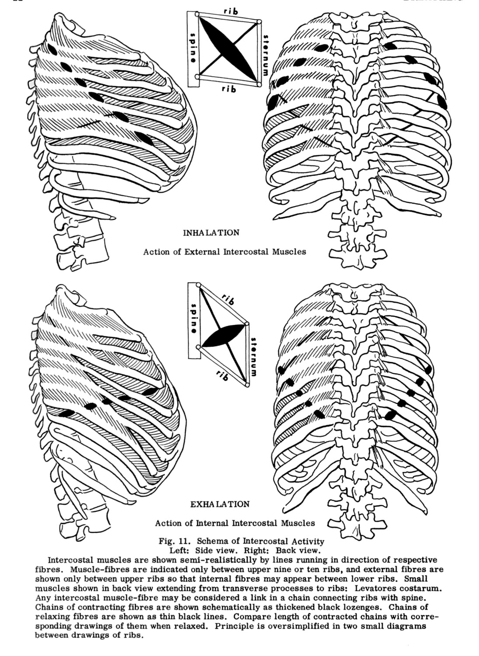

Figure 4: The primary muscles of inhalation and exhalation. Image reproduced from Kari Ragan, A Systematic Approach to Voice: The Art of Studio Application, (San Diego, CA: Plural Publishing Inc, 2020): 23.

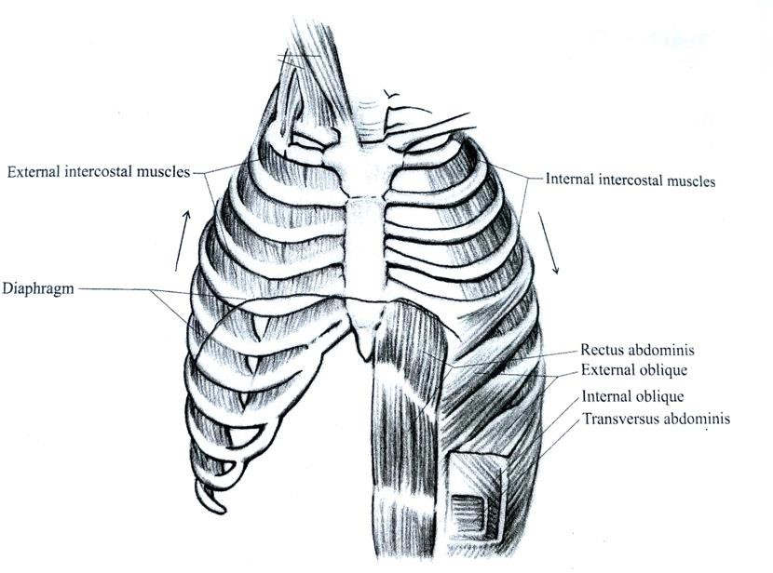

Figure 5: Front and side views of diaphragm and its movements during breathing. Image reproduced from Theodore Dimon, Anatomy of the Voice: An Illustrated Guide for Singers, Vocal Coaches, and Speech Therapists, (Berkeley, CA: North Atlantic Books, 2018): 12.

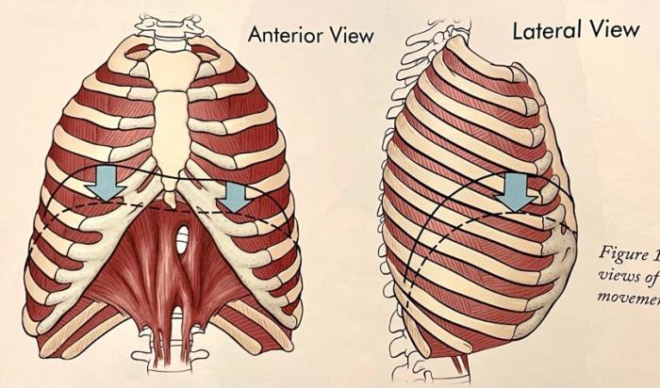

Figure 5 – Refers to the movement of the diaphragm.

Figure 6 – Relates to the Diaphragm in relation to rib movement – Indicating how the movement of the ribcage affects the diaphram.

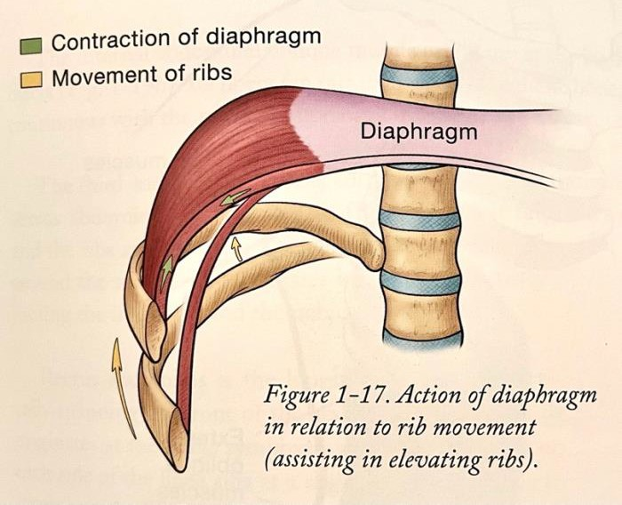

Action of the diaphragm in relation to rib movement. Image reproduced from Theodore Dimon, Anatomy of the Voice: An Illustrated Guide for Singers, Vocal Coaches, and Speech Therapists, (Berkeley, CA: North Atlantic Books, 2018): 13.

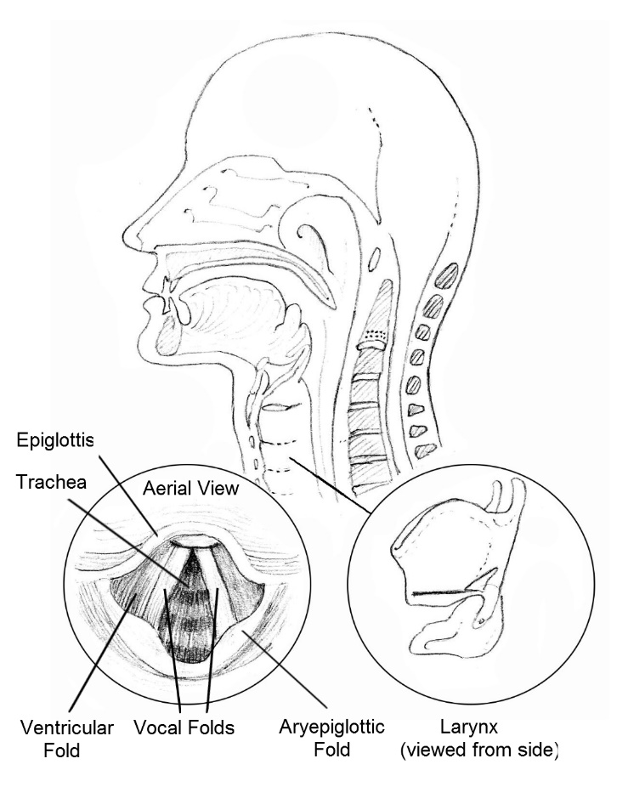
(Risdale, L; 2017) The Complete Vocalist; Authorhouse Publishing

Appendix 1 – Sternocleidomastoid (Figure 4) (Figure 5) Semispinalis Capitis

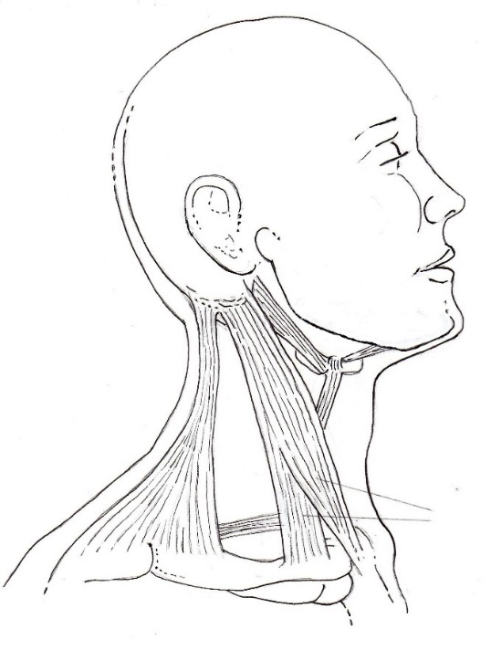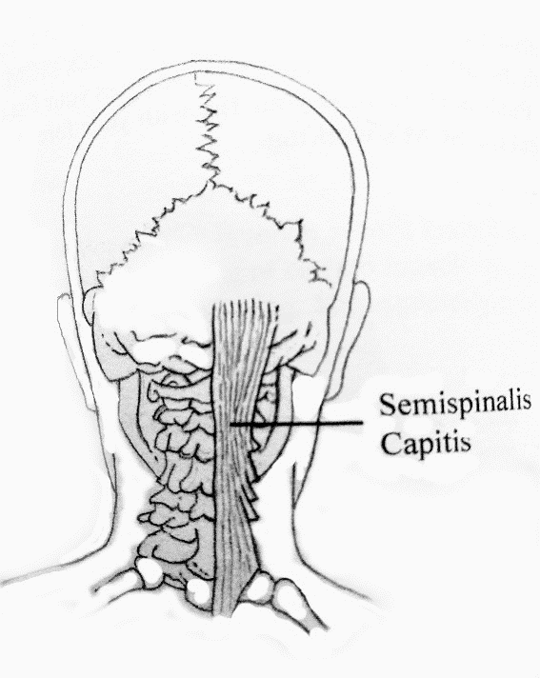

(Risdale, L; 2017) The Complete Vocalist; Authorhouse Publishing

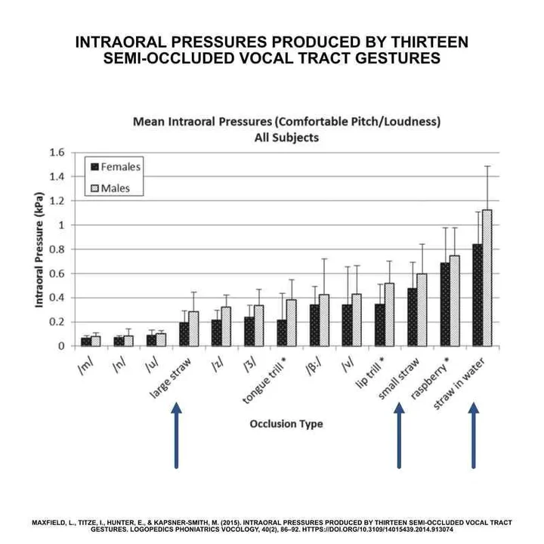
(Figure 6) Variations of intraoral pressure created by SOVT Exercise

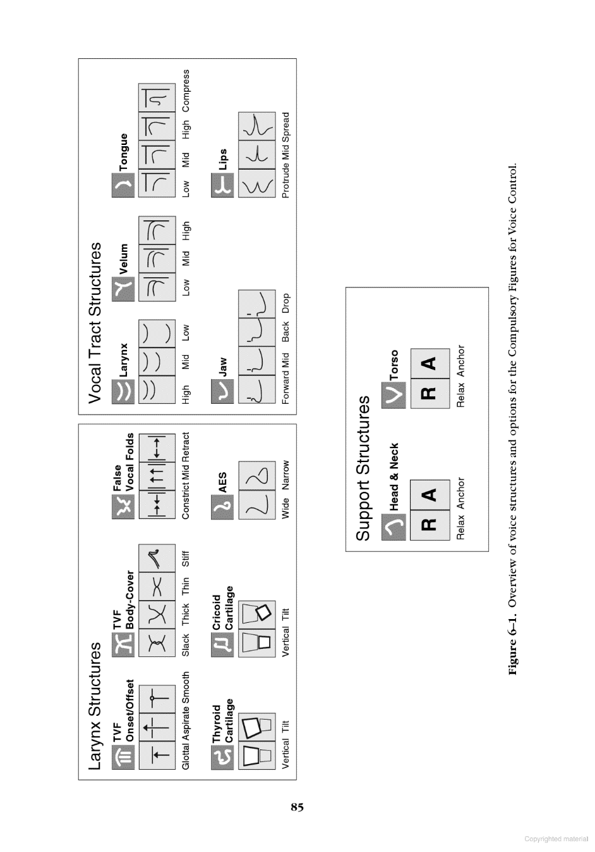Appendix 1 (Fig. 7) Estill
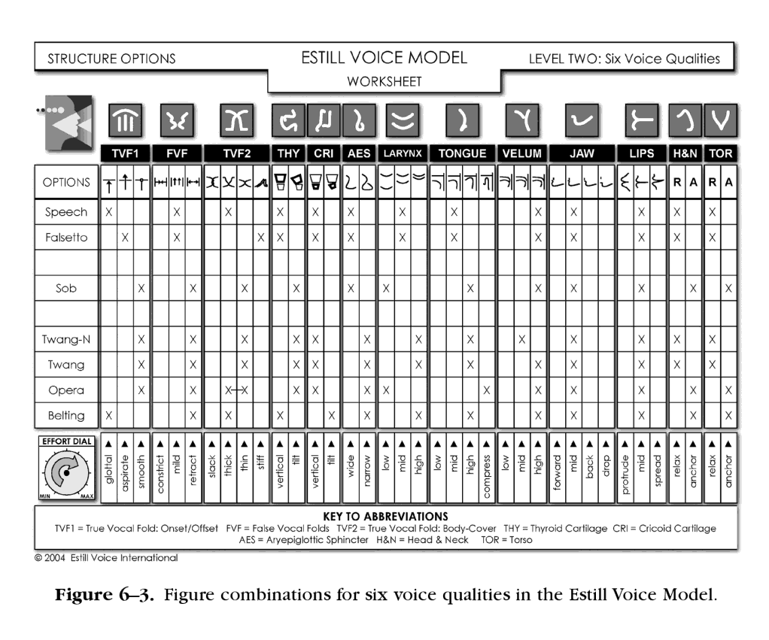
Appendix 1 (Fig. 8) Estill

Appendix 2 – Vocal Breathing Exercises
A) Exercises should begin from the resting tidal end-expiratory level (the end of a quiet breath). Adequate rest should be taken between exercises and between repetitions.
- Take in half of the air possible. Relax.
- Take in all of the air possible. Relax.
- Take in half of the air possible. Pause & breath hold.
Take in all of the air possible. Relax.
- Blow out half the air possible. Relax.
- Blow out all the air possible. Relax.
- Blow out half the air possible. Pause and breath hold.
Blow out all the air possible. Relax.
- Take in all the air possible. Blow out all the air possible. Relax.

B) Singing Exercises for Breath
- Take in half of the air possible. Sing a vowel until the resting level is reached. Relax.
- Take in ALL of the air possible. Sing a vowel until the resting level is reached. Relax.
- Take in ALL of the air possible. Sing a vowel until half the air taken in is expended. Pause and breath hold. Sing a vowel again until the resting level is reached. Relax.
- Sing a vowel until half the air supply is expended. Relax.
- Sing a vowel until the air supply is depleted. Relax.
- Sing a vowel until half the air supply is expended. Pause and breath hold. Sing a vowel again until the air supply is depleted. Relax.
- Take in ALL of the air possible. Sing a vowel until the air supply is depleted. Relax.
- Complete exercises 1 through 7 using more complex utterances, scales, runs or vowel combinations.

Respiratory Exercises – Abdominal Wall
- Move the abdominal wall in half as far as possible. Relax.
- Move the abdominal wall in as far as possible. Relax.
- Move the abdominal wall out half as far as possible. Relax.
- Move the abdominal wall out as far as possible. Relax.
- Move the abdominal wall in as far as possible. Pause.
Move the abdominal wall out as far as possible. Relax.

*Now take the Breath & Singing Exercises (A+B) again and combine them with the abdominal exercises above.

Appendix 3:
Breathing Assessment: Tempo
An adult should take around 9-12 breath cycles per minute. Sit quietly for sixty seconds and count your breath cycles. Since you are cognitively aware of your breathing tempo as you do this drill, it's not a fool proof assessment. A more precise test is to watch a minute of yourself on video and count your breaths when you're not conscious of respiration.
In your usual breathing pattern, your exhalation should be around 1.5-2 times longer than the inhalation, and there should be a brief pause at the bottom of the exhalation. If your inhalation lasts for two seconds, your exhalation should be around three or four seconds, with a 1-2 second pause at the end of the exhalation.
Breathing Assessment: Low, Slow, and Through the Nose
Sit tall and place one hand on your belly, with the other resting on your chest. On an inhalation, you should feel your bottom hand moving out more than your top hand. The motion should be measured and distinct, and the air should be entering and exiting through your nose. The dimensions of your torso should increase on inhalation and decrease on exhalation. The mantra should be "Low, slow, and through the nose."
Watch for any the following problems on inhalation: The upper hand moves before the lower hand. The upper hand lifts toward the chin rather than moving slightly forward. The upper hand moves more than the lower hand
It is also possible that the lower hand will move in on inhalation, instead of out. This is known as paradoxical breathing, where standard breathing mechanics get reversed. Our cultural worship of a flat stomach can cause confusion as to the correct respiration pattern. To be clear, the abdomen is supposed to expand in all directions on an inhalation, not contract.

Air Hunger Test
1. Sit down and rest for two minutes before beginning the test.
2. Pinch your nose closed at the bottom of an average exhalation.
3. Start a timer and see how many seconds you can hold your breath comfortably.
4. Release your nose when you feel the first distinct desire to breathe. You will know it's time to release when your brain says, "Enough!" You also may feel a spasm in the diaphragm; this is your brain telling your diaphragm to resume respiration. You might even notice a constriction in your throat or a desire to swallow.
5. Pay attention to the first breath after the release. Did you need to gasp for air? If so, you held too long. The first breath back should come in through the nose; it should feel normal and under control.
The goal of this test is to make it comfortably to forty seconds. Anything over thirty seconds is considered pretty good, over twenty is borderline, and anything below twenty seconds indicates a threat response to increased CO2 levels.

Breathing Exhalation Increase Drill:
In for Two, Out for Eight

Ideally using a metronome app-1 usually set it between 80 and 90 beats per minute.

1. Sit in a comfortable upright position.
2. Inhale a small amount of air through your nose for two beats.
3. Exhale through pursed lips (think of a pucker) for eight beats. You should feel your lips providing resistance to the air, and your abdominals should be squeezing most of the air out of your body by the end of the eight beats.
4. Repeat for ten reps. Take a small breath in through the nose for two beats and exhale for eight through pursed lips.
5. Redo the Air Hunger Test. See if your numbers changed.
For many of us, after doing the "In for Two, Out for Eight" drill, you will find your Air Hunger Test numbers improved. You may have been able to hold your breath for longer, and you may notice that you felt less panicked in the breath-hold. Because your resisted exhalation was four times as long as your inhalation, and because your inhalation was modest, the receptors that control breathing were rewired. Rising CO2 was no longer perceived as such a major threat.
Appoggio: The concept of appoggio encourages the singer to allow the voice to ride upon the breath rather than have the diffused breath pass through the voice.

Appendix 3 (Continued)
EXERCISE PHYSIOLOGY AND VOICE TRAINING (Nix, 2017) - Four basic principles of physical training have been identified which, when carefully manipulated, can evoke training benefits.
Overloading involves asking more from a muscle or group of muscles than normal.
Specificity means that the training must match the task or skills to be developed.
Individuality concerns adjusting the training to match the performer’s age, physical development, experience, health, and skill level. Matching singers and repertoire.
Reversibility is how training benefits are lost over time without continued training. An example of this in singing would be a song that a singer decides to discontinue practicing for a while; when work on the piece resumes, it is rusty.

Appendix 4
Belting Exercise: Produce a bright call, such as “hey.” This is the speech version of a belt. Alternately, the singers can first produce a twang (the sound of a plucked guitar string). A twang narrows the pharyngeal part of the vocal tract which raises the overall inertance (Titze et al, 2011).
Thus, a wide-open mouth with a raised larynx and a narrow pharynx maintains a high first formant, so that both the fundamental and the second harmonic can possibly be reinforced with the vocal tract (Titze et al, 2011).
Table 2 - Below illustrates differences of emphasis across a participant group. However, there appears to be an underlying, unconscious, agreement in consideration of the necessity for training in these areas of technique. Variations due to stylistic considerations (Bartlett, 2020)

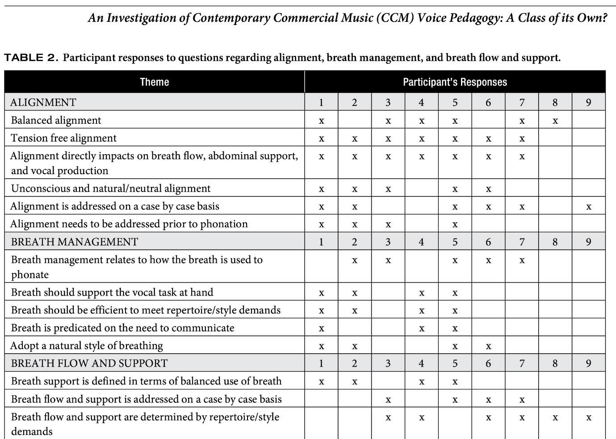

Appendix 4 (Fig.2) Example Breathing Exercise Assessment Chart

Appendix 5
Seth Riggs/ Margareta with Michael Bolton – Working on Nessun Dorma
https://www.youtube.com/watch?v=nD_A0PUAkm0 - Seth Riggs with Michael Bolton - Margareta on breathing and support
https://www.youtube.com/watch?v=rjFrXW6PchU - Margareta & Seth Riggs with Michael Bolton - Margareta on breathing and support

Appendix 5; Figure 1, Table 1 & 2 Below. Traser, et al, 2020. Respiratory kinematics and the regulation of subglottic pressure for phonation of pitch jumps–a dynamic MRI study. Plos one, 15(12), p.e0244539.
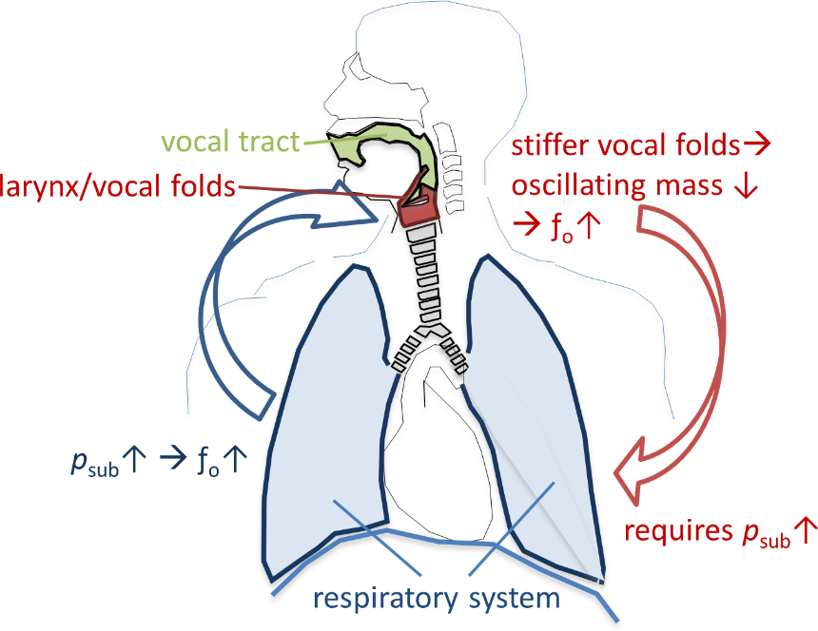
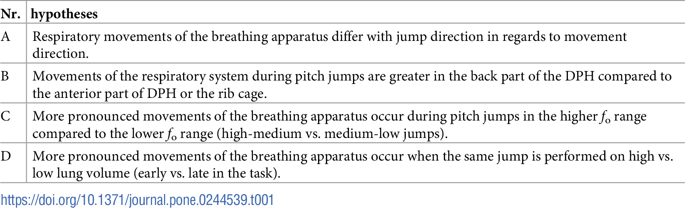

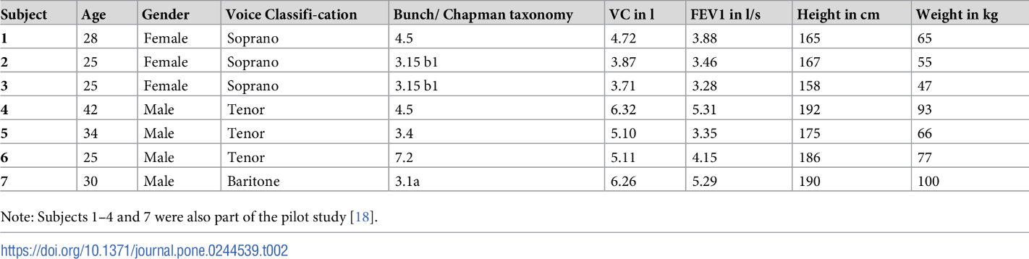
Appendix 5 – Figure 2; https://completesingers.com/technique/posture-in-singing/



