

Coronary Heart Disease as a Public Health Challenge: Epidemiological Measurement, Prevention, Community Impact and Health and Social Care Support
Student Name: Nadarajah Shanmugam
Student ID: 2531585
Module Code: LCHS4008
Module Title: Introduction to Public Health
Assessment: Assignment 2 – Report on a Health Issue
Level: Level 4
University: University of Wales Trinity Saint David (UWTSD)
Word Count: 1,500 words
Submission Method: Turnitin
Submission Date: 18 August 2026
Academic Year: 2026/27

Table of Contents
Coronary Heart Disease as a Public Health Challenge: Epidemiological Measurement, Prevention, Community Impact and Health and Social Care Support 1
Chapter 1: INtroduction 4
Chapter 2: Epidemiological Measurement and Monitoring of Coronary Heart Disease 6
2.1 Incidence, Prevalence and Mortality as Population Measures 6
Figure 1. Decline in Age-Standardised Ischaemic Heart Disease (IHD) Mortality in England and Wales, 2001–2019 6
2.2 Surveillance Through Routine Health Data 7
2.3 Risk Surveillance and Limitations of Measurement 7
CHAPTER 3: PREVENTION, MANAGEMENT AND CONTROL OF CORONARY HEART DISEASE 9
3.1 Primary Prevention: Reducing Population Risk 9
3.2 Secondary and Tertiary Control 9
CHAPTER 4: CONSEQUENCES OF CORONARY HEART DISEASE FOR INDIVIDUALS AND COMMUNITIES 11
4.1 From Mortality to Chronic Disease Burden 11
4.2 Social Inequality and the Distribution of Harm 11
4.3 Community and Health-System Consequences 11
Chapter 5: Health and Social Care Support for People with Coronary Heart Disease 13
5.1 Integrated and Multidisciplinary Care 13
Figure 2. Cardiac Rehabilitation Referral-to-Participation Gap in England, 2024/25 14
5.2 Social and Person-Centred Support 15
Chapter 6: Conclusion 17
References 18



Chapter 1:
Introduction

Chapter 1: INtroduction

Atherosclerotic plaque promotes narrowing of the coronary arteries resulting in reduced supply of oxygenated blood to the myocardium which results in angina, myocardial infarction or sudden cardiac death (British Heart Foundation, 2026). The classic presentation is chest pain or pressure with shortness of breath, fatigue, and pain spreading to the arm, neck, jaw or back. The term silent ischemia implies that the clinical presentation underestimates the burden of disease in the population . Coronary heart disease is not only a concern of the individual practitioner but a severe public health problem: Estimated mortality from ischemic heart disease (IHD) were 9.0 million in 2021, representing approximately 13% of all deaths worldwide (World Health Organization, 2024). In the UK there are over 2.3 million people living with CHD and over 63,000 people die each year which is equivalent to roughly 170 deaths each day (British Heart Foundation, 2026). These data suggest that although there has been a considerable decline in CHD mortality over time, the burden of CHD death is still high.

Chapter 2:
Epidemiological Measurement and Monitoring of Coronary Heart Disease

Chapter 2: Epidemiological Measurement and Monitoring of Coronary Heart Disease

2.1 Incidence, Prevalence and Mortality as Population Measures
Public health surveillance of CHD should be based on a set of complementing indicators rather than on a single figure to be effective. Incidence is the number of new cases of a disease that occur in a particular population in a stated period of time. It is very helpful for examining the influence of preventive activities on the incidence of disease. Prevalence is an index of the size of an ailment at present and hence of the present needs for treatment, rehabilitation and social aid. Mortality is a metric of the deadly load. A better technique to compare groups with different age distributions is to compare age-standardised death rates.

Figure 1. Decline in Age-Standardised Ischaemic Heart Disease (IHD) Mortality in England and Wales, 2001–2019
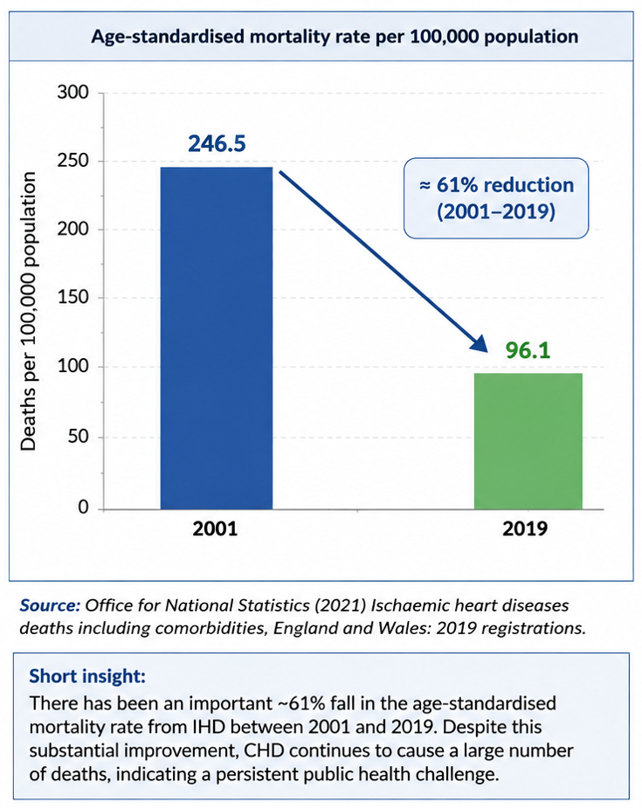
Source: Adapted from Office for National Statistics (2021), Ischaemic heart diseases deaths including comorbidities, England and Wales: 2019 registrations.
This is important because decreases in mortality may not be accompanied by decreases in overall disease burden. The age standardized mortality rate for IHD in England and Wales decreased by nearly 61% from 246.5 deaths per 100,000 individuals in 2001 to 96.1 per 100,000 in 2019 (Office for National Statistics, 2021). However, IHD still caused 54,097 fatalities in England and Wales in 2024, representing 9.6% of all deaths but 6.6% lower than 2023 (Office for National Statistics, 2025). So for example improvement in mortality we should not presume the public health issue has disappeared

2.2 Surveillance Through Routine Health Data
In the UK CHD is monitored by death registration, computerized primary care data, hospital admission, diagnostic coding and disease specific clinical research . The ONS monitor identifies deaths from IHD using ICD-10 codes I20-I25 and this is comparable across time and between areas (Office for National Statistics, 2025). There is also additional possibility to discriminate between incident and prevalent disease in primary care and hospital data sets, and to track treatment of risk variables.
The analytical application of linked electronic health records is demonstrated by Harris et al. (2024). The incidence of IHD in the Welsh population dataset decreased from 399 per 100,000 in 2010 to 336 per 100,000 in 2022 (15.8% decline). The reported incidence of IHD decreased throughout this period from 4877 to 4596 per 100,000, a much smaller decrease of around 5.8% (Harris et al., 2024). The slower fall in prevalence is conceptually important, since a low incidence may be consistent with a large prevalent population due to improved survival and thus longer survival with CHD.

2.3 Risk Surveillance and Limitations of Measurement
Surveillance is also carried out before clinical disease. NICE guidance promotes routine identification of cardiovascular risk in primary care using QRISK3 which provides an authoritative estimate of 10-year cardiovascular risk (NICE, 2023). QRISK3 prevention is based on risk stratification based on a mix of variables (Hippisley-Cox et al., 2017) and not risk indicators.
Surveillance data are not epidemiologically dead. Observed incidence is affected by access to health care, testing for diagnosis and quality of coding. The diminishing detection, rather than true prevention, can be explained in part by the decreasing incidence observed. For example, testing for LDL cholesterol in the records of patients with atherosclerotic cardiovascular disease dropped by 8.7 percentage points (58.0% to 49.3%) from 2010 to 2022 (Harris et al, 2024). Silent CHD and differential health care usage also suggest underdiagnosis. Triangulation provides for a more rigorous examination than any one indicator can provide. The incidence, prevalence, mortality, hospital activity, risk factor data and age-standardised rates combine to create a richer picture.

Chapter 3:
Prevention, Management and Control of Coronary Heart Disease

CHAPTER 3: PREVENTION, MANAGEMENT AND CONTROL OF CORONARY HEART DISEASE

3.1 Primary Prevention: Reducing Population Risk

CHD requires intervention pre and post clinical disease. The concept of primary, secondary and tertiary prevention thus provides a useful paradigm, since CHD is not a one-factor disease but the result of cumulative exposure to modifiable risk factors. The most modifiable risk factors are smoking, high blood pressure, abnormal blood lipids, obesity, lack of physical activity and poor diet. NICE (2023) recommends atorvastatin 20 mg with lifestyle adjustment for all those with a QRISK3 10 year CVD risk of ≥10% This threshold is an operationalization of an epidemiological forecast in the preventative targeted domain . Let's say there are 1000 people and a 10% predicted risk of occurrence. So if we do nothing in the future and we don't change the risk, we would expect roughly 100 cardiovascular incidents in 10 years.

But a more restricted focus on high-risk people may miss the greater number of happenings that are happening in the much bigger group at moderate risk. This is the case of Rose's preventative method (Rose, 1985). So, “QRISK3 suggests that smoke restrictions, healthier eating environments and opportunities for physical activity improve individual treatment. This is relevant analytically, because individual activity is enmeshed in the socio-economic system, not simply a matter of personal choice.

3.2 Secondary and Tertiary Control

Treatment of CHD is directed toward preventing recurrence and functional impairment. NICE recommends high intensity statin therapy with atorvastatin 80 mg for all patients with confirmed CVD with objectives for LDL cholesterol of ≤2.0 mmol/L or non-HDL cholesterol of ≤2.6 mmol/L (NICE, 2023; NICE, 2025). Secondary prevention after MI can include statins, antiplatelet medicines, ACE inhibitors and beta blockers, appropriate revascularization and cardiac rehabilitation (NICE, 2020).

Practice and proof are worlds different. This year in England, 81% of patients who had a heart attack were referred to cardiac rehab, while 41% of patients with acute coronary syndrome were offered rehab. (NICOR, 2025) This is about half the amount of patients referred to rehab. Only 78% of heart attack patients who should have gone home on all the regular prophylactic medications did so, a relative fall of 7.4% over five years (NICOR, 2025). We think it is fantastic drugs but necessary control of course. It’s not only the amazing treatments. It's about translation of clinical eligibility to sustained uptake and adherence.

Chapter 4:
Consequences of Coronary Heart Disease for Individuals and Communities

CHAPTER 4: CONSEQUENCES OF CORONARY HEART DISEASE FOR INDIVIDUALS AND COMMUNITIES

4.1 From Mortality to Chronic Disease Burden
CHD has consequences other than premature death. The UK has a large population of 2.3 million people living with CHD requiring constant medications, surveillance and risk factor management (British Heart Foundation, 2026). A public health interpretation must, therefore, be able to differentiate death and morbidity. Better survival after acute coronary events reduces mortality but increases the number of persons living with long term illness .
A person with recurrent angina may be restricted in job, mobility and social participation due to decreased exercise capacity and fear of another myocardial infarction. This has implications for the family, in respect of informal caring, transport to appointments, and psychological pain. So just counting deaths does not give the complete picture, which also includes loss of healthy life, loss of independence and greater demand on community services.

4.2 Social Inequality and the Distribution of Harm

The Dahlgren and Whitehead model better explains inequities in CHD than a simple behavioral model, because it incorporates individual lifestyles within the wider context of job, income, housing, social networks and wider socioeconomic determinants (Dahlgren and Whitehead, 1991). Thus smoking or bad food may be influencing pathways from structural disadvantage to CVD.
This is important for prevention since an intervention could be physically successful but socially ineffective. NICE have identified sex, age, race and deprivation as characteristics of inequality relevant to secondary prevention of CVD (NICE, 2025). So, prescribing universal exercise, nutrition changes or rehabilitation for those with precarious jobs, transit challenges, care responsibilities or limited access to nutritional food can provide unequal benefits.

4.3 Community and Health-System Consequences

Moreover, there are opportunity costs of CHD to the health system. This need comprises emergency treatment, coronary angiography, revascularization, medications, primary care assessments and rehabilitation. NICE predict that now there are 126,605 patients eligible for cardiac rehabilitation in England (NICE, 2025). However, only 41% of patients with acute coronary syndrome in England were included in rehabilitation, showing a considerable scope for prevention (NICOR, 2025).
The wider community implication of the gap is that insufficient rehabilitation may transmit unnecessary risk downstream into recurring illness and increasing usage of health care. Thus, CHD should be considered in terms of a socio-ecological model, where biological risk, individual behavior, socioeconomic determinants and access to health care are interrelated. A good public-health policy will thus have to minimize both the average cardiovascular risk and the unequal social distribution of that risk.

Chapter 5:
Health and Social Care Support for People with Coronary Heart Disease

Chapter 5: Health and Social Care Support for People with Coronary Heart Disease

5.1 Integrated and Multidisciplinary Care
CHD is a coordinated process, not just hospital care. In patients with myocardial infarction (MI) NICE suggests a collaborative care plan with primary care comprising optimization of medication, blood pressure and renal function monitoring and secondary prevention (NICE, 2020). This means GPs lead on long-term risk, cardiologists on complex disease and pharmacists on drug optimization. “Cardiac rehabilitation involves exercise, health education, psychological support and reduction of risk factors. This is a holistic biopsychosocial approach, as opposed to a purely biomedical approach (NICE, 2018).
Table 1. Quantitative Public Health Profile of Coronary Heart Disease
This would be the single most useful table.
Indicator | Quantitative Evidence | Analytical Interpretation
Global IHD mortality | ~9.0 million deaths, 2021 | Demonstrates continuing global severity
UK population living with CHD | ~2.3 million | Indicates substantial chronic-care burden
UK CHD deaths | ~63,000 annually | Equivalent to approximately 170 deaths daily
England & Wales age-standardised IHD mortality | 246.5 → 96.1 per 100,000, 2001–2019 | ~61% reduction indicates substantial mortality improvement
Welsh IHD incidence | 399 → 336 per 100,000, 2010–2022 | ~15.8% decline
Welsh recorded prevalence | 4,877 → 4,596 per 100,000 | Only ~5.8% decline, showing persistent chronic burden
Cardiac rehabilitation referral | 81% | Relatively high referral
Rehabilitation participation | 41% | Reveals major implementation/access gap
Source: Compiled by the author from WHO (2024), ONS (2021; 2025), Harris et al. (2024), BHF (2026) and NICOR (2025).

But the service gap is still huge. In England, 81% of heart attack patients were referred to rehabilitation while only 41% of patients with acute coronary syndrome participated in rehabilitation, demonstrating a 40 percentage point gap between referral and participation (NICOR, 2025). Then just additional referrals ain't the way ahead. There also exist barriers of transit, work, disability, language and socio-economic to overcome. NICE recommends flexible provision in hospital, community and home settings, with digital rehabilitation being an emerging alternative for patients with geographical or scheduling limits (NICE, 2020; NICE, 2025). Digital distribution, however, can also represent inequality in the form of insufficient connectivity or online literacy in general.

Figure 2. Cardiac Rehabilitation Referral-to-Participation Gap in England, 2024/25
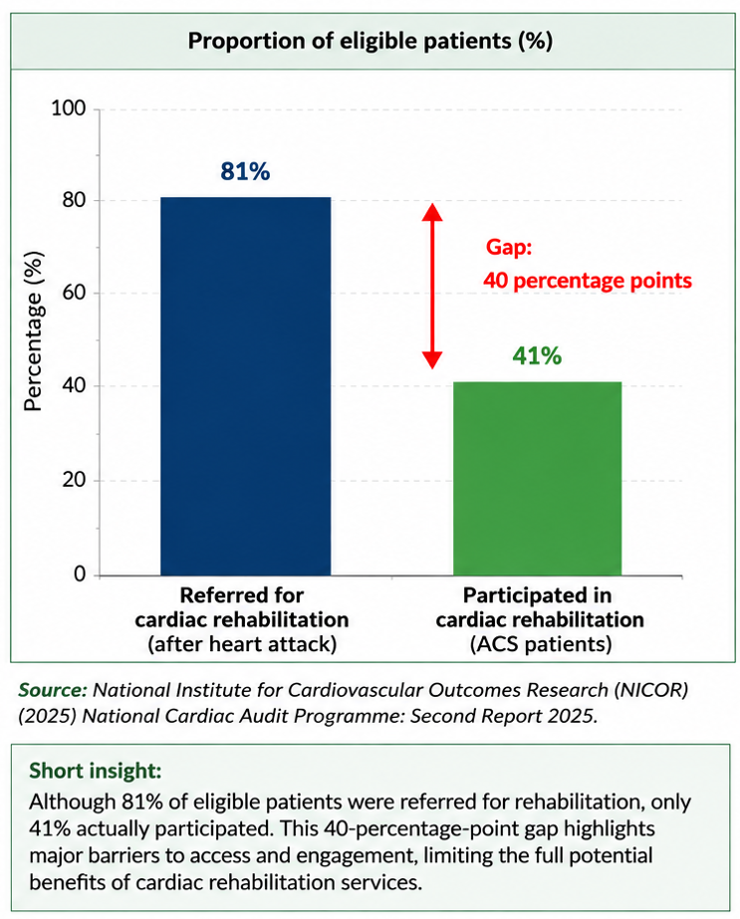
Source: Adapted from National Institute for Cardiovascular Outcomes Research (NICOR) (2025), National Cardiac Audit Programme: Second Report 2025.

5.2 Social and Person-Centred Support

In particular the biopsychosocial paradigm is vital, as healing comprises biological function, psychological adjustment and social reintegration. NICE therefore recommends addressing economic concerns, welfare entitlements, housing and social support needs in the post-MI period (NICE, 2020). Thus social workers, community nurses, rehabilitation specialists and voluntary organizations can supplement medical therapy by encouraging independence and return to work.
This is an economically and clinically important combination. In 2023, 64,217 patients entered cardiac rehabilitation, increasing 61% from 40,000 patients 10 years earlier (NICOR, 2025). But participation is not full. A preferable strategy would include automatic referral, culturally relevant therapy, home-based rehabilitation and follow-up of non-attenders. The program moves CHD management from a reactive treatment model to a proactive ongoing model of risk reduction and addresses the socioeconomic drivers of whether evidence-based therapy translates into real-world effect.

Chapter 6:
Conclusion

Chapter 6: Conclusion

Although there has been a considerable decline in mortality, coronary heart disease remains a major public-health problem. In the UK, survival has improved and what was once an acute mortality crisis has become a chronic health and social care problem. There are over 2.3 million people living with CHD (British Heart Foundation, 2026). Therefore, epidemiological interpretation is not a single metric, but observation of incidence, prevalence, mortality and risk factor surveillance.
The analysis shows that the effective management is the combination of primary prevention, secondary prevention in clinical practice and tertiary prevention in rehabilitation. However, the fact that 81% of patients were referred for rehabilitation but only 41% participated in England, shows that access does not mean usage (NICOR, 2025). So biological treatment is not a management of CHD. The Dahlgren-Whitehead and biopsychosocial models consider socioeconomic determinants, health behaviors, psychological health and healthcare access as important elements impacting results . Future public-health practice should therefore combine evidence-based cardiovascular treatment with available rehabilitation, targeted inequality reduction and integrated community care.

References
British Heart Foundation (2025) Heart and circulatory disease statistics 2025. London: British Heart Foundation. Accessed on 8/08/2026. Available at: British Heart Foundation heart statistics
British Heart Foundation (2026) UK cardiovascular disease factsheet. London: British Heart Foundation. Accessed on 8/08/2026. Available at: British Heart Foundation cardiovascular statistics
Dahlgren, G. and Whitehead, M. (1991) Policies and strategies to promote social equity in health: Background document to WHO – Strategy paper for Europe. Stockholm: Institute for Futures Studies.
Harris, D.E. et al. (2024) ‘Trends in atherosclerotic cardiovascular disease and lipid management in a population-based cohort between 2010 and 2022’, European Journal of Preventive Cardiology, 31(15), pp. 1778–1789. https://doi.org/10.1093/eurjpc/zwae233
Hippisley-Cox, J., Coupland, C. and Brindle, P. (2017) ‘Development and validation of QRISK3 risk prediction algorithms to estimate future risk of cardiovascular disease: prospective cohort study’, BMJ, 357, j2099. https://doi.org/10.1136/bmj.j2099
National Institute for Cardiovascular Outcomes Research (NICOR) (2025) National Cardiac Audit Programme: Second Report 2025. London: NICOR. Accessed on 8/08/2026. Available at: NICOR National Cardiac Audit Programme
National Institute for Health and Care Excellence (NICE) (2020) Acute coronary syndromes (NG185). London: NICE. Accessed on 8/08/2026. Available at: NICE NG185 Acute coronary syndromes
National Institute for Health and Care Excellence (NICE) (2023) Cardiovascular disease: risk assessment and reduction, including lipid modification (NG238). London: NICE. Accessed on 8/08/2026. Available at: NICE NG238 Cardiovascular disease guidance
National Institute for Health and Care Excellence (NICE) (2025a) Cardiovascular risk assessment and lipid modification: secondary prevention of cardiovascular disease. London: NICE. Accessed on 8/08/2026. Available at: NICE cardiovascular disease guidance
National Institute for Health and Care Excellence (NICE) (2025b) Digital platforms to support cardiac rehabilitation: early value assessment (HTG761). London: NICE. Accessed on 8/08/2026. Available at: NICE HTG761 Digital cardiac rehabilitation
Office for National Statistics (2021) Ischaemic heart diseases deaths including comorbidities, England and Wales: 2019 registrations. Newport: ONS. Accessed on 8/08/2026. Available at: ONS IHD deaths 2019 registrations
Office for National Statistics (2025a) Deaths registered in England and Wales: 2024. Newport: ONS. Accessed on 8/08/2026. Available at: ONS deaths registered in England and Wales
Office for National Statistics (2025b) Deaths due to coronary heart disease by month of occurrence and age group, local authority, England and Wales, 1993 to 2024. Newport: ONS. Accessed on 8/08/2026. Available at: ONS coronary heart disease mortality data
Rose, G. (1985) ‘Sick individuals and sick populations’, International Journal of Epidemiology, 14(1), pp. 32–38. https://doi.org/10.1093/ije/14.1.32
World Health Organization (2024) The top 10 causes of death. Geneva: World Health Organization. Accessed on 8/08/2026. Available at: WHO The top 10 causes of death

