Jessica Morris (P152153)
BA(Hons) Sports Management

Sales and Merchandise Management (M6X02094)

Executive Summary
This report examines the literature around sales and merchandising in order to define the key concepts. A particular focus will be on an emerging theme within the sales and merchandising industry, specifically the use of digital technology and how this is used to improve the customer experience. The report will look into digital signage in particular and how this is used within the retail industry and the sporting sector, identifying the advantages, disadvantages and the likely impact of digital signage on the sports industry. The final part of the report consists of a visual representation of digital signage in practice as this is an emerging theme and considering its practical application of sales and merchandising within a particular setting.

Contents Page

1.0 Introduction………………………………………………………………4
2.0 Literature Review of Sales and Merchandising Key Concepts…….4
2.1 Retailing………………………………………………………………….4
2.2 Store Layout……………………………………………………………..5
2.3 Visual Merchandising…………………………………………………...5
2.4 The Shopping Experience………………………………………………5-6
2.5 Impulse Purchasing……………………………………………………..7
2.6 Advertising and Promotion……………………………………………..7
3.0 An Emerging Theme within the Sales and Merchandising Industry.8
3.1 Advantages of Digital Signage…………………………………………8-10
3.2 Disadvantages of Digital Signage……………………………………..10
3.3 Impact on the Sporting Industry……………………………………….10-12
4.0 Visual Representation of Digital Signage…………………………….12
4.1 Digital Signage in the Retail Industry…………………………………12-16
4.2 Digital Signage in Sporting Stadiums…………………………………17-22
5.0 Conclusion……………………………………………………………….23
6.0 References……………………………………………………………….24-26

1.0 Introduction
This report examines the literature around the sales and merchandising in order to identify the main themes within this industry. In addition, an emerging theme will be identified which will be critically evaluated and the likely impact of the theme on the sports industry will be discussed. Furthermore, a visual representation of the sales and merchandising in practice will be created that considers its practical application within a specific setting.

2.0 Literature Review of Sales and Merchandising Key Concepts
There are a variety of key concepts focusing on sales and merchandising which are explored below.
According to the American Marketing Association, merchandising is a wide term that encompasses promotional activities run by the manufacturer in the form of special presentations that take place within stores, as well as initiatives run by the retailer to make the product stand out. Buttle (1984) define it as “any form of on-store or in-store promotion other than personal selling which is designed to trigger purchasing behaviour.” Merchandising is an essential aspect of attracting customers to a specific store. Sheth (1983) states that consumers can decide their purchase before the entry or once they have entered in the store, therefore, it is possible to stimulate or influence the purchase at these two moments.
AMA (American Marketing Association) defines sales as “any of a number of activities designed to promote customer purchase of a product or service which can be done in person or over the phone, through e-mail or other communication media” (American Marketing Organization 1995).

2.1 Retailing
Retailing is a key theme which consists of many different areas to attract the customer and ultimately obtain sales. A key concept which is important is the visual identity of a store, this is defined as “the creation of favourable public images via visual means through logos and symbolism.” Architecture reflects the brand in the consistency of its design and visual appearance. For retailers these distinctions are particularly important, since retail identity is communicated in and experienced through their stores, both internally and externally (Din, 2000). For example, Macy’s in New York and Harrods in London are stores which are extremely large in size and have a unique appearance resulting in many people visiting them to say they have been there.

2.2 Store Layout
A further concept is the store layout, there are a variety of ways in which are store can be laid out including: free flow, grid pattern, circulation, spine layout, etc. Store layouts are dependent on the consumers it wishes to attract e.g. JD Sports target customers who wish to purchase the newest and exclusive sportswear released by brands and will therefore design their store layout with the newest products as a feature area. Customers’ reactions to the layout of merchandise in the store is of importance as it has major influence on sales, for example a store such as Primark may be considered too hectic as there are a number of levels and different arrangements of products resulting in people feeling stressed and confused.

2.3 Visual Merchandising
Visual merchandising, initially expanded this function beyond the window to include a design-led approach to the interior. It contributed to efficient retail practices, from the planning of floor layouts to the merchandise presentation and signage, but it also created visually appealing shopping environments where the layout facilitates sensory and tactile interaction between the customer and the product. Window displays and visual merchandising were drawn together with the emergence of lifestyle retailing, with its emphasis on the retail brand and coherent communication through close attention to design throughout the store environment. A store's image constitutes a variety of tangible elements, ranging from the exterior to store music. A strategic layout of a selling environment, whether this be exterior or interior, helps initiate consumers' positive purchasing decision. A number of studies (Bellizzi, Crowley & Hasty 1983; Eroglu & Machleit 1990; Grewal, Barker, Levy & Voss 2003; Milliman 1982; as cited by Ailawadi & Keller 2004) have suggested that store image is essential in influencing consumers' shopping behaviour, as to whether or not they visit a store, the duration of their visit and how much money they spend there. According to Sen (2002), store window displays plays an essential role in attracting consumers' attention and encouraging their purchase decision. For example, a store within minimal display and an item in a glass space with large amounts of space around it implies luxury e.g. Gucci, Jimmy Choo.

2.4 The Shopping Experience
Retail businesses aim to make as many sales as possible in order to remain a competitor in the industry and encourage repeat business. The shopping experience for the customer is essential in order to create an environment where they will purchase a product and return to the store. The shopping experience consists of many elements including: value perceptions, research suggests a consumer’s shopping experience facilitates between rational and hedonic elements. Hedonic value from a pleasing store design influenced perceptions of utilitarian value of a product, which in turn affected store patronage intentions (Baker et al., 2002). Perceptions of value are the cost or sacrifice made to own the product versus the benefit (Zeithaml, 1988). The purchase decision involves information about the product and an evaluation of the product which will lead to a purchase. The consumer is envisioned to be a goal-directed problem solver, who searches for product related information, weighs evidence, and arrives at a carefully considered evaluation leading to a purchase decision (Holbrook and Hirschman, 1982). The shopping experience is important for the customer as it initiates customer processes including attitude formation, product evaluation and responses such as: purchase behaviour and satisfaction which are affected by the shopping environment e.g. shopping centre, brick-and-mortar retail store, catalogue, and online store, situation, and consumer characteristics (Fiore and Kim 2007). The stimulus is the impetus within the shopping environment with potential to affect the consumer’s cognitive/consciousness and affective/emotional processes. (Foire and Kim 2007). When customers decide what to purchase, they usually think about the uses of the particular product e.g. Pretty Little Thing occasionally have offers for ‘going out’ items which includes shoes, outfit and accessory for a set price. This makes the customer think where they will wear the outfit. According to Fiore and YU, (2001), examining the effect of store display and scent cues found that pleasurable imagery of sensory qualities of a product and fantasies involving the use of a product had a positive influence on consumer responses.
Experimental retailing is also part of the shopping experience. In many shops, the store layout will be changed due to a variety of reasons such as: different seasons, Easter, Christmas, Valentine’s Day or for events happening throughout the year in the sporting industry such as Six Nations Ruby, Football World Cup, Wimbledon, etc to promote products that are associated with the event. This provides the customer with a different experience and a new opportunity for creativity as well as an important value differentiating element. The consumers’ emotions and senses are excited by new strategies engaging with spectacle and theatre, creating a sense of awe, expectancy, and being “part of something much larger”.
The instore experience is equally important, stores serve not only as a place for purchasing goods, but also as a place for socialising and leisure (Hu and Jasper, 2006). For example, in Timberland, the customer has the option to use a virtual screen to decide what product to purchase as they can see what it looks like before buying using a screen. This saves time as they don’t need to use the changing facility. This is an interactive environment which some customers prefer. Additionally, there has been an increasing focus on a wider range of senses. Many stores use different sensory elements such as in-store music, carefully chosen aromas, different textures and surfaces and lighting techniques to create unique “micro-environments” within a conventional retail space e.g. Nike stores play music within their stores. Colours are used to stimulate this sense and change the emotional state of the consumer. Lighting cannot only convey information about a space but also it can give meaning (Peterson and Albaum, 2002).

2.5 Impulse Purchasing
Many customers buy things in impulse which leads to another key concept impulse purchasing. Once the customer has already purchased one item, it’s easier to sell an additional item. Many sports retailers strategically place impulse buys like socks and water bottles by the checkout desk e.g. Sports Direct. Similarly, supermarkets will place chocolate and sweets by the checkout to encourage customers to purchase them. In terms of stores generating sales, they usually group products based how consumers use the product, this is known as category management.

2.6 Advertising and Promotion
In terms of stores promoting and advertising their products, this is usually done via social media platforms such as Facebook, Instagram, their own website, tv advertisements, etc in order to attract customers and encourage repeat business, therefore leading to more sales. Many stores use celebrities to advertise their products which makes the consumer more likely to purchase them, e.g. Under Armour clothing is currently sponsoring Anthony Joshua who is a World Heavy Weight Boxer. Anthony Joshua also advertises Under Armour sportswear for JD Sports and he is also sponsored by Lucozade in which he frequently appears in televised adverts. Similarly, Anne Marie who is not a sports person but a successful singer models Elesse clothing for JD Sports. Furthermore, Rihanna has a sportswear and shoe range with Puma, she is an extremely successful artist in the music industry and therefore her Puma collaboration sold out because customers wanted products she was modelling and advertising.
In relation to digital technology, many retail stores offer student discount through Unidays and Student Beans apps. This gives students the opportunity to purchase items with a discount. For example, Adidas offer 15% discount all year round for students and they will occasionally increase this to 20% for certain events throughout the year e.g. Black Friday. The majority of stores also send out emails to customers regarding current offers and latest products such as: Adidas, Asos, Nike, etc which may encourage the consumer to purchase the latest products. Additionally, stores use digital technology because if an item is out of stock they allow you to type your email address into the virtual screen and they alert customers when the item is back in stock, for example in Schuh they have a touchscreen device installed into a wall allowing customers to search for stock and provide their email addresses if the product they want is out of stock.

3.0 An Emerging Theme within the Sales and Merchandising Industry
There are a number of emerging themes within the sales and merchandising sector. The use of digital technology is an emerging theme in the sales and merchandising industry which is constantly growing. The sports retail sector is a competitive market and companies are finding new ways to attract the attention of the customer. The use of technology within sports retail stores is essential factor that helps brands evolve and to adapt to the new ways of shopping. This section will focus specifically on digital signage and how retail stores utilize this to attract the customers’ attention and generate sales and retain customers.
Digital signage, also called dynamic signage, is a specialised form of slivercasting in which video or multimedia content is displayed in public places for informational or advertising purposes. A digital sign usually consists of a computer or playback device connected to a large, bright digital screen such as an LCD or plasma display. (SearchCRM, 2019)
Digital signage is a forefront of a retail revolution as more stores are realising the benefits in terms of attracting customers and engaging with them and ultimately encouraging them into the store. They are a way for stores to make a statement and help to create a dynamic store experience. Additionally, digital technology is a useful tool for sporting brands to increase their brand awareness and encourage customers to purchase products by displaying what they have currently on offer or latest sportwear. Statistics show that 84% of UK retailers believe digital signage helps create significant brand awareness (TrouDigital, 2019). There are a number of digital screens which retail stores can use including Android Advertising Display which is useful for showcasing adverts, High Brightness Screen which is usually placed at the shop window to grab the attention of customers and attract them into the store and PCAP Touch Screens can be used to provide customers with the opportunity to search for products and educate themselves on what the product has to offer.

3.1 Advantages of Digital Signage
Digital signage in retail store opens up a whole world of new possibilities for promoting products, serving customers, and generally enhancing the store experience. The benefits of digital signage begin before customers even set foot in your store. Digital signage can help you to create more powerful and engaging window displays and has the power to turn ‘window shoppers’ into customers. Digital signage can encourage customers to spend up to 30% more time browsing (TrouDigital, 2019). Retail stores can use digital signage software to update window displays to reflect whatever focus or sales are happening in-store. Retail stores can use and combine text, graphics, sounds and animation to introduce and illustrate concepts more effectively than traditional signs or bulletin boards, therefore stores can experiment with their digital signage. One of the main benefits of digital signage is movement. Digital signs can move and change, therefore more likely to catch the eye of shoppers and passers-by. Printed signs only capture shoppers’ interest for as long as it takes to read them. When signs change and move, this help to draw shoppers in, both visually and physically. This means the store have attracted their interest and have a literal foot in the door which could result in a possible purchase and potential repeat business. It is clear that digital signage is is more memorable and eye catching compared to static media. A 1999 & 2001 joint study by Indiana University and Point of Purchasing Advertising International (POPAI) found that people are 5-10 times more likely to notice dynamic than static media, and 2-5 times more likely to recall its message (Risevision.com, 2019). In addition, digital signage is versatile in terms of informing customers, entertaining customers and selling products. Digital signs can employ all the tools and techniques available to both television and the internet to captivate and engage the viewer in ways that are much more versatile and influence customers’ purchasing decisions. From a financial perspective, digital signage is initially expensive however it eliminates the cost of creating and distributing print campaigns. Studies show digital signage for retail purposes can increase sales by 29.5%. In fact, one in five consumers make unplanned purchases following visual triggers in store (TrouDigital, 2019).
Furthermore, digital technology is a way in which retailers can demonstrate their brand story through a series of images, videos and moving objects e.g. Nike Store in London uses moving objects to tell a story to their customers. A further benefit is digital signage can help to engage customers with interactive displays that provide them the information they are looking for, freeing up floor staff to use their time more productively. It is useful to stores as digital signs can be completely tailored and sent to a very specific target audience. This allows retail stores and brands to communicate directly to your customers with the right message, at the right time. Digital signage allows retailers to offer robust product comparisons, making it easier for customers to make a buying decision. Similarly, digital signage provides retailers with the option to program digital displays to offer recommendations and promote add-on items and packages which can increase revenue for the store/brand. Prior to the digital revolution, large budgets were required if a business wanted to add video, animation and live data to its marketing promotions. Today, an electronic display can easily and economically show live data, custom-made motion, photography, videos, audio and internet content.
Retailers such as UGG and Timberland use digital signage that enables customers to customise the products they wish to purchase. Some specific digital signage will alert customers of alternative products, style tips and videos. This allows companies to increase their cross-selling potential and the value of the consumer’s shopping basket.
Evidence reveals 68% of customers stated that digital signage would make them more likely to buy advertised products (Abbamonte, 2018). Also, 44% percent of people even stated it would influence them to buy the advertised product instead of a product they already planned to purchase. (Abbamonte, 2018). Digital signage in retail stores opens up a variety of possibilities for promoting products, serving customers, and generally enhancing the store experience. It is evident that digital signage installations are growing by nearly 40% year over year, with retail leading the industry at 25% of sales (Abbamonte, 2018). Research shows that digital signage industry accounted for 19.6 billion USD in 2016 (Hjorth, 2019). The digital signage industry is expected to reach USD 27.34 Billion by 2022, at a growth rate of 6.7% between 2016 and 2022 (Risevision.com, 2017). In 2032, it’s expected to reach more than 32 billion USD. Digital signage is a rapidly growing industry with enormous potential (Hjorth, 2019).
Guiding customers to exactly where they want to go in terms of their retail experience exponentially increases the chance of the customer making a purchase. Recent statistics show that digital screens can reduced perceived waiting times at the checkout desk by 35% and 80% of brands experienced a significant increase of up to 33% in additional sales after introducing digital signage to their retail stores (Allsee-tech.com, 2019).

3.2 Disadvantages of Digital Signage
Digital signage is a useful advertising tool; however, it may not be applicable to all businesses as they may not benefit from using digital signage. Also, due to digital signage being a form of technology there is a risk that there could be technical difficulties or hitches that retailers will have to repair or pay an external person to repair, therefore can be an inconvenience to the company. Another disadvantage of digital signage is too much activity on one screen may be difficult for some people to read and pay attention to, especially if the screen is constantly changing. A further disadvantage is that the initial cost of digital signage will be significantly higher compared to other methods of advertising and promotion, which is something retailers need to budget for. The use of digital signage may require multiple partners, this is because hardware such as LCD enclosures, screens, media players, content and networking involved in many campaigns there may be four or five different companies involved in a single project. A further disadvantage of digital signage is specifically those that scan an individual to find out their age and interests, due to the new General Data Protection Regulation which came into force in 2018 which was designed to modernise laws that protect the personal information of individuals. It also boosts the rights of individuals and gives them more control over their information. Therefore, this proves more difficult for companies to do. An example of this was the then year challenge launched by Facebook, it was a way to harvest data via facial recognition. This resulted in Google being fined $57 million for violating Europe’s new privacy laws that went into effect last May. The General Data Protection Regulation (GDPR) requires that tech firms fully disclose to individuals how their personal data is used.

3.3 Impact on the Sporting Industry
Digital signage technology is finding its way into other parts of sports venues to enhance customer experiences and both inform and excite athletes. Many major sporting teams across the world use digital signage to benefit their teams and athletes, e.g. New York Mets have numerous screens with different content around the clubhouse areas of Citi Field, the team’s home stadium. Different screens and channels make players and officials such as umpires, drivers, medical team, etc aware of schedules, weather conditions and even traffic conditions for leaving the stadium. Along with single LCD displays, facilities such as athletes’ training grounds and stadiums are also incorporating digital signage. LCD videowalls are a place to show highlights and motivational messaging as well as a screen for players to utilize for entertainment and video games. Many sports such as baseball, basketball, American Football will use digital signage to display live data e.g. scores, real-time analysis, graphs and charts relating to performance in that particular sport.
Additionally, digital signage is beneficial to customers who attend sporting events at stadiums because they inform customers of perceived waiting times in queues for the toilet or kiosks to ensure they don’t miss the match or game. For example, Detroit-based start-up Wait time uses artificial intelligence to interpret data from sensors located around venue to inform fans, in real-time, where the toilet and concession lines are shortest during game breaks such as half-times. Supporters are provided with the information from digital signage screens located around the concourse areas, with visual and numeric cues that suggest the wait for beer at one stand is ten minutes, while another concession stand just around the corner has only a two-minute wait time. The screens enhance the customer experience by not forcing fans to wait too long and miss the game action, and help arena and stadium operators by reducing the number of people who take a look at line-ups and return to their seats empty-handed. Concession sales are a big part of sports and entertainment revenues, and every sale counts. The on-screen analytics also serve to load-balance lines around the venue, reducing congestion around the facilities.
Many sports brands advertise their products via digital signage at large events e.g. football matches, rugby matches, horse racing, cricket, etc. This helps to create brand awareness and generate potential leads. In the Old Trafford Stadium located in Manchester, Adidas pay for their brand to be advertised via the stadium’s digital signage around the pitch. Additionally, the Liberty Stadium, home of Swansea City Football Club advertises Joma via digital signage around the pitch. This is because the Swansea City Football kits are designed by Joma and they want to encourage supporters to purchase the latest kits from the Swans shop at the stadium.
A fully integrated venue-wide platform, with co-ordinated content broadcast live across all digital media at the venue and create exhilarating, immersive experiences for fans can provide new revenue opportunities for venue-owners, brands and sponsors. Digital signage at sporting venues can help to maximise commercial platform value and drive stadium atmosphere. Over half the LED screens installed in the Premier League and EFL use Virtual LED technology, which has been designed specifically for the sporting environment. Epoch LED screens is a completely revolutionary viewing experience, delivering fresh, unique experiences for fans and unrivalled opportunities for commercial partners. Epoch brings the consumer experience to the larger screen, providing a platform that can easily switch between portrait and landscape formats for flexibility and impact. The DigiBoard TV are available in a range of heights and resolutions. They have the potential to deliver live data and statistics to an audience. In addition, the DigiBoard also has a crowd facing option which is particularly useful for a variety of sports to enable thousands of supporters to see the live action e.g. Boxing matches – those in the stands can view the match via crowd facing screens. These screens also allow advertisers to target the tens of thousands of fans behind the boards, opening up additional advertising revenues for sporting clubs and sports brands.
Digital signage can positively affect the sports industry by improving the experience for supporters who attend events at stadiums and sports arenas. It can also assist athletes and sports teams as having digital signage can make them aware of crucial information in a fast and effective way rather than using other methods to find out the information required. In addition, digital signage has a positive impact on sporting brands as it allows them to promote and advertise their brand in the way they wish to portray which can create brand awareness, attract and retain customers. Therefore, this can lead to sales and increased revenue.

4.0 Visual Representation of Digital Signage
4.1 Digital Signage in the Retail Industry

Today’s society revolves around technology and retail stores are changing the way in which customers shop. The retail industry is a fast-growing sector which has adopted digital signage to gain a competitive advantage. Statistics show that 8/10 customers have entered a store because of a digital signage catching their interest. (Screen.cloud, 2019). Stores that use digital signage can lead to individual purchasing decisions.
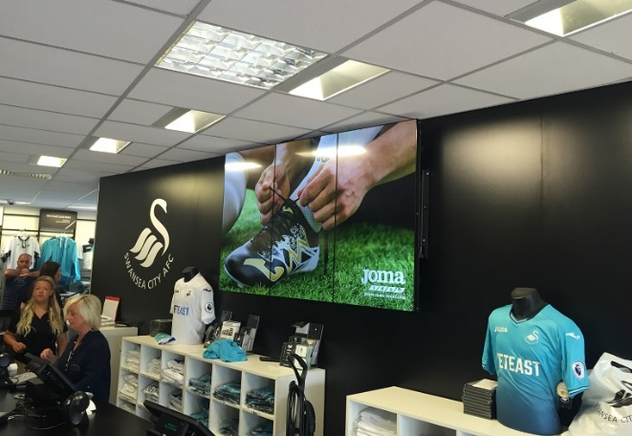

(Image: https://pioneergroup.co.uk/project/swansea-fc-club-shop/)

The above image shows a sport store in particular Swansea City Football Club Shop which sells football kits, clothing and other Swansea City related football merchandise. There is digital signage behind the till area displaying the Joma brand story and information about particular items within the store such as personalised kits. Studies show that serving relevant information close to the point of purchase can also increase purchasing decisions. (Screen.cloud, 2019). The human brain receives 90% of visual information, digital signage in retail stores is an effective communication platform to heighten brand and product awareness, especially when placed in strategic locations particularly near Point of Sale as 68% of shoppers agree that digital advertising influences their decision to buy. (Westbase Technology | Better Connected, 2018)

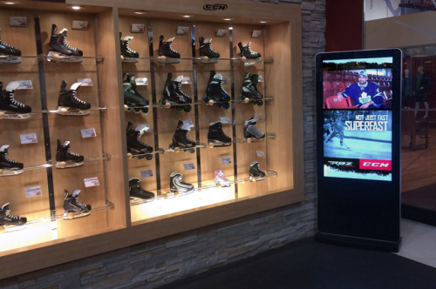

(Image: http://www.allsee-tech.com/digital-signage-solutions/retail-advertising-stores-shops-fashion-digital-signage-solutions.html)
Additionally, many retail stores use social media to influence and entice shoppers and with the use of digital signage, it is fairly straight forward to repurpose social media content to ensure it is in front of the targeted audience without other distractions. The above image is of a winter sports shop and next to the display is a digital signage which is using social media to encourage the customer to purchase a pair of ice skates. The digital signage is specifically showing a well-known athlete within ice hockey possibly discussing the skates and on the bottom half of the screen there is a brand advertising skates which claim to be ‘Superfast’ to influence the customer and encourage them to purchase that particular brand.

Digital signage in the retail industry specifically is an experience for customers in terms of entertainment. It is a way of engaging with the customer and improving the way in which they shop, therefore stores are more likely to gain sales and secure customer retention. It is evident in the image below that the customer is using interactive technology to help decide what items to purchase. This differs to ordinary shopping; the device can pair items which may go together to meet the customers’ needs. This type of shopping may be enjoyable for the customer and encourage them to return. An advantage of the use of interactive technology within stores is that it saves time for the customers as they can decide what to purchase from the screen rather than trying on a range of outfits.
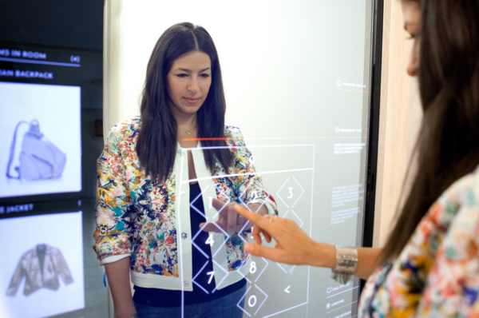

(Image: https://www.shopify.co.uk/retail/digital-signage-is-it-worth-the-investment-and-how-can-retailers-use-it)

The use of digital signage enables retail stores to create powerful window displays to make a statement and advertise their latest products. It can also allow brands to tell their story which will help to create brand awareness. Digital signs can be updated in seconds which is beneficial to retail stores as it can assist with visual merchandising in terms of how effective it is to change the signage around the store, enables retailers to adapt the physical set us as often as they choose.
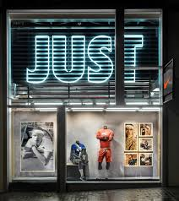
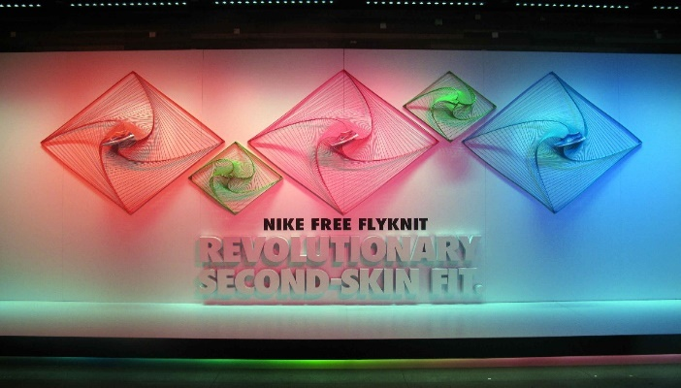
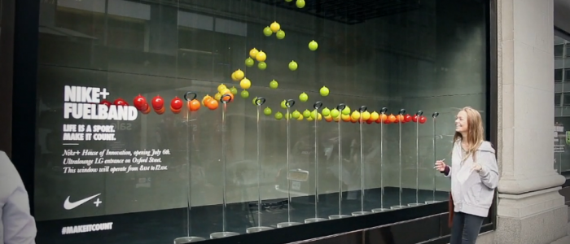

Images:
(https://i.pinimg.com/originals/d1/80/77/d180771b4fab92018a7d3f42518feb75.jpg)
(https://www.kalory.co.uk/2018/02/interior-visual-merchandising-photography-for-nike/)
(https://ceedsproject.files.wordpress.com/2013/04/nike-innovation-selfridges-staat-0-700x300.png)

The images above are of Nike window displays the brands flagship store in London Oxford Street. Nike is successful in creating unique window displays which are eye catching and appealing. Therefore, they are more likely to attract customers into the store rather than just walking past. Nike is a well-known sporting brand and is the sponsor of a number of sports teams and athletes throughout the world, their window displays are relative to their brand. This ensures that potential customers can get a good idea and understanding of what your store is about. It is clear that Nike has a unique and individual displays that help the stores stand out from the rest of the retail businesses. The three images above are highlighting Nike’s latest products which include: ‘Just Do It’ clothing, Nike Flyknit trainers and Nike Fuelband watches. Therefore, Nike’s window displays are an effective way to highlight latest products and promotional offers. Furthermore, having a statement window display is a way of creating brand awareness and allow the brand to tell a story.
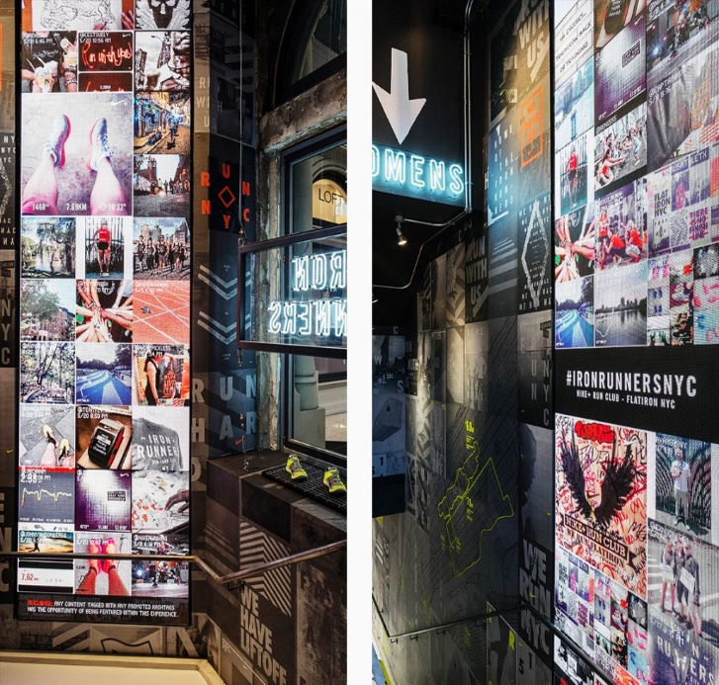
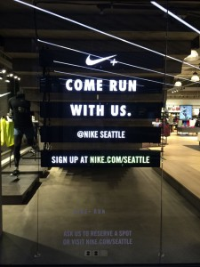
(Images: https://digitalplacesolutions.com/nike-in-store-digital/)
The above image on the left shows LED display technology which is used at a Nike store in Seattle to enhance its in-store messaging. This example of window messaging and in-store digital canvas walls exemplify digital signage leadership. This type of digital signage is a simple, practical and economical solution for continuous communication, even when the store is closed. The messaging is bright and has effective design capabilities to attract attention of customers, so they are more likely to read the digital signage. These displays can be programmed with time sensitive messages and NanoLumens can provide on board WIFI, Beacon and audience recognition capability. The image on the right is from Nike’s Flagship Store in New York 5th Avenue, inside the store features a large social media video wall, a never-ending waterfall of social media posts by Nike fans, their brand ambassadors, living and using the brand every day.
4.2 Digital Signage in Sporting Stadiums
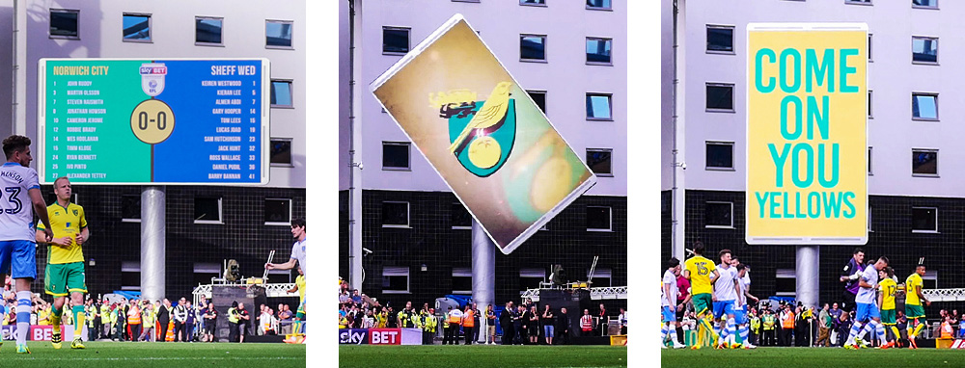
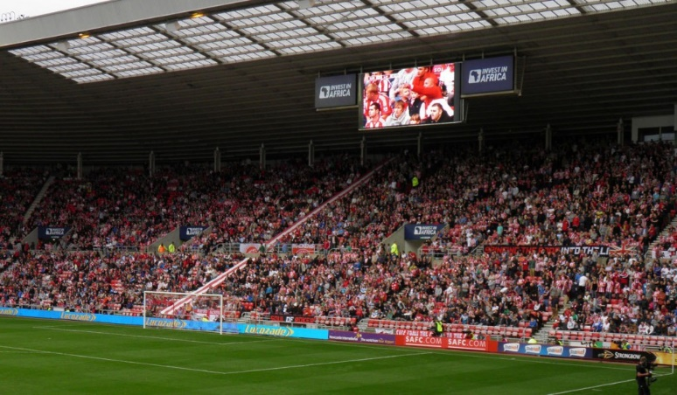

(Images: https://www.adi.tv/sales/markets/sport)
From a sporting perspective, digital signage is a way of informing the audience of the current scores of the sport they are watching e.g. Horse racing, cricket, basketball, etc. It is clear in the two images above that digital signage is used to alert the audience of the current scores and showing the footage of the game to ensure that customers in the stands can see the game. This can aid the customer experience and increase their loyalty to the team.

In addition, digital signage is also useful for athletes as many major sporting teams have digital signage within their training areas to alert athletes of important information and to share motivational message for their upcoming events. Digital signage can provide real time information such as current schedules, weather, traffic, etc which is useful to the athlete but also for other employees working for the team. Therefore, they can receive this information quickly and effectively.
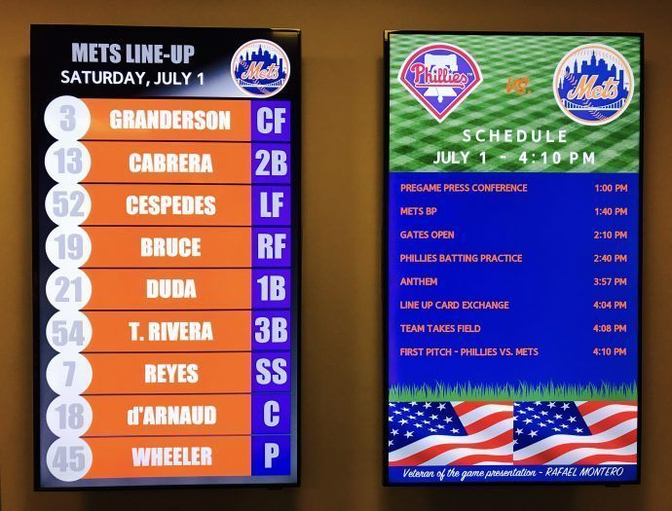
(Image: https://pinghd.com/ping-hd-installs-new-digital-signage-ny-mets-citi-field/)
The New York Mets Clubhouse have digital signage which is displayed in the image above. It shows players the line-up for the day and specific schedule and timings. This is useful to athletes and their teams as they know exactly what is planned for the day ahead. The New York Mets needed an up-to-date way to display information regarding the team, game day schedules, opposing team information, game day weather, and upcoming events. Ping HD is the technology they use to make dynamic changes to their clubhouse communication. Ping HD installed Samsung Tizen, System on Chip (SoC) commercial screens which are driven by EngagePHD™, their cloud based proprietary CMS. The features of EngagePHD™ enables the clubhouse to make real-time adjustments to any digital sign throughout Citi Field, including ticketing windows and Digital Menu Boards. A large facility like the Citi Field, the EngagePHD™ Software makes updating and sharing information effortless. The cloud-based technology behind this digital signage creates a more modern environment as well as a more engaging experience for their players and staff. This clubhouse and locker room signage was an innovative addition to the progressive facilities at Citi Field. (PingHD, 2017)
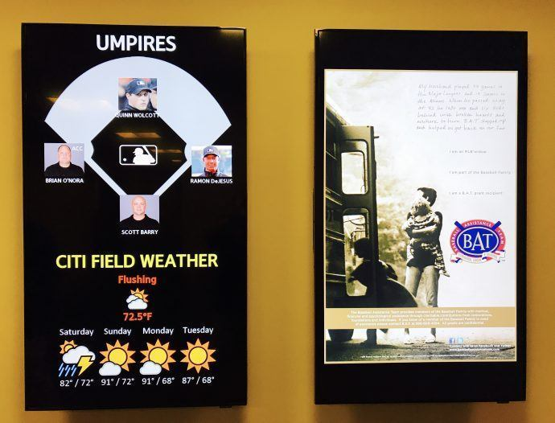
(Image: https://pinghd.com/ping-hd-installs-new-digital-signage-ny-mets-citi-field/)
The New York Mets also use digital signage to alert athletes and their teams of the weather and the umpires for upcoming games/matches. The image also displays motivational messages for athletes specifically to motivate them for the game ahead and encourage them to perform at the best of their ability.

Digital signage is extremely useful for informing customers of directions and locations at large sporting venues such as stadiums. Digital signage within the sporting industry can be used to direct customers to specific products or services, upsell items, direct customers to toilets, entry and emergency exits. This reduces employee costs and places customers in charge of their own experience. The image below shows a fast food chain advertising their products at a large sporting venue to generate sales and potentially increase revenue. Directions and locations shown via digital signage is beneficial to the venue as it reduces queues around the venue which improves the customer experience and the schedule of events are much more efficient.
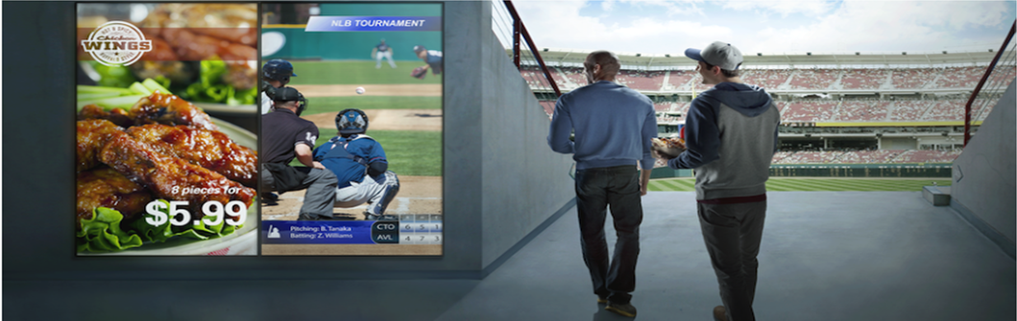

(Image: https://insights.samsung.com/2017/12/14/4-ways-sports-venues-are-using-digital-signage-to-enhance-the-customer-experience/)


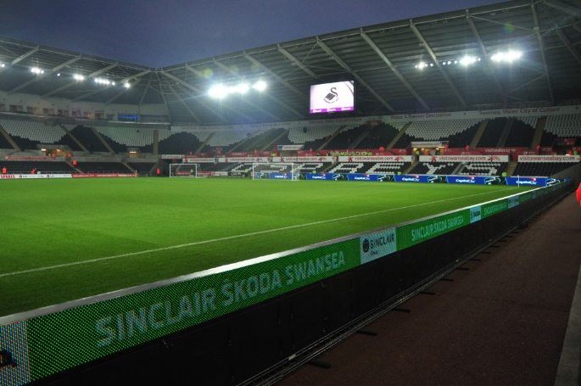
(Images: https://www.adi.tv/sales/markets/sport)
At major sporting venues, digital signage provides opportunities for brands and companies to advertise their products and service to a large audience. This can be done via the digital signage around the stadium or around the pitch itself to create brand awareness and new revenue opportunities e.g. Audi is one of FC Barcelona’s partners and is advertised around the football grounds via digital signage. It is evident in the above image on the left that Sinclair Skoda Swansea pay to have their brand advertised around the pitch at the Liberty Stadium.

For multi-purpose sporting venues, digital signage can easily be changed and updated to meet the requirements of events. Large stadiums are often rented out for other events during the off-season such as: concerts, conferences, or promotional events sponsored by big businesses. A stadium with engaging digital video displays supports these types of events and makes the venue more valuable to the sponsors contributing. (Mvix, 2019) e.g. Liberty Stadium has hosted many concerts including: Pink, JLS, Little Mix, etc as well as other sporting events such as boxing. There are a number of digital signage displays available which function differently which sporting venues can select to maximise the customer experience.
The image below displays how digital signage can be utilised at different functions. It shows a rock concert with digital signage on both sides of the main stage showing the concert so members of the audience can see the action from far distances. This enhances the customer experience.
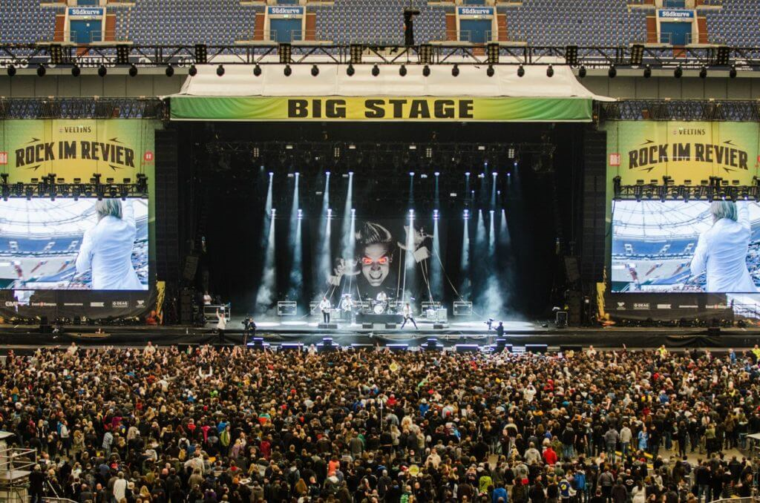

5.0 Conclusion
It is evident that there are a number of key concepts within the sales and merchandising industry, which is underpinned with academic literature. Similarly, there are a variety of emerging themes within this sector including: the use of technology, esports, etc. It is clear that many retail stores and brands are using digital signage to attract customers to their stores, increase brand awareness, generate leads and increase revenue and retain customers by improving their shopping experience. As well as retail stores using digital signage, stadiums and sporting venues use digital signage which is beneficial to customers and athletes as they can provide real time data and information quickly and effectively which is useful for supporters and sports teams. Within stadiums and sporting venues, many brands and companies pay to have their name advertised via digital signage to ensure large audiences are aware of the products and services they offer which is an opportunity for them to generate sales and increase their revenue.

6.0 References

Abbamonte, K. (2018). Digital Signage: Is it Worth the Investment and How Can Retailers Use It? — In-person Selling and Pop-Up Shops. [online] Shopify. Available at: https://www.shopify.co.uk/retail/digital-signage-is-it-worth-the-investment-and-how-can-retailers-use-it [Accessed 17 Mar. 2019].
Adi.tv. (2019). Powering Fan Engagement: Sports Stadium LED Screen Solutions | ADI.tv. [online] Available at: https://www.adi.tv/sales/markets/sport [Accessed 17 Mar. 2019].
Ailawadi, K. and Keller, K. (2004). Understanding retail branding: conceptual insights and research priorities. Journal of Retailing, 80(4), pp.331-342.
Allsee-tech.com. (2019). Retail Digital Signage Solutions. [online] Available at: http://www.allsee-tech.com/digital-signage-solutions/retail-advertising-stores-shops-fashion-digital-signage-solutions.html [Accessed 17 Mar. 2019].
Buttle, F. (1984). “Merchandising”, European Journal of Marketing, 18, 6/7, pp. 104-123.
Ceedsproject.files.wordpress.com. (2013). [online] Available at: https://ceedsproject.files.wordpress.com/2013/04/nike-innovation-selfridges-staat-0-700x300.png [Accessed 30 Mar. 2019].
Digitalplacesolutions.com. (2019). NIKE IN-Store Digital - Digital Place Solutions. [online] Available at: https://digitalplacesolutions.com/nike-in-store-digital/ [Accessed 30 Mar. 2019].
Fiore, A. and Kim, J. (2007). An integrative framework capturing experiential and utilitarian shopping experience. International Journal of Retail & Distribution Management, 35(6), pp.421-442.
Haynes, D. (2017). 4 Ways Sports Use Digital Signage To Enhance Customer Experience. [online] Samsung Business Insights. Available at: https://insights.samsung.com/2017/12/14/4-ways-sports-venues-are-using-digital-signage-to-enhance-the-customer-experience/ [Accessed 17 Mar. 2019].
Haynes, D. (2017). MLB's Mets Keep Players Informed With Clubhouse Digital Signage - Sixteen:Nine. [online] Sixteen:Nine. Available at: https://www.sixteen-nine.net/2017/10/02/mlbs-mets-keep-players-informed-with-clubhouse-digital-signage/ [Accessed 28 Mar. 2019].
Hirschman, E. and Holbrook, M. (1982). Hedonic Consumption: Emerging Concepts, Methods and Propositions. Journal of Marketing, 46(3), p.92.
Hjorth, S. (2019). Digital Signage: Everything you need to know. [online] Airtame. Available at: https://airtame.com/blog/digital-signage/ [Accessed 17 Mar. 2019].
Hu, H. and Jasper, C. (2006). Social cues in the store environment and their impact on store image. International Journal of Retail & Distribution Management, 34(1), pp.25-48.
I.pinimg.com. (2019). [online] Available at: https://i.pinimg.com/originals/d1/80/77/d180771b4fab92018a7d3f42518feb75.jpg [Accessed 30 Mar. 2019].
Jehanne, F. (2018). Interior & Visual Merchandising photography for Nike | Kalory | Photo and Video | London UK Photographer and Photography studio. [online] Kalory.co.uk. Available at: https://www.kalory.co.uk/2018/02/interior-visual-merchandising-photography-for-nike/ [Accessed 30 Mar. 2019].
Mvix. (2019). The Evolution of Digital Signage for Sports Venues | Mvix. [online] Available at: https://mvixdigitalsignage.com/blog/digital-signage-for-sports-venues/ [Accessed 17 Mar. 2019].
Mvix. (2019). The Evolution of Digital Signage for Sports Venues | Mvix. [online] Available at: https://mvixdigitalsignage.com/blog/digital-signage-for-sports-venues/ [Accessed 23 Mar. 2019].
nibusinessinfo.co.uk. (2019). Visual merchandising: advantages of retail window displays. [online] Available at: https://www.nibusinessinfo.co.uk/content/visual-merchandising-advantages-retail-window-displays [Accessed 28 Mar. 2019].
Peterson, R. and Albaum, G. (2007). On the Ethicality of Internal Consumption in Multilevel Marketing. Journal of Personal Selling & Sales Management, 27(4), pp.317-323.
PingHD. (2017). Ping HD Installs New Digital Signage for the NY Mets at Citi Field - PingHD. [online] Available at: https://pinghd.com/ping-hd-installs-new-digital-signage-ny-mets-citi-field/ [Accessed 28 Mar. 2019].
Pioneer Group. (2019). In-store videowall | Pioneer Group. [online] Available at: https://pioneergroup.co.uk/project/swansea-fc-club-shop/ [Accessed 30 Mar. 2019].
Risevision.com. (2017). 9 Benefits of Digital Signage for Retail Stores & Shops. [online] Available at: https://www.risevision.com/blog/digital-signage-for-retail [Accessed 17 Mar. 2019].
Screen.cloud. (2019). 8 Digital Signage Retail Benefits. [online] Available at: https://screen.cloud/ideas/ideas/digital-signage-retail-benefits [Accessed 23 Mar. 2019].
SearchCRM. (2019). What is Digital Signage (dynamic signage)? - Definition from WhatIs.com. [online] Available at: https://searchcrm.techtarget.com/definition/digital-signage [Accessed 17 Mar. 2019].
Sheth, J.N. (1983). “An integrative theory of patronage preference and behaviour”, on Darden, W.R., lusch, R.F. (Eds.): patronage behaviour and retail management, Editorial: Elsevier-north, Holland, pp. 7-28
Signs, W. (2015). Digital Signage vs Traditional Signage -. [online] Westmountsigns.com. Available at: http://www.westmountsigns.com/uncategorized/digital-signage-vs-traditional-signage/ [Accessed 17 Mar. 2019].
Sin, L., Tse, A., Yau, O., Lee, J. and Chow, R. (2002). The effect of relationship marketing orientation on business performance in a service‐oriented economy. Journal of Services Marketing, 16(7), pp.656-676.
TrouDigital. (2019). Digital Signage For Retail - Innovative Retail Screens | TrouDigital. [online] Available at: https://troudigital.com/retail/ [Accessed 17 Mar. 2019].
Westbase Technology | Better Connected. (2018). Digital Signage in Retail | Westbase.io News. [online] Available at: https://www.westbase.io/digital-signage-in-retail/ [Accessed 30 Mar. 2019].
Yu, W., Ramanathan, R. and Nath, P. (2014). The impacts of marketing and operations capabilities on financial performance in the UK retail sector: A resource-based perspective. Industrial Marketing Management, 43(1), pp.25-31.
Zeithaml, V. (1988). Consumer Perceptions of Price, Quality, and Value: A Means-End Model and Synthesis of Evidence. Journal of Marketing, 52(3), pp.2-22.

