
Managing diabetes Interventions to control blood glucose are as follows:
*combination of diet/portion intake.
*physical activity
*monitoring your blood sugar level
*increase your fiber intake
*drink water and stay hydrated
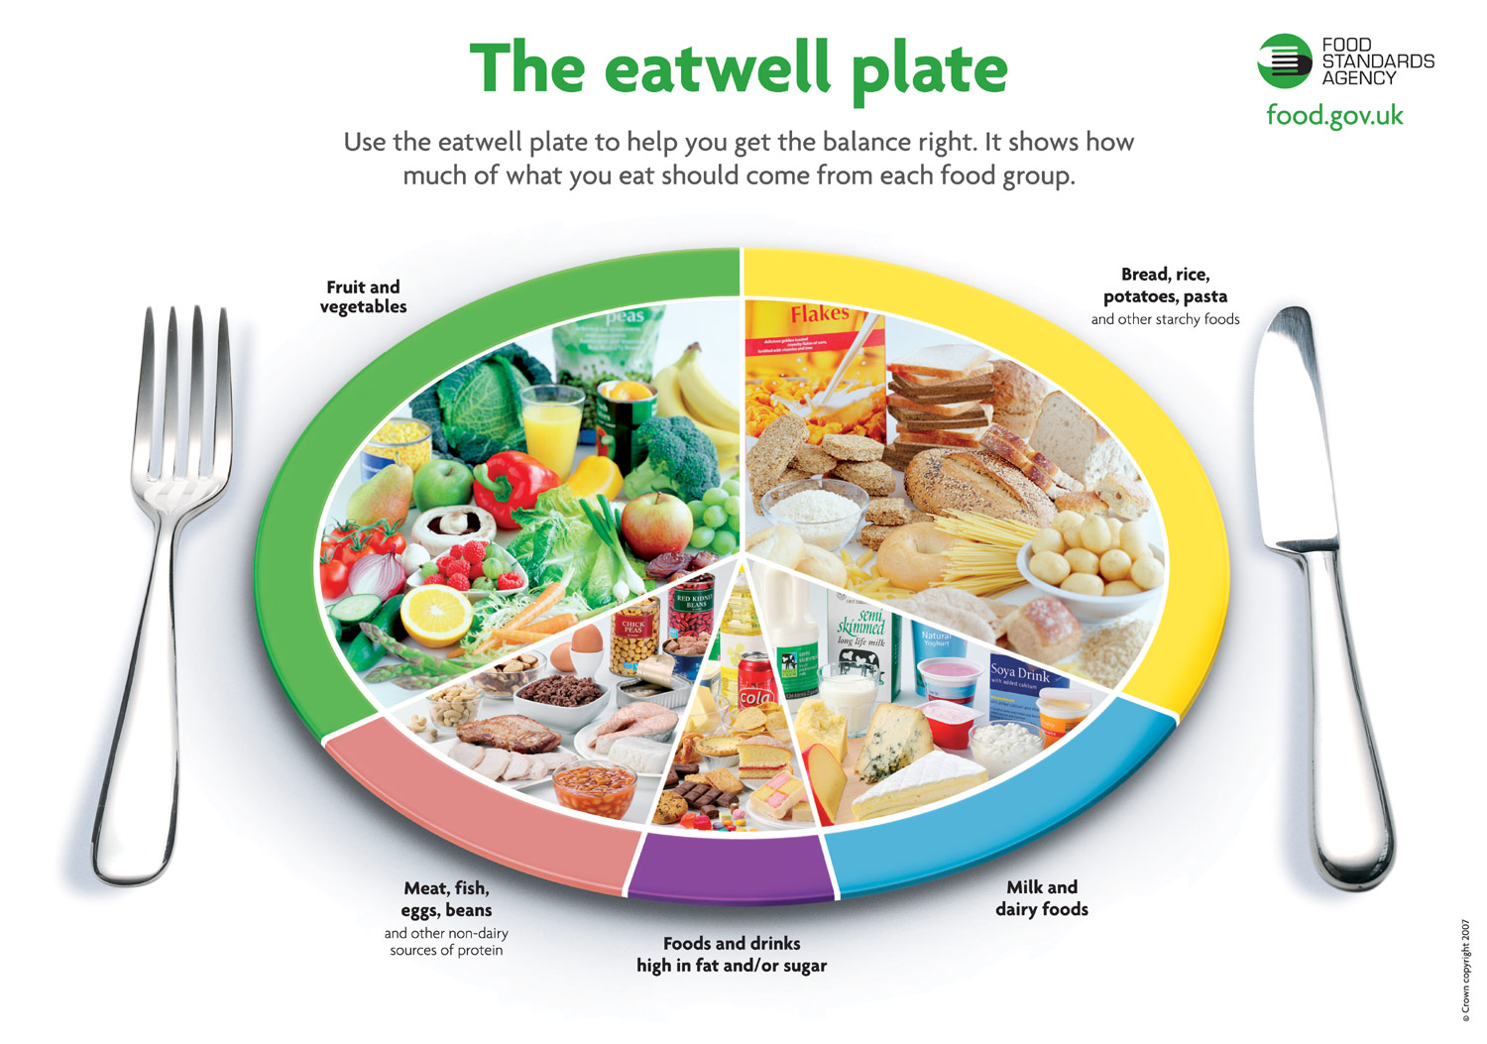

diabetes
key message
*diabetes of all type can lean to complication in many parts of your body and may increase overall risk of premature deaths.

diabetes is a chronic and progressive disease caused by elevated levels of blood Gulcose

Causes: Eating large amounts of process food that is high in fat and sugar.
Excessive drinking of alcohol
Intaking too much sugary drinks
Risk Factors:
Cardiovascular Disease
Obesity
Shorter life span
Stroke
Sleep Apnoea
Liver and kidney disease
Although type 1 diabetes cannot be prevented, effective approach has been made available to prevent type 2 diabetes in order to prevent complication and premature deaths. research has shown that overweight and obesity are the strongest risk factors for type 2 diabetes
Diabetes is a chronical disease which occurs when the pancreas does not produce enough insulin or when the body cannot use the insulin it produces effectively.

There are 2 types of diabetes 1 and 2.
- Type 1 diabetes is known as inherited which is caused when your level of glucose (sugar) in your blood is too high. This is caused when the body cannot produce enough hormone known as insulin, which assist the body to control blood glucose. (National Health Service,2018).
- Type 2 diabetes is when too much glucose (sugar) is in the blood that can potentially cause serious health problems if it is not treated. According to (NHS, 2018) individuals who are at more risk of developing type 2 diabetes are of Caribbean, Asian and African descent world wide. People of age 40 and over (25 for South Asian ethnicity )and if you are also overweight and obese.
Some symptoms of type 2 diabetes are as follows:
- Peeing more than usual, mostly at night.
- Fatigue.
- Weightloss.
- Blurred vision.
- Wounds taking longer than usual to heal.

As shown Patient A is a 45-year-old smoker with hight blood pressure of 140/90 weight of 80 kg (176 pounds) and height of 160 cm (5.2ft) who is not physically active. Have a family history of high cholesterol, stroke with no known reason. Patient A has an intake of process fatty foods daily who also consumes 2 units of red wine every day. From this information gathered it shows that Patient A is obese according to guidelines from the (National Health Service Calculator, 2018) stating that anything over 40 is classified as obese. In this case Patient A can be referred to a dietician for help and also gain assistance in the NHS in regard to fitness and exercise programme. There can also engage with the diabetes UK charity programme.

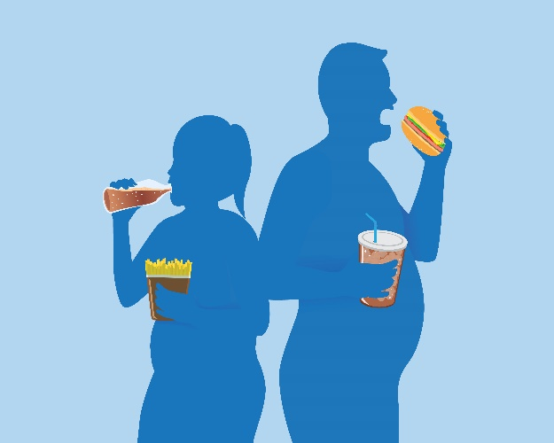
This Photo by Unknown Author is licensed under CC BY-SA-NC

Speakers note
For my poster I have chosen Diabetes.
According to (Time,2016) diabetes is a chronic disease that occurs in the body when the pancreas as is not able to perform or produce enough insulin a hormone that regulates the blood sugar or glucose. According to public Health England, 2020 diabetes is a major public health problem which has increases over the past decades.
For my poster I have include a picture I obtain from my GP practise with information on help that is available for anyone who has diabetes and where they can get further help from such as their GP practise, NHS, and Diabetes UK (research charity) which they run a program called national Diabetes Audit (NDA). I have also included information on diabetes, what diabetes is, some of the complications caused by diabetes and ways on how to help manage your diabetes. I have included problems that may arise with diabetes and obesity. Some serious health conditions that were related to diabetes were cardiovascular, stroke and in general having a shorter life span.

Cite
Roglic G. who global report on diabetes: a summary .int J Non-Commun dis 2016;1:3-8

References
Jojka, R. (2016) international journal of noncommunicable diseases.1(1),3
Buchwald.H, Estok.R, Fahrbach.K, Banel.D(2009) the American journal of medicine
O’Dowd, A., 2020. Public Health England denies conspiracy over obesity report’s timing. BMJ, p.h5604.
National Hearth services 2018
Diabetes UK, 2020

