Reflection upon the application of the academic and professional skills learned
Chloe Roberts – ROB19850920
HND Applied Computing
Academic and Employability Skills – ACCA4016
Submission Date – 22/03/2024

Table of Contents
1.0 Introduction 3
2.0 Fundamental Learning Techniques 3
2.1 Learning styles (VAK tests) 3
2.2 Positive Engagement 4
2.3 Personal Inspiration 4
2.4 Motivation Goals and Values 4
3.0 Self-Management 5
3.1 Study Area 5
3.2 Time Management 7
3.3 Managing Change 11
3.4 Organising Resources 11
3.5 Positive Attitude 12
4.0 Problem-solving techniques 12
4.1 Action Plan 12
4.2 Solution-Focused Thinking 14
4.3 Thinking Outside the Box 16
4.4 Creative Problem-Solving Techniques 16
5.0 Research Methods 17
5.1 Note Taking 17
5.2 Use of Library and Online Resources 17
5.3 Reading Log 18
5.4 Standard Referencing Methodology 19
6.0 Academic Skills and Development 19
6.1 Communicating and Presenting Information 19
6.2 Academic and Professional Writing of Reports 24
7.0 Professional Skills 28
7.1 Soft Skills 28
7.2 Employability Skills and Competencies 30
7.3 Team-Working 33
7.4 Professional, Legal, Ethical, and Sustainability 34
Conclusion 34
Bibliography 35
Appendix 35
List of Figures 35
List of Tables 36
Appendices 37
Appendix a – Reading Log Term 1 (continued) 37
Appendix b – Reading Log Term 2 (continued) 38
Appendix c – Snippet of Academic Journal - Term 1 39
Appendix d – Snippet of Academic Journal - Term 2 40
Appendix e – Action Plan 40
Appendix f – Use of Library and Online Resources 41
Reflective Journal 41

1.0 Introduction
Throughout this academic year, I have monitored my progress while I have improved my skills on the course while also researching how I can improve as a student. With the progression from level 3 to level 4, I have had to modify the format of my assignments and find out my learning style so I can use techniques to work more effectively as well as more factors covered in this report.

2.0 Fundamental Learning Techniques

2.1 Learning styles (VAK tests)
At the beginning of the academic year, it was crucial for me to know what kind of learner I was in order to have a further understanding of what learning techniques would be better suited to me to assist with my progress and success this year. In order to achieve this, I completed three VAK tests throughout the year to monitor if my learning style had changed and to know what kind of learner I was. The first VAK test was completed on the 10th of October 2023 in which it was established I was a strongly visual learner (See figure 1).

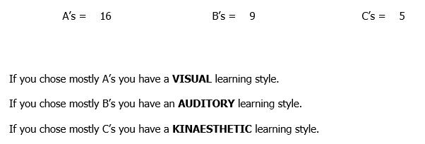
Figure 1 - VAK Test 1 Results - 10/10/2023
Upon completing the second VAK test on the 28th of January 2024, I became more of a visual learner and less of a kinaesthetic learner (See figure 2).

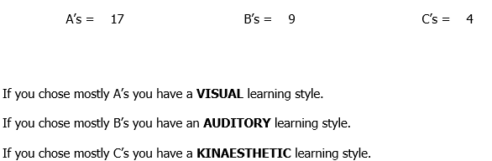
Figure 2 - VAK Test 2 Results - 28/01/2024
However, when I completed my third and final VAK test on the 22nd of February 2024, I was still a visual learner but my auditory and kinaesthetic scores were almost equal as I had become more kinaesthetic since the second test (See figures 2 and 3).

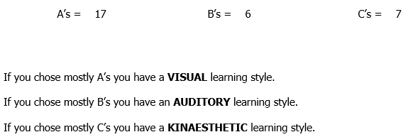
Figure 3 - VAK Test 3 Results - 22/02/2024

Upon completing these tests, I learnt that reading and writing notes was heavily useful to help me remember information but also played a crucial part in assisting me with recalling some information when needed. I also did some research to inform myself of learning methods that could be useful to me, as a visual learner when studying or completing assignments. From this research, I found that note taking, highlighting, studying alone, and noting key information on its own could be useful in addition to making my study area visually appealing [1].

2.2 Positive Engagement
Throughout the academic year, I always tried to attend my lectures with a positive attitude and the enthusiasm to learn. I participated during lectures sometimes and asked questions when unsure of something or finding something particularly difficult to understand. To improve my understanding, I would ask lecturers for clarification or discuss it with my peers and if further assistance would be required I would do personal research to improve my understanding. An effort was made to maintain my motivation to put my full effort and concentration into my work throughout the academic year however, some periods of time made it difficult to do so as sometimes I would be constantly working on assignments outside of lectures causing me to eventually become unmotivated and burnout due to me not giving myself enough breaks to make the work easier to manage and complete. I always put my full effort into my work whether it was assignments or preparing for exams to ensure that I could achieve higher grades. I also always listen attentively to feedback from assignments in order to thoroughly understand why I missed out on marks in parts and where I was just of the mark for an aspect so I could learn from this for future assignments. I have also been creating a weekly plan to remain effective with the completion of my work.

2.3 Personal Inspiration
My career aspirations, and my enjoyment towards learning and computing served as inspiration for me to pay attention and work hard throughout the academic year. This is because I am aware that the course can lead me into a job in computing but also that I am not limited to one field. In addition to this, my love of learning further encourages me to do well on the course as I am learning new things while I prepare myself with knowledge and grades that could and will benefit me when going into a job in computing. In addition to this, achieving high grades act as further motivation for me because if I have achieved a high grade once, then I can achieve high grades for each assignment provided that I put the work in for it.

2.4 Motivation Goals and Values
My primary goals currently are to achieve high grades this academic year for my assignments and to put as much hard work, time, and effort as I can into preparing and performing in assignments and exams. However, should I achieve a grade that is lower than expected, I am prepared to gain understanding as to how I achieved less than expected and to improve upon this for future assignments or exams, especially if its something that is transferrable thereof. My current plan, approach, and attitude to assignments this year could be improved upon slightly but could help me achieve my main goal of the HND of getting an interview and a job in computing, providing that I continue to put a lot of hard work and effort into my assignments as I understand the importance of doing this and the importance of these modules this year as preparation for the modules and assignments next year.

My primary values regarding academia include integrity, perseverance, and when suitable, collaboration. Integrity is important to me due to the fact that I believe that by copying or plagiarising someone else’s work for your own gain whether it is an assignment or personal works, the consequences that would most likely follow are not worth it. In addition to this, by using or copying someone else’s works and passing it off as your own, the achievement and gratitude felt as a result of achieving a high grade is less fulfilling and replaced with guilt as I believe that it would not have been deserved so it is better to try as hard as you can to make the best piece of work you can for an assignment but can include other works to back up your views and statements as long as they are credited. Perseverance is important to me due to the fact that in workplace scenarios it would be likely that I would come across an issue in which I may struggle to solve or I may burnout but I am becoming aware now, while in education, how I can overcome these issues or to manage this better should I come across such issues in the workplace and from there persevere to continue with my work. Collaboration is important to me as it can be a requirement for projects in which I may need to collaborate with others but also as I could be assisting others with an issue they are having and then they sometimes would return the favour if I were struggling, and they have an understanding. In addition to this, I find that helping my peers when they are struggling with something can be personally rewarding purely from helping others and improving their understanding on a topic.

3.0 Self-Management

3.1 Study Area
In order to effectively manage myself for my studies, I had to ensure that I have an environment conducive to learning.

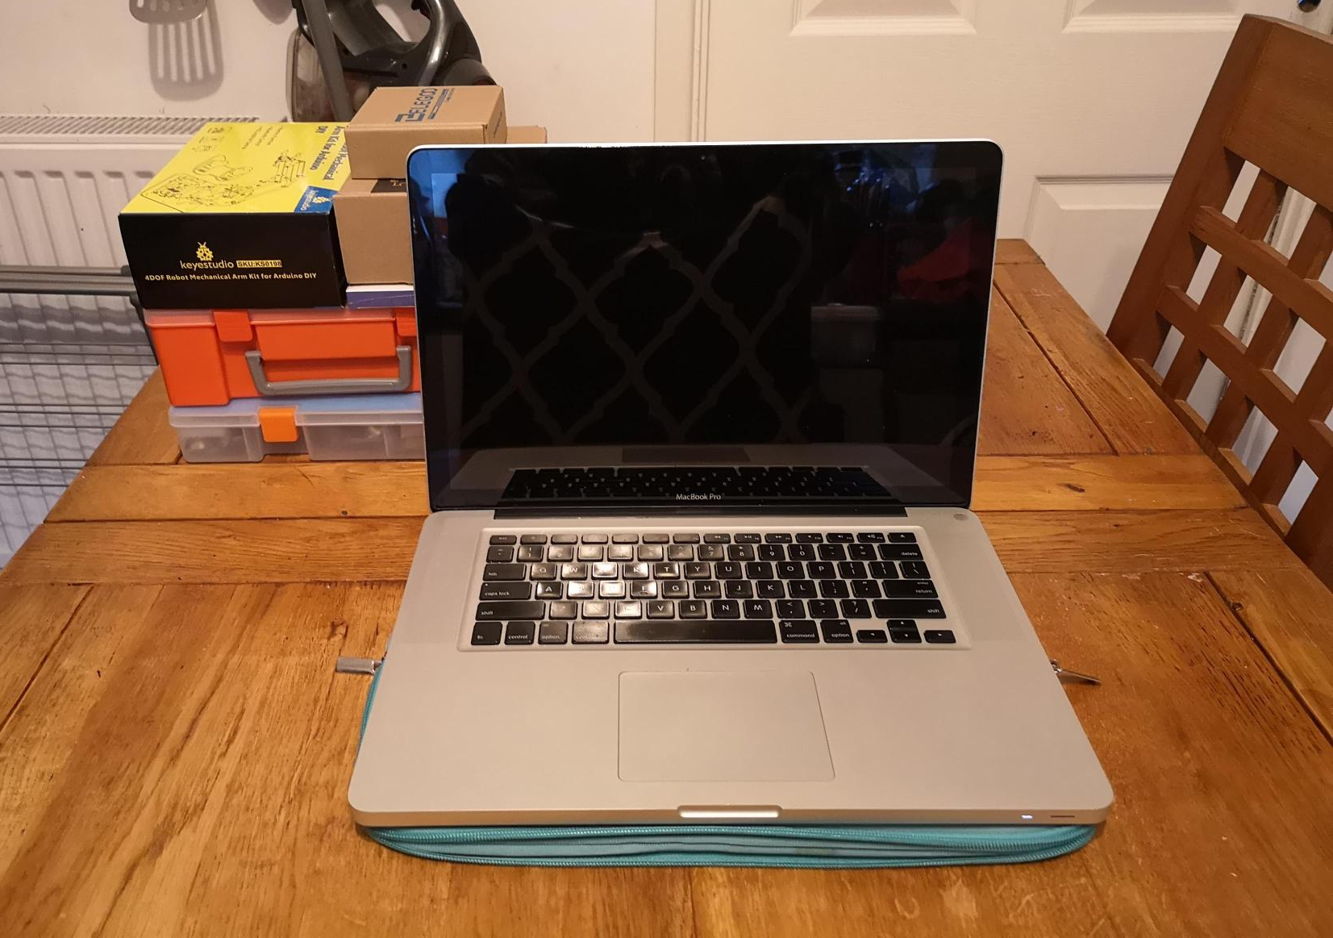
Figure 4 - My Study Area - 12/10/2023

In the beginning of the academic year, my study area was not suitable for learning. This was due to the fact that I was limited in space by working at the table in the kitchen as shown in figure 4. In addition to this, I was constantly distracted by people walking through the kitchen, people cooking, and people communicating while I was trying to work. This made it difficult to work effectively.

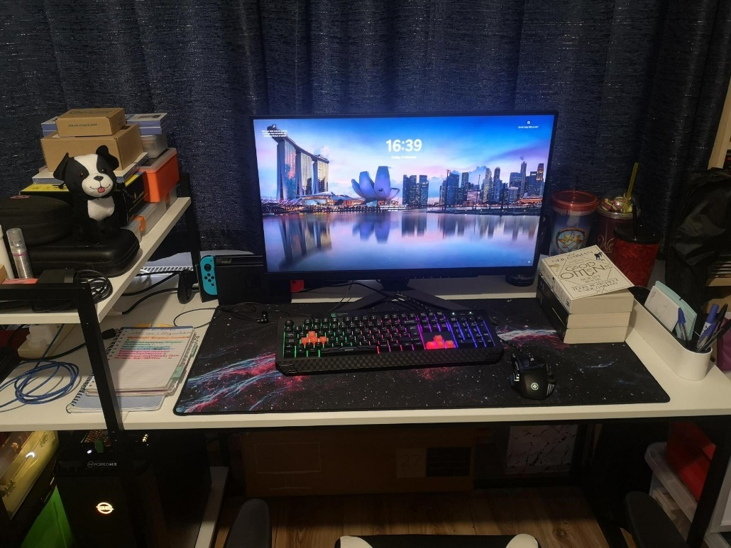
Figure 5 - My Study Area - 09/02/2024

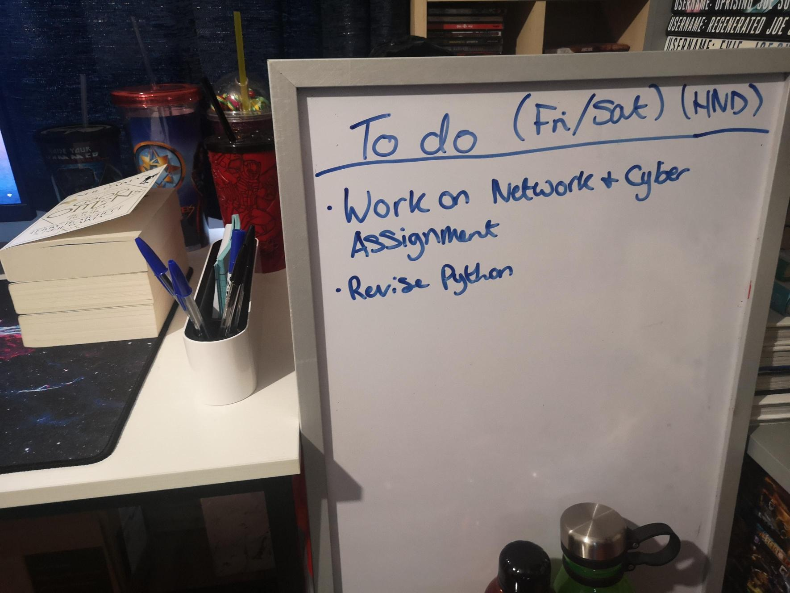
Figure 6 - The remainder of my Study Area - 09/02/2024

From this, I realised that I needed to improve my workspace to make it easier to focus with less distractions. Therefore, I made my study area in my living room in which there was more space available for my computing equipment and desk, providing plenty of room to study as shown in figure 5. In addition to this, I also placed my whiteboard next to my desk so that I could note what needed to be completed during the week or on the weekend as shown in figure 6. This proved to be extremely useful as I could monitor task completion and manage myself much easier. However, I still occasionally get distracted by background noise from the television or my family, but it was the most efficient location for my study area considering I was unable to have a quiet room specifically for my studies. Although there are still distractions in my workspace, I utilise them as a reward and break from the work by enabling myself to play on a console or watch something after completing tasks or working for a certain period of time.

3.2 Time Management
Throughout the academic year, it was important to have a grasp on time management and to implement it into my studies.

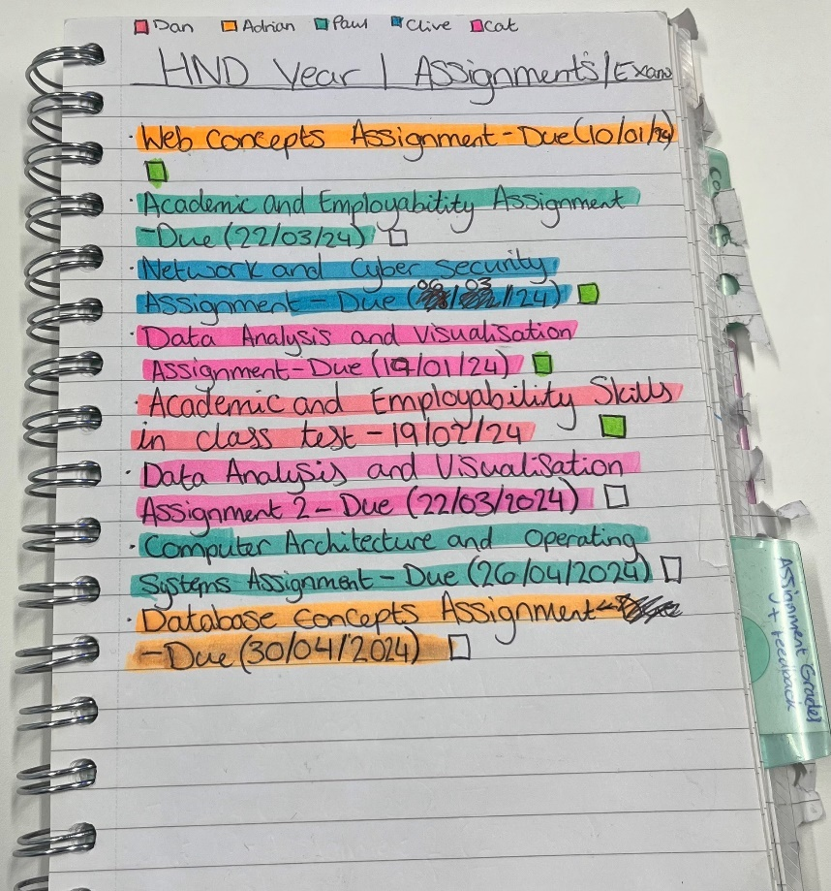
Figure 7 - Assignment due dates and Exam dates
Figure 7 shows an example of how this was achieved as I documented my assignments or exams upon announcement of them and the date they would be due. I also colour coded these by lecturer to assist in visualising the due dates. In addition to this, the colour coding helped to separate the assignments from one another making it easier to read while including a tick box for me to colour in upon completion.
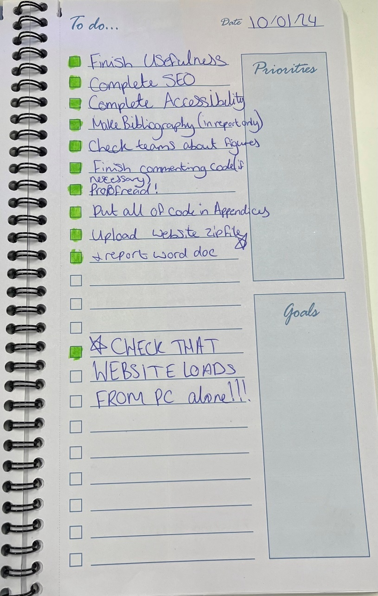
Figure 8 - To Do List from start of Term 2 - 10/01/2024
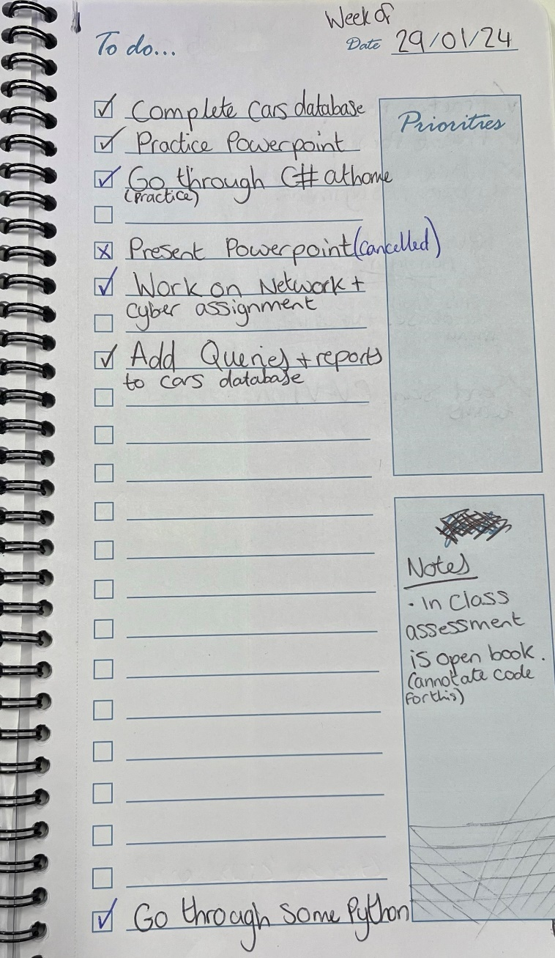
Figure 9 - To Do List from Term 2 - 29/01/2024
I also made and used to do lists throughout the year, shown in figures 8 and 9, in which I documented in lectures or at home what needed to be completed for the week which I then transferred to the whiteboard shown in figure 6 to help me monitor while at home. Then, like the due dates in figure 7, I utilised the tick boxes to track my progress of completing the tasks for that week. The to do list tasks also worked as a way to ensure that the tasks were completed by Sunday of that week.

Aside from when any homework was set, assignments have always taken priority in which I would work on an assignment for an hour, take a break, work on a different piece of work for an hour or until finished, take a break, then continue working on the assignment. This method helped to ensure that assignments were being completing without neglecting the additional hours of work to put in for modules outside of lectures.

3.3 Managing Change
The main changes I have had to adapt to with my work throughout the academic year included the transition from a Level 3 BTEC to the Level 4 HND, assignment issues, and life. The transition from the BTEC to the HND was something I had to adapt to only because of the raised expectations for the assignments but aside from that it was easily adaptable as I had the sense of familiarity in my environment in lectures and I only felt that my assignments had to be improved appropriately for said expectations and the single submission as opposed to the BTEC having two submissions for an assignment. I needed to adapt when I had assignment issues when creating my website for the introduction to web and database concepts assignment as I had issues regarding the layout and images which caused me to restart the website twice, therefore costing me time so as a result, I had to miss out on marks by having to deal with the website as it was and focus on the report element with what remaining time I had left from this assignment. My grade, mark allocation and discussion with my lecturer proved this as I was told that there were none to very little bootstrap and additional features within my website which cost me marks on the assignment while my report benefitted me in regard to marks. Life is another factor that I had to adapt to sometimes as there would be times in which my environment, mentality or special occasions impacted my capability to complete work. In cases in which my environment or mentality was a factor, I assessed whether a day long break or shorter would be beneficial to me, while also considering any due dates, to make me work effectively when I would circle back to the work after said break.

3.4 Organising Resources
I found that organising my files and resources throughout the academic year to be useful especially as some modules or topics would contain multiple files.
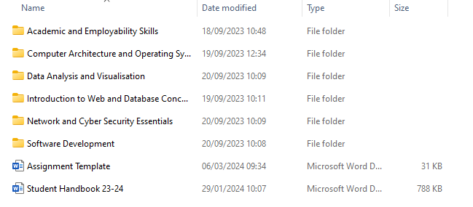
Figure 10 - Folders for each module

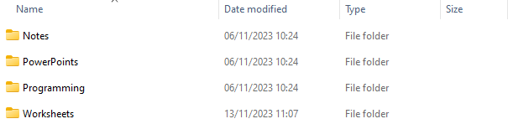
Figure 11 - Folders for the Software Development module
In order to organise my digital files, I organised the files by module, then what is the purpose of the file (examples include notes for documents containing notes and assignments for my assignments). I ensured that the folders had meaningful names relevant to what was stored. Figures 10 and 11 show my use of folders to organise my files. I also organised my written notes by allocating a section of my notebook with named dividers to each module for which I write notes for the corresponding module that could be useful for exams or when revisiting for assignments. Colour coding methods were also used in order to organise my due dates as shown in figure 7. Organising a schedule to be used outside of lectures was attempted however, I found that listing the tasks that I needed to complete in a larger time limit without constraint of the order tasks needed to be completed was much easier to manage. Each of these methods have proven to be extremely useful and effective to myself throughout the academic year.

3.5 Positive Attitude
I always try to maintain a positive attitude when completing assignments and I try to maintain my motivation as I believe these makes me work more efficiently. In order to maintain a positive attitude, I ensure that I am enthusiastic in what I am learning and writing about, efficient with my time spent and task completion, and resilient even when I am facing a point in which I lack proper understanding or an issue has occurred so I increase my understanding with the assistance of further research and discussion with peers.

4.0 Problem-solving techniques

4.1 Action Plan
When approaching an assignment, after highlighting and ensuring that I understand the brief, I try to narrow it down by creating the headings for the report and then from this, I class each heading as a new section which helps to separate the assignment into small tasks through the process of decomposition. From this, when creating my work plan for the week, I establish which sections I would want to complete for an assignment.

When approaching an issue in an assignment, I gain an understanding on what is the issue whether it is a lack of understanding on what needs to be discussed or my discussion is not relevant to the scenario of the assignment. Once the issue has been identified and the cause of it, then I am able to determine whether I need to take a short break and then proofread to ensure that the discussion is relevant and modify accordingly or do further research to increase my understanding. In addition to this, upon receiving feedback from assignments, I gain an understanding of what I did wrong or missed out on marks for in the hopes that reflecting upon the feedback would help me learn for future assignments.
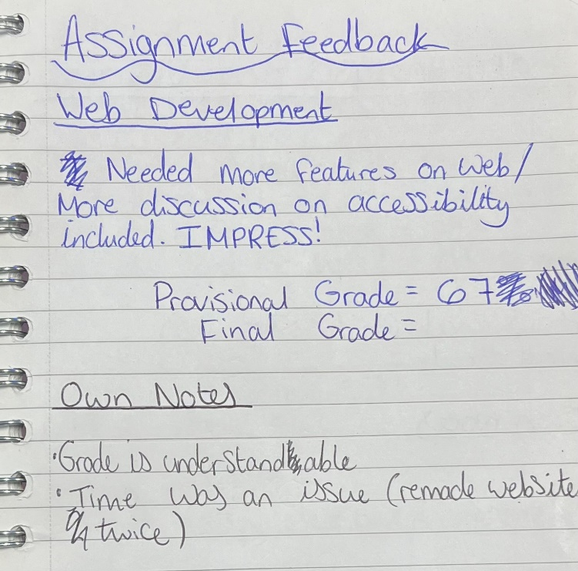
Figure 12 - Feedback and Reflection for Web Development Assignment

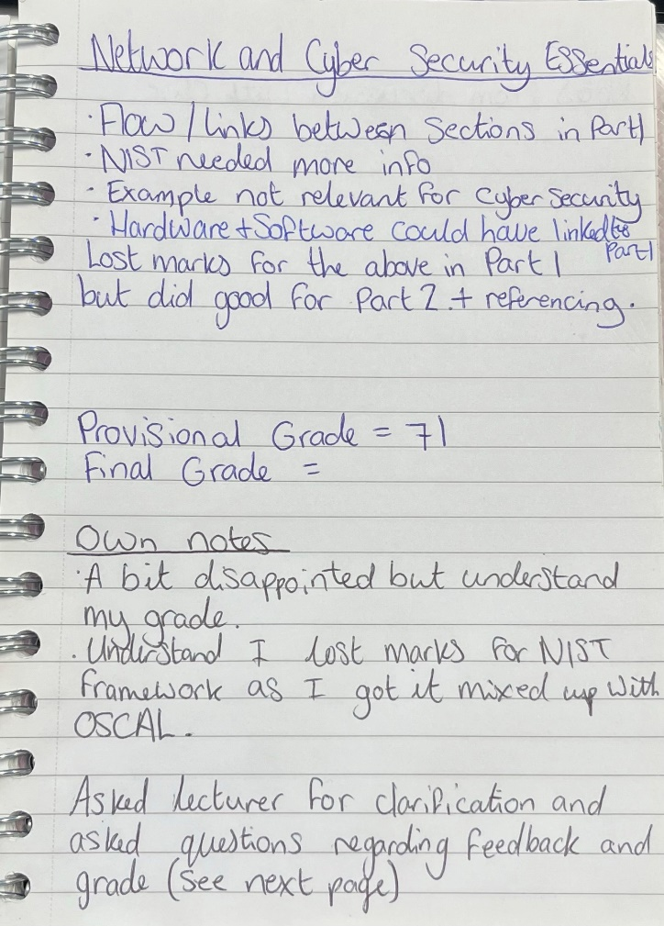
Figure 13 - Feedback and Reflection for Network and Cyber Security Assignment

Figures 12 and 13 show my notes that I made while receiving feedback on assignments but also the reflection I made upon the feedback and grade after receiving feedback.
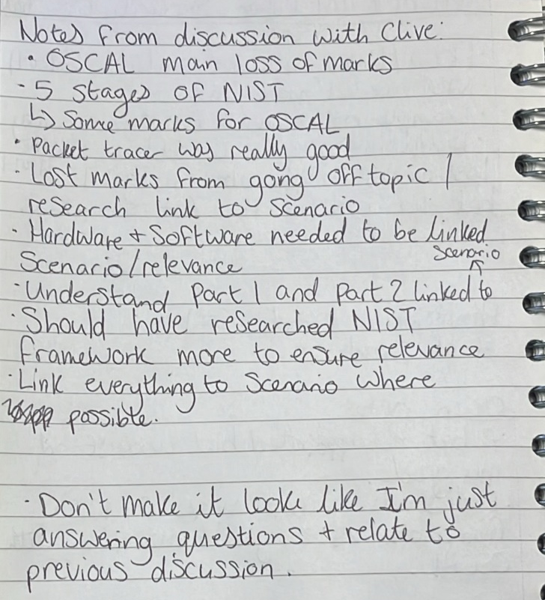
Figure 14 - Notes from discussion about my Network and Cyber Security Essentials assignment

I also had a discussion with a lecturer about my feedback and grade for clarification and wrote notes during that as shown in figure 14.
(See appendix e)

4.2 Solution-Focused Thinking
Upon completion of assignments, lecturers have given feedback of which I have reflected upon as shown in figures 12 and 13. In addition to this, I identify my weaknesses based off the feedback so I am aware and understand what I will need to improve upon in the future.
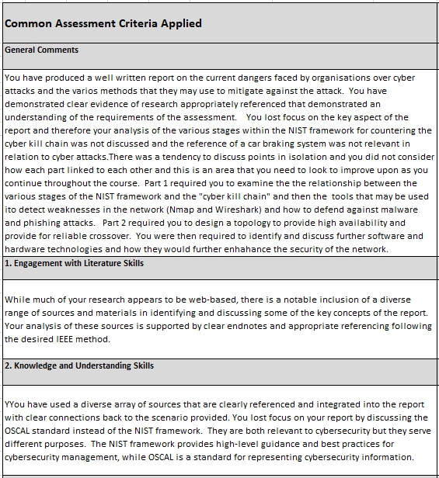
Figure 15 - Network and Cyber Security Essentials Assignment Feedback
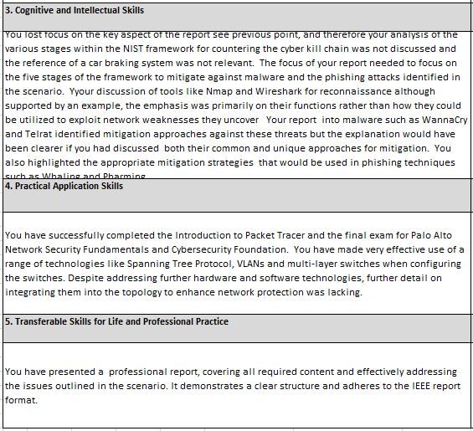
Figure 16 - Network and Cyber Security Essential Assignment Feedback (continued)
An example of this is shown in figures 15 and 16 which shows feedback I received from the Network and Cyber Security Essentials Assignment. This feedback, along with the discussion, helped me to understand that the relevance of my example and going off topic with the discussion were the fundamental issues that prevented me from achieving more marks. As a result of this, I now know that I need to read through the assignment brief and my own work more thoroughly in order to ensure that it remains on topic and relevant to the scenario and discussion. I will apply this to all assignments in the future to prevent encountering the same issue again and losing marks as a result. If I could do that assignment gain, I would have carried out more research to ensure that I was discussing the correct topic as I discovered after submission that OSCAL, which I discussed in the assignment, was made by NIST as well as the NIST cybersecurity framework and this misunderstanding costed me marks on the assignment.

4.3 Thinking Outside the Box
Throughout the academic year, I have carried out research about subject matters for each module, however, it has been apparent to me that this research and reading has been done for assignments and exams mainly. A realisation that I had after completing the Web Development assignment was that Bootstrap 5 had been released recently which I could have implemented into my website or Bootstrap 4 whereas I used Bootstrap 3. This research could have enabled me to implement more features into my website that was not available for Bootstrap 3 however, some features of Bootstrap 3 is not supported by Bootstrap 4 and vice versa.

4.4 Creative Problem-Solving Techniques
When preparing to produce an original product alongside a report for an assignment, I plan accordingly to be certain of my idea and to decide colour schemes, if necessary, and what I would expect the final result to look like and what features would I include. When completing the Web Development assignment, I created a PowerPoint in order to contain my design decisions for my website.
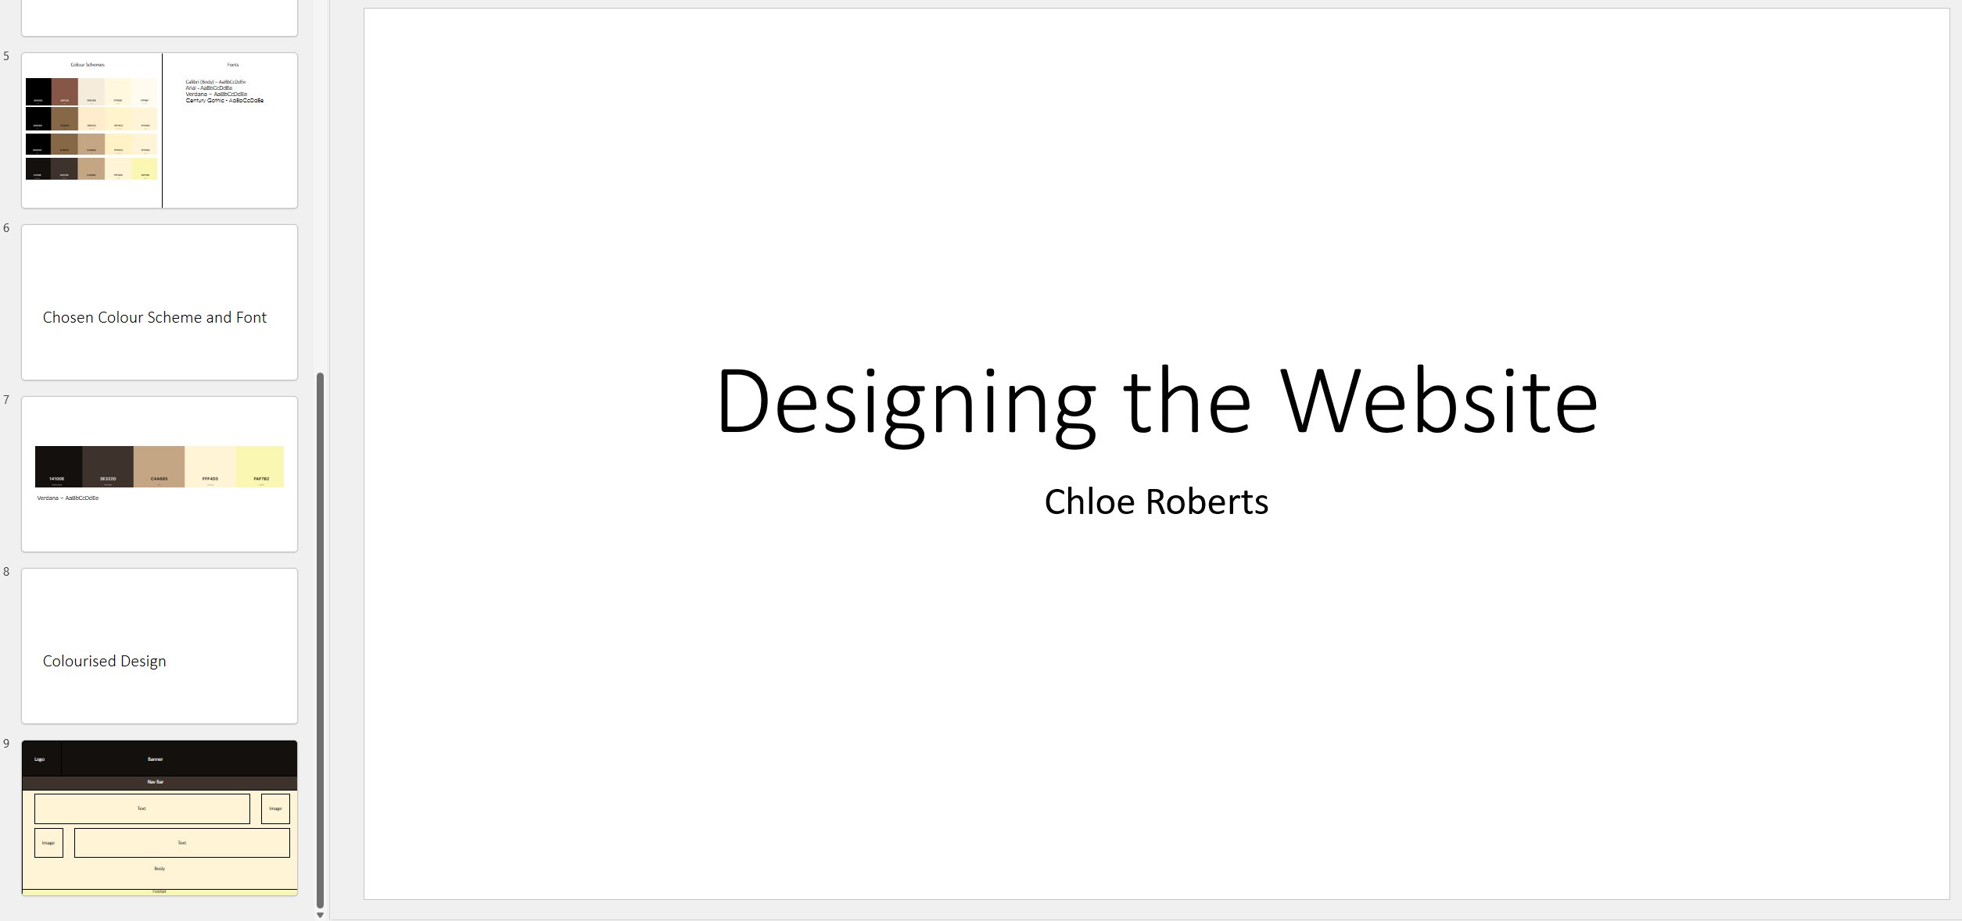
Figure 17 - Design Ideas for the Website for the Web Development assignment
This plan contained a wireframe, colour scheme options, font style options and a colourised variation of the wireframe for the website as shown in figure 17. However, I only created a wireframe for the homepage due to the fact that the general layout would be consistent throughout the website with only the content in the body changing between pages. This brainstorming process helped me to decide upon the colour scheme and font style as I was pleased with the wireframe. From the brainstorming, the finalised colour scheme and font style were selected and these along with the wireframe helped me to prepare and begin the development and design of the actual website for the assignment as I had a clear idea of what I wanted the website to look like. Although the creation of the PowerPoint in figure 17 was not a requirement in the assignment brief, it was extremely useful to help structure the website.

5.0 Research Methods

5.1 Note Taking
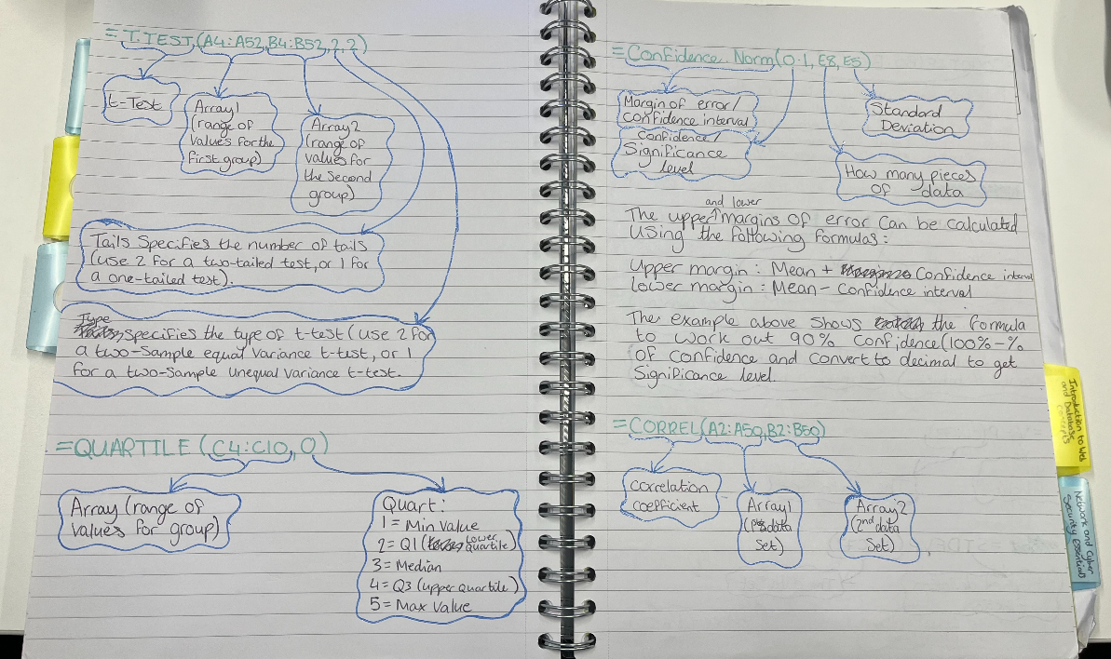
Figure 18 - Notes of Formulas and guidance for Data Analysis and Visualisation
Throughout the academic year, I have been manually writing notes to assist with revision or assignments. The information that I write is dependent on the module. For example, figure 18 shows a portion of my notes for the Data Analysis and Visualisation module in which I wrote formulas we had learnt in lectures, what each part of the formula means or requires, and the purpose of the formula. I also wrote additional notes when necessary. Writing notes like this was extremely beneficial to me due to the fact that after taking the VAK tests (See figures 1, 2, and 3), it was established that I am a visual learner so this assisted my learning style but also assisted as a general form of reference when completing the first assignment for the Data Analysis and Visualisation module as I had documented all formulas learnt and guidance in one section of a notebook.

5.2 Use of Library and Online Resources
Throughout the academic year, I have utilised numerous resources in order to aid my studies. As my reading log will reflect, most of these resources were online aside from some articles, conferences proceedings and books that were read through the internet and one physical book. Some online resources that assisted in my studies, of which were not mentioned within my reading log, include Solo Learn and W3Schools. (See appendix f)

5.3 Reading Log
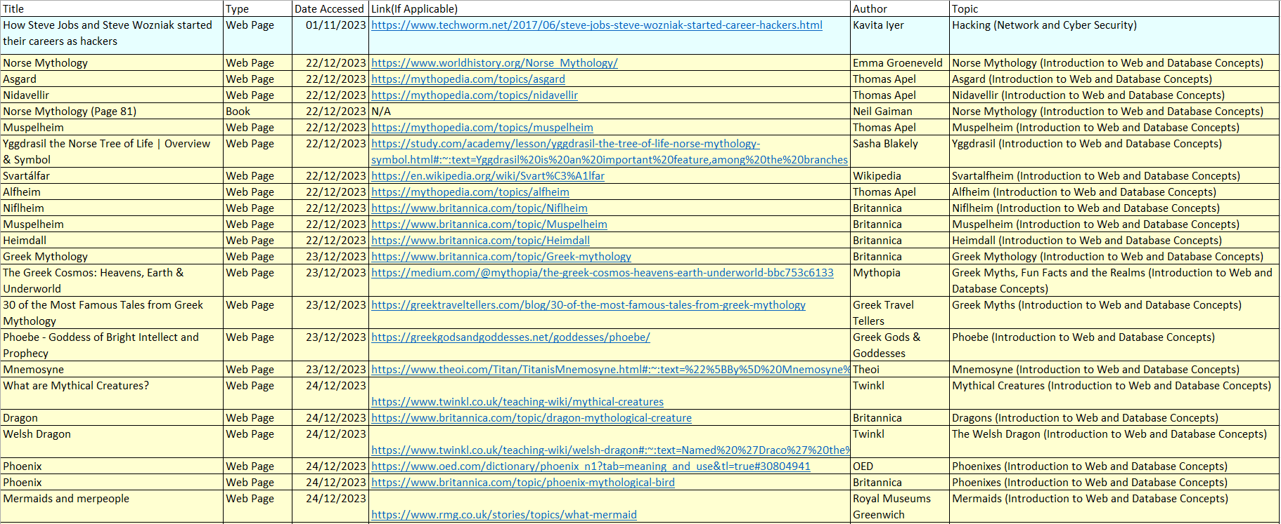
Table 1 - Reading Log Term 1

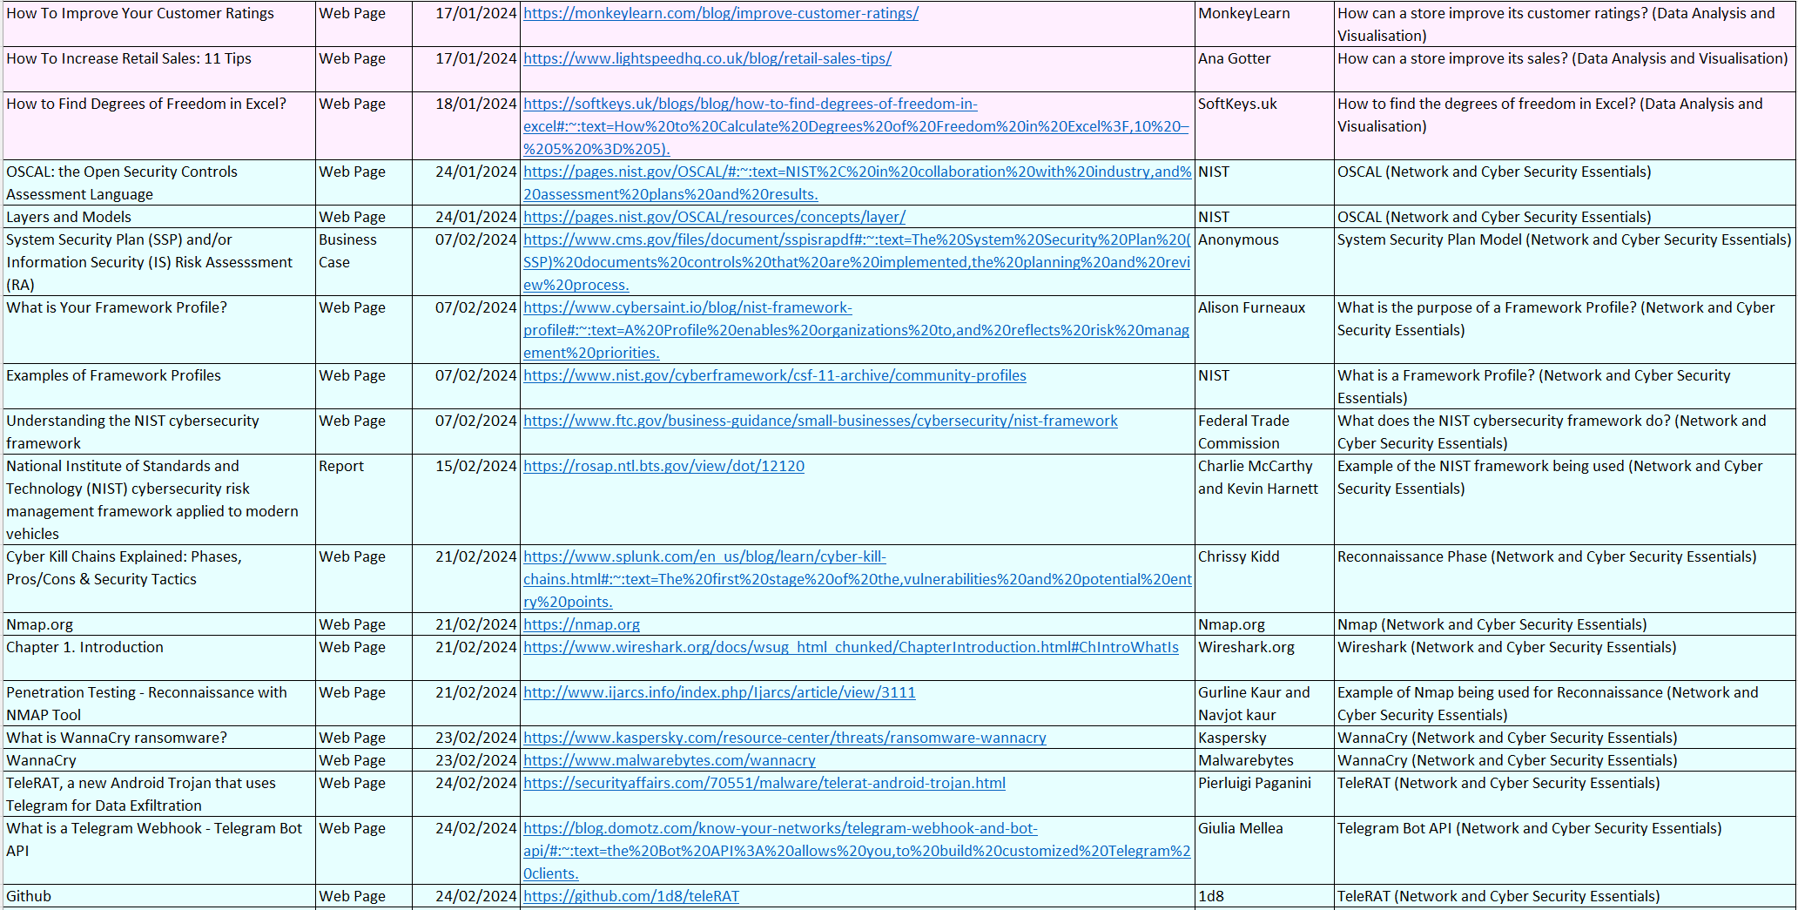
Table 2 - Reading Log Term 2
At the beginning of the academic year, I created a reading log of which I frequently updated throughout the year as shown in table 1, table 2, appendix a, and appendix b. However, in the first term, I was not as thorough with my documenting as I failed to reference and document all of the sources of information of which I read and included within my website for the Academic and Employability Skills assignment, only some of the references were documented in the reading log. During the second term, I have been more thorough and effective in my referencing as shown in table 2 and appendix b. The reading log was also colour coded to help me identify what was read for what module.

5.4 Standard Referencing Methodology
In each assignment this year I have used the IEEE referencing system in order to cite my references throughout the assignments. I have used this referencing system in particular as it is the selected referencing method for the course. I received guidance from lecturers and the librarian as to how to reference sources using IEEE at the beginning of the year and have successfully used this referencing system throughout the academic year, in my assignments. The Victoria University in Melbourne, Australia [2] provides guidance to IEEE referencing while providing examples.
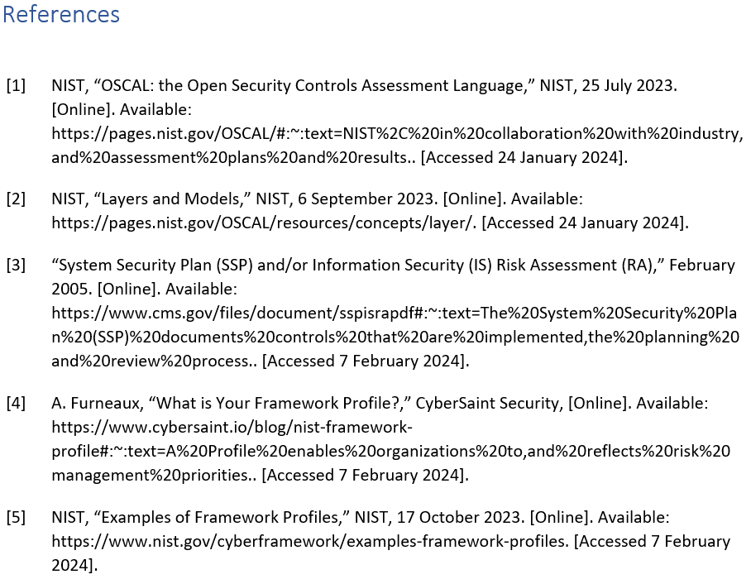
Figure 19 - IEEE References from my Network and Cyber Security Essentials assignment
Upon comparing the examples regarding web-based documents or sources to my own referencing in previous assignments as shown in figure 19, I acknowledge that they follow the same structure and that I have correctly referenced my sources.

6.0 Academic Skills and Development

6.1 Communicating and Presenting Information
I created PowerPoint about the History of Marvel in order to display my ability to present and communicate information to an audience. Before creating the presentation, I carried out research in order to fill any blanks in my knowledge and I looked through a PowerPoint provided by a lecturer which provided guidance on how to make a presentation which aided in the creation of my presentation.

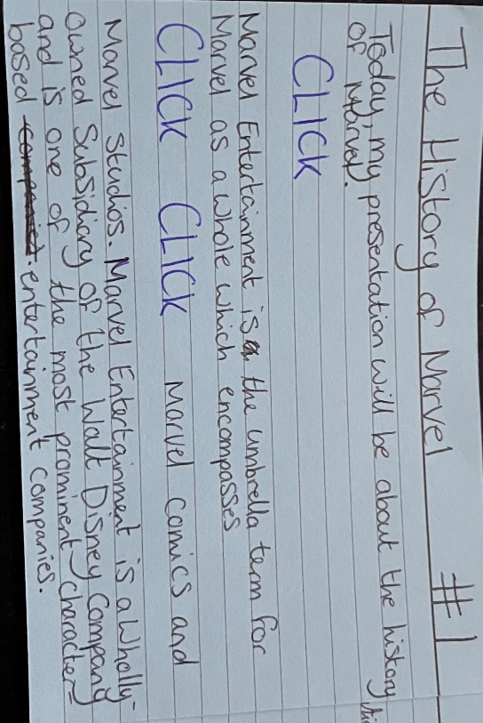
Figure 20 - An image of a cue card used for my presentation
To assist with my presentation, I wrote cue cards with cues to play an animation or to change slide but also to continue the flow of the presentation, ensuring I remained on the current topic.


Figure 21 - My First Presentation about the History of Marvel

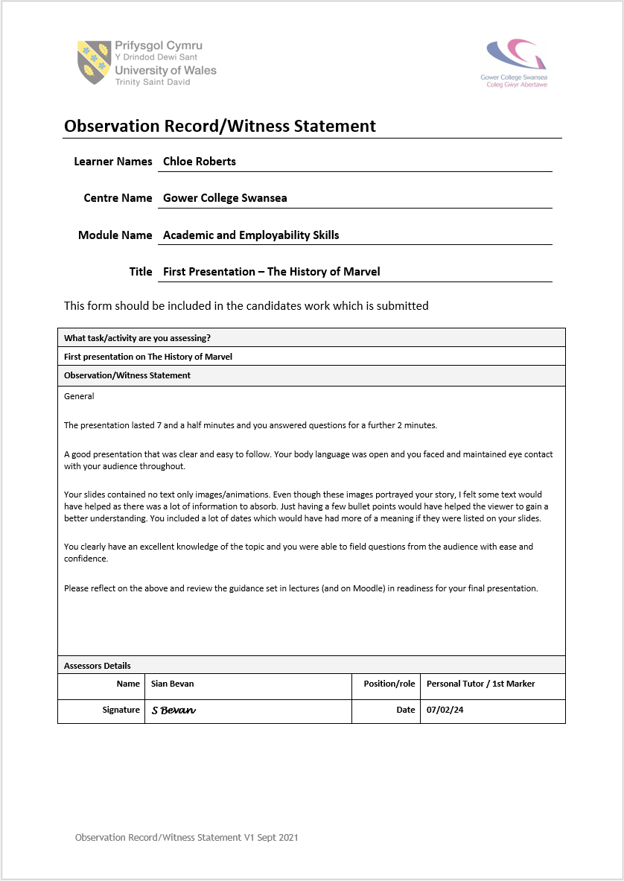
Figure 22 - Observation Record/Witness Statement for my First Presentation
Upon presenting my first presentation (shown in figure 21), I received feedback and an observation record/witness statement from the lecturer of whom I presented the information to. During this presentation, I was relying on my cue cards a lot and I felt like I did not present with as much confidence as I could have due to nerves. I agreed with the feedback received and from this, I took into consideration the feedback (see figure 22) and therefore improved upon my original presentation and prepared to present an improved version three weeks later.

Figure 23 - My Second Presentation about the History of Marvel

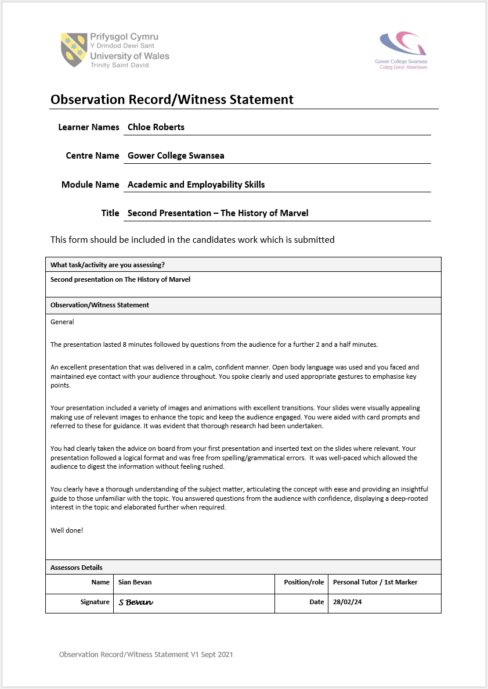
Figure 24 - Observation Record/Witness Statement for my Second Presentation
While presenting the PowerPoint a second time (see figure 23), I felt like I improved a lot more with my communication as I was relying less on my cue cards, engaged more with my audience, and I felt more confident presenting. In addition to this, I also included more text to the second presentation as my first presentation was suitable for auditory learners, but the additional text added for the second presentation improved the overall experience for the audience as it provided more visual aids, especially for visual learners. After presenting my PowerPoint the second time, I received a second observation record/witness statement as shown in figure 24 of which I agree with as I felt like I had improved from the first presentation which is evident based off the PowerPoints and feedback alone.

I also did some research regarding producing a presentation to compare my presentation in comparison to the guidance for qualities of a good presentation. According to Krystle Wong [3], a clear structure, an engaging opening, relevant content, and effective visual aids are some of the most important qualities to have in a presentation. I believe that these qualities were in fact present during my second presentation and I communicated the information in a professional manner.

6.2 Academic and Professional Writing of Reports
My approach to writing reports have changed since the beginning of the year as I had to slightly modify the layout of my reports as some additional features had to be added to meet a level 4 standard.

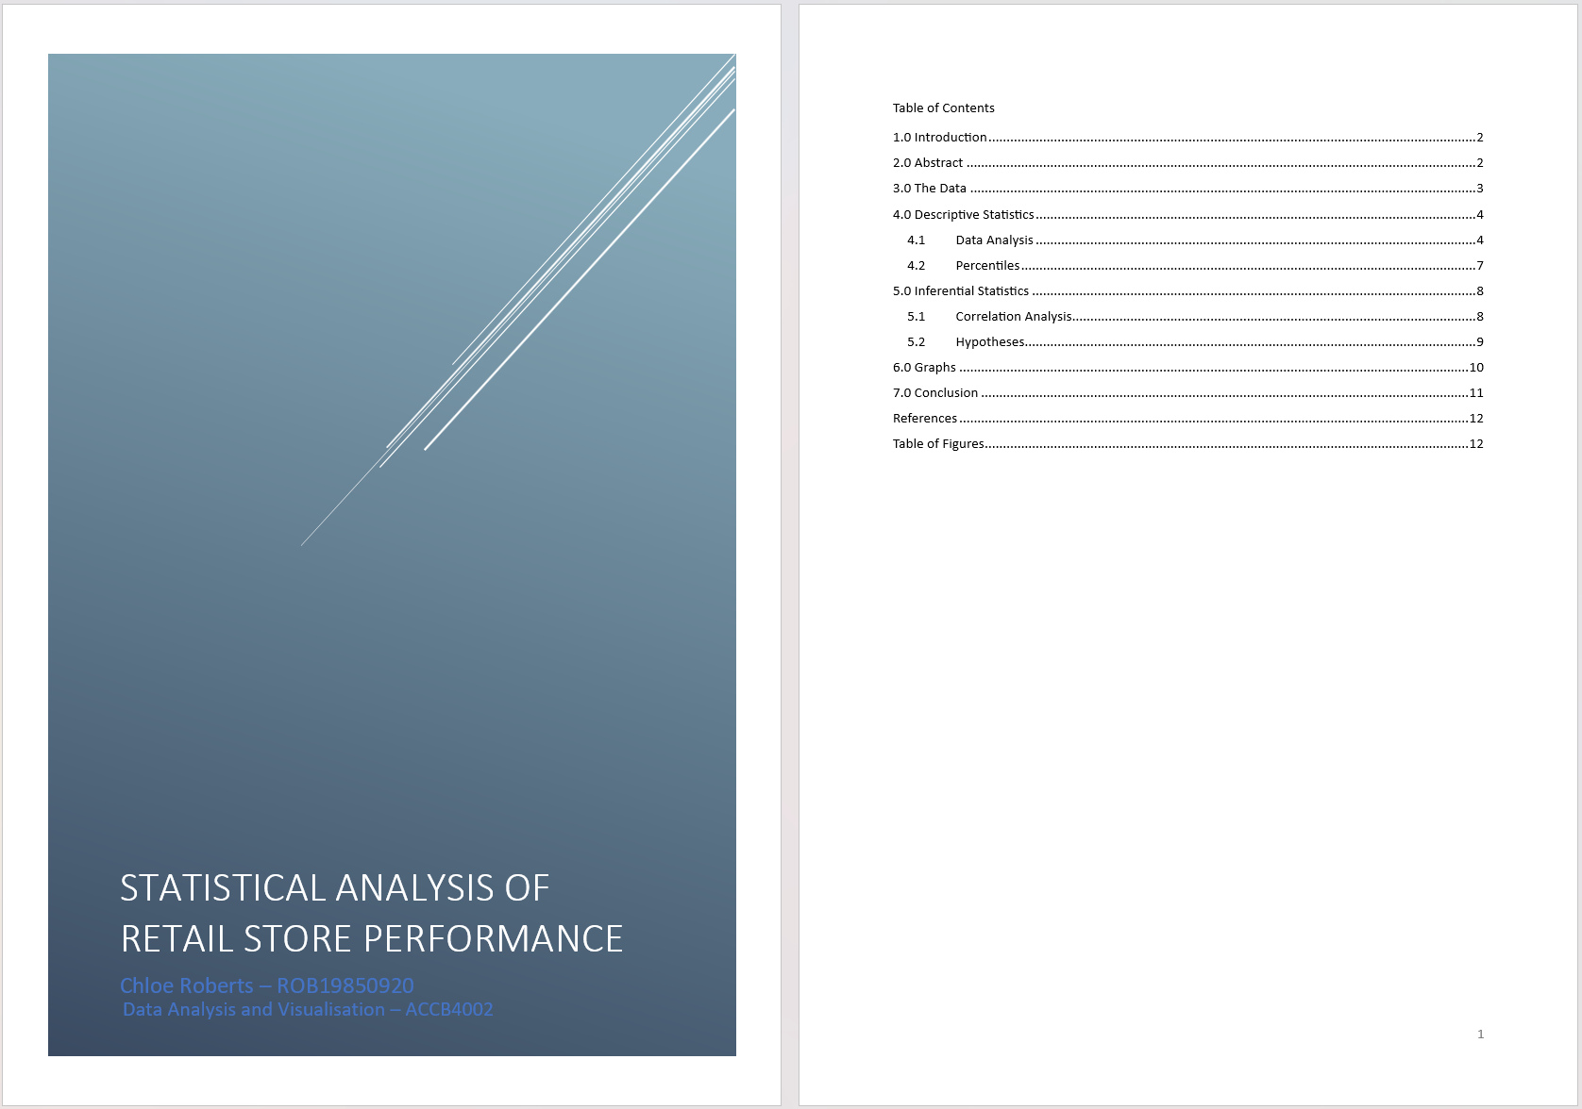
Figure 25 - The format of my first assignment for Data Analysis and Visualisation - 19/01/2024

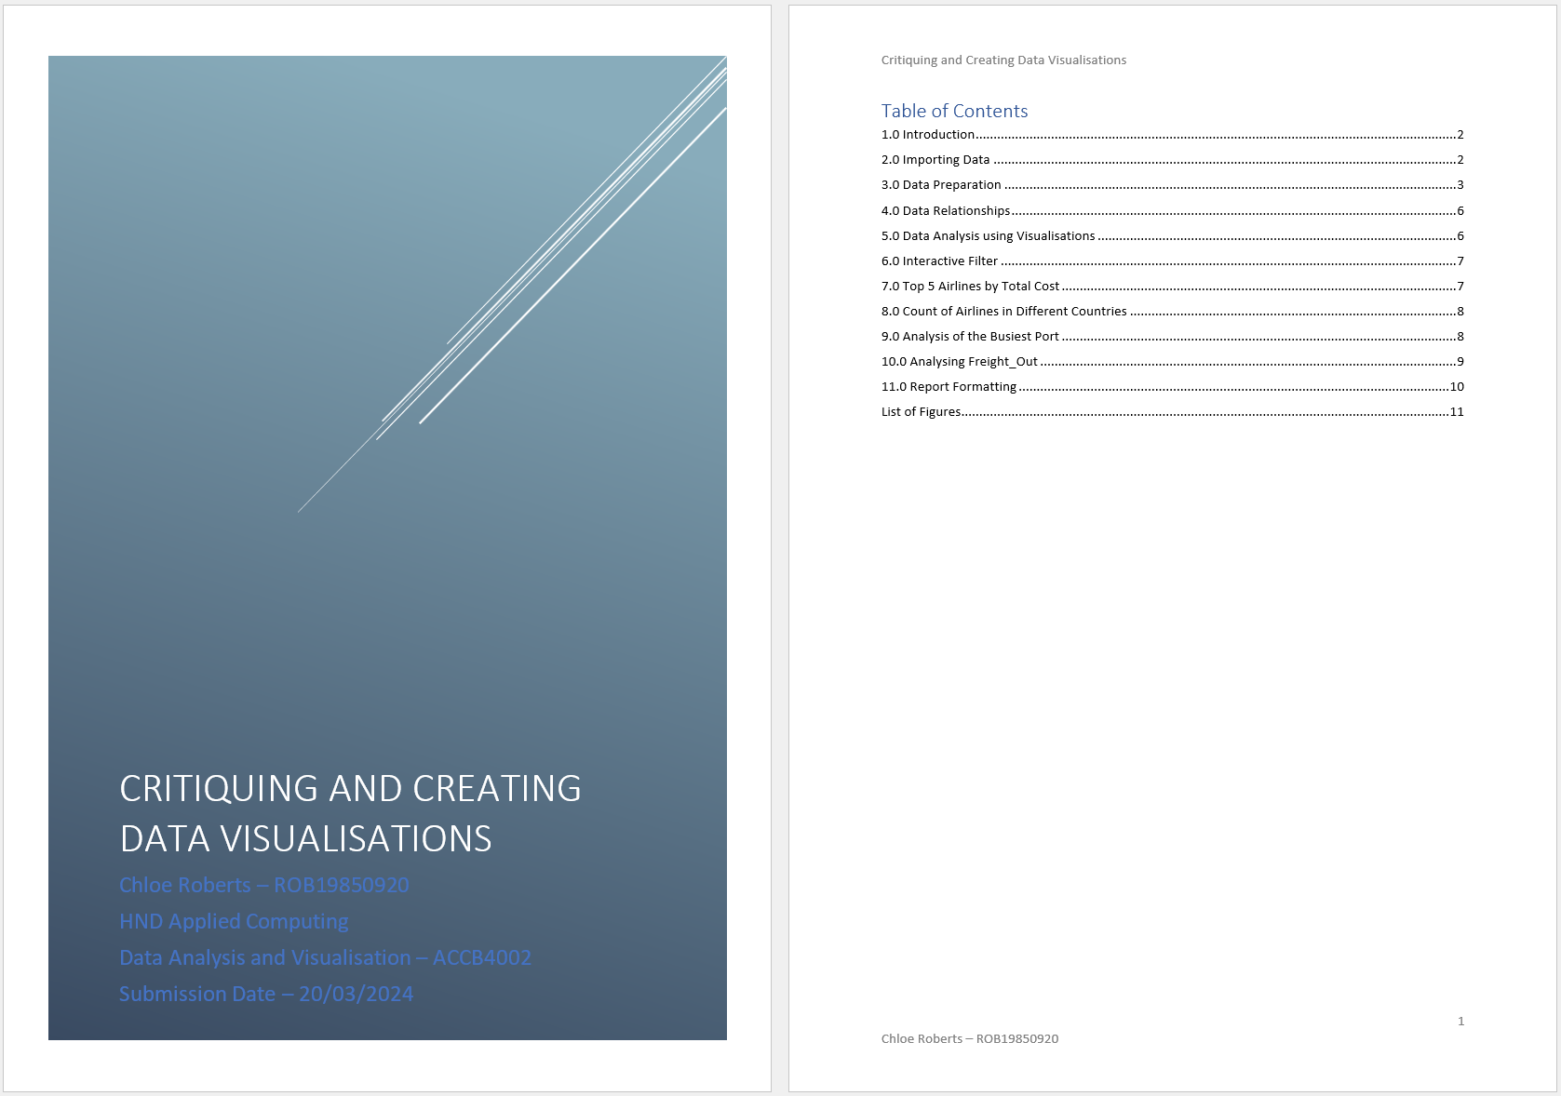
Figure 26 - The format of my second assignment for Data Analysis and Visualisation - 20/03/2024
Figures 25 and 26 show my report layout in the beginning of the year and now based off the cover page and contents page these modifications have improved the professionalism of the report and raise it from a level 3 standard, as shown in figure 25, to a level 4 standard, as shown in figure 26. In order to ensure that I have written reports in a professional and academic format, I save multiple versions of my assignments, one for each time I proofread and modify a document.

Figure 27 - My Version Control for the Network and Cyber Security Essentials assignment
An example of this is in figure 27 in which I have saved two versions of my Network and Cyber Security Essentials assignment the first of which is the original version and the second is after proofreading and removing unnecessary information. After creating the second version, I was pleased with the word count and proofreading hence only two versions were created. I also used IEEE referencing in my reports and reflected on feedback from assignments.

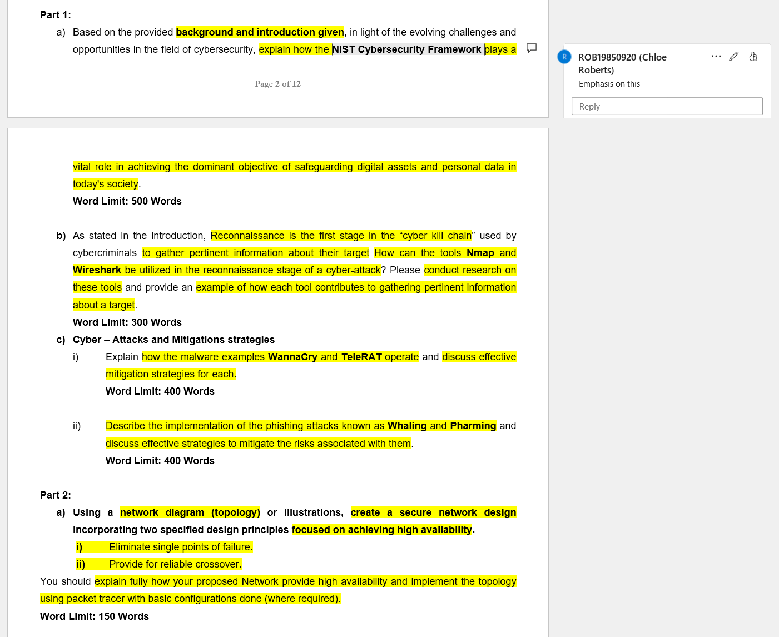
Figure 28 - Highlighted and annotated assignment brief for the Network and Cyber Security Essentials assignment
I believe that I have a good understanding of assignment briefs before producing the report. This is mainly done by highlighting important pieces of information within the brief that is required for the report but also by occasionally annotating the brief, as shown in figure 28. This process assists me to structure my reports. I believe that this standard of work for my reports is good enough to be maintained into level 5 as I remain professional and enthusiastic about the topics.


Figure 29 - My assignment template
To prepare for writing reports, I made an assignment template that I can modify to suit an assignment as shown in figure 29. Aside from the web development and second data analysis and visualisation assignments, I always exceeded the additional 10% of the word count but not by much.

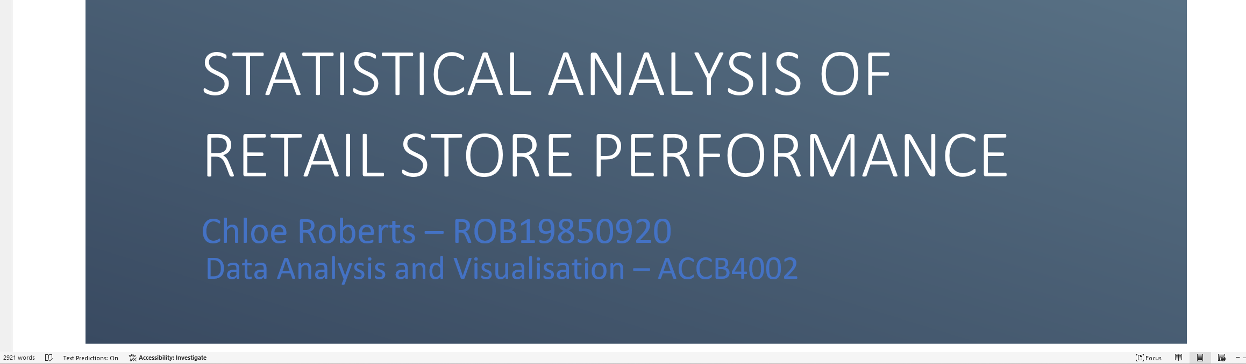
Figure 30 - First Data Analysis and Visualisation assignment Word Count of 2921 words - 10% limit of 2750 words

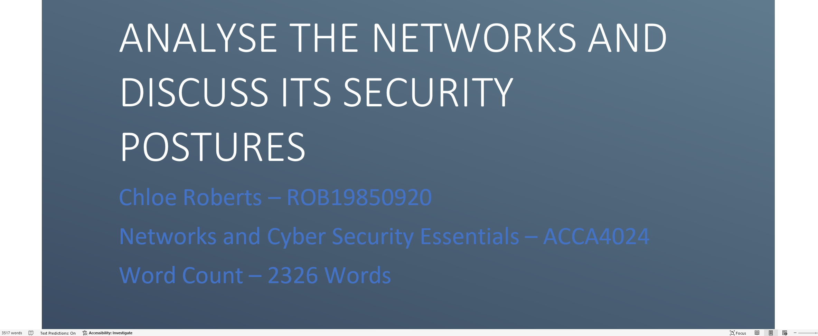
Figure 31 - Network and Cyber Security Essentials assignment Word Count of 2326 words - 10% limit of 2200 words
Examples of these include the first data analysis and visualisation assignments and the network and cyber security essentials assignment as shown in figures 30 and 31. However, I understand that I will need to improve upon this as I progress onto level 5 as I will need to keep to the word count as I was informed that the word count is currently advisory and that it is there in order to prevent or reduce unnecessary information being included in the assignments. Although lecturers have given guidance on how to structure assignments in tutorial lectures, resources like the University of Leeds [4] could also be used for guidance in the future as they give a detailed guide to assist in understanding the structure and writing of a typical report.

7.0 Professional Skills

7.1 Soft Skills
I believe I have the skills required for higher education both academically and professionally as my learning techniques and approach to assignments have so far resulted in me achieving relatively high grades. In addition to this, when given an assignment brief, I highlight and annotate the brief, as shown in figure 28, and ask question about it in order to get as much of an understanding of the assignment brief before commencing.

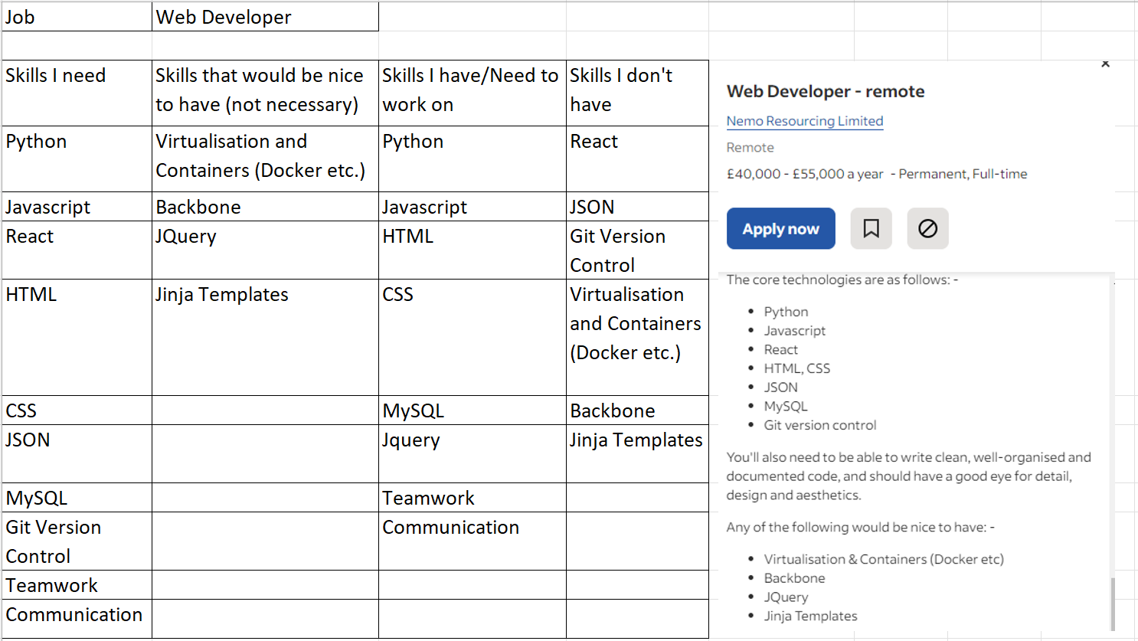
Figure 32 - My first Skills Audit - 21/11/2023
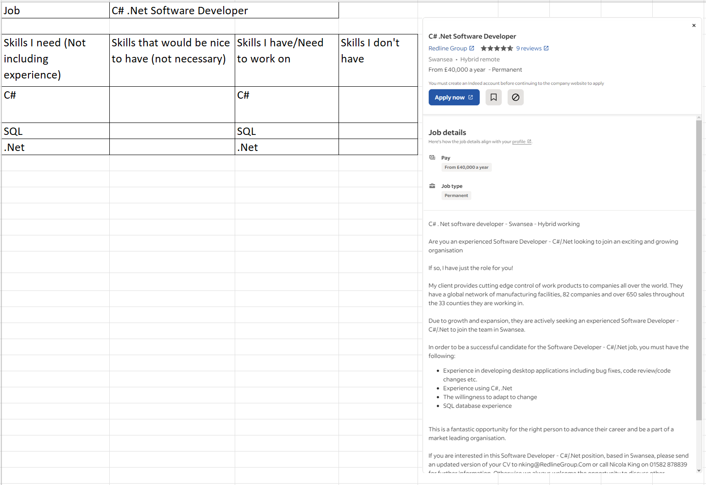
Figure 33 - My second Skills Audit - 23/02/2024
In order to understand how useful my current skills are and what skills are required in regards to a career I would like to pursue, I created two skills audits, see figures 32 and 33, in which I documented the job type, skills they require, and skills that would be beneficial to have along with the skills I currently have, skills I need to improve upon, and skills I do not have. Although my skills audits are industry specific, I am considering completing the level 6 of the course and a PGCE in the future after some experience in industry to teach others about computing as I enjoy supporting and teaching my peers when they do not understand a topic.

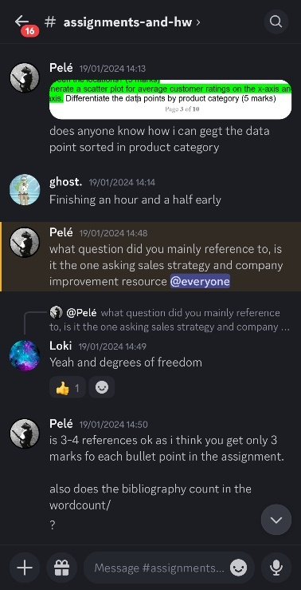
Figure 34 - Screenshot of the educational Discord group chat with peers

I also communicated with my peers on a group chat on Discord in order to help each other with assignments. This proved to be helpful, especially if multiple people needed help with a topic outside of lectures.

I also ensure that I am prepared for lectures by completing work set previously and communicating with lecturers and peers if I am unable to attend a lecture so that I can complete the work missed before ethe next lecture. I also support my peers in the class if they me ask for help or clarification.

7.2 Employability Skills and Competencies
In preparation of going into the industry of computing, a lecturer gave guidance during a tutorial lecture, and I created a CV of which I received feedback on from a lecturer and then improved the CV upon receiving the feedback, making a second version. Sources like Gov.uk [5] are useful in order to understand the contents require for a CV and advice for writing a CV.

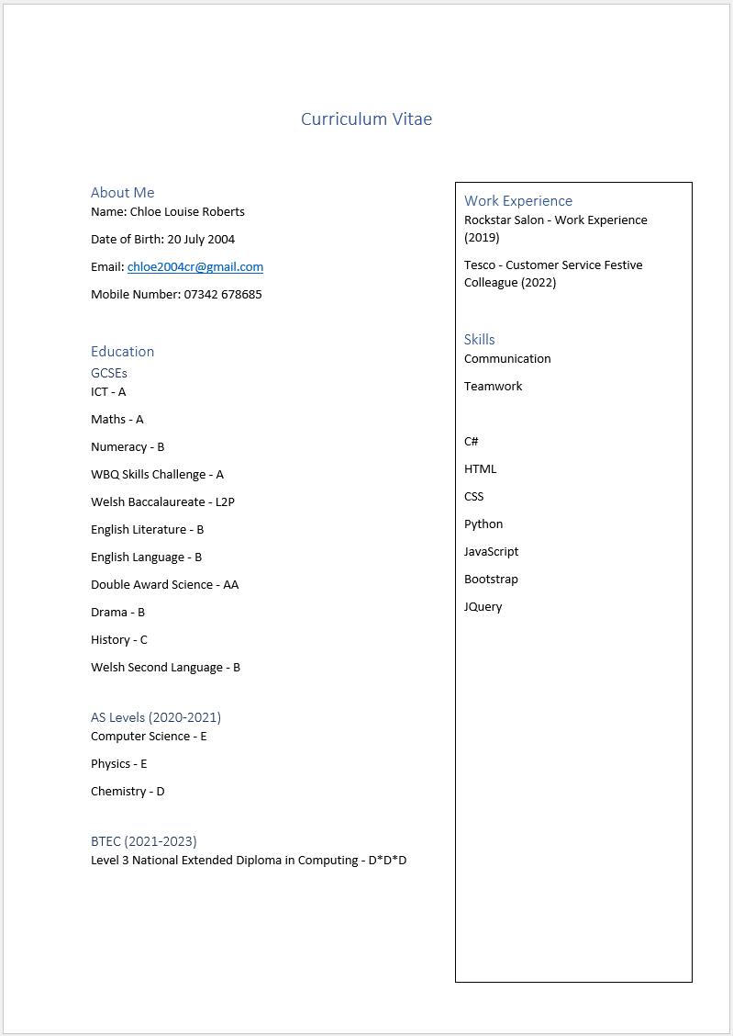
Figure 35 - CV V1 - 21/11/2023

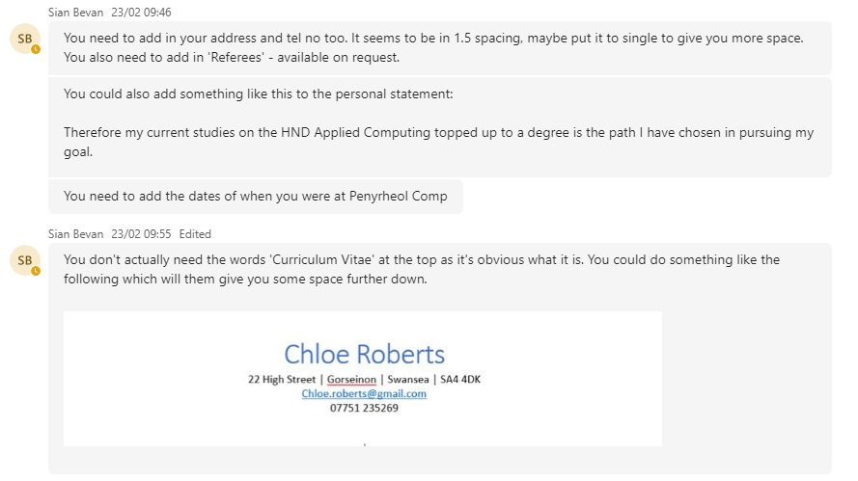
Figure 36 - Feedback from CV V1
Figure 35 shows the first version of my CV in which it is unprofessional and appears empty due to the vast amount of white space within the CV. Upon receiving the feedback shown in figure 36, I implemented the improvements recommended and increased the professional appearance of the CV.
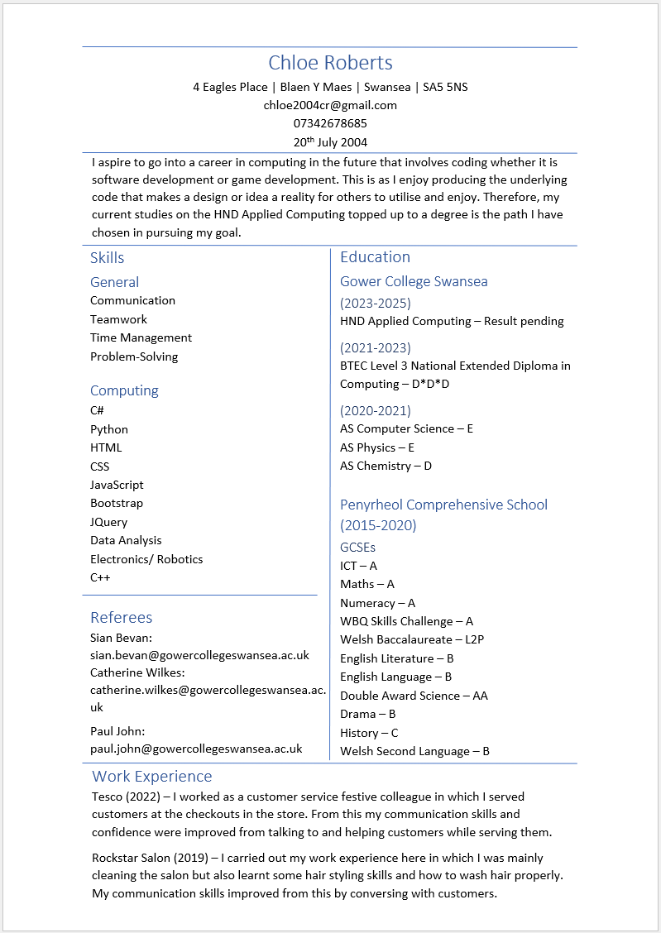
Figure 37 - CV V2 - 29/02/2024
Figure 37 shows the improved CV in which it looks professional and contains all of the necessary information required.

7.3 Team-Working
My ability to work with other is a useful quality as it is likely that I would be working in a team in a professional setting in which I would need to be able to collaborate and help each other. This academic year, me and my peers have been supporting each other with the work and discussing issues if struggling on topics in order to help us progress through assignments. We also discuss feedback as a collective in case there is something we all missed on an assignment or if a peer is helping someone with something they did not understand so they understand for the future. Discussing the brief and assignments with peers have been a useful tool in order to complete the assignments with an understanding of what is required.
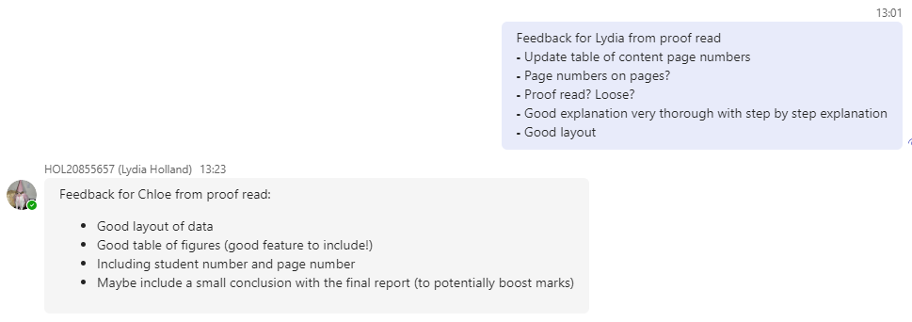
Figure 38 - Screenshot of an exchange of feedback from proofreading each other’s work
A way in which I have displayed teamwork with my peers is by proofreading a peer’s work and we exchanged feedback and fix any issues mentioned in the feedback as shown in figure 38.

7.4 Professional, Legal, Ethical, and Sustainability
Regarding legality, I have ensured that the sources that I use for my assignments are legal and reliable in order to back up my discussions or to provide further information to my current knowledge. However, I did not ensure that images used in my work obtained from online were royalty free. For example, for the web development assignment, although I made some of the images myself, the remainder of the images were not royalty free. The images included in my presentation were also not royalty free. I am aware though that in a professional setting, I would not be able to use and include images that are not royalty free as legal consequences would likely follow. Regarding ethics, I ensured that I did not purposefully plagiarise other’s work in my assignments and that I cited references within my assignments when I used other sources in my discussion. I also ensured not to use AI in as a form of research and only used it in order to get the definition of a word or to understand a topic further of what a source states so that I could knowledgably continue the discussion while discussing the source itself. Regarding professionalism, I always ensure that I remain professional with my lecturers, assignments, and my peers, when discussing assignments.

Conclusion
Over the academic year I believe that I have in fact improved as a student and that I have furthered my skills. My ability to communicate information, my ability to study and produce reports, my ability to manage change and any issues correlating to that, but also my ability to utilise these skills when completing assignments are just some of the skills that I have improved upon throughout this academic year. I also successfully documented what I had done in and outside of lectures throughout the academic year as shown in appendices c and d. As a result, I feel that with these skills and my attitude to learning, I am prepared to progress onto the level 5 course and that these skills demonstrated will be extremely useful in a career in computing and potentially make me more employable than other candidates.

Bibliography

[1] | C. S. C. College, “Study Tips for the Visual Learner,” Columbia State Community College, [Online]. Available: https://www.columbiastate.edu/tutoring-learning-center/ap-study-skills/study-tips-visual-learner.html. [Accessed 13 March 2024].
[2] | V. University, “IEEE Referencing: Sample Reference List,” Victoria University, [Online]. Available: https://libraryguides.vu.edu.au/ieeereferencing/referencelist. [Accessed 21 March 2024].
[3] | K. Wong, “How To Make a Good Presentation [A Complete Guide],” Venngage, 20 July 2023. [Online]. Available: https://venngage.com/blog/how-to-make-a-good-presentation/. [Accessed 21 March 2024].
[4] | U. o. Leeds, “Report writing,” University of Leeds, [Online]. Available: https://library.leeds.ac.uk/info/14011/writing/114/report-writing. [Accessed 21 March 2024].
[5] | N. C. Service, “How to write a CV,” Gov.uk, [Online]. Available: https://nationalcareers.service.gov.uk/careers-advice/cv-sections. [Accessed 21 March 2024].

Appendix

List of Figures
Figure 1 - VAK Test 1 Results - 10/10/2023 3
Figure 2 - VAK Test 2 Results - 28/01/2024 3
Figure 3 - VAK Test 3 Results - 22/02/2024 3
Figure 4 - My Study Area - 12/10/2023 6
Figure 5 - My Study Area - 09/02/2024 6
Figure 6 - The remainder of my Study Area - 09/02/2024 7
Figure 7 - Assignment due dates and Exam dates 8
Figure 8 - To Do List from start of Term 2 - 10/01/2024 9
Figure 9 - To Do List from Term 2 - 29/01/2024 10
Figure 10 - Folders for each module 11
Figure 11 - Folders for the Software Development module 11
Figure 12 - Feedback and Reflection for Web Development Assignment 13
Figure 13 - Feedback and Reflection for Network and Cyber Security Assignment 13
Figure 14 - Notes from discussion about my Network and Cyber Security Essentials assignment 14
Figure 15 - Network and Cyber Security Essentials Assignment Feedback 15
Figure 16 - Network and Cyber Security Essential Assignment Feedback (continued) 15
Figure 17 - Design Ideas for the Website for the Web Development assignment 16
Figure 18 - Notes of Formulas and guidance for Data Analysis and Visualisation 17
Figure 19 - IEEE References from my Network and Cyber Security Essentials assignment 19
Figure 20 - An image of a cue card used for my presentation 20
Figure 21 - My First Presentation about the History of Marvel 20
Figure 22 - Observation Record/Witness Statement for my First Presentation 21
Figure 23 - My Second Presentation about the History of Marvel 22
Figure 24 - Observation Record/Witness Statement for my Second Presentation 23
Figure 25 - The format of my first assignment for Data Analysis and Visualisation - 19/01/2024 24
Figure 26 - The format of my second assignment for Data Analysis and Visualisation - 20/03/2024 25
Figure 27 - My Version Control for the Network and Cyber Security Essentials assignment 25
Figure 28 - Highlighted and annotated assignment brief for the Network and Cyber Security Essentials assignment 26
Figure 29 - My assignment template 27
Figure 30 - First Data Analysis and Visualisation assignment Word Count of 2921 words - 10% limit of 2750 words 27
Figure 31 - Network and Cyber Security Essentials assignment Word Count of 2326 words - 10% limit of 2200 words 28
Figure 32 - My first Skills Audit - 21/11/2023 28
Figure 33 - My second Skills Audit - 23/02/2024 29
Figure 34 - Screenshot of the educational Discord group chat with peers 30
Figure 35 - CV V1 - 21/11/2023 31
Figure 36 - Feedback from CV V1 32
Figure 37 - CV V2 - 29/02/2024 33
Figure 38 - Screenshot of an exchange of feedback from proofreading each other’s work 34

List of Tables
Table 1 - Reading Log Term 1 18
Table 2 - Reading Log Term 2 18

Appendices

Appendix a – Reading Log Term 1 (continued)
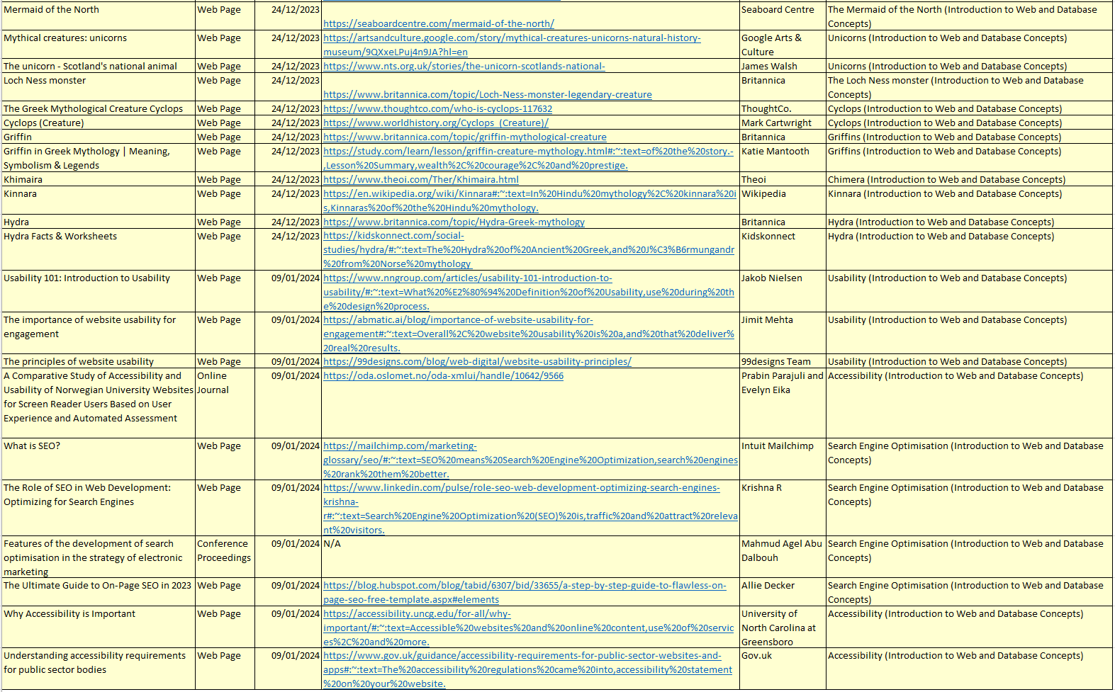
Appendix a - Reading Log Term 1 (continued)

Appendix b – Reading Log Term 2 (continued)
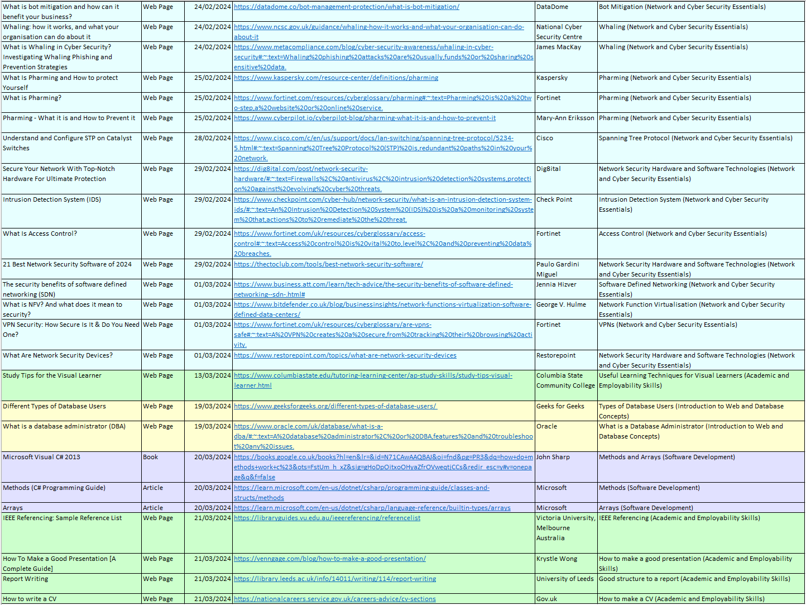
Appendix b - Reading Log Term 2 (continued)

Appendix c – Snippet of Academic Journal - Term 1
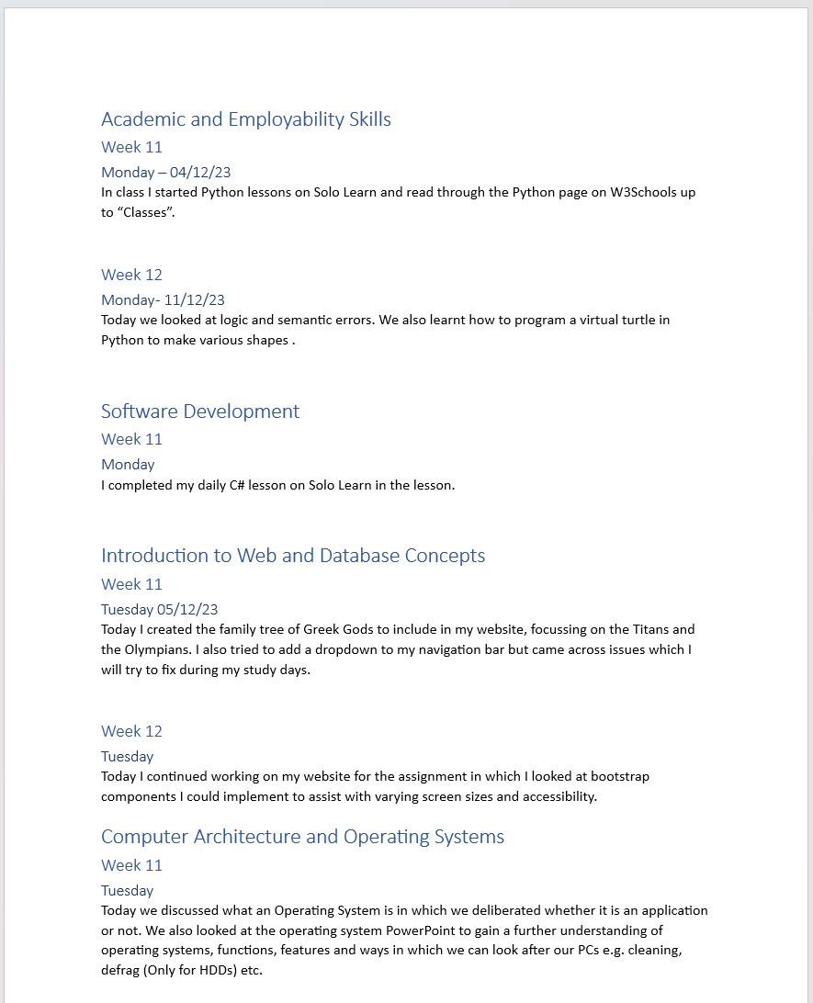
Appendix c - Snippet of Academic Journal - Term 1

Appendix d – Snippet of Academic Journal - Term 2
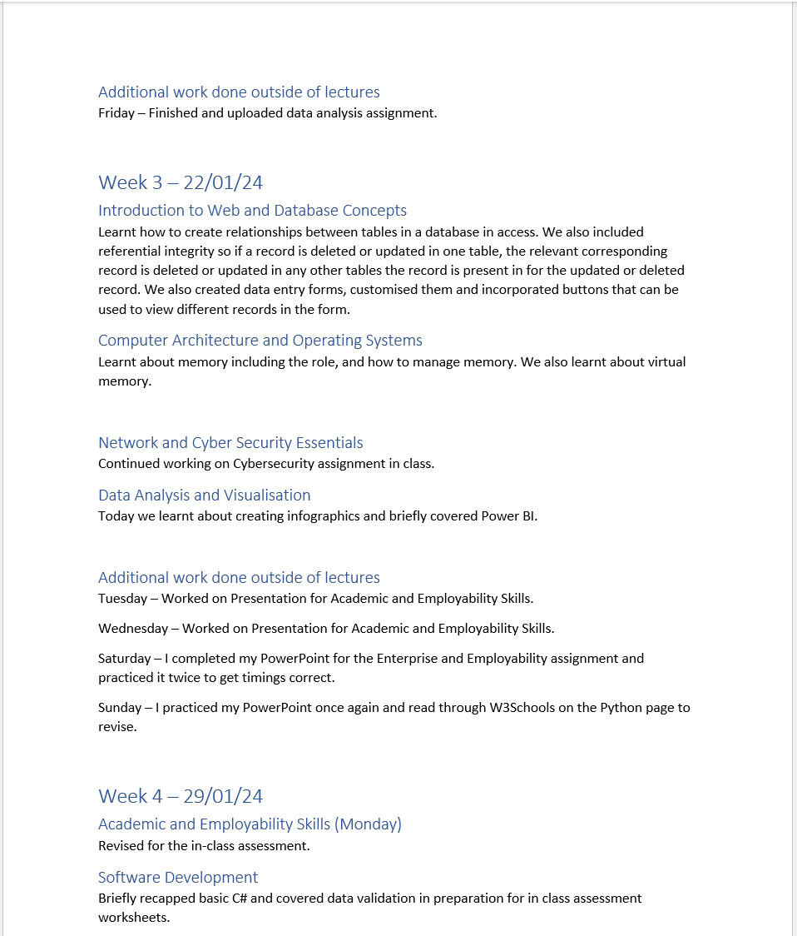
Appendix d - Snippet of Academic Journal - Term 2

Appendix e – Action Plan
When approaching a bug in my code, I thoroughly read through the code I have written in case it is a small issue like the lack of a semi-colon when necessary or the presence of one when it is not required. From this, I run the code again to ensure that the bug has gone and that the code runs as expected. An example of where I was frequently encountering bugs in my code was when I was completing the website element of the web development assignment for the Introduction to Web and Database Concepts module in which I had to restart my website three times due to constant issues regarding images and the layout of the website resulting in me restarting the website from scratch in order to finely identify the bugs and then I modified the website more and then encountered more bugs hence me having to restart three times as I was unable to identify the bugs in the code just from reading it. However, I have learnt from this as I have encountered these issues so when coding in the future or for future assignments, I know how to approach such issues and therefore work smarter.

Appendix f – Use of Library and Online Resources
Solo Learn was mentioned as a useful tool by a lecturer and was utilised in order to improve my C# and Python skills and furthered my understanding of some elements of the programming languages. Although I am a visual learner, I found that completing the practical tasks in Solo Learn was still useful. W3Schools was utilised for reading about elements of Python and C# but also assisted for guidance when completing my Web Development assignment for the Introduction to Web and Database Concepts module. This website has been useful to me but there are still instances in which I would be reading through a topic on Python or C# and not fully understand it in which I carry out further research or ask a lecturer. Although library resources were available as both physical resources and digital resources, I briefly looked at the digital resources available through the library on Moodle by trying to find a book on C# however, I did not look thoroughly enough through the books available on the online library therefore not finding what I was looking for specifically regarding C# as a result of a lack of effective searching for the information required.

Reflective Journal
Throughout the academic year, I have learned about IEEE referencing, how to make a good CV and presentation, how to code in Python, but also how to become a better student. These skills I have learnt in the Academic and Employability Skills module. I have learnt a vast variety of skills this year, some of which enhanced or refreshed prior knowledge, like my C# skills, while also learning new skills from scratch, like my Python skills. Overall, the Academic and Employability Skills module did in fact help me to become a better student.

