In the VISUALIZER Module:
- Select VIEW ODB display options:
- 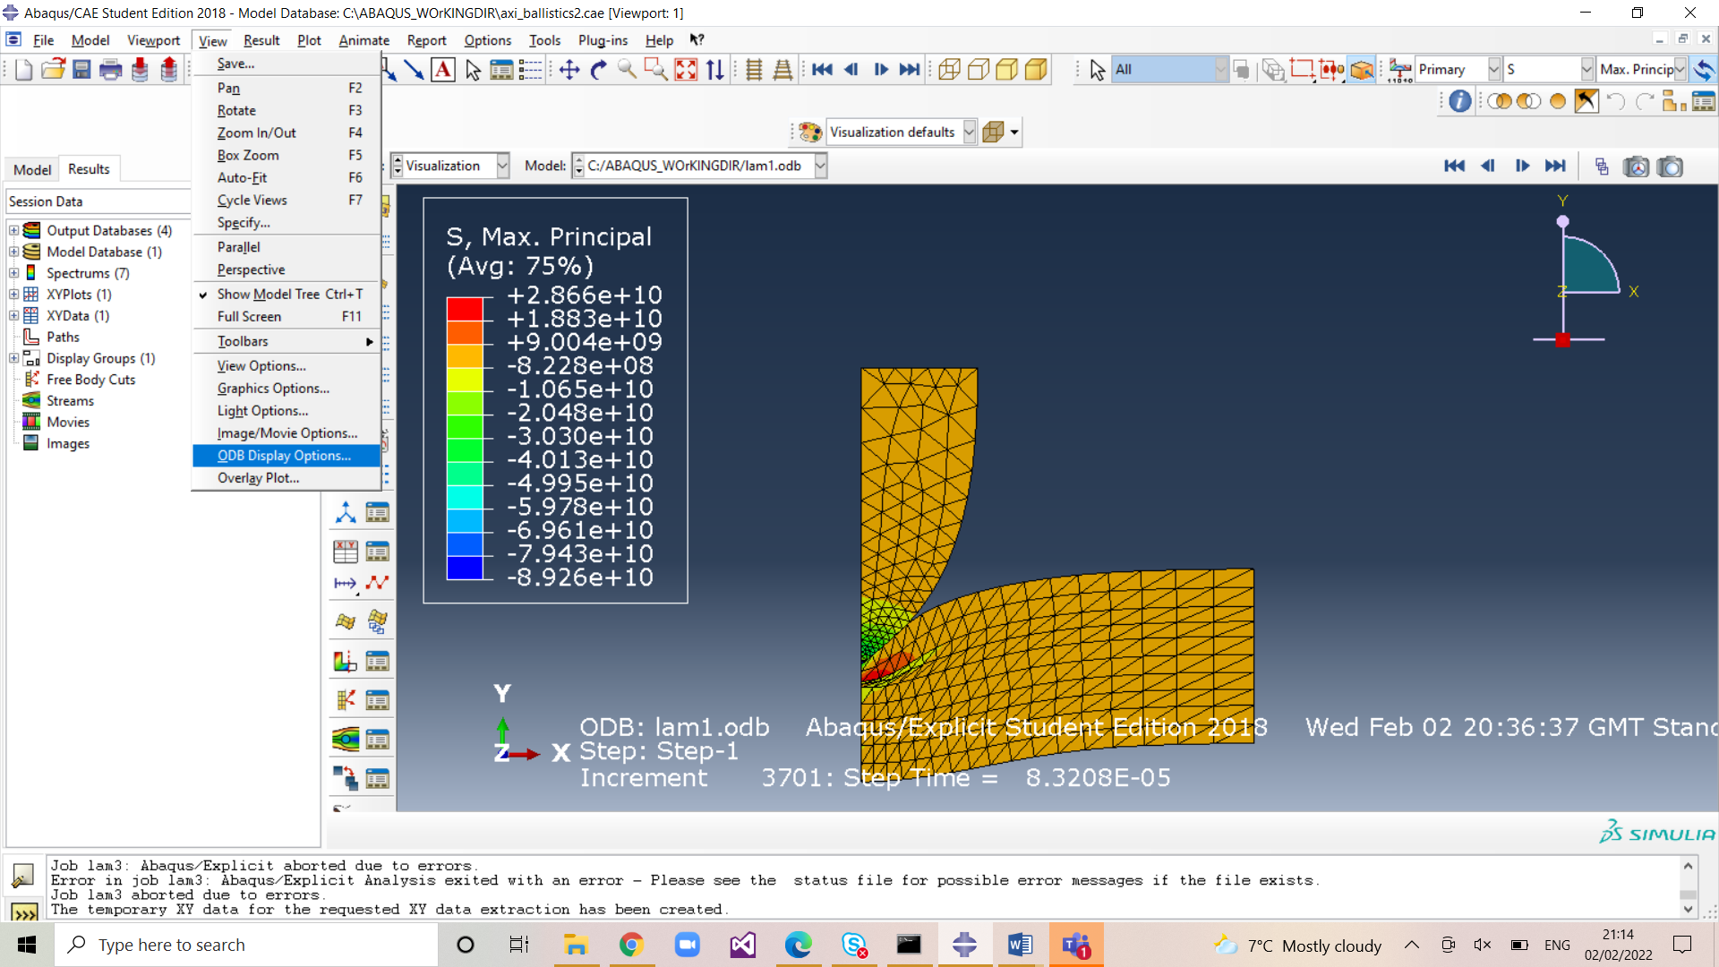

In the SWEEP Tab:
Choose the rotation angle to sweep through and choose the number of segments for refinement. In thi exmaple I sweep through 360 degrees with a segment angle of 10 degrees:
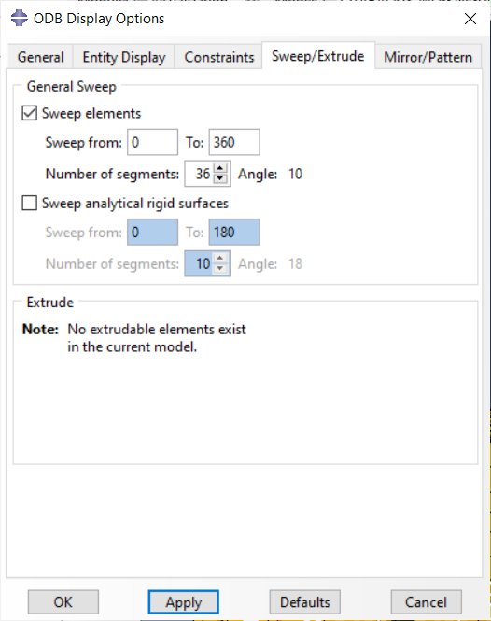

This gives:
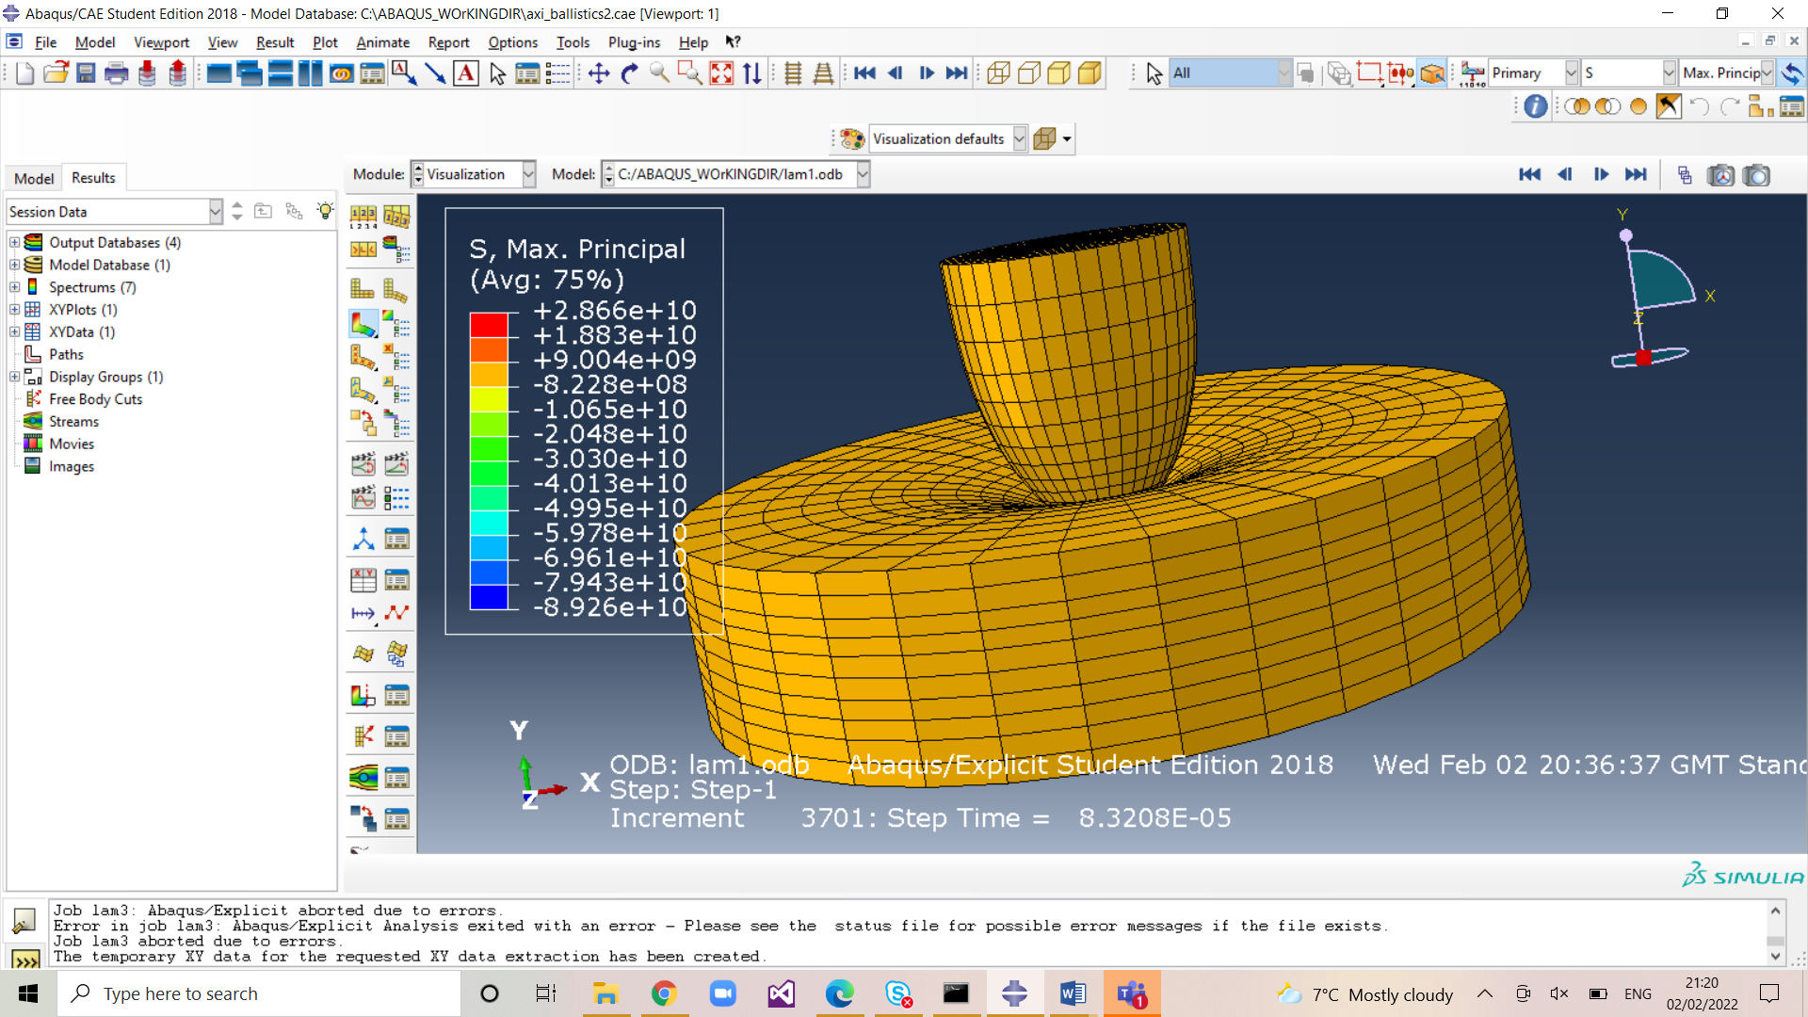

You can vary the parameters to give the display you desire
In the next example I choose to sweep through only 180 degrees and it is more informative:


