

LOCATION: Swansea | LLEOLIAD: abertawe
LEVEL 4 | LEFEL 4
EXAMINATION PERIOD | CYFNOD ARHOLIADAU
May 2024 | Mai 2024
MODULE CODE: ACDA4004
Micros Peripherals & Interfaces

Marking Scheme

ANSWER ALL QUESTIONS (marks add up to 50 in total)

- The following comprise a number of mnemonics from the PIC16F84 microprocessor instruction set. Give the meaning of what each mnemonic stands for and explain what the instruction actually does.

  - RETFIE – Return from Interrupt – pulls the return address from the stack and places it int the program counter to return execution back from when the interrupt occurred.
[2 Marks]
  - NOP – No Operation – does nothing, but wastes clock cycles (causes a fixed delay)
[2 Marks]
  - ADDWF – Add W register and contents of the File location
[2 Marks]
  - BSF f, b – Bit Set file – Sets bit b in the file location f to 1
[2 Marks]
  - XORWF – Exclusive Or W reg with File – XOR the W register with the contents of the file location, result stored in W
[2 Marks]

- a) Explain what is meant by a PWM signal (include diagrams to assist your answer).
Diagram such as the following (2.5 marks) – 2.5 marks for the description
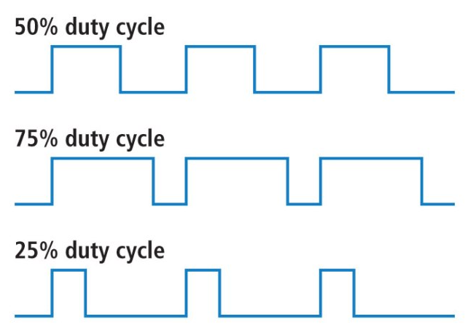
- Explain the general principles of how you could generate a PWM signal on a PIC microcontroller IO pin, firstly by software means alone, then secondly, If the microcontroller had a built in PWM hardware module.
2.5 marks for a description of ‘bit bashing’ an output pin by using two separate delays in a software loop – one for the ON time and one for the OFF
2.5 marks for describing how to set the registers of the PICs dedicated counter timer modules in PWM mode to automatically set the repeating on/off cycle needed for the PWM signal, without any further intervention.

[10 Marks]

- Draw the logic symbol for an NOR gate and provide the truth table for it.
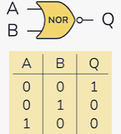
[3 Marks]

4. Produce a truth table for the following logic circuit, solving the states for the final ‘output’ block, but also showing all the intermediate nodes that were used in this final calculation. (7 marks)

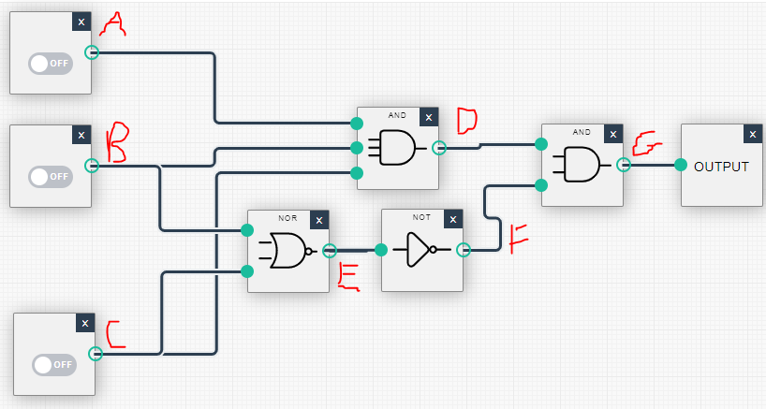

A B C D E F G
0 | 0 | 0 | 0 | 1 | 0 | 0
0 | 0 | 1 | 0 | 0 | 1 | 0
0 | 1 | 0 | 0 | 0 | 1 | 0
0 | 1 | 1 | 0 | 0 | 1 | 0
1 | 0 | 0 | 0 | 1 | 0 | 0
1 | 0 | 1 | 0 | 0 | 1 | 0
1 | 1 | 0 | 0 | 0 | 1 | 0
1 | 1 | 1 | 1 | 0 | 1 | 1

b) By visually inspecting the final truth table, suggest a far simpler logic diagram that would produce the same result. (3 marks)

It can be observed that the triple AND gate is the determining function therefore only this function needs to be considered – all other gates are superfluous.

- a) Provide diagrams that depict typical Harvard and Von Neumann processor architectures. [8 marks]
b) What type of architecture is used in the PIC 16 series microcontrollers?
[2 Marks]
4 marks each for the Harvard and Von Neumann diagrams
2 marks for identifying the PIC is based on the Harvard architecture.

Harvard
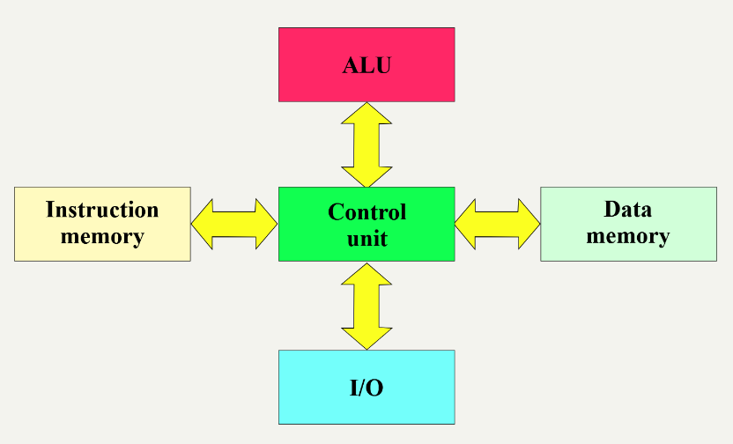

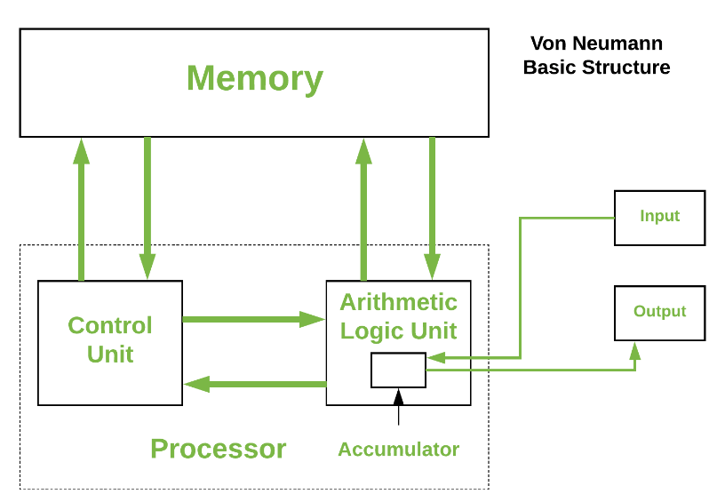

- With the aid of both text and a circuit diagram, explain the principle of operation of a Binary weighted DAC and state the main disadvantage of using this implementation.
3 marks for the circuit
3 marks for the description of its operation (use of an opamp in summing mode with different voltages selected by switched bits)
1 mark for commenting on the need for some uncommon (and all different) resistor values

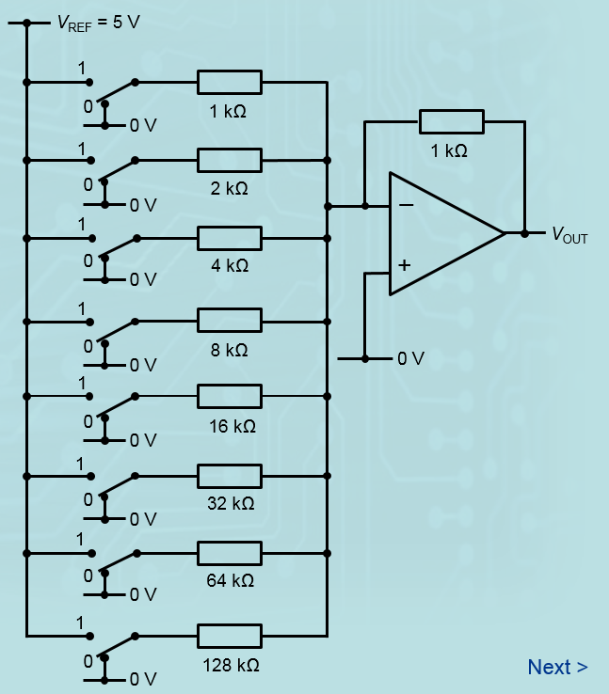

[7 Marks]

Diwedd/End

