Chloe Lee Hughes
P150344

Introduction

For my final dissertation I intend to research on the history of manipulation in art and

photography. I’m going to consider the pros and cons of manipulation in photography with

particular reference to key artists and the influence they have had on my work.

I will attempt to create a timeline that will highlight some of the most important events,

artists and impacts that intentional manipulation has had from its birth to the modern day.

I will conclude that manipulation is a creative force of photography and while there are some

cons there are far more pros, and I hope my research will help conclude this point.

First Key Word- Paradox

I intend to create a timeline of the history of manipulation of photography from when

photography was invented to the current day. I intend to document the effect manipulation

has had on art and society.

I will also explore the paradox within photography where by images can accurately reflect

reality and where some images manipulate our understanding of reality.

Photography has a long history of producing images that accurately reflect the times.

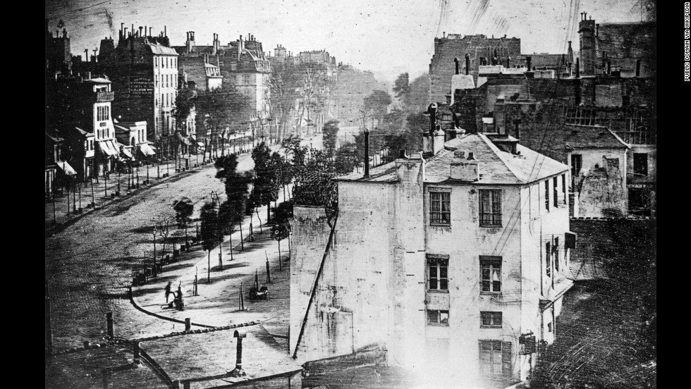

Fig 1: (This photo of a Paris street was taken by Louis Daguerre in 1838)

This image taken by Louis Daguerre in Paris is a complete accuracy of the time in the 19th

century Europe. There has been no manipulation of this image and its completely accurate to

the time. Although showing that the image is almost completely empty the busyness of the

Paris street then would not of been able to pick up on the plate at that time. Which then

shows more evidence of the technology of the time which shows its true nature of the

photograph and the history. Understandable photographs at those times were mostly

documentation of life and we are still to believe that they are its true accuracy with more

research and development this is what photographs are supposed to be used for. To

document our history.

However, manipulation also has a long history.

‘Photo manipulation involves transforming or altering a photograph using various methods

and techniques to achieve desired results’ (Wikipedia sourced definition)

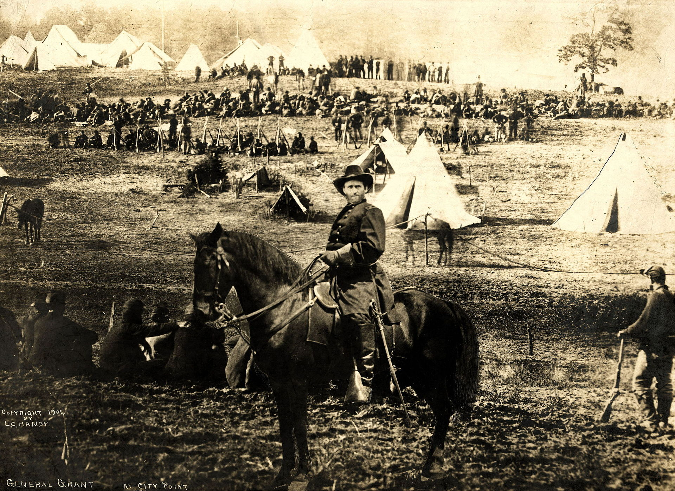

Fig 2: ("Ulysses S. Grant at City Point", a montage.)

This image use to be classified as a specific historical fact and figure. Since further

investigation and research it has been found that this image is in fact made up of a selection

of different images. Ulysses S. Grant’s head has been taken and added to the body of Major

General Alexander McDowell McCook atop his horse from another photograph, and for the

background, an 1864 photograph of Confederate prisoners captured at the Battle of Fisher's

Hill. Further investigating show that the photograph is a little obscure as the head isn’t on the

correct angle for the body and are all clearly taken at different dates. It’s this kind of

manipulation that can conflict a lot of people specially historians on what is in fact true to the

date of the photograph.

“Who controls the past controls the future. Who controls the present controls the past.”
― George Orwell, 1984

One of the greatest books written by George Orwell ‘1984’ about the manipulation of the

media and how they continuously erase information or change speeches and text to suit their

political gain the relevance to today’s society is uncanny showing the political and dishonest

misleading that can concur when manipulation is involved.

How can we be so sure that the history of the photograph is its true form? Is photography

true to its namesake anymore?

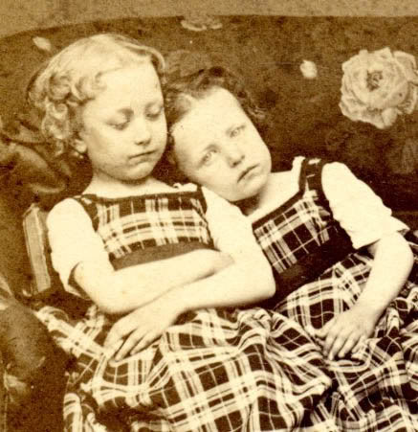

Fig 3: (The image shows two little sisters and one of them being propped up by a book being the corpse)

Victorian Death photography (Momento Mori) is a great example on how manipulation can

be seen as a helpful and endearing subject matter. Victorian England had a unique

relationship with death. Because Victorians died young, quickly or of infections. They

invented elaborate grieving rituals to give meaning to their loved ones’ ephemeral lives. The

family would ask for the body to be positioned and propped up in a certain way as though

they were still alive to create a ‘Momento Mori’ so that they had an image of them

pretending to be alive to re animate their memory. It’s certainly an eerie subject matter but

it’s such a creative way of using manipulation.

Second Key Word- Creativity

An example of creativity is the Dadaism movement flourished in the 1920’s during World War

I in Paris. The concept of Dadaism was banishing the idea of normality of art at that time and

creating something obscure and abstract. Many artists came from this movement Marcel

Duchamp was one of the greatest and well-known artists to be included in this movement

and created some incredibly thought provoking art based on it.

Dadaism was the first conceptual art movement where it focused on the artists and not the

aesthetics of pleasing objects and art. The artists in the Dadaism movement often generated

difficult questions about society and what the role of the artists and to question the artists

process.

Some Dada artists were known to use already made objects and give them different context.

For example Marcel Duchamp transformed a cheap postcard of the Mona Lisa by Leonardo

Da Vinci which was already a well-known work of art. On the postcard, Duchamp drew a

moustache and a goatee onto Mona Lisa's face and labelled it L.H.O.O.Q. Which from French

is "Elle a chaud au cul," which loosely translates as "She has a hot ass." Although this can be

seen as Duchamp’s comedic offence to the art he also poses questions that challenged

artistic values creativity, and the overall canon. This is one example where manipulation can

be used as an example for a philosophical point. It grows the mind and gives the audience a

sense of place and purpose in the art world. Something they can relate to. Not a lot of people

are interested in art or fictions things but most can relate on the idea of questioning the

mind and questioning societies idea of the norm. Manipulation gives art more than aesthetic

it gives it a sense of purpose in the world and an understanding to the human nature.

Salvador Dali was heavily inspired by this movement that he created his own surrealists of

the reality in different mediums. One well known and a personal favourite of the

manipulation genre was a certain scene in a film he created called ‘Un Chien Andalou’. In this

scene the camera flashes to a full moon landscape and back to a woman’s eye being cut with

a razor. When the cloud passes the moon that is when the razor slices the woman’s eye. Of

course the real eye was of a deceased animal and the idea of creating props to manipulate

the audience into thinking otherwise is a genius and incredibly creative idea of manipulation.

Dadaism really changed the concept of fiction and surrealism/manipulation in today’s society

in nearly every medium shown. Dali and the Dadaism movement have really taken effect on

artists to this current day.

Surrealism/Manipulation is taking things beyond reality and it creates a new one. There are

many other inspirational artists and photographers who do this also in which I will be

discussing in my dissertation.

Third Key Word- Inspiration

Damien Hirst is my main inspiration to my work. It wasn’t long ago that I watched his

documentary ‘Treasures From The Wreck of The Unbelievable’ The documentary is about the

story of a sunk ship in the middle of the ocean that held all these wonderful treasures. The

documentary was so incredibly realistic that many people believed it to be true. Due to this

some people have taken screenshots of the film and have claimed it as a true document. I

find the idea of that so fascinating but it goes back to the idea that people will believe

anything they see if it’s realistic enough.

“it’s not what’s there, it’s about what’s not there” – Damien Hirst

Damien Hirsts concept of creating a fake reality completely changed the way I see and do

work. As a fan of the image manipulation I love the concept of turning the mundane into

something beautiful and creative and it’s his influence that has set me off on my search for

this concept of manipulation imagery.

There are many other mediums that interest, influence and inspire me. Science Fiction and

Fantasy play a big role in my life when it comes to creativity. I believe in the idea of

transforming into a character and create new world’s for people to enjoy.

Science Fiction is my main source of inspiration, films such as Star Wars or books such as

Nyxia by Scott Reintgen or Leviathan Wakes by James S A Corey. The reason for this is the

concept of it is believable as we have always grown up to believe that technology is the

future and the sciences in the book are incredibly accurate it makes it undeniably realistic

and creates this whole new imagination of what the world could really be.

But also how it can be seen as still be seen as a bad thing as we still believe that the

photograph is its true form. ‘We believe everything we see’

Even though everyone manipulates to make things better like the Aurora Borealis isn’t as

bright and contrasted as you might think it’s quite faint it’s the photographs that make it look

unbelievably un earth like. Which again can create false hope in peoples understandings of

the world and that everything isn’t as beautiful as it seems. When going to Giza to see the

Pyramids people don’t understand the poverty and the slums in the area as photographs

portray just the beautiful and glorious architecture of the area. This idea of creating a false

world and manipulating photographs in this way can change our concept of what History is.

No one likes the idea of poverty, everyone wants the beauty in something. It’s ideas like that,

that make me want to dive back into the fictions world and bring the beauty back in the

mundane. Sometimes we need that escapism of the conflict that is happening in our own

world.

Conclusion

I’m also inspired by this idea of the changing of the canon of photography and its relation to

manipulation as seen as a conflict theme. There are many points that can be taken into

consideration and I hopefully plan to undergo this research and theory during my

dissertation. During the essay I will be looking at the beginning to end of manipulation in the

art word and its relevance to today’s society and other artists work and how its effected my

work. My focus will be, How manipulation in photography changed the canon of photography

and created conflict?. I will extend upon the keywords that I have researched in this essay

and create more work based on manipulation. I hope to find and add more theories and

artists to help expand upon my dissertation. Creating a thorough essay and hopefully

concluding the answer to my question.

Word Count- 1,852

Bibliography

Fig 1

Article title: First Ever Photograph of a Human Being
Website title: PetaPixel
URL: https://petapixel.com/2010/10/27/first-ever-photograph-of-a-human-being/

Fig 2

(This image is available from the United States Library of Congress's Prints and Photographs division under the digital ID ppmsca.15886.)

1) the head, from Grant at his Cold Harbor, Va. headquarters, [1];
(2) the horse and man's body, from Maj. Gen. Alexander McDowell McCook, [2];
(3) the background, from Confederate prisoners captured in the battle of Fisher's Hill,

I also clearly must state that this photograph is clearly stated as U.S Coms copyright and has not been digitally altered. (ironically)

Fig 3

Article title: If You Ever See A Photo Like This In A Book, There's Something You Should Know
Website title: ViralNova.com
URL: http://www.viralnova.com/post-mortem-victorian-photographs/

Websites

Article title: Photo Tampering throughout History | February 2016
Website title: izitru
URL: http://pth.izitru.com/2016_02_00.html

Article title: Dada
Website title: En.wikipedia.org
URL: https://en.wikipedia.org/wiki/Dada

Article title: Photo manipulation
Website title: En.wikipedia.org
URL: https://en.wikipedia.org/wiki/Photo_manipulation

Article title: First Ever Photograph of a Human Being
Website title: PetaPixel
URL: https://petapixel.com/2010/10/27/first-ever-photograph-of-a-human-being/

Article title: Dada Movement, Artists and Major Works
Website title: The Art Story
URL: http://www.theartstory.org/movement-dada-artworks.htm#pnt_5

Website title: Bradford.ac.uk
URL: https://www.bradford.ac.uk/academic-skills/media/academicskillsadvice/documents/academicskillsresources/writing-essaystraditionalacademic/Teach-Yourself-Writing-your-Dissertation-(and-other-long-assignments).pdf

Books

1984 By George Orwell

Films

Un Chien Andalou by Salavador Dali- Youtube

Treasures From The Wreck of The Unbelievable by Damien Hirst- Netflix

