University of Wales Trinity Saint David
School of Engineering

Energy in a Flywheel
Engineering Science 1 – M4X00385

Iestyn Webber
1901363
13/12/2019

Contents
1 Introduction 1
1.1 Aims 1
1.2 Objectives 1
2 Literature Review 2
3 Methodology 3
4 Results 4
5 Analysis 5
6 Evaluation 6
7 Conclusion & Further Work 7
8 References 8

Introduction

Aims
- To gain relevant data from the completion of the experimental procedure
- To interpret data obtained resulting in the final values of the investigation being calculated

Objectives
- To follow specified methodology in the practical kit to accurately obtain data.
- To record repeat data points to ensure reliability of data collected.
- To put the data obtained into relevant equations.

This report will encompass the findings of two main sections: the experimental procedure, and the calculation of data based upon that. Not only must primary data be discussed, but it must be compared with research and its correlation commented on simultaneously. As such, equations and further data manipulation will be covered, with
[The aims and objectives of a report should be included within the introduction chapter. The introduction may also comment on the topics and sections that will be discussed in the report. It needs to set the scene for the report and then allow the main body to start.]

Literature Review/Research

Methodology
Initially, the apparatus for the equipment had to be set up. This required for the necessary equipment to first be gathered, which consisted of:
- Work panel,
- Pulley block,
- Flywheel,
- 300-millimetre magnetic rule,
- Weight hanger,
- 400g in 100g masses,
- Length of cord,
- Stopwatch,
as specified by the experiment kit (UWTSD). If a specific methodology is being used, then references to sources detailing the methodology should be included in the methodology chapter.
For appropriate setup in preparation, the flywheel was attached to the pulley block; fastened in turn to the work panel to hold the flywheel aloft. One end of the cord was attached to the pulley block, with the weight hanger secured at the other end: hanging from the pulley block. The cord’s length was cut to sufficient length for the weight hanger to move vertically between 280mm and 290mm. The magnetic ruler was positioned so the bottom of the weight hanger, at maximum vertical travel, was aligned with the 0mm mark on the rule, to allow the calculation of bounce height (h2). 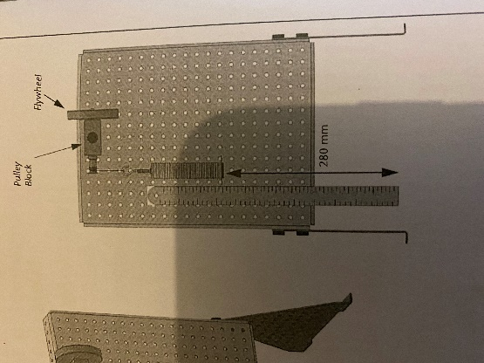

Correct experimental procedure was started with weights added to the hanger to create 100g for the first increment. The experimental process was conducted for the initial increment as follows:
- The flywheel was wound to wrap the cord around the pulley, raising the bottom of the weight hanger to 280mm.
- The flywheel was released allowing the weight hanger to drop; the stopwatch was initiated simultaneously.
- Separate team members measured the h2, and the time taken to reach it on the stopwatch.
- Steps 1-3 were repeated three times per mass, in 100g increments up until 500g and an average created to improve reliability. Anomalies were ignored when calculating averages.
- Raw results and averages plotted in results table.
Once results were collated, further investigation was needed to fulfil the table and answer the questions presented. The potential energy (PE) was calculated using the equation PE = mgh, followed by the PE loss (adjusted) which was required as the weight hanger travelled in two directions. This would allow for analysis of discrepancies when investigating the kinetic energy (KE) of the hanger. The mg was calculated for use in later equations. Crucial values of falling time and acceleration were calculated next, using time and heights. The linear falling velocity was calculated as the acceleration multiplied by the falling time, creating
V = aTf
Additionally values for(mg-ma)r were calculated as these are equivalent to the cord’s torque value. The equation
a/r
gave the value for angular acceleration, which consequently meant the average value for total inertia, It, could be calculated when substituting (mg-ma)r for torque in the equation
T = I.a/r
A graph with a/r on the x-axis was plotted, which meant that a value for I could be calculated from the gradient.

Results

Table of Recorded Data
Mass (g) | Total time (s) | H2 (m)
0 | 0 | 0
0.1 | 4.06 | 0.24
0.2 | 3.25 | 0.251
0.3 | 2.38 | 0.254
0.4 | 1.93 | 0.251
0.5 | 1.72 | 0.241
Figure 2
[talk about using equations to calculate]
Further results

Analysis

Table 1 Results from Experiment

Speak about results in table, describe trend
Describe equation results and compare
Analyse graphical correlations

Evaluation
Evaluate how the methodology was followed, good and improved
Evaluate results obtained
Explore deviations e.g. results began to decrease because of non-linear movement/wobbling in the string

Conclusion & Further Work
Conclusions drawn from the experiment are as follows:
- What the graphical correlations show
- What the results say about the experiment
- Conclusions about the deviation
Questions:
- Note relationship between mass applied and PE loss. Heavier masses should give greater PE loss. Why?
- Does value of I compare with nominal values
- Think about sources of error; what could show discrepancies in: PE+PE loss = KE
In terms of further work to be conducted, :
- Experimentation with less rigid rope
- With a hanger that does not wobble so energy is not lost
- Smaller increments?

References
1 - https://moodle.uwtsd.ac.uk/pluginfile.php/324439/mod_resource/content/1/M4X00385_SEM1_CW_2019_2020.pdf accessed 18th November 2019
2 -

