Modern & Traditional Design and monitoring the construction process.

Contents
Introduction 2
Primary Structure 2
Foundation type 3
Structural Elements 3
System of enclosure 5
Conclusion 7
Reference List 8

Introduction
The steel frame construction illustrated in the drawings provided show the designs for an office building that has been erected. The aim is to identify, with justification, the appropriate systems of primary structure for the building including annotations of all of the primary structural elements. The system of enclosure will also be identified and explained in relation to the primary structural elements identified in the building. The locations of such elements of enclosure will be annotated and explained throughout.

Primary Structure
According to Design Buildings, 2022 concrete, timber and steel are the most common used materials within the construction industry so an argument can be made why each material can be used. In this case the diagrams of the case study suggest using steel framed structure system based on its many advantages in comparison to other methods.
  - What is steel framed construction?
Geoffrey White, 2017 tells us that the steel framing construction method in which is steel columns and beams are joined together to form the skeleton of the building as well as the floors and roofs.
  - Advantages of using steel frame.
Steels high strength and adaptability to shape/size is one of the key factors to why it’s used in many projects like ours. As well as its mass off site production and fabrication, steel also can resist dynamic forces such as wind and some earthquakes. It also has many others such as its ease of installation, adaptability to any shape/size and its ability to be cladded over with a variety of materials. (Geoffrey White, 2017)
  - Higher Strength
In comparison to timber and concrete steel has a much higher density meaning that the same dimensions of steel will be heavier. Although it will be heavier the steel will be able to carry more load than the other types. (Design Buildings, 2022)
  - Versatility
Steel can be fabricated into different shapes whilst keeping strength. Giving architects and designers the opportunity to use creative and innovative designs to create structures that are aesthetically pleasing as well as stable.
  - Longevity
Design Buildings, 2022 tells us that steel does not crack as it ages like timber and isn’t vulnerable to mould, mildew or insect infestations/attacks. If there is an increase of moisture steel will not rot or expand. However, corrosion may result if the correct precautions aren’t taken for example to protect the steel, a coat of fire- and water-resistant material is applied before installation to ensure the steel doesn’t lose its strength during a fire and the water-resistant material prevents rusting.
  - Production
According to Design Buildings, 2022 steel frame are all prefabricated off site suiting the specification prior to arriving at construction sites. Once made they are ready to be constructed unlike concrete where we must wait for it to set before walking on it etc. Unlike timber and concrete there is minimal waste as there isn’t a need for temporary framework which wouldn’t need to be dismantled afterwards.

  - Safety
The raw strength of steel allows it to be the ideal material to use within our case study due to its performance in extreme weather and natural disasters as well as these it also performs better in emergencies such as impact and explosions.

  - Cost
As mentioned by Design Buildings, 2022 steel is fabricated off site so therefore on-site labour can be reduced by 10%. With the construction times being shorter the building that’s being constructed can be occupied sooner than if we used timber. Due to its durability repair or maintenance cost remain low and insurance companies may offer a better package or premium due to its ability to withstand natural disasters.

Foundation type
Pile foundations are a slender column made up of steel or concrete and are constructed by driving the piles into the desired foundation level or once excavated to the exact level drilling in tubes are used. They are most used to transfer load within a structure.
Atkinson, 2007 tells us that pile foundations are of three main types based on structural behaviour: End Bearing Piles, Friction Piles, and combinations of the two.

Structural Elements
  - Columns
  - The typical steel column occupies 75% less floor space than an equivalent concrete column. At the same time structural steel allows longer spans that eliminate intermediate columns creating open floor areas ideal for today’s office layouts. Parking structures benefit from smaller structural steel columns and longer spans as well.
  - Most Common Profile?
The shape profile of this section looks like alphabet “C” hence we call them C shape. This section is mostly used for uniformly distributed load applications with small movement/bending.
(Liang, Z 2022)
  - Advantages
Liang Z, 2022 tells us that steel provides a high structural capacity when used within a multiple member system. Floor Joist system and purlins in roof truss are examples that can be used. The C profile steels have many uses as they can be placed back-to-back to create a virtual I-shape section and this provides good compatibility for connecting to other steel members and concrete/brick surfaces.

  - Walls
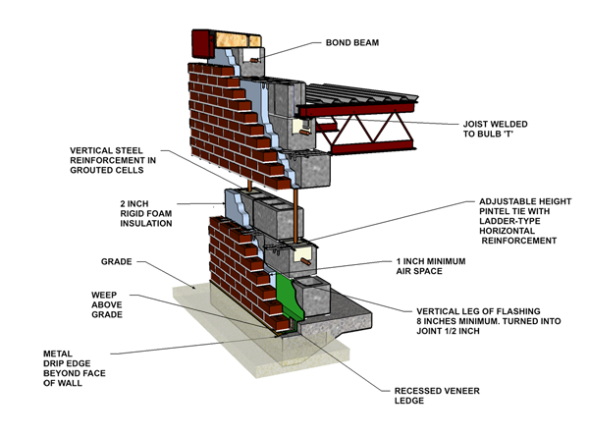
Block and brick are one of the most common way to form the external skin of the building. Since its very cost affective. The internal skin is made up of many layers shown in the diagram. The concrete block is the internal of the two blocks measuring 440mm x 100mm x 215mm. the advantages of using this method in comparison to a timber stud wall is that the blocks are very lightweight as well as dense. This is to help the block achieve their desired energy efficient level. Haseeb J, 2021 also tells us that there are other advantages such as:
The concrete blocks are much better at resisting fire and flood than timber. Cost efficiency is a huge factor when constructing buildings as well as blocks being a lot cheaper than timber it also has minimal need for ongoing maintenance.

Image taken from: https://masoncontractors.org/systems/cavity-wall-brick-veneer-reinforced-concrete-block/

  - Floors
A concrete floor slab can either be poured in-situ or precast in a factory usually using steel rebar. Steel rebar is a metal bar or mesh sheeting is used to strengthen concrete and enhance the floor slabs durability.
- Basement or ground floors – the concrete slab is directly supported onto a construction which may involve hardcore, blinding, and other materials.
- Suspended ground floors – where the slab is supported on beams and/or loadbearing sleeper walls and is not in direct contact with the ground.
- Suspended upper floors – where the slab is supported by beams (steel or concrete) and/or columns or on loadbearing walls.
Roof
The rubber insulated flat roof is made up of rubber or plastic polymers with both having parts of burnt tyres and slate dust. This method is used to reduce leaks and improve thermal performance. The single-ply synthetic membrane roofing is strong, waterproof, and flexible. In comparison to your typical asphalt roofing system the rubber system can be made to suit shapes that the asphalt cannot. Hendrick, S (2021).

  - Lifespan
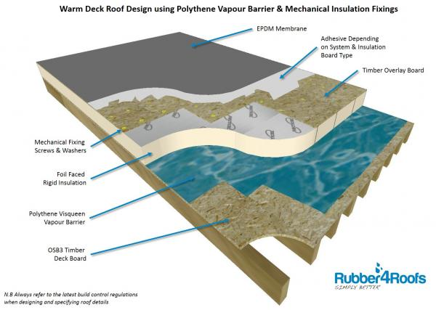
As mentioned above the rubber roofing system is very durable and has nearly double the lifespan than the asphalt system does. Hendrick, 2021 tells us that most domestic properties use asphalt shingles that have a lifespan of 15-20 years depending on maintenance weather conditions etc. on the other hand, the rubber roofing option can last 30-50 years. In comparison to the other option, it needs very little maintenance if installed correctly.

  - Weather
Rubber shingles or rolls are much stronger and less likely to crack during extreme weather conditions than asphalt roofing. When roofs are flatter, water damage is common, as water does not run off as quickly as on steeper roofs, allowing it to be blown underneath shingles that are not well sealed.
  - Durability
In addition to being weather resistant and completely waterproof. If installed properly, rubber roofing shouldn’t crack or become brittle due to hot or cold temperatures. It’s able to withstand hail and other extreme weather conditions and shows a very high resistance to ultraviolet radiation
  - What is an appropriate strategy for accommodation of wind loads?
wind damage involves strengthening areas where buildings could come apart. The walls, roof and foundation must be strong, and the attachments between them must be strong and secure.

System of enclosure
  - Different types of cladding
  - Stone Cladding
This is a type of cladding that involves the use of thin layers of natural stones. Exterior wall cladding using stones gives any dwelling a natural elegance and style that is also unique from other styles of cladding.
  - Brick Cladding
Bricks are one of the more popular choice of cladding material and act as a great finish of a structure and is aesthetically pleasing. It also has many advantages such as not being affected by cold/warm weather. External brick cladding requires low maintenance. (Tritech Building Contractors Admin, 2018).

  - UPVC Cladding
UPVC is simply Unplasticized Poly Vinyl Compound. You just need to wash it and you will keep your building in the right condition. Most uPVC windows have a UV stabilizer within it which prevents the covered area from direct sunlight. uPVC cladding is also weatherproof and corrosive resistant. It is thus used to cover any exterior cladding panels regardless of the climate condition of the area you reside in. uPVC is also fire resistant.
  - Timber
Timber is a great cladding option because timber is a natural material, and it is warm and comforting. Timber also comes in varying colours, styles and textures that will make your building unique and attractive. In addition, timber is also a renewable resource, and you can re-use it in future if you opt for a new cladding project.
  - Glass
Glass is used in most business offices and residential building. The glass panels are supported by upstands which allows the glass panels to have the security and protection from intense winds and heavy rain.
  - Metal Cladding
Metal cladding is mostly made up of steel or aluminium. Comparing both types of cladding steel is very durable so therefore it will be a lot harder to damage in comparison to glass for example. On the other hand, some companies may choose in favour of aluminium as it’s fire-resistant properties can help the dwelling from extensive damage. Metal cladding also has many more benefits, similarly to uPVC it comes in all shapes, sizes, and colours. All that’s needed is a design to suit the structure. As well the above surprisingly metal cladding acts as a great insulator within the building.

  - Rainscreen cladding
What is it?
The rainscreen cladding system is made with a bearing wall, an insulation layer and a cladding material that is fixed to the building using a supporting structure. An air cavity is created between the load bearing wall and the cladding material which allows continuous ventilation.
  - Thermal Performance
The rainscreen cladding system has a natural convection process within it, sometimes referred to as the “chimney effect”. Which is simply when the convection process makes the warm air cold during the summer months and during the winter it helps keep the warmth in. The chimney affect is used to make sure the material avoids overheating during the summer and maintain a steady temperature during the winter. So, a steady constant circulation to get top performance out of the rainscreen cladding. (Tritech Building Contractors Admin, 2018).
  - Advantages
This façade system reduces condensation and humidity coming both from inside and outside the building. The continuous circulation of air inside the air cavity works as an extra protection layer and removes the possible water filtrations that can slip through the cladding joints.
The constant ventilation inside the air cavity improves the durability of the exterior cladding material since it keeps it dry. The façade’s lifetime is even longer when using a durable and resistant material like natural slate for example (Tritech Building Contractors Admin, 2018).
With the air cavity allowing a stable temperature within the dwelling prevents the risk of cracking and many other issues. This will allow the structure to be less likely to suffer expansion movement.
The rain cladding system increases the thermal and acoustic levels significantly. Which will have a massive impact on environmental pollution. This system also removes thermal bridges.
The Tritech Building Contractors Admin, (2018) creates the impression that rainscreen cladding makes cooling the building easier during summer and provides a better control of the heating during winter, favouring both thermal comfort and energy saving. Thanks to the rainscreen cladding system, energy bills can be reduced between 30 and 40%.
Rainscreen cladding systems require minimal maintenance, especially if you choose a cladding material that can withstand adverse weather conditions like a natural slate for example.
The rainscreen cladding system is durable, energy efficiency and low maintenance cost of the façade. So rainscreen cladding is an excellent choice both for new construction sites and refurbishment projects.
(Tritech Building Contractors Admin, 2018).
Conclusion
The write up on the case study office building has identified, with justification, the appropriate systems of primary structure relevant for the specification given for the building. Annotations have been used throughout to highlight and explain key aspects of such systems as well as identifying and justifying the elements of enclosure within the structure.

Reference List

Geoffrey White . (2017). Advantages & Disadvantages of Steel Frame Construction. Available: https://blog.glwengineering.co.uk/the-advantages-disadvantages-of-steel-frame-construction. Last accessed 03.03.2022.

Design Buildings. (2021). Pile Foundation. Available: https://www.designingbuildings.co.uk/w/index.php?title=Pile_foundations&oldid=219282. Last accessed 03.03.21.

GeoEngineer. (2018). Pile Foundations. Available: https://www.geoengineer.org/education/foundation-design-construction/deep-foundations/pile-foundations. Last accessed 03.03.21.

Midwest Steel. (2022). Advantages of using steel columns . Available: https://www.midweststeel.com/about/advantages-of-steel.html#:~:text=The%20typical%20steel%20column%20occupies%2075%25%20less%20floor,structural%20steel%20columns%20and%20longer%20spans%20as%20well.. Last accessed 04.03.21.
Zoe Liang. (2022). Steel Columns & Beams. Available: https://skyciv.com/technical/benefits-of-different-steel-sections/. Last accessed 17.05.17.
Haseeb, J. (2021). Block and Brick advantages and disadvantages. Available: https://www.aboutcivil.org/bricks-advantages-disadvantages-uses.html. Last accessed 03.03.2022
Hendrick, S. (2021). Benefits of rubber roofing. Available: https://www.hedrickconstructioninc.com/blog/the-benefits-of-rubber-roofing. Last accessed 03.03.2022.
Tritech Building Contractors Admin . (2018). Types of Cladding. Available: https://tritecbuildingcontractors.co.uk/blog/types-of-cladding-for-buildings/#:~:text=The%20most%20common%20types%20of,%2C%20Weatherboard%20Cladding%2C%20Glass%20Cladding.. Last accessed 07.03.2022.

