Student Name : Saeed Ahmad
Student ID: 2027769
Module Code: BMSW5105
Assignment Title; Workplace Culture and its Impact on Organisational Efficiency
Lecturer: Khaza Ahmed

Table of Contents
Introduction 3
The organizational structure of Just Eat Takeaway & its impacts on organizational culture. 4
External influencing factors of Just Eat Takeaway’s work culture 5
Ethical organizational culture of Just Eat Takeaway and recommendations 9
Barriers in Just Eat Takeaway’s culture and recommendations to enhance it 11
Conclusion 12
References 13

Introduction
The company Just Eat Takeaway.com connects customers and restaurants in 22 different countries through a food delivery online marketplace. The Amsterdam-based company was established in January 2020 by merging two of the most prominent names in the global food delivery industry: Takeaway.com (established in the Netherlands in 2000) and Just Eat (established in Denmark in 2001). Both firms were founded by ambitious businesspeople who expanded their operations to become industry leaders in their respective countries and elsewhere throughout the world (JustEatTakeaway, 2022). Outside of China, Just Eat Takeaway.com is now the most popular online marketplace for ordering and having meals delivered.
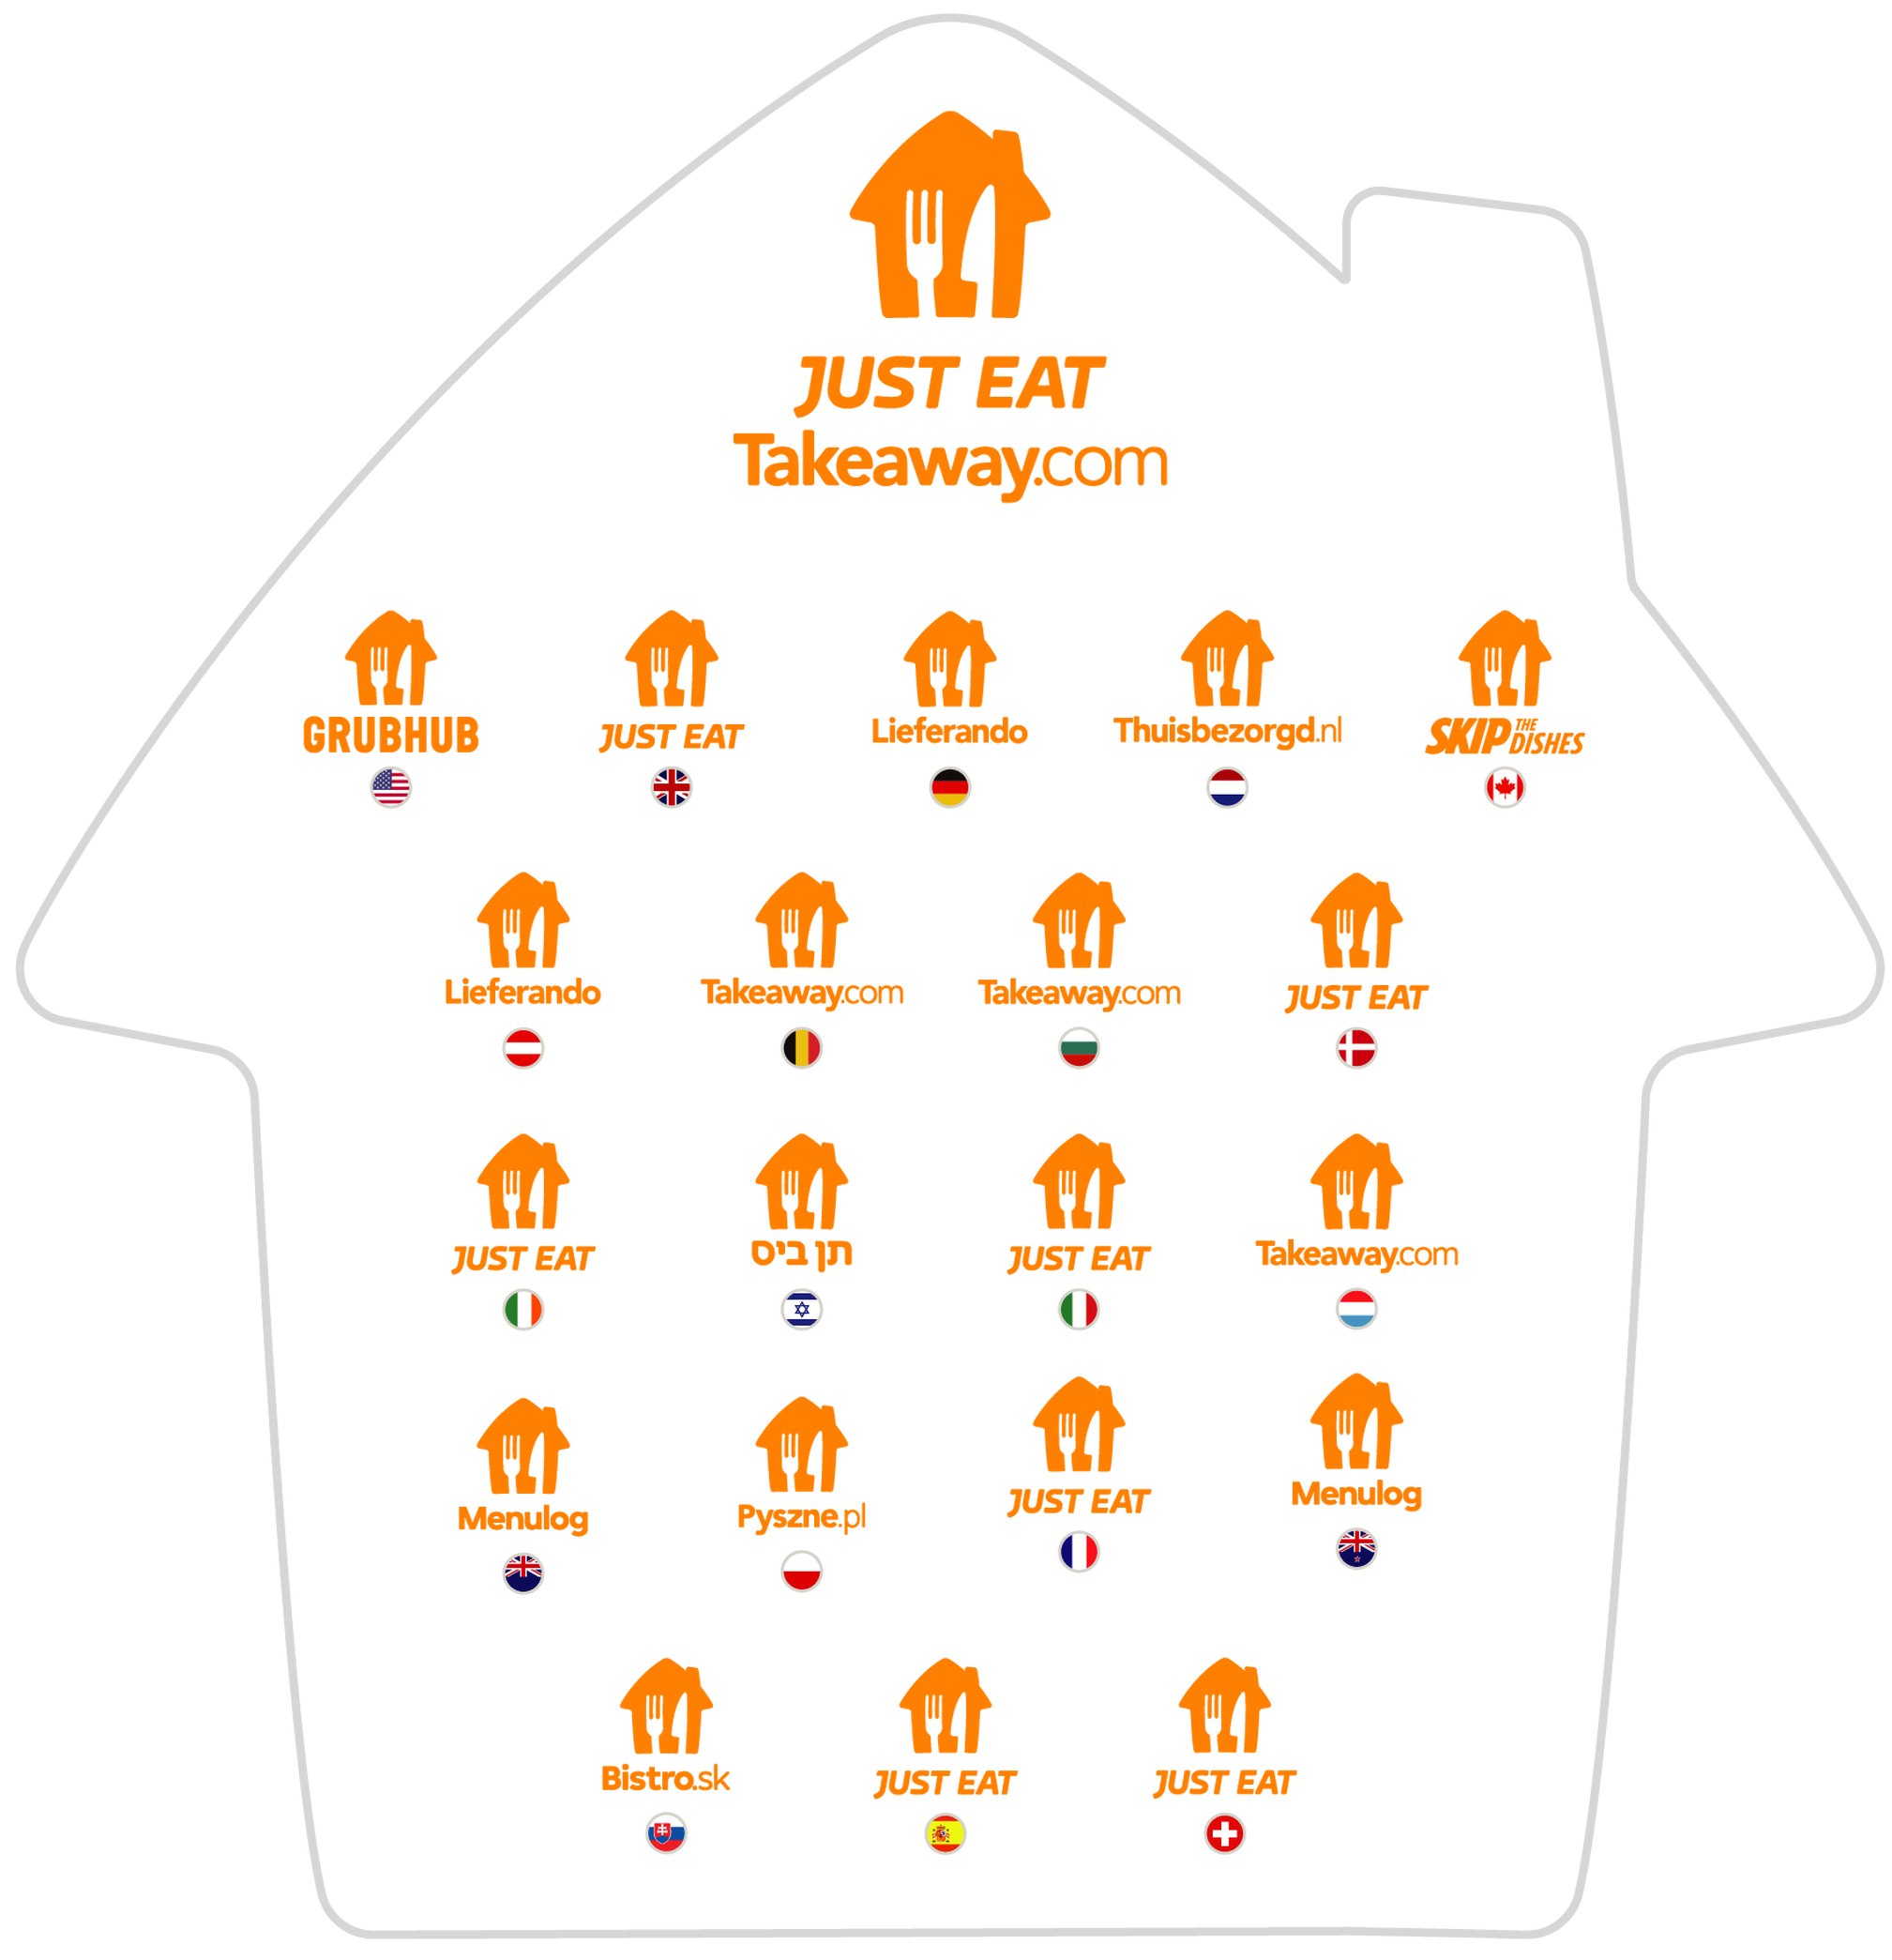
Figure 1: Just Eat Takeaway’s Markets.
Source: (JustEatTakeaway, 2022)
The above data shows most of the countries where Just Eat Takeaway has active operations, which include the United Kingdom. In 2006, Just Eat Takeaway made its debut in the United Kingdom as the first service of its kind (Dephna, 2022). Since its release as an iOS and Android app, it has quickly become the go-to for finding and sharing delicious new meals. Although UberEats and Deliveroo appeared to have the upper hand for a while, Just Eat made some adjustments to their operations and is now a formidable competitor. As of the year 2021, Just Eat has a 45% share of the market, with UberEats trailing far behind at 27% (Dephna, 2022).

The organizational structure of Just Eat Takeaway & its impacts on organizational culture.
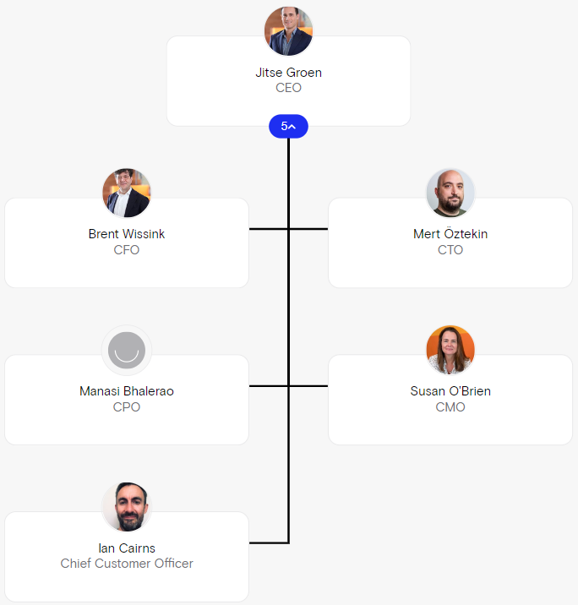
Figure 2: Org chart of Just Eat Takeaway
Source: (Theorg, 2022)
The above data shows the company’s top-level management structure and who plays which role. The company always focuses on its employees’ working conditions and satisfaction by closely analyzing the ongoing commercial and personal issues of their employees to sustain them for a long time. CEO Jitse Groen changed the way the company treated its employees by implementing an employment-based model across Europe that would no longer rely on gig workers and instead focus on recruiting a focused and skilled set of workers who have both dedication and energy to represent Just Eat Takeaway in the best possible way to its customers (Sonnemaker, 2020). What this action creates is an employee culture within the organization that supports and maximizes benefits for the qualified employees and shapes them to be even better with upper management support.
Because all employees are given the chance to innovate and contribute to every aspect of the business by working together, the organizational structure is unique. This promotes a culture of positivity and goal-driven performance. The company has flexible organizational structures, which means that anyone can find and transition to their perfect jobs in sales, software, and everything in between, offering flexible career pathways and chances for growth. Talent programs, mentoring, and several other initiatives help them reach their full potential (JustEatTakeaway, 2022).
These above-mentioned organizational structures and decisions within them help the brand cultivate positive cultures, which in turn creates favourable outcomes and employee-customer satisfaction, both of which are much needed for any company to find success and sustain it for a long time.

External influencing factors of Just Eat Takeaway’s work culture
It is critical for any business to monitor external environmental factors because any small to large outside element can have a significant impact and cause drastic changes for the company. The company's operations, employees, and revenues can all be affected in some direct or indirect way by the external environment. The external factors can both help the company but also bring in challenges and that is why it is important to keep track of it (Janet, 2020). The next part will be a PESTLE analysis of Just Eat Takeaway to look at their external competitors and the most important factors that affect them.
- Political: As a result of the Food Standards Agency's efforts to improve food safety and consumer protection through the establishment of standards that businesses must follow, competition increased as businesses compete to ensure they are best positioned to supply safe, high-quality food to customers (Seaman, 2021). Because of its membership in the European Union, the United Kingdom welcomed a variety of companies from inside the EU into its market, leading to an increase in the number of online food ordering companies. Just Eat Takeaway faced stiffer competition as a result, forcing the company to find ways to improve its working conditions and culture to continue providing customers with safe and healthy meals (Bradshaw, 2021).
- Economical: The European Union, home to the vast majority of Just Eat Takeaway's markets, has had dismal growth over the past three years. Poor GDP and a high rate of unemployment led to decreased consumer spending (Amicarelli, 2021). Because of this, rivalry heated up between Just Eat Takeaway and its competitors for the limited number of food delivery consumers. Since the firm was experimenting with various promotional methods and activities to differentiate itself from the competition, it had to revise its spending culture and patterns accordingly (Collinson, 2021).
- Social: In the United Kingdom, about 69 percent of the population regularly orders takeout via the Internet. Even in other EU nations, many choose to order takeout rather than cook at home.
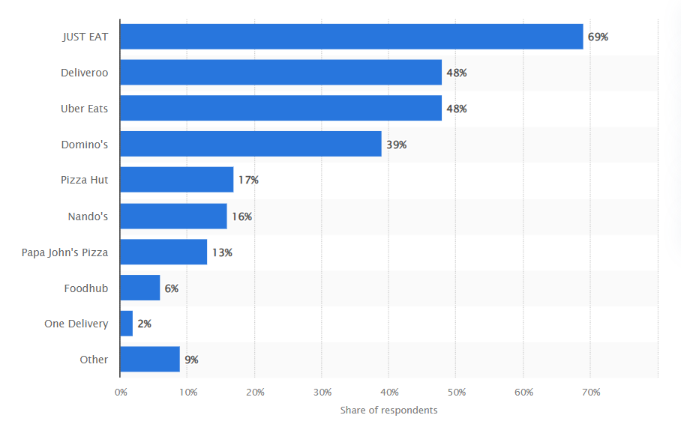
Figure 3: Online food delivery bookings by brand in the UK in 2022
Source: (Statista, 2022)
Just Eat Takeaway was able to expand its business thanks to the positive effects of social trends such as those mentioned above, and the company has adopted new practices into its organizational culture and workplace system to keep up with the ever-increasing demand for its services.
- Technological: The services provided by Just Eat Takeaway in the UK are being affected by technology developments in a wide variety of ways. Technological considerations include supply chain disruption driven by technology, everyone's accessibility to information, new product and service innovations, enhanced customer service, etc. (Vergara and Poblete, 2021). Just Eat Takeaway has been affected by these events in a big way because the company's competitors are all trying to outdo each other in some way. This has led to big changes in the company's operational activities and technical updates, which in turn have had a big effect on the company's work culture.
- Environmental: In recent years, concerns about the environment and sustainability have emerged as top priorities for many companies. Organizations are under increasing pressure from the government and advocacy groups to improve their environmental practices (Klava and Correia, 2021). Changing climates, proper waste disposal, pollution regulations, a growing emphasis on sustainability, and reducing carbon footprints are all examples of environmental considerations. As a result, companies like Just Eat Takeaway reduced their pollution rate by shifting to less harmful materials, and they also altered their production patterns to create less waste overall (Peterdy, 2022).
- Legal: Management at Just Eat Takeaway had to take into account the legislation in areas such as data protection, copyrights, and intellectual property safety. The company's Law Department processes and work culture had to adapt to accommodate the ever-evolving nature of patents, copyrights, and other intellectual property rights, particularly in the United Kingdom (Marsh, 2022).
The above analysis of PESTLE on Just Eat Takeaway shows how, because of different external factors, the company has gone through different drastic changes over time. It had to make shifts and alterations in almost every aspect of its business, and those happened because of situations it could not control. These shifts give a clear picture of how their work culture in organizations and every other segment where they have operations have had to adapt over time, and this is why being careful about external factors is necessary as it helps to be cautious and analyze the surroundings. As a result, external factors can be used to benefit the company by keeping it alert to them, and it is important to keep them in mind to sustain it in the long term.
Now that PESTLE has provided a general idea of external factors influencing the work culture and pattern of Just Eat Takeaway, Porter’s Five Forces will showcase even more in-depth information regarding the market and competition to better understand the situation and its effects on Just Eat Takeaway.
- Supplier Power: Restaurants are the major suppliers in the market since they can mass-produce a wide range of foods for easy delivery through online food delivery companies. This makes the bargaining power of the suppliers moderate (Masry, 2022). Due to the abundance of restaurants, a single provider can't have any impact on the prices charged by online food delivery services. As a result, Just Eat Takeaway has control over its suppliers and can make changes whenever they see fit (Masry, 2022).
- Buyer Power: The sector is mostly fueled by customers who buy takeout meals. The bargaining power of the buyer is moderate. Because there are so many customers in the market, it is difficult for one buyer to significantly affect the price of goods or services. This eases pricing competition for companies like Just Eat Takeaway and others. Customers, however, have very small switching costs (Sorrentino and Russo, 2021). The Internet's abundance of ordering service providers means they can easily switch without major expense. Consumers select vendors based on factors such as meal quality, convenience of delivery, and cost per user. As a result, consumers drive market rivalry by demanding ever better service (Hirschberg, 2022). A large customer base is attracted to businesses whose offerings consistently satisfy customers' needs regarding cost, quality, and timeliness of delivery.
- The threat of Substitution: Eating outside and making meals at home are two primary alternatives for customers. Because most customers live and work in areas with plenty of other dining options, making the competition is fierce (Chawla, 2021). Consumers can save money by visiting restaurants in person rather than placing online meal orders. Unfortunately, takeaways are not quite as appealing due to worries about the health consequences of eating fast food. The online meal ordering industry faces stiff competition from traditional delivery and pickup services. In this regard, businesses need to prove that their offerings are more beneficial to customers than those of competitors (Chawla, 2021). Since there are already competing alternatives, businesses like Just Eat Takeaway face challenges.
- The threat of New Entrants: Due to the low barrier to entry, new entrants pose a significant threat to established businesses. If a company wants to enter the market, all it needs is a good website and a reliable distribution network, neither of which needs a huge financial investment (Masry, 2022). There have always been companies like Delivery Hero and FoodPanda in this space, and now there are many more. When capital is readily available, startups have a better chance of succeeding. New competitors mean that established companies like Just Eat Takeaway have to work harder to keep their good brand image and long-term relationships with the best restaurants and customers (Masry, 2022).
- Competitive Rivalry: As a result of so many businesses competing for the same customer base, there is intense competition. To attract and retain customers, most businesses emphasize delivering exceptional services (Kumar and Shah, 2021). Due to the need for hundreds of workers to ensure timely meal deliveries, this sector is extremely labour-intensive. As a result, there is less money available to put toward things like advertising and quality control of the service provided. As a result, businesses like Just Eat Takeaway and its rivals are in danger of closing down or losing a significant portion of their market share if they do not keep up their current levels of customer service and promotional efforts (Louca, 2022).
The above analysis of Porter’s 5 forces shows us the buyer and supplier power in this industry, which is under the control of Just Eat Takeaway. But the increasing number of competitors and availability of substitutes always create problems for them. Situations like this force Just Eat Takeaway to implement new strategies that make them the leader in the market and the customer’s top choice of service provider by providing excellent delivery service and deals.
Both of these frameworks gave key information and insights about the market situation of Just Eat Takeaway and all of its surroundings in the industry. Considering everything, the brand is in a good position in the market and has been able to combat many challenges so far by adjusting its working patterns and culture over time. But as the future is always uncertain, they need to be up to date and more cautious than ever to be ready to address any heavy influencing external environmental factors.

Ethical organizational culture for Just Eat Takeaway and recommendations
Just Eat Takeaway prioritizes ethical practices all over the organization, whether it is about employees, systems, or partners. They do everything on a local and global scale with ethical considerations in mind, guided by their vision of empowering every food moment, which they summarize in three words: lead, deliver, and care (JustEatTakeaway, 2022). For any business in today’s world, ethical practices and participation in CSR activities are a must because they represent who they are and what they care for. Those ethical activities show they are not operating by sacrificing the environment, and CSR activities show they are doing things to make the world better (Gheraia and Abdelli, 2020).
Respect for human rights, freedom from harassment and other types of intimidation, and a commitment to doing the right thing are all part of Just Eat Takeaway’s ethical culture.
- They welcome all kinds of people and do not practice any kind of discrimination. In the workplace or the supply chain, it will not stand for any type of discrimination, harassment, or intimidation (JustEatTakeaway, 2021).
- Because the company offers competitive pay and satisfying career paths, it can keep employees and keep them motivated.
- All personnel decisions, including those involving employment, promotion, pay, and training and development, are made unbiasedly.
- The company does not stand for any sort of modern slavery in its operations or supply chains.
- It adheres to age restrictions set by law in all jurisdictions where it operates. They never employ slave labour and hire anyone younger than 16 years old (JustEatTakeaway, 2021).
- It won't let any kind of bribery or corruption happen in its business deals or networks of suppliers.
The above-mentioned ethical practices are some of the codes of conduct that are universally practised in every country Just Eat Takeaway operates, and it strictly enforces them to be an ethically responsible entity (JustEatTakeaway, 2021).
Just Eat Takeaway places a strong emphasis on doing well for the community and the environment. Their goal is to lessen their impact on the environment. Office waste reduction and a decrease in plastic packaging used by their restaurant partners are two of their top priorities (JustEatTakeaway, 2022). They’ve taken several initiatives to become more socially responsible, including,
- Accelerating e-delivery: It increased the number of electric cars used in logistics to speed up e-delivery and cut down on fuel energy and carbon emissions.
- Packaging innovation: The business partnered with the eco-friendly packaging company Notpla to introduce 100% biodegradable food packages to its UK operations.
- Supporting charities: The company launched its first worldwide charity campaign in 2020, donating 1.5 million euros to food banks and partner organizations (JustEatTakeaway, 2022).
Just Eat Takeaway is dedicated to operating in a socially and environmentally sustainable manner with a focus on continuous improvement for society and also influencing others in the industry to be aware of and participate in CSR activities too.
The business is already actively participating and practising ethical and CSR activities, but it can always be better than before. Some suggestions for making the ethical culture even better can be,
- Ethics Training Program: If a business is serious about its ethical standing, it should invest in a structured ethics training program. To reaffirm the organization’s conduct standards and make it clear what kinds of actions are acceptable and what are not, the organization should provide conferences, seminars, and other forms of ethical training (Watts, 2020). Future ethical difficulties and other circumstances can be addressed and mitigated if Just Eat Takeaway can develop such programs.
- Promote reporting of unlawful or unethical behaviour: A company should foster a culture of open communication by providing employees with clear channels for reporting instances of unlawful or unethical behaviour on the part of other employees or third parties related to the company (Walker, 2022). This will guarantee that everyone associated with Just Eat Takeaway is acting ethically and taking precautions to avoid causing harm to others.
The suggestions can help make their existing practices even better by eliminating possible incidents as well as teaching moral lessons and increasing their ethical practices.

Barriers in Just Eat Takeaway’s culture and recommendations to enhance it
Some of the barriers that are in Just Eat Takeaway’s culture are,
- Gig worker culture: One of the problems the company is facing is its handling of gig workers. Because gig workers are unstable and work temporarily, it is hard for the company to teach them the right methods and culture for an extended period. The gig workers do not get the benefits and workplace protection either (Josephs, 2021). This combination of practices makes the culture's implementation and functional strategies ineffective.
- Sudden layoff issue: There was a barrier to the company's long-term functioning because of the Covid situation, and 390 people lost their employment, representing 40 offices and 350 couriers. The layoffs were the result of the company's strategy to restructure globally, which affected a large number of people (Sawers, 2022). Their operations have been disrupted by the difficulty of reorganizing and restaffing.
- Refocus on the European market: Another disruption in the functioning of Just Eat Takeaway was its decision to sell its acquired company, Grub Hub. The company faced pressure from its stakeholders to balance the portfolio because they want the business to shift from the US market and focus only on the European markets, which are bringing the most profits and success. This meant letting go of a whole portfolio for the delivery giant, which had its aligning function just like the other companies under Just Eat Takeaway (Browne, 2022). As a result, the barrier was in handling the company culture as the best service provider since Grub hub’s dropping popularity and market share affected the main company as well.
The above-mentioned issues can be resolved by effective strategy implementations. The recommendations would be,
- For the gig worker issue, the company needs a new set of terms and conditions in its recruitment policy and strategies. The goal should be to build a solid workforce that can serve the company for a sustainable period. They can provide them with the proper employee benefits and workplace protection that could not be implemented for gig workers. This will also enforce the organizational culture within them, and they can represent that culture to the customers.
- The layoff issue and European market focus can be handled by proper repositioning of new employees at new locations in the European market. Because the company finds the majority of its success in European regions, heavy employment where there is a demand can be a good solution to re-hire previous employees because they have the necessary training and knowledge. The shift in placement and rotation will increase their workforce’s skills, and they can adapt to the same organizational culture at a different location. As a result, they can both properly utilize employees and also meet the demand of the European market.

Conclusion
Just Eat Takeaway’s organizational culture has some unique perspectives, and it clearly shows the success and operations of its services worldwide. But the culture has to shape and reconstruct itself over time to match the current perspective of the organization's vision. Many internal and external elements force this culture to change and to be cultivated across the organization. But just as problems emerge over time, solutions also exist to mitigate them, and the recommendations and suggestions are the reflections of those problems that can help Just Eat Takeaway foster its culture in every segment and part of its operation while also being ethically considerate and socially responsible.

References
Amicarelli, V., 2021. Food Delivery Platforms During the COVID-19 Pandemic. New Trends in Sustainable Business and Consumption, pp.158-164.
Bradshaw, T., 2021. Losses at Just Eat Takeaway widen as competition bites. [online] Ft.com. Available at: <https://www.ft.com/content/e98533e0-f6fd-49f8-91f5-c7d6129d6ebf>
Browne, R., 2022. TECH Just Eat Takeaway is exploring a sale of Grubhub barely a year after buying the company. [online] CNBC. Available at: <https://www.cnbc.com/2022/04/20/just-eat-takeaway-is-exploring-a-sale-of-grubhub.html>
Chawla, M., 2021. A COMPARATIVE STUDY OF ONLINE FOOD DELIVERY START-UPS IN THE FOOD INDUSTRY. International Journal of Current Research, 13(5), pp.17540-17549.
Collinson, P., 2021. Food delivery apps fuel a junk economy that never fills the productivity gap. [online] the Guardian. Available at: <https://www.theguardian.com/business/2019/oct/26/food-delivery-apps-junk-economy-productivity-gap-just-eat>
Dephna, 2022. Who Delivers? Best Food Delivery Apps in the UK for Sellers! | Dephna. [online] Dephna. Available at: <https://www.dephna.com/insights/who-delivers-best-food-delivery-apps-in-the-uk-for-sellers>
Gheraia, Z. and Abdelli, H., 2020. Business Ethics and Corporate Social Responsibility: Bridging the Concepts. Open Journal of Business and Management, 07(04), pp.2020-2029.
Hirschberg, C., 2022. The changing market for food delivery. [online] McKinsey & Company. Available at: <https://www.mckinsey.com/industries/technology-media-and-telecommunications/our-insights/the-changing-market-for-food-delivery>
Janet, T., 2020. The PESTEL Environment and Its Impact on the Value Created. INTERNATIONAL JOURNAL OF MANAGEMENT &amp; INFORMATION TECHNOLOGY, 6(2), pp.805-816.
Josephs, J., 2021. No more gig economy workers for Just Eat Takeaway, CEO says. [online] QSRMedia UK. Available at: <https://qsrmedia.co.uk/human-resources/news/no-more-gig-economy-workers-just-eat-takeaway-ceo-says>
Just Eat Takeaway, 2022. Our Markets. [online] Just Eat Takeaway.com. Available at: <https://www.justeattakeaway.com/our-markets>
Just Eat Takeaway, 2022. Our Story. [online] Just Eat Takeaway.com. Available at: <https://www.justeattakeaway.com/what-we-do>
JustEatTakeaway, 2022. Code of Conduct. [online] Just Eat Takeaway. Available at: <https://www.justeattakeaway.com/download/ac4d0ba4-5945-4c0a-b386-5dffab083164#:~:text=Ethical%20working%20practices,-We%20take%20the&text=We%20will%20not%20tolerate%20modern,make%20use%20of%20forced%20labour.>
JustEatTakeaway, 2022. Who are we? [online] Just Eat Takeaway. Available at: <https://uk.indeed.com/cmp/Just-Eat/about>
Klava, D. and Correia, P., 2021. Environmental Issues as Drivers for Food Choice: Study from a Multinational Framework. Sustainability, 13(5), p.2869.
Kumar, S. and Shah, A., 2021. Revisiting food delivery apps during the COVID-19 pandemic? Investigating the role of emotions. Journal of Retailing and Consumer Services, 62(2), p.102595.
Louca, E., 2022. How the growth of the food delivery industry has changed the way we market - Eat Marketing The growth of food delivery | Eat Marketing. [online] Eat Marketing. Available at: <https://eat-marketing.co.uk/how-the-growth-of-the-food-delivery-industry-has-changed-the-way-we-market/>
Marsh, A., 2022. What effect does new UK food legislation have on smaller businesses? [online] New Food Magazine. Available at: <https://www.newfoodmagazine.com/article/161493/uk-food-legislation-impact-on-small-businesses/>
Masry, A., 2022. Porter's Five Forces Analysis; is this the end of the Restaurant Industry?! Market Review. [online] LinkedIn. Available at: <https://www.linkedin.com/pulse/porters-five-forces-analysis-end-restaurant-industry-market-amir-el/?trk=pulse-article_more-articles_related-content-card>
Pratap, A., 2022. External factors that can affect organizational culture. [online] notesmatic. Available at: <https://www.notesmatic.com/discuss-the-external-factors-that-can-affect-organizational-culture/>
Sawers, P., 2022. TechCrunch is part of the Yahoo family of brands. [online] Techcrunch.com. Available at: <https://techcrunch.com/2022/07/21/just-eat-takeaway-scales-back-in-france-as-market-value-drops-84-in-10-months/>
Seaman, P., 2021. Implementation of food safety management systems in the UK. Food Control, 22(8), pp.1216-1225.
Sonnemaker, T., 2020. The CEO of Just Eat Takeaway, one of the world's largest food delivery companies, reportedly pledged to stop relying on gig workers. [online] Business Insider. Available at: <https://www.businessinsider.com/just-eat-takeaway-ceo-plans-stop-using-gig-workers-report-2020-9>
Sorrentino, A. and Russo, C., 2021. MARKET POWER AND BARGAINING POWER IN THE EU FOOD SUPPLY CHAIN: THE ROLE OF PRODUCER ORGANIZATIONS. New Media, XVII(4), pp.21-31.
Statista, 2022. Online food delivery bookings by brand in the UK 2022 | Statista. [online] Statista. Available at: <https://www.statista.com/forecasts/997812/online-food-delivery-bookings-by-brand-in-the-uk>
Theorg, 2022. Just Eat Takeaway.com - Org chart | The Org. [online] THE ORG. Available at: <https://theorg.com/org/just-eat-takeaway-com/org-chart>
Vergara, M. and Poblete, J., 2021. Technological Innovation in the Food Industry: A Bibliometric Analysis. Engineering Economics, 32(3), pp.197-209.
Walker, J., 2022. Tips To Create an Ethical Business Culture - business.com. [online] business.com. Available at: <https://www.business.com/articles/justin-o-walker-ethical-business-culture/>
Watts, L., 2020. Benefits of effective ethics training. Ethics Training for Managers, pp.33-46.

