

Professional Career Development - Reflective Portfolio

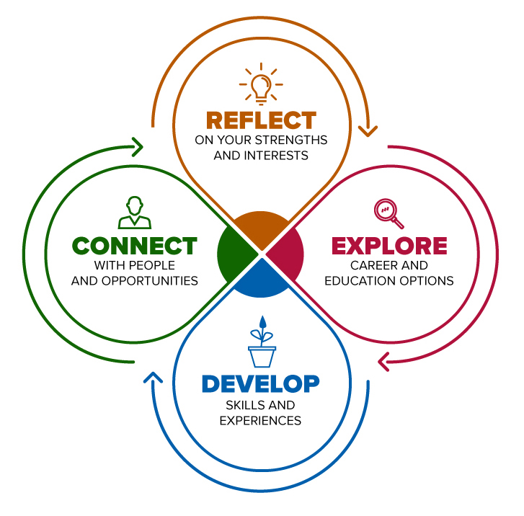

Student Name | Farhana Musharrath Tahura
Student ID | 2109147
Module Code | BMSW4005
Assignment Section | Task 3
Lecturer | Munodzinesa Zuwirai

Table of Contents
Introduction 3
Chosen Career 4
Personality Test 5
Learning Style 6
Evaluate 7
Assess 8
Conclusion 9
References 10

Introduction

In this reflective portfolio I will be deciding my chosen career and then researching what skills and knowledge are required for that specific career. I will then be identifying my skills by using analysis tools such as the MBTI personality test by Myers Briggs which consists of 16 different personality types. After which I will find out what learning style out of visual, tactile, and auditory is best suited to me. Once comparing them I will assess and reflect my findings and determine if my skills and the skills required for my career line up and how important they are when choosing a career. Lastly, I will go over what this module has taught me through the use of SWOT analysis before giving my final thoughts.

Chosen Career

The career I want to pursue is digital marketing. Digital marketing involves all kinds of marketing approaches that include the use of technology or the internet. To communicate with old and new customers, loyal and potential one’s businesses use digital methods such as social media, emailing, search engines and their internet sites. The use of terms such as “online, internet and web marketing” can also use to describe these. Utilising various online strategies and platforms to connect with customers digitally, which their consumers spend most of their day using is the meaning of digital marketing. A wide range of strategies fall into the category of "digital marketing," including websites, email marketing, online brochures, and other online branding assets for businesses (Desai, 2019, p. 196). Some soft skills that are required to work in digital marketing are: communication since marketing is mostly about engaging with an audience, so it should come as no surprise that communication is the number one attribute required for people working in the industry. You'll need to be able to communicate ideas to other people in a straightforward and engaging manner if you want to be successful; creativity and problem solving, delivering a message that fits with your target audience is the key to effective marketing. One of the traits of a good marketer is their ability to be creative and think outside the box to find innovative ways to do things. Marketing requires the capacity to approach issues from fresh perspectives and develop unique solutions to escalating difficulties; attention to detail, whether it's a blog post, a social media visual, or printed advertisements, many people will see your work. To protect the reputation of your business and to make sure that your consumers are receiving the correct information, accuracy is crucial. Some hard skills required are: writing, writing is a highly desirable ability in any industry, but it's especially crucial in marketing because, as was mentioned above, communication is a necessary piece of your day-to-day duties; research you'll regularly need to manage research in marketing in order to produce campaigns and supply content. Such research could take a lot of shapes, such as inspecting the marketing strategies used by competitor businesses, learning more about a subject connected to the services and goods your company provides, or assembling a list of contacts in a particular sector. An undervalued yet crucial talent that will raise the level of your work is the ability to carry out reliable research (Krakoff, 2020).

Personality Test

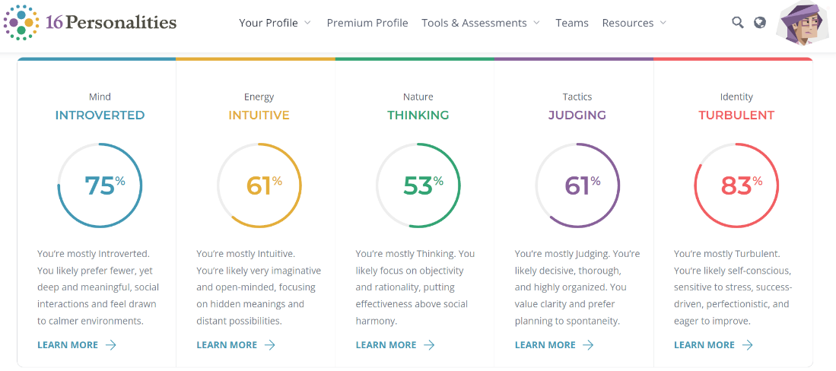
To figure out what career paths would suit me based on my personality I needed to find out what my personality type was to be able to understand what I am like and what careers would suit me specifically. I took the Myers Briggs Type Indicator test better known as the MBTI test. The MBTI test was originally created in 1942 by Isabel Briggs Myers and her mother Katherine Briggs. There are a total of 16 MBTI types, and I am part of the INTJ-T group, a turbulent architect. Turbulent Architects are Introverted, Intuitive, Thinking, Judging and Turbulent. The careers which are recommended for INTJ personality types are jobs in engineering, research, science, and technology, project managers, systems engineers, marketing strategists, systems analysts, management consultants, and military strategists. Creative fields, from architecture to musical composition to video game design and Architects’ relentless desire to get to the bottom of things can lead them to careers as auditors, cybersecurity specialists, or business analysts. Individuals with this personality type typically find the most fulfilment in occupations that provide them the freedom to innovate and experiment in both big and minor ways. Therefore, it should not come as a shock that careers in engineering, research, science, and technology are popular alternatives for architects. But inventive people can also find fulfilment in the creative industries, like music composition, architecture, and video game design. Additionally, architects' insatiable thirst for knowledge can lead them to work as auditors, cybersecurity experts, or business analysts. (16Personalities, n.d.)

Learning Style

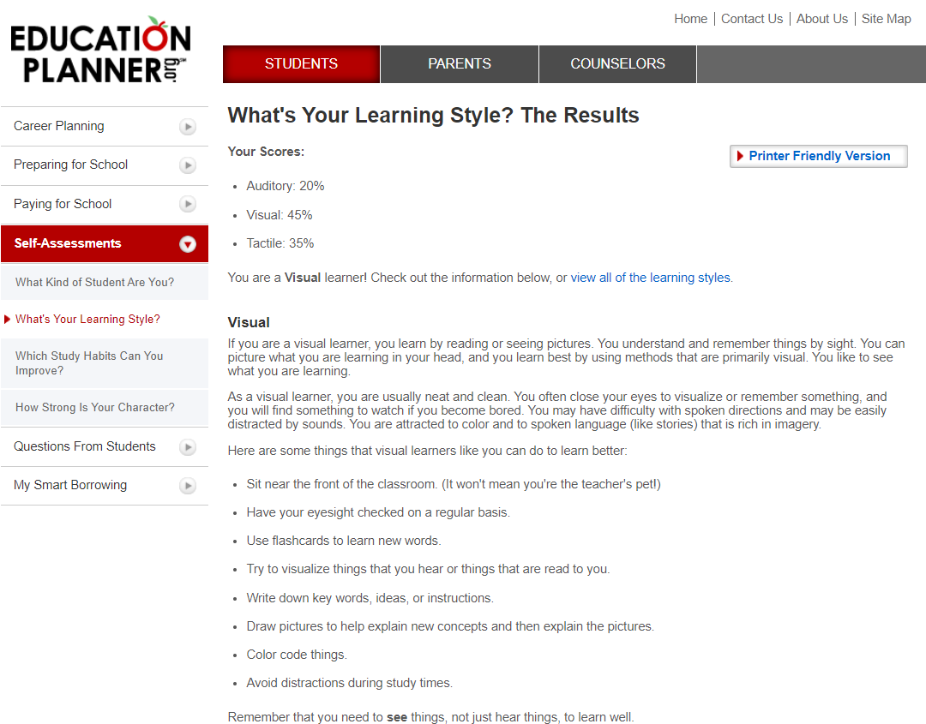
After completing the MBTI personality test, I did another test on the website education planner to find out what my learning style is (Education Planner, n.d.a). Learning styles are based on the notion that every person has a unique method or manner of learning. According to the theory, teaching students according to the sort of style or approach that has been recognised as their style of learning will make the learning process more beneficial or efficient. For instance, teachers should use storytelling and discussion more often than typical written assignments when instructing students who are classified as having a "listening" learning style. In this test there are three types of learning styles those are: auditory learner, an auditory learner acquires knowledge through listening and hearing. They comprehend what they hear and can recall it. They remember information based on how it sounds, and verbal instructions are simpler to comprehend than written ones. Reading aloud helps them learn since they need to hear or speak something to understand it; visual learner, reading or viewing images is how visual learners learn. They learn best when applying approaches that are mostly visual since they can mentally envision what they are learning; tactile learners absorb information by touching and doing. Movement helps them comprehend and recall information. They are a "hands-on" learner who prefers to touch, move, build, or draw what they study, and often retain information better when there is some sort of physical activity involved. They often gesture with hands and can have trouble staying motionless (Education Planner, n.d.b). The test asked twenty questions and after answering those questions I found out my learning style was 45% visual, 35% tactile and 20% auditory this means I am mostly a visual learner.

Evaluate

A career path I would like to pursue is technology specifically digital marketing. A career in technology would be ideal for me as it is a field that is ever growing, and this means that it will always be in demand. All fields are dependent on technology, therefore there are lots of work prospects now and in the future for experts who know the most recent developments and have specialised knowledge of or interests in the target area (Champlain College Online, n.d.). After taking the MBTI personality test and seeing the careers that would suit my personality type, as an INTJ-T I have seen that technology would be a good fit for my personality. After researching and finding out more information about myself and comparing that information with the skills required for a digital marketer, I believe that digital marketing is compatible with my personality type. A study found that 25% of the general population are extroverted whereas 67% of IT experts are introverted. The study found that IT work is favoured to introverts because of the longer times where they are required to work by themselves (Lounsbury et al, 2005, p. 179). INTJ-T’s are introverts and unlike the classic style of marketing jobs which would require face to face interaction with customers, the job of digital marketing has the advantage of being behind screens and also sometimes working from home or in smaller groups which is ideal for an introvert. Plenty of introverts have succeeded in digital marketing thanks to the technology of this day and age (Brooks, 2019) As mentioned previously those in digital marketing need to be creative and architects are creative personalities as they will need to create and upload their posts on social media or come up with ideas for video advertisements (Prospects, n.d.)

Assess

I will now use a reflective model to analyse my experiences during this module of Professional Career Development. The model I will be using is the SWOT analysis model to find out what I think are my strengths, weaknesses, opportunities, and threats are. My strengths after completing this module are topics such as the Johari window and SWOT analysis and this module has helped me learn and now, I am confident in my knowledge of these topics. For example, the Johari window it consists of four squares which look like a window 2 of these squares are information that is known to you and 2 are unknown by you. The first square is knowledge everyone including yourself knows about you, the second is knowledge that people in the same group as you will know about you, but you are oblivious to, the third is information that you know but no one else does and the last one is information that no one knows including yourself (Communication Theory, n.d.). My weakness during this module is the topic personal development plan. I understand to an extent that for personal development plans I need to decide a goal, create a plan of action, and look for opportunities (CMI, 2020). Although when it came down to creating my own, I found it difficult to get down in writing, so I understand this is something I need to work on to improve. My opportunities during this module were the use of personality tests and learning style. I feel as though learning about these has helped me learn more about myself and figure out what I need and want in a career. Lastly the section for threats could be my lack of knowledge in employment legislations and interviews. Not knowing enough about employee rights and employer rights could be harmful during my career as I will not know what my rights are. During interviews I tend to get nervous and forget what I had been preparing for so this could be bad for me in the future or even now as first impressions are important.

Conclusion

After researching and assessing the contents of this reflective portfolio I have come out understanding much more about myself than before I began this module. This module has helped me understand tools such as SWOT, learning style, personality type and Johari Window which will help me in the future to understand what I want and expect from in a career. I now know what careers are recommended for a personality type like mine and I have confidence that knowing more about yourself is very useful when it comes to figuring out what you want to do in life.

References

Champlain College Online (n.d.) Why Information Technology is a Good Career. Available at: https://online.champlain.edu/blog/why-information-technology-good-career#:~:text=IT%20Career%20Advancement%20and%20Diversity&text=Every%20industry%20is%20reliant%20on,industry%20of%20a%20potential%20employer (Accessed: 28 November 2022)

CMI (2020) Personal Development Planning. Available at: https://www.managers.org.uk/knowledge-and-insights/research/personal-development-planning/ (Accessed: 1 December 2022)

Desai, V. (2019) Digital marketing: A review. International Journal of Trend in Scientific Research and Development. Available at: https://www.researchgate.net/publication/333709419_Digital_Marketing_A_Review (Accessed: 30 November 2022)

Education Endowment Foundation (2021) Learning Styles. Available at: https://educationendowmentfoundation.org.uk/education-evidence/teaching-learning-toolkit/learning-styles (Accessed: 30 November 2022)

Education Planner (n.d.a) What’s Your Learning Style? Available at: http://www.educationplanner.org/students/self-assessments/learning-styles-quiz.shtml?event=results&A=4&V=9&T=7 (Accessed: 23 November 2022)

Education Planner (n.d.b). What’s Your Learning Style? The Learning Styles. Available at: http://www.educationplanner.org/students/self-assessments/learning-styles-styles.shtml (Accessed: 30 November 2022)

Harvard T.H. Chan School of Public Health (n.d.) Career Development and Framework Tools. Available at: https://www.hsph.harvard.edu/career-services/career-tools/ (Accessed: 20 November 2022)

Lounsbury, J. W. et al. (2005) An Investigation of Personality Traits in Relation to Job and Career Satisfaction of Information Technology Professionals. Journal of Information Technology. Available at: https://journals.sagepub.com/doi/abs/10.1057/palgrave.jit.2000094 (Accessed: 23 November 2022)

Brooks, A. (2019) Marketing for Introverts: Do You Really Need to Be Social to Succeed? Available at: https://www.rasmussen.edu/degrees/business/blog/marketing-for-introverts/ (Accessed: 29 November 2022)

Myers Briggs (n.d.) Original Research. Available at: https://www.myersbriggs.org/my-mbti-personality-type/mbti-basics/original-research.htm (Accessed: 21 November 2022)

16Personalities (n.d.) Personality Traits (INTJ-T). Available at: https://www.16personalities.com/profile/reports/personality-traits (Accessed: 20 November 2022)

Prospects (n.d.) Digital Marketer. Available at: https://www.prospects.ac.uk/job-profiles/digital-marketer (Accessed: 1 December 2022)

Sonya, K. (2020) Champlain College Online. What Skills do you Need for Marketing in 2020? Available at: https://online.champlain.edu/blog/what-skills-do-you-need-for-marketing (Accessed: 29 November 2022)

Communication Theory (n.d.) The Johari Window Model. Available at: https://www.communicationtheory.org/the-johari-window-model/ (Accessed: 1 December 2022)

