
BA Honours Leadership and Management Skills for the Workplace
BMSK 5001 Developing Workplace Critical Thinking

Farzana Hussen (1709301)
Critical Analysis of Management Theories relevant to workplace

Executive Summary
The purpose of this report is to demonstrate critical thinking. Critical Thinking is a skill that HR seek in organisations. In this report the researcher will identify management theory that is relevant to the individual’s role. The research attempts to predict the behaviour of TSB. The researcher will use Pearson RED critical thinking model to evaluate Management theory that is practiced in TSB Bank PLC and its effectiveness. Evaluate assumptions, criticism and arguments by leading writers of the theory and the impact it has on organisations and its workers. Critically analyse values, beliefs and attitudes and the importance in the workplace. How can organisations influence its worker? The researcher will evaluate in accordance to evidence, literature whether TSB is a valued-led organisation. The researcher will draw conclusion and recommend for management and individuals.

Table of Contents
A. 0
II. 3.0 Introduction 3
III. 3.1.0 Critical Thinking 3
IV. 3.1.1 Critical Thinking Model 3
A. 4.0 Findings 4
B. 4.1.0 Recognise Assumptions 4
C. 4.1.1. Evaluate Argument 4
D. 4.1.2 Management Theory 4
E. 4.1.3 Max Weber Bureaucracy Management Theory 5
F. 4.1.4 TSB and Bureaucracy Management Theory in Practice 7
G. 4.1.5 Aligning TSB values with its Employee 8
V. 5.0 Conclusion 10
A. 6.0 Recommendation 11
(1) 7.0 Appendices 12
(2) 7.0 Appendices 13
(3) 7.0 Appendices 14
(4) 8.0 Reference list 15
(a) 9.0 Bibliography 19

3.0 Introduction

3.1.0 Critical Thinking
Critical thinking is a cognitive attitude, cognitive represents an individual’s mind, thoughts, beliefs and opinion of something. To be analytical and evaluative is about using the mental process of being attentive, selective, judgemental and categorisation. (Cottrell 2011) There is great benefit to critical thinking such as; focus reading, ability to identify key points in texts and written communication, improving individuals’ ancillary skills. Critical thinking is about questioning everything. The researcher believe that good decision-making focuses on the most relevant information, questioning and separating the facts from flawed assumption. According to author Judge et al (2013) organisations have identified that critical thinking, analysis and problem solving are key requirement that HR seeks for person specification in graduates, however the expertise is fairly scarce. Chartrand et al (2009) conducted primary research; the survey evaluated that critical thinking skills ranked the highest position exceeding information technology desired by HR. Judge et l (2013) agrees that having the ability to be critical guarantees job enrichment and enlargement into leadership and management. Facione (2015) expresses that it is not always a requirement to be competitive, the potential to effectively prove a point, problem-solve, analysing what something means is far greater than being biased and the ability to block out emotions and opinions. An individual that can question from different perspectives, looking for hidden false assumptions will gain knowledge in the long term. The researcher acknowledges that the advantages of the skill provides effective job performance, the knowledge will influence possibility to move up the hierarchy in the organisation. Facione (2015) argues that although being educated and practicing critical thinking does not always guarantee success, happiness or virtue, however it gives a better opportunity to be those things. It is better to be skilled and trained than to endure the consequences of making bad decisions. Chartrand et al (2009) indicates that once organisations understand the importance of the role of critical thinking in every day decisions, this will encourage to take action to develop the skills in their managers and staff.

3.1.1 Critical Thinking Model
To Critically assess the researcher has identified models such as; Pearson RED critical thinking.
RED critical thinking model is a framework with clear instruction supporting the step by step guide to questioning everything in a piece of report or statement., Talent lens from Pearson (2009) has developed this model, it is a way to view and apply critical thinking principles when faced with decision, this model is suitable in training programs.
RED description:
R - Recognise assumptions – it is the ability to separate facts from opinions
E - Evaluate argument – establishing what is it about? Analysing the information objectively and accurately, questioning the quality of the evidence using the CRAAP test. Avoiding being influenced by emotions. Learning to put personal assumptions aside and working with the facts
D - Drawing conclusion – by being critical will give the true picture, using the evaluation to solve problem.
University of Plymouth (2010) developed critical questions – A Linear model. This model provides individuals with simple questions to ask during evaluation. (appendix 1)

4.0 Findings
The researcher will now demonstrate Pearson RED Model to Identify a Management Theory that is practiced in TSB Bank PLC. Is TSB a value-led organisation? Will the management model and values work for the individual? Highlight limitations of theory. The researcher will combine the RED conclusion and report conclusion together.

4.1.0 Recognise Assumptions

- How management theories are essential to organisations?
- Is the management theory effective as claimed by Weber?
- Doe TSB values influence the employee to perform well with aligning Weber management theory
- Is TSB a value led organisation?

4.1.1. Evaluate Argument

4.1.2 Management Theory
Management is the concept and practice of achieving goals through people. Olum (2004) explains management is about designing and maintaining an environment in which employees work together in teams and groups to accomplish a goal. Management has the authority, potential and ability to plan, organise, lead, control, direct staff of its interest to productivity through the commitments of its people. Management is about problem solving, decision making, accompanied by critical thinking which is required in many organisations. (Olum 2004) According to Enock and Beynon (2017) management is applied in a structured organisation setting with direct, authorised roles. It is governing towards the success and achievement of objectives through influencing, coaching and mentoring the efforts and commitments of others.

Enock and Beynon (2017) describe Management theory being associated with motivation, leadership and management and applying the models to situations and problems. There are four concepts of theories; classical, human relations, neo-human relations and system theory.
The researcher agrees with Mullins (2005) that managers who analyse and evaluate work of international leading writers on management theories, can interpret the knowledge of the writers and use ideas to implement how they should behave. Mullins quotes “theory provides a sound basis for action, however if action is to be effective, the theory must be adequate and appropriate to the task and to improve organisation performance.” (Mullins 2005 p66) Olum (2004) summarises that managing is a key requirement of human activities. It has become essential to coordinate employees’ efforts. As economic environment changes frequently, organisations growing, the duties and responsibilities of management becomes more complex, thus why management theories are crucial and should be used as a framework. He quotes; “It has been unequivocally emphasized that those managers who have mixed management theory in their day-today practice, have had better chances of managing their organisations more efficiently…” (Olum 2004 p.1) It is evident that theories have boundaries to enable effective communication in complex relationships.

4.1.3 Max Weber Bureaucracy Management Theory
Max Weber (1864-1923) was German sociologist developed Bureaucratic Management Theory. A classical Theory (appendix 2) Weber developed interest in authority of structure. Weber was intrigued to understand why people obey those in authority over them, leading Weber to invented bureaucratic theory. The model is influenced by theorist Henri Foyal’s (1841 – 1925) model characteristics include authority structure, order and more. (Clegg et al 2008) (appendix 3) Weber quotes:
Bureaucratic theory is used globally, majority businesses and public sector adapts to Weber’s characteristics. (Cole 2004) According to Mead & Andrews (2009) Weber’s model expresses conviction that bureaucracy is ideal for organisations, it is logical in the recognition of sensible rules. The employee is employed to merely serve only the company’s interests and values. Bureaucratic rules are created to make staffs behaviours predictable and to reduce inefficiencies. Button et al (2012) stated that Weber illustrated bureaucrat as a calculating, intelligent operative, following regulations, rules of conduct, managing through written communications, working in a hierarchy of responsibilities and authority, providing ritualistic flow of business. It is believed that control will make organisations effective. Grey (2013 p.102) claimed that Bureaucratic theory is always used; “as a weapon to pursue particular agenda”. Beynon (2017) also emphasised Weber’s analysis that bureaucracy as the most efficient way of working. Button et al (2012) agrees of the principles in Weber’s theory; emphasises the flow and progress of formal structure, code of conduct, rule requirement, the implementation of hierarchy of duties and responsibilities leads to effectiveness.

The theory has been criticised by Mullins (2005) for its red-tape approach, due to adherence of rules and formalities. Clegg et al (2008) also argues that there are literatures that cite criticisms of leading writers. Although the theory is practiced, many have expressed bureaucracy rules develop uncertainty, unpredictable outcomes. It should be perceived that workers must share the same vision as managers of its organisational cultures and values to be prepared to go beyond individuals’ abilities to achieve its goals, not just following rules. The researcher acknowledges that control and rules delay results, however it is better to be efficient, competence to avoid litigation by consumers and regulators. Grey (2013) argued that bureaucracy is a hostile attraction. Grey (2013) commented that any literature on management and organisation will argue of its limitations that it is deemed unsuitable in the current universal form. Grey suggests that organisations should discontinue practicing bureaucracy and look at post-bureaucratic theory. Church & Conger (2018) argue that it can be difficult to stand out as an individual and differentiate one self, due to formal structure. Individuals highly ambitious, may not achieve their career aspiration within their desired timeframe, as organisations focuses on shared goals. Grey (2013) reviewed case studies of post-bureaucracy practice in organisations. Grey could not bring forward evidence from the company to support writers’ claims. This made Grey (2013) question if critics assumptions of removing bureaucracy was a sensible suggestion. According Daft (2010) Weber’s theory has advantages; an effective way to control large quantity of people and prevents abuse of power. Daft states, organisations that do not use control can potentially lead to corrosive, Grey’s evidence; eBay accused of corruption because sellers abuse the system. The rationality is, critics acknowledge that bureaucracy implies ethics and fairness, with impersonality structure, equal treatment towards workers, leads to protection and reduced corruption.

Hamel (2014) stated in Harvard Business Review that Weber’s theory was incompatible and incompetent of present-day demands. Hamel argued there’s limited executives that are champions of bureaucracy. The researcher established that it has been perceived by Hamel; “formal hierarchy overweight’s experience and underweight new thinking…” Command and control is not sufficient for success in this environment and should be eliminated. Hamel & Zanini (2016) later argued that Bureaucracy has been growing, with evidence presented to show management occupation has increased. (Appendix 4) Research shared that more individuals are working in large bureaucratic organisations. The articles evidence (appendix 5) demonstrated that after the economic crisis in 2008 bureaucracy made appearance and maintained a consistent level. The researcher defines; writers are against the theory, however, praise its effectiveness. Researcher is influenced by Weber’s quote; “The decisive reason for the advance of bureaucratic organization has always been its purely technical superiority over any other form of organization.” (Hickson & Pugh 2007 p1)

4.1.4 TSB and Bureaucracy Management Theory in Practice
TSB is a financial institution licensed to market lending. TSB is a commercial/retail bank providing financial products and services in the UK. The organisation is subsidiary of Spanish Bank; Sabadell Group. Authorised by Prudential Regulation Authority. BOE instructs regulations and rules to ensure firms hold sufficient capital and have appropriate risk controls in action. PRA supervise closely to ensure that institutions are operating adequately. (Bank of England 2019) TSB is regulated by FCA. TSB is covered by FCSC, scribing to the lending code and Modern slavery ACT (TSB 2019).

TSB practice many characteristics of Weber’s bureaucracy theory; Hierarchy of authority- commands and orders are being delivered by the CEO & Operations officer. CEO communicates throughout the business via written or visual communication. Agile engagement has been introduced for feedback from employees to senior managers for improvements. (Doherty 2019)

Formal rules and regulations; TSB employees at lower hierarchy level have the ability to problem solve, decision make through critical thinking within guideline, such as consumer complaints. Managers monitor, coach and supervise frequently to ensure its partners are compliant and competent.

Mullins (2005) cited in his publication that Argyris (1964) insisted that bureaucracies restricted the psychological growth of workers resulting to feelings of defeat, frustration and conflict, the researcher at some extent visualises Argyris point of view and criticism, reflecting on Weber’s main features. The researcher argues that organisations do practice the psychological contract in the workplace, if it was restricted it would have leaded to employee dissatisfaction and affect performance and contribute to reduced production.

Primary research evaluated; TSB have departments that is divided throughout the UK. In 2015 Swansea centre developed two Mortgage team, the learning and development teams have supported employees to receive three months training, finance covered by the organisation for the CeMAP qualification. (Hussen 2019) The qualification meets the FCA examination standards for providing advice. CeMAP qualification leads to authorised mortgage adviser. (The London Institute of Banking and Finance 2019)

TSB have been ranked in the top 10 of Best Companies to work for. Two consecutive years they have been recognised and accredited. (Best Companies 2018) This indicates the effectiveness of Weber’s theory in practice. TSB has been recognised by CEO Tom O’Byrne of Great Place to work he said; “…The hallmark of a great workplace like TSB is that their policies and practices are designed around the employee…” (TSB 2017) The researcher agrees that despite criticism Bureaucracy is effective and successful for TSB and this evidence proves it. Weber’s Theory influences worker, reduced litigation and disciplinary action. Improved performance management.

4.1.5 Aligning TSB values with its Employee
The researcher defines Values as what is important to the individual or organisation, Values have important lasting beliefs about what is favourable and unfavourable. Values has a continuous influence on individuals’ attitude and behaviour. Individual and organisational beliefs are assumptions and conviction that is perceived to be true. (Furnham 2008) Attitude is about responding negatively or positively towards a perception. Behaviours influence choice of action. Clegg et al (2008) explains that values are something individual’s feel strongly about. Values has strong motivational aspects to them. Values are guidance of individual behaviours throughout individual’s life. Values will change frequently, due to internal and external business environment rapidly changing. The author persuades that organisations require to take interest in workers values to sustain, improve relationship or motivate them.
Barrett (2010) a British writer who studied Human values interprets that values are important due to the verity it supports individual and organisations to grow and develop, values help organisations to build and create the future they want to experience.

TSB values; straightforward, collaborative, transparent, responsible and pioneering. TSB values will develop relationship values such as; honesty and trust and internal cohesion culture. Barrett (2014) explains for an organisation; values is a shorthand method of describing what is important to an individual or collectively at any given moment in time. It is implemented as ‘shorthand’ as the concept of values can be captured in one word.

The researcher has found evidence in Barrett’s most recent publication, Barrett said that values have much more depth than just ‘what is important’. Barrett adds that values are energetic drivers of individuals aspiration and intentions, which is a source of all human motivation of decisions.

The researcher assessed the employee’s Personal Value Assessment (appendix 6). Barrett Value centre assessment is used by leaders and organisations internationally. A PVA defines that human beings grow and develop with seven level of consciousness. (appendix 7) Each level focuses on particular needs. The development of an individual will vary depending on the ability to satisfy the needs. According to employee’s results; an individual for whom meaning is relevant. They have strong set of morale standards, which reflects that they want to be treated fairly. Overcoming barriers of fears and anxiety. The employee’s value shows that they strive for success and set high aspirations, passionate and taking the lead, being proactive. Dedication, motivation, creativity to develop ideas and concepts. Close relationship is important and the purpose of its decision making. Always seeking opportunities to develop and grow. Barrett (2018) claims that many people are not aware of their values. This may potentially be because, they have not required or never reflected on what is important to them.
TSB believe in developing talented resources, and employee has aspiration to develop, take lead and demonstrate ideas and suggestions. Committed, self-disciplined to be responsible, pioneering to initiate being creative. Independence which support the diverse culture. CIPD (2018) states that an inclusive workplace enables diverse range of staff to work together, everyone feels valued, their contribution matters, and they are able to use their abilities to the fullest whatever their ethnics, identity or circumstances may be positive attitude to deliver great customer experience. The researcher has evidence that TSB partners are inspired by its values. The new forthcoming CEO Crosbie said: “I’ve known and admired TSB for many years and I have huge respect for the values on which TSB has been built. A lot of banks talk about creating the right culture, but TSB has it. The passion and commitment of TSB partners to deliver for customer is second to none.” (TSB 2018 p3)
The researcher explains as a new appointee, it is important to understand the organisations culture within a limited timeframe. By understanding the values and culture are the earliest will contribute to the success. (Church and Conger 2018) Values can be underlined through training programs demonstrating the importance for organisation. (People Management 2017) Barrett (2018) Illustrated that organisations must support its workers to be successful. When workers feel employers care about them and their values, the worker will feel sense of commitment and devotion to be energetic in the workplace.

5.0 Conclusion

The researcher concludes that it is important to develop critical thinking skills. By Having the ability to think objectively and critically about a problem and presenting it with a well-constructed argument contributes to career advancement in the workplace. Academically necessary. The researcher critically analysed the impact of management theory and the workplace values.

The researcher concludes the impact of management theory, it is necessary in any organisations. The concept of management is when an individual is responsible for controlling a company. The impact is substantial as it contributes to organisational growth. Theories enable to focusing on understanding the management process of being effective with the support of its people. When managers study the theories, then they will have the capabilities to use the theory in practice to problem solve issues that may arise in the enterprise. The researcher believes by exploring writers and management theories will benefit and influence their behaviours and attitudes towards practice. In the field of management, the aspects of theories are to present a means of important and appropriate management knowledge.

Weber’s Bureaucratic theory is effective and influential despite criticism, it is an invention by a sociologist that has no management practice. Weber’s theory is very powerful and difficult to defeat. The advantage of the theory are the rules and regulations; stimulates increased awareness of the workers which leads to consistency. TSB have been successful with formal structure in the workplace. TSB motivates its partners to learn and develop within a planned structure. Although writers want freedom in organisations, it is attractive however the negative impact is far more superior, providing too much freedom leads to consequences due to negligence, and inefficiency. Weber’s theory will continue to be criticised, throughout this report many writers described as military operated, to later contradict that the theory is effective due to strong presence of its characteristics.

The researcher has studied Barrett’s evolution and agrees that when individual values are aligned with organisation values, they feel liberated. Only then can individual be committed, motivated to bring energy, creativity and enthusiasm to the workplace. for an organisation to be successful they must meet their worker’s needs. The researcher has evaluated that the individual values is aligned with TSB values, this influences the individual to perform well and work successfully. The researcher concludes TSB is a value-led organisation, TSB focuses on its partners, TSB belief and attitude resemble the “employer of choice” market, through financial incentives, performance culture, positive workplace environment that attracts, retains talented employees.

6.0 Recommendation

The researcher will recommend supporting individuals and managers in learning and development.

- Develop Critical Thinking skill; training, register for online courses and local colleges.
- Study: RED critical thinking tool
- Study: Toulmin’s Critical thinking model
- Management should study alternative classical theories; Henri Fayol and FW Taylor these theories emphasise on structure and prescriptive of what is good for the organisation.
- Study Richard Barrett publication on Values
- Individuals should carry out a personal value assessment, this allows individuals to discover themselves and what motivates them. Available on: https://www.valuescentre.com/our-products/products-individuals/personal-values-assessment-pva
- Frequent agile engagement in the workplace, use feedback data to implement change, appraisals and review performance management to support employee needs.

7.0 Appendices

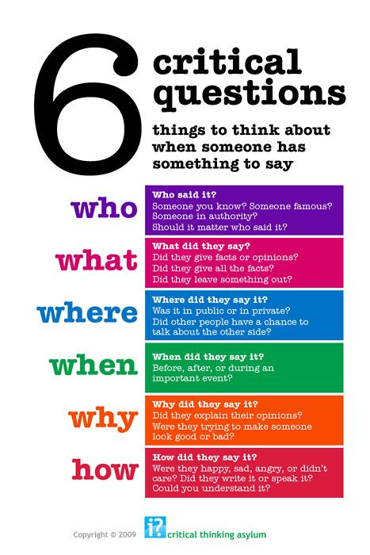
- 1709301 Brief description of some of the characteristics of Weber’s Bureaucratic Theory:
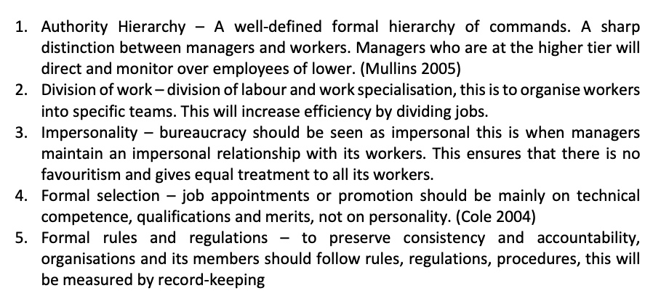
- Henri Fayol Theory
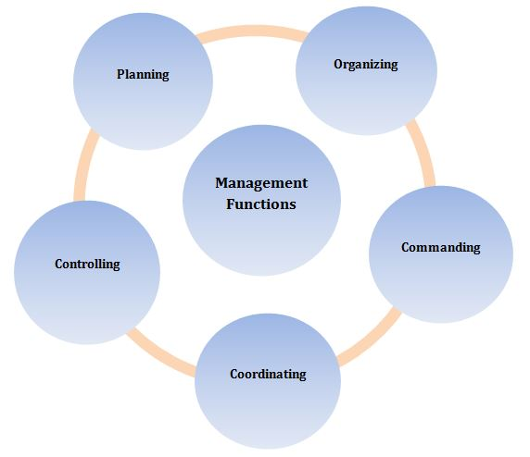

7.0 Appendices
- HBR (2016)
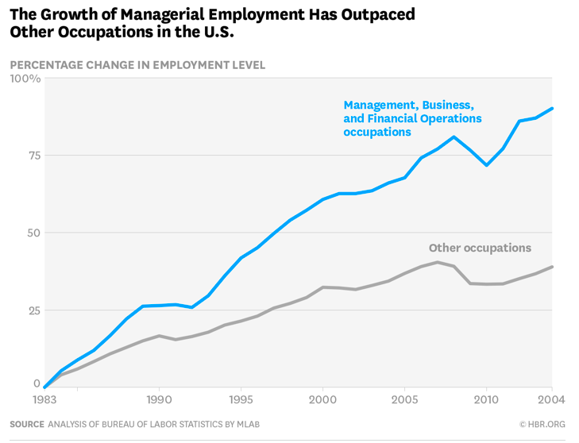

- Harvard Business Review (2016)

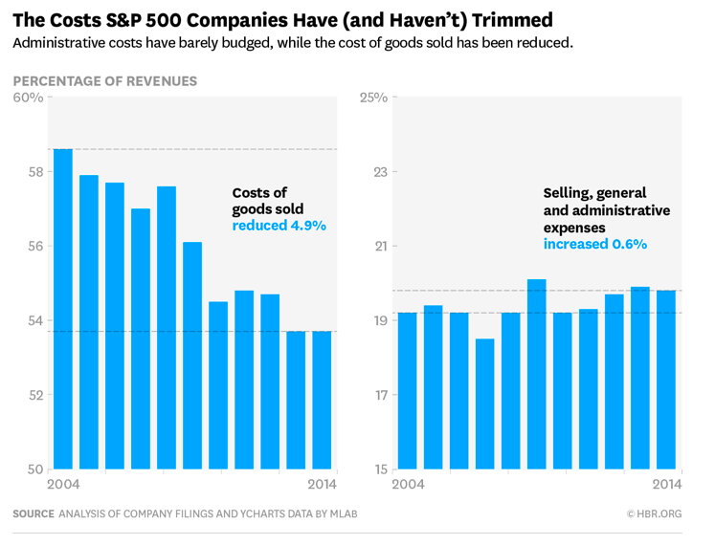

7.0 Appendices

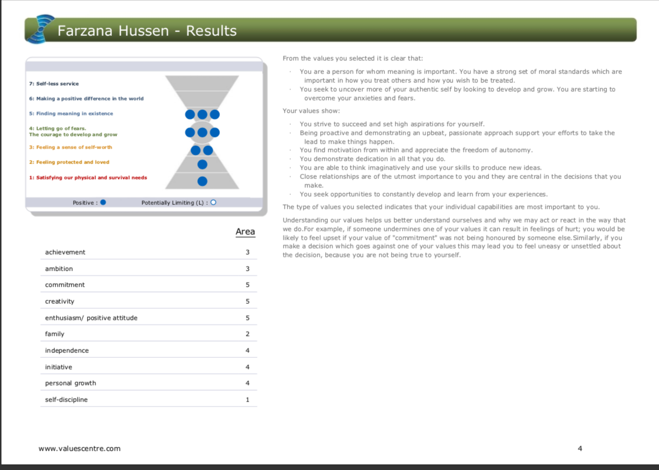

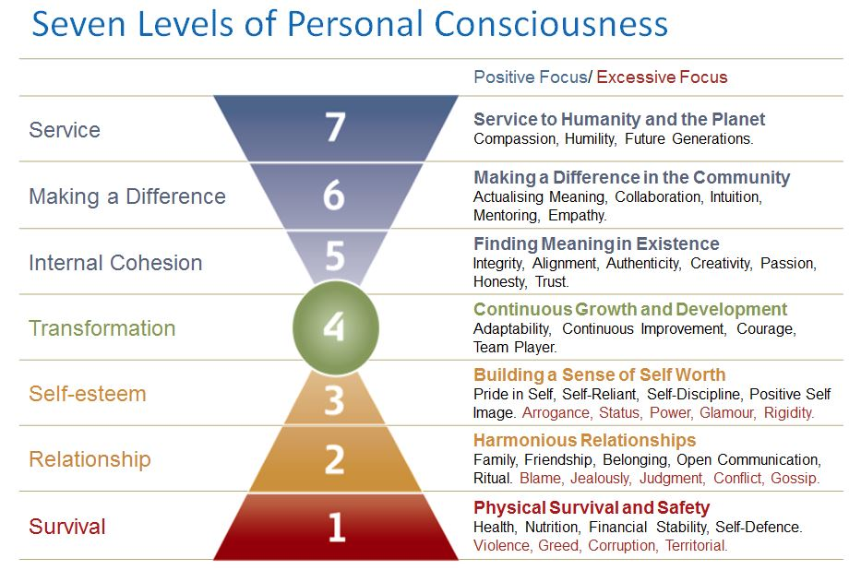

8.0 Reference list
Textbooks:

Barrett, R. (2014) The value-driven organization. Unleashing human potential for performance and profit. Oxon: Routledge

Barrett, R. (2018) everything I have learned about values. LULU publishing service

Clegg, S and et al (2008) Management and Organizations an Introduction to Theory and Practice. 2nd ED. London: Sage Publication LTD

Cole, G.A (2004) Management Theory and Practice. 6th ED. London: Thomson

Cottrell, S. (2011) critical thinking skills. Developing effective analysis and argument. 2nd ED. Hampshire: Palgrave Macmillan

Daft, R.L. (2001) Organization Theory and Design. 7th ED. USA: South Western, Thomson Learning

Facione, P.A. (2015) Critical Thinking: What is it and why it counts. Hermosa Beach, CA: Measured Reasons LLC

Furnham, A. (2008) Personality and intelligence at work, exploring and explaining individuals at differences at work. East Sussex: Routledge

Grey, C. (2013) A Very, short, Fairly Interesting and Reasonably Cheap Book about Studying Organizations. 3rd ED. London: Sage Publication LTD

Hickson, J. and Pugh, D.S (2007) Writers on Organization. 6th ED. USA: Sage Publication

Judge, B & et al (2013) critical thinking skills for education students. 2nd ED. London: sage publication

Mead, R. and Andrews, T.G. (2009) international management culture and beyond. 4th ED. West Sussex: john wiley & sons

Mullins, J. (2005) Management and organisational behaviour. 7TH ED. Essex: Pearson Education Limited

Olum, Y. (2004) Modern Management Theories and Practices. Department of political science and public administration. Makerere University

Personal Communication:

Doherty, S. (2019) Text to Farzana Hussen, 9th April

Hussen, F. (2019) Conversation to Farzana Hussen, 1st April
Online Articles:

Church, A.H and Conger, J.A. (2018) Harvard Business Review. Professional Transitions: When you start a new job, pay attention to these 5 aspects of company culture.
Available at: https://hbr.org/2018/03/when-you-start-a-new-job-pay-attention-to-these-5-aspects-of-company-culture?utm_medium=social&utm_source=linkedin&utm_campaign=hbr
(accessed: 10th April 2019)

Enock, K. and Beynon, C. (2017) Health Knowledge: Education, CPD and Revalidation from Phast. Management Models and Theories Associated with motivation, leadership and change management, and their application to practical situations and problems.
Available at: https://www.healthknowledge.org.uk/public-health-textbook/organisation-management/5c-management-change/basic-management-models#Max_Weber_(1864_-_1924),_Germany
(accessed: 9th April 2019)

Hamel, G. (2014) Harvard Business Review. Bureaucracy Must Die
Available at: https://hbr.org/2014/11/bureaucracy-must-die
(Accessed: 16th April 2019)

Hamel. G and Zanini, M. (2016) Harvard Business Review. More of us are working in a big bureaucracy organisation than even before
Available on: https://hbr.org/2016/07/more-of-us-are-working-in-big-bureaucratic-organizations-than-ever-before
(accessed: 16th April 2019)

Health knowledge (2017) management models and theories associated with motivation, leadership and change management, and their applications to practical situations and problems
Available on: https://www.healthknowledge.org.uk/public-health-textbook/organisation-management/5c-management-change/basic-management-models#Max_Weber_(1864_-_1924),_Germany
(accessed: 10th April 2019)

Pearsons Talentlens (2009) Critical thinking means Business
Available at: https://www.pearsonclinical.com.au/files/Critical%20Thinking%20Means%20Business.pdf
(accessed: 9th April 2019)

People Management (2017) Fixer: How can we inspire staff to live our values?
Available at: https://www.peoplemanagement.co.uk/experts/advice/fixer-inspire-staff-live-values
(accessed: 11th April 2019)

Springer Button, G. Martin, D. O’neill, J. and Colombino, T. (2012) ‘Lifting the mantle of protection from Weber’s Presuppositions in his Theory of Bureaucracy ‘
Available at: https://link-springer-com.ezproxy.uwtsd.ac.uk/content/pdf/10.1007%2Fs10746-012-9229-x.pdf
(accessed: 10th April 2019)

Websites:

Bank of England (2019) Prudential Regulations
Available on: https://www.bankofengland.co.uk/prudential-regulation
(accessed: 10th April 2019)

Barrett Value Centre (2010) The Importance of Values in Building a high Performance Culture
Avaliable at: https://www.valuescentre.com/sites/default/files/uploads/2010-07-06/The%20Importance%20of%20Values.pdf
(accessed: 7th April 2019)

Best Company (2017) Best 30 Big Companies
Available at: https://www.b.co.uk/the-lists/big-companies/?year-2017-p-241-676/
(accessed: 7th April 2019)

Best Company (2018) Best 25 Big Companies
Available at: https://www.b.co.uk/the-lists/big-companies/?year-2018-p-266-751/
(accessed: 7th April 2019)

CIPD (2018) Diversity and Inclusion in the Workplace
Available at: https://www.cipd.co.uk/knowledge/fundamentals/relations/diversity/factsheet
(Accessed: 8th April 2019)

The London Institute of Banking & Finance (2019) Professional Qualifications CeMAP
Available at: https://www.libf.ac.uk/study/professional-qualifications/mortgage-advice/certificate-in-mortgage-advice-and-practice-(cemap)
(accessed: 13th April 2019)

Plymouth University (2010) Critical Thinking
Available on: https://www.plymouth.ac.uk/uploads/production/document/path/1/1710/Critical_Thinking.pdf
(accessed: 11th April 2019)

TSB (2018) TSB announces Debbie Crosbie as new CEO
Available at: https://www.tsb.co.uk/news-releases/tsb-announces-new-ceo/
(accessed: 5th march 2019)

TSB (2017) TSB recognised as great place to work
Available at: https://www.tsb.co.uk/news-releases/tsb-recognised-as-a-great-place-to-work/
Accessed: 14th April 2019

TSB (2019) Information about us
Available at: https://www.tsb.co.uk/legal/information/information-about-us/
(Accessed: 10th April 2019)

TSB (2019) Truth and banking
Available at: https://www.tsb.co.uk/investors/truth-and-banking/#Modern_Slavery_Act-1490876234829
(Accessed: 10th April 2019)

9.0 Bibliography
Textbooks:

Argyris, C. (1964) Integrating the individual and the Organization. John Wiley & Son

Argyris, C. (2017) Integrating the individual and the Organization. OXON: Routledge

Peters, T. and Waterman, R. (1982) In Search of Excellence: Lessons from America’s Best Run Companies. Sydney: Harpers & Rowe

Weick, K.E. (1969) The Social Psychology of Organizing Reading. MA: Addison - Wesley

Weick, K.E. (1979) The Social Psychology of Organizing Reading. 2nd ED. MA: Addison - Wesley

Websites:

Cambridge dictionary (2019) the meaning of bureaucratic in English
Available on: https://dictionary.cambridge.org/dictionary/english/bureaucratic
(Accessed: 10th April 2019)

