I confirm that I have not used any AI tools in the research and creation of this assignment. I confirm that I have not presented any AI generated materials as my own work. I confirm I have copies of my drafts, notes, and other resources I used, which I may be asked to provide in evidence.
Reflective Commentary
Boundaries, Self-Disclosure and Sustainability in Substance Use Support Work

Description
This commentary follows Gibbs' Reflective Cycle (University of Edinburgh, 2024a). I work part-time as a substance use and domestic abuse support worker, delivering most of my sessions as outreach in the homes of the people I support. My caseload is approximately fifteen people, several presenting with complex needs alongside their substance use. Early in the role I prioritised establishing rapport and was largely successful in doing so. As those relationships developed, however, I began receiving contact outside my working hours, including evening and weekend messages carrying an expectation of immediate reply, and unannounced visits to the office on days I was not scheduled to work. I also received requests for practical assistance falling outside my remit and had to decide how to respond to informal or affectionate signoffs in written communication. I eventually issued everyone on my caseload with a written record of my working hours.

Feelings
My initial response was quiet satisfaction. Being sought out felt like evidence that the rapport I had worked hard to build was genuine. That gave way to unease. I felt guilty for wanting time away from the role, and anxious that any correction would be experienced as rejection by people already accustomed to being let down by services. I noticed irritation when my days off were interrupted, followed almost immediately by shame at feeling irritated at all. Underlying this was a fear I found difficult to admit: that being "by the book" would make me appear cold and would undo the relational work I valued most. When I finally set the boundaries out explicitly, I felt considerable relief, alongside a lingering worry that I had left it too late.

Evaluation
Several aspects worked well. My deliberate efforts to share power established trust quickly and were genuinely effective: offering a choice of seating, checking proximity and personal space, using self-deprecating humour to reduce the sense of professional distance, and providing a notebook so people could record thoughts between sessions. Written confirmation of my working hours, framed as clarity rather than restriction, was received far better than I had anticipated. What worked less well was my timing. I responded to a pattern only once it was well established, rather than setting expectations at the outset. I had also treated boundaries as something separate from, and in tension with, the supportive relationship, when the two are not in fact opposed.

Analysis
Doel et al. (2010) examined how practitioners actually determine professional boundaries and found that formal research played little part, that only a small minority referred regularly to professional codes, and that a clear majority relied instead on their own sense of what felt appropriate. They further observed that agency guidance tended to avoid the ambiguous areas of practice altogether and functioned as a kind of insurance policy, retrieved once something had already gone wrong. This describes my position accurately. I was improvising, and the situations I found hardest are precisely that ambiguous territory: the use of humour, the disclosure of my own recovery journey, and whether to reciprocate an affectionate sign-off. Rather than prescribing further rules, Doel et al. advocate ethical engagement, in which practitioners exercise judgement through regular discussion of boundary dilemmas. This reframes my difficulty as ordinary rather than deficient and locates the remedy in supervision rather than in a longer policy document.
Where I did act, my error was to treat limits and warmth as opposites. I had implicitly equated good relational practice with limitless availability, whereas the BACP (2018) situates the management of limits within ethical practice rather than personal preference. Withholding a boundary in order to protect a relationship is therefore not a kindness; it defers a cost onto both parties.
Theodosius et al. (2021) distinguish surface acting, the display of an emotion one does not feel, from deep acting, and found surface acting to be positively associated with burnout and with intention to leave among nurses in the United Kingdom. This names what I found hardest. Presenting as consistently available while privately resenting the intrusion is surface acting, and it carries the clearest cost. Maslach and Leiter (2016) identify workload and reward imbalance as central to burnout, and my circumstances contained both, with fifteen people supported within 18.75 contracted hours during a restructure that substantially reduced the workforce and left recovery-focused work feeling deprioritised. Read together, this literature reframes boundary-setting as a safeguard for the people I support rather than merely for myself, since an exhausted worker is a less effective one.

Conclusion
What I know now that I did not know before is that boundaries are a component of care rather than a limit placed upon it. Clear limits are a form of reliability, and reliability is precisely what many of the people I support have not previously experienced from services. My assumption that firmness and warmth were opposing forces was mistaken and holding both at once is the actual skill. A second, related shift concerns language. I no longer describe people as addicts or alcoholics, having recognised that such terms attach a permanent identity to a changeable condition. Zwick et al. (2020) argue that terminology in this field lags behind that of comparable areas of health care, and that the words practitioners choose can either promote stigma or reduce it, with consequences for whether people seek and remain in treatment.

Action plan
Faced with the same situation again, I would state my working hours, contact methods and the limits of my role at the first meeting, framing this as information about what can be relied upon rather than as a restriction imposed. I would use supervision proactively to raise boundary dilemmas as they emerge rather than once they have consolidated, which is the ethical engagement that Doel et al. (2010) recommend in place of further prescription. I intend to complete the classroom-based safeguarding training I am awaiting, and to carry the What? So what? Now what? structure used in my placement log (University of Edinburgh, 2024b) forward as a habit rather than an assessed requirement, writing entries close to the events they describe rather than reconstructing them later, since Koshy et al. (2017) note that structured prompts help move reflective writing beyond description towards analysis. Finally, I will treat my own responses as data rather than as failings. My irritation, in this instance, was accurate information about an unsustainable arrangement.

References
British Association for Counselling and Psychotherapy. (2018). Ethical framework for the counselling professions. BACP. https://www.bacp.co.uk
Doel, M., Allmark, P., Conway, P., Cowburn, M., Flynn, M., Nelson, P., & Tod, A. (2010). Professional boundaries: Crossing a line or entering the shadows? British Journal of Social Work, 40(6), 1866–1889. https://doi.org/10.1093/bjsw/bcp106
Koshy, K., Limb, C., Gundogan, B., Whitehurst, K., & Jafree, D. J. (2017). Reflective practice in health care and how to reflect effectively. International Journal of Surgery Oncology, 2(6), e20. https://doi.org/10.1097/IJ9.0000000000000020
Maslach, C., & Leiter, M. P. (2016). Understanding the burnout experience: Recent research and its implications for psychiatry. World Psychiatry, 15(2), 103–111. https://doi.org/10.1002/wps.20311
Theodosius, C., Koulouglioti, C., Kersten, P., & Rosten, C. (2021). Collegial surface acting emotional labour, burnout, and intention to leave in novice and pre-retirement nurses in the United Kingdom: A cross-sectional study. Nursing Open, 8(1), 463–472. https://doi.org/10.1002/nop2.649
University of Edinburgh. (2024a, October 15). Gibbs’ reflective cycle. Reflection Toolkit. https://reflection.ed.ac.uk/reflectors-toolkit/reflecting-on-experience/gibbs-reflective-cycle
University of Edinburgh. (2024b, October 15). What? So what? Now what? Reflection Toolkit. https://reflection.ed.ac.uk/reflectors-toolkit/reflecting-on-experience/what-so-what-now-what
Zwick, J., Appleseth, H., & Arndt, S. (2020). Stigma: How it affects the substance use disorder patient. Substance Abuse Treatment, Prevention, and Policy, 15, 50. https://doi.org/10.1186/s13011-020-00288-0

Appendix A
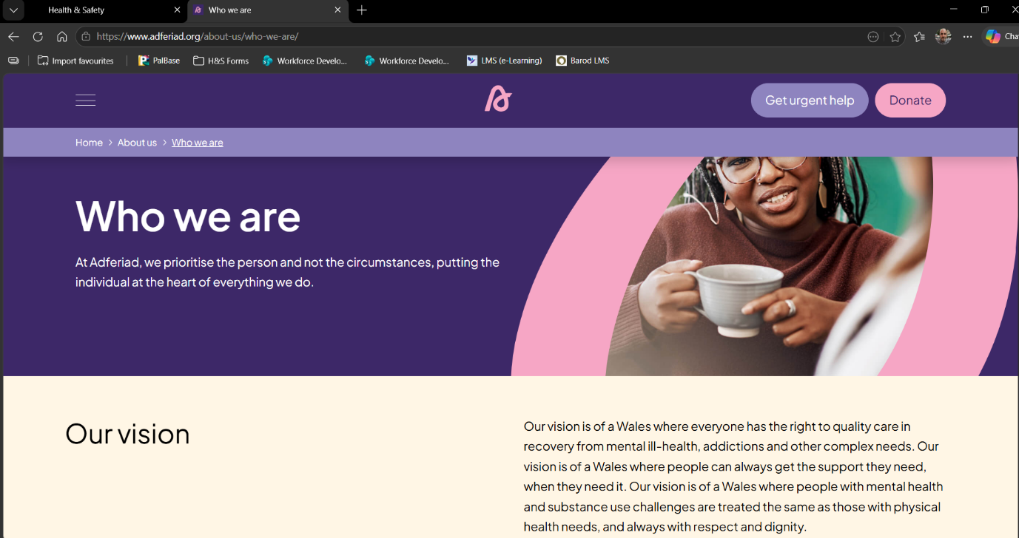

Appendix B
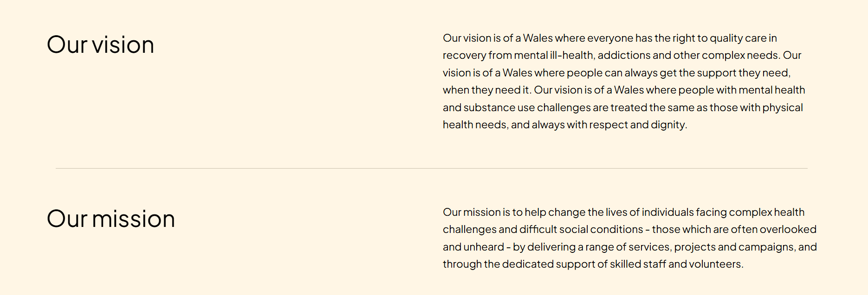

Appendix C


Appendix D
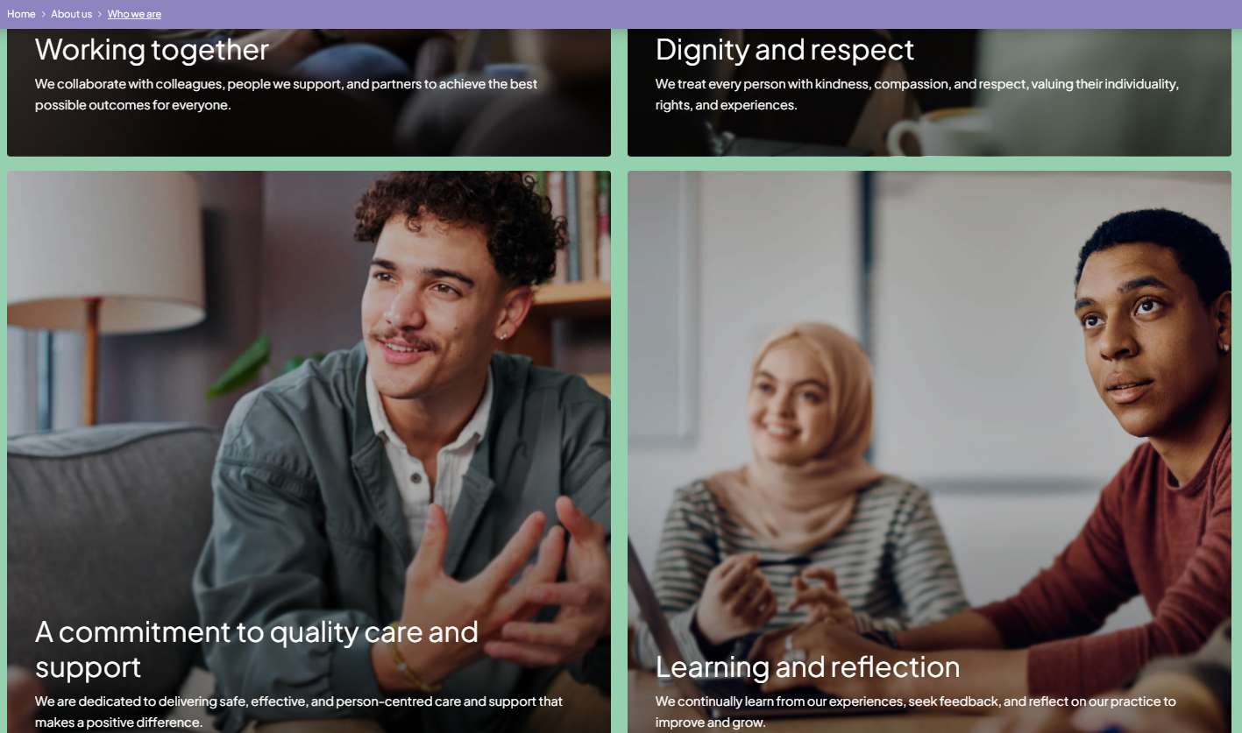

Appendix E


Adferiad Recovery
41 St James Crescent
Uplands, Swansea
SA1 6DR

Tel: 01792 472 519

NAME
ADDRESS
REDACTED FOR GDPR
Date: 01/05/2026

Dear XXXXXXXX.

We have attempted to contact you on numerous occasions since 16/02/26 and have been unsuccessful. As you are not currently engaging with our services, we have now discharged you from Adferiad.

If you still require support from our service, please attend our drop-in Coffee Connect group on Fridays at 2pm (excluding Bank Holidays) but call earlier in the week to confirm. Alternatively, you can self-refer to us at any time again via the NEWID Helpline on 03007904044, or online at https://newidcymru.co.uk/make-a-referral/.

Our address is 41 St James’ Crescent, Uplands, Swansea, SA1 6DR.

Kind regards,

Alex Evans
Substance Use, Women’s worker & Outreach Support Worker
Service | What They Support | Contact Details | Availability
Mental Health 24-Hour Helpline | Mental health crisis support | 📞 0800 132 737  📱 Text HELP to 81066 | 24 hours
Swansea Mind | Local mental health support | 📞 01792 642 999 | Office hours
Samaritans | Emotional distress & crisis | 📞 116 123 (Free) | 24 hours
DAN 24/7 | Alcohol-related support | 📞 0808 808 2234 (Freephone)  📱 Text DAN to 81066 | 24 hours
Alcoholics Anonymous (AA) | Alcohol dependency support | 📞 0800 917 7650  📧 help@aamail.org  💬 alcoholics-anonymous.org.uk | 24 hours
Narcotics Anonymous (NA) | Drug dependency support | 📞 0300 999 1212 | 10am til midnight
Live Fear Free | Domestic abuse & sexual violence | 📞 0808 801 0800 | 24 hours
CALM | Suicidal feelings, isolation | 📞 0800 585 858  💬 thecalmzone.net/help/webchat | 5pm til midnight

Narcotics Anonymous (NA)
UKNA Helpline: 0300 999 1212 (10am–midnight)
Regular Meetings
- Monday: 8:00pm – 9:15pm
Annexe, Quaker House, Page Street, Swansea, SA1 4EZ
- Wednesday: 8:00pm – 9:30pm
Main Building, Quaker House, Page Street, Swansea, SA1 4EZ
- Friday: 8:00pm – 9:30pm
Annexe, Quaker Meeting House, Page Street, Swansea, SA1 4EZ
- Saturday: 6:30pm – 7:30pm
Quaker House, Page Street, Swansea, SA1 4EZ

Cocaine Anonymous (CA)
UK Helpline: 0800 612 0225 (10am–10pm)
Regular Meetings
- Tuesday (Morning): 11:00am – 12:00pm
Kings Church, Heol Y Gors, Townhill, SA1 6RY
- Tuesday (Evening): 8:00pm
St Benedict’s Catholic Church, Llythrid Avenue, Sketty Road, Uplands, Swansea, SA2 0JJ
- Thursday (Morning): 11:00am – 12:00pm
Kings Church, Heol Y Gors, Townhill, SA1 6RY
- Thursday (Evening): 7:00pm
Penlan Methodist Church, Heol Gwyrosydd, Penlan, SA5 7BX
- Friday (Evening): 7:15pm
Linden Church, Elm Grove Road, West Cross, SA3 5LD
- Saturday (Morning): 10:00am – 11:00am
Penlan Methodist Church, Heol Gwyrosydd, Penlan, SA5 7BX

Alcoholics Anonymous (AA)
Local Helpline: 01792 301 907 (24 hours)
Monday
- 1:00pm – 2:00pm
Missionaries of Charity, 235–236 The Strand, Swansea, SA1 2AW
- 7:30pm – 8:30pm
Siloam Baptist Church, 458A Gower Road, Killay, Swansea, SA2 7AL
- 7:30pm – 8:30pm
City Church, Dyfatty Street, Swansea, SA1 1QQ
- 7:30pm – 8:30pm
The Salvation Army, Sunninghill Terrace, Llanelli, SA15 3DQ
Tuesday
- 12:00pm – 1:00pm (Women Only)
Missionaries of Charity, 235–236 The Strand, Swansea, SA1 2AW
- 1:00pm – 2:00pm
Dunvant Social Centre, Dunvant Square, Swansea, SA2 7BH
- 6:30pm – 7:30pm
Murton Methodist Church, Manselfield Road, Murton, Swansea, SA3 3AR
Wednesday
- 1:00pm – 2:00pm
Missionaries of Charity, 235–236 The Strand, Swansea, SA1 2AW
- 1:00pm – 2:00pm
Linden Church, Elm Grove Road, West Cross, SA3 5LD
- 7:00pm – 8:00pm
Ystalyfera Development Trust, 22 Commercial Street, SA9 2HR
- 7:30pm – 8:30pm
Matthews House, High Street, Swansea, SA1 1LW
- 7:30pm – 8:30pm
Quaker House, Page Street, Swansea, SA1 4EZ
Thursday
- 7:00pm – 8:00pm
The Institute, Lime Street, Gorseinon, SA4 4EE
- 7:00pm – 8:00pm
St Mary’s Church, 42 Church Road, Burry Port, SA16 0SB
Friday
- 12:00pm – 1:00pm (Women Only)
Missionaries of Charity, 235–236 The Strand, Swansea, SA1 2AW
- 6:30pm – 7:30pm
St Philips Community Centre, 11 Clarence Terrace, Swansea, SA1 3QT
- 7:30pm – 8:30pm
Tabernacle Chapel, 14 Thomas Street, Pontardawe, SA8 4HD
Saturday
- 11:00am (Welsh Speaking)
St Anne’s Church Hall, Bryngwili Road, Cross Hands, Llanelli, SA14 6LR
- 12:00pm – 1:15pm
Brynmill Community Centre, Albans Road, Brynmill, SA2 0BP
- 6:30pm – 7:30pm
Dunvant Social Centre, Dunvant Square, Swansea, SA2 7BH
- 7:00pm – 8:00pm
Victoria Hall, 6 Dunns Lane, Mumbles, SA3 4AA
Sunday
- 7:30pm – 8:30pm
Christ Church Hall, Rodney Street, Sandfields, Swansea, SA1 3UE

Family Members & Concerned Others
Al-Anon
For friends and families of alcoholics
- Monday: 8:00pm – 9:15pm
Cockett Community Centre, St Peters Terrace, Cockett, Swansea, SA2 0FW
- Friday: 7:30pm – 8:30pm
Cockett Community Centre, St Peters Terrace, Cockett, Swansea, SA2 0FW
Family Anonymous
- Wednesday: 7:30pm – 9:00pm
St Benedict’s Hall, Llythrid Avenue, Uplands, Swansea, SA2 0JJ

Other Support Links
- Al-Anon: https://al-anonuk.org.uk/
- Family Anonymous: http://famanon.org.uk/meetings/online-meetings/
- SMART Family & Friends: https://smartrecovery.org.uk/smart_family__friends/
- Adfam: https://adfam.org.uk/help-for-families/finding-support/forum
- NACOA: https://nacoa.org.uk

Appendix F

Student Work Placement Log
Student Work Placement Log
Student Name: | [Insert your full name]
Name of Host Employer: | [Insert organisation name]

All entries are written at a level of abstraction that contains no information capable of identifying any individual supported. Dates have been deliberately omitted for the same reason, since a date combined with a described situation could narrow identification within a small service. Entries are therefore numbered rather than dated and are presented in the order in which they occurred. A full record of the hours and dates attended is provided separately in the appendices.
Reflections follow the What? So what? Now what? approach reflected in the prompts supplied with this log. The three questions were first posed by Borton (1970), a schoolteacher writing about process education, and were subsequently adapted for nursing and the helping professions by Gary Rolfe and colleagues, who describe incorporating the model into a curriculum for graduate-entry students (Rolfe, 2014). It is this adapted version that the prompts supplied with this log reflect (University of Edinburgh, 2024). Koshy et al. (2017) note that structured prompts of this kind help move reflective writing beyond description towards analysis, which was the intention here.
Record of work carried out.
Entry: | 1 — Induction and safeguarding training
Tasks completed: | - Completed the organisation's mandatory safeguarding module.  - Reviewed prior general safeguarding training completed through a third sector agency.  - Registered for classroom-based specialist safeguarding training
Reflection: | I recognised a gap between generic competence and role-specific competence. Being able to recite a policy is not the same as being able to apply it under pressure, with an individual, in their own home. Neither course I had completed addressed contexts where substance use intersects with complex medical comorbidity and domestic abuse. What I know now that I did not know before is that my confidence in the training was misplaced in relation to this setting. I identified early that I would need to rely on supervision rather than my own judgement alone while that gap remained open. Until the specialist training is delivered, I will take any emerging concern to supervision rather than deciding independently and record my reasoning either way.  Skills evidenced: Enthusiasm and willingness to learn; self-management; decision making.

Entry: | 2 — First independent outreach visit
Tasks completed: | - Conducted my first home visit unaccompanied.  - Negotiated seating and personal space with the person supported.  - Sought permission before moving further into the home
Reflection: | Outreach inverts the usual dynamic: I am a guest rather than a host, and the person retains territorial authority over the space. Small acts of permission-seeking addressed the power imbalance without my having to name it, which would have been clumsy. This was completely new to me, as my previous experience had been in settings where the person came to us. I was more anxious than I anticipated, and I noticed that I filled a silence too quickly rather than allowing it to run its course. I will continue explicit checking around proximity and personal space at every first visit and will deliberately practise tolerating silence rather than closing it.  Skills evidenced: Interpersonal and listening skills; confidence and assertiveness; flexibility and adaptability.

Entry: | 3 — Language, labelling and stigma
Tasks completed: | - Reviewed the language used in my own case recording and conversation.  - Adopted person-first terminology in line with organisational practice
Reflection: | I became aware that my existing vocabulary did not match the language used within the organisation. Terms such as substance abuse, alcoholic and addict are still used by mainstream media and the wider public, and some mutual aid fellowships maintain that the identity is lifelong. That framing may reflect reality for some individuals and can support vigilance against relapse, but it is not the only evidenced route to recovery, and attaching a permanent identity to a changeable condition can be actively unhelpful. This surprised me because I had not thought of my own language as carrying any judgement. It was the first point at which I noticed my assumptions operating unexamined. I will maintain person-first language consistently, including in case recording and in conversation with colleagues, where old terminology is easiest to slip back into.  Skills evidenced: Enthusiasm and willingness to learn; self-awareness; interpersonal skills.

Entry: | 4 — Withdrawal risk and the limits of common sense
Tasks completed: | - Received guidance on the risks associated with abrupt cessation of alcohol.  - Compared harm reduction approaches for alcohol and for opioid use
Reflection: | I learned that abrupt cessation of alcohol carries a genuine risk of death, and that harm reduction in alcohol dependence therefore differs substantially from the needle exchange model I was more familiar with in relation to opioid use. I had assumed that stopping was always the safest immediate outcome. This was the most surprising thing I encountered, and a clear instance of intuition being not merely incomplete but dangerous. It changed how I respond when someone tells me they intend to stop drinking without support, and reinforced that my role is to route people towards clinical decision-making rather than to endorse a plan simply because it sounds positive. I will always establish whether a stated intention to stop drinking has clinical oversight and escalate where it does not.  Skills evidenced: Enthusiasm and willingness to learn; decision making; problem solving.

Entry: | 5 — Introducing a notebook as a practical tool
Tasks completed: | - Introduced a notebook and pen for each person supported to keep.  - Explained its use for recording thoughts and questions between sessions
Reflection: | I work part-time, and although I state my hours, they are not always retained, often because of the effects of substance use, mental health difficulties, or unstable housing rather than any lack of interest. The notebook gives people somewhere to put a thought or an emotion at the moment it arises, rather than losing it or directing it at me on a day I am not working. It also transfers a small amount of control to them. This was my own initiative rather than established practice, and I found it satisfying to see it adopted, because it addressed a practical problem without adding to anyone's workload. I will track over time whether the notebooks are actually used and adapt the idea for people for whom writing is not accessible.  Skills evidenced: Creativity and initiative; problem solving; planning and organising.

Entry: | 6 — Humour and the professional distance
Tasks completed: | - Used self-deprecating humour during first meetings to reduce formality.  - Reassured people that the condition of their home was not being assessed
Reflection: | Humour landed well and visibly reduced tension, but I have had to think carefully about when it is appropriate. Used early it functions as a leveller and makes me legible as a person rather than an official, which addresses the power imbalance discreetly. Used at the wrong moment it would deflect from something the person was trying to say. The distinction seems to be whether the humour is serving their comfort or my own. I will continue using humour to open a relationship but will monitor whether I reach for it at points when a conversation becomes uncomfortable for me.  Skills evidenced: Interpersonal skills; creativity and initiative; self-awareness.

Entry: | 7 — Deciding how much of my own experience to share
Tasks completed: | - Responded to questions about my own recovery journey.  - Established a personal rule governing the scope and timing of disclosure
Reflection: | I chose to be open, when asked, about being on my own recovery journey, while omitting timescales, substances and specific details, and stating clearly that I have not been through what the person in front of me is going through. Disclosure of this kind can build relational depth and credibility quickly. It can also relocate the focus onto me or invite comparison. My working rule became only when asked, only where it adds context, only as far as I am comfortable, and preferably deferred until the relationship can hold it. Keeping the focus on their journey rather than mine is the test I apply. I will continue deferring detailed disclosure and will bring any instance where I disclosed more than intended to supervision.  Skills evidenced: Self-management; decision making; interpersonal skills.

Entry: | 8 — Balancing trust with my own safety
Tasks completed: | - Discussed protective arrangements with my line manager where allegations had previously been made against staff.  - Proposed an alternative to moving to two-worker sessions.  - Ensured that records of the arrangement were stored securely
Reflection: | This was the first time I experienced a genuine tension between two legitimate imperatives: protecting myself and the organisation and protecting a fragile working relationship. Strong rapport had already been established in a one-to-one meeting, and I judged that the default protective measure would damage it. The problem was resolved by discussing an alternative arrangement that was acceptable to both the organisation and the person supported. What I learned is that the default option is not the only safe option, and that reaching a workable position required negotiation rather than compliance. Faced with the same problem again I would raise it sooner. Where a standard protective measure risks the relationship, I will propose an alternative with my reasoning attached rather than either accepting or resisting the default.  Skills evidenced: Decision making; problem solving; negotiation; assertiveness.

Entry: | 9 — Conversations about pregnancy
Tasks completed: | - Supported women navigating decisions about continuing or terminating a pregnancy.  - Discussed likely outcomes and the risks associated with continued substance use during pregnancy
Reflection: | I had assumed, naively, that termination would be the straightforward choice where removal of the child at birth was probable. That assumption was wrong and revealed more about me than about the people I support. As a gay man who has decided not to have children, I cannot access this experience directly, and I was initially anxious about the conversations for that reason. What I have come to understand is that pregnancy and birth can hold real meaning for someone even where they will not take the child home, and that the decision is moral and emotional as well as practical. This has been the most challenging and the most affecting part of the role. The conversations have become more natural; they have not become easier, and I doubt they will. I will continue to enter them without a predicted outcome and use supervision to process them rather than carrying them home.  Skills evidenced: Helping and listening skills; self-awareness; emotional regulation; flexibility.

Entry: | 10 — Managing a caseload against available hours
Tasks completed: | - Reviewed and prioritised a caseload of approximately fifteen people.  - Scheduled sessions within 18.75 contracted hours, including travel time.  - Prioritised those with medical comorbidity and existing safeguarding plans
Reflection: | The arithmetic does not resolve. I cannot see everyone weekly within my hours, and those I classify as lower priority frequently classify themselves as high priority. Those people are often the ones who have achieved stability, and maintaining that stability is itself a priority, both for them and for me. Prioritisation is therefore not a neutral scheduling exercise but a judgement with consequences, and it is uncomfortable to hold. At times this has felt overwhelming. I will make my prioritisation reasoning explicit and recorded rather than intuitive, so that it can be reviewed in supervision and defended if it is ever challenged.  Skills evidenced: Planning, organising, and time management; prioritisation; numeracy and IT literacy; self-management.

Entry: | 11 — Setting limits on availability
Tasks completed: | - Issued a written statement of working hours to everyone on my caseload.  - Explained expected response times for contact received outside those hours.  - Explained my approach to informal or affectionate signoffs in written communication
Reflection: | I had been receiving messages outside working hours with an expectation of immediate reply, and people were attending the office unannounced on days I was not working. I delayed addressing this for longer than I should have, because I feared that firmness would read as coldness and would undo the rapport I had built. The response was considerably better than I expected. Clear limits turned out to communicate reliability rather than rejection, which is not what I predicted. I also noticed irritation when my days off were interrupted, followed by shame at feeling irritated at all; I now read that irritation as accurate information about an unsustainable arrangement rather than as a personal failing. If faced with this again I would state my working hours, contact methods and the limits of my role at the first meeting, framed as what can be relied upon rather than as a restriction.  Skills evidenced: Assertiveness; boundary setting; written communication; self-management.

Entry: | 12 — Organisational restructure and its effect on practice
Tasks completed: | - Participated in the organisational consultation process  - Continued casework throughout the period of workforce restructure.  - Reviewed the implications of the proposed signposting model for people approaching abstinence
Reflection: | The organisation entered a consultation period following an alliance with other providers, substantially reducing the workforce. Under the proposed model, people who have achieved abstinence would be signposted to community resources to maintain it. I found this period difficult, and not only because of the uncertainty about my own position. The people we support seemed to recede behind the discussion of restructuring and cost. Mutual aid fellowships help a great many people, but they are not a universal solution, and returning someone to the cycle of seeking help, finding help, and not receiving what they need risks undoing work that took months. Holding my own professional uncertainty while remaining a stable presence for people whose stability depends partly on me has been the hardest demand of the role. I will raise the risk of disengagement following signposting through the appropriate channels and use supervision to keep my own anxiety separate from the support I provide.  Skills evidenced: Flexibility and adaptability; resilience; drive and determination; teamwork.

Summary of skills evidenced.
Included as a navigational aid; it does not form part of the required template and may be removed.
Entry | Focus | Primary skills evidenced
1 | Induction and safeguarding training | Enthusiasm and willingness to learn; self-management; decision making
2 | First independent outreach visit | Interpersonal and listening skills; confidence and assertiveness; flexibility and adaptability
3 | Language, labelling and stigma | Enthusiasm and willingness to learn; self-awareness; interpersonal skills
4 | Withdrawal risk and the limits of common sense | Enthusiasm and willingness to learn; decision making; problem solving
5 | Introducing a notebook as a practical tool | Creativity and initiative; problem solving; planning and organising
6 | Humour and the professional distance | Interpersonal skills; creativity and initiative; self-awareness
7 | Deciding how much of my own experience to share | Self-management; decision making; interpersonal skills
8 | Balancing trust with my own safety | Decision making; problem solving; negotiation; assertiveness
9 | Conversations about pregnancy | Helping and listening skills; self-awareness; emotional regulation; flexibility
10 | Managing a caseload against available hours | Planning, organising, and time management; prioritisation; numeracy and IT literacy; self-management
11 | Setting limits on availability | Assertiveness; boundary setting; written communication; self-management
12 | Organisational restructure and its effect on practice | Flexibility and adaptability; resilience; drive and determination; teamwork

References
Borton, T. (1970). Reach, touch and teach: Student concerns and process education. McGraw-Hill.
Koshy, K., Limb, C., Gundogan, B., Whitehurst, K., & Jafree, D. J. (2017). Reflective practice in health care and how to reflect effectively. International Journal of Surgery Oncology, 2(6), e20. https://doi.org/10.1097/IJ9.0000000000000020
Rolfe, G. (2014). Reach touch and teach: Terry Borton. Nurse Education Today, 34(4), 488–489. https://doi.org/10.1016/j.nedt.2013.11.003
University of Edinburgh. (2024, October 15). What? So what? Now what? Reflection Toolkit. https://reflection.ed.ac.uk/reflectors-toolkit/reflecting-on-experience/what-so-what-now-what

