ENTREPRENEURSHIP
BMIH5001 REWORK
Name: Madalina Ghera
ID: 2128167
Tutor name: Chris Wilkin

Part 1: Word Essay

Introduction
Launching a start-up business in the hospitality industry is more complicated than leaders in most of the other industries appreciate (Al-Massalkhi, 2022). However, savvy hospitality leaders are proficient in knowing their customers whereby keeping up with technology and staying on top of industry trends as well as taking cues from other business sectors. This report will focus on accurately portraying a proper business plan for establishing a restaurant business in the city of London, UK. In precise, this report will emphasise on developing the entire hospitality business concept using the elements of Business Model Canvas to inform the business decisions.

Proposal of the New Business Concept of Meet&Meat Restaurant
In the busy Piccadilly Bound High Street of London, the new restaurant Meet&Meat will emerge as the best service and farm-to-table food provider in a sparkling environment. The new restaurant will innovatively bring live cooking, breakfast buffet and continental recipes for the Britons. With the vision of achieving a high level of sustainability, Meet&Meat will offer high-quality organic food. Meet&Meat will offer complementary prosecco with a 3-course dinner and À-la-carte dinner. By conveying high business values, Meet&Meat will address suppliers’ expectations and help employees behave proficiently. Food innovation continued to be influenced by flavour extremes and the impact of social media is spreading visually stimulating and pleasurable concepts (Brockman, 2024). For thematic parties, Meet&Meat will offer a 10% discount on Italian night on Tuesdays, Mexican night on Thursdays and Greek night on Sundays. On these days, all recipes will be made by Italian, Mexican and Greek chefs respectively to ensure authenticity.
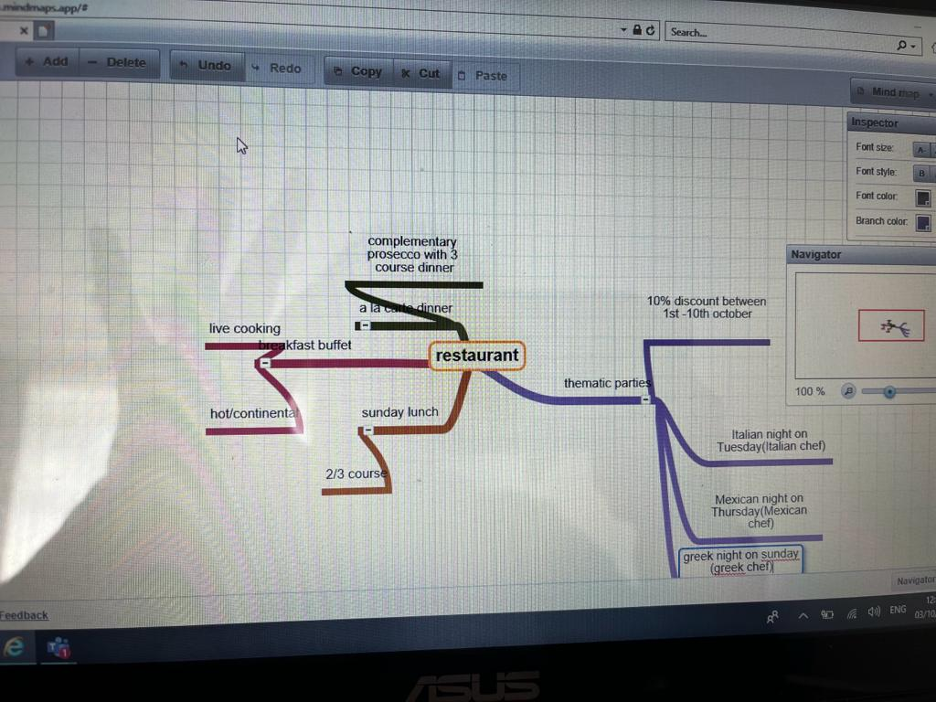
Figure 1: Mindmap of Meet&Meat
(Source: Refer to Lecture Notes)

Business Model Canvas of ‘Meet&Meat’ Restaurant
A proper portrayal of the business model canvas will help the entrepreneur think through the most crucial aspects of the start-up business such as the product lines and services, the target market and the resources required for breakfast, lunch, or dinner in a chart form (Lesonsky, 2019). For Meet&Meat, the business model canvas will be a well-planned management tool to offer a pictorial representation of the key components of business and the way those interact with one another. For the start-up entrepreneur of Meet&Meat, the business model canvas will create value for the consumers and favour generating high revenue.

Key Partnerships
This indicates the organisations or individuals, which the restaurant will collaborate with to create value and operate effectively. In the opinion of Boroh (2021), by developing a strong brand image, restaurants can leverage that power while negotiating with important partners like financial institutions, suppliers and so on. Meet&Meat will partner with dealers of kitchen equipment and food ingredients, marketing agencies for promotion and ads, local growers or farmers for fresh produce and even local wineries or breweries for beverages.

Key Resources
As stated by Bakar et al. (2022), key resources are regarded as human resources including reliable cooks, intellectual resources like special recipes, cooking and kitchen equipment, point-of-sale and utility systems and other essential resources that the restaurant will require for delivering and gaining greater business value. Hence, the key resources for Meet&Meat restaurant will include kitchen staff and skilled chefs for continental dishes, live cooking, breakfast buffet, À-la-carte dinner, and other courses. Other assets or resources of Meet&Meat will include chairs and décor, social media channels like Facebook, Instagram, etc. for online presence, and excellent quality beverages and food ingredients.

Value Proposition
This refers to the unique value, which the restaurant would offer to the customers. The value proposition of Meet&Meat will include unique, delicious, and high-quality cuisine on Greek nights, Mexican nights, and Italian nights. As opined by Mohammad and AbouElezz (2020), value proposition distinguishes an enterprise as well as sets it apart from competitors through novel and innovative product or service offerings. The new restaurant will offer a pleasant dining experience and superb guest service by creating a comfy and convivial atmosphere. The restaurant will make use of sustainable and locally sourced ingredients as well as offer a varied menu which creates an appeal to various dietary preferences and needs.

Customer Relationships
The restaurant requires establishing a good relationship with the customers. To achieve this, Meet&Meat will provide excellent guest service, build loyalty by offering repeat business through promotions like a 10% discount and personalised dining experience at thematic parties and interact with customers to address their feedback or concerns. Precisely, customer relationships prioritise identifying the perfect strategies to manage guest relations depending on the targeted customer segments and various value propositions.

Customer Segments
Customer segments are the group of consumers that the restaurant will target as well as serve. Meet&Meat may include local workers and residents, visitors and tourists, people looking for special dining celebrations or experiences and customers with specific dietary preferences or needs. From the viewpoint of Ferranti and Jaluzot (2020), given the significance of business-class customers as being the key source of revenue, enterprise requires identifying their customers and understanding their preferences and necessities. Hence, in this respect, for thematic parties, Meet&Meat will mainly target business-class customers who are most likely to spend more on dining.
Key Partners
Cross-sectional partnership within the local communities helps in business development, marketing and delivering Meet&Meat products to the market.
Online delivery channels such as Deliveroo, Uber Eats, Foodhub, Just Eat, Grubhub, DoorDash and others can appreciably enable Meet&Meat in fast develop their business.
Local Grocery delivery companies can be very useful partners to Meet&Meeat to resource fresh and organic food materials like vegetables, chicken and other ingredients that are needed for Thematic Parties, live cooking, Sunday lunch, Breakfast buffet and others.

Key Activities
Test and refine recipes for Thematic Parties
Plan and develop menus for lunch, breakfast, and dinner in addition to continental food and live cooking.
Hire and manage staff.
Marketing and advertisement
Value Proposition
Meet&Meat will offer high-quality food and services on Greek nights, Mexican nights, and Italian nights.
Meet&Meat will offer an outstanding dining experience with good customer service.
Meet&Meat can also offer value through loyalty and subscription programs.
A wide range of delivery menus will offer more value to the business prospectus of Meet&Meat
The brand will further offer a menu using fresh vegetables procured from local farmers.
Customer Relationships
Meet&Meat will develop in-person and online relations with customers by offering good quality and healthy foods.

Customer Segments
Meet&Meat will mainly focus on local residents, visitors, tourists and business-class people.
The restaurant will also target people with dietary preferences and needs.
The fine dining, breakfast buffet and lunch courses will attract affluent people.
The Thematic Parties will draw the attention of younger demographics.
Key Resources
Meet&Meat will require human resources, intellectual resources and ingredients for Sunday Lunch, continental dishes, live cooking, breakfast buffet, À-la-carte dinner, and other courses.
Channels
Meet&Meat can use online ordering and delivery apps.
Social media channels can be used for marketing and ads.
Word-of-mouth referrals can be effective for Thematic Parties
Cost Structure
The cost involved in buying food ingredients.
Cost of paying employees
The cost involved in rent and other utilities.
Cost for advertisements and marketing, insurance and licensing, etc.
Revenue Streams
Revenue is generated from selling various recipes for breakfast, lunch, and dinner.
Hosting events Italian nights, Mexican nights, and Greek nights
Online ordering and delivery system

Figure 2: Business Model Canvas for Meet&Meat
(Source: Created by Learner)

Key Activities
These are considered the main operations tasks which the restaurant is required to undertake for creating, delivering, and capturing value (Refer to Bibliography 1). In the present case, key activities in Meet&Meat will include recipe testing and refinement for theme parties, menu planning and development for Sunday lunch or breakfast buffet, inventory management and food purchasing, continental food preparation and live cooking, managing, and hiring staff, advertisement and marketing and forming a very pleasant dining experience.

Channels
In the opinion of Mohammad and AbouElezz (2020), channels indicate the approaches in which the restaurant will communicate as well as reach the target customer segments. The specific channels that can be used by Meet&Meat include online ordering and delivery, word-of-mouth referrals, social media presence and advertisements.

Cost Structure
As opined by Ferranti and Jaluzot (2020), cost structure shows the costs, which the restaurant incurs for running the business, which in turn contributes to raising their business value. In addition, as discussed by Meethavornkul et al. (2018), cost structure includes operation cost, variable cost, and fixed cost. Hence, for Meet&Meat restaurant, cost structures must include foodstuffs and ingredients, restaurant and kitchen kits, staff benefits and salaries, utilities and rent, ads and promotion expenses and licensing and insurance fees.

Revenue Streams
Revenue streams indicate how the restaurant business will generate revenue. In this respect, the point-of-sale system can be helpful for restaurants to go contactless while at a concurrent time integrating all the revenue streams with high precision (Forbes, 2021). Likewise, such an integrated omnichannel backend can provide Meet&Meat valuable insights regarding the buyers whereby allowing the restaurant to create highly targeted messages, cross-promote their offerings and build a long-term relationship with the customers. Furthermore, in Meet&Meat, the revenue streams must comprise revenue from selling various foods and beverages for lunch, breakfast and dinner, revenue from events and catering and revenue from delivery fees and online ordering.

Conclusion
To summarise, the Business Model Canvas could be a very worthwhile tool for Meet&Meat, which is focused on building and modifying their start-up plans. The framework would assist Meet&Meat in better understanding their competitive landscape, discovering opportunities for innovation and development, and finally increasing their prospects of achieving success by identifying essential components such as the value proposition, revenue streams and customer segments. However, this must be kept in mind that the Business Model Canvas is never a static document and must be observed as well as modified regularly for reflecting changeovers in the industry, customer likings and other things that may affect the success of the restaurant. Meet&Meat may improve its chances of reaching its objectives and thriving in the competitive business by making proper use of the Business Model Canvas to inform its decision-making and constantly adjusting its tactics to cope with the market dynamics.

Part 2: Word Reflective Essay
Success seems nothing to do with extraversion, introversion, or personality type. Indeed, there is a key set of traits which set accurately successful entrepreneurs apart and facilitate them in achieving success (Prossack, 2021). To reflect on entrepreneurial traits, this is perfect to focus on Gibb's reflective cycle. Gibb's reflective cycle is a perfect management and self-reflective tool, which helps people think systematically and clearly about the learning experience and inspires them to make sense of the situation and work out the way to do things better next time (Medium, 2024). Hence, I preferred to apply Gibb’s reflective cycle.
Description- I have realised that learning entrepreneurial competencies and skills is best done through experiential learning which favours delivering tangible outcomes for the venture by applying entrepreneurial methods and concepts. Accepting the outlook of entrepreneurship can provide strategic insights into what makes entrepreneurs successful (Bradley, 2023). I soon realised that the uniqueness in my habits and traits most often distinguishes me as an entrepreneur from others, which in turn drives me to innovate by taking well-calculated risks and hence build very thriving enterprises.
Feelings- Entrepreneurship has been a journey filled with setbacks and obstacles. I feel that one of the vital entrepreneurship traits is resilience in provides the ability to bounce back from failure and stick it out in the face of adversity. Further, optimism, which is another crucial entrepreneurial trait, provides me with a confident and positive outlook about the future. In addition, entrepreneurs are most often comfortable in taking calculated risks. Indeed, I have best felt that venturing into the unknown has been a crucial part of the process and that failure has been the stepping stone to achieving success.
Evaluation- While engaging in evaluation, I must say that resilience has empowered me to learn from my mistakes, adapt and continue pursuing the vision with renewed vigour. Being highly optimistic helped me see challenges as prospects as well as believe in the capability of perfectly shaping a better future that could be crucial to maintain motivation and inspire my teammates. In entrepreneurship, risk tolerance must be balanced with the propensity for thoughtful decision-making as well as effective risk management (Travers, 2019). I have always focused on consistent learning, which is important by reading widely and attending seminars and even various workshops.
Analysis- Even though certain entrepreneurial traits have been perfect in me; however, I need to develop more to attain higher success. This seems vital to have a strong network at the disposal for making the most of available resources (Jobanputra, 2023). Therefore, I think in entrepreneurship, one of the crucial requirements of building networks is to be diverse and strong.
Conclusions- Entrepreneurs should take time to reflect regularly. This will help in evaluating progress, learning from experiences, and making essential adjustments. Reflecting on my entrepreneurial traits provided me with valuable insights as well as stimulated creative problem-solving.
Action Plans- To develop my networking skills I must invest more time in building proper connections with mentors, other entrepreneurs, potential investors, and industry experts.

References
Al-Massalkhi, O., (2022). Council post: Finding the best business practices for a hospitality startup, Forbes. Available at: https://www.forbes.com/sites/forbesbusinesscouncil/2022/10/26/finding-the-best-business-practices-for-a-hospitality-startup/?sh=642bd1371e66 (Accessed: 11 January 2024).
Bakar, M.A.A., Huey, A.Y., Majid, M.F. and Ismail, N., (2022). Applying the Business Model Canvas on Haji Yahya’s Restaurant in Ipoh. Asian Journal of Research in Business and Management, 4(2), pp.82-86.
Boroh, J., (2021). Strategies during pandemic for restaurant and café businesses using Business Model Canvas. The European Business Review, pp.74-77.
Bradley, L., (2023). The psychology of entrepreneurship: Traits and habits of successful entrepreneurs, LinkedIn. Available at: https://www.linkedin.com/pulse/psychology-entrepreneurship-traits-habits-successful-bradley-lawton/ (Accessed: 13 January 2024).
Brockman, C., (2024). 10 Innovative Food and drink products launched across T, Mintel. Available at: https://www.mintel.com/food-and-drink-market-news/10-innovative-food-and-drink-products-launched-across-the-globe/ (Accessed: 13 January 2024).
Ferranti, E.J. and Jaluzot, A., (2020). Using the Business Model Canvas to increase the impact of green infrastructure valuation tools. Urban Forestry & Urban Greening, 54, p.126776.
Forbes, (2021). Square Brandvoice: 3 lessons for restaurants looking to the future, Forbes. Available at: https://www.forbes.com/sites/square/2020/12/15/3-lessons-for-restaurants-looking-to-the-future/ (Accessed: 12 January 2024).
Jobanputra, K., (2023). Council post: Five tips for building a profitable network as an entrepreneur, Forbes. Available at: https://www.forbes.com/sites/forbesbusinesscouncil/2023/05/30/five-tips-for-building-a-profitable-network-as-an-entrepreneur/ (Accessed: 13 January 2024).
Lesonsky, R., (2019). Looking for a business plan alternative? consider a business model canvas for startups, Forbes. Available at: https://www.forbes.com/sites/allbusiness/2019/09/30/business-model-canvas-for-startups/?sh=7363084234d9 (Accessed: 12 January 2024).
Medium, (2024). Gibbs reflective cycle: Feel the benefit of experiential learning, Medium. Available at: https://makingbusinessmatter.medium.com/gibbs-reflective-cycle-feel-the-benefit-of-experiential-learning-87e2f0eaae59 (Accessed: 13 January 2024).
Meethavornkul, P., Jituea, N., Jandasang, D. and Pooripakdee, S., (2018). The business guideline of new entrepreneur toward business model canvas. International Journal of Business and Economic Affairs, 3(1).
Mohammad, A.A. and AbouElezz, M., (2020). A Holistic Model for Sustainable Restaurant Operations using the Business Model Canvas Approach. Journal of Association of Arab Universities for Tourism and Hospitality, 19(3), pp.207-227.
Prossack, A., (2021). 6 traits of successful entrepreneurs, Forbes. Available at: https://www.forbes.com/sites/ashiraprossack1/2021/08/18/6-traits-of-successful-entrepreneurs/?sh=4034e0837139 (Accessed: 12 January 2024).
Travers, M., (2019). Assessing risk tolerance among inventors, CEOS, and entrepreneurs: Who’s the riskiest?, Forbes. Available at: https://www.forbes.com/sites/traversmark/2019/12/16/assessing-risk-tolerance-among-inventors-ceos-and-entrepreneurs-whos-the-riskiest/ (Accessed: 11 January 2024).

Bibliography
[1] Linkedin, (2023). From concept to success: Using the Business Model Canvas (BMC) to launch your restaurant, LinkedIn. Available at: https://www.linkedin.com/pulse/from-concept-success-using-business-model-canvas-bmc/ (Accessed: 11 January 2024).

