Web Development Assignment 1
Ben Archer
Ian Lewis | 11/02/2018

Contents
Introduction 1
Database Structure 1
Security Considerations For Live 2
Scalability Considerations For Live 2
Usability Considerations For Live 3
Advanced Features and Website Screenshots 3
Conclusion 3
References 4
Bibliography 4
Appendix 5

Introduction

The aim for the assignment was to build a website that linked to a backend MySQL database. The server-side scripting language required for the assignment was PHP. The website developed for this assignment was named ‘Rent-0-Car’ and functioned as a simple car rental service for business or private citizens. The website includes role allocations and validation, account creation and login, as well as admin functionality that allows administrators to manipulate key information contained within the website.

Database Structure

The database management system used for this assignment was phpMyAdmin. This management system is built upon MySQL and offers the ability for users to build databases through MySQL script or through phpMyAdmin’s user interface.
The database structure for the ‘Rent-o-Car’ database was built in accordance to the Third Normal From of database construction; wherein a table is not only in the second normal form, but ‘contains only columns that are non-transitively dependent on the primary key’ [1]. The most notable instance of this is the construction of cars within the database [Appendix a] where car makes, models, and individual cars occupy their own database tables to prevent data repetition. ✓ good point

Security Considerations For Live

There are many areas within the website that could be argued to be vulnerable to SQL Injection attacks, wherein, as stated by W3Schools [2], ‘the user gives you an SQL statement that you will unknowingly run on your database’, the causes of these vulnerabilities mainly revolve around the lack of sanitization of inputs, as well as query construction. Some of these vulnerabilities are as follows.
Within the login area of the website, an SQL query is run that tries to find a user within the users table whose email matches the email given within the login email input. After reviewing the query, it could be argued that the login process is vulnerable to SQL Injection as an attacker could manipulate the variable being placed into the query with malicious code. The solution to this problem would be to use parameterized queries within the PHP code that is carrying out the login process.✓
Within the car search area of the website, users can enter a search term that is used to find cars within the database. Again, this uses an SQL query to find data and return it in the form of an array which is then displayed on the website. The lack of sanitization within the text input of the search function could allow attackers to return information that is not desired such as user information. To remedy this problem, proper sanitization of these inputs (not allowing the form to post if certain characters are within the text input) should be implemented.✓
It should be noted however that there are some security considerations that the website carries out well within accordance to industry standard practices. For example, sensitive user information within the database is hashed using a secure hashing algorithm with the addition of a salt. Moreover, when deleting users within the database, user records are removed from the database instead of being ‘softly’ deleted.✓ good consideration

Scalability Considerations For Live

Scalability, or ‘the ability for a computer application or product to continue to function well when it or its context is changed in size or volume’ [3], would have to be taken into consideration within the report’s website due to the nature of the application. When thinking about the physical aspects of increased growth, since user information is saved within the database, more users using the application would result in more space being taken up within the server the website is hosted on, leading to a need for increased hard disk space. The same scenario could also be applied to booked cars within the database, as well as the cars themselves. ✓
In terms of the websites ability to handle an increase in growth, since only administrators possess the necessary power to add car makes, models, and individual cars themselves, more and more administrators would be required as the website grew to sustain an efficient and responsive experience for users.
In addition to the previous points, one of the key considerations with regards to usability that should be considered is the amount of database calls an average user makes within the website. Database calls should be minimal unless necessary. This could be implemented through increased usage of client-side validation or interaction.✓ this could prove difficult to identify and implement, but worth consideration

Usability Considerations For Live

The usability within the website is of great importance if the website were to be made live. Due to the time constraints however, the report’s website does not contain many of the W3C’s Web Content Accessibility Guidelines. However, due to the nature of the website, it does fulfill some of the requirements. For example, due to the lack of images within the website, measures such as alternative text for users who may be legally or fully blind. On the other hand, the website does invalidate other requirements within the ‘Operable’ section of the WCAG such as making all functionality available through the keyboard. Although it may be argued that due to the nature of the website, trying to fulfill this requirement would totally change the way in which the website operates and could be detrimental to the functionality of the website.✓

Advanced Features and Website Screenshots

There are several advanced features that exist within the website. Such features include Inner Joins on SQL queries, complex searches of multiple database tables, password hashing, and user role allocation and analysis. Details of these features, as well as screenshots from the completed website can be viewed in the Appendix.✓ Good use of these features

Conclusion

When reflecting on the finished website, a number of considerations should be taken into account in it were to become a live website, however it is clear that it serves the purpose that the brief had assigned, as well as excelling beyond that in certain areas. A little bit brief

References
- Essential SQL (2017) Database Third Normal Form Explained in Simple English, Available at: https://www.essentialsql.com/get-ready-to-learn-sql-11-database-third-normal-form-explained-in-simple-english/ (Accessed: 11/02/2018).
- W3Schools (2017) SQL Injection, Available at: https://www.w3schools.com/sql/sql_injection.asp (Accessed: 11/02/2018).
- Margaret Rouse (2013) Scalability, Available at: http://searchdatacenter.techtarget.com/definition/scalability (Accessed: 11/02/2018).

Bibliography
- Wordpress.org (2017) Validating Sanitizing and Escaping User Data, Available at: https://codex.wordpress.org/Validating_Sanitizing_and_Escaping_User_Data(Accessed: 11/02/2018).
- W3C (2008) Web Content Accessibility Guidelines (WCAG) 2.0, Available at: https://www.w3.org/TR/WCAG20/#text-equiv (Accessed: 11/02/2018).

Appendix

a.
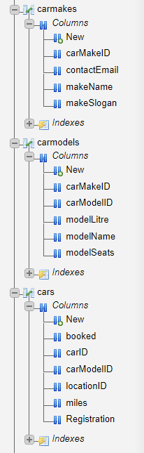

b. Advanced Feature 1 – Query Inner Join
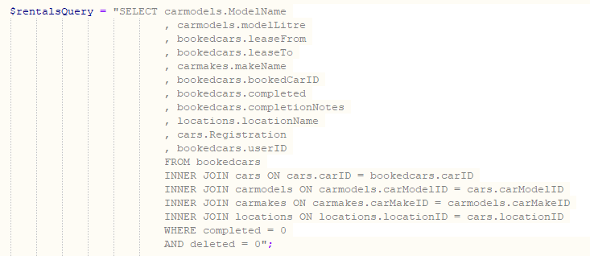
Here we can see an example of the use of an INNER JOIN within an SQL query that populates a table within the website that details active rentals.✓
c. Advanced Featured 2 – Complex Query
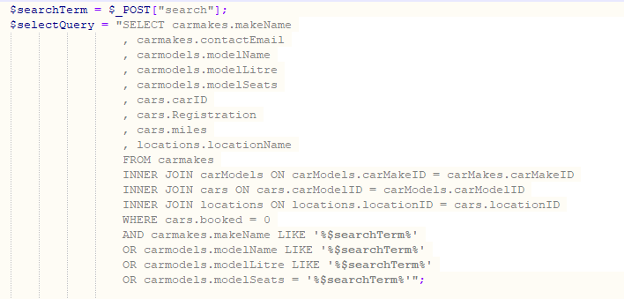
Here we can see an example of a complex search wherein a search parameter is used to search multiple tables. We can also see the use of Inner Joins within this SQL Query✓

d. Advanced Feature 3 – Password Hash and Verification
Password Hashing on User Creation
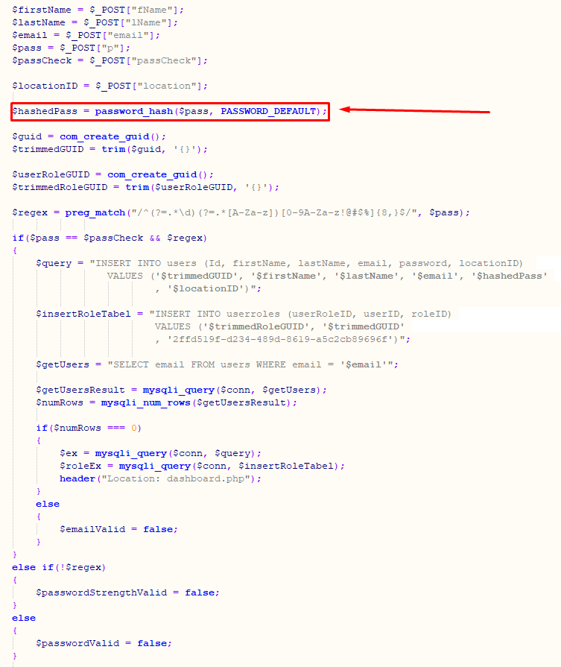
Here we can see the use of the PHP function ‘password_hash’ as well as PHP’s built in regex verification functionality. ✓

Password Verification on User Login
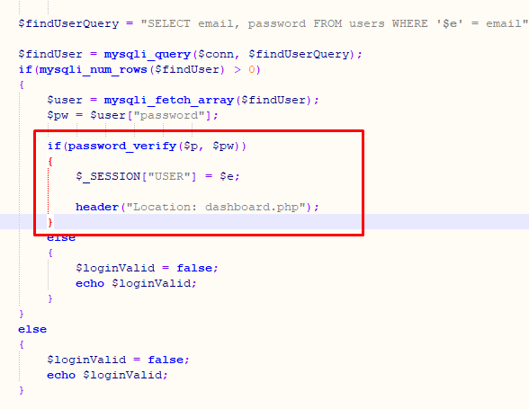
Here we can see the use of the PHP function ‘password_verify’ that when used in conjunction with ‘password_has’ securely verifies an unhashed password against a hashed password (with salt) within the user database table. ✓ good

e. Role Validation
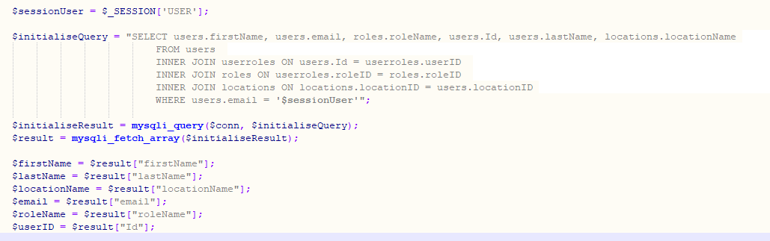
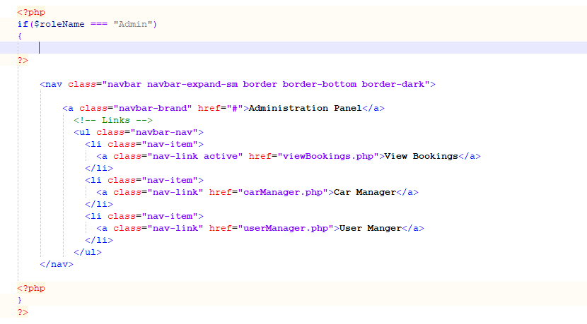
Here we can see the use of a query to view a current users role within the database. With this information we can render certain html items. For example, within the reports website, if the current user is in the Admin role, an administration bar is loaded below the main navigation bar. Practical use of this feature to keep interface clean

Website Screenshots


