
Asthma in Adolescents: Evidence-Based Management
BMHP5023 — Introduction to Physiology Case Study 2: Asthma in Adolescents
Student name: Mihaela Valkova
Student number: 2243479
Lecture Name: Gillian Weaver

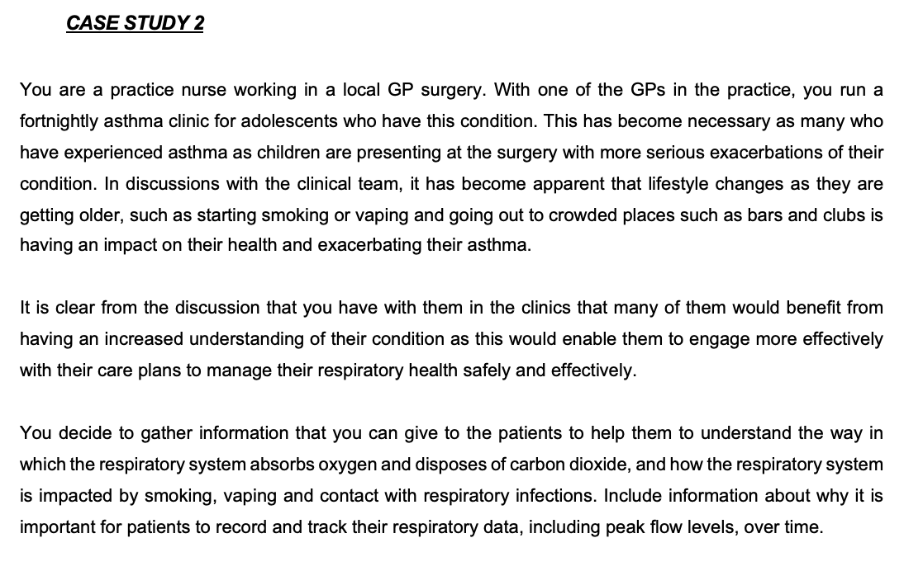
Table of Contents
1.Introduction 2
2.Anatomy and Physiology of the Respiratory System 2
3.Pathophysiology and Impact of Asthma 3
4. Monitoring and Respiratory Data 4
5. Evidence-Based Lifestyle Recommendations 5
6. Conclusion 7
References 8

1.Introduction

Asthma is a chronic respiratory condition characterised by airway inflammation, bronchial hyperresponsiveness and variable airflow limitation. These physiological changes cause symptoms including wheezing, coughing, chest tightness and breathlessness. The World Health Organization (WHO, 2026) identifies asthma as a major chronic respiratory disease affecting children and adults, while the Global Initiative for Asthma (GINA, 2025) emphasises that inadequate control increases the risk of severe exacerbations and impaired daily functioning.
Asthma develops through interactions between genetic susceptibility and environmental influences. Common triggers include respiratory infections, allergens, tobacco smoke and air pollution (NHS, n.d.-a). However, individual responses vary, making it important to distinguish underlying susceptibility from factors that provoke deterioration.
The case study concerns adolescents attending a fortnightly GP asthma clinic because of increasingly severe exacerbations. Smoking, vaping and crowded social environments have been identified as possible contributing factors. Nevertheless, attributing deterioration solely to adolescent behaviour risks overlooking inadequate inhaler technique, treatment adherence and environmental circumstances. Ahmad and Sorensen (2016), in a systematic review, identified multiple influences on adolescent adherence, demonstrating that effective management requires more than providing information.
This report examines respiratory anatomy, mechanical ventilation and gas exchange before explaining how asthma disrupts these processes. It then evaluates respiratory monitoring and evidence-based management. The central argument is that preventing exacerbations requires physiological understanding combined with individualised, developmentally appropriate care.

2.Anatomy and Physiology of the Respiratory System

The respiratory system supplies oxygen for cellular metabolism and removes carbon dioxide produced by body tissues. Its principal structures include the nose, pharynx, larynx, trachea, bronchi, bronchioles and alveoli (Weaver, 2025). OpenStax (2022) distinguishes between conducting airways, which transport and condition inhaled air, and the respiratory region, where gas exchange occurs.
Air travels through the trachea into the primary bronchi, which divide into progressively smaller bronchioles. The trachea and larger airways contain mucus-producing cells and cilia that trap and remove inhaled particles. This protective mechanism becomes problematic when excessive mucus accumulates during asthma, contributing to airway obstruction.
Mechanical ventilation depends on pressure changes generated by respiratory muscles. During inspiration, the diaphragm contracts and flattens while the external intercostal muscles elevate the ribs. Thoracic volume increases, reducing pressure within the lungs below atmospheric pressure and drawing air inward. During quiet expiration, these muscles relax and elastic recoil reduces lung volume, increasing pressure and expelling air (OpenStax, 2022).
Although expiration is normally passive, narrowed bronchioles increase resistance to outward airflow. Consequently, individuals experiencing asthma exacerbations may require greater respiratory effort, particularly when exhaling. This demonstrates how altered airway function disrupts otherwise efficient mechanical ventilation.
Gas exchange occurs across the thin alveolar-capillary membrane. Oxygen diffuses from alveolar air into pulmonary capillary blood because its partial pressure is higher in the alveoli. Carbon dioxide moves in the opposite direction before being exhaled. Oxygenated blood returns through the pulmonary veins to the left side of the heart for circulation throughout the body (OpenStax, 2022).
Efficient gas exchange requires adequate ventilation of alveoli alongside sufficient pulmonary blood flow. In asthma, narrowed bronchioles may reduce ventilation to some lung regions despite continued circulation. This ventilation–perfusion imbalance can impair oxygen transfer during severe exacerbations. Importantly, asthma primarily restricts airflow rather than directly destroying alveolar structures. Understanding this distinction explains why airway inflammation can interfere with gas exchange even when the gas-exchange surfaces remain intact.

3.Pathophysiology and Impact of Asthma

Asthma disrupts respiratory function through airway inflammation, bronchoconstriction and excessive mucus production. Exposure to respiratory viruses, allergens or irritants can activate inflammatory responses in susceptible airways. GINA (2025) explains that these responses contribute to swelling of the airway lining, mucus accumulation and contraction of bronchial smooth muscle.
Leukocytes, or white blood cells, participate in this inflammatory process. In many individuals, eosinophils release substances that contribute to airway inflammation and tissue irritation. However, inflammatory patterns vary, meaning eosinophils are not equally prominent in every person with asthma (GINA, 2025). Recognising this variation prevents the inaccurate assumption that all adolescents experience identical disease mechanisms.
Inflammation causes airway swelling, while mucus-producing cells increase secretions. Simultaneously, bronchoconstriction reduces the diameter of the bronchi and bronchioles. Together, these changes increase airflow resistance. Even relatively small reductions in airway diameter can substantially restrict airflow, explaining why combined inflammation and mucus accumulation may cause significant breathing difficulties.
Expiration becomes particularly difficult because narrowed airways impede air leaving the lungs. Air trapping may occur, increasing the effort required for subsequent breaths. These mechanisms contribute to wheezing, chest tightness and breathlessness. During severe exacerbations, inadequate alveolar ventilation may also impair oxygenation.
Smoking and vaping are relevant to the case study because inhaled smoke and aerosols may irritate susceptible airways. Respiratory infections can additionally intensify inflammation. Nevertheless, exposure to a potential trigger does not establish that it caused deterioration in an individual adolescent.
NICE (2024) recommends assessing treatment adherence, inhaler technique, smoking and vaping exposure, environmental factors and psychosocial circumstances when asthma remains uncontrolled. Ahmad and Sorensen (2016) further demonstrate that adherence is influenced by interacting personal and social factors rather than knowledge alone.
For example, an adolescent experiencing a viral infection while inconsistently using prescribed anti-inflammatory medication may develop worsening symptoms through several interacting mechanisms. Therefore, identifying one trigger may be insufficient.
The increasing frequency of severe exacerbations should prompt comprehensive clinical assessment rather than assumptions about behaviour. Understanding how inflammation restricts airflow also demonstrates why relieving immediate bronchoconstriction is not equivalent to controlling the underlying inflammatory disease.

4. Monitoring and Respiratory Data

Monitoring asthma provides information about symptoms, airflow limitation and treatment effectiveness. Peak expiratory flow (PEF) measures the maximum speed of forced expiration after full inspiration, expressed in litres per minute. Using a peak flow meter, the individual performs three forceful expirations, with the highest acceptable reading recorded (NHS, n.d.-b).
PEF is physiologically relevant because narrowed airways increase resistance and may reduce expiratory airflow. Comparing measurements with an individual’s personal best can help identify deterioration. However, readings depend on effort, technique and normal variability, meaning isolated results may be misleading.
Within the adolescent clinic, the practice nurse could assess symptom frequency, night-time waking, reliever use, missed school and previous exacerbations alongside selected PEF measurements. Declining readings accompanied by worsening symptoms could indicate deteriorating control. Nevertheless, NICE (2024) advises against routine PEF monitoring solely to assess asthma control unless there is a person-specific reason.
This distinction highlights that collecting more measurements does not automatically improve outcomes. PEF measures airflow rather than oxygenation and cannot replace clinical assessment.
Gibson and Powell (2004) identified benefits associated with appropriately structured written asthma action plans. However, these findings do not establish that daily PEF recording is necessary for every adolescent. NICE (2024) generally favours symptom-based action plans for children, while recognising that PEF can support individualised management.
Osama et al. (2024), in a systematic review and meta-analysis, found that adherence-promoting interventions produced an overall statistically significant improvement, with electronic monitoring showing stronger effects than some alternative measurement approaches. However, improved adherence measurements do not necessarily demonstrate equivalent reductions in severe exacerbations, and technological interventions may not be equally accessible to every adolescent.
Therefore, respiratory monitoring should be individualised and clinically meaningful. The nurse should explain the purpose of measurements, assess technique and agree how symptoms or declining readings will inform further assessment and action.

5. Evidence-Based Lifestyle Recommendations

Effective asthma management requires interventions addressing physiological triggers and barriers to adolescent self-management. Lifestyle advice should complement prescribed treatment rather than imply that behavioural changes alone can control chronic airway inflammation.
Firstly, smoking and vaping should be addressed through confidential, non-judgemental discussions. Tobacco smoke and vaping aerosols may irritate susceptible airways and contribute to worsening respiratory symptoms (GINA, 2025). However, nicotine dependence and peer relationships may complicate cessation. NICE (2021) recommends appropriate tobacco cessation support, while NICE (2024) specifically advises asking adolescents about smoking and vaping. Ahmad and Sorensen (2016) further highlight the influence of social circumstances on treatment behaviours. Consequently, personalised support is more appropriate than simply instructing adolescents to stop.
Secondly, respiratory infection prevention is important because viral illnesses may intensify airway inflammation and trigger exacerbations. Recommended vaccinations, hand hygiene and reducing avoidable exposure to infectious individuals may help minimise risk (NHS, n.d.-a). Improving ventilation in crowded environments may also be beneficial. Nevertheless, complete avoidance of schools and social activities would be unrealistic and potentially harmful to adolescent wellbeing. Risk reduction should therefore be proportionate.
Thirdly, medication adherence and inhaler technique require particular attention. Inhaled corticosteroids reduce underlying airway inflammation, whereas incorrect technique may prevent sufficient medication reaching the airways. NICE (2024) recommends observing inhaler technique during reviews. Practical demonstrations, supervised practice and discussion of difficulties using medication at school may improve effective treatment use.
Osama et al. (2024) found that adherence interventions, including educational and electronic approaches, can improve treatment adherence. However, their findings should not be interpreted as evidence that technology is always the most suitable intervention. Costs, accessibility and individual preferences must be considered when applying research to routine GP care.
Fourthly, regular physical activity should be encouraged when asthma is adequately controlled. Avoiding exercise unnecessarily may restrict fitness, confidence and social participation. GINA (2025) supports physical activity alongside appropriate asthma management. Persistent exercise-related symptoms should therefore prompt assessment of asthma control rather than automatic withdrawal from sport.
Finally, adolescents should receive personalised written asthma action plans supported by education. Gibson and Powell (2004) identified benefits associated with well-structured plans. However, Gatheral et al. (2017) found uncertainty regarding the additional benefits of personalised action plans in the adult populations and comparisons examined. These findings are not necessarily contradictory because they address different research questions, and adult evidence cannot automatically be generalised to adolescents.
More directly relevant evidence comes from Harris et al. (2019), whose Cochrane systematic review found that school-based asthma self-management programmes probably reduced hospital admissions and produced small improvements in asthma-related quality of life. Nevertheless, many included studies involved younger children, limiting direct applicability to older adolescents. Together, the evidence supports combining individualised action plans with practical education, appropriate family involvement and cooperation with schools. The fortnightly clinic could use this approach to identify barriers, reinforce inhaler skills and evaluate whether agreed strategies improve asthma control.

6. Conclusion
Asthma demonstrates the relationship between respiratory anatomy, physiological function and chronic disease management. Normally, respiratory muscles generate pressure changes enabling ventilation, while the alveolar-capillary membrane facilitates oxygen uptake and carbon dioxide removal. In asthma, inflammatory swelling, bronchoconstriction and excessive mucus restrict airflow, increasing respiratory effort and potentially impairing oxygenation during severe exacerbations.
The increasing frequency of exacerbations among adolescents attending the GP clinic requires comprehensive assessment. Smoking, vaping and respiratory infections may contribute to deterioration, but inhaler technique, treatment adherence and individual circumstances must also be evaluated. Assuming adolescent behaviour alone explains worsening symptoms risks overlooking modifiable clinical factors.
Although peak flow measurements can support selected patients, their limitations demonstrate why respiratory data should be interpreted alongside symptoms and clinical assessment. Similarly, research indicates that written action plans should form part of broader education and continuing review.
Ultimately, healthcare professionals play an essential role in translating physiological knowledge into individualised advice. Smoking and vaping cessation support, infection prevention, correct inhaler use and safe physical activity can strengthen adolescent self-management. Combining clinical evidence with an understanding of adolescent development offers a balanced approach to improving asthma control and reducing preventable exacerbations.

References

Ahmad, A. and Sorensen, K. (2016) ‘Enabling and hindering factors influencing adherence to asthma treatment among adolescents: A systematic literature review’, Journal of Asthma, 53(8), pp. 862–878. Available at: https://doi.org/10.3109/02770903.2016.1155217.
Gatheral, T.L., Rushton, A., Evans, D.J.W., Mulvaney, C.A., Halcovitch, N.R., Whiteley, G., Eccles, F.J.R. and Spencer, S. (2017) ‘Personalised asthma action plans for adults with asthma’, Cochrane Database of Systematic Reviews, 2017(4), CD011859. Available at: https://doi.org/10.1002/14651858.CD011859.pub2.
Gibson, P.G. and Powell, H. (2004) ‘Written action plans for asthma: an evidence-based review of the key components’, Thorax, 59(2), pp. 94–99. Available at: https://doi.org/10.1136/thorax.2003.011858.
Global Initiative for Asthma (GINA) (2025) Summary Guide for Asthma Management and Prevention: For Adults, Adolescents and Children 6–11 Years. Available at: https://ginasthma.org/wp-content/uploads/2025/06/GINA-Summary-Guide-2025-WEB_FINAL-WMS.pdf (Accessed: 22 October 2026).
Harris, K., Kneale, D., Lasserson, T.J., McDonald, V.M., Grigg, J. and Thomas, J. (2019) ‘School-based self-management interventions for asthma in children and adolescents: a mixed methods systematic review’, Cochrane Database of Systematic Reviews, 2019(1), CD011651. Available at: https://doi.org/10.1002/14651858.CD011651.pub2.
National Health Service (NHS) (n.d.-a) Asthma. Available at: https://www.nhs.uk/conditions/asthma/ (Accessed: 18 October 2026).
National Health Service (NHS) (n.d.-b) Peak flow test. Available at: https://www.nhs.uk/tests-and-treatments/peak-flow-test/ (Accessed: 18 October 2026).
National Institute for Health and Care Excellence (NICE) (2021) Tobacco: preventing uptake, promoting quitting and treating dependence. NICE guideline NG209. Available at: https://www.nice.org.uk/guidance/ng209 (Accessed: 15 October 2026).
National Institute for Health and Care Excellence (NICE) (2024) Asthma: diagnosis, monitoring and chronic asthma management (BTS, NICE, SIGN). NICE guideline NG245. Available at: https://www.nice.org.uk/guidance/ng245 (Accessed: 15 October 2026).
OpenStax (2022) Anatomy and Physiology 2e. Houston, TX: OpenStax, Rice University. Available at: https://openstax.org/books/anatomy-and-physiology-2e/pages/1-introduction (Accessed: 15 October 2026).
Osama, H., Alghamdi, S., AbdElrahman, M. and Abdelrahim, M.E.A. (2024) ‘Evaluating adherence and inhaler monitoring among adolescent asthmatic patients: a systematic review and meta-analysis of interventions’, The Egyptian Journal of Bronchology, 18, article 85. Available at: https://doi.org/10.1186/s43168-024-00336-4.
Weaver, G. (2025) The Respiratory System. Introduction to Physiology, Week 4. Lecture slides. University of Wales Trinity Saint David.
World Health Organization (WHO) (2026) Asthma. Available at: https://www.who.int/news-room/fact-sheets/detail/asthma (Accessed: 15 October 2026).

