Amy Drewett
2009929

Additional Learning Needs in Context
ECIE4003

Contents Page

Cover Page - Page 1

Contents Page - Page 2

Introduction - Page 3

Element 1 - Page 4 - Poster

References - Page 5

Element 2 - Page 6

Element 3 - Page 8

Element 4 - Page 10

Conclusion - Page 11

References - Page 12

Appendices - Page 14

The medical and social models of disability and how it links to an inclusive education for all, taking into consideration current and previous policies, legislation, and government documents.

Inclusive Education is a term now used widely across learning environments. What does an inclusive education mean for learners and how does legislation, policies and framework support the term ‘inclusive education’ in education settings?
This portfolio of work will distinguish the difference between the medical and social models of disability within education and what legislations, framework and policies do to support the models. Leading on from this the author will identify how its own work setting supports the development and inclusivity of a child with Additional Learning Needs (ALN). The portfolio will conclude by looking at what the setting does to provide a learner with the best possible experience of inclusivity and what it can do to improve opportunities. The European agency state that,

‘the ultimate vision for an inclusive education system is to ensure all learners of any age are provided with meaningful, high quality education and opportunities in their local community, alongside their friends and peers’ (European Agency for Special Needs and Inclusive Education, 2015).

The portfolio will start with Element 1 (poster format), followed by Element 2 and concludes with Element 3 and 4.
Medical and Social Models of Disability within Education

What is a disability?

Under the Equality Act 2010 a disability is defined as ‘a physical or mental impairment that has a ‘substantial’ and ‘long-term’ negative effect on your ability to do normal daily activities’ (Government Digital Service, 2011). This definition under the equality act is a broad and indefinable statement.

Medical Model

The medical model of disability identifies the person with the disability as having the problem. The focus is on curing the condition through a range of medical services (Heery and Noon, 2017).

This model is seen to be,

- Limiting
- Lonely
- Discriminating
- Restrictive
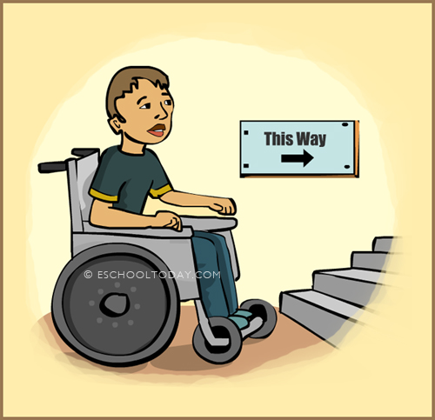
- Leaves the person with the disability with little voice in what happens to them

What does this picture say to you?
Should barriers like this still be getting in the way of learning?

(eSchoolToday, 2006)
Social Model

The social model of disability identifies the person with the disability as the most important part of its process. It places emphasis on external barriers being removed for more inclusivity (Trade union congress, 2015).

This model is seen to be,

- Inclusive
- Positive
- Empowering
- Accepting
- Gives the disabled independence and a sense of freedom (Trade union congress, 2015).

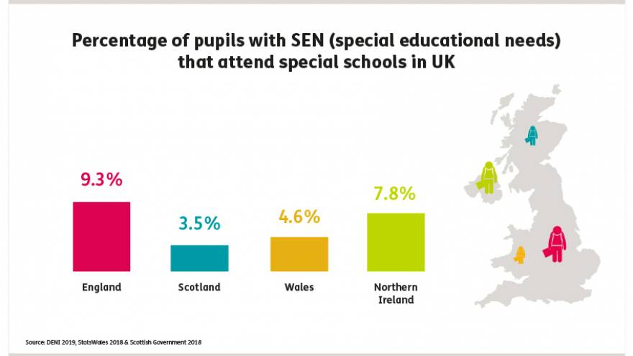

(Mencap, n.d.)

The above picture shows that only 4.6% of students with SEN attend special schools in Wales in 2018, meaning that a large percentage of children with Additional learning needs attend mainstream settings.

4
The future for an Inclusive Education

Although the social model is the model that has been embraced in more recent times. The use of services from the medical model are still needed for children with Additional Learning Needs. The use of strong multiagency partnerships within education settings is paramount in providing an inclusive education system for all learners.

‘Inclusion and participation are essential to human dignity and to the enjoyment and exercise of human rights. Within the field of education this is reflected in the development of strategies that seek to bring about a genuine equalisation of opportunity’(UNESCO, 1994).

‘There is no greater disability in society than the inability to see a person as more.’ (Hensel, n.d).

Reference list
eSchoolToday 2006. What is a disability?. Available at: https://eschooltoday.com/people-with-disabilities/what-is-a-disability.html [Accessed: 17 August 2021].
Government Digital Service 2011. Definition of disability under the Equality Act 2010. Available at: https://www.gov.uk/definition-of-disability-under-equality-act-2010.
Heery, E. and Noon, M. 2017. A dictionary of human resource management. 3rd ed. Oxford: Oxford University Press.
Hensel, R. [no date]. My Quotes: Available at: https://roberthensel.webs.com/myquotes.htm [Accessed: 17 August 2021].
Mencap [no date]. Percentage of Pupils with SEN (special education needs) that attend special school in the UK. Available at: https://www.mencap.org.uk/learning-disability-explained/research-and-statistics/children-research-and-statistics [Accessed: 9 August 2021].
Parliamentary and Health Service Ombudsman [no date]. Introduction to the Social and Medical Models of Disability. Available at: https://www.ombudsman.org.uk/sites/default/files/FDN-218144_Introduction_to_the_Social_and_Medical_Models_of_Disability.pdf [Accessed: 17 August 2021].
Trade union congress 2015. Trade Unions and Disabled Members: Why the social model matters Taking forward TUC policy on the social model of disability. Available at: https://southeast.unison.org.uk/content/uploads/sites/41/2017/06/TUCsocialmodel.pdf [Accessed: 17 August 2021].
UNESCO 1994. The Salamanca Statement and Framework for Action on Special Needs Education. Paris: UNESCO, p. 11.

Element 2

This poster has clear distinctions between the medical and social model of disability. The medical model is limiting and isolating for a learner with additional learning needs (ALN). The framework of the model places constraints and restrictions for learners with ALN to make the most or attend a mainstream education setting. Historically the medical model,

‘Focuses on the individual deficit theory. It categorises and locates deficits (problems) within the learner and prescribes curative interventions such as therapy, medicine, surgery or special treatment (such as adapting the curriculum), which is then delivered within a separate class, this view places the learner as the problem, placing continuous barriers ahead of them. ‘Learners were placed in ‘special schools’ or didn’t attend education settings at all’ (Labramrathan, Lesley Le Grange and Higgs, 2017, p.389).

This has meant in the past learners with ALN were placed in ‘special schools’ or did not attend education settings at all.
The social model allows a person with disabilities a sense of freedom and independence by changing the environment around them and accepting the person for who they are. The TUC describe the social model as recognising ‘the vital point that the barriers that currently exclude disabled people are not only the obvious physical obstacles, but also the attitude that accompanies the medical model’ (Trade union congress, 2015). According to Mencap the percentage of learners in Special Education Settings in Wales in 2018 was 4.2% (Mencap, n.d.).
This number shows how many learners in Wales with ALN are currently being educated in mainstream schools. This is not the case globally. UNICEF have found that in many low-income countries many disabled children are unaccounted for and in order for real change to take place all children need too be seen, heard and accounted for (Waltham, 2018). The social model allows learners access to learning environments by changing the environment rather than excluding the learner. Although the social model of disability is an accepting model in comparison to the medical model it has its limitations with regards to making the education system a fully inclusive one. Terzi describes the medical model as ‘understates the relational and social character of disability, conversely the social model ends up over socialising causes and misplacing responsibility for impairment and disablement’ (Terzi, 2005).
Over time society and concepts have changed radically and dramatically (Frederickson and Cline, 2015, pp.3–4) with this change has come reports, legislation, government guidelines and codes of practice. The history of ALN reform and development is a long one with many milestone events which have propelled it to where it is today. The Salamanca report is seen as a pioneering moment with regards to inclusive education (Krehl, Leechin Heng and Walker, 2021, p.3). It adopts views from the social model of disability. The report declares that all children have the right to an inclusive education in a mainstream setting where possible, it believes that every child is unique and individual and education environments should accept and provide a safe and welcoming environment without discrimination or exclusion (UNESCO, 1994). The report is extensive and sets out a framework for governments worldwide to build strong legal legislation to build a more acceptable education system for learners with ALN.
Inter-Agency collaboration is vital for successful inclusion. The continuum of needs identifies different levels of support for a child with ALN needs. One of the key components of the continuum of needs is the use of a multi-agency approach. This approach can be linked to both the social and medical models of disability as various agencies and practitioners need to be involved for a learner to have the best access to education. The new ALN transformation programme in Wales goes even further and places the learner at the heart of all decisions being made. Person centred planning is at the centre of the reform, as well increased collaboration between all agencies (Welsh Government, 2020). Wales is currently in a transition period for the transformation. In September 2021 it becomes a legal requirement for schools to be implementing the new system. The first minister for education described the previous system as,
‘An assessment process which is inefficient, bureaucratic and costly, as well as insufficiently child-centred or user-friendly. Needs are sometimes identified late, and interventions are not planned or implemented in a timely or effective way’ (Welsh Government, 2014).

The new reform sets out to be a fully inclusive system, placing learners and their families at the forefront of change.

Element 3

In this part of the portfolio the author is going to discuss how its educational setting provides a learner with ALN with support. The author will refer to its setting as School A. The learner that the author is going discuss is a 12-year-old male. The child has ALN. The child is diagnosed with Autistic Spectrum Disorder (ASD), Development Coordination Disorder (DCD) and a rare condition, Perthes Disease. The child will be identified as Child A in this piece of work. Child A is supported within a Secondary mainstream setting and supported on a 1-1 basis by the author.
Child A attends mainstream classes with his peers and accesses the full curriculum. Although child A does this, he is part of the Special Learning Centre which is a specialist provision that oversees children with ALN in mainstream settings. Although child A’s ALN can be challenging to manage he has a fantastic character and determination that allows him to always do more.
On the continuum of needs Child, A falls into Level 3 as he has multiple and complex needs that need a multi-agency approach. It is called a universal partnership plan where Child A receives targeted, and specialist support to meet their requirements (Children and Young Peoples Trust, East Sussex, n.d.). Child A has a statement of educational needs placed on them by the Local Education Authority (LEA) which is a legally enforceable document that outlines what support and services a learner must receive from their setting.
School A uses person centred planning, which is part of the Welsh Governments vision as part of the new ALN transformation. Child A’s needs are complex and can change from day to day. ASD means that Child A can become overwhelmed in situations within the learning environment and finds it hard to regulate emotions and behaviour. Changes to routine can exasperate ASD tendencies, School A support Child A by tailoring a bespoke timetable and providing him with the same LSA on a daily basis. The school also keeps clear lines of communication between the home and school environment so any changes to a planned routine are communicated ahead of time so Child A’s parents and LSA can reaffirm them with Child A. As per Child’s Statement of Educational Needs, he must be provided with an LSA at all times within the school day. School A makes sure this happens.
When heightened, emotions occur in Child A and can cause challenging behaviours such as rudeness, shouting, aggression, pacing, the complete inability to calm or see things rationally. School A and Child A’s LSA support Child A in times of crisis by staying calm and observing from a safe distance. They allow Child A to make their way to a safe place where Child A feels comfortable. Once Child a begins to regulate his LSA is able to sit with them and they forgo the intended curriculum and do therapeutic activities such as play sport, colour, listen to music. Child A can take an hour to self-regulate or a few days where he struggles to reintegrate into their mainstream classroom. School A apply no pressure to Child A and allow them to do activities in their time and when they are ready.
School A provide Child A with 1 – 1 ELSA (Emotional Literacy Support Assistant) on a weekly basis. ELSA is an intervention programme that was developed by an educational psychologist that supports learners with emotional needs, without having to wait for a referral (ELSA Network, 2017). Child A relies on 1 – 1 support from his learning support assistant (LSA). In order to support Child A, the LSA made sure they were fully aware of Child A’s conditions, needs and previous schooling experience by reading Child A’s Independent Development Plan (IDP), Pen Picture (See Appendix A), One Page Profile (See Appendix B), Statement of Educational Needs and spoke in depth to Child A’s mother and previous LSA on the best ways to help and support child A especially whilst in crisis. Child A has a plan in place if they start to feel overwhelmed or in crisis. All documents relating to Child A are available for teaching staff to read to understand the best way in which to help Child A. School A provide relevant staff access to any documents relating to child A’s needs. Staff are also provided with regular training to support all learners with ALN. School A have multiple policies in place, one of which is the Adittionla Learning Needs policy. Within this policy School A state to ‘endorse the legal requirements of the Equality Act 2010 (taking into account the Disability Equalities Act part of the SENDA Special Educational Needs Disability Act) framework’ (School A, 2019). All school policies are available for staff, learners, and families to read on the school’s website.
Within the classroom Child A is supported by their 1-1 LSA, who sits with them and explains work to them in clear, understanding way. The LSA also writes down any work from the board so Child A can copy it at their own speed. DCD slows down the ability to handwrite. DCD also means Child A needs help with organising and following instructions. School A follow all legal legislation and framework set out by LEA and Welsh Government to ensure Child A is supported.

Element 4

Child A and his family are at the centre of all decisions that are made with regards to his educational experience. School A uses person centred planning and has certainly applied this to Child A. Child A’s needs are complex and can change from day to day.
The recent coronavirus pandemic has impacted a range of situations in the learning environment for child A. The constant change in situations and circumstances as well as the environment around them. A recent OFSTED report found that the pandemic had prefound effects on children with disability’s / ALN (Care Quality Commission, OFSTED, 2020). The range in multi-agency support and face to face contact with practitioners ceased. Child A found it difficult not seeing his practitioners throughout the pandemic and the lack of access to physiotherapy and doctors saw a decline in their movement with Perthes disease and a decline in mobility and increased pain. The change in routine such as going to school and seeing the same people exasperated their ASD tendencies and on return to the learning environment careful management of structure and plans had to be put in place to accommodate child A needs. A holistic, person centre planned approach was taken. During the pandemic Child A transitioned from Year 6 in Primary School to Year 7 in Secondary School. School A supported Child A by listening to Child A’s needs and causes of anxiety.
School A have a wide range of policies available on their school website which lay out clear expectations of what support School A and staff are expected to provide learners. Every learner in the school have a One Page Profile as set out by the new ALN transformation.
Teachers within the school find it hard to support Child A. This is because they spend a small amount of time in a week with him and are not fully aware of his complex needs or how to deal with him. Often Child A can be triggered by a teacher or another pupil saying or doing the wrong thing unintentionally. Most staff within the school use the LSA to communicate and deal with Child A’s behaviours and learning.
Child A is supported from outside the school by a team consisting of orthopaedic specialist, physiotherapist, and dietician. Child A has good family connections in the home environment and his mother provides fantastic support and communication with School A. ELSA support means that Child A is able to talk in a safe place about the anxieties that being in the learning environment cause him. Within a large secondary school there is a large amount of pressure on the ELSA support staff as the volume of learners needing access to the support is far greater than the time they have to offer.
Child A is given a fantastic opportunity for an inclusive education, but the author can’t help but wonder that the constant change between classroom teachers, new classrooms environments and at times lack of understanding of his conditions by teachers has on his learning. School A can provide training and draw up policies but if staff do not read and implement strategies put in place then Child A will not receive the support they require for a fully inclusive education in a mainstream setting.
Although school A provide training to all staff with regards to the ALN transformation and the Additional Learning Needs Education Tribunal (ALNET) more can be done by staff to implement the practices across the whole school for learners. School A need to adopt a whole school approach to make mainstream learning fully inclusive for all.

This portfolio of work has identified that although the social model of disability has been adopted widely across the social and education settings in place of the medical model it is not exclusively prevalent in the change to inclusive education. The key to inclusive education is a system that puts the learner and its families at the forefront of its planning. All children are individuals which means all learners need something different. The author has outlined key pieces of legislation such as the Additional Learning Needs transformation in Wales, that does just this, person centre planning, placing learners and their families as an integral part of decision making. Learners with ALN should all have access to mainstream settings if they so wish. This should not be at a detriment to their learning and education experience. Teachers and staff all need to be trained and confident in delivering a multipurpose education that can facilitate learning for all its learners. The social model wants barriers to be removed in order for learners with ALN to attend and be included in mainstream classes, but if the class that they are placed in has a member of staff with no training, no resources and no way of giving the fully inclusive education then is this best place for the learner to be placed? The Salamanca report was a key element in shifting the balance of Inclusive Education and if implemented and followed properly the new ALN transformation has the capacity to really push for inclusion and fairness for learners and their families.
For a fully inclusive education system questions need to be constantly asked. Medical advances and research into the huge varying needs of ALN are continuously changing. Learning environments and staff need to be ever adapting and facilitating, providing a whole school approach to facilitate the most inclusive education for all.

Reference list
Care Quality Commission, OFSTED (2020). COVID-19 series: briefing on local areas’ special educational needs and disabilities provision. [online] Government. Available at: https://assets.publishing.service.gov.uk/government/uploads/system/uploads/attachment_data/file/933499/SEND_COVID-19_briefing_October_2020.pdf [Accessed 4 Sep. 2021].
Children and Young Peoples Trust, East Sussex (n.d.). Continuum a4 poster. [online] Available at: https://www.eastsussex.gov.uk/media/5443/continuum-a4-poster.pdf [Accessed 5 Sep. 2021].
ELSA Network (2017). About ELSA. [online] ELSA Network. Available at: https://www.elsanetwork.org/about/ [Accessed 5 Sep. 2021].
European Agency for Special Needs and Inclusive Education (2015). Agency position on inclusive education systems. [online] European Agency. Available at: https://www.european-agency.org/sites/default/files/PositionPaper-EN.pdf [Accessed 17 Aug. 2021].
Frederickson, N. and Cline, T. (2015). Special educational needs, inclusion and diversity. Maidenhead, Berkshire: Open University Press, pp.3–4.
Krehl, M., Leechin Heng and Walker, P. (2021). Inclusive Education Is a right, right? Leiden ; Boston: Brill | Sense, p.3.
Labramrathan, Lesley Le Grange and Higgs, P. (2017). Education studies for initial teacher development. Cape Town: Juta, p.389.
Manchester disabled people's access group (n.d.). The Medical Model of Disability. [online] www.mdpag.org.uk. Available at: http://www.mdpag.org.uk/resources/the-medical-model-of-disability/ [Accessed 17 Aug. 2021].
Mencap (n.d.). Percentage of Pupils with SEN (special education needs) that attend special school in the UK. [online] Mencap. Available at: https://www.mencap.org.uk/learning-disability-explained/research-and-statistics/children-research-and-statistics [Accessed 20 Aug. 2021].
[School A] (2019).[School A] ALN Policy. [online] Pembrokeshire: [School A]. Unpublished.
Terzi, L. (2005). Beyond the Dilemma of Difference: The Capability Approach to Disability and Special Educational Needs. Journal of Philosophy of Education, 39(3), pp.443–459.
Trade union congress (2015). Trade Unions and Disabled Members: Why the social model matters Taking forward TUC policy on the social model of disability. [online] , p.7. Available at: https://southeast.unison.org.uk/content/uploads/sites/41/2017/06/TUCsocialmodel.pdf [Accessed 17 Aug. 2021].
UNESCO (1994). The Salamanca Statement and Framework for Action on Special Needs Education. Paris: UNESCO, p.viii.
Waltham, M. (2018). Inclusive education for children with disabilities. First, recognise their fundamental right to education. Second, start counting them. Available at: https://blogs.unicef.org/blog/inclusive-education-children-with-disabilities/ [Accessed 20 Aug. 2021].
Welsh Government (2014). White Paper, Legislative proposals for additional learning needs. [online] Welsh Government, p.2. Available at: https://gov.wales/sites/default/files/consultations/2018-01/140604-consultation-document-en_0.pdf [Accessed 21 Aug. 2021].
Welsh Government (2020). Additional learning needs (ALN) transformation programme. [online] . Available at: https://gov.wales/sites/default/files/publications/2020-03/additional-learning-needs-aln-transformation-programme-v3.pdf [Accessed 21 Aug. 2021].

ALN Department
APPENDIX A
Pen Picture for Ben Stanton
Statement of Special Educational Needs
All about Ben, his needs, his strengths and the things he needs help with
- Ben has a statement of special educational needs which lists the following needs: - social communication difficulties, receptive and expressive language difficulties, behaviour arising from anxiety and understanding issues, attention and concentration difficulties, locomotor difficulties, Perthes disease, Autism Spectrum Disorder, and Developmental Coordination Disorder.
- He has good average ability, with vocabulary and comprehension skills identified as a strength by the Educational Psychologist.
- Although he is very anxious, Ben likes school and is very positive about the move to secondary school.
- Ben has an excellent general knowledge and is really interested in Geography and Languages. He knows some vocabulary of many languages and is keen to develop his foreign language skills. He also knows the flags of many countries and their capital cities. Currently I would say this is a special interest topic for him.
- He enjoys sport and plays rugby.
- He has an excellent sense of humour and can relate interesting and thought-provoking riddles. He enjoys it if others share riddles and lateral thinking puzzles.
- Ben has extreme anxiety relating to his learning needs.
- He does not cope with changes of routine. He needs to be prepared for changes as much as possible.
- He has sensory needs and finds overly noisy situations stressful.
- He has a restrictive diet and will not eat certain foods.
- Ben has sensory processing disorder. He can sometimes explain what is troubling him. He needs to be listened to.
- Ben can appear very loud and angry if something has upset him. He will not be able to verbalise this at the time but will be able to explain it much later when he has regulated down.
- Ben is extremely polite and tries to apologise if he thinks he is sounding rude. At times he may appear rude as he says things literally as he sees them. This may come across as blunt or unfeeling.
- He does have literal understanding and although he has a sense of humour, staff will need to avoid responding with sarcasm or ironic humour which Ben will find difficult to understand.

Individual Support Strategies
- Ben’s needs will be met in the mainstream classroom but Ben will have an LSA with him at all times as directed in his statement.
- Ben must be allowed to go to the toilet when he requests.
- His IDP (IEP) will be issued to staff early in September. Staff should pay special attention to pre teaching key vocabulary, building on Ben’s confidence as a learner and ensuring he has understood instructions. Positive reinforcement and praise will help Ben understand what is expected of him.
- The Special Learning Centre (SLC) will be his safe place. If Ben needs to manage his emotions out of class his LSA will bring him to the SLC. Rose Probert Head of SLC and Cath Liddell will be points on contact during the school day for Ben and his support staff.
- Ben will keep in his bag a tool kit of things that help him calm down and self-regulate. Ben should be allowed to access these in class if necessary.
- Ben will probably spend break times in the SLC.
- Ben will have a leave class early card and will go early to break and lunch with his LSA. He will join the LRC in the main refectory for early lunch. He will then go to the SLC.
- In mainstream lessons teachers must ensure that Ben is included and all work repeated to aid understanding. Frequent checks on understanding need to me made.
- Staff must address his anxiety by being calm and clear. If any routines change, they must try and prepare him for this as quickly as possible. Staff must establish a clear line of communication with his LSA and any support staff with Ben to ensure it is a team effort to meet his needs.
- He will need help with organisation
- If routines change Ben will need to be prepared by the LSA and class teacher.
- Teachers must at all times be mindful of his needs and seek advice if they have concerns.
- Teachers must manage his learning, differentiate appropriately and work closely with the LSA to keep Ben interested in the subject.
- Teachers should ensure they maintain a pivotal approach with Ben.
- Gentle reminders of putting his hand up and not shouting out can be used.
- Positive reinforcement and praise will ensure Ben understands expectations.
- Teachers may need to check that Ben has understood instructions and
- modify language.
- He may not read facial expressions and other people’s feelings, so will need further explanation in some class situations.
- If Ben becomes anxious, he is likely to appear very angry. He may shout and sound very aggressive and threatening. This is a verbal reaction to perceived threat. In these situations, Staff must not ask him why he is behaving like this or ask him to calm down. This will cause the situation to escalate. Allow him space and time to regulate and the LSA will take him to either the SLC or a quiet room by Cath Liddell’s office where he will self-regulate. Staff need to remain calm and supportive throughout.
- Ben will have a box of items held in Cath Liddell’s office that he can use to calm him self down. His LSA will make sure Ben is familiar with the location of her office, the quiet room and the SLC.
- Ben will have one session a week ELSA with Mrs Hannah McNally to address his social communication issues and his anxiety. The LSA will also attend if this helpful to Ben.
- Although Ben does not have a place in the LRC but further advice on pupils with Autism can be sought from discussion with Neil Truman the Head of the LRC.
- Please report any concerns to Mentor Ceri Brace, Stephanie Martin Head of Key Stage, Rose Probert Head of SLC, Cath Liddell AALNCO, and Ann Andrews ALNCO/Assistant Headteacher.

Please see ASD Strategies top tips on the next page and saved in shared area. Ann Andrews Assistant Headteacher/ ALNCO

Top Tips for Autistic Spectrum Disorder

- Be aware of and avoid triggers that upset ASD pupils eg. change of room, change of staff, (inform ASD pupils in advance where ever possible).
- Do not demand eye contact.
- Follow the ten second, eg. allow ASD pupils time to absorb and process instructions or, if necessary, repeat instructions word for word.
- Keep your language short and simple.
- Tell ASD pupils “what to do” not “what not to do.”
- Use visual supports with your spoken language (where possible).
- Virtually all ASD pupils have special interests. Try to use these in a positive way.
- ASD pupils respond best to rules and routines.
- Prepare ASD pupils for school events, eg. Eisteddfod, Sports Day, Exams and Tests, Drama Productions etc.
- Make yourself aware of ASD safe bases/bolt holes. In moments of distress ASD pupils may have been told that they can go to Pupil Support or Broadhaven Support Centre. It makes sense to let them go and then check with Pupil Support immediate.
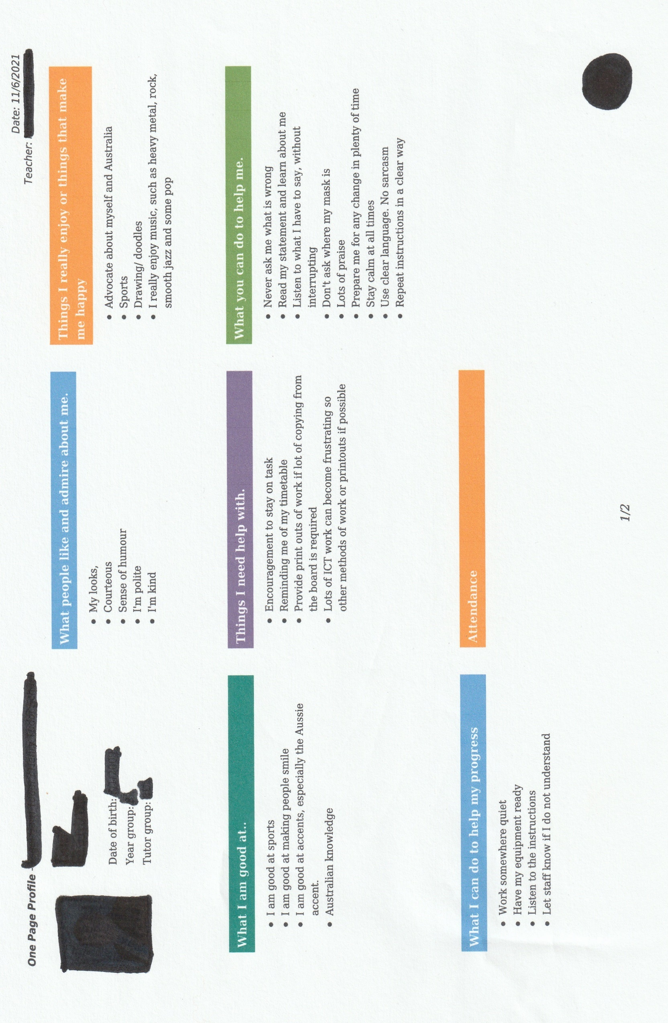
Appendix B

