

BA (Hons) Leadership and Management Skills for the Workplace

Module: Emergent Leadership Skills in the Workplace
Module code: BMSW6101

Student: Rupia Hussain-ID: 2010133
Lecturer: Ejiro Esohwode

Assignment Title 1: Individual Report on: “What emergent leadership skills, do you consider, may be effective for the leaders of your chosen organisation in analysing and assessing strategies for making decisions amid uncertainty caused by the COVID-19 pandemic and ongoing economic uncertainty?”

Task 2 – Individual Reflective Essay

Executive summary

The primary purpose of this report is to critically evaluate leadership theories and styles implemented at Marks and Spencer, a renowned retail company. The report aims to provide insights into the leadership approaches and styles that have been utilised within the organisation, analysing their effectiveness and impact on the company's performance and employee satisfaction. By examining these aspects, the report intends to offer recommendations for potential improvements.
This critical review will highlight the complexities and limitations associated with each of these leadership theories:- The Great Man theory, The Trait and the Transactional theory in various contexts. Effective leadership often requires a nuanced approach that integrates insights from multiple theories while considering the specific needs of the situation and the individuals involved (Armstrong, 2016).
The best leadership approach will depend on factors such as the company's current situation, market dynamics, employee needs and the company's long-term vision. A leader who can integrate leadership skills while remaining adaptable and responsive to the changing environment will be well-equipped to guide M&S successfully post-COVID-19.
This report also provides consequences for failing to act on recommendations for the new leadership team to enhance organisational effectiveness and manage the company more efficiently and adaptively.

Contents

Page Number

1. Introduction……………………………………………………………………………………………………………..….4
1.2. Justification for Choosing the Organisation……………………………………………………..5
2. What is Emergent Leadership?..........................................................................................5
3. Critical Evaluation of Three Leadership Theories……………………………………………………….…..7
3.1. Outlining Positive and Negative Aspects……………………………………………………….….8
4. Evaluation of Leadership Styles/Approaches…………………………………………………………………11
5. Critically Comparing and Contrasting Theories……………………………………………………………..13
6. Marks & Spencer’s present Leadership Style…………………………………………………………………14
7. Recommendation of New Leadership Style……………………………………………………………………14
8. Recommendations…………………………………………………………………………………………………………15
8.1. Consequence for not Following Recommendations…………………………………..…….16
9. Conclusion……………………………………………………………………………………………………………………..17
10. Task 1- Reference…………………………………………………………………………………………………………18
Task 2- Individual Reflective Essay………………………………………………………………………………………20
Task 2- Reference……………………………………………………………………………………………………………….23
Appendix……………………………………………………………………………………………………………………………23

1. Introduction

 (Image: Marks & Spencer, 2023)
This report is being prepared to understand how different leadership theories and styles have influenced the company's management practices and organisational culture. Marks and Spencer Initially, began as a market stall in Leeds, UK. Established in 1884 by Michael Marks and Thomas Spencer, known for its wide range of products including clothing, food and home goods. 76,000 people work for M&S both in the UK and overseas (Forbes, 2022). Marks & Spencer has a long history and has been an influential player in the retail industry, often regarded as a symbol of British quality and reliability.
The COVID-19 pandemic and its subsequent economic impact have disrupted industries worldwide, requiring leaders to navigate through unprecedented levels of uncertainty. Organisations like Marks and Spencer (M&S) have faced challenges in formulating strategies and making decisions amidst this uncertainty. M&S has gone through various leadership styles and approaches over the years, adapting to changing market trends and consumer preferences (Marks & Spencer, 2023). This report delves into the emergent leadership skills that could prove effective for M&S's leaders in analysing and assessing strategies during these challenging times.
1.1. Products and Services Offered by Marks and Spencer
Marks and Spencer offers a diverse range of products and services, catering to various customer needs. Their primary categories include:
- Clothing and Apparel: M&S clothing lines, including men women and children's clothing, footwear and accessories. The brand emphasizes quality, style and affordability (Marks & Spencer, 2023).
- Food and Beverages: M&S is a major player in the grocery market, providing high-quality food products such as fresh produce, prepared meals, baked goods and premium items. Their focus on innovation, sustainability and healthy options has contributed to their reputation in this sector (Marks & Spencer, 2023).
- Home and Lifestyle Products: range of home goods, bedding, furniture, kitchenware and decorative items.
- Beauty and Personal Care: M&S offers cosmetics, skincare products, fragrances and personal care items. The brand's commitment to ethical and sustainable beauty practices has gained traction among conscious consumers (Marks & Spencer, 2023).

1.2. Justification for Choosing the Organisation.
Being employed as a sales assistant at Marks and Spencer, it was a natural decision for me to compose a report concerning this establishment. The alterations that unfolded during the COVID-19 pandemic have impacted us as staff in various manners—some yielding positive outcomes, while several changes have been unfavourable and challenging to acclimate to. Marks and Spencer maintain a noteworthy presence within the retail sector and the strategies enacted by its leadership hold a crucial position in moulding the triumph of the company. Over the decades, M&S evolved into a major high-street retail giant with a global presence. The company's commitment to quality, value and customer service has played a significant role in its success and enduring popularity.

2. What is Emergent Leadership?
Emergent leadership transpires when an individual within a group assumes the role of a leader organically, rather than being formally designated or chosen. These emergent leaders intrinsically drive themselves to discover solutions and offer assistance to their peers. They tackle issues by inquiring and exchanging thoughts, often taking the initiative to propose solutions for demanding circumstances. Exhibiting self-initiative, emergent leaders play a pivotal role in generating and sustaining the drive for projects or situations (Erkic, 2022).

2.1. What are Leadership Attributes and Skills?

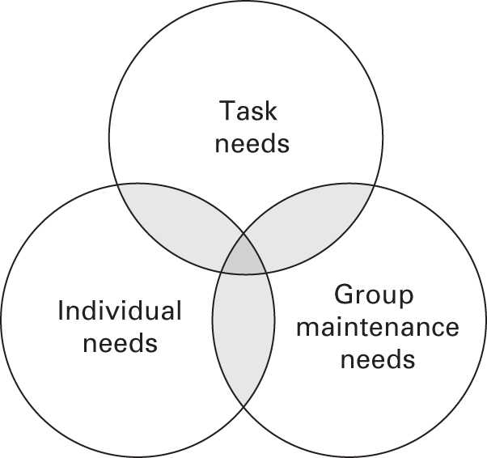 (Armstrong, 2016, p.26).
Emerging leaders embody action, addressing events as they unfold, all while maintaining a vital concern for their trajectory. This demands prowess in strategic cognition, especially at more elevated tiers. Functioning as strategic visionaries, leaders cultivate a sense of mission and constructs for outlining aspirations and forthcoming paths. Their involvement lies in the realm of strategic administration (Armstrong, 2016, p.35). Essential attributes for effective managerial leadership encompass:
- Distinct clarity of purpose.
- Firm principles and individual uprightness.
- Devotion to cultivating others through guidance and tutelage.
- Advocate for inclusivity and multiplicity.
- Proficiency in engaging and communicating across all echelons.
- The consciousness of self and allocation of time for introspection.
- Embracing collaboration, interconnectedness, and an absence of hierarchy.
- Adaptable and inventive, harbouring technological inquisitiveness and acumen.
- Personal tenacity and resilience.
- An impressive history of achievements (Armstrong, 2016, p.35).
Leadership entails guiding individuals to give their utmost effort to attain a sought-after outcome. It can be characterized as the skill to convincingly encourage others to modify their actions voluntarily. Leadership encompasses the tasks of formulating and conveying a forward-looking vision, inspiring individuals and ensuring their active participation in the assigned responsibilities (Armstrong, 2016, p.35).

3. Critical Evaluation of Three Leadership Theories.
3.1. Outlining Positive and Negative Aspects
1. The Great Man Theory of Leadership
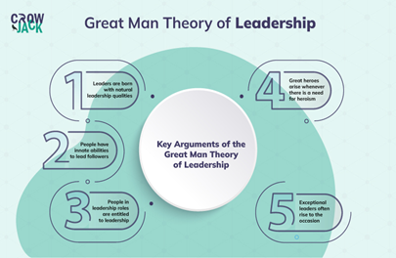 (Image: Crowjack, n.d.)
Analyses: Positive Aspects
- Recognition of Innate Traits: The importance of natural leadership traits such as intelligence, charisma, confidence and assertiveness. It acknowledges that certain individuals possess these traits inherently and the ability to guide others effectively (Armstrong, 2016).
- Inspiration and Motivation: Their exceptional qualities can drive people to achieve greater goals and perform beyond their perceived capabilities (Armstrong, 2016).
- Historical Examples: Historical leadership impact has been undeniable, such as Abraham Lincoln, Martin Luther King Jr. and Winston Churchill, shaping history through their remarkable leadership abilities.
Negative Aspects:
- Lack of Empirical Support: Leadership is complex and multifaceted by various factors including context, culture and followers' needs, which the theory oversimplifies by focusing solely on individual traits.
- Limited Scope: Neglects the role of situational and contextual factors in leadership effectiveness. Leadership success is contingent on the environment, the challenges at hand and the dynamics between leaders and followers. Ignoring these compromises, the theory's validity (Kishore, 2020).
- Exclusivity and Bias: Assumes that only a selected few possess the inherent traits of a great leader, neglecting the potential for leadership development in others. Which hinders diversity in leadership positions (Kishore, 2020).
- Ignoring Skill Development: By emphasising innate qualities, disregards experience and learning in becoming an effective leader. Oversight continuous improvement and growth (Kishore, 2020).
- Role of Followers: Emphasis only on the leader. Effective leadership involves a reciprocal relationship between leaders and their followers, where influence flows both ways (Kishore, 2020).
- Cultural and Gender Limitations: The theory is rooted in a historical context that may not resonate with contemporary leadership practices and expectations. Focuses on masculine traits, suggesting that only certain traits are suitable for leadership.

2. Trait Theory:- The Big Five
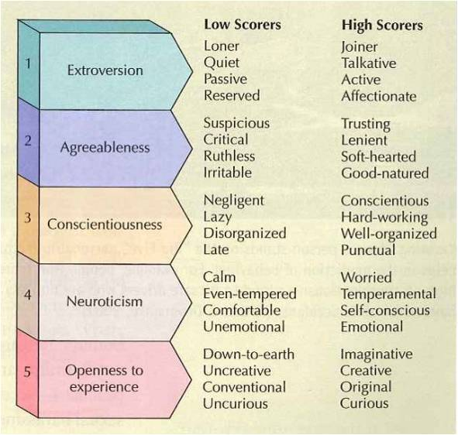 (Image: Janaenahirney, 2015)
Analyses: Positive Aspects
- Predictive Value: demonstrates only certain behaviours and tendencies individuals who exhibit specific traits, such as extraversion, tend to engage more in social activities and are likely to be organised and responsible (Armstrong, 2016).
- Common Language: This allows psychologists, researchers and individuals to communicate and understand personality differences (Armstrong, 2016).
- Scientific Approach: Trait Theory relies on empirical research and quantitative methods, making it a relatively scientific approach to understanding personality. Data collection enhances the theory's credibility.
- Personal Development: By identifying one's traits and understanding their implications, individuals can work on enhancing positive traits and managing negative ones.

Negative Aspects:
- Simplistic View of Personality: People are multifaceted their behaviours often result from interactions between various traits and situational factors (Cherry, 2023).
- Lack of Explanation: The theory fails to explain why individuals possess certain traits or how they develop. This lack of explanation limits the theory's depth in understanding the underlying mechanisms of personality (Cherry, 2023).
- Inflexibility: Trait Theory contradicts the idea that individuals can change and grow through experiences and personal development. This rigidity ignores the potential for personality change and adaptation (Cherry, 2023).
- Cultural and Contextual Differences: The influence of cultural and contextual factors on personality. What is considered a positive trait in one culture may not hold the same value in another and the impact of certain traits can vary depending on the situation.
- Predictive Limitations: Traits predict certain behaviours may not be accurate, People act differently based on the specific circumstances they find themselves in.
3. Transformational Leadership Theory: the "Four I's"
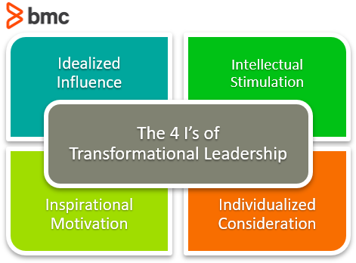 (Image: Hornay, 2020)
Analyses: Positive Aspects
  - Inspiration and Motivation: Inspire and motivate followers to achieve beyond their expectations, fostering a sense of commitment and enthusiasm (Armstrong, 2016).
  - Visionary: encourages leaders to have a clear and compelling vision, which can align the organisation and drive innovation (Armstrong, 2016).
  - Positive Organizational Culture: Promote a culture of learning, collaboration and personal development, which can lead to improved performance and engagement.
Negative Aspects:
  - Dependency on the Leader: Over-reliance on the leader's charisma and vision, potentially causes issues when the leader is absent (Schuh, Zhang and Tian, 2012).
  - Ethical Concerns: Leaders may focus too much on their vision and goals and may neglect ethical considerations and the well-being of individual employees (Schuh, Zhang and Tian, 2012).
  - Burnout Potential: A high-energy approach can lead to burnout if not managed well, both for the leader and the followers (Schuh, Zhang and Tian, 2012).
Each theory has its strengths and limitations. The effectiveness of any leadership approach depends on the leader's ability to adapt and apply the theory in the given context.

4. Evaluation of Leadership Styles/Approaches

The effectiveness of leadership styles holds considerable sway over an organisation's achievements and the overall welfare of its members. A multitude of styles and methodologies exist, each tailored to varying organisational contexts and circumstances. Presented below are several approaches, accompanied by their respective merits and demerits:
1. Autocratic Leadership:
Positive Aspects:
- Quick Decision-Making: Make fast decisions without waiting for consensus.
- Clear Direction: The leader's clear instructions can prevent confusion and maintain focus on goals.
- Efficiency: Hierarchical structure enables efficient implementation of decisions (Armstrong, 2016).
Negative Aspects:
- Lack of Collaboration: Employees might feel excluded from the decision-making process, leading to decreased morale and innovation (Indeed Career Guide, 2022).
- Reduced Creativity: The absence of input from diverse perspectives can hinder creative problem-solving.
- Employee Dissatisfaction: The authoritarian nature of this style can lead to dissatisfaction and higher turnover rates (Indeed Career Guide, 2022).
2. Transactional Leadership:
Positive Aspects:
- Clear Structure: Transactional leaders establish clear expectations, rules, and performance standards, promoting order and efficiency.
- Rewards and Punishments: Motivation through rewards (bonuses) and punishments (like reprimands) can drive performance in the short term.
- Predictability: Employees know what to expect in terms of outcomes, creating a stable work environment (Armstrong, 2016).
Negative Aspects:
- Limited Innovation: Focus on task completion might discourage creative thinking and innovation.
- Short-Term Focus: Emphasis on immediate goals might hinder long-term strategic thinking (Kark, Van Dijk and Vashdi, 2018)
- Dependency: Employees might become solely motivated by rewards, leading to a lack of intrinsic motivation (Kark, Van Dijk and Vashdi, 2018).
3. Servant Leadership:
Positive Aspects:
- Empathy: Servant leaders prioritise employee well-being, leading to a positive and caring work environment.
- Ethical Focus: Decision-making is rooted in ethical considerations, promoting fairness and moral values (Rude, 2004).
- Strong Teams: Encourages collaboration, open communication and a sense of community within the organisation (Rude, 2004).
Negative Aspects:
- Decision-Making Delays: Focus on consensus and employee needs might slow down decision-making processes.
- Balancing Act: Balancing employees' needs with organisational goals can be challenging.
- Perceived Weakness: Some might perceive servant leaders as lacking the assertiveness needed for effective leadership (Rude, 2004).
Each leadership style/approach has its own merits and drawbacks and the effectiveness depends on factors such as the organisational culture, the nature of the tasks and the characteristics of the team (Northouse, 2022). An effective leader should be able to adapt their style based on the situation, understand when to provide guidance, foster collaboration, inspire transformation or empower autonomy to achieve the best outcomes for their team and organisation (Rude, 2004).

5. Critically Comparing and Contrasting Theories:

6. Marks & Spencer’s present Leadership Style

M&S has now embarked on the second phase of its transformation initiative, known as "Shaping the Future." The Board's perspective is that the current team has achieved significant strides in the business and maintaining strategic and leadership continuity is beneficial (Marks & Spencer, 2022). M&S has appointed a robust new leadership team to expedite advancements in its transformation journey. M&S is now commencing the execution of its predetermined succession plan (Marks & Spencer, 2022).
Regarding Marks and Spencer, a thorough investigation by Satti, (2023), indicates that its prevailing leadership approach leans toward being authoritative. This form of leadership mobilizes all available resources to attain a shared objective. In this fashion, their method of handling projects and other endeavours exudes confidence, combined with elements of consultation leadership style. They outline the goals while entrusting their staff to execute tasks according to their discretion, thereby enabling them to discover the most optimal path to achievement. The reorganisation of both the organisational framework and the managerial team of Marks and Spencer stands as a prominent illustration of this approach (Satti, 2023).

7. Recommendation of New Leadership Style

The Transactional leadership style is advantageous for Mark & Spencer due to its alignment with the retail industry's characteristics and the specific challenges posed by the pandemic. By providing structure, performance incentives and hierarchical clarity, this approach can contribute to M&S's goal achievement, employee motivation and overall operational efficiency.
7.1. Emerging Post-COVID- New Leadership Style

Opting for a Transactional leadership style amid the challenges posed by COVID-19 can bring several benefits to Mark & Spencer (M&S) due to the nature of its business and the specific circumstances it faces:
- Clarity and Structure: The Transactional leadership style is characterised by clearly defined roles, responsibilities and tasks, which is crucial in a retail setting like M&S. With routine operations and tasks, employees need precise guidance, especially during uncertain times like the pandemic.
- Performance Focus: M&S's commitment to maintaining high performance aligns well with the Transactional leadership approach. As M&S strives to achieve its goals, the focus on performance can drive employees to contribute to the company's success.
- Motivation through Rewards: In the retail industry, where routine tasks are prevalent, the rewards-based approach of Transactional leadership can be particularly effective (Northouse, 2022). Which can enhance employee’s job satisfaction and productivity. This approach can help M&S retain motivated employees who contribute to the company's overall performance.
- Hierarchical Structure: M&S operates within a hierarchy that spans various levels, from frontline staff to managerial positions. The Transactional leadership style aligns well, as it provides a clear chain of command, making it easier to communicate expectations, monitor performance and provide feedback. This hierarchical alignment can aid consistent performance and efficient decision-making (Satti, 2023).
- Guidance for a Diverse Workforce: Transactional leadership involves supervision and guidance. This leadership style allows M&S to mentor and support less experienced staff while acknowledging the capabilities of seasoned team members (Satti, 2023).
- Bureaucracy in Retail: The bureaucratic aspect of the Transactional style suits the retail company. M&S, where efficiency is essential to meet customer demands, has a well-defined and regulated approach to maintaining consistency and quality in operations.
- Adaptation to Crisis: Amid the COVID-19 pandemic, businesses faced unprecedented challenges. The Transactional style's emphasis on task-focused management provides stability during uncertain times. M&S can use this approach to navigate the crisis and maintain operational continuity.

8. Recommendations

The recommendations provided in this report offer a comprehensive guide for the new leaders at Marks and Spencer to improve organisational management and navigate the challenges of the modern retail industry. By adopting a transformational leadership style, embracing digitalization, empowering employees, supporting diversity and implementing innovative management practices, M&S can position itself for sustained success and growth in an ever-evolving market (Satti, 2023). Selecting the most effective leadership skills for an (M&S) requires an understanding of the organisation's challenges and needs. While there are several leadership theories and styles to consider, key leadership skills that would be valuable in this context:
- Empathy and Emotional Intelligence: Leaders who can understand and relate to the emotional experiences of their employees and customers are better equipped to create a supportive and empathetic work environment. Boosting morale and addressing the emotional toll that the pandemic might have taken on the workforce (Satti, 2023).
- Effective Communication: Leaders need to be skilled communicators who can share information, set expectations and guide in a way that reduces ambiguity and fosters trust. This includes active listening and conveying empathy (Northouse, 2022).
- Innovation and Creativity: The post-COVID-19 landscape may require new approaches and innovative solutions. Leaders who can foster a culture of innovation and encourage creative problem-solving can help M&S adapt its strategies, products and services to meet changing customer demands (Satti, 2023).

8.1. Consequence for not Following Recommendations.
If the recommended strategies for improving and managing Marks and Spencer under the new leadership style are not followed, the consequences could be significant and detrimental to the organisation's success and sustainability:
- Lack of Agility: Without adopting agile management practices, the organisation might struggle to respond quickly to market changes and emerging trends and increase vulnerability to disruptions.
- Ineffective Decision-Making: If decentralized decision-making is not implemented, decision-making processes might become slow, hierarchical and inefficient. This can hinder the organisation's ability to adapt swiftly (Satti, 2023).
- Reduced Diversity and Inclusion: This lack of diverse perspectives can limit creativity, innovation and problem-solving capabilities, ultimately impacting the company's competitiveness.

9. Conclusion

A combination of these skills, tailored to the specific context and challenges faced by M&S, would be most effective. The best leadership approach will depend on factors such as the company's current situation, market dynamics, employee needs and the company's long-term vision (Northouse, 2022). A leader who can integrate these skills while remaining adaptable and responsive to the changing environment will be well-equipped to guide M&S successfully post-COVID-19.
In the process of returning to a sense of "normalcy" post the COVID-19 pandemic, leaders at M&S must exert their utmost effort. Generally, managers bear the responsibility of overseeing a team of individuals and providing them with direction and guidance. It is customary for them to maintain direct communication with their team, members stationed in various locations, including their homes, collaborating on interdependent tasks.
Ethical and Values-Driven Leadership: Demonstrating strong ethics and values is paramount for leaders, as it helps in building trust, maintaining employee morale and upholding the organisation's reputation in challenging times. Building a cohesive and collaborative team is essential for post-pandemic success. Leaders who can harbour a sense of belonging, facilitate effective teamwork and leverage the diverse skills of their team members will be better positioned to achieve organisational goals (Armstrong, 2020).
In summary, failing to follow the recommended strategies for improving and managing Marks and Spencer under the new leadership style could lead to a downward spiral of declining performance, eroded employee morale, loss of customer trust and missed opportunities for growth. To ensure long-term success, the new leadership must embrace these recommendations and proactively steer the organisation toward a more adaptive, collaborative and innovative path.

10. Reference

Armstrong, M. (2016). Armstrong’s handbook of management and leadership for HR : developing effective people skills for better leadership and management. 4th ed. [online] London [England]: Kogan Page, p.21. Available at: https://r4.vlereader.com/EpubReader?ean=1780749478162# [Accessed 15 Aug. 2023].
Armstrong, M. (2020). Armstrong’s handbook of management and leadership : developing effective people skills for better leadership and management. 3rd ed. London ; Philadelphia: Kogan Page.
Cherry , K. (2023). What the Trait Theory Says About How Our Personalities Are Composed. [online] Verywell Mind. Available at: https://www.verywellmind.com/trait-theory-of-personality-2795955#:~:text=The%20first%20trait%20theory%20was [Accessed 16 Aug. 2023].
Crowjack. (n.d.). Engaging explanation of The Great Man Theory of Leadership. [online] Available at: https://crowjack.com/blog/strategy/leadership-theories/great-man-theory [Accessed 16 Aug. 2023].
Forbes (2022). Marks & Spencer. [online] Forbes. Available at: https://www.forbes.com/companies/marks-spencer/ [Accessed 16 Aug. 2023].
Hornay, R. (2020). Transformational Leadership in the Enterprise. [online] BMC Blogs. Available at: https://www.bmc.com/blogs/transformational-leadership/ [Accessed 16 Aug. 2023].
Indeed Career Guide. (2022). Pros and Cons of Autocracy. [online] Available at: https://www.indeed.com/career-advice/career-development/pros-and-cons-of-autocracy [Accessed 16 Aug. 2023].
Janaenahirney (2015). The Big Five – Personality Testing in Psychology. [online] janaenahirney. Available at: https://janaenahirney.wordpress.com/2015/09/26/the-big-five-personality-testing-in-psychology/ [Accessed 16 Aug. 2023].
Kark, R., Van Dijk, D. and Vashdi, D.R. (2018). Motivated or Demotivated to Be Creative: The Role of Self-Regulatory Focus in Transformational and Transactional Leadership Processes. Applied Psychology, 67(1), pp.186–224. doi:https://doi.org/10.1111/apps.12122.
Khan, Z.A., Nawaz, A. and Khan, I.U. (2016). Study on Leadership Styles and Theories. [online] 16. Available at: https://www.researchgate.net/publication/293885908 [Accessed 14 Aug. 2023].
Kishore, K. (2020). Great Man Theory Of Leadership. [online] Harappa. Available at: https://harappa.education/harappa-diaries/great-man-theory-of-leadership/#:~:text=Criticism%20Of%20The%20Great%20Man%20Theory&text=Sociologist%20Herbert%20Spencer%20suggested%20that,instrumental%20in%20shaping%20their%20qualities. [Accessed 16 Aug. 2023].
Marks & Spencer. (2023). Our Leadership. [online] Available at: https://corporate.marksandspencer.com/about-us/our-leadership [Accessed 10 Aug. 2023].
Northouse, P. (2022). Leadership: Theory and Practice. 9th ed. Los Angeles: Sage Publications.
Rahaman, Md.S. (2020). Management Theories Applied by Marks and Spencer. [online] CIRCLE OF BUSINESS. Available at: https://circlebizz.com/management/management-theories-applied-by-marks-and-spencer/ [Accessed 14 Aug. 2023].
Rude, W. (2004). Servant Leadership and Burnout THE CONNECTION BETWEEN SERVANT LEADERSHIP AND JOB BURNOUT. [online] Available at: https://www.twu.ca/sites/default/files/rudewally_0.pdf [Accessed 16 Aug. 2023].
Satti, R.M. (2023). Marks & Spencer. [online] www.linkedin.com. Available at: https://www.linkedin.com/pulse/marks-spencer-reshayl-m-satti [Accessed 14 Aug. 2023].
Schuh, S.C., Zhang, X. and Tian, P. (2012). For the Good or the Bad? Interactive Effects of Transformational Leadership with Moral and Authoritarian Leadership Behaviors. Journal of Business Ethics, 116(3), pp.629–640. doi:https://doi.org/10.1007/s10551-012-1486-0.
The Dark Side of Transformational Leader Behaviors for Leaders. (n.d.). Available at: https://www.sc.edu/study/colleges_schools/moore/documents/center_for_executive_succession/2020_126_the_dark_side_of_transformational_leader_behaviors_for_leaders.pdf [Accessed 16 Aug. 2023].

Task 2- Individual Reflective Essay

1. This self-reflective report aims to explore how the Gibbs Reflective Cycle can be utilised to develop and enhance leadership skills within the context of a customer service assistant's role.
In my role as a Customer Service Assistant, my next goal is to ascend to a leadership position, overseeing the shop floor team. Opting for the right leadership style depends on personal traits, strengths, organisational culture and team dynamics. Here are some leadership styles suitable for aspiring leaders in customer service like me:
- Servant Leadership:- This approach emphasizes team and customer support, prioritizing others, fostering collaboration, and enhancing customer experiences. My self-motivation can inspire teams effectively.
- Transformational Leadership:- Transformational leaders inspire and motivate the team to achieve extraordinary results. Create a vision for the future, communicate it effectively and encourage innovation and growth. In a customer service role, this style can help me inspire the team to provide exceptional service and exceed customer expectations.
- Adaptive Leadership:- Adaptive leaders flexibly adjust their style based on team needs and changing situations, effective in diverse customer service.
- Transactional Leadership:- Transactional leaders emphasize precise structures, goals and rewards, guiding and overseeing performance, valuable for process-driven customer service roles.
In essence, the optimal leadership approach will be contingent upon the strengths, values and requisites of both the team and the organisation. Additionally, maintaining a malleable disposition and a willingness to modify the leadership methodology per evolving circumstances is of paramount significance. Proficient leaders frequently amalgamate facets from various styles to aptly align with varying scenarios and individual inclinations. Upon a comprehensive study and discerning analysis of numerous leadership paradigms, I am inclined to adopt the Transformational leadership style as I embark on a new transformative journey toward becoming an inspirational leader.

2. Ethics of Leadership
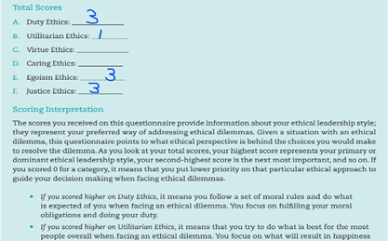 (Results: Questionnaire from Moodle, 2023)
- Higher Duty Ethics score: Following moral rules and fulfilling obligations.
- Higher Egoism Ethics score: Prioritizing personal goals, asserting own interests.
- Higher Justice Ethics score: Emphasizing fairness and equitable sharing of outcomes.
These scores reflect my diverse ethical approach, considering varied factors in decisions. They're relative and don't wholly define me. Ethical choices are intricate, balancing perspectives based on situations. Interpreting these tendencies aids self-awareness, informed decisions and alignment with personal values.
3. Strengths and Weaknesses
Achieving a prominent position within the realm of customer service necessitates the amalgamation of fundamental skills, expertise and formal instruction. Addressing certain areas of vulnerability, to transform them into strengths, mandates the pursuit of specific skills and training avenues. These endeavours are geared towards enhancing my leadership proficiencies.
1. Problem-Solving and Decision-Making:- Leaders require quick, informed decision-making. Developing strong problem-solving skills and handling pressure is vital.
Action: Keep learning to stay updated on industry trends, customer service and leadership theories for ongoing skill enhancement.
2. Conflict Resolution:- Customer service includes conflict management. Master de-escalation and conflict resolution for positive outcomes.
Action: Learn to handle common service conflicts, boosting leadership skills.
3. Time Management:- Leaders must juggle tasks, prioritize, and manage time effectively.
Action: Workshops on time management, prioritization and productivity for multitasking leaders.
4. Training and Development:- Invest in leadership programs. Seek workshops and courses on management and soft skills.
Action: Customer service staff - Find programs for communication, team leadership and problem-solving.
5. Feedback and Self-Reflection: I regularly seek feedback from my supervisors, peers and team members. Engaging in self-reflection will help me to identify areas for improvement and growth.
What I understood from this module are leadership skills develop over time through consistent effort and learning. As I acquire new skills and experiences, I'll become better equipped to lead and inspire others in my customer service role.

4. Developing Emerging Leadership Skills through Gibbs Reflective Cycle
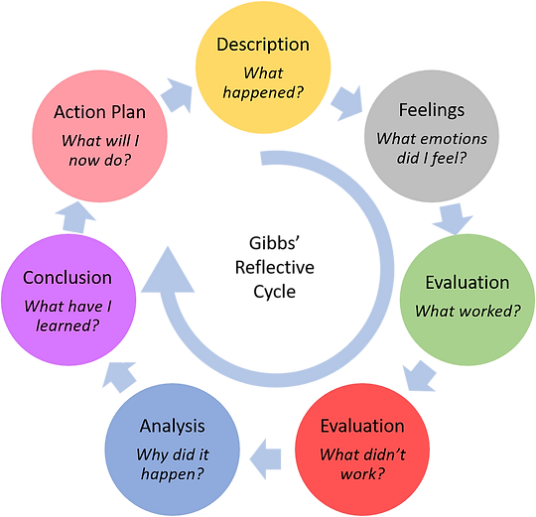 (Image Gibbon, 2019)
The role of a customer service assistant encompasses more than just addressing customer inquiries. It presents an opportunity to cultivate and showcase emerging leadership skills that can contribute to personal and professional growth.
1. Description - The Experience:
I will reflect upon a specific experience where I had the opportunity to demonstrate leadership skills in my role as a customer service assistant. For instance, I could recount a situation where I took the initiative to lead a team during a particularly busy period or facilitated a training session for new colleagues (Wallbridge, 2022).
2. Feelings - Initial Reactions:
I will examine my initial feelings and emotions during the experience. Did I feel confident, anxious or excited about taking on a leadership role? Did I face any internal or external challenges that influenced my reactions?

3. Evaluation - Positive and Negative Aspects:
A critical analysis of the positive and negative aspects of the experience. I will evaluate how my leadership actions contributed to the overall outcome. Did my efforts lead to improved teamwork, customer satisfaction or operational efficiency? Were there any areas where I could have handled things differently or made better decisions? (Gibbon, 2019).
4. Analysis - Understanding the Situation:
This requires a deeper analysis of the experience. What leadership skills did I employ during the situation? Did I demonstrate effective communication, problem-solving, delegation or conflict-resolution skills? How did my actions align with the expectations of a customer service assistant's role? (Wallbridge, 2022).
5. Conclusion - What Could Have Been Done Differently:
Involves identifying what could have been done differently to enhance the leadership skills demonstrated. Were there any missed opportunities for further growth? Could I have taken on more responsibilities or provided additional guidance to my team members?
6. Action Plan - Development of Leadership Skills:
Based on the analysis, I will formulate an action plan to further develop my emerging leadership skills as a customer service assistant. This plan could include steps such as seeking out leadership training or workshops, actively seeking opportunities to lead projects or initiatives, and setting goals for continuous improvement (Wallbridge, 2022).

5. Conclusion

The entire module has illuminated numerous avenues for me to discover various leadership styles and approaches that were previously unfamiliar to me. This has motivated me to cultivate and explore my capabilities, fostering a drive to ascend to higher positions. These skills can be applied in both my professional and personal life, enabling me to manage challenging situations.
Using Gibbs Reflective Cycle strengthens my growth as a customer service assistant, aiding analysis of my leadership development. By reflecting on experiences, understanding consequences, and planning for growth, I build effective leadership qualities for personal and professional advancement, preparing for future leadership roles.

Task 2- Reference

Gibbon, J. (2019). We do not learn from experience... we learn from reflecting on experience. [online] Performance Management Systems. Available at: https://www.pmsystems.co.uk/post/we-do-not-learn-from-experience-we-learn-from-reflecting-on-experience [Accessed 22 Aug. 2023].Wallbridge,
Wallbridge, A. (2022). Gibbs reflective cycle – How to learn from experience and become a better leader. [online] TSW Training. Available at: https://www.tsw.co.uk/blog/leadership-and-management/gibbs-reflective-cycle/ [Accessed 22 Aug. 2023].

Appendix



