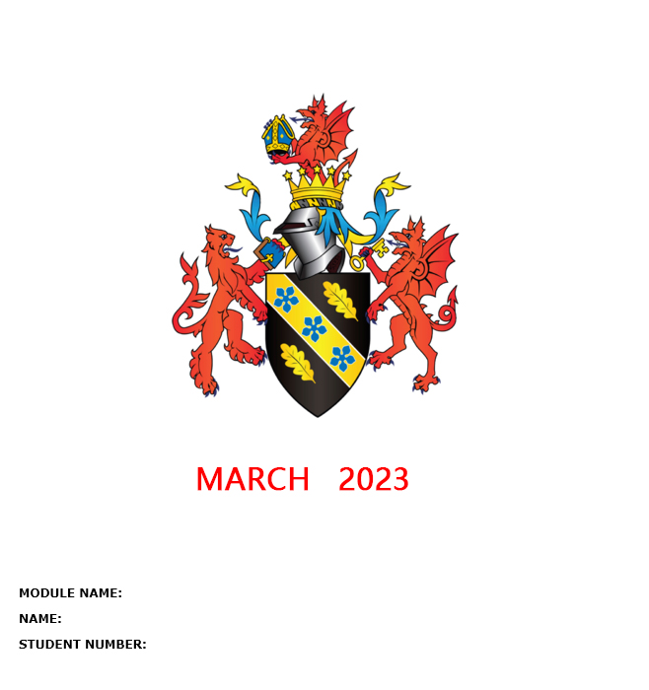
2203623
Yuchi Zhang
BMMB 7007 Human Resource Management
Video Link:

https://web.microsoftstream.com/video/1460d3b7-bdd2-459f-b33f-4df515cf4026
Reference list:
Ashok Chanda and Jie Shen (2009) HRM Strategic Integration and Organizational Performance. Los Angeles: Sage Publications Pvt. Ltd (Response Books). Available at:https://search-ebscohost-com.ezproxy.uwtsd.ac.uk/login.aspx?direct=true&db=nlebk&AN=305676&site=ehost-live (Accessed: 21 March 2023).
Chaudhary, M. (2023) How CHATGPT can be a game changer in human resource management, Spiceworks. Available at: https://www.spiceworks.com/hr/future-work/articles/chatgpt-can-be-a-game-changer-in-hrm/ (Accessed: April 27, 2023).
CIPD (2019) Psychological contract: Factsheets, CIPD. Available at: https://www.cipd.co.uk/knowledge/fundamentals/relations/employees/psychological-factsheet (Accessed: March 20, 2023).
CIPD (2021) Harnessing Digital Learning platforms to support talent growth, CIPD. Available at: https://www.cipd.co.uk/knowledge/work/technology/digital-transformation-insights/learning-platforms-innovation (Accessed: April 27, 2023).
CIPD (2022) Employee communication: Factsheets, CIPD. Available at: https://www.cipd.co.uk/knowledge/fundamentals/relations/communication/factsheet (Accessed: April 27, 2023).
Conway, N. and Briner, R.B. (2006) Understanding Psychological Contracts at Work: A Critical Evaluation of Theory and Research. Oxford: Oxford University Press, Incorporated. Available at: https://doi.org/10.1093/acprof:oso/9780199280643.001.0001.
Guest, D., Isaksson, K. and Witte, H. de. (2010) Employment contracts, psychological contracts, and employee well-being an international study. Oxford: Oxford University Press.
Mellahi K and DG Collings (2010) The barriers to effective global talent management: The example of corporate elites in MNE. Journal of World Business 45(2), 143–149.
Paauwe, J. (2004) ‘HRM and Strategy: Does It Matter?’, in HRM and Performance. Oxford: Oxford University Press. Available at: https://doi.org/10.1093/acprof:oso/9780199273904.003.0002.
PwC (2017) Artificial Intelligence in HR A no brainer - PWC. Available at: https://www.pwc.nl/nl/assets/documents/artificial-intelligence-in-hr-a-no-brainer.pdf (Accessed: March 22, 2023).

