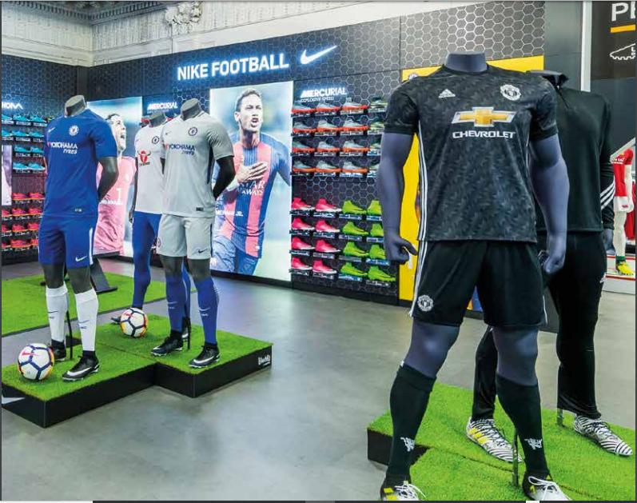  Mike Ashley: The rise of Britain's craziest retailer  (Sports Direct International plc, 2017) | Abstract  Mike Ashley one of British wealthiest people, He is a retailer and a self-made Billionaire His success made Telegraph (2014) to declare Ashley as ‘Britain's craziest retailer’ while (BBC, 2018) Labelled Ashley as ‘The saviour of the High Street’, the "Selfridges of Sport" for Sports Direct and the "Harrods of the High Street" for House of Fraser. (BBC, 2018d).  Adekoyejo Sobola (1601748)

The "Selfridges of Sport" for Sports Direct and the "Harrods of the High Street" for House of Fraser.

Executive Summary
This paper is about Mike Ashley, the founder of Sports Direct (SD), the largest sportswear retailer in the United Kingdom. Mike Ashley one of British wealthiest people, is reported to worth$3Billion (Forbes, 2019). He is a retailer and a self-made Billionaire. In 1982, at the age of eighteen, after leaving school, he founded Sports Direct. In 2007, the company went public and became Sports Direct International plc (SDI) (Sports Direct, Group or the Company). He bought the Newcastle Football club (2007) as well as Rangers football club (2014), this two-acquisition contributed to him being viewed as the public enemy in United Kingdom (UK) (MarketLine, 2018; Sports Direct International plc, 2017). Ashley displayed different leadership skills to lead his company. Despite the public outcry against him and his company in 2016, he has managed to transform his company culminating in Sports Direct being selected among the most innovative companies in the world. Asley claimed SD has one of the highest Share Schemes for staff in the UK. He has his set of trusted managers the in-group and how he treated the warehouse staff who are treated as out-group. Ashley is a very interesting character.

Introduction
Sports-Direct (SD) has a diversified portfolio that includes sports, fitness, fashion products and brands through its physical stores and e-commerce portals in 20 countries and is now the UK’s largest sporting goods retailer by revenue with over 826 stores and 26,500 staff across five business segments: UK Sports Retail, European Sports Retail, Premium etc. But SDI directly engaged 17,700 staff in the UK (MarketLine, 2018; Sports Direct International plc, 2018, 2019a) figures 1 and 2.
Figure 1
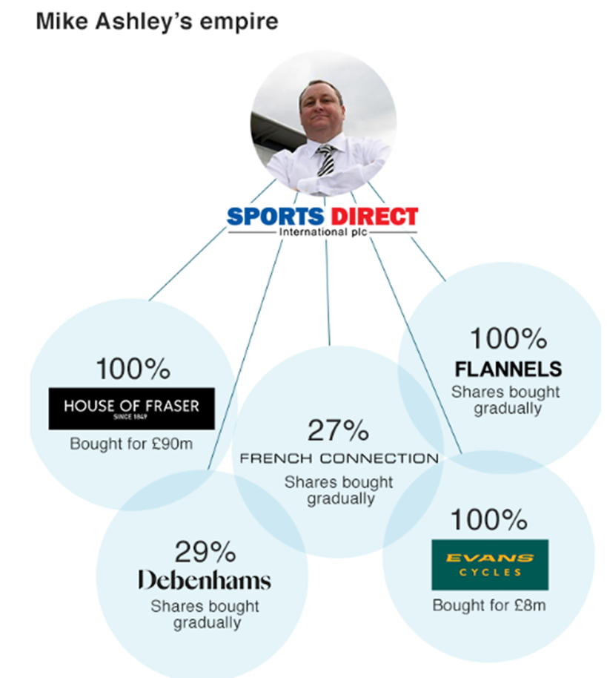
(BBC, 2018d/f)

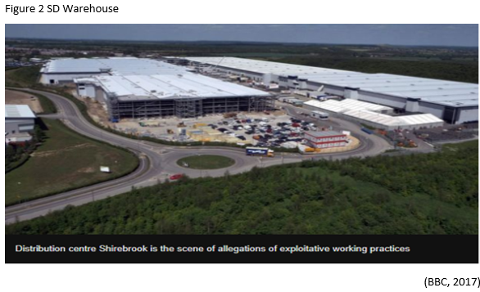

2.0 Main Findings
The company was accused in 2016 of creating a culture of fear, paying less than the national minimum wage, unpaid after-hours work, and questionable punitive practices. This incident forced Ashley to respond after being summoned to the commons’ business, innovation and skills (BIS) select committee. This incident revealed more of Ashley’s leadership traits and qualities. Ashley admitted that SD’s failings (MarketLine, 2016).
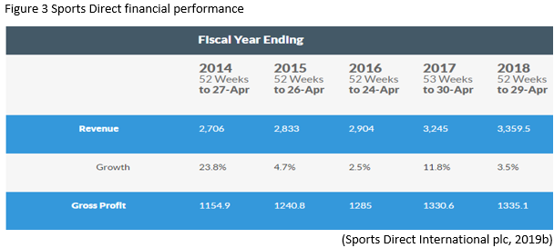
Although, Ashely is a villain in the public eye, and despite severe criticism and oppositions, his organisation is going stronger figure 3. SD, a major high-street retailer since 1996 and this has culminated in acquiring rivals and recently, House of Frazer in 2018. Ashely hoped to turn House of Fraser into the Harrods of the High Street. Ashley reported that the company was named among the ten companies with the most improved reputation in the UK, and they also ranked among the top five in an index of international retailers (Sports Direct International plc, 2018; 2019a). His success made Telegraph (2014) to declare Ashley as ‘Britain's craziest retailer’ while (BBC, 2018) Labelled Ashley as ‘The saviour of the High Street’, the "Selfridges of Sport" for Sports Direct and the "Harrods of the High Street" for House of Fraser. (BBC, 2018d).

2.1. History of Leadership
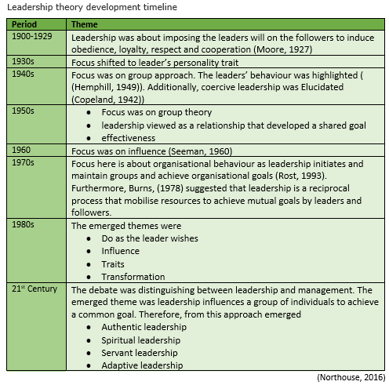
There is little consensus about what leadership means, and There are multiple definitions of leadership according to (Northouse, 2016). The definition has been evolving from 1900 to date. Leadership is Pervasive in businesses and society and many authors have conceptualised leadership. Figure 4 shows all the emerged themes from 1900 to date (Northouse, 2016).
Figure 4
Bass (1990), viewed leadership as the focus of group process, the leader is at the core of the group and its activity, and, the leader encapsulates the will of the people. Conversely, other definition sees leadership from a personality perspective. They elucidated that leadership is a combination of traits or characteristics. Many writers advanced the view of power relationship that exists between leaders and followers. They emphasised the leaders have powers to effect change. Still, other writers averred that leadership is a transformational process that motivates to accomplish more. Equally, other authors extended the viewpoint that skills perspective underpins leadership. They insisted that knowledge and skills impact effective leadership (Northouse, 2016)
According to (CIPD, 2019) leadership is the “ability to influence people by demonstrating positive personal attributes and behaviours. Different leadership styles and qualities may be needed in different circumstances.” But, Jago (1982) insisted that “Leadership is a property or set of properties possessed in varying degrees by different people. While for (Northouse, 2016), “leadership is a process whereby an individual influences a group of individuals to achieve a common goal.”
From the (Northouse, 2016), definitions above, if leadership is a process, the emphasis is not on the inherent traits or characteristics in the leader. There is a transaction between the leader and the follower. Both the leader and the follower are mutuality affected by each other, the leader influences the follower. Influence is a core ingredient of leadership. Equally, without a group, there is no need for leadership, therefore, leadership can only exist in a group. Lastly, there must be a mutual desire to achieve a common goal between a leader and the followers (Rost, 1991). Leaders need follower and followers need leaders (Burns, 1978; Heller and Til, 1982; Hollander, 1992; Jago, 1982). It is imperative to differentiate between leadership as a trait or as a process, to differentiate between appointed leadership and emergent (appendix 1), leadership and the power (appendix 2), coercion, and differentiating between leadership and management.
Trait versus Process Leadership
Traits is about the innate or inborn qualities that made then leaders the qualities are listed in figure 5 (Bryman, 1992) whereas the process views leadership as an interaction between leader and followers. It believed leadership could be observed in a leader (Jago, 1982)
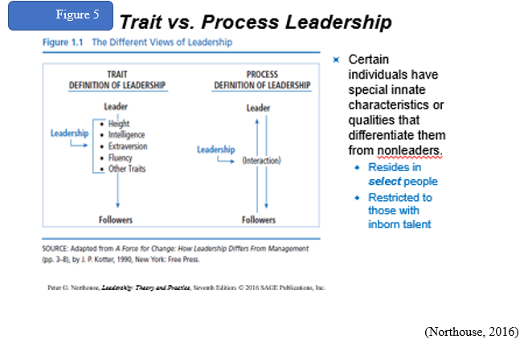

The differences between leadership and management
Kotter, 1990) found dramatic differences between leadership and management by firstly agreeing with Fayol 1916 that managements overriding function is to ensure organisations run effectively and efficiently by reducing disorderliness by planning, controlling, directing and staffing the firm (figure 6). Kotter (1990) proposed that leadership is underpinned by creating visions of change and movement. An organisation with good leadership and poor management will be misdirected in pursuit of change while strong management without strong leadership will only create bureaucracies that stifle the attainment of an organisation’s goal. Therefore, Bennis and Nanus (1985) commented that leaders seek to do the right things whereas, managers seek to do things right. Similarly, Rost (1993) developing a group's mutual purpose is central to leadership but to management, the focus is coordinating various aspects of an organisation to achieve the result.
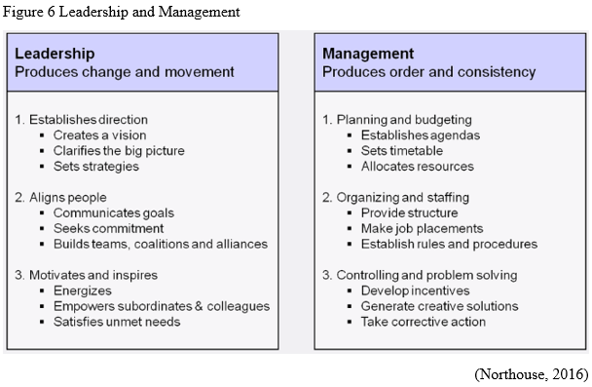

Despite arguments by authors, both leadership and management have several competencies, like goal setting, customer focus etc, but some qualities were found to be unique to leaders such as strategic planning, motivating and creative thinking and managers are unique focusing on rules, short-term planning, health and safety etc (Simonet and Tett, 2012). Zaleznik (1977) further distinguished between leadership and management by claiming that management is reactive, love to solve-problems without no emotional involvement but leaders have emotional intelligence see appendix 2a.

2.2. Current themes in Leadership
From the 20th century, scholars came up with Trait approach in their attempt to study leadership. They developed a “great man’s theory.” They identified the inborn qualities and characteristics of great people that made them different from their followers (Bass, 1990; Jago, 1982).
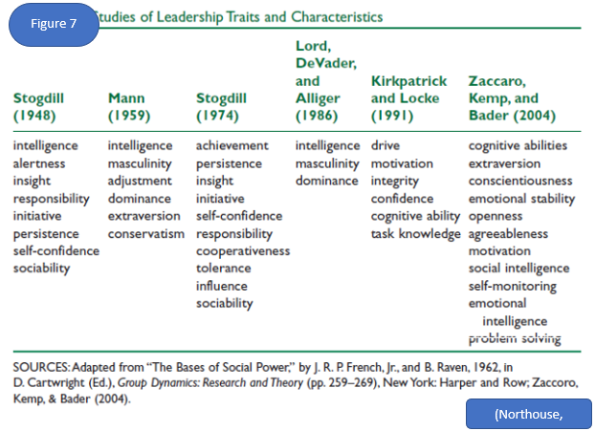
(Northouse, 2016)
Bryman (1992) believed traits influence leadership. Since Stogdill (1948) questioned leadership traits, there have been several studies on leadership Traits and Characteristics see (figure 7; Fleenor, 2006; Appendix 3).
Behavioural Approach
This approach focuses on the behaviours of the leaders and not their mental, physical or social characteristics. Thus, the behavioural approach measures the cause of an effects relationship of specific human behaviours from leaders. The emphasis is on the leader’s behaviour that is what they do and how they act. Two general behaviours underpin this approach namely task and relationship behaviours (Leadership-central, 2019; Northouse, 2016; Appendix 4)

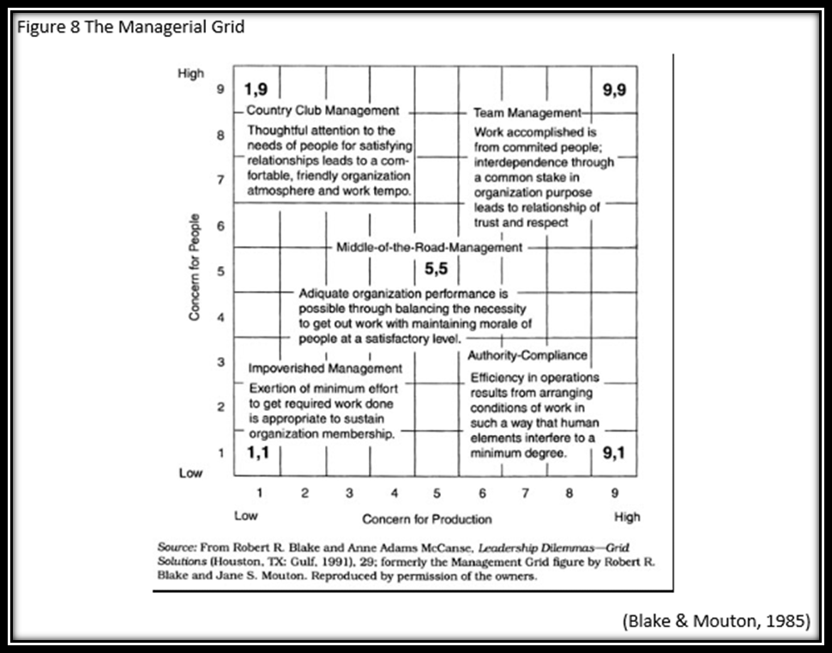
Blake and Mouton developed a similar approach to leadership style called the leadership Grid. They insisted that the primary leadership behaviours have concern for production and concern for people.
The concern for production focus on attaining organizational tasks while the concern for people focus on how a leader builds trust, commitment etc, with followers to achieve its goals (Blake and Mouton, 1985). Ashley takes his staff to the pub after work (BBC, 2018; CMI, 2016), his management style could be categorised between country club management and team management in The Managerial Grid in figure 8.
Situational approach
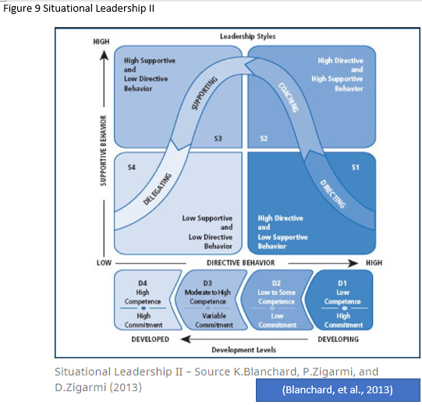
This approach focusses on different situations, that could necessitate a different kind of leadership. Being adaptable is essential to be an effective leader in different situations. In this approach, leadership is in two dimensions: directive and supportive. These dimensions require an evaluation of the follower’s commitment and competence to complete a task by the leader (Hersey and Blanchard, 1993; Sports Direct International plc, 2019c; appendix 5). The figure 9 below highlights the different leadership styles within Situational-Leadership (S1, S2, S3, S4) and within this, the Development Level of followers (D1, D2, D3, D4; Northouse, 2016).
Transformational
The term transformational-leadership was coined by Downton (1973) and Bryman (1992) suggested that it is part of the “new leadership paradigm” because it emphasized the charismatic and effective fundamentals of leadership. This approach changes and transforms people. It taps into satisfying the followers' motivation to reach mutual goals of leadership and followers. This leadership is not only charismatic but is also visionary as it influences followers on one-to-one to the whole organisation. Burns (1978) linked the roles of leaders and followers and stated that transformational-leaders engage and creates a connection with followers which raised the motivation and ethical morality of both leaders and followers (appendix 6; Sportsdirect, 2019d; Sports Direct International plc, 2019c; Reynolds Porter Chamberlain LLP, 2016; Mail Online, 2015).
Secondly, none of SD warehouse staff is on 'zero hours', he even promised to make SD be the new John Lewis by increasing employees pay above minimum wage after the fallout of the Parliamentary inquest (Mail Online, 2015). However, Ashely was a Pseudo-transformational leader when it comes to agency staff. He did not care about their welfare as long as they deliver, his focus was solely on SD’s interest (Bass, 1990). Despite this, Ashley is an Authentic transformational-leader because he is concerned with the collective good of his staff (Sports Direct International plc, 2019c).
He is a charismatic leader with his staff (House, 1976), during the publicised crisis, SD staff stood by him, they trusted him (figure 10). As a transactional-leader, Ashley shares the wealth of SD with his employee, he promotes mostly from within when possible (Sports Direct International plc, 2019c; ProductiehuisEU, 2018; Appendix 7).
He shows his leadership skills by bringing ideas on how to save the high streets in the UK (ProductiehuisEU, 2018). A major criticism of transactional-leadership is sometimes transformational-leadership could be viewed as elitist and anti-democratic, because the transformational-leader like Ashley is responsible for effecting change, establishing the vision, direction and strategy of SD (Avolio, 1999; Bass and Avolio, 1993).
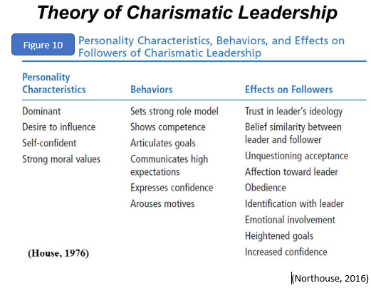
In the current business climate, Ashley’s name is attached to every high-street deal, Richard Hyman a retail industry expert commented that “Mike Ashley’s about making money,”. Even though Ashley was summoned into the parliament again for how to rescue the high-streets, Richard Hyman still insisted that Ashley is a trader that sees opportunity in the uncertain economic climate, his strategy was not to take over the high street or save the high street or rescue businesses (Guardian, 2019).
Path-Goal Theory (PGT)
PGT focused on the relationship between a leadership style and the distinctiveness of the followers. The PGT emphasis on how leaders can motivate followers for the attainment of agreed goals, by enhancing follower performance and follower satisfaction through follower’s motivation (House and Mitchell, 1974; Evans, 1970; Northouse, 2016). Path-goal theory centres on how leaders motivate followers to accomplish designated goals by removing obstacles or by creating an enabling environment. They facilitate training and coaching, SD focused on continual development to nurture staff towards their full potential, rewarding employees and retaining people and investment in talent. There are numerous examples of staff that started as casual work that are now senior managers. SD regularly appraised employee to highlight the knowledge gaps and then offer staff training to develop their understanding. SD used share schemes to attract, motivate and incentivise our people and potential future employees.
In FY17, 17.4% of SD UK salaried staff left the Group and SD achieved 85.0% stability of Store Manager. Ashley utilised a shared-goal which in turn improved employee satisfaction levels, this is an expectancy theory of motivation (Vroom, 1964). See figure 11 for the PTG ideas and figure 12 for the components of PTG (Sports Direct International plc, 2019c; Vroom, 1964). Ashley utilised the PTG for his SD staff but not for the agency staff. SD instituted policies and systems for monitoring and maintaining staff welfare. SD communicates with their staff through line managers, training programmes, news emails, letters, staff portal/staff app and the intranet, this is participative and supportive leadership that was geared towards achievement orientation (House and Mitchell, 1974; Sports Direct International plc, 2019c). Tasked were designed for followers and overseen by formal authorities. Under PTG, leadership intervention is required to remove ambiguity, but Ashley failed to do this in the case of the 3000 Warehouse-staff as they were agency-staff, that led to the culture of fear in the warehouse until the public outcry. The leaders of the warehouse were authoritarian, and the staff were unsupported. However, after the inquest, Ashley constituted an impartial people to carry out a review of the company (BBC, 2016a; CMI, 2016; Reynolds Porter Chamberlain LLP, 2016)
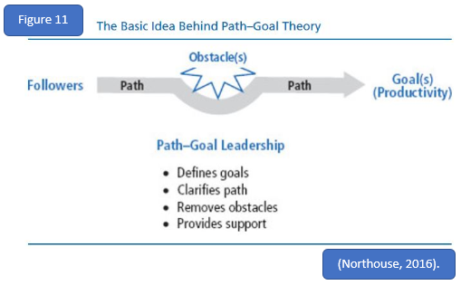

Forsey, a spokesman for SD, highlighted the leadership role of Ashely by stating that Ashley is a massive strength to the business, as
“The whole team benefits from his passion, enthusiasm and creativity around how we should tackle the next challenges. It is not just the Mike Ashley story. He's not the only one controlling everything, but he's such a key part of bringing the whole thing together. The rest of the team benefit from him and he benefits from having us as well "He is primarily focused around – and enjoys most – the operational side, the product and the logistics. His team is set up to help the buyers and help the retail and to develop the business. That is his passion and what he enjoys the most. I am quite different, and the two strengths that we have a match together quite neatly." (Telegraph, 2014).

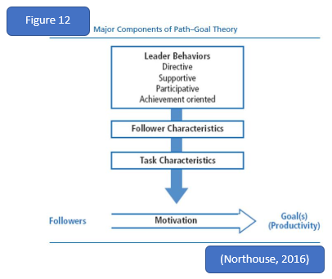

Leader-Member Exchange (LME)Theory
The (LME) approach elucidates the interactions between Ashley and his followers. (LME) in figure 13 illustrates the dyadic relationship between Ashley and his staff. The LMX expounded the differences that existed between the leader and each of the followers and the dyadic relationship is the focal point of the leadership process. Ashely did not view all staff working for SD in a collective way (Northouse, 2016). LME-Theory has undergone several revisions since its inception and continues to be of interest to researchers Appendix 8. figure 14. From figure 13 and 14, the position of the leader is above the followers, but the leader still develops separate exchange relationships with each subordinate.
Furthermore, upon research of the VDL, two linkages or relationships were uncovered, namely the in-group that is an expanded/negotiated role responsibility (extra-roles). In the in-group there is mutual trust, respect, liking, and reciprocal influence, they are well informed, influential, confidence, involved dependable, concern and experience communication than out-group members. But for the out-group, the relationship is marked by formal communication based on job descriptions (Dansereau, et al., 1975; Graen, 1976).
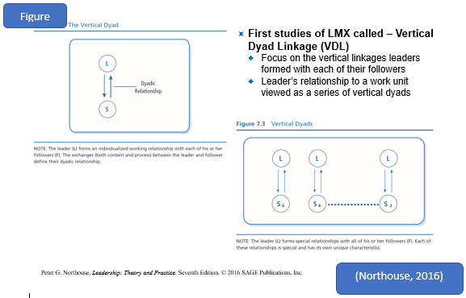

According to CMI, (2016), Ashley in-group could be broken into two groups. Staff employed by SD (in-group) compared to the Warehouse staff who are the out-group. But in managing his business empire, Ashley has in-group (figure 15) of a strong circle of executives that have worked with him for a long time. This close-knit group implements and drives the SD’s company strategies across the business. And the fall out of the public outcry against the SD, Ashley was asked to widen his network of trusted managers(in-group) and bring in more of the out-group to handle the day-to-day management duties, as he admitted the struggle of being able to oversee his versed empire.
Furthermore, after all the turmoil of 2016, SD was impacted positively by the high quality of LMX through reduced labour turnover etc, and the company being announced among the world's most innovative retailers which SD attributed to Staff’s loyalty and hard work (BBC, 2018b; CMI, 2016; Graen and Uhl-Bien, 1995).
The LMX is real, it is typically what will be experienced at work, but it could be unfair and creates inequality and discrimination. The treatment of the warehouse staff at the SD was an example (McClane, 1991).

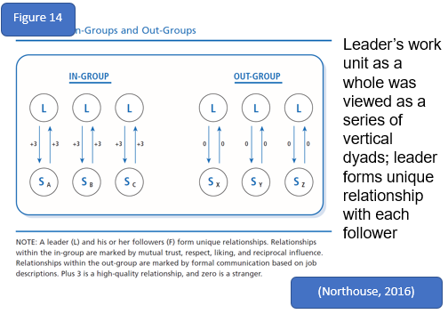

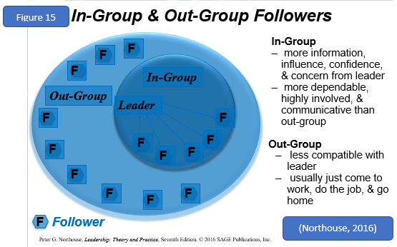

3.0 Conclusion

Ashley though is reclusive, but to his inner circle and to staff directly employed by, he is a charismatic leader, but because of his laid-back attitude by allowing his staff to get on with things got his company into trouble, but he has learnt, and changes were made that has now culminated in SD being name among the most innovative companies in the world.

4.0 Recommendations
To avoid the media circus and negative publicity he should divest from Newcastle as most to the negative that besiege him was because of his involvement in Football Newcastle FC and Rangers FC (MarketLine, 2018b).
Ashley is a born retailer, he understands the value of talking to people, he should embrace talking with the media as well.
Although Ashley stated the overarching desires of warehouse staff to be on Zero-hour contracts, he could extend the share offering to these staff.

Reference
Antonikis, J., 2012. Transformational and Charismatic Leadership In D.V. Day and J. Antonikis. 2 ed. Thousands Oaks CA: Sage Publications.
Avolio, B. J., 1999. Full leadership development: Building the vital forces in organizations. Thousand Oaks, CA: Sage.
Bass, B. M., 1990. Bass and Stogdill’s handbook of leadership theory, research, and managerial applications. 3 ed. New York: The Free Press.
Bass, B. M., 1990. From transactional to transformational leadership: Learning to share the vision. Organizational Dynamics, 18(3), pp. 19-31.
Bass, B. M. & Avolio, J. B., 1993. Transformational leadership : A response to critiques. In M.M. Chemers and R. Ayman Leadership theory: Perspectives and directions. SanDiego, CA: Academic Press.
BBC, 2014. Sports Direct's Mike Ashley: nasty or nice?. [Online]
Available at: https://www.theguardian.com/football/2014/jan/17/sports-direct-mike-ashley-newcastle-united-profile
[Accessed 1 3 2019].
BBC, 2015. Sports Direct staff searches criticised. [Online]
Available at: https://www.bbc.co.uk/news/business-35058974[Image]
[Accessed 1 3 2019].
BBC, 2016a. Sports Direct founder Mike Ashley admits pay errors. [Online]
Available at: https://www.bbc.co.uk/news/business-36465404
[Accessed 1 3 2019].
BBC, 2016c. Sports Direct founder Mike Ashley admits pay errors. [Online]
Available at: https://www.bbc.co.uk/news/business-36465404
[Accessed 1 3 2019].
BBC, 2017. Six new things we know about Mike Ashley. [Online]
Available at: https://www.bbc.co.uk/news/business-40513271[Image]
[Accessed 1 3 2019].
BBC, 2018b. Sports Direct pips Apple in global retailers' list. [Online]
Available at: https://www.bbc.co.uk/news/business-44645567
[Accessed 1 3 2019].
BBC, 2018c. Sports Direct boss says he's been 'stabbed in the back'. [Online]
Available at: https://www.bbc.co.uk/news/business-45523294
[Accessed 1 3 2019].
BBC, 2018d. What is Mike Ashley's plan for the High Street?. [Online]
Available at: What is Mike Ashley's plan for the High Street?
[Accessed 1 3 2019].
BBC, 2018. Mike Ashley: The saviour of the High Street?. [Online]
Available at: https://www.bbc.co.uk/news/business-35863847
[Accessed 1 3 2019].
Bennis, W. & Nanus, B., 1985. Leaders: The strategies for taking charge. New York: Harper and Row.
Blake, R. R. & Mouton, J. S., 1985. The Managerial Grid III The Key To Leadership Excellence. Houston Texas: Gulf Publishing Co.
Blanchard, K., Zigarmi, P. & Zigarmi, D., 2013. Leadership and the one minute manager: increasing effectiveness through Situational Leadership II. New York: William Morrow.
Bowers, S., 2015. Sports Direct to hand managers total of £155m in bonuses. [Online]
Available at: https://www.theguardian.com/business/2015/jul/16/sports-direct-managers-155m-bonus
[Accessed 15 3 2019].
Bryman, A., 1992. Charisma and Leadership in Organizations. London: Sage Publications.
Burns, J. M., 1978. Leadership. New York: Harper & Row.
Butler, S. & Kollewe, J., 2016. More shareholders criticise Sports Direct's corporate governance. [Online]
Available at: https://www.theguardian.com/business/2016/aug/25/sports-direct-corporate-governance-criticised-investor-forum
[Accessed 13 3 2019].
Cattell, M. J., 1943. Proposed Changes in the American Psychological Association. Psychological Review, Volume 50, pp. 61-64.
Christine, A., Bartling, J. & Turner, N., 2011. Pseudo-Transformational Leadership: Model specification and outcomes.. Journal of Applied Social Psychology, 44(12), pp. 2943-2984.
CIPD, 2019. Leadership. [Online]
Available at: https://www.cipd.co.uk/knowledge/strategy/leadership
[Accessed 1 3 2019].
CMI, 2016. 5 THINGS WE LEARNED ABOUT MANAGEMENT AT SPORTS DIRECT. [Online]
Available at: https://www.managers.org.uk/insights/news/2016/june/5-things-we-learned-about-management-at-sports-direct
[Accessed 6 3 2019].
Copeland, N., 1942. Psychology and the Soldier. Harrisburg: Military Service Pub. Co.
Costa, P. T. J. & McCrae, R. R., 1992. Revised NEO Personality Inventory (NEO-PI-R) and NEO Five-Factor Inventory (NEO-FFI) professional manual. Psychology, 13(6), pp. 653-665.
Dansereau, F., Graen, G. & Haga, W. J., 1975. A vertical dyad linkage approach to leadership within formal organizations: A longitudinal investigation of the role making process. Organizational Behavior and Human Performance, 13(1), pp. 46-78.
Evans, M., 1970. The effects of supervisory behaviour on the path-goal relationship. Organizational Behavior and Human Performance, Volume 5, p. 277–298.
Fisher, A., 1974. Small group decision making: communication and the group process. New York: McGraw-Hill.
Fleenor, J., 2006. Encyclopedia of industrial and organizational psychology. 1 ed. s.l.: Sage.
Forbes, 2019. [Online]
Available at: https://www.forbes.com/profile/michael-ashley/
[Accessed 28 2 2019].
Goldberg, L. R., 1990. An Alternative "Description of Personality": The Big-Five Factor Structure. An Alternative "Description of Personality": The Big-Five Factor Structure, 59(6), pp. 1216-1229.
Graen, G., 1976. Role making processes within complex organizations. In M. D. Dunnette (Ed.), Handbook in industrial and organizational psychology. Chicago: Rand Mcnally.
Graen, G. & Uhl-Bien, M., 1995. Relationship-based approach to leadership: development of leader-member exchange (LMX) theory of leadership over 25 years: applying a multi-level multi-domain perspective. Leadersh Q, 6(2), p. 219–247.
Guardian, 2018. Sports Direct says parliamentary witch-hunt led to assaults on staff. [Online]
Available at: https://wwwom/business/2018/may/04/sports-direct-parliament-witch-hunt-staff-assaults
[Accessed 15 3 2019].
Guardian, 2019. The Direct approach: why ailing UK retailers are turning to Mike Ashley. [Online]
Available at: https://www.theguardian.com/business/2019/feb/16/mike-ashley-direct-approach-ailing-uk-retailers-debenhams
[Accessed 1 3 2019].
Heller, T. & Til, J. V., 1982. Leadership and Followership: Some Summary Propositions. The Journal of Applied Behavioral Science, 18(3), p. 405–414.
Hemphill, J. K., 1949. Situational factors in leadership. Columbus, Ohio: Ohio State University.
Hersey, P. & Blanchard, K. H., 1993. Management of organisational behaviour: utilising human resources. 6 ed. Englewood Cliffs New Jersey: Prentice Hall.
Hollander, E. P., 1992. Leadership, followership, self, and others. The Leadership Quarterly, 3(1), pp. 43-54.
House, R., 1976. Theory of Charismatic Leadership in Hunt J.G. and Larson L.L. Leadership the cutting edge. Carbondale, Southern Illinois: University Press.
House, R. & Mitchell, T., 1974. House, R.J., Mitchell, T.R. Journal of Contemporary Business, Volume 3, pp. 1-97.
Jago, A., 1982. Leadership: Perspectives in theory and research. Journal of management science, 28(3), pp. 315-332.
Kotter, J. P., 1990. A Force for Change: How Leadership Differs from Management. New York: Free Press.
Leadership-central, 2019. Leadership Theories. [Online]
Available at: https://www.leadership-central.com/leadership-theories.html
[Accessed 3 3 2019].
Mail Online, 2015. Sports Direct tries to be the new John Lewis: Mike Ashley makes New Year's resolution to hike employees pay to above minimum wage. [Online]
Available at: https://www.dailymail.co.uk/money/markets/article-3380673/Sports-Direct-tries-new-John-Lewis-Mike-Ashley-makes-New-Year-s-resolution-hike-employees-pay-minimum-wage.html
[Accessed 1 3 2019].
MarketLine, 2016. Sports Direct Working conditions scandal fallout must be managed to minimize damage. [Online]
Available at: file:///C:/Users/koyes/AppData/Local/Packages/Microsoft.MicrosoftEdge_8wekyb3d8bbwe/TempState/Downloads/MLAI0001-076%20(1).pdf
[Accessed 1 3 2019].
MarketLine, 2018b. Sports Direct staff abused. [Online]
Available at: https://advantage-marketline-com.ezproxy.uwtsd.ac.uk/Product?ptype=Company+News&pid=062A9DA2-F459-4B15-9164-A4C1B0E68DAA
[Accessed 13 3 2019].
MarketLine, 2018. COMPANY PROFILE Sports Direct International Plc. [Online]
Available at: file:///C:/Users/koyes/AppData/Local/Packages/Microsoft.MicrosoftEdge_8wekyb3d8bbwe/TempState/Downloads/8DA08736-B7EC-415B-8714-B9583EABFFB9%20(1).pdf
[Accessed 1 3 2019].
McClane, W. E., 1991. Implications of Member Role Differentiation: Analysis of a Key Concept in the Lmx Model of Leadership. Group & Organization Studies, 16(1), p. 102–113.
McCrae, R. R. & Costa, Jr, P. T., 1987. Validation of the Five-Factor Model of Personality Across. Journal of Personality and Social Psychology, 52(1), pp. 81-90.
Moore, B. V., 1927. The May conference on Leadership. Personnel Journal, Volume 6, pp. 124-128.
Murray, R. M., 2015. STYLE Theory Page. [Online]
Available at: https://wikispaces.psu.edu/display/P5PFL/STYLE+Theory+Page
[Accessed 3 3 2019].
Northouse, P., 2016. Leadership: theory and practice. 7 ed. Los Angeles: SAGE.
ProductiehuisEU, 2018. "I'm not Father Christmas & it's not my fault high street dies", Sports Direct boss Ashley tells MPs, London: Youtube.
Reynolds Porter Chamberlain LLP, 2016. Sports Direct tries to be the new John Lewis: Mike Ashley makes New Year's resolution to hike employees pay to above minimum wage. [Online]
Available at: http://www.sportsdirectplc.com/~/media/Files/S/Sports-Direct/documents/sports-direct-international-plc-working-practices-report-6-sep-2016.pdf
[Accessed 1 3 2019].
Rost, J. C., 1993. Leadership for the twenty-first century. New York: Praeger.
Seeman, M., 1960. Social status and leadership; the case of the school executive. Ohio: Columbus, Bureau of Educational Research and Service Ohio State University.
Simonet, D. V. & Tett, R. P., 2012. Perspectives on the Leadership–Management Relationship: A Competency-Based Evaluation and Integration. journal of Leadership & Organizational Studies, 20(2), p. 199–213.
Smith, J. A. & Foti, R. J., 1998. A pattern approach to leader emergence. The Leadership Quarterly, 9(2), pp. 147-160.
Sports Direct International plc , 2017. Annual Report and Accounts 2017. [Online]
Available at: http://www.sportsdirectplc.com/~/media/Files/S/Sports-Direct/annual-report/Annual%20Report%202017%20-%20v3.pdf
[Accessed 1 3 2019].
Sports Direct International plc , 2017. Annual Report and Accounts 2017. [Online][Image]
Available at: http://www.sportsdirectplc.com/~/media/Files/S/Sports-Direct/annual-report/Annual%20Report%202017%20-%20v3.pdf
[Accessed 1 3 2019].

Sports Direct International plc, 2018. Annual Report 2018. [Online]
Available at: http://www.sportsdirectplc.com/~/media/Files/S/Sports-Direct/annual-report/annual-report-2018.pdf
[Accessed 1 3 2019].
Sports Direct International plc, 2019a. Where We Operate. [Online]
Available at: http://www.sportsdirectplc.com/about-us/where-we-operate.aspx
[Accessed 1 3 2019].
Sports Direct International plc, 2019c. People. [Online]
Available at: http://www.sportsdirectplc.com/corporate-responsibility/people.aspx
[Accessed 1 3 2019].
Sportsdirect, 2019d. The Sports Direct familystand together. [Online]
Available at: https://www.sportsdirect.com/jobs
[Accessed 5 3 2019].
Stogdill, R. M., 1948. Personal factors associated with leadership: A survey of the literature. Journal of Psychology, Volume 25, pp. 35-71.
Telegraph, 2014. Sports Direct: the rise of Britain's craziest retailer. [Online]
Available at: https://www.telegraph.co.uk/finance/newsbysector/retailandconsumer/10547946/Sports-Direct-the-rise-of-Britains-craziest-retailer.html
[Accessed 28 2 2019].
Telegraph, 2018. Mike Ashley attacks ‘greedy’ House of Fraser store landlords. [Online]
Available at: https://www.telegraph.co.uk/business/2018/09/22/mike-ashley-attacks-greedy-house-fraser-store-landlords/
[Accessed 1 3 2019].
Vroom, V., 1964. Work and motivation. New York: Wiley.
Vroom, V., 1964. Work and Motivation. New York: McGraw Hill.
Yukl, G. A., 1994. Leadership in Organizations. 3 ed. Leadership in Organizations: Leadership in Organizations.
Zaleznik, A. J., 1977. Managers and Leaders: Are They Different?. Harvard business review, 55(3), pp. 67-78.

Appendices
Appendix 1
Appointed/ Assigned leadership and emergent leadership
Usually, there are two types of leadership. Assigned leadership is attained by occupying a position in an organisation people like Plant managers, Marketing managers etc. but these assigned leaders may not real leaders in other situations. Emergent leaders, unlike assigned leaders, is someone that is perceived by a group to have influence regardless of their position or power. They emerged through usually through positive communication behaviour, they are well informed, build consensus, initiates new ideas and also firm and adaptable (Fisher, 1974). The emergent leader also displays a big personality trait, they could be dominant, intelligent and confident (Smith & Foti, 1998)

Appendix 2
Leadership and power
Researches have been carried out about power and leadership. Leaders influence followers and power is in influence. Power is the capacity or potential to influence. In organisations, power could be firstly a positional power derived from a rank in an organisation and secondly personal power and this power as a result as a person’s preserved influence by followers as being likeable or knowledgeable. (Burns, 1978) argued that in leadership phenomenon, power is based on relationship, purpose, motive and values. Power is not coercive or used achieved a leader's selfish goal but rather power is exercised to influence a group in attaining the common goal (Northouse, 2016). In addition, the era of social media makes leaders be more accountable. Kellerman asserted the end of leadership. Nonetheless, leaders' power may be declining but leaders still wield power.
Appendix 2a
They are emotionally involved, they are proactive instead of being reactive, they are about showing the followers what is possible. In conclusion, both functions overlap, managers do influence and when they do their operating as a leader. Leaders are also involved in planning, controlling etc, then they are operating an in management and the essence of both is influencing their follower or whom they have oversight on.

Appendix 3
Regardless of this, (Goldberg, 1990), (McCrae & Costa, Jr, 1987) argued for the five-factor personality Model and Leadership that were derived from (Cattell, 1943) set of 35 bipolar clusters of related terms and are listed in (figure 8).
Intelligence, self-confidence, determination Integrity and sociability were central to Traits research. The focus was on the personal attributes of the leader, but the approach failed to recognise the impact on situational variables on a leader’s effectiveness.
The drawback of the trait approach overarching focus on the leader but not on the followers or the situation, it has a male trait. Likewise, the trait approach does not state any principle or prescribed formula on what a leader should do in a given situation, the traits are not transferable. Despite its shortcomings, researches have begun to recognise the link between leadership traits and organizational performance. Researchers are now linking and examining combinations of clusters of personality traits that may succeed in a different situation. The Trait researches conclude that the effective trait or characteristic of a successful leader will be the same in any situation (Fleenor, 2006).

Figure 8
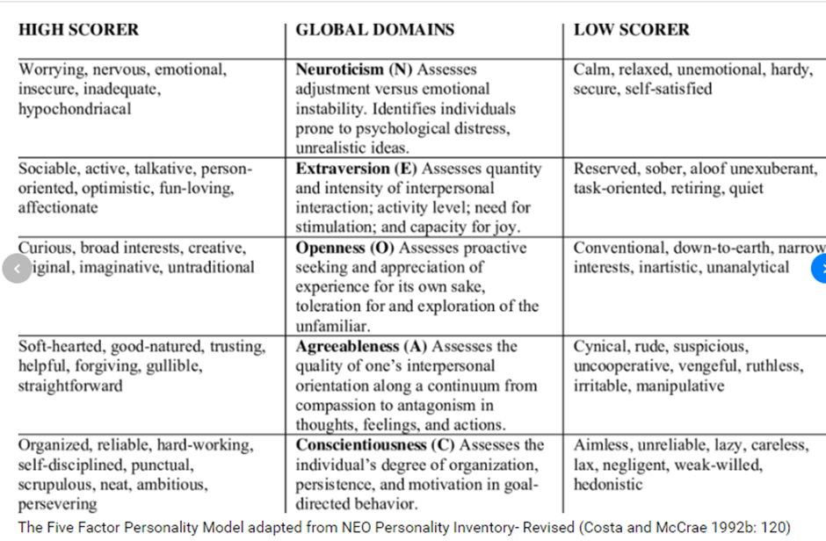
(Costa and McCrae, 1992)
Appendix 4
The Ohio Studies used a questionnaire called, The Leader Behaviour Description Questionnaire (LBDQ) to analyse how subordinates rated their leaders and the University of Michigan study also came up with similar results (Murray, 2015) (Northouse, 2016).
The task behaviour is directed towards goal accomplishment while the Relationship behaviour focuses on helping followers to be comfortable in any situation, with others and certainly with themselves. Therefore, the overarching idea is how leaders combine the two behaviours to influence followers to achieve the set goals
The benefits of the behavioural approach are it highlighted the behaviours and actions of leaders and leaders. Also, it allows leaders to learn about themselves and how their behaviour is perceived by their followers in relation to the task and relationship dimensions. But, critics pointed out that it failed to link a leader's behaviour to performance outcomes (Bryman, 1992) (Yukl, 1994). This approach also failed to develop an effective universal leadership style (Northouse, 2016). The situational approach is easy to understand, widely used in training employees for leadership and is very prescriptive by outlining options for different settings. Nonetheless, fails to adequately address the issue of one-to-one versus group leadership in an organizational setting, there were no cultural considerations and the questionnaires are biased in favour of situational leadership (Northouse, 2016)

Appendix 5
Crucially the leaders adjust their styles to telling, selling, participating, and delegating in consideration of the readiness of their followers (Hersey & Blanchard, 1993). This approach superimposes on the leader to adapt the level of directive or support according to the changing need of follower. According to the Hersey-Blanchard Situational Leadership Theory, the leadership style and the maturity level of those being led are vital. At SD, the organisational structure is hierarchical because the company is versed and with many departments with responsible managers that provide oversight for their departments (Sports Direct International plc, 2019c).
Appendix 6
Mike Ashley is a transformational leader especially to the staff of SD. He specified to his followers' responsibilities and task requirements and they are well rewarded for achieving their targets within the contractual agreement between him and the employee. In Ashley's evidence to the Committee that the culture, he declared that his staff work hard and are rewarded for their performance (Sportsdirect, 2019d) (Sports Direct International plc, 2019c)(Reynolds Porter Chamberlain LLP, 2016) Mail Online, 2015).

Appendix 7
He delegates, he spends time with his employee, he gives a directive, he is renowned for nights out drinking with football fans in the Bigg Market, with the management team in pubs (BBC, 2014). Ashley believes he is a fair guy. He is not the crazy capitalist that people think he is (Antonikis, 2012) (Christine, et al., 2011).
Appendix 8
The early theories developed what is called vertical dyad theory (VDL). The VDL focuses on the vertical linkages between leaders and the follower’s

