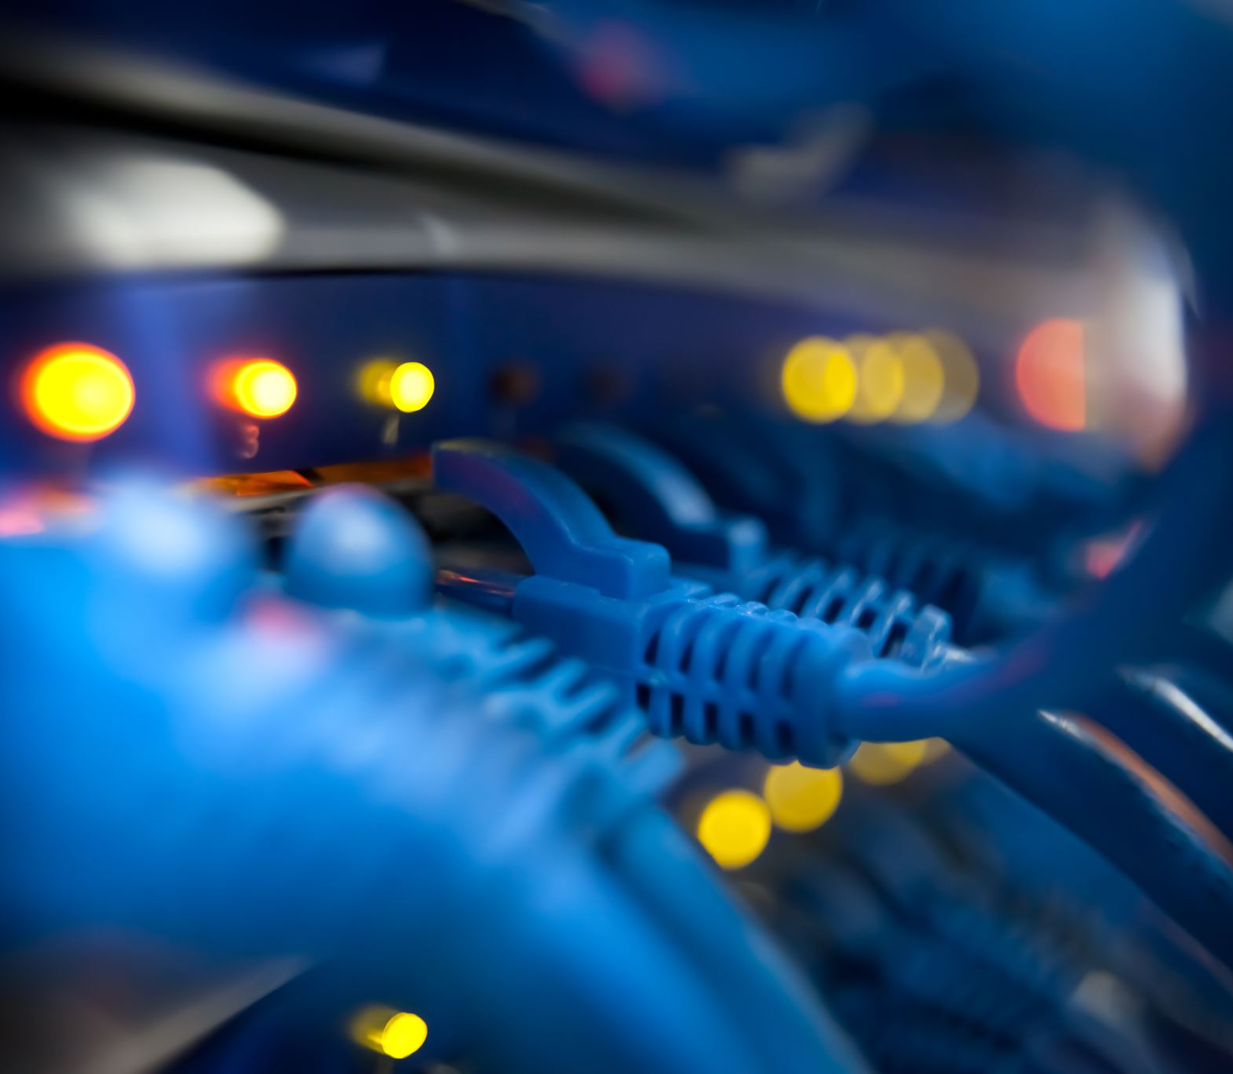
Assignment 1 – Research, Build, and deploy a Virtualised Enterprise Network
ACCA5023 - Network Operating Systems and Services
Luke Davies | 3/3/26 | Student Number: 2315714

Contents
Introduction 2
Task 1 – Research 3
Task 2 – Technical Documentation 6
Task 3 – Report Reflection 20
Conclusion 21
References 22

Introduction

This paper outlines the research and implementation of a network topology for a corporation called NOSS 2026.
Task 1 of the below report contains research on hypervisor type and suitability, IP addressing, routing, and network devices.
Task 2 of the below report justifies a suitable hypervisor type for use in the topology. Evidence is included of server and client downloading and configuration, and IP address configuration and network connectivity is evidenced.
Task 3 of the below report outlines a reflection of issues and challenges with deploying the chosen topology.
Finally, a list of references is included.

Task 1 – Research

2.1 – Research on Hypervisor
A hypervisor is a software layer that enables multiple virtual machines to operate on a single physical computing platform [1] . It creates a virtual environment by allocating CPU, memory and storage for use by the created guest system. Through this process of hardware abstraction – where the hypervisor mediates and manages access to the virtualised system’s requests to physical hardware resources [2] - the guest operating system interacts solely with the allocated virtualised hardware, rather than the physical host system.
Two types of hypervisor exist, differentiated by the hardware/software level in which they are placed. A type 1 hypervisor runs on the physical hardware, whereas a Type 2 (Hosted) Hypervisor runs on top of a pre-existing operating system [3].
The topology of NOSS 2026 is modest, including two servers and two host machines. Whilst type 1 hypervisors, absent a resource-draining operating system, are suitable for more complex topologies and are thus better for scaling (e.g. many servers), a Type 2 hypervisor operating on a system with around 16-32 GB of RAM and several CPU cores would be adequate to allocate the resources for the required virtual machines (2 clients and 2 servers) for NOSS 2026.
A type 2 hypervisor also has the benefit of being easier to deploy, given it can run directly from a pre-existing operating system without requiring dedicated hardware. From a security perspective, a type 1 hypervisor is likely to have a smaller attack surface given a lack of an operating system.
In a controlled and secure study environment, security concerns are likely to be mitigated and outweighed by the ease-of-use and flexibility offered by a Type 2 solution. However, if the topology was extended to additional infrastructure in a large enterprise, a Type 1 solution may be more suitable due to hardware constraints.
2,2 – Research on IP Addressing
An IP address is a “unique numerical identifier" which is allocated to each device connected to a network [4]. This identifier acts as an address does for a physical letter [5], and in doing so facilitates the routing of information packets from one network to another. This is achieved through using networking devices such as routers and switches. Switches operate on the Layer 2 of the OSI model by transporting packets within local networks using MAC addresses, whereas routers, operating on the network layer, transport packets with specific details according to set rules, such as IP packets which contain source and destination information [6].
IP addresses are formatted in dotted decimal notation, the structure of which has changed with an increase in devices needing a unique address. IPV4 addresses were structured in a 32-bit format, whereas IPV6 addresses now contain a 128-bit number [7]. The hexadecimal format of IPV6 allows for additional scalability.
Subnetting is used to divide a network into smaller networks using subnet masks. This is achieved by borrowing bits from the host portion of the IP address to segment the network. Subnetting improves network performance by reducing broadcast traffic within a subnet, thereby introducing an organised network structure. The enclosed network environment generated by subnetting also ensures networking issues are easier to identify. [8]
A worked example of IPV4 addressing and subnetting is provided in Figure 1 below.

Figure 1 – Worked example – IPV4 and subnetting [9]

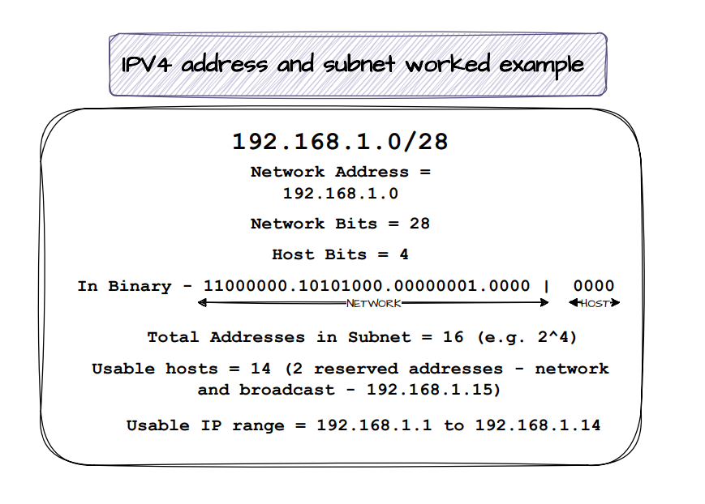
2.3 – Research on Routing
Routing protocols in computing networks establish rules for forwarding of data between networks [10]. Routing is achieved by routers, performing at the network layer, which examine details of IP packets and consulting routing tables. The router then forwards the data to its destination IP according to these tables [11].
The data contained in routing tables Routing can be configured either statically or dynamically. Static routing involves a manual configuration of data packet routes within a network, whereas dynamic routing uses routing protocols to allow network devices to develop data transmission paths automatically. Both have their advantages and disadvantages, with static routing being better for defined, smaller networks and dynamic for scalable, growing networks [12].
For NOSS 2026 and noting the modest network topology, a static routing method may be beneficial insofar as predictability of the network can be maintained as all routing will be predefined, thus increasing ease of troubleshooting if any issues arise. However, if NOSS 2026 were to scale their network topology, for example with additional severs or subnets, then manual configuration may become impractical, and so a dynamic protocol is likely best in adapting to further changes in topology.
Within the topology, the Debian sever will act as a DHCP relay agent to forward DHCP broadcast requests from the client subnet to the Windows server, which will then provide IP allocation via DHCP. The relay agent is required as DHCP broadcast requests do not travel beyond routers, and can therefore not enter a new subnet unless a configured agent forwards network requests to a different subnet [13].
2.4 - Research on Network Services
DHCP (Dynamic Host Configuration Protocol) is used by a server to manage and allocate IP addresses. This eliminates manual configuration and becomes more essential where there are many IP addresses required, for example in larger networks [14].
A VPN (Virtual Private Network) creates a secure channel between a VPN server and the host device via encryption, which has the effect of the host device appearing as if it is a part of the remote network. The client device is typically assigned an IP from the remote network via the VPN sever, and outward internet traffic is routed through this server. Given the encryption inherent in VPN data transfer, VPNs are preferred for secure, confidential and authenticated internet interaction over public networks. [15].
Active Directory Domain Services acts as a form of ‘phonebook’ for devices connected to a network. Through the hierarchical structure of the directory, relationships between network users, computers, groups, and policies can be defined to support policy enforcement and authentication. The framework promotes secure intra and inter-network communication by ensuring controlled access to network resources. [16].
Certificate authorities are trusted bodies which verify the authenticity and legitimacy of domains on networks. This is achieved by these organisations issuing digital certificates, such as TLS/SSL certificates, which allow for encrypted communication between users and websites. This results in secure communication across network boundaries and gives confidence in ensuring legitimate domains are being contacted by end users [17].

Task 2 – Technical Documentation

3.1 – Hypervisor Selection
As discussed in Section 2.1 of this Report, important architectural distinctions exist between Type 1 and 2 hypervisors, and as such the selection of an appropriate architecture, which balances student requirement with technical requirement, is paramount.
A Type 2 hypervisor is preferred for this assignment, and for continuation into Coursework 2, for the following reasons:
- Scalability – Scalability is a consideration when selecting a hypervisor. Whilst Type 1 hypervisors can be provided with dedicated resources, and are therefore better suited to larger scale enterprise environments (as they do not lie on top of a pre-existing operating system), a Type 2 hypervisor with the resources mentioned in Section 2.1 are more than adequate for the NOSS 2026 topology, which does not scale in the Topology Enhanced diagram provided in the assignment brief. As such a A Type 2 hypervisor is sufficient to support the implementation of the NOSS 2026 topology, which is modest.
- Security –A Type 1 hypervisor has the benefit of a reduced attack surface, as there is no underlying host operating system. However, and noting the topology is being created for an academic purpose, the increased security risk in utilising a Type 2 hypervisor is mitigated and preferred against the complexity of configuring a Type 1 hypervisor.
- Ease of use – A type 1 hypervisor would require a ‘bare metal’ installation, replacing any host operating system. A type 2 hypervisor is preferred for this assignment given, with adequate resources, its installation and subsequent uninstallation is much easier than replacing an underlying operating system.
- Ease of networking – Type 2 hypervisors provide dedicated virtualised options for networking between virtual machines (e.g. NAT, internal network), and as such are a more accessible method of establishing networks in a student lab environment. A type 1 hypervisor can require manual configuration and require manual hardware, firmware, and driver maintenance, and therefore adds complexity to network creation [18].

3.2 – Download and Setup
The below screenshots evidence the downloading of/setting up of the virtual machines required:
Figure 2 – Download of Windows files
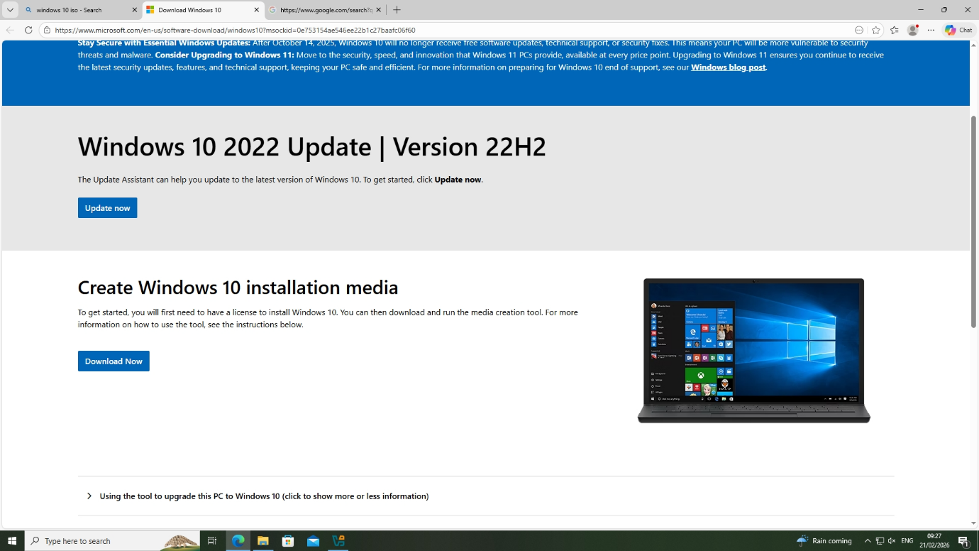
Figure 3 – Download of Debian client and server
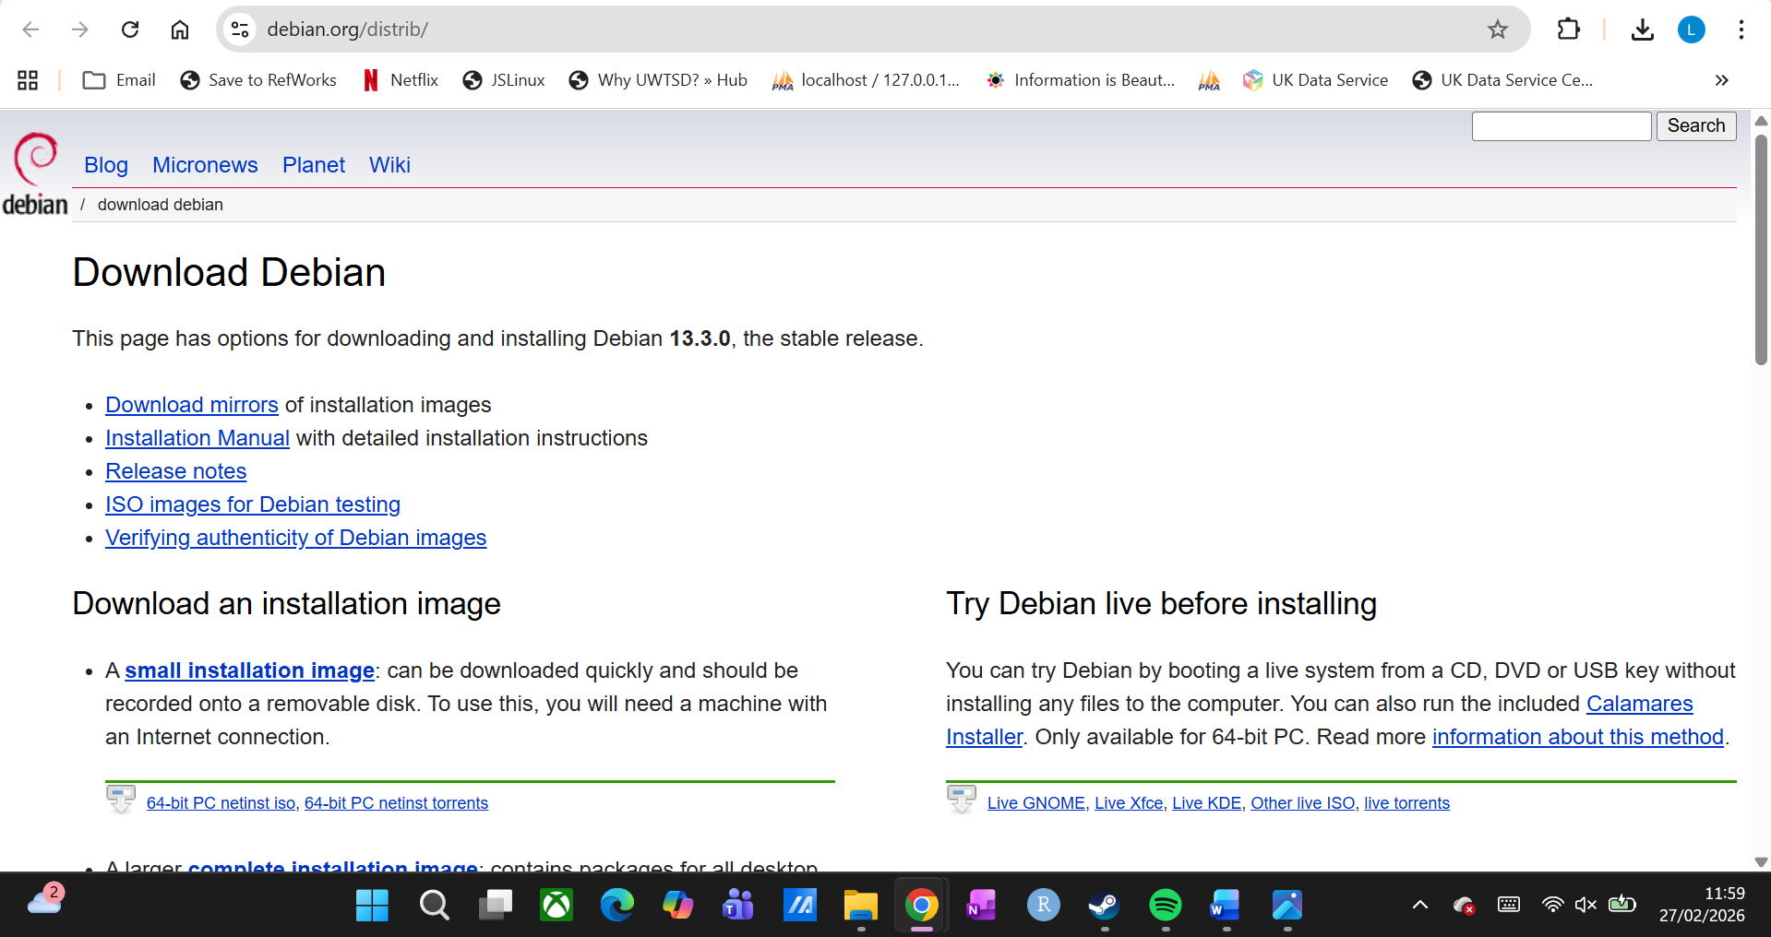

Figure 4 – Evidence of download of required files
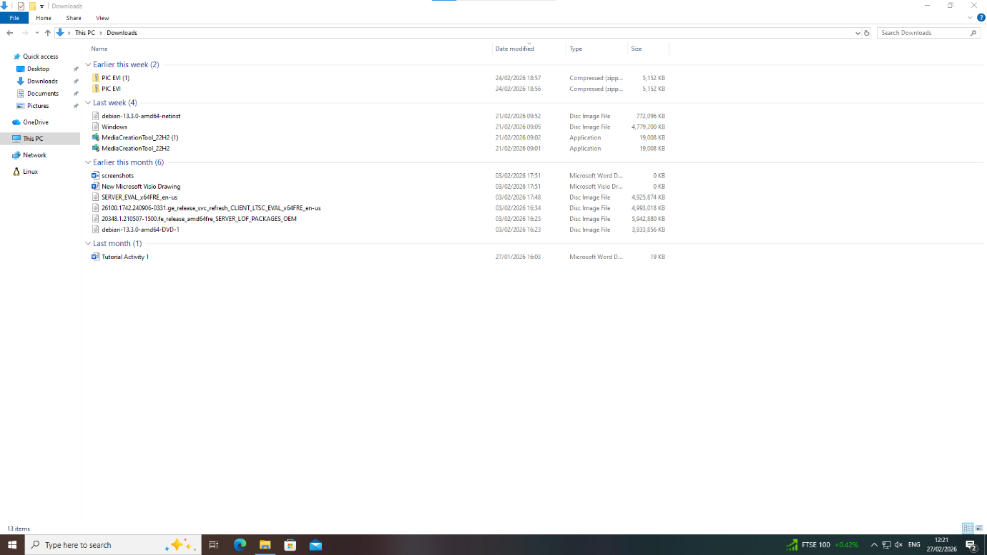

Figure 5 – Installation of windows client
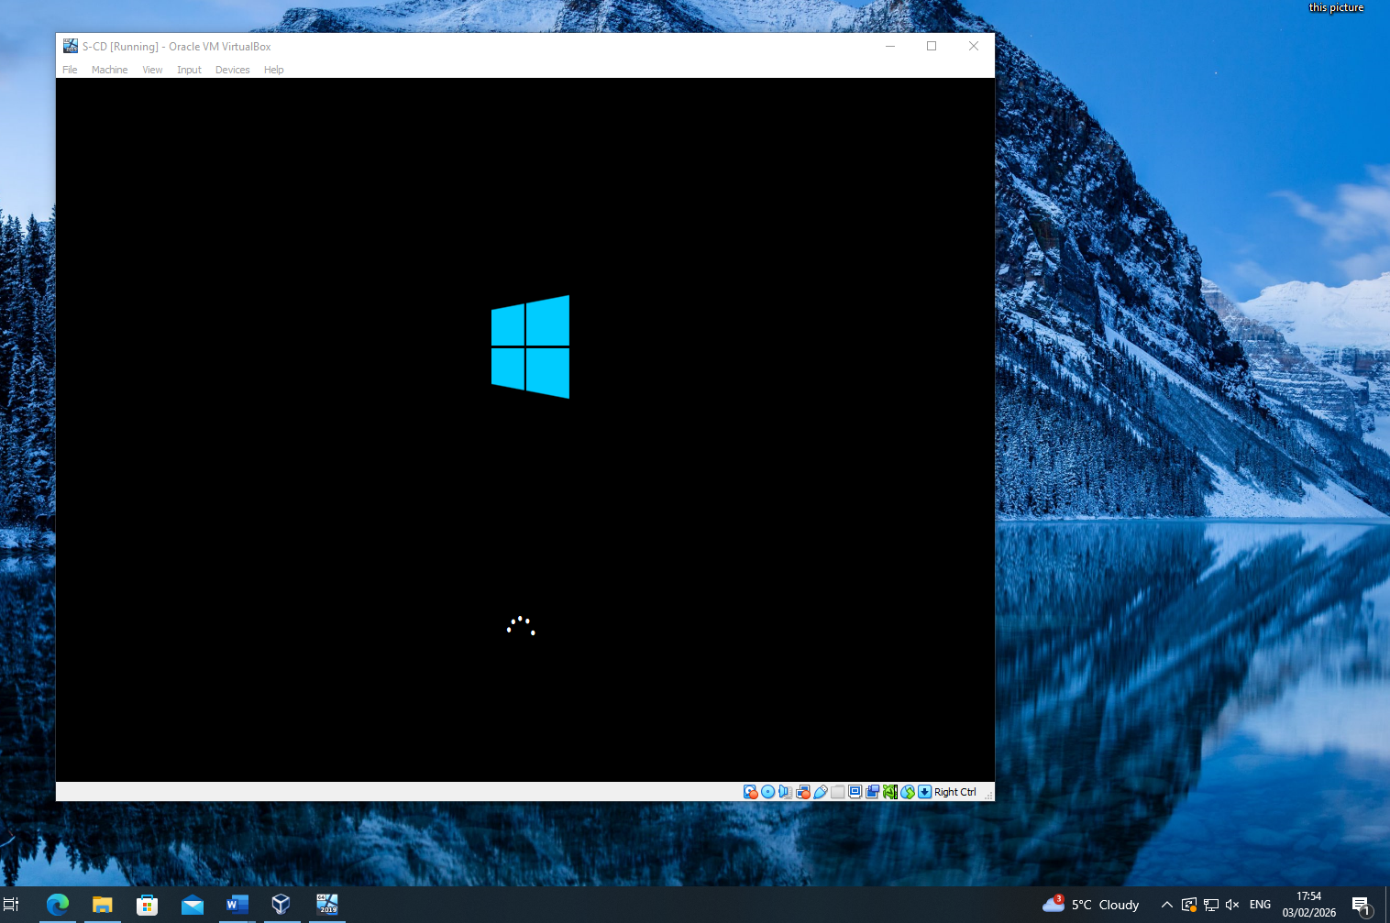

Figure 6 – Configuration of windows client
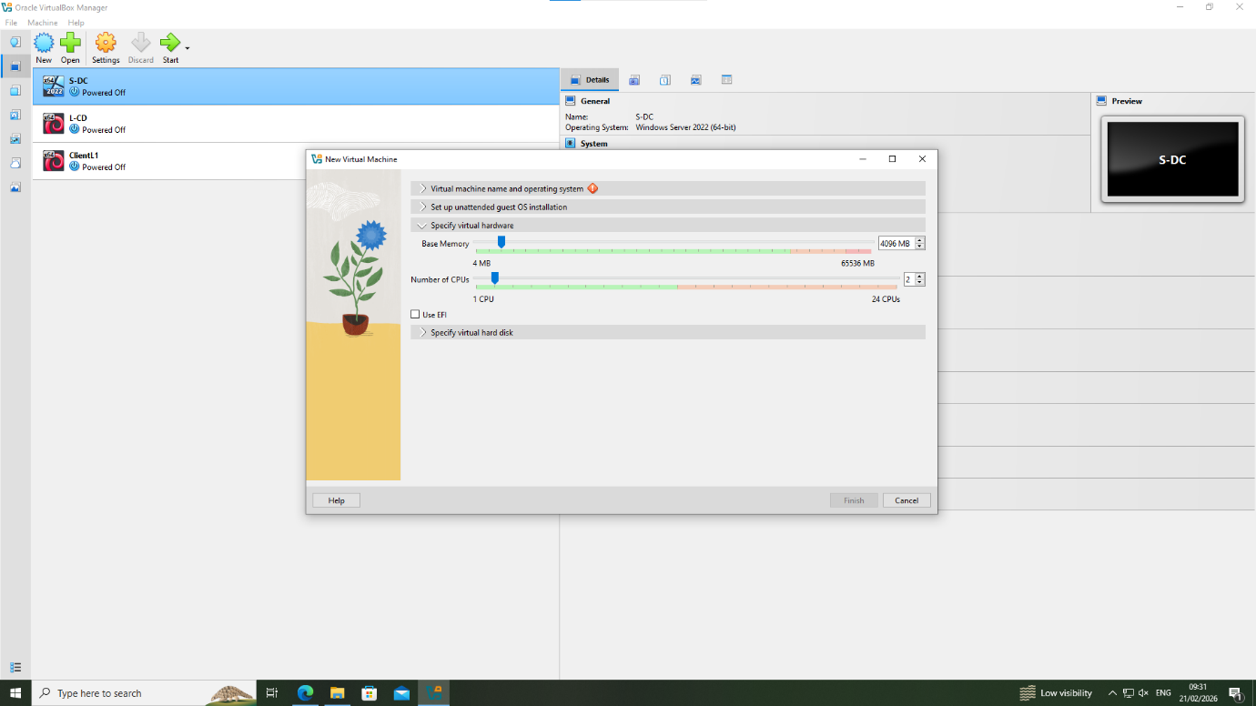

Figure 7 – View of Debian server after installation
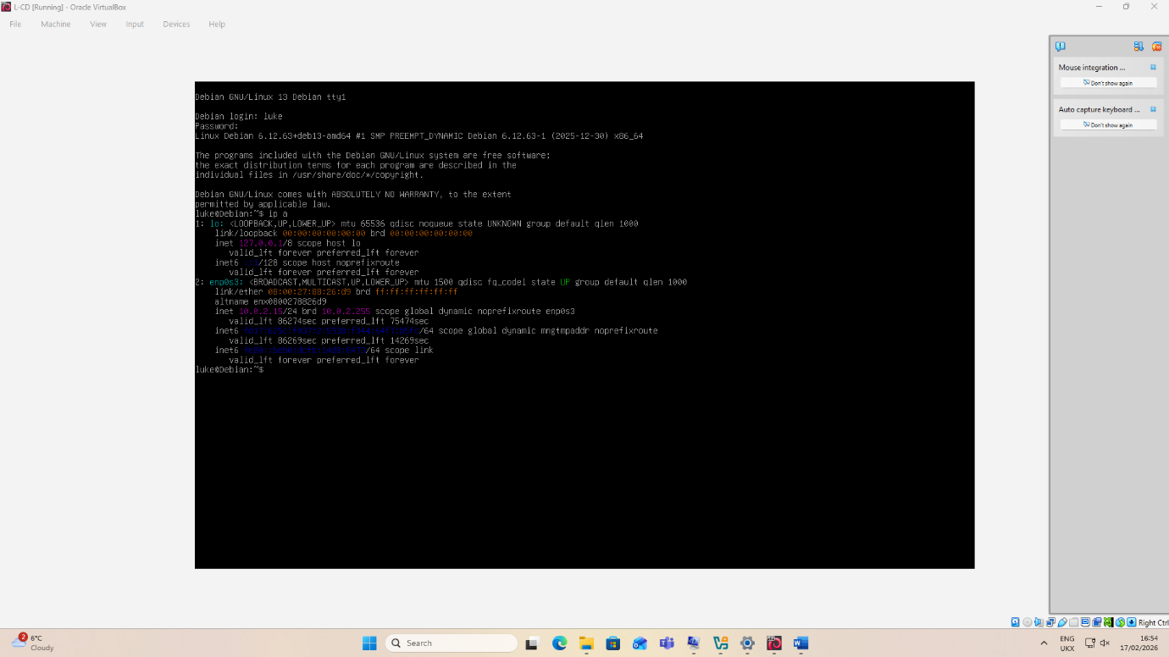

3.3 – Evidence of network deployment
The below screenshots evidence that the NOSS 2026 topology has been set up as follows:
- Suitable processor, RAM, and storage configurations are configured.
- S-DC includes a network configuration for ‘intswa’ which is the Swansea subnet (client to server).
- S-DC also includes a configuration for ‘intnet’ which is the Debian to Windows server subnet.
- L-CD contains ‘intlon’ and ‘intnet’ to connect the Debian subnet and server.
- Both clients are connected to the servers via the appropriate subnet configuration.

Figure 8 – S-DC VM configuration
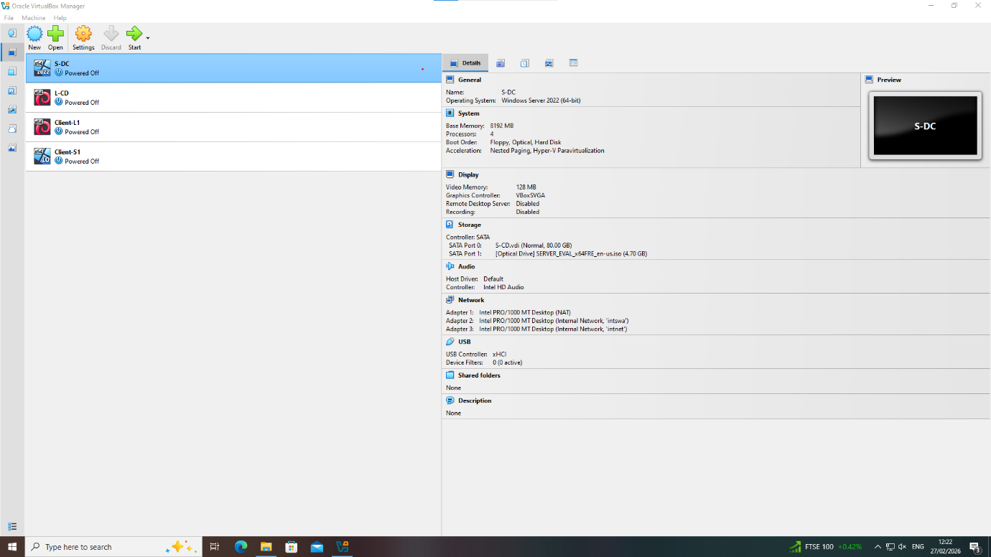

Figure 9 – L-CD VM Configuration
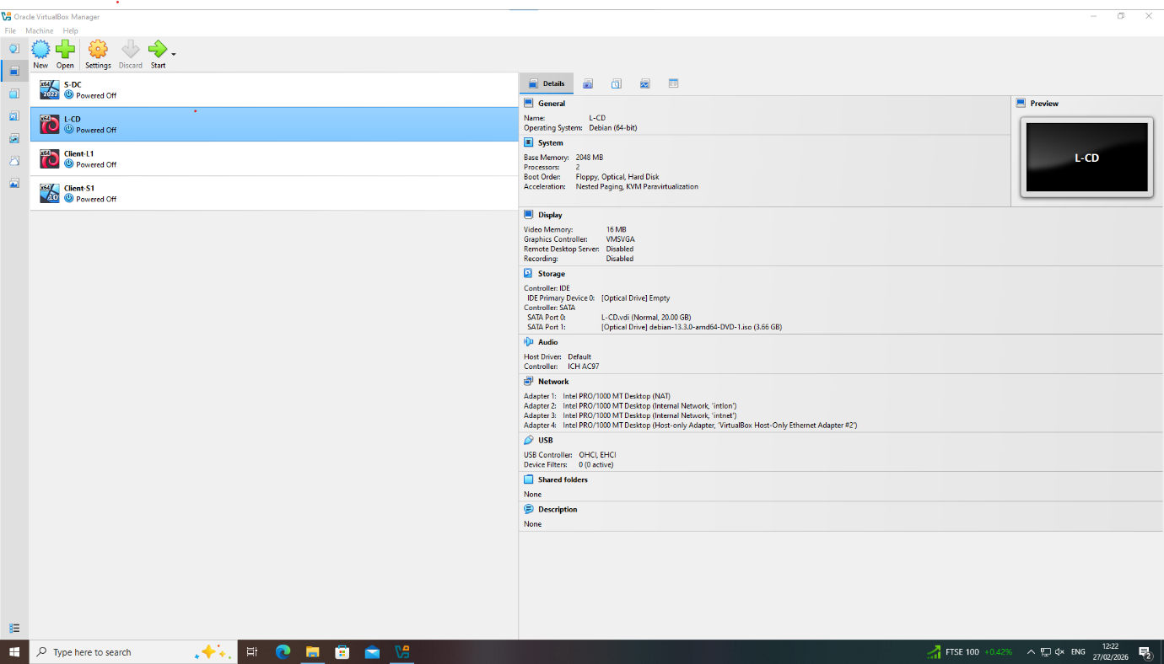

Figure 10 – Client-L1 VM Configuration
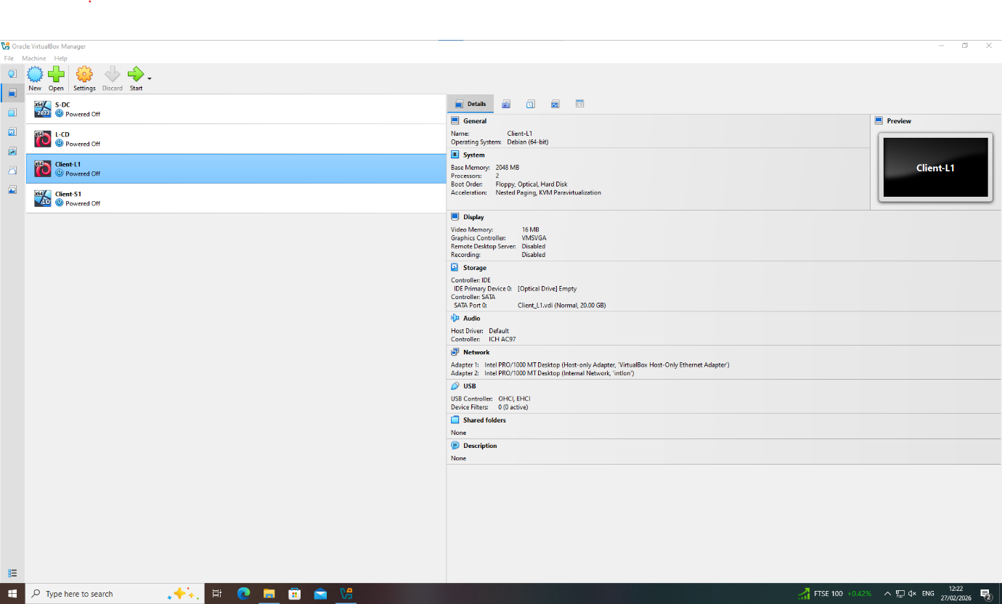

Figure 11 – Client-S1 VM Configuration
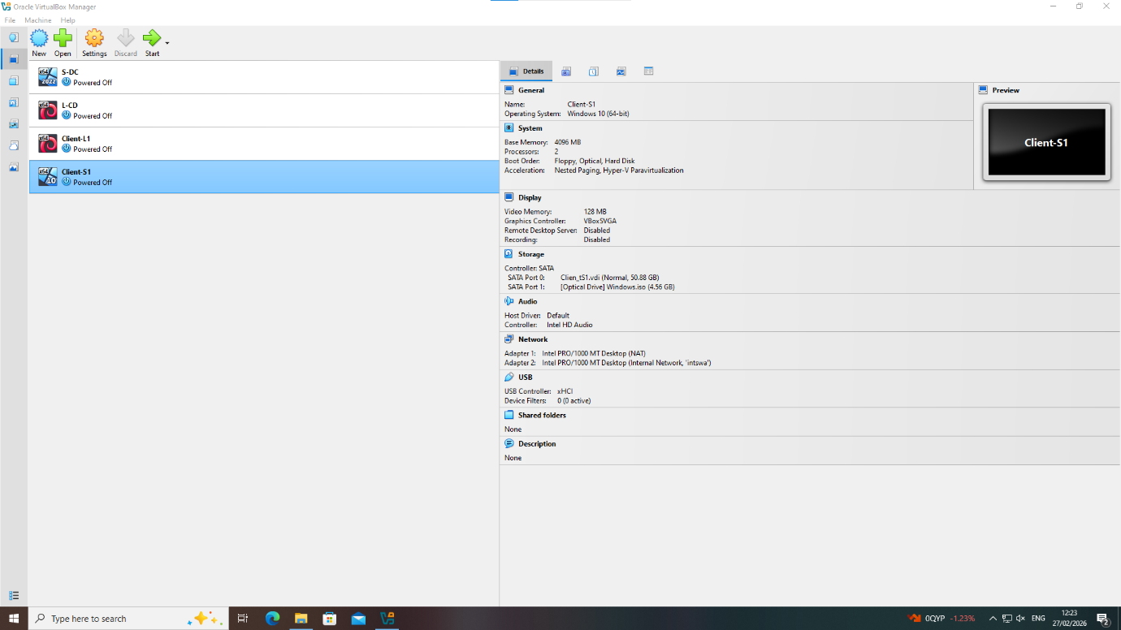

3.4 – IP configuration
The NOSS 2026 topology diagram uses the following 3 subnets:
- 192.168.1.0 /24 (Windows Network – Windows Server and Client connected)
- 192.168.2.0 /24 (Debian network – Debian Server and Client connected)
- 20.0.0.0 /30 (Server network – Debian and Windows Server connected)
For the topology, a Variable Length Subnet Mask scheme can be utilized to create subnets of different sizes, suiting the topology in question and to prevent IP wastage [19]. Suitable private enterprise ranges are defined in RFC 1918 [20]. This includes range 192.168.0.0 /16, which is used by the present topology, and thus this block is suitable for use here. However, 20.0.0.1/30 does not fall within the private range and is rather a public address [21].
The current topology for Swansea and London allocates 8 bits per subnet, allowing 256 addresses within each subnet, of which 254 can be used (i.e. excluding network/broadcast). This is inefficient given the topology and leaves a significant (252) total unused IP addresses within each subnet, given there is only a single server and client machine within each subnet.
To allow for a small organisational growth of hosts within the business, suitable alternative subnets are as follows:
Windows network - 192.168.1.0 /28
Subnet mask: 255.255.255.240
Usable range: 192.168.1.1 – 192.168.1.14
Debian network – 192.168.2.0 /28
Subnet mask: 255.255.255.240
Usable range: 192.168.2.1 – 192.168.2.14
This allows for 14 hosts per subnet (allowing for a small hypothetical growth of the business) which reduces the number unused addresses.
Regarding the server address, the block which is more suitable is as follows:
Server to server network: 10.0.0.0 /30
Subnet mask: 255.255.255.252
Usable range: 10.0.0.1 – 10.0.0.2
This allows for a point-to-point server connection only and minimises address wastage. This was already present in the original topology; however, the block now falls within the range of enterprise addresses noted in RFC 1918.

3.5 – Test and troubleshooting
Below, screenshots are provided demonstrating successful connectivity within the Swansea and London Networks, and between servers.
The IP addresses configured are those within the topology and not those defined within section 3.5 above, as the suitable addressing scheme was developed after screenshots were taken. However, and to implement the above IP configuration, the same techniques of setting IP addresses, subnet masks, and testing connectivity would be used.
Figure 12 – Ping from Windows server to Windows client
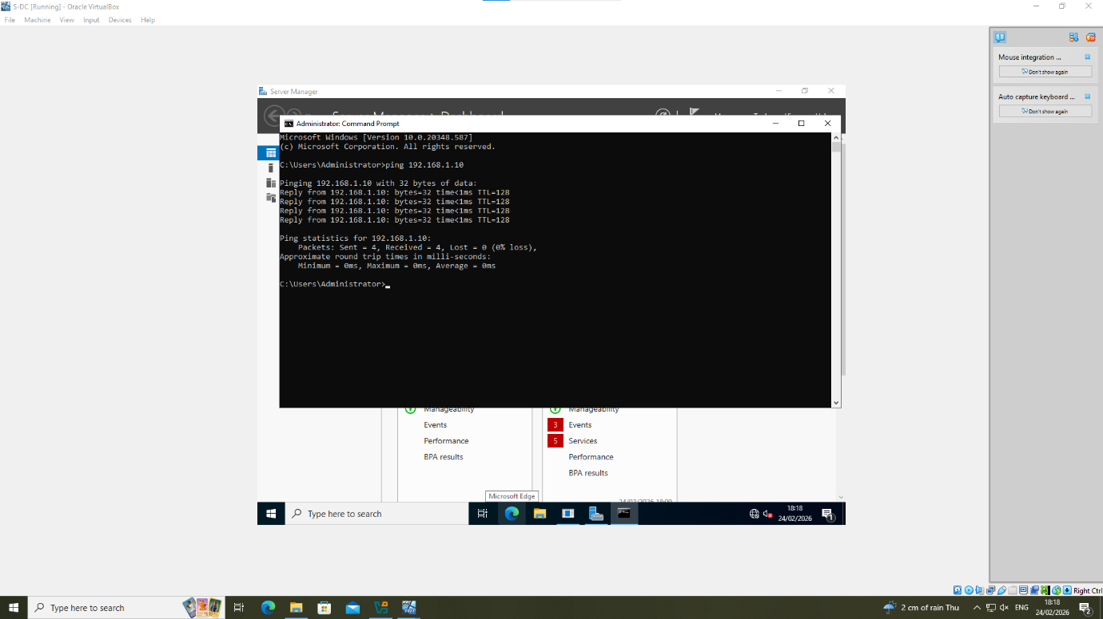

Figure 13 – Ping from Windows client to Windows server
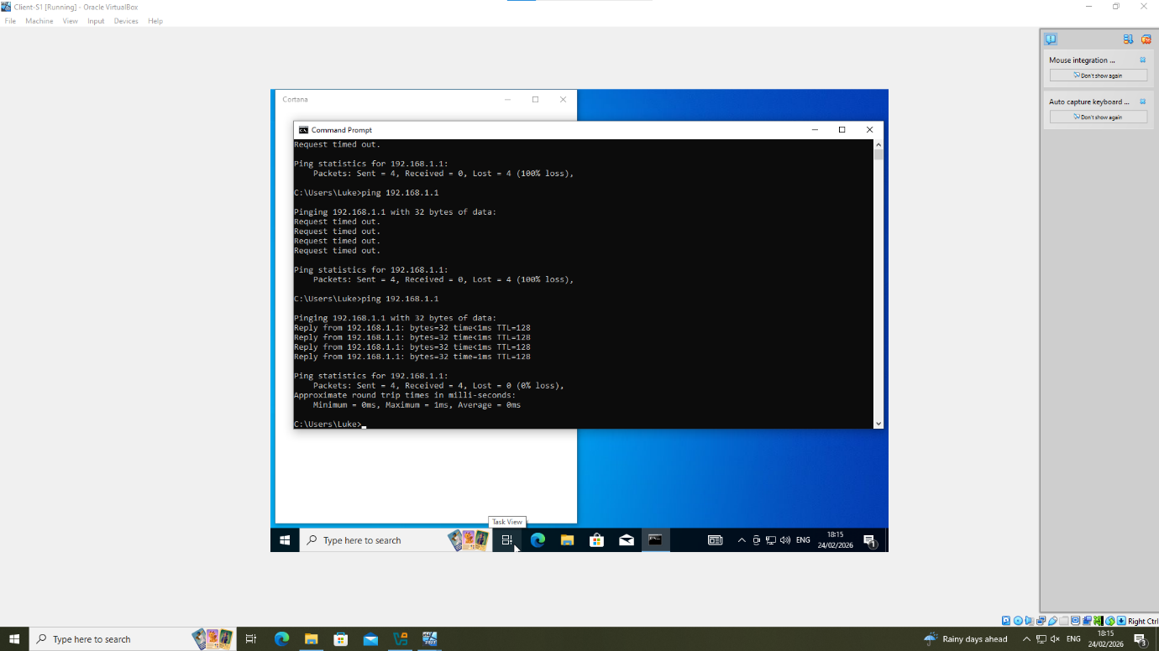
Figure 14 – Ping from Debian server to Debian client
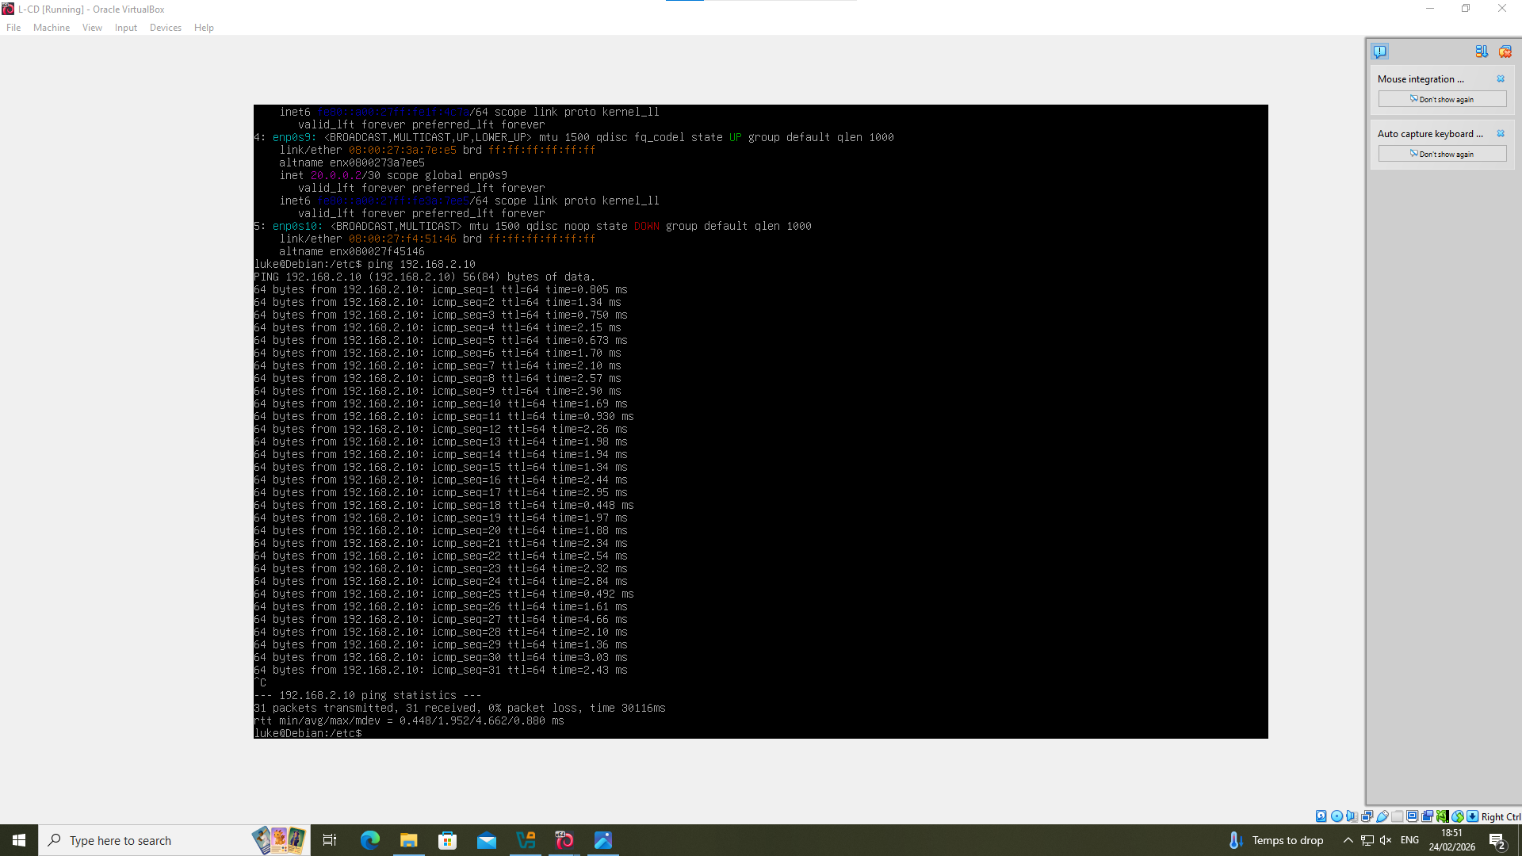

Figure 15 – Ping from Debian client to Debian server
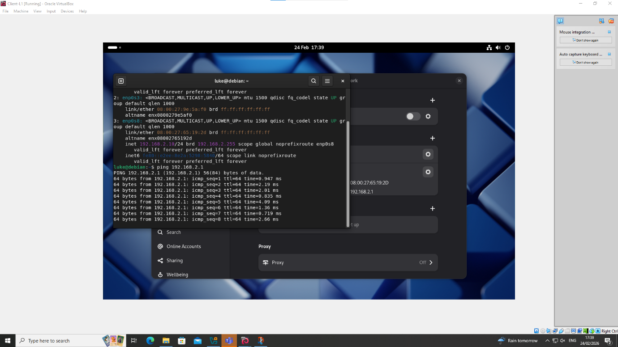
Figure 16 – Ping from Debian Server to Windows Server
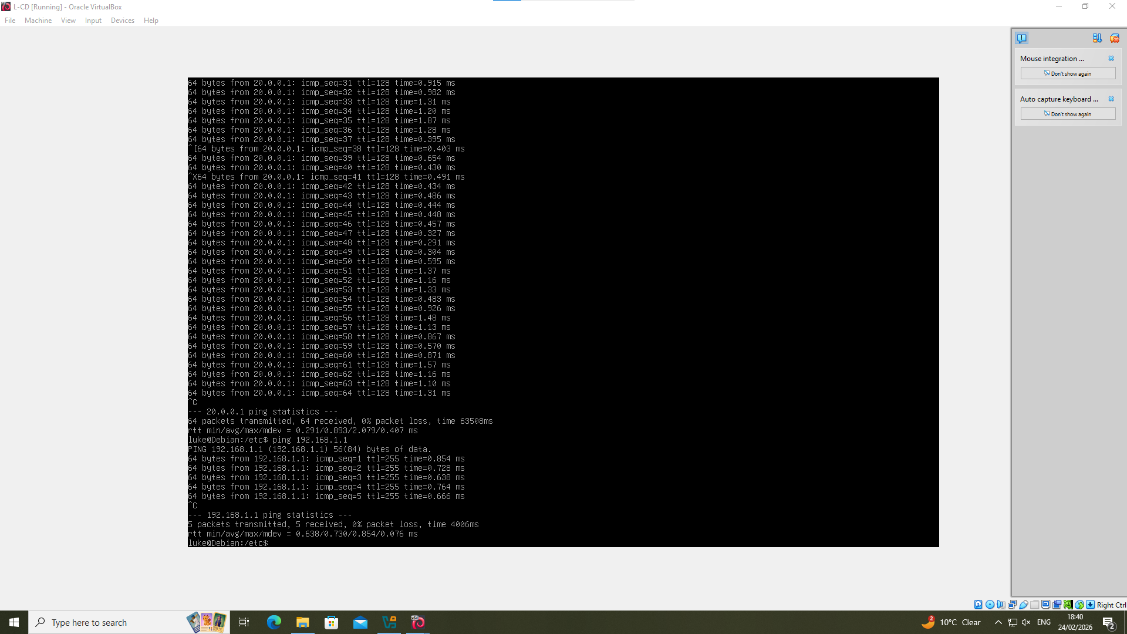

Figure 17 – Ping from Windows Server to Debian Server
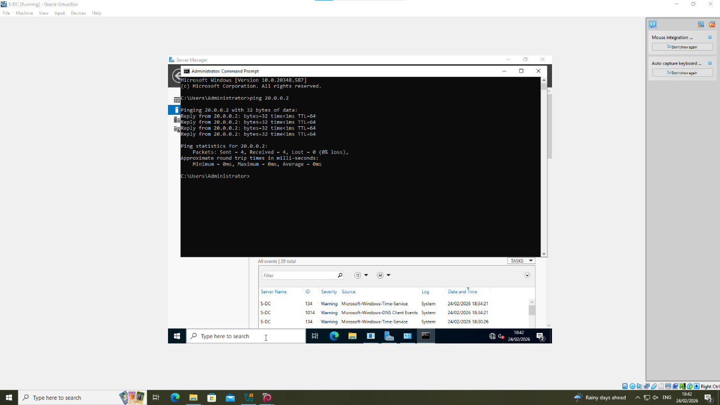

Task 3 – Report Reflection

4.1 – Technical Reflection
A challenged faced during the setting up of the NOSS 2026 topology was, initially, unsuccessful connectivity between the Windows networks. The issue arose due to Windows Firewall Defender blocking inbound and outbound traffic to the specified IP addresses. To resolve this, Windows Firewall was turned off as per the below:
Figure 18 – Disabling Windows Firewall
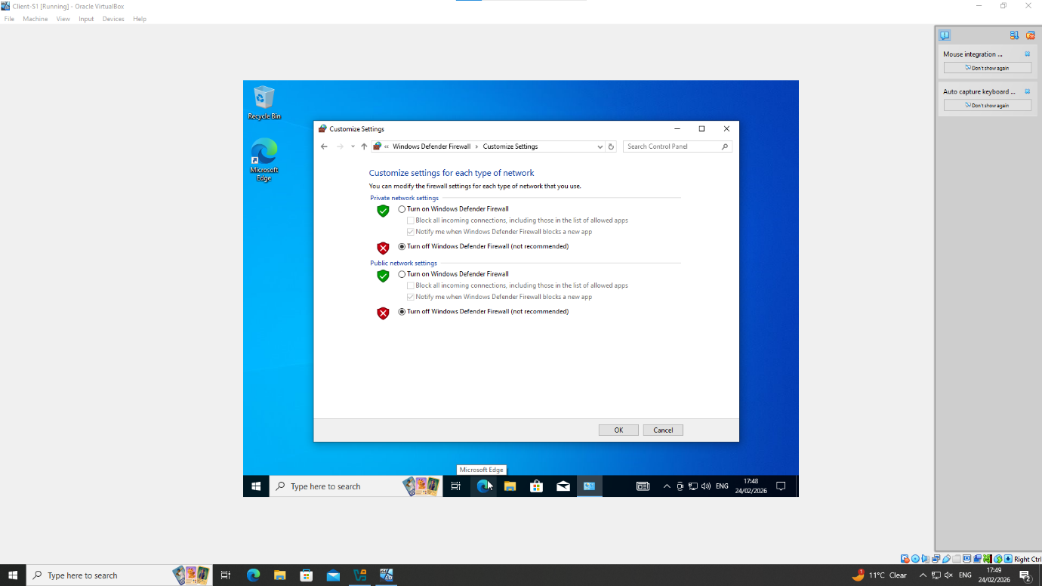
Whilst this resolved the issue, it is not industry best practice to fully disable a firewall. On reflection, a better method would have been to configure inbound and outbound rules within the Firewall, as per NIST recommendations [22].
4.2 – Personal reflection
Setting up the NOSS 2026 topology was a well enjoyed challenge. This assignment was the writer’s first setup of a network and interacting with Linux software, and as such several difficulties were faced.
An initial challenge was successfully configuring the 4 virtual machines required for this assignment, which involved multiple installations on occasion due to issues with the virtual machine not loading correctly. Becoming familiar with Linux commands was another challenge, in particular in the Debian Server, however effective lecturer support and online research allowed for navigation through the Debian CLI to carry out the network configurations required.
To aid in my learning of new Linux commands and navigating the networking process for this assignment, generative AI (ChatGPT) was used within the remit of the task description.

Conclusion

The above report outlines the writers networking topology considerations for the assignment. Research is conducted to configure the selected hypervisor and virtual machines. An IP addressing configuration is designed in theory, however not implemented in the final screenshots. Finally, a conclusion is drawn with outlines technical and personal reflections on the assignment.

References

[1] A. Blenk, A. Basta, M. Reisslein, and W. Kellerer, “Survey on Network Virtualization Hypervisors for Software Defined Networking,” IEEE Communications surveys and tutorials, vol. 18, no. 1, pp. 655–685, 2016, doi: 10.1109/COMST.2015.2489183.
[2] GeeksforGeeks, “Hypervisor,” GeeksforGeeks, Jul. 23, 2018. https://www.geeksforgeeks.org/system-design/hypervisor/#google_vignette (accessed Feb. 20, 2026).
[3] Z. Aalam, V. Kumar, and S. Gour, “A review paper on hypervisor and virtual machine security,” Journal of physics. Conference series, vol. 1950, no. 1, p. 12027, 2021, doi: 10.1088/1742-6596/1950/1/012027.
[4] GeeksforGeeks, “Structure and Types of IP Address,” GeeksforGeeks, Mar. 2021. https://www.geeksforgeeks.org/computer-networks/structure-and-types-of-ip-address/ [Accessed 27/01/2025]
[5] M. Dooley and T. Rooney, IP address management, Second edition. Hoboken, New Jersey: Wiley, 2021. doi: 10.1002/9781119692263.
[6] GeeksforGeeks, “TCP/IP Packet Format,” GeeksforGeeks, Sep. 11, 2023. https://www.geeksforgeeks.org/computer-networks/tcp-ip-packet-format/
‌[7] S. L. Levin and S. Schmidt, “IPv4 to IPv6: Challenges, solutions, and lessons,” Telecommunications policy, vol. 38, no. 11, pp. 1059–1068, 2014, doi: 10.1016/j.telpol.2014.06.008.
[8] S. N. Sisat, P. S. Bhopale, and V. K. Barbudhe, “IP Subnetting,” International journal of electronics, communication and soft computing science and engineering, vol. 2, no. 5, pp. 5–5, 2012.
[9] Figure created using JGraph Ltd., “diagrams.net,” diagrams.net, 2024. [Online]. Available: https://www.diagrams.net/. [Accessed: 27-Feb-2026].
[10] J. I. Consul and B. R. Japheth, “Survey of the Influence of Routing Protocols to Network Performance Enhancement,” Journal of Advances in Mathematical & Computational Science, vol. 11, no. 4, pp. 13–28, 2023.
[11] Jun Xu, A. Kumar, and Xingxing Yu, “On the fundamental tradeoffs between routing table size and network diameter in peer-to-peer networks,” IEEE journal on selected areas in communications, vol. 22, no. 1, pp. 151–163, 2004, doi: 10.1109/JSAC.2003.818805.
[12] Jodionisio Muachifi, “In networking, routing decisions define performance, resilience, and scalability. One of the first architectural choices every network engineer faces is deciding between static routing and dynamic routing, or how to combine both wisely.,” Linkedin.com, Jan. 06, 2026. https://www.linkedin.com/pulse/static-vs-dynamic-routing-when-use-each-jodionisio-muachifi-pndqe/ (accessed Feb. 21, 2026).
‌ [13] “Configuring IPv4 Broadcast Packet Handling [Support],” Cisco, 2026. https://www.cisco.com/en/US/docs/ios-xml/ios/ipapp/configuration/15-1sy/iap-bph.html (accessed Feb. 21, 2026).
[14] Andrew Butterfield, Gerard Ekembe Ngondi, and Anne Kerr, “DHCP,” A Dictionary of Computer Science. Oxford University Press, 2016.
[15] Kaspersky, “What is a VPN and how does it work?,” Kaspersky, Nov. 03, 2020. https://www.kaspersky.com/resource-center/definitions/what-is-a-vpn
‌[16] GeeksforGeeks, “Introduction of Active Directory Domain Services,” GeeksforGeeks, Aug. 14, 2018. https://www.geeksforgeeks.org/computer-networks/introduction-of-active-directory-domain-services/#google_vignette (accessed Feb. 21, 2026).
‌[17] SSL.com, “What is a Certificate Authority (CA)?,” SSL.com, 2024. [Online]. Available: https://www.ssl.com/article/what-is-a-certificate-authority-ca/. [Accessed: 27-Feb-2026].
[18] A. S. Walia, “Bare Metal Hypervisors: Benefits and Use Cases,” Digitalocean.com, Jan. 24, 2025. https://www.digitalocean.com/community/conceptual-articles/what-is-bare-metal-hypervisor [Accessed: 27-Feb-2026].
‌[19] GeeksforGeeks, “Introduction of Variable Length Subnet Mask (VLSM),” GeeksforGeeks, Aug. 28, 2018. https://www.geeksforgeeks.org/computer-networks/introduction-of-variable-length-subnet-mask-vlsm/#google_vignette (accessed Feb. 27, 2026).
‌[20] Y. Rekhter, B. Moskowitz, D. Karrenberg, G. de Groot, and E. Lear, “Address Allocation for Private Internets,” RFC 1918, IETF, Feb. 1996. [Online]. Available: https://datatracker.ietf.org/doc/html/rfc1918. [Accessed: 27-Feb-2026].
[21] Internet Assigned Numbers Authority (IANA), “IPv4 Address Space Registry,” 2024. [Online]. Available: https://www.iana.org/assignments/ipv4-address-space/. [Accessed: 27-Feb-2026].
[22] K. Scarfone and P. Hoffman, “Guidelines on Firewalls and Firewall Policy,” NIST Special Publication 800-41 Rev. 1, Sep. 2009.

