MSc Digital Transformation
for the Health and Care Professions
BMDS7005

Perceptions of the Nursing Workforce on Usability and Workload of a Critical Care Clinical Information System

Dissertation submitted in partial fulfilment of the award of
Master of Science in Digital Transformation for the Health and Care Professions

Charlotte Elizabeth Adams
2308569
May 2026

Acknowledgements

I would like to express my deepest gratitude to my family for their unwavering support over the past three years. To my husband, Neil, and my wonderful children, Lily and Elijah, thank you for your love, patience, and encouragement throughout this journey. I am also profoundly grateful to my parents and father-in-law for their continued support and belief in me.
My heartfelt thanks also go to Hywel Dda University Health Board for funding my course and enabling me to pursue this important step in my career. Finally, I would like to acknowledge my tutors for their guidance, expertise, and support, all of which have been invaluable to my learning and development.

Declaration

This work has not previously been accepted in substance for any degree and is not being concurrently submitted in candidature for any degree.

Signed……………………………………………

Date… ……………………………………………

Use of Generative AI
RESEARCH | For this assessment, you can use Generative AI to support you in research, including searching for bibliography, using tools to summarise, compare and interrogate materials. | Yes ☒  No ☐
STRUCTURE | For this assessment, you can use Generative AI to support you in structuring your submission, including creating a draft argument structure, identifying parts and headings, etc. | Yes ☐  No ☒
PROOFREADING | For this assessment, you can use Generative AI to check your own text/creation for grammatical and syntactical mistakes, including rephrasing of your own work within specific standards. | Yes ☐  No ☒
WRITING | For this assessment, you can use Generative AI to create text for submission. | Yes ☐  No ☒
CREATIVE | For this assessment, you can use Generative AI to create creative materials, such as images. | Yes ☒  No ☐
PROGRAMMING | For this assessment, you can use Generative AI to create and check code. | Yes ☐  No ☒

Table on Contents

1 Introduction 8
1.1 Critical Care Informatics 8
1.2 Nursing Workforce 10
1.3 Research aim 11
2 Literature Review 12
2.1 Literature Review Screening 12
2.2 Finalised Screening 12
2.3 What are the benefits of implementing a critical care CIS? 13
2.4 The Nursing Workforce in Critical Care 14
2.5 Perceived usability of CISs 16
2.6 Perceived workload of CISs? 17
2.7 Critical Analysis of Evidence Strength and Potential Bias 20
3 Methodology 24
3.1 Key concepts and frameworks 25
3.2 Organisational challenges 27
3.3 Data Gathering 28
3.4 Quantitative component 28
3.5 Statistical package for social science (SPSS) 31
3.6 Thematic analysis of qualitative data 33
3.7 Data saturation 35
3.8 Transferability 37
3.9. Ethical considerations 38
4 Results 41
4.1 Survey of nursing perception 41
4.2 Perceived overall usability 42
4.3 Usability by documentation method 43
4.4 Perceived overall workload 45
4.5 Workload by documentation method 45
4.6 Perceived CIS Usability and Workload 47
4.7 Perceived CIS Usability and Workload Versus Role 48
4.8 Perceived CIS Usability and Workload Versus Training 49
4.9 Summary of Key Thematic Findings 52
5 Discussion 54
5.1 Are critical care CISs perceived as being useable by the nursing workforce? 54
5.2 Are critical care CISs perceived as reducing nursing workload? 57
5.3 Integrate findings within theoretical frameworks 58
5.3.1 Soft System Methodology 59
5.3.2 Behavioural Economics 63
5.4 Implications for Critical Care digitalisation 64
5.5 Limitations 65
6 Conclusions 67
References 71
Appendix 1 82
Appendix 2 88
Appendix 3 101

Table of tables and figures
Figure 1.1 Rich picture demonstrating the complexities of ICU 10
Figure 2.2 Summary of literature screening using a PRISMA flow diagram 14
Table 2.7 Critical analysis and study characteristics 24
Figure 3 Mixed methodology convergence (Smajic et al., 2022) 25
Table 3.1 Usability evaluation criteria (Almasi et al., 2023) 27
Figure 3.4a The system usability scale (Brooke, 2013) 30
Figure 3.4b NASA-TLX scale (Hart, 1988) 31
Table 3.5 SPSS v30 Statistical analysis test performed 33
Table 3.6 Steps of thematic analysis (Braun and Clarke, 2006b) 35
Figure 3.7a Factors affecting sample size saturation (Ahmed, 2025) 36
Figure 3.7b Clear stages of reaching data saturation in qualitative research (Ahmed, 2025) 37
Figure 3.8 The process of theory formulation and transferability (Mayring, 2007) 38
Table 3.9 Data ethics framework (Gov.uk, 2018) 39
Figure 3.9 Ethical principles of digital innovation (Mennella et al., 2024) 39
Table 4.1 Usage frequency and training status of participants 41
Figure 4.2 Histogram of SUS with mean and standard deviation 42
Figure 4.3 Histogram of SUS by documentation method 43
Table 4.3a Cohen's d interpretation guidelines (Field, 2018) 44
Table 4.3b SUS by documentation method 44
Figure 4.4 Histogram of NASA-TLX scores 45
Table 4.5 NASA-TLX by documentation method 46
Figure 4.5 Histogram of NASA-TLX by documentation method 46
Figure 4.6 Relationship between usability and workload 47
Table 4.7a Nursing role, responsibilities and CIS interactions 48
Table 4.7b Descriptive results by nursing role 49
Figure 4.7 Usability and workload by role 49
Table 4.8a Perceived usability and workload by training status 50
Table 4.8b Kolmogorov-Smirnov normality test 50
Table 4.8c Parametric One-Way ANOVA test 51
Table 4.8d Test of equality of means 51
Figure 4.8a Perceived usability by training status 51
Figure 4.8b Perceived workload by training status 52
Figure 4.9 Key qualitative themes related to CareView usability and workload 53
Figure 5.1a The FITT framework (Ammenwerth, Iller and Mahler, 2006) 55
Figure 5.1b The learning health cycle (Flynn et al., 2018) 56
Table 5.3.1 Soft system methodology for CIS digital informatics system 60
Figure 5.3.1 Rich picture of nurses perception of digitalisation within ICU 63
Table 5.3.2 Principles of behavioural economics (Hodson et al., 2024) 65
Table 6.0 Conclusion summary 68

Introduction

The conceptualisation and classification of patient acuity, referring to the degree of physiological instability or illness severity, have been significantly refined in recent decades. Earlier hospital models did not differentiate care by acuity, leading to suboptimal outcomes for patients with complex needs (Vincent et al., 2014). Advances in pathophysiological understanding, triage systems, and outcome measurement have facilitated a shift toward nuanced, evidence-based resource allocation (Singer et al., 2016). This progression is demonstrated by the development of specialised critical care units: High Dependency Units (HDUs) for patients requiring intensive monitoring and intervention short of full organ support, and Intensive Care Units (ICUs) for those experiencing life-threatening multi-organ dysfunction. The distinction between these care environments is grounded in critical analysis of patient trajectories, risk prediction tools, and the ethical obligation to align care intensity with patient needs (Morgan et al., 2015). As a result, critical care provision now involves a complex interaction among clinical evidence, resource management, and patient-centred outcomes, shaping contemporary critical care delivery models.
ICUs and HDUs are integral to contemporary healthcare infrastructure, providing highly specialised monitoring and therapeutic interventions for patients with life-threatening conditions. The inception of the UK’s first ICU at St Thomas’ Hospital in 1966 (Intensive Care Society, 2024), signified a significant advancement in acute care provision. Since then, the demand for critical care has risen markedly, with an estimated 110,000 admissions each year in England and Wales (NICE, 2017). In recognition of both increasing patient acuity and the complexity of clinical care, the Welsh Minister for Health and Social Services has prioritised the development of digital innovations across critical care environments (DHCW, 2020). Clinical Information Systems (CISs), which systematically aggregate, analyse, and present high-resolution physiological and clinical data, have emerged as pivotal tools in supporting this transformation. For nursing professionals contending with intensifying workloads and complex documentation requirements, the deployment of well-conceptualised CISs can mitigate information overload, optimise workflow efficiency, and facilitate prompt, evidence-based decision-making. The automation of real-time data acquisition, alongside the deployment of user-centric dashboards, may substantially reduce cognitive burden and allow nurses to allocate greater attention to direct clinical care (Docherty et al., 2026).
Nevertheless, the realisation of these benefits is frequently impeded by enduring barriers to effective CIS implementation. Saleem et al. (2015), identify persistent challenges, including suboptimal system usability, misalignment with existing clinical workflows, insufficient staff training, and varying degrees of organisational readiness, all of which may compromise system uptake and sustained utilisation. Furthermore, the inherently dynamic, multidisciplinary, and time-sensitive nature of the ICU environment introduces additional complexities that can obstruct the smooth integration of digital technologies (De Georgia et al., 2015a; DHCW, 2020).
One significant challenge in implementing CISs is that studies often do not fully assess the complexity of user acceptability, which represents a critical weakness in the implementation process (da Silva et al., 2025). According to the International Organisation for Standardisation, software usability encompasses efficiency, effectiveness, and user satisfaction (ISO, 2018). This definition highlights the disparity that can exist in usability perceptions across different critical care CISs (Broekhuis, van Velsen and Hermens, 2019a). Notably, there has been a scarcity of research that investigates the usability of electronic health information systems from nurses’ perspectives, which is a critical oversight in understanding the factors contributing to user acceptance (Kaipio et al., 2020). Despite the documented benefits of CIS, including enhanced health data management, reduction in medical errors, improved operational efficiency, and superior decision-making capabilities, the adoption rates of these systems remain low (Richemond and Huggins-Jordan, 2023). This situation highlights a significant disconnect between academic research and practical application in healthcare technology (Sligo et al., 2017). The literature suggests that the effectiveness of CIS implementation can be significantly enhanced by considering the diverse perceptions of various stakeholders (Doherty, Ashurst and Peppard, 2012).
The implementation of a CIS is a complex endeavour that goes beyond mere adoption. As highlighted by Rye and Kimberly (2007), there is a distinction between adoption and actual implementation. Simply adopting a system does not guarantee its practical use (Sligo et al., 2017). Successful implementation is often a protracted journey involving multiple phases of planning, designing, and piloting, followed by usage, modifications, and acceptance by users (Rye and Kimberly, 2007). While a human-centred design approach may be essential for developing CISs tailored to nursing practice, achieving this in the context of real-world technological and financial constraints may prove difficult. This method emphasises the necessity of directly involving healthcare practitioners in the design process, as noted by Davidson et al. (2022). By incorporating the perspectives of end-users, the design can better align with their needs, bridging the divide between theoretical benefits and practical applications. Such engagement is pivotal in enhancing efficiency, safety, and job satisfaction among healthcare professionals, ultimately leading to improved uptake and effectiveness of CISs in critical healthcare environments.

1.1 Critical Care Informatics
The significance of clinical informatics is recognised within critical care environments, which benefit from access to and generation of large volumes of patient data. CISs provide clinicians with real-time access to this crucial information (Plummer, 2023). Although essential data required for clinical decision-making is already accessible to ICU staff, it is often dispersed across various applications, devices, and paperwork throughout the ward. This fragmentation can lead to missed signs of patient deterioration and hinder effective communication regarding patient updates (Davidson et al., 2022). Despite the growth of critical care, the essential data collection and management approach has remained largely unchanged over the past 40 years (De Georgia et al., 2015b), and is especially evident in Welsh ICUs. Consequently, efforts are being made to rectify this by digitising ICUs, acknowledging the complexities of behaviour as demonstrated within the rich picture of real-world activities of critical care (See Fig. 1.1), and integrating information gathered from patient monitoring systems, bedside devices, and care process records (Bodí et al., 2021). This approach not only enhances the accuracy of patient data but also facilitates better communication among healthcare professionals. By leveraging technology, we can streamline workflows, reduce errors, and ultimately improve patient outcomes. The integration of digital tools into critical care settings is essential to adapt to the evolving healthcare landscape and meet the growing demands for efficiency and effectiveness in patient management.

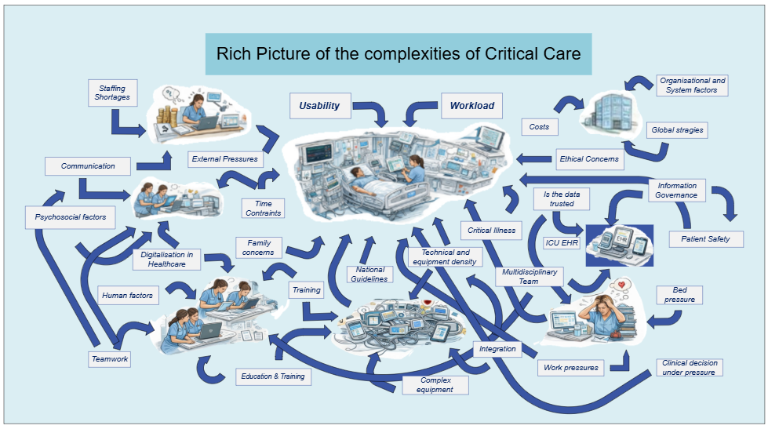
Figure 1.1 Rich picture demonstrating the complexities of ICU

1.2 Nursing Workforce
The nursing profession represents a significant portion of the healthcare workforce and is the primary user of CISs (Abu Raddaha, 2018). Nurses are noted to play a crucial role in implementing digital systems, as they are responsible for documenting and managing patient information, synchronising care, and collaborating with other multidisciplinary team members (Akhu‐Zaheya, Al‐Maaitah and Bany Hani, 2018). Additionally, in critical care units, nurses face unique challenges; the level of care they provide requires greater vigilance than in other departments (Adam, Osborne and Welch, 2017). The intricate nature of clinical interventions and the use of advanced monitoring devices necessitate that nurses possess sophisticated informatics skills and knowledge (Kleib and Nagle, 2018). This need is underscored by the persistence of paper-based clinical records and observations in many settings within Welsh ICUs. Despite the necessity for such technological competencies in effectively implementing a digital CIS in critical care contexts, there remains a limited understanding of nurses' perceptions and confidence in using these systems (Abu Raddaha, 2018). Consequently, addressing these gaps is essential to facilitate the integration of digital tools that enhance patient care and nursing practice.
Staffing constitutes a fundamental and often the most significant expense in the healthcare sector (Yuan et al., 2023). Within this context, the nursing workforce emerges as a crucial stakeholder in the utilisation of CISs. The Faculty of Intensive Care Medicine’s Workforce Data Bank (2021), reports that although adult ICUs in the UK operate as multi-professional teams, nurses form the largest proportion of the clinical workforce, accounting for approximately 60–70% of the total clinical workforce. Consequently, a nuanced understanding of nurses' perceptions and emotional responses to data management systems, particularly in critical care settings, is essential for evaluating practice efficiency. Emerging evidence indicates a correlation between the usability of CISs and the incidence of burnout among healthcare practitioners (Edward R. Melnick et al., 2020), in which complex, difficult-to-use systems can result in clinician cognitive overload, technical errors, and potential patient harm (Howe et al., 2018).
This research, therefore, aims to critically analyse nurses' experiences with CIS, focusing on usability and workload, measured through the utilisation of 2 research questions:

- Are critical care CISs perceived as being usable by the nursing workforce?
- Are critical care CISs perceived as reducing nursing workload?

Additionally, this study will conduct a rigorous, systematic evaluation of the feasibility of implementing a CIS within a critical care unit. It will critically examine both the operational challenges and potential benefits, contextualising these within the broader landscape of health informatics and nursing practice. Employing a prominent commercial data management system as a case study, the research will apply advanced analytical frameworks to generate robust, evidence-based findings. These findings are intended to contribute meaningful insight at the intersection of nursing, informatics, and critical care, ultimately supporting the optimisation of patient care delivery in complex healthcare environments.

1.3 Research aim
This study aims to comprehensively explore nursing staff's experiences with critical care CISs using a mixed-methods approach that incorporates both qualitative and quantitative methodologies. By using qualitative insights alongside a quantitative cross-sectional survey, the research will assess crucial factors, including workflow integration, system responsiveness, and user training. The objective is to identify barriers to effective CIS implementation and to propose actionable strategies for enhancement. The structured questionnaire will gather detailed data on various sociodemographic factors, clinical experience, perceptions of digital healthcare records, and confidence levels in using these systems. To ensure the reliability and validity of the study, validated instruments such as the Systems Usability Scale (SUS) (J Brooke, 2013), and the NASA Task Load Index (NASA-TLX) (Hart, 2006), will be employed. Quantitative data analysis will be conducted using SPSS version 30 (IBM, 2025), while thematic analysis will be applied to the qualitative findings. Collaborating with critical care nursing professionals underscores the study's potential to improve digital health record systems and guide future developments of CIS within critical care environments, ultimately aiming to enhance patient care and operational effectiveness.

Literature Review

A systematic review was conducted using the online library resources of the Cumulative Index to Nursing & Allied Health (CINAHL), The Cochrane Library database, a library search of University of Wales Trinity Saint David, and PubMed. This review followed the Preferred Reporting Items for Systematic Reviews and Meta-Analyses (PRISMA) guidelines, which are designed specifically for systematic reviews assessing the effects of health interventions (Page et al., 2021). The aim was to identify relevant literature with a strong strength of evidence.

2.1 Literature Review Screening
A systematic approach was adopted, employing a combination of ten carefully chosen keywords: “critical care,” “intensive care,” “nursing,” “clinical information systems,” “perceptions,” “workload,” and “usability,” to identify relevant studies that align to collect, synthesise, and critically analyse nursing perceptions regarding the usability and workload implications associated with CISs in critical care settings. The investigation was guided by the following pivotal questions: What are the perceptions of the nursing workforce regarding the usability of critical care CISs, and are critical care CISs perceived as reducing the nursing workload? To address these inquiries, a thorough search of specified academic databases was conducted to locate systematic reviews that encapsulate the desired outcome measures. This refined methodology aims to enhance the understanding of how CISs can support nursing practices in complex clinical environments

2.2 Finalised Screening
A systematic literature review was conducted to evaluate the perceived usability of critical care and clinical information systems and the nursing workload. Boolean operators (AND, OR, NOT) were used to combine relevant key terms. The search strategy included combinations such as “critical care” AND “clinical information systems” AND “nursing workload,” “intensive care” OR “critical care” AND “usability” AND “nursing perception,” and “intensive care” OR “critical care” AND “workload” AND “nursing perception.” Exclusion criteria were applied to refine the results, specifically “NOT paediatric” OR “NOT child.” The search was limited to peer-reviewed articles published from 2015 onward, focusing on literature addressing the complexities of these topics. Identified articles were collated for comprehensive review and analysis. Abstracts were screened for significant findings, methodologies, and conclusions, and excluded if not relevant to the research hypothesis. The remaining literature was analysed to assess the strength of evidence, identify gaps, and extract insights relevant to the research inquiry (see Fig. 2.2).
Of the articles identified, most were initially sourced from electronic databases and registers. Duplicate entries were systematically removed to ensure the integrity of the dataset. Additional studies were identified through citation tracking and formal lectures. Further relevant research was located via reputable websites and recognised professional organisations, ensuring a comprehensive and diverse evidence base for the review. Studies that did not align with the research aims were excluded from further analysis.

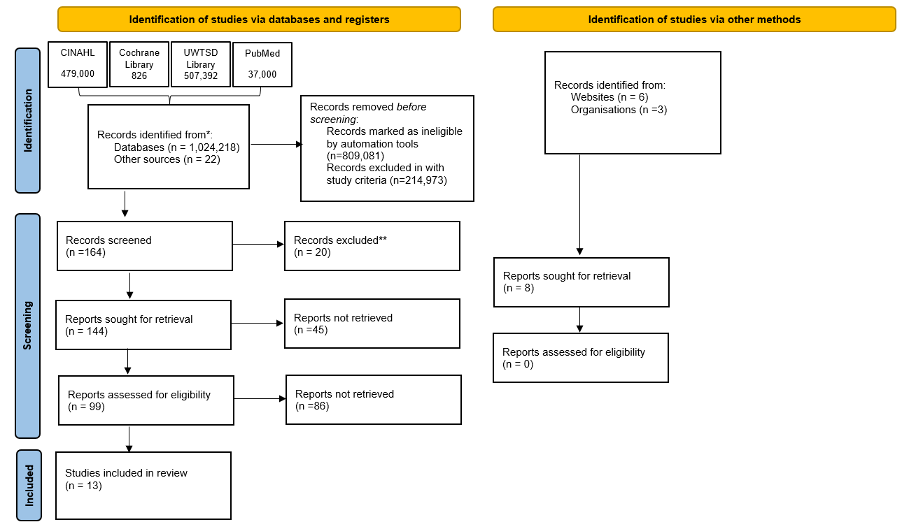
Figure 2.2 Summary of literature screening using a PRISMA flow diagram

2.3 What are the benefits of implementing a critical care CIS?
Critical care units epitomise environments where the interplay between technological advancement and clinical complexity is particularly pronounced. Although clinicians are required to process an average of 1,300 clinical data points per patient per day, and respond to an average of 187 alerts per patient per day, only a limited subset of this information meaningfully informs clinical decision-making (Nadkarni & Sakhuja, 2023; Jalilian & Khairat, 2022). The implementation of critical care CISs, catalysed by major policy interventions such as the Institute of Medicine’s reports on patient safety, was premised on the promise of harnessing this data to drive improvements in care quality, patient safety, and operational efficiency, suggesting that medical error may stem from suboptimal interactions between humans and technology (von Dincklage et al., 2019); Cho et al., 2024; Lin et al., 2019; Nadkarni & Sakhuja, 2023). Nevertheless, a closer examination of the literature reveals a persistent gap between the theoretical potential of CISs and their realised impact in practice.
While some empirical studies report enhancements in care quality and documentation efficiency (von Dincklage et al., 2019), others highlight that such benefits are highly context-dependent and often mediated by factors such as organisational culture, leadership engagement, and the alignment of digital tools with existing clinical workflows (Strudwick et al., 2018). The mixed and inconclusive nature of the evidence base, exacerbated by methodological variation, short follow-up periods, and an emphasis on quantitative data, suggests that a technologically deterministic view is insufficient (Lai et al., 2022). Furthermore, even sophisticated digital systems can inadvertently contribute to new forms of error, alert fatigue, or workflow disruption.
High-quality implementation, therefore, underscores the necessity for a human-centred approach to CIS implementation. wherein user needs and clinical workflows are prioritised, ensuring such tools are developed and implemented as a result of clinical pull, not technological push, thereby limiting technology resistance or avoidance (Davidson et al., 2022). This highlights the need for future research to adopt more nuanced evaluative frameworks and consider the complex interplay among technological, human, and organisational factors that influence CIS outcomes.
This suggests that technological solutions, while necessary, are insufficient to address deeply embedded systemic challenges without concurrent attention to staffing levels, workflow optimisation, and institutional culture. Moreover, while participatory design is intended to promote the usability and adoption of digital tools (Cho et al., 2024), operational barriers, such as heterogeneous staff digital literacy, remain significant.
To align digital tools more effectively with the realities of clinical practice, the integration of mandatory usability feedback loops, whereby nurses regularly evaluate and critique digital tools, has been advocated as a mechanism to refine systems in response to frontline experiences iteratively (El‐Sayed et al., 2025). This highlights the importance of comprehensive change management strategies that simultaneously address technical, human, and organisational factors to ensure that digital transformation yields meaningful improvements in both patient care and practitioner well-being.

2.4 The Nursing Workforce in Critical Care
The mere implementation of CISs does not guarantee that healthcare organisations will realise the anticipated improvements in patient care or operational efficiency (Strudwick et al., 2018). Despite the widespread adoption of health information technology, persistent barriers, including workflow disruption, resistance to change, and inadequate alignment with clinical practice, continue to hinder both implementation and sustained use. Notably, the adoption of CISs in critical care environments is often hindered by their inability to meet the complex cognitive and collaborative demands of frontline clinicians (Saleem et al., 2015).
To address these challenges, it is imperative to critically evaluate CIS design and functionality through a user-centred lens, drawing on socio-technical theories and human factors research. This higher-level analysis underscores the importance of iterative system development that incorporates end-user feedback, contextualises adoption within organisational culture, and rigorously assesses real-world impacts on clinical outcomes (Jalilian and Khairat, 2022). Ultimately, it is essential to define the primary CIS users in critical care and examine how their roles and workflows determine system requirements.
In the contemporary healthcare landscape, the clinical judgement of critical care nurses is increasingly mediated by digital technologies, notably CIS systems, rather than relying exclusively on professional experience or intuitive reasoning (El‐Sayed et al., 2025). Despite nurses being the primary providers of direct patient care and experiencing the greatest impact of CIS implementation, there remains a lack of research capturing their firsthand perspectives (Cho et al., 2024).
A clear gap emerges in the literature: studies addressing CIS usability from a nursing perspective in critical care are constrained by limited to moderate evidence strength, producing findings that lack consistency and depth. This gap is important because nurses constitute the largest segment of the global health workforce (World Health Organisation, 2021), and their interactions with CIS systems largely determine whether the intended benefits of these digital tools are achieved or compromised (Strudwick et al., 2018).
To address this, future research should adopt robust quantitative and qualitative methodologies to clarify the complex day-to-day realities of nurses using CIS. Such research would generate more substantive, practical evidence to guide system design improvements and inform policy decisions.
Digital information platforms provide nurses with extensive data on patient conditions and treatments. As a result, nurses dedicate about 35% of their shift to documentation tasks (Cho et al., 2024). Guo et al. (2019), note that CISs can create an information-rich environment, which may paradoxically hinder timely and appropriate care. However, this finding is limited by the study’s low to moderate evidential strength and its lack of focus on the nursing perspective.
Most existing literature uses quantitative methods, like surveys and time-motion analyses. While these methods are valuable, they provide only a partial view of the challenges nurses face with CIS in daily practice (Cho et al., 2024). This reveals a gap in current research, that the lived experiences and nuanced realities of nurses using CIS are underexplored. The lack of evidence therefore limits insight into how such systems shape care delivery and bedside judgment.

2.5 Perceived usability of CISs
Transitioning from paper records to digital systems represents an inflexion point in the evolution of healthcare information management, promising to transform information flow by enabling seamless movement of patient data between wards and minimising reliance on fragmented, offline protocols. Yet, this transition is fraught with complexity: entrenched legacy systems, technological heterogeneity, and the deep-seated challenge of fostering staff adaptation persist as formidable (Davidson et al., 2022). Despite advances in mobile technology and software, users continue to struggle with data entry, workflow bottlenecks, and the often unintuitive layout of critical care CISs (Jansson et al., 2022). Extensive research highlights that the most significant obstacle in clinical informatics is not merely technical, but arises from a persistent misalignment between system design and the lived realities of clinical practice.
CISs are tools for clinical empowerment, but often feature convoluted interfaces and inefficient workflows. These problems lead to clinician frustration and burnout (Nadkarni and Sakhuja, 2023). Systemic pressures, rising patient-to-nurse ratios, increasing patient acuity, and time constraints, intensify documentation burdens. Usability issues, including limited functionality, inflexibility, and poor customisability within CIS components, block digital health’s potential (Cho et al., 2024). Therefore, technological innovation alone is not enough. Advancement in clinical informatics requires an integrated approach, combining user-centred design with organisational transformation to address the interplay of technology, workflow, and the human element in healthcare.
The promise of CIS customisability serves as a pivotal plot point in the story of digital transformation, offering the potential to adapt generic platforms to the nuanced needs of individual hospitals and clinical settings. Yet, the presence of customisable features alone does not guarantee improved usability; instead, it shifts responsibility onto end-users and organisations to actively configure and refine these systems (von Dincklage et al., 2019). The Healthcare Information and Management System Society (HIMSS) framework posits that effective clinical data presentation must satisfy the five 'rights': the right information, to the right person, in the right format, via the right channel, at the right time (Jalilian and Khairat, 2022). Despite this blueprint, a persistent chasm exists between these ideals and actual outcomes. Notably, many CIS implementations fall short, with empirical studies indicating that charting times remain unchanged or even increase (von Dincklage et al., 2019). This recurring gap underscores the urgent need for continuous evaluation and user-driven iteration to prevent technological advancement from becoming yet another obstacle in care delivery.
Dashboard visualisation empowers clinicians to quickly interpret and synthesise patient-level data. It breaks down information barriers and supports rapid, evidence-based decisions (Lai et al., 2022). Yet, the impact of CIS usability on critical care nursing goes beyond interface looks. It shapes the quality and speed of clinical judgement. More than technology affects success. Leadership, resources, digital literacy, professional experience, and ward culture all influence system acceptance and integration (Thissen et al., 2025; von Dincklage et al., 2019). Evidence shows nurses’ experience affects documentation efficiency. Less experienced staff need more time for CIS tasks, which risks disrupting care (Guo et al., 2019). Poor CIS design can hinder even expert clinicians and slow the progress of digital innovation toward better patient outcomes (El‐Sayed et al., 2025). The solution is a holistic, context-aware approach that aligns system design, strategy, and workforce development to optimise usability and clinical impact.
The conclusion is clear: human factors engineering and usability must be part of every stage of system development. This includes initial requirements, design, implementation, and ongoing monitoring. These steps safeguard patient safety, align with clinical workflows, and ensure the effective use of CIS systems (Saleem et al., 2015; Jansson et al., 2022). Expert users may adapt to usability problems with training and resourcefulness. However, such workarounds are insufficient to meet the evolving needs of healthcare and CIS technology (Jalilian and Khairat, 2022). Applying human factors principles is not just an improvement, but a basic requirement for future health IT procurement and safe, user-centred care.

2.6 Perceived workload of CISs
Recent studies suggest that digital solutions in critical care can significantly reduce staff cognitive load and clinical errors, especially during periods of heightened demand (Davidson et al., 2022). While not exclusively focused on nursing, this research shows that the adoption and use of digital tools in decision-making are shaped by an organisation’s digital culture, its shared values, attitudes, and technological readiness. However, these positive impacts depend on staff digital competence and the usability of information systems (El‐Sayed et al., 2025). Focusing only on digital culture, without investing in skills and system optimisation, is unlikely to improve clinical outcomes (El‐Sayed et al., 2025). Therefore, a comprehensive approach is needed, one that integrates cultural transformation, targeted educational initiatives, and continuous technological enhancement to fully realise the potential of digital innovation in critical care.
CISs are part of complex sociotechnical environments. In these settings, the mix of context, setting, and organisational dynamics deeply influences clinical care delivery (Saleem et al., 2015). It may seem easy to link end-user experience mainly to interface design or technology, but the evidence is more complex. For instance, Strudwick et al. (2018), showed that neither typical usability metrics, such as ease of use, system features, or workload, nor organisational supports, such as leadership, training, and the work environment, consistently predicted nurses’ attitudes toward CIS adoption. This unexpected gap points to deeper, less visible factors that shape perceptions of workload and system acceptance among critical care nurses. These findings highlight the need for more nuanced, systems-level investigations.
Individual nurse characteristics may influence how barriers and facilitators affect electronic health record adoption (Strudwick et al., 2018). However, introducing critical care CISs often meets substantial staff resistance. This resistance stems from usability challenges and broader psychological effects. The impact of CISs extends beyond technical hurdles: it can reduce autonomy, increase a sense of external control, and increase workload (Guo et al., 2019). These factors together lead to “technostress,” a phenomenon associated with lower job satisfaction and increased risk of burnout among nurses (Thissen et al., 2025). Today, documentation burden is a major contributor to nurse burnout.
Health systems now prioritise CIS optimisation to reduce attrition and support morale (Cho et al., 2024). Nurses with over 6 years of experience tend to demonstrate greater competency (Jansson et al., 2022), but the effects of experience on workflow and CIS adaptation require further study. Addressing these gaps is crucial for targeted interventions that optimise workflow and clinician well-being and build a more resilient workforce (Guo et al., 2019).
Within the nursing profession, digital competence transcends mere technical proficiency; it forms the very bedrock of sound clinical judgement and patient safety. This multifaceted competence empowers nurses to critically assess, adapt, and creatively deploy digital technologies amid the unpredictable realities of clinical care. Its impact reverberates throughout the healthcare system, directly streamlining documentation processes, optimising CIS performance, and liberating valuable time for direct patient care (Guo et al., 2019). Nowhere is this more consequential than in critical care, where the rapid, accurate synthesis of complex patient data can mean the difference between life and death.
Nurses equipped with advanced digital competence harness tools such as electronic health records, telehealth, and predictive analytics, drive evidence-based practice and deliver precise, life-saving interventions (El‐Sayed et al., 2025). However, critical analysis exposes persistent barriers, including poor integration between technology and social systems and misalignment with nursing workflows (Saleem et al., 2015), that limit progress, fuel resistance, and squander opportunities for improvement. Starkly, deficiencies in clinical judgement, compounded by insufficient digital competence, are associated with a 25% increase in patient mortality and prolonged critical care stays (El‐Sayed et al., 2025). These findings cast the issue as both an ethical imperative and a practical necessity, underscoring the urgent need to elevate nurses' digital literacy.
A strong digital culture helps align technology with clinical goals. However, it is not enough without investing in nurses' digital skills. High digital competence lets nurses detect patient deterioration earlier, reduce errors, and improve care quality (El‐Sayed et al., 2025). Achieving these results takes more than cultural change. It needs a detailed understanding of the specific barriers and facilitators affecting nurses’ CIS engagement. Evidence shows that only targeted, context-driven interventions can truly link technology to hands-on practice.
Through rigorous critical analysis, it becomes clear that targeted, context-sensitive interventions are necessary to bridge the gap between technology and practice, ensuring that digital transformation in nursing yields substantive improvements in patient outcomes (Strudwick et al., 2018). This highlights the urgent need for ongoing digital literacy initiatives as a cornerstone of strategic advancement in critical care nursing.
The usability of critical care CISs is shaped by competing forces, ease of use, system features, navigational clarity, and perceived workload (Strudwick et al., 2018). When usability is poor, clinicians face obstacles that slow them down. These barriers manifest as excessive documentation requirements (Cho et al., 2024).
Leading CIS platforms often have recurring pain points: redundant documentation, slow system performance, outages, poor interoperability, and safety problems (Jansson et al., 2022). These challenges are both technical and human. Decision fatigue now affects about 40% of critical care nurses, reducing clinical vigilance and delaying urgent interventions (El‐Sayed et al., 2025). Consequently, inadequate user-centred interface design and ongoing usability shortcomings are directly linked to CIS-induced fatigue, undermining both system efficiency and quality of patient care (Jansson et al., 2022). Solving these challenges is essential for strong clinical judgement, patient safety, and better outcomes.
Recent qualitative investigations indicate that nurses perceive a documentation burden from the use of CIS. This burden is linked to poor system usability and insufficient tailoring to the clinical context. Both issues are associated with increased risks of adverse patient outcomes and staff burnout (Cho et al., 2024). On the other hand, well-designed CIS platforms, which focus on usability, improve effectiveness, efficiency, and satisfaction. They also raise care quality, hospital productivity, and staff morale (von Dincklage et al., 2019). Yet again, the connection between usability, workload and patient outcomes is complicated.
Highly customisable CIS platforms can be tailored for specific needs, but they may also increase error risk. This risk grows in high-stress settings with cognitive overload (Davidson et al., 2022). So, the promise of customisation should be balanced against its risks for staff and patient safety.
CIS usability and workload challenges are complex and context dependent. A system can streamline one workflow but make another harder (von Dincklage et al., 2019). Usability interventions should focus on removing unnecessary tasks, optimising workflow navigation, and simplifying data entry. These interventions must also be designed and evaluated by different nursing teams (Cho et al., 2024). Still, CIS developers sometimes miss key design or integration elements. This increases documentation burden and weakens the benefits of CISs (Cho et al., 2024). If left unsolved, these issues fuel burnout, lower clinical performance, and discourage the use of technology meant to improve care. Therefore, user-informed, holistic solutions are urgently needed.
Finally, nursing experience plays a pivotal role in shaping workflow efficiency during CIS documentation, underscoring the need for in-depth exploration of how varying levels of clinical expertise affect nurses’ interactions with these systems (Guo et al., 2019). Authoritative literature calls for healthcare institutions to implement systematic digital competence assessments for critical care nurses, both at the commencement of employment and throughout ongoing professional development. Such strategies ensure not only foundational digital literacy but also the adaptive capacity needed to master emerging technologies (El‐Sayed et al., 2025).
These imperatives underscore the strategic value of embedding targeted digital training and usability optimisation into critical care environments (El‐Sayed et al., 2025). However, despite this consensus, current evidence gaps constrain our understanding of how nurses’ perceptions of CIS usability and workload are shaped and enacted in practice. As such, there is a pressing need for rigorous, high-quality research to unravel these intricate interdependencies and guide evidence-based advancements in policy and clinical practice.

2.7 Critical Analysis of Evidence Strength and Potential Bias
Research on usability, cognitive workload, and digital transformation in critical care CISs employs diverse methodologies, directly influencing evidence strength and credibility. The interplay between technological change, shifting clinical priorities, and frontline nursing experience underpins the research landscape. Critically, methodological choices and stakeholder engagement are not neutral; they determine why findings on CIS usability and workload are often inconsistent. Each approach offers distinct insights yet introduces specific biases, demanding a reflexive interpretation of CIS implementation from the nursing perspective.
Randomised controlled trials (RCTs), exemplified by Lai et al. (2022), are often upheld as the gold standard due to methodological rigour and statistical validity. However, Lai et al.'s cluster-RCT, while evidencing workflow and communication gains with a visualisation dashboard, is constrained by single-centre scope, limited sample size, and absence of patient-level outcomes. Furthermore, the artificiality of trial conditions fails to reflect the complexity of clinical realities. Thus, while RCTs advance efficacy claims, their real world value for CIS implementation in practice remains questionable, underscoring the necessity for contextually grounded research.
Mixed-method studies by Cho et al. (2024), and Strudwick et al., triangulate quantitative and qualitative evidence, offering nuanced insights into CIS impacts often missed by singular approaches. Nevertheless, methodological limitations arise from small, single-site cohorts and reliance on self-reporting, introducing selection and recall bias. While such studies enrich understanding of nursing experiences, their limited external validity constrains policy impact, positioning them as hypothesis-generating tools rather than foundations for generalisable conclusions.
Cross-sectional surveys by von Dincklage et al.(2019), Jansson et al.(2022), and El-Sayed et al. (2025), afford wide-ranging perspectives on usability and digital literacy, leveraging large cohorts and validated measures. Yet their cross-sectional design precludes causal inference and fails to capture dynamics in attitudes as CISs evolve. Consequently, such surveys are best interpreted as descriptive tools, with limited explanatory power regarding the drivers of usability or workload challenges.
Lin et al.'s (2019), systematic review and meta-analyses exemplify high-level evidence synthesis for complex constructs such as cognitive workload. However, marked heterogeneity, reliance on simulated data, and the risk of outdated literature critically weaken the review’s applicability. For nursing perspectives on CIS usability, these methodological shortcomings limit the review to broad overviews, necessitating cautious interpretation regarding practical or contextual recommendations.
Narrative reviews by Jalilian & Khairat (2022), synthesise conceptual frameworks but, lacking systematic rigour, are especially prone to selection and confirmation bias. In the context of CIS usability and cognitive workload, such reviews should be viewed as discursive rather than authoritative, serving to highlight gaps and provoke debate rather than inform policy or evidence-based practice.
Financial conflicts of interest are rarely transparent, and often embedded in institutional priorities or digital innovation agendas. Such influences risk distorting study design, outcome selection, and interpretation, potentially producing unduly favourable results. Investigator involvement in both system development and evaluation, as seen in Lai et al. (2022), heightens bias risk. Similarly, narrative reviews may reinforce dominant discourses while marginalising dissenting perspectives. Critical recognition of these dynamics is essential for generating credible, practice-relevant evidence.
Methodological biases are pervasive and consequential. Convenience sampling, voluntary participation, and self-reporting intensify selection, non-response, and social desirability biases, particularly in sensitive domains like workload and usability. Studies evaluating proprietary systems are susceptible to vendor bias, while narrative reviews may preferentially cite supportive literature, reinforcing prevailing assumptions. Transparent methodologies and critical reflexivity are imperative to safeguard research integrity in this field.
In summary, the evidence base for nursing perceptions of CIS usability and workload is methodologically diverse but undermined by persistent design, generalisability, and transparency deficits. While Lai et al.’s (2022), RCT demonstrates internal validity, its practical relevance is limited; mixed-methods and cross-sectional studies provide context-specific insights with constrained external validity. Narrative reviews lack actionable authority. Unaddressed biases further constrain evidence utility for policy or practice. Therefore, advancing the field requires rigorous, multi-site, and reflexive research designs to authentically capture nursing experience and inform meaningful CIS and patient care enhancements.

Table 2.7 Critical analysis and study characteristics
Reference | Study Design & Sample | Includes Usability | Includes Workload | Includes Nursing Perceptions | Strength of Evidence | Potential Bias Sources
Cho et al., 2024 | Mixed methods; n=20 nurses; single site | Yes. Examines usability issues | Yes. Focuses on documentation burden | Yes. Uses interviews & surveys | Moderate | Selection bias, unclear survey validity
Davidson et al., 2022 | Qualitative; single ICU | Yes. Addresses usability | Yes. Explores alleviating staff burden | No. Focus is on Multidisciplinary Rounds | Moderate | Interpretation bias, organizational pressure
von Dincklage et al., 2019 | Cross-sectional survey; n=535 clinicians | Yes. The paper addresses usability | Yes. Looks at workload but does not measure or analyses | Yes. Includes nurses and physicians | Moderate | Self-report bias, no confounder control
El-Sayed et al., 2025 | Multi-centre survey; n=550 | Yes. Usability is a core variable | No. Does not indicate workload as a measured factor | No. Addresses nurses’ clinical judgment but not workload | Moderate | Convenience sampling, institutional agenda
Guo et al., 2019 | EMR audit log; small sample | Yes. The study identifies usability problems | Partially. Explores mental workload in ED but not within ICU setting | No. Perception is not covered in this paper | Low-to-Moderate | Academic bias, limited peer review
Jalilian & Khairat, 2023 | Narrative review | Yes. Extensively discusses usability | Yes. Covers clinician cognitive workload | No – Physicians | Low | Confirmation bias, selective citation
Jansson et al., 2022 | National survey; large sample | Yes. This is the core subject of the paper | No. Only indirectly addressed | Yes. Includes perceptions from ICU professionals | Low-to-Moderate | Voluntary participation bias
Lai et al., 2022 | Cluster RCT; single centre | Yes. The study examines usability aspects | Yes. The study measures workload | Yes. Including multidisciplinary team feedback | Moderate-to-High | Performance bias (authors involved in design)
Lin et al., 2019 | Systematic review & meta-analysis | Yes. The review examines user-centered design and usability | Yes. The study evaluates cognitive workload | Partially. Includes nurses and physicians | Low-to-Moderate | Publication bias, simulated settings
Nadkarni & Sakhuja, 2023 | Narrative review | Partially. It discusses the challenges | Partially. It covers the burden of data, but no engaging workload | No. Does not address nursing perceptions | Low | Selection bias, optimistic framing
Saleem et al., 2015 | Rapid ethnography; multi-site | Yes. The study identifies usability barriers | Partially. Indirectly covers themes contributing to workload | Yes. Nursing perceptions included in studies | Low-to-Moderate | Researcher interpretation bias
Strudwick et al., 2018 | Mixed methods; single site | Yes. The study discusses usability factors | Yes. Workload was one of the themes | Yes. Nursing perceptions specifically within Critical Care | Moderate | Social desirability bias
Thissen et al., 2025 | Qualitative; ICU context | Yes. Focus on usability | Yes. Workload discussed indirectly | Yes. Perceptions of nurses included | Moderate | Institutional bias
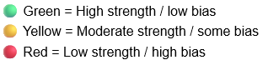

Methodology

This study aims to critically examine the barriers to effective CIS implementation within intensive care settings, with a particular focus on workflow integration, system responsiveness, and user training among nursing staff. By employing a robust mixed-methods research design, the study seeks to generate nuanced insights that inform the development of targeted improvement strategies. The overarching objective is to contribute to the enhancement of patient care quality and operational effectiveness through evidence-based recommendations. The methodological approaches underpinning these objectives are detailed below and demonstrate alignment with current best practices in health informatics research at the postgraduate level.
A convergent mixed-methods design will be adopted, integrating a cross-sectional quantitative survey with open-ended qualitative questions to achieve a comprehensive understanding of nursing staff experiences (See Fig. 3). The structured questionnaire will systematically collect data on sociodemographic characteristics, clinical background, digital literacy, perceptions of the current digital healthcare record system, and self-reported confidence in CIS usage. To maximise reliability and validity, the study will employ established, psychometrically validated instruments.

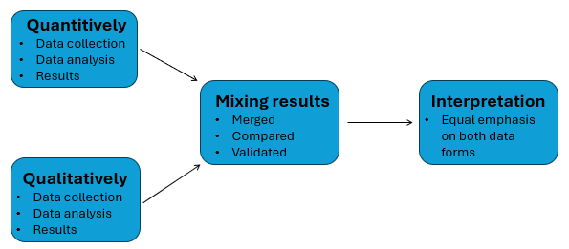
Figure 3 Mixed methodology convergence (Smajic et al., 2022)

Quantitative data will be collected using the Systems Usability Scale (SUS; Brooke, 2013) and the NASA Task Load Index (NASA-TLX; Hart, 2006), enabling multidimensional assessment of usability and workload. These standardised tools ensure methodological rigour and enable benchmarking against the existing literature, thereby strengthening the study’s external validity. Additionally, qualitative data from open-ended questions will be analysed thematically to elucidate contextual factors and to provide deeper insights into the barriers and facilitators of CIS implementation (see Appendix 1).
Data integration will occur at the interpretation stage, ensuring that quantitative findings are contextualised with qualitative perspectives. Statistical analysis will be conducted using the Statistical Package for the Social Sciences (SPSS) version 30 (IBM, 2025), while qualitative data will be coded and analysed according to Braun and Clarke’s (2006b), framework for thematic analysis. This collaborative research will actively engage critical care nursing professionals as research partners, ensuring relevance and practical applicability. The findings are anticipated to generate actionable recommendations for optimising digital health records in critical care and to inform the strategic development of future CIS projects, thus advancing both practice and knowledge in the field.

3.1 Key concepts and frameworks
Usability is a critical factor in health technology, shaping users’ ability to use systems effectively and with satisfaction (Broekhuis, van Velsen and Hermens, 2019b). It is not just a technical concern; it also involves technological, organisational, and human factors that together determine the success of digital health interventions.
Building upon this understanding, Paz and Pow-Sang (2014), define usability as,
“the extent to which a product can be used by specified users to achieve specified goals with effectiveness, efficiency, and satisfaction in a specified context of use.”
This definition foregrounds the interdependence of user, task, and context, indicating that robust usability evaluation requires nuanced consideration of these interrelated dimensions.
Such a conceptualisation underscores the centrality of user experience in mediating human-technology interaction. This demands rigorous application of human-centred design and evidence-based usability principles (Carayon and Hoonakker, 2019). The inherently subjective and context-dependent nature of usability complicates its operationalisation. Both individual perceptions and situational factors shape usability outcomes, particularly in the healthcare context (Zwaanswijk et al., 2011).
Designing health information systems that are user-friendly and clinically robust presents significant methodological and practical challenges. Measuring user satisfaction and aligning with clinical workflows are particularly difficult (Broekhuis, van Velsen and Hermens, 2019b). A critical appraisal of existing evaluation frameworks reveals a constellation of pertinent themes for assessing clinical information systems (Almasi et al., 2023; see Table 3.1). Therefore, a nuanced understanding of usability is essential for advancing health technologies that promote user satisfaction and high-quality healthcare delivery.
Table 3.1 Usability evaluation criteria (Almasi et al., 2023)
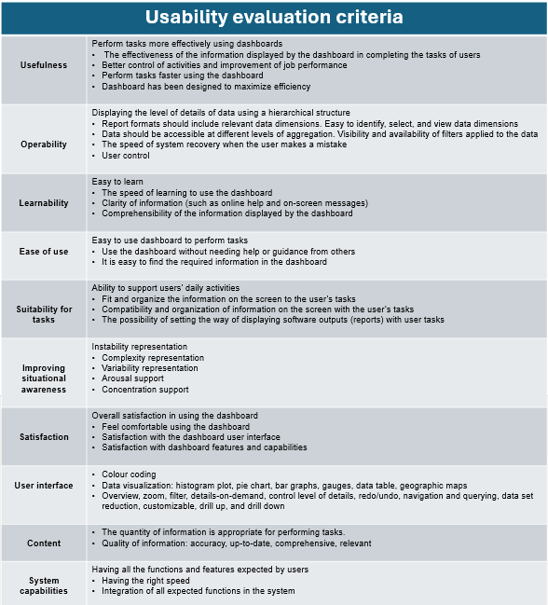

Recent research offers many methods for checking software usability, but there is still no agreed-upon or best way (Paz and Pow-Sang, 2014). This uncertainty grows because no single tool has been proven superior through robust evidence, leading to ongoing debates in the field. Researchers continue to search for a gold standard for measuring usability and agree that tools should provide high-quality, reliable, and context-appropriate data (Paz and Pow-Sang, 2014).
Given these challenges, this study uses the SUS, a well-tested and practical tool for evaluating CISs (Almasi et al., 2023). The SUS helps gather users' views in an organised manner, allowing for a deeper look at CIS usability. Using this established tool makes the findings more reliable and easier to compare, supporting better standards in usability research.
The research is situated within a distinctive healthcare context encompassing four critical care units located in separate hospitals, all governed by a single Welsh health board. Of these, three units continue to employ traditional paper-based clinical documentation, whereas the largest unit has transitioned to a digital CIS, namely the IntelliSpace Critical Care and Anesthesia (ICCA) platform (Phillips, 2024), commonly referred to as “CareView”.
Despite this difference, uniformity in nursing policies, procedures, and guidelines across all units ensures methodological consistency. This consistent approach supports a robust comparative analysis of nurses’ perceptions of digital versus paper-based CIS, particularly among practitioners with experience in both systems. Furthermore, the centralised management structure helps control potential confounding variables, thereby enhancing both the internal validity and reliability of the study’s findings.

3.2 Organisational challenges
To address the complex organisational challenges inherent in the digital transformation of critical care, this study adopts a critically robust mixed-methods research design, consistent with the study aims. The methodological approach will be underpinned by the integration of several established frameworks, each selected for its capacity to illuminate different dimensions of CIS implementation.
The learning health cycle is employed to facilitate iterative evaluation and continuous organisational learning (Flynn et al., 2018), ensuring that CIS adaptations remain responsive to emergent clinical needs. The HIMSS EMRAM framework provides a systematic, evidence-based approach to benchmarking digital maturity and readiness (HIMSS, 2025), enabling structured comparison across contexts. The FITT framework is utilised to interrogate the alignment between users, tasks, and technology, revealing sociotechnical determinants of acceptance and resistance that are often overlooked by purely technical assessments (Ammenwerth, Iller and Mahler, 2006). Complementing these, Soft Systems Methodology (SSM) is applied to capture the complexity of organisational contexts and the multiplicity of stakeholder perspectives (Lamé, Jouini and Stal-Le Cardinal, 2020), supporting the identification of both explicit and latent factors that influence digital health initiatives. In addition, principles from behavioural economics are incorporated to critically examine how cognitive biases and systemic influences shape organisational decision-making and adoption processes within digital health transformation (Hodson et al., 2024).
By synthesising quantitative modelling with in-depth qualitative inquiry, this methodological strategy facilitates a comprehensive and theoretically informed analysis of CIS implementation. Crucially, it also acknowledges the limitations and contextual boundaries of each approach, positioning the study to offer a nuanced and critical perspective. The discussion chapter will further interrogate the interplay among these frameworks in light of the gathered results, drawing upon emergent findings and relevant literature to provide a deeper critical synthesis of their implications for digital transformation in critical care.

3.3 Data Gathering
Evaluating digital health interventions poses significant methodological challenges. Traditional healthcare assessment frameworks often fail to capture the complex, multifaceted nature of digital health (GOV.UK, 2024). The complexity and context-specificity of these interventions can lead to outcome measures that fail to accurately represent their real-world impacts or effectiveness (David Maguire et al., 2021).
Within the socio-technical paradigm and the SSM framework, employing a mixed-methods approach is not only justified but also essential for generating robust, contextually rich evidence (Littell and White, 2018). This methodological perspective is increasingly recognised as critical for advancing evidence-based health informatics, as it enables researchers to address practical questions and bridge the gap between theory and practice (Scott Philip J., 2016).
Mixed-methods research is particularly effective in understanding the complex human, organisational, and technological dynamics inherent in digital health. Such research requires sophisticated and reflexive study designs. Although limitations exist, including integration challenges and methodological incongruence, a mixed-methods approach provides a dynamic and rigorous framework for analysis (Sandelowski, 2000).
In clinical health research, methodological convergence enhances the validity and credibility of findings. Mixed-methods strategies are especially valuable for disentangling the layered complexities of healthcare delivery (Sadan, 2014; John W. Creswell et al., 2010; Smajic et al., 2022), as demonstrated within this work. However, maintaining a critical awareness of potential biases is imperative when evaluating CIS systems. Personal preconceptions and subjective interpretations may inadvertently influence data collection, measurement, and analysis, thereby affecting results (Morgan, 2007; Fretheim and Tomic, 2015).

3.4 Quantitative component
This study employed a quantitative, cross-sectional design to evaluate nurses’ perceptions of CIS usability and workload within critical care settings. Methodological rigor was ensured through the use of validated, standardised instruments and a structured data collection process.
Usability evaluation in digital health remains a subject of scholarly debate, largely owing to the absence of universally accepted definitions of 'usability' and 'user experience' (Sauer, Sonderegger and Schmutz, 2020). Despite this conceptual ambiguity, structured questionnaires offer a pragmatic, widely endorsed means of systematically capturing subjective user experiences . Accordingly, the SUS was selected as a validated quantitative instrument for assessing overall CIS usability. Extensive empirical research has established the SUS as a reliable benchmarking tool for perceived system usefulness, benefits, and user engagement (Broekhuis, van Velsen and Hermens, 2019b).
The SUS consists of a 10-item Likert scale, producing a composite score reflecting overall usability (John Brooke,1996; see fig. 3.4a). Notably, the SUS condenses multidimensional experiential feedback into a single metric, enhancing interpretability (Bangor, Kortum and Miller, 2008). However, as recommended by Brooke (1996), caution is warranted against over-interpreting individual items, with robust conclusions best drawn at the scale level.

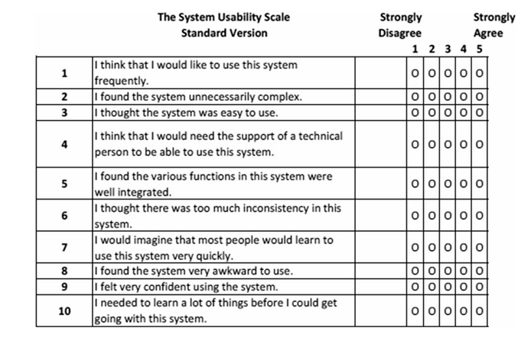

Figure 3.4a The system usability scale (Brooke, 2013)

It is essential to recognise that, although the SUS provides a broad indication of perceived usability, it does not reliably predict real-world clinical outcomes nor furnish a comprehensive understanding of system performance (Broekhuis, van Velsen and Hermens, 2019b). Therefore, using the SUS score in isolation to draw definitive conclusions about the usability of CIS software is methodologically inadequate. A more rigorous evaluation paradigm should converge SUS findings with additional empirical metrics, such as direct observation of task success and failure rates during usability testing. This integrative approach affords a richer and more nuanced appraisal of system usability and its implications for clinical practice (Bangor, Kortum and Miller, 2008).
To address the study’s aims and following a critical appraisal of the evidence base, a bespoke questionnaire was formulated. This instrument integrated the SUS and the NASA Task Load Index (NASA-TLX; see Fig. 3.4b), enabling the collection of comprehensive quantitative data on nurses’ perceptions of CIS usability and workload. The use of these validated scales ensured methodological robustness, facilitating multidimensional insight into both system usability and operator cognitive demands.
Sole reliance on the SUS is insufficient for evaluating perceived workload in critical care CIS contexts. Workload, as defined by Hart (2006), encompasses the cognitive and physical costs required of human operators to accomplish their tasks. While CISs are often associated with improved safety, their implementation may inadvertently elevate occupational stress among nurses (Colligan et al., 2015). Thus, changes to the cognitive demands of routine nursing activities may have significant ramifications for both care quality and patient safety.

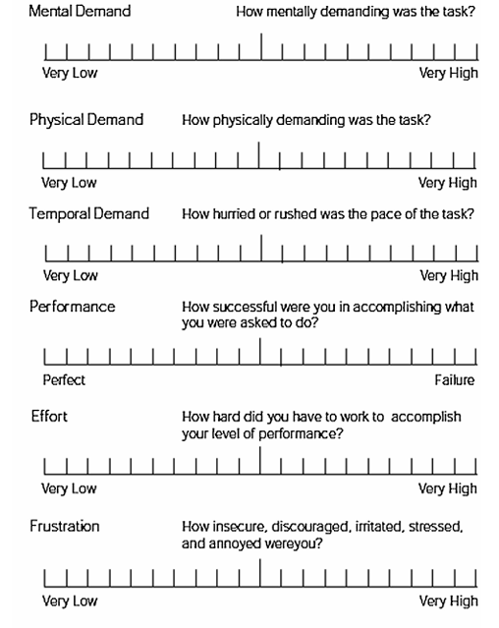
Figure 3.4b NASA-TLX scale (Hart, 1988)

The NASA Task Load Index, developed by Hart and Staveland (1988), was incorporated as a validated measure of operator workload. The NASA-TLX utilises a 20-point bipolar scale to assess six key workload dimensions: mental demand, physical demand, temporal demand, effort, performance, and frustration (Yuan et al., 2023). Although no systematic reviews or meta-analyses have quantified nurses’ workload using the NASA-TLX, current empirical evidence suggests that, for intensive care nurses, an overall workload score is most appropriately calculated by summing four subscales: mental demand, physical demand, temporal demand, and effort (Tubbs-Cooley et al., 2018). This approach aligns with best-practice recommendations for workload assessment in ICUs.

3.5 Statistical package for social science (SPSS)
A comprehensive interpretation of the study’s findings requires a sequential evaluation, in which clinical significance is considered only after statistical significance has been established (Jakobsen et al., 2014). Given the prevalence of big data and advanced analytics, it is crucial to explicitly define the efficiency and performance metrics that underpin the methodological framework (Housawi et al., 2020). Following this framework, raw data will be subjected to rigorous analysis using SPSS to determine statistical significance, which will then inform subsequent clinical interpretation (see Table 3.5).

Table 3.5 SPSS v30 Statistical analysis test performed
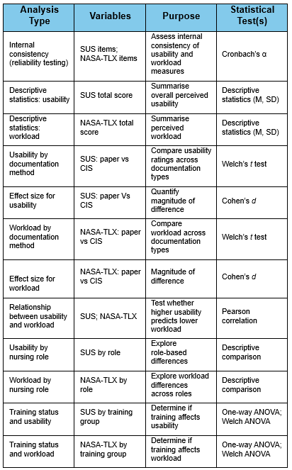

In statistical analysis, the P-value remains a central, though sometimes debated, indicator of evidence (Goodman, 2005). Although a thorough assessment of statistical significance supports meaningful interpretation, it is not always sufficient on its own (Jakobsen et al., 2014). Demonstrating the effectiveness of an intervention is strengthened when statistical significance is accompanied by clinically meaningful effect sizes (Jakobsen et al., 2014). Thus, evaluating the clinical significance of ICCA usability from the nursing staff perspective is enhanced by a nuanced analysis that considers both benefits and adverse outcomes (Jakobsen, 2013).
This comprehensive approach can improve the reliability and validity of the research. Furthermore, reliance on 95% confidence intervals and P-values does not always provide a definitive threshold for significance, highlighting the need for careful interpretation of statistical results (Jakobsen et al., 2014). The generalisability of the study’s clinical implications is also shaped by the characteristics of the included patient populations, which may restrict the external validity and transferability of CIS usability findings beyond the immediate context of this investigation (Jakobsen, 2013).

3.6 Thematic analysis of qualitative data
Qualitative research provides critical insights into the complexities of human experiences by understanding the mechanisms and contextual factors that influence behaviour. This methodology prioritises a comprehensive examination of the 'how' and 'why' underlying phenomena, rather than solely quantifying observable events (John W. Creswell et al., 2010; Dowding, 2013). Within contemporary public health research, this epistemological approach is considered essential for understanding the multifaceted nature of health behaviours and interventions.
The integration of qualitative methods with quantitative instruments, specifically the SUS and NASA-TLX questionnaire formats, constitutes a robust and systematic research design. This methodological approach enhances analytical rigour, supports methodological convergence, and addresses limitations associated with single-method strategies. The purposeful inclusion of open-ended qualitative components enriches the contextual relevance and interpretive depth of usability data within CIS frameworks. This mixed-methods design enables the identification of nuanced patterns and emergent themes that quantitative metrics may overlook, thereby aligning with best practices in advanced research methodology (Ayre and McCaffery, 2022; Chapman, Hadfield and Chapman, 2015; see Appendix 1).
This emphasis on nuanced understanding is operationalised through iterative and reflexive processes that characterise advanced qualitative analysis. Usability and workload data in CISs are systematically coded, with each code representing a distinct conceptual element that informs thematic categorisation (Boyatzis, 1998). The deliberate aggregation of these codes produces robust, analytically defensible themes, which serve as the foundation for critical synthesis and theoretical development (Braun and Clarke, 2006b; see Table. 3.6).
Thematic analysis is widely recognised for its flexibility, which introduces both strengths and challenges. Inconsistencies and reduced coherence may arise during theme development (Holloway and Todres, 2003). The concurrent collection and analysis of data in qualitative research further complicate the analytical trajectory and increase the risk of interpretive overlap (Thorne, 2000). The convergence of methods, as illustrated in Figure 3.3, directly addresses these challenges.
Constructing a theoretical model that authentically reflects the complexity and nuance of the data is essential (Chapman, Hadfield and Chapman, 2015). When rigorously applied, thematic analysis yields trustworthy, in-depth findings (Braun and Clarke, 2006b), facilitating a comprehensive examination of research subjects. However, the absence of a universally accepted standard for thematic analysis remains a subject of debate, complicating efforts to ensure methodological consistency (Nowell et al., 2017).
In this project, systematic coding will be used to generate themes for developing a theoretical model, which will be iteratively validated against both existing and emerging data. The analytical process will require cognitive and creative strategies, including clustering, comparison, hypothesis formation, and the pursuit of conceptual coherence (Chapman, Hadfield and Chapman, 2015). Qualitative research, therefore, remains a vital paradigm, necessitating a disciplined, systematic approach to produce meaningful insights. This approach is particularly significant for understanding critical care CIS usability and workload from the perspectives of nursing professionals.

Table 3.6 Steps of thematic analysis (Braun and Clarke, 2006b)
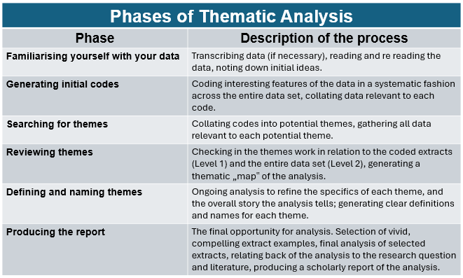

Using grounded theory makes research more complex because it requires switching between building ideas from data and evaluating them as you collect and analyse information (Chapman et al., 2015). To address these challenges, a steady, careful, and thoughtful analytical approach is needed, as shown by SSM, to ensure results are robust and trustworthy. Careful checks of data collection tools enhance the quality of the research. It is also important to reduce researcher bias by keeping complete records and having more than one person review results (Elliott and Jordan, 2010); Chapman et al., 2015).

3.7 Data saturation
Data saturation is a fundamental concept in qualitative research, as it underpins methodological rigor and ensures the reliability of results (Ahmed, 2025). Saturation is reached when additional data collection produces no new themes, signifying the completion of analysis (Tight, 2024). However, inadequate saturation can compromise trustworthiness and lead to ambiguous interpretations (Hennink and Kaiser, 2022).
Achieving code saturation, where no new codes are identified, further demonstrates analytical thoroughness (Hennink and Kaiser, 2022). Nevertheless, excessive emphasis on saturation may lead to the collection of redundant data and obscure important findings (Saunders et al., 2018). Therefore, the appropriate sample size is determined by study design, population heterogeneity, and research objectives (see fig. 3.7a). Research suggests that for homogeneous groups, 12 interviews are often sufficient, whereas heterogeneous groups may require larger samples (Guest, Bunce and Johnson, 2006). Therefore, employing a systematic and transparent approach, strengthens both saturation and the overall robustness of the study (Ahmed, 2025; see fig. 3.7b).

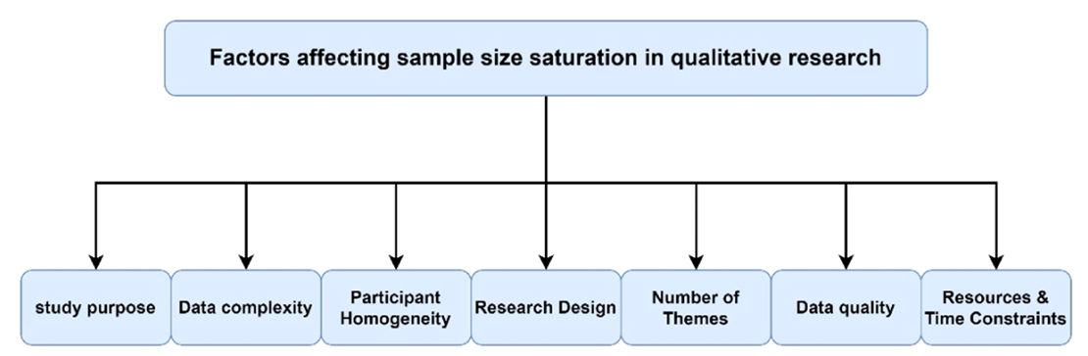
Figure 3.7a Factors affecting sample size saturation (Ahmed, 2025)

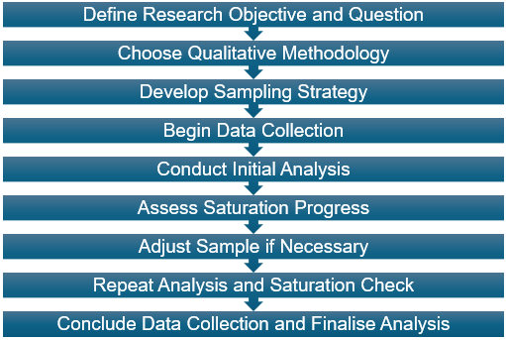
Figure 3.7b Clear stages of reaching data saturation in qualitative research (Ahmed, 2025)

Considering methodological requirements and the necessity for a robust, representative dataset, the questionnaire will be distributed electronically via email to all staff members across the four critical care units, encompassing approximately 160 individuals. This strategy is designed to maximize response rates and capture the full spectrum of staff perspectives, thereby supporting data saturation and enhancing the credibility of the findings. Sampling the entire cohort addresses potential variability in staff experiences and strengthens the reliability and generalisability of the results.

3.8 Transferability
When conducted with methodological rigour, research can significantly influence clinical practice, inform policy development, and guide future research (Drisko, 2025). Rigorous research practices ensure that robust evidence is translated into complex healthcare settings, thereby bridging the gap between theory and practice. In this context, transferability refers to the critical evaluation of whether research findings are applicable to specific clinical situations. This evaluation is informed by an understanding of perceived usability and workload among critical care nurses (Hellström, 2008).
As key stakeholders, ICU nurses are uniquely positioned to assess the contextual relevance and applicability of qualitative findings. Their experiential and contextual knowledge enables a nuanced interpretation of research outcomes (Pratt, Kaplan and Whittington, 2020). Implementing from mixed-methods research requires proactive and collaborative engagement with stakeholders. Specifically, involving critical care nurses is essential prior to modifying clinical protocols or procedures (Drisko, 2025).
Therefore, with this in mind, this project will employ inductive analytical approaches to develop novel conceptual frameworks, with careful consideration of the practical implications and transferability of the findings across diverse healthcare environments (Mayring, 2007; see Fig 3.8).

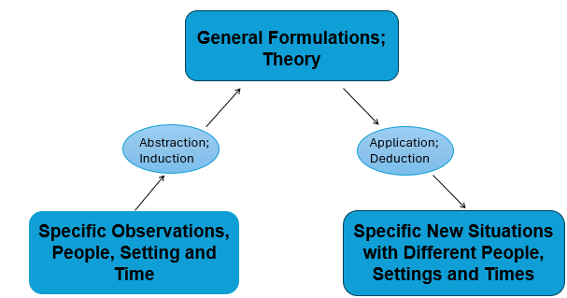
Figure 3.8 The process of theory formulation and transferability (Mayring, 2007)

3.9. Ethical considerations
Digital healthcare tools are transforming patient care delivery and conceptualisation, promising improved outcomes, and more responsive health systems. Achieving these benefits requires rigorous, reflective methods that address the technical, ethical, and socio-political complexities. Implementing CISs introduces interrelated challenges, including data governance, privacy, equity, and stakeholder involvement.
Effective CIS governance must integrate ethical, regulatory, data protection, and trust imperatives in an adaptive, context-aware model. The Data Ethics Framework (Gov.UK, 2018; see Table. 3.9), and similar structures support transparent, responsible data use and participant rights. Yet, rigid application can hinder innovation and context relevance (Califf and Sugarman, 2015; Stevenson et al., 2015), underscoring the need for anticipatory, reflexive ethical leadership beyond procedural compliance.
Managing health data draws added attention to ethics, requiring transparent and strong oversight (Mennella et al., 2024). However, relying on only dominant ethical views may exclude other perspectives and slow innovation (Stevenson et al., 2015). Therefore, oversight, from institutions like the National Research Ethics Service, is vital, but works best as part of ongoing, flexible improvement (Mennella et al., 2024; see fig. 3.9).
Table 3.9 Data ethics framework (Gov.uk, 2018)
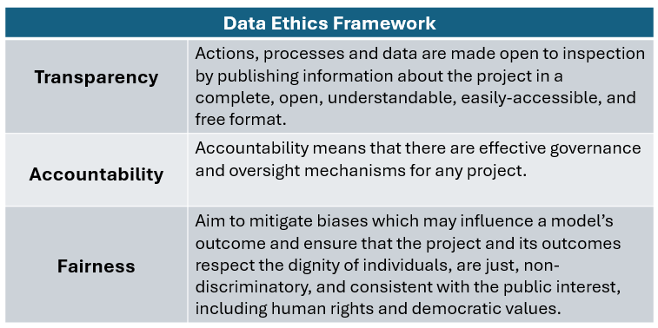

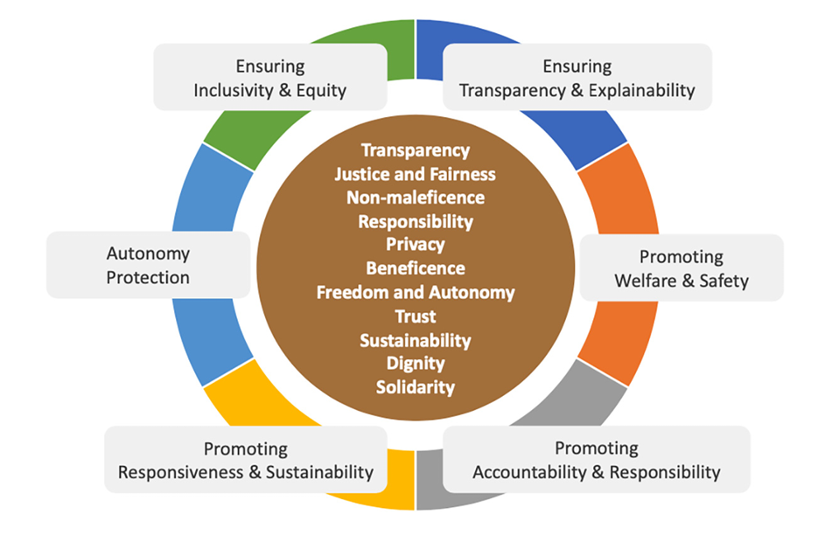
Figure 3.9 Ethical principles of digital innovation (Mennella et al., 2024)

This project adheres to high ethical standards, emphasising ongoing openness, fairness, safety, and equity (Gov.UK, 2021). Utilising this approach aims to prevent harm and supports responsible and creative solutions.
Current health technology frameworks need ongoing focus on ethics, regulation, safety, and quality at every stage. Key values like fairness, accountability, and transparency guide this research (Reddy et al., 2020). Therefore, the project follows standards such as the Guide to Good Practice (Gov.UK, 2021), and the Data Ethics Framework (Gov.UK, 2018), and applies principles such as respect, beneficence, and justice (Mennella et al., 2024). Applying these, the research addresses real-world digital innovation challenges, for which this study secured ethical approval before beginning (see Appendix 2), helping to ensure responsible outcomes.
Recognising that procedural compliance alone is insufficient for ethical robustness marks a key shift in digital health governance (Nicholls et al., 2015). Modern, data-rich research needs adaptive, context-specific, and innovative ethical models beyond traditional frameworks (Faden et al., 2013). Therefore, a shift toward learning health systems is vital for balancing quality improvement, sustainability, and patient protection (Faden et al., 2013; Shimm and Spece, 1993). Within the NHS, this is seen in rigorous scrutiny and committee approvals, as met by this project (Jamrozik, 2004). The challenge for this work, is balancing necessary oversight with the flexibility needed for ongoing innovation, since excessive rigidity can hinder improvement and new knowledge generation.
In summary, technology, ethics, and governance in CISs create changing risks and opportunities. Meeting these challenges requires constant review of ethical and governance practices. Flexible, inclusive processes, involving stakeholders, questioning assumptions, and adapting to change, help balance ethics and innovation. balance is pivotal for CISs to deliver not only technologically advanced but also ethically robust and socially just solutions that enhance patient care, advance equity, and underpin the long-term sustainability of health systems.

Results

4.1 Survey of nursing perception
A total of 52 critical care nurses, representing a broad spectrum of experience within the critical care environment (see Table 4.7a), participated in the survey. These nurses were recruited from four critical care units within a single Welsh health board, thereby capturing both clinical diversity and organisational uniformity. A purposive sampling strategy was deliberately implemented to optimise sample representativeness. Incomplete questionnaires were excluded to preserve the validity of the convergent mixed methodology design. As a result, 38 fully completed responses were available for analysis, affording comprehensive datasets for both the SUS and NASA–TLX scales.
Documentation practices were evenly distributed between paper-based systems (n = 17) and the CareView clinical information system (n = 21). The frequency of CIS use exhibited substantial heterogeneity: 20 nurses reported regular use, 15 reported infrequent use, and 3 indicated no prior experience with the system. Training status also demonstrated considerable diversity. Over half of respondents (n = 21) reported no formal CIS training, 11 had received formal instruction, and 6 were uncertain regarding their training status. Usage frequency and training status are summarised in Table 4.1.

Table 4.1 Usage frequency and training status of participants
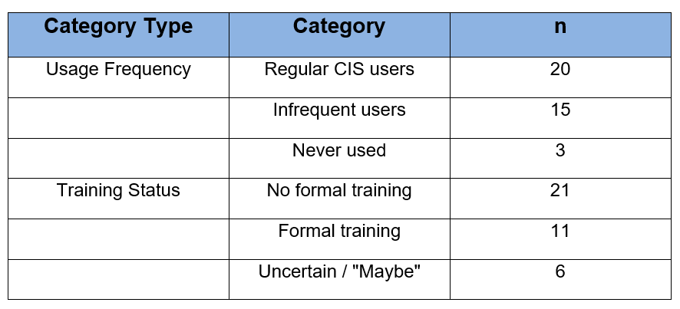

Self-assessed technological proficiency ranged from novice (n = 11) and basic (n = 9) to advanced (n = 17) and expert (n = 1), with the majority of participants identifying at either the novice or advanced level.
Following rigorous statistical analysis of the raw data using SPSS software, internal consistency testing revealed excellent reliability for both measurement instruments. Internal consistency is defined as the degree to which all items within a scale measure the same underlying construct (Cronbach, 1951), specifically, that the SUS items collectively assess perceived usability, while the NASA-TLX items consistently capture perceived workload. Cronbach’s alpha coefficients were α = .866 for the SUS and α = .907 for the NASA-TLX, indicating strong inter-item coherence and confirming that both scales demonstrated reliable performance in this sample. These reliability values strengthen the validity of the distributed questionnaire and reinforce confidence in the robustness of subsequent inferential analyses.
A range of SPSS statistical analyses, as detailed in the methodology, were conducted to rigorously evaluate the questionnaire data and ensure the reliability of the findings (see Appendix 3). The results are presented and discussed in the subsequent sections of this chapter.

4.2 Perceived overall usability
Across all participants, the mean SUS score was 58.82 (SD = 18.49), as demonstrated in Figure 4.2, indicating usability that falls between “marginal” and “acceptable.” The standard deviation (SD) quantifies the extent to which individual responses deviate from the mean; the relatively high SD observed here reflects considerable variability in perceptions (Field, 2018). Thus, participant ratings ranged widely, with some nurses assessing the system favourably and others much less so. Overall, these findings suggest that nurses regarded the CIS as moderately usable, revealing significant opportunities to enhance efficiency, intuitiveness, and user interaction.

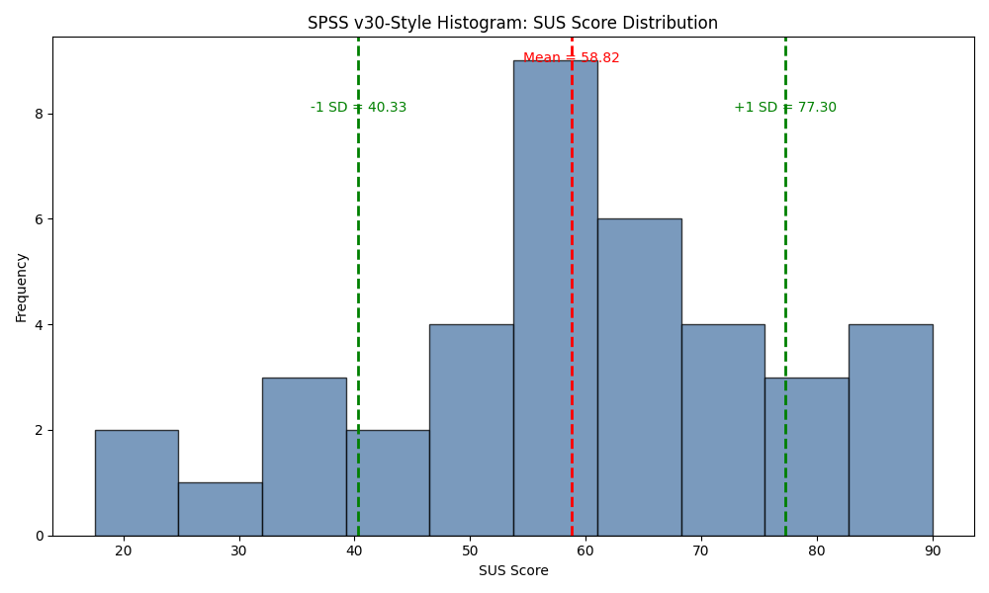
Figure 4.2 Histogram of SUS with mean and standard deviation

4.3 Usability by documentation method
Further analysis by documentation method revealed substantial differences in perceived system usability (see Fig. 4.3). Nurses utilising paper-based documentation rated usability considerably lower (M = 45.88, SD = 14.11), than those using the electronic CIS (M = 69.29, SD = 14.69). The closely aligned standard deviations indicate that the degree of variability in responses was similar for both groups, reflecting substantial heterogeneity in individual perceptions regardless of the documentation modality.

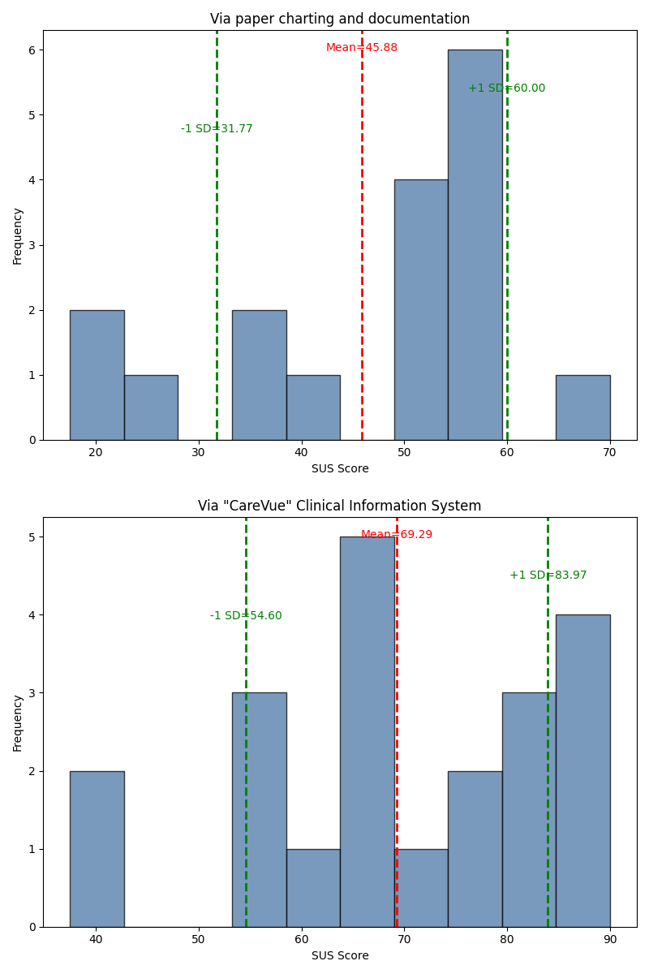
Figure 4.3 Histogram of SUS by documentation method
A Welch’s t-test was employed to compare nurses’ perceived usability of two documentation methods: paper-based notes and CIS. This test is appropriate when the assumption of equal variances between groups may be violated, providing a more robust and reliable comparison. The analysis revealed a statistically significant difference in usability ratings between the two methods (Welch’s t(34.90) = −4.99, p < .001). The very small p-value indicates robust evidence that the observed difference is unlikely to have occurred by chance.
To evaluate the practical significance of this finding, Cohen’s d was calculated, as effect size measures capture the magnitude of observed differences beyond mere statistical significance. The computed effect size (d = 1.62) is considered exceptionally large, signifying a profound and meaningful disparity in usability perceptions between paper notes and the CIS. Conventional thresholds classify effect sizes exceeding 0.8 as large (Field, 2018: see Table 4.3a), further underscoring the substantial practical importance of this outcome. These results indicate that the CIS offers a distinctly different usability experience relative to traditional paper documentation, affirming the real-world relevance of this distinction in clinical practice (see Table 4.3b).

Table 4.3a Cohen's d interpretation guidelines (Field, 2018)
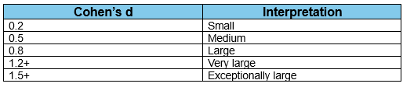

Table 4.3b SUS by documentation method
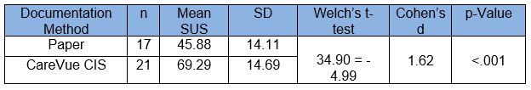

Collectively, these findings provide compelling evidence that nurses perceive the surveyed CIS as markedly more usable than paper-based documentation. The convergence of a substantial mean difference, a highly significant p-value, and an exceptionally large effect size substantiates the superiority of electronic documentation in critical care environments. This difference suggests that the Phillips ICCA CIS offers not just a marginal improvement, but a significant usability advantage over traditional paper records. These findings reveal a pronounced usability gap between digital and paper-based documentation in critical care settings. The high usability ratings for ICCA reinforce the rationale for ongoing or expanded digitalisation initiatives, whereas the low scores for paper systems underscore the inherent limitations of manual documentation workflows within fast-paced, information-dense clinical environments.

4.4 Perceived overall workload
The overall NASA–TLX score indicated a moderate perceived workload, with a mean score of 45.94 out of 100 (SD = 16.82: see Fig. 4.4). The considerable standard deviation indicates substantial variability in participants’ experiences, likely attributable to the diversity of clinical pressures and documentation environments across units. Although the workload was perceived as noticeable and demanding, it did not reach levels considered overwhelming for the majority of respondents, thereby suggesting an overall manageable task burden within these settings.


Figure 4.4 Histogram of NASA-TLX scores

4.5 Workload by documentation method
Further analysis, repeating the same processes as for the raw SUS data, using the Welch t-test, Cohen’s d and p-value, revealed a significantly lower perceived workload among CareView users compared to paper documentation users (see Table 4.5 & Fig. 4.5).

Table 4.5 NASA-TLX by documentation method
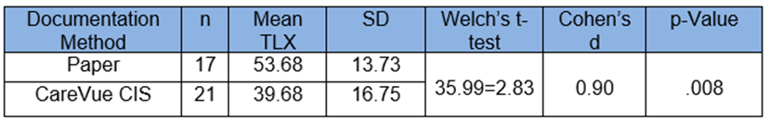

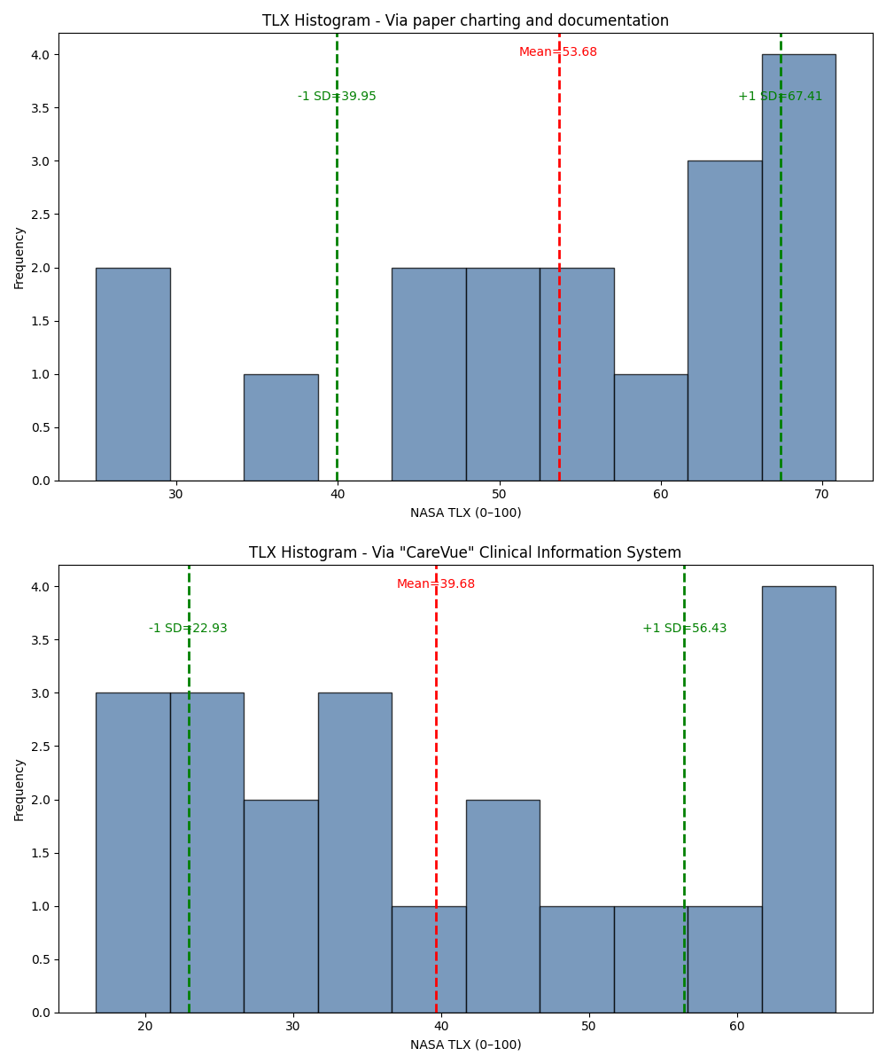
Figure 4.5 Histogram of NASA-TLX by documentation method

Statistical tests confirm that nurses who used paper documentation reported a higher workload, with an average score of about 54 out of 100. In contrast, nurses who used ICCA reported a lower workload, averaging about 40 out of 100. Furthermore, a p-value of 0.008 demonstrated that this difference is real and meaningful, not due to chance, showing that nurses using this CIS consistently felt their work was less mentally and physically demanding than those using paper notes. Additionally, Cohen’s effect size of greater than 0.8 shows a moderate-to-large difference, meaning it is not just noticeable on paper, but something nurses would likely feel in their day-to-day work.
In practical terms, Phillips ICCA CIS appears to make nurses’ jobs easier by reducing repetitive paperwork, automatically recording some observations, and making patient information easier to access. Overall, this suggests that using the electronic system helps reduce workload, making work more manageable for nurses compared with traditional paper documentation.

4.6 Perceived CIS Usability and Workload
An exploratory Pearson correlation analysis was undertaken to investigate the relationship between nurses’ perceived usability of the system and their perceived workload. Pearson’s correlation coefficient (r) is a statistical measure that quantifies the strength and direction of a linear relationship between two continuous variables (Field, 2018). The analysis revealed a weak negative correlation (r = −0.11), indicating that higher usability scores were marginally associated with lower workload scores. However, the p-value of 0.51 highlights that this association is not statistically significant and is likely attributable to random variation rather than indicative of a genuine relationship within the population.

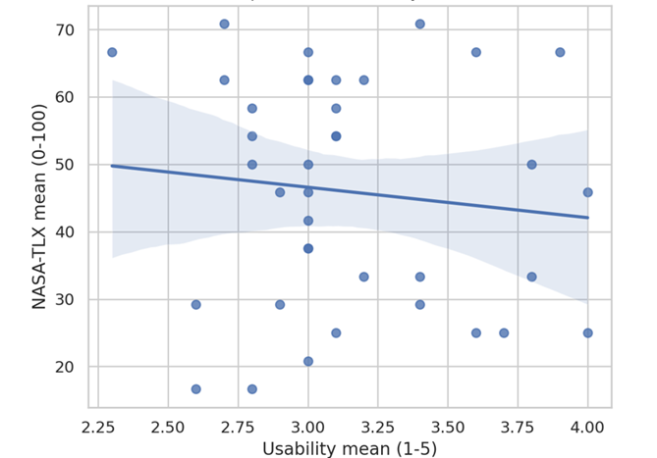
Figure 4.6 Relationship between usability and workload

In practical terms, this means that within this sample, nurses who rated the system as more usable did not consistently report lower workload (See Fig. 4.6). Although the negative direction of the correlation aligns with theoretical expectations (i.e., better usability might reduce workload), the strength of the relationship is very small and not statistically reliable. Therefore, based on this analysis alone, the evidence suggests that there is no direct association between perceived usability and perceived workload, although this conclusion is limited by the relatively small sample size. This finding suggests that workload in critical care may be influenced by multiple interacting factors, such as clinical acuity, staffing levels, workflow design, and organisational context, rather than usability perceptions in isolation.

4.7 Perceived CIS Usability and Workload Versus Role
Descriptive analyses demonstrated substantial variation in both perceived usability and workload across distinct clinical roles (see Table 4.7a).

Table 4.7a Nursing role, responsibilities and CIS interactions
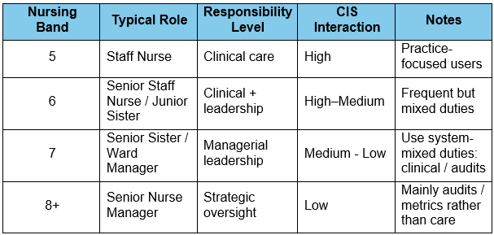

Notably, Staff Nurses and Junior Sisters attained the highest usability scores, whereas Senior Sisters consistently reported the lowest levels of perceived usability. Contrastingly, disparities in perceived workload were even more pronounced: Senior Nurse Managers experienced the lowest workload in relation to ICCA CIS, while Senior Sisters reported the highest. This pattern implies that role-specific responsibilities may have a more significant impact on perceived workload than on perceptions of usability alone (See Table 4.7b & Fig. 4.7)

Table 4.7b Descriptive results by nursing role
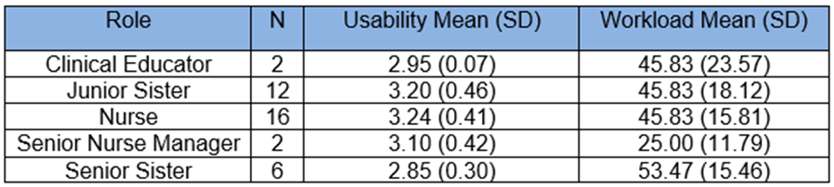

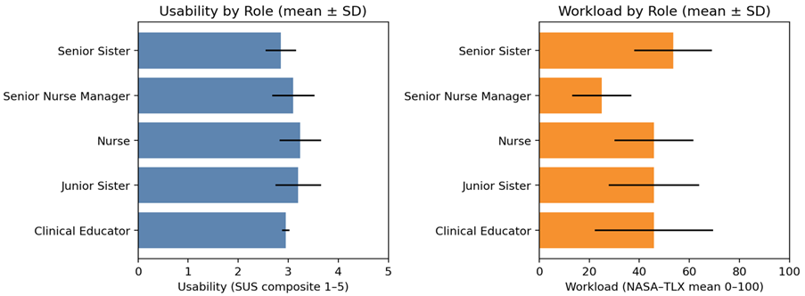
Figure 4.7 Usability and workload by role

However, two roles are represented by very small sample sizes (n = 2 each). As a result, the corresponding mean scores for these groups are potentially unstable and highly sensitive to individual responses. These findings should therefore be interpreted descriptively only, and caution is required to avoid over-interpretation of apparent rank ordering between roles.
Taking these limitations into account, the overall pattern of results provides tentative support for the conclusion that clinical role appears to influence perceived workload more strongly than perceived usability. Senior Sisters, who often combine direct clinical care with supervisory responsibilities, reported both higher workload and slightly lower usability. Nonetheless, given the small and uneven subgroup sizes, these findings should be regarded as directional rather than definitive, pending confirmation in studies with larger, more evenly distributed samples.

4.8 Perceived CIS Usability and Workload Versus Training
Descriptive analysis of the initial results suggests that nurses who underwent formal training reported slightly higher perceived usability than those without training or who were uncertain about it. Nevertheless, these differences were minor and accompanied by considerable overlap in standard deviations, restricting the strength of any conclusions that can be drawn from this observation (see Table 4.8a).

Table 4.8a Perceived usability and workload by training status
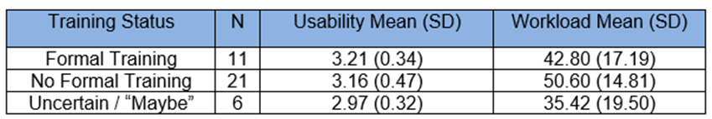

To further interrogate the patterns identified within the descriptive data, inferential statistical analyses were undertaken. Prior to the selection of an appropriate statistical test, the SUS and NASA-TLX variables were subjected to the Kolmogorov–Smirnov test of normality to assess conformity with the assumption of a normal distribution (Field, 2018). Both measures satisfied this assumption (see Table 4.8b). Homogeneity of variance was assessed using Levene’s test, and with a p-value greater than 0.05 (p= .715), equal variance can be assumed (Field, 2018). Although SUS and NASA-TLX scores are derived from Likert-type scales, they were treated as approximately interval, consistent with established practice and the validated use of both instruments. Collectively, these conditions provided the statistical basis for the application of one-way ANOVA.

Table 4.8b Kolmogorov-Smirnov normality test
Variable | K–S Statistic | p-value | Normality?
SUS Total | 0.1039 | 0.7678 | ✔ Normally distributed
TLX Mean | 0.1302 | 0.4988 | ✔ Normally distributed

Following the confirmation of normality, a parametric one-way ANOVA was conducted in accordance with established SPSS analytical guidelines (Field, 2018) (see Table 4.8c). To further safeguard the integrity of the findings, a Welch ANOVA was subsequently employed as a robust alternative to account for potential violations of the homogeneity of variance assumption (see Table 4.8d). The results revealed statistically significant effects of training condition on perceived CIS usability, corroborating earlier observations and reinforcing the assertion that formal training constitutes a critical determinant of both perceived usability and cognitive workload among end-users (see Figure 4.8a).

Table 4.8c Parametric One-Way ANOVA test
Variable | Source | Sum of Squares | df | Mean Square | F | p-Value
SUS Total | Between Groups | 3812.349 | 2 | 1906.175 | 7.55 | .002
 | Within Groups | 8834.361 | 35 | 252.410 | — | —
 | Total | 12646.711 | 37 | — | — | —
NASA-TLX | Between Groups | 1227.785 | 2 | 613.893 | 2.33 | .113
 | Within Groups | 9240.508 | 35 | 264.015 | — | —

Table 4.8d Test of equality of means
Variable | Statistic | p-Value
SUS_Total | Welch | 6.893
TLX_Mean | Welch | 1.900

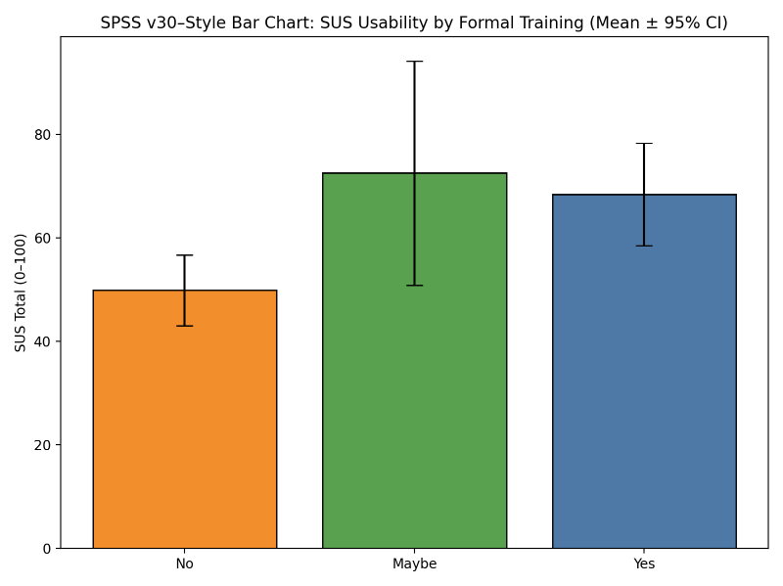
Figure 4.8a Perceived usability by training status

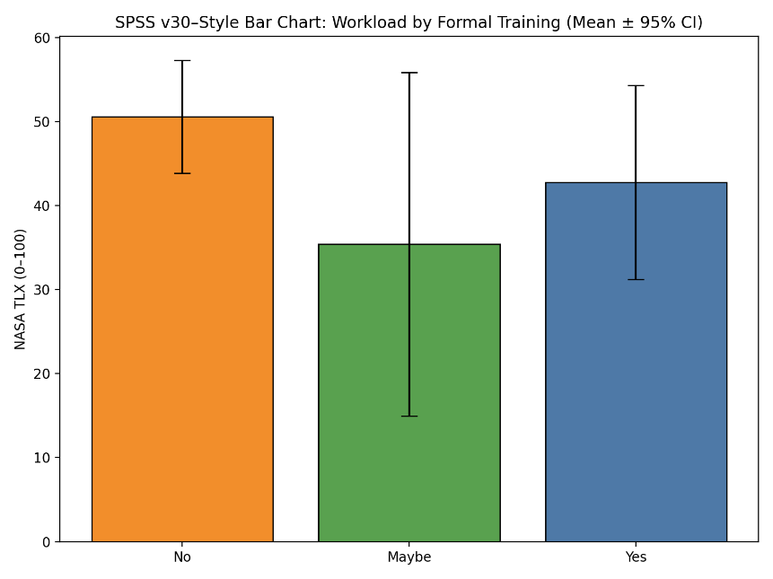
Figure 4.8b Perceived workload by training status

While Figure 4.8b appears to show a trend toward lower workload among the trained and unsure groups relative to those without training, the corresponding ANOVA and Welch p-values indicate that this difference is not statistically significant (see Tables 4.8a and 4.8b). Thus, the evidence indicates that staff workload does not differ meaningfully based on formal training status. Despite observable numerical trends, inferential analyses failed to identify any significant effect of training on perceived workload. These findings suggest that perceptions of workload are likely shaped more profoundly by contextual variables such as system configuration, workflow integration, frequency of system use, and the broader clinical environment than by the presence or absence of formal training alone.

4.9 Summary of Key Thematic Findings
The findings reveal a persistent tension between the anticipated efficiencies of digital clinical documentation systems and their experienced impact on frontline nursing practice, particularly during periods of high clinical demand such as patient admissions. Although participants consistently valued core ICCA CIS functionalities, including device integration and the centralisation of patient information, these benefits were frequently undermined by deficiencies in usability, system reliability, and alignment with real-world clinical workflows. Consequently, digital documentation did not consistently reduce workload as intended, and in some contexts, contributed to increased cognitive burden, frustration, and perceived risk of documentation error.
Figure 4.9 presents a thematic map illustrating the interrelationships among the eight emergent themes, demonstrating that nurses’ perceptions of usability and workload are shaped by interacting system and workflow factors rather than isolated technical issues. System performance and workflow alignment emerged as central influences, mediating whether the CIS supported or hindered clinical practice. Features intended to enhance usability, such as device integration and auto-population were experienced as beneficial only when functioning reliably, indicating that perceived usability is contingent on consistent operational performance. In contrast, admission and setup complexity, duplicated documentation pathways, restrictive saving mechanisms, and system instability were associated with increased mental effort and inefficiency, directly contributing to perceived workload.

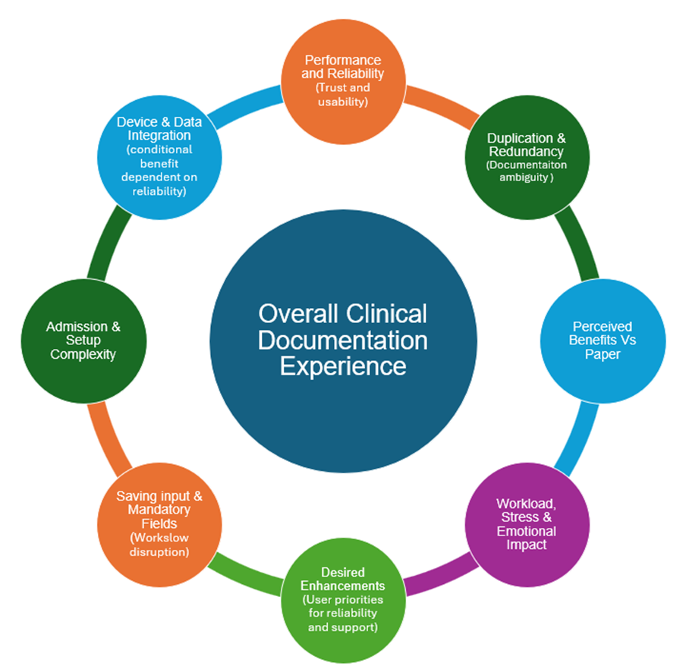
Figure 4.9 Key qualitative themes related to CareView usability and workload

Despite these challenges, participants consistently expressed a preference for digital documentation over paper-based records when systems functioned as intended, citing faster documentation and improved access to patient information. This finding aligns with the study’s objective of assessing the acceptability of CISs within critical care and suggests strong conceptual support for digital documentation among the nursing workforces. However, the qualitative data also highlight important constraints, as nurses’ recommendations for improvement focused on issues, such as reliability and simplification of workflows. Collectively, these findings indicate that the success of CIS implementation in critical care environments is determined less by technological sophistication and more by usability, workload impact, and alignment with clinical practice.

Discussion

Within this chapter, the quantitative and qualitative findings derived from the questionnaire will be synthesised, integrating these results with insights from the literature review and established theoretical frameworks, including the Fit between Individuals, Task and Technology (FITT), framework (Ammenwerth, Iller and Mahler, 2006), the Learning Health Cycle (Flynn et al., 2018), Soft Systems Methodology, and Behavioural Economics. These elements will be subjected to critical analysis in order to provide a robust response to the two research questions presented below:
- Are critical care CISs perceived as being usable by the nursing workforce?
- Are critical care CISs perceived as reducing nursing workload?

5.1 Are critical care CISs perceived as being useable by the nursing workforce?
The quantitative findings from this study demonstrate that, while the Phillips ICCA CIS achieves only marginally acceptable usability according to standard thresholds, its performance relative to paper-based documentation is both statistically and practically significant. The observed mean difference in SUS scores (45.88 for paper versus 69.29 for CIS), coupled with a highly significant p-value (p < .001), and an exceptionally large effect size (d = 1.62), provides robust evidence for the superior usability of the digital platform across diverse nursing roles. Nevertheless, the pronounced standard deviations observed in the data indicate significant variability in individual user experiences.
The qualitative data illuminate these variations by highlighting the contextual conditions that shape users’ perceptions of usability. Nurses consistently reported that when the system functioned effectively, particularly when device integration and auto population operated as intended, participants emphasised that centralised patient information enhanced situational awareness, reduced unnecessary duplication, and supported safer decision-making. These accounts rationalise why ICCA users, on average, rated usability favourably.
Nurses also highlighted several factors that diminished perceived usability, including inconsistent training, differing levels of digital competence, system slowdowns, and difficulties during cognitively demanding tasks such as admissions. These qualitative insights closely mirror the quantitative findings that usability perceptions are variable and underscore how system performance and user context critically influence the overall usability experience.
Importantly, this interpretation aligns with socio-technical perspectives, specifically the FITT framework (see Fig 5.1a), which emphasises the dynamic interaction between users, tasks, and technology as a source of variation in system adoption and usability. Such insights reinforce the necessity of tailoring implementation strategies to address both technical and human factors, thereby optimising the effectiveness of CIS deployment in complex clinical environments.
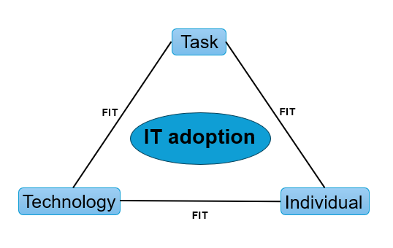
Figure 5.1a The FITT framework (Ammenwerth, Iller and Mahler, 2006)

Building on the guidance of previous strategists, the application of the FITT framework not only offers strategies for mitigating implementation risks but also, akin to other technology acceptance models, provides a means to systematically examine the interconnected elements that influence the success of CIS usability (Schnall et al., 2012). This is particularly relevant given the evidence gained from this study, which highlighted substantial variability in user experiences and usability outcomes associated with perceptions of CIS usability. The FITT model's compatibility with learning health cycle framework (see Fig. 5.1b), further demonstrates its utility in illustrating how knowledge transitions from development to practical application. However, the current variability in usability perceptions suggests that the CIS has not yet undergone sufficient iterative optimisation to fully realise its potential across all sites.

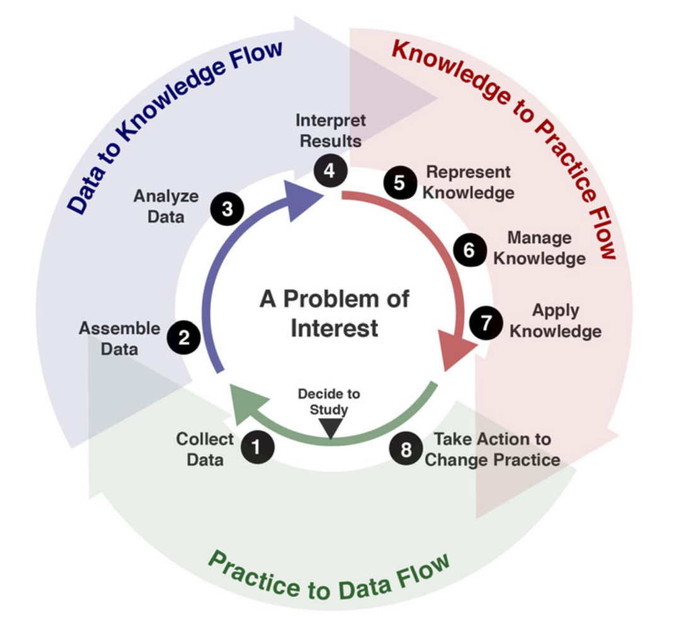
Figure 5.1b The learning health cycle (Flynn et al., 2018)

The results gained from this study support the findings previously documented, that successful adoption of information technology in clinical environments relies on strong alignment among the essential components: the user, the technology, and the task (Ammenwerth, Iller and Mahler, 2006). The inconsistencies reported by nurses, such as duplicated documentation pathways, inflexible mandatory fields, and reduced system responsiveness during periods of high demand, indicate misalignments that create cognitive friction and undermine usability.
Additionally, the qualitative findings highlight that usability is influenced not only by interface design but also by organisational structures, workflow processes, and the adequacy of training and digital resources. Participants noted that uneven training provision and episodes of system downtime or poor connectivity intensified these challenges.
Achieving sustained high usability, therefore, requires comprehensive organisational support, robust digital infrastructure, and ongoing professional development, in addition to technical soundness (De Leeuw, Woltjer and Kool, 2020). By explicitly considering these interdependencies, this study provides a more nuanced assessment of CIS usability and emphasises the necessity for meticulous planning and adaptive implementation when introducing new clinical information systems.
Synthesising the convergent quantitative and qualitative findings, this study robustly evidences that the Phillips ICCA CIS is perceived as markedly more usable than traditional paper-based documentation, conferring substantial benefits in terms of efficiency, accuracy, and workflow integration. Nevertheless, these advantages are not absolute; rather, they are significantly shaped by contextual contingencies such as system reliability, equitable access to training, task complexity, and the wider sociotechnical setting of critical care. These findings are concordant with the existing digital health literature, which repeatedly highlights the transformative potential of electronic systems in enhancing information management, reducing fragmentation in care pathways (Jalilian and Khairat, 2022), and improving usability perceptions (Strudwick et al., 2018).
Collectively, the results reaffirm the inherent complexity of CIS implementation, frequently impeded by entrenched legacy systems, heterogeneous technological maturity, and persistent challenges in cultivating organisational adaptation (Davidson et al., 2022). The significantly higher usability ratings recorded in this investigation not only demonstrate a distinct advantage of digital documentation, but also illuminate the enduring limitations of paper-based systems, particularly in dynamic, data-intensive critical care settings. Importantly, these findings substantiate the practical value of the Phillips CIS and accentuate the imperative for sustained investment in digital infrastructure and strategic optimisation throughout NHS Wales, ensuring that realised usability gains are systematically embedded within the broader organisational and sociotechnical landscape.

5.2 Are critical care CISs perceived as reducing nursing workload?
A persistent challenge in clinical informatics is the misalignment between system design and the complex realities of clinical workflow, which often manifests as increased cognitive load and documentation burden (Jansson et al., 2022; Cho et al., 2024). The evidenced findings of this study reinforce the theme that, while the Phillips ICCA demonstrably reduces perceived workload compared to paper documentation, the extent of this benefit is partial and highly dependent on the critical care context. Quantitative analysis revealed that nurses utilising the CIS reported a significantly lower mean workload (≈ 40/100), than those employing paper-based methods (≈ 54/100), supported by a statistically significant p-value (0.008), and a moderate–large effect size. This suggests that the CIS alleviates certain physical and cognitive strains, primarily by reducing duplication and improving access to patient data.
The qualitative findings corroborate this, with nurses emphasising that the CIS, when functioning optimally, expedites routine documentation tasks through device integration, automated observation entry, and centralisation of patient information. However, these benefits are not universally realised and are sensitive to broader contextual influences intrinsic to the intensive care environment. Crucially, qualitative insights underscore that the workload-reducing advantages of the CIS are conditional upon system reliability and performance. Instances of software lag, unreliable device integration, and protocols were commonly cited as increasing cognitive load and eroding efficiency. Thus, while CIS technology holds the potential to alleviate documentation burden, it paradoxically introduces new sources of workload when operational shortcomings arise.
Nevertheless, the overall NASA-TLX mean score of 45.94 demonstrates that documentation, whether digital or paper-based, continues to exert a substantial workload on critical care nurses. Qualitative testimony indicates that participants reported the workload intensified during high-pressure clinical episodes, such as admissions, escalation events, and periods of increased patient acuity, regardless of the documentation modality. This observation is further substantiated by the weak, non-significant correlation between usability and workload (r = –0.11), illustrating that usability improvements alone are insufficient to reduce the cognitive and temporal demands placed on nurses. Instead, workload is fundamentally shaped by context-dependent pressures, such as time sensitivity, multitasking, and fluctuating staffing ratios, which may overshadow system-level enhancements.
The effect of training on perceived workload was negligible within this study, as indicated by non-significant differences in NASA-TLX scores. This finding aligns with the qualitative accounts, highlighting that, while training improved confidence and navigational competence, it failed to alter the core workload demands arising from clinical context or system design. Participants repeatedly observed that high-complexity tasks, such as admissions, remained labour-intensive regardless of CIS familiarity. These data points collectively highlight that workload in critical care is inextricably linked to task complexity and organisational pressures, as opposed to being solely mediated by technological proficiency.
Synthesising the quantitative and qualitative findings, it is evident that CIS implementation can reduce certain aspects of documentation workload, principally through automation and more effective information management, but its overall impact is limited by issues of system reliability, workflow alignment, and the intrinsic demands of intensive care nursing. While electronic documentation is capable of alleviating selected burdens, it cannot fully offset the cognitive and temporal pressures endemic to high-acuity clinical environments. In addition, the weak correlations between usability and workload further reinforce the view that improvements in interface design, while necessary, are insufficient in isolation. Instead, it is the interaction of clinical acuity, staffing levels, time-pressured care processes, and the unpredictable dynamics of the ICU environment that ultimately shapes workload.
These findings resonate with broader clinical informatics literature, which consistently documents the persistent misalignment between technological design and the lived realities of clinical workflow (Jansson et al., 2022; Cho et al., 2024). This misalignment often results in heightened cognitive demands and persistent documentation burdens. The present study’s evidence of only a moderate overall reduction in perceived workload among CIS users underscores that the advantages of digital documentation are inherently limited by contextual and organisational factors.
Similarly, the present study corroborates prior research showing that customisability alone does not guarantee effective workflow integration (von Dincklage et al., 2019). Despite the availability of configurable features in CIS platforms, qualitative accounts reveal that clinicians frequently must adapt their practices to accommodate system limitations, rather than technology adapting to their workflow. Moreover, the enduring gap between the theoretical ideals of optimal data presentation (Jalilian and Khairat, 2022), and the practical challenges of CIS use is evident. This persistent asymmetry in adaptation underscores the ongoing challenge of achieving meaningful user-centred design within the dynamic realities of critical care.

5.3 Integrate findings within theoretical frameworks
The evidence presented underscores the necessity of patience and stability for the successful implementation of CIS. The inherent complexity of healthcare, particularly within critical care settings as depicted in the rich picture (see Fig 1.1), indicates that IT system implementation is fundamentally an exercise in managing people and facilitating significant organisational change, rather than a purely technological endeavour (Scott and Briggs, 2010); Justinia, 2017). This study reinforces the argument that healthcare improvement is inherently challenging due to the multifaceted and dynamic nature of healthcare delivery (Harrison, Ni She and Debono, 2022).
Despite the transformative potential of CIS technology, a persistent gap remains between technological development and effective clinical integration (McLennan, Fiske and Celi, 2024). Checkland's systems thinking emphasises the continuously evolving nature of our environment, requiring adaptive management of perceptions and responses (Paucar-Caceres and Jerardino-Wiesenborn, 2020). Furthermore, digital transformation yields heterogeneous outcomes, advancing certain objectives while posing new complications for others (Ricciardi et al., 2019). Given the complexity typical of most healthcare digital projects (Greenhalgh and Abimbola, 2019), it is imperative for the NHS to employ a suite of complementary strategies to enhance the likelihood of success (Topol, 2019).
In the context of this study, alongside the central frameworks of the learning health cycle and the FITT framework, which have already been integrated with the study’s findings, it is essential to deepen our understanding of the complex perceptions surrounding CIS usability and workload. Employing perspectives from SSM and behavioural economics will enable a more nuanced analysis of how sociotechnical factors, and human decision-making processes, influence the acceptance and sustained use of CIS within critical care environments.

5.3.1 Soft System Methodology
Harrison, Ni She, and Debono (2022), highlight the inherent challenges of enacting change within healthcare, largely attributable to the sector’s complex delivery systems. This study has established that frameworks such as FITT and the learning health cycle, when applied to CIS implementation, are designed to bridge the divide between best-practice ideals and operational realities. Nevertheless, these frameworks alone are insufficient to address the full spectrum of managerial and organisational issues, as traditional methodologies are often ill-equipped to deal with the uncertainty and dynamism characteristic of complex healthcare environments (Gomes Júnior and Schramm, 2022). Drawing on Checkland’s systems thinking, the perpetually evolving nature of healthcare, necessitates agile management of stakeholder perceptions and actions (Paucar-Caceres and Jerardino-Wiesenborn, 2020). This aligns with the study’s findings that persistent asymmetries in perceptions of usability and workload continue to impede the realisation of truly user-centred CIS design in the dynamic, unpredictable context of ICUs.
Building on the preceding discussion of integrating established frameworks such as FITT and the learning health cycle, it is beneficial to further examine SSM. SSM illuminates how the reality of complex, real-world situations such as those evidenced in this study’s results is constructed through social context and individual perspectives (Lamé, Jouini and Stal-Le Cardinal, 2020). By incorporating SSM (see Table 5.3.1), this research provides an analytical lens for interpreting diverse stakeholder viewpoints and navigating the multifaceted challenges in healthcare environments, as visually depicted in the rich picture of care complexities (see Fig. 1.1).
Table 5.3.1 Soft system methodology for CIS digital informatics system
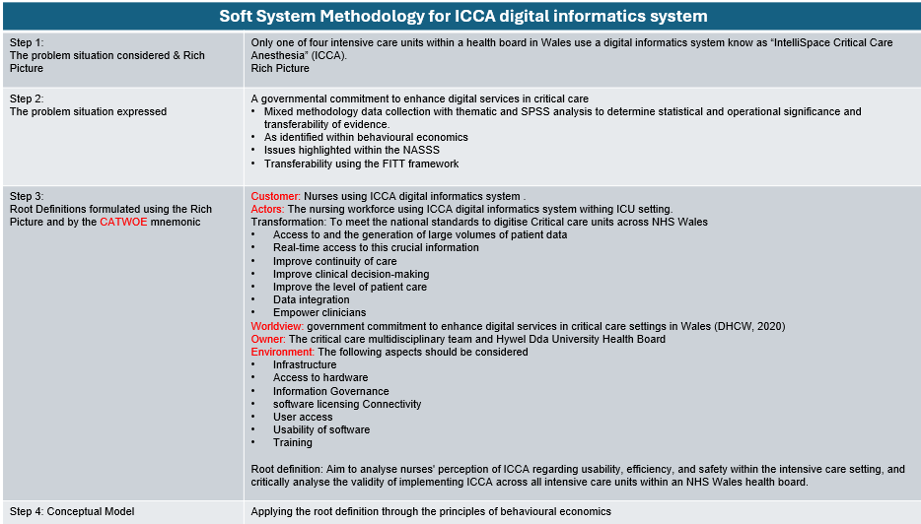

Although SSM may not provide prescriptive solutions to complex problems (Nakakawa et al., 2024), it excels in facilitating the management of dynamic, multi-stakeholder healthcare environments (Shahabi et al., 2020). In contrast to hard systems methodologies, SSM foregrounds the role of human perception and interpretive processes in shaping organisational realities (Emes et al., 2017). This emphasis on sensemaking aligns with the principles of the learning health cycle, which involves the continual reinterpretation and refinement of evolving narratives (Weick, Sutcliffe and Obstfeld, 2005). In this context, the present study demonstrates that, although CISs are generally perceived as more usable and less workload-intensive than traditional paper documentation, nurses’ experiences remain highly heterogeneous. Such variability is attributable to factors including system reliability, task complexity, disparities in training, and the intricate interplay of behavioural economic influences, all of which are encapsulated within the developed and enriched, rich picture of real-world clinical activities (see Fig. 5.3.1).
The application of SSM within this study provides a robust theoretical basis for understanding why the Phillips CIS was experienced so differently by staff occupying distinct roles within the same critical care setting. SSM enables the identification of divergent worldviews, such as those held by senior nurses who navigate both supervisory responsibilities and hands-on clinical care, compared with nurses whose primary focus is bedside practice. These role-dependent perspectives account for the observed variation in SUS and NASA-TLX scores, as well as the qualitative friction points identified around patient admissions, documentation duplication, and system lag. Crucially, this analysis positions usability and workload not as fixed technical attributes but as emergent properties of a socially constructed system, shaped by context, interaction, and ongoing stakeholder negotiation.
The progression from the initial rich picture (see Fig. 1.1) to the refined iteration (see Fig. 5.3.1), reflects a substantive analytical development: from a broad, exploratory mapping of the complex, interdependent pressures inherent to critical care, towards a theoretically grounded interpretation of how CISs shape usability and workload for nurses. The first figure captures the problem situation by mapping the sociotechnical pressure inherent to critical care. By contrast, the second rich picture builds on this foundation by integrating multiple theoretical frameworks to provide a more structured interpretation of the complexities and to offer hypotheses on why CIS usability challenges occur and how individual cognitive load affects perceived workload.
Considered together, the visualisation of the complexities of real-world activities clarifies why digitalisation in critical care is a non-linear, negotiated process. Benefits from device integration are realised when they “fit”, but the same features also produce extra cognitive load when reliability or clinical logic understanding is required. Therefore, perceptions of usability and workload should be understood as a human system negotiation that evolves through iteration and sensemaking, rather than a one-off technical rollout. These results complement the FITT alignment and learning health cycle, while recognising that the “fit” must be negotiated based on the nurse's experience and training.

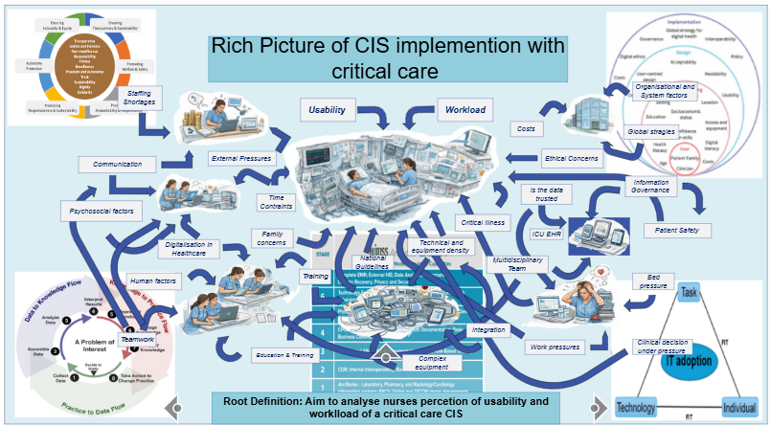
Figure 5.3.1 Rich picture of nurses perception of digitalisation within ICU

5.3.2 Behavioural Economics
The collective evidence from this study also supports the crucial role of human factors engineering. Nurses’ perceptions of the CIS's performance align with established findings that even small disruptions in digital workflows can have a disproportionate impact in fast-paced, high-acuity environments (Nadkarni and Sakhuja, 2023). These observations again reinforce the need for continuous monitoring, iterative refinement, and robust support structures to sustain the benefits of digital systems over time.
Behavioural change is shaped by a dynamic interplay of internal and external influences, underpinned by broader economic and psychological determinants (Wang and Groene, 2020; see Table 5.3.1 and Fig. 5.3.1). For instance, status quo bias accounts for the persistent reliance of some nurses on established paper-based practices or hybrid documentation workarounds, even in contexts where digital processes demonstrably enhance efficiency (Saleem et al., 2015; Davidson et al., 2022; Strudwick et al., 2018). Behavioural economics provides a framework for understanding these influences by explaining how cognitive biases, heuristics, and structural conditions govern decision-making among individuals and organisations (Guo et al., 2019). Loss aversion, for example, can lead nurses to overestimate the risks associated with digital errors or system failures, thereby encouraging a default to documentation methods perceived as less risky (Thissen et al., 2025; Melnick et al., 2020).
Additionally, behavioural mechanisms such as cognitive load, decision fatigue, and friction costs can enhance frustration and reduce perceived usability (Nadkarni and Sakhuja, 2023; Jalilian and Khairat, 2022), patterns that closely mirror the workload and usability issues identified in this study. The NASA-TLX findings reinforce that workload is more heavily influenced by contextual and cognitive pressures than by usability alone (von Dincklage et al., 2019). Behavioural economics further clarifies that elevated mental effort diminishes the likelihood of adopting new workflows. This perspective also sheds light on why improved training enhances perceived usability without substantially reducing workload: while training bolsters confidence and navigation skills, it does not mitigate the environmental sources of cognitive overload that perpetuate resistance to behavioural change (Jansson et al., 2022).
A nuanced understanding of social norms and peer influence, as revealed by the qualitative data, is equally essential for comprehending the behavioural landscape of CIS adoption. Nurses frequently described relying on informal training and adopting workarounds disseminated by colleagues and senior staff, behaviours indicative of strong herd dynamics within clinical teams (Strudwick et al., 2018). Notably, apprehension or scepticism expressed by senior nursing personnel regarding the CIS has a demonstrable effect on the attitudes and practices of less experienced staff (Jansson et al., 2022; Cho et al., 2024). This phenomenon was evident in the study’s findings, which showed significant variation in usability and workload scores across different nursing roles and experience levels. Overlooking these behavioural economic factors risk undermining the long-term sustainability and effectiveness of CIS implementation in clinical environments (Hodson et al., 2024; see Table 5.3.2).

Table 5.3.2 Principles of behavioural economics (Hodson et al., 2024)
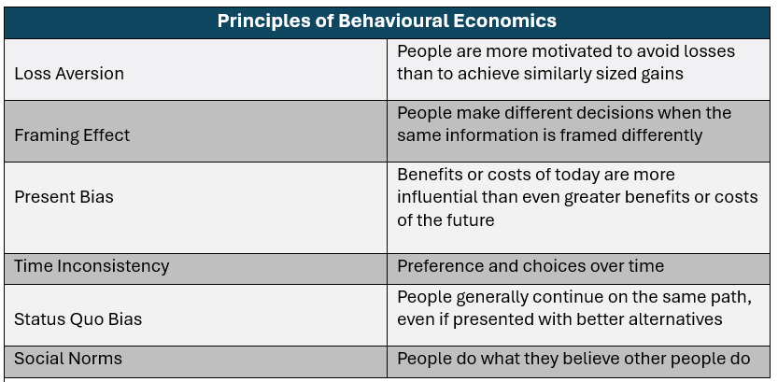

Taken together, these behavioural mechanisms are deeply embedded in the study’s findings and theoretical interpretation. The FITT framework explains the persistent misalignments that can arise among users, tasks, and digital systems, while behavioural economics provides critical insight into why these misalignments persist even in technically sound environments. SSM highlights the multiplicity of sociotechnical worldviews and the negotiation of meaning among stakeholders; behavioural economics further illuminates the drivers of this variation, demonstrating that CIS implementation is fundamentally a socially mediated, rather than a purely technical endeavour. Ultimately, these integrated perspectives enrich the learning health cycle by emphasising that behavioural change is an incremental, habit-forming process, one that gradually lowers psychological and cognitive barriers to digital transformation.

5.4 Implications for Critical Care digitalisation
In summary, this research provides robust quantitative and qualitative evidence substantiating the usability advantages of a critical care CIS over traditional paper-based documentation , which aligns with prior work showing digital systems enhance information flow and documentation quality (Strudwick et al., 2018; Jalilian and Khairat, 2022; von Dincklage et al., 2019; Lai et al., 2022). Nevertheless, it reveals the multifaceted, interdependent challenges that continually shape nurses’ engagement with digital systems. Perceptions of workload are intricately affected by factors including system reliability, patient admission complexity, digital literacy, role-specific demands, fragmented workflows, and contextual variables such as patient acuity and staffing levels (Strudwick et al., 2018; Lin et al., 2019; Lai et al., 2022). These findings reinforce the evolving scholarly consensus that successful CIS implementation extends beyond mere technological advancement. Sustainable improvement depends on ongoing organisational commitment, comprehensive and equitable training, iterative system optimisation, and authentic engagement with the daily realities encountered by clinical staff (von Dincklage et al., 2019; Jansson et al., 2022; Nadkarni and Sakhuja, 2023). Without a holistic, human-centred approach, the transformational promise of digital health initiatives may be limited by the very complexities they aim to overcome. Accordingly, while the advantages of CISs in critical care are real, they remain precarious due to the intricate dynamics of the clinical environment.
Collectively, this synthesis of findings underscores that technological innovation alone is insufficient to achieve meaningful digital transformation in critical care. Digitalisation must be conceptualised as a complex sociotechnical and behavioural endeavour, necessitating both technical optimisation and systematic attention to user experience, practitioner perspectives, training equity, workflow analysis, and organisational culture. Evidence from previous attempts to implement CISs in Welsh critical care units demonstrates that persistent barriers can obscure potential system benefits (Wilson et al., 2021). The results of this study, in conjunction with inconsistent outcomes reported in earlier digital health initiatives (Department of Health and Social Care, 2016), establish a foundation for evaluating the scalability of a unified CIS across Welsh critical care settings. This emphasises the imperative need for rigorous, context-sensitive evaluation frameworks that address not only technical integration, but also the organisational, behavioural, and contextual determinants, such as resource allocation, ongoing financial and staffing requirements, and structured initial and continuous training, which underpin the effective functioning of digital systems in complex, high-acuity clinical environments.

5.5 Limitations
In summary, this study is subject to several methodological limitations that merit consideration. The relatively small sample size (n = 38), and the restriction to a single Welsh health board, constrain the generalisability of the findings beyond this setting. Additionally, reliance on self-reported data introduces potential biases, including the possibility that people may answer in ways they think are expected, thereby influencing response accuracy. The cross-sectional design further limits the ability to show cause-and-effect relationships. Moreover, uneven subgroup sizes reduce the statistical power of comparative analyses, rendering the results largely descriptive. Such limitations are characteristic of practice-based research in complex healthcare settings and underscore the necessity for cautious interpretation and prudent application of the findings (Creswell, 2014).

Conclusions

Table 6.0 Conclusion summary
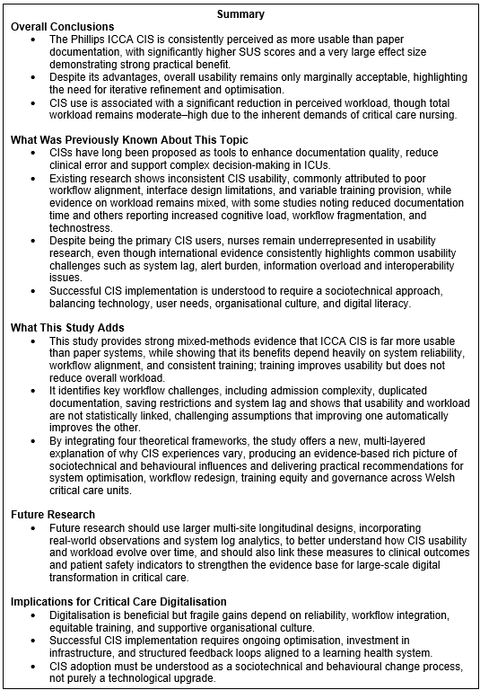
The objective of this research was to examine the perceptions of the critical care nursing workforce regarding the usability and workload of a CIS assessed through two research questions:
- Are critical care CISs perceived as being usable by the nursing workforce?
- Are critical care CISs perceived as reducing nursing workload?
A convergent mixed-methods research design was used, combining quantitative and qualitative approaches anchored in validated instruments (SUS; NASA-TLX), and complemented by thematic analysis. The study provided a nuanced synthesis, revealing that the evaluated Phillips ICCA CIS, is consistently perceived as more usable and less burdensome than paper documentation. However, these benefits are conditional and fragile, shaped by system reliability, workflow alignment, role demands, and the broader sociotechnical environment.
Quantitative analysis demonstrated that CIS usability was significantly higher than paper documentation (CIS SUS ~69.3 versus Paper SUS ~45.9), with an exceptionally large effect size (d=1.62). This evidence strongly supports the claim that the Phillips CIS is perceived as more usable than paper documentation by nurses. However, this gain in usability is only marginally acceptable overall, indicating that further improvement is needed. The high variability in the results suggests that usability is context dependent. Qualitative themes reinforce this variability, highlighting device integration, auto-population, and centralised information as positives of CIS implementation, while system lag, downtimes, duplication of documentation, and admission complexity are cited as negatives. Collectively, the Phillips CIS is more usable than paper, but its performance remains inconsistent in real-world critical care activities.
The second research question, considered whether critical care CISs are perceived as reducing nursing workload, yielded complex and nuanced findings. CIS users reported a statistically significantly lower workload score (CIS NASA TLX ~40/100 versus Paper NASA TLX ~54/100), but overall workload remained moderate to high. There was a weak and non-significant correlation between usability and workload, largely influenced by clinical context rather than the system itself. Qualitative evidence indicated that CIS workload decreased when the system functioned reliably, but issues such as lag, unreliable device connectivity, and workflow misalignment increased workload. Collectively, the evidence supports that CIS use reduces documentation burden, but does not meaningfully alleviate the broader workload pressures inherent in critical care nursing.
To further analyse the findings, the results were examined through four theoretical frameworks: the FITT framework, the Learning Health Cycle, SSM, and Behavioural Economics. These frameworks are integral to both the study’s findings and its theoretical analysis. The FITT framework clarifies ongoing misalignments between users, tasks, and digital systems, while behavioural economics illuminates the reasons these misalignments persist even when technical solutions exist. SSM draws attention to the diversity of sociotechnical perspectives and the active negotiation of meaning among stakeholders, and behavioural economics deepens this understanding by revealing the behavioural drivers behind such variation. This synthesis demonstrates that implementing CIS is fundamentally a social process, not merely a technical one. Collectively, these perspectives advance the learning health cycle by highlighting behavioural change as a gradual, habit-building process that steadily reduces psychological and cognitive barriers to digital transformation.
Therefore, digitalisation of critical care units is beneficial but fragile. There is clear evidence that ICCA CIS is superior to paper, supporting continued digital investment across Welsh ICUs. However, system reliability is crucial; when workflows are poorly aligned, perceived benefits can diminish significantly. This highlights the importance of ensuring safety and quality requirements during CIS implementation, with service-led agreements and informatics governance supporting both perceived and actual performance at the bedside.
Formal training was associated with higher perceived usability but did not significantly reduce perceived workload, suggesting that training can boost confidence but cannot alleviate the inherent pressures of critical care. Therefore, training programmes should move beyond one-off inductions towards providing consistent, equitable, and ongoing support, with feedback loops that facilitate iterative CIS refinements within the learning health cycle. Additionally, behavioural nudges should complement technical changes to support adoption.
In conclusion, this study offers strong quantitative and qualitative evidence that critical care CISs provide significant usability advantages over traditional paper documentation, echoing broader findings that digital systems improve information flow and documentation quality. However, the results also highlight the complex, interrelated challenges shaping nurses’ engagement with these systems. Workload perceptions are deeply influenced by factors such as system reliability, admission complexity, digital literacy, role expectations, fragmented workflows, and contextual pressures, such as patient acuity and staffing levels. These findings make clear that successful CIS implementation goes well beyond simply introducing new technology. Lasting improvements depend on organisational commitment, equitable training, continuous optimisation, and close alignment with the realities of clinical practice. Although CISs deliver real benefits, these gains remain vulnerable within the demanding critical care environment, where human, organisational, and behavioural factors heavily influence outcomes.
Thus, digital transformation should be seen as a multifaceted sociotechnical process that requires careful attention to user experience, staff perspectives, workflow design, and organisational culture. Experience from previous CIS projects in Welsh critical care, demonstrates that persistent barriers can limit system effectiveness. This study’s findings, alongside mixed results from earlier digital initiatives, underscore the need for rigorous, context-sensitive evaluation frameworks that balance technical integration with resource allocation, staffing, financial planning, and ongoing structured training to ensure digital systems succeed in high-acuity settings.
Building on the findings and limitations of this study, future research should adopt a larger, multi-site design to capture how CIS usability and workload perceptions evolve over time, supported by real-world observational data and system log analytics to validate and deepen understanding of workflow technology alignment. Future studies should link CIS usability and workload to clinical outcomes, and patient safety indicators to strengthen the evidence base for large-scale digital transformation initiatives in critical care.

References

Abu Raddaha, A.H. (2018) “Nurses’ perceptions about and confidence in using an electronic medical record system,” Proceedings of Singapore Healthcare, 27(2), pp. 110–117. Available at: https://doi.org/10.1177/2010105817732585.
Adam, S., Osborne, S. and Welch, J. (eds.) (2017) Critical Care Nursing. Oxford University Press. Available at: https://doi.org/10.1093/med/9780199696260.001.0001.
Ahmed, S.K. (2025) “Sample size for saturation in qualitative research: Debates, definitions, and strategies,” Journal of Medicine, Surgery, and Public Health, 5, p. 100171. Available at: https://doi.org/10.1016/j.glmedi.2024.100171.
Akhu‐Zaheya, L., Al‐Maaitah, R. and Bany Hani, S. (2018) “Quality of nursing documentation: Paper‐based health records versus electronic‐based health records,” Journal of Clinical Nursing, 27(3–4). Available at: https://doi.org/10.1111/jocn.14097.
Almasi, S. et al. (2023) “Usability Evaluation of Dashboards: A Systematic Literature Review of Tools,” BioMed Research International, 2023(1). Available at: https://doi.org/10.1155/2023/9990933.
Ammenwerth, E., Iller, C. and Mahler, C. (2006) “IT-adoption and the interaction of task, technology and individuals: a fit framework and a case study,” BMC Medical Informatics and Decision Making, 6(1), p. 3. Available at: https://doi.org/10.1186/1472-6947-6-3.
Annemarie Docherty et al. (2026) Guidelines for the Provision of Intensive Care Services (GPICS), Version 3. , https://www.ficm.ac.uk/sites/ficm/files/documents/2026-01/GPICS%20V3%202026_0.pdf.
Ayre, J. and McCaffery, K.J. (2022) “Research Note: Thematic analysis in qualitative research,” Journal of Physiotherapy, 68(1), pp. 76–79. Available at: https://doi.org/10.1016/j.jphys.2021.11.002.
Bangor, A., Kortum, P.T. and Miller, J.T. (2008) “An Empirical Evaluation of the System Usability Scale,” International Journal of Human-Computer Interaction, 24(6), pp. 574–594. Available at: https://doi.org/10.1080/10447310802205776.
Bodí, M. et al. (2021) “Automatic generation of minimum dataset and quality indicators from data collected routinely by the clinical information system in an intensive care unit,” International Journal of Medical Informatics, 145, p. 104327. Available at: https://doi.org/10.1016/j.ijmedinf.2020.104327.
Braun, V. and Clarke, V. (2006a) “Using thematic analysis in psychology,” Qualitative Research in Psychology, 3(2), pp. 77–101. Available at: https://doi.org/10.1191/1478088706qp063oa.
Braun, V. and Clarke, V. (2006b) “Using thematic analysis in psychology,” Qualitative Research in Psychology, 3(2), pp. 77–101. Available at: https://doi.org/10.1191/1478088706qp063oa.
Broekhuis, M., van Velsen, L. and Hermens, H. (2019a) “Assessing usability of eHealth technology: A comparison of usability benchmarking instruments,” International Journal of Medical Informatics, 128, pp. 24–31. Available at: https://doi.org/10.1016/j.ijmedinf.2019.05.001.
Broekhuis, M., van Velsen, L. and Hermens, H. (2019b) “Assessing usability of eHealth technology: A comparison of usability benchmarking instruments,” International Journal of Medical Informatics, 128, pp. 24–31. Available at: https://doi.org/10.1016/j.ijmedinf.2019.05.001.
Califf, R.M. and Sugarman, J. (2015) “Exploring the ethical and regulatory issues in pragmatic clinical trials,” Clinical Trials, 12(5), pp. 436–441. Available at: https://doi.org/10.1177/1740774515598334.
Carayon, P. and Hoonakker, P. (2019) “Human Factors and Usability for Health Information Technology: Old and New Challenges,” Yearbook of Medical Informatics, 28(01), pp. 071–077. Available at: https://doi.org/10.1055/s-0039-1677907.
Chapman, A., Hadfield, M. and Chapman, C. (2015) “Qualitative research in healthcare: An introduction to grounded theory using thematic analysis,” Journal of the Royal College of Physicians of Edinburgh, 45(3), pp. 201–205. Available at: https://doi.org/10.4997/jrcpe.2015.305.
Cho, H. et al. (2024) “Electronic health record system use and documentation burden of acute and critical care nurse clinicians: a mixed-methods study,” Journal of the American Medical Informatics Association, 31(11), pp. 2540–2549. Available at: https://doi.org/10.1093/jamia/ocae239.
Colligan, L. et al. (2015) “Cognitive workload changes for nurses transitioning from a legacy system with paper documentation to a commercial electronic health record,” International Journal of Medical Informatics, 84(7), pp. 469–476. Available at: https://doi.org/10.1016/j.ijmedinf.2015.03.003.
Creswell, J.W. (2014) Research design: qualitative, quantitative, and mixed methods approaches. 4th ed. Thousand Oaks, California : SAGE.
Cronbach, L.J. (1951) “Coefficient Alpha and the Internal Structure of Tests,” Psychometrika, 16(3), pp. 297–334. Available at: https://doi.org/10.1007/BF02310555.
David Maguire et al. (2021) Shaping the future of digital technology in health and social care .
Davidson, B. et al. (2022) “Requirements for a Bespoke Intensive Care Unit Dashboard in Response to the COVID-19 Pandemic: Semistructured Interview Study,” JMIR Human Factors, 9(2), p. e30523. Available at: https://doi.org/10.2196/30523.
Department of Health and Social Care (2016) Making IT work: harnessing the power of health information technology to improve care in England, https://www.gov.uk/government/publications/using-information-technology-to-improve-the-nhs/making-it-work-harnessing-the-power-of-health-information-technology-to-improve-care-in-england.
DHCW (2020) £13 million technology investment for NHS Wales’ intensive care patients, https://dhcw.nhs.wales/news/archived-news/13-million-technology-investment-for-nhs-wales-intensive-care-patients/.
von Dincklage, F. et al. (2019) “Investigation of the Usability of Computerized Critical Care Information Systems in Germany,” Journal of Intensive Care Medicine, 34(3), pp. 227–237. Available at: https://doi.org/10.1177/0885066617696848.
Doherty, N.F., Ashurst, C. and Peppard, J. (2012) “Factors Affecting the Successful Realisation of Benefits from Systems Development Projects: Findings from Three Case Studies,” Journal of Information Technology, 27(1), pp. 1–16. Available at: https://doi.org/10.1057/jit.2011.8.
Dowding, D. (2013) “Best Practices for Mixed Methods Research in the Health Sciences John W. Creswell, Ann Carroll Klassen, Vicki L. Plano Clark, Katherine Clegg Smith for the Office of Behavioral and Social Sciences Research ; Qualitative Methods Overview Jo Moriarty,” Qualitative Social Work, 12(4), pp. 541–545. Available at: https://doi.org/10.1177/1473325013493540a.
Drisko, J.W. (2025) “Transferability and Generalization in Qualitative Research,” Research on Social Work Practice, 35(1), pp. 102–110. Available at: https://doi.org/10.1177/10497315241256560.
Elliott, N. and Jordan, J. (2010) “Practical strategies to avoid the pitfalls in grounded theory research,” Nurse Researcher, 17(4), pp. 29–40. Available at: https://doi.org/10.7748/nr2010.07.17.4.29.c7922.
El‐Sayed, A.A.I. et al. (2025) “The Impact of Digital Culture, Digital Competence and Clinical Decision Support System Usability on Critical Care Nurses’ Clinical Judgement: A Moderated Moderation Analysis,” Nursing in Critical Care, 30(4). Available at: https://doi.org/10.1111/nicc.70118.
Emes, M. et al. (2017) “Care and Flow: Using Soft Systems Methodology to understand tensions in the patient discharge process,” Health Systems, 6(3), pp. 260–278. Available at: https://doi.org/10.1057/s41306-017-0027-6.
Eric Topol (2019) The Topol Review: Preparing the healthcare workforce to deliver the digital future.
Faden, R.R. et al. (2013) “An Ethics Framework for a Learning Health Care System: A Departure from Traditional Research Ethics and Clinical Ethics,” Hastings Center Report, 43(s1). Available at: https://doi.org/10.1002/hast.134.
Field, Andy. (2018) Discovering statistics using IBM SPSS statistics. Sage Publications Inc.
Flynn, A.J. et al. (2018) “The Knowledge Object Reference Ontology ( <scp>KORO</scp> ): A formalism to support management and sharing of computable biomedical knowledge for learning health systems,” Learning Health Systems, 2(2). Available at: https://doi.org/10.1002/lrh2.10054.
Fretheim, A. and Tomic, O. (2015) “Statistical process control and interrupted time series: a golden opportunity for impact evaluation in quality improvement,” BMJ Quality & Safety, 24(12), pp. 748–752. Available at: https://doi.org/10.1136/bmjqs-2014-003756.
De Georgia, M.A. et al. (2015a) “Information Technology in Critical Care: Review of Monitoring and Data Acquisition Systems for Patient Care and Research,” The Scientific World Journal, 2015(1). Available at: https://doi.org/10.1155/2015/727694.
De Georgia, M.A. et al. (2015b) “Information Technology in Critical Care: Review of Monitoring and Data Acquisition Systems for Patient Care and Research,” The Scientific World Journal, 2015(1). Available at: https://doi.org/10.1155/2015/727694.
Gomes Júnior, A. de A. and Schramm, V.B. (2022) “Problem Structuring Methods: A Review of Advances Over the Last Decade,” Systemic Practice and Action Research, 35(1), pp. 55–88. Available at: https://doi.org/10.1007/s11213-021-09560-1.
Goodman, S.N. (2005) “Introduction to Bayesian methods I: measuring the strength of evidence,” Clinical Trials, 2(4), pp. 282–290. Available at: https://doi.org/10.1191/1740774505cn098oa.
Gov.UK (2018) Data Ethics Framework, https://www.gov.uk/government/publications/data-ethics-framework.
Gov.UK (2021) A guide to good practice for digital and data-driven health technologies, https://www.gov.uk/government/publications/code-of-conduct-for-data-driven-health-and-care-technology/initial-code-of-conduct-for-data-driven-health-and-care-technology#how-to-operate-ethically.
GOV.UK (2024) Get started: evaluating digital health products, https://www.gov.uk/guidance/get-started-evaluating-digital-health-products.
Greenhalgh, T. and Abimbola, S. (2019) “The NASSS Framework A Synthesis of Multiple Theories of Technology Implementation,” Studies in Health Technology and Informatics, 263. Available at: https://doi.org/10.3233/SHTI190123.
Guest, G., Bunce, A. and Johnson, L. (2006) “How Many Interviews Are Enough?,” Field Methods, 18(1), pp. 59–82. Available at: https://doi.org/10.1177/1525822X05279903.
Guo, W. et al. (2019) “How Nurse Experience Influences the Patterns of Electronic Medical Record Documentation in an Intensive Care Unit,” Proceedings of the Human Factors and Ergonomics Society Annual Meeting, 63(1), pp. 708–712. Available at: https://doi.org/10.1177/1071181319631052.
Harrison, R., Ni She, E. and Debono, D. (2022) “Implementing and evaluating co-designed change in health,” Journal of the Royal Society of Medicine, 115(2), pp. 48–51. Available at: https://doi.org/10.1177/01410768211070206.
Hart, S.G. (2006) “Nasa-Task Load Index (NASA-TLX); 20 Years Later,” Proceedings of the Human Factors and Ergonomics Society Annual Meeting, 50(9), pp. 904–908. Available at: https://doi.org/10.1177/154193120605000909.
Hart, S.G.S.L.E. (1988) “Development of NASA-TLX (Task Load Index): Results of Empirical and Theoretical Research,” pp. 139–183. Available at: https://doi.org/10.1016/S0166-4115(08)62386-9.
Hellström, T. (2008) “Transferability and Naturalistic Generalization: New Generalizability Concepts for Social Science or Old Wine in New Bottles?,” Quality & Quantity, 42(3), pp. 321–337. Available at: https://doi.org/10.1007/s11135-006-9048-0.
Hennink, M. and Kaiser, B.N. (2022) “Sample sizes for saturation in qualitative research: A systematic review of empirical tests,” Social Science & Medicine, 292, p. 114523. Available at: https://doi.org/10.1016/j.socscimed.2021.114523.
HIMSS (2025) ELECTRONIC MEDICAL RECORD ADOPTION MODEL, https://www.himss.org/maturity-models/emram/.
Hodson, N. et al. (2024) “How can a behavioral economics lens contribute to implementation science?,” Implementation Science, 19(1), p. 33. Available at: https://doi.org/10.1186/s13012-024-01362-y.
Holloway, I. and Todres, L. (2003) “The Status of Method: Flexibility, Consistency and Coherence,” Qualitative Research, 3(3), pp. 345–357. Available at: https://doi.org/10.1177/1468794103033004.
Housawi, A. et al. (2020) “Evaluation of Key Performance Indicators (KPIs) for Sustainable Postgraduate Medical Training: An Opportunity for Implementing an Innovative Approach to Advance the Quality of Training Programs at the Saudi Commission for Health Specialties (SCFHS),” Sustainability, 12(19), p. 8030. Available at: https://doi.org/10.3390/su12198030.
Howe, J.L. et al. (2018) “Electronic Health Record Usability Issues and Potential Contribution to Patient Harm,” JAMA, 319(12), p. 1276. Available at: https://doi.org/10.1001/jama.2018.1171.
IBM (2025) IBM SPSS software, https://www.ibm.com/spss.
Intensive Care Society (2024) A History of Intensive Care, https://ics.ac.uk/about-icu/history-of-icu.html.
International Organization for Standardization (2018) ISO 9241-11:2018(en) Ergonomics of human-system interaction — Part 11: Usability: Definitions and concepts, https://www.iso.org/obp/ui/#iso:std:iso:9241:-11:ed-2:v1:en.
J Brooke (2013) “SUS: A Retrospective ,” Journal of Usability Studies, 8(2), pp. 29–40.
Jakobsen, J. (2013) “The Necessity of Randomized Clinical Trials,” British Journal of Medicine and Medical Research, 3(4), pp. 1453–1468. Available at: https://doi.org/10.9734/BJMMR/2013/3208.
Jakobsen, J.C. et al. (2014) “Thresholds for statistical and clinical significance in systematic reviews with meta-analytic methods,” BMC Medical Research Methodology, 14(1), p. 120. Available at: https://doi.org/10.1186/1471-2288-14-120.
Jalilian, L. and Khairat, S. (2022) “The Next-Generation Electronic Health Record in the ICU: A Focus on User-Technology Interface to Optimize Patient Safety and Quality.,” Perspectives in health information managemen, 19(1), p. 1g.
Jamrozik, K. (2004) “Research ethics paperwork: what is the plot we seem to have lost?,” BMJ, 329(7460), pp. 286–287. Available at: https://doi.org/10.1136/bmj.329.7460.286.
Jansson, M. et al. (2022) “The negative impact of interface design, customizability, inefficiency, malfunctions, and information retrieval on user experience: A national usability survey of ICU clinical information systems in Finland,” International Journal of Medical Informatics, 159, p. 104680. Available at: https://doi.org/10.1016/j.ijmedinf.2021.104680.
john Brooke (1996) Usability Evaluation In Industry. First Edition. CRC Press.
John W. Creswell et al. (2010) Best Practices for Mixed Methods Research in the Health Sciences.
Justinia, T. (2017) “The UK’s National Programme for IT: Why was it dismantled?,” Health Services Management Research, 30(1), pp. 2–9. Available at: https://doi.org/10.1177/0951484816662492.
Kaipio, J. et al. (2020) “Physicians’ and nurses’ experiences on EHR usability: Comparison between the professional groups by employment sector and system brand,” International Journal of Medical Informatics, 134, p. 104018. Available at: https://doi.org/10.1016/j.ijmedinf.2019.104018.
Kleib, M. and Nagle, L. (2018) “Factors Associated With Canadian Nurses’ Informatics Competency,” CIN: Computers, Informatics, Nursing, 36(8), pp. 406–415. Available at: https://doi.org/10.1097/CIN.0000000000000434.
Lai, C.-H. et al. (2022) “Integration of an Intensive Care Unit Visualization Dashboard (i-Dashboard) as a Platform to Facilitate Multidisciplinary Rounds: Cluster-Randomized Controlled Trial,” Journal of Medical Internet Research, 24(5), p. e35981. Available at: https://doi.org/10.2196/35981.
Lamé, G., Jouini, O. and Stal-Le Cardinal, J. (2020) “Combining Soft Systems Methodology, ethnographic observation, and discrete-event simulation: A case study in cancer care,” Journal of the Operational Research Society, 71(10), pp. 1545–1562. Available at: https://doi.org/10.1080/01605682.2019.1610339.
Lin, Y.L. et al. (2019) “Association of Data Integration Technologies With Intensive Care Clinician Performance,” JAMA Network Open, 2(5), p. e194392. Available at: https://doi.org/10.1001/jamanetworkopen.2019.4392.
Littell, J.H. and White, H. (2018) “The Campbell Collaboration,” Research on Social Work Practice, 28(1), pp. 6–12. Available at: https://doi.org/10.1177/1049731517703748.
McLennan, S., Fiske, A. and Celi, L.A. (2024) “Building a house without foundations? A 24-country qualitative interview study on artificial intelligence in intensive care medicine,” BMJ Health & Care Informatics, 31(1), p. e101052. Available at: https://doi.org/10.1136/bmjhci-2024-101052.
Melnick, Edward R et al. (2020) “Perceived Electronic Health Record Usability as a Predictor of Task Load and Burnout Among US Physicians: Mediation Analysis,” Journal of Medical Internet Research, 22(12), p. e23382. Available at: https://doi.org/10.2196/23382.
Melnick, Edward R. et al. (2020) “The Association Between Perceived Electronic Health Record Usability and Professional Burnout Among US Physicians,” Mayo Clinic Proceedings, 95(3), pp. 476–487. Available at: https://doi.org/10.1016/j.mayocp.2019.09.024.
Mennella, C. et al. (2024) “Ethical and regulatory challenges of AI technologies in healthcare: A narrative review,” Heliyon, 10(4), p. e26297. Available at: https://doi.org/10.1016/j.heliyon.2024.e26297.
Morgan, D.J. et al. (2015) “Setting a research agenda for medical overuse,” BMJ, p. h4534. Available at: https://doi.org/10.1136/bmj.h4534.
Morgan, D.L. (2007) “Paradigms Lost and Pragmatism Regained,” Journal of Mixed Methods Research, 1(1), pp. 48–76. Available at: https://doi.org/10.1177/2345678906292462.
Nadkarni, G.N. and Sakhuja, A. (2023) “Clinical Informatics in Critical Care Medicine,” The Yale Journal of Biology and Medicine, 96(3), pp. 397–405. Available at: https://doi.org/10.59249/WTTU3055.
NICE (2017) Rehabilitation after critical illness in adults , www.nice.org.uk/guidance/cg83 .
Nicholls, S.G. et al. (2015) “A Scoping Review of Empirical Research Relating to Quality and Effectiveness of Research Ethics Review,” PLOS ONE, 10(7), p. e0133639. Available at: https://doi.org/10.1371/journal.pone.0133639.
Nowell, L.S. et al. (2017) “Thematic Analysis,” International Journal of Qualitative Methods, 16(1). Available at: https://doi.org/10.1177/1609406917733847.
Page, M.J. et al. (2021) “The PRISMA 2020 statement: an updated guideline for reporting systematic reviews,” BMJ, p. n71. Available at: https://doi.org/10.1136/bmj.n71.
Paucar-Caceres, A. and Jerardino-Wiesenborn, B. (2020) “A bridge for two views: Checkland’s soft systems methodology and Maturana’s ontology of the observer,” Journal of the Operational Research Society, 71(4), pp. 660–672. Available at: https://doi.org/10.1080/01605682.2019.1578629.
Paz, F. and Pow-Sang, J.A. (2014) “Current Trends in Usability Evaluation Methods: A Systematic Review,” 2014 7th International Conference on Advanced Software Engineering and Its Applications. IEEE, pp. 11–15. Available at: https://doi.org/10.1109/ASEA.2014.10.
Philipp Mayring (2007) “On Generalization in Qualitatively Oriented Research,” Forum: Qualitative Social Research, 8(3).
Phillips (2024) IntelliSpace Critical Care and Anesthesia, https://www.documents.philips.com/assets/20240328/1f29e4ae828e40078b61b141013de55f.pdf.
Plummer, N.R. (2023) “Clinical relevance of informatics systems,” Anaesthesia & Intensive Care Medicine, 24(8), pp. 490–493. Available at: https://doi.org/10.1016/j.mpaic.2023.05.009.
Pratt, M.G., Kaplan, S. and Whittington, R. (2020) “Editorial Essay: The Tumult over Transparency: Decoupling Transparency from Replication in Establishing Trustworthy Qualitative Research,” Administrative Science Quarterly, 65(1), pp. 1–19. Available at: https://doi.org/10.1177/0001839219887663.
Reddy, S. et al. (2020) “A governance model for the application of AI in health care,” Journal of the American Medical Informatics Association, 27(3), pp. 491–497. Available at: https://doi.org/10.1093/jamia/ocz192.
Ricciardi, W. et al. (2019) “How to govern the digital transformation of health services,” European Journal of Public Health, 29(Supplement_3), pp. 7–12. Available at: https://doi.org/10.1093/eurpub/ckz165.
Richard E. Boyatzis (1998) Transforming qualitative information: thematic analysis and code development. 1st ed. Thousand Oaks, CA: Sage Publications, Sage Publications, Inc.
Richemond, D. and Huggins-Jordan, T.D. (2023) “The Impact of Health Information Systems on Patient Outcomes,” OALib, 10(08), pp. 1–11. Available at: https://doi.org/10.4236/oalib.1110518.
Rye, C.B. and Kimberly, J.R. (2007) “The Adoption of Innovations by Provider Organizations in Health Care,” Medical Care Research and Review, 64(3), pp. 235–278. Available at: https://doi.org/10.1177/1077558707299865.
Sadan, V. (2014) “Mixed Methods Research: A New Approach,” International Journal of Nursing Education, 6(1), p. 254. Available at: https://doi.org/10.5958/j.0974-9357.6.1.052.
Saleem, J.J. et al. (2015) “Understanding barriers and facilitators to the use of Clinical Information Systems for intensive care units and Anesthesia Record Keeping: A rapid ethnography,” International Journal of Medical Informatics, 84(7), pp. 500–511. Available at: https://doi.org/10.1016/j.ijmedinf.2015.03.006.
Sandelowski, M. (2000) “Combining Qualitative and Quantitative Sampling, Data Collection, and Analysis Techniques in Mixed-Method Studies,” Research in Nursing & Health, 23(3), pp. 246–255. Available at: https://doi.org/10.1002/1098-240X(200006)23:3<246::AID-NUR9>3.0.CO;2-H.
Sauer, J., Sonderegger, A. and Schmutz, S. (2020) “Usability, user experience and accessibility: towards an integrative model,” Ergonomics, 63(10), pp. 1207–1220. Available at: https://doi.org/10.1080/00140139.2020.1774080.
Saunders, B. et al. (2018) “Saturation in qualitative research: exploring its conceptualization and operationalization,” Quality & Quantity, 52(4), pp. 1893–1907. Available at: https://doi.org/10.1007/s11135-017-0574-8.
Schnall, R. et al. (2012) “Employing the FITT framework to explore HIV case managers’ perceptions of two electronic clinical data (ECD) summary systems,” International Journal of Medical Informatics, 81(10), pp. e56–e62. Available at: https://doi.org/10.1016/j.ijmedinf.2012.07.002.
Scott Philip J. (2016) “Mixed Methods: A Paradigm for Holistic Evaluation of Health IT.” Available at: https://doi.org/10.3233/978-1-61499-635-4-102.
Scott, P.J. and Briggs, J.S. (2010) “STAT-HI: A Socio-Technical Assessment Tool for Health Informatics Implementations,” The Open Medical Informatics Journal, 4(1), pp. 214–220. Available at: https://doi.org/10.2174/1874431101004010214.
Shahabi, A. et al. (2020) “Combining Soft Systems Methodology with Interpretive Structural Modeling and System Dynamics for Network Orchestration: Case Study of the Formal Science and Technology Collaborative Networks in Iran,” Systemic Practice and Action Research, 33(4), pp. 453–478. Available at: https://doi.org/10.1007/s11213-019-09490-z.
Shimm, D.S. and Spece, R.G. (1993) “Ethical Issues and Clinical Trials,” Drugs, 46(4), pp. 579–584. Available at: https://doi.org/10.2165/00003495-199346040-00001.
da Silva, A.A. et al. (2025) “Digital health interventions in adult intensive care and recovery after critical illness to promote survivorship care,” Journal of the Intensive Care Society, 26(1), pp. 96–104. Available at: https://doi.org/10.1177/17511437241311105.
Singer, M. et al. (2016) “The Third International Consensus Definitions for Sepsis and Septic Shock (Sepsis-3),” JAMA, 315(8), p. 801. Available at: https://doi.org/10.1001/jama.2016.0287.
Sligo, J. et al. (2017) “A literature review for large-scale health information system project planning, implementation and evaluation,” International Journal of Medical Informatics, 97, pp. 86–97. Available at: https://doi.org/10.1016/j.ijmedinf.2016.09.007.
Smajic, E. et al. (2022) “Mixed Methodology of Scientific Research in Healthcare,” Acta Informatica Medica, 30(1), p. 57. Available at: https://doi.org/10.5455/aim.2022.30.57-60.
Stevenson, F.A. et al. (2015) “Reconsidering ‘ethics’ and ‘quality’ in healthcare research: the case for an iterative ethical paradigm,” BMC Medical Ethics, 16(1), p. 21. Available at: https://doi.org/10.1186/s12910-015-0004-1.
Strudwick, G. et al. (2018) “Acute care nurses’ perceptions of electronic health record use: A mixed method study,” Nursing Open, 5(4), pp. 491–500. Available at: https://doi.org/10.1002/nop2.157.
The Faculty of Intensive Care Medicine (2021) WORKFORCE DATABANK for Adult Critical Care, https://ficm.ac.uk/sites/ficm/files/documents/2021-10/workforce_data_bank_2021_-_for_release.pdf.
Thissen, A. et al. (2025) “Barriers and Facilitators of the Use of Computerized Critical Care Information Systems in the Intensive Care Unit: Qualitative Interview Study,” Journal of Medical Internet Research, 27, p. e49254. Available at: https://doi.org/10.2196/49254.
Thorne, S. (2000) “Data analysis in qualitative research,” Evidence Based Nursing, 3(3), pp. 68–70. Available at: https://doi.org/10.1136/ebn.3.3.68.
Tight, M. (2024) “Saturation: An Overworked and Misunderstood Concept?,” Qualitative Inquiry, 30(7), pp. 577–583. Available at: https://doi.org/10.1177/10778004231183948.
Tubbs-Cooley, H.L. et al. (2018) “The NASA Task Load Index as a measure of overall workload among neonatal, paediatric and adult intensive care nurses,” Intensive and Critical Care Nursing, 46, pp. 64–69. Available at: https://doi.org/10.1016/j.iccn.2018.01.004.
Vincent, J.-L. et al. (2014) “Assessment of the worldwide burden of critical illness: the Intensive Care Over Nations (ICON) audit,” The Lancet Respiratory Medicine, 2(5), pp. 380–386. Available at: https://doi.org/10.1016/S2213-2600(14)70061-X.
Wang, S.Y. and Groene, O. (2020) “The effectiveness of behavioral economics-informed interventions on physician behavioral change: A systematic literature review,” PLOS ONE, 15(6), p. e0234149. Available at: https://doi.org/10.1371/journal.pone.0234149.
Weick, K.E., Sutcliffe, K.M. and Obstfeld, D. (2005) “Organizing and the Process of Sensemaking,” Organization Science, 16(4), pp. 409–421. Available at: https://doi.org/10.1287/orsc.1050.0133.
Wilson, J. et al. (2021) “Barriers and facilitators to the use of e-health by older adults: a scoping review,” BMC Public Health, 21(1), p. 1556. Available at: https://doi.org/10.1186/s12889-021-11623-w.
World Health Organisation (2021) Global strategy on digital health 2020-2025.
Yuan, Z. et al. (2023) “The levels and related factors of mental workload among nurses: A systematic review and meta‐analysis,” International Journal of Nursing Practice, 29(5). Available at: https://doi.org/10.1111/ijn.13148.
Zwaanswijk, M. et al. (2011) “Benefits and problems of electronic information exchange as perceived by health care professionals: an interview study,” BMC Health Services Research, 11(1), p. 256. Available at: https://doi.org/10.1186/1472-6963-11-256.

Appendix 1
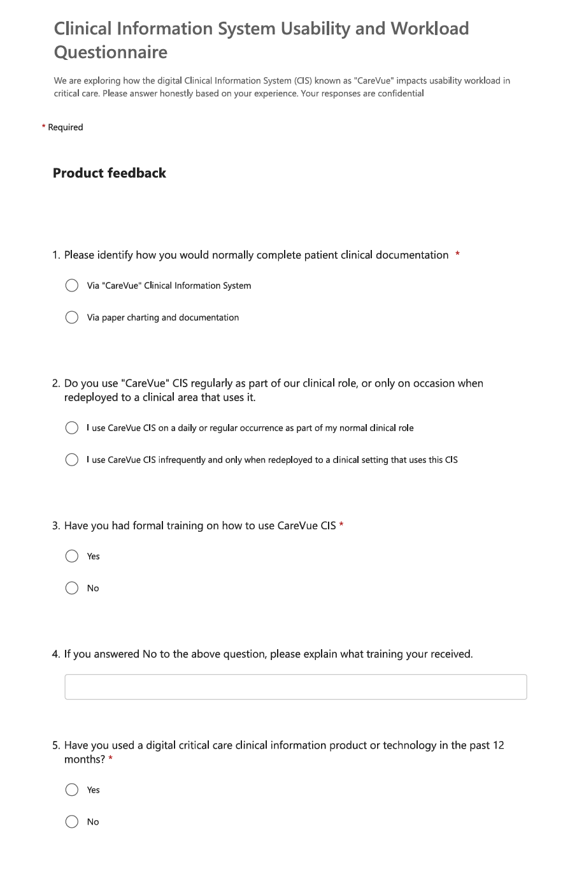
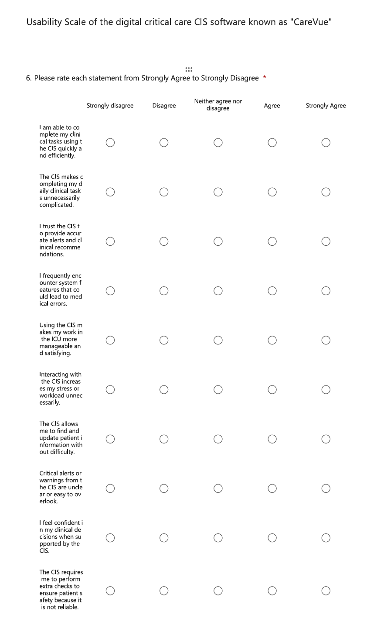
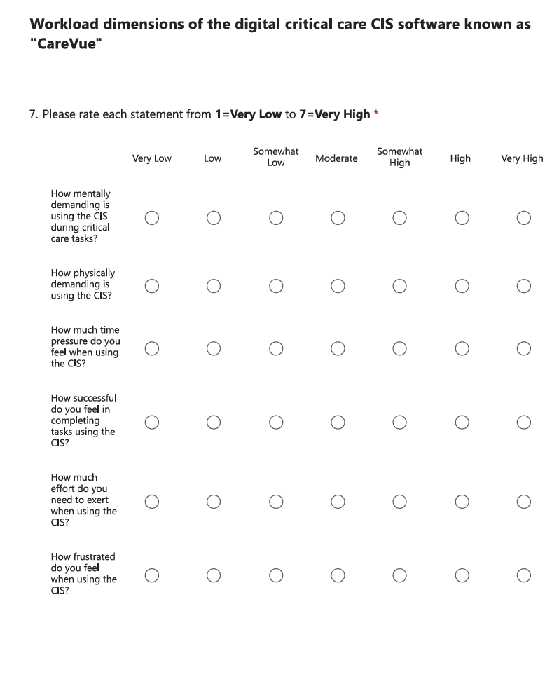
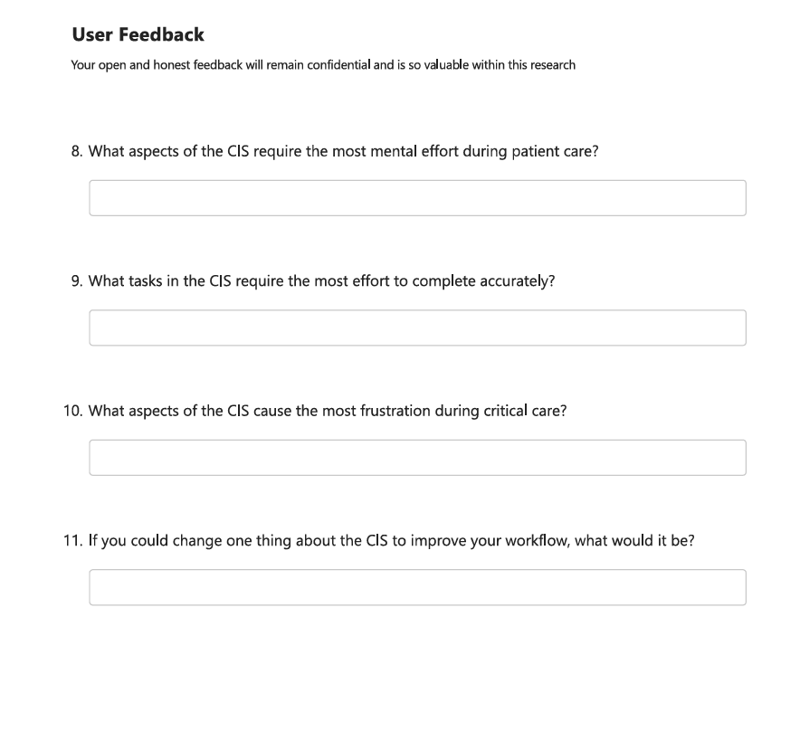
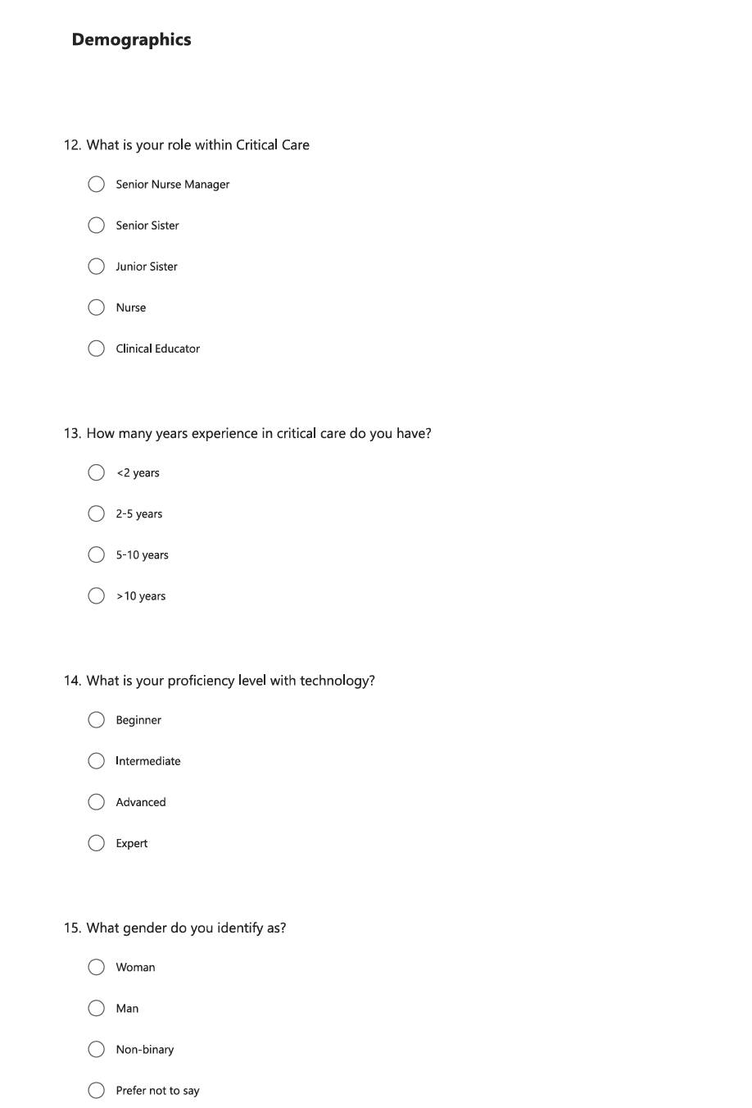


Appendix 2
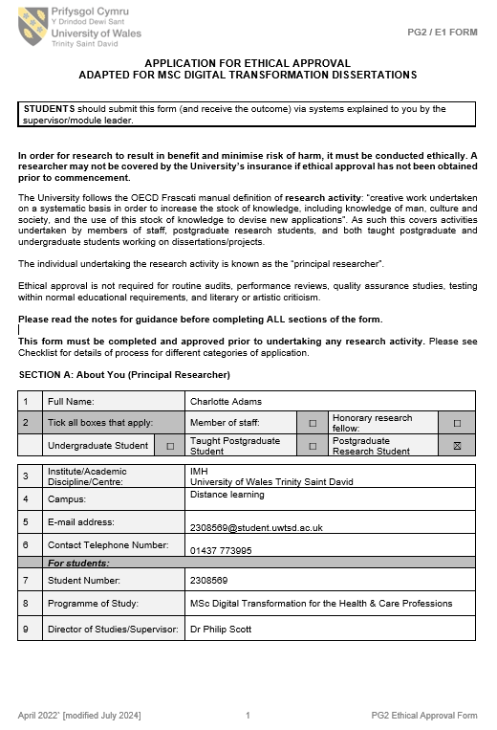


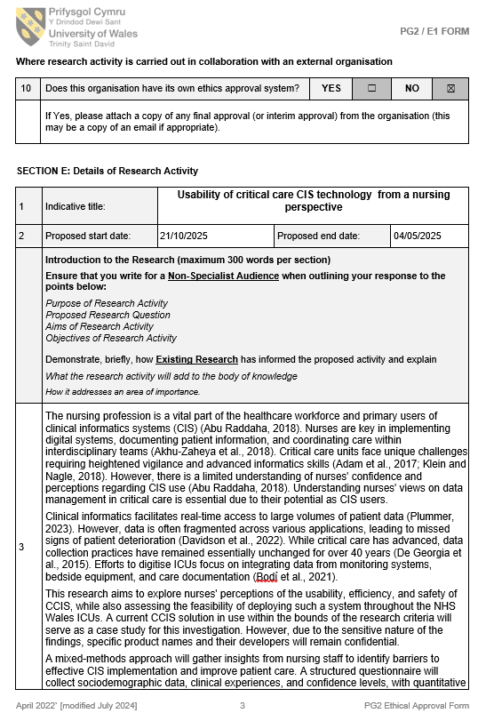
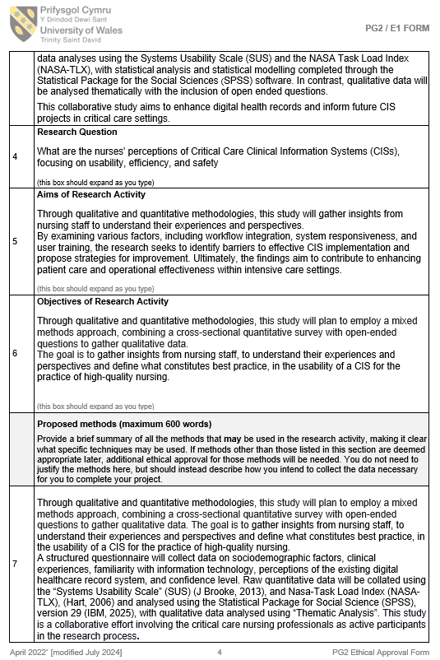
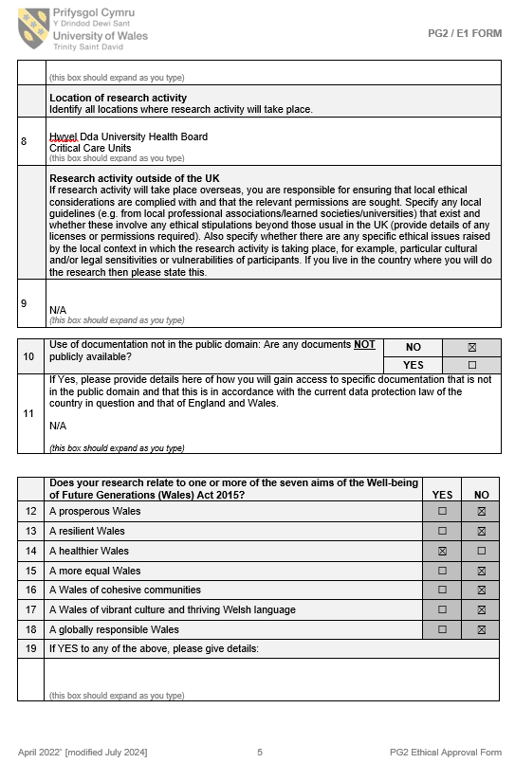
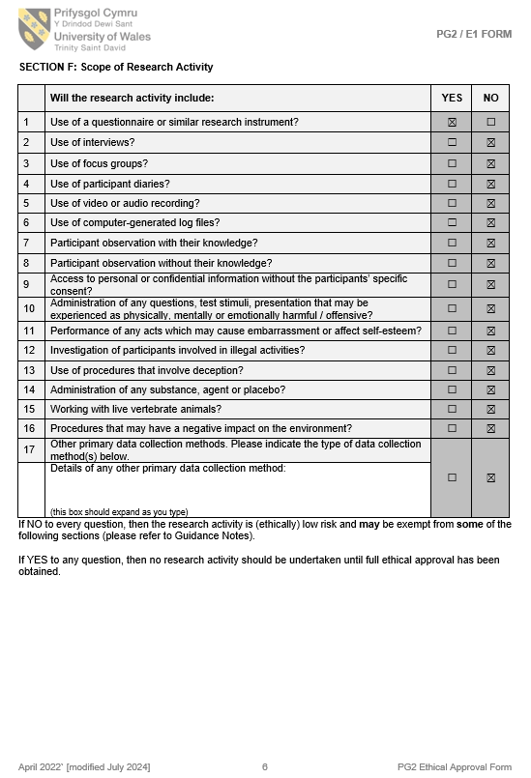

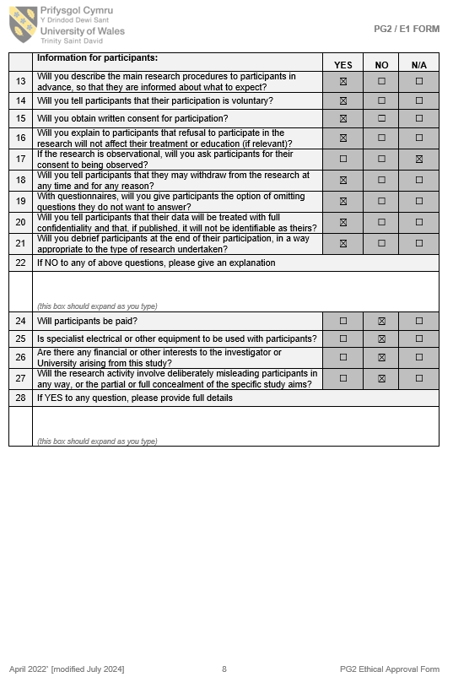
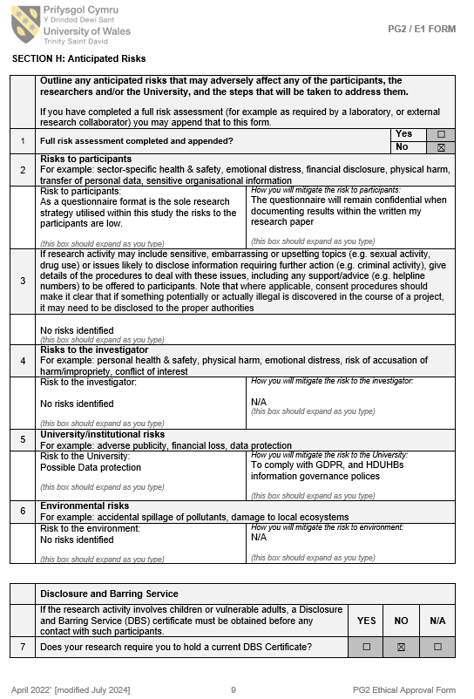

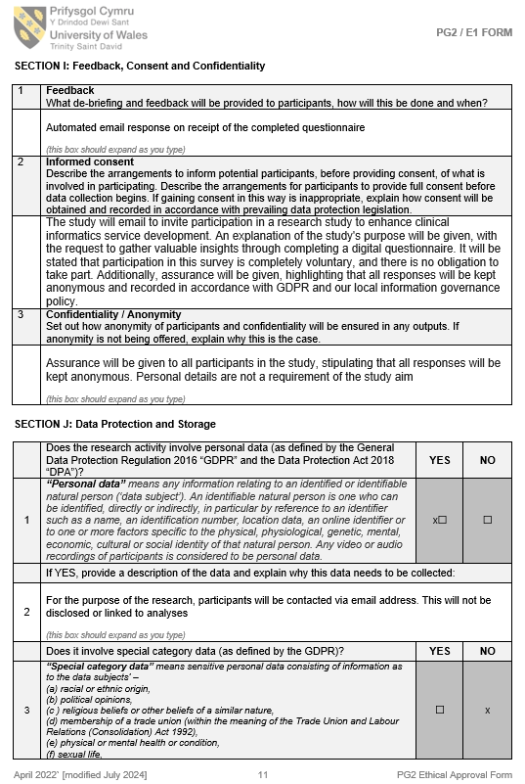
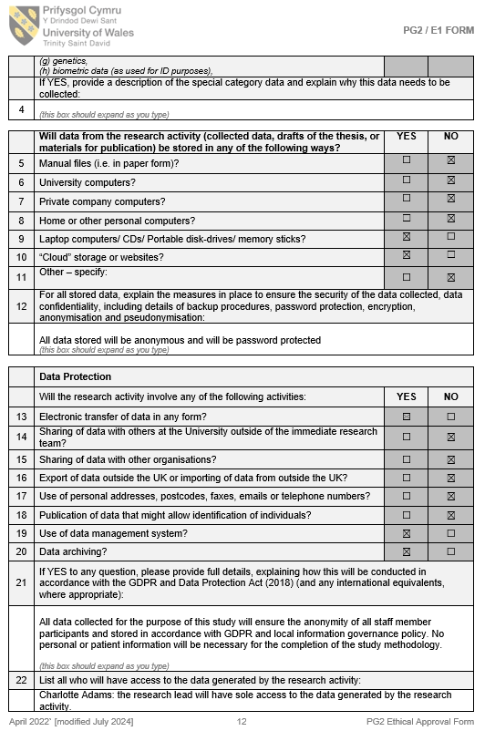


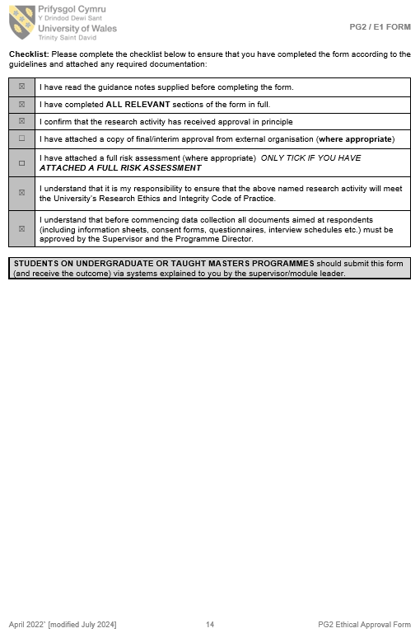Appendix 3
Analysis Type | Variables | Purpose | Statistical Test(s) | Key Results | Interpretation
Internal consistency (reliability testing) | SUS items; NASA-TLX items | Assess internal consistency of usability and workload measures | Cronbach’s α | SUS α = .866; NASA-TLX α = .907 | Both instruments demonstrated excellent reliability.
Descriptive statistics: usability | SUS total score | Summarise overall perceived usability | Descriptive statistics (M, SD) | M = 58.82; SD = 18.49 | Usability rated between marginal and acceptable, with wide variability.
Descriptive statistics: workload | NASA-TLX total score | Summarise perceived workload | Descriptive statistics (M, SD) | M = 45.94; SD = 16.82 | Indicates moderate workload with notable variation across participants.
Usability by documentation method | SUS: paper vs CIS | Compare usability ratings across documentation types | Welch’s t test | t(34.90) = −4.99, p < .001 | CIS usability is significantly higher than paper documentation.
Effect size for usability | Same as above | Quantify magnitude of difference | Cohen’s d | d = 1.62 | Exceptionally large effect, indicating meaningful practical difference.
Workload by documentation method | NASA-TLX: paper vs CIS | Compare workload across documentation types | Welch’s t test | p = .008 | CIS is associated with significantly lower workload than paper.
Effect size for workload | Same as above | Magnitude of difference | Cohen’s d | > 0.80 | Moderate-to-large effect, indicating meaningful reduction in workload.
Relationship between usability and workload | SUS; NASA-TLX | Test whether higher usability predicts lower workload | Pearson correlation | r = −.11, p = .51 | Weak, non-significant relationship; usability not directly linked to workload.
Usability by nursing role | SUS by role | Explore role-based differences | Descriptive comparison | Means reported descriptively | Variation observed; results interpreted with caution due to small subgroup sizes.
Workload by nursing role | NASA-TLX by role | Explore workload differences across roles | Descriptive comparison | Means reported descriptively | Senior Sisters reported highest workload; Senior Nurse Managers lowest.
Training status and usability | SUS by training group | Determine if training affects usability | One-way ANOVA; Welch ANOVA | ANOVA: F(2, 35) = 7.55, p = .002 | Formal training significantly improves perceived usability.
Training status and workload | NASA-TLX by training group | Determine if training affects workload | One-way ANOVA; Welch ANOVA | p = .113 (ns) | No significant difference in workload by training status.

