
Strategic Management ( LCMB 7003 )

Strategic Analysis of Delicious



Student Name : Aditya Pratap Gurjar
Student Number : 2239855
Lecturer: Vasilios Tavlaridis / Gladius Kulothungan
Word Count : 5810
Submission Date : 1 January 2024

TABLE OF CONTENT

- Introduction…………………………………………………4
- Background…………………………………………4
- Mission & Objectives…………………………..5

- Macro- Environmental Analysis……………………6
- PESTLE Analysis…………………………………..7

- Micro-Environmental Analysis……………………..8
- Industry life cycle………………………………..9
- Porter’s Industry Five Forces
Analysis …………………………………………….10

- Internal Analysis…………………………………………12
- Strategic Resources……………………………12
- Strategic Capabilities…………………………13

- Value Chain Analysis………………………………….13
- Primary Activities………………………………14
- Secondary Activities………………………….15

- VRIO Analysis of Distinctive Resources
and Capabilities. ……………………………………….16

- SWOT Analysis…………………………………………..17

- Strategies to Sustain Competitive
Advantage…………………………………………………19

- Growth Strategy………………………………………..22

- Green Strategy and CSR…………………………….24

- Conclusion…………………………………………………26

- Recommendations…………………………………….27

- References………………………………………………..28

INTRODUCTION

The dynamic restaurant sector relies on a careful balancing act between strategic vision, operational efficiency, and culinary skill to achieve success. This in-depth analysis explores the complex operations of “ Delicious “, a restaurant ready to leave its mark on the dynamic field of food and hospitality.

We identify the elements that contribute to the restaurant's current position and plot a course for its future growth and prosperity by carefully examining its strengths and weaknesses using different types of analysis. At the same time, we pinpoint any potential flaws that would prevent it from moving forward, including a narrow marketing focus or ineffective operations.

We extend our investigation outside the restaurant's walls and investigate the surrounding area, finding both possible threats and exciting prospects.

Equipped with these understandings, we develop a thorough set of strategic suggestions catered to the unique requirements and goals of Delicious . We suggest tactics to improve its competitive advantage, streamline its business processes, and seize new market opportunities. Our suggestions include a wide range of topics, such as financial management, primary as well as secondary activities ,marketing and growth strategies , and some recommendations .

Readers will have a comprehensive grasp of Delicious 's strategic position, growth potential, and feasible next steps to accomplish its long-term objectives by the end of this research. We cordially invite you to join us on this delicious adventure as we analyze the restaurant's strategic environment and lay the foundation for its long-term success.

- BACKGROUND

Company Name : Delicious

Company History : A group of enthusiastic foodies established Delicious in 2022 with the goal of establishing a dining experience that was unmatched. Our goal was to create food that would entice customers' palates and take them on a gourmet adventure.

Number of Workers: Our team consists of 20 committed workers at the moment, which includes chefs, waiters, and hostesses. In order to ensure that our employees can provide our visitors with an outstanding dining experience, we are dedicated to offering them extensive training and development opportunities.

Financial Information : Delicious is a privately held business, hence it does not make its financial data available to the general public. Nonetheless, we are pleased to state that since our founding, we have grown steadily and earned a average profit margin of 3-5 %.

Operating Markets : At the moment, Delicious is only running one location in the centre of London. In the near future, we intend to open more stores both domestically and abroad.

- MISSION AND OBJECTIVES

Following are the mission of Delicious :

- Cultivate a warm and friendly environment: To maintain and tend to attain a welcoming , friendly behaviour with customers.
As first impression is the last impression.

- Implement effective cost control measures: keep an eye on all expenses carefully and identify areas for cost reduction without compromising the quality and quantity.

- Implement consistent quality control measures: Establish strict quality control procedures to ensure that every dish is prepared to high standard.

- Invest in employee training and development: Employees should get proper training on how to deal in any situation and resolve it in best possible manner as to deliver exceptional customer service.


Some of the main objectives would be :

- Exceptional Service: Provide impeccable and personalized service that anticipates and exceeds guests’ expectations, fostering a warm and welcoming atmosphere.

- Innovation and Adventure: Continuously innovate and explore new culinary frontiers, offering guests a journey of culinary discovery and delight.

- Employee Empowerment: Create a nurturing and empowering work environment where employees feel valued, respected, and inspired to contribute their best.

- Brand Recognition: Establish Delicious as a leading culinary destination in London, recognized for its exceptional cuisine, service, and innovation.

MACRO ENVIRONMENT ANALYSIS

the major uncontrollable, external forces (economic, demographic, technological, natural, social and cultural, legal and political) which influence a firm's decision making and have an impact upon its performance.

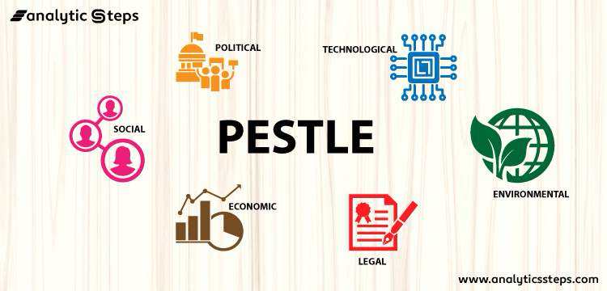

- Pestle Analysis :

Francis J. Aguilar, a professor at Harvard Business School, introduced the idea of the PESTLE analysis. In 1964, he presented the framework in his book "Scanning the Business Environment.
Since then, the PESTLE analysis has gained popularity as a strategic tool for evaluating an organization's macro environment on a global scale.
Here is the PESTLE Analysis for Delicious:

Political factors:

• Government regulations: The restaurant needs to abide by all relevant rules and regulations pertaining to labour, health, and food safety.

• Trade regulations: Modifications to trade regulations may increase the cost or difficulty of importing ingredients.

• Political stability: The state of politics in the nation or area where the restaurant is located may have an impact on the confidence and purchasing patterns of its consumers.

Economic factors:

• Spending by customers: This has a direct impact on how profitable the restaurant is. Customers are eager to spend more the more variety and quality they receive.

• Food costs: The cost of labour, energy, and food components all have an impact on the restaurant’s expenses.

• Interest rates: The cost of capital for the restaurant may be impacted by interest rates. For eateries that are growing or buying new equipment, this can be crucial.

Social Factors:

• Health consciousness: As consumers are awareness of their health grows, they are calling for healthier food options.

• Convenience: To accommodate clients with hectic schedules, the restaurant can provides dine-in, takeaway, delivery, and online ordering options.

• Sustainability: Using locally sourced food and cutting waste are two examples of sustainable practises the restaurant can use to avoid buying in large quantities.

Technological Factors:

• Online ordering and delivery: Modern technology is very effective. These platforms provide the restaurant the opportunity to reach a larger audience and boost sales.

• Food preparation technology: The restaurant can cut expenses and increase efficiency by implementing new developments in this field.

• Social media: Social media can be utilised to raise brand awareness and market the restaurant to prospective patrons.

Legal Factors:

• Taxes: Food enterprises must pay sales tax, property tax, and income tax, among other taxes. So, in order to prevent inconvenience, these taxes should be paid on time.

• Labour laws: Food establishments are required to abide by all relevant labour laws, which address matters like workplace safety, overtime compensation, discrimination, and minimum wage.

• Requirements for licencing: Food establishments must apply for government licences; certain licences may be needed for operations like food preparation, food service, and alcohol sales.

Environmental Factors:

• Food safety issues: Food-borne infections can harm a restaurant’s brand and financial performance.

• Climate change: By purchasing food from regional growers and implementing sustainable practises, the restaurant can lessen the effects of climate change.

• Waste management: It’s necessary to dispose of food waste properly. This could entail recycling, composting, or giving food to nonprofit organisations.

MICRO ENVIRONMENT ANALYSIS

The conditions that prevail throughout the economy, as opposed to just one specific industry or geographic area, are referred to as the macro environment. The macro environment, in general, consists of developments in the GDP, employment, inflation, spending, and monetary and fiscal policy.

Industry Life Cycle :

Introduction Stage:
- There is curiosity and excitement surrounding the restaurant's opening as Delicious opens in London, offering a unique concept of serving food that is available in the market

- customers are eager to try this cutting-edge dining experience

- word of mouth about the restaurant's delicious food and unique concept spreads, creating a positive brand image in the city.

Growth Stage:
- Delicious gets great reviews from food critics and media outlets, further solidifying its reputation as a must-visit location for foodies

- The restaurant expands its menu to include more unique dishes and experiences, catering to a wider range of tastes and preferences

- Delicious's popularity continues to grow, leading to an increase in demand for reservations and longer wait times.
Maturity Stage:
- Delicious becomes a well-known and respected establishment in London's booming restaurant industry.

- It does this by attracting customers with its bright concept and consistently high-quality food and service.

- Over time, the restaurant builds a devoted clientele that enjoys its special offerings and the feeling of wonder they arouse.

Decline Stage:
- Despite its popularity, Delicious is facing difficulties as its approach starts to weaken.
Newer restaurants with creative ideas might open and draw in diners looking for fresh dining experiences.
- To remain competitive and appealing, the restaurant might need to modify and enhance its menu or service offerings.

Extension Stage
- Delicious could explore new partnerships or collaborations to increase its customer base and strengthen its brand presence.

- The restaurant could further innovate its concept by incorporating technology or interactive experiences to enhance the dining experience.

- Delicious could think about expanding its reach by opening additional locations in other cities or providing catering services in order to revitalize its business.

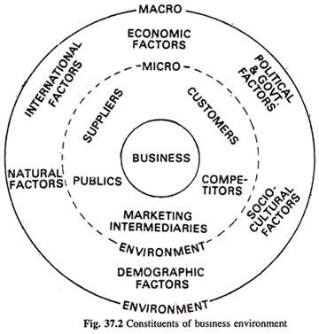

Porters’s Industry five forces Analysis :

Porter's Five Forces framework assesses an industry's competitive environment and offers insightful information about the major players in a market. The analysis's findings enable confident, well-informed strategic decision-making.

- Threat of New Entrants:
London is a difficult city to open a restaurant because of the fierce competition from already-existing restaurants. The substantial overhead expenses, which include rent, labor, and ingredients, put pressure on fledgling businesses' profit margins. Complying with strict standards, such as health codes and licensing requirements, increases the complexity and costs associated with it. Getting a new restaurant off the ground in London requires overcoming these obstacles and making a name for itself in the competitive food market.
- Bargaining Power of Buyers:
London's large restaurant alternatives give its customers a moderate amount of negotiating power. They can therefore demand greater value for their money and force down prices. By supplying distinctive and differentiating menu items, delivering top-notch customer service, and cultivating enduring customer connections, restaurants may offset this advantage.

- Bargaining Power of Suppliers:
Restaurant equipment and food suppliers are examples of suppliers with a moderate amount of bargaining power. This is due to the fact that restaurants typically rely on a small number of major suppliers for their supplies and machinery. Nonetheless, restaurants may have some clout due to the fragmented nature of the restaurant business and the availability of several suppliers for comparable goods.
- Threat of Substitute Products:
In London, there are plenty of options to restaurants, such as packaged meals, home cooking, and takeout and delivery services. This puts pressure on eateries to continue offering reasonable rates, meals that are worth the money, and top-notch dining experiences.
- Rivalry Among Existing Competitors:
London's restaurant market is fiercely competitive, with many well-known and up-and-coming companies fighting for patronage. Restaurants must continually innovate, set themselves apart, and prioritize customer pleasure due to the fierce competition.
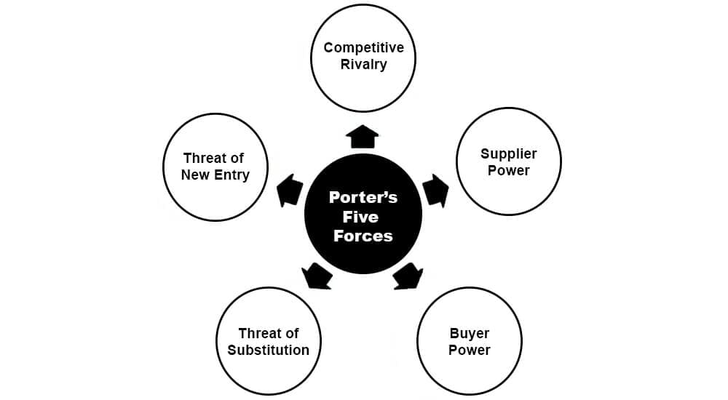

INTERNAL ANALYSIS
Let’s divide Strategic Resources and Strategic Capabilities of Delicious to understand them very effectively :

Strategic Resources :
• Exclusive idea or cuisine: To differentiate itself from the competitors, the restaurant should provide a special eating experience. This could be a remarkable menu item, a distinctive eating experience, or both.
• Premium ingredients: Only the best ingredients should be used by the restaurant to make its cuisine. This will guarantee that the meal is safe, nourishing, and delightful.
• Seasonal and fresh produce: Whenever feasible, the restaurant need to serve seasonal and fresh produce. This will guarantee that the food is sustainably produced in addition to being tasty.
• Innovative and creative menu: New and interesting meals should be added to the restaurant's menu on a regular basis. Both attracting new clients and retaining existing ones will benefit from this.
• A skilled and motivated group of chefs: The restaurant should employ a group of skilled and motivated chefs that can produce dishes of the highest caliber that are aesthetically pleasing and delectable.
• A committed and knowledgeable staff: All customers should receive exceptional customer service from the restaurant's committed and knowledgeable personnel.
• A well-trained and effective kitchen crew: To guarantee that the food is produced promptly and precisely, the kitchen staff needs to be well-trained and effective.
• A cutting-edge and effective point-of-sale (POS) system: To track orders, manage inventory, and handle payments, the restaurant has to implement a cutting-edge and effective POS system.

Strategic Capabilities
• Effective marketing and promotion: In order to draw in new business and keep existing patrons, the restaurant needs to have a strong marketing and promotion plan. This could involve traditional advertising, email marketing, and social media marketing.
• Solid supplier ties: To guarantee that it has access to the premium ingredients it need, the restaurant needs to maintain solid relationships with its suppliers.
• Data-driven decision-making: The eatery ought to utilize data to inform choices regarding its day-to-day operations. This can entail keeping tabs on revenue, client comments, and kitchen efficiency.
• Continuous improvement: The eatery needs to make a commitment to this. This can entail offering new technology, changing the menu, and educating the personnel.
• Flexibility: The eatery must have the capacity to adjust to shifting consumer tastes and market conditions. This might entail altering the menu.

VALUE CHAIN ANALYSIS
Value chain analysis is a method that was first presented by Michael Porter in the 1980s and has since grown in popularity as a means of giving businesses a competitive edge. Value chain analysis focuses on a company's internal operations to understand its costs and how various activities might enhance the value of its output.
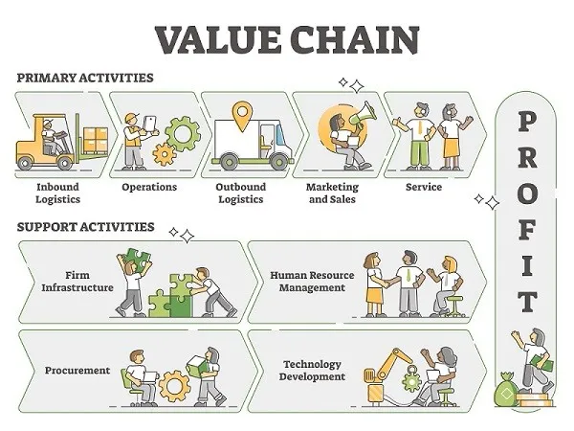

The five primary activities, as identified by Michael Porter, are:
1. Inbound Logistics:
- Receiving and storing raw materials and supplies.
- Managing inventory levels.
- Negotiating with suppliers.
- Handling customs and transportation.
2.Operations:
- Transforming raw materials into finished products or services.
- Assembly, processing, packaging, and production.
- Maintaining infrastructure and equipment.
- Quality control and assurance.
3. Outbound Logistics:
- Storing and packaging finished products.
- Distributing products to customers.
- Managing delivery channels and logistics.
- Handling returns and refunds.
4. Marketing and Sales:
- Promoting and advertising products or services.
- Pricing and revenue generation.
- Customer acquisition and retention.
- Sales force management.
- Brand building and communication.
5. Service:
- Providing after-sales support and customer service.
- Handling complaints and inquiries.
- Maintenance and repair services.
- Warranty and guarantee claims.
There are four main categories of secondary activities:
1. Procurement:
- Identifying and selecting suppliers.
- Negotiating contracts and prices.
- Managing purchasing processes.
- Ensuring quality and delivery standards.
2. Human Resource Management:
- Recruitment, training, and development of employees.
- Compensation and benefits management.
- Motivation and performance management.
- Maintaining a positive work environment.
3. Technology Development:
- Research and development of new products and services.
- Investing and maintaining technology infrastructure.
- Software development and implementation.
- Data analysis and decision making.
4. Firm Infrastructure:
- General management and leadership.
- Financial management and accounting.
- Legal and regulatory compliance.
- Planning and strategy development.
- Quality management and risk management.

VRIO ANALYSIS OF DISTINCTIVE RESOURCES
AND CAPABILITIES
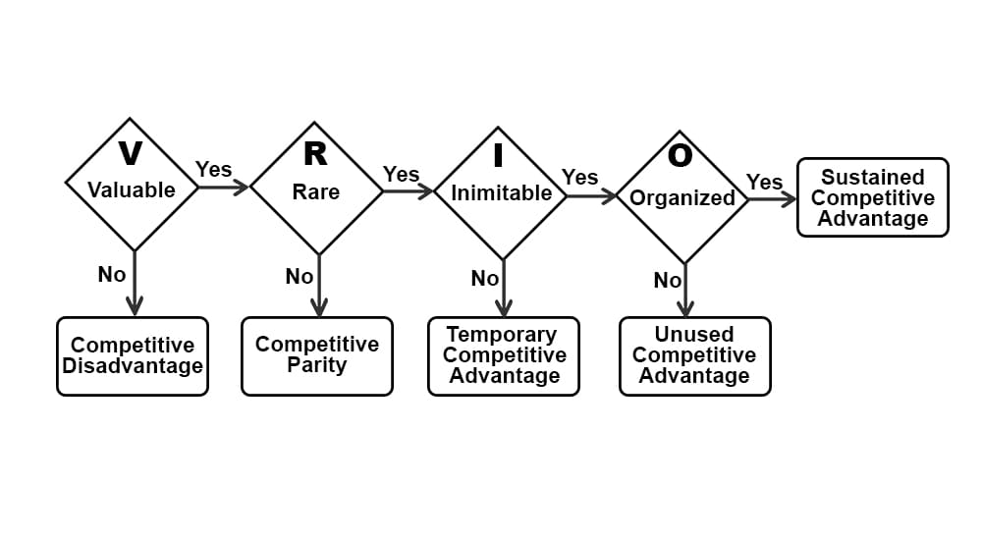
When assessing how the resources within your company affect your position in the market, VRIO Analysis can be quite helpful. It is important to nurture and fully utilize your most precious, unique, unusual, and well-organized resources since they will have the biggest impact on your market position.
- Value:This refers to the worth that the restaurant's resources and capabilities bring. Consider how its prime location, unique menu offerings, top-notch ingredients, exceptional service, and a strong brand image contribute to its success in standing out among other restaurants in London. These aspects should add value and make the restaurant appealing to customers in ways that competitors might struggle to match.

- Rarity:This aspect focuses on the uniqueness of the restaurant's offerings. Evaluate whether its recipes, culinary expertise, or the overall dining experience are uncommon in London's food scene. The goal is to understand if these elements are rare and difficult for other restaurants to replicate, giving the restaurant a distinctive edge.

- Inimitability:Assess how hard it is for competitors to imitate the Delicious’s resources and capabilities. This involves examining whether the recipes, culinary skills, or the restaurant's ambiance are so unique or specialized that other restaurants would find it challenging to copy or reproduce.

- Organizational leverage:This part involves looking at how effectively the Delicious management and operations capitalize on these unique resources. Consider how the restaurant utilizes its prime location, special recipes, skilled chefs, and other strengths through efficient processes, innovative marketing strategies, and strong management to maintain and enhance its competitive advantage in the market.
SWOT ANALYSIS
Strengths, Weaknesses, Opportunities, and Threats are referred to as SWOT. An organization can use a SWOT analysis as a framework to evaluate and comprehend the internal and external factors that could present opportunities or hazards.
Weaknesses and strengths are internal components. These are attributes of a company that offer it a comparative advantage (or disadvantage, correspondingly) over rivals.
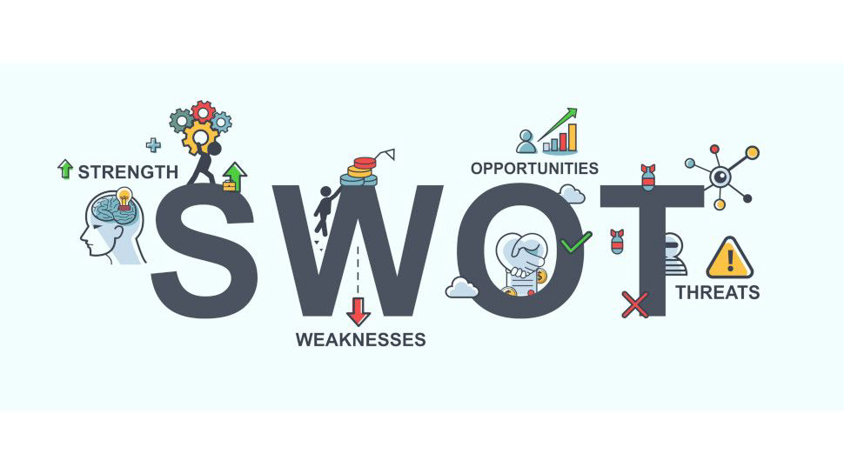
On the other hand, opportunities and risks come from outside sources. Management can take advantage of opportunities found in the external environment to boost company performance (such revenue growth or increased profitability).

Strengths:

- Distinctive and creative menu: Provide an assortment of items that aren't easily found at other eateries nearby. This could include foods that are prepared using fresh, locally obtained ingredients or dishes from many ethnicities or cuisines.
- Outstanding customer service: Treat each and every one of your visitors with the utmost care. This can entail paying close attention to client requirements, processing their orders quickly, and ensuring that their meal and service meet their standards.
- Creating an affluent and elegant setting: Establish an upscale and elegant atmosphere. This can entail having attentive employees, comfy seating, and exquisite décor.
- Strategic location: Pick a site that will appeal to your intended audience. This can be in a busy neighbourhood with lots of foot activity, next to a commercial zone, or in a well-known tourist destination.
- Strong online presence: Use social media and other online channels to promote your restaurant. This will assist you in expanding your consumer base and reaching a larger audience.

Weaknesses:

- High startup costs: It can be costly to open a restaurant. This could cover the price of furniture, merchandise, remodelling, and rent.
- Exorbitant food expenses: For restaurants, food can represent a major outlay of funds. This can be as a result of the price of storage, shipping, and ingredients.
- High labor costs: For restaurants, labor can also be a major expense. The price of pay, perks, and training is to blame for this.
- Rivalry: London's restaurant scene is highly competitive. This suggests that your restaurant needs to differentiate itself from the competition in order to succeed.
- Diverse client preferences: In London, there is a great deal of variation in client preferences. This implies that in order to serve a diverse clientele, you will need to be adaptable with your menu and products.

Opportunities:

- Growing need for organic and healthful food: In London, there is a growing need for organic and healthful food. This implies that you might profit from this trend by providing a menu with items created using products that are acquired locally and freshly.
- Growing popularity of delivery and takeout: In London, the use of delivery and takeout services is growing. This implies that by providing these services, you might be able to reach a larger clientele.
- Investigating new business models: You may look into a variety of different business models, including food trucks, pop-up restaurants, and catering services.
- Opening other locations: If your restaurant is a hit, you might open more in London or perhaps other cities.
- Forming partnerships with other companies: To reach a larger audience, consider forming partnerships with companies that provide lodging, bars, or event spaces.

Threats:

• Economic downturn: A downturn in the economy may result in lower customer spending, which could have an impact on the operations of your restaurant.
• Shifts in customer preferences: It may be challenging to maintain the relevancy of your menu and products given how quickly consumer tastes can change.
• Fresh competition: London is always seeing the opening of new eateries. This implies that to succeed, you will have to maintain an advantage over your rivals.
• Regulatory changes: You may incur higher expenses and find it more challenging to run your restaurant if there are changes to the minimum wage or food safety laws.
• Increasing competition from foreign chains: As international chains grow into London, local businesses may face pressure.

After getting all things considered, this is the SWOT analysis for delicious .To create an effective company strategy, you must recognize your opportunities, threats, weaknesses, and strengths.

STRATEGIES TO SUSTAIN
Sure, here are some strategies for a food restaurant in London to sustain competitive advantage using different strategic analyses:

Porter's Generic Strategies

Michael Porter created a collection of tactics known as Porter's Generic Strategies in the 1980s. Businesses employ these tactics to obtain a competitive edge in their particular marketplaces. The strategies are predicated on the notion that companies can concentrate on distinctiveness, cost leadership, or a mix of the two.

Cost Leadership:
- To cut unit costs, concentrate on high-volume production.
- Reach advantageous agreements with suppliers to reduce the cost of inputs.
- Use effective operating procedures to save waste and downtime.
- Streamline or automate monotonous operations to increase worker productivity.

Differentiation:
- Serve inventive and distinctive food that distinguishes the restaurant from rivals.
- Give top-notch products and cooking methods top priority to produce unforgettable eating experiences.
- Create a distinctive brand identity and a solid reputation for quality to draw in a discerning customer base.
- Develop a team of enthusiastic and competent employees who can deliver first-rate customer service.
- Add special touches to the meal that make it unforgettable, such as interactive features, music, or atmosphere.

Focus Strategy:
- Focus on a particular clientele or niche market, such as foodies, business executives, or eaters who are health-conscious.
- Adjust the food and ambiance to suit the target market's particular requirements and tastes.
- Put the restaurant in a well-chosen location that will appeal to the target market.
- Use promotions and marketing that is specifically targeted to the niche market in order to increase brand awareness.
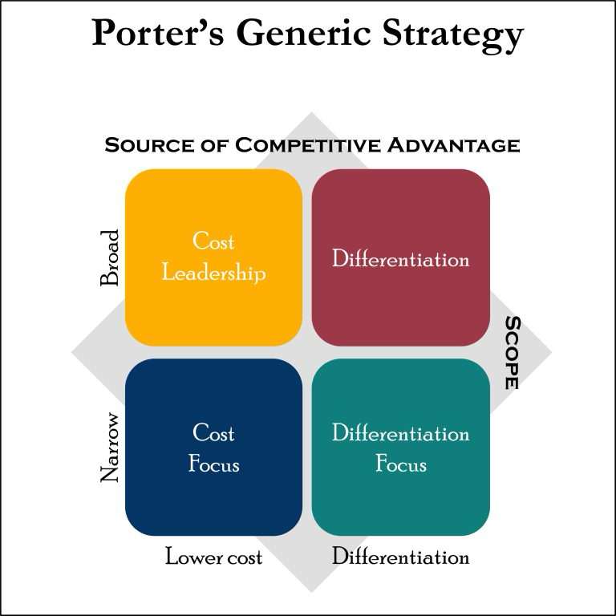

Ansoff's Matrix

Marketers can use the Ansoff Matrix, a tool for strategic planning, to create strategies that will help their products and services grow and expand, as well as the market. Additionally, it enables companies to assess the risks related to the implemented strategy.

Market Penetration:
- Increase the restaurant's market and advertising efforts to attract a wider audience.
- Collaborate with nearby companies or groups to provide special offers.
- Hold unique promotions or events to draw in new clients and create buzz.
- To increase the restaurant's delivery area, look into joint ventures with delivery providers.

Market Development:
- Add new menu items to reflect evolving consumer trends and tastes.
- Extend into other regions by establishing more branches or providing catering services, for example.Create a new concept or cuisine, like a food truck or sister restaurant, to develop a brand extension.
- Form strategic collaborations to cross-promote goods and services with other food-related businesses.
Product Development:
- To increase client happiness, innovate and enhance current menu items.
- To keep ahead of the competition, try out novel cooking methods and flavour combinations.
- To create a feeling of excitement and exclusivity, serve limited-edition cuisine and seasonal specialties.
- Create fresh presentation or packaging designs to improve the dining experience.

Diversification:
- Enter new markets for goods including groceries, catering, and food delivery.
- Start a line of branded goods, including culinary books, cookware, or clothing.
- Collaborate with other companies to provide supplementary goods or services, such culinary classes or gift baskets.
- Make investments in cutting-edge food-related technologies and trends, such as innovative cooking techniques or online ordering platforms.

By putting these tactics into practice, Delicious will be able to draw in new business and keep its existing clientele. To make sure that the tactics are current and useful, it's critical to keep an eye on consumer preferences, market trends, and rivalry.
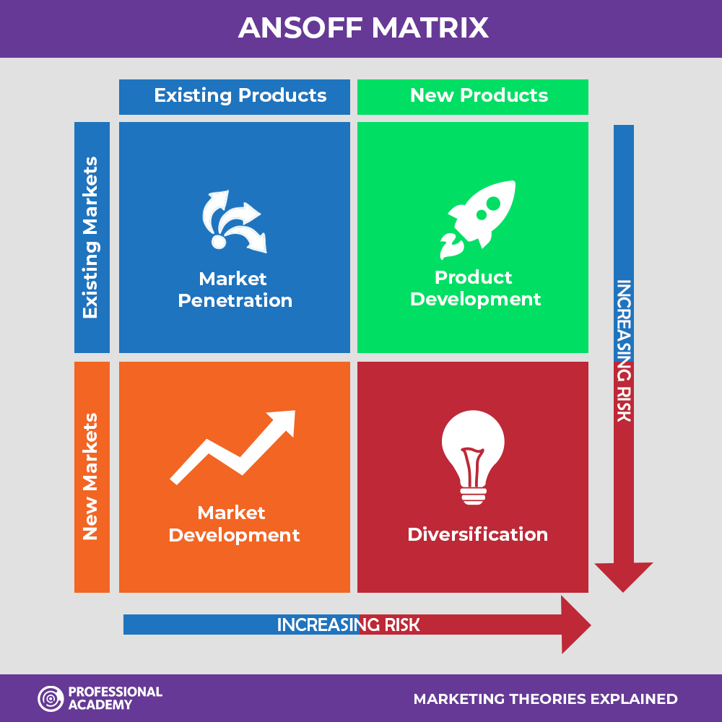

GROWTH STRATEGIES :

Market Analysis and Positioning:
• Competition Analysis: Conduct a thorough examination of the local restaurant industry to determine direct and indirect rivals, as well as any potential holes in the market and their advantages and disadvantages. This assists you in focusing on particular client segments and improving your unique selling proposition (USP).
• Customer Segmentation: Create discrete groups within your target market according to their dining habits, psychographics, and demographics. Make sure that your marketing, ambiance, and cuisine are appropriate for each segment.
• Trend Research: Recognize new dietary habits, eating experiences, and food trends to stay ahead of the curve. Think about adding them to your offerings while preserving your essential character.
Operational Enhancement:
• Cost Optimization: To keep food and beverage expenses under control, use effective inventory management, menu costing, and purchasing procedures. Examine labor expenditures and enhance staffing arrangements to enhance productivity.
• Technology Integration: Ordering, point-of-sale, reservation systems, and data analytics can all be done using restaurant management software. For added convenience, think about using online ordering and delivery platforms.
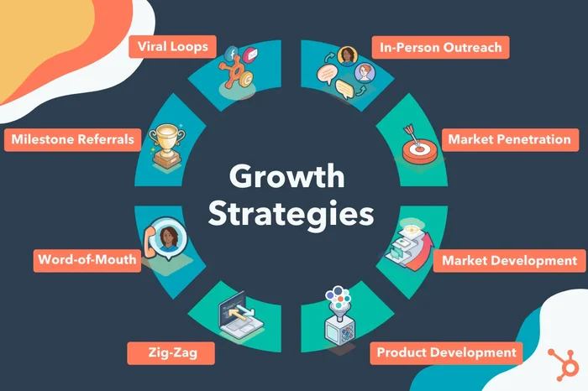
• Customer Relationship Management (CRM): Use a CRM system to collect client information, tailor communications, and foster a sense of loyalty. To encourage return visits, implement loyalty programs, birthday rewards, and customized promotions.

Marketing and Brand Building:
• Digital marketing: Establish a powerful online identity with interesting content, an active social media presence, and a user-friendly website. To increase traffic and brand exposure, make use of search engine optimization (SEO) and online advertising.
• Community Engagement: To organize events, provide exclusive deals, and raise awareness, collaborate with nearby companies, celebrities, or nonprofit organizations. Get involved in your neighbourhood to create goodwill and generate word-of-mouth advertising.
• Storytelling and Public Relations: Create an engaging brand narrative that emphasizes your beliefs, distinctive story, and dedication to excellence. Take advantage of PR possibilities to get favorable press coverage and establish your company's reputation.
Innovation and Differentiation:
• Menu Development: To keep customers interested, review your menu frequently and add new, seasonal items or special deals. Think about providing dietary alternatives and accommodating new culinary fads.
• Experience Design: Enhance the eating experience with a distinctive setting, special evenings, live music, or interactive features. To draw in new clients, think of providing individualized services, cooking lessons, or exclusive events.
• Delivery and Takeout Optimization: Use effective packaging, collaborate with dependable delivery platforms, and provide special takeout menus or offers to streamline your delivery and takeout operations.

GREEN STRATEGY & CSR
Green CSR is the recognition of obligation or the waste-reduction practice of firms’ operation to maximize the efficiency of their inputs and minimize the means of negatively influencing the future generations of the country
Focus on Resource Efficiency:
• Conserve water by installing low-flow dishwashers, toilets, and faucets. Keep an eye on your water usage, and for non-potable purposes, install grey-water systems or rainfall gathering.
• Energy Efficiency: Make the switch to smart thermostats, energy-efficient appliances, and LED lights. If at all possible, use renewable energy sources, such as solar panels. Adopt operational procedures such as shutting down machinery while it's not in use.
• Reducing Waste: Reduce food waste by portioning food wisely, changing the menu creatively, and planning ahead. For organic garbage, start composting; for other materials, implement recycling programs. Think about providing reusable tableware and napkins.

Sustainable Sourcing and Procurement:
• Seasonal and Local Ingredients: To help the community and cut down on transportation-related emissions, collaborate with nearby farmers and producers. To draw in environmentally conscientious customers, emphasize on your menu where your ingredients come from.
• Sustainable Seafood: To guarantee ethical fishing methods, select seafood certified by the Marine Stewardship Council (MSC) or other comparable organizations. Choose plant-based substitutes when it makes sense.
• Conscientious Product Selections: Invest in sustainable packaging materials, biodegradable paper goods, and environmentally friendly cleaning supplies. Encourage vendors who have a strong commitment to the environment.
Engaging Guests and Building Brand Values:
• Express your Green Values: Make sure visitors understand your green initiatives by using social media, menus, and signs. Provide instructional resources on how dietary decisions affect the environment.
• Encourage Sustainable Decisions: Highlight vegan and vegetarian selections, provide smaller servings for less money, and give patrons who bring their own containers a prize. Urge visitors to use water and energy responsibly.
• Collaborate for Impact: To increase your influence and establish credibility, team up with other environmentally conscious companies, neighbourhood environmental organizations, or take part in sustainability projects.
Strategic Management Integration:
• Cost-Benefit Analysis: Determine how green efforts will affect the bottom line, taking into account possible savings from resource efficiency as well as a rise in consumer loyalty.
• Risk management: Evaluate the hazards to the environment that are related to your business activities and put preventative measures in place to reduce possible liabilities.
• Performance measurement: Use pertinent measures, such as waste reduction, local sourcing percentages, and energy and water use, to monitor your progress toward your green targets.
By implementing these green strategies with a strategic management approach, Delicious can contribute to a healthier planet while attracting environmentally conscious customers and solidifying its position as a responsible and forward-thinking business.
CONCLUSION

A thorough examination of Delicious reveals a restaurant that is both an exquisite dining place and a key participant in London's cutthroat food industry. It is prepared to take advantage of its advantages and correct any shortcomings in order to establish a long-lasting presence in the market. Delicious has successfully carved out a niche for itself through a unique menu, outstanding customer service, and an elegant atmosphere—all while overcoming obstacles like high startup costs and fierce competition.
Delicious offers a lot of potential to investigate when taking into account the macro- and micro-environmental issues, such as the rising popularity of delivery services and the growing need for health-conscious solutions. Agility and adaptation are needed to counter risks like economic downturns and changing consumer tastes.The restaurant maintains its competitive edge by leveraging its strategic resources, which include excellent products, inventive menu items, and a talented staff.
Delicious can improve its position by following the strategies provided in Ansoff's Matrix and Porter's Generic Strategies, which include everything from cost leadership to market development. Delicious can maintain its position in the market by concentrating on providing experiences that are centered around the needs of its customers, constantly developing its offerings, and entering new markets.
Market study, operational improvement, marketing and brand promotion, innovation, and a strong green strategy are all woven together in Delicious' extensive strategic plan. Delicious may improve its unique selling proposition and cater to particular interests by breaking down the local restaurant market and segmenting its clientele, guaranteeing a customized dining experience for each and every customer. Streamlining procedures, increasing productivity, and cultivating better client relationships are all achieved through operational improvements brought about by cost optimization, technology integration, and customer relationship management.
In terms of public relations, storytelling, internet presence, community involvement, and brand creation, these strategies will increase Delicious's visibility and foster stronger ties within the community. By utilizing innovative techniques in menu development, experience design, and delivery optimization, the restaurant can maintain its allure and adapt to changing culinary trends.
The green strategy stands as a testament to Delicious’s commitment to sustainability. By focusing on resource efficiency, sustainable sourcing, engaging guests, and integrating green values into strategic management, Delicious not only champions environmental responsibility but also attracts a segment of conscientious consumers seeking eco-friendly dining experiences. These initiatives, woven into a comprehensive strategy, position Delicious as an industry leader poised for sustained success while contributing positively to the environment.
RECOMMENDATIONS

It is clear from a thorough examination of the internal and external environments that Delicious has a solid base and lots of room to develop. I advise it to include innovation into its main functions in order to build on its advantages. Accept technology's contributions to culinary methods as well as to customer service via social media and online ordering systems. Give creative and flexible menu innovation top priority, keeping it in line with shifting consumer preferences. Working together with regional growers to get seasonal, fresh products may strengthen environmental initiatives and reaffirm the commitment to quality. Enhancing its outstanding customer service by funding continuous training and empowerment initiatives for staff members would guarantee a consistently outstanding dining experience.
Growth will also be fueled by branching out to new areas, carefully selecting strategic locations, and investigating a variety of market niches. Moreover, initiatives for cost optimization ought to be a constant priority, guaranteeing that costs are properly controlled without sacrificing quality. Delicious can establish itself as a leading player in London's dynamic restaurant industry by implementing a strategic expansion plan, innovation, and customer-centric practices that promote long-term sustainability and client loyalty.

It's clear that Delicious can take a big step forward by including a strong green strategy into its business plan. It is my suggestion that you make sustainability your top priority and use eco-friendly methods for everything from obtaining supplies to cutting down on waste. Delicious promotes eco-friendly dining practices, maximizes energy efficiency, and uses sustainable sourcing to attract a rising group of environmentally concerned customers while simultaneously improving the environment. In addition to being in line with changing values and trends, Delicious's green approach distinguishes it as a conscientious and progressive establishment. By strategically incorporating these sustainability activities, you'll not only build a favourable brand image but also draw in a devoted clientele of people who appreciate companies that care about the environment.

REFERENCES

- Wallstreetmojo Team . Macro Environment. [online] Available at: https://www.wallstreetmojo.com/macro-environment/ [Accessed 06 December 2023].

- Heubel, M. (2023) ‘PESTLE Analysis: The Macro-Environmental Analysis Explained,’ Consulterce. Available at: https://consulterce.com/pestle-analysis/ (Accessed: 06 December ,2023).

- Pathak, Ritesh. (Published on December 6, 2020; Updated on November 21, 2023). “What is PESTLE Analysis?” [Online] Analytics Steps. Available at: https://www.analyticssteps.com/blogs/what-pestle-analysis

- Investopedia, The Investopedia Team. (Updated December 20, 2023). “Macro Environment.” Reviewed by Khadija Khartit. Fact checked by Pete Rathburn. [Online] Available at: https://www.investopedia.com/terms/m/macro-environment.asp

- Son, Nicolette. (Published on July 20, 2023). “Porter’s 5 Forces Analysis of Walmart: A Practical Example.” [Online] 365 Financial Analyst Knowledge Hub. Available at: https://365financialanalyst.com/knowledge-hub/business-analysis-and-strategy/porters-5-forces-analysis-of-walmart-a-practical-example/

- Corporate Finance Institute. (Accessed date 23-12-2023). “Value Chain.” [Online] Available at: https://corporatefinanceinstitute.com/resources/accounting/value-chain/

- Gordon, Jason. (Updated October 20, 2023). “VRIO Analysis Strategy Explained.” [Online] The Business Professor. Available at: https://thebusinessprofessor.com/business-management-amp-operations-strategy-entrepreneurship-amp-innovation/vrio-analysis-strategy-explained

- Peterdy, Kyle. (Accessed date 25-12-2023). “SWOT Analysis.” [Online] Corporate Finance Institute. Available at: https://corporatefinanceinstitute.com/resources/management/swot-analysis/

- Lee, Kelly. (Accessed date 25-12-2023). “Understanding Porter’s Generic Strategies: Definition, Types, and Uses.” [Online] Nesta. Available at: https://www.nesta.com.hk/understanding-porters-generic-strategies-definition-types-and-uses/

- Sindujha. (26-12-2023). “Environment of Business: Micro and Macro.” [Online] Business Management Ideas. Available at: https://www.businessmanagementideas.com/business-environment/environment-of-business-micro-and-macro/10135
- Pathak, Susmita. (Accessed date 25-12-2023). “Ansoff Matrix.” Edited by Ashish Kumar Srivastav, Reviewed by Dheeraj Vaidya, CFA, FRM. [Online] Wall Street Mojo. Available at: https://www.wallstreetmojo.com/ansoff-matrix/

- Suttle, Rick. (Accessed date 25-12-2023). “Growth Strategies for Business.” [Online] Chron Small Business. Available at: https://smallbusiness.chron.com/growth-strategies-business-4510.html

- Rahman N., Post C. Measurement issues in environmental corporate social responsibility (ECSR): Toward a transparent, reliable, and construct valid instrument. J. Bus. Ethics. 2012;105:307–319. doi: 10.1007/s10551-011-0967-x. [CrossRef] [Google Scholar]

- (Accessed date 28-12-2023). “Value Chain Analysis Models.” [Online] TradeBeyond Blog. Available at: https://tradebeyond.com/blog/value-chain-analysis-models/

- Usmani, Fahad. (Published on April 5, 2022). “VRIO Framework.” [Online] Parsadi. Available at: https://parsadi.com/vrio-framework/

