
Module Title: LCMB7034 – International Business Concepts
Assignment Title: A Strategic Consultancy Report of BP’s International Operations and Localisation Approach in India

Module Leader: Akshay Narayanan
Student Name: Mouin Uddin
Student ID: 2434996
Word Count: 5540 (excluding Bibliographies)
Submission Date: 15th December 2025

Table of Contents
1. Introduction 3
2. Benefits & Challenges of International Operations 3
2.1 Why BP Qualifies as an MNC/TNC 3
2.2 BP’s Global Value Chain Analysis 4
2.3 International Entry Modes Used by BP 8
2.4 Key Benefits of BP’s Internationalisation 9
2.5 Key Challenges 10
3. OLI Analysis for BP’s India Market Entry 10
3.1 Ownership Advantages (O) 11
3.2 Location Advantages (L) 11
3.3 Internalisation Advantages (I) 12
3.4 OLI (Final Entry Mode Choice: JV with Reliance) 13
4. Cultural Differences and Their Impact on BP’s India Strategy 14
4.1 Hofstede Comparative Table (UK vs India) 14
4.2 Critical Interpretation of Scores 15
4.3 Implications for Market Entry Strategy 16
4.4 Implications for BP’s Operational Success 17
4.5 Limitations of Cultural Frameworks 19
5. SOP Adjustments Required for BP in India 19
5.1 SOP Adjustment 1: Localised Operational Risk & Safety Governance 19
5.2 SOP Adjustment 2: Cross-Cultural HR & Leadership Integration 21
5.3 SOP Adjustment 3: Localised Supply Chain & Market Adaptation 22
6. Conclusion 24
References 25

1. Introduction
A critical assessment of BP as an international expansion strategy with a specific emphasis on its activities in India, which is one of the fastest-growing markets in the global energy industry, is presented in this consultancy report. As a major international MNC, BP is increasingly adapting to a strategic shift of moving away from hydrocarbons to integrated low-carbon solutions, hence placing the emerging economies at the centre of its long-term growth and diversification strategy (BP PLC, 2024). India presents an attractive location with its rising energy consumption, massive population level, and governmentally mandated transition of energy systems to renewable and mobility infrastructure. Based on the existing frameworks of international business, such as the OLI Paradigm, cultural analysis paradigms, value-chain analysis and entry-mode theory, the report analyses the way BP’s global capabilities are interacting with the Indian institutional, cultural, and market realities (Lee, Hayakawa and Park, 2023). It also examines the threats and opportunities that BP can seize in its process of adjusting global standards to a complex emerging-market environment. At the end of the report, there are specific SOP changes, which are aimed at enhancing the effectiveness of operations, cultural compatibility, and the ability of BP to be competitive in India in the long term.

2. Benefits & Challenges of International Operations

2.1 Why BP Qualifies as an MNC/TNC
BP unquestionably qualifies as a multinational corporation (MNC) or transnational corporation (TNC) by its far-reaching presence in operations in over seventy countries, including upstream exploration, downstream refining and fast-growing renewable-energy projects (BP PLC, 2024).
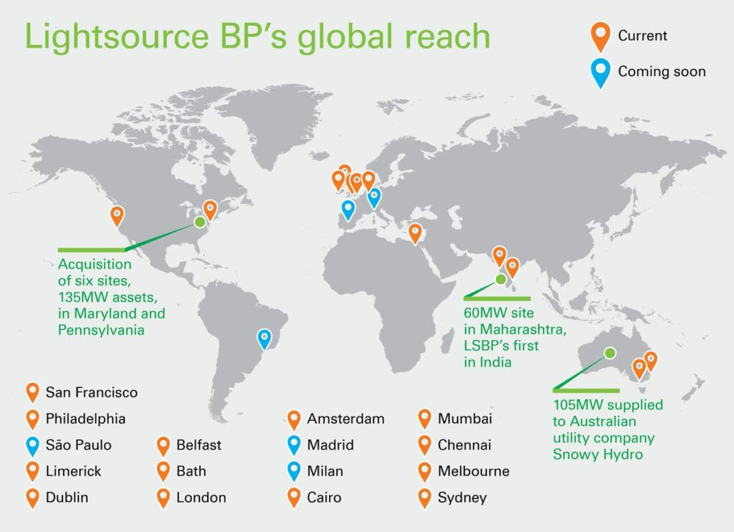
Figure 1: BP Global Operations Map
Source: (BP PLC, 2024)
Its organisational structure bears the transnational model that Bartlett and Ghoshal developed. It is centrally managed by strategic control, but decentralised operational freedom is provided to accommodate various institutional settings (BP PLC, 2024). The ability of BP to access the global capital markets, its proprietary technologies and its integrated energy value chain depict how difficult coordination is in the advanced TNCs. This system of strategic and global distribution allows BP to gain access to resources, geopolitical risks and provide alternative energy solutions in different regions at the same time (Clemente and Wei, 2024).

2.2 BP’s Global Value Chain Analysis
Research and Development (R&D)
The refining efficiency, advanced lubricants, EV-charging solutions, and other hydrogen technologies are the core of the competitive advantage of BP, which is based on its R&D capabilities (Alinasab et al., 2025). It has a heavy concentration of its R&D centres in the United Kingdom and the United States, which shows that the ownership benefits are still embedded in home-country innovation systems (Batschauer da Cruz, Eliete Floriani and Amal, 2022). This focus also supports the capacity of BP at the use of proprietary innovations in subsidiaries and joint ventures throughout the world. However, relying on high-end economy R&D centres creates a knowledge asymmetry: though BP enjoys technological leadership, it has to keep changing these solutions in response to the infrastructural limits and regulatory heterogeneity of new markets like India.
Sourcing and Supply
The sourcing network of BP extends globally to the Middle East, West Africa and the United States crude oil fields, and an ever-growing liquefied natural gas (LNG) portfolio linked by a shipping fleet and terminals. These interdependent systems allow BP to optimise sourcing against pricing, quality, as well as geopolitical risk evaluations (BP PLC, 2024). However, the international scope poses supply-chain risk to BP as a result of regional tensions, sanctions and price shock. The case of the Russia-Ukraine conflict and the instability in the Middle East demonstrates the way the global integration of BP increases both its opportunity and vulnerability. India BP has strengths in global sourcing, but needs to overcome the changing regulations governing energy security in the country and the tariff frameworks.
Production and Refining
The company of BP has a network of refineries and petrochemical stations in Europe, Asia, and North America, which offers them economies of scale and highly developed technology. It is also linked to BP downstream presence through its partnership with Reliance Industries in India, which links BP to one of the largest refinery complexes in the world at Jamnagar (Alinasab et al., 2025). But global production assets provide a conflict between scale efficiency and the decarbonisation move in the world, which is rapidly accelerating. The refining strategy of BP has the dual issue of being cost-competitive in the avenue of re-investing in the low-carbon fuel alternative, which is being unevenly distributed across regions.
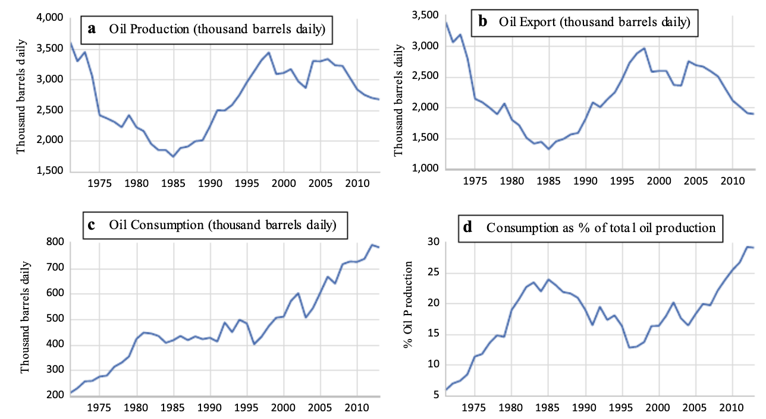
Figure 2: Oil Production, Export and Consumption by BP
Source: (BP PLC, 2024)
Sales, Marketing, and Distribution
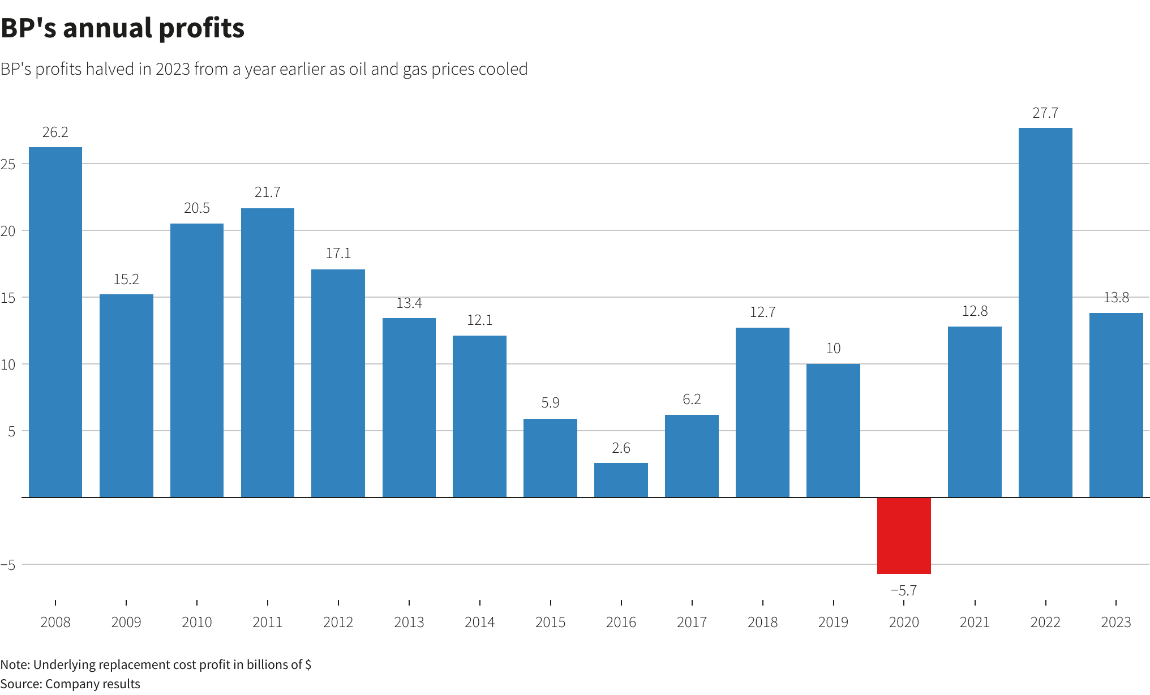
Figure 3: BP makes record profit in 2022
Source: (BP PLC, 2024)
The strength of BP in marketing lies in its global brands, which are in India, with Castrol, which has a strong brand in the Indian lubricant market due to its familiarity and performance image. However, the retail fuel industry of India is highly fragmented and price sensitive and controlled by state-owned corporations like IOC, HPCL, and BPCL (Clemente and Wei, 2024). Such fragmentation necessitates the use of differentiated marketing capabilities, branding localisation, and retail formats, which conform to the Indian mobility preferences by BP. The joint venture of Reliance BP Mobility Ltd (Jio-BP) that BP has established with Reliance in India is an example of an adaptive strategy based on the local distribution and consumer networks.
Financing and Risk Management
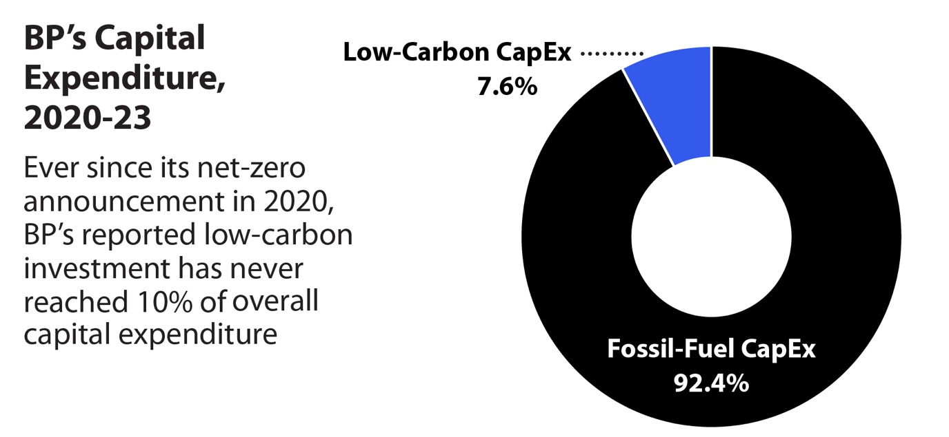
Figure 4: BP's Capital Expenditure, 2020-23
Source: (BP PLC, 2024)
The global treasury system allows BP to distribute risk and manage money intelligently across all its businesses. BP has demonstrated financial strength, as in one quarter it produced approximately US$8.1 billion in operating cash flow. That enables BP to make large investments, such as LNG, mobility, and even renewables (Booyse and Scheepers, 2024). Yet international fluctuations - crashes in the price of oil, exchange rates, geopolitical hassles - make life more difficult. In the present day, BP has to juggle between pressure to be green and upstream and downstream assets, which are expensive to finance, and thus, it is a difficult yet necessary juggling process.

2.3 International Entry Modes Used by BP
The entry modes that are deployed by BP are a varied mix of host-country regulations, market structure, and strategic goals. The joint venture with Reliance in India is a typical joint venture (JV), which was aimed at manoeuvring through regulatory limitations, gaining local legitimacy, and utilising the vast distribution channels of Reliance (Nomani, Rithi and Negi, 2025). Conversely, BP has wholly owned subsidiaries (WOS) in areas with stable regulatory environments, such as the United Kingdom and the United States, where full ownership would allow closer control over technology, safety standards, and brand.
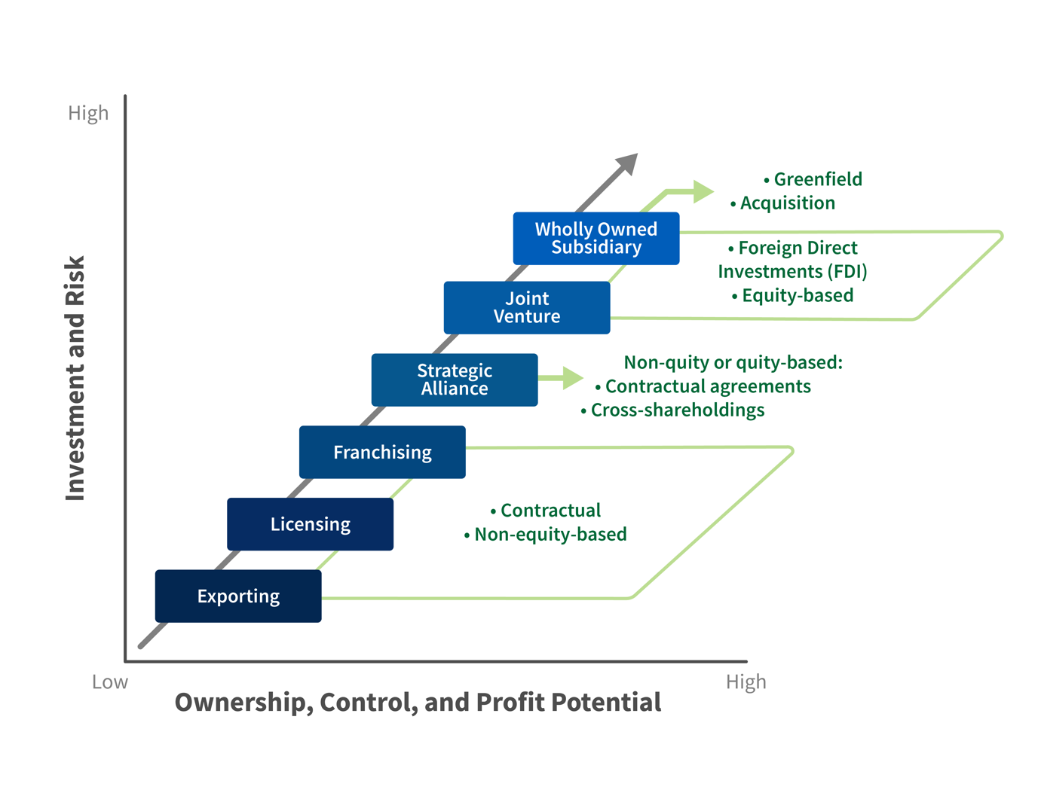
Figure 5: International Entry Modes
Source: (Barua and Aziz, 2022)
Acquisitions have also helped BP to expand, particularly Castrol, which has offered them instant access to the market, brand equity and downstream capabilities (Barua and Aziz, 2022). Further, the company pursues strategic partnerships in LNG infrastructure and renewable-energy networks, as well as offshore exploration, to help it share risks and capital needs in volatile settings.
On a critical comparison, BP has mostly dominated in emerging economies with the JV as opposed to the WOS, which is attributed to institutional limitations, the cultural distance is high, and local political and market expertise is prioritised (Barua and Aziz, 2022). Meanwhile, in developed economies with well-developed legal systems, BP prefers WOS to retain internalisation benefits and control. This opposition shows the context-driven approach of the global strategy of BP.

2.4 Key Benefits of BP’s Internationalisation
The internationalisation of BP provides large-scale efficiencies shown by its global refinery of 1.39 million barrels per day and production of 2.36 million boe/d. On which it can offer lower unit cost in sourcing, refining, logistics and marketing (BP PLC, 2024). Other high-capacity facilities that facilitate portfolio optimisation and cost competitiveness include the 440,000 bd Whiting refinery and a logistics system transferring 1.1 million barrels per day (Booyse and Scheepers, 2024). Second, international diversification minimises the risks associated with the political, regulatory or supply shocks within a specific region, which enhances the risk-management ability of BP (Mahbub et al., 2022). Third, there are long-term revenue potentials in mobility, lubricants, EV charging, and LNG, with the availability of fast-growing markets like India. Fourth, BP enjoys the spillovers of learning: the advanced markets can be tailored to cost-sensitive emerging markets, and the local innovations in such a place as India facilitate frugal engineering and market responsiveness.
Fifth, internationalisation enhances the transfer of technology along the global network by BP to achieve uniformity in the standards of operations and safety measures. However, these advantages are becoming more offset by green activism, increased regulation, and the carbon transition agenda across the world (Ashraf, Doytch and Uctum, 2021). BP is under pressure trying to reconcile profitability on hydrocarbons with investment in net-zero commitments. Also, geopolitical instability and the changing demand in the world pose vulnerabilities, which partially counterbalance gains of scale and diversification.

2.5 Key Challenges
The global activities of BP are faced with major challenges. Strategic flexibilities are inhibited by strict environmental policies and the increasing demand for carbon transparency. JV complexity in governance, particularly in our emerging economies like India, poses a challenge to the coordination of decisions, safety and capital allocation (Ashraf, Doytch and Uctum, 2021). The revenue predictability is compromised by the price volatility of global commodities markets caused by geopolitical uncertainty. The misfit in culture between the UK-based management style of BP and the various host environments can stymie organisational integration. The logistics, the safety enforcement and the quality control are also complicated by the infrastructure limitations in the emerging economies. The issues demand responsive measures to protect the operational and strategic stability of BP.

3. OLI Analysis for BP’s India Market Entry
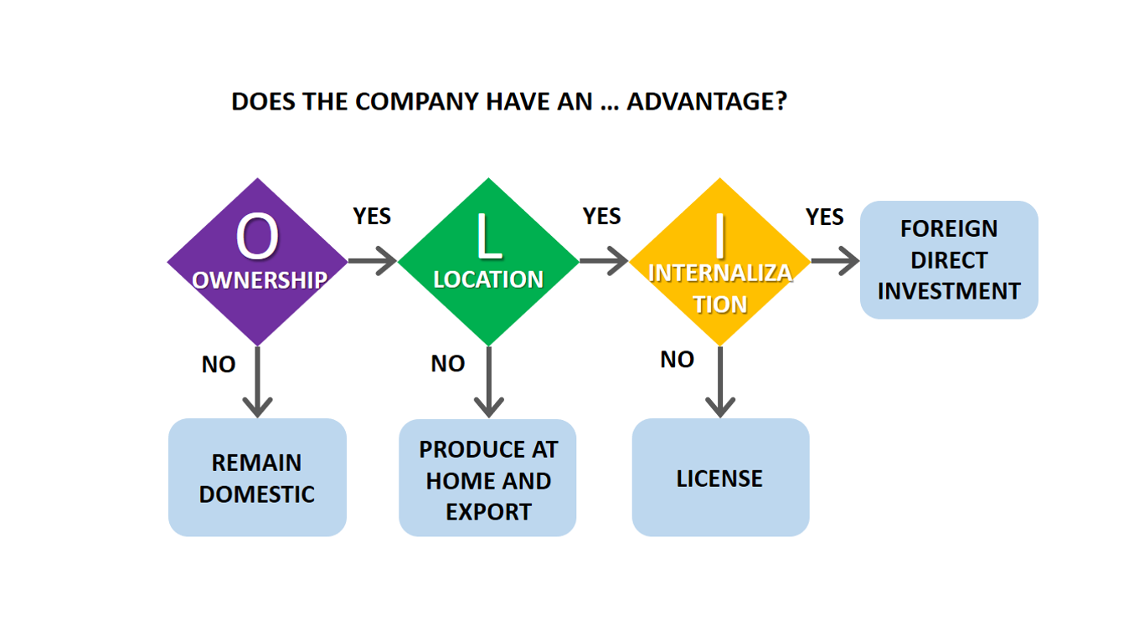
Figure 6: OLI Analysis
Source: (Llaneza, Lorda and Canal, 2021)

3.1 Ownership Advantages (O)
BP has large ownership benefits that, in theory, allow it to conduct business via wholly owned subsidiaries (WOS) in the foreign market. It has a portfolio of proprietary technologies, including innovative refining processes and high-performance lubricants, EV-charging designs and digital fleet-management systems, which create a very strong competitive moat and enable the global transfer of high-end capabilities (Llaneza, Lorda and Canal, 2021). The financial strength of BP is complemented by these technological assets, which allow investing in capital-intensive areas, including LNG terminals, mobility networks, and renewable-energy infrastructure. The fact that its brands are globally known, especially BP and Castrol, are also a boost to consumer confidence and helps the company penetrate the markets very easily (BP PLC, 2024). Additionally, BP enjoys the decades of managerial experience gained as a result of running complex upstream and downstream projects in politically diverse areas.
Theoretically, these ownership advantages would be favourable to the high-control entry mode, i.e. the WOS, because internalisation of operations would maximise the capability of BP to safeguard the knowledge-based assets and enhance consistency of safety, quality and standards of operation. There are, however, great constraints to the viability of complete ownership presented by the practical realities of the institutional environment in India (Booyse and Scheepers, 2024). The energy industry of India is being typified by a complex regulatory process, the existence of the state-owned enterprises (SOE), an intricate licensing process and political sensitivity of foreign ownership of strategic assets. As a result, the huge ownership benefits of BP, albeit a theoretically conducive venture within WOS, are focused in a joint venture (JV) format, which responds to the regulatory and market environment in India.

3.2 Location Advantages (L)
India is the third largest energy consumer, its usage is 39.02 EJ and demand is expected to increase at 6-6.5% per year owing to population increase, urbanisation and industrialisation (Nazzal, Sánchez-Rebull and Niñerola, 2025). Its lubricants business alone will grow alone of US $4.8 billion (2025) to US $6.6 billion by 2032, due to growing mobility demands (Biswanath Behera et al., 2024). These trends generate significant location advantages to BP in fuels, lubricants, as well as EV-charging infrastructure. The National Electric Mobility Mission Plan (NEMMP), ethanol-blending requirements, and incentives on investment in renewable energy support the attractiveness of India as a market partner in the long run-in regard to integrated energy solutions (BP PLC, 2024). The demographic setup of India also increases the opportunity landscape of BP. The presence of a high number of trained engineers and technicians, and IT specialists provides operational capacity at relatively low cost, and therefore BP can downsize the operations in the downstream and mobility operations effectively (Nazzal, Sánchez-Rebull and Niñerola, 2025). Furthermore, India is increasingly becoming digital, which can enable the way of integration of technology-based services, including smart-charging systems and online customer interfaces.
Nevertheless, these benefits are accompanied by major limitations. The regulatory conditions of India, especially in the energy distribution, fuel prices, infrastructure licensing and environmental procedures, are complex, multilayered and prone to political variation. The regional differences in the implementation of policies, the difficulties in the acquisition of lands, and the bureaucratic disintegration make the establishment of the completely-owned operations difficult (Nazzal, Sánchez-Rebull and Niñerola, 2025). As a result, despite the good location benefits, India, regulatory uncertainty and institutional opaque reduce the capacity of BP to internalise its operations. This market potential/governance complexity conflict eventually drives BP to collaborative forms like the joint venture with Reliance that offers local embeddedness and regulatory navigation capability.

3.3 Internalisation Advantages (I)
According to the internalisation theory, high-control entry mode is suitable as predicted by firms like BP to protect proprietary technologies, ensure operational coherence and reduce transaction costs. The portfolio held by BP is made up of sensitive technological resources, such as refining algorithms, EV-charging systems, digital route-optimisation tools, and sophisticated lubricant formulations (Choi, Velez‐Calle and Contractor, 2025). It might be exposed to imitation or a lack of expertise in case they are transferred via market-based contracts. By bringing such assets under the control of the firm, the same would provide greater security, reduce risks related to opportunistic behaviour shown by external partners, and make it easier to stabilise the global safety and operational standards. Moreover, internalisation plays an essential role in the energy industry, where the risks of operations are highly dangerous and the level of regulatory inspection is high. In the past, BP has embraced the use of integrated control systems in order to control the intricate supply chains, thus maintaining the uniformity of safety controls, environmental controls, and risk-management controls (Ozalp et al., 2022). In addition, the transaction costs relating to contract negotiation, performance monitoring, and compliance enforcement in multiple external providers may also be high in the emerging markets with institutional weaknesses.
Although it has these high internalisation benefits, the institutional situation in India constrains the capacity of BP to fully adopt high-control entry modes. The processes of energy retail, fuel distribution and mobility infrastructure development demand regulatory approvals, local land coordination, and stakeholder engagement procedures which cannot be easily absorbed by a foreign entrant (Lee and Wen, 2025). The legitimacy in the Indian market requires conformity to the local norms, relations with the governmental agencies, and an acquaintance with the informal governance systems. Therefore, the internalisation advantages of BP are associated with the control, whereas in India, the institutional complexity requires a collaborative entry structure, which is a strategic trade-off between the internalisation requirements and the benefits of a local partnership.

3.4 OLI (Final Entry Mode Choice: JV with Reliance)
The synthesis of ownership, location, and internalisation factors highlights the reason why a joint venture with Reliance was the best entry mode of BP in India. WOS structure would apparently be supported by the strong ownership benefits of BP, which comprise technological leadership, financial capacity and global branding (Li and Gao, 2022). However, location-based institutional constraints, the fragmentation of a retail fuel market and regulatory obscurity of India limit the viability of full ownership. Dependence provides comprehensive domestic resources such as refinery integration, distribution systems, regulatory experience, as well as consumer access, thus supplementing the resources of BP and increasing market fit.
The joint venture gives BP some vital advantages: direct entry to the market, rapid expansion of retail business, a robust political legitimacy, and decreased capital expenditure through collective investment (BP PLC, 2024). It further allows BP to customise its technologies and business models to fit the infrastructure and consumer behaviour in India by using the local knowledge of Reliance. At the same time, the internalisation requirements of BP are partially fulfilled with the structured systems of governance in the joint venture, institutionalising the global safety and operational standards and permitting the required localisation.
Nevertheless, contradictions are also presented in the joint-venture model. Whereas OLI theory postulates that high internalisation levels and ownership are expected to result in high levels of control, institutional pressure prevails over theoretical consumption in India (Montiel et al., 2021). The joint venture in itself reduces the independence of BP, makes SOP standardisation difficult, and makes it difficult to have a consistent execution of global protocols. However, the strategic compromise made by OLI, that is, balancing the capabilities of BP and the situation inside India, makes the joint venture the most feasible and coherent entry mode towards long-term success.

4. Cultural Differences and Their Impact on BP’s India Strategy

4.1 Hofstede Comparative Table (UK vs India)
Dimension | UK Score | India Score | Strategic Implication
Power Distance | 35 | 77 | India’s hierarchical norms require structured authority and local leadership.
Individualism | 89 | 48 | UK autonomy contrasts with India’s collectivist expectations in teams and partnerships.
Uncertainty Avoidance | 35 | 40 | Both cultures tolerate ambiguity, aiding adaptive strategies.
Masculinity | 66 | 56 | Competitive orientation aligns but differs in expression of achievement.
Long-Term Orientation | 51 | 51 | Similar future orientation enables strategic alignment.
Indulgence | 69 | 26 | UK’s openness contrasts with India’s restraint, affecting consumer and employee behaviour.

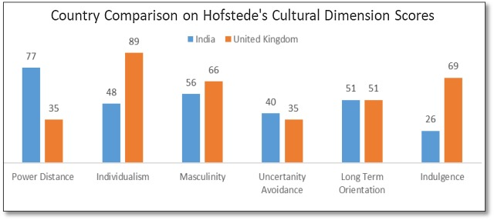
Figure 7: Country Comparison on Hofstede's Cultural Dimension
Source: (Zreik, 2023)

4.2 Critical Interpretation of Scores
The drastic difference in Power Distance (UK 35 and India 77) reveals that the Indian organisational culture traditionally accepts the hierarchy, authoritative positions, and centralised decision-making. Therefore, to BP, a UK-type of flat organisation, empowered decision-making rights and informal communication systems might not be well received in India (Zreik, 2023). Indian workers will most likely require direction, dictatorship in leadership and formalisation. This disparity impacts cooperation, assignment, and the worsening of the struggles in the joint venture.
The Individualism-Collectivism difference (UK 89 and India 48) reflects opposite assumptions with respect to autonomy, teamwork, and loyalty. Whereas UK operations focus on personal responsibility and autonomy in solving problems, the teams in India prefer to operate in a group and are relationship-oriented (Zreik, 2023). This cultural gap affects project management, performance checks and rewards in the Indian operation of BP.
Compared to the UK (35), the country with a score of 40 and above indicates that the country does not fear ambiguous regulations and accommodative behaviours, which is why the level of Uncertainty Avoidance is relatively similar in the UK and India (Zreik, 2023). This fit contributes to the experimental mobility efforts and the propositions of charging electric vehicles at BP.
They have an identical score in Long-Term Orientation (51 versus 51), and it means that they share the ability to be strategically patient (Shrimali, 2021). The alignment supports the India-focused renewable and mobility programmes of BP, which require long-term investment commitments.
The significant difference in Indulgence (UK 69 against India 26) highlights the dissimilarity in consumer preferences, safety behaviours, as well as organisational communication (Shrimali, 2021). The Indian culture is restrained, requiring discipline and obedience, as well as conservative messages, which should be considered when developing the brand communication and internal policies of BP.
Even though the Hofstede model provides general advice, it simplifies sophisticated socio-cultural forces and needs to be applied to the multi-layered and heterogeneous Indian energy industry.

4.3 Implications for Market Entry Strategy
The cultural variance has a massive impact on the mode of entry and consequent strategic alignment of BP in India. Power-distance norms are high, which predetermine the manner of negotiations; Indian counterparts appreciate the role of senior levels, etiquette, and respect to senior people (Shrimali, 2021). UK-oriented, efficiency-focused negotiations can seem abrupt or too transactional in the Indian context, and, as a result, BP will have to adjust to the relationship-oriented engagement techniques.
It is also important in trust-building. The collectivist setting of India assumes the importance of the long-term relationships between people instead of formalism in the contract. BP is then required to send local managers to build relational capital with the government agencies, suppliers and major distributors (Batschauer da Cruz, Eliete Floriani and Amal, 2022). This is a cultural requirement that reinforces the justification of a joint venture of BP with Reliance, where the local networks will build instant trust and legitimacy. Joint-venture governance is also a complex that is compounded by cultural distance (Choi, Velez‐Calle and Contractor, 2025). Managers in the UK can expect open channels of escalation, decentralised decision making, but Indian associates might value respect for authority and decisions based on situations. Mismatch of expectations can lead to stalling or stifling of operational decisions, procurement approvals and project roll-out.
The difference also has an impact on the alignment between headquarters and subsidiaries. UK headquarters can emphasise global standardisation and compliance, whereas the situation on the Indian market requires situational flexibility because of regulatory ambiguity and market fragmentation (Ashraf, Doytch and Uctum, 2021). These conflicting priorities can only be harmonised through adaptive standard operating procedure design.
Lastly, the supplier and contractor management structures are influenced by the cultural norms, which is a major concern in the Indian market that is dominated by fragmented fuel retail and mobility infrastructure (Booyse and Scheepers, 2024). Relational contracting, informal communication and flexible schedules are common in local contractors and require further oversight mechanisms by BP to be culturally sensitive.

4.4 Implications for BP’s Operational Success
The cultural dynamics have had deeper operational implications on the BP operations in India, especially related to the operation in safety-sensitive industries. The power distance in India is an issue that might prevent upward safety communication since employees might have a fear of reporting near-misses or confronting supervisors (Booyse and Scheepers, 2024). The safety ownership systems that are UK-style are not sustainable without support mechanisms that have a cultural aspect to them. BP should thus institutionalise the anonymous reporting structures, safety training with culturally applicable illustrations and enable the Indian supervisors of the middle level to become the safety ambassadors.
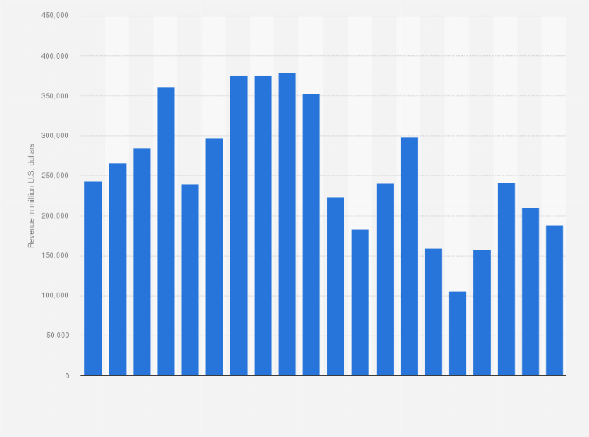
Figure 8: BP: Revenue 2024
Source: (BP PLC, 2024)
The styles of communication are different. UK direct and explicit communication is opposed to Indian indirect communication, which relies more on context. Misunderstandings may be experienced with regard to deadlines, quality expectations, risk disclosure, or protocols regarding escalation (Adedoyin et al., 2023). The successful work of the company needs BP to use bilingual communication, state the expectations clearly, and train the UK and Indian teams in cross-cultural pragmatics.
Expectations of leadership are also different. The directive leadership style, focused instructions and more pronounced management control are better able to attract the Indian employees, but the UK managers tend to emphasise empowerment and autonomy (Lee, Hayakawa and Park, 2023). This gap has an effect on talent management, delegation and performance evaluation. BP needs to re-tune the leadership development programmes to achieve a balance between authority and transparency.
Collectivist norms influence workforce motivation. Indian workers treasure team spirit, job stability, as well as acknowledgement by status symbols and interpersonal management. Things that will motivate Indian teams in the UK might not be effective in incentive systems (Llaneza, Lorda and Canal, 2021). BP needs to incorporate group-based rewards, formal career ladders, and authoritative culture-sensitive appreciation programmes.
The customer behaviour is also very different. Reliability, affordability, and brand reputation are more important values in the minds of Indian value-sensitive consumers as compared to premium positioning. This will require BP to localise product bundling, pricing, and brand communication, especially of electric vehicle charging services and Castrol products, to local expectations (Llaneza, Lorda and Canal, 2021). Knowledge of these behavioural nuances enhances the capacity of BP to attain sustainable performance of operations.

4.5 Limitations of Cultural Frameworks
Despite the generalised broad comparative information, Hofstede is constrained by its generalisation on a national level, outdated sampling and failure to represent the internal cultural diversity of India. It generalises regional, generational and sector-specific differences that directly determine the work of the energy sector (Barua and Aziz, 2022). Supportive frameworks like the GLOBE Study and Institutional Theory can give a more profound understanding of the leadership behaviours, societal behaviour, and the forces of regulation. By incorporating these views, BP can come up with a cross-cultural approach that is more contextual and analytically sound.

5. SOP Adjustments Required for BP in India

5.1 SOP Adjustment 1: Localised Operational Risk & Safety Governance
Problem: There are serious safety and operational risks faced in BP’s India operations due to infrastructure variability, inconsistent application of regulatory standards and a fragmented contractor ecosystem. Differences between states, such as fuel-station facilities to the presence of EV-chargers, contribute to the execution risk (Alinasab et al., 2025). High rates of accidents in the energy and construction industries in India also intensify the ability of BP to have homogeneous global safety standards.
OLI/Cultural Insight: The theory of internalisation suggests that BP needs high control to guarantee compliance with proprietary technologies and safety. Nevertheless, the complexity of the Indian institutions makes it difficult to exercise direct control, especially with the third-party contractors and state agencies. Indians have high power distance, which intensifies safety-escalation problems: employee frontline workers can be reluctant to criticise authority or disclose near-misses (Montiel et al., 2021). The results of Hofstede show that the risk disclosure may be hindered by the hierarchical norms and indirect means of communication, which reduce the potential of BP to detect and control the hazards in the initial stage.
SOP Adjustment: BP must also introduce a localised Operational Risk & Safety Governance standard operating procedure that standardises safety processes and also takes the infrastructural realities of India into consideration. The four elements included in the SOP have to be:
Digital safety monitoring tools
India-specific safety measures based on the difference in infrastructure
Stronger contractor pre-qualification requirements
Behaviour-based safety (BBS) programmes with the aim of around the obstacles of the culture in escalation.
Implementation Plan: BP must install digital observation systems, such as IoT-powered sensors, mobile safety-reporting applications, and a predictive-risk dashboard, to identify irregularities at the fuel stations, logistics routes, and EV-charging stations. The India-specific protocols should include the local risk evaluation and adapt to the road conditions, electricity infrastructure, and weather differences (Clemente and Wei, 2024). The areas that should be improved to control contracts include strict safety audits, compulsory training, and performance-based contracting. In order to defy the high power-distance cultural beliefs, BP must establish anonymous reporting mechanisms, safety ambassadors, and mid-level local safety champions who are trained to cut across the UK and India cultural communication style.
Expected Impact: The SOP will decrease operational accidents, reinforce BP to operate with a license as well and boost reliability in compliance in the heterogeneous Indian environment. Digital monitoring provides early-warning facilities, whereas culturally adjusted BBS programmes help employees express safety grievances more assertively (Nazzal, Sánchez-Rebull and Niñerola, 2025). Enhanced contractor oversight enhances the quality of execution in retail, mobility and supply-chain business processes.
Risks: Excessive dependence on digital systems can lead to adoption challenges in the low-infrastructure regions. Cultural barriers can be hard to overcome, even after training, and contractors might be reluctant to be subjected to a more stringent audit (Lee and Wen, 2025). Too much localisation may result in global standardisation being watered down unless closely aligned with the headquarters.

5.2 SOP Adjustment 2: Cross-Cultural HR & Leadership Integration
Problem: The Indian workplace expectations are not completely aligned with the BP systems of HR and leadership, which are centralised in the UK. The inevitable disparities in the hierarchy, communication standards, motivation motives, and performance appraisal practices establish disparity between BP’s global systems and the performance expectations of local employees. BP and Reliance will have conflicting styles in the JV that slows down the speed of decision-making and cause a lack of clarity in terms of authority.

OLI/Cultural Insight: In terms of internalisation, BPs’ global HR systems are control systems, which ensure safety practices and organisational culture, as well as standards of managerial practices. But the cultural differences need to be adapted in order to sustain engagement and performance. Indians have a low degree of individualism (48), implying that team harmony and the reputation of the supervisor play a large role in motivating people (Mahbub et al., 2022). Power distance is high, and these expectations strengthen the directive leadership and formal communication. The conflict between UK standards - low power distance, high individualism generates conflict in the leadership behaviour and performance systems.

SOP Adjustment: The BP needs to adopt a Cross-cultural HR and Leadership Integration SOP, which demands that leadership practices be localised at the cost of global performance standards. The SOP should include:
A restructured leadership development programme that encompasses the Indian cultural expectations (Nomani, Rithi and Negi, 2025).
Localised communication conventions in directness versus the sensitivity of context;
A re-organised system of grievance-management adjusted to the norms of hierarchical life;
Reward alignment with team-based compensation, status-recognition policies and defined career-advancement strategies (Nomani, Rithi and Negi, 2025).

Implementation Plan: The leadership training must be restructured to incorporate cases on Indian workplace psychology, indirect communication and relationship-based management. To balance expectations in the JV, BP ought to use cross-cultural coaching for expatriates based in the UK and the Indian managers. The performance-management systems should embrace hybrid outlooks in their evaluation techniques by balancing between the individual KPIs and the team performance (Biswanath Behera et al., 2024). Confidential reporting and peer support structures, as well as local ombudsman roles, should be accommodated in the grievance channels to overcome the hesitation to escalate. The reward systems must include visible rewards, training, and stability-based rewards in line with the Indian preferences.

Expected Impact: A more appropriate cultural fit will lead to a decrease in friction among managers, higher levels of employee engagement, and an increase in leadership credibility. JV governance process will be easier, the decision rights are well established, and the miscommunication is minimised. The retention of local talent will enhance, and it will increase the capacity of BP to scale the mobility, retail, and EV-charging operations.

Risks: Overlocalisation will undermine global HR uniformity. Although cultural training might not be adequate in eradicating implicit biases (Li and Gao, 2022). The performance-management principles may vary between the JV partners, which means that the negotiation should be done continuously.

5.3 SOP Adjustment 3: Localised Supply Chain & Market Adaptation
Problem: The fuel, lubricant and mobility markets in India are very fragmented, with price elasticity and high players in the market who are state-owned companies (IOC, HPCL, BPCL) (Ozalp et al., 2022). EV-charging and mobility infrastructure development is also largely different in various regions and hinders the planning of a supply chain and customer-experience design of BP.
OLI/Cultural Insight: The location benefits, such as high market size, access to skilled labour and opportunity to grow, are favourable to the entry of BP. Institutional complexity and cultural demands, however, demand that there be operational localisation in order to capture demand (Ozalp et al., 2022). The internalisation theory implies that BP has to manage quality and technology transfer, whereas the practice realities require BP to heavily collaborate with the local vendors, distributors, and contractors (BP PLC, 2024). The cultural knowledge points out that the collectivism and relationship-based contracting of India affect the supply-chain negotiations and the vendor governance.
SOP Adjustment: BP must launch a Localised Supply Chain & Market Adaptation SOP which includes: (1) region-specific sourcing policies; (2) intensive vendor-risk management policies which are culturally-appropriate to India's fragmented contractor community; (3) culturally-adapted marketing and customer-engagement models; and (4) localised EV-charging infrastructure standards that reflect India's urban heterogeneity.
Implementation Plan: BP should also create a regional cluster of suppliers to eliminate reliance on centralised imports, as well as to become cost-effective in market responsiveness. The assessment of the vendors must include capacity audits, safety compliance checks, and relationship-management processes that adhere to the local negotiation norms (Zreik, 2023). The marketing strategies should have to be adjusted to the Indian scene and ensure value, reliability and community trust as opposed to pure positioning of the product as a premium product. EV-charging infrastructure rollouts should take into account local power supply, land use limitations, and demand of demand.
Expected Impact: An enhanced localisation strategy will increase the competitiveness of BP, supply reliability and customer value propositions in Indian customer preferences. Individual EV infrastructure design will empower market uptake and bolster the BP long-term mobility strategy (Shrimali, 2021).

Risks: Local sourcing exposes the organisation to the variability in the performance of the vendor. Global brand identity may be watered down due to over-adaptation. Without strong governance, regional disparities might arise (Shrimali, 2021).

6. Conclusion
The move and growth of BPs in India exemplifies the complex relationship between international business strategy and global capabilities and host-country realities. As it is shown through the analysis, strong ownership benefits of BP, such as technological knowledge, financial resources, and a global brand name, can make the company achieve long-term growth, but institutional complexity, cultural distance, and regulatory fragmentation in India make high-control entry modes unachievable (Clemente and Wei, 2024). The joint venture with Reliance is therefore a strategic, consistent compromise between internalisation requirements and location specifics. The hierarchies, communication, and workforce expectations in different cultures have a great impact on leadership behaviour, coordination and safety practices in operations, hence the need to have adaptive management (Li and Gao, 2022). The suggested changes in the SOP, i.e., the localised safety governance, cross-cultural HR integration, and supply-chain localisation, contribute to achieving more alignment of BP with the market environment in India. All in all, the ability of BPs to compete in India in the future lies in the successful reconciliation of global standardisation with localised localisation in order to find its way through the fast-moving energy and mobility environment.

References
Adedoyin, F.F. et al. (2023) ‘Energy policy simulation in times of crisis: Revisiting the impact of renewable and non-renewable energy production on environmental quality in Germany’, Energy Reports, 9, pp. 4749–4762. Available at: https://doi.org/10.1016/j.egyr.2023.03.120.
Alinasab, J. et al. (2025) ‘Small firms’ foreign market entry framework: rational and cognitive perspectives’, International Marketing Review, 42(2-3). Available at: https://doi.org/10.1108/imr-08-2023-0204.
Ashraf, A., Doytch, N. and Uctum, M. (2021) ‘Foreign direct investment and the environment: disentangling the impact of greenfield investment and merger and acquisition sales’, Sustainability Accounting, Management and Policy Journal, 12(1), pp. 51–73. Available at: https://doi.org/10.1108/sampj-04-2019-0184.
Barua, S. and Aziz, S. (2022) ‘Making green finance work for the sustainable energy transition in emerging economies’, Energy-Growth Nexus in an Era of Globalization, pp. 353–382. Available at: https://doi.org/10.1016/b978-0-12-824440-1.00014-x.
Batschauer da Cruz, C.B., Eliete Floriani, D. and Amal, M. (2022) ‘The OLI Paradigm as a Comprehensive Model of FDI determinants: a sub-national Approach’, International Journal of Emerging Markets, 17(1). Available at: https://doi.org/10.1108/IJOEM-07-2019-0517.
Biswanath Behera et al. (2024) ‘A blend of renewable and non-renewable energy consumption on economic growth of India: The role of disaggregate energy sources’, Environmental science and pollution research international, 31(3), pp. 3902–3916. Available at: https://doi.org/10.1007/s11356-023-31372-0.
Booyse, D. and Scheepers, C.B. (2024) ‘Barriers to adopting automated organisational decision-making through the use of artificial intelligence’, Management research review, 47(1). Available at: https://doi.org/10.1108/mrr-09-2021-0701.
BP PLC (2024) Annual report 2024, BP Global. BP Global. Available at: https://www.bp.com/content/dam/bp/business-sites/en/global/corporate/pdfs/investors/bp-annual-report-and-form-20f-2024.pdf (Accessed: 18 November 2025).
Choi, J., Velez‐Calle, A. and Contractor, F. (2025) ‘International Joint Venture Governance Mechanisms: The Role of Institutional Environment on Contract Design’, Corporate governance, 33(3). Available at: https://doi.org/10.1111/corg.12605.
Clemente, R. and Wei, J. (2024) ‘Investigating factors to promote energy: Socio-political barriers to renewable energy sector in India’, The Electricity Journal, 37(2), pp. 107366–107366. Available at: https://doi.org/10.1016/j.tej.2024.107366.
Lee, C.-C. and Wen, H. (2025) ‘Global value chain embedding and enterprise energy efficiency: A worldwide firm-level analysis’, Renewable and Sustainable Energy Reviews, 207. Available at: https://doi.org/10.1016/j.rser.2024.114955.
Lee, H.-H., Hayakawa, K. and Park, C.-Y. (2023) ‘The Effect of COVID-19 on Foreign Direct Investment’, Global Economic Review, 52(1), pp. 1–17. Available at: https://doi.org/10.1080/1226508x.2023.2171459.
Li, M. and Gao, X. (2022) ‘Implementation of enterprises’ green technology innovation under market-based environmental regulation: An evolutionary game approach’, Journal of Environmental Management, 308, p. 114570. Available at: https://doi.org/10.1016/j.jenvman.2022.114570.
Llaneza, A.V., Lorda, P.S. and Canal, E.G. (2021) ‘Entry mode choice in emerging markets: is there any difference between emerging and developed country multinationals’, European J. of International Management, 15(4), p. 539. Available at: https://doi.org/10.1504/ejim.2021.114627.
Mahbub, T. et al. (2022) ‘Factors encouraging foreign direct investment (FDI) in the wind and solar energy sector in an emerging country’, Energy Strategy Reviews, 41(1), p. 100865. Available at: https://doi.org/10.1016/j.esr.2022.100865.
Montiel, I. et al. (2021) ‘Implementing the United Nations’ Sustainable Development Goals in international business’, Journal of International Business Studies, 52(5), pp. 999–1030. Available at: https://pmc.ncbi.nlm.nih.gov/articles/PMC8144281/.
Nazzal, A., Sánchez-Rebull, M.-V. and Niñerola, A. (2025) ‘Foreign direct investment by multinational corporations in emerging economies: a comprehensive bibliometric analysis’, International Journal of Emerging Markets, 20(13). Available at: https://www.emerald.com/insight/content/doi/10.1108/ijoem-12-2021-1878/full/html.
Nomani, A., Rithi, S.R. and Negi, R. (2025) ‘Mapping the Foreign Investments (OFDI) From Emerging Economies Toward Developed Nations: A Consequential Convergence of Investment Outflows and the OLI Paradigm’, Thunderbird International Business Review, 64(4). Available at: https://doi.org/10.1002/tie.22435.
Ozalp, H. et al. (2022) ‘“Digital Colonization” of Highly Regulated Industries: An Analysis of Big Tech Platforms’ Entry into Health Care and Education’, California Management Review, 64(4), p. 000812562210943. Available at: https://doi.org/10.1177/00081256221094307.
Shrimali, G. (2021) ‘Financial Performance of Renewable and Fossil Power Sources in India’, Sustainability, 13(5), p. 2573. Available at: https://doi.org/10.3390/su13052573.
Zreik, M. (2023) ‘Analytical study on Foreign Direct Investment Divestment Inflows and Outflows in Developing Economies: Evidence of China’, The Chinese Economy, 56(6), pp. 1–16. Available at: https://doi.org/10.1080/10971475.2023.2193118.

