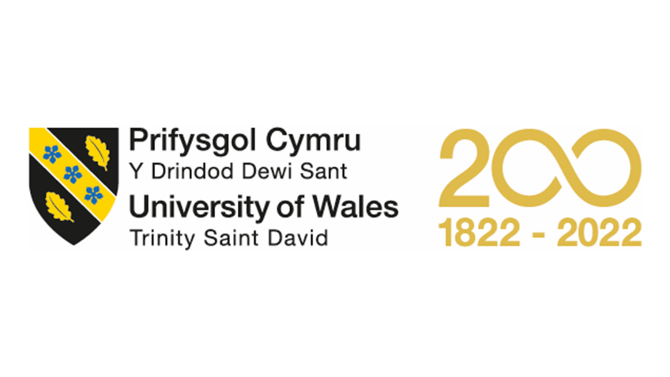

Assignment Title: Task 3 and 4 Reflective Journal
Module Name: Skills Development in the Workplace
Module Code: ACMA4031
Program of Study: Foundation Year (Computing and Electronics)
Student Name: Andrea Vargova
Student ID #: 2127239
Lecturer Name: Dr. Moutushi Tanha

Task 3: Mobilising Support
Topic 4: Be In It To Win It
Reflective Journal
I have selected the topic from task 3 is Be In IT to Win It with the aim to gain understanding of the value of marketing using the suitable channels such as, social media. The topic has 3 parts, navigating social media, developing your professional persona and LinkedIn, the professional network. The topic is linked to the task 3 mobilising support and reason for selection of this topic is to identify how the new ways give benefits to marketing. I have also given the reflection that what is learned from this topic and how it will impact on my professional career.
The first part discusses the use of social media and its different usage. The advancement of internet gave birth to different applications and social media sites are one of them. In the globe, human has been connected to each other since the advancement of technologies but never get closer as social media did very recently. The device smartphone is actually working as a switchboard opens different connections globally. In general, all of us are users of social media and our personal identity becomes more powerful with the use of social media features, such as, Facebook, WhatsApp and YouTube channels.
In the part 1, Teresa Heath-Wareing's video highlights the transformative role of social media in marketing (TEDx Talks, 2018). With 2.47 billion users, it connects people globally and opens doors for businesses. Social media enhances communication, enables users to share experiences, and helps companies target potential customers. It also aids research and research, as students discuss career opportunities in social groups. Viral marketing, where people create profiles on social media tools, generates millions of views.
In the navigating social media, students were asked to answer which social media they use, why they use and what benefits it give according to their profession. I am a student I have mentioned in my post on the Task 3 Forum (Appendix 1) that I use Facebook, WhatsApp, YouTube, LinkedIn, etc. I have also mentioned which social media tools I will consider and which tools I will avoid with the reasons. Personally, I have found social media very useful to my studies and I feel connected to the latest information spread all over the world.
Part 2 focuses on developing a professional persona to effectively characterize in online and face-to-face spaces. Nicola Osborne highlights the importance of digital footprints on social media, suggesting leaving positive digital footprints (TEDx Talks, 2016). To maintain a professional persona, it is recommended to keep personal and professional profiles separate, delete irrelevant posts or photos, and review privacy settings. Tips for online personal include making a good impression, keeping up-to-date information, starting conversations in relevant groups, and creating a simple portfolio.
The discussion on developing a professional persona further leads to branding own self. Peters (1999) stated that we are all brands and we have to invest in ourselves through improving our intellect which get marketed. The statement is justifiable because many intellectuals, celebrities, and personnel have their own face value as a brand. A video is shared discussing brand characteristics with the example that bad impression lasts for longer and someone behaved immorally at first will be considered again wrong besides trying to do something good (TED-Ed, 2013). Therefore, leaving the first impression in positive sense is a key for success.
Part 3 of the unit focuses on creating a powerful LinkedIn profile, a reputable social networking site that connects people from various occupations, shares professional views, and offers job opportunities. Ortiz (2022) suggests writing in first-person narrative, using short-concise paragraphs, highlighting work experience, using bullets for skills, and applying visibility settings. LinkedIn has the potential to connect people with positive change, even those with disabilities or issues, who excel under its umbrella.
Conclusion:
In summary, I feel that this topic was much needed to me because I am an active user of social media but I was not properly aware of its benefits to my professional career. I properly understood about digital id footprints as it gives long lasting impression to others. I had a profile on LinkedIn but it was not so professional and the tips I have received from this unit helped me to upgrade my profile. Overall, this topic reflected me professionally and gave me a visionary approach to see the digital world as an opportunity for a career growth. I have decided to open my own consultancy firm after my graduation and for this purpose LinkedIn is a good platform to approach clients.

Task 4: Evaluation
Topic 2: Personal Evaluation
Reflective Journal:
I have selected the topic, Personal Evaluation from the task 4 and the reason is it provides me an opportunity to do self-evaluation how far I have learned in my previous units in this module. The topic is divided into three parts which are, your project success, you your project & others and success through teamwork. I will discuss the reflection I have received after studying this topic at the end.
The learning outcomes of the first part your project success is to evaluate the success of projects done in previous units. I would like to mention here as well, the skills I have developed studying this module which are, sustainability in my workplace, change making, collaboration, storytelling and use of social media (see Appendix 2). In the topic, the question is asked what success means to you. I have answered the question considering the success criteria that I have completed my tasks, it was about time, used the authentic necessary resources, satisfied the audience, and met the quality as expected.
The video from Project Parallel Training (2014) is shown in the differentiation of success criteria, success factor and Key Performance Indicator than the knowledge check appeared to remember the points said in the video. I have answered correctly and in the Appendix 3 it is given below. I have developed idea to open my consultancy firm and for this purpose I have to make following arrangements. I will develop a professional profile using social media, use effective storytelling skills to attract clients, collaborate with other professionals in my network and maintain sustainability in my workplace.
The second part of the topic is evaluation of change maker idea based on own perception and impacts of idea’s campaign on others. An example of essay marking is used to identify ‘Your criteria vs. others’ that how see the success, marks received, comments in the feedback or personal satisfaction. I would answer feedback in the comments before studying this whole unit, but now I can say the personal satisfaction because I have done the job and received reflection through studying lessons for that essay.
An article is suggested Gaming and personal success by Klimmt et al. (2009). In this article, the relation between a game’s difficulty and success rate is highlighted showing the outcome as players enjoyed games because are task based give self-experience and competence. I have also evaluated my satisfaction level answering these questions which are, what makes me happy, what my personal values are and what is important to me. According to me, I get happy when I complete a task in a given time because it gives a feeling of satisfaction, my personal values are meeting the commitment and be honest to everyone, my inner peace is important to me.
The third part of this is to evaluate how successfully work with others. In order to work with others, I have evaluated myself through OCEAN test to know my personality traits. I have chosen Truity.com where answered questions and my score came in five major dimensions of personality which are, openness, conscientiousness, extraversion, agreeableness and neuroticism. I have scored 90% in openness, 79% in conscientiousness, 83% in both extraversion and agreeableness, and 29% in neuroticism. As per the test score, I feel confident that I am able to work with others successfully and in my previous work experience I was a cooperative team member.
Conclusion
The reflections I have received from this topic are multiple. The first part helped me to revise what I have done in previous tasks also the skills I have learned. The first part also assessed me about my success in previous project/ideas and I have found myself quite successful as I have done my tasks as per the requirements. Through learning this topic, I have rechecked my plan to open a consultancy firm after my graduation and I have evaluated my arrangements which I have found satisfactory.
Furthermore, this unit game me an opportunity to assess my satisfaction level which and I have realised I am more comfortable now compare to the time when I was starting this course. Besides developing the skills as discussed above, now I am able to work on projects and complete them in time. The OCEAN personality trait test helped to self-actualise my creative, intellectual, and social potential. In a bottom line, this whole module accelerated me towards new heights and gave me a vision to think out of the box.

References:
Klimmt, C., Blake, C., Hefner, D., Vorderer, P., and Roth, C. (2009) ‘Player Performance, Satisfaction, and Video Game Enjoyment’. ICEC 5709, pp. 1–12, 2009.
Ortiz, K. (2022) How Do I Create a Good LinkedIn Profile? Available at: https://www.linkedin.com/help/linkedin/answer/a554351 (Accessed: 02-Jul-2023)
Parallel Project Training, (2014) Project Success Criteria, Success Factors and KPIs. [Video] Available at: https://www.youtube.com/watch?v=64NKhNocgo0 (Accessed: 04-Jul-2023)
Peters, T. (1999) The Brand You 50 Fifty Ways to Transform Yourself from an “Employee” into a Brand That Shouts Distinction, Commitment, and Passion! USA: Knopf.
TED-Ed, (2013) Should you trust your first impression? - Peter Mende-Siedlecki. [Video]. Available at: https://www.youtube.com/watch?v=eK0NzsGRceg (Accessed: 03-Jul-2023)
TEDx Talk, (2018) How Social Media is changing the face of Marketing | Teresa Heath-Wareing | TEDxTelford. [Video] Available at: https://www.youtube.com/watch?v=ekPGf3QeBlE (Accessed: 02-Jul-2023)
TEDx Talk, (2016) What Do Your Digital Footprints Say About You? | Nicola Osborne | TEDxYouth@Manchester. [Video] Available at: https://www.youtube.com/watch?v=RVX8ZSAR4OY (Accessed: 02-Jul-2023)

Appendix 1
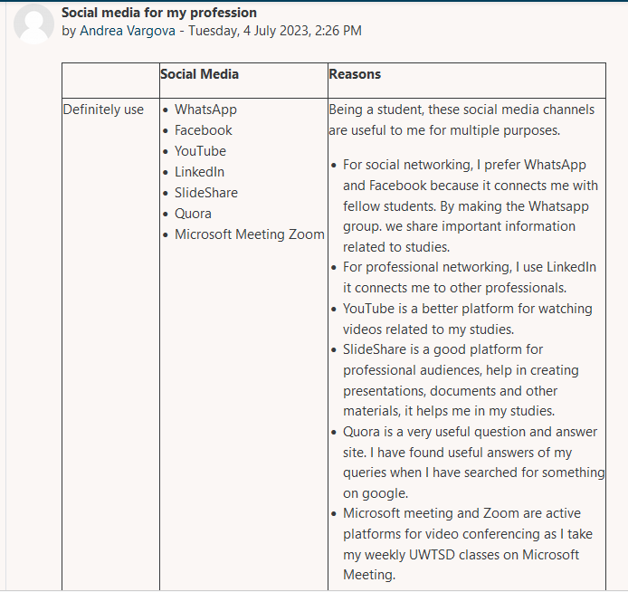

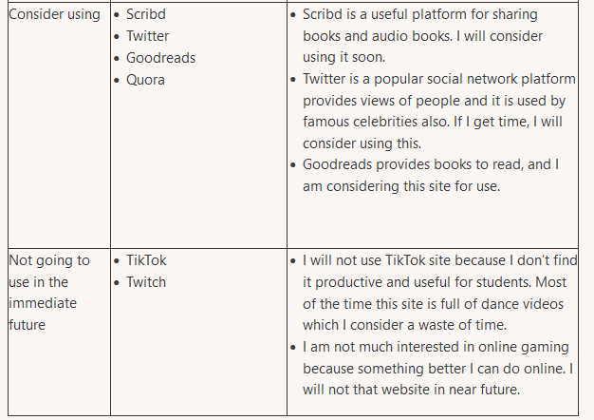
Appendix 2

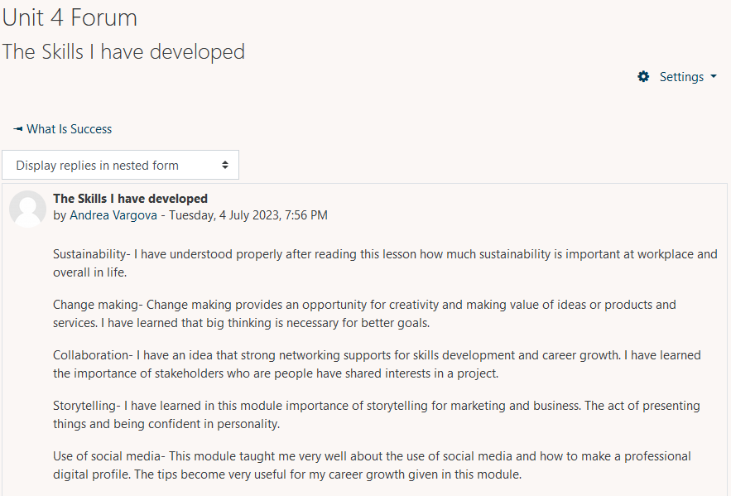
Appendix 3


