

Module: Developing and
Managing Individuals and Teams
Module code: LCLM5002

Student Name: Hasibull Khandeker
Student Id: 2423897
Teacher Name: Dr Doreen Nyaa Amundam (d.nyaa-amundam@uwtsd.ac.uk)

Table of Contents
1. Introduction 3
2. Key HR Factors Affecting Organisations 4
2.1 Technological Advancement 4
2.2 Talent Acquisition and Retention 4
2.3 Diversity, Equity and Inclusion (DEI) 4
3. Evaluation of Contemporary HR Practices 5
3.1 Practices for Technological Advancement 5
3.2 Practices for Talent Acquisition and Retention 6
3.3 Practices for Diversity, Equity and Inclusion 7
4. Critical Evaluation of Managerial Implementation 8
5. Conclusion 9
6. Reference List 11

1. Introduction
The modern organisation is in a more sophisticated human resource (HR) environment, influenced by a changing fast technology, more competition over talent, as well as mounting expectations on fair and inclusive workspaces. Ability of an organisation to successfully lead people is one of the most significant pre-conditions of long-term competitive advantage (Prikshat et al., 2023). This report discusses three main HR issues, namely, technological development, talent recruitment and retention, and diversity, equity and inclusion (DEI), and specifically the Tesco PLC, one of the largest employers in the United Kingdom, in the private sector. Tesco with more than 330, 000 staff members offering a variety of products in the UK serves as a case study relevant to the context and can be used to analyse the macro-HR trends and organisational reactions. The report illustrates that modern HR is changing with respect to these challenges although major implementation gaps continue to exist. The analysis should be able to provide a well-informed, fact-based assessment of HR issues, modern trends, and the management accountability.

2. Key HR Factors Affecting Organisations

2.1 Technological Advancement
The digitisation of HR processes may be regarded as a significant turn in the management of the people within the organisation. Recruitment and HR analytics is becoming more and more automated, using AI and necessary AR to improve decision-making (Prikshat et al., 2023). Indicatively, however, according to the CIPD (2024a), currently, 31 per cent of organisations in the UK recruit using AI with better efficiency results. This implies that integration of technology could be very beneficial in enhancing the effectiveness of HR. Nevertheless, one might say that they also create ethical issues with such systems. Hunkenschroer and Luetge (2022) emphasise that bias can be reproduced in AI-driven recruitment in case it is not effectively controlled. This risk is quite common in organisations such as Tesco because of diversity in the workforce. Hence, AIs implementation will probably increase organisational effectiveness, but their achievement will require ethical leadership and the development of HR capacity.

2.2 Talent Acquisition and Retention
Acquisition and retention of talents have been a major challenge to UK organisations in the competitive labour markets. According to CIPD (2024a), 69 per cent of companies are experiencing more competition in a search of skilled employees, and early turnover has been high. This implies that recruitment is not necessarily a guarantee of workforce stability. It might be implied that there is similarity of importance in the retention strategies to sustain organisational performance. According to Al Ariss, Cascio and Paauwe (2014), strategic HR entails attraction and development of the employees. Nevertheless, most organisations, such as Tesco, seem to be reactive. CIPD (2024a) also adds that little attention to the internal talent development undermines the retention results. Thus, there is a high probability that organisations that lack comprehensively developed retention models can face increased expenditures and loss of knowledge, especially in those industries that are characterised by a prominent turnover rate (CIPD, 2024b).

2.3 Diversity, Equity and Inclusion (DEI)
Diversity, Equity and Inclusion (DEI) can be viewed as one of the most important elements of contemporary HR approach. It includes policies that encourage equality, level playing, and inclusion in organisations. Its importance is reinforced in the UK by such structures as the Equality Act 2010. According to Shore et al. (2011), the issue of inclusion is complex based on belongingness and uniqueness. It means that DEI does not just serve as a compliance tool but rather is strategically important. Nevertheless, there is a possibility to state that it is taken in superficial terms most of the time. According to CIPD (2024a), there are still issues related to the attainment of diversity, especially in top positions. Besides, AI-driven recruitment can minimise and strengthen bias (Hunkenschroer and Luetge, 2022). Thus, although DEI initiatives have become commonplace, their success is probably to rely on authentic organisational dedication and leadership incorporation instead of the policy.

3. Evaluation of Contemporary HR Practices

3.1 Practices for Technological Advancement
The use of AI-enabled HR practise is becoming popular among organisations in the UK to deal with challenges in technological transformation. They are applicant tracking systems, predictive analytics, and digital learning platforms, which could be effective to improve efficiency in workforce planning and recruitment (Prikshat et al., 2023). Indicatively, Tesco has been using the data-driven tools in the scheduling and mobility of talents. According to the CIPD (2024a), over three-quarters (78) of organisations have increased their adoption of technology in the HR field, which indicates faster and more accurate hiring. It may be misconstrued though that practises like these add ethical complications. According to Hunkenschroer and Luetge, AI are of concern when it comes to transparency, privacy, and AI algorithm bias during recruitment (2022). Although AI might lead to the elimination of human bias, the use of AI will probably rely on its responsible use. In that way, the organisations should strike the right balance between efficiency benefits and ethical governance to achieve balanced and reproducible HR results (Office for National Statistics, 2024).
HR Technology Practice | Potential Benefit | Key Risk
AI-driven CV screening | AI enhances recruitment efficiency by automating applicant filtering and improving hiring decisions through data-driven insights (Prikshat et al., 2023). | Algorithmic bias may reinforce existing inequalities, potentially disadvantaging minority groups and undermining diversity (Shore et al., 2011).
Predictive workforce analytics | Enables proactive talent planning by forecasting turnover and skill needs, supporting strategic HR alignment in dynamic labour markets (Office for National Statistics, 2024). | Raises concerns over employee data privacy, surveillance, and potential misuse, which may reduce trust and create compliance risks (Prikshat et al., 2023).
Digital learning platforms | Facilitates scalability, continuous learning and supports workforce adaptability in evolving job environments (Tobback et al., 2023). | Unequal access and digital literacy gaps may widen skill disparities and negatively affect job satisfaction (Latifah et al., 2023).
HR Information Systems (HRIS) | Centralises HR processes and data, improving efficiency and enabling informed decision-making (Prikshat et al., 2023). | High implementation and maintenance costs, along with risks of system failure or data breaches, can disrupt operations.

3.2 Practices for Talent Acquisition and Retention
Talent acquisition and retention in contemporary HR practises have increasingly been pushed towards employer branding, flexible working and systematic career development (Tobback et al., 2023). According to the CIPD (2024a), 71% of employers in the UK that are providing work in hybrid forms have enhanced their talent attraction and retention capabilities, which indicates that flexibility can be used to enhance organisational competitiveness. Nevertheless, one might state that these practises do not apply everywhere. Al Ariss et al. (2014) assert that knowledgeable talent management requires a correlation of organisational targets with his or her goals, aided by the development and reward system. On top of that, there is an increased attention to internal mobility and learning programmes, and 56% of organisations pay more attention to in-house development (CIPD, 2024a). These strategies could improve retention in the long term in the case of Tesco. However, they are probably to be limited in direct personnel work where a flexible working arrangement is still unavailable (Al Ariss et al., 2014).
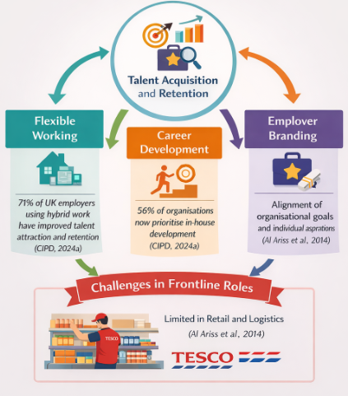
Figure 01: Practices for Talent Acquisition and Retention (Self Made)

3.3 Practices for Diversity, Equity and Inclusion
To meet regulatory as well as social expectations, organisations have adopted various practises of DEI, such as inclusive recruitment, bias training, and mentoring programmes. According to Shore et al. (2011), the concept of true inclusion presupposes that belongingness and uniqueness should coexist, meaning that diversity will not be enough to make any significant contribution to organisations. These strategies are seen in the efforts Tesco has made in addressing gender balance targets and gender pay gap reporting. Nevertheless, it may be implied that the efficiency of these types of practises is different at organisational levels. According to the CIPD (2024a), recruitment and retention of a diverse range of talent at high ranks remains challenging, and policy and practise seem to have a gap. What is more, Shore et al. (2011) also notes that the implementation of inclusive leadership is likely to become the major success factor. Thus, although DEI strategies are commonly applied, they can be less effective, but dependent on the behaviour of managers and organisational culture instead of formal policies in isolation (Latifah et al., 2023).
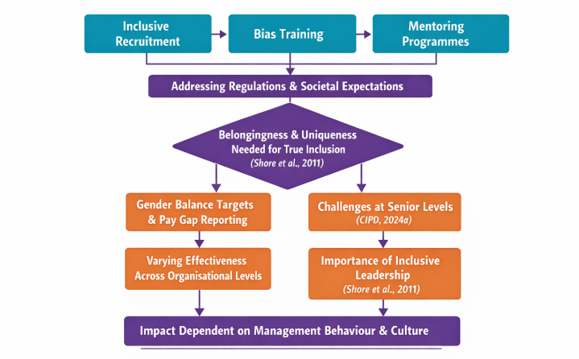
Figure 02: Practices for Diversity, Equity and Inclusion (Self Made)

4. Critical Evaluation of Managerial Implementation
The success of HR policies can strongly rely on the performance of the departmental managers. Arguably, an effective HR strategy can hardly work well without regular application by the managers. According to Lai et al. (2020), transformational leadership is very important in converting the HR practise into improved employee performance. The behaviours exhibited by managers like communication, engagement, and value alignment are likely to secure a successful implementation. This implies that the HR outcomes can be very much affected by the leadership style. It might be proposed, however, that not every manager has the availability of the required leadership competencies, which might restrict uniformity in practise among organisations (Karaca-Atik et al., 2023).
Structural complexity can make the implementation issues heavier in large organisations like Tesco (Khogali and Mekid, 2023). The presence of many store level managers may pose inequalities between policy and practise due to differences in HR knowledge and leadership capability. According to Prikshat et al. (2023), the implementation of AI-based HR systems implies the necessity of new managerial skills, especially in the field of data analysis and ethics supervision. Nevertheless, these skills might not be available to many frontline managers. This implies that technological progress cannot prevail on its own unless it is accompanied by investment on managerial capability. As such, implementation effectiveness can be a factor of system adoption and human expertise.
The different forms of resistance to change can be a major obstacle to successful implementation of HR. According to Hunkenschroer and Luetge (2022), it is possible that managers are not ready to embrace new HR technologies, especially when the pressure to operate may lead to shortcuts. This may nullify the desired gains of innovation. Likewise, Shore et al. (2011) believe that managers incompetent of creating inclusive environments can undermine DEI results. This implies that managerial attitudes will tend to affect the organisational culture unlike formal policies. Although accountability includes the use of KPI, which can help to decrease these problems, their performance might be determined by the degree of their incorporation into performance management systems (Lai et al., 2020).
The disparity between the intent and experience of the policy in terms of HR implementation is a critical issue. According to Al Ariss et al. (2014), poor managerial performance is one of the most frequent reasons behind ineffective talent management, and not the cause of bad strategy. This in Tesco can be manifested in different retention levels among stores. This further suggests that local practises of managing employees would most likely influence their experience. Consequently, one might claim that regular leadership development is needed. In the absence of it, HR policies can never bring the desired results, which validates the role of managerial capability as a core contributor of organisational success.

5. Conclusion
The report has explored three essential HR issues which contemporary UK organisations grapple with using Tesco PLC and they include technological advancement, talent acquisition and retention, and diversity, equity and inclusion. It is evident through the analysis that even though the current state of human resources practises in all these aspects has been changing, pursued by data-driven recruitment systems, flexible working arrangement, and equal opportunity employment frameworks, significant infrastructural obstacles to the process are still present. It is shown that HR strategies cannot be more effective than managers who operationalise them, and that the capability of transformational leadership is a decisive mediator whether policy will translate into any meaningful change in the organisation.
6. Recommendations
Following the above-realised analysis, the following recommendations are given to organisations like Tesco PLC:
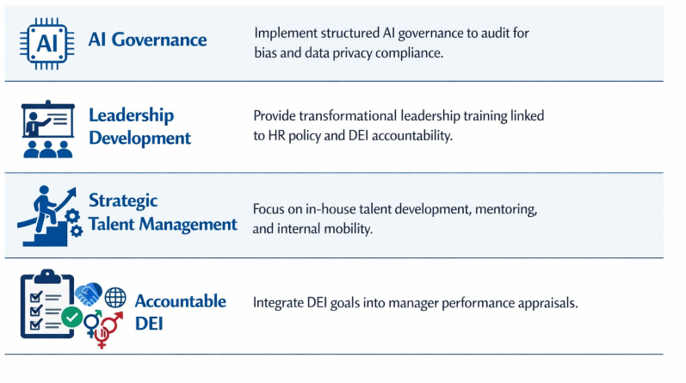
Figure 03: Recommendations for Tesco PLC (Self Made)
AI Governance: Establish organised AI governance systems to make sure that AI-based recruitment instruments are frequently reviewed to determine compliance with the algorithmic bias and data privacy measures.
Leadership Development: Require all managers to undergo transformation leadership development training with express connexions to HR policy implementation and DEI accountability.
Strategic Talent Management: Reactive recruitment to proactive in-house talent management, such as mentoring, internal promoting, skills-based career growth, etc., to minimise the costs of turnover and enhance the Employee Value Proposition.
Accountable DEI: Make DEI commitments count as part of the manager performance appraisal criteria in such a way that the inclusive leadership behaviour is not an informal or an aspirational virtue to be deployed sporadically but rather systematically incentivised and measured.

6. Reference List
Al Ariss, A., Cascio, W.F. and Paauwe, J. (2014) 'Talent management: Current theories and future research directions', Journal of World Business, 49(2), pp. 173–179.
CIPD (2024a) Resourcing and talent planning report 2024. London: Chartered Institute of Personnel and Development. Available at: https://www.cipd.org/globalassets/media/knowledge/knowledge-hub/reports/2024-pdfs/8662-resource-and-talent-planning-2024-report-web.pdf (Accessed: 24 March 2026).
CIPD (2024b) Benchmarking employee turnover: What are the latest trends and insights? London: Chartered Institute of Personnel and Development. Available at: https://www.cipd.org/uk/knowledge/reports/employee-turnover-trends (Accessed: 24 March 2026).
Hunkenschroer, A.L. and Luetge, C. (2022) 'Ethics of AI-enabled recruiting and selection: A review and research agenda', Journal of Business Ethics, 178(4), pp. 977–1007.
Karaca-Atik, A., Meeuwisse, M., Gorgievski, M. and Smeets, G., 2023. Uncovering important 21st-century skills for sustainable career development of social sciences graduates: a systematic review. Educational Research Review, p.100528.
Khogali, H.O. and Mekid, S., 2023. The blended future of automation and AI: Examining some long-term societal and ethical impact features. Technology in Society, 73, p.102232.
Lai, F.Y., Tang, H.C., Lu, S.C., Lee, Y.C. and Lin, C.C. (2020) 'Transformational leadership and job performance: The mediating role of work engagement', SAGE Open, 10(1), pp. 1–11.
Latifah, I.N., Suhendra, A.A. and Mufidah, I., 2023. Factors affecting job satisfaction and employee performance: a case study in an Indonesian sharia property companies. International Journal of Productivity and Performance Management.
Office for National Statistics (2024). Unemployment - Office for National Statistics. [online] ons.gov.uk. Available at: https://www.ons.gov.uk/employmentandlabourmarket/peoplenotinwork/unemployment (Accessed: 24 March 2026).
Prikshat, V., Islam, M., Patel, P., Malik, A., Budhwar, P. and Gupta, S. (2023) 'AI-augmented HRM: Literature review and a proposed multilevel framework for future research', Technological Forecasting and Social Change, 193, p. 122645.
Shore, L.M., Randel, A.E., Chung, B.G., Dean, M.A., Ehrhart, K.H. and Singh, G. (2011) 'Inclusion and diversity in work groups: A review and model for future research', Journal of Management, 37(4), pp. 1262–1289.
Tobback, I., Verhaest, D., Baert, S. and De Witte, K., 2023. Vocational education, general education, and on-the-job learning over the life cycle. European Sociological Review, p.jcad015.

