Student Name: Kouadio Affoue Denise
Student Number:2412968

Module Title: Introduction to Physiology
Module Code: BMHP5023

Assignment Title: Component 1: Written Assignment (Case Study Report)

TABLE OF CONTENTS
ASSIGNMENT 1: CASE STUDY REPORT (CASE STUDY 1) 4
a) Introduction (describing what diabetes is and what the risk factors are). 4
b) Explaining how blood sugar levels are maintained at a safe and effective level for the body’s needs. 5
c) Showing how oxygen and glucose are used to produce energy through cell metabolism. 7
d) Briefly examining how recording and tracking blood sugar levels help individuals with Type 2 diabetes to safely manage their condition. 9
e) Including evidence-based recommendations on how lifestyle changes could help improve their condition. 11
f) Conclusion. 13
g) Reference List 14

LIST OF FIGURES
Figure 1: Complementary Roles of Insulin and Glucagon 5
Figure 2: Producing Energy through Cell Metabolism 7
Figure 3: Improved Blood Sugar Control 9

ASSIGNMENT 1: CASE STUDY REPORT (CASE STUDY 1)

a) Introduction (describing what diabetes is and what the risk factors are).
The report will concentrate on Type 2 Diabetes Mellitus (T2DM), which will be defined as a chronic metabolic condition that influences how the body handles and utilises glucose as an energy source. It will set in when the body becomes either insulin-resistant or fails to produce sufficient insulin to maintain normal blood sugar levels. Consequently, glucose will accumulate in the blood instead of being taken into the cells to be used as energy.
This report will analyse how Type 2 diabetes will largely impact adults, but will increasingly be observed in the younger population as a result of their lifestyle. The significant risk abbreviations will be obesity, physical inactivity, unhealthy food, smoking, family history, and ageing. It will also be developed under social and environmental factors.
This report will describe the physiological processes which will ensure the blood sugar stays at normal levels and through which oxygen and glucose are utilised to produce energy. In addition, it will accentuate the necessity to check the level of sugar in the blood and implement the evidence-based changes in a lifestyle to handle the disorder. The overall objective will be to enhance awareness of managing diabetes to enhance health and well-being.

b) Explaining how blood sugar levels are maintained at a safe and effective level for the body’s needs.
According to Xiang et al., (2023) Blood sugar is regulated in the body by a delicate mechanism that is largely regulated by the hormone’s insulin and glucagon, which are secreted in the pancreas. It is released by the beta cells and has assisted in the reduction of blood sugar, as glucose can pass through the blood into the cells of the body, where it has been utilised as energy or stored as glycogen in the liver and muscles. Conversely, glucagon also increases the level of sugar in the blood by turning stored glycogen into glucose at the time of need, and it is secreted by alpha cells (Nirmalan and Nirmalan, 2023). The symbiotic association has kept the sugar in the blood at a safe and steady level, which is referred to as homeostasis (Kapoor, 2025).
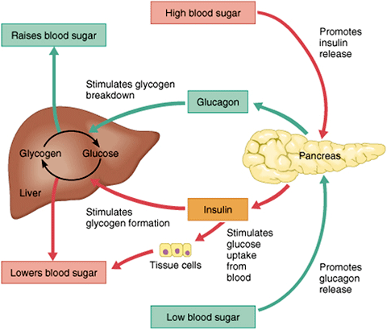
Figure 1: Complementary Roles of Insulin and Glucagon
(Source: atrainceu.com, 2020)
One of the strengths in this system is that it can be effective in changing its energy needs based on staying administrators like weakening, or after snacking, making the body stabilise at various events. On the other hand, Codazzi et al., (2023) stated that the system has also demonstrated a deficiency as it has been extremely susceptible to lifestyle as well as genetic pressures. In diabetics with T2D, the cells are now insulin-resistant, which means that glucose does not enter cells efficiently, causing high blood sugar levels (hyperglycaemia) (Carlberg et al., 2023). This has interfered with the usual glucagon-insulin interactivity and impairs the body's ability to keep in check.
On the other hand, the human body has an effective system for controlling the level of glucose. It has equally proven to be less effective against poor habits of eating, low mobility, and obesity, which has eventually placed Type 2 diabetes as an increasing health problem internationally (Gupta et al., 2024). Thus, the knowledge of such mechanisms has played a pivotal role in the explanations of how diabetes has evolved and in the ways of using effective methods to prevent or treat this condition.

c) Showing how oxygen and glucose are used to produce energy through cell metabolism.
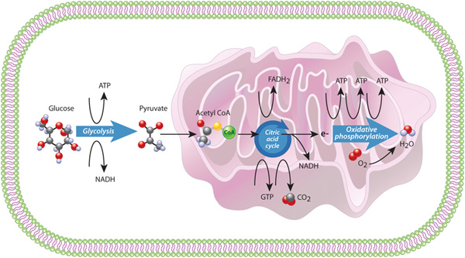
Figure 2: Producing Energy through Cell Metabolism
(Source: Nature.com, 2010)
According to Aliyari Rad et al., (2022) Cellular respiration is the process that the human body has employed to generate energy, and it happens in the cells, primarily in the mitochondria. This process has involved the use of glucose present in food and oxygen in breathing to produce adenosine triphosphate (ATP), which is the major energy source of the body (Biro, 2022). Three major steps have been involved in the process, which include glycolysis, the Krebs cycle and oxidative phosphorylation. The process has already happened in the cytoplasm when the glucose is converted into pyruvate, resulting in a minor production of ATP. This has been succeeded by the Krebs cycle that occurs in the mitochondria, whereby the pyruvate is further broken down to release carbon dioxide and hydrogen atoms. Lastly, in oxidative phosphorylation, oxygen is utilised to combine with hydrogen to produce a large amount of water (Mbugua, 2022).
As per Banerjee et al., (2023) this system has been most effective in providing energy used by the body in performing vital functions such as muscle contraction, transmission of nerves and repairing of cells. One of the advantages of this process has been that it generates constant energy when oxygen has been present to make sure that the body survives. Hence, the limitation is that low oxygen levels have caused the body to continue with anaerobic respiration and generate less energy and lactic acid, leading to fatigue of the body's muscles (Gopal et al., 2023). In general, cellular metabolism has played a critical role in the management of Type 2 Diabetes since failure to have sufficient glucose uptake decreases the production of ATP and energy balance (Safaie et al., 2024).

d) Briefly examining how recording and tracking blood sugar levels help individuals with Type 2 diabetes to safely manage their condition.
Pleus et al., (2022) stated that self-management of the blood sugar levels of people with Type 2 Diabetes Mellitus (T2DM) has been a significant aspect that has helped in its management. The process has helped the patients and the health practitioner to detect variations in glucose levels and make the necessary amendments to treatment and lifestyle. Devices like glucometers or continuous glucose monitors (CGMs) have been used to monitor by providing real-time data of blood glucose readings.
Continuous monitoring has served in avoiding serious complications like hypoglycaemia (low blood sugar) and hyperglycaemia (high blood sugar), which have contributed negatively to the body organs, say the heart, kidneys and eyes (Lewis et al., 2023). The data provided by the daily monitoring has been instrumental in the development of person-based care and measurement of intervention efficacy. Furthermore, patient monitoring has provided patients with a feeling of power and health awareness to develop self-management.
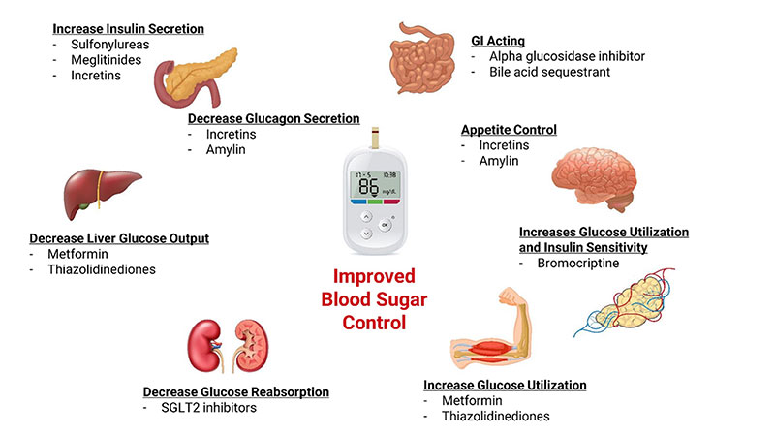
Figure 3: Improved Blood Sugar Control
(Source: Iafelice et al., 2025)
Continuous blood sugar surveillance has been identified to have an important advantage that generates real-time and accurate information, enabling officers to make suitable clinical judgments (Suganthi and Kalaiselvi, 2024). To illustrate, in cases when the sugar level has been constantly high, the treatment has been modified with the introduction of new drugs or alteration of diets. Also, the development of technology in glucose monitoring has enhanced accuracy, convenience, and adherence in patients (Ghosh and Verma, 2024). These enhancements have enhanced more active management, which has resulted in less hospitalisation and complications in the long run.
There have been limitations, as well as this advantage. Others have found self-monitoring to be stressful or perplexing, particularly with regard to understanding the changing values. Also, the process of regular testing has involved dedication of time and money, which are not universal for every patient (Natale et al., 2023). In addition, excessive dependence on glucose measurements without understanding the effects of lifestyle became a menace, which made the inferences uneven. An example is that patients can make records without confronting other factors, including food quality, type, and timing of exercise.
The other limitation is the psychological weight of continuous testing that can lead to anxiety and frustration of having low results in comparison with expectations. Also, Mancia et al., (2023) discovered that poor documentation and a lack of action on abnormal readings have reduced the overall usefulness of monitoring. In this regard, making a record of tracking and recording the levels of blood sugar has shed some light on the process of managing diabetes. Whereas it has empowered patients and aided clinical decision-making, its efficacy has been conditional on patient education, uniformity and motivation (Salmon, 2025). Thus, the application of data monitoring along with the use of professional advice and lifestyle modification has been a crucial milestone in securing safe, effective blood glucose management.

e) Including evidence-based recommendations on how lifestyle changes could help improve their condition.
Treatment of Type 2 Diabetes Mellitus (T2DM) has demanded changes in lifestyle that are backed by solid evidence in both research and practice (Diez-Valcarce et al., 2025). The changes have been geared towards the improvement of diet, physical activity, cessation of smoking, and a healthy weight. These measures have been used to supplement medical interventions that have enabled the body to use insulin more efficiently and normalise the level of sugars in the blood.
One of the most effective interventions has been the balanced diet. Diabetics have been encouraged to adhere to diets that are high in whole grains, fruits, vegetables, lean proteins, and healthy fats and low in processed sugars and refined carbohydrates. Small and frequent meal intake has helped avoid blood sugar spikes. This strategy has had the strength of being flexible, in that it has provided individuals with the ability to customise their eating habits as per culture and individual preference (Hargreaves et al., 2022). Nonetheless, one weakness has been the challenge of upholding long-term food discipline, especially with the social or economic constraints. In certain societies, nutritious food has not been made affordable and therefore, controlling food consumption has become more difficult.
Physical activity has contributed to managing diabetes as well. Exercise increases insulin sensitivity and has helped reduce excess weight, particularly through regular exercise, such as fast walking or cycling, for at least 150 minutes a week. It has been found that moderate exercise reduces the level of fasting blood glucose and also enhances cardiovascular health. One of the strengths of this recommendation is its widespread accessibility, as it allows for simple activities to be performed without requiring both equipment and access to a gym (Kanaley et al., 2022). The downside has been the inability among people with mobility problems, obesity or other health-related complications to engage in regular physical exercises, which has hindered long-term gains.
Another important lifestyle change has been smoking cessation. Smoking has also aggravated insulin resistance and predisposed individuals to heart disease and neuropathy. Cessation of smoking has enhanced blood circulation and lung capacity and reduced the general diabetic complications (Rahman et al., 2025). Despite the immense health safeguards for the health of the citizens, a challenge that has arisen in response to this change has been the highly addictive quality of nicotine. It has rendered quitting hard for many despite the counselling and support mechanisms.
It has also been essential in weight management. Studies have shown that even a slight decrease in weight (5-10%) can improve glucose control and reduce the need for medication. Loss of weight has made the pancreas work better and sensitised the body to insulin (Qin et al., 2022). One of the strengths of this strategy is that it is a proven approach to preventing and controlling diabetes. Nevertheless, sustaining weight loss has proved to be very difficult, particularly for such individuals who have not been given constant support or encouragement.
Finally, structured education and self-management programmes like the DESMOND programme (Diabetes Education and Self-Management for Ongoing and Newly Diagnosed) have helped patients to make informed decisions, having known their condition (NHS England, 2020). Such programmes have been seen to produce good evidence in enhancing long-term health. However, the constraint has been disparate access, especially in rural or low-income regions.

f) Conclusion
This report has discussed the key physiological and lifestyle factors of Type 2 diabetes Mellitus (T2DM) and indicated how knowledge on the functioning of the body has been relevant in the management of the condition. It has been described how insulin and glucagon regulate the balance of blood sugar and disrupt the balance, resulting in insulin resistance and elevated blood glucose. The cellular metabolism has been discussed, showing that glucose, as well as oxygen, has played a crucial role in energy production, and the depletion of energy sources due to poor glucose regulation in diabetic patients. The report has also revealed that the frequent checking of the levels of sugar in the blood has given useful information on the safe and effective management of diabetes. However, it has also realised that the frequent testing has posed an area of difficulty, including stress and adherence among some patients.
Recommendations that involve a healthy lifestyle, based on evidence such as healthy dieting, physical activity, quitting smoking, and weight management, have been helpful in increasing insulin sensitivity and lowering the risks of long-term complications. Nonetheless, these habits have demanded a constant source of motivation and education to sustain. Overall, it has been revealed in the current report that effective management of diabetes has been based on the integration of physiological knowledge, regular checkups, and a change of lifestyle. Collectively, these factors have strengthened health delivery and provided future management of Type 2 diabetes.

g) Reference List
Aliyari Rad, S., Dehghanian, Z., Asgari Lajayer, B., Nobaharan, K. and Astatkie, T. (2022) ‘Mitochondrial Respiration and Energy Production under Some Abiotic Stresses’, Journal of Plant Growth Regulation, 41(8), pp. 3285–3299. Available at: https://doi.org/10.1007/s00344-021-10512-1
atrainceu.com (2020) Regulation of Blood Glucose | ATrain Education, www.atrainceu.com. A Train Education. Available at: https://www.atrainceu.com/content/4-regulation-blood-glucose (Accessed: 13 October 2025).
Banerjee, D., Das, P.K. and Mukherjee, J. (2023). Nervous System, Textbook of Veterinary Physiology. Cham: Springer International Publishing, pp. 265–293.
Biro, G.P. (2022) Oxygen and ATP: the Energy Economy of the Cell, Blood Substitutes and Oxygen Biotherapeutics. Cham: Springer International Publishing, pp. 21–32.
Carlberg, C., Velleuer, E. and Molnár, F. (2023). Insulin Resistance and Diabetes, Springer eBooks. Cham: Springer International Publishing, pp. 633–651.
Codazzi, V., Frontino, G., Galimberti, L., Giustina, A. and Petrelli, A. (2023) ‘Mechanisms and Risk Factors of Metabolic Syndrome in Children and Adolescents’, Endocrine, 84(1), pp. 16–28. Available at: https://doi.org/10.1007/s12020-023-03642-x
Diez-Valcarce, I., Pisano-González, M.M., García, C.F., Linstrom, J., Zaletel, J., Giacomozzi, C., Tolika, F., Hidalgo, I.R. and Lana, A. (2025) ‘Multidisciplinary Lifestyle Treatment for Type 2 Diabetes in 12 European countries: Protocol for a quasi-experimental Study’, BMC Public Health, 25(1), pp. 1–9. Available at: https://doi.org/10.1186/s12889-025-22246-w
Ghosh, N. and Verma, S. (2024) ‘Technological Advancements in Glucose Monitoring and Artificial Pancreas Systems for Shaping Diabetes Care’, Current Medical Research and Opinion, 40(12), pp. 2095–2107. Available at: https://doi.org/10.1080/03007995.2024.2422005
Gopal, K., Abdualkader, A.M., Li, X., Greenwell, A.A., Karwi, Q.G., Altamimi, T.R., Saed, C., Uddin, G.M., Darwesh, A.M., Jamieson, K.L., Kim, R., Eaton, F., Seubert, J.M., Lopaschuk, G.D., Ussher, J.R. and Rami Al Batran (2023) ‘Loss of Muscle PDH Induces Lactic Acidosis and Adaptive Anaplerotic Compensation via pyruvate-alanine Cycling and Glutaminolysis’, Journal of Biological Chemistry, 299(12), pp. 105375–105375. Available at: https://doi.org/10.1016/j.jbc.2023.105375
Gupta, M.K., Gouda, G. and Vadde, R. (2024) ‘Relation between Obesity and Type 2 Diabetes: Evolutionary Insights, Perspectives and Controversies’, Current Obesity Reports, 13(3), pp. 475–495. Available at: https://doi.org/10.1007/s13679-024-00572-1
Hargreaves, D., Mates, E., Menon, P., Alderman, H., Devakumar, D., Fawzi, W., Greenfield, G., Hammoudeh, W., He, S., Lahiri, A., Liu, Z., Nguyen, P.H., Sethi, V., Wang, H., Neufeld, L.M. and Patton, G.C. (2022) ‘Strategies and Interventions for Healthy Adolescent growth, nutrition, and Development’, The Lancet, 399(10320), pp. 198–210. Available at: https://doi.org/10.1016/s0140-6736(21)01593-2
Iafelice, R., Williams, M., Sandhaus, S., Tapanes, S., Decker, C. and Faloon, C. (2025). Diabetes and Glucose Control, Lifeextension.com. Life Extension®. Available at: https://www.lifeextension.com/protocols/metabolic-health/diabetes-and-glucose-control?srsltid=AfmBOor7Y7Y8zMH9Tuul3PmMjEoze1SE8wKWQyPoVawaMq-Zbhvl4BSg (Accessed: 11 October 2025).
Kanaley, J.A., Colberg, S.R., Corcoran, M.H., Malin, S.K., Rodriguez, N.R., Crespo, C.J., Kirwan, J.P. and Zierath, J.R. (2022) ‘Exercise/Physical Activity in Individuals with Type 2 diabetes: a Consensus Statement from the American College of Sports Medicine’, Medicine & Science in Sports & Exercise, 54(2), pp. 353–368. Available at: https://doi.org/10.1249/mss.0000000000002800
Kapoor, A. (2025). Total Wellness and The Sugar Syndrome: Book of Existence: Vol 12. Xlibris Corporation.
Lewis, D.M., Oser, T.K. and Wheeler, B.J. (2023) ‘Continuous Glucose Monitoring’, BMJ, 380, pp. 1–20. Available at: https://doi.org/10.1136/bmj-2022-072420
Mancia, G., Cappuccio, F.P., Burnier, M., Coca, A., Persu, A., Borghi, C., Kreutz, R. and Sanner, B. (2023) ‘Perspectives on Improving Blood Pressure Control to Reduce the Clinical and Economic Burden of Hypertension’, Journal of Internal Medicine, 294(3), pp. 251–268. Available at: https://doi.org/10.1111/joim.13678
Mbugua, S.N. (2022) ‘Targeting Tumour Microenvironment by Metal Peroxide Nanoparticles in Cancer Therapy’, Bioinorganic Chemistry and Applications, 2022(1), pp. 5–41. Available at: https://doi.org/10.1155/2022/5041399
Natale, P., Chen, S., Chow, C.K., Cheung, N.W., Martínez-Martín, D., Caillaud, C., Scholes‐Robertson, N., Kelly, A., Craig, J.C., Strippoli, G.F.M. and Tong, A. (2023) ‘Patient Experiences of Continuous Glucose Monitoring and Sensor‐augmented Insulin Pump Therapy for diabetes: a Systematic Review of Qualitative Studies’, Journal of Diabetes, 15(12), pp. 1048–1069. Available at: https://doi.org/10.1111/1753-0407.13454
Nature.com (2010) Cell Energy, Cell Functions | Learn Science at Scitable, Nature.com. Nature Education. Available at: https://www.nature.com/scitable/topicpage/cell-energy-and-cell-functions-14024533/ (Accessed: 13 October 2025).
NHS England (2020) DESMOND, DESMOND programme (Diabetes Education and Self-Management for Ongoing and Newly Diagnosed). Leicester Diabetes Centre. Available at: https://www.desmond.nhs.uk/ (Accessed: 13 October 2025).
Nirmalan, N. and Nirmalan, M. (2023) ‘Hormonal Control of Metabolism: Regulation of Plasma Glucose’, Anaesthesia & Intensive Care Medicine, 24(10), pp. 618–623. Available at: https://doi.org/10.1016/j.mpaic.2023.07.001
Pleus, S., Freckmann, G., Schauer, S., Heinemann, L., Ziegler, R., Ji, L., Mohan, V., Calliari, L.E. and Hinzmann, R. (2022) ‘Self-Monitoring of Blood Glucose as an Integral Part in the Management of People with Type 2 Diabetes Mellitus’, Diabetes Therapy, 13(5), pp. 829–846. Available at: https://doi.org/10.1007/s13300-022-01254-8
Qin, W., Ren, X., Zhao, L. and Guo, L.-H. (2022) ‘Exposure to Perfluorooctane Sulfonate Reduced Cell Viability and Insulin Release Capacity of Β Cells’, Journal of Environmental Sciences-China, 115, pp. 162–172. Available at: https://doi.org/10.1016/j.jes.2021.07.004
Rahman, M., Alatiqi, M., Jarallah, M.A., Hussain, M.Y., Monayem, A., Panduranga, P. and Rajan, R. (2025) ‘Cardiovascular Effects of Smoking and Smoking Cessation: A 2024 Update’, Global Heart, 20(1), pp. 1–15. Available at: https://doi.org/10.5334/gh.1399
Safaie, N., Masoumi, S., Alizadeh, S., Mirzajanzadeh, P., Nejabati, H.R., Hajiabbasi, M., Alivirdiloo, V., Basmenji, N.C., Radvar, A.D., Majidi, Z. and Faridvand, Y. (2024) ‘SGLT2 Inhibitors and AMPK: the Road to Cellular housekeeping?’, Cell Biochemistry and Function, 42(1), pp. 3–22. Available at: https://doi.org/10.1002/cbf.3922
Salmon, P. (2025). Clinical communication: The ideal of patient empowerment and the reality of patient vulnerability and dependence. Cambridge University Press.
Suganthi, V. and Kalaiselvi, K. (2024). Decision Support System in Healthcare Monitoring, Artificial Intelligence‐Based System Models in Healthcare. Wiley Online Library, pp. 55–78.
Xiang, Y., Su, B., Liu, D. and Webber, M.J. (2023) ‘Managing Diabetes with Hydrogel Drug Delivery’, Advanced Therapeutics, 7(1), pp. 23–127. Available at: https://doi.org/10.1002/adtp.202300127

