

Assessment 1
Human Resource Management

Student name: AVUKU SAI SHARAN
Student ID: 2116880
Module code: LCMB7000
Module name: HUMAN RESOURCE MANAGEMENT
Lecturer name: Gladius Kulothungan

Table of Contents
Introduction 3
Current changes in the external environment 4
Pandemic COVID-19 changes on environment 4
External environment changes due to BREXIT 5
Changes in the company due to COVID 19 6
1. E-commerce 6
2. Training and Development 7
3. Technology 7
4. Keeping workers safe 8
Changes and methods of Implementation as an HR manager 8
1. Sainsbury RECRUITMENT AND SELECTION 9
2. Opportunities for Graduates 11
3. Soft Model of HRM 12
Recommendations 12
Conclusion 12
References 13

Introduction
The two major challenges that many of the UK companies and also the Government faced in the last three years are
i) BREXIT ii) COVID 19
Firstly talking about BREXIT, it is an acronym of two words and they are Britain and exit, which is nothing but the withdrawal of United Kingdom from European countries. It took place on 31rd January 2020.
As a coin has two sides, even BREXIT has its own advantages and disadvantages. Few of the positives are, they are freer to trade with many non-EU markets like America, Australia etc.
The relation with the European countries get spoiled, now to import goods from European countries they have to follow many policies and regulations unlike before BREXIT.
Secondly, as the virus (COVID-19) broke down to many countries, the government announced lockdown so as to not to spread the virus. People were asked to stay indoors and asked many of the employers to work from home. So, this is a huge loss for offline stores which my study will be focussing on.

The most adversely hit sector due to COVID-19 along with BREXIT in UK is RETAIL sector. Moreover, the following study focuses on “SAINSBURY”, which is second largest chain of stores in UK; with regards to the changes in Macro-environment. The study also highlights how quickly the company made changes to their strategies to survive in this competitive market and also their comeback towards BREXIT.
Sainsbury has several number of stores which offers both food and non-food products. Their main motto is to give the best service to its consumers.

Current changes in the external environment

Pandemic COVID-19 changes on environment
If we look at the GDP (the value of goods and services sold in a particular year) it has drastically fallen down at the first phase of COVID-19. When it came to second phase that is during the period of October to November we can notice that the GDP has reached its minimum level. Speaking in numbers, at the first phase it was around 20% and it reduced to almost 8% in the span of 4 months.
From January to March 2020, the working population was 32 million, whereas in November 2021 to January 2022 the number of people working have fallen down to 32.50 million.
From the below graph, it can be concluded that when the scheme started almost nine million people are covered by furlough scheme

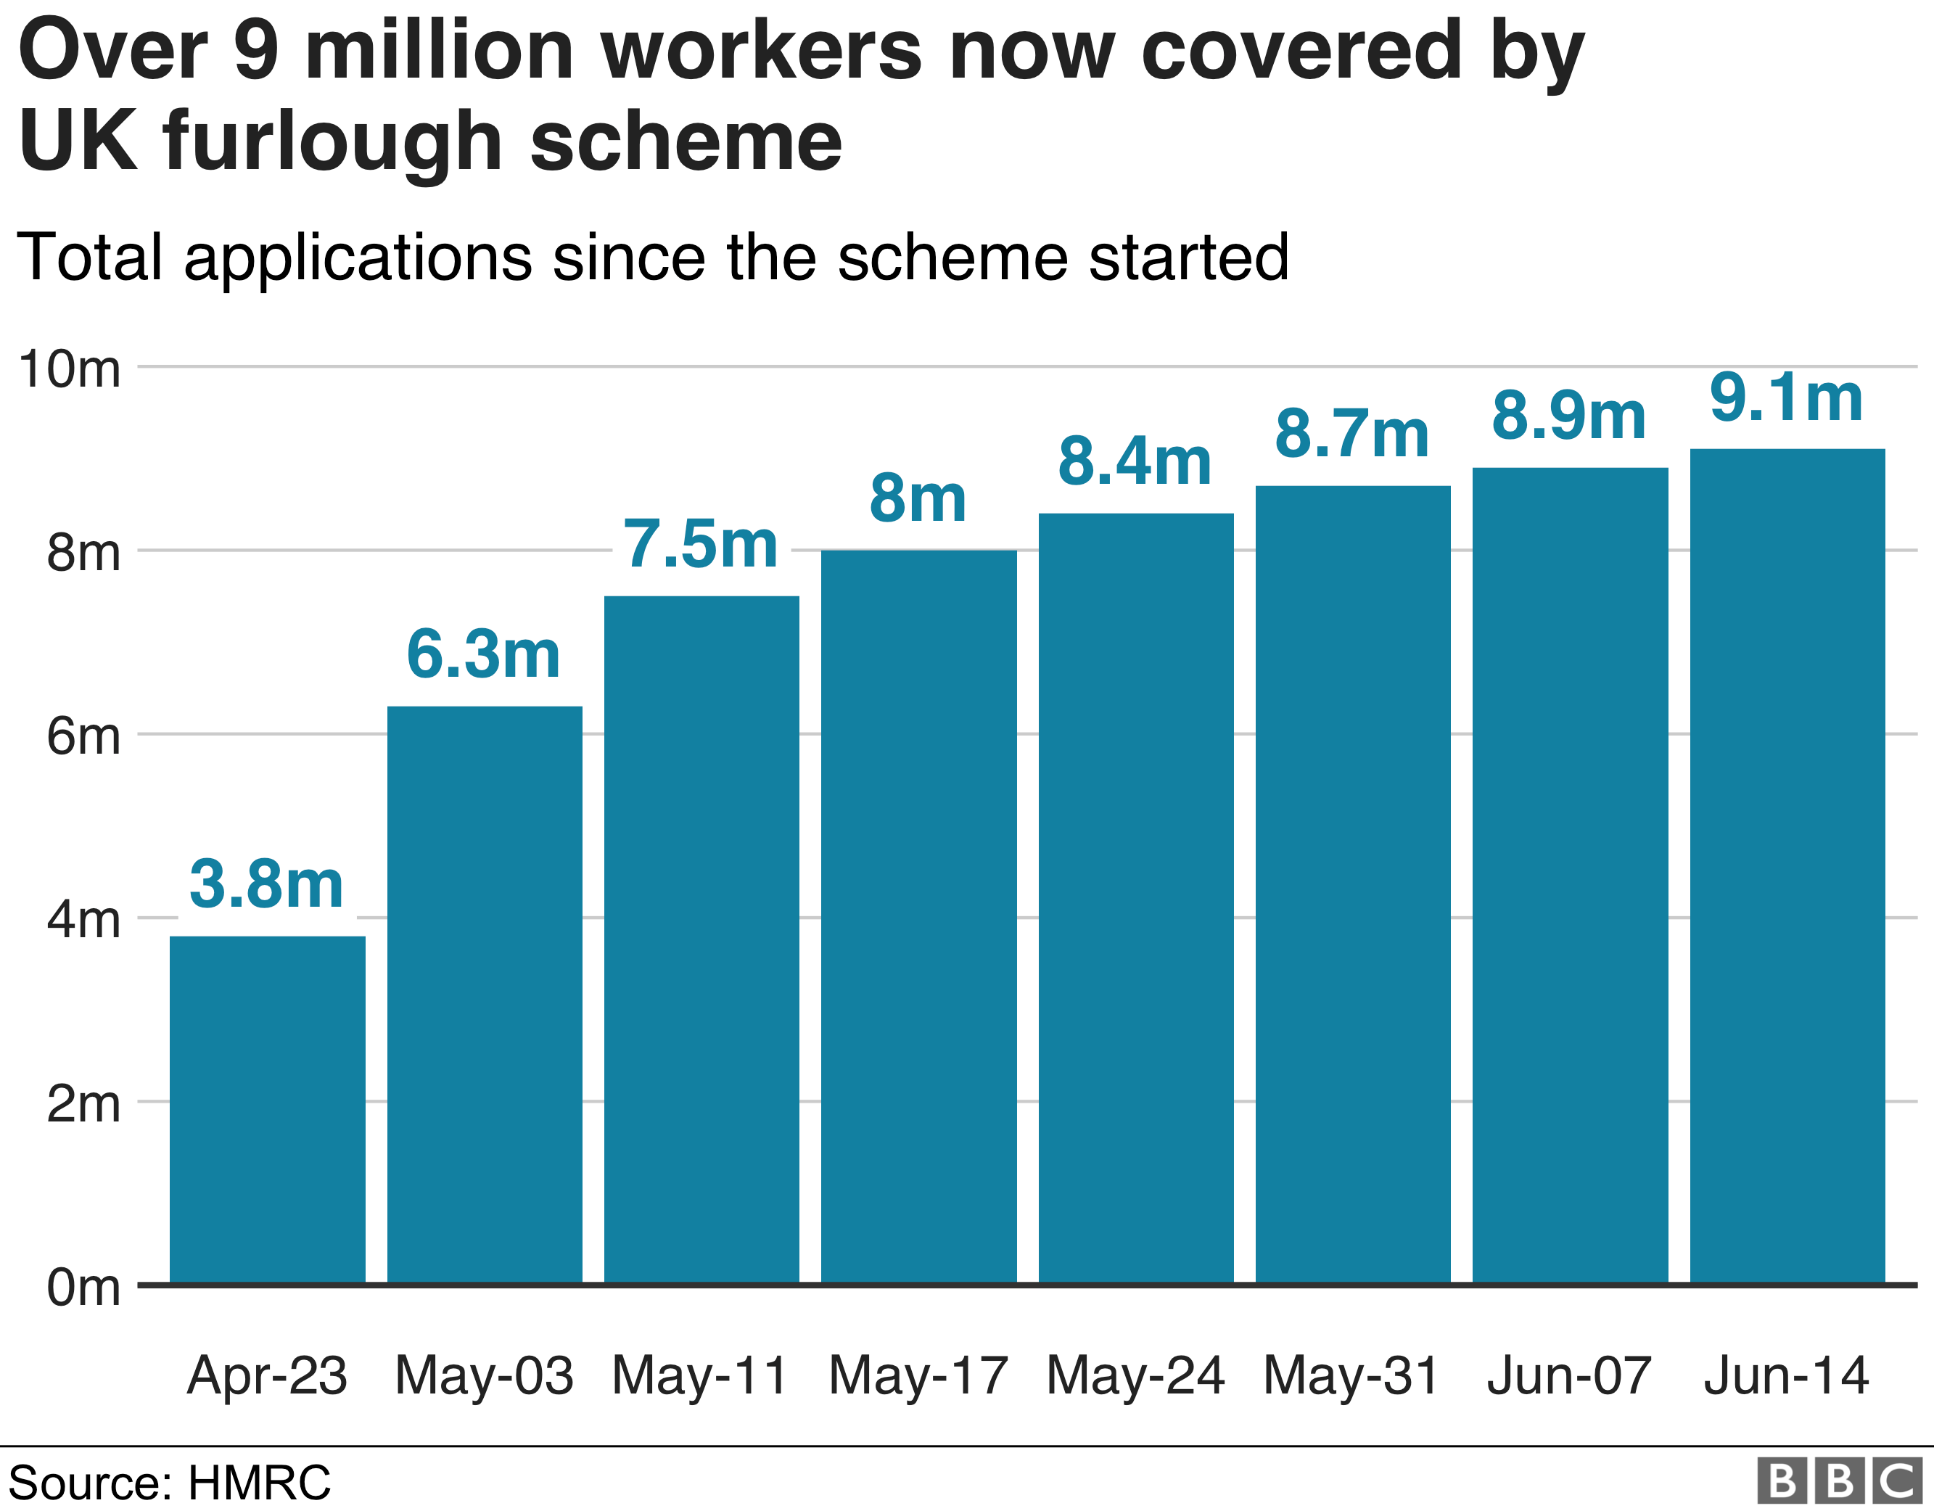
Source: HMRRC
There were many changes in the different sectors. All sectors have more or less moved towards digital market. If we look at retail sector, it has fallen down badly due to the lockdown. All the stores were asked to shut down. As well as the service sector which comprises of restaurants.
Whereas the pharmacy sector have done well. More of masks, sanitizers and medicines production boosted their profits.
If we look at the stats it says that almost 7.6 million jobs were at risk. Almost 20% of UK employed people were furloughed on April 2020. The COVID phase was so dreadful for all the organisations.
There was so much of inflation from 2019 to 2021. The prices of the commodities hit high making it difficult for people to buy.
At the time of pandemic, Sainsbury had a loss of £ 261 million. They focussed more on employees and customers safety which was very important.

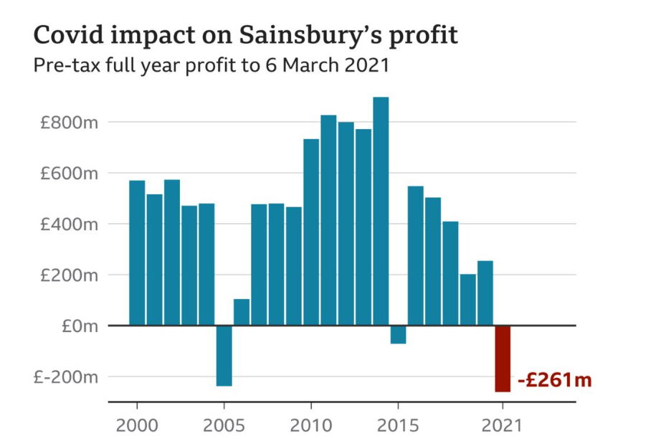
Source: Sainsbury’s

There were shelves empty in many of the stores. In, Sainsbury there was very less stock of mainly sold products like drinks and salads. There was this shortage because of lack of lorry drivers to get the stock amidst lockdown.
There were many difficulties in supply chain management like transportation, manufacturing delays, and also the shift towards digital market which had affected many non-food companies.

External environment changes due to BREXIT

The issue is straightforward: vehicles deliver practically all of our goods, yet there aren't enough drivers to go around. As a result, everything with a limited shelf life is likely to be affected, resulting in the current food shortages. However, every product delivered by truck is subjected to this problem.
Mike, one of the truckers, who drives long-haul on journeys to and from Europe which can last up to two weeks. He believes that industry talk reinforces reports that the UK has a driver shortage of 60,000 to 100,000. Part of it is due to Brexit, with many EU drivers stopped from visiting the UK due to increased border paperwork, but it is also due to a lack of resources in the UK.
The city of London has almost people from all over the world. Many people will come to find jobs and there are many people working in low-talent jobs. To name a few, working as a waiter or waitress in the restaurants etc. Nevertheless, the majority population in UK are people from European countries.
Prior to the vote, researchers looked examined the impact of free mobility on the UK labour market. They investigated three industries: hospitality, construction, and food and beverage manufacturing.
The hiring practices became difficult after BREXIT for the sectors like Hotel and tourism industries.
Post BREXIT, there is complete breakdown in UK’s environmental policy. Initially UK faced many problems but later on they got adjusted to European Union’s financial policies. However, as the economic crisis worsened and the UK government pursued an economic plan, environmental protection in the EU became a focus of proper political discussion. As a result, the government's claims that it wants a "Green Brexit" have been received with scepticism. There has been a lot happening in the areas of environmental policy, where Michael Gove, the energetic Environment Secretary, has pushed to make a success of his mission by bringing forward a number of key projects.

Changes in the company due to COVID 19

All through the COVID period, the corporation had to make some difficult decisions in order to ensure the company's long-term profitability. The corporation chose to do it in a transparent manner. To cope UP with the challenges and expand the business, several labour market enforcement methods are required. In the new normal, there would be numerous possible dangers in the market that might lead to labour exploitation.
It happened that many people lost their jobs, apart from it employees were paid less salary etc. there were few schemes set up by UK government which made employees safe at the time of COVID like task retention scheme.

1. E-commerce
When COVID started all the companies shifted their gear towards Digital market to make their companies profitable at the even odds of lock down.
Each and every company had their own strategies to improve their sales volume. Moreover, I would be discussing about Sainsbury’s strategies. How the then CEO, Mike Coupe acted towards the COVID 19 circumstances with his brilliant ideas which made their sales increase by 77%.
Initially they developed an app called SmartShop, where people can purchase groceries online.
In the world of technology, Sainsbury made shopping very easy offering everything at customer’s doorstep just with a click on their smart phones or store handsets. As they had multichannel policy, their investment in online shopping didn’t go in vain. Their collaborations with Deliveroo, Uber Eats and also their own Chop Cop service made their sales volume high.
ARGOS closed 36 stores and opened up new 37 stores with Sainsbury’s partnership. By uniting with ARGOS, Habitat Logistics and supply chains it made them cut down the costs nearly by 300 million pounds.
Volunteer shopping card – There were many self-isolated, their relatives or friends can go up to the shop with their card and get an E-gift Voucher to your mail and can redeem it in the store. They can get discounts.
They mainly focussed on their employees’ health and also customer’s satisfaction despite the pandemic.
Sainsbury’s products were at stake due lack of suppliers supplying the commodities. Sainsbury faced the problem in supplying salad packs, Beers and soft drinks etc. because the staff were asked to self-isolate at the time of pandemic. It was the time during lockdown, where people wanted to enjoy their time in homes with their family members by having drinks, barbecue foods.
The company spent almost £ 500 million for the employees who worked at the time of pandemic and also to the ones who did extra shifts gave them extra bonuses.
Recently the company announced that 1,150 jobs were at risk whilst closing down an online store in East London.
By shutting down 200 cafes it affected a small proportion of employees and also said the workers who were affected by closures will be given a chance for vacancy roles in other stores.

2. Training and Development
Sainsbury’s objectives Is to develop their employees skills and reward them by incentives for their success in the company.
The first thing is social distancing. Being a grocery store, there will be many people coming to buy both food and non-food products. So, there should be proper social distancing between people so as to avoid the virus spreading and also the wearing of masks compulsory. For not making people wait at the till counters, they can use the latest technology like scanning the products, moreover like a cashless payments. By, doing this it may reduce the job of employees, but the company can use them for other roles.
The timings of the shops can be extended and also sanitizing the shop once in two days for people’s safety.
As the working conditions aren’t same before and after COVID 19, they require to give more training for the employees.
- They should mainly focus on healthy environment. By training and development, the company’s productivity level will increase which makes the company to achieve its goals quickly.
- It should improve the quality of employees rather than quantity, which in-turn it improves the employee personality development and also gain good knowledge.
- It will develop the team leadership. When many hands join, the company will prosper easily and also can tackle any problem like COVID 19.

3. Technology
According to migrant labour limits, BREXIT may affect the availability of workers in UK (Bloom et al. 2019). Most of the supermarkets typically hire employees who are low-skilled and also their wage rate is low and the same thing happened with Sainsbury. When there are less number of employees hired it would have direct relation with the profits. If the company increases the prices of the products, consumers have many alternatives. So, it’s very easy for them to shift to buy other company’s products.
By opening 24 hour Sainsbury's stores with self-checkout machines, Sainsbury's has become a leader in the use of self-checkout devices. Because there aren't many establishments open 24 hours a day, self-checkouts may help boost sales.
Currently, Sainsbury's is a UK-based company that primarily trades within the EU, but in order to expand their sales, they should open pop-up stores in various EU countries, and if this proves to be a success, they should consider trading with countries outside of the EU, such as Africa and Asia, or opening pop-up shops in these countries as well.
Sainsbury has its presence only in United Kingdom. Instead they can expand their country to other developing countries to become more profitable.

4. Keeping workers safe
Our Sainsbury’s main aim was to keep workers safe. As factories began to reopen, they maintained regular communication with our suppliers to ensure that we were aware of the issues they were facing in balancing to the introduction of new methods of working in order to keep everyone safe while also ensuring the lives of all their employees. These discussions involve assisting factories in prioritising the things they manufacture and ensuring that our suppliers are equipped to comply with all relevant safety regulations.

Sainsbury had shared government-issued instructions with their supplier. For example, they’ve conducted a series of seminars that demonstrate safe work practises in these unique times. They have also asked vendors to fill out a questionnaire so that they could learn more about them.

Changes and methods of Implementation as an HR manager
Amidst this COVID rules, like wearing masks, sanitizing very often, social distancing keeping all these in mind Sainsbury have come up with a brilliant idea. It is like you needn’t wait in the queue to enter into the supermarkets. Instead you can book your slot virtually and the application name is called ufirst app. And they are going to experiment it across London.
On the other side, as there was surge in their online sales they decided to expand the use of their SmartShop mobile app, which accounts to more than million user.
At the moment, this app is been used by many customers. If we look at the reports, it tells us that Sainsbury’s half of the sales comes from this. Customers can scan the bar chord on the products and with the help of the app, they can pay simultaneously and put it in their cart which reduces customer’s time instead of standing in long queue.
There are wide range of products in Sainsbury. But the sale of few commodities is very less. So, there will be few products kept near the till counters so that it falls into the customer’s eyes.
By changing our approach to expenses, streamlining our organisation, and reducing our costs, which will make them increase their efficiency. They are focusing more on cutting costs so that they can increase their product varieties which helps people to purchase through different mediums.

The main goal of Sainsbury is to make their customers satisfied. Apart from this they improve the skillset of their employees which in turn develop their overall development and also achieve company’s purpose.
The brand is known for its quality goods at the affordable prices. They supply fresh and nutritious food to the customers and they want to get new products to the public.
They employ almost 1 million people and serve millions of consumers every week. Sainsbury's offers a wide range of products, including food, groceries, and other home items.
They sell branded items as well as Sainsbury's own products, which are usually less expensive than branded alternatives.

1. Sainsbury RECRUITMENT AND SELECTION

Recruitment is the process of employing people for a certain field of work through a series of stages and selecting the best candidate with the appropriate abilities for the organization's many departments (Thite, 2018). Sainsbury, being one of the largest supermarket can get more advantages from this strategy. There are two types of recruitment:
1) Internal recruitment:
In this recruitment, the already working people get a chance to showcase their skills and demonstrating them (Taylor, 2017). Instead of employing workers from outside, they give a chance to the ones who have already been working. Sainsbury always prefer internal recruiting. It will cost down many costs like advertisement costs and also saves time rather than conducting exam and taking interview. It is a quick step for hiring workers. It allows Sainsbury's to keep its industrial flow, distribution network, and business processes running smoothly. By this way, they RETAIN their own employees. And by recruiting people from within, it will give motivation for the other workers as well.
2) External recruitment:
In most of the companies, they hire workers externally which means people from outside their company. By hiring people from outside, then the company gets new ideas. For external recruitment everything should be wisely planned. Because there will be many people who would be applying for the job position. The recruiter should know to choose a correct person for the correct job. It is time taking and also costs more.
Examples- Advertisements; websites like Indeed Job search, sonic jobs etc.

Employee retention
It is the capability of companies to make their workers work for more years in their company rather than quitting their jobs. The companies have to make sure that they reach to workers requirements. Because by getting new people, it would cost more money and time for the company.
Employee retention includes a variety of strategies and procedures aimed at keeping employees within businesses for as long as possible so that they may benefit them.
Sainsbury's won this year's prize due to a strategy focused on the use of technology to provide a more cost-effective, consistent, and better experience for potential recruits.
Employee turnover is significant in huge corporations like Sainsbury’s. Store Roles, Store Management, and Store Support Centre are the three primary categories in Sainsbury's recruiting area, and each of these categories has a variety of opportunities to fill. As a consequence, job searchers should follow the recommendations of a clear job description.
When it comes to employee retention, motivation is a critical factor.
Internal ads are commonly used by Sainsbury's to attract supervisors and internal staff; notifications are posted on the business bulletin board or announcements are made at regional meetings. It will be easier for the organisation to select appropriate personnel because current workers have greater expertise and cost less.
The better working environment and programmes will undoubtedly attract staff to stay with the firm, as well as push them to maximise their contributions to Sainsbury’s.

Job analysis tells us about the requirements of the job and also the skills required for it. So based on these details managers will hire candidates who fit in to those qualities.
They have many job openings in different locations. They are in need of employees who have the ability to deal with their potential customers and also the one who can handle the technological aspects. They post their new job postings in local newspapers and also in their markets as well. They are setting up new stores in various parts of UK especially London and the selected candidates are given two months training. They have many openings like part time or full time etc.
For recruiting the candidate the very first step is to get their curriculum vitae (C.V.)
Then after getting a pool of applications they then shortlist few candidates based on the skills on their CV.
Then comes the very important step that is interview. The recruiting manager will make sure that the candidate possess the knowledge which they require for the job position. Here, the candidate will be asked questions to check his ability to answer. There can be a writing test as well along with one to one meeting.
Based on his response to the questions asked, the manager then recruits the employees based on the job position.
The best candidate for the position is chosen based on the company's criteria.

2. Opportunities for Graduates
Sainsbury hires more than 200 new graduates and they are employed in the stores. The Sainsbury's graduate recruiting website is where graduates may apply for jobs. When the graduates join for training, they get trained in all aspects of shop management. They will work in various departments of the shop during this training time and then conduct their tasks under the supervision of the management.
In Sainsbury, human resources department is in charge of the company's human division and works closely with each department to ensure that staff development plans are aligned with the company's objectives. They have used creative recruitment and selection procedures to present job possibilities to a large number of people while also selecting the best candidate for the right position through a selection process.
It is very important for every business to have the right person for the right position. In this context, they both play a crucial role. As there is advancements in technology there is a lot of pressure on how they recruit. The goal of the Talent Acquisition process is to identify potential sources of labour to satisfy the needs of the company.

3. Soft Model of HRM

According to Miller (2016), planning process and human resource planning are the two terminologies used by companies to meet their goals for their processes, methodologies, theories, strategic plans and recruiting strategies, among other things.
The correct individual for their business functions and marketing plays a significant role in the development and growth of the company. Workers with a variety of educational backgrounds and different skills are allocated to their particular fields such as manufacturing, customer service, sales, supply chain, marketing. Human resources planning, on the other hand, includes the methods for hiring personnel and employees.
Sainsbury's uses the notion with its employees since they are the most important stakeholders in the company. Democratic leadership encourages workers to engage in decision-making and cooperation with their employers by creating a friendly environment (Sparkman, 2018).

Recommendations
We can’t predict what happens in the very next minute. Everything is uncertain but the response to the situation is certain. Moreover, we should be ready to adjust and adapt to the new challenges.
If we look at the study, BREXIT and COVID-19 are uncertain events, but majority of the companies flexibly adapted to the required adjustments rather than giving up their hands up. The only sector which prospered at the time of COVID-19 is HEALTHCARE sector. As UK have good connections with other countries like India, Australia etc. might have hired people from those countries not only for employment but also to fill up the vacancies where it occurred during BREXIT time.
Sainsbury instead of depending only on European Countries for their products, they can create good relationship with other countries for their supply chain.

Conclusion
To recapitulate, initially in this assessment we have briefly discussed about the company and its environment during BREXIT as well as COVID-19 pandemic. Because of these two uncertainties, many people’s life and jobs are at stake. There was a turbulent disturbance in all the sectors. As mentioned earlier, as a coin has two sides, this too had few positives and negatives. In this fast moving technological world, during the pandemic everyone turned to digital life making customer’s life easy. Companies have gone through many challenges and came back with brilliant ideas. Majority of the companies have invested their money in the technology development. The companies are now recurring their losses due to pandemic.

References

https://www.cambridge.org/core/journals/transnational-environmental-law/article/impact-of-brexit-on-the-environment-exploring-the-dynamics-of-a-complex-relationship/DC586129B4BE5672D6DF25B6032F8A27
https://www.ukessays.com/essays/management/how-recruitment-and-selection-procedure-effect-sainsburys-management-essay.php
https://journals.openedition.org/rfcb/2385
https://www.bbc.co.uk/news/uk-northern-ireland-54840257
https://www.theguardian.com/politics/2020/nov/05/brexit-may-reduce-food-to-northern-ireland-sainsburys-supermarkets
https://blogs.lse.ac.uk/businessreview/2020/05/22/the-impact-of-covid-19-on-human-resource-management-avoiding-generalisations/
https://internetretailing.net/covid-19/covid-19/two-ways-sainsburys-is-using-mobile-technology-to-help-customers-avoid-queuing-in-its-shops--21784
https://studymoose.com/sainsbury-the-retail-industry-essay
https://www.linkedin.com/in/helen-paxton-734aa02a/?originalSubdomain=uk
https://www.personneltoday.com/hr/sainsburys-500m-on-pandemic-staff-costs-hits-profits/
https://commonslibrary.parliament.uk/research-briefings/cbp-8898/
https://voxeu.org/article/impact-brexit-uncertainty-uk-exports
De Lyon, J. and Dhingra, S., 2021. The impacts of Covid-19 and Brexit on the UK economy: early evidence in 2021.
https://www.mcgill.ca/jean-monnet-chair/files/jean-monnet-chair/2018-08-31-brexit_literature_review.pdf
https://www.researchgate.net/publication/320383611_Brexit_A_review_of_impact_on_future_of_United_Kingdom_outside_the_European_Union
https://www.about.sainsburys.co.uk/news/latest-news/2022/01-03-22-eat-in-takeaway-home-delivery-offer
https://www.hrmagazine.co.uk/content/other/hr-excellence-awards-2010-most-effective-recruitment-and-retention-winner-sainsbury-s

Davenport, A. and Levell, P., 2022. Brexit and labour market inequalities: potential spatial and occupational impacts. Oxford Review of Economic Policy, 38(1), pp.50-67.
Roscoe, S., 2020. The future of UK supply chains in a disrupted world: Brexit and Covid-19. LSE Business Review
Smith, J., 2021. COVID-19, Brexit and the United Kingdom–a year of uncertainty. The round Table, 110(1), pp.62-75.
Hadjimichalis, C., 2021. An uncertain future for the post-Brexit, post-COVID-19 European Union. European Urban and Regional Studies
Heald, D. and Hodges, R., 2020. The accounting, budgeting and fiscal impact of COVID-19 on the United Kingdom. Journal of Public Budgeting, Accounting & Financial Management.
Mayhew, K., 2022. Brexit and UK higher education. Oxford Review of Economic Policy, 38(1), pp.179-187.
Lisa O'Carroll, H. S. (2017). The government had outlined it is positioned on the negotiation on the future of EU migrant currently here that they will be allowed to stay based on condition terms that will be negotiated withthe EU. LONDON: THE GUARDIA
Christian Dustmann, F. F. (2005). THE IMPACT OF IMMIGRATION ON THE BRITISH LABOUR MARKET. THE ECONOMIC JOURNAL, 18.

