MODULE CODE: EMPL4012
STUDENT NAME: ABDUL ALIM
STUDENT ID: 1605704
TUTOR:MR MUSHFIQUR RAHMAN

Researching and Analysing Data

Contents
Prof. Russell Ackoff’s definitions of data, information, knowledge, understanding and wisdom 2
Potential sources of information to solve workplace problems 2
The ways in which numeracy, knowledge and reasoning are integral to most employment areas 3
Statistics in the interpretation and analysis of data – averages, types of graph, arithmetic mean, standard deviation 4
Basic computer uses for numerical handling – excel spreadsheets, databases 11
The development of skills needed to utilize information gathered in a critical and analytical way 13
The ethical implications of gathering information and matters of data protection 19
Reference 20

Prof. Russell Ackoff’s definitions of data, information, knowledge, understanding and wisdom
Data: Data is unorganized raw facts from which no interpretation or result can be generated. Generally, scattered information is termed as data.
Information: Information is more organized and structured facts from which relationship can be developed or interpretation can be made (Cottrell, 2010).
Knowledge: Knowledge is the collection of information in the desired way by which decision making can be made and result analysis can be developed. Anybody gaining information and using it effectively has successfully amassed knowledge. Knowledge follows the deterministic process.
Understanding: It is the combination of the interpolative and probabilistic process by which cognitive analysis can be carried forward through the development of understanding regarding something. Understanding is more organized that also helps to develop new information synthesis (Levin, 2014). The core point of differentiation between understanding and knowledge.
Wisdom: Wisdom is the combination of extrapolative and non-deterministic, a non-probabilistic process which takes the previous consciousness and understandings and helps to generate unique solutions to a particular event. Wisdom follows a high level of logical reasoning that allows distinctive thinking and solution generations.

Potential sources of information to solve workplace problems
The chosen context in order to solve the workplace solution is the “Working from Home” and the article that has been selected Article-1 which is regarding Yahoo’s case. The article signifies the problem of the employees of Yahoo who are working from home. Yahoo has allowed its employees to work from home mainly to enable them enough flexibility and also to accommodate extra employees which proved to be failed as productivity in working from home and office is not the same. Yahoo has 125000 employees like this and so making the employees working in the office environment in a mandatory basis can be a solution for getting rid of extra employees but this is not the only reason marked as working from home is totally different compared to working in office desk (Shulman, 2017). The problem mounts up when most of the employees tend to develop thinking that working at home as an alternative to working in an office which is not as collective creativity and environment go missing.
To solve this problem, the potential sources that can be used include both primary and secondary sources of data. Primary sources of data indicate the data in which no statistical techniques have not been applied and these are the raw data that are directly collected from the field. For primary data collection to solve the underlying problem of working from home at Yahoo survey questionnaire can be used. In addition to the primary data, secondary data can also be used to solve the underlying problem (Mercer, 2006). To collect the secondary data relevant to this different journals, books and articles can be taken for granted. Secondary data helps to confirm the result produced by the primary data by providing a guideline and helps to reach a better solution point avoiding mistakes from previous researchers.

The ways in which numeracy, knowledge and reasoning are integral to most employment areas
The business world is fast changing and unique problems can arise so often in the successful operation of the business and so numeracy, knowledge and reasoning are getting integral to most of the employment areas. The data-driven management has illustrated new issues in the employment areas as quantitative techniques are proved to be effective in providing a logical and impeccable solution to complex problems with ease and also by saving a lot of time (Pritchards, 2008). Numeracy, knowledge and reasoning these have equal implications in all employment areas such as the accountancy, banking, management consultancy, production, hospitality services, environment, agriculture and so on.
These techniques help in data procurement helping the company to enable big data analysis to respond to complex problems with ease as data-driven decision making are proved to be more effective in this fast-changing world. Moreover, with the development of artificial intelligence numeracy, knowledge and reasoning techniques have become easier to be applied at different context covering all these areas. In the underlying case as well to solve the working from home at Yahoo numeracy, knowledge and reasoning can be used as the primary data analysis can be conducted by these by designing close-ended survey to know the response of the employees in this regard and so these techniques have become integral to most employment areas (Seely, 2015).

Statistics in the interpretation and analysis of data – averages, types of graph, arithmetic mean, standard deviation
The problem context that has been chosen for the underlying task is working from home instead of working in the office considering the context of the Yahoo. Different statistical tools can be used to respond to solve this problem. The analysis of the data using statistical techniques have been provided below:
Averages or arithmetic mean: This represents the representative value of a data set which is determined by dividing the total sum of the value of the data set by the number of data in that particular data set van (Emden, & Becker, 2010). The formula for determining arithmetic mean is provided below:
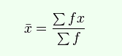
Figure 1: Formula for mean
Source: (Glendinning 2012)
Standard Deviation: The deviation from the mean value is represented by the standard deviation calculation. The inconsistency among the data set can be determined by calculating standard deviation analysis. The formula for calculating standard deviation analysis is below:
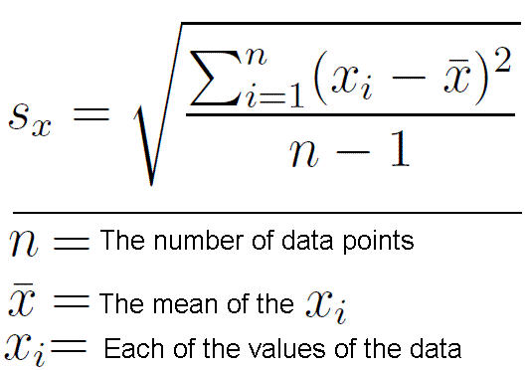
Figure 2: Formula for STD
Source: (Van Dyke, et al, 2009)
Types of Graph: Different types of a graph such as the bar chart, pie chart, column chart, trend line and also different charts are used mainly to represent the data in a summarized way so that the outcome of the data analysis can be understood so easily.
As planned a close-ended survey questionnaire has been designed. The survey has been conducted within 100 employees of Yahoo selected through the convenient sampling method. Convenient sampling is choosing the sample participant with enough flexibility and ease of reach. The survey questionnaire designed is below:
Name of the Customer:
Age:
Nationality:
Questions | Strongly Disagree | Disagree | Neutral | Agree | Strongly Agree
I prefer working at home rather than offices
I think productivity remains same irrespective of my workplace
I like to work in home only at emergency time
I will be happy if Yahoo allows me to work in offices regularly
I think professionalism gets hampered in home environment
I will be happy working in the desk of office regularly
I like the office environment more than the home environment
The application of the mentioned statistical techniques based on the data collected from the survey questionnaire is presented below:
Mean, median and mode calculation
Question 1:
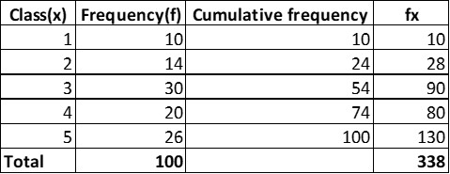
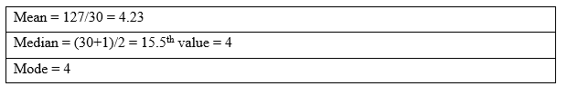
Question 2:
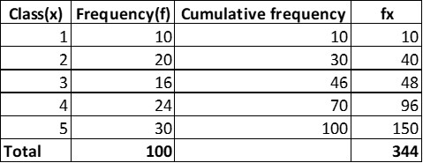
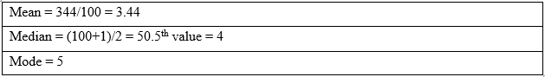
Question 3:
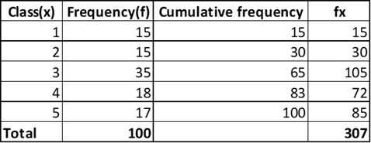
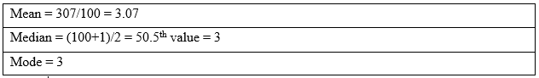
Question 4:
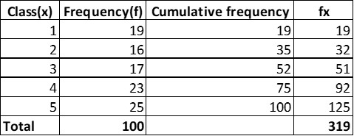
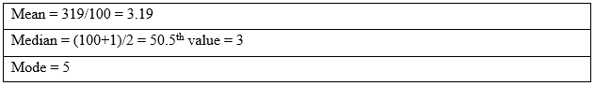
Question 5:
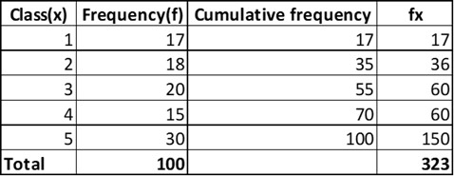
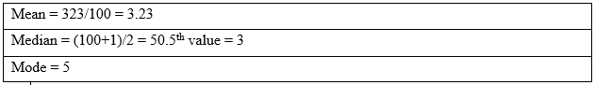
Question 6:
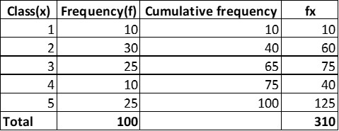
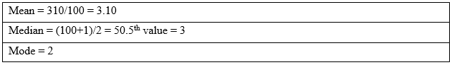
Question 7:
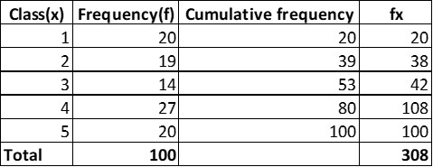
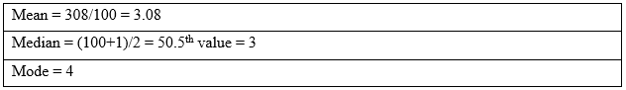
Standard Deviation Calculation
Question 1:
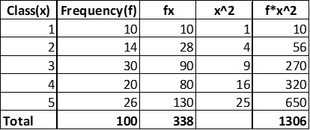
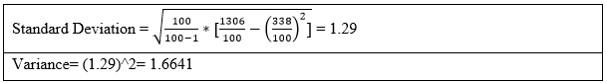
Question 2:
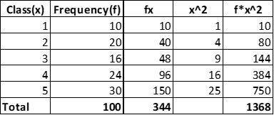
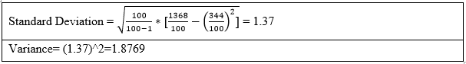
Question 3:
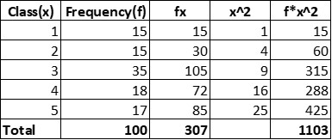
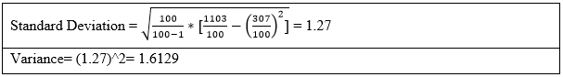
Question 4:
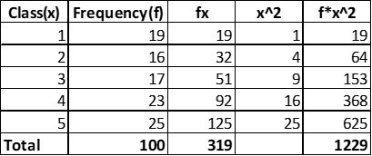
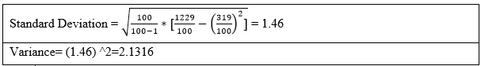Question 5:
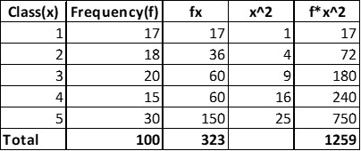
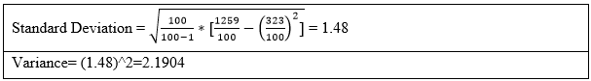
Question 6:
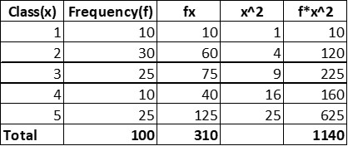
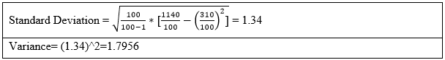
Question 7:
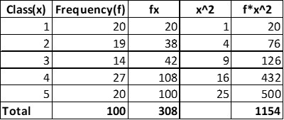
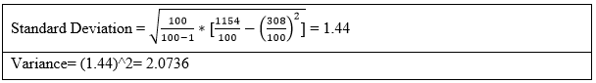

Basic computer uses for numerical handling – excel spreadsheets, databases
Computer applications have made the data analysis far easier as by using computer applications such as Excel spreadsheet and database management software inconsistencies can be avoided to large extent and also accurate fast data analysis can be conducted with ease. Excel spreadsheet is the combination of thousand sales by which fast calculation can be conducted and data pattern and relationship can be drawn with ease (Hoyles et al, 2010). The database is the combination of thousands of sales which help to record and organize the data effectively and help make the data usable in taking effective decisions. The application of basic computer software in the Yahoo’s survey data analysis is presented below:
Graphs and charts based on the survey result

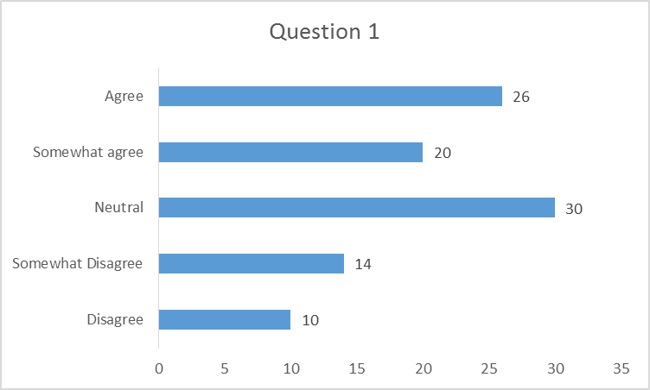
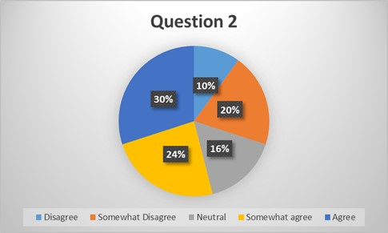
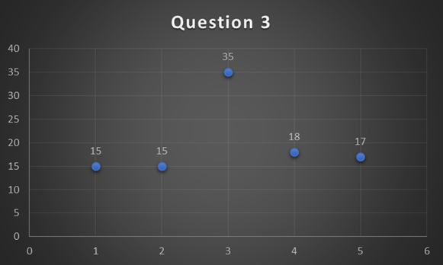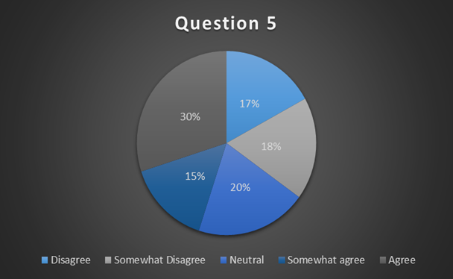
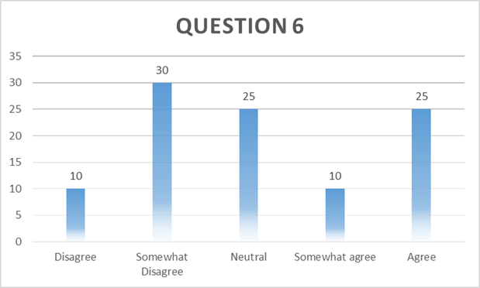
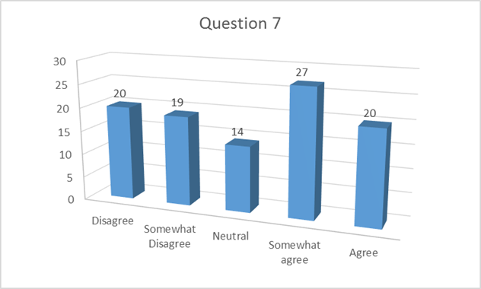
The above graphs have been produced by using Microsoft Excel program based on the survey response given the sample participants. The graphs have helped to understand the response pattern of each question effectively.

The development of skills needed to utilize information gathered in a critical and analytical way
To solve the underlying problem of working from home both primary and secondary data have been considered and analyzed. They depict the result from information the analysis need to be analytical and critical as well and should follow a consistent flow. At first, the analysis of the survey result has been done below in a precise way:
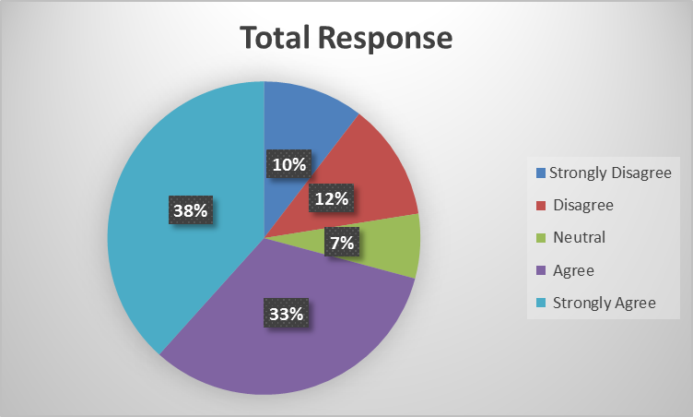
Figure 3: Total response of the survey participants
Source: Author
The overall survey response pie chart shows that most of the selected Yahoo’s employees have agreed or strongly agreed with the given statement that indicates that most of the employees feel comfortable working at home and they also believe that their productivity remains same irrespective of their workplace. However, they would like to work in the office if they are allowed and they also firmly believe that working in the office brings more professionalism and excellence in the workplace. The survey data can be further analyzed by the summarized mean, median, mode and standard deviation result:
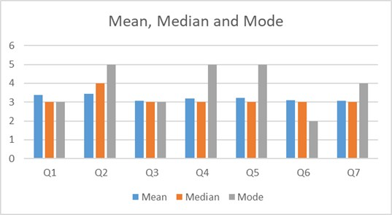
Figure 4: Mean, median and mode analysis
Source: Author
The mean result also signals the same as the result demonstrated by the pie chart as most of the questions have to mean of 4 to five which means most of the responses were either agree or strongly that provides a summarized result that employees are keen to work in the office if Yahoo can create favourable office environment.
The standard deviation result confirms the outcome more strongly. The summarized result can be demonstrated below:
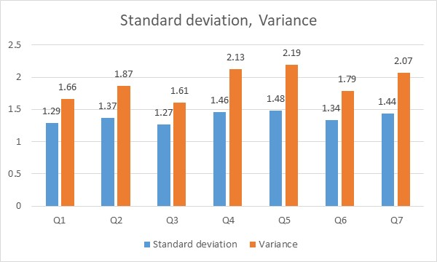
Figure 5: Standard deviation and variance analysis
Source: Author
The standard deviation result shows that there has been little deviation from the mean response although question 4,5 and 7 had the greater response variation than the other questions. These were regarding whether employees will remain the same level of happy if they are asked to work in the office and also their opinion regarding whether professionalism gets distracted in the home environment. Yahoo will need to be extra careful in these areas to develop solutions for the underlying problem.
Secondary data analysis
Working at home rather than in offices is not a new concept. The concept is getting popularized day by day as because of the rising concern regarding the employee rights and all and companies like Airbnb and Google have been successful with this strategy (Laursen, and Thorlund, 2010). The increase in a number of employees working in the home can be understood from the below graph:
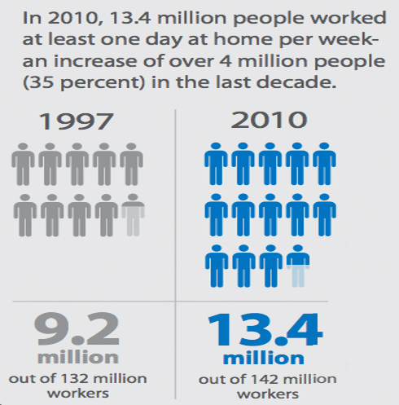
Figure 6: Employee trend working at home
Source: (Gionis, 2016).
From the above information, it can be seen that the number of employees allowed to work at home has drastically increased over the span of last decade and the percentage is expected to go up by further. The reason for this can be demonstrated by below survey result:
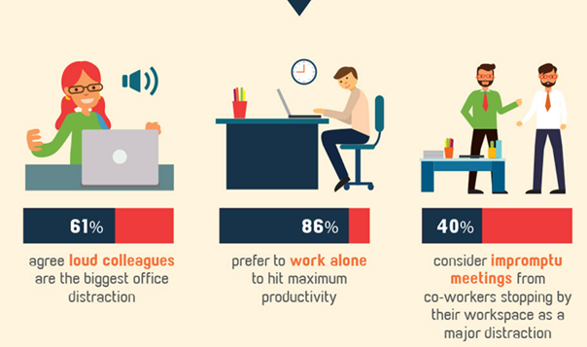
Figure 7: Employee trend working at home
Source: (Fifield, and Power, 2016)
The result shows that majority of the employees prefer to work alone and their productivity goes higher when they work alone compared to meeting with colleagues and amidst of distractions. The sectors in which home-based work is mostly practised can be understood from below chart:
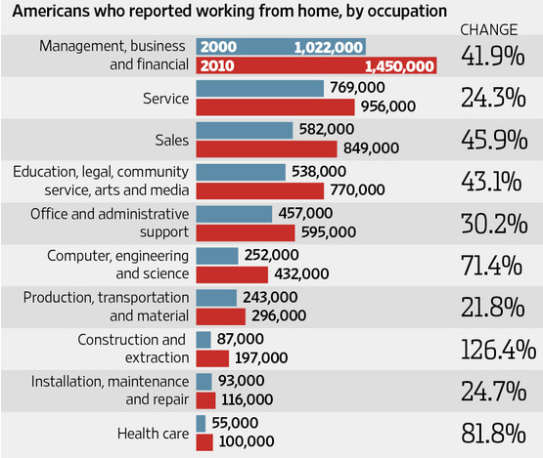
Figure 8: Sector categorization of employee working in home
Source: (Downing, and Clark, 2016)
The above chart shows that management, business, financial and service sectors are the ones that allow their employees working from home but the number is decreasing though because of the extra advantages and ill practices took by the employees which are exactly the Yahoos’ problem. From the above primary and secondary data analysis, the following recommended steps can be taken by Yahoo to resolve the problems presented:
- The company shouldn’t invite all the employees to come to the office at a time rather they should start shift based slot if they really want all their employees to work from the office.
- To keep the employee motivation and satisfaction at the same level in the office extra incentive must be ensured which may come as a reward or extra incentive compared to than that of the workplace.
- Before establishing the practice of not letting employees work from home the convenient office environment must be ensured by Yahoo so that they can ensure the optimum level of productivity from the employees.
These steps can potentially solve the problems that have been deployed in the underlying task.

The ethical implications of gathering information and matters of data protection
Ethical issues are sensitive enough hence close attention must be given to these issues. Ethical implications have been well maintained while collecting data for the underlying task. In primary data collection process through the survey questionnaire, no discriminatory treatment based on gender, race and other issues have been conducted. The privacy of the personal information has been maintained with care. Moreover, in terms of secondary data collection, the credible and reliable sources have been only taken into consideration.

Reference

Cottrell, S. (2010) Skills for Success: The Personal Development Planning Handbook (2nd edition). Hampshire: Palgrave MacMillan.
Downing, D. and Clark, J. (2016) Business statistics. Hauppauge, NY: Barron's Educational Series.
Fifield, S. and Power, D. (2016) Managerial finance. [Bradford, UK]: Emerald.
Gionis, A. (2016). Data Analysis. Data Science Journal, 12(0), pp.GRDI13-GRDI18.
Glendinning P (2012) Maths in Minutes: 200 Key Concepts Explained in an Instant, London: Quercus.
HoylesC, Noss R, Kent P & Bakker A (2010) Improving Mathematics at Work The Need for Techno-Mathematical Literacies, Abingdon, Oxon: Routledge.
Laursen, G. and Thorlund, J. (2010) Business analytics for managers. Hoboken, N.J.: Wiley.
Levin, P. (2014) Write Great Essays. Maidenhead: Open University Press.
Mercer, N. (2006) The Guided Construction of Knowledge: talk amongst teachers and learners. Clevedon: Multilingual Matters Ltd.
Pritchards, A. M. (2008) Studying and Learning at University: Vital Skills for Success in your Degree. London: Sage Publications.
Seely, J. (2015) Oxford Guide to Effective Writing and Speaking (2nd edition). Oxford: Open University Press.
Shulman, A. (2017). Alexandra Shulman on working from home: it's not an adequate alternative. [online] the Guardian. Available at: https://www.theguardian.com/money/2013/mar/02/alexandra-shulman-working-from-home [Accessed 20 Nov. 2017].
Van Dyke J, Rogers J & Adams H (2009) Fundamentals of Mathematics, Enhanced Edition, Belmont, CA: Cengage Learning.
van Emden, J. & Becker, L. (2010) Presentation Skills for Students (2nd edition). Palgrave Macmillan.

