Effective Team Work and Communication Assessment 1
Oana Pantiru ( student ID: 2017912)
Lecturer: Timothy Hopkins
Cert HE Skills for the Workplace (Health and Social Care)
Module code: BMSW4002_LON

Table of Contents

1 Introduction ………………………………………………………………………………. 2

2 Models of Communication …………………………………………………………..….. 2

2.1 Shannon and Weaver ……………………………………………………………… 2

2.2 Schramm ……………………………………………………………………………. 4

2.3 Berlo ………………………………………………………………………………… 5

3 Methods of communication ( Verbal, Non-verbal, Listening) ………………….….…7

4 Conclusion ………………………………………………………………………………. 7

5 References …………………………………………………………………………...…. 8

INTRODUCTION
Effective communication is the most significant part of team work and requires updating every person without assuming that the person has the same information. This report will shed light on various models of communication and their needs along with their examples in real life. It will also refer to various case studies for explaining the importance of communication and the various problems because of poor communications along with the ways in which they can be solved.

Models of communication

Communication is the way people can exchange their ideas thoughts opinions and suggestions. Communication has been categorised into three forms such as verbal communication nonverbal and textual. There are some models of communication is available such as linear model and another is transactional model these are the most popular models of communication.
By using this model sender can easily send their opinions and thoughts to the receiver. These models are very important for different schemes such as transferable skills through which people can transfer their qualities and skills to other people and exercise their personal responsibilities as well.
These models are useful for knowledge and understanding skills because when people have knowledge but they do not know how to communicate with others then it will become waste of their knowledge and understanding as well (Csányi, 2020). Show with the help of proper communication models knowledge and information can be shared by one person to another person and they can share some facts and reliable information as well.

Shannon and Weaver Model of Communication
This model of communication was introduced by Shannon and Weaver for developing effective communication between the sender and receiver. This also helps in analysing the factors which affect the communication process known as noise. Initially it helped in improving the technical communication. Various concepts are included in this model including source, transmitter, noise, message, channel, information destination, and receiver, decode and encode. This can be evidenced from the example of Thomson who made a call to the assistant for calling him as he wanted to see him. But unfortunately, some kind of noise appeared which was considered as transmission error and his assistant was not able to listen to complete message but heard only starting half of the message (Daylight, 2017). This is why; the complete message was not conveyed and the assistant was not able to listen to what Thomson wanted to convey. The main reason behind this issue was the noise which affected the flow of communication between them. Understanding about the noise can help in resolving problems which rose between the communication between assistant and Thomson. This is why; it is also known as mother of all models and also known as information theory model. The primary value of this model is to explain the ways in which messages are lost and distorted in the process of communication. The pressure points are also highlighted where communication is distorted. The given example of Pedro and Maria also helps in understanding this model because Pedro was already working in a noisy environment and suddenly he received a call from his wife but as he was not at a silent place he was unable to listen to what his wife tried to convey. Shannon and Weaver believed that noise is the major thing which interrupts a message when this is on its way from the sender to receiver. This can also interrupt the understanding of the message. The noise is basically divided into two types: external and internal. External noise happens when something from outside impedes the message. There is no interference because of either the sender or the receiver. But the sender can try to minimise the cause of the noise so that the quality of the message can be improved. On the other hand, in the Shannon and Weaver model the internal noise is happened when the sender makes mistake in encoding the message or the receiver makes mistake decoding the message (Xu and Zhang, 2021). This can be happened due to two major reasons and two places. If it happens at encoding, then this can be due to the misspelling a word in the message and if it happens at the place of decoding then this can happen as someone misinterprets a sentence when listening or reading. For instance, the internal noise can be due to the headache which becomes obstacle between the concentration and speaking with heavy accent or this can also happen when the sender mumbles while speaking. Therefore, it is also must to have effective communication skills in this case as if there is any kind of noise in between the communication then the sender can take the feedback from the receiver to ensure that they have received the accurate message. The communication skills of the sender as well as the receiver must be efficient for the quality of the message being conveyed. From my workplace experience I was able to identify one particular situation which can describe this model of communication. I remember one day returning from work and waiting in the bus station. I received a phone call from somebody from the hospital where I work and told me that I missed an appointment that day. I replied that I didn't have any appointment to attend. Actually it was my teamleader asking if any of my patients missed the appointment that day.

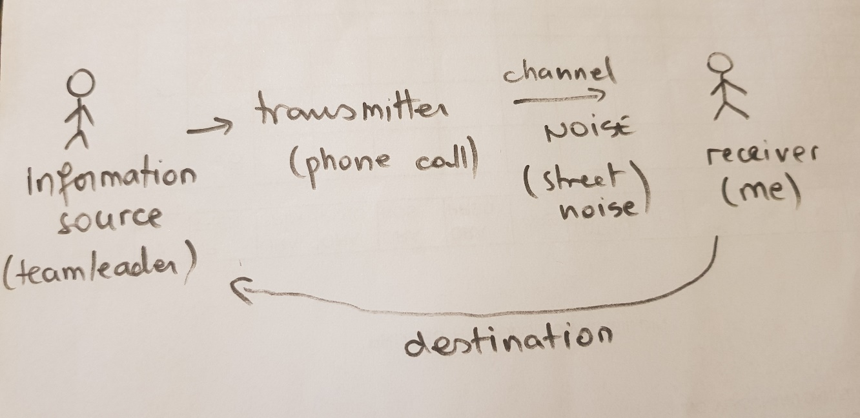
Drawing created by the author

Schramm model of communication

Schramm considered the communication model as circular instead of linear and makes use of classical approach for explaining the flow of communication. The main basis of the model is that the message must be understood between the sender and the receiver. The main elements of this model includes sender or encoder, interpreter, message, decode or receiver. This is considered as two way highway because at the first time the sender sends the message to the receiver but after receiving the message, the receiver sends again a message which makes him the sender and the sender becomes the receiver. This means that sender and receiver are necessary for communication. Both are equally required for improving the effectiveness as well as the interpretation of the message. This is evident as when the receiver gets the information sent by the sender but he is not able to comprehend the message sent by the sender then the entire communication process is of no use. This is why, encoding and decoding both are equally important for the effective communication. This can also be analysed from the model that communication is not considered to be complete until the sender gets any kind of feedback from the receiver regarding the receiving of the message (Kimmel and Mutto, 2019). This is why; unlike the traditional models of communication, this model of communication follows a bidirectional flow of communication. This is possible only when the sender and receiver interchange their roles. Firstly, the message starts with the sender encrypting the message and sending it to the receiver. This is then followed by the receiver decoding the message and understanding it. After this, the receiver becomes the sender as they need to send the feedback for the message they received to the one who sent the message. The sender now becomes the receiver now and the sender is now the one who was the receiver now. This model can be evident in any example where the receiver gives a feedback message to the sender regarding whether they have received the information or not (Lin and Lin, 2020). In this case, there are fewer chances of misunderstandings or misinterpretations. This is how; this model has more practical usability than any other model of communication.

Berlo’s Model of Communication

This model of communication is somewhat different from the others because when the Aristotle considered speaker as the most important part of the communication, this model focuses on the emotional aspects of the sender and the message. This is based on the SMCR model which means stands for source, message, channel and receiver (Llopis-Lorente and et.al., 2017). These are then divided into further aspects. The source is divided into various aspects such as communication skills, attitude, knowledge, social system and culture. Message is then classified into various sections including content, element, treatment, structure and code. The channel is then classified into hearing, tasting, seeing, smelling and touching. Receiver includes decoding. This means that communication of the message is affected by various factors along with sender and receiver. This can be evident from the example that one of the Professors sends the message in a very complicated manner or vocabulary to the receiver. The people of village were the receiver who was not able to understand the complicated language (Timony, 2020). This can be explained from the Berlo’s model of communication where the communication skills and attitude of the sender are most important for the effective conveying of the message. This can be evident from other example also where a patient who was 93 years old had hip mobility issues and were prescribed some techniques through physiotherapy terms such as extension, flexion etc. The physiotherapist double asked for the feedback where he assured that the message is received by the patient correctly. But after 10 days, when the patient came for check up he admitted that he did not properly understood the message and also forgot the specific terms.

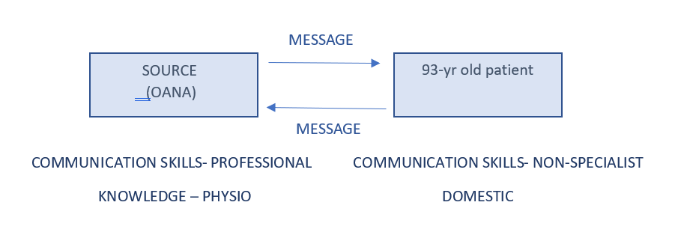
Diagram created by the author

This is why, the Schramm model was followed but the Berlo’s model was not followed as the receiver was not able to decode the message properly (Alshanqiti and Khozium, 2021). Therefore, all the aspects mentioned above are equally important for the effective conveying of the message. This communication model is helpful at workplace also because this model focuses on emotional aspect employment get benefit from this because when you were there was in managers show some emotional aspect to employees then it will definitely boost the morale of the employees and they get more encouraged towards the work. Along with this when you were employees get moral support from their senior and management then it’s definitely reflect in their work because employees can work more effectively and enthusiastically. Therefore this model is very useful for the workplace situation as well as it will increase the overall productivity of the organisation by providing emotional support to their employees.
The importance of communication and the skills can also be explained from example in which the company deals in delivering the medical equipment including orthotics, disposable equipments, walking aids etc. to various care homes. Various considerations need to be kept for these products such as proper sterilisation, free from bacteria, no marks on the surfaces etc. the products were regularly transported from Italy and Germany according to the needs of the customers as well as the businessman but after the Brexit, there was a great delay in the products which is creating various problems for the customers. This is why there is a need for the company to up to date the customers when they will have the goods physically then only they will take the orders. This is how communication skills are important for proper conveying of the message and effective communication.

Methods of communication

There are various methods of communication available through which people can easily communicated and share their opinions and thoughts.
Verbal communication
This communication occurs when communication take place between different people it can happen through face-to-face over the telephone and over video call as well. In verbal communication, people can easily transfer their opinions with the help of words.
Non-verbal communication
Nonverbal communication include various facial expression, posture ,eye contact gesture and hand movements. As per my personal experience is concerned whenever I get a conversation with my boss I always try to have nonverbal communication because it is more effective and I can express my views effectively.
Written communication
This type of communication takes place through email report and tweet as well. All this form of communication have same goal of sending information. Written communication is more concise and clear but sometimes as objective may not get achieved.

CONCLUSION
The report focussed on the importance of effective communication by shedding light on various models of communication including Shannon and Weaver’s, Schramm’s, Berlo’s etc. These models helped in analysing the ways in which communication depends on various aspects including the sender and receiver and can be affected by various factors including noise etc. It also highlighted the various problems which can be faced due to poor communication and those which can be solved by effective communication.

References

Elleström, L., 2018. A medium-centered model of communication. Semiotica. 2018(224). pp.269-293.
Csányi, V., 2020. The brain's models and communication. In The Semiotic Web 1991: Biosemiotics (pp. 27-44). De Gruyter Mouton.
Llopis-Lorente, A. and et.al., 2017. Interactive models of communication at the nanoscale using nanoparticles that talk to one another. Nature communications. 8(1). pp.1-7.
Kimmel, M.R. and Mutto, M., 2019. Report: An analysis of communication models and their applications since 1948. Copyrighted by Collibri Text.
Daylight, R., 2017. Saussure and the model of communication. Semiotica, 2017(217), pp.173-194.
Alshanqiti, A.M. and Khozium, M.O., 2021. Communication Models Comparisons: Tackling Approach for Corporate Communication. Psychology and Education Journal. 58(4). pp.4075-4079.
Timony, K., 2020. Say What You Mean to Say: Unpacking the Complexities of Communication Between Patients and Their Providers.
Lin, X. and Lin, C., 2020, March. Communication theories applied in mentimeter to improve educational communication and teaching effectiveness. In 4th International Conference on Culture, Education and Economic Development of Modern Society (ICCESE 2020) (pp. 870-875). Atlantis Press.
Xu, H. and Zhang, L., 2021, July. Urban Interactive Installation Art as Pseudo-Environment Based on the Frame of the Shannon–Weaver Model. In International Conference on Human-Computer Interaction (pp. 318-336). Springer, Cham.

