Guide to submitting an assignment via Turnitin on UWTSD Moodle

 | - Locate the UWTSD website, www.uwtsd.ac.uk , and click on ‘Quick Links’ as indicated
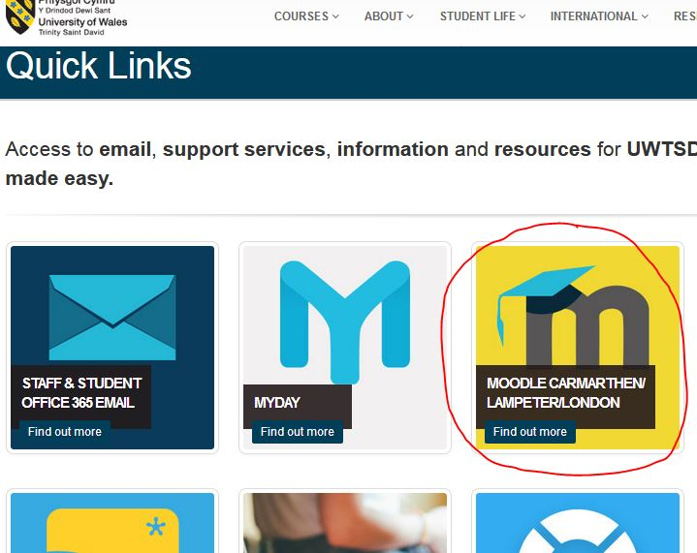 | - Now click on ‘Moodle’ ‘tile’ (its appearance may have changed slightly)
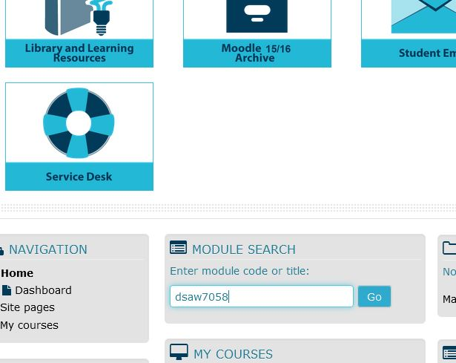 | - You will need to log in to Moodle using your student number and password (your student number is sent to you upon enrolment).  You should see the module you need (eg. ‘BMPF7005’) listed on the initial Moodle page, but if not, you can search for it as indicated
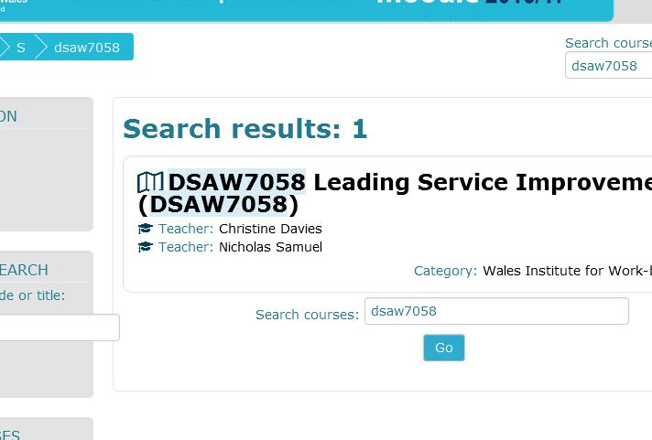 | - Click on the Module title to open the module
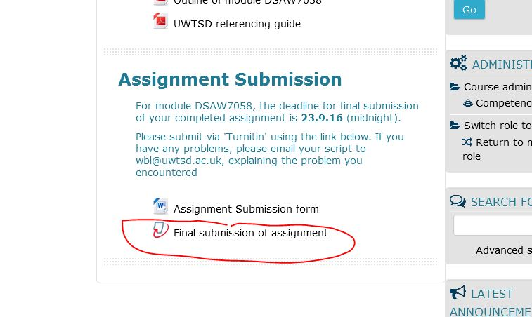 | - Scroll down to the section on ‘Assessment’ or ‘Assignment Submission’, and click on ‘Draft submission’ or ‘Final submission’ as required.  Make sure you do this well in advance of the deadline to ensure that any technical problems do not affect your submission.
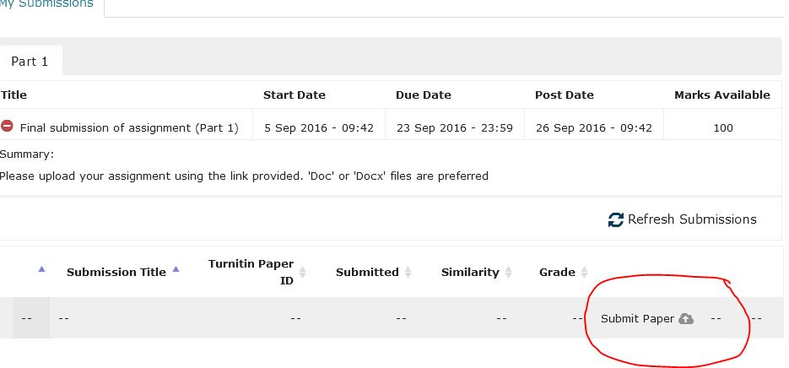 | - You should see a screen with the appearance as shown. Click on ‘submit paper’ in the lower right-hand corner as indicated
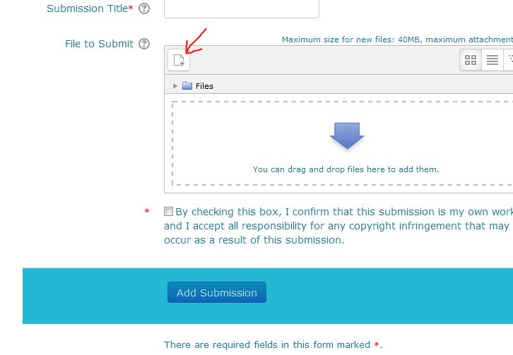 | - You now need to provide a title (eg. ‘Assignment for BMPF7005’), and then upload your document. If you open the folder containing this, you can drag and drop the document into the box with the arrow. Alternatively, click on ‘Add’ (indicated with the red arrow) to navigate to the file where your assignment is located. Lastly, click on ‘Add submission’
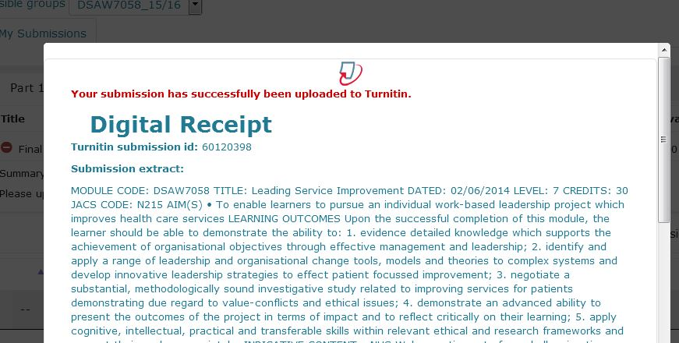 | - If you have submitted correctly, you should now see a page entitled ‘digital receipt’ as shown (close by clicking on top right hand corner). You will also receive an email acknowledging your submission.

