The University of Wales Trinity Saint David- London


Data Handling and Business Intelligence:
Component 2 Coursework: Essay

Student’s Name: Elena Roxana Pantiru
Student Number: 2237886
Module Code: LCBB5000
Module Title: Data Handling and Business Intelligence
Lecturer: Dr. Molly Jack
Date of submission: 24/08/2024
Part 1
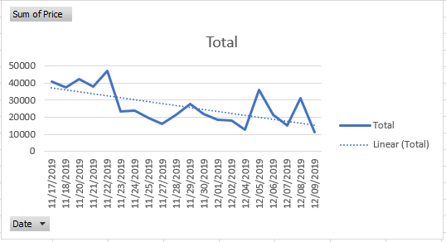
Question1:

Line Graph 1. Represents the sale trend over the months
Analysis
The sales trend represented in the provided graph, shows a fluctuating but overall declining sales pattern. Total sales vary significantly daily, with noteworthy increases in late November and early December. Despite these fluctuations, the linear trend line indicates a general declining sales trajectory, this fall could indicate a post-promotional drop-off or a decrease in customer engagement as time goes on. The initial increase in sales, followed by a gradual decline, could be attributable to seasonal variables or the impact of special marketing initiatives that originally drove higher sales volumes. For the company, this declining trend indicates the need for a strategic evaluation of promotional activity and customer retention strategies. Identifying the drivers of sales peaks and tackling the elements contributing to the decrease could help stabilise and possibly improve sales. Implementing targeted marketing tactics around major occasions, optimising product offerings, and increasing consumer interaction activities could be critical measures towards reversing the downward trend (Chaffey and Ellis-Chadwick, 2012).
Future recommendations
To address the observed downward trend in revenue and capitalise on the peaks revealed throughout the analysis period, the company could choose many strategic choices. At first, experimenting with new marketing channels may help you reach a larger audience and possibly attract new clients. For example, increasing social media interaction or engaging in targeted internet advertising may increase website traffic and sales. Secondly, improving client segmentation could lead to more personalised marketing activities. By analysing data to better understand customer behaviour and preferences, businesses may build targeted promotions that appeal to certain segments, increasing conversion rates.
While the analysis provides valuable insights, it is important to acknowledge potential limitations in the data that might affect the validity of the conclusions. One major restriction is the data's relatively short time frame of only a few weeks. This short time frame may not adequately capture longer-term sales trends or account for seasonal differences that could influence purchase behaviour.
Question 2:
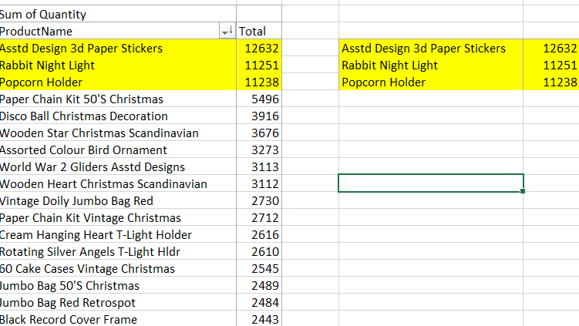

Pivot table 1: represents the most purchased products
Analysis
The data presented in the table shows the quantities of various products purchased, with a clear emphasis on identifying the most frequently purchased items. The three products with the highest purchase quantities are:
- Assorted Design 3D Paper Stickers - 12,632 units
- Rabbit Night Light - 11,251 units
- Popcorn Holder - 11,238 units
The products listed at the top stand out as the most frequently purchased items, each with over 11,000 units sold. This indicates these items have a high demand among customers, potentially due to their general appeal, affordability, or perhaps their utility as gift items. The list also includes several Christmas-themed items, such as the Paper Chain Kit 50's Christmas and Disco Ball Christmas Decoration. These products have lower quantities compared to the top three but still indicate significant seasonal purchasing patterns. It suggests that the sales are influenced by seasonal demand, particularly around the Christmas period, which might account for the high sales of these festive products.
Future recommendations
Given the popularity of these items, the company should consider maintaining adequate inventory levels for them, especially during peak seasons. Understanding the factors that contribute to their appeal, such as pricing, quality, or unique features, could help to inspire the development of similar items or product line expansions. This method is consistent with the concepts of effective product lifecycle management, in which constant innovation is critical to maintaining customer interest and sales (Kotler & Keller, 2016). The business could enhance visibility and sales of these top products through targeted marketing campaigns, particularly during periods of high consumer activity such as holidays.
Question 3:
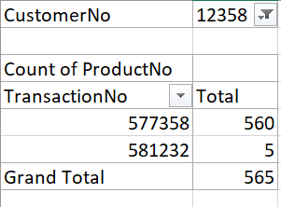

Pivot Table 2: showing the most bought products by a particular customer
Analysis
The provided data reveals the purchasing behaviour of a specific customer (Customer Number: 12358) across two transactions. The number of products purchased in each transaction is as follows:
- Transaction Number: 577358 = 560 products
- Transaction Number: 581232 = 5 products
Grand Total: 565 products
In the first transaction the customer purchased 565 products, which suggests this could be a bulk purchase, likely for business purposes or resale. In contrast, the second transaction involved the purchase of only 5 products, which is more typical of an individual consumer purchase. This dual purchasing behaviour suggests that the customer might be a small business owner or reseller who also occasionally makes smaller, personal purchases. Understanding this pattern is critical for tailoring marketing efforts, such as offering volume discounts or personalized recommendations based on the customer's buying habits (Kotler & Keller, 2016).
Future recommendations
Given the customer's purchasing behaviour, the company may benefit from using segmented marketing methods. For consumers like this one, who make both large and little purchases, the company may create targeted campaigns. For example, offering bulk discounts or special deals on large orders may encourage more regular bulk purchasing. They could also similarly introduce a loyalty program that rewards customers for both types of purchases could help in retaining such customers. By utilizing purchase history data to generate targeted product recommendations it could enhance the customer's shopping experience. For instance, after a large purchase, the business could follow up with suggestions for complementary products or restocking reminders, particularly for items that are likely to be consumed or sold quickly.

Question 4:
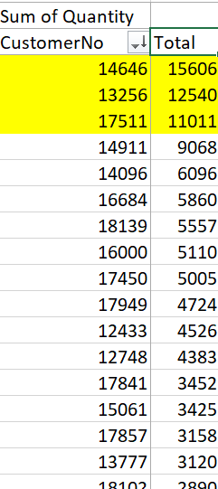

Pivot table 3: representing the most profitable segment customers
Analysis
The data provided displays the quantity of products purchased by various customers, with a focus on identifying the most profitable customer segments based on their total purchases. The top three customers, highlighted in yellow, are:
- Customer Number 14646: 15,606 products purchased
- Customer Number 13256: 12,540 products purchased
- Customer Number 17511: 11,011 products purchased
Understanding the characteristics of these high-value customers is crucial for tailoring marketing strategies and maintaining their loyalty. For instance, they may prioritize bulk purchasing discounts, faster shipping options, or personalized customer service. (Laudon & Traver, 2021).

Future recommendations
Investing in an efficient CRM system will enable the company to better understand and manage its connections with these high-value clients. A CRM can assist manage client interactions, preferences, and purchase history, allowing businesses to give more personalised offers and communication. (Laudon & Traver, 2021).
Question 5:
Based on the data analysis, there are many strategies for increasing profitability that might be recommended to the business. These strategies are aimed at utilising customer behaviour analytics, optimising product offerings, increasing customer retention, and enhancing marketing efforts.
- Segmented Marketing and Personalised Promotions
The data demonstrates that certain customers (e.g., Customer Nos. 14646, 13256, and 17511) frequently make substantial purchases, implying that they are either resellers or highly loyal clients. To capitalise on this, the company should use a segmented marketing strategy. Using client Relationship Management (CRM) systems, the company can track and analyse individual purchase behaviours to provide personalised promotions and discounts to distinct client segments. Personalised marketing not only improves customer happiness but can also dramatically raise sales and profitability by ensuring that promotions resonate with the specific demands of each consumer category.
- Expansion of High-Demand Product Lines
The data identified Assorted Design 3D Paper Stickers, Rabbit Night Light, and Popcorn Holder as the most frequently purchased products. To enhance profit margins, the company might extend its product lines around these high-demand items. This could entail releasing new varieties, colours, or complementary products that appeal to the same target audience. For example, if Rabbit Night Lights are popular, the company may consider producing similar themed products, such as night lights portraying different animals or characters, or even bundled packages with complimentary things such as bedding or wall decorations. By broadening its product offers within these popular categories, the company can boost average transaction value and stimulate repeat purchases, resulting in increased overall profitability (Laudon & Traver, 2021).
- Optimizing Inventory and Supply Chain Management
Effective inventory management is critical for maintaining profitability, particularly considering the large volume of purchases made by specific consumers. The company should consider introducing just-in-time (JIT) inventory management systems, which can reduce holding costs and waste by better aligning inventory levels with real demand. This method is especially useful when dealing with seasonal items, since it allows the company to avoid overstocking products that may have little demand outside of peak seasons.
If the company implements these strategies, it can significantly boost profitability by increasing customer satisfaction, driving higher sales, and reducing operational costs.

Part 2 –
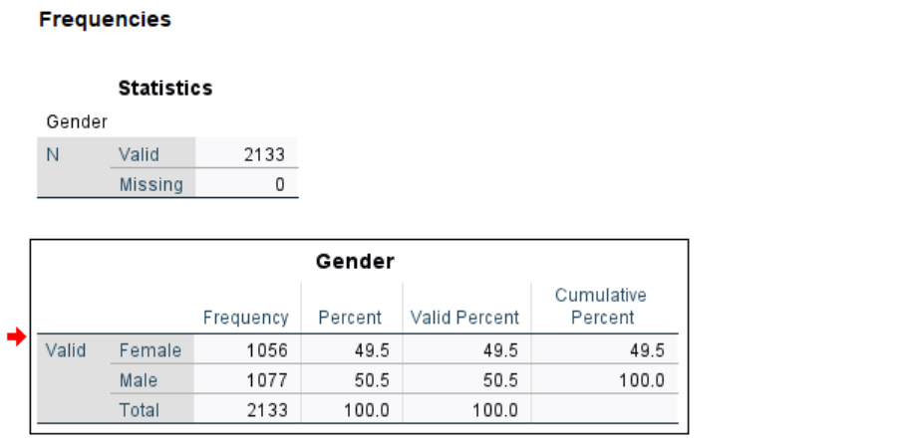
Question 1:

Frequency Table 1: shows frequency table of genders
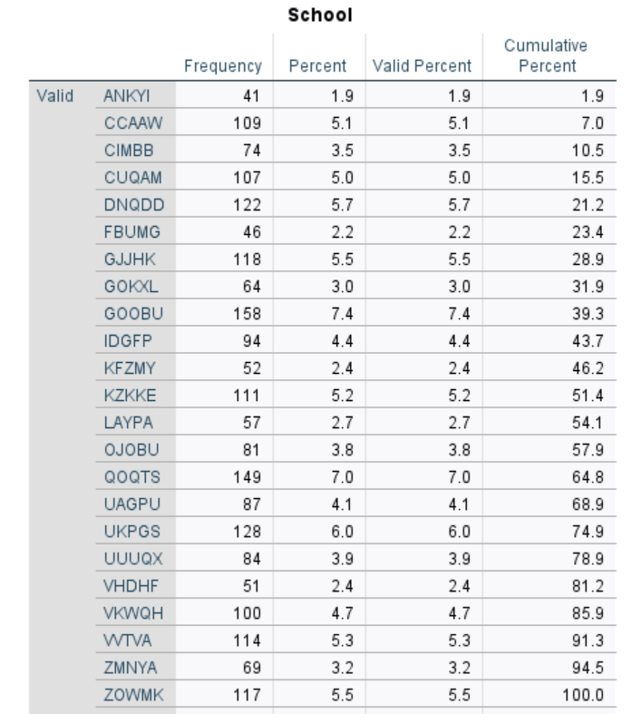

Frequency Table 2: Showing Gender distribution
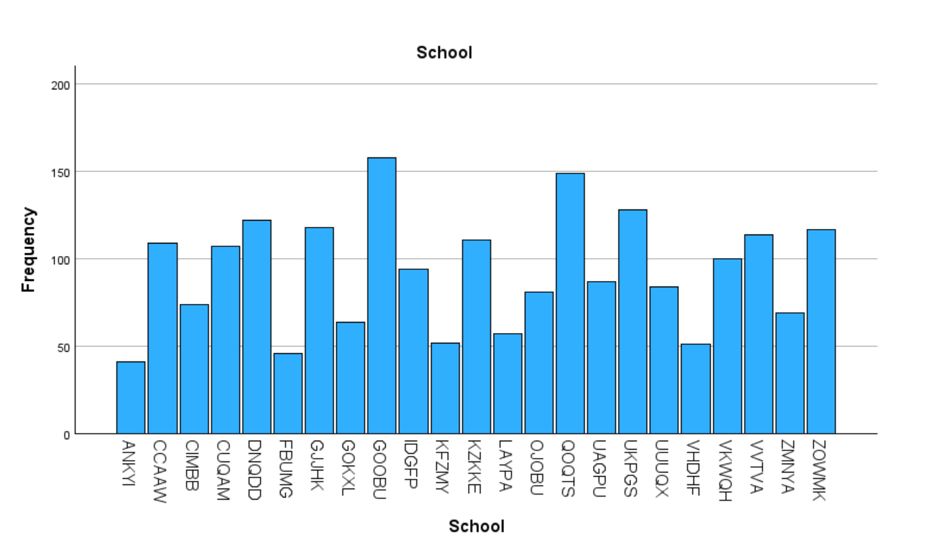
Bar chart 1: Illustrates student distribution across schools
Analysis
The SPSS frequency table shows the distribution of students by gender, with the following details:
- Female Students: 1,056 students, representing 49.5% of the total population.
- Male Students: 1,077 students, representing 50.5% of the total population.
The roughly equal distribution of male and female students indicates that there is no substantial gender imbalance in the student groups. Such a balanced gender distribution is critical when investigating further correlations between gender and other variables such as test scores or eligibility for reduced/free lunch, as it reduces the possibility of gender-based biases in the results (Field, 2018).
The frequency table and bar chart illustrate the distribution of students across various schools. The schools with the highest number of students include:
- GOOBU: 158 students (7.4% of the total population).
- UKPGS: 128 students (6.0% of the total population).
- QQOTS: 149 students (7.0% of the total population).
These schools represent the largest segments of the student population, while others like ANKYI and FBUMG have much smaller student bodies, with only 1.9% and 2.2% of the total population. Schools with larger student population may offer more diversified educational programs or resources, which may have an impact on average test scores or the number of children eligible for reduced/free meals. In contrast, schools with smaller populations may encounter resource allocation issues, which may have an influence on student performance (Moore, 2010).
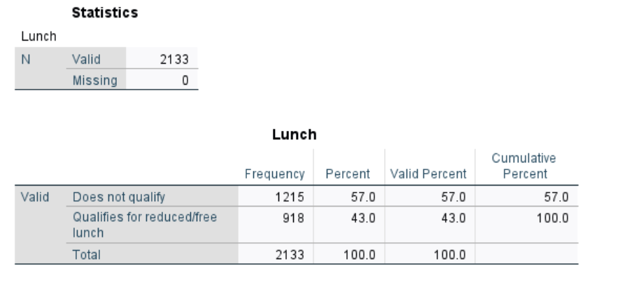
Question 2:

Frequency Table 3: Shows a breakdown of who qualifies for free lunch and who doesn’t
Analysis
The SPSS output provides a clear breakdown of the number of students who qualify for reduced/free lunch and those who do not:
- Students Who Do Not Qualify: 1,215 students (57.0% of the total population).
- Students Who Qualify for Reduced/Free Lunch: 918 students (43.0% of the total population).
According to this data, a significant part of the student population (43%) qualifies for reduced/free lunch, making up a sizable minority. The fact that more than half of the students (57%) do not qualify indicates a socioeconomic difference among the student population. The eligibility for reduced/free lunch is frequently employed as an indicator of socioeconomic status (SES), with individuals who qualify typically coming from lower-income families (Moore, 2010).

Question 3:
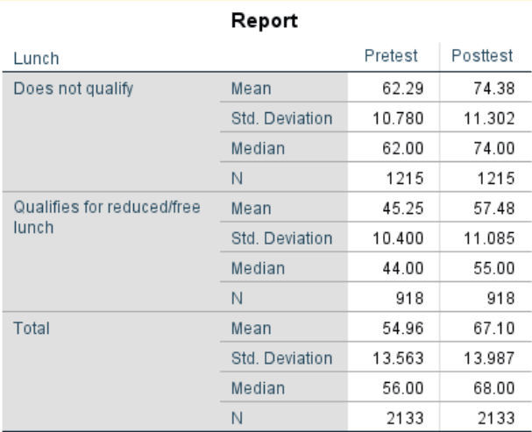

Frequency Table 3: Shows the descriptive statistics of the variable- lunch’
Analysis
The table provided shows the pretest and post-test scores of students, categorized by whether they qualify for reduced/free lunch or not. The key statistics provided include the mean, standard deviation, and median for both groups.
1. Pretest Scores
- Students Who Do Not Qualify for Reduced/Free Lunch:
  - Mean: 62.29
  - Median: 62.00
  - Standard Deviation: 10.780
- Students Who Qualify for Reduced/Free Lunch:
  - Mean: 45.25
  - Median: 44.00
  - Standard Deviation: 10.400
The mean and median pretest scores for students who do not qualify for reduced/free lunch are significantly higher (62.29 and 62.00) compared to those who do qualify (45.25 and 44.00). This suggests a noticeable performance gap between the two groups even before any interventions or additional educational support.
2. Post-test Scores
- Students Who Do Not Qualify for Reduced/Free Lunch:
  - Mean: 74.38
  - Median: 74.00
  - Standard Deviation: 11.302
- Students Who Qualify for Reduced/Free Lunch:
  - Mean: 57.48
  - Median: 55.00
  - Standard Deviation: 11.085
Similarly, the post-test scores also show a substantial gap between students who do not qualify (mean of 74.38, median of 74.00) and those who do qualify (mean of 57.48, median of 55.00). While both groups show improvement from the pretest to the post-test, the gap between the two groups remains consistent. The findings clearly show that children who do not qualify for reduced or free lunch regularly outperform those who do, both before and after the test. The improvement in scores from pretest to post-test in both groups suggests that some learning occurred.
Future Recommendation
Given the significant difference in test scores between the two groups, the school should consider implementing targeted interventions for students eligible for reduced/free lunch. This could involve more tutoring, better study materials, or even mentoring programs geared at enhancing academic achievement. The goal should be to close the gap between these two groups, so that socioeconomic status does not continue to influence academic achievement (Field 2018).

Question 4:
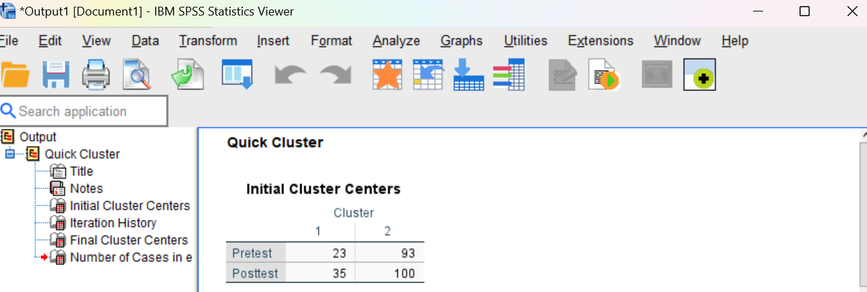

Table 1: presents the Initial quick cluster centres

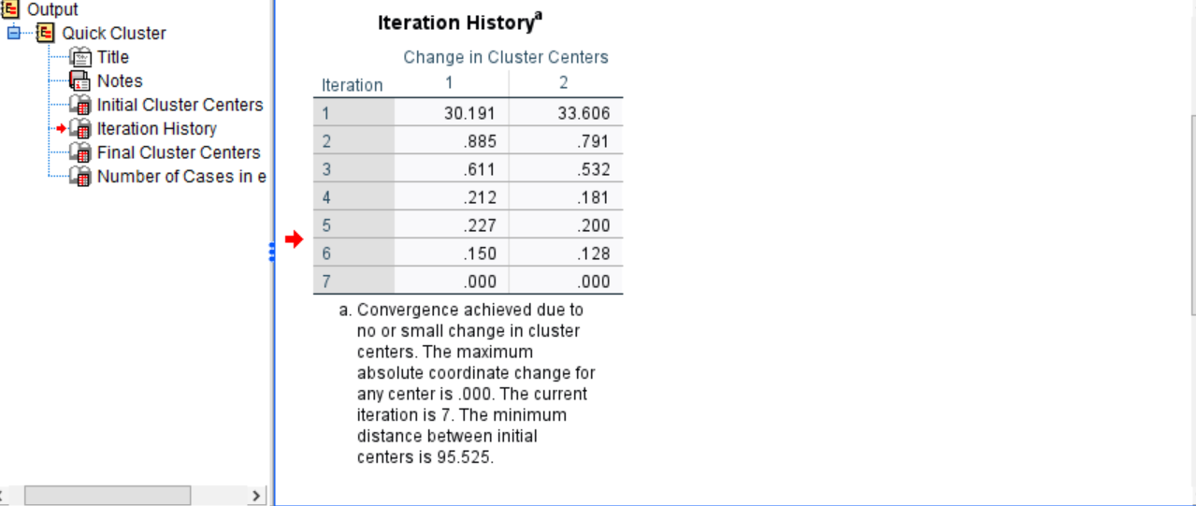

Table 2: shows the Iteration history

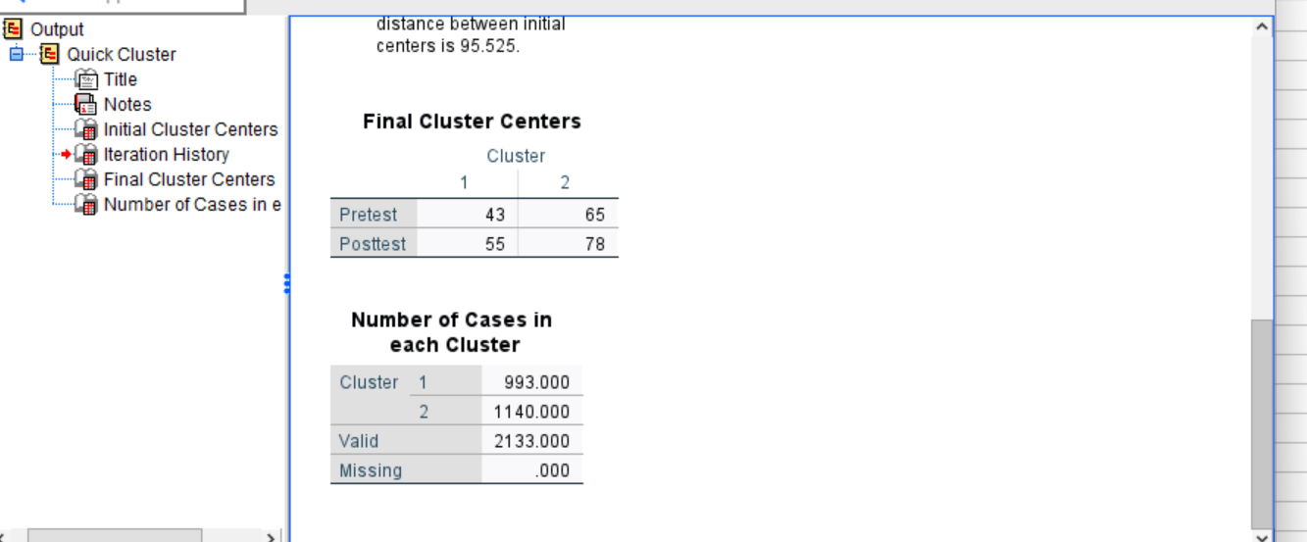
Table 3: present the final cluster centres

K-Means clustering works by dividing the data into a predefined number of clusters (in this case, two clusters). The algorithm starts by selecting initial cluster centres (also known as centroids), which are the initial points from which the algorithm will begin grouping the data. After the initial cluster centres are chosen, each data point in the dataset is assigned to the nearest centre based on a distance metric, typically Euclidean distance. This means that every student will be initially grouped into the cluster whose centre they are closest to.
Once all data points are assigned to clusters, the algorithm recalculates the cluster centres as the mean of all points assigned to each cluster. The algorithm then reassigns data points to the new cluster centres and repeats this process iteratively until the cluster centres no longer change significantly between iterations, indicating that the algorithm has converged on a stable clustering solution.
Both initial cluster centres are the starting points of the K-means algorithm process. The choice of initial cluster centres can significantly impact the final clustering outcome
Initial clusters centres
Cluster 1
Pre-test = 23
Post-test = 35
Cluster 2
Pre-test= 93
Post-test = 100
Cluster 1 represents students who had very low pretest and post-test scores. Cluster 2 represents students who had very high pretest and post-test scores. Over the iterations, as the algorithm reassigned students and recalculated cluster centres, it moved these centres closer to the actual mean scores of the groups of students, resulting in the final cluster centres.
Final cluster centres
Cluster 1
Pretest = 43
Post-test = 55
Cluster 2
Pretest = 65
Post-test = 78
The distribution of students across the clusters was:
- Cluster 1: 993 students
- Cluster 2: 1,140 students
This relatively even distribution suggests that the student population is split into two distinct groups, with a slight majority in the higher-performing group (Cluster 2).
Future Recommendations
- Support for students in Cluster 1
Students in Cluster 1 could benefit from targeted academic interventions. This might include catch up programs, personalized tutoring, or additional support to help them improve their academic performance. Given the lower scores in both pretest and post-test, it is crucial to provide these students with the resources that they need. The school could also help by engaging parents or guardians of students in Cluster 1 by offering resources or workshops that enable them to support their children's education at home. This can help reinforce learning outside of the classroom.
- Enrichment programs for cluster 2
For students in Cluster 2, the school could introduce enrichment programs that challenge these students and help them maximize their potential. They could also start recognizing the achievements of Cluster 2 students through awards or special programs can serve as a motivation for continued excellence and encourage other students to strive for higher academic performance.

- Different type of teaching
Teachers should consider adopting differentiated teaching techniques that cater to the diverse needs of both clusters.
- Regular reassessments
The school should implement a system for regularly monitoring the progress of students in both clusters. This could involve periodic reassessment using similar variables to ensure that the interventions are effective and that students are progressing as expected.
The K-Means clustering analysis has successfully identified two distinct groups of students based on their academic performance. These clusters provide valuable insights for the school in tailoring educational strategies to meet the specific needs of different student groups. By implementing the recommended interventions and continuously monitoring progress, the school can work towards improving the academic outcomes for all students.
Question 5:

Criteria | SPSS | EXCEL
Practicality | SPSS is highly specialized for statistical analysis, offering a wide range of built-in functions for complex statistical tests, data transformations, and clustering methods like K-Means.  However, it is less flexible for general-purpose tasks like data entry or basic calculations.  Practical Example: A university researcher uses SPSS to analyse survey data, applying advanced statistical tests like ANOVA or regression analysis to determine significant patterns in the data. | Excel is widely used for a variety of tasks, including data entry, basic calculations, and graphs. It is highly practical for small to medium-sized datasets and everyday business tasks. However, performing complex statistical analysis in Excel often requires additional manual setup which may provide inaccurate results.  Practical Example: A small business owner uses Excel to track daily sales, calculate totals, and create simple graphs to visualize monthly revenue trends.
Data Handling | SPSS Handles large datasets efficiently and is designed to process and analyse data without performance issues. It also produces high quality and accurate graphs.  Practical Example: A government agency uses SPSS to analyse large amount of data | Excel can handle large datasets, but good performance may decrease with very large datasets or complex calculations. Also, larger scale graphs require many adjustments for it to be accurate. Its functions are very limited compared to SPSS.  Practical Example: An accountant uses Excel to manage a company's financial data, using functions to calculate budgets, and perform pivot table analysis on thousands of data.
Cost | SPSS requires a paid license, which can be expensive, especially for individual users or small organizations. However, some institutions like universities often provide access to SPSS.  Practical Example: A market research firm purchases SPSS licenses for its analysts to conduct in-depth consumer behaviour studies | Excel is generally more cost-effective, with most versions included in the Microsoft Office suite, which is widely available in both educational and business environments. It is also subscription based.  Practical Example: A startup uses Excel as part of the Office 365 subscription to manage business operations
Is it difficult to use? | SPSS is more difficult to learn for beginners due to its focus on statistical analysis and the complexity of its functions. Users often require formal training to become proficient. However, for those with a background in statistics, SPSS is user-friendly.  Practical Example: A psychology graduate student undergoes training to use SPSS for their exam | Excel is generally easier to learn and use, particularly for beginners. Excel is often the first tool that students and professionals learn.  Practical Example: A new employee quickly learns to use Excel for tracking project timelines and generating basic reports

Conclusion
The comparison of SPSS vs Excel indicates that each tool has specific strengths and limits, making them appropriate for different sorts of data analysis tasks. SPSS is a powerful tool specifically developed for advanced statistical analysis, giving a wide range of capabilities for managing big datasets, executing complex statistical tests, and generating high-quality graphs. However, its complexity and cost may provide difficulties for people without a strong experience in statistics or for people with a small budget.
Excel, on the other hand, is a powerful and easily available application that excels at data management, basic analysis, and reporting. While Excel can perform basic statistical calculations, it lacks the depth and precision required for more complex analysis, which is where SPSS thrives.
In conclusion, the choice between SPSS and Excel should be driven by the task's specific requirements. SPSS is the best alternative for advanced statistical analysis and research, despite its steeper learning curve and higher cost. Excel remains a practical and efficient solution for more everyday data operations, particularly when costs and ease of use are the most significant factors. The user could also combine them e.g. use excel for sorting data and SPSS for analysing it.

References
Chaffey, D. and Chadwick, F.E. (2019). Digital Marketing. 7th ed. Pearson UK.
Chaffey, D. and Ellis-Chadwick, F. (2012). Digital marketing : strategy, implementation and practice. 5th ed. Harlow: Mexico City.
Field, A. (2018). Discovering Statistics Using IBM SPSS Statistics. 5th ed. Los Angeles: Sage Publications.
Kotler, P. and Keller, K.L. (2016). Marketing Management. 15th ed. Boston: Pearson.
Laudon, K.C. and Traver, C.G. (2021). E-commerce : business, technology, society. Harlow, England ; New York: Pearson.
Moore, D.S. (2010). The basic practice of statistics. 5th ed. New York: Freeman.

