

Digital Skills and Research Methods
(BMSK4003_LON)

Student: Andreea Ioana Pitica

Student ID: 1714745
Lecturer: Ze Zook

Table of Contents

Introduction 2
Evaluating the effectiveness of the use of cloud computing and smartphones 3
1. Cloud computing 3
2. Smartphones 4
Social media as a tool of marketing 6
Conclusion 8
Reference list: 9
Appendix 1 – Evidence of professional online presence – Facebook 13
Appendix 2 – Evidence of professional online presence – LinkedIn 14

Introduction
The purpose of this report is to evaluate the effectiveness of the use of cloud computing resources and smartphones in hospitality industry at Ibis Hotel, in part one. The second part describes how social media is used as a tool of marketing at Ibis Hotels. In the end of this report, a professional online presence for Facebook and LinkedIn will be illustrated to evidence this research.

Evaluating the effectiveness of the use of cloud computing and smartphones

Cloud computing
Cloud computing allows companies to manage online resources and to access their information virtually at any time and any place. Mell and Grance (2011) say that cloud computing is “a model for enabling ubiquitous, convenient, on-demand network access to a shared pool of configurable computing resources (e.g., networks, servers, storage, applications, and services) that can be rapidly provisioned and released with minimal management effort or service provider interaction”. Cloud computing offers many benefits for the workplace. Using cloud services companies can increase productivity because information can be accessed from every location and can be easily shared. With cloud technology, employers can hire from any location and they can reduce the cost of managing IT systems, without purchasing expensive software and hardware. Furthermore, cloud computing allows employees to be more flexible at work, because they have opportunity to access data from any place, from work, home or when they are in holiday.
Companies are reducing the use of hardware and infrastructure by using cloud storage. Because there are many providers, companies must choose one who offers the maximum storage for low cost and which can keep data safe. The two most popular cloud storage services are Dropbox or Google Drive.
Dropbox is the oldest cloud storage, it offers 2GB for free and it can be increased to 16GB if linking Dropbox to social media or if friends are referred. Business pricing starts from £10 per user each month, or it can be used for free with a 30-day trial. Google Drive is a pure cloud storage, which works with apps like: Google Docs, Google Sheets, and Google Slides. Google Drive is a usual choice for Android owners as it is already integrated. Compared with Dropbox, Google Drive offers 15GB free storage and 1TB for 7.99 per month (TechRadar Website, 2018).
Google Drive offers more storage and price plan flexibility, it has 100 GB plan for more storage, while with Dropbox people can buy more storage only as business users. Meanwhile, Dropbox is considered being a better cloud storage for synchronization (files can be automatically copied to different devices), as it uses block-level synchronization. Furthermore, Dropbox offers same flexibility as Google Drive regarding file sharing, but business account holders can set passwords and expiry dates on links, which help users protect their data for long term (Cloudwards Website, 2018).
Hospitality industry has been suffered transformation in the last years because of mobile technology and the millennial generation. Guests are demanding individualized experiences before, during and after their arrival. Hoteliers are using cloud-based information systems to accomplish tasks like: managing staff needs, reservations, check-in, financial operations, guest data management, loyalty tracking, kitchen and housekeeping. As more and more consumers share information about themselves and their preferences, hotels can engage guests with personalized offers and services that will increase revenue in addition to boosting brand recognition and solidifying customer satisfaction, leading to increased bookings (Oracle Website, 2016).
Ibis Hotel uses Oracle Hospitality OPERA Cloud services, a next-generation hotel management platform that is mobile-enabled and cloud-based. The advantages of using cloud for Ibis Hotel are: improved relationship between guests and hotel, fully secure information processing, teams spend less time on administrative tasks and cost savings (Accor Hotels Group Website, 2018).

Smartphones
In 2007, the first iPhone was released. Only after eleven years, smartphones are no longer regarded as gadgets, but as necessary tools. Statista displayed a forecast about smartphone user numbers in the UK from 2015 to 2022. According to it, in 2022, the number of monthly active smartphone users is projected to reach 53.96 million, an increase of over 12 million new users from 41.09 million users in 2015 (Statista Website, 2018).
In 2017, the Labour Force Survey discovered that there are approximately 32 million people in employment across UK. With 10 million more smartphone users than employees in the UK it is important for employers to know how they can benefit from this. Bring Your Own Device (BOYD) means letting employees use their own devices at work (phones, laptops, tablets, and other devices). When employees are connected to a wireless internet network, they can complete tasks without sitting at a desk or in an office. This flexibility can increase productivity, communication can be improved, and costs can be reduced (Emanuelli, 2017).
In a survey conducted by Samsung and Frost & Sullivan to 500 business leaders, respondents report that smartphones increase productivity in the workplace. The research indicated that, by using smartphones, they earn almost an hour of work time every day and reported an increase in productivity by 34% percent. This productivity increase is because some applications were used within workplace. In these days, 51% percent of employees are using application mandated by employers (Turek, 2016). In contrast to this research, a CareerBuilder survey on 2,000 employers showed that nearly 20 percent of employers believe workers are productive for less than five hours a day. Fifty five percent of employers think that this decrease in productivity is because the use of phones in workplace, which are the biggest source of distraction (Farber, 2016).
In 2017, Ibis Hotels launched a new concept, transforming the way guests are welcomed into a hotel by using mobile technology. This concept transforms traditional reception areas into vibrant revenue-generating spaces, and improves customer service, operational efficiency and employee satisfaction. AccorHotels developed FOLS Mobile back in 2017, and then a partnership with Microsoft was made. Employees can access all information they need by using their mobile devices. They can access: check-in, information about customers and their preferences, housekeeping and maintenance, only with one app. In some hotels across UK employees are greeting customers on arrival with room keys in hand. With FOLS mobile software, employees are happier and more satisfied at work, but also a fully personalized experience will be remembered by customers (Hospitality-on Website, 2017).
Housekeeping team is using this application which allows team members to see their tasks from their own smartphones. Check-ins and check-outs from reception are immediately received by housekeeping manager who will send messages to team members. Cleaning lists with rooms ready to be cleaned are displayed each morning and housekeepers receive updates about check-in and check-out hours. Housekeepers use this application to send pictures with different maintenance problems found in rooms. If a housekeeper detects a maintenance problem in one room, she can inform her supervisor and the supervisor will send the information to maintenance team. In this way problems will be solved before guests will check-in. Housekeepers inform manager about items found in rooms (can use pictures) and in this way reception will be immediately updated.

Social media as a tool of marketing
Social media has become an important tool of marketing for companies which want to advertise to a wide range of consumers. Social media has transformed the mode companies are communicating with customers, and it is cost effective compared with traditional advertising. Chi (2011, p. 46) describes social media marketing as a “connection between brands and consumers, [while] offering a personal channel and currency for user centred networking and social interaction.” In addition, Kaplan and Haenlein (2010, p. 61) define social media as “a group of Internet based applications that build on the ideological and technological foundations of Web 2.0 and allow the creation and exchange of user generated content.” Social media changed the way how companies are communicating with customers. Social media is seen as a mean of advertising, which every brand wants to use. Social media contribute to a direct relation between brands and online users. On social media, users can communicate, influence and retain a strong position towards brands.
Social media have become an indispensable aspect for hospitality industry. Because mobile technology has transformed the way people travel, people are now using mobile devices to plan their trip. While people are looking for total travel experience, booking companies are becoming more and more focused on mobile technology. By using social media channels, hotels encourage their customers to share their experiences. While many social media websites are available, the most often used for hospitality are: Facebook, YouTube, TripAdvisor, Myspace, Twitter, LinkedIn, and Flickr (McCarthy, Stock and Verma, 2010). Verma et al., (2012) think that people are using different social media channels depending on every travel stage, while Cox et al., (2009) argued that social media demonstrated his most important role in the stage before travel, when people explore social media to plan their trip, search for information and to take a decision about their trip.
Chu (2011) said that group members from Facebook have a positive view regarding social media and advertising and that it is probable for them to join a company’s Facebook group to receive promotional information. Chu suggests that young users have the most positive attitude regarding social media advertising, meaning that social media can be used for marketing purposes. “Facebook promotes a consumer to consumer approach, exploited by consumers to share experiences and create a common knowledge on products and services; on the other, it provides managers a direct channel for communicating with clients through a business to consumer approach” (Di Pietro and Pantano 2012, p. 21).
According to Technopedia Website (2018), user-generated content (UGC) is “any digital content that is produced and shared by end users of an online service or website. This includes any content that is shared or produced by users that are members or subscribers of the service, but it is not produced by the website or service itself”. UGC means “the sum of all ways in which people make use of social media, usually applied to describe the various forms of media content that are publicly available and created by end users” (Kaplan and Haenlein 2010, p. 61).
Travel-related UGC is very important for future travellers to know previous travellers’ experiences (Sigala et al., 2012). Consumers trust more on shared experiences from other travellers through social media compared with information from tourism websites and advertising. (Fotis et al., 2012). When people are searching for a hotel, they can be influenced by good and bad reviews, that can change someone’s attitude regarding an accommodation. (Vermeulen and Seegers, 2009). For example, Verma et al. (2012) demonstrate that a hotel with bad reviews, it is less probable to be booked by travellers.
Ibis Hotel is using many social media channels like: Facebook, Foursquare, Google Places, TripAdvisor, Twitter, LinkedIn, Holiday Check, YouTube, Snapchat, Twitter, Qype, Yelp and blogs. To manage all this social media platform, AccorHotels created the AccorHotels Social Desk, which is a platform used as a tool for social media, with trainings, education and content for each hotel. With this tool, employees can find user generated content, see from where messages have been sent, and share previous approved content from company. With AccorHotels social Desk, hotels can find future customers, observe guest interactions, and send messages to guests about their experience. As a result, “AccorHotels has doubled their social media adoption across their hotels through training and inspirational content. This increased adoption and engagement has allowed them to grow their social following 4.5 to 10 million people. By monitoring requests and chatting with customers daily on social, customer satisfaction ratings are at an all-time high” (Hootsuite Website, 2018).

Conclusion
The hospitality industry has changed during last several years because of technology evolution. To be successful in hospitality industry, hoteliers must be open to use new technologies to ensure satisfaction for travellers. Using cloud in hospitality industry is important because customers want their personal data being safe. Furthermore, cloud computing allows hoteliers to improve staff collaboration, because they can respond easier when guests need assistance. This way, guests will be happier and will give higher reviews for theirs experiences.
In the hospitality industry, using devices – such as smartphones or tablets – at the front desk will simplify the check-in and check-out process. By using smartphones, hoteliers will improve employee satisfaction, they will save time and will focus more on guest experience. In addition, by using smartphones in workplace, communication between employees will improve and productivity will increase.
Social media has changed the relationship between guests and hoteliers. Guests are sharing experiences with others through social media channels. First thing a person will do before choosing one hotel is to read the reviews about it. Reviews are important for guests, they have created a competitive market for hospitality industry. Bad reviews are threats to hoteliers, and they need to exceed guest expectation.

Reference list

- Accor Hotels Group Website (2018) [Online] Available from: https://www. accorhotels. group/en/hotel-development/services/power-your-hotel (Accessed 22 July 2018)

- Chi, H.H. (2011) ‘Interactive digital advertising vs. virtual brand community: exploratory study of user motivation and social media marketing responses in Taiwan.’ Journal of Interactive Advertising. 12 pp. 44-61 [Online] Available from: https://www.researchgate .net/profile/Hsu_Hsien_Chi/publication/258847419_Interactive_digital_advertising_vs_virtual_brand_community_Exploratory_study_of_user_motivation_and_social_media_marketing_responses_in_Taiwan/links/572ffb0508aee022975b7041.pdf (Accessed 02 August 2018)

- Chu, S. C. (2011) ‘Viral advertising in social media: Participation in Facebook groups and responses among college-aged users.’ Journal of Interactive Advertising. 12 pp:30-43 [Online] Available from: https://is.muni.cz/el/1423/podzim2013/ZUR589b/um /SM_W8_ Facebook_Viral_Advertising.pdf (Accessed 02 August 2018)

- Cox, C., Burgess, S., Sellitto, C. and Buultjens, J. (2009) ‘The role of user-generated content in tourists’ travel planning behavior’, Journal of Hospitality Marketing and Management, 18 (8), pp. 743-764, [Online] Available from: https://www.tandfonline. com/doi/abs/10.1080/19368620903235753

- Drake, N. (2018) The best cloud storage of 2018. [Online] Available from: https://www.techradar.com/news/the-best-cloud-storage (Accessed: 18 July 2018)

- Di Pietro, L. and Pantano, E. (2012) ‘An empirical investigation of social network influence on consumer purchasing decision: The case of Facebook.’ Journal of Direct Data and Digital Marketing Practice 14 (18), [Online] Available from: https://link. springer. com/article/ 10.1057/dddmp.2012.10
- Emanuelli, E. (2017) The Pros of Using Smartphones in the Workplace [Online] Available from: http://bizsmallbiz.com/pros-using-smartphones-workplace/ (Accessed: 22 July 2018)

- Farber, M. (2016) Smartphones are making you slack off at work [Online] Available from: http://fortune.com/2016/06/09/smartphones-making-you-slack-at-work-survey/ (Accessed: 22 July 2018)

- Fotis, J., Buhalis, D. and Rossides, N. (2012) Social media use and impact during the holiday travel planning process [Online] Available from: https://pdfs.semanticscholar. org/6a4a/d700a7a466ff0e45da1b8e76021818f75711.pdf

- Gildred, J. (2018) Dropbox vs Google Drive: the battle of the titans. [Online] Available from: https://www.cloudwards.net/dropbox-vs-google-drive/ (Accessed: 18 July 2018)

- Hootsuite Website (2018) How AccorHotels Increased their Reach by 2X with the AccorHotels Social Desk [Online] Available from: https://hootsuite.com/resources/how-accorhotels-increased-reach-by-2x#

- Hospitality-on Website (2017) Ibis campaign - reinventing the guest experience [Online] Available from: https://hospitality-on.com/en/worldwide-hospitality-awards/ibis/ibis-reinventing-guest-experience (Accessed: 24 July 2018)

- Kaplan, A. M. and Haenlein, M. (2010) ‘Users of the World, Unite! The Challenges and Opportunities of Social Media.’ Business Horizons 53 pp:59-68 [Online] Available from: http://michaelhaenlein.com/Publications/Kaplan,%20Andreas%20%20Users%20of%20the%20world,%20unite.pdf (Accessed 02 August 2018)

- McCarthy, L., Stock, D. and Verma, R. (2010) ‘How travelers use online and social media channels to make hotel-choice decisions.’ Cornell Hospitality Reports. 10 (18), [Online] Available from: https://scholarship.sha.cornell.edu/cgi/viewcontent.cgi?article=1096& am p= & context=chrpubs&amp=&seiedir=1&referer=https%253A%252F%252Fscholar. google.co.uk%252Fscholar%253Fhl%253Dro%2526as_sdt%253D0%25252C5%2526q %253DHow%252Btravelers%252Buse%252Bonline%252Band%252Bsocial%252Bmedia%252Bchannels%252Bto%252Bmake%252Bhotelhoice%252Bdecisions%2526btnG%253D#search=%22How%20travelers%20use%20online%20social%20media%20channels%20make%20hotel-choice%20decisions%22 Accessed (03 August 2018)

- Mell, P. and Grance, T. (2011) ‘The NIST definition of cloud computing.’ National Institute of Standards and Technology Special Publication 800(145), pp 2 [Online] Available from: http://faculty.winthrop.edu/domanm/csci411/Handouts/NIST.pdf (Accessed: 18 July 2018)

- Oracle Website (2016) The power of cloud for the hotel industry [Online] Available from: http://www.oracle.com/us/industries/hospitality/hosp-power-cloud-hotel-3711550.pdf (Accessed 22 July 2018)

- Sigala, M., Gretzel, U. and Christou, E. (2012), Social Media in Travel, Tourism and Hospitality: Theory, Practice and Cases Farnham, Surrey: Ashgate Publishing

- Statista Website (2018) Forecast of smartphone user numbers in the United Kingdom (UK) from 2015 to 2022 (in million users) [Online] Available from: https://www.statista.com/ statistics/553464/predicted-number-of-smartphone-users-in-the-united-kingdom-uk/ (Accessed 22 July 2018)

- Technopedia Website (2018) Definition - What does user-generated content (UGC) mean? [Online] Available from: https://www.techopedia.com/definition/3138/user-generated-content-ugc (Accessed: 03 August 2018)

- Turek, M. (2016) Employees say smartphones boost productivity by 34 percent: Frost & Sullivan Research [Online] Available from: https://insights.samsung.com/2016/08/03/ employees-say-smartphones-boost-productivity-by-34-percent-frost-sullivan-research/ (Accessed: 22 July 2018)

- Verma, R., Stock, D. and McCarthy, L. (2012) ‘Customer preferences for online, social
media, and mobile innovations in the hospitality industry’, Cornell Hospitality
Quarterly, 53 (3), pp. 183-186 [Online] Available from: https://scholarship.sha.cornell. edu/cgi/viewcontent.cgi?article=1047&context=articles (03 August 2018)

- Vermeulen, I.E. and Seegers, D. (2009) ‘Tried and tested: the impact of online hotel reviews on consumer consideration’ Tourism Management. 30, pp. 123-127 [Online] Available from: https://s3.amazonaws.com/academia.edu.documents/33947213/ Tried_and_tested_The_impact_of_online_hotel_reviews_on_consumer_consideration .pdf?AWSAccessKeyId=AKIAIWOWYYGZ2Y53UL3A&Expires=1535656924&Signature=3wWH1DXqjZLqAHCAvxh5nJI9umk%3D&response-content-disposition= inline%3B%20filename%3DTripAdvisor_research.pdf

Appendix 1 – Evidence of professional online presence – Facebook

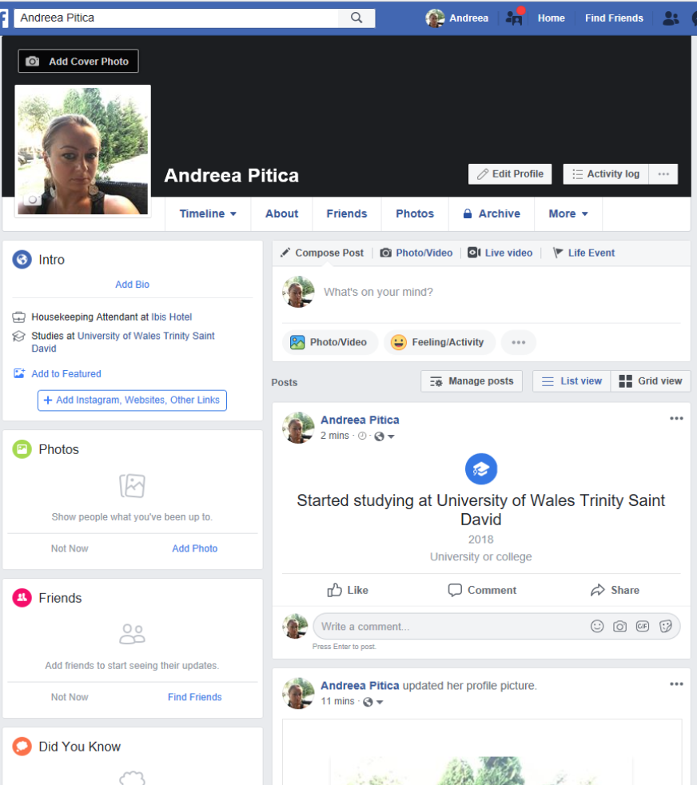

Appendix 2 – Evidence of professional online presence – LinkedIn



