Laraib Khan
2005781 ACCA4024
Networks and cyber security essentials

TABLE OF CONTENT

1 Executive Summary 2
2 Targeted Threat Landscape 2
2.1 External Threats 2
2.2 Internal Threats 3
2.3 Critical Analysis of VTAM’s Exposure 3
3 Zero Trust Security Model 4
3.1 Application to VTAM 4
4 Focused Security Policies 5
5 Technical Mitigation Measures 6
5.1 Phishing & Identity Attacks 7
5.2 Ransomware Mitigation 7
5.3 Cloud & Supply Chain Risk 7
5.4 Vulnerability Management 7
5.5 Critical Perspective 7
6 Monitoring & Incident Response 8
6.1 Monitoring Strategy 8
6.2 Detection Capabilities 9
6.3 Incident Response (Ransomware Focused) 10
6.4 Critical Insight 10
7 Continuous Training & Awareness 10
8 Conclusion 11
9 References 12
10 Presentation 13
VTAM Cyber Case Study

Executive Summary

The current VTAM risk environment has shown clearly control weaknesses. The recent phishing attack was able to evade the existing email security filters, which suggests a failure in the ability to ensure identities and to detect them.
As IT Security Manager, the root cause of this, of course, is a structural problem. The perimeter security approach is still in use with VTAM, based on the premise of having a secure internal environment and minimal external vulnerabilities. This assumption is no longer true in today's hybrid and cloud-based world and has been successfully used in the real world.
It's not just a technical issue. This effect is significant both from a financial and regulatory compliance standpoint as well as a loss of client trust, which are all key elements for business continuity in financial services. Taking a Zero Trust approach, is therefore, not an IT improvement, but a risk reduction strategy that is critical for an organization’s survival and resilience.

Targeted Threat Landscape

Some of the causes are below:

External Threats

Ransomware-as-a-Service (RaaS) has made it much easier for everyone to get started. Now attackers require only a fair amount of technical expertise as they can just buy an off-the-shelf toolkit and attack an organisation such as VTAM at scale. This is why ransomware attacks have tried to affect us—it's because we are now in a high frequency targeting model, not a one-off attack [4].
Meanwhile, phishing and vishing attacks are being generated by AI and are becoming more sophisticated. They often circumvent the conventional email filters as they are not based on an obvious malicious signature. Rather they take advantage of trust and behavioral gaps in people, which is what seems to have occurred in our phishing incident [3].
The challenges of risks in the supply chain add to the complexity. Indirect entry points because of the usage of SaaS platforms and third-party vendors. Having a compromised vendor can effectively be a circumvention of perimeter controls [1].

Internal Threats

Internally, in hybrid environments, privileges are being stretched too thin. Employees continue to have access to things they don't need, making it more likely they will use them – or misuse them – either on purpose or by accident. In addition, with shadow IT and unmanaged devices, the security controls don't necessarily apply, creating blind spots.

Critical Analysis of VTAM’s Exposure

The incidents make them focus on certain aspects of the failures in control. Traditional email filtering was not enough as it didn't have the ability of behaviour analysis. Most significantly, there was no strong identity verification in place (such as adaptive MFA), which enabled the phishing attack to be successful. Finally, it was a ransomware attack in which the attacker attempted to infect the network but failed to do so, suggesting a relatively flat network architecture in which the attack could have continued if it had been successful.

Table 1: Threat → Exploited Weakness → Business Impact
Threat | Exploited Weakness | Business Impact
RaaS | Lack of endpoint isolation and backup resilience | Operational disruption, financial loss
AI-driven phishing/vishing | Weak identity verification, user susceptibility | Credential compromise, data breach
Supply chain attack | Limited vendor risk visibility | Indirect system compromise
Privileged misuse | Excessive access rights in hybrid work | Data leakage, compliance failure
Shadow IT / unmanaged devices

Zero Trust Security Model

The problem with VTAM is that there are no tools, there is only implicit trust. Access once obtained, the system is legitimate. For most modern attacks, such as credential compromise via phishing, for most attacks today it is this assumption that attackers rely on [1]. This, in reality, can be one compromised identity that can be a portal to many systems.

Application to VTAM

The true control boundary is a place for Zero Trust to be part of the solution for VTAM. All access requests, internal or external, should be continually checked not only when logging in. This ranges from adaptive authentication to device validation, and contextual risk checks. But least privilege access is key: Users should only have access to what they need for their job, which will limit the damage wrought by ransomware or insider abuse.

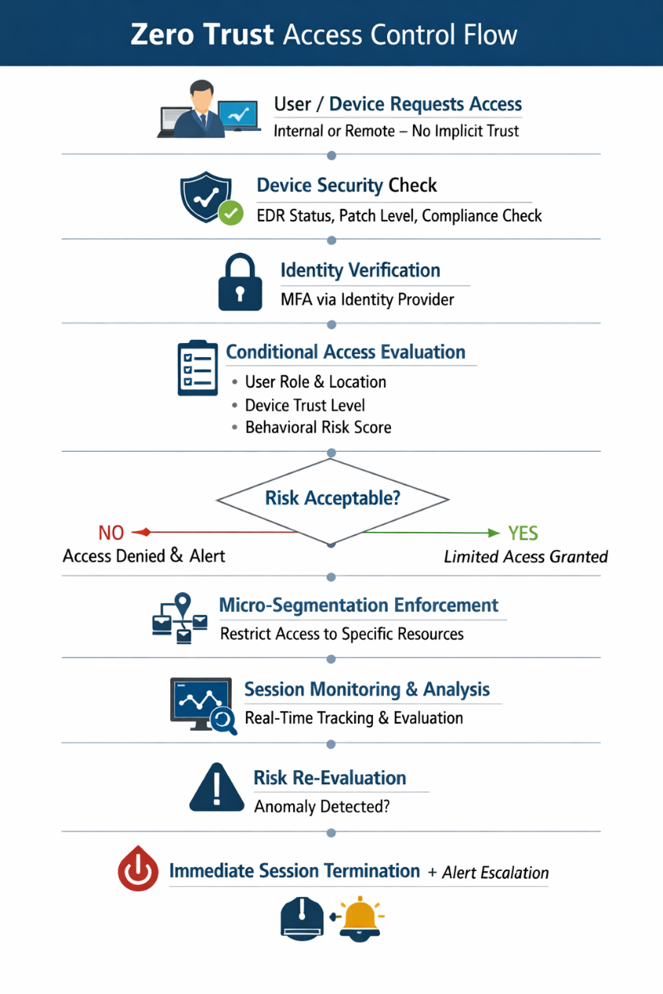
Figure 1: Zero Trust Access Control and Continuous Verification Model at VTAM

Focused Security Policies

The big problem at the security management level at VTAM is not that there aren't any policies, but that there are no policies enforced. In reality, there are a lot of organisations that have documented controls that don't work for them when they get attacked, due to either poor implementation or lack of relevance to new threat models such as Zero Trust.
- Identity & Access Management Policy: Implements MFA, high authentication and least privilege access. This is a response to the phishing incident: Credential compromise means that the identity controls were not hardened enough.
- The Cloud & SaaS Security Policy: provides security protection for shadow IT and third party vendor access. This decreases the supply chain exposure, as it is a common practice in today's attacks [4] and is particularly important for VTAM since it depends on external platforms.
- The Endpoint & BYOD Policy, it is ensured that only compliant devices can have access to corporate systems. Unmanaged endpoints are frequently a ransomware's easiest way to infiltrate the network in hybrid environments.
- Lastly, the Incident Response Policy unifies the response of VTAM to ransomware and intrusion attacks, allowing quicker containment and recovery, instead of responses that are ad-hoc.
Most importantly, these policies are not effective unless monitored and implemented in conjunction with NIST CSF and ISO 27001 controls [2]. They are not enforceable procedures, but only procedures unless enforced.

Table 2: Policy Alignment Matrix
Policy | NIST CSF Function | Risk Addressed
Identity & Access Management | Protect | Credential theft, phishing attacks
Cloud & SaaS Security | Identify / Protect | Supply chain compromise, shadow IT
Endpoint & BYOD Policy | Protect | Malware entry via unmanaged devices
Incident Response Policy | Respond | Ransomware impact, breach containment

Technical Mitigation Measures

The biggest change from an operational security perspective at VTAM will be the integration of security tools to a threat-based approach.

Phishing & Identity Attacks

VTAM needs to implement Adaptive Multi-Factor Authentication (MFA) and Conditional Access policies in order to directly tackle the phishing incident. With adaptive MFA, access will be based on changing factors like device posture, location, login behaviour and more, depending on the risk signal. This greatly decreases the chances of account takeover, even if there is a compromise of user credentials [1].

Ransomware Mitigation

Endpoint Detection and Response (EDR/XDR) can be deployed to monitor for suspicious activity behaviourally, and network segmentation can help to prevent lateral movement. The most critical is that immutable backups allow recovery even if there's encryption, without having to pay ransom.

Cloud & Supply Chain Risk

Cloud Security Posture Management (CSPM) is a key component of VTAM's strategy to keep the platform secure and continuously monitor for misconfigurations, which are vital in the context of SaaS platforms. In addition, the access controls of vendors are also restricted, minimizing the exposure of third parties, a type that is commonly used in contemporary attacks on the supply chain [4].

Vulnerability Management

One of the areas to improve is to focus on patching vulnerabilities that are in the CISA [3] Known Exploited Vulnerabilities (KEV) catalog and not all vulnerabilities. This will allow resources to be directed towards vulnerabilities being exploited in the wild, the place of true risk.

Critical Perspective

These controls can only be effective when integrated. I have seen them deployed in isolation in organisation’s so far, without integration to response (EDR), without policy enforcement (MFA), without remediation ownership (CSPM). This gives the false sense of security.

Table 3: Technical Controls Mapping
Control | Threat Mitigated | Practical Feasibility
Adaptive MFA & Conditional Access | Phishing, credential theft | High (cloud-native integration available)
EDR/XDR + Network Segmentation | Ransomware propagation | Medium (requires tuning & architecture changes)
Immutable Backups | Data destruction, ransomware extortion | High (storage-level implementation)
CSPM & Vendor Controls | Cloud misconfigurations, supply chain risk | Medium (depends on vendor maturity)
KEV-Based Patch Management

Monitoring & Incident Response

Security teams will spend money on monitoring tools, but not put them into practice as a quick and automated response. It is here where attacks are effective in the modern world.

Monitoring Strategy

VTAM needs to deploy a Security Information and Event Management (SIEM) system to consolidate and correlate logs of endpoints, cloud services and identities. But SIEM is not enough; it only tells us what's going on, it doesn't tell us what to do. To fill this gap, Security Orchestration, Automation and Response (SOAR) need to be integrated in order to be able to trigger automated containment actions like disabling accounts or isolating hosts before human intervention is required [1].
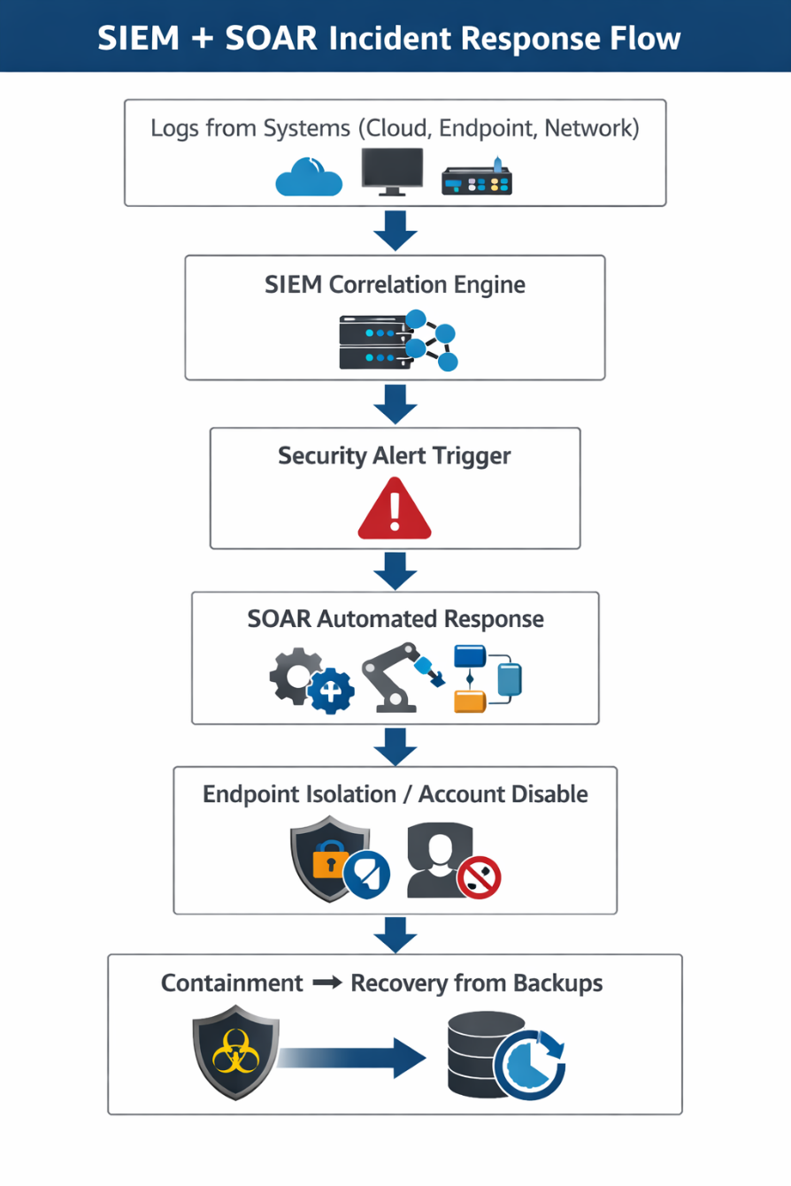
Figure 2: Integrated SIEM and SOAR Incident Response Workflow for Ransomware Containment

Detection Capabilities

The deployment of User and Entity Behaviour Analytics (UEBA) is a key step in helping to detect accurately. This is useful for detecting abnormal activity – such as when someone logs in at an unusual time or accesses data in an unusual way – that can be early signs of a compromised account. Concurrently, the use of threat intelligence feeds guarantees that VTAM does not act blindly, but rather that it knows what the current attack campaigns against the financial sector are [4].

Incident Response (Ransomware Focused)

Ransomware response needs to be timely and proactive: Identify the anomaly, isolate the compromised endpoints, disable the compromised credentials, and restore from immutable backups. The important thing is speed, anything can happen in minutes and be laterally moved and fully encrypted.

Critical Insight

Too often, alert actions are not completed in real time, leading to the failure of many organisations in practice. VTAM needs to progress towards automated, real-time containment, in which detection automatically activates response actions, without any delay.

Continuous Training & Awareness

VTAM needs to get rid of the annual training procedures, as they are not effective in behaviour change. Rather, monthly simulated phishing campaigns should be launched to assess actual user reaction, and pinpoint high-risk departments. At the same time, it is crucial to have vishing simulations targeting executives and finance teams, as they are usually targeted in social engineering attacks. Also, training should be tailored to the role: Finance users have a very different risk profile to that of an IT administrator or general staff member.
Most importantly, effectiveness needs to be measured and not taken for granted. The metrics that are important to consider over time include phishing click rates and reporting rates, which measure behavioural improvement and vulnerabilities, respectively.

Table 4: Training Effectiveness Mapping
Training Type | Target Group | Expected Outcome
Simulated Phishing Campaigns | All employees | Reduced phishing click rates, improved reporting behaviour
Vishing Simulations | Executives, Finance teams | Improved resistance to social engineering attacks
Role-Based Security Training | IT, Finance, Operations | Reduced role-specific security errors and misconfigurations

Conclusion

In terms of IT security management, VTAM is in a reactive and disjointed security state with security controls in place but not well-coordinated to provide protection against today's threats. The latest phishing and ransomware attacks highlight the need for a different approach to security in a hybrid and cloud-first world than just relying on perimeter security.
The Zero Trust approach, along with its real-time monitoring capabilities, is a paradigm change for VTAM and introduces a proactive defence approach. The organisation is not just able to verify identities, detect anomalies and contain threats after compromise but can do so continuously in real time.
The first message to send to the Board is: Cybersecurity is no longer an IT problem; it's a business survival problem, affecting financial stability, regulatory compliance and client trust.

References

[1] National Institute of Standards and Technology (NIST), Special Publication 800‑207: Zero Trust Architecture, Gaithersburg, MD, U.S. Department of Commerce, 2020. [Online]. Available: https://nvlpubs.nist.gov/nistpubs/SpecialPublications/NIST.SP.800-207.pdf. [Accessed: May 21, 2026].

[2] International Organization for Standardization (ISO), ISO/IEC 27001: Information Security Management Systems — Requirements, Geneva, ISO, 2022. [Online]. Available: https://www.iso.org/standard/27001. [Accessed: May 21, 2026].

[3] Cybersecurity and Infrastructure Security Agency (CISA), Known Exploited Vulnerabilities Catalog, Washington, D.C., U.S. Department of Homeland Security, 2026. [Online]. Available: https://www.cisa.gov/known-exploited-vulnerabilities-catalog. [Accessed: May 21, 2026].

[4] European Union Agency for Cybersecurity (ENISA), ENISA Threat Landscape 2023, Heraklion, ENISA Publications, 2023. [Online]. Available: https://www.enisa.europa.eu/sites/default/files/publications/ENISA%20Threat%20Landscape%202023.pdf. [Accessed: May 21, 2026].

Presentation





