
Student Name: Abdullah Al Mamun PAVEL
Student ID: 2528449

Module Name: Marketing Management
Module Code: LCMB7024

Topic: Market pioneers Amazon vs Market follower Alibaba

Lecturer’s Name: Dr Muhammed Tariq

Word Count: 2748

Term 1
Table of Contents
1. Introduction 3
2. Task 1: Critical Analysis of the Macro Marketing Environment 4
2.1 Macro Marketing Environment 4
2.2 Analysis of Macro Factor 1: Technological Factors 5
2.2.1 Impact on the Pioneer Organisation: Amazon 5
2.2.2 Impact on the Follower Organisation: Alibaba 7
2.3 Analysis of Macro Factor 2: Legal Factors 7
2.3.1 Impact on the Pioneer Organisation: Amazon 7
2.3.2 Impact on the Follower Organisation: Alibaba 8
3. Task 2: Strategic Responses of Pioneering and Follower Organisations 9
3.1 Pioneering Organisation’s Strategic Responses: Amazon 9
3.1.1 Critical Evaluation of Amazon’s Response to External Factors 9
3.1.2 Application of Ansoff’s Growth Matrix in Amazon’s Strategy 9
3.2 Follower Organisation’s Strategic Responses: Alibaba 11
3.2.1 Critical Assessment of Alibaba’s Strategic Adaptation 11
3.2.2 Application of Porter’s Generic Strategies in Alibaba’s Approach 12
4. Conclusion 13
5. References 14

1. Introduction
Marketing management is a term used to describe the process of analysis, planning, implementation, and control of marketing activities to achieve organisational goals and generate customer value, while at the same time ensuring a competitive advantage (Köhne, 2025). In strategic marketing management, it is important for organisations to constantly assess environmental forces to ensure competitiveness and respond to environmental changes. In this report, the UK e-commerce industry is used as a case study, which is a highly dynamic and competitive industry worth USD 297.0 billion in 2024, with online retail representing 26% of total retail sales, a figure that is likely to increase to more than 30% in 2026.
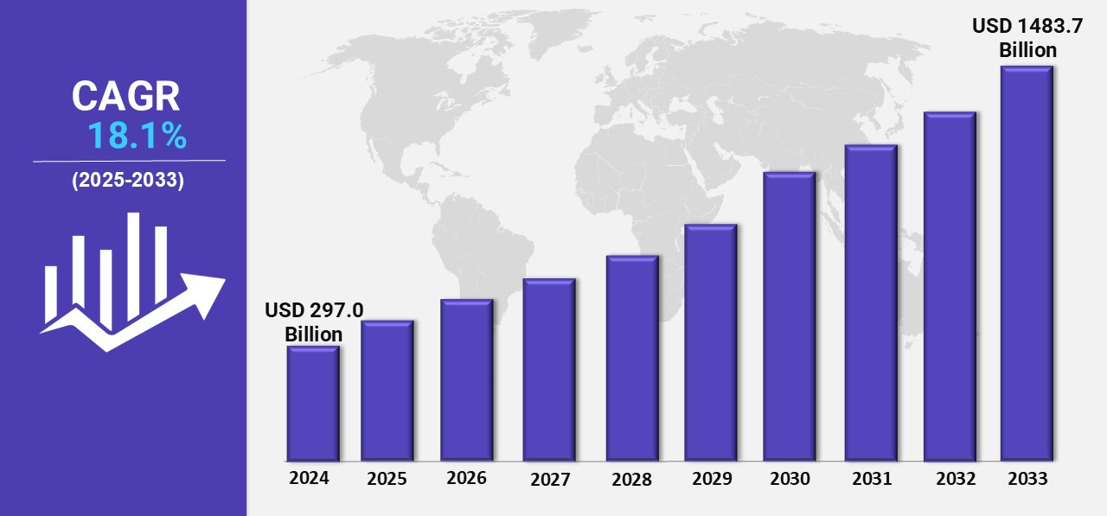
Figure 1: UK e-commerce market size
Source: (Tarang, 2025)
It is important to analyse the macro environment in which an organisation operates to understand the opportunities and challenges that affect strategic management decisions and organisational success. Various frameworks, including PESTLE, have been proposed to help organisations understand environmental forces that are not under their control. In this report, a critical analysis of the technological and legal factors influencing two organisations, Amazon, a pioneer, and Alibaba, a follower, is presented, together with an evaluation of strategic decisions made by the two organisations using relevant strategic management models, including Ansoff’s Growth Matrix and Porter’s Generic Strategies.

2. Task 1: Critical Analysis of the Macro Marketing Environment

2.1 Macro Marketing Environment
2.1.1 Understanding the PESTLE Framework
The PESTEL model offers an orderly method of examining macro-environmental forces, which is specifically applicable in this UK e-commerce market worth USD 297.0 billion in 2024, with online retail representing about 26% of all retail sales and expected to rise to over 30% by 2026 (Tarang, 2025). The framework allows companies to spot external forces that affect profitability, especially in a market where e-commerce growth has averaged at 8-12 per annum despite economic turbulence.
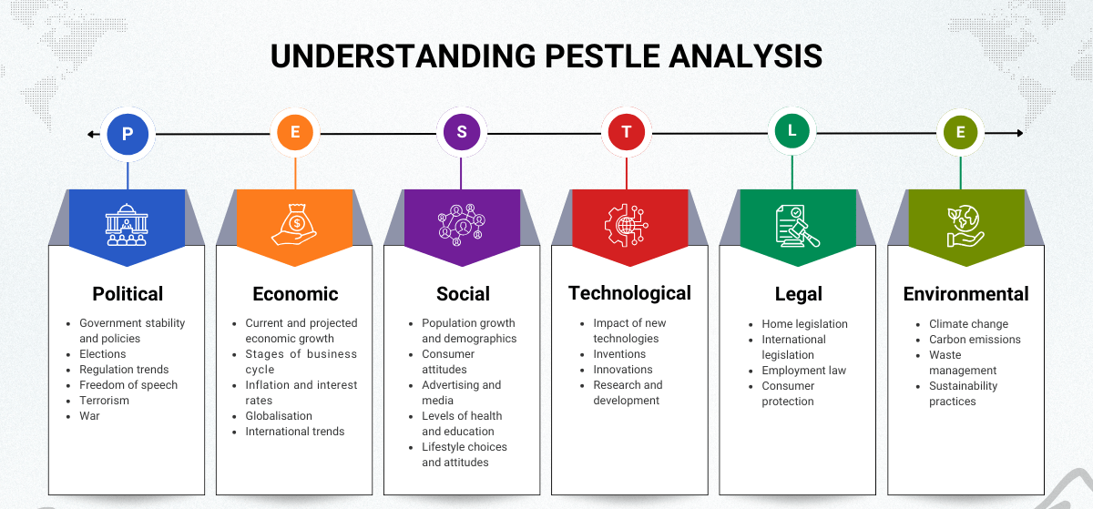
Figure 2: Understanding Pestle Framework
Source: (lbtcdev, 2025)
Justification for Selected Macro Factors
Technological and Legal factors are chosen because they have a disproportionately high effect on e-commerce competitiveness, with firms that invest over 10-15 per cent of revenues in digital infrastructure often being 20-25 per cent more efficient in operations, in terms of fulfilment and logistics. Technology is a major growth driver, as in the UK, mobile commerce is approaching close to 60 per cent of all online transactions, and the use of artificial intelligence in retail has boosted conversion rates by up to 30 per cent. At the same time, legal compliance costs UK companies more than 1.6 billion every year, and breaches of the GDPR may impose sanctions in the form of up to 4 per cent of the global turnover, which underscores the financial and strategic significance of the legal aspects to both local and global companies (GDPR Advisor, 2023).
Strategic Significance in the Industry
In a market where 73% of the UK consumers expect next-day service and 40% expect same-day service, technological innovation directly dictates the quality of service, compelling companies to invest heavily in automation and logistics networks. Legal considerations influence the risk of entry and operational risk, especially since the UK digital services tax of 2% on companies earning more than 500 million internationally exerts pressure on the costs of multinational companies (Ting and Gray, 2023).

2.2 Analysis of Macro Factor 1: Technological Factors

2.2.1 Impact on the Pioneer Organisation: Amazon
Identification of Opportunity and Threat: The technological improvement is also a significant opportunity to Amazon, which spent more than 88.5 billion on technology and infrastructure in the year 2024, which is about 17 per cent of the global revenue of over 570 billion and is capable of capturing nearly 30 per cent of the UK online commerce market (Statista, 2024). By incorporating artificial intelligence, machine learning, and robotics, Amazon can sort more than 1.6 million packages per day in the UK alone and deliver faster and with greater precision.
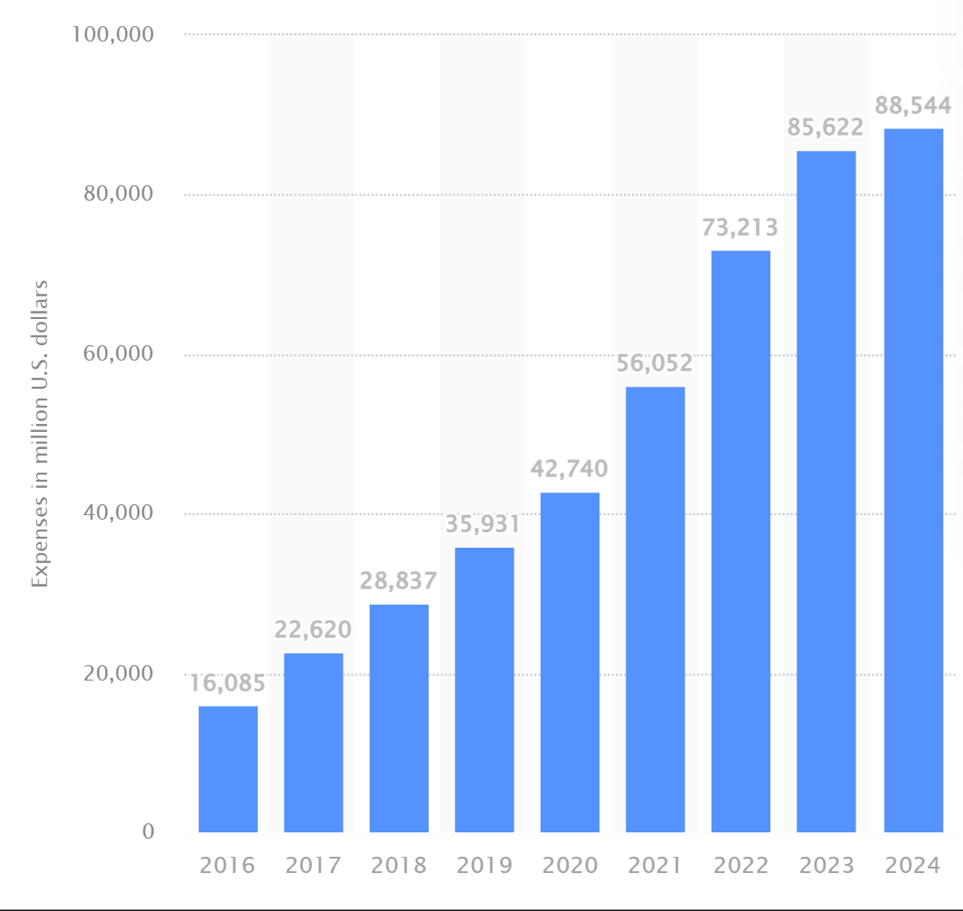
Figure 3: Annual technology and infrastructure expenses of Amazon
Source: (Statista, 2024)
Evidence from Industry Data: Amazon has over 50 fulfilment centres in the UK, and the automation technologies have saved the cost of picking and packing by about 20-25 per cent and made it over 30 times more efficient (Amazon, 2025). Furthermore, Amazon Web Services provides approximately 15 per cent of total revenue and over 70 per cent of operating profit, proving the key role of technological diversification in the financial performance.
Implications for Competitive Advantage: The continued investment in technology allows Amazon to deliver at 60-80 times faster than the industry averages, a fact that has increased customer satisfaction levels above 85. Such an ability poses entry barriers, since new entrants would have to invest at least £5 billion to match the similar infrastructure (Amazon, 2025).

2.2.2 Impact on the Follower Organisation: Alibaba
Opportunity and Threat: In the case of Alibaba, technological aspects pose a dichotomy, with the global technological investment of about 25 billion, which constitutes less than a tenth of its revenue, constraining its capacity to match the scale of Amazon in the UK market. Although the AI-based recommendation systems lead to a 20 per cent higher customer engagement and a 15 per cent higher conversion rate, cross-border logistics result in Alibaba's delivery times of 7-10 days on average, which is far longer than Amazon's delivery time of 12 days (Vishal sresth and Aakash Srivatava, 2024).
Comparative Vulnerability or Adaptability: Alibaba has a solid technological ecosystem, such as Alibaba Cloud with approximately 6 per cent global market share, to support its digital processes, but its inadequate physical presence in the UK limits its capacity to attain last-mile efficiency (Kotler et al., 2020). About 65% of consumers in the UK value quick delivery rather than cost, which puts Alibaba in a bad position despite its products being sometimes 10-20% low priced.
Implications for Market Position: The technological weaknesses of Alibaba mean that the company has a UK market share of less than 5%, which means that it is not as competitive as Amazon (Zhang and Wang, 2023). However, it can utilise its data analytics and digital marketing capabilities to reach niche segments, especially price-sensitive consumers who form about 25 per cent of the market. This situates Alibaba in a place where it can still be relevant even with its technological drawbacks.

2.3 Analysis of Macro Factor 2: Legal Factors

2.3.1 Impact on the Pioneer Organisation: Amazon
Identification of Opportunity and Threat: The UK presents opportunities and threats to Amazon because adhering to the GDPR facilitates the trust of 80% of UK consumers who consider data security a priority, and non-compliance results in fines of up to 4% of global revenues, which can be higher than 20 billion pounds (Vander Maelen, 2023). Moreover, anti-monopoly laws against big tech companies heighten competition, and the constant investigations may impact the operational autonomy of Amazon.
Evidence from Industry Data: In Europe, between 2020 and 2023, Amazon had to pay regulatory fines of over 1 billion euros, and and compliance costs reached 3-5 per cent of operating costs (Amazon, 2025). The UK digital services tax levies a 2 per cent tax on incomes earned through online markets, which means additional expenses worth more than 200 million annually to Amazon. Moreover, labour laws that apply to the functioning of warehouses add up to 10-12 per cent more costs to the staffing per year.
Implications for Competitive Advantage: Amazon has the ability to absorb regulatory costs at a greater rate, owing to its scale, and continues to record profit margins of over 68 per cent in major markets. The ability to comply improves brand trust, and its customer loyalty rates are beyond 70, which makes it a long-term competitive strength.

2.3.2 Impact on the Follower Organisation: Alibaba
Opportunity and Threat: Legal considerations are more difficult for Alibaba because the UK has more stringent scrutiny of foreign firms, with compliance costs pegged at 6-8 per cent of revenue, in contrast to 3-5 per cent when dealing with the domestic or legal entity (Colino, 2023). Concerns about data protection diminish consumer trust, and only 40-45% of consumers in the UK have trust in foreign sites that process their personal data.
Comparative Vulnerability or Adaptability: Alibaba is especially susceptible to customs policies and import taxes, which add 15-25 to the cost of goods, diminishing its pricing power in the market where consumers are exceptionally price-conscious yet equally desire speed and reliability (Hill, 2025). Also, regulatory uncertainty is brought about due to geopolitical tensions, which cause an operational risk 20-30 per cent higher than that of domestic competitors.
Implications for Market Position: Such legal boundaries severely restrict the growth of Alibaba, where the UK sales increase by single digits every year as opposed to the double digits growth rates of 10-15 of Amazon. Nonetheless, Alibaba has been flexible by moving to B2B, which has lower regulatory limitations, and it can remain stable but limited.

3. Task 2: Strategic Responses of Pioneering and Follower Organisations

3.1 Pioneering Organisation’s Strategic Responses: Amazon

3.1.1 Critical Evaluation of Amazon’s Response to External Factors
Technological Investment as a Source of Competitive Dominance: To achieve exceptional investment levels in automation, artificial intelligence, and logistics infrastructure, Amazon has reacted strategically to technological opportunities by spending over 85 billion dollars in 2023, or about 17 per cent of all its revenue globally (Vidani, 2024). For example, AI-enabled demand prediction and warehouse robotics have decreased fulfilment costs by 2025, allowing Amazon to keep prices competitive with inflation rates of 68% and increasing labour costs of 10-12% per year in the UK logistics industry.
Strategic Response to Legal and Regulatory Pressures: The company has been proactive and resource-consuming in terms of legal compliance, spending about 35% to 5% of its operations on the regulation mandates, including the GDPR and UK digital tax polices (Amazon, 2025). This is equivalent to several billion dollars of compliance spending each year in Europe, with more than £200 million of digital service taxes in the UK alone. With rigorous compliance with data protection rules, Amazon has gained the loyalty of more than 80% of the UK shoppers who consider data protection a paramount concern in their online purchases.

3.1.2 Application of Ansoff’s Growth Matrix in Amazon’s Strategy
The Ansoff Matrix is a tool that an organization uses to map out strategies for future growth (VanZandt, 2023). The application of this model is following:

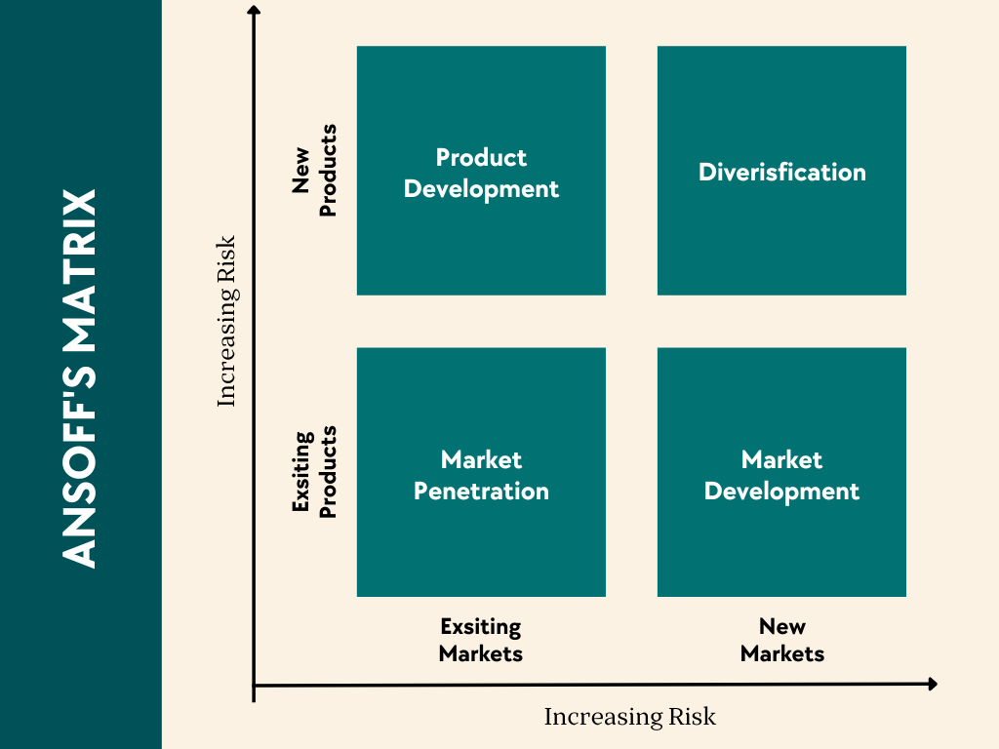
Figure 4: Application of Ansoff Matrix
Source: (VanZandt, 2023)
Market Penetration through Service Excellence: Amazon widely employs a market penetration strategy, as it reinforces its role in the current UK market, the market share of which is about 30 per cent of e-commerce sales. This is realised by projects like Amazon Prime that have exceeded 20 million subscribers in the UK, or almost 60 per cent of online customers (Gereffi, 2022). Prime boosts customer loyalty with a set of benefits, including rapid delivery within the same day, exclusive offers, and digital content, which leads to retention rates above 70, in contrast to 50-55 in the industry.
Product Development through Technological Innovation: The product development strategy at Amazon is reflected in its ongoing growth of services, especially Amazon Web Services (AWS), which brings in about 15 per cent of total revenue and produces more than 70 per cent of operating profit (Amazon, 2025). This shows the use of technological capability that Amazon uses to revolutionise the traditional retail business segments into high-margin businesses. Also, voice commerce via Alexa, AI-based recommendation engines, and so on can engage customers further, raising the frequency of purchases by 2025.
Diversification to Mitigate External Risks: Another strategy Amazon employs to limit reliance on e-commerce that is highly regulated is the diversification strategy that has seen it invest more than 10 billion dollars in a year in other areas like digital streaming, healthcare and smart devices. For example, Amazon Prime Video faces competition in the UK streaming industry with a valuation of more than £8 billion, and AWS in the global cloud market that has a valuation of over 600 billion (Zhu and Liu, 2022).
Critical Evaluation of Strategic Effectiveness: The use of the Ansoff Growth Matrix by Amazon shows a very well-integrated strategy in which technological investments are used to maintain market penetration and product development, and diversification is used to reduce legal and operational risks (Amazon, 2025). Nevertheless, the company depends on sustained capital expenditure, which on average is over 60 billion in logistics and infrastructure per year, which can lower the profitability in the short run, especially in the economic slowdown when consumer spending drops by 5-10 per cent.

3.2 Follower Organisation’s Strategic Responses: Alibaba

3.2.1 Critical Assessment of Alibaba’s Strategic Adaptation
Technological Adaptation through Asset-Light Model: Alibaba has been dealing with technological pressures by taking an asset-light approach, and it has invested around 25 billion in technology, which is less than 10 per cent of its total revenue and much less than what Amazon has at the same level (EcommerceStrategy, 2022). Instead of the large-scale creation of physical infrastructure in the UK, Alibaba invests in digital and AI-based systems to enhance customer interaction, and the recommendation algorithms raise the conversion rates by 15-20.
Strategic Response to Legal Constraints and Market Entry Barriers: Alibaba has greater legal risks than domestic and established foreign competitors; compliance expenses range from 6 to 8 per cent of revenue due to tighter examination of foreign companies, as well as additional importation charges of between 15 and 25 per cent (Gereffi, 2022). To alleviate these pressures, Alibaba has been tactical in taking the B2B business direction via Alibaba.com, where regulatory pressure is less strict and annual trade is more than 1 trillion.

3.2.2 Application of Porter’s Generic Strategies in Alibaba’s Approach
Cost Leadership as the Primary Competitive Strategy: Alibaba majorly uses a cost leadership strategy where the products are 10-20 per cent lower than those on rival sites, appealing to the 25-30% of the UK consumers who are very price-conscious. Alibaba saves on the fixed cost by about 30-40 percentage points in comparison with the Amazon model because it does not have to invest heavily in physical infrastructure and relies on third-party logistics providers. As an example, AliExpress, an Alibaba subsidiary, offers inexpensive substitutes in sales categories like fashion and electronics and appeals to low-end consumers due to the longer delivery time (Zhang, 2023).
Focus Strategy on Niche and B2B Segments: Another focus strategy used by Alibaba involves niche markets like small and medium-sized enterprises (SMEs) and bulk buyers, where price is more sensitive, and delivery speed is not a priority. It has a B2B platform that links more than 40 million active buyers around the world with businesses buying at reduced prices and quantities. This approach helps Alibaba to remain relevant in the UK market even though it has little presence in mainstream B2C e-commerce, where Amazon leads.
Limited Differentiation through Digital Ecosystem: Cost leadership is the main approach of Alibaba, but it also includes differentiation, utilising its digital ecosystem, especially the Alibaba Cloud, occupying about 6% of the world cloud market (Schmuck and Benke, 2020). This helps in high data analytics and customised marketing, enhancing operational efficiency by 20 per cent or more.
Critical Evaluation of Strategic Effectiveness: The use of Porter's Generic Strategies at Alibaba is a very practical reaction to the external constraints since its cost leadership strategy and focus strategy allow it to compete well in price-sensitive and niche markets (Suleman and Rashidirad, 2022). Nonetheless, it relies on long-distance logistics and lacks local infrastructure, hindering its scalability in a market where more than 70 per cent of buying behaviour is determined by delivery speed and the quality of service.

4. Conclusion
The report clearly establishes that technology and legal factors are critical in determining the nature of competition in the e-commerce industry in the UK. The report also establishes that Amazon, as a market leader and pioneer in the industry, utilises significant investments in technology and infrastructure to dominate the market and improve efficiency, thereby creating entry barriers for new entrants. On the other hand, Alibaba utilises a flexible approach to remain at the forefront in the market by employing a cost leadership approach and focusing on niche markets to remain competitive despite the poor infrastructure and regulatory challenges. The report also establishes that technology plays a critical role in enhancing service quality and satisfaction, while legal factors are critical in determining operational costs and risks, as well as building trust among consumers. The above report also establishes that organisations that are capable of adapting to environmental changes and scanning the market are critical in determining sustainable competitive advantage.

5. References
Amazon (2025). Amazon Fulfillment UK - Free Shipping, Storage & Returns. [online] Amazon Seller Services UK. Available at: https://sell.amazon.co.uk/fulfil [Accessed 24 Mar. 2026].
Colino, S.M. (2023). The case against alibaba in China and its wider policy repercussions. Journal of Antitrust Enforcement, 10(1). doi: https://doi.org/10.1093/jaenfo/jnab022.
EcommerceStrategy (2022). Why Alibaba should combine its asset light and heavy strategies to enhance efficiency? [online] Ecommercestrategychina.com. Available at: https://www.ecommercestrategychina.com/column/why-alibaba-should-combine-its-asset-light-and-heavy-strategies-to-enhance-efficiency [Accessed 24 Mar. 2026].
GDPR Advisor (2023). GDPR Fines and Penalties: What You Need to Know to Avoid Costly Mistakes | GDPR Advisor. [online] GDPR Advisor. Available at: https://www.gdpradvisor.co.uk/gdpr-fines-and-penalties [Accessed 24 Mar. 2026].
Gereffi, G. (2022). Amazon and Alibaba: Internet Governance, Business Models, and Internationalization Strategies. Progress in International Business Research, [online] 13(1), pp.327–356. Available at: https://www.emerald.com/insight/content/doi/10.1108/s1745-886220180000013014/full/html [Accessed 24 Mar. 2026].
Hill, M. (2025). Sales Tax Vat: Structure, Specifications, and Common Industry Applications. [online] Alibaba.com. Available at: https://www.alibaba.com/product-insights/sales-tax-vat.html [Accessed 24 Mar. 2026].
Köhne, T. (2025). Marketing Management: Planning, Implementation and Controlling of Marketing Activities. Insurance Marketing, 3(1), pp.531–542. doi: https://doi.org/10.1007/978-3-658-47345-7_16.
Kotler, P., Armstrong, G., Harris, L. and Piercy, N. (2020). Principles of marketing. 8th European edn. Harlow: Pearson.
lbtcdev (2025). Understanding PESTLE Analysis: A Practical Tool for Business Strategy. | London Business Training & Consulting. [online] London Business Training & Consulting. Available at: https://lbtc.co.uk/leadership-soft-skills/leadership/understanding-pestle-analysis-a-practical-tool-for-business-strategy/ [Accessed 24 Mar. 2026].
Schmuck, R. and Benke, M. (2020). An overview of innovation strategies and the case of Alibaba. Procedia Manufacturing, [online] 51(7), pp.1259–1266. doi: https://doi.org/10.1016/j.promfg.2020.10.176.
Statista (2024). Amazon technology and infrastructure expenses 2024| Statista. [online] Statista. Available at: https://www.statista.com/statistics/991947/amazons-annual-technology-and-content-expenses/?srsltid=AfmBOoqb7r74OnupVJWZ3Zbe6ykU7yrEK3yJCfiKGHuQZ_aFyKvOqoTt [Accessed 24 Mar. 2026].
Suleman, M.F. and Rashidirad, M. (2022). The applicability of Porter’s generic strategies in pure online firms: A case study approach. Strategic Change, [online] 28(3), pp.167–176. Available at: https://onlinelibrary.wiley.com/doi/abs/10.1002/jsc.2258 [Accessed 24 Mar. 2026].
Tarang (2025). UK E-commerce Market Growth, Size, Trends and Analysis Report 2025-2033. [online] Substack.com. Available at: https://latestmarketreports.substack.com/p/uk-e-commerce-market-growth-size?utm_campaign=post&utm_medium=web [Accessed 24 Mar. 2026].
Ting, A. and Gray, S.J. (2023). The rise of the digital economy: Rethinking the taxation of multinational enterprises. Journal of International Business Studies, 7(3). doi: https://doi.org/10.1057/s41267-019-00223-x.
Vander Maelen, C. (2023). GDPR Codes of Conduct and the Impact on Global Business: A Case Study of Amazon Web Services. [online] Social Science Research Network. doi: https://doi.org/10.2139/ssrn.4505297.
VanZandt, P. (2023). Analysis and Advantages of Ansoff Matrix. [online] IdeaScale. Available at: https://ideascale.com/blog/analysis-and-advantages-of-ansoff-matrix/ [Accessed 24 Mar. 2026].
Vidani, J. (2024). E-Commerce Supply Chain Efficiency: A Case Study of Amazon E-Commerce Company. Social Science Research Network, [online] 7(1). doi: https://doi.org/10.2139/ssrn.4849852.
Vishal sresth and Aakash Srivatava (2024). AI-Driven Product Recommendations in eCommerce: Enhancing User Engagement and Sales. International Journal of AI, BigData, Computational and Management Studies, [online] 5(2), pp.38–47. doi: https://doi.org/10.63282/3050-9416.IJAIBDCMS-V5I2P105.
Zhang, Q. and Wang, L. (2023). The Business Competitiveness and Future Proposing of Alibaba Group. Proceedings of the 2021 3rd International Conference on Economic Management and Cultural Industry (ICEMCI 2021), 203(6). doi: https://doi.org/10.2991/assehr.k.211209.060.
Zhang, S. (2023). An analysis on the ‘E-commerce’ trade model with Alibaba case - Webthesis. Polito.it, [online] 4(4). doi: https://webthesis.biblio.polito.it/secure/13926/1/tesi.pdf.
Zhu, F. and Liu, Q. (2022). Competing with complementors: An empirical look at Amazon.com. Strategic Management Journal, [online] 39(10), pp.2618–2642. doi: https://doi.org/10.1002/smj.2932.

