Student name: Ionut Alin Sacalus
Student number: 1907523

Module code: BMSW4005
Module title: Professional and Career Development

Lecturer name: Olubukola Adegbite

Assignment title: Portfolio of work

Introduction
Skills for work are focused on generic employing skills for success in the workplace. These skills offer opportunities to learn sour skills through a variety of practical law experiences of professional fields. Competition courses for work help young people develop themselves.
Social skills are important skills – personal qualities (compared to professional skills gained through education, training or professional experience) that are particularly important for communicating with other people.
Top five skills
1. Empathy
Empathy is a very important skill in the employment. For a good communication with colleagues, all people need to be capable to understand how they feel. Empathy is very important when dealing with customers who come up with questions or problems. You must express real concern for their problems, as well as solutions in solving them.
2. Cooperation
Cooperation is particularly important when working in a team, where association with others will be required to achieve a common goal. However, even if you are not working in a team, cooperation is still required on those occasions when it is necessary to work alongside colleagues to help achieve the company's goals.
3. Verbal and written communication
Verbal communication is the ability to express yourself using clear language that others can understand. it takes solid verbal communication skills whenever communicating with other people or over the phone. Written communication comes into play whenever an email, text, letter, report, or presentation is written – this is where the appropriate grammar, spelling and format are required.
4. Listening
Another important communication skill that is required in interacting with others is listening. it takes the ability to listen carefully to what the employer says, what colleagues say in a meeting and what employees ask. You should listen to customer concerns and express that you understand them. People respond well to others when they feel they are being heard.

5. Nonverbal communication
While verbal communication is an important skill, so is nonverbal communication. Through body language, eye contact and facial expressions, it is good to specify the sympathy to listen to others. (Doyle, 2020)
A personal development plan (PDP) will guide all people in their career, whatever grade they are at and whether they work in an acute or community setting. Personal Development Plan help all people to become more self-aware, enabling them to understand how to improve performance and develop new skills. All of us should engage in this process, as it is now a key component of appraisals and revalidation.

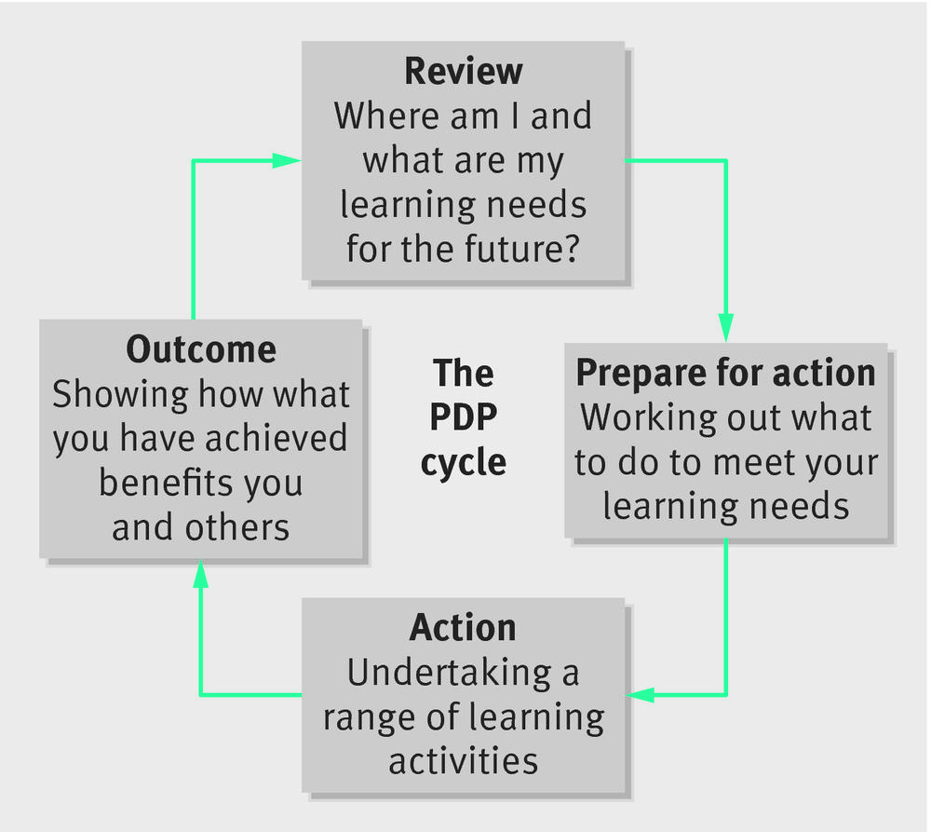

The Personal Development Plan is an important aspect of a professional life and should be planned to meet patients’ needs as well as those of doctors. All of people who want to get a job should choose goals that motivate them as this will provide the energy and drive to achieve them.

Planning and evaluating learning should be a continual process as circumstances change and plans may need to be modified. The final step is to reflect on how effective the Personal Development Plan has been and whether there are areas that have not been tackled or have not worked. Reflection must drive learning, and a completed Personal Development Plan should be a building block for future Personal Development Plan. (Tasker, 2015)
Personal development plans: Plans intended to develop those skills that are important in working life, particularly within an organization. This may include IT skills, interpersonal skills, communication skills, management skills.
Personal Development Plan
Objectives | Actions | Resources | Criteria for success | Target
Communication written | Read more to improve how to write professionally. | Articles, books, YouTube, internet resources. | Be able to write well. | 1 month
Time management | Attend your class. | Showing a good attendance. | Try to work efficiency and be present in class. | 1 month
Initiative | Be active in class, with your group. | Friends and colleagues. | Initiate the work in group, initiate a start of presentation. | 1 month
To learn a new skill | Taking a course, reading books, volunteering. | Colleagues, friends, tutor. | Successfully to pass any tests. | 1 month
Pass the interview | Successfully to pass any interview. | Tutor, books, colleagues. | Successfully pass the interview. | -
Do more research from books | Go to library to read. | Library, friends, myself. | I will put more references in my assignment | 1 month

Skills required for Adoption Social Work Team Manager
- Supporting the service manager by contributing to the overall operational functioning of the adoption service and their support, as necessary.
- Take part in the development of services and ensure that they are targeted, delivered at a high level focused on children and culturally sensitive.
- Ensure that they comply with agreed service quality standards.
- To represent their field of activity and service offered for management through clear presentation and reporting.
- Sign and manage revenue and expenditure within prescribed delegated budgets and contribute to resource planning within the service area.
- Liaising with existing and potential partners, including local authorities' social welfare services and regional adoption agencies that place children at all times, supporting team members in the process of making and supporting placements.
- Act as a mentor and coach within teams, including taking responsibility for induction programmes and initial training, as well as direct observation of adoption practitioners as part of their professional qualification.
- Provide effective feedback to the Service Manager about the developmental needs, performance, and workload of those supervised.
- With the support of the Service Manager, take responsibility for the oversight, allocation, and monitoring of new and existing cases within the team.
- Recruitment, preparation, and assessment of families for children referred to the agency, including presentation of PARs at panel meetings.
- Provide good liaison with care agencies to match suitable children with approved applicants and in co-operation with the placing agency to support the applicants both pre and post placement, including where necessary post adoption. To attend planning meetings, reviews, and Court as necessary.
- To offer advice and, where appropriate, counselling to birth parents and extended families, adoptive parents and extended families and adoptees.
- To attend staff and team meetings and supervision with Service Manager. To chair team meetings if required.
- To be a member of a team expanding its philosophy and its commitment in the field of adoption and permanency and to share in the agency’s development plans.
- To comply with the agency’s statutory obligations, including adoption and safeguarding of children.
- At all times when carrying out principal responsibilities to maintain financial and budgetary awareness and ensure that operation management approval is obtained for any expenditure outside own delegated maximum.

As an Assistant Manager, you have been tasked to assess the learning and development training methods for your new employees who are due to start in your organisation. You can use theories learned in the class. Explain and evaluate why you have selected these theories and methods.
Training is the process to enhance work performance and improve current or special personal knowledge, skills, and attitudes so that a job is performed accurately, effectively and ensures continuing improvement of work quality. On other hand training is a process which is planned to facilitate learning so the people can become more effective in carrying out aspects of their work.
Learning is means aims to deliver qualitative and relatively permanent change in how an individual sees, experiences or understands something in the real world.
Development is a more wide-ranging, long-term concept. Nadler and Wiggs (1986) see development as preparation of employees for an uncertain future. It may include linking the organisations strategy for employees and linking career with learning plans. In terms of employability, development may also include learning and experience outside the immediate organisational boundaries. (Maund, Schriek and Tinkler, 2017)
Continuous learning and development are important for all social and health care staff, including Assistants. This is often referred to as continuing professional development or CPD. Tracking and documenting skills, knowledge, and the experience that employees acquire both formally and informally, beyond any initial training. It's a record of what learn and then implement. Skills or qualifications that are gained through learning and development can also support in building a career in the field of social care or health.
Training gives staff the opportunity to develop new skills and knowledge, building their confidence and widening their experience. It shows employer regard for individual workers and their development.
Many companies, recognising that learning goes beyond typical face-to-face class are using technology to make it easier for employees in different locations to learn and share knowledge through formal courses as well as through collaboration. (Noe and Kodwani, 2016)

The process of learning

Most used is Honey and Mumford learning styles approach. They think that people learn in four ways.
Activists who learn by having an active involvement in concrete tasks and relatively short-term tasks.
Reflectors who review and reflect, stand back, listen, and think. Reflectors need to take care not to seen as quiet or day- dreaming.
Theorists who learn by taking on new situation but need to relate these to theory. Reflectors need to be aware that absorbing new ideas might distance them from day-to-day situations.
Pragmatists who learn by linking between new information and real-life problems. Pragmatists like techniques which can be applied immediately.
Training methods used for new employee:
Classroom- based on training programs. Usually a specialized person is designated to provide training to new employees for several days. It is based on presentations, activities, case studies and information. The advantage of classroom training is that more information is retained in real time. Disadvantage being the waste of time on the way to the location and the costs of transportation.

Interactive training. One of the most effective methods of training in the workplace is the interactive one. This involves the participation of each person by sharing their own experiences. You can receive feedback, apply realistic scenarios, and play games.
On-the-job training. This method does not only involve employees which stimulate participation in activities. This method is the most effective in the learning process. This method of learning gives faster results, but it can be a little stressful because it consumes a lot of time.
Social learning. This method of learning is defined as the most common method used so far. that's because it's easy to structure and control. Is an efficient method because employees are made to do activities that need to be performed daily, so they acquire new perspectives and manage more easily in solving problems.
Online training. Online learning has become one of the most organized and effective training methods. The online learning program includes video viewing, Power Point presentations and tests. The advantage is the lack of costs and the waste of time. (Andriotis, 2020)

Reflection on own experience before and after Health and Social Care course.
Before I started this course, I thought I was happy with my personal and professional life. But along the way I realized that I am not satisfied with the choices so far, maybe also the previous jobs and of course the monthly salary for which I worked without having time for myself. In previous jobs I have not gained any experience in health and social care. But for a few years I worked as a security guard in two hospitals in my town. And there I have seen many medical cases where I can say that if I had knowledge and power, I would have given first aid. This job has developed my need to give help. In other cases, patients just needed someone to listen to them, and I was doing well, and I liked to listen to them, lift their spirits and encourage them. My affection for them made them attach themselves quite easily to me and we quickly gained their trust. Another work experience is my involvement in the political world which I can say made me a great man. I've learned a lot of things I've used throughout my life. There I learned to communicate with different types of people, from different social classes, and that developed my vocabulary and behaviour by chiselling me. The rest of my professional experience has been and continues in storage. I started out as a warehouse worker. over time I learned better and better language and struggled to climb higher and higher for a better job and a better salary. I think it's not wrong to want a better life and a better salary for a comfortable life. I am currently working as a leading team for a spare parts company in Birmingham. I am proud of my choices and where I ended up, working with my own hands and what I learned. At the same time, I am studying health and social care at The University Wales Trinity San David, foundation year. In a few months I gained digital knowledge, prepared for future interviews, the behaviours of future patients that I will care for, the attributes of a manager in a care institution, rules for effective communication and how to react to each behaviour and disability. In the following I intend to continue my studies in health and social care at University Wales Trinity San David. I believe that studies are particularly important for a successful career and future. Without studies we cannot advance, in some cases we cannot even dream of a job that we think suits us. Studies will help me achieve my goal, advance, and get where I want to go. I need studies to learn more about what this job entails and to gain experience. Preparing for a job as a health and social care manager involves a lot of work and time. I want this job for a better future, because I think I can and deserve more than that. I like to fight for my dreams and get to where I set out to go.
Why this profession? Because I consider myself a man of solidarity, ready to help people and support them. I am a compassionate and sensitive person who is ready to give everything a patient need. I want to see if I really know who I am. If I really know what I want from the future. If I'm aware of my resources when I set goals. The questions I started asking myself helped me define my goals clearly and specifically. That is the only way you can really get to fulfil them. I believe that with every help you offer, the gratitude of the recipient comes back to you and further enhances your happiness. That way I will fall asleep and wake up every day happy.
We are guided by eminently human values. Not only in our professional activity, but also in our free time. We believe that good is well rewarded and that change begins with ourselves. We may not be perfect, we may sometimes fail, but we tend to get better. We tend to be better. That is why I searched and found better examples in the stories of people all over the world!
This portfolio contains methods of learning and development of new employees. The methods and theories used have been chosen because they fit best, are the closest for each person and the easiest to use.

Conclusion
Professional training is the learning process through which participants acquire theoretical knowledge and practical skills to perform the tasks of service to the performance standards imposed by the organization. Career Planning takes a lot of work, but there is nothing more rewarding that doing something you enjoy and getting paid for it. Professional training of employees has two important functions: usefulness and motivation. Utility characterizes the extent to which professional training programs contribute to the development of knowledge, skills, skills and, in the same direction, also targets the impact it will have on the behaviour of employees. The performance of the correct service tasks justifies participation in the professional training programs by showing results on a personal level, by acquiring new knowledge and in the organizational plan by obtaining performance.

References
- Adoption Matters. 2020. Adoption Social Work Team Manager - Adoption Matters. [online] Available at: <https://www.adoptionmatters.org/vacancy/adoptionsocialworkteammanager/> [Accessed 4 November 2020].
- Andriotis, N., 2020. 5 Popular Employee Training Methods For Workplace Training - Elearning Industry. [online] eLearning Industry. Available at: <https://elearningindustry.com/how-choose-training-methods-for-employees> [Accessed 11 November 2020].
- Doyle, A., 2020. Top 5 Important Social Skills Employers Want. [online] The Balance Careers. Available at: <https://www.thebalancecareers.com/top-social-skills-for-workplace-success-4142848> [Accessed 4 November 2020].
- Maund, A., Schriek, M. and Tinkler, P., 2017. Certificate In Higher Education. London, pp.336-343.
- Morgan, P., 2017. The Business Student's Guide To Study And Employability. London: Sage, p.27.
- Noe., R. and Kodwani, A., 2016. Ise Employee Training & Development. [Place of publication not identified]: Mcgraw-Hill.
- Skillsforcare.org.uk. 2020. [online] Available at: <https://www.skillsforcare.org.uk/Employing-your-own-care-and-support/Resources/Working-as-a-PA/5.-Training-and-qualifications/A-practical-guide-to-learning-and-development-for/A-practical-guide-to-learning-and-development-for-personal-assistants.pdf> [Accessed 11 November 2020].
- Sqa.org.uk. 2020. Skills For Work. [online] Available at: <https://www.sqa.org.uk/sqa/79148.html> [Accessed 4 November 2020].
- Tasker, F., 2015. How to prepare a personal development plan. BMJ, [online] p.h4603. Available at: <1 doi: https://doi.org/10.1136/bmj.h4603> [Accessed 4 November 2020].

