

Assignment 2

Module Code: LCLM4005
Module Name:Employability and Career Development
Lecturer: Lizeta Demetriou

Submission Date:

Table of Contents
Task 01 Comparing job adverts 1
Task 02 Self- Assessment and Evidence of readiness 3
SWOT analysis 3
Task 03 Personal development Plan 6
SMART objectives 6
Personal Development Plan (PDP) 7
References 15

List of Figures
Figure.1: Evaluating readiness 5
List of Tables
Table 1 SWOT analysis 3
Table 2 PDP Table 7

Task 01 Comparing job adverts
This discussion is based on the current status of restaurant supervisor or restaurant team leader jobs in London, based on four recent advertisements in major hospitality job boards. Throughout the adverts, the main duties involve overseeing day to day front of house functions, staff coordination, and good flow of communication between kitchen and service departments as well as high levels of customer service, hygiene and food safety. Supervisors will also be required to assist in opening and closing process, bookings and queues, guest complainants and respond in a confident and professional way (Training Hotels, 2025). These requirements are aligned with industry directives of restaurant supervisors as the conduit between the employees and the management, the quality of services and the performance of the team.
There are a few major skills that are recurring. First, it is vital to have excellent customer-service skills: adverts focus on the possibility of creating a friendly environment, managing challenging experiences, and transforming negative experiences into positive ones. Second, teams have to be coordinated, information has to be relayed between kitchen and floor and a variety of customers, and this requirement is based on the wider research that emphasizes communication, teamwork and emotional intelligence as important employability skills in the hospitality industry (Ghani et al., 2025; Moussa, Saber and El-Yamani, 2024) . Third, it is based on leadership and people-management skills, such as delegation of duties, training new employees and providing feedback, which is consistent with the research that revealed that great leaders of restaurants are associated with increased job satisfaction and performance.
Organisational and time-management skills and particularly prioritizing in the midst of a busy period, reservations and digital point-of-sale or booking systems are also mentioned in the adverts. Most employers require some basic financial knowledge like learning how to read sales reports, cash management and cost management. Current studies of employability in hospitality highlight the same mixes of soft (communication, teamwork, stress management, etc.) and hard (digital literacy, basic finance and operations) skills, especially in technology-focused Industry 4.0 workplaces (Islam, 2022; Moussa et al., 2024). However, the adverts have a portrait of a restaurant supervisor, who involves an experience in hands-on services as well as a leader, and digital, and problem-solving skills.

Task 02 Self- Assessment and Evidence of readiness
The self-evaluation relies on a personal SWOT analysis (Strengths, Weaknesses, Opportunities and Threats) to check whether one is ready to assume the position of restaurant supervisor. Personal SWOT framework also assists in managing self-reflection of the existing capabilities and external situations, and is generally suggested to use career planning and employability development.

SWOT analysis
Table 1 SWOT analysis
Strengths  The candidate has a number of strengths that were in line with the expectations of employers. Prior skills during the current work as Restaurant Manager and Waitress at Dosa and Sambal Express since 2019 have gained experience working in front-of-house service, serving and clearing tables, taking orders in person and on the phone, and answering customer demands during peak times. Besides that, there is also the responsibility of ordering supplies to the restaurant, weekly staff scheduling and staff payment which indicate that the individual is exposed to operational and people management rather than simple service responsibilities (Mesa, 2023; Advance HE, 2025). The feedback saved to the curriculum vitae and cover letter reveals that the candidate had excellent communication skills, positive and professional attitude, and the capacity to maintain an appropriate level of organisation when working under pressure. The skills that help to communicate effectively with the international guests and multinational teams are also supported by multilingual skills in Bulgarian, English and Spanish. | Weaknesses  There are also some developmental needs that are depicted by the profile. Formal management training does not seem to exist; most of the supervisory experience has been acquired informally through on-the-job training, and no formal training has been provided in the areas of leadership, conflict resolution or performance management. Practice in more advanced digital systems, which are applied in larger chains (e.g. integrated reservation, workforce and inventory software) are yet to be fully proven (Peshev, 2025). English writing and presentation skills are still developing making it a limitation to development into higher management and further studies where reports and presentations are crucial.
Opportunities  The current environment has immense opportunities. Continued higher education learning also offers access to careers services, skills training and employer events, which help in the acquisition of communication, leadership and digital skills. The hospitality industry has remained keen on employees with good soft skills and flexibility as well as digital competence, which leaves room to growth among employees willing to engage in lifelong self-improvement(Torrens University Australia, 2023) | Threats  Simultaneously, external threats exist: competition on the supervisory positions in big cities is rather high, and the speed of technological evolution implies that workers who fail to follow the new technology will be at a disadvantage. Economic instability may also have impacts on the working conditions and stability of the jobTraining Hotels, 2025).
Source: Self
Evidence of readiness
Cumulatively, the SWOT analysis indicates that the candidate has already displayed a strong base in restaurant supervisor role. A number of years of combined service and time management experience, good references on communication and trustworthiness, and being a multilingual perfectly fit the criteria of most of the skills mentioned in recent job advert and studies of hospitality employability (Peshev, 2025).
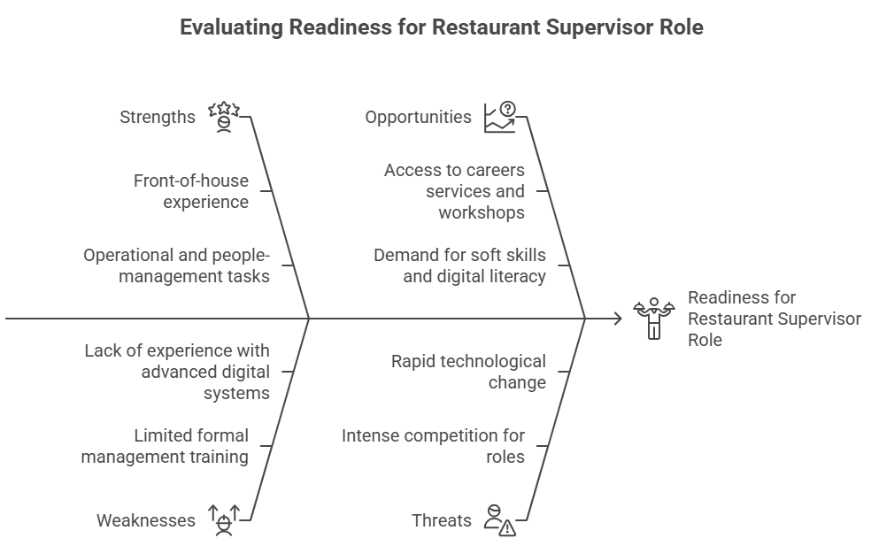
Figure.1: Evaluating readiness
Source: Own

Task 03 Personal development Plan
Using the above-identified weaknesses, this section describes both short-term and long-term employment objectives and a Personal Development Plan (PDP).. PDP is a reflective process on learning identified in the literature of higher education and employability as a process that entails setting of goals and planning on skills development. A SMART method (Specific, Measurable, Achievable, Relevant and Time-bound) helps in effective and realistic planning.

SMART objectives
Short-term work objectives (within 6 to 12 months)
- Gain a formal position of restaurant supervisor in a casual-dining restaurant or quick-service restaurant, where you are responsible to supervise shifts and coordinate the staff and assist in opening and closing the restaurant.
- Accomplish a minimum of two official short courses, e.g. Level 2 Food Safety and a simple team-leading or customer-service certification, to enhance compliance expertise.and formal management.
- Develop professional English communication by meeting current academic coursework successfully and by receiving positive comments regarding one or more presentations or written assignments by teaching personnel or supervisors at workplace.
Employment objectives (two to three years)
- Advance to assistant restaurant manager within a bigger hospitality organisation and assume the role of training novice employees, assisting in performance appraisal, and impacting the stores and simple financial reporting.
- Successful achievement of a higher degree in business, management or hospitality through part time study and employment thus enhancing theoretical knowledge in the areas of leadership, finance and operations.
- Develop a prominent career presence in the hospitality industry through keeping a current CV, building or renewing a LinkedIn account and attending at least one industry event or careers fair annually.

Personal Development Plan (PDP)
Table 2 PDP Table
 | Short-Term Time Frame  What do I want to  accomplish in the next  three to six months? | Long-Term Time Frame  What do I want to  accomplish in the next  two to three years?
Section 1 - My Goals  What are my overall goals that I want to accomplish in this time period? | Three goals  By January 2026, I would like to graduate with a CertHE Business skills for the workplace with distinction.  During the three to six months I would also like to:  - Leadership skills and interpersonal skills: at any opportunity in the current location of employment offer to take on shifts of leadership like opening and closing of the working area, receive and present common client complaints and so on. Get the owner or the manager of the restaurant to provide feedback concerning the shift, make decisions and conflict resolution.  - Online and technologic skills: ask to be trained on any point-of-sale, booking or stock-control systems that are in place at the workplace. Provide this with free online tutorials and practice activities like simple spreadsheet skills in order to do rota planning, lists of stock, and the simple minimum cost monitoring.  - Learning and communication skills: attend university seminars on academic writing, presentations and assistance in English language. Have tips and guidelines regarding coursework and practice presentations aloud to have some confidence and clarity. Request tutors/peers to comment and take notes on what needs to be improved.  - Networking and popularity: invite and former managers and classmates to LinkedIn and subscribe to hospitality industry organisations. Visit one careers fair, employer talk/ industry networking event annually with a goal of identifying potential employers and mentors. | Within two or three years I would like to:  - Formal qualification: organize proper short training programs in food safety, team leadership and customer services, the costs, time and accolades comparison. Aim: to complete at least two courses within 12 months and include certificates in the resume.  - Advancement in the hospitality industry through the integration of specific skills, experience and reflection to make me highly employable.  - Conduct periodic review of my goals after every three to four months (see PDP) in order to ensure that my goals remain in line with contemporary demands of employability in the hospitality industry..
Section 2 - Skills and Knowledge to be  Learned  What specifically do I need to learn? What project do I need to work on? | Goal 1 would require me to enhance my academic skills, in order to be able to write the assignments.  Moreover, to achieve my short-term objectives I should:  - Leadership and interpersonal skills: whenever the opportunity arises at the current workplace, volunteer to lead the shift like opening or closing the working place, picking up and dropping regular customer complaints, etc. Feedback of the owner or the manager of the restaurant concerning these shifts based on the communication, decision making and conflict resolution.  - Internet and technological skills: ask to receive training on any existing point-of-sale, booking or inventory systems at the office. Provide this with free online tutorials and exercises like simple spreadsheet skills to perform rota planning, lists of stock, the simple minimum cost monitoring.  - Academic and communication skills: attend university seminars on academic writing and support and presentation in English language. Take tips and guidelines in context of coursework, rehearse presentations in order to be confident and clear. Ask tutors or peers to comment and make notes in areas to improve.  - Networking and visibility: invite and former managers and college peers to LinkedIn, as well as subscribe to trade associations in the hospitality industry. One careers fair, employer talk/ industry networking event per year with a goal of identifying potential employers as well as mentors. | To achieve my long-term objectives I should:  - Formal qualification: organize suitable short training programs related to food safety, team leadership and customer service, the costs, time and accolades comparison. Aim: To complete no less than two courses within 12 months and include certificates in the CV.  - Implement the targeted skills development, experience and reflection in my PDP.  - Develop my knowledge in the sphere of hospitality operations further and maintain professional visibility and contacts.
Section 3 - Next Steps  How am I going to acquire the skills and knowledge? How am I going to do this project?  Example: take Dreamweaver class; do an  informational interview; set up a project outline | Next steps for the next three to six months:  - Leadership and interpersonal skills: as far as possible in the current working environment volunteer to take up shift-leading tasks, e.g., opening or closing the work area, collecting and delivering regular customer grievances, etc. Receive feedback of the owner or the manager of the restaurant on such shifts based on the communication, making decisions and solving conflicts.  - Online and technologic skills: ask to be trained on any point-of-sale system, booking system or stock-control system, that is in place at the workplace. Provide this with free online instructions and exercises like simple spreadsheet skills to do rota planning, stock lists and the simple minimum cost monitoring.  - Academic and communication skills: attend university seminars on academic writing, presentation and assistance in English language. Give tips and guidelines on coursework and rehearse on presentation to be more confident and clear. Request tutors or peers to make comments and record some areas to improve.  - Building and professional presence: add friends and former managers and friends on LinkedIn and subscribe to organisations in the hospitality industry. Visit 1 careers fair, employer talk/ industry networking event annually, and with a goal of identifying possible employers and mentors. | Next few steps to be taken over the next two to three years:  - Formal qualification: they should do proper, short training courses on food safety, team leadership and customer service, the costs, the time and accolades comparison. Goal: to complete at least two courses within 12 months and include certificates in the CV.  - It should be reviewed following every three to four months and revise the SWOT analysis to assess the achievements and compare them with the SMART targets. The signs of the enhancement will include such aspects as new work tasks, obtained certificates, improved academic achievements, and the feedbacks of the supervisors and tutors. Through continuous implementation of this PDP, the candidate will be in a position to ascend to the front-of-house employee with experience to become an effective restaurant supervisor and ultimately to an assistant manager degree and live up to the present-day demands of employability in the hospitality industry..

 | Short-Term Time Frame  What do I want to  accomplish in the next  three to six months? | Mid-Term Time Frame  What do I want to  accomplish in the next  six months to two years? | Long-Term Time Frame  What do I want to  accomplish in the next  two to three years?
Section 4 - Resources  What resources do I need?  Example: free time; funding | Free time; support of the manager; POS/computer/internet; skills workshops in the university. | Scholarship of short courses; continuing employment; careers fairs/employer lectures; tutor/mentor advice. | Consistent hospitality work; career contacts; industry knowledge.
Section 5 - Time Schedule  What is my time schedule? | Now–6 months (short-term). | 6–24 months (mid-term). | 2–3 years (long-term).
When will I start? | Immediately, this term. | The short-term actions should be established around month 6. | After approximately two years, after the mid-term goals are being fulfilled.

References
Advance HE (2025) ‘Personal development planning and employability’. Available at: https://www.advance-he.ac.uk/knowledge-hub/personal-development-planning-and-employability (Accessed 5 December 2025).
Ghani, M.A.H.A., Wan Talib, W.H.S., Wan Nawawi, W.N., Che Ngah, H. and Dewantara, Y.F. (2025) ‘The importance of employability skills for hospitality graduates toward employment status’, Information Management and Business Review, 17(1S), pp. 145–154. Available at: https://ojs.amhinternational.com/index.php/imbr/article/view/4434
Islam, M.A. (2022) ‘Industry 4.0: Skill set for employability’, Social Sciences & Humanities Open, 6, 100280. Available at: https://doi.org/10.1016/j.ssaho.2022.100280
Mesa, M.P. (2023) ‘Employability skills among hospitality management students in the province of Albay towards designing enrichment competency’, International Journal of Education, Business and Economics Research, 3(3), pp. 148–167. Available at: https://ijeber.com/employability-skills-among-hospitality-management-students-in-the-province-of-albay-towards-designing-enrichment-competency/
Moussa, M.H.B., Saber, M. and El-Yamani, M.I. (2024) ‘Graduates’ employability: Hospitality Industry 4.0 and skill gaps in Egypt’, Athens Journal of Tourism, 11(1), pp. 45–72. Available at: https://doi.org/10.30958/ajt.11-1-2
Peshev, M. (2025) ‘How to conduct a personal SWOT analysis for career advancements?’, MarioPeshev.com, 1 January. Available at: https://mariopeshev.com/swot-analysis-career-growth/
Torrens University Australia (2023) ‘Top 10 essential skills that hospitality employees need’. Available at: https://www.torrens.edu.au/stories/blog/hospitality/top-10-essential-skills-that-hospitality-employees-need (Accessed 5 December 2025).
Training Hotels (2025) ‘The role of soft skills in hospitality: Training for excellence’. Available at: https://traininghotels.com/2025/02/28/the-role-of-soft-skills-in-hospitality-training-for-excellence/ (Accessed 5 December 2025)

