
APPENDIX GA36a

LEVEL 4 ASSESSMENT SPECIFICATION

Student name: |  | Student ID number:
Programme: | HNC Process Operations Engineering
Module: | Industrial Process Operation and Control
Module code: | PCPO4004 | Contribution to Overall Module Assessment (%): | 50%
Lecturer: | Nigel Richards | Internal Verifier: | Lance Rutherford
Assignment Title: | Measurement systems and controller tuning techniques | Word count (or equivalent): | 2000
Submission deadline: | 31/01/22 | Return date of provisional marks & written feedback: | 14/02/22
Submission method: | All written assessments, where practical and possible, must be submitted via Turnitin unless otherwise instructed by the Lecturer. (Please DO NOT put this assessment specification into Turnitin or it will match many similarities with other students’ submissions.)  Alternative submission method (if applicable):  Late submission of the assessment will result in a late penalty mark. Penalties for late submission: Up to one week late, maximum mark of 40%. Over one week late, 0%. Only the Extenuating Circumstances Panel may approve a change to submission dates.
Academic honesty / referencing: | Academic honesty is required. In the main body of your submission you must give credit to authors on whose research and ideas your work is based. Append to your submission a reference list that indicates the books, articles, etc. that you have used, cited or quoted in order to complete this assessment.

Module Learning Outcomes
(from module syllabus)
LO1 Explain the elements required to ensure effective control is maintained over an industrial process.

LO2 Select an appropriate control strategy and develop an operational procedure based on knowledge of the industrial process.

LO3 Effectively operate a virtual industrial process to meet the specific requirements of the manufacturing standard operating procedure and batch sheet record.

TASK DESCRIPTION

Part A. Industrial Measuring Systems

Introduction

The Welsh industrial landscape contains a wide variety of national and international companies involved in operations ranging from power generation (renewable and non-renewable) and oil refining to chemical processing and food manufacture. For this part of the assignment you are required to answer the following questions:

Exercise A1

Explain the elements required to provide an effective control system over a selected (typical) industrial process. Include in your answer an overview of the industrial process operation, the sensors’ principle of operation and any advantages and disadvantages with respect to the operating environment.

Exercise A2

Assess and select an appropriate control strategy for an operating procedure to an industrial process. Examples should include continuous control, batch control and sequential control. Include in your answer any advantages and disadvantages with respect to your chosen control process.

Part B. Industrial Control Systems

Introduction

To use a three-term controller on an industrial process we need to understand the natural frequency and potential damping ratio of the system. Through the application of the Ziegler-Nichols three term controller tuning techniques the appropriate values for Proportional, Integral and Derivative control can be derived.
For this part of the assignment you are required to carry out the following practical exercise that demonstrates:
- A comprehensive knowledge of control system and process measurement techniques.
- An analysis of the control system operation and tuning techniques.
- An analysis and critical assessment of the issues relating to the identified measurement and control process.

Exercise B1 - Tuning a PID controller using the ultimate cycle tuning method.

In this exercise you will be using the ultimate cycle method to tune a three-term controller. The TSC process simulation software will be used for this exercise. Initial conditions are: Proportional Gain = 2.0, Integral Time Constant = 0, Derivative Constant = 0.

Procedure

- Set the controller to Auto
- Adjust the Set Point value to 25% and settle the system into a normal operating condition.
- Remove all control actions and ensure the Proportional Gain is initially be set to 2.0.
- Introduce a slight increase to the Set Point (i.e. 20% of range)
- Observe and note the response.
- Reset the Set Point to 25% and increase the proportional gain.
- Repeat step 4 until the plant exhibits sustained oscillatory behaviour which does not increase or decrease in amplitude (see figure 1).
- Note the proportional gain value (K_{U}) and the oscillation time period (T_{u}).
- Derive the controller PID settings by applying the calculations shown in table 1.
- Apply the calculated values to the PID setting for the level control system
- Observe the response with respect to varying changes in Set Point values.

Table 1: Controller Settings

Control Type | PID
Controller Gain | K_{U} ÷ 1.7
Integral (T_{i}) | T_{u} ÷ 2
Derivative (T_{d}) | T_{u} ÷ 8
Note: K_{u} = Proportional Gain T_{u} = Oscillation Period

Figure 1. Representation of control system oscillatory response

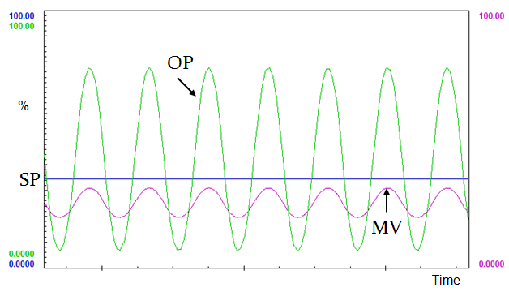

Exercise B2 - Tuning a PID controller using the reaction curve tuning method.

In this exercise you will be using the reactive curve method to tune a three-term controller.
The TSC process simulation software will be used for this exercise.
Initial conditions: Proportional Gain = 2.5, Integral Time Constant = 0, Derivative Constant = 0.

Procedure
- Set the controller to manual and settle the plant into a normal operating condition.
- Apply a small step change to the controller output and record the response. Refer to figure 2 for an example of the required response and analysis of results.
- Find the maximum slope of curve N and draw a tangent at that point.
- Determine the effective delay D by measuring the time between the application of the step change and the point where the maximum slope of N intersects the plant initial response point.
- Extrapolate the line of maximum slope back to intersect the initial time line at the point where the step change was applied to the system.
- Derive the controller PID settings by applying the values for Δu, N and D in table 2.
- Apply the calculated values to the PID setting for the level control system and observe the response with respect to changes in Set Point values.

Table 2: Controller Settings

Control Type | PID
Controller Gain | 1.2(Δu ÷ ND)
Integral (Ti) | D ÷ 0.5
Derivative (Td) | D ÷ 2

Figure 2. Representation of reaction curve control system response
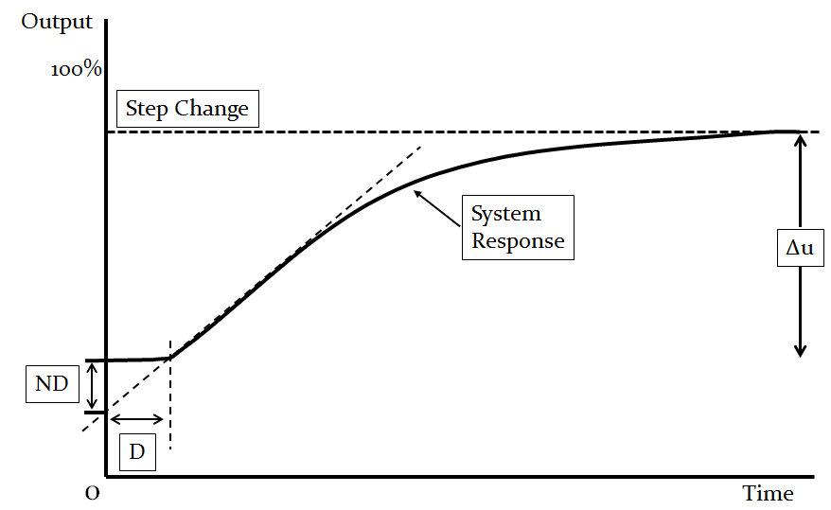

Exercise C - Control systems evaluation

Examine, compare and contrast the ultimate cycle and reaction curve methods used to tune the three-term controller, in particular on issues associated with the following:
- Techniques to achieve controller PID values.
- Application of the final values and system response.
- Key characteristics such as rise time, overshoot, steady state error.

Use screen shots from the control system simulator to support your discussion and to illustrate the results of the practical tuning exercises.

Report structure

The report must be constructed with the following:

- A cover page or document title page
- A table of contents page.
- Sections or paragraph headings related to each aspect of the report.
- Headers on each page with the title of your report.
- The text format should be Times New Roman or Arial with a font size of 12.
- Paragraphs should be spaced using ‘1.5 line spacing’.
- Footers with author’s name on the right and ‘Page … of …’ on the left.
- A references page and bibliography as appropriate.
- Appendices where appropriate for larger quantities of data.
- Diagrams, charts or tables, suitably incorporated and labelled.
- A word count of 2000 words (± 10%).

GUIDANCE FOR Students IN THE COMPLETION OF TASKS

NOTE: The guidance offered below is linked to the five generic assessment criteria overleaf.

- Engagement with Literature Skills
Your work must be informed and supported by scholarly material that is relevant to and focused on the task(s) set. You should provide evidence that you have accessed an appropriate range of sources, which may be academic, governmental and industrial; these sources may include academic journal articles, textbooks, current news articles, organisational documents, and websites. You should consider the credibility of your sources; academic journals are normally highly credible sources while websites require careful consideration/selection and should be used sparingly. Any sources you use should be current and up-to-date, mostly published within the last five years or so, though seminal/important works in the field may be older. You must provide evidence of your research/own reading throughout your work, using a suitable referencing system, including in-text citations in the main body of your work and a reference list at the end of your work.

Guidance specific to this assessment: You must provide evidence of individual research with respect to the area of study and provide relevant referencing.

- Knowledge and Understanding Skills
At level 4, you should be able to demonstrate knowledge of the underlying concepts and principles associated with your area(s) of study. Knowledge relates to the facts, information and skills you have acquired through your learning. You demonstrate your understanding by interpreting the meaning of the facts and information (knowledge). This means that you need to select and include in your work the concepts, techniques, models, theories, etc. appropriate to the task(s) set. You should be able to explain the theories, concepts, etc. to show your understanding. Your mark/grade will also depend upon the extent to which you demonstrate your knowledge and understanding.

Guidance specific to this assessment: Your report should show you gained knowledge of the subject area.

- Cognitive and Intellectual Skills
You should be able to present, evaluate and interpret qualitative and quantitative data, in order to develop lines of argument and make sound judgements in accordance with basic theories and concepts of your subject(s) of study. You should be able to evaluate the appropriateness of different approaches to solving problems related to your area(s) of study and/or work. Your work must contain evidence of logical, analytical thinking. For example, to examine and break information down into parts, make inferences, compile, compare and contrast information. This means not just describing what! But also justifying: Why? How? When? Who? Where? At what cost? You should provide justification for your arguments and judgements using evidence that you have reflected upon the ideas of others within the subject area and that you are able to make sound judgements and arguments using data and concepts. Where relevant, alternative solutions and recommendations may be proposed.

Guidance specific to this assessment: The report should show analysis of the research.

- Practical Skills
At level 4, you should be able to apply the basic underlying concepts and principles to evaluate and interpret these within the context of your area of study. You should be able to demonstrate how the subject-related concepts and ideas relate to real world situations and/or a particular context. How do they work in practice? You will deploy models, methods, techniques, and/or theories, in that context, to assess current situations, perhaps to formulate plans or solutions to solve problems, or to create artefacts. This is likely to involve, for instance, the use of real world artefacts, examples and cases, the application of a model within an organisation and/or benchmarking one theory or organisation against others based on stated criteria.

Guidance specific to this assessment: Completion of the practical tasks with clear evidence of achieving a stable control systems.

- Transferable Skills for Life and Professional Practice
Your work must provide evidence of the qualities and transferable skills necessary for employment requiring the exercise of some personal responsibility. This includes demonstrating: that you can communicate the results of your study/work accurately and reliably, and with structured and coherent arguments; that you can initiate and complete tasks and procedures, whether individually and/or collaboratively; fluency of expression; clarity and effectiveness in presentation and organisation. Work should be coherent and well-structured in presentation and organisation.

Guidance specific to this assessment: Your work should be well organised and presented in a professional manner.

Student FEEDBACK FORM

This section details the extent to which the assessment criteria are demonstrated by you, which in turn determines your mark. The marks available for each category of skill are shown. Lecturers will use the space provided to comment on the achievement of the task(s), including those areas in which you have performed well and areas that would benefit from development/improvement.

Generic Assessment Criteria | Marks available | Marks  awarded
1. Engagement with Literature Skills
.
 | 10
2. Knowledge and Understanding Skills

 | 20
3. Cognitive and Intellectual Skills

 | 20
4. Practical Application Skills

 | 40
5. Transferable Skills for Life and Professional Practice

 | 10

Assessment Mark (Assessment marks are subject to ratification at the Exam Board. These comments and marks are to give feedback on module work and are for guidance only until they are confirmed. ) | Late Submission Penalties (tick if appropriate) |  | %
 | Up to 1 week late (40% Max) |  | %
 | Over 1 week late (0%) |  | %

GENERIC ASSESSMENT CRITERIA

Level 4
In accordance with the Framework for Higher Education Qualifications, at the end of Level 4 students will be expected to have demonstrated knowledge of the basic underlying concepts and principles of a subject, and an ability to evaluate and interpret these within the context of that area of study. They should be able to present, evaluate and interpret qualitative and quantitative data in order to develop lines of argument and make sound judgements in accordance with basic theories and concepts of their subject(s) of study. They will have learned how to evaluate different approaches to solving problems, and will be able to communicate the results of their study/work accurately and reliably, and with structured and coherent arguments. They will be able to undertake further training and develop new skills within a structured and managed environment and will have the qualities and transferable skills necessary for employment requiring the exercise of some personal responsibility.

Level 4 | FAIL | MARGINAL FAIL | SATISFACTORY  (3rd / Pass) | GOOD  (2.2 / Pass) | VERY GOOD  (2.1 / Merit) | EXCELLENT  (1st / Distinction) | EXCEPTIONAL  (1st / Distinction)
Category | 0-29% | 30-39% | 40-49% | 50-59% | 60-69% | 70-84% | 85-100%
Engagement with literature (including reading, referencing,  academic conventions and  academic honesty) | Little or no evidence of reading and/or reliance on inappropriate sources.  Views and findings mostly unsupported and non-authoritative.  Referencing conventions used incoherently or largely absent. | Poor engagement with essential reading. No evidence of wider reading. Reliance on inappropriate sources, and/or indiscriminate use of sources. Heavily reliant on information gained through class contact. Inconsistent and weak use of referencing. | Engagement with a limited range of mostly relevant and credible sources but with some reliance on information gained through class contact. Some omissions and minor errors.  Referencing conventions evident though not always applied accurately or consistently. | Engagement with an appropriate range of literature, including sources retrieved independently. Some over-reliance on texts rather than other sources. Referencing may show minor inaccuracies or inconsistencies. | Engagement with a wide range of literature, including sources retrieved independently.  Selection of relevant and credible sources. Generally sound referencing, with no/very few inaccuracies or inconsistencies. | Engagement with an extensive range of relevant and credible literature. Consistently accurate application of referencing. | Exceptional engagement with an extensive range of relevant and credible literature. High-level referencing skills consistently applied.
Knowledge and understanding (Knowledge of the basic underlying concepts and principles of a subject.) | Major gaps in knowledge and understanding of the basic underlying concepts and principles of the subject matter. Inclusion of irrelevant material. Substantial inaccuracies. | Gaps in knowledge of the basic underlying concepts and principles, with flawed or superficial understanding. Some significant inaccuracies and/or irrelevant material. | Limited knowledge and understanding of the basic underlying concepts and principles within the subject area. Some elements may be missing. | Knowledge of the basic underlying concepts and principles is accurate with a good understanding of the field of study but lacks depth and/or breadth. | Competent knowledge of the basic underlying concepts and principles. Exhibits very good understanding. | Excellent knowledge and understanding of the basic underlying concepts and principles of the subject. | Exceptional, detailed knowledge and understanding of the basic underlying concepts and principles
Cognitive and intellectual skills  (Evaluate underlying concepts and principles of a subject and interpret qualitative and quantitative data in order to develop lines of argument and make sound judgements.) | Wholly or almost wholly descriptive work. Little or no evaluation of the underlying concepts and principles.  Failure to develop arguments, leading to illogical or invalid judgements. Minimal or no use of  evidence to back up views. | Largely descriptive work, with superficial evaluation of the underlying concepts and principles. Weak interpretation of data, flawed development of arguments and judgements. Information accepted uncritically, uses generalised statements made with scant evidence and unsubstantiated opinions. Ideas sometimes illogical and contradictory. | Limited attempt at evaluation of the underlying concepts and principles, tending towards description.  Can interpret qualitative and quantitative data but with some errors. Some evidence to support emerging arguments and judgements but these may be underdeveloped or with a little inconsistency / mis-interpretation. | Good evaluation of the underlying concepts and principles. Can interpret qualitative and quantitative data, with minor errors.  An emerging ability to use evidence to support the argument.  Mostly valid arguments and logical judgements. | Sound evaluation of the underlying concepts and principles. Can interpret qualitative and quantitative data accurately. Ability to devise arguments using evidence to make mostly appropriate and valid judgements. | Excellent evaluation of the underlying concepts and principles. Can interpret qualitative and quantitative data accurately and with some insight. Excellent ability to devise arguments using evidence and make appropriate and valid judgements. | Exceptional evaluation of the underlying concepts and principles based evidence. Outstanding interpretation of qualitative and quantitative data.  Exceptional ability to devise arguments using evidence and make wholly appropriate and valid judgements.
Practical skills  (Different approaches to solving problems in particular contexts.) | Limited or no use of taught, basic methods, materials, tools and/or techniques.  Little or no appreciation of the context of the application.  Very weak evidence of different approaches to problem-solving in particular contexts. | Rudimentary application of taught, basic methods, materials, tools and/or techniques but without consideration and competence. Flawed appreciation of the context of the application.  Weak evidence of different approaches to problem-solving in particular contexts. | An adequate awareness and mostly appropriate application of basic methods, materials, tools and/or techniques.  Basic appreciation of the context of the application.  Can identify problems in particular contexts and propose basic alternative approaches or solutions though there may be errors. | A good and appropriate application of basic methods, materials, tools and/or techniques.  Clear appreciation of the context of the application.  Good evidence of different approaches to problem-solving in particular contexts and proposes mostly appropriate solutions. | A very good application of a range of basic methods, materials, tools and/or techniques.  Very good consideration of the context of the application. Very good evidence of different approaches to problem-solving in particular contexts and proposes appropriate solutions. | An advanced application of a range of taught, basic methods, materials, tools and/or techniques.  The context of the application is well considered, and insightful.  Excellent evidence of different approaches to problem-solving in particular contexts and proposes appropriate solutions. | Exceptional levels of application and deployment skills in particular practical contexts. Outstanding identification of problems in particular contexts and formulation of wholly appropriate, thoughtful solutions / different approaches.
Transferable skills for life and professional practice  (Communicate the results of their study/work accurately and reliably, and with structured and coherent arguments; the qualities needed for employment requiring the exercise of some personal responsibility within a structured and managed environment.) | Work is poorly structured, disorganised, inaccurate and/or confusingly expressed. Very weak use of language and/or very inappropriate style. Failure to work effectively individual or as part of a group. Little or no evidence of the skills for employment requiring the exercise of some personal responsibility. | Work is poorly presented in a disjointed manner. It is loosely, and at times incoherently, structured, with information and ideas often poorly expressed. Weak use of language and/or inappropriate style. Flawed approach to individual or group work, meeting only partial obligations to others. Limited evidence of the skills for employment requiring the exercise of some personal responsibility. | Mostly ordered presentation and structure in which relevant ideas / concepts are reasonably expressed. Work may lack coherence and/or accuracy in places. Can work as part of a group, meeting most obligations to others but perhaps with limited involvement in group activities.  Demonstrates the basic skills for employment requiring the exercise of some personal responsibility, with some areas of minor weakness. | Mostly coherent, organised and accurate work, in a suitable structure and is for the most part clearly expressed. Can work effectively independently and/or as part of a team, with clear contribution to group activities.  Demonstrates the skills for employment requiring the exercise of some personal responsibility, with some areas of strength and some of minor weakness. | Work is accurate, coherent, fluent, well-structured and organised.  Can work effectively independently and/or as part of a team, with very good contribution to group activities. Demonstrates very good skills for employment requiring the exercise of some personal responsibility, with just occasional minor weakness. | Work is coherent, very fluent and is presented professionally. Can work effectively independently and/or as part of a team, with an excellent contribution to group activities. Demonstrates excellent skills for employment requiring the exercise of some personal responsibility with an appetite for further development. | Work is accurate, exceptionally coherent, very fluent and presented well. Can work effectively independently and/or as part of a team, with an exceptional contribution to group activities. Demonstrates exceptional skills for employment requiring the exercise of some personal responsibility with an appetite for further development.

THIS DOCUMENT IS ALSO AVAILABLE IN WELSH

