Early Years Education and Care The Professional Practice ECEY4014/C


005
Alimah Akter
Student Number: 2601739
Lecturer: Paul Darby

Content:
Content page – page 1
Personal Development plan – page 2 – 3
Personal reflection – page 4
Poster – page 5 – 7
Writing piece – page 8 – 12
Reference list – page 14 – 15

Personal Development Plan (PDP)
Below is my Personal development plan (PDP) that includes personal and professional aims to help develop my professional practitioner skills, including a personal reflection on my DPD.
No | Improvement and Development Goals | Success Criteria  (How I will know when I have made this change) | The actions I will take to achieve the goal | Timelines | What will this help me to achieve?
1 | Improve my time management and organisation skills | I will manage my university deadlines, work responsibilities and personal commitments more effectively. | I will make a weekly plan and a to-do list which will priorities my important tasks. | 1 months | This goal will help me become more organized, reduce stress when managing various tasks and responsibilities.
2 | Develop my understanding of Additional Learning Needs (ALN) | I will understand how to recognise individuals learning needs and use appropriate strategies to support children. | I will complete relevant training, look over the children’s Individual Development Plan (IDP), communicate with other staff and agencies and learn different strategies to support the child. | 5 months | This goal will be beneficial as it improve my ability to support inclusion and individual children’s needs.
3 | Successfully complete and graduate from my Early Years Education and Care degree. | I will successfully complete my assignments, attend my lectures, meet deadlines and complete all the requirements of my course so that I can graduate. | To achieve this goal I will attend my university sessions once a week, keep my assignments organised and make a to-do list to manage my deadlines. Ensure I ask lecturers for support when needed and ensure I make time to complete my assessments. I will balance my university studies with my role as a teaching assistant | every 3 months | These actions will help me gain my degree, increase my knowledge and understanding of children and my confidence. This will also support my future career in education and childcare.

Personal refection
Reflecting on my current personal, academic and professional development, I recognise that I have already gained valuable experience through my role as a Teaching Assistant in a primary school. This experience has allowed me to develop my understanding of working with children and has given me the opportunity to apply some of the knowledge I am gaining through my Early Years Education and Care degree. However, I also recognise that there are areas where I can continue to develop my skills, knowledge and personal qualities.

My short-term goal is to improve my time management and organisational skills over the next three months. Managing my university studies alongside my employment and personal responsibilities can sometimes be challenging. I plan to use a weekly planner, to-do lists and deadlines to organise my workload more effectively. I will measure my progress by monitoring whether I complete tasks and assignments on time. Improving these skills will help me become more organised and prepared in both my academic and professional life.

My medium-term goal is to develop my understanding of Additional Learning Needs (ALN). Working as a Teaching Assistant means I may support children with a range of individual learning needs. I want to develop my knowledge of inclusive practice and learn different strategies that can support children's learning and development. I will use my university studies, professional experiences and relevant professional development opportunities to develop this area. This will help me become more confident when supporting children and responding to their individual needs.

My long-term goal is to successfully complete and graduate from my Early Years Education and Care degree. I will work towards this by attending university, completing my assignments, meeting deadlines and seeking support when required. Graduating will give me an important qualification and further develop the knowledge and skills I need for my future career.

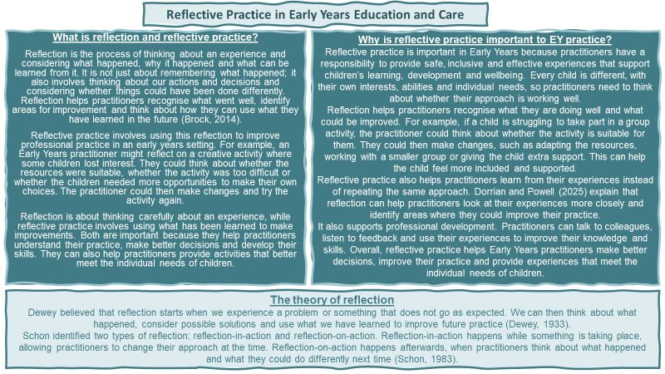
This is an Academic Poster that explores the importance of reflective practise within the early years and analyses different reflective models.
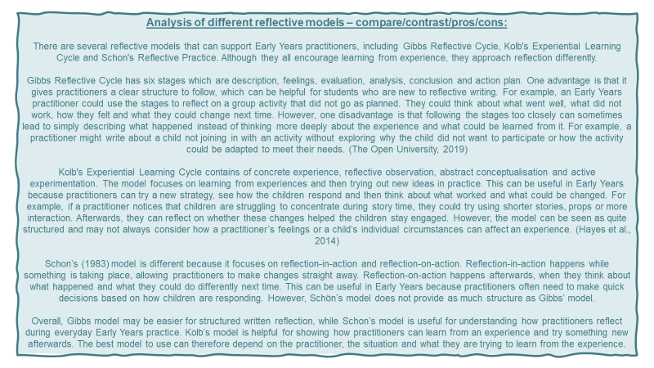
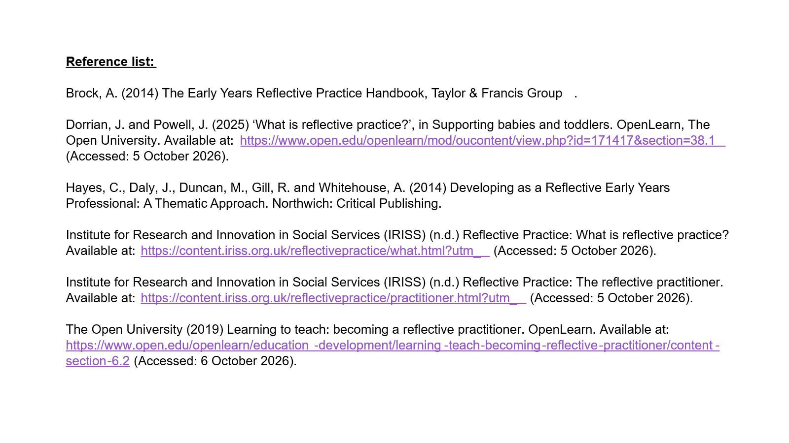
Introduction
In this assessment will explore the importance of professional practice in early years settings, including safeguarding communication partnership working the observation and planning cycle, children rights and reflective practice. Professional practice in early years means using your knowledge, skills, values and behaviour to ensure high quality care and education is provided to the children and you people. Professionalism in early years means ensure you are responsible toward and Infront of children as they see professional practitioners are role models and someone to look up to. Is also means treating children and families with respect, maintaining confidentiality and following settings policies, procedures and legislations. Every practitioner has a duty to ensure roles and responsibilities, safeguarding children, promoting equality and meeting the children’s individual needs. Maintaining effective communication, positive relationships and partnership working are vital as it ensures suitable support is given to the child to meet its individual needs.
Building a positive relationship and communicating with children and young people will make them feel safe, valued and confident. When children feel safe and secure they are most likely to feel confident to explore the environment more and join in learning activities. Some children may be verbal or non- verbal. When children have a communication barrier it is vital for practitioners to listen carefully, observe body language and respond to children emotions, to understand their need. This is particularly important for babies and young children who may not yet have the words to communicate effectively. For practitioners to provide consistent care and support to children’s learning and well-being it is vital to have a working partnership with families. Having a professional relationship and good communication with parents and carers is highly important as they can share information about the child’s routine, interest, additional learning needs and if there are any dietary requirements. For children to feel safe, valued and understand as a practitioner you must have a positive relationship and communicate effectively. Practitioners should listen to children, communicate positively and build nurturing relationships to support their emotional well-being and confidence (Welsh Government, 2026).
Early years practitioners have an in-depth knowledge and understanding of the importance of professional practice because it helps practitioners meet children’s individual needs and support their leaning, development, health and wellbeing. The main key knowledge and understanding a practitioner needs are child development, behaviour, inclusion and different ways of children learning. Having these key knowledge and understanding allows practitioners plan suitable activities, identifies developmental concerns and allows every individual child to have appropriate support plan.
Every practitioner has a responsibility to protect every child from abuse, neglect and harm this is why having knowledge of safeguarding is important. The Welsh Government (2026) identifies safeguarding as a priority for childcare settings and states that protecting children is everyone's responsibility. Practitioners must familiarise themselves with understanding the signs of physical, emotional and sexual abuse, as well as neglect. This knowledge and understanding will help practitioners recognise when a child or you person may be as risk. An example of when safeguarding procedures will take place is when practitioners notices a child’s behaviour rapidly changing or signs of a child’s basic needs are not being met or when unexpected injuries appear. Any concern about a child or signs of neglect or abuse must be taken seriously. Every childcare setting has a safeguarding procedures, when a child discloses concerning information or a practitioner notices something concerning about a child they must not investigate further and record relevant information accurately and report it directly to the designated safeguarding person along side following the settings safeguarding procedures. If a child discloses a concerning information to a practitioner, the practitioners should never promise anything to the child and ensure to inform the child they did a good thing by telling them. To maintain a safe environment and for practitioners to make responsible decisions understanding safeguarding policies, professional boundaries, confidentiality and relevant legislation helps practitioners to do their job smoothly.
Early years professional practitioners working alongside multi-agencies is highly important because having a partnership with other professionals boost support for children and young people’s individual needs, learning and development, health and wellbeing. Practitioners do not only work alongside multi-agencies they also work effectively with parents and carers to which contributes different knowledge and skills to help identify children's needs and provide suitable support. The Welsh Government (2025) explains that effective multi-agency working can improve outcomes for children and families through collaborative problem-solving. The agencies that early years practitioners may be in communication with are health visitors, speech and language therapists, social workers and additional learning needs co-ordinator (ALNco) specialists.
Early years practitioners working with other agencies and organisations is every beneficial. An example of an outside agencies cooperating with early years practitioners would be if a child had difficulties with speech and language, the teacher and ALNco will discuss and review their observations and other evidence. They will then approach the child’s parent and carers and discuss the evidence and inform them reaching out to a speech and language therapist would help the child to access suitable support and develop communications skills. Having a working in partnership with parents and carers will help practitioners understand the individual child more and the child’s home environment., cultural background and daily routine.
In early years practice observing and planning helps practitioners to understand each and every child’s interest, abilities, needs and stages of development. Observation and planning cycle is a way of assessing and analysing children’s learning, planning appropriate activities and reviewing the pros and cons of the activities. Analysing and assessing helps practitioners provide suitable and appropriate opportunities that support children’s progress. When early years practitioners observe children this is allowing them to recognise the child’s strengths, interests and if there are any areas where additional support may be needed. According to the Welsh Government (2022), practitioners should observe, analyse and respond to children's learning to inform future planning. This ensures that planning is based on children's actual needs rather than assumptions. (Welsh Government, 2023)
For example, if a practitioners is observing a child showing interest in building a tower with blocks but is showing frustration when balancing the blocks and also struggling to share the blocks with other children. The practitioner will use the child’s interest plan an activity using different construction materials such as foam bricks. This activity will help the child’s coordination, gross and fine motor skills, it will also help the child develop sharing skills and positive relationships with other. The practitioner would then observe the child's progress and adapt future activities accordingly. Sharing this observation with other staff members and the child’s parents and carers will help them to understand does this behaviour occur at home or in other settings. This will also give them a fuller picture of the child’s development and help maintaining consistency between home and setting. The observation and planning cycle allows practitioners to implement inclusion in to the setting as well as identifying potential developmental delay or additional needs. This cycle also allows practitioners to add in appropriate approaches to help the child participate. Overall, the observation and planning cycle informs professional decisions by ensuring that learning experiences are responsive, inclusive and developmentally appropriate. By continually observing, analysing and responding, practitioners can support children's individual progress, wellbeing and learning.
The Welsh Government (2022), states that The United Nations Convention on the Rights of the Child (UNCRC) and the Children Act are laws that supports practitioners to protect children’s rights, support their wellbeing and ensure their needs are being met. The UNCRC is a legislation that states children have a right to be protected, educated, given support on their development and their voices to be heard. In a professional practice in Wales children’s rights are the most essential this is why the Welsh Government implemented the UNCRC in settings to create appropriate policies that involve children and you people. (Welsh Government, 2022).
The key value and purpose of the UNCRC is for everyone to be non-judgemental, beneficial for the child, for children to have the right to life and development, and for children’s views to be respected, these are all stated in article 2,3,6,and 12. This legislation ensures all practitioners treat every child and young person fairly, ensure the decisions that are being made for the child is in the child’s best interest and made sure their opinions are being heard and taken in to accountability. An example would be a practitioner setting up an activity chosen by the children and ensuring the activity has accessible resources so that children with different abilities or difficulties can participate the activity.
The Children Act 1989 emphasises the importance of children's welfare in decisions concerning their upbringing (Children Act 1989, s. 1). The Children Act 2004 also places safeguarding duties on specified organisations and agencies (Children Act 2004, s. 11). In Wales, practitioners must follow safeguarding procedures to identify concerns, report suspected abuse or neglect and work with other professionals when necessary (Welsh Government, n.d.).
The two legislations allow professional practices to place children’s rights, safety and wellbeing at the centre of every decisions. Ensuring practitioner have a full understanding of these two legislations supports practitioners to make the right decision and create a welcoming, safe, inclusive environment. They also ensure children are respected as individuals, protected from harm and supported to reach their potential.
Conclusion:
In conclusion, professional practice in Early Years is essential for supporting children's learning, development, safety and wellbeing. This assignment has explored the importance of effective communication, positive relationships, professional knowledge, safeguarding and partnership working. It has also explained how the observation and planning cycle helps practitioners identify children's individual needs and plan appropriate learning experiences. The UNCRC and Children Act guide practitioners to protect children's rights and prioritise their welfare. Finally, reflective practice encourages practitioners to evaluate their actions and improve their skills. Overall, professionalism requires responsibility, teamwork and continuous learning to ensure every child receives appropriate care, support and opportunities to thrive.

Reference list:
Welsh Government (2026) National Minimum Standards for Regulated Childcare for children up to the age of 12 years: statutory guidance. Available at: https://www.gov.wales/national-minimum-standards-regulated-childcare-children-age-12-years-statutory-guidance-contents-standard-6⁠ (Accessed: 17 October 2026)
Welsh Government (2026) National Minimum Standards for Regulated Childcare for children up to the age of 12 years: Standard 20 – Safeguarding. Available at: https://www.gov.wales/national-minimum-standards-regulated-childcare-children-age-12-years-statutory-guidance-standard-20 (Accessed: 19 October 2026).
Welsh Government (2025) National multi-agency practice framework for children’s services. Available at: https://www.gov.wales/national-multi-agency-practice-framework-childrens-services (Accessed: 20 October 2026).
Welsh Government (2022) A curriculum for funded non-maintained nursery settings. Available at https://hwb.gov.wales/curriculum-for-wales/curriculum-for-funded-non-maintained-nursery-settings/ (Accessed: 20 October 2026).
Hwb – Curriculum for funded non-maintained nursery settings⁠ Welsh Government (2023) Assessment arrangements for funded non-maintained nursery settings. Available at: https://hwb.gov.wales/curriculum-for-wales/curriculum-and-assessment-arrangements-for-funded-non-maintained-nursery-settings/assessment-arrangements-for-funded-non-maintained-nursery-settings (Accessed: 20 October 2026).
Welsh Government (2022) Children's rights in Wales. Available at: https://www.gov.wales/childrens-rights-in-wales?%E2%81%A0 (Accessed: 21 October 2026).
Children Act 1989, c. 41. Available at: https://www.legislation.gov.uk/ukpga/1989/41/section/1 (Accessed: 21 October 2026). ⁠
Children Act 2004, c. 31. Available at: https://www.legislation.gov.uk/ukpga/2004/31/contents (Accessed: 21 October 2026). ⁠
Wales Safeguarding Procedures (n.d.) The Wales Safeguarding Procedures for children and adults at risk of abuse and neglect. Available at: https://safeguarding.wales/en/int-i/int-i-i1/i1-p1/ (Accessed: 21 October 2026).

