Automotive engineering
ACHA4011
2103608
Jordan-Michael Harley
Engineering Project Technical Report

Contents:
Introduction
(3)
Research
(4-5)
Methodology
(6-7)
Discussion
(8)
Conclusion
(9)
Reference list
(10)

Introduction
In this technical report I will be covering all aspects into what goes into developing a new product. This technical report will demonstrate all the processes that need to be carried out when developing a new product as they are essential to the development of any product that wants to be made and be a success on the market. Depending on how well these processes are carried out has a huge impact on how well it will do on the market and how profitable it will be. The product that I will be designing and creating is called simply headphones. This product separates itself from any ordinary pair of headphones as these headphones have a feature which allows them to self-naturalise any unwanted bacteria that may be lingering on the headphones after usage. This is done be having an installed uv light in the headphone case that comes with the headphones. When the headphones are placed into the case, the light takes action killing unwanted organisms in seconds.
I feel this product would be something that did well on the market as not only would it be providing the standard comfortability and good clear sound that allows the user to be emersed, but it will also provide the user with protection against any unwanted bacteria or organisms that may be lingering on the device. Due to the latest pandemic that we suffered a tole from and are still suffering from it is essential that daily products we use are sterilised and cleaned properly to not spread the virus further, that’s why these headphones in our day in age would be a good alternative to any other standard headphones as like I said it does not only provide comfort and good quality sound but also provides the user with protection against unwanted organisms lingering on the device.

Research
To develop and create my new product I needed a team and a department structure so that my product could be developed properly and effectively ensuring it would cover all aspects of the design process. So, I first started looking at an engineering team, this team would cover the design process of the product making sure they covered all aspects of the design specification and meet the users’ needs. In this diagram you can see the aspects that the engineering team will be covering while carrying out the design process of the product.
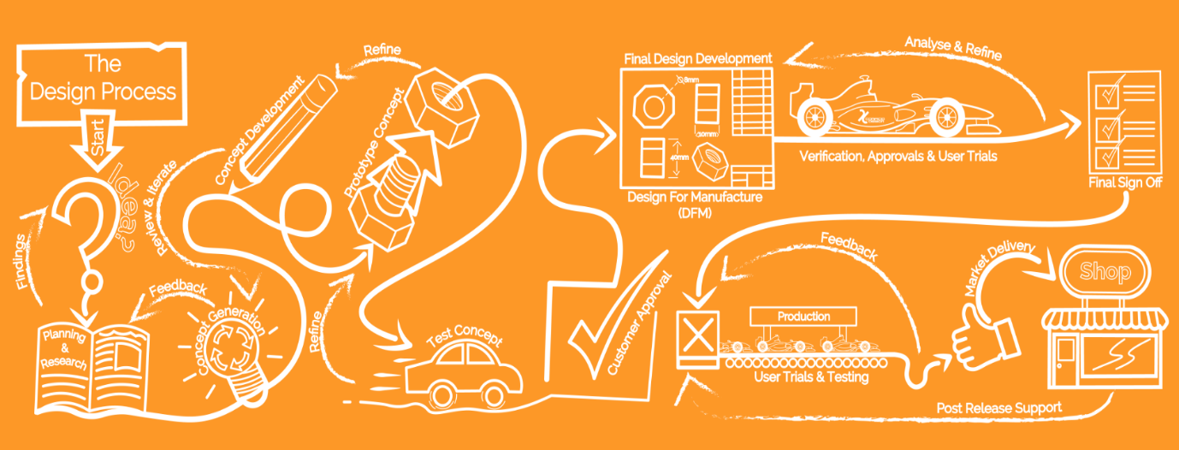

Other departments that were required to develop the new product included a resource team, marketing team and a biologist team. These sub sectors were essential to the successful development of the new product. The resource team would help to gather resources that would be essential to the production of the product such a production facility, materials, and equipment. The marketing team Is one of the most critical sectors in the department as that team has a huge impact on how well the product does on the market, for example the marketing team is tasked with deciding who our target audience is aimed at for this particular product and how well this product with suit that audience to see if it will be successful on the market. Not only do the marketing team deal with how suited the product is with our target audience, but they also manage the financial side of the product and how well it does on the market for example, this team will cover the sale pitches of the product to get the product out there on the market, they will also cover financial details of the product to make sure the target audience get a product worth their money.
The marketing team helps to build a brand which is important for any product to be successful because that brand will help to show awareness of what your company offers and stands for. An example of this is BOSE which is a very successful sound product developing company known for having good quality sounding products, their name stands for “better sound through research” and due to having this brand name this company is worldwide known for their product and how successful they are. The marketing also deals with the uniqueness of the product and the legal side of producing and selling it. When producing any product legal actions should be taking to make sure your product is unique on the market and stays that way.
My marketing team would have been tasked with making sure the product design was patented, the logo trademarked, and slogan copy right protected to make sure our product could not be copied and resold on the market. The marketing team strategies how well this product will do on the market, this team will be doing most of the research required to know how successful this product will be and also to know which time to release this new product. A product that is not well known that gets released to the public around the same time a new similar product get released by a well-known company is a bad thing as it could have a negative effect on the sales of the product. For this pacific product I felt it was necessary to have a biologist team. I felt this team was necessary to the development of the new product as the product aims to eliminate organisms and bacteria. Biologists are well known for having a wide knowledge of microorganisms and how they can be eliminated safely without causing harm to any human life. It was essential to have this team in the development of the product as the information they can provide would be very beneficial to how successful the product would turn out once fully developed.
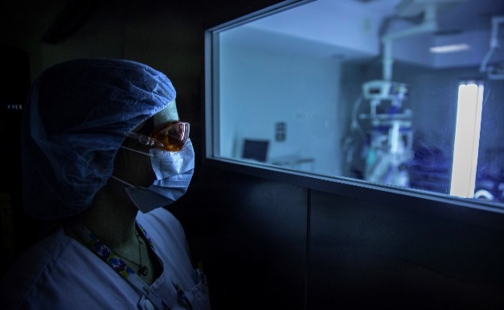
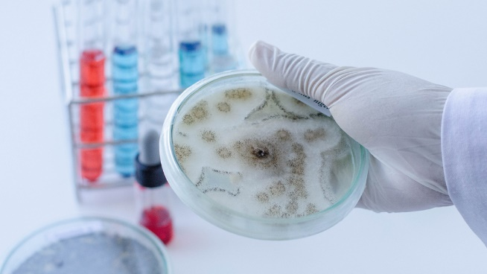

To ensure all members of the department structure are working at a professional level within the workplace codes of conduct will be enforced. Due to me not being well known with the codes of conduct I turned to a trusted organisation that is well known with what the codes of conduct are, the organisation is called The National Society of Professional Engineers. As stated by their organisation their vision is “A world where the public can be confident that engineering decisions affecting their lives are made by qualified and ethically accountable professionals”. That is why I turned to their organization to get information on what the proper engineering codes of conduct are which are as follows.
Engineers, in the fulfilment of their professional duties, shall:
- Hold paramount the safety, health, and welfare of the public.
- Perform services only in areas of their competence.
- Issue public statements only in an objective and truthful manner.
- Act for each employer or client as faithful agents or trustees.
- Avoid deceptive acts.
- Conduct themselves honourably, responsibly, ethically, and lawfully so as to enhance the honour, reputation, and usefulness of the profession.
With these codes of conduct in place it will ensure all members within the department structure will be working at a professional level which is beneficial to my business as it will help to show how professional we are and how much we care about what we do, this would help to show the public why they should choose our product over any other business due to us having such a professional and hardworking image they would know they are getting a product of good quality standards.

Methodology
Certain steps need to be followed in order to ensure successful development of my product, these steps will help to create a product that is the best functioning and most useful product that my team can come up with. In order to create a product of a high standard and functionality, firstly specifications of the product must be made this will help to ensure that the user gets what they are asking for and complies with what we are wanting to make. With these specifications first-hand designs need to be created of multiple ideas so that we can really find a product which best suits the user, will do well on the market and fits with what I want to make.
With the first-hand design ideas completed, these designs would be second drafted in much higher detail making sure they fit the specification of the product, next comes the problem solving, in order to choose a design idea that will be used to make the final product evaluation techniques must be used, examples of these techniques include a Qualitative and Quantitative table, a Radar Chart and a Decision Matrix. A Qualitative and Quantitative table is one of the best evaluation techniques as not only does this give a rating but for each point it gives an explanation to why that idea is the best suited in that certain area making it very easy to see what each idea excels in making it easier to choose the final design idea.
Specification points | Design 1 | Design 2 | Design 3 | Design 4
Function | Rating | Rating | Rating | Rating
Aesthetics | Rating | Rating | Rating | Rating
Cost | Rating | Rating | Rating | Rating
Materials | Rating | Rating | Rating | Rating
Range of customers | Rating | Rating | Rating | Rating
Service life | Rating | Rating | Rating | Rating
Special processes | Rating | Rating | Rating | Rating
This is a simple Qualitative and Quantitative table layout design that could easily be used to get the best suited design idea that fitted the specifications and could be used to make the product, as you can see in the table for each specification there is a rating for each design idea, first you would rate how much the idea suits the specification then with the space underneath you would justify why that rating was giving, then once the table had been filled out you would add up all the point of each column and whatever idea got the most points would be used to make the final product as it would be best suited to the wanted specifications.

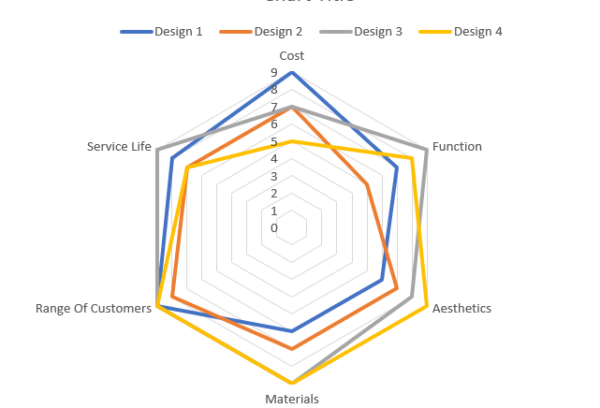
A radar chart is a lot simpler in that is mostly uses numbers to rate each idea and is then plotted into a graph.

Decision matrixes are very unique in that they use addition and multiplication to come to a conclusion.
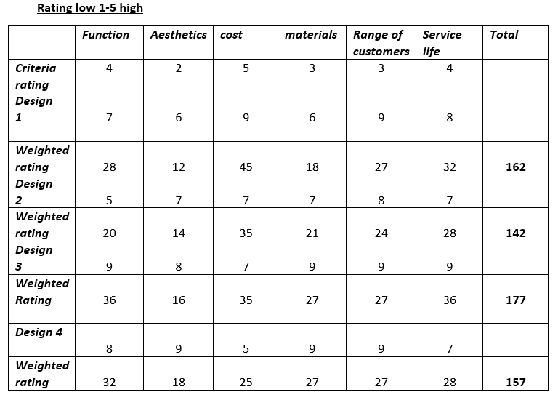

Discussion
When developing any new products certain factors need to be considered for example if it will cause harm to the user, have an environmental impact and if any ethical considerations need to be taking into account for. For the headphones there is only one major health risk that comes to using them which includes risk to users hearing, precautions have been considered for example there will be a limited amount of sound the headphones are allowed to produce without damaging the users hearing. Due to the headphones being waterproof and secured in a watertight casing there will be no risk to electric shock. Environmental factors that were taking into consideration includes whether or not the materials used were going to be recyclable and also how the product was made. For this product all materials being used are 100% recyclable which includes the copper wiring, the plastic casing, and the inner circuit boards. This will help to reduce landfill space, reduce water, and air pollution and also limits the creation of non-biodegradable materials, all of this to help benefit the environment.
” In the UK approximately 4.7 million tonnes of plastic products are used in various economic sectors “, a statement taking from the book of polymer science and technology for scientists and engineers. With that much plastic being produced alone in the UK it’s no wonder why landfill spaces keep increasing that why it’s essential when creating any giving product to a create a product that won’t add to the environmental damage that is already being done. No ethical considerations were considered as developing the product would not be harmful to society or any individual. The standards that are applicable to this product includes ISO 11904-1:2002 which applies the determination of sound emissions close to the ear, IEC 62680-1-3:2018 which applies to the power connection of the charging case which uses USB C and ISO/IEC 27033-6:2016 which applies to the product as it operates on a wireless connection.

Conclusion
Within the development of my product process such as empathising with the user, defining the problem, brainstorming to solve problem, building a prototype and testing the solution to make sure it was ready to be sold would have led to a successful development of the product. In the future the career path I see myself taking is revolved around the design aspects of engineering whether it be as simple as designing a handheld product to as large as a vehicle. However, in order for me to achieve this goal and have a better chance at going into that line of industry, I will need certain skills as well as a degree in engineering. These skills include mathematical, teamworking, design, brainstorming, communication, and science skills. I feel these as well as an engineering degree will help better my chances at achieving my goal, these skills do need to be worked so I can achieve my career goals. Also, since I would like to go into the design industry of engineering it would help if I had more knowledge on the design side of engineering this could be done by taking classes on design after getting my degree to help in the future.

Reference list
Page 4 diagram from : organisation website
https://conficio.design/?gclid=Cj0KCQiAkNiMBhCxARIsAIDDKNUvZIujF5otPJ9L0A-XbGacER6qbR86XVhH4qx5fSf6i9Y7pCSwhR0aAlWtEALw_wcB
Page 5 codes of conduct from: organisation website
https://www.nspe.org/resources/ethics/code-ethics
Page 5 organisation vision: organisation website
https://www.nspe.org/membership/nspe-who-we-are-and-what-we-do
Page 8 statement from: Book
Polymer science and technology for scientists and engineers by Pethrick, Richard A.
Page 8 standards: from websites
https://www.iso.org/obp/ui/#iso:std:iso:11904:-1:ed-1:v1:en
https://webstore.iec.ch/publication/61599
https://www.iso.org/obp/ui/#iso:std:iso-iec:27033:-6:ed-1:v1:en

